Design Innovation Technology 7–10 – sample assessment task
Disruptive lighting solution
Syllabus focus areas:
- Design and innovation
- Applying design processes
- Applications of technology

Contents
Task description 2
Submission details 4
Steps to success 7
What is the teacher looking for? 10
Student-facing rubric 11
Student support material 15
Glossary 15
Sample of a completed Design investigation portfolio 16
1. Disruption focus and assumption audit 16
2. User and context investigation 19
3. Emerging technologies insight 20
4. Early experimentation 21
5. Emergent design direction 23
Support and alignment 24
References 25

Task description
Type of task: design investigation portfolio
Suggested weighting: 20%
Investigate how conventional lighting systems fail to meet the needs of certain users, contexts or sustainability goals.
Use design thinking to challenge assumptions about what lighting is for, who it serves and how it behaves.
Select one disruption lens and use research, analysis and early experimentation to define a clear design opportunity for a lighting solution.
Task description
Lighting is everywhere – in our homes, schools, streets and devices. But most lighting systems are designed with certain assumptions about who will use them, how they will be used and what they are meant to do.
Conventional lighting does not always work well for everyone. Some users are overlooked. Some environments are poorly supported. Some lighting systems waste energy or negatively impact wellbeing and the environment.
Your task
Your challenge is to investigate how current lighting systems fail to meet the needs of a particular user, context or sustainability goal.
Instead of designing a finished product straight away, you will take an emergent design approach. This means you will:
- question common assumptions about lighting
- investigate user needs and contexts
- explore how lighting affects behaviour and the environment
- experiment with simple lighting tests
- identify a clear opportunity for improvement.
You must select one disruption lens to guide your investigation. Below are some ideas:
- Users: Who is not being considered in current lighting design? (Examples include neurodivergent users, children, older people, shift workers or users with low vision).
- Contexts: Where does lighting not work effectively? (Examples include shared bedrooms, rental housing, public transport or outdoor spaces).
- Behaviour-changing light: How can light influence focus, sleep, mood or habits? (Examples include a desk lamp that changes to bright white light during homework to help improve focus and concentration, a lamp that gradually dims and changes to warm orange light at bedtime to help users relax and fall asleep, a waterproof light that changes from green to yellow to red as shower time increases, encouraging shorter showers and saving water).
- Low-impact systems: How can lighting reduce environmental harm? (Examples include energy, materials, lifecycle or light pollution).
By the end of this task, you will determine and describe a clear design opportunity that will guide your future prototyping and development of a lighting product.
You are not designing the final solution yet. You are identifying and clearly describing a problem worth solving.
Assessment criteria
You will be assessed on your ability to:
- use and document experimentation and evidence to justify a clear and logical design opportunity
- analyse existing lighting solutions and identify assumptions about users, contexts, behaviour or sustainability
- reflect on findings and identify informed next steps for future development
- assess the needs of an end user and explain how these needs create an opportunity for innovative design
- evaluate designer responsibilities, including ethical, social and environmental considerations
- explain how current or emerging technologies influence lighting design and future possibilities.

Submission details
The final submission should include a structured design investigation portfolio (digital or physical) containing the 5 criteria listed below.
- Disruption focus and assumption audit
- Identify a chosen disruption lens.
- Analyse 2 to 3 existing lighting products or systems and document your findings using written explanations, sketches, diagrams or annotations.
- Identify at least 3 assumptions about:
- the user
- the context
- behaviour
- energy or materials.
- Explain who or what may be excluded, disadvantaged or negatively impacted by the existing lighting products.
- User and context investigation
In this section of the design investigation portfolio, you must include the following information:
- evidence of user insight (interview, persona user profile, empathy map, scenario sketch or observation)
- a clear explanation of the unmet need
- summarise key insights of the user and context investigation.
You must demonstrate consideration of:
- designer responsibility
- ethical implications
- environmental impact.
- Emerging technologies insight
Explain how at least one current or emerging technology could influence lighting design in your context, such as:
- smart sensors
- Internet of Things (IoT) systems
- smart materials
- low-energy LEDs
- adaptive lighting systems
- renewable integration.
You must also explain:
- how the technology changes what lighting can do
- how it impacts designers’ responsibilities.
- Early experimentation
Plan, conduct and document 2 simple lighting experiments, such as:
- diffusion tests
- directional light trials
- colour temperature testing
- glare or shadow studies
- reflective surface experiments.
Each experiment must include a documented:
- aim
- method
- observation or result
- reflection on your findings and an explanation of what should happen next.
- Emergent design direction
You should develop:
- a design opportunity statement (not a full brief)
- an explanation of how research and experimentation shaped this direction
- an identification of uncertainties or next questions.
Example structure
There is an opportunity to design a lighting system that …
This could respond to …
Further investigation is needed into …
Suggested due date: Term 4 Week 4 (confirm the exact date with your teacher.)
Outcomes being assessed
A student:
- evaluates the responsibilities of designers and factors affecting their work DIT5-WOR-01
- assesses the needs of end users to support innovative design solutions DIT5-USR-01
- explains the influence of current and emerging technologies on the practice of designers DIT5-IVT-01
Design Innovation Technology 7–10 Syllabus © NSW Education Standards Authority (NESA) for and on behalf of the Crown in right of the State of New South Wales, 2025.
Note: the decisions made in this assessment task will guide the students’ future development of functional and creative design solutions for a lighting product through iterative design processes.

Steps to success
Table 1 – assessment preparation schedule
Steps | Student actions and timeline
Understand the challenge | What do I need to do?  - Read and unpack the task notification.  - Understand and identify possible disruption lenses.  - Select one disruption lens.  - Write a short justification explaining why this area needs improvement.  When do I need to do it?  Week 1 Lesson 2.
Disruption focus and assumption audit | What do I need to do?  - Analyse 2 to 3 existing lighting products or systems and document your findings using written explanations, sketches, diagrams or annotations.  - Identify at least 3 assumptions the existing products make about users, contexts or behaviour.  - Explain who is excluded or negatively impacted by the existing products.  - Document findings with annotated images or notes.  When do I need to do it?  Week 1 Lessons 2 to 3.
User and context investigation | What do I need to do?  - Conduct user research (interview, persona user profile, empathy map or scenario sketch).  - Provide a clear explanation of the unmet need.  - Consider designer responsibilities, including social, ethical and environmental impacts.  - Summarise key insights of the user and context investigation.  When do I need to do it?  Week 2 Lessons 1 to 2.
Emerging technologies insight | What do I need to do?  - Research at least one emerging or current technology related to lighting.  - Explain how it could change lighting design.  - Explain how it influences designer responsibilities, including social, ethical and environmental impacts.  When do I need to do it?  Week 2 Lesson 3.
Early experimentation | What do I need to do?  - Plan and conduct 2 simple lighting experiments.  - Document the aim, method, observations.  - Reflect on your findings and explain what should happen next. Identify what worked, failed or surprised you.  When do I need to do it?  Week 3 Lessons 1 to 2.
Emergent design direction | What do I need to do?  - Write a design opportunity statement.  - Explain how research and experimentation informed the design opportunity statement.  - Identify remaining questions for future development.  - Finalise and organise your portfolio for submission.  When do I need to do it?  Week 3 Lesson 3.
Submission | What do I need to do?  - Review the entire portfolio for accuracy, spelling and layout.  - Add a simple contents page and headings for each section.  - Submit the portfolio as stipulated by your teacher (for example, physically print it out and put it in a folder or digitally upload it).  When do I need to do it?  Week 4.

What is the teacher looking for?
- Clearly explain and communicate your ideas using writing, sketches, annotations and photos of your experiments.
- Analyse existing lighting and identify the assumptions designers have made.
- Show strong understanding of your chosen user or context and explain their unmet needs.
- Analyse designer responsibilities, including social, ethical and environmental considerations.
- Explain how current or emerging technologies could influence future lighting design.
- Use experimentation to justify a clear and logical design opportunity.
- Reflect on your findings and explain what should happen next.
Stronger responses will show deeper thinking, clear evidence to support ideas and strong links between research, testing and your final design direction.

Student-facing rubric
Table 2 – rubric for assessment
Criteria | Outstanding | High | Sound | Basic | Limited
Disruption focus and assumption audit | Insightfully analyses 2 to 3 existing lighting products or systems using detailed annotations, sketches and explanations. Clearly identifies and evaluates multiple assumptions about user, context, behaviour, or energy or materials. Thoroughly explains exclusions or negative impacts. | Clearly analyses existing lighting products or systems with relevant detail. Identifies and explains assumptions and exclusions or impacts. | Describes existing products or systems and identifies some assumptions and impacts. | Provides basic research of products or systems and identifies few assumptions or impacts. | Provides minimal or inaccurate research with little understanding of assumptions or impacts.
User and context investigation | Thoroughly investigates user and context through detailed evidence (for example, interview, empathy map or persona user profile). Clearly explains a significant unmet need and insightfully considers designer responsibility, ethical implications and environmental impact. | Clearly investigates user and context with relevant evidence. Explains unmet need and considers responsibility, ethics and environmental impact. | Identifies user and context needs with some evidence. Describes unmet need and some considerations. | Identifies basic user or context information with limited evidence or explanation. | Demonstrates limited understanding of user or context or unmet need.
Emerging technologies insight | Insightfully explains how current or emerging technologies could transform lighting design in context with detailed examples. Clearly explains implications for designers’ responsibilities. | Clearly explains how technologies influence lighting design and designers’ responsibilities. | Describes how a technology may influence lighting design with some explanation. | Identifies a technology with basic explanation of influence. | Demonstrates limited or inaccurate understanding of technology and its impact.
Early experimentation | Thoroughly documents 2 purposeful experiments with clear aim, method, observations or results and insightful reflections informing next steps. | Clearly documents 2 experiments with relevant observations and reflections. | Documents experiments with some detail and simple reflections. | Documents basic experimentation with incomplete detail or reflection. | Minimal or incomplete experimentation documented.
Emergent design direction | Develops a highly considered design opportunity statement clearly informed by research and experimentation. Insightfully explains design direction and identifies uncertainties or next questions. | Develops a clear design opportunity statement informed by research and experimentation. Explains design direction and identifies next questions. | Develops an appropriate design opportunity statement with some links to research. | Develops a simple or unclear design direction with limited links to research. | Provides minimal or incomplete design direction.
This student facing rubric was developed using the Common grade scale (7–11) (NESA n.d.).

Student support material

Glossary
Table 3 – glossary of terms for this assessment task
Term | Definition
assumptions | An idea designers believe to be true about users, environments or needs, which must be tested or researched.
context | The situation or environment where a product is used or where a problem exists.
design opportunity statement | A sentence that clearly identifies a problem or need and suggests an opportunity for a new or improved design solution.
disruption lens | A disruption lens is a different way of examining existing products, systems or experiences to identify assumptions, limitations, exclusions or opportunities for improvement. They help designers look critically at current designs from a particular perspective, such as sustainability, accessibility, emerging technologies, ethics, user needs or social change.
emerging technology | New or developing technology that is beginning to influence design and production practices.
justification | A clear explanation of why you made a design choice using reasons and evidence.

Sample of a completed Design investigation portfolio
Student name:
Disruption lens: | Users – neurodivergent and sensory-sensitive students in classrooms

1. Disruption focus and assumption audit

Existing product or system analysis

Product 1: standard fluorescent classroom lights
Description: long fluorescent tube lights mounted on the ceiling in rows
Strengths
- Bright and evenly distributed light
- Cheap to install and maintain
- Suitable for general classroom tasks
Weaknesses
- Flickering can trigger headaches or sensory overload
- Harsh white or blue light may cause eye strain
- No personal control for individual users
Annotations
[Student would include labelled sketch here showing glare zones, flicker and bright spots.]
Assumptions identified
- Users can tolerate bright overhead light
- Everyone needs the same brightness
- The classroom is only used for focused academic work
- Energy efficiency is more important than comfort
Who may be excluded or disadvantaged?
- Students with autism or ADHD
- Students with migraines or sensory sensitivities
- Students with visual processing difficulties

Product 2: desk lamp
Description: small, directional light source for individual tasks
Strengths
- User has control over direction
- Focused light reduces need for overhead lighting
- Can create a calm work zone
Weaknesses
- Creates shadows
- Can produce glare
- Only benefits one user at a time
Annotations
[Student would include labelled sketch here showing directional light, glare and shadow zones, and bright spots.]
Assumptions identified
- The user has enough desk space.
- Users can adjust the lighting themselves.
- Individual lighting is enough to solve the problem.
Who may be excluded or disadvantaged?
- People with vision impairments who may require brighter, more even lighting than a desk lamp provides.
- Users with limited mobility or dexterity who may find adjusting the lamp difficult.
- People working in shared spaces, as only one person benefits from the light while others may still have poor lighting.

Product 3: motion-sensor corridor lighting
Description: lights switch on when movement is detected
Strengths
- Saves energy
- Convenient in transitional spaces
Weaknesses
- Delayed activation
- May turn off while user is still present
- Can startle users when suddenly switching on
Annotations:
[Student would include labelled sketch here showing motion sensors, detection zones, LED light fittings.]
Assumptions identified
- Users are always moving.
- Sudden changes in light are acceptable.
- Energy saving is more important than comfort.
Who may be excluded or disadvantaged?
- People with limited mobility who may remain still, causing the light to switch off.
- People with sensory sensitivities who may find sudden changes in light uncomfortable.
- Wheelchair users or children if the sensor does not reliably detect their movement.
Conclusion of audit
Most lighting systems are not designed for the users with neurodiversity or sensory sensitivities and prioritise cost and energy efficiency over accessibility and wellbeing. There is an opportunity to create adaptable lighting for neurodivergent users in shared spaces.

2. User and context investigation

User insight – empathy map
I have created an empathy map for a 14-year-old student with autism.
Figure 1 – empathy map sample
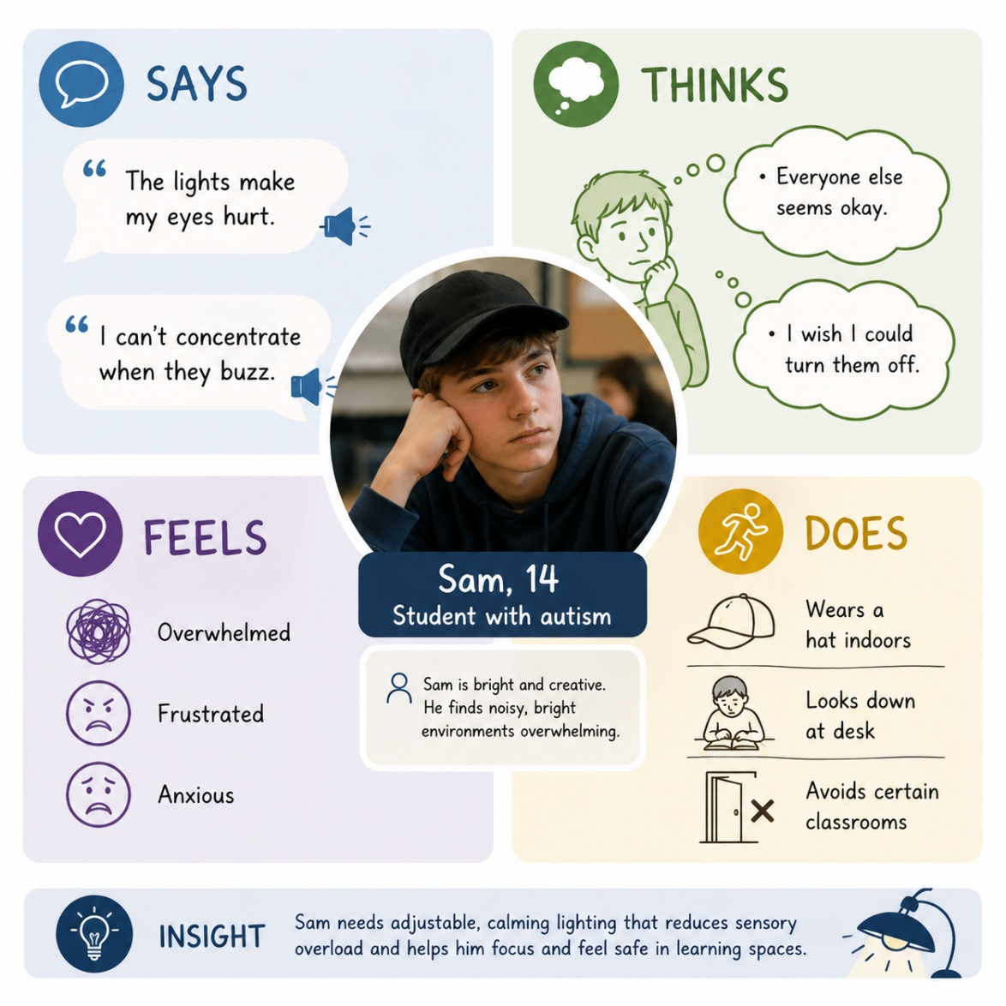
This work has been generated using artificial intelligence. Any copyright subsisting in this work is owned by © State of New South Wales (Department of Education) 2026.
Observation
During a classroom observation, 3 students moved seats away from direct overhead light. One student covered their eyes when lights were switched on.
Unmet need
Students need adjustable, calming and less harsh lighting that supports focus without causing discomfort or sensory overload.
Designer responsibilities
Designers must consider:
- accessibility: include diverse users
- ethics: avoid causing harm
- environmental sustainability: reduce energy use
- safety: ensure lights are not distracting or hazardous.

3. Emerging technologies insight
Technology chosen: adaptive smart lighting system
Adaptive smart lighting uses sensors and programmed controls to change brightness and colour temperature automatically.
How it changes what lighting can do
- Adjusts brightness based on daylight levels
- Shifts to warm tones for calming environments
- Detects occupancy and usage patterns
- Allows individual zones to be controlled
Example: schools in Scandinavia use human-centric lighting to improve concentration and reduce fatigue.
Impact on designer responsibilities
Designers must now consider:
- data privacy when using sensors
- user choice and override options
- programming for inclusivity
- environmental impact of electronic components.

4. Early experimentation
Experiment 1: diffusion test
Aim
To test which material softens light best.
Method
Shine a torch through:
- baking paper
- frosted plastic
- tracing paper.
Observations or results
Table 4 – observation table to record experiment 1 results
Material | Result | Images
Baking paper | Warm, soft light
Frosted plastic | Even but dull
Tracing paper | Soft but fragile
Reflection
Baking paper created the calmest effect but is not durable. Frosted acrylic may be a better long-term material.
Experiment 2: colour temperature test
Aim
To compare the emotional effects of warm and cool light.
Method
Tested LED strip on warm white and cool white settings.
Observations or results
Table 5 – observation table to record experiment 2 results
Colour | Effect | Images
Warm white | Calm, relaxed
Cool white | Bright, alert

Reflection
Warm white light is better for users with sensory sensitivities. Cool white light may still be useful during high-focus tasks.

5. Emergent design direction
Design opportunity statement
There is an opportunity to design an adaptive classroom lighting system that creates calm, adjustable and inclusive learning environments for students with sensory sensitivities.
How research and experimentation shaped this direction
My research showed that current lighting excludes some users. My experiments proved that warm light and diffused materials create more comfortable environments.
Uncertainties and next questions
- How can users control their own lighting zone?
- Can the product be low cost for schools?
- How can sensors adapt without becoming distracting?
- Which materials are durable and sustainable?

Support and alignment
Resource evaluation and support: all curriculum resources are prepared through a rigorous process. Resources are periodically reviewed as part of our ongoing evaluation plan to ensure currency, relevance and effectiveness. For additional support or advice, or to provide feedback, contact the TAS Curriculum team by emailing TAS@det.nsw.edu.au.
Differentiation: further advice to support Aboriginal and Torres Strait Islander students, students learning English as an additional language or dialect (EAL/D), students with a disability and/or additional needs and high potential and gifted students can be found on the Planning programming and assessing 7–12 webpage. This includes the Inclusion and differentiation 7–10 advice webpage.
Assessment: further advice to support formative assessment is available on the Planning programming and assessing 7–12 webpage. This includes the Classroom assessment advice 7–10. For summative assessment tasks, the Assessment task advice 7–10 webpage is available.
Explicit teaching: further advice to support explicit teaching is available on the Explicit teaching webpage. This includes the CESE Explicit teaching – Driving learning and engagement webpage.
Consulted with: TAS Curriculum subject matter experts, Teaching and Learning, Effective Teaching Practice, Literacy and Numeracy.
Alignment to system priorities and/or needs: School Excellence Policy, Our Plan for NSW Public Education.
Alignment to the School Excellence Framework: this resource supports the School Excellence Framework elements of curriculum (curriculum provision) and effective classroom practice (lesson planning, explicit teaching).
Alignment to Australian Professional Standards for Teachers: this resource supports teachers to address Proficient Teacher Standard Descriptors 3.2.2, 3.3.2.
Creation date: 18 June 2026.

References
This resource contains NSW Curriculum and syllabus content. The NSW Curriculum is developed by the NSW Education Standards Authority (NESA). This content is prepared by NESA for and on behalf of the Crown in right of the State of New South Wales. The material is protected by Crown copyright.
Please refer to the NESA Copyright Disclaimer for more information https://www.nsw.gov.au/education-and-training/nesa/copyright.
NESA holds the only official and up-to-date versions of the NSW Curriculum and syllabus documents. Please visit NESA https://www.nsw.gov.au/education-and-training/nesa and NSW Curriculum https://curriculum.nsw.edu.au.
Design Innovation Technology 7–10 Syllabus © NSW Education Standards Authority (NESA) for and on behalf of the Crown in right of the State of New South Wales, 2025.
This resource contains content obtained from Canva, and its use outside of this resource is subject to Canva’s Content Licence Agreement.
NESA (NSW Education Standards Authority) (n.d.) Reporting and using grades, NSW Curriculum website, accessed 3 June 2026.

© State of New South Wales (Department of Education), 2026
The copyright material published in this resource is subject to the Copyright Act 1968 (Cth) and is owned by the NSW Department of Education or, where indicated, by a party other than the NSW Department of Education (third-party material).
Copyright material available in this resource and owned by the NSW Department of Education is licensed under a Creative Commons Attribution 4.0 International (CC BY 4.0) license.

This license allows you to share and adapt the material for any purpose, even commercially.
Attribution should be given to © State of New South Wales (Department of Education), 2026.
Material in this resource not available under a Creative Commons license:
- the NSW Department of Education logo, other logos and trademark-protected material
- material owned by a third party that has been reproduced with permission. You will need to obtain permission from the third party to reuse its material.
Links to third-party material and websites
Please note that the provided (reading/viewing material/list/links/texts) are a suggestion only and implies no endorsement, by the New South Wales Department of Education, of any author, publisher, or book title. School principals and teachers are best placed to assess the suitability of resources that would complement the curriculum and reflect the needs and interests of their students.
If you use the links provided in this document to access a third-party's website, you acknowledge that the terms of use, including licence terms set out on the third-party's website apply to the use which may be made of the materials on that third-party website or where permitted by the Copyright Act 1968 (Cth). The department accepts no responsibility for content on third-party websites.

