Graphics Technology - CAD Exercises – Stage 5

‘Here be Dragons!’

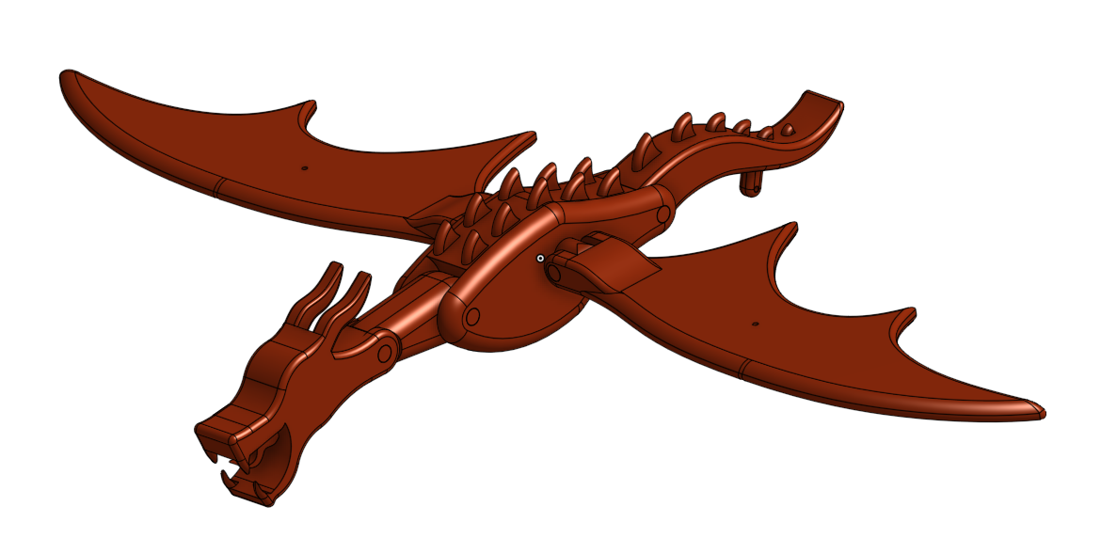

Contents
Contents 2
Setting up Onshape 3
CAD exercises 6
Base enclosure 6
The crankshaft 20
Spacer rings 22
Central and outer crankshaft connectors 22
Crank handle connector 24
Main crankshaft follower 24
Automaton neck 26
Automaton body 31
Automaton tail 39
Automaton head 43
Automaton wings 46
Wing control rods 48
Tail control rod 56
Head control rod 57
Body to wing connector 58
Body control rod 58
Body control rod guide block and pivot 59
Assembly 60
The base enclosure 60
The triad manipulator 61
Fastened mate 62
Assembled base enclosure 65
Assembling the crankshaft 65
The first sub-assembly 66
Follower, rod and guide blocks 70
Assembling the dragon 75
Composite part tool 76
Animation 83
Generated Drawings 85
AS1100 85
Creating a drawing in CAD 87
Selecting the file 89
Generated views 91
Dimensioning 93
Detail view 94
Callouts 96
Parts list 98
Title block 100
Other drawings 101
All of the following instructions relate to Onshape, if using a different CAD package, changes may need to be made in relation to shortcuts and naming conventions for tools.

Setting up Onshape
To create a free Onshape education account simply click here and follow the instructions to gain access from any device that has a browser and internet connection. Students should create their account using their school email and password as their username and password (as this avoids forgotten passwords). Once logged in, the first thing students will see is the main landing page for Onshape, where they can access existing documents and folders or create new ones.
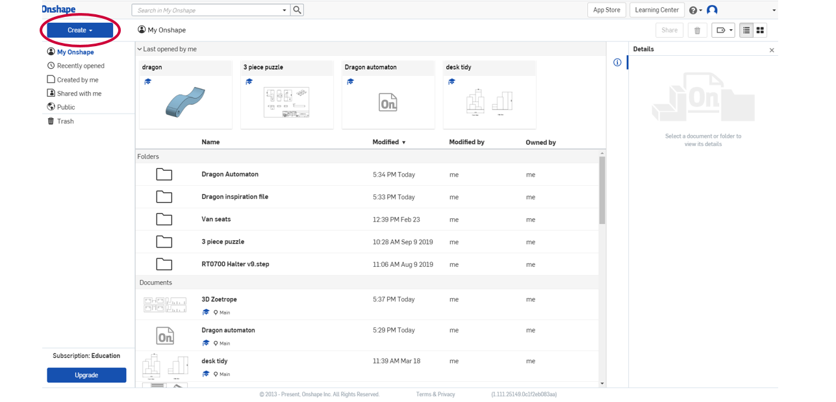
Onshape utilises a hierarchical structure where a part studio is the base level, on which everything is built. This is where initial sketches are produced and extruded into 3D forms.
Next there are assemblies, where part studio files can be combined and mated together providing information about how they interact with one another, including creating animations to show how they will move and react.
Then sitting somewhere alongside assemblies are drawings, which are 2D working drawings using orthographic projection with dimensions, either generated from individual part studio objects, or from assemblies of part studio objects.
Next is the folder where all of the part studios, assemblies and drawings related to one aspect of a project can be brought together in one place.
The second highest level is the document, within which all other part studios, drawings, assemblies and folders relating to a project can be found. Pdf files, images or other information can also be imported into a document so that all reference material can be found in one spot.
The top level is once again folders. This is so that projects (in the form of documents) can be grouped together. In industry this may mean all the projects for a particular client could be placed in one folder, or, if the project is particularly large and involves different people working on different aspects of the one project, it can provide them with the space to bring all of those parts together.
In a school setting it means that students could have a Year 9 Graphics folder, or a Year 10 Graphics folder inside of which they could gather together all of their documents for the different projects they have undertaken in those courses. This level is only really necessary if producing large volumes of work and can easily be added at a later date if there is a need to tidy up files. So, for the purposes of the Here be Dragons project we will consider the document to be the top level.
For this project, students will require one main document for the automaton, then inside that one they will need to create a series of folders:
- Base enclosure – for all the components that make up the base enclosure including a sub-assembly of all those parts
- Crankshaft – for all the parts relating to the construction of the crankshaft including a sub-assembly of all the components ready to be installed into the base enclosure
- Dragon components – for all the parts that make up the dragon including the pieces that hold it together and a sub-assembly of all those parts
- Connector rods – for all the rods and blocks that are used to control the movement of the automaton including any sub-assemblies as required
- Assembled automaton – for all the sub-assemblies to be brought together in one place and then animated to ensure it works.
This will make it a lot easier to manage and keep track of what has been completed and what needs to be completed. Here is an example what they look like inside the document in Onshape.
There are over 30 parts required to assemble the finished automaton and without some sort of filing system it can all get a little confusing, so set up the folders inside the document first and make sure to immediately rename the part studios as they are created with a name that makes sense and indicates what it is.

To start a new project, click on the Create tab and select the document option from the drop-down list that appears.
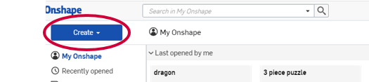
To make it easier for identification and marking, the naming convention for any documents created should be the student’s name, their class and then the name of the project. So that might look like:
Jane Smith, 9GT1, Automaton project
That way when the files are shared for checking or if help is required, the teacher will be able to identify individual student’s work more easily.
One final point to note about Onshape is that it saves your work automatically. Every time you left click to finalise a command or press the enter key on the keyboard it saves, so work can never be lost. As an added bonus it also keeps a record of the history of the file, so if you make change and then decide against it, you can always go back to a previous version before the change was made.
These exercises are accompanied by a series of six tutorial videos available through the TAS Statewide Staffroom. They take the viewer through the step-by-step processes involved in the use of the tools, functions and mates employed within the following CAD exercises, as well as how to set up the work space, assemble the components and produce an animation.
Alternatively, Onshape provides a series of Self-Paced Courses through their Learning Centre, which explain all of what is covered in this booklet and much more.
If you have completed some of the courses under the heading of Fundamentals then you may be able to skip some of the instructions on how to use the tools and just move on with sketching the parts and assembling them to create your automaton. However, the instruction are still there, just in case you need recap and equally the courses allow you to go over them as many times as necessary until you understand what to do.

CAD exercises
This section will take students through a series of exercises to create parts to assemble and then animate, making an automaton. Once completed, you will be able to modify and customise the parts, which could eventually be 3D printed and built.

Base enclosure

Part 1 - Top
This part introduces the centre rectangle, centre circle, three-point arc, dimension, trim and mirror tools, and the ‘extrude’ function. This part is best drawn on the top plane, as that way it will be orientated correctly when it comes to its assembly.
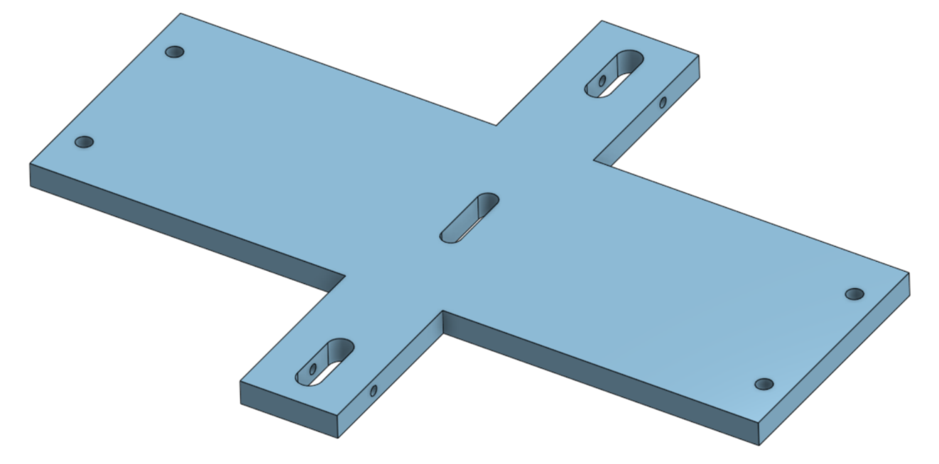
Begin by selecting sketch in the top left-hand corner of the screen.

Next select the top plane by clicking on it, to tell the software where you want to draw.
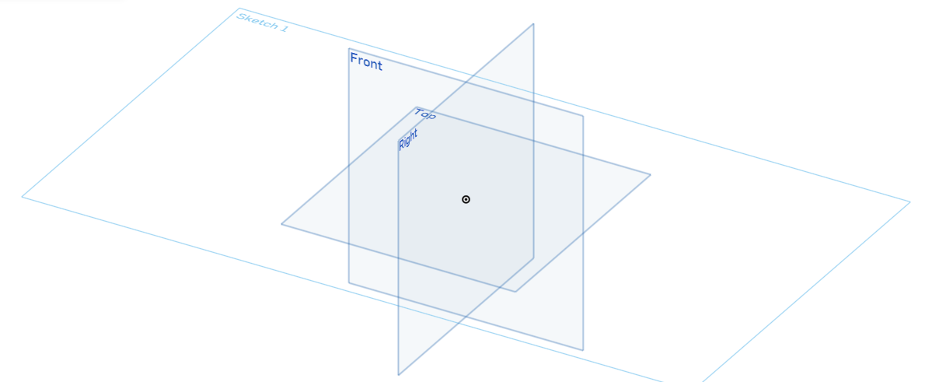
The order of the previous two steps is not critical, as the plane can be selected first and then the sketch button clicked and it will have the same effect. On more complex components any flat surface or face can be selected to draw on, which will be necessary later in this example.
Once the sketch is active a dialog box will appear just below and to the right of where the sketch button was, with a green tick and a red cross at the top of the box. Often this is misinterpreted as asking for a confirmation of what has been selected. Do not click on either, as this actually finalises the sketch if the green tick is selected, or cancels (deletes) the sketch if the red cross is selected. If, however the cross is inadvertently clicked at any time, Onshape always provides a pop-up box, which asks the user if they would like to restore the sketch again, as a safety feature.
If the tick is prematurely clicked, all this does is save and close the sketch. In order to reopen it, it needs to be located in the feature list on the left hand side of the screen, then right click on it and select edit, which will reopen the sketch and allow work to continue.
The dialog box also provides a range of options appropriate to whichever tool is being used, for instance the one below for the sketch command confirms which plane is being drawn on, whether constraints should be shown and whether it shows if the sketch becomes over-defined. This last point will be covered later.
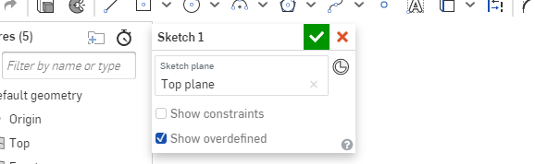
The next step is to normalise the view so that it is looking straight down on the plane. This is done by pressing ‘n’ on the keyboard, now you are ready to start drawing.

The centre point rectangle tool
First select a centre point rectangle from the toolbar across the top. It can be found on the toolbar as shown below.
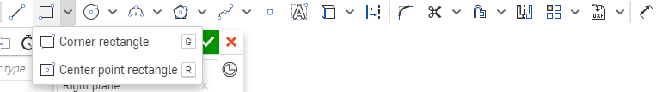
Click on the drop down arrow next to the corner rectangle tool, as it is the default rectangle tool, then click on the centre point rectangle to select it (note Onshape uses the American spelling of centre as they are an American company).
Draw the first rectangle running horizontally 150mm wide and 50mm high, with its centre at the origin point in the centre of the axes on the plane. Then draw the second rectangle running vertically with the same starting point as the first, 20mm wide and 120mm high. It should look like the image below.
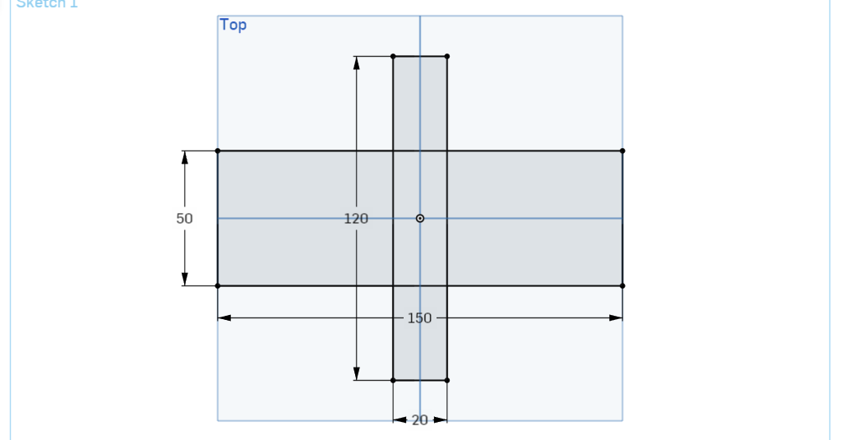
In Onshape the method of drawing any shape is to draw first and dimension second. For the centre point rectangle this means that you left click on the start point, which is the centre of the rectangle and as you drag the mouse away from the start point a rectangle shape forms. When the rectangle looks close to what you want, and the dimensions are approximately correct left click the mouse again. It is not necessary to try and get the dimensions accurate at this stage.
By clicking the mouse for the second time, this finalises the rectangle shape and the dimensions become editable. Simply type in the value required, press the enter key on the keyboard and it will lock in that value and switch to the other dimension for the rectangle, where the process is repeated to finalise this part of the drawing.

The trim tool
Once you have both rectangles drawn the next tool required is the trim tool.
This tool removes parts of lines which are no longer necessary for the drawing, such as guidelines, or where more complex shapes are created by overlapping them.
Once selected, click on the overlapping parts of the two rectangles to delete the lines, leaving only the perimeter as shown at the top of the next page forming a cross shape (the two remaining vertical lines that are lighter are construction lines and cannot be deleted in the trimming process).
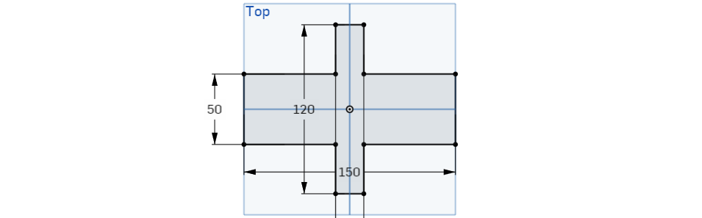
The next step is to draw two more centre rectangles with their centre point on the blue vertical axis going through the origin point on the plane. The first is 12mm high and 4mm wide, with its centre point actually on the origin point (in the same way as the first two rectangles) and the second is 10mm high and 4mm wide with its bottom edge 7mm higher than the bottom edge of the original vertical rectangle as shown below.
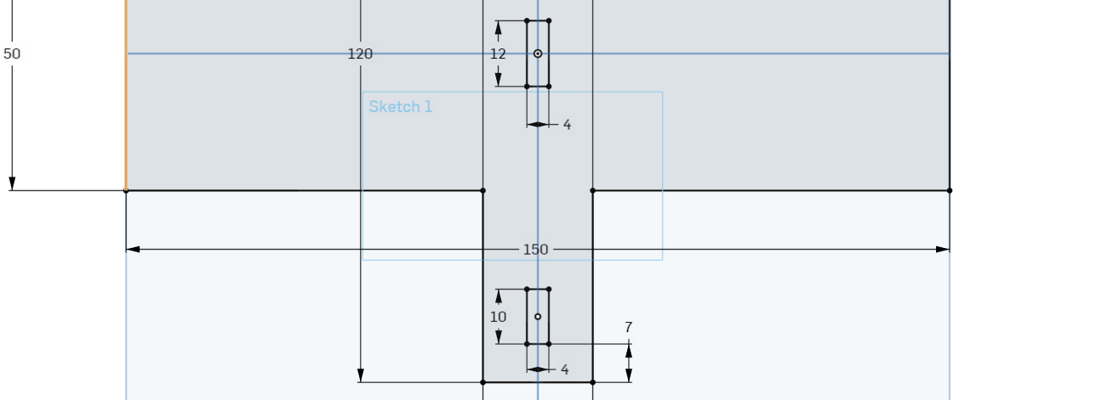
As the lower rectangle is drawn with its centre point on the vertical line, its horizontal location is already correct, however, the vertical position needs to be adjusted.

The dimension tool
In order to accurately locate the lower rectangle you will need to use the dimension tool, which can be found on the toolbar as shown below.
Simply select the dimension tool then click on the bottom edge of the new rectangle, then click on the lowest edge of the cross shape. A dimension will appear and as with any dimension in Onshape, you need to click somewhere (ideally away from other dimensions and details so that it does not become too cluttered) to locate where it will be displayed, then when prompted with the editable box type in the value of 7mm. This will cause the new rectangle to move so that it is in the correct location.

The three-point arc tool
The next step is to add the curve to the ends of these rectangles you have just drawn. This can be done multiple different ways, but for this example you will use the three-point arc tool as shown below. It can be quite complex, so read carefully.
Select the three-point arc tool and then click on one of the nodes (the dot on the corner where the two edges meet) on the top of the rectangle then click on the node on the other side. This will draw an arc between these two points. As you move the cursor the radius of the arc will change, making it bigger or smaller. The design calls for a 2mm radius, which means the arc will be a semicircle drawn on the end of the rectangle.
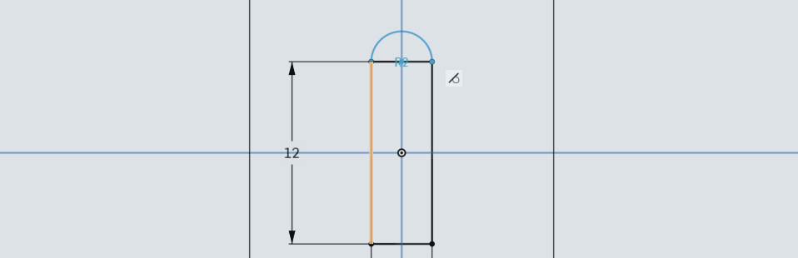
As you move the mouse look for a tangent symbol to appear (shown near the upper right corner of the rectangle shown above), which will be a diagonal line on top of a circle. Once the tangent symbol is visible the arc will ‘feel’ like it wants to lock in that position. If you left click or press enter to finish the arc now, that tangent will become a constraint that is used to define the sketch. However, as with each shape that you draw, once you finish it, it will also prompt you to provide the dimension and if you put in 2, as that is what the radius is, all the lines will go red and a message will pop up saying ‘sketch could not be solved’. This is because the sketch is over-constrained.
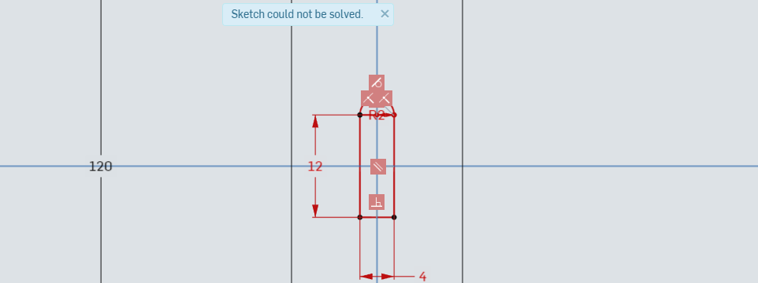
What has happened is that by allowing the tangent constraint to stay, the software already knows that an arc that is tangent to the end of a rectangle 4mm wide, must have a 2mm radius, but then we also told it the radius was 2mm. It does not matter that the two dimensions are the same, all the software knows is that we are giving it two values for one dimension and it does not like it.
So why would we choose the tangent constraint over a dimension?
By allowing the tangent constraint and then not putting in a second dimension when prompted (done by hitting the escape (Esc) key or by starting a new 3 point arc somewhere else), it means that the arc will always remain at a tangent to the rectangle.
This means that if we needed to change the rectangle to 8mm wide instead of 4mm, the arc would automatically resize too.
If however, we had made sure the tangent constraint was not in place and instead physically entered the dimension, it would then go into an error state, this time the dimension would cause the problem, as the arc would refuse to change size with the rectangle, causing the error to pop up and preventing the rectangle from changing sizes either.
In this instance, allow the tangent constraint to lock on and then click the left mouse button to finish the arc. Start drawing the next three-point arc to get rid of the dimensioning option and repeat the process until you have arcs on each end of both rectangles, the press Esc on the keyboard to finish the command.
Once all the arcs are in position use the trim tool to remove the top and bottom ends of both of the rectangles which should leave it looking like this with two pill shaped sections.
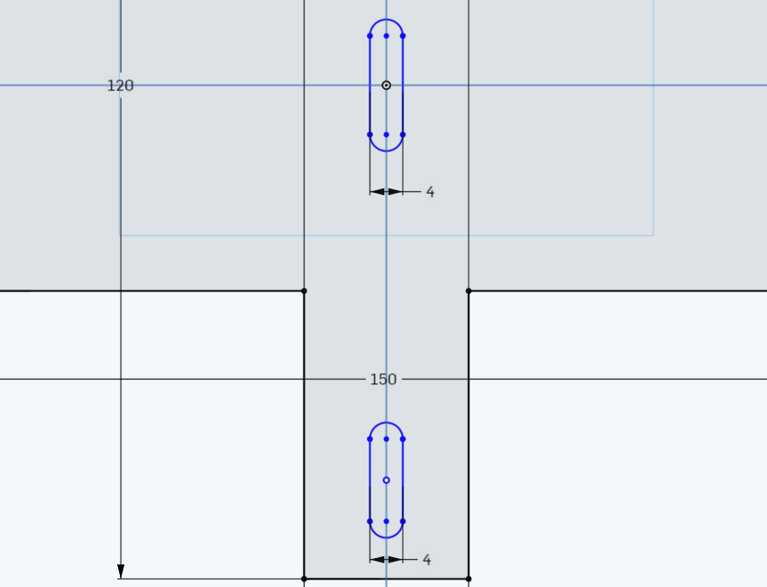

The mirror tool
The next tool used is the mirror tool and it can be found on the toolbar as shown below.
The mirror tool allows you to mirror entities, features and sketches so that you only have to do it once. If all three shapes had been the same, we could have used the pattern tool, but as only the two outside shapes are the same we can draw one and then mirror it.
Start by selecting the mirror tool. A prompt will pop up asking you to select a mirror line. In this case we are going to select the blue horizontal axis that passes through the origin point. In the image below you can see it has been highlighted in gold.
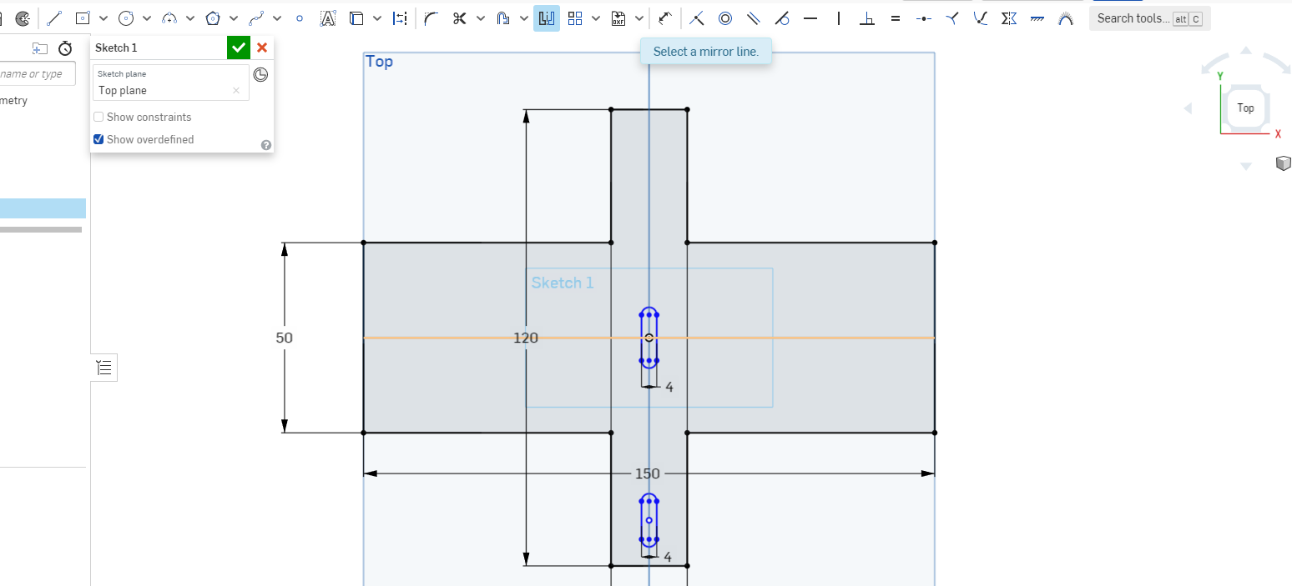
Once the mirror line is selected the prompt changes to ‘select entities to be mirrored’ and you can do this one of three ways. The first is to click on each line individually and as you click on them, they will be mirrored up to the top location. The other two options are called window selection or crossing selection (sometimes also called a window box or crossing box) and they involve drawing a box with your mouse over the shape you want to select. We will explore them more now.

Window selection
A window selection is where you click to the left of the object and hold down the left mouse button while dragging to the right. In Onshape, a translucent blue box with a solid outline will appear so you can see what you are selecting. If there is other geometry close by that might be overlapped with the selection box, but is not supposed to be selected, then this is type you should choose. Only objects fully enclosed within the box will be selected.
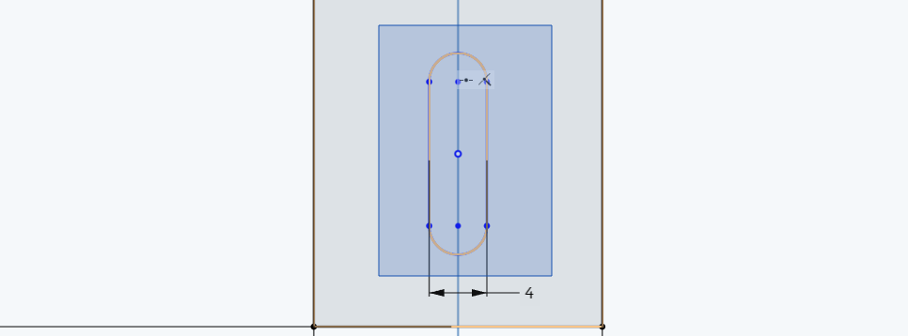

Crossing selection
A crossing selection is where you click to the right of the object and hold down the left mouse button while dragging to the left. In Onshape, a translucent yellow box with a dashed outline will appear so you can see what you are selecting. If there is nothing nearby, or you want to select everything without worrying about missing a line, use this selection. Any objects enclosed within or touching the box will be selected.
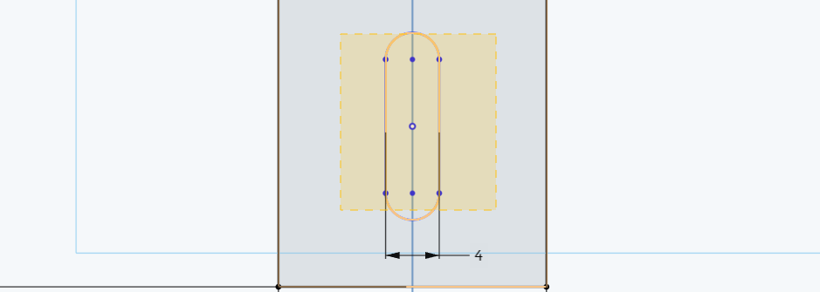
For the purposes of this task it does not matter which way you do it so long as all parts of the pill shape are selected, which will then cause it to be mirrored to the top part of the drawing, which should look like this.
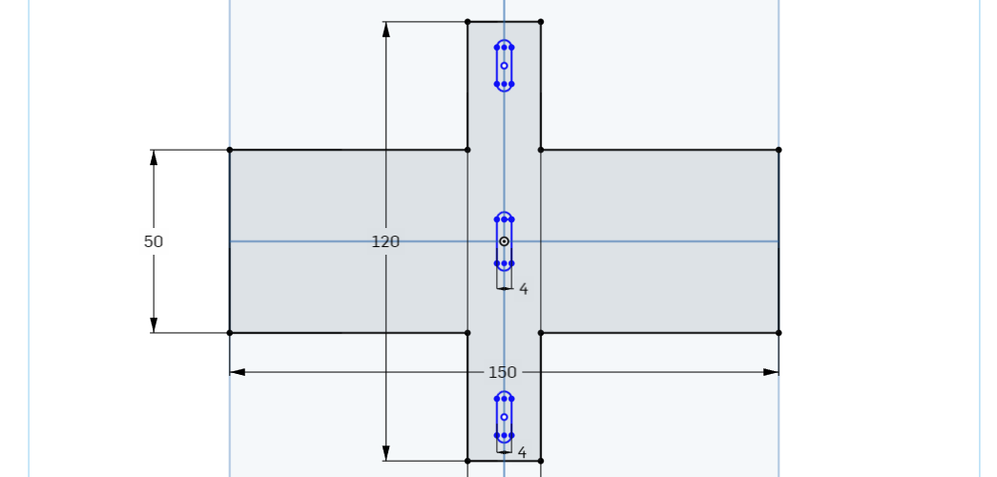
The next step is to draw the four holes, with two at either end of the wider part of the cross shape. For this we are going to use the same skills just covered of drawing an object, using the dimension tool to accurately locate it and mirroring to duplicate the object.

The centre point circle tool
The centre point circle tool can be found on the toolbar as shown below.
The centre point circle tool allows you to draw a circle by choosing the location of the centre and then providing the diameter for it.
Start by selecting the tool and then clicking somewhere near the top right corner of the wider section of the cross. The design calls for 3.2mm diameter holes. The symbol for diameter, as can be seen on the drawing below, is Ø. Once your circle is approximately the right size, left click with the mouse to finish the object and input the 3.2 for the diameter when prompted.
Now use the dimension tool by selecting it from the toolbar and clicking on the centre of the circle and then the nearest vertical edge of the cross shape, the distance should be 5mm. Then repeat the process for the nearest horizontal edge, this time the distance is 10mm. you should end up with something looking like this.

The next step is to mirror this circle down, to its corresponding location on the bottom right, using the same horizontal axis used for the pill shapes, so you end up like this.
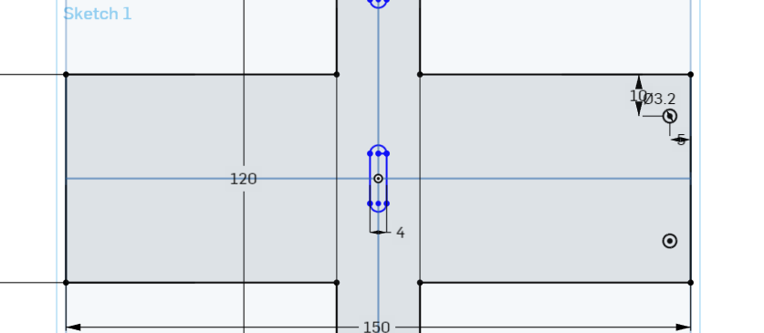
And then simply mirror both of them across to the other side, this time using the vertical blue axis passing through the origin point as your mirror line. It should end up looking like this.
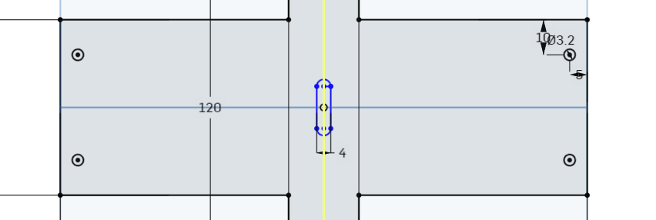
This finishes the main sketching on this part and it is ready to extrude. You can click on the green tick now to finalise the sketch.
This will remove all the dimensions from view, and leave you looking straight down at the sketch. In order to reorientate into a 3D view, go to the small cube with the drop-down arrow next to it on the far right of the screen. When you hover over it the name comes up as ‘Camera and render options’ and this will allow you to select from a range of set views. Click on the cube and select ‘Trimetric’, which is back to the initial 3D view that we started with. Try out the different views and see the slight differences between Isometric, Dimetric and Trimetric.

The extrude function
Once back in a pictorial view (3D), select the extrude icon on the toolbar as shown below. You should notice the toolbar has now changed to 3D modelling tools rather than the 2D sketching tools we have been using.
The extrude function allows you to take a 2D flat sketch and turn it into a 3D object. Simply select the extrude function then click anywhere on the main body of the sketch you have just made, but not inside any of the pill shapes or circles. A dialog box with options will pop up and the part will be given the default thickness of 25mm as shown below. Note that this is automatically classed as a new extrusion in the dialog box as there have been no previous extrusions performed on this sketch.
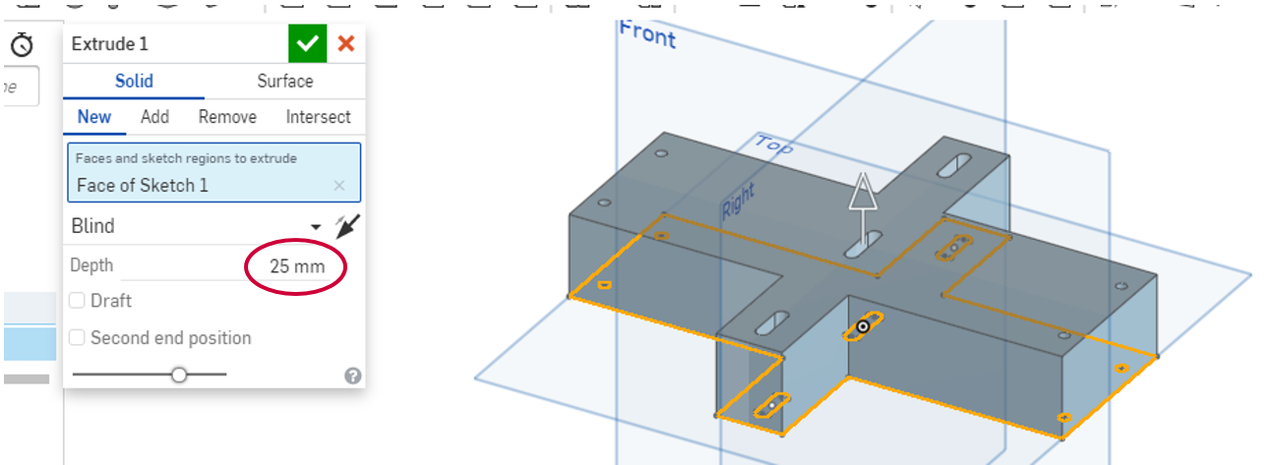
This top part of the base enclosure is 5mm thick, so the depth of the extrusion will need to be changed to 5mm in the dialog box. Once done, click on the tick to finalise the extrusion.
We could have chosen to draw the initial shape, extrude it, then draw the pills and circle shapes and perform a remove extrusion to get rid of them, but that would have meant twice the number of sketches and extrusions in the features list on the left side of the page. Although that is not a great deal now, as the parts become more complex and you begin assembling them, they will quickly add up and make the file larger. The less you can have the better.
The final step for this part are the holes for the control rod pivots going through the front and rear pill shaped holes. For this, instead of sketching on a plane we are going to sketch on a surface.
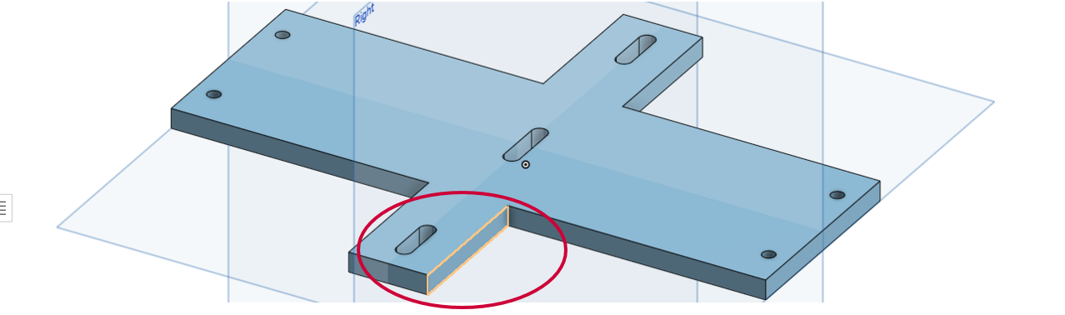
Select the sketch function and then click on the highlighted face in the image above.
Next press the N key to normalise the view and look directly at the face you are going to sketch on. We only need to draw one circle, locate it with the dimension tool and then mirror it to the other side using the same techniques as before.
The holes need to be Ø2mm, centred on the height of the face (in other words 2.5mm up or down from the surfaces) and 12mm in from the outside edge. The finished sketch should look like the image below. Once complete, tick it off and get ready to extrude them.
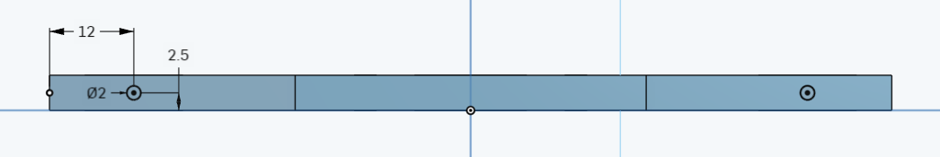
Reorientate back to trimetric view and select the extrude function. You may need to zoom in and out again to click inside the two circles. The default option is to extrude them outwards which is shown below. Note that now the classification in the dialog box has changed to add as it interprets it as an addition on the original extrusion.
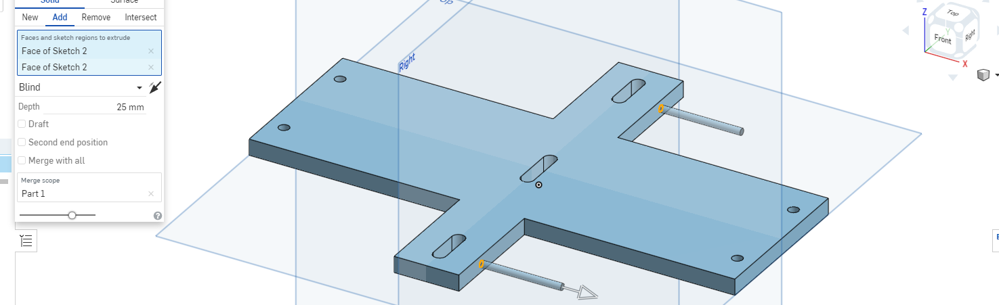
However, we want to remove the material not add more, so we need to change the classification to remove.
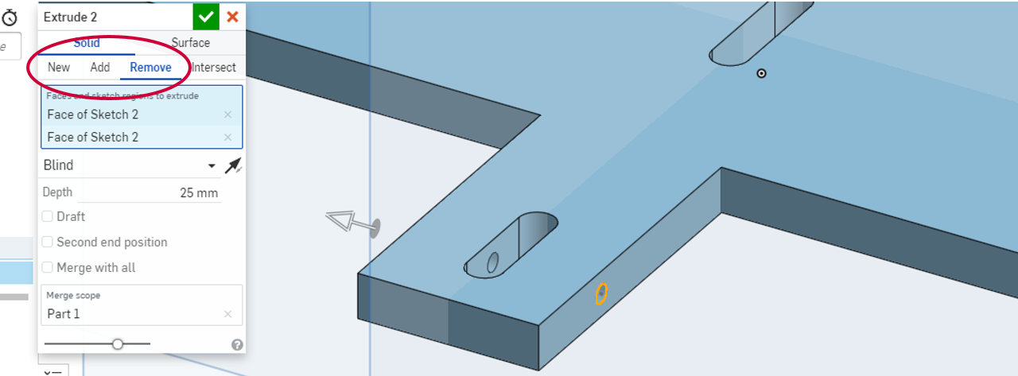
This makes it change direction and ‘cut’ the material away, which is the reason why this is often referred to as performing a cut. You can now see the hole passing all the way through and out the other side. As much as it will not make a difference in this instance, it is good practice only to perform cuts as far as you need to create the hole, so we should also reduce the depth of cut to 20mm. Once that is done you can finish the extrusion and this part is complete.

Part 2 – Sides
This part reinforces the skills you have just learned. Due to the nature of 3D modelling you will only need to draw one side for the base enclosure, as you can re-use identical parts multiple times. This not only saves on file size, but also means that if a part needs to be resized you will only need to modify the one part, rather than multiple parts.
This is best drawn on the side plane. It has holes on the top and bottom faces which are 10mm deep, as per the section view shown on the next page.
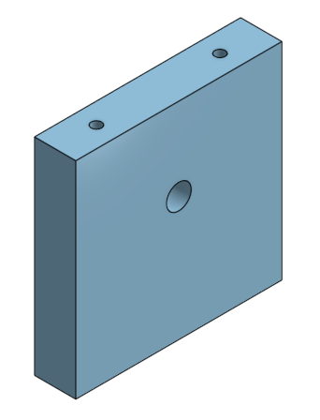
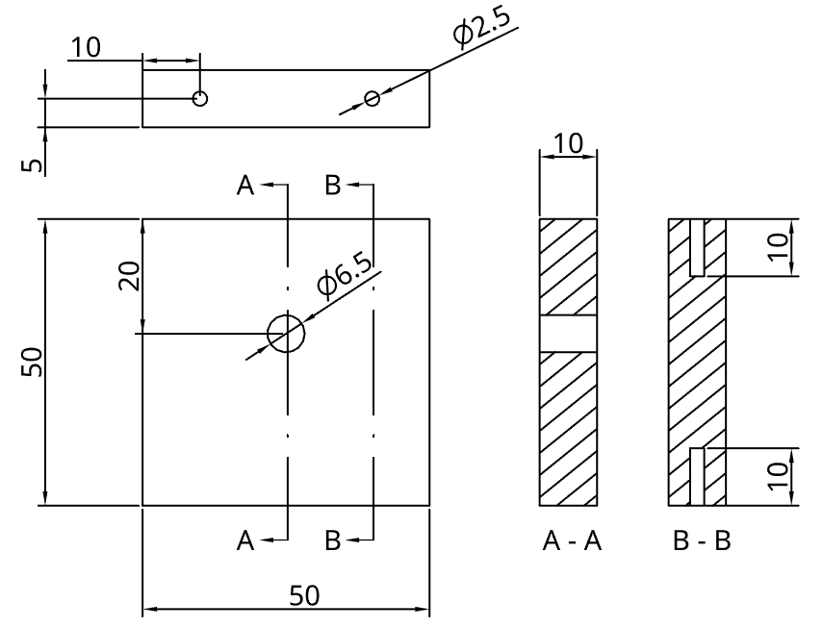
Use the same cutting process as you did for the top, adjusting the depth of cut to match the required depth of holes. The Ø6.5mm hole provides a clearance fit, meaning that it is slightly larger, for the shaft from the crankshaft to rotate freely.

Part 3 – Base
This part finishes off the base enclosure. The hole tool is used to create the counter bored holes to allow the base to be screwed onto the sides. This part should be drawn on the top plane centred in the same way as the top. The view here is from the underside of the base so that you can see what the counter bored holes looks like.
Start by drawing the 150mm x 50mm rectangle without the holes and extrude it to 10mm thick. Then select the underside of the object you have just created and sketch the location of the holes using the centre diameter circle, dimension and mirror tools as you did for the top.
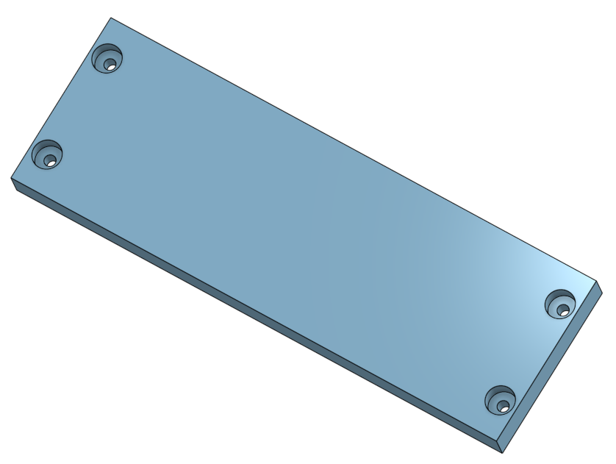
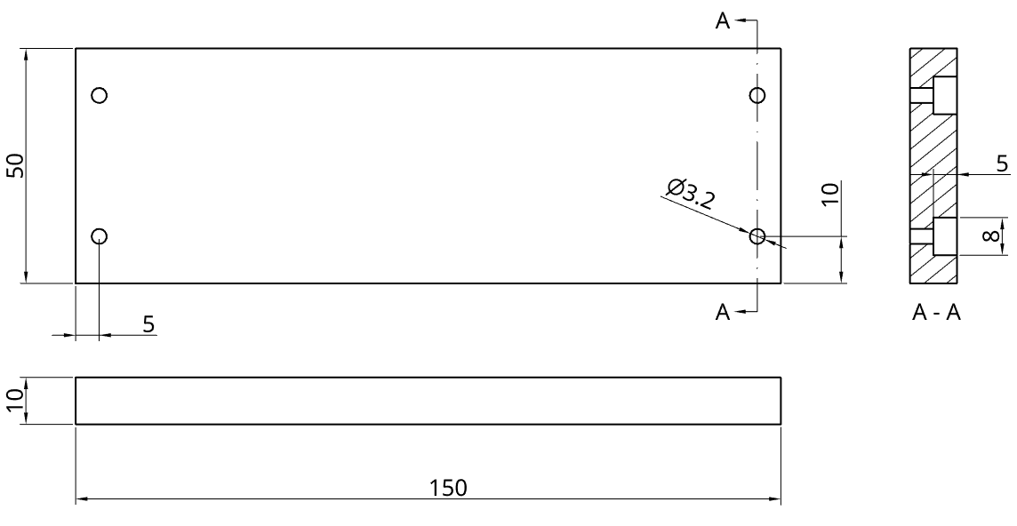

The hole tool
The hole tool is found on the 3D modelling space toolbar, as shown below.
With the view still looking at the underside of the base, instead of extruding the holes, select the hole tool from the toolbar. Select the centre point of each of the circles as the points to place holes. In this case we want a counterbored through hole of Ø3.2mm, with an Ø8mm counterbore, to a depth of 5mm as can be seen in the dialog box. Once complete tick it off.
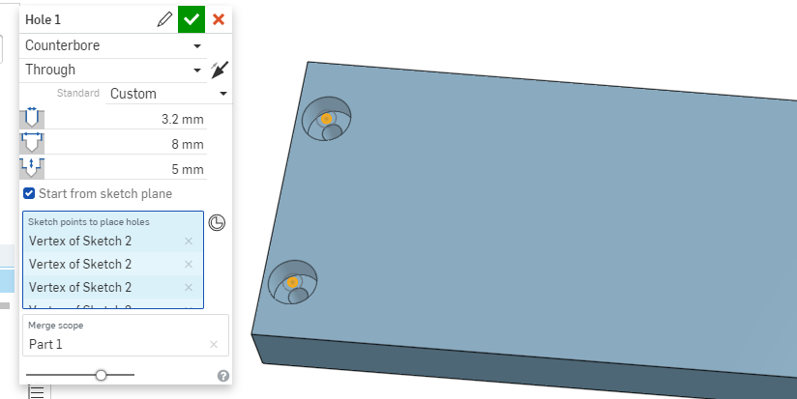
All of the parts for the base enclosure are complete, the next step is to draw up the mechanism that will make the automaton move.
If you have time once you have finished the automaton, draw up and create the round head screws and insert them into the correct locations to hold the enclosure together.

The crankshaft
The main part of the device that controls the movement of the automaton is the crankshaft. It transfers the rotational motion of the crank handle into vertical motion to move the automaton. Below is the working drawing of the assembled crankshaft and beneath it again are a list of the parts needed to assemble it.
The crankshaft is designed so that the parts can be individually 3D printed and then assembled rather than trying to do it all in one go, which would use more material in terms of support and would require a larger 3D printer to accommodate the print job. All of the shafts could also be replaced with 6mm dowel to save on 3D printing cost and time.
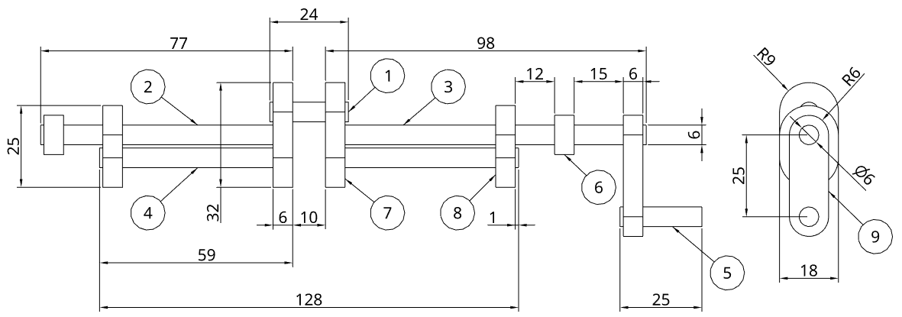

No | Component | Length/Depth | Diameter | Quantity
1 | Upper main shaft | 24mm | 6mm | 1
2 | Left centre shaft | 77mm | 6mm | 1
3 | Right centre shaft | 98mm | 6mm | 1
4 | Lower shafts | 59mm | 6mm | 2
5 | Cranking handle | 25mm | 6mm | 1
6 | Spacer rings | 6mm | 12mm ext./ 6mm int. | 2

No | Component | Length | Width | Thickness | Quantity
7 | Central crankshaft connector | 32mm | 18mm | 6mm | 2
8 | Outer crankshaft connector | 25mm | 18mm | 6mm | 2
9 | Crank handle connector | 37mm | 12mm | 6mm | 1
Parts 1-5 are all simple cylinders or rods that will need to be drawn as per the dimensions provided, starting with a circle matching the diameter and then using the extrude function to make it the correct length. As with the previous parts, only one needs to be drawn per component, regardless of the quantity required. Each of these should be drawn with the initial sketch on the side plane.
Parts 6, 7, 8 and 9 are more complex and as such the pictorial drawings and plans are provided for each of them on the following pages. Once all the parts are completed the crankshaft can be assembled and then add that assembly to the base enclosure.

Spacer rings
The spacer ring is effectively a 6mm thick donut that has a 12mm diameter with a 6mm hole in the centre. Its purpose is to hold the crankshaft in the correct position within the base enclosure.
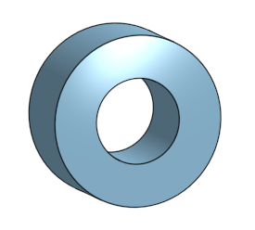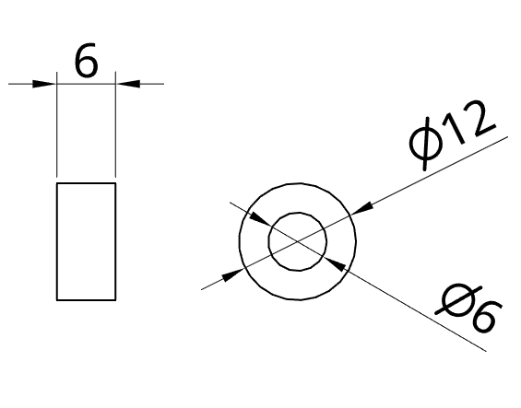

Central and outer crankshaft connectors
These 6mm thick connectors hold all the rods in place to make up the crankshaft. The design is intended to be sturdy yet lightweight. The holes in the connector discs are the same size as the rods so that they form an interference fit, in other words, they do not slide around. The easiest way to make it is using concentric circles at either end with 6mm and 18mm diameters and then connect the larger circles with lines that are tangentially connected to both of them. The central connector is just an elongated version of the outer one.
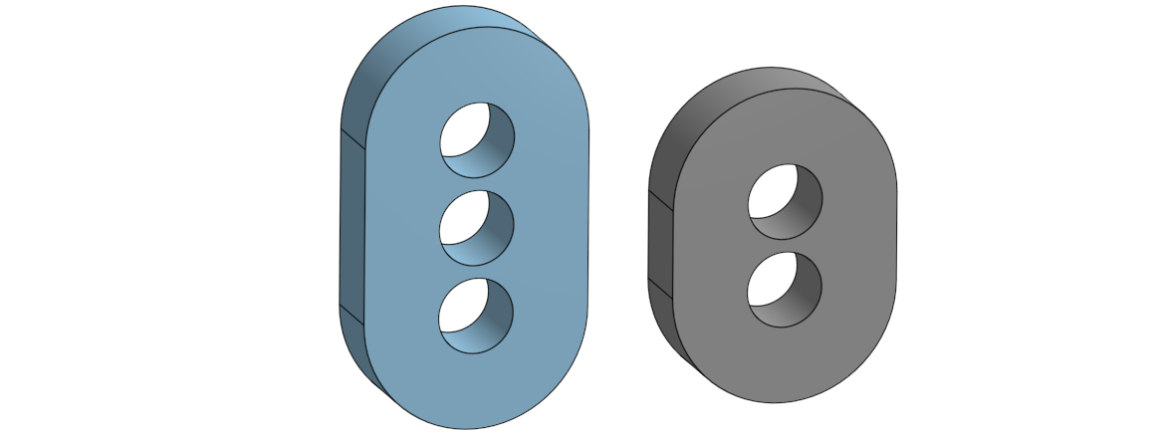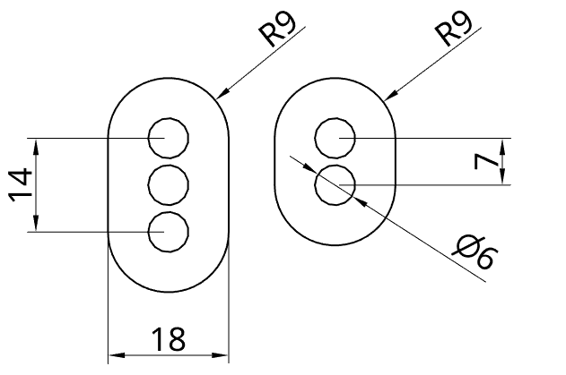

The line tool and tangent setting
The line tool can be found on the 2D sketching toolbar.
As the name suggested the line tool allows you to draw lines between two points. As part of that the functionality you can select the relationship the line has with the objects it is touching. In this case we want the line to be tangent to the two circles.
Start by laying out all the circles as per the drawing below.
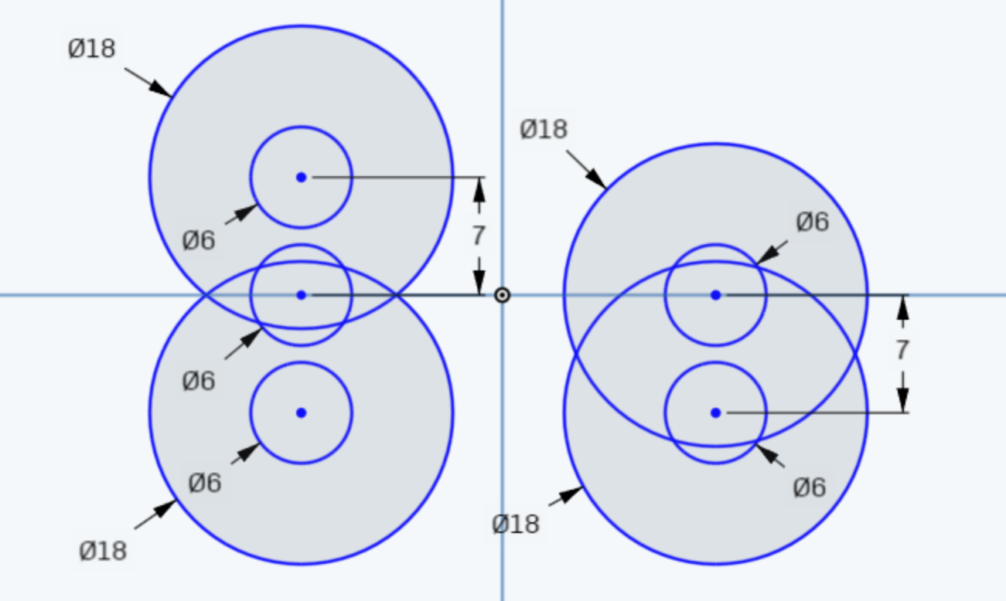
Then select the line tool and draw a line from the outside edge of the upper Ø18mm circle to the lower Ø18mm circle on both sides for both of the connectors. It should look like this.
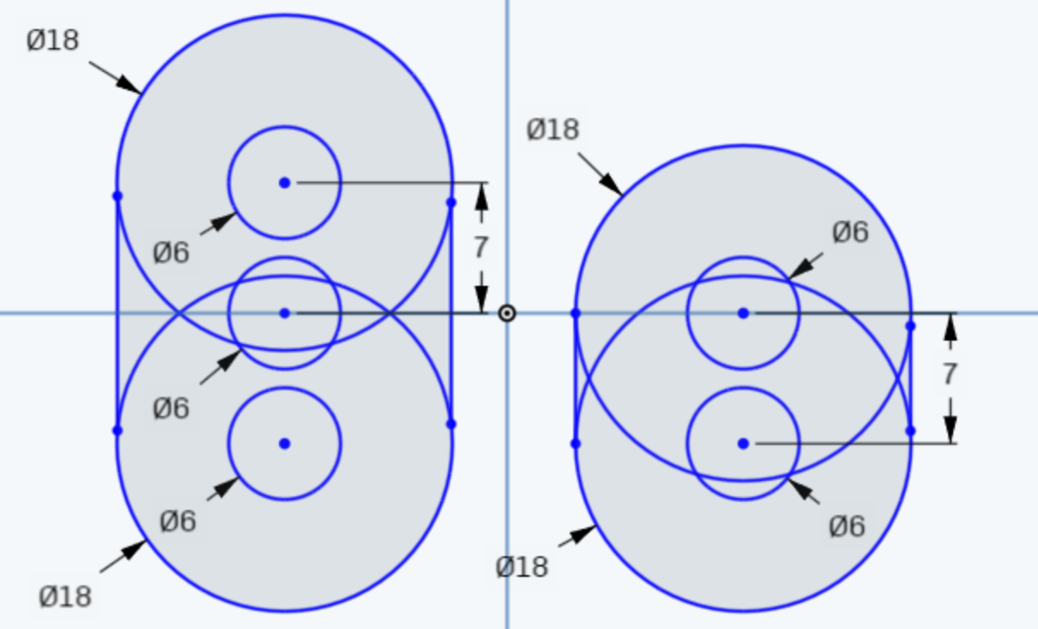
Then you will need to select the tangent setting from the toolbar as shown below.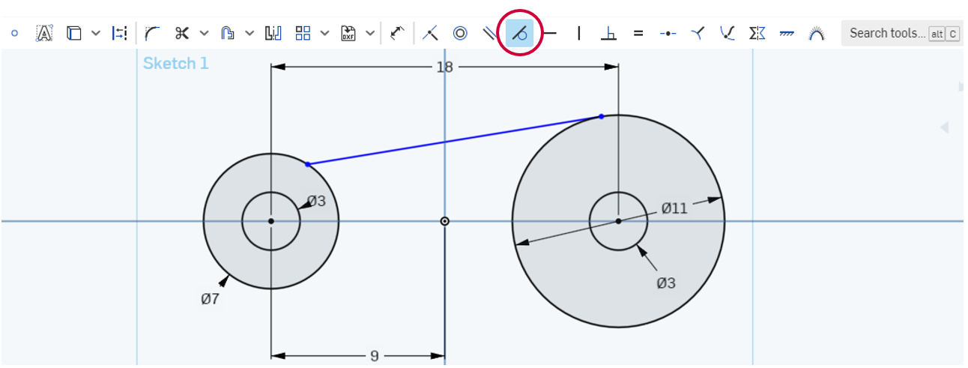
Once selected, click on the end of the line and then the circle nearest to it, the line will shift so that it is now tangent to the edge of the circle. If the line drawn was perfectly vertical then as both circles are the same size and directly above one another, the line will also automatically be tangent to the bottom circle. However, if the line was not drawn perfectly vertical then the tangent will need to be applied to both ends of the line and their nearest circle.
In the same sort of situation as with the 3-point arc, if the tangent is applied to both ends and the line was vertical everything will go red and the over-constrained error will appear. In that instance, simply use press the ctrl and z keys at the same time or click on the undo arrow below the Onshape logo in the top left corner of the screen and it will undo the last constraint, which will return everything to normal.
Once you have the lines associated correctly, use the trim tool to remove the extra overlapping lines from the Ø18mm circles, finalise the sketch and then extrude it to 6mm thick.

Crank handle connector
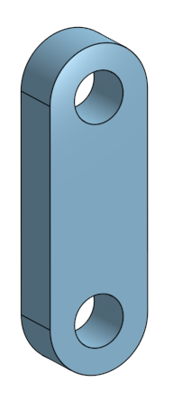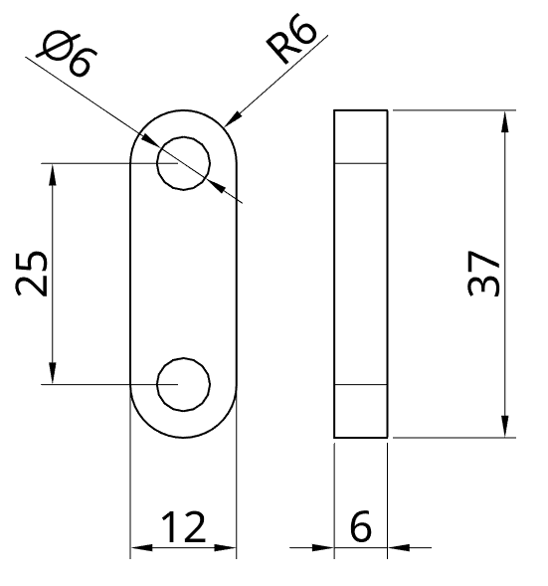
The crank handle connecter attaches to the right centre shaft coming out of the base enclosure and allows the connection of a handle to drive the crank. It is a fairly simple piece to make using the method above for the crankshaft connectors or alternatively with a centre rectangle, centre point circle drawn at the middle of the top and bottom and three point arcs drawn at the top and bottom too, then with a bit of trimming to tidy the sketch before extrusion.

Main crankshaft follower
The main crankshaft follower attaches to the crankshaft and drives the control rod that makes the body move. It is another relatively simple sketch and extrusion as per the plans on the next page. The Ø4mm hole in the top is 6mm deep.
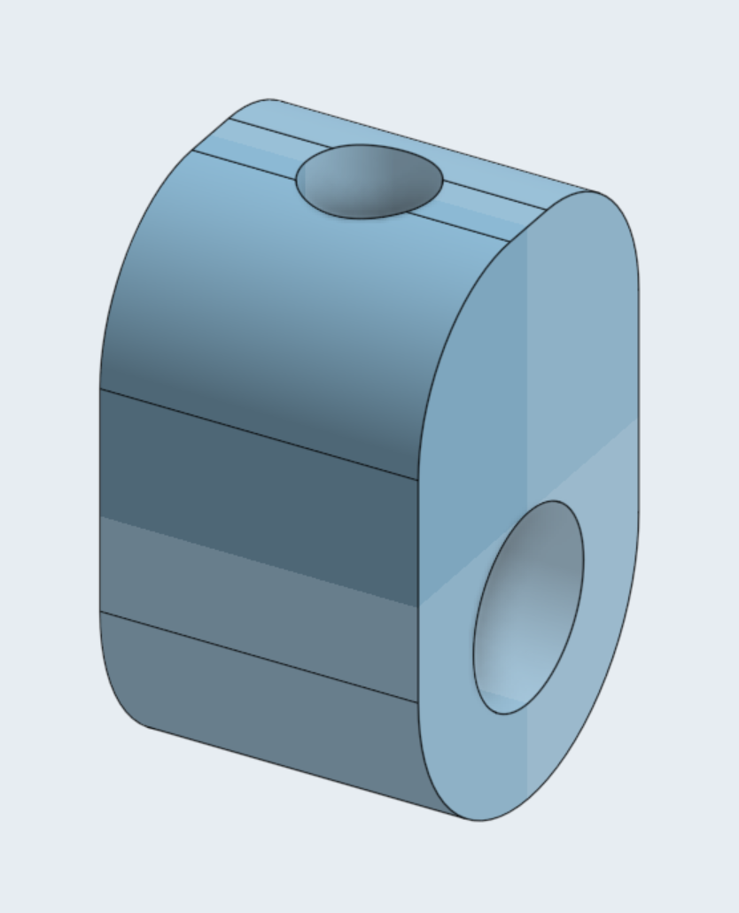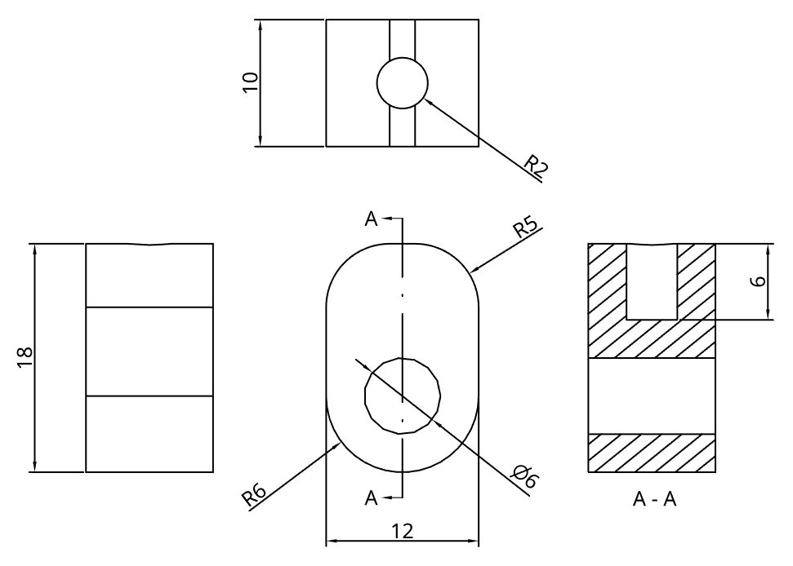
The design calls for the same approach as for either the handle or crankshaft connectors on the bottom and then the application of a fillet on the top two edges. The basic shape before applying the fillet looks like the image below on the left, which is made up from a 12mm x 12mm centre point rectangle, a Ø6mm circle and a tangent three point arc, with the bottom edge of the rectangle trimmed out. This is then extruded out to 10mm thick to look like the image on the right. The next step is to sketch the circle for the hole on the top face and apply a remove extrude 6mm deep, then finish off by applying the fillet.
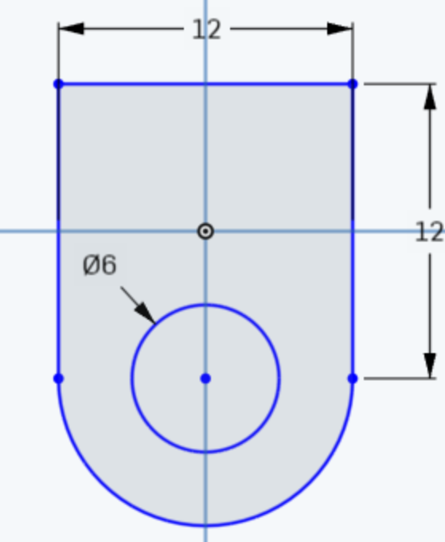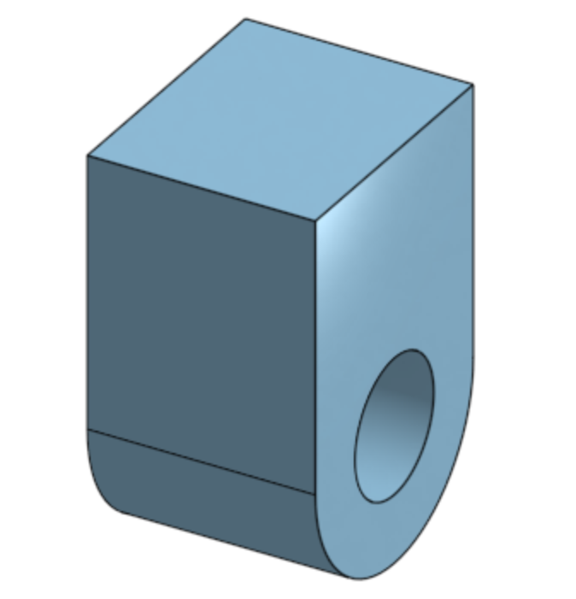

The fillet tool
The fillet tool can be found on the 3D toolbar as shown below.
As the graphic for the tool suggests, the fillet tool applies a fillet or radius between two faces on a part. However, it can also be found in the 2D sketching space, as a fillet can also be applied in order to create a radius where two lines meet. So technically the fillet could have been applied during the initial sketch with the same result. As it is, once the fillet tool is selected, select the front and back edges of the top, remembering that the face with the hole in it is the side. The image below shows the edges selected and the dialog box showing the 5mm radius setting. Once the fillet has been applied and ticked off, all of the components for the crankshaft are now complete. The next step is the dragon itself.
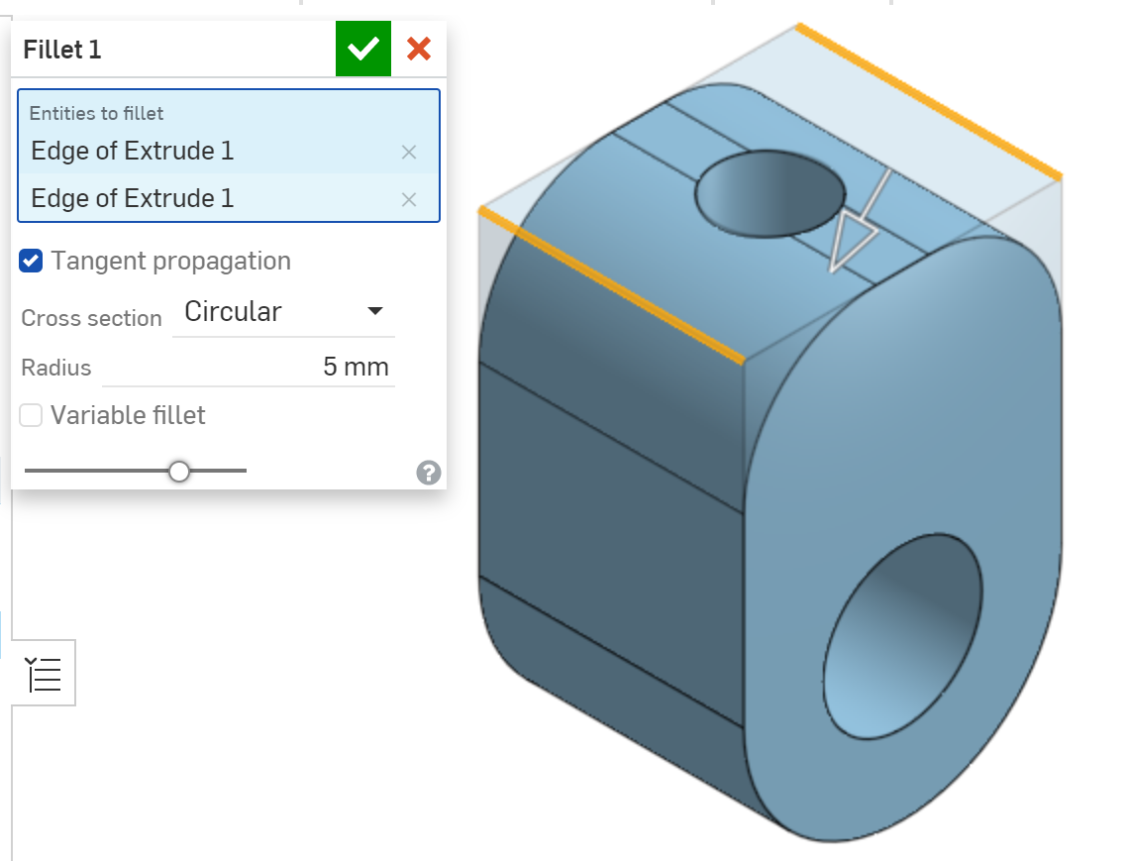

Automaton neck
The development of the automaton starts with the neck. This is the easiest part of the dragon to start with as it only has holes going through it on one plane. Below is the initial sketch, see the working drawing for clearer dimensions.
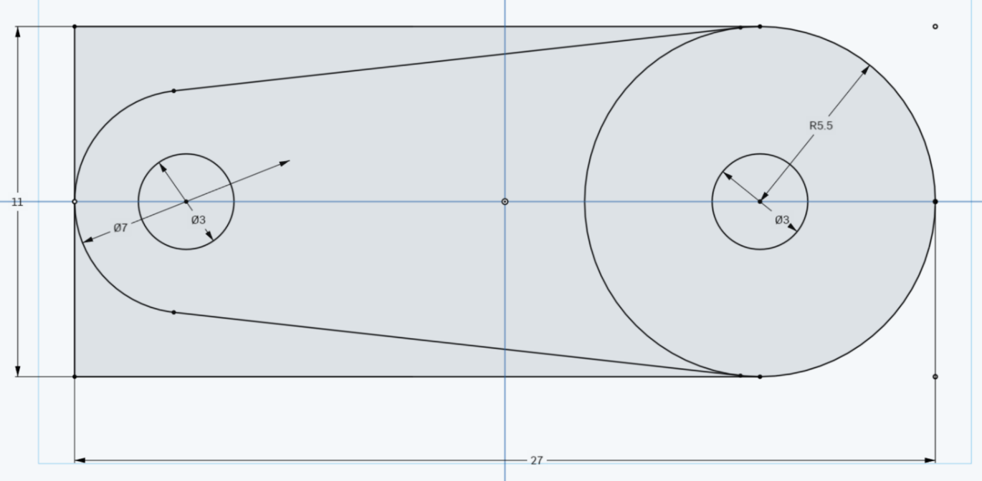
The basic shape can be started with a centre rectangle that is 11mm high and 27mm wide as a guide and then the geometry is laid from there, or you can go ahead and just place the geometry so that it is evenly spaced. The working drawing can be seen below.
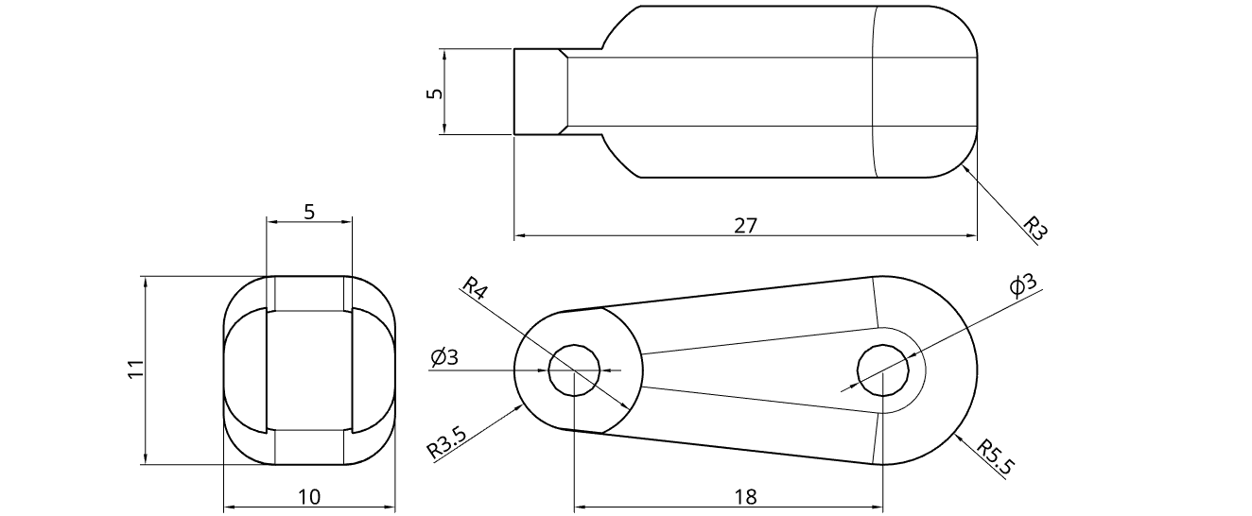
Using the same technique as for the central and outer crankshaft connectors, use the line tool and tangent setting to create tangent lines between the two outer circles. We will recap the method as the circles are not the same diameter.
Start by drawing a line between the two larger circles. Then you will need to select the tangent setting from the toolbar as circled below.
To use the tangent setting, simply click on the one end of the line and then the circle. The line will shift slightly until it is tangent with the circle, as in the image above. Then repeat the process for the other end of the line.
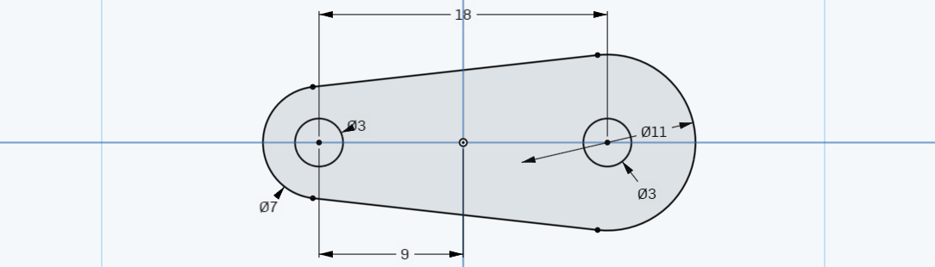
Then once you have added the bottom line and made each end tangent as well, you can trim out the sections of the larger circles so that you end up with it looking like the image above. This is the sketch finished, so finalise it and begin the extrusion process.

Symmetrical extrusion
With the sketch complete and the surface selected for extrusion, change the setting as circled on the next page to symmetric. This means that it extrudes equally either side of the plane the sketch was drawn on. Unlike some CAD packages, Onshape handles the depth value you input as the total value of the extrusion in both directions, so if you want the finished object 10mm wide then simply input 10mm in the depth field on the dialog box.
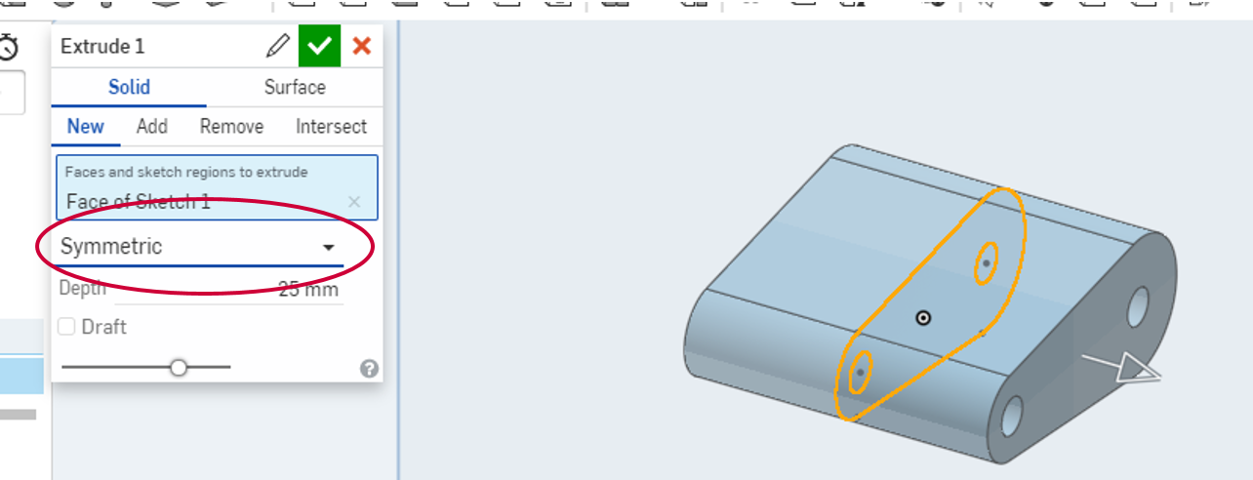
This will give you the basic shape and you will then need to do a second sketch on the face of the object to create the cutaway. Select the right-hand face to sketch on, then normalise the view so that you are looking straight at the face as below. Draw an Ø8mm circle on same starting point as the centre of the hole, as shown below.
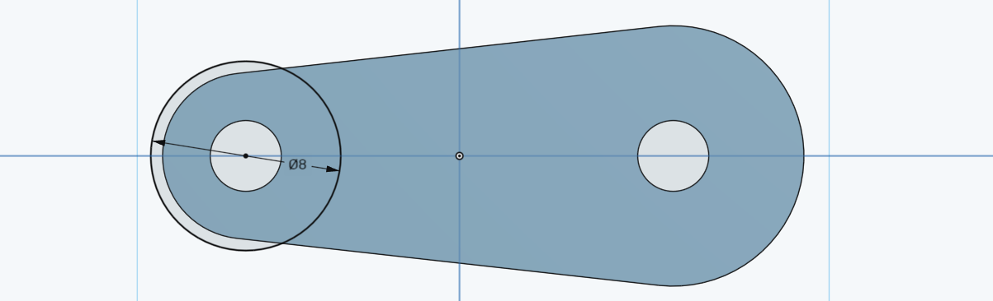
There is no need to trim the extra part of the circle away in this instance, so finalise the sketch and select the extrude function, then select the area to extrude as highlighted below and cut it back 2.5mm using a remove extrude.
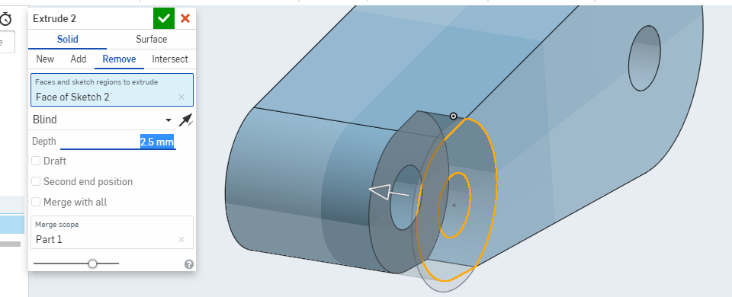

Mirroring in the 3D space
Once you have finalised the extrusion you can mirror it to the other side. You will find that there is a version of the mirror tool in the 3D space as well as the one you have used in the sketching space. It’s location on the 3D modelling toolbar is shown at the top of the following page.
Once you select the tool a dialog box will appear and you will need to adjust the settings in it to match what is shown below. When you mirrored before in the 2D sketching space, you were mirroring part of a sketch, now in the 3D space, you can choose to mirror an entire part, features on a part or the face of a part. In this instance you will mirroring the extrusion which is a feature of this part. You can select the extrusion by either clicking on the face you just extruded inwards, or simply click on the ‘Extrude 2’ heading in the features list on the left side of the screen as circled below.
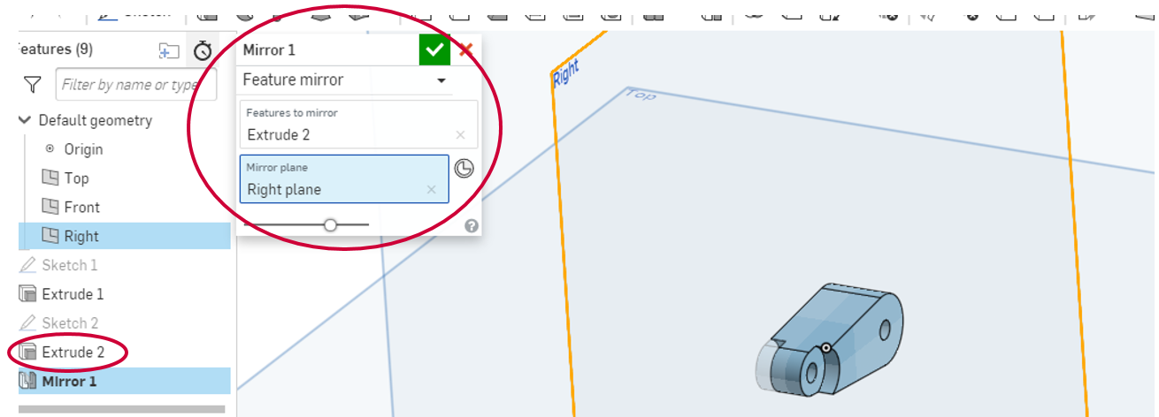
Once completed tick it off. The final step is to apply a fillet to the edges to make the neck look more organic.
Once you have clicked on the fillet tool the dialog box will appear as shown below.
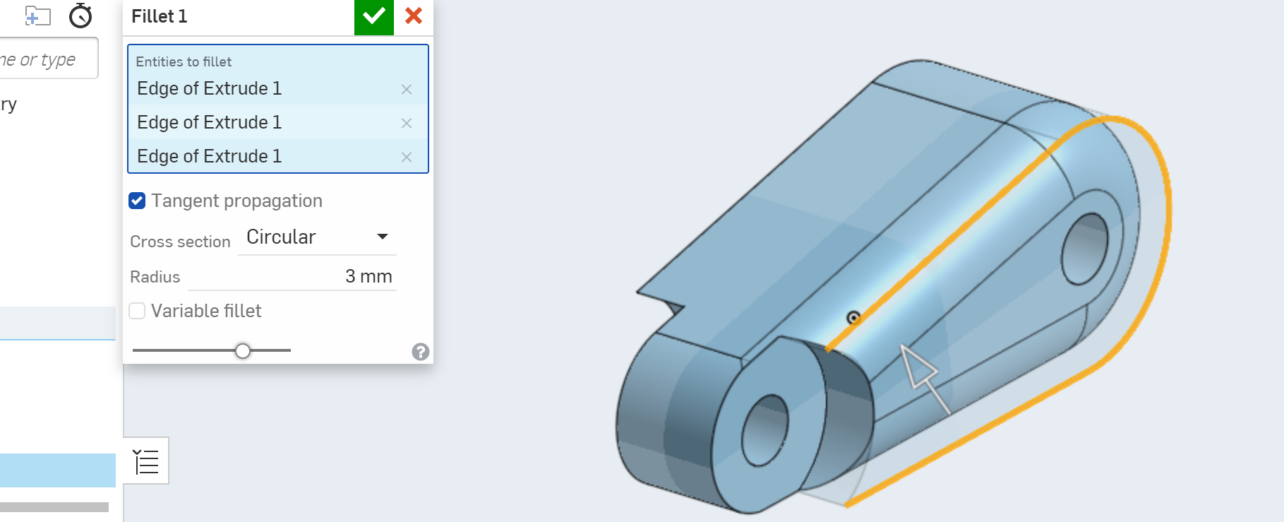
In order to choose the entities to be filleted, just as you did with the crankshaft follower, select the edges as highlighted in orange above. If you choose the wrong edge, simply click on the edge again to deselect it, or find it on the list in the blue cell on the dialog box and click on the feint blue cross next to it. Once you are happy with the choice of edges change the radius value from the default of 5mm to 3mm as required in the part drawing provided. You will notice that as you change the radius value and press the enter key on your keyboard, the program will provide a sample view of what it will look like.
If the program cannot apply the fillet as it is too large the orange line will show as red instead and a preview will not be provided.
Before finalising the fillet for the neck, you should also select the three matching edges on the other side of the neck so that all of them will be filleted at the same time.
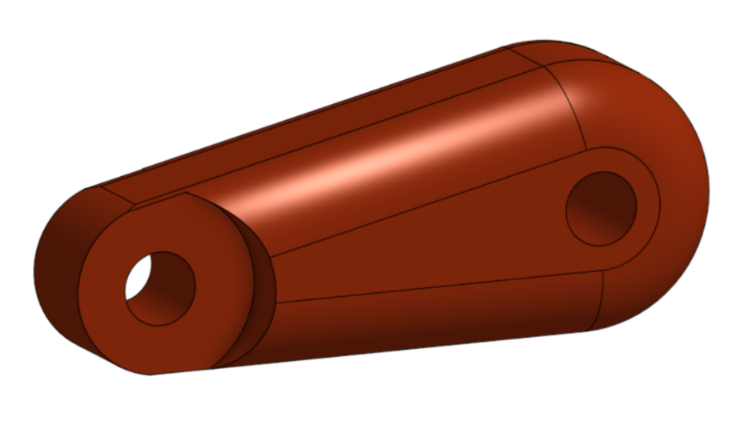
Here is the finished neck piece with the appearance edited to colour it red. Once the dragon is complete you can return to this part to add extra features, such as the back plates shown on the body, if there is time.

Appearance settings
The appearance settings are accessed by right clicking anywhere on the part. It will bring up a menu a shown below on the left and at the bottom of the menu is the option to edit the appearance. This brings up the appearance dialog box, as shown below on the right, where you can select a colour from the palette, use the RGB value or the hexadecimal value, or by selecting directly from the colour mixer.
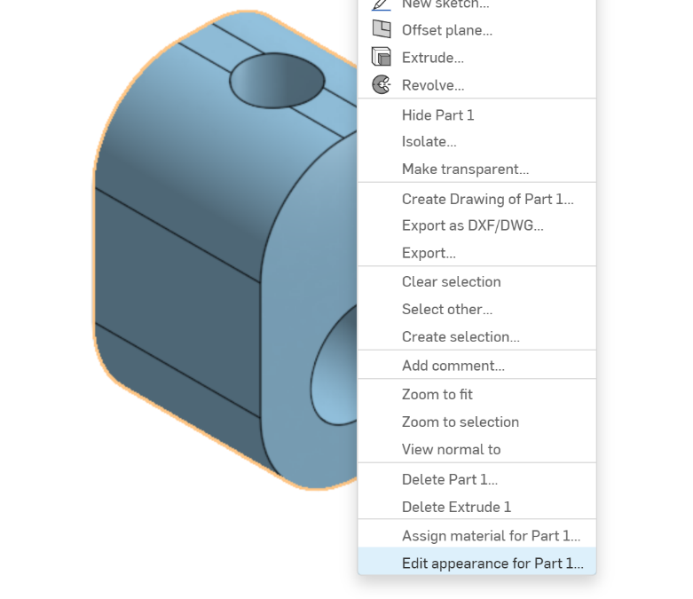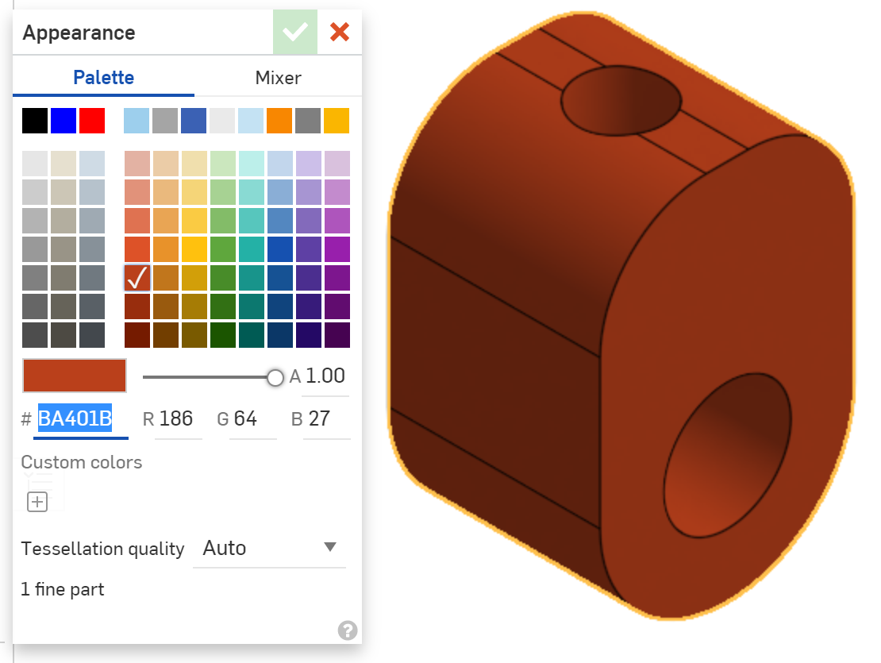
Appearance settings can be applied at the time of creating the part or can be altered at a later date when you have an idea of the colour scheme you want to use. Even if the part has been used in an assembly, the appearance value has to be set at the part studio level.

Automaton body
The body of the automaton is where the geometry starts to get more complex. As you can see from the plans below there is a need for more detail and you will be using some of the tools already covered such as three point arcs and tangent settings as well as learning about some new functions such as offset planes to make it easier to ensure accuracy in your drawing.
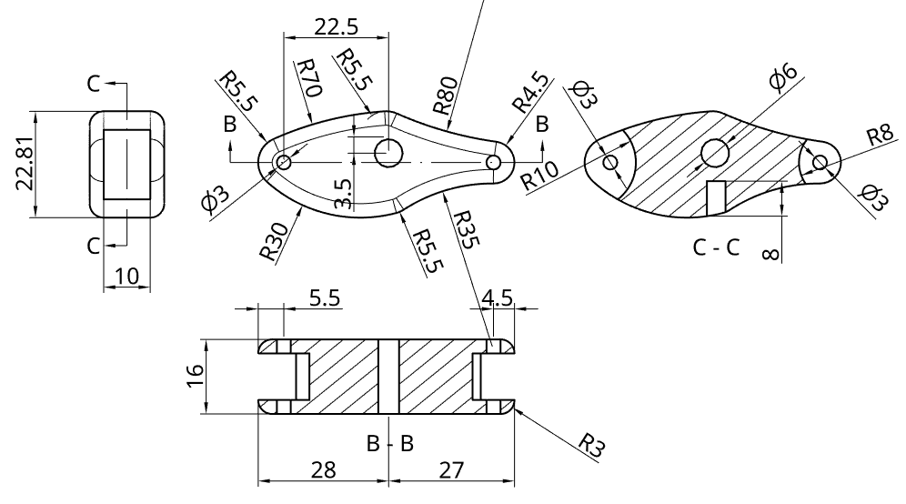
This part will need to be drawn on the side plane and you will need to use a symmetrical extrusion for the main body and for the cutaways at each end. Once you have the basic shape you will be able to customise it and add features such as plates down the spine as seen below.
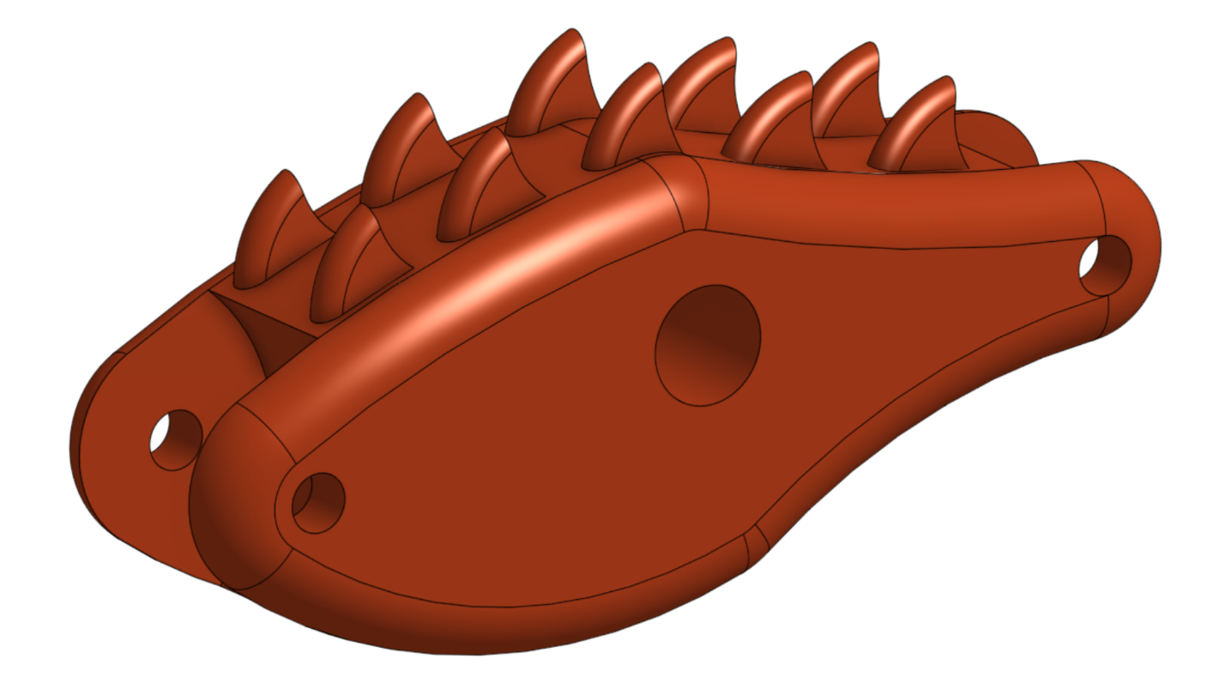
These can be done a number of ways including patterning or mirroring, but your teacher can show you more about that.
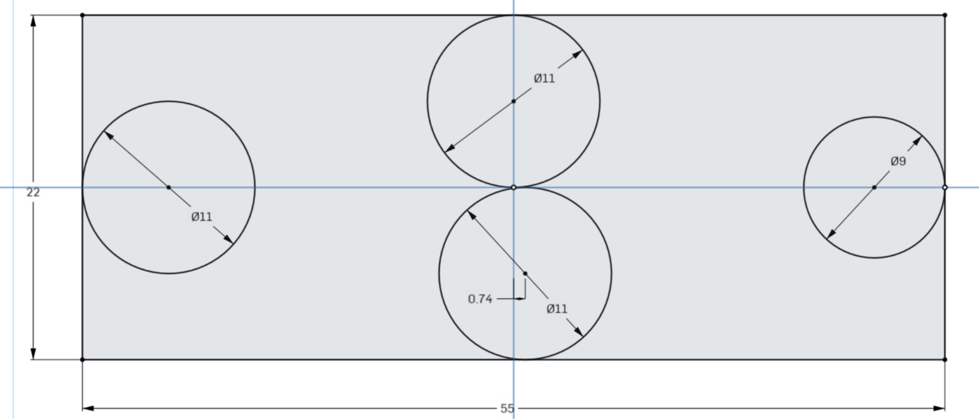
Start with a centre point rectangle which is 22mm high and 55mm wide and set out the circles so that they are all tangent to an edge. The two in the middle and the one on the left are all Ø11mm circles and the one on the right is a Ø9mm circle. The lower centre circle should be offset 0.74mm to the right of the blue vertical axis and the other three should all have their centre points on their closest axis.
In order to create the larger chest and narrowing waist, a series of three-point arcs can be used to join the circles together. This is done in the same way as before, by selecting the first point on one circle, then a second point on the next circle and then entering the correct radius. It is important that these arcs are made tangent to the circles to give a smooth transition.
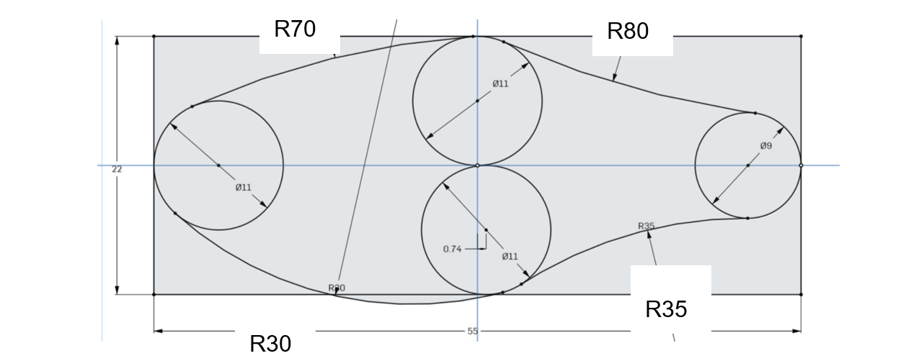
The radii required for the different three-point arcs are shown enlarged and superimposed on the image above.

The next step involves adding the three holes (by drawing circles) at the locations as per the plans. It should end up looking like this.
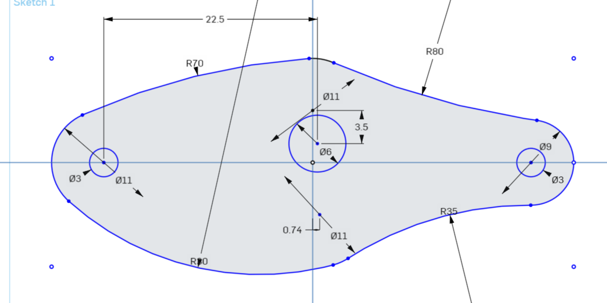
The Ø3mm left hand circle uses the same centre point as the original Ø11mm circle used to create the left-hand section of the perimeter of the shape.
The Ø6mm middle circle is drawn with its centre point 22.5mm offset from the left circle centre point and 3.5mm below the top perimeter circle centre point. When drawing this circle make sure the initial position of its centre point is not on either of the blue axis lines and then use the dimension tool to move it to its exact coordinates once drawn to the correct size.
The final right hand Ø3mm circle uses the same centre point as the Ø9mm circle used to create the right-hand section of the perimeter of the shape.
Once this is all done, you can trim out the parts of the original four circles not making up the perimeter of the body using the same technique as employed previously.
From there perform a symmetrical extrusion to create a part that looks like this, which is 16mm wide, but importantly has the plane running through the middle (shown in orange) in the same way as the neck.
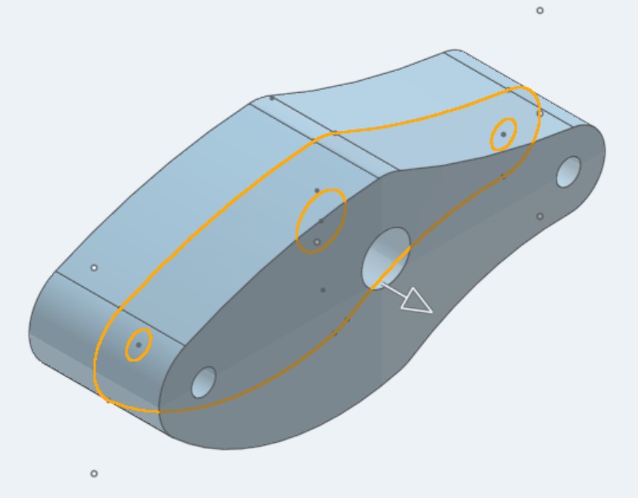
Now create a second sketch on the side plane to create the cut-outs at either end, make sure not to draw on the face of the object as has been the case previously.
In order to find the centre point for the larger circles, which create the curve of the cut-outs, start by drawing the two smaller Ø11mm and Ø9mm circles with their centre points matching the existing holes at each end. This should result in a circle with its edge matching that of the curve of the body at each end.
Now draw the larger circles with their centres on the horizontal axis between the existing holes and their respective ends of the body, as highlighted below. Make sure that the outside edge of these new circles form a tangent at x and y with the existing smaller circles. Once done you can set the diameter of each of the larger circles to Ø20mm on the left and Ø16mm on the right, which will make their centre points move to the correct position.
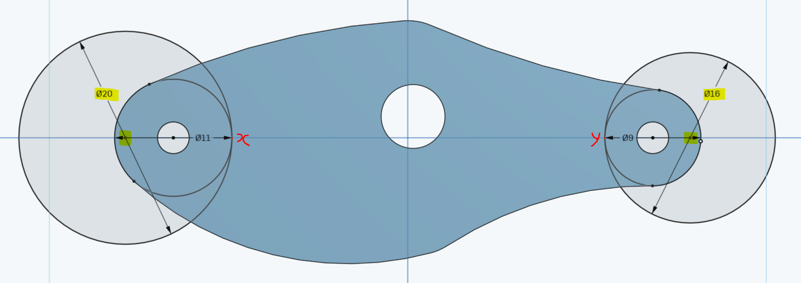
The image above shows what it should look like when all four circles are drawn. The smaller circles will need to be trimmed out before continuing.
When extruding the circles, use a 10mm symmetrical remove extrusion as per the plans on page 30. The image below shows the extrusion taking place with the circles being used to create the extrusion highlighted in gold.
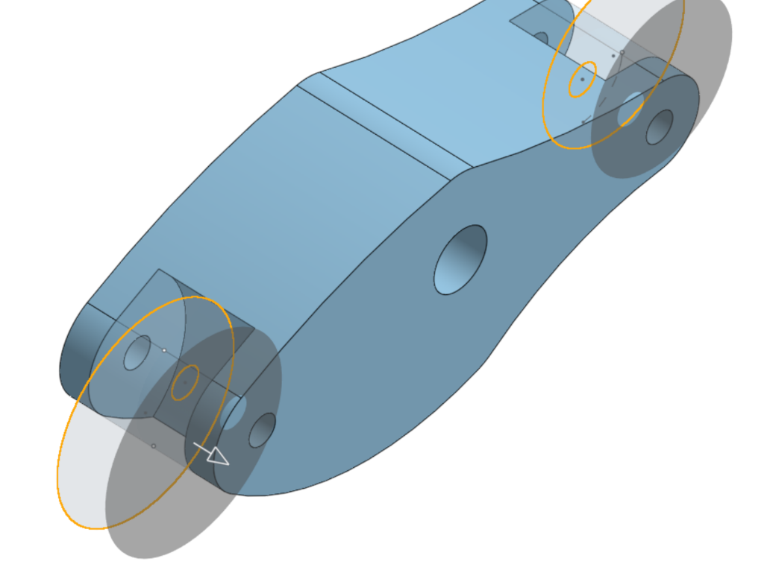
Once the extrusion is complete apply the 3mm fillet to the outside edges of the two sides to make them more organic.

The plane tool
The next step is to offset the top plane to create a new plane 11mm lower, which is then in line with the base of the body. This is done using the plane tool from the toolbar, which can be found in the drop-down options as shown below.
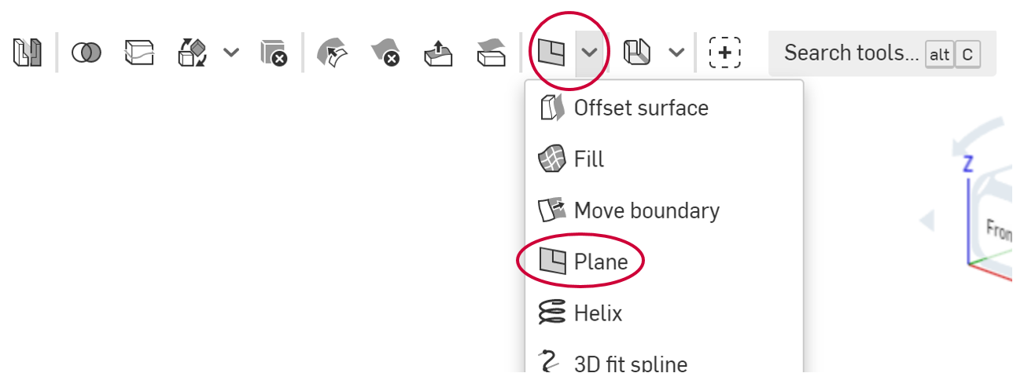
This tool creates a new plane by referencing an existing plane or other geometry in the part studio such as a surface or edge. In this instance the top plane will be the reference.
Select the tool and the default will be to create an offset plane, then select the top plane. The arrow shows the direction of offset and the distance needs to be set at 11mm. If the arrow is pointing up either click on it and it will switch to the other direction, or click on the two arrows next to the value in the pop up dialog box and it will have the same effect. Then tick it off to create the new plane.
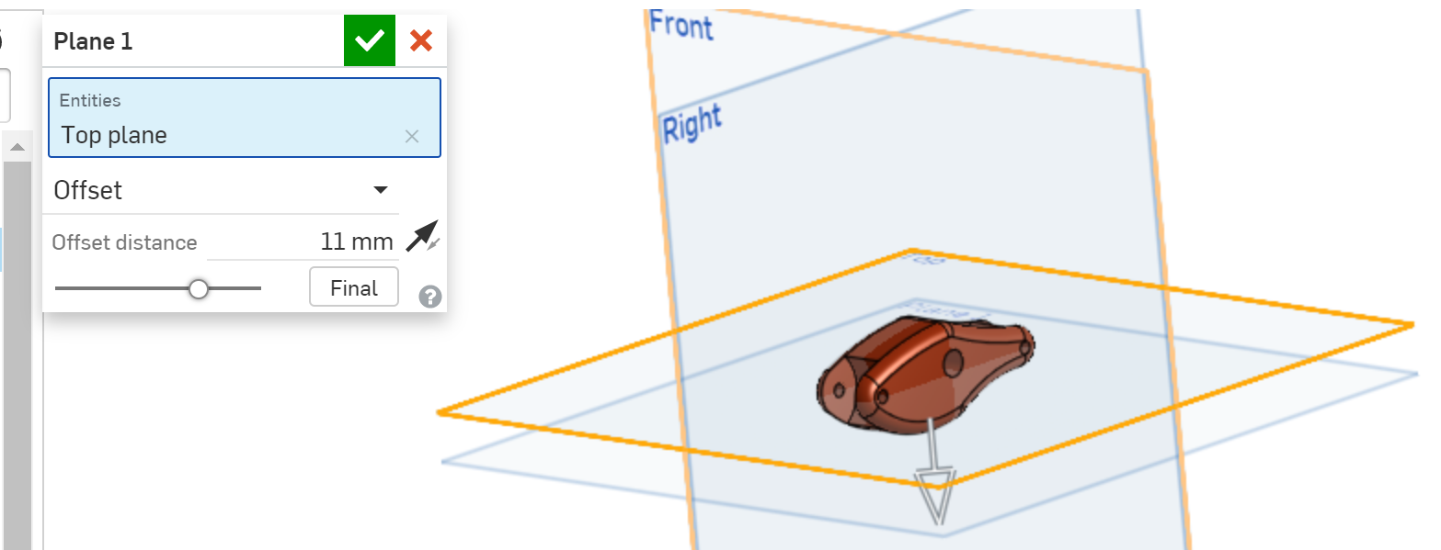
Sketch on this plane to locate the hole that the connector rod goes into. The location of the hole needs to be 0.74mm offset along the horizontal axis to the right from the centre point and Ø4mm as shown at the top of the next page.
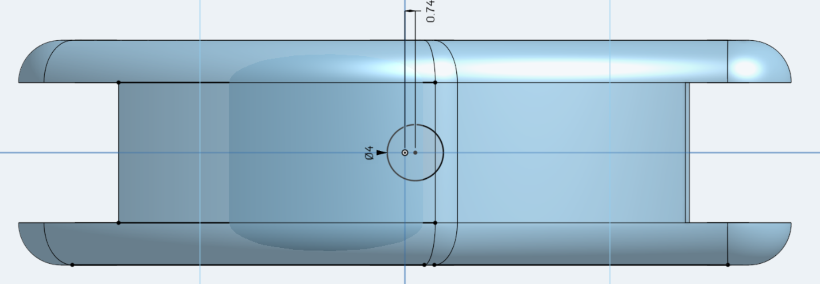
This sketch then needs to be remove extruded 7mm up into the body. Due to the nature of creating the curves of the dragon’s body, for this design there is also the need to extrude down slightly, as part of the body is actually below the level of the plane. The easiest way to do this is to do a symmetrical remove extrusion of 14mm, so that it goes up 7mm into the body and down 7mm at the same time, clearing any low hanging sections of the body.
The automaton body does not have to be exactly the same as the one pictured on the previous five pages, however, in order for it to guarantee to animate smoothly, the main mounting holes need to be located in the positions shown. The easiest way to modify the design is to alter the radii of the three-point arcs used to create the wide chest and narrow waist. Instead of the design shown the chest could be smaller and the waist bigger or other features such as holes for attaching legs could be added. The choice is entirely up to you, but it is a good idea to leave any modifications until after you have a fully assembled and working automaton.
If you choose to customise your body by adding spikes or plates, without creating an assembly, make sure that once you have finished the drawing that you group all of the different elements using the composite part tool (more details for this can be found in the assembly section, later in this booklet). That way when you come to assemble the modified part it will be treated as a single entity.
In the student work booklet, sketch some possible different body shapes you could use for your design.

Automaton tail
The tail of the automaton is reasonably straightforward and also has plenty of scope for customisation. As long as the connection to the body and the distance between that connection and the point for attachment of the control rod does not change, then the rest is open for interpretation. Below are the plans for the basic dimensions and then on the next page is an example of a finished version with a suggestion of how it could be customised.
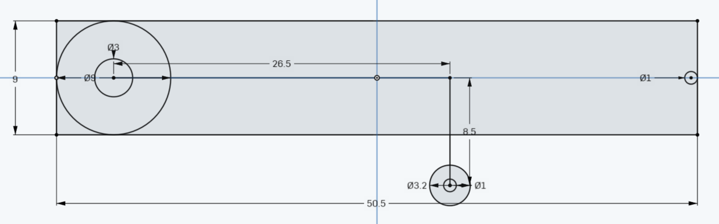
Start with a centre point rectangle that is 9mm high and 50.5mm wide.
On the left-hand side of the rectangle, draw a Ø9mm centre point circle with its centre on the horizontal axis and its left-hand edge tangent to the left-hand side of the rectangle.
Then draw a Ø3mm circle using the same centre point as for the Ø9mm circle. This will be the hole where the tail connects to the body.
On the right, repeat the same process for the Ø9mm circle, except this time draw a Ø1mm circle with its edge tangent to the right-hand side of the rectangle. This will be the tip of the tail.
The lower Ø1mm hole for the control rod and its relationship to the Ø3mm hole are the key points. Make sure the lower Ø1mm circle is 26.5mm to the right of the centre of the Ø3mm hole and 8.5mm below the horizontal axis.
To finish off draw another Ø3.2mm circle at the same point as the lower Ø1mm circle to create the end of the control rod connection. The circles can then be joined using the spline tool and you can control how thick or thin you want the tail to be.
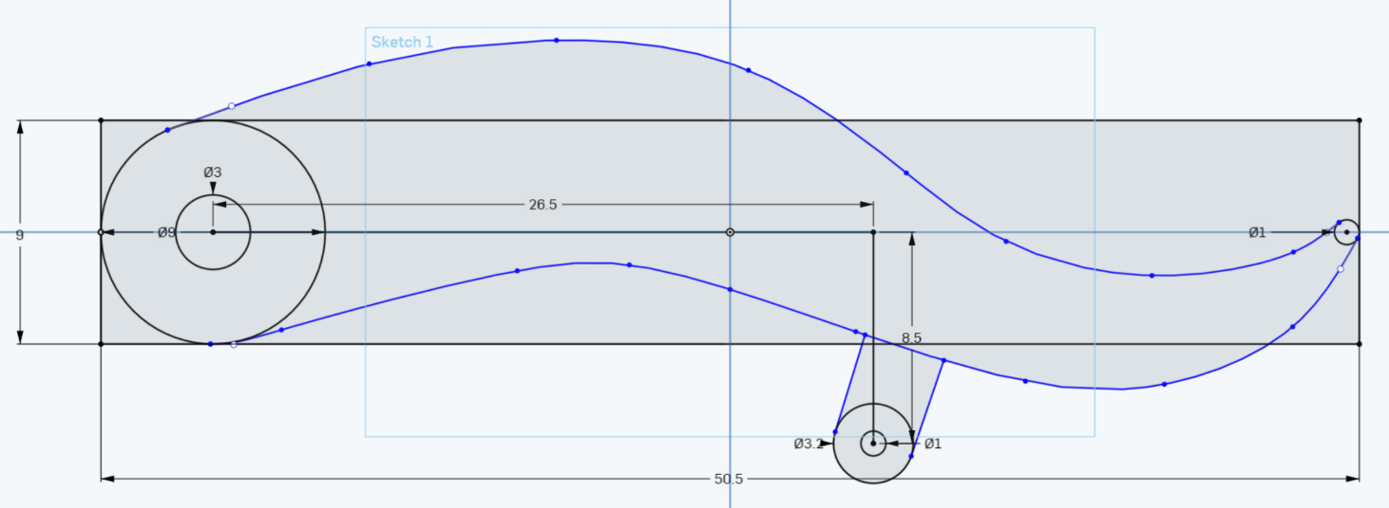

The spline tool
The spline tool can be found in the sketching toolbar as shown below.
It allows a curved line to be drawn by selecting a series of points along the length of its curve. Start by clicking on the Ø9mm circle and then click multiple times along the way until you finish on the Ø1mm tail circle. Finish the spline by pressing the ‘Esc’ key on the keyboard.
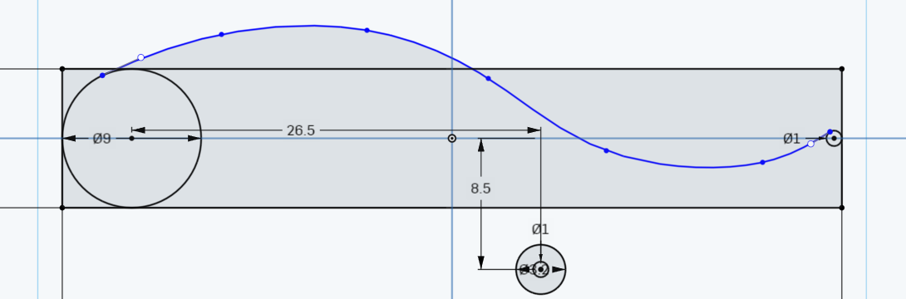
Use the tangent setting to ensure the ends of the spline curve are tangent to the circles. To adjust the curve, simply grab any one of the nodes (the dots along the curve) by clicking on it and holding down the mouse button, then drag it to a new position and release the button. Repeat for the lower line of the tail and adjust until happy with the curve.
Next use the trim tool to remove the original rectangle and any parts of the Ø9mm and Ø1mm circles used to form the tail that are not part of the tail perimeter.
Then use the line tool to create the attachment for the control rod as shown below.
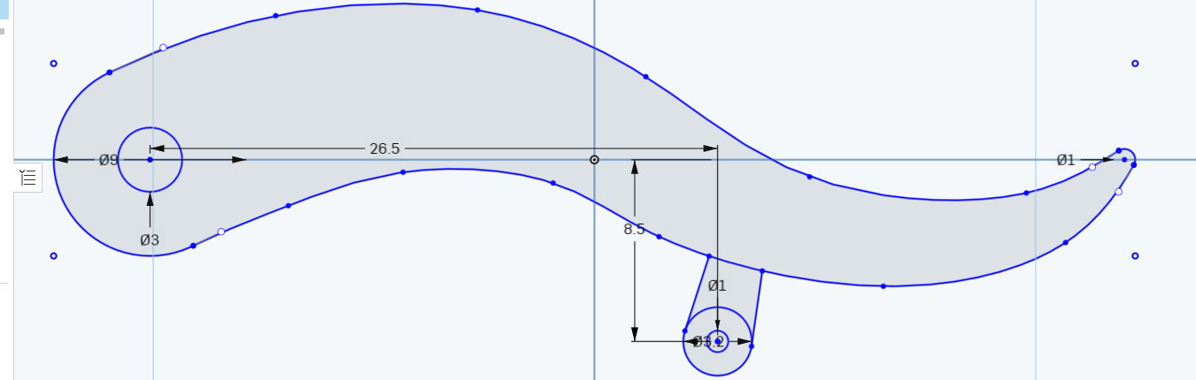
You need to make sure the lines drawn are attached to the Ø3.2mm circle using the tangent setting and then make it look more uniform by using the parallel setting.

The parallel setting
The parallel setting allows you to create a relationship between two or more lines and tells the software that they need to be parallel. It can be found on the toolbar as shown below.
Once the parallel setting is selected, simply click on each of the lines and one will move to become parallel with the other as shown in the image below.
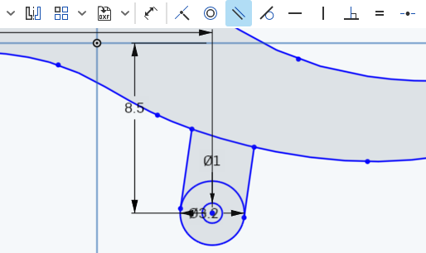
Trim out the top of the Ø3.2mm circle, but not the section of the lower edge of the tail where it crosses the attachment, it is needed to allow the tail to be extruded in two sections. Finish off by finalising the sketch.
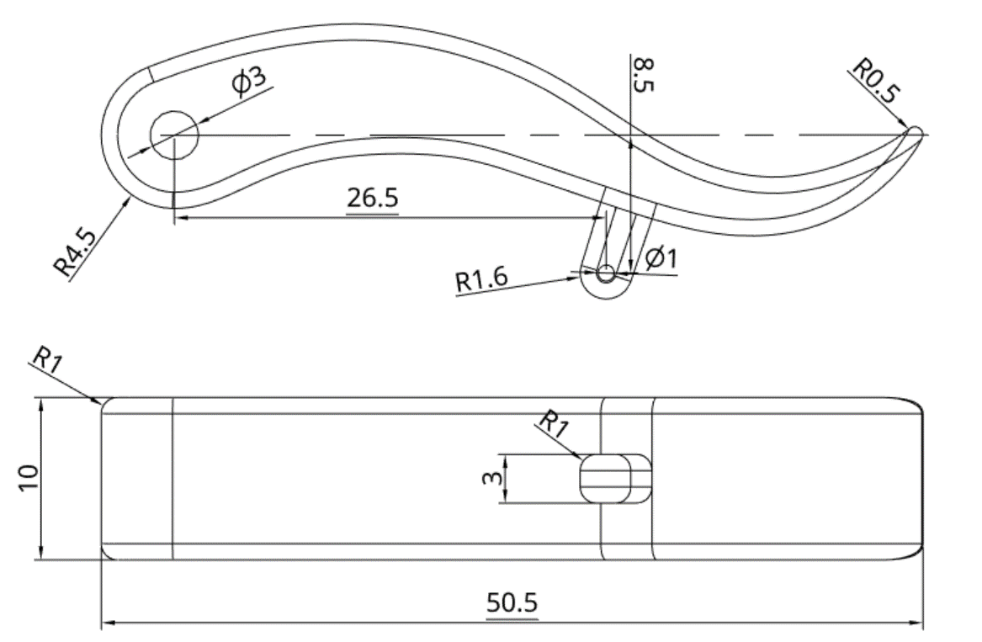
The drawing above shows the side view and the view from below, in order to see the thickness of the control rod attachment. These two different thicknesses are achieved by perform two separate extrusions using the one sketch.

First do a 10mm symmetric extrude of the tail portion of the sketch and tick it off, then make the sketch visible again by clicking on the eye that appears when you hover over the sketch in the features list as shown below.
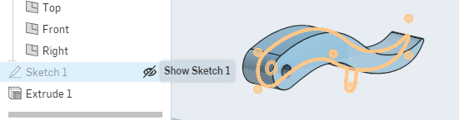
Secondly, perform 3mm symmetric extrude, this time of just the connector.
Then it is just a matter of applying a 1mm fillet to all edges, including on the connector.
Before we move onto the head, below is one possible way of finishing the tail off. These were individually on the right plane, following the curve of the tail and then symmetrically extruded and filleted.
As mentioned previously, depending on the way that they are drawn, they may need to be grouped afterwards so that they do not get separated when performing mates and assembling your automaton.
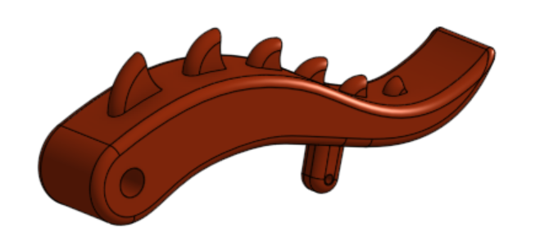
In the student work booklet, experiment with ideas for the tail by generating some sketches of what it might look like. You may want to extend it further, add a greater curve, or even use a Swept Blend to make the tip pointier.

Automaton head
The head will be the most complex part attempted so far and special attention will need to be paid to the shape to get the fillets to work and make the finished head look less blocky.
Start off by looking at the finished rendered head and then go back and see how we got there, then you can apply your own creativity to generate your own dragon head.
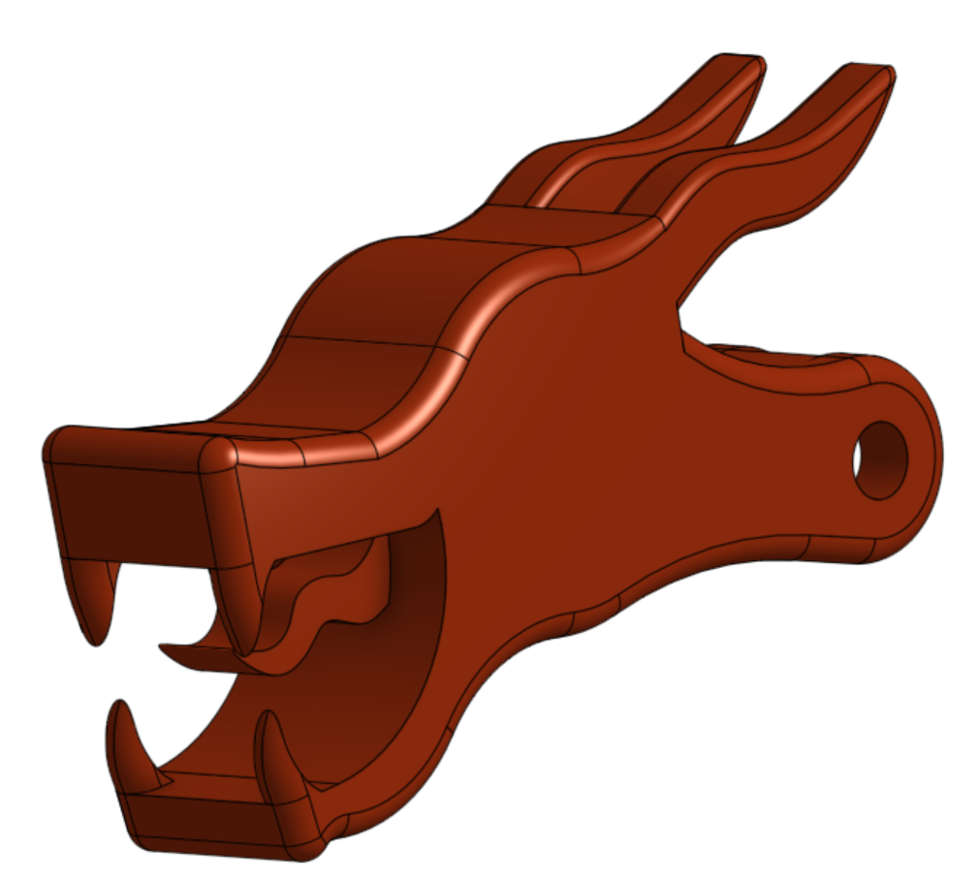
This one has open jaws, teeth and a tongue and looks fairly fierce, but you can make yours as placid or angry as you like.
Starting with the initial sketch on the right plane, this is how the important features are laid out. First draw a 20mm high and 42mm wide centre point rectangle to provide a layout guide with its centre at the origin point, then draw a Ø15mm centre point circle, also at the origin point.
Next draw an Ø8mm diameter centre point circle with its centre point on the horizontal axis and its edge tangent to the right side of the rectangle. Finish with a smaller Ø3mm circle using the same centre point as the Ø8mm circle.
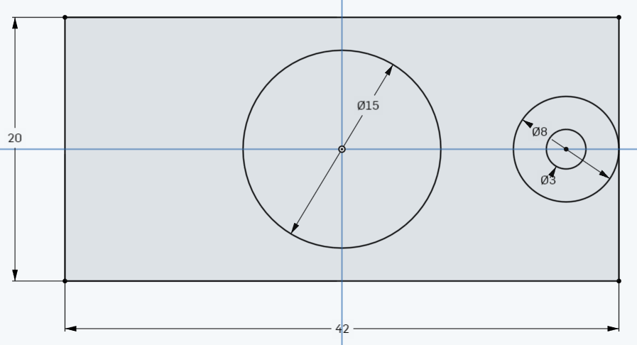
The rectangle provides a guide for length and height. You can go longer and taller if you want but stick relatively close to these dimensions. The circles lay out the space and from there you can create the rest using lines, arcs and spline curves. You can either draw it all in one, then reference it several times, or you can add other details once you have a shape you like.
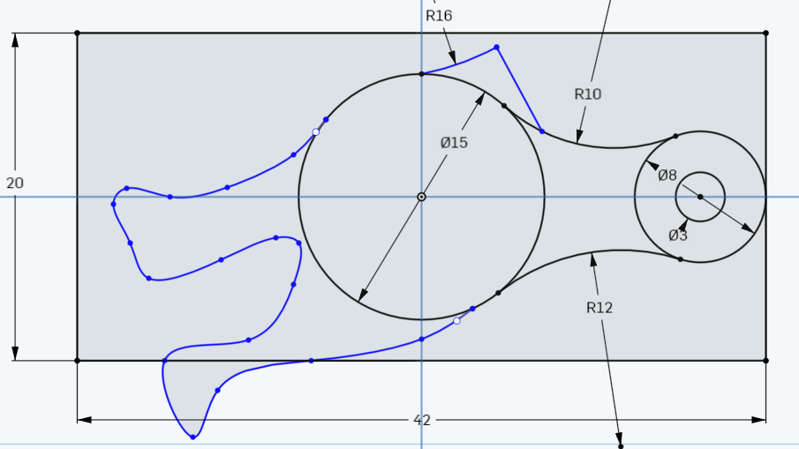
As can be seen in the example above, a combination of line types have been used to create the basic shape. This would be refined further before extruding it to a thickness of 10mm. The circles on the right will be used to create a cut-out to accept the neck part. On the next page is the working drawing for the head design shown on the previous page. Not all dimensions are present as you will need to customise it.
The straight line on the upper right of the centre circle provides a flat area to attach the horns. In the example above a spline curve has been used to create the inside of the mouth, in the red example a combination of spline curves and straight lines were used towards the front to provide a flat surface for the teeth. You will need to decide if this is something you want on your design.
When creating the Ø1mm hole in the bottom of the head to accept the control rod, you will need to use the same procedure as you did for the body, by offsetting the plane and then drawing on the new plane and extruding up to remove/cut the material away.
If you experience any problems or are not sure what to do with this check with your teacher. The main fillet to round the edges was 1mm and the horns, due to their shape, were 0.5mm.

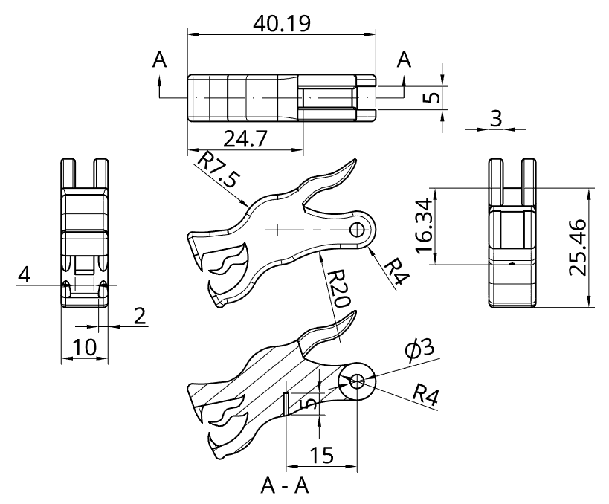
In the student work booklet, sketch some ideas of features you would like your dragons head to have. You may want to do some research online to get some more ideas.

Automaton wings
The last major part of the automaton are the wings. These too can be customised to a certain extent, but some basic information has been provided to assist with your design. The wings should be drawn on the top plane.
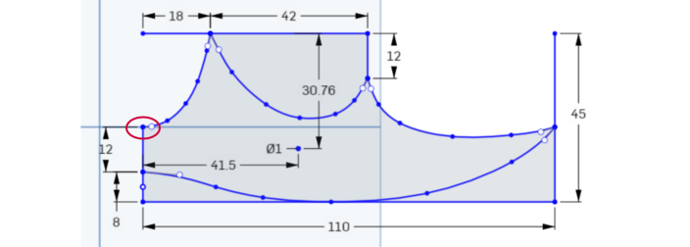
The basic setup points are provided with the dimensions. The curves in between are created using the spline tool. Try not to create too much of a sharp point, otherwise if they are 3D printed there is a chance they could snap off. These example ones have been 3D printed successfully.
When laying out the wing, the upper end of the 12mm long vertical line on the left-hand side (as circled in the image above) needs to be on the horizontal axis, as it makes the next step easier. Once completed, extrude it to a thickness of 3mm.
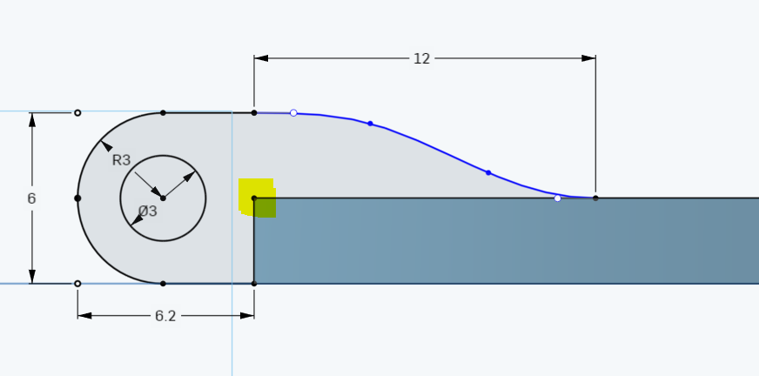
The next sketch, as shown above is then drawn on the front plane. By ensuring the 12mm line coincided with the horizontal axis in the previous step, we can now draw directly onto the front plane and the drawing will line up with it. The highlighted node is the end view of the 12mm line.
The rest of this section is fairly straight forward with the only variable being the 12mm horizontal length spline curve that connects this sketch to the top of the wing. You can make it a shallower curve, but it needs to provide plenty of support as the wing pivots at this point. This sketch is then extruded forwards 12mm. The 6.2mm measurement provides the clearance required for the body pivot to wing connection.
Once completed it will look like the image below, then the middle section of the new extrusion will need to be cut out.
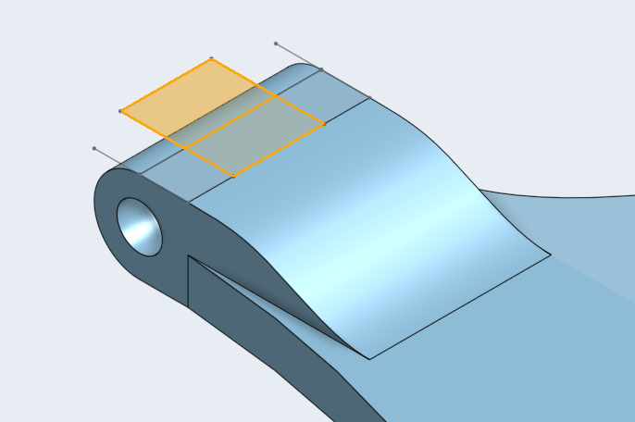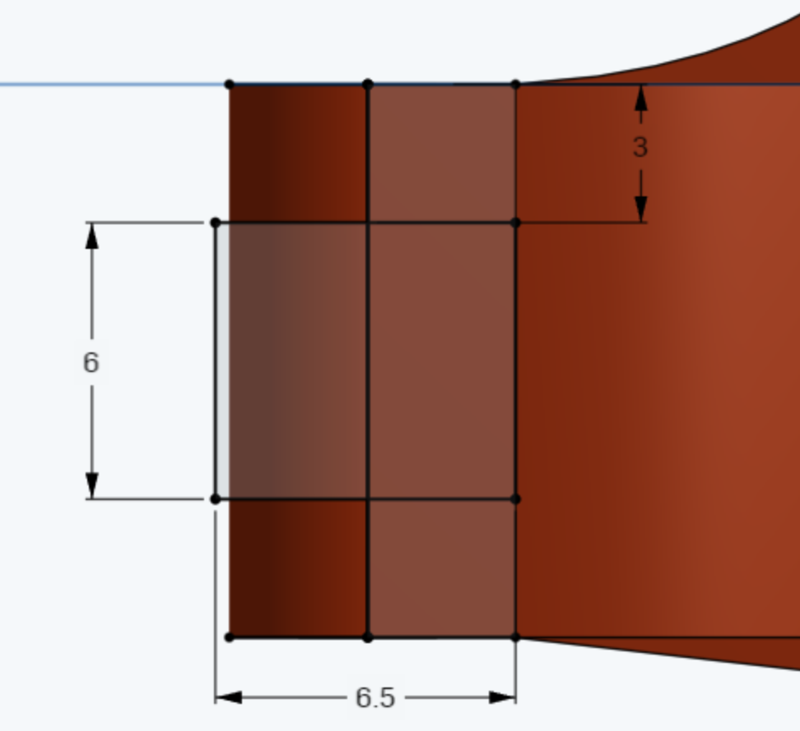
The rectangle that will be used to remove the section is 6mm x 6.5mm. The image on the right shows the view from above, with the front of the wing at the bottom of the image. The 6mm is measured front to back, which is offset in 3mm from the front and back edges. It aligns on the right hand side with the original end of the wing, before the last section was added, and overlaps the curved surface so that when it is extruded down and the material is removed/cut it will leave a space for the pivot point.
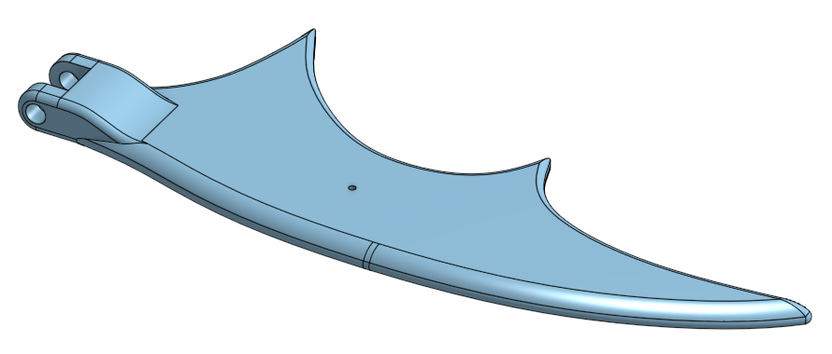
The finished wing shown above has a 1mm fillet all around except for the upper leading edge of the wing which is a 3mm fillet. The hole in the middle is for the control rod to make it flap. The final dimensioned drawing is below.
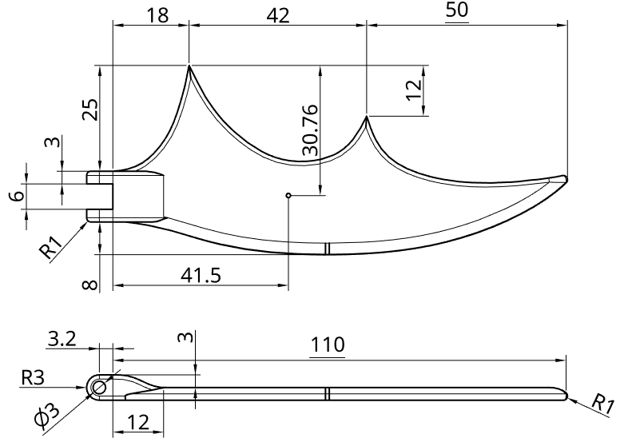
Now that you have completed all the main parts for your automaton you will need to make the control rods and attachments.

Wing control rods
The first of the rods to control movement of the automaton are the wing control rods. These use the same technique as will be used for the head and tail control rods, but as the tail has a slightly more complex design, we are starting here first. These parts will be made using the sweep command, which allows the user to create or remove features of parts by transforming a sketch or face along a path.
The wing control rods are made up of three separate sections in order to allow for articulation. The first section, which is shown below, is the lower control rod which is fixed into the ends of the pivot that goes through the body control rod guide blocks.

Start the sketch on the front plane. From the origin point draw a line 7mm long to the right along the horizontal axis. Then below this draw a Ø2mm circle with the centre point directly below the end of the line and the edge of the circle creating a tangent with the line as shown below.

Next draw another circle with the start point further along the horizontal axis, drag it out until it touches the first circle, creating a tangent connection between them. Then resize it so that it is also Ø2mm, as shown below.

As the second circle was started on the horizontal axis, that point is constrained and therefore the centre point of the circle will remain on that axis. As it was also drawn making a tangent connection to the first circle, that provides a second point of constraint. This means that when the second circle is resized those two relationships will remain, which is what we want.
From the centre of the second circle draw a diagonal line up and to the left until it is past the outside edge of the second circle at an angle of 35° to the horizontal.

Then trim out all the extra parts to create the path required, which should look like this.

This is the path for the sweep to follow. Keeping the diagonal line isn’t completely necessary, but in the event you cannot draw from the centre of the axes or origin point, it will come in handy and we will use it on the next rod to demonstrate that technique.
Finish this sketch and start a new one on the right plane, which should be perpendicular to the first plane you drew on and also vertical.
At the centre point (origin) draw a Ø1mm circle, then you can finish this sketch too. The result should look like this, when viewed as a trimetric view.


The sweep tool
The sweep function involves selecting a plane or face which can be used to make something new, add to an existing shape or remove material, based on the path the face is swept along. The sweep tool can be found on the 3D toolbar as shown below.
Once you have selected the sweep command, you need to click on the Ø1mm circle as the face to sweep. Then select the different sections of the original sketch as the sweep paths. It is always good practice to start by selecting the part of the path attached to the face being swept first, continuing along the path selecting consecutive sections until it has done what you want. If you select parts of the path not connected to the face being swept it can generate some very odd shapes.
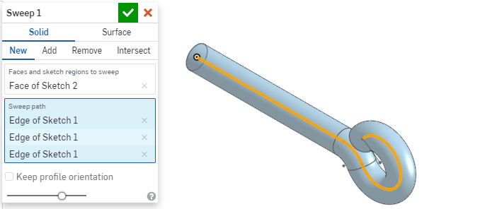
The same technique is required for the other two parts of the wing control rods. The next one is the upper wing control rod and it is very similar but is shorter and has a different end instead of just terminating as a straight rod.
Start by creating a sketch on the front plane using the layout below, ensure that the start of your sketch is not started at the origin point. Use the same relationship for the circles to the line as before, only with the whole sketch rotated 90° clockwise.
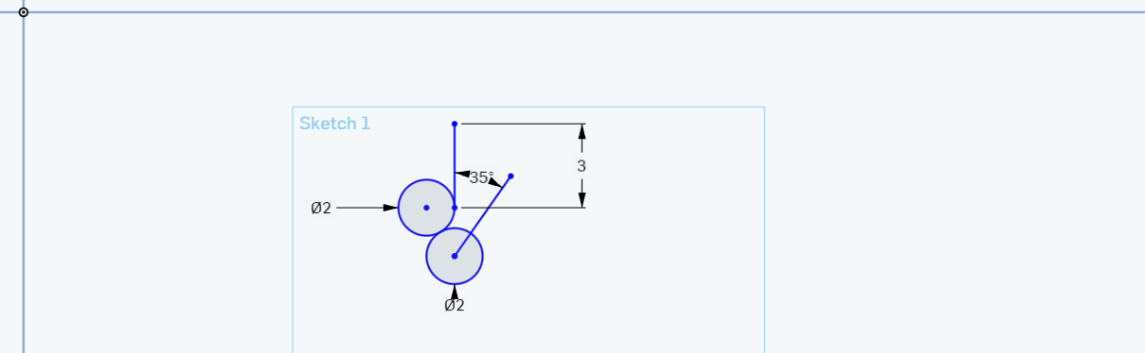
Trim out the excess lines as before and finish the sketch.
Select the plane tool and then instead of creating an offset plane as we did for the body, select the line angle option from the drop-down list. Choose the short line at 35° and the right plane as references, then finalise the plane tool to generate a plane at the angle of the short line.
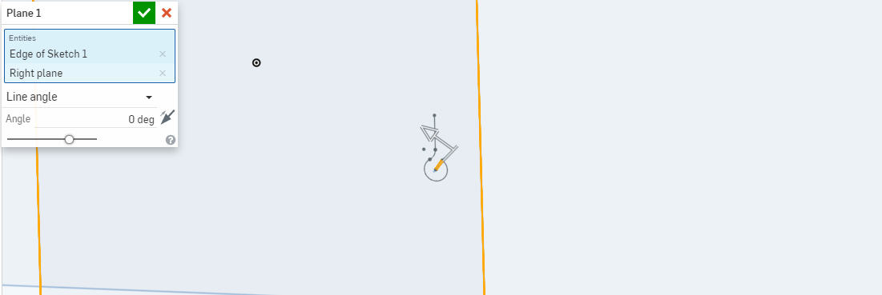
Once you have generated the plane it will look like this and the outline for it will be much smaller than the other planes, because the line used to create it is only 3mm long. This doesn’t affect how much can be drawn on it.

Draw a Ø1mm circle on the plane so that it is roughly in the middle as shown below.

Then use the dimension tool to set the distance from the line to the centre of the circle to zero and then distance from the end of the line where it meets the curve to the centre of the circle to zero. This should look like this.

Next use the same process as for the lower control rod to create the sweep, selecting the circle at the face and then working along the path, but this time in the opposite direction.

To finish it off we will create a dome on the top of the rod. Start by selecting the top horizontal end of the rod as the face to sketch on, then draw a Ø4mm circle on top of the rod. This then needs to extrude 1.5mm up to create the cylinder shape as shown below.

The next step could be achieved in a number of ways including applying a fillet to the top edge of the cylinder, but we are going to use the revolve tool instead so that we can explain its operation.

The revolve tool
The revolve tool can be found on the 3D modelling toolbar as shown below.
The revolve tool allows the user to create, add to or remove material by revolving a sketch around a central axis. In this instance it will be used to remove material from the cylinder to create a dome shaped lump on top, which will be visible on top of the wing and will look like the image below.
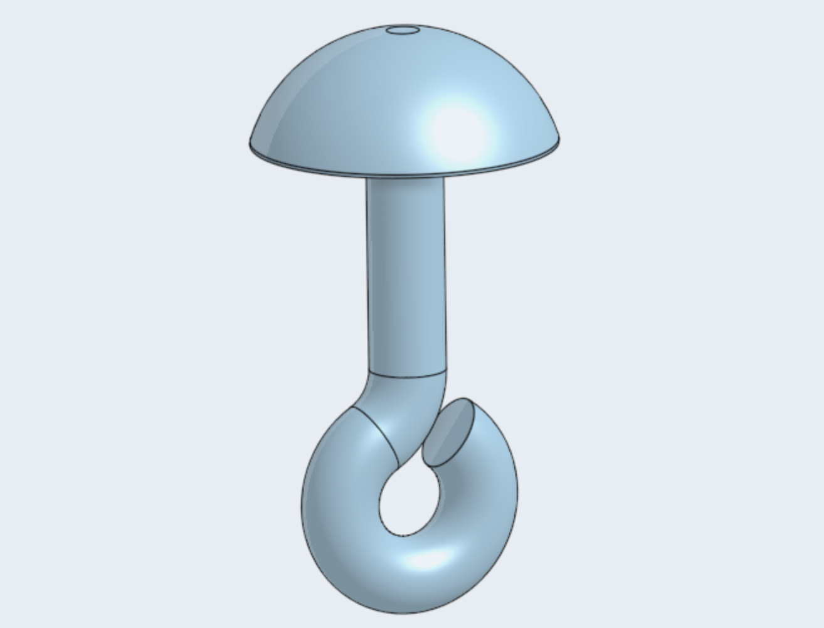
Start by selecting to sketch on the front plane and normalise the view.
The next step can be quite difficult. In order to reference the new sketch, it either needs to know where the original sketch was or reference directly off it. The problem is twofold, the original sketch was randomly drawn in space somewhere on the front plane, and it doesn’t like referencing off the cylinder just created, as what appears in the image below as a rectangle, is actually a curved surface.
Start by drawing two lines as below, one line running 1.5mm vertically next to the drawing and the other starting at the end of the first line and running to the left 2mm, so that it looks like this.
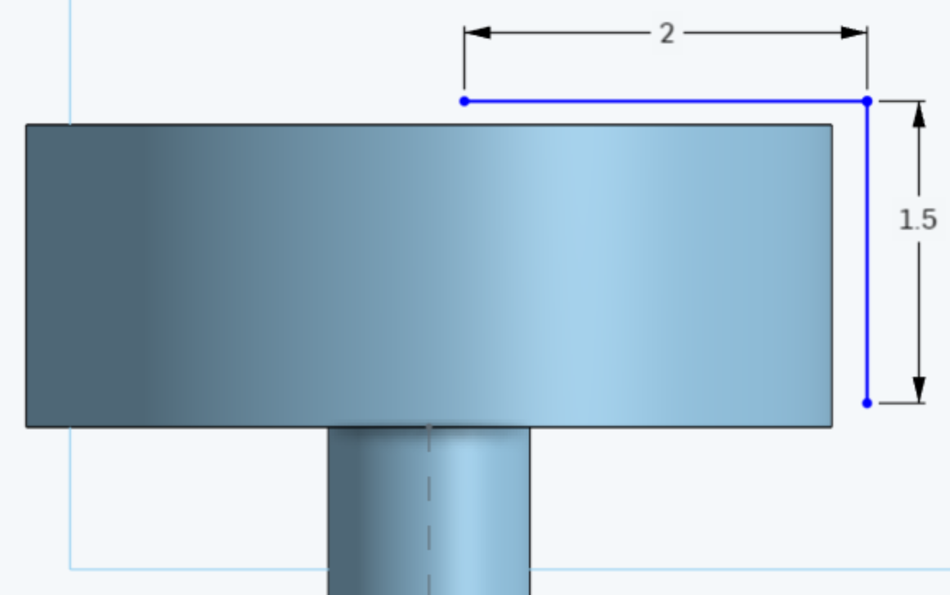
Then use the dimension tool to identify locations that will allow themselves to be referenced off. If they change to gold when hovered over or clicked on, they will work.
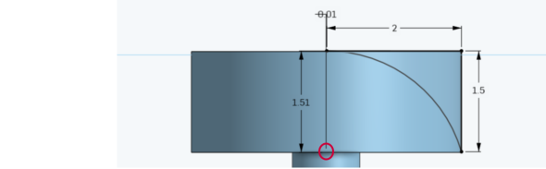
Using this method it is possible to reference and measure the distance between the underside of the cylinder and the horizontal line, which should be 1.51mm. Then measure the horizontal distance between the end of the sweep path found at the middle of the underside of the cylinder (circled in red) and the end of the line previously measured. This distance should be 0.01mm. This will result in the lines being very slightly offset from the side and the top of the visible rectangle.
Then draw a three-point arc so that the arc is tangent with the horizontal line. This creates the closed face that will be revolved around the axis to remove material from the top of the wing control rod.
Finish the sketch and reorientate the view so that the rod is back in trimetric view.

Start the revolve by making sketch 1 visible and then select sketch 4 in the features list by clicking on it. Then select the revolve tool and the dialog window will appear.
The ‘Faces and sketch regions to revolve’ cell should be prefilled with ‘Faces of Sketch 4’. Change the setting to Remove instead of the default Add and then click in the Revolve axis cell to activate it. Click on the final straight part of Sketch 1 as the axis, it should highlight, and a ghosted preview should show you what is going to happen.
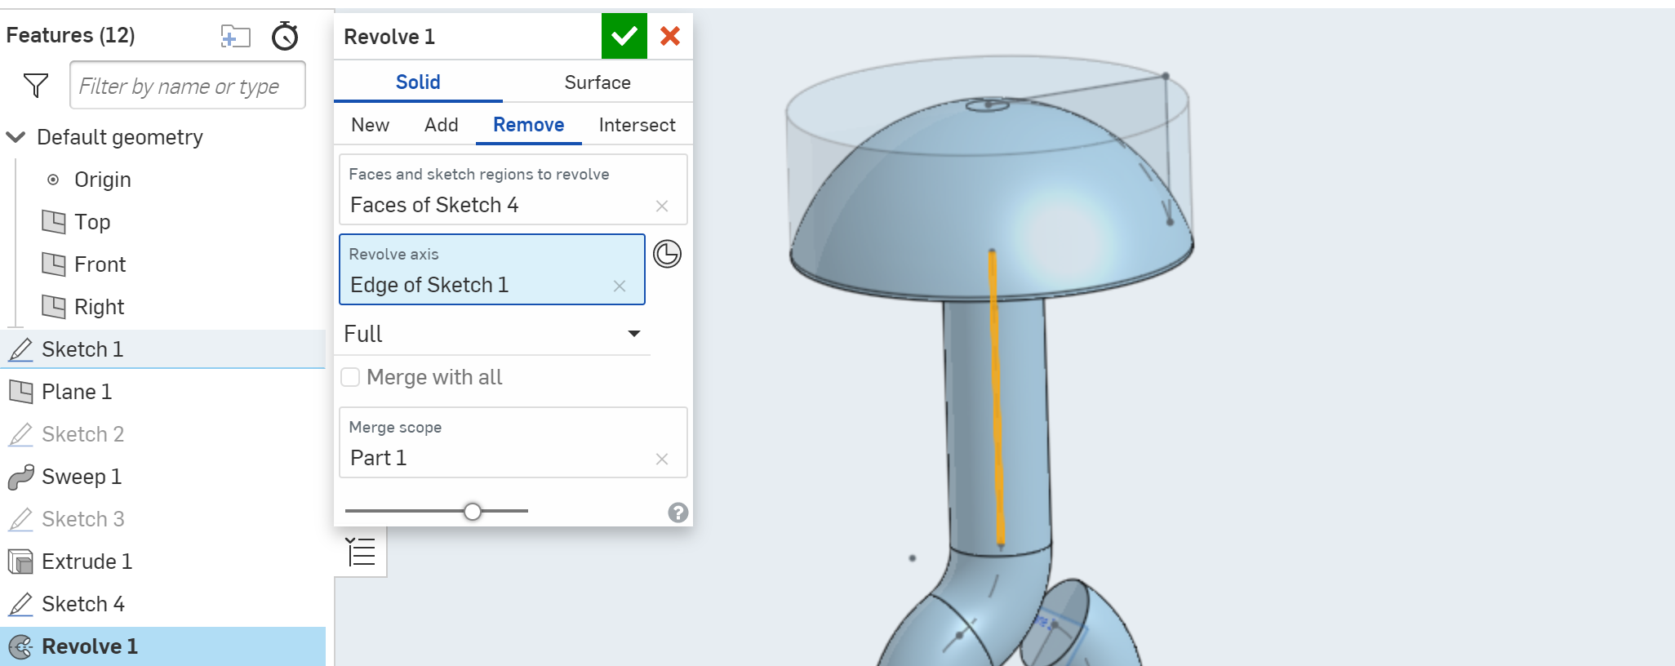
Finalise the revolve tool and start a new part studio to create the middle section of the wing control rods.
The final part of the wing control rod is a double ended version of the lower wing control rod. This time start with a line 57.5mm long and draw the circles on both ends. Use the same technique as for the upper wing control rod to create an angled plane and then use the sweep tool to form the rod as below.


Tail control rod
In real life this rod would be made from 3 parts, the 3D printable pivot holder, the 2mm metal pivot itself and the wire rod, so we will draw it as three separate parts and then assemble them, in the same way as if you were to make it.
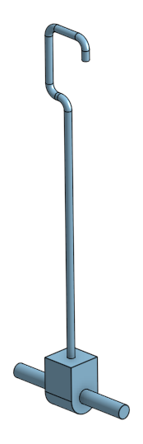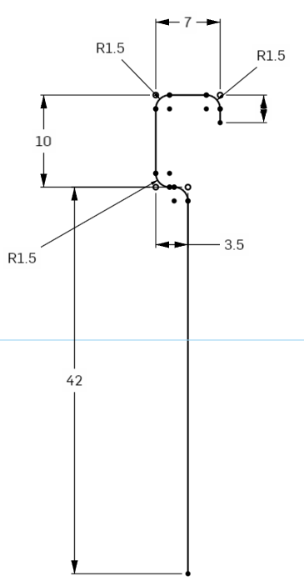
The completed component is shown on the left and the pivot holder and pivot are fairly straight forward. The only slightly complex part of this is the wire rod, which in the same way as the wing control rods, is created using the sweep tool.
Start by drawing the image shown on the right and use a Ø1mm circle as the cross section at the base of the rod. Begin drawing the rod from the base up on the front plane with your start point at the origin. That way you will be able to draw the cross section on the top plane also at the origin.
Then you can select the circle as the face to sweep and all the sections of the wire rod drawing as the sweep path.
When generating the path, draw the shape using only straight lines and the dimensions shown. Then use the fillet tool, this time within the 2D drawing toolbar, to apply a 1.5mm radius fillet on all the corners.
The pivot holder and pivot should be drawn as two distinct parts and then assembled for use separately with the head and tail control rods. Use the working drawing on the next page to create your parts.
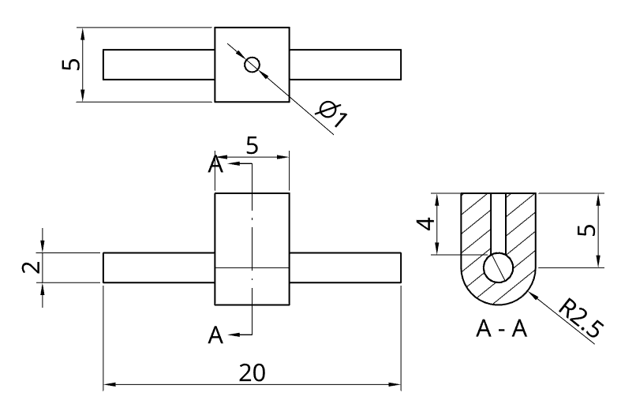

Head control rod
Once you have created the pivot holder and pivot as individual parts, then assembled them as shown above, you will use the same assembly with a straight wire rod that is 54mm long and 1mm diameter.
Below is how the two of them look together. The only reason the tail rod is more complex is that without the extra articulation provided by the hook and eye to the underside of the tail, the automaton jams up and will not animate.
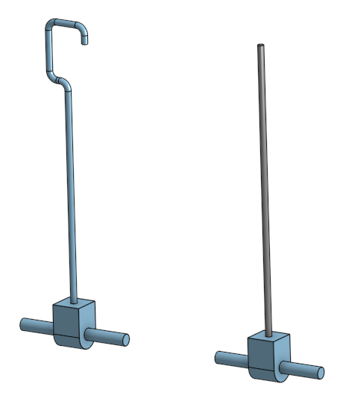

Body to wing connector
The body to wing connection is made up of three parts. A central section that is able to rotate inside the body, allowing the body of the automaton to move back and forth smoothly and then two axles/pivots that engage with the end of the wings. These pass through either end of the central section and into the wing connection.
The image below shows how it all goes together, but first we will look at how to make the individual components.
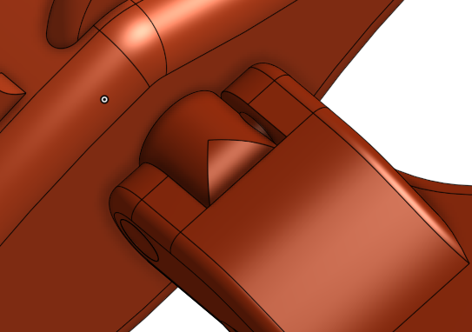
If we start with the central section, on its own it looks like the image on the left and the working drawing for it is on the right. It can be drawn as a circle on the right plane on the origin point, which is then symmetrically extruded into a cylinder 28.4mm long. Then the ends and holes can be formed as remove extrusions drawn on the front plane.
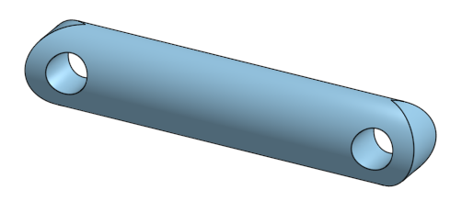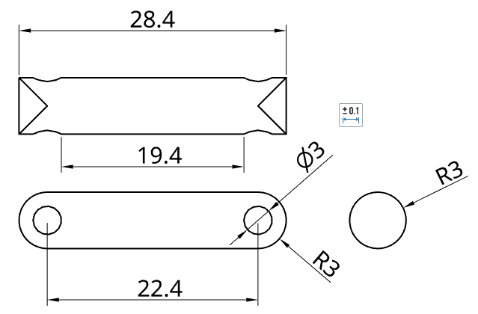
The axles/pivots that go through the holes on this one are simple 3mm diameter cylinders that are 12mm long.

Body control rod
The body is supported on a 4mm rod that connects the body down to the main crankshaft follower. It is a simple extrusion of a 4mm diameter circle and should be 70mm long. It will be attached with a fastened or solid mate into the holes in the top of the follower and bottom of the body.

Body control rod guide block and pivot
The body control rod passes through the slot in the top of the base enclosure but needs to be constrained so that it does not move around too much. In order to achieve this it slides through a pivot rod which is held in place by two guide blocks, one either side of the slot as shown below.
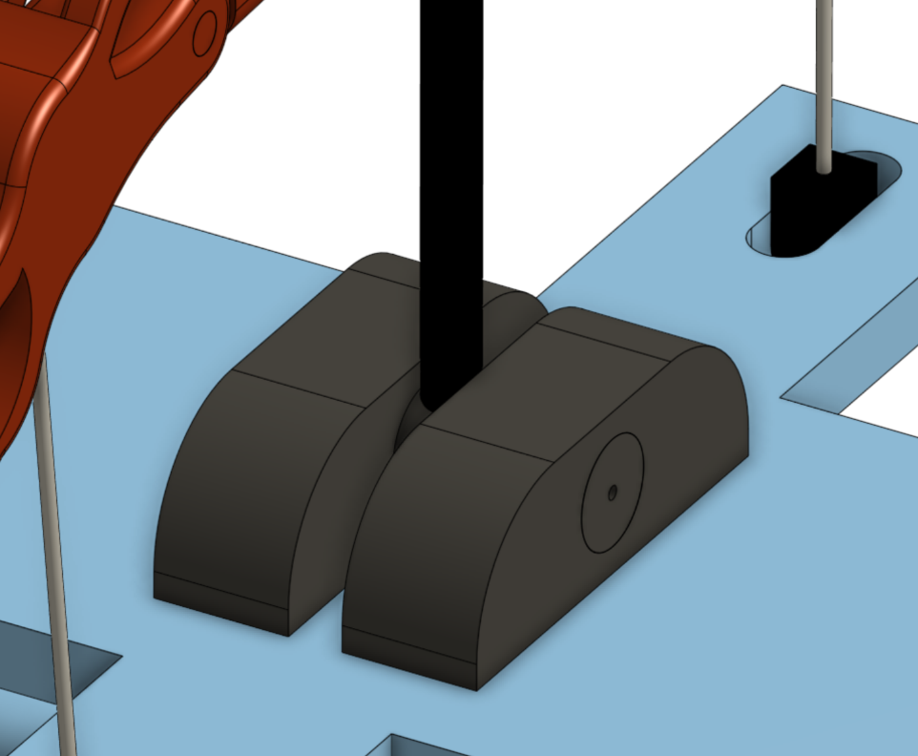
Note the hole in the end of the pivot, which is on both ends, accommodates the wing control rods.
Below is the dimensioned drawing of the guide block on the right and pivot on the left.
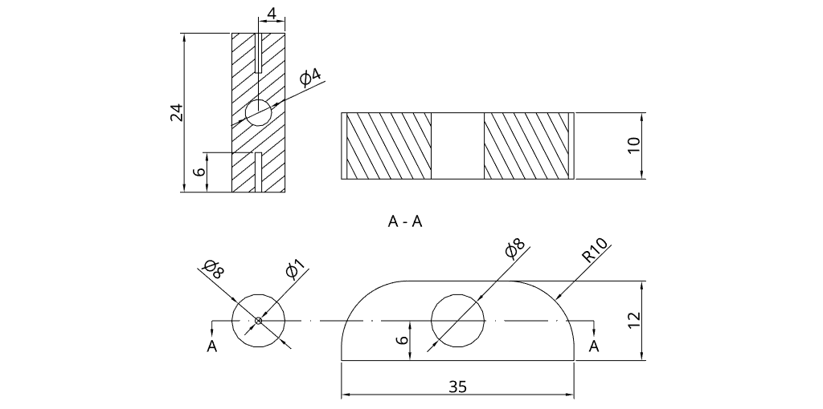

Body axles/pivots
The last things we need to make before assembling the automaton is to make three pivots to connect the head to the neck, the neck to the body and the body to the tail. These are all 3mm diameter cylinders, two of which are 16mm long (so you only need to draw one of them and then use it twice) to go through the body and one is 10mm long to go through the head.


Assembly
Work through the Assembly section of the student work booklet so that you have some understanding of the process and the types of mates available. The easiest place to start is with the base enclosure and will help you to become more familiar with the process.

The base enclosure
The base enclosure is simply the top, sides and bottom and they will be mated together using a fastened mate or equivalent. We do not need or want them to move independently once they are attached to each other.
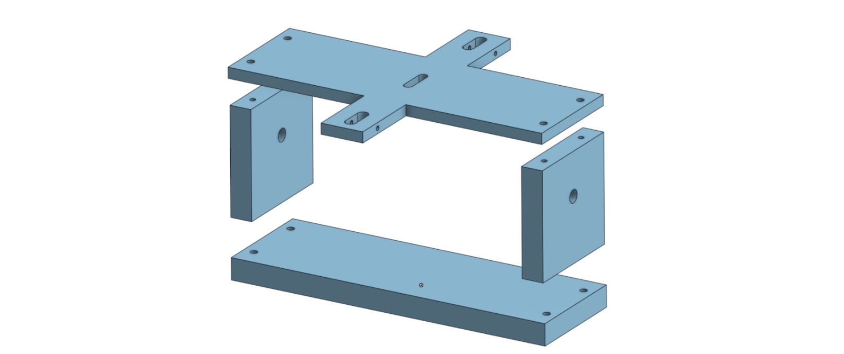
The image above shows all the components after they have been brought into the assembly ready to be put together. If the parts have been drawn on the incorrect plane or are not in the correct orientation you can click on it and drag to a new location, this is called free drag, or you can use the triad manipulator to reorientate the part before mating.

The triad manipulator
Although it may sound sinister, the triad manipulator is Onshape’s tool to allow you to reposition, reorientate and generally manipulate parts within the Onshape environment.
Whenever you click on a part within an assembly the triad manipulator will appear allowing rotation or translation around or along any or all of the three axes or planes.
As you can see below, when bringing part studio objects into an assembly they land wherever you click them, and in whatever orientation they were drawn. For something like the base enclosure that is not a big deal, as the sides are symmetrical and can be used in either position and the top and bottom will move once we start to assemble them. For more complex assemblies, this is more important, especially where a component is used multiple times in different locations and orientations.
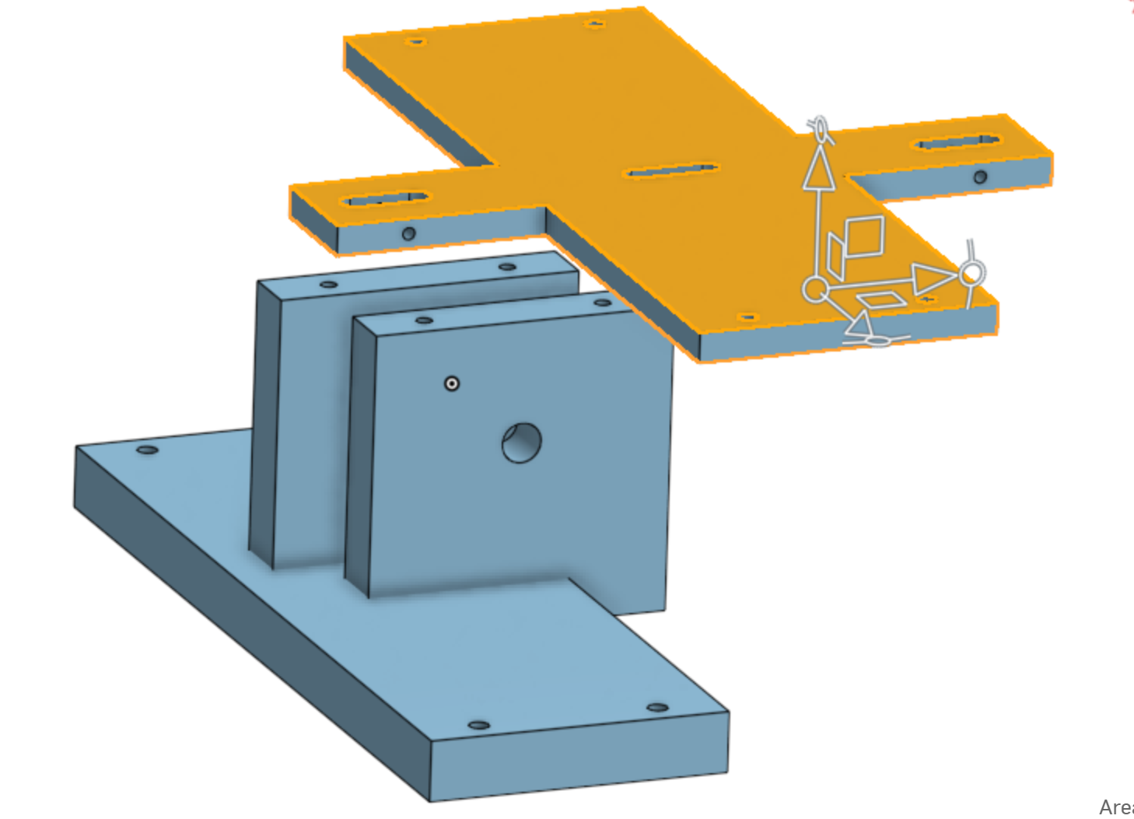
The triad manipulator allows you to control where and how objects are placed, depending on where you click on it.
- Repositioning the manipulator itself - the centre circle allows the triad manipulator to be moved to a different location on or off the object and this will affect the way the object moves as it will be in relation to that point.
- Move the object along an axis - the arrows allow the object to be moved a measured distance up or down along the orientation of the arrow.
- Move the object along a plane - the three rectangles allow the object to be moved anywhere within that plane of movement.
- Rotate the object around the x, y or z axis - the circle at the tip of the arrow allows the objects to be rotated through that plane of travel around the axis selected.
It is very intuitive and something that you will get used to quickly once you start using it.
Once you have the part studio objects where you want them, it is time to perform some mates.

Fastened mate
The fastened mate can be found on the assembly toolbar as shown below.
The fastened mate is as the name suggests, a secure connection at a known point with no degrees of freedom between them.
The very first one we need to do is between the first part brought in and the origin point. This is so that the software knows where everything else is in relation to that one point.
Start by selecting the fastened mate from the toolbar, then click on the centre mate connector on the underside of the base followed by the origin point in the assembly.
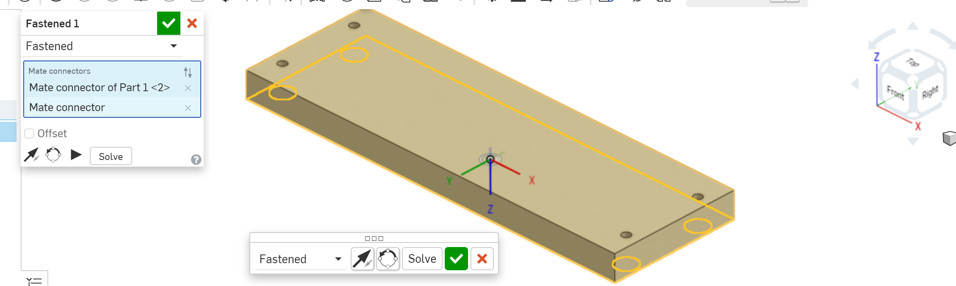
It will highlight the underside of the base and the connection point is visible as can be seen above. Simply tick it off and then start bringing in the other part studio objects to assemble.
Start by selecting the fastened mate again and then select a point on one of the sides. Select the bottom right corner on the highlighted face (as shown below). This is done by hovering the mouse over the surface you want to select until it is highlighted and the nodes around the perimeter are visible, then slowly move the cursor to the appropriate corner ensuring the selection does not slip around to another face.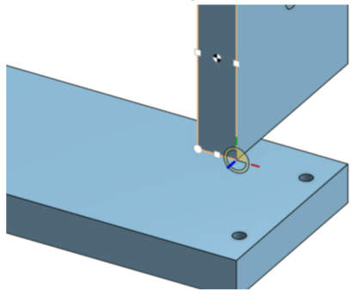
If the points on a face or feature are not selectable, try zooming in with the scroll button and they should become available.
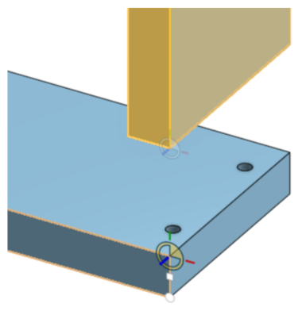
Once the bottom right-hand corner of the side is clicked on, it gets highlighted, showing it has already been selected, then allowing you to select the second point for your mate. This is the upper right-hand corner of the highlight face on the base as we want the two points to be next to each other.
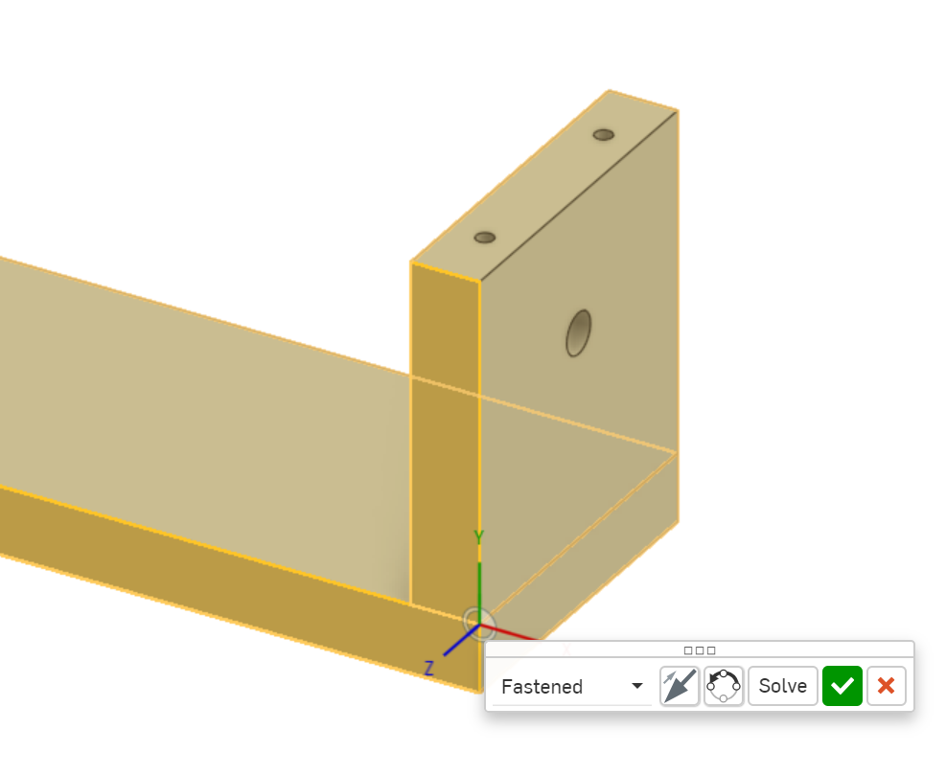
This then results in the two parts being joined and a pop up asking you to tick off that this is what you wanted. As long as it looks like this you can go ahead. However, if it comes up as something else, we will need to adjust it. If it looks like the one below, we need to flip the axis and we do that by clicking on the two arrows (highlighted in the red circle) and it will just flip over into the correct spot.
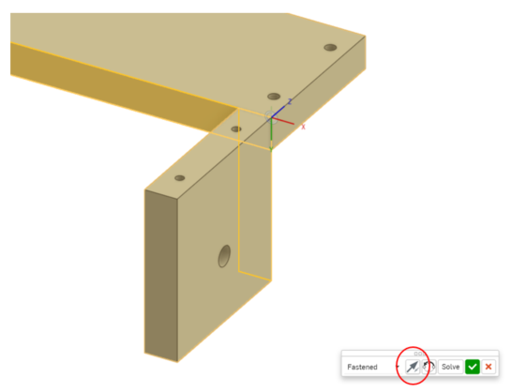
As previously noted, these instructions are for Onshape, but just in case you are using Fusion 360, it has similar controls. If you find that the two parts have mated oddly (below on the left) then it is simply a matter of clicking on the ‘flip’ button highlighted blue, which will flip it around to the correct orientation (as shown on the right) and as you can see the flip button, which has been circled, is no longer activated and therefore not blue.
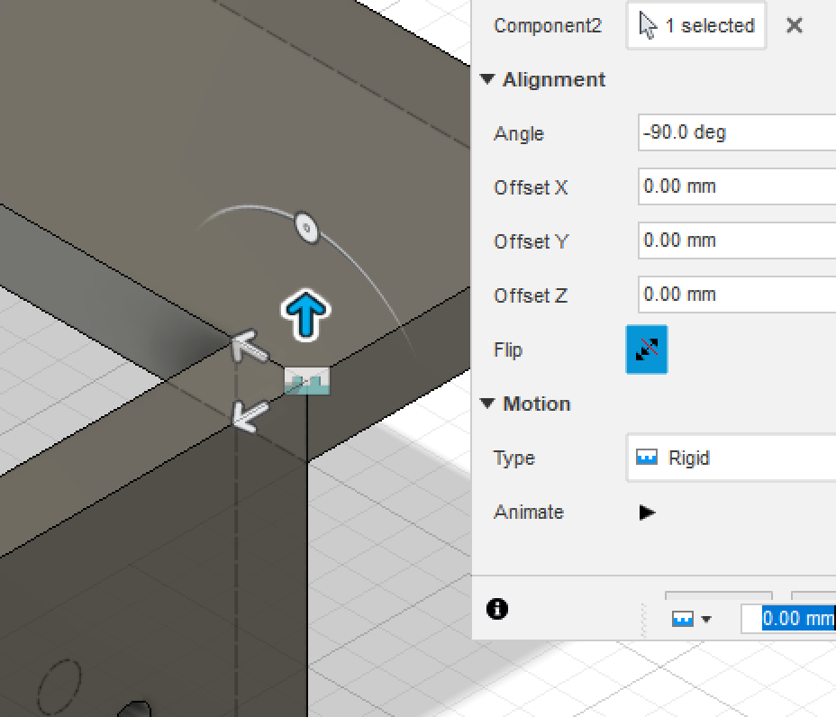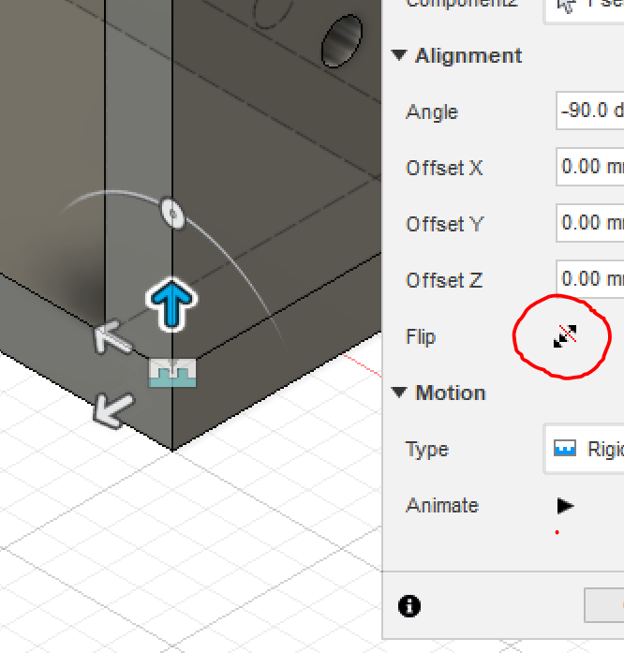
Each of the other components that make up the base enclosure are attached in a similar way.

Assembled base enclosure
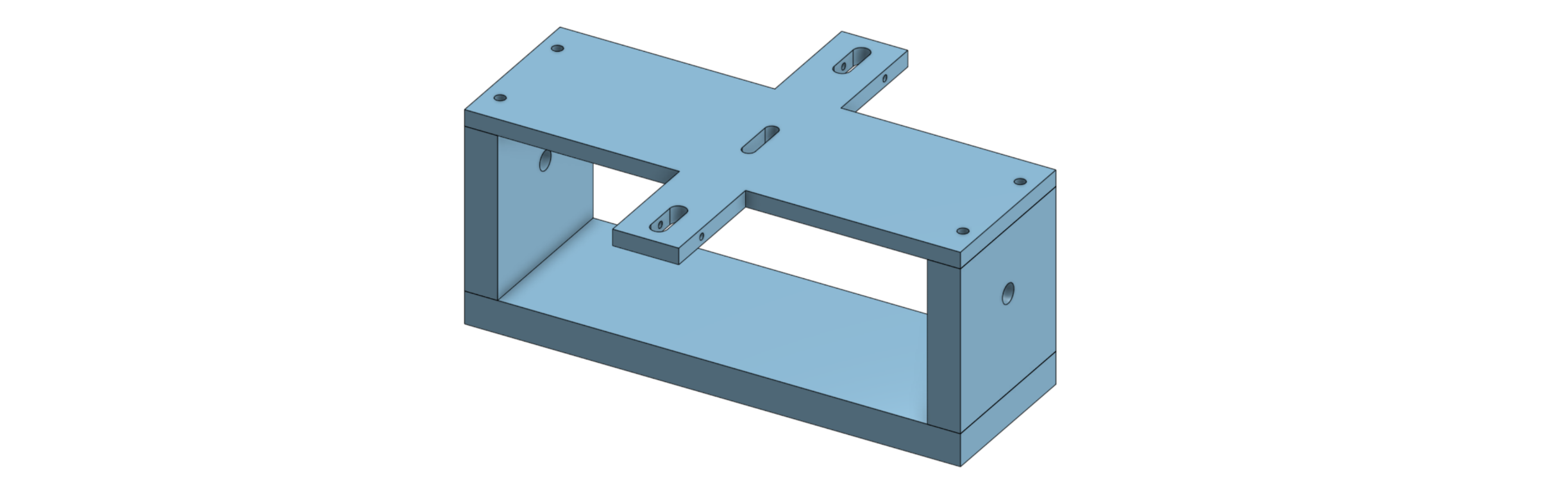
This is what the assembled base enclosure will look like. Note that the two holes on the top and bottom at either end are so that you can screw the enclosure together if you go on to print it. As an extra challenge, once you have completed your assembly and animation you can design and draw up some screws suitable for this task. Now you can move on and create a new assembly, this time of the crankshaft.

Assembling the crankshaft
If you were 3D printing the parts of your automaton you would need to partially assemble your crankshaft (as shown below) before inserting it into the base enclosure. However, thanks to the magic of CAD, even though you have already ‘built’ your base enclosure the completed crankshaft can just pass through the walls to get into position.
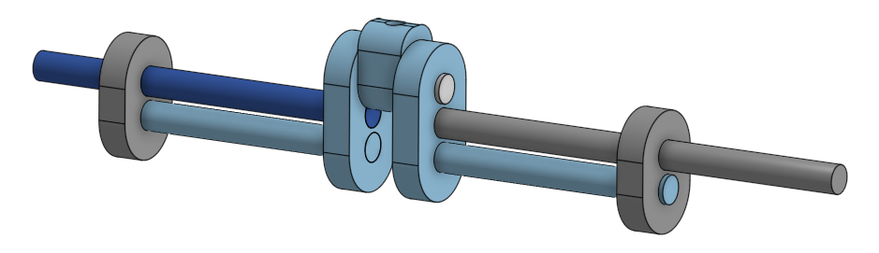
As you can see here the crankshaft has had the main follower inserted onto the upper main shaft and it is ready to receive the rod which will control the main movement of your automaton. This will need to have the base enclosure added to it before you add the spacer rings and the cranking handle to make them easier to locate.
But before we get to that we’ll need to actually assemble the crankshaft. Below is the drawing for it.
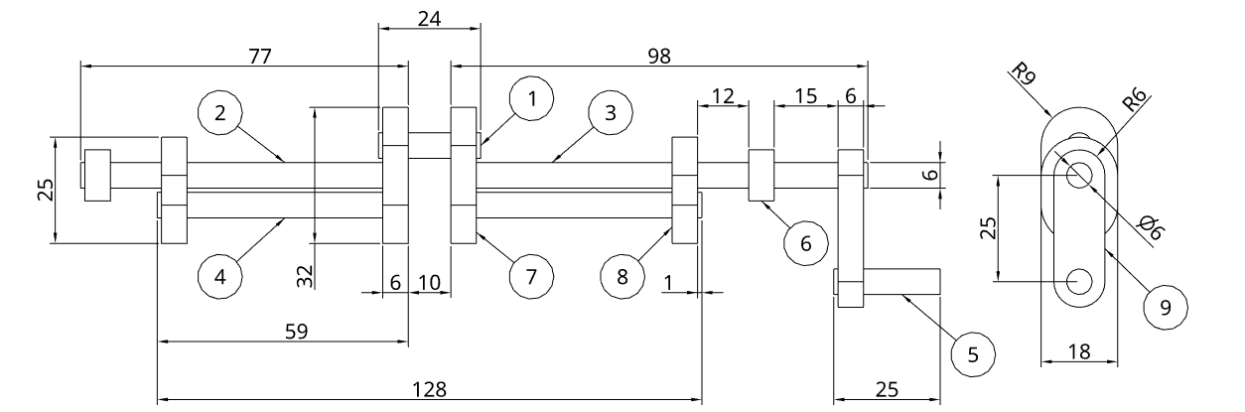
In the same way as we used the side of the base enclosure twice, we can use the different components above multiple times when assembling our crankshaft. In fact, to make our life easier, we can assemble certain components into a sub assembly and then use that sub assembly multiple times in our final assembly.

The first sub-assembly
If we start with the central and outer crankshaft connectors and the lower shafts, they can be assembled into our sub assembly as shown below. The far end is mated flush and the end shown is offset 1mm. This extension (or offset) serves as a spacer to stop the connector disc rubbing on the inside of the base enclosure.
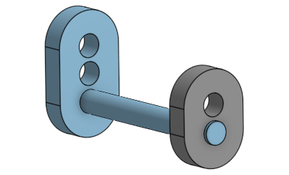
Then we can create the rest of the crankshaft by making another assembly and adding our sub assembly twice. All we need to do is flip the one sub assembly through 180° using the triad manipulator so that it is orientated correctly as shown below.
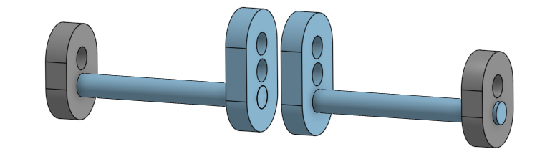
Then add the other components such as the upper main shaft, the left and right centre shafts, the spacer rings and then the cranking shaft and handle. Note that when attaching and mating the upper main shaft it has a 1mm offset at both ends, this may need to be either a positive or negative number depending on which component you selected first. This extension serves no other purpose than to visually match the one on the outer crankshaft connector.
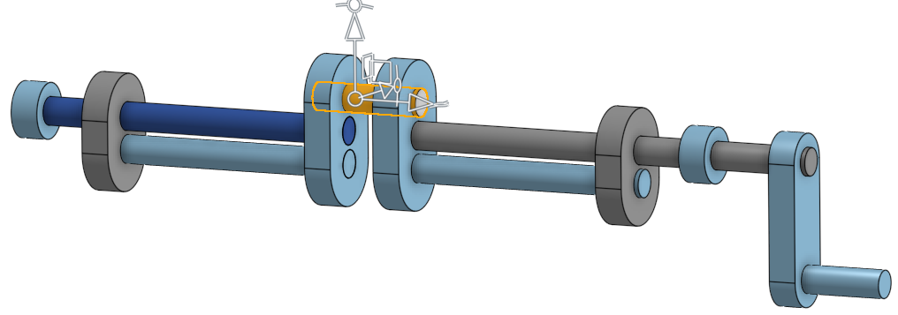
Once the cranking shaft and handle have been added to the crankshaft, the whole assembly can then be added, along with the base enclosure assembly, to yet another assembly, this time the final one for the base section of the automaton. The reason for doing this is that each part and sub assembly are editable separately and minor changes can be made to them more easily, which will then automatically update the final larger assembly. If we kept just drawing and adding in the one file, making changes later on would be much more difficult.
First, we need to bring in our two sub-assemblies from the Insert menu.
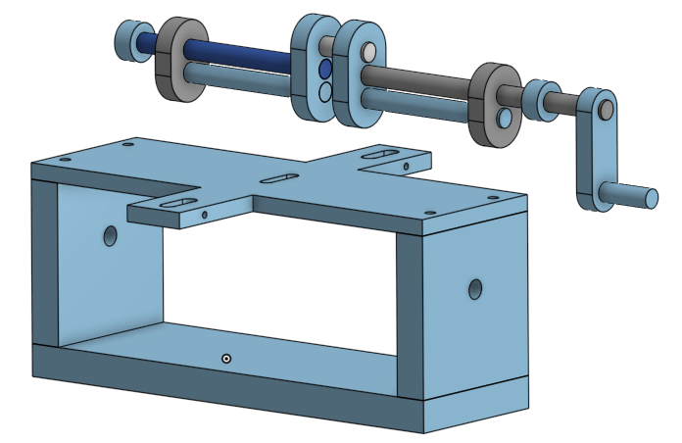
Then we need to create the revolute mate by associating the right central shaft with the hole going through the right side.

Revolute mate
The revolute mate can be found on the assembly toolbar as shown below.
Start by selecting the end of the right central shaft and then the outside face of the hole going through the side of the base enclosure as shown below.
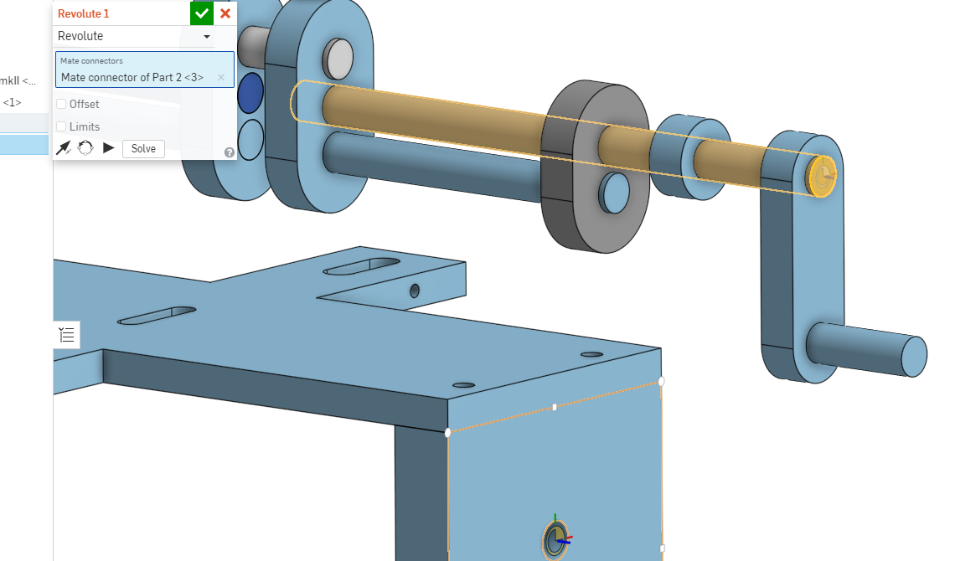
Then we will need to offset that mate by 28mm, which is the distance between the end of the right central shaft and the inside face of the spacer ring that will end up against the side of the base enclosure.
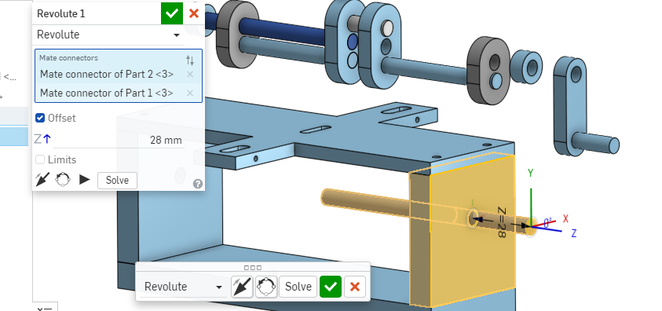
You will notice that the shaft being mated temporarily leaves its sub-assembly while you create the offset, as per the dialog box shown. Once you are happy with the location of the shaft tick it off in either of the dialog boxes and the rest of the crankshaft sub-assembly will join the central shaft.
Here is what it looks like when it has been ticked off and the base is complete. The mate between the enclosure and the crankshaft allows the crankshaft to turn. You can test this by clicking on the crank handle and using the grab handle on the controls that appear to rotate it. Although it will work the base enclosure will also move.
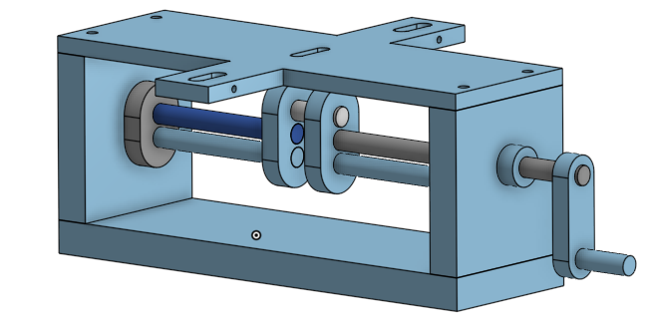
To stop this from happening you will need to ‘fix’ the base enclosure in space so that when you animate it everything else moves and it will stay in the correct location.
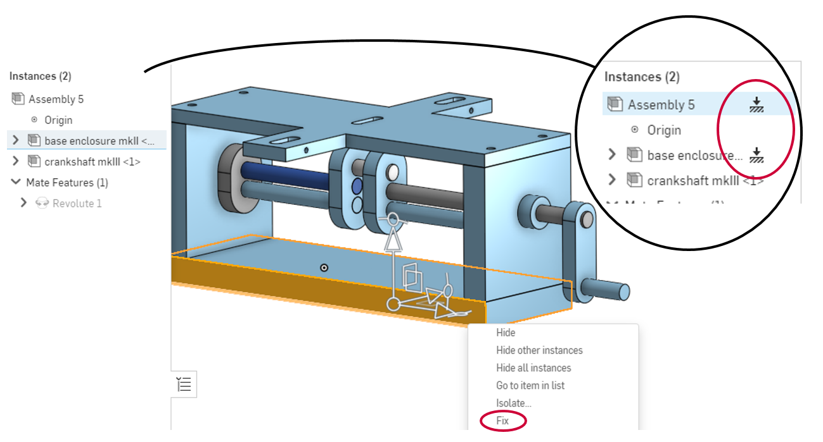
This is done by selecting the base and right clicking on it, which will bring up the menu at the bottom of the image. When you select the fix option the dialog box changes from the original on the left to the new version on the upper right where the fixed icon has been added.
Now when you select the ‘grab handle’ on the triad manipulator and rotate it the base enclosure will remain in the same location whilst the crankshaft rotates.
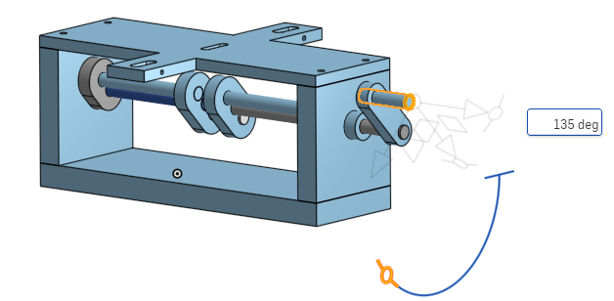

Follower, rod and guide blocks

Above is the assembled crankshaft follower, the body control rod, the guide blocks and pivot. The first thing to do here is to assemble the two guide blocks and the pivot into a sub assembly. The pivot needs to be mated to each of the guide blocks with a revolute mate, so that it can rotate freely.
The image below shows the second revolute being made.
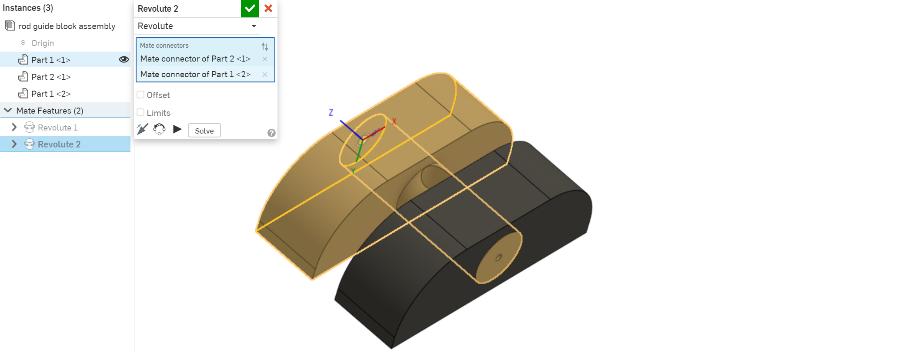
Then the two guide blocks need to have a parallel mate applied to their underside.

Parallel mate
The parallel mate can be found on the assembly toolbar as shown below.
Once the guide blocks and pivot have been assembled with revolute mates on each end of the pivot, we next need to perform a parallel mate so that they cannot rotate independently of one another.
This is done by selecting the middle of the two surfaces as shown below.
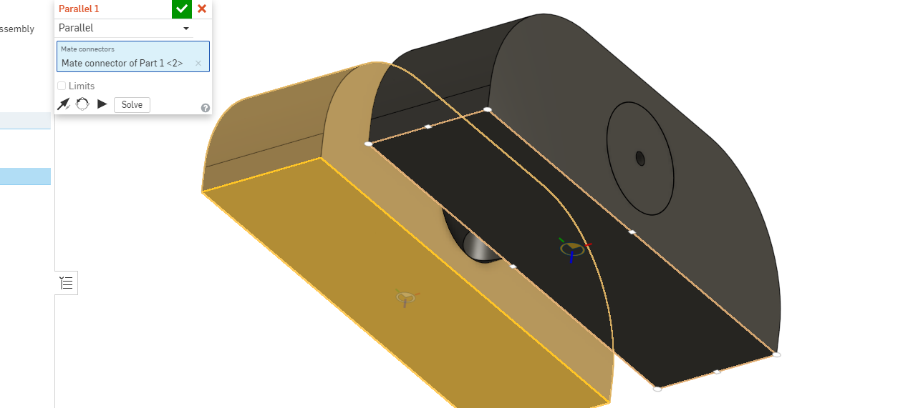
Which will cause the one block to overlay on the other temporarily until we tick it off and finalise the mate, when it will return to its normal position as shown below, on the left and right respectively.
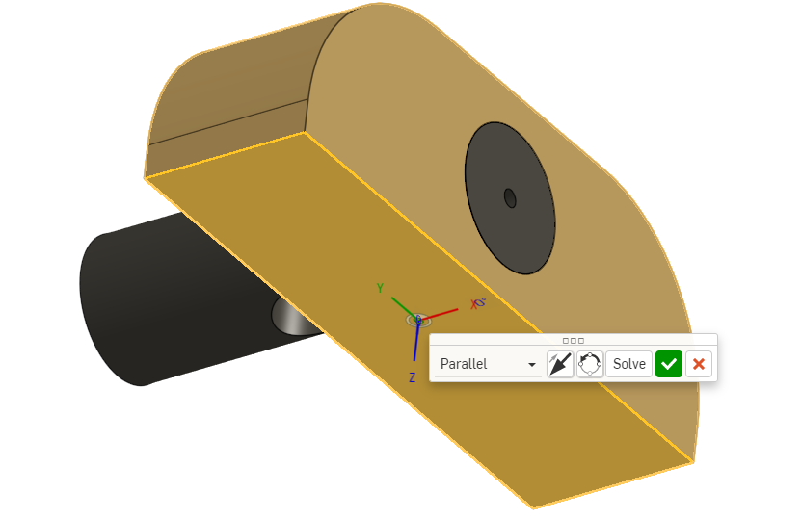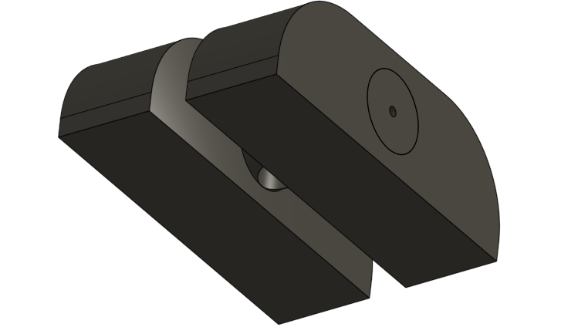
There is no obvious change but whithout this mate you would have to perform a fastened mate for each guide block onto the surface of the top on the base enclosure later on. This way, you only need to fasten mate one of them.
The next step is for the body control rod to be attached with a fastened mate into the hole in the follower, then the rod needs to go through the pivot in the guide block assembly and be attached with a slider mate to allow it to move up and down.

Slider mate
The slider mate can be found on the assembly toolbar as shown below.
Here we can see the crankshaft follower and body control rod have been fastened mated to one another and the follower has been revolute mated to the upper main shaft of the crankshaft. The pivot and guide block assembly has been brought in ready for the slider mate.
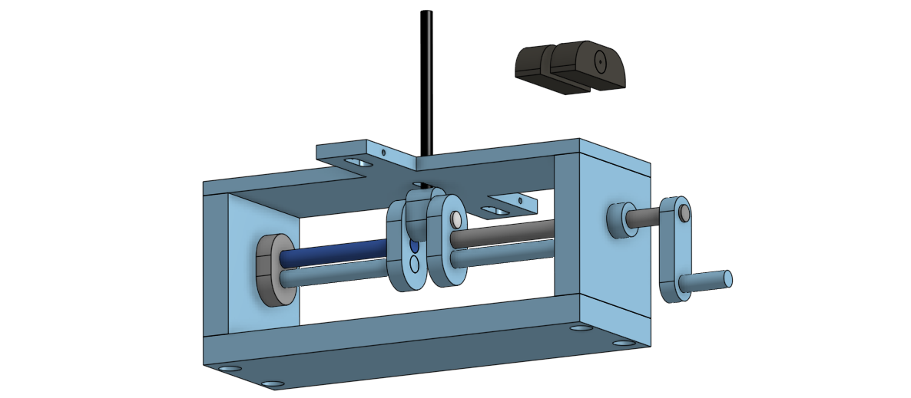
The first step is to select the slider mate from the toolbar then the middle connection point for the body control rod and finally the middle connection point for the hole going through the pivot as highlighted on the right below.
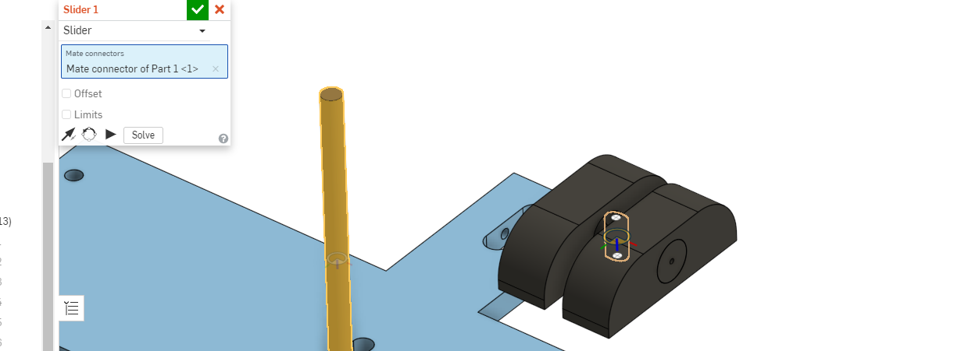
The pivot will then move onto the control rod temporarily and we can select the limits box to bring up the limits, through which the two parts can move. The default is no minimum and no maximum, but we could provide values here, if we wanted or needed to. In this instance they are fine to be left as the default but if we were drawing something like suspension, then we would have to limit the travel.
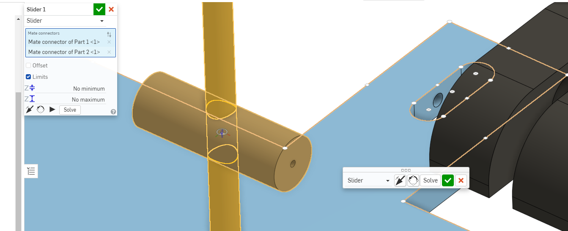
Tick off the slider mate to finalise it and then you will need to create a fastened mate between each of the guide blocks and the surface of the top of the base enclosure.
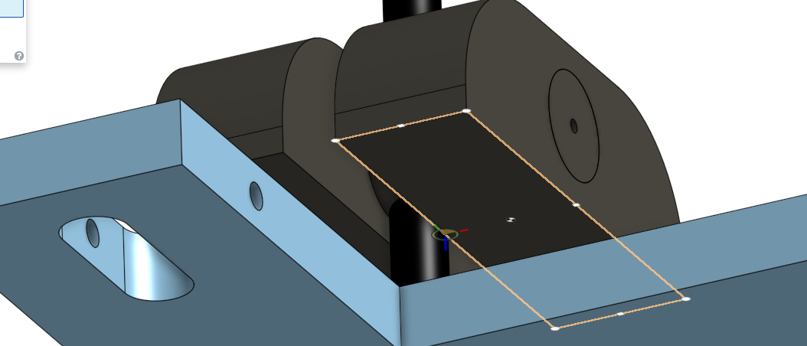
First select the middle node on the edge of the underside of the guide block as the location for mating that component as shown above, then select the middle node of the edge of the opening on the surface of the top of the base enclosure as shown below.
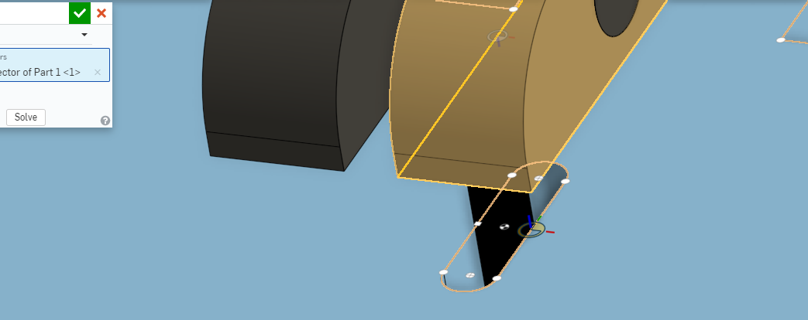
This will cause the guide block to temporarily move into position and you can check that it is situated properly, then tick it off and the whole guide block and pivot assembly will move into position as below.
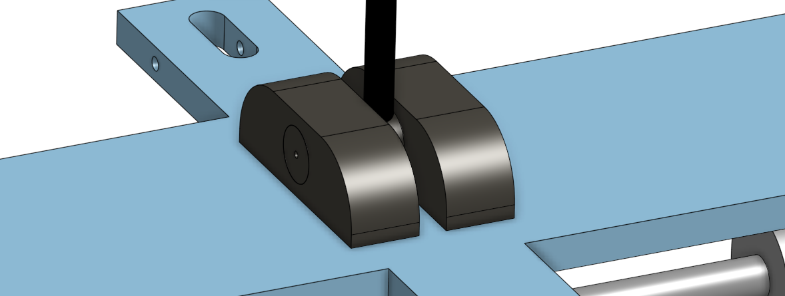
You can now once again use the triad manipulator on the crankshaft to rotate it and make sure everything still moves that is supposed to and nothing that isn’t supposed to move does.
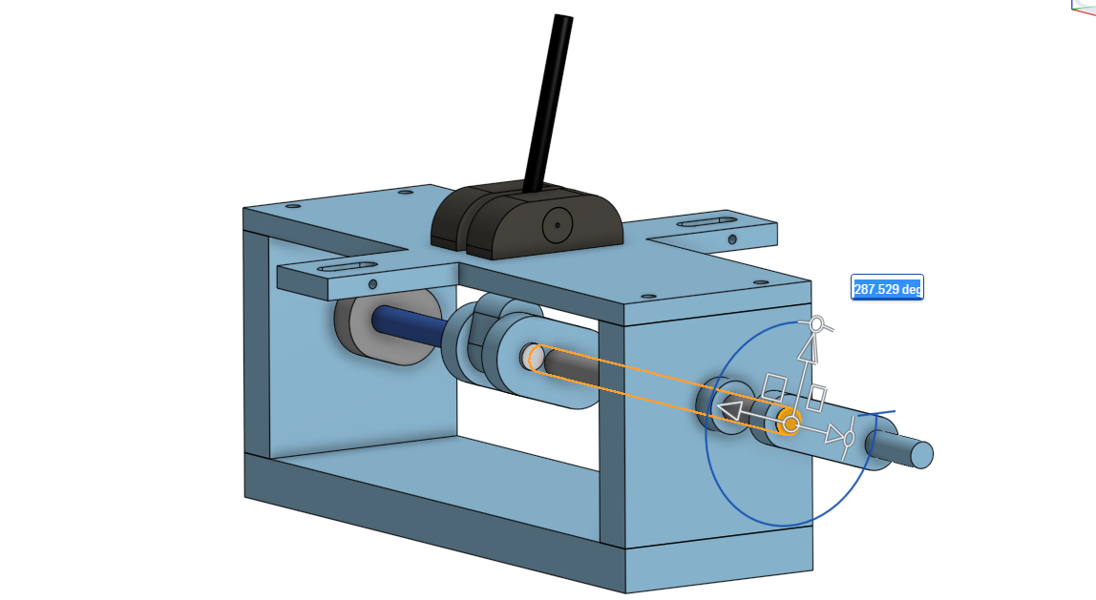

Assembling the dragon
This can be done a number of ways, but I think the easiest way is to start with the main body of the dragon, working from head to tail and then attach the wings. So, the first parts to assemble will be the dragon body, tail, neck and head.

Create revolute mates between each of the parts and their associated 3mm body axles/pivots. The axles need to be fastened mated to the wider part in each instance and revolute mated to the inner part. Below shows the pivot fastened to the head and revolute to the neck (the mates have been made visible so that you can see the icons for them).
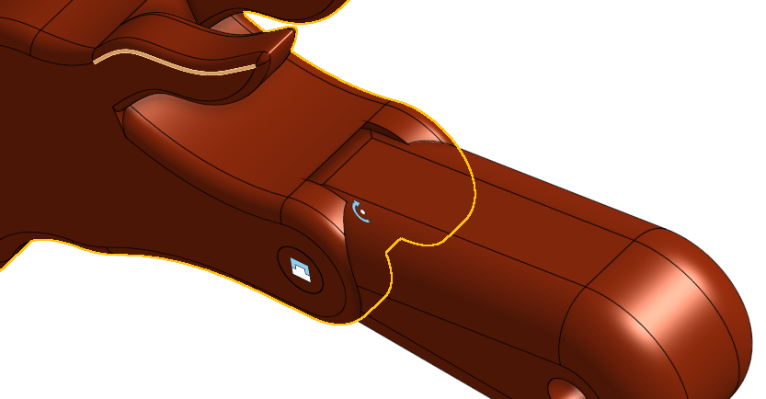
This is then repeated on the other two connections to make up the body of the dragon. Make sure that any extra features such as spines of plates on the dragons back that have been created in the same part studio as a new extrusion, rather than assembled, are turned into a closed version of a composite part to avoid the example below happening where they get left behind.
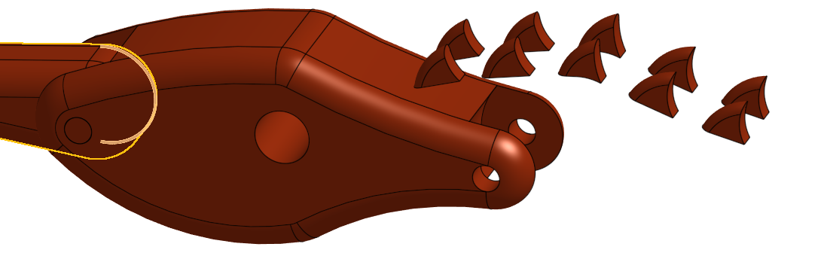

Composite part tool
This is done back in the original part and can be found at the end of the 3D drawing toolbar as shown below.
Simply select everything by drawing a window selection over all of the parts then click on the composite part tool and in the dialog box that appears tick the closed option as shown below.
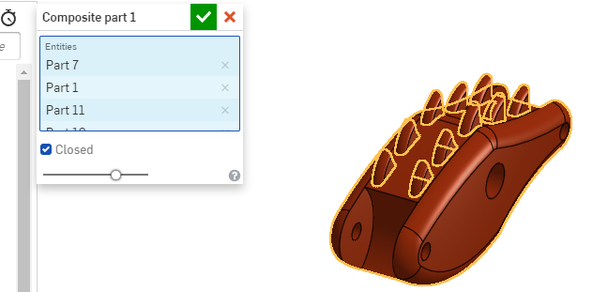
This will prevent the separation from occurring when you come to assemble your parts.
Once together it should look like this apart from any modifications you have made.
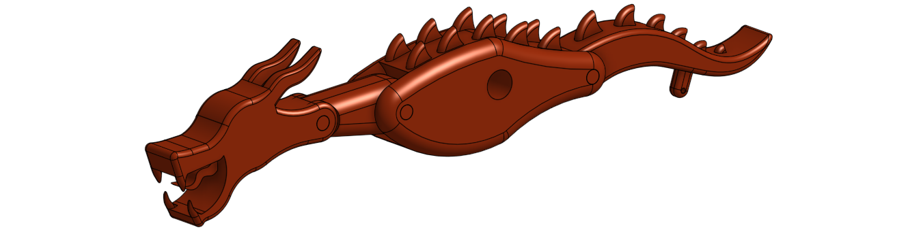
Then you can add the wings using the body central pivot and centre pivot axles. The central pivot is a revolute mate to the body and the axles are a revolute mate in the holes at each end of the pivot. Below they have been put in place and the mates have been made visible.
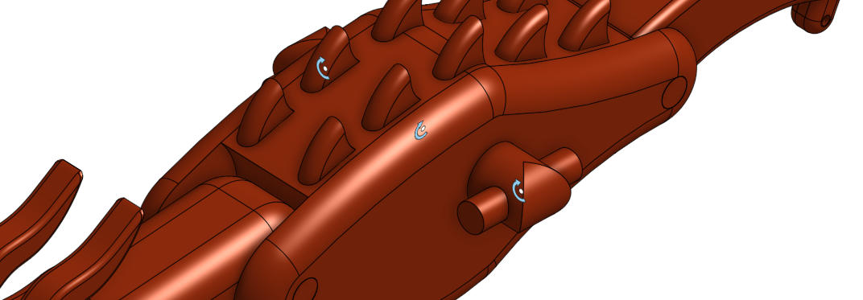
Then the wings are a fastened mate to the ends of the axles. Note that this version has had some extra customisation on the tail and wings.
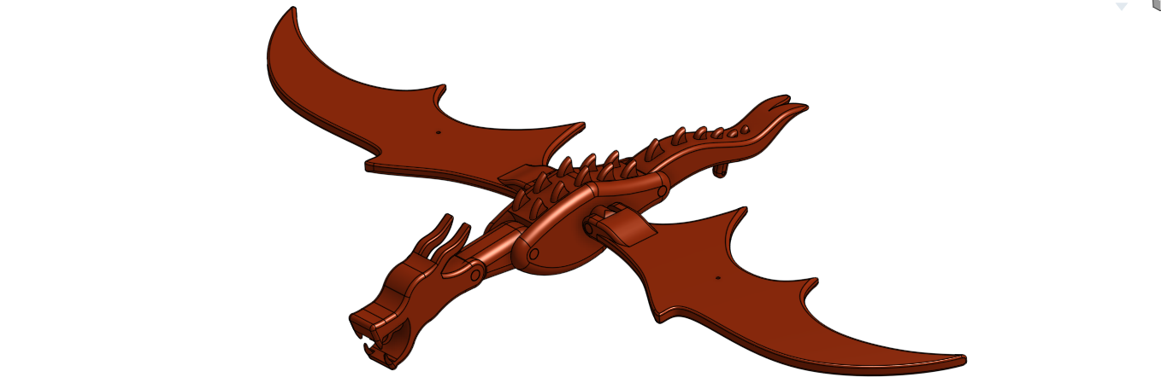
The next step is to add the dragon to the base enclosure and body control rod assembly. This is done with a simple fastened mate from the end of the control rod to the bottom of the hole on the underside of the dragon.
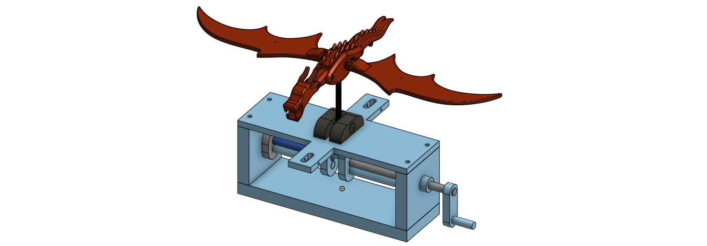
Then the head and tail control rods can be added using a revolute mate for each of the connections between the pivot holder pivots and the base enclosure, a fastened mate for the head control rod and a revolute mate for the tail control rod. If you do the pivot holder first for the head control rod, this can happen depending on how well you have followed instructions.
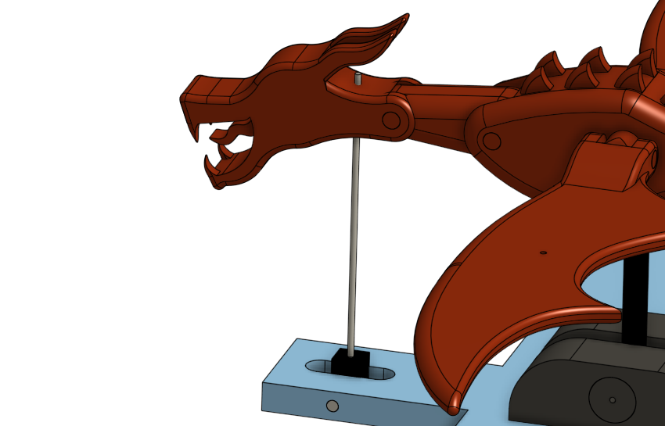
This makes it difficult to complete the fastened mate, so it is better to do the fastened mate into the underside of the headfirst, then the revolute mate for the pivot second.
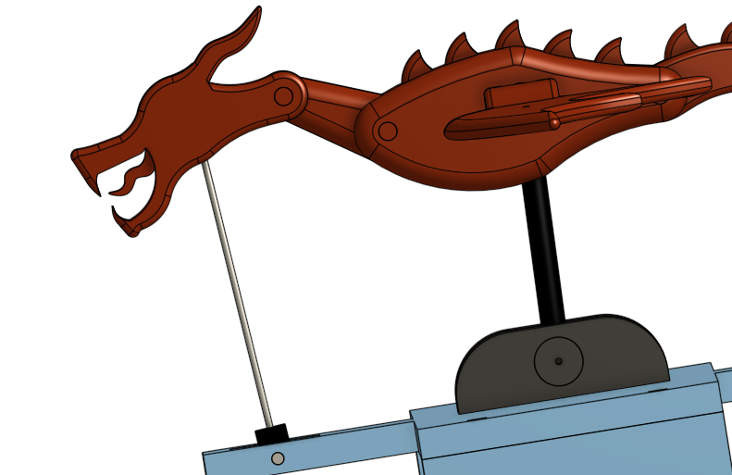
This causes the neck to move and the head to raise slightly if the crankshaft is at the bottom of its travel, and for the neck to move and head lower slightly if the crankshaft is at the top of its travel. Use the same procedure for the tail, connecting the control rod to the tail first before connecting to the base enclosure.
Here is the finished side view with the control rods in place and the crankshaft at the bottom of its travel. In this position the body control rod is at its lowest, so as the crankshaft is turned, the body will rise causing the head and tail to undulate.
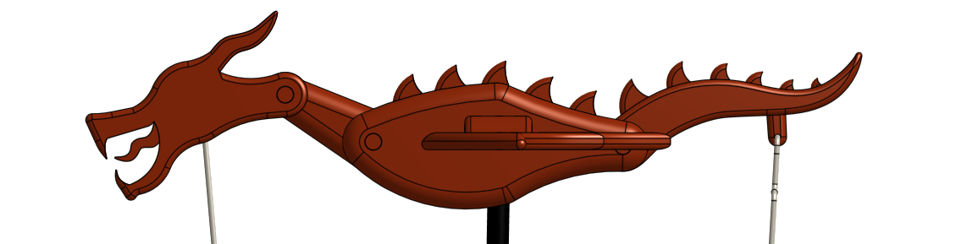
To add the last feature, the wing control rods need to be connected. The upper and lower ones are located first and then the middle rods bring the whole thing together.
On the upper wing control rods the best place to select is under the domed head at the top of the rod as shown below.

Then select the top of the hole in the wing to create a fastened mate between the upper rod and the wing.

Which will end up with the upper control rod looking like the image below.
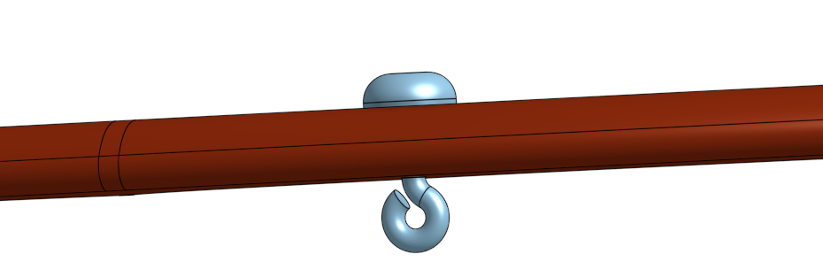
The next connection is between the lower rod and the body control rod guide bush pivot. This also needs to be a fastened mate connection and should be orientated so that it is in line with the upper rod.
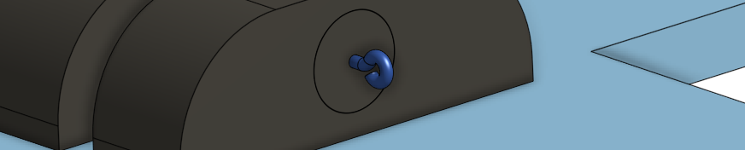
Here you can see the relation between the two control rods. This is now ready for the middle rod to link at each end to the rods shown.
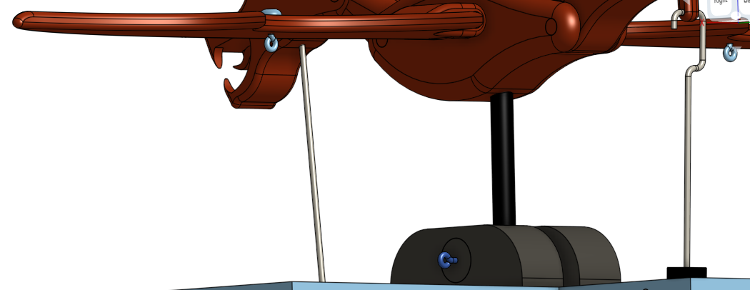
The limitations of the software in interpreting the next joint where the two links connect mean that we have to cheat a little to get it to work. In real life the linkages would allow the automaton to function correctly, however, even the manufacturers of the software could not get it to animate without a work around, so here is the best solution.
A ball mate needs to be used at the centre of the loops where the bottom end of the middle rod connects to the lower rod. When it is brought into the assembly, the middle control rod needs to be rotated using the triad manipulator so that the loops are in the same direction as the ones on the end of the other control rods and it needs to be angled to somewhere between 45° – 55° so that it is close to where it needs to be. This will help to eliminate possible issues when applying the ball mate.
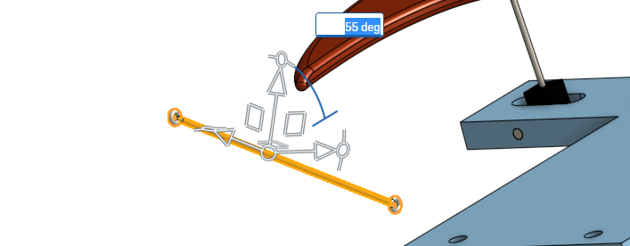
Once the ball mate is selected, the centre of the loop as shown below needs to be picked as the point of connection and then repeated on the middle rod.
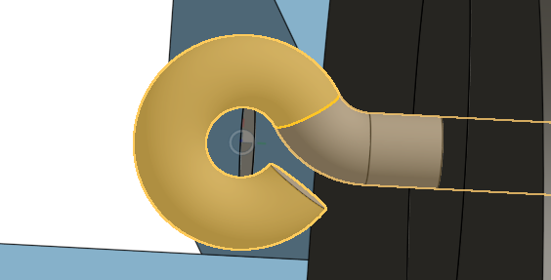
Which should result in something looking like this.
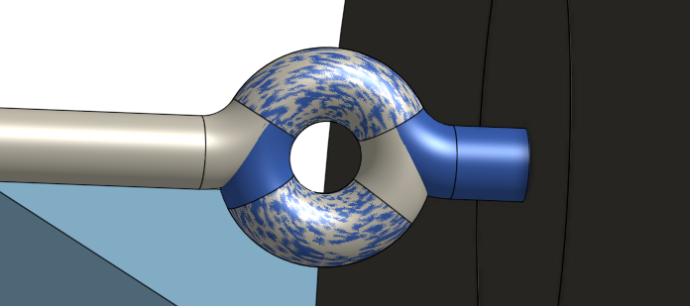
Then the same centre point of the loop on the other end of the middle rod and the upper wing control rod can be mated with a revolute mate. This should result in an automaton with no issues and one which is able to be animated such as the one below.

However, sometimes things go wrong and some of the issues you may encounter, due to this workaround are pictured below.
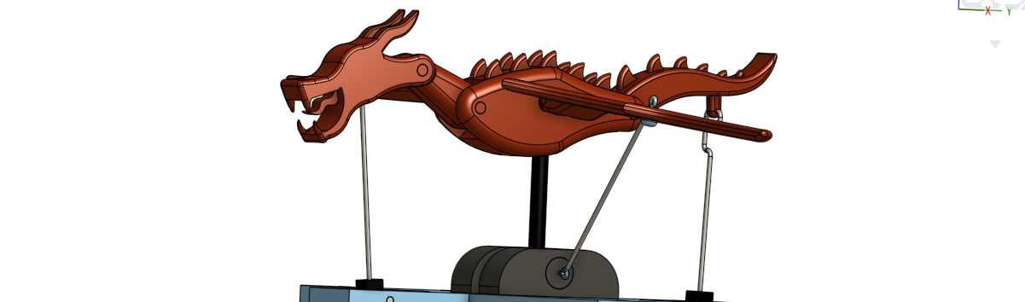
Although this may look like it has worked, when we look at it from a different angle, we can see that the wings have flipped. This isn’t an error in the method of connection, rather a glitch in the software and is simply fixed by rotating the wings back over again using the central body pivot as the reference for the rotation. This is done by clicking on the pivot and using the triad manipulator that appears as shown below to rotate the part 180°.
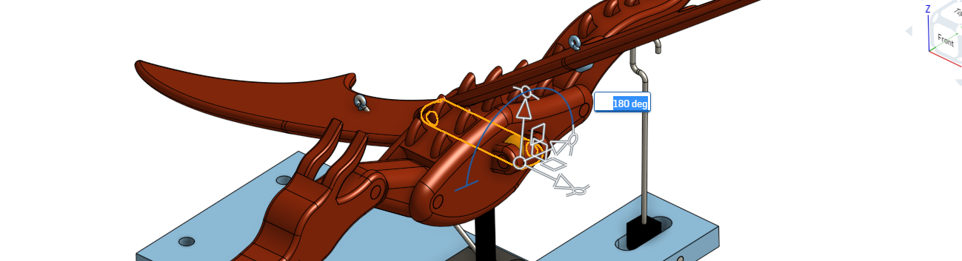
Although this works to orientate the wings the right way round, it may also cause them to fold to the other side, but we can fix this too by following the same procedure. This is annoying, but worthwhile once it is functional and can be animated. In the worst-case scenario, you may need to select several parts and move them back manually in order to be able to attach the last control rod. However, these occurrences seem to be the exception rather than the rule and normally the components can be mated together accurately the first time with no issues. If all else fails, choose to undo until before the middle rods were brought in the first time. Invariably if the steps are followed correctly the automaton works.

Animation
Now that you have successfully assembled the automaton, you will want to check and see if it works. This can be done manually by selecting the crank handle and using the triad manipulator to control it.
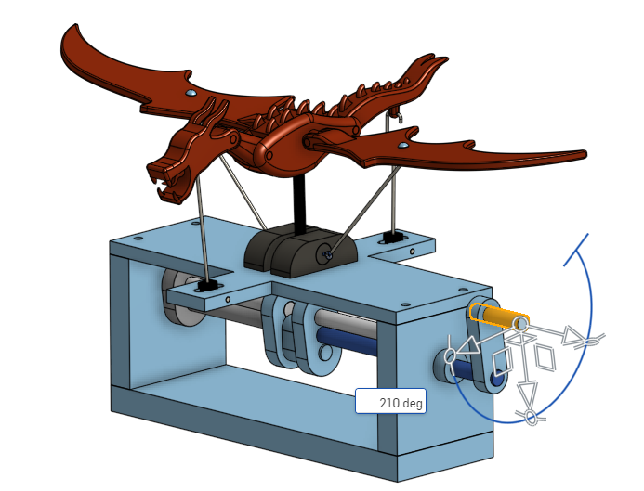
The alternative is that the software can animate it for you. By selecting the revolute mate that controls the motion of that part in relation to the others, you can right click on it and select the animate function from the drop-down menu that appears.
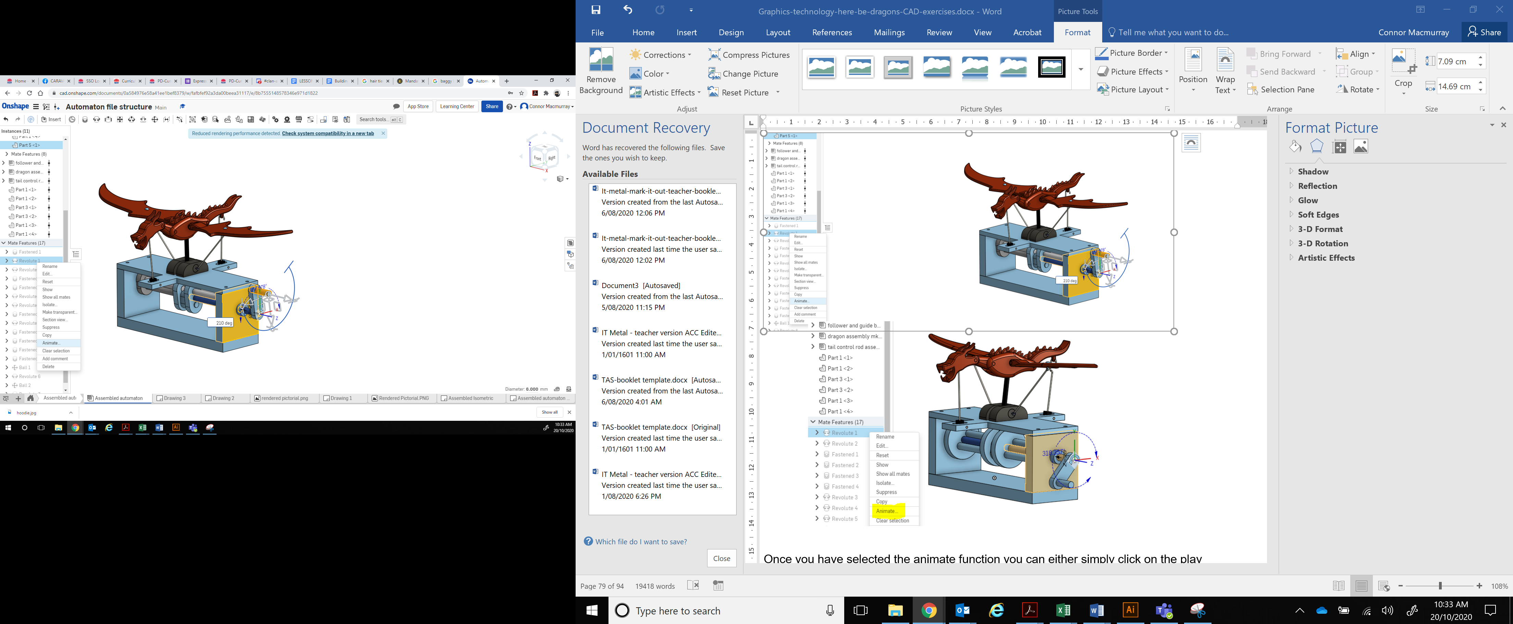
Once you have selected the animate function you can either simply click on the play button or you can change some of the controls to make it run for longer or for it to rotate in a different direction. The only issue with the length is that as the software is cloud based, if the internet connection isn’t very fast the animation can take a while to load.
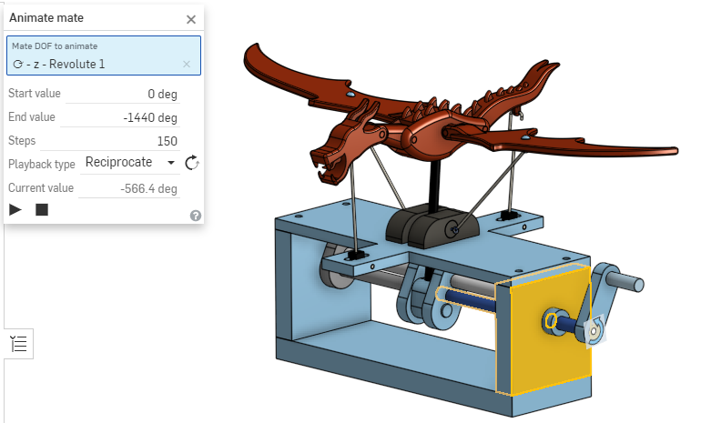
By changing the end value to a negative number it rotates in the opposite direction to the directional arrow on the crank handle, so if you feel your automaton looks like it is running backwards, then selecting a negative number will be the solution.
The number 1440 will provide four full revolutions of the shaft and gives you a longer animation. Any more than this and it can start to lag depending on your connection speed.
Think of the steps as the number of frames. The greater that number the smoother the animation but the slower it will run and the longer it will take to load, due to the extra processing required.
If you tick the reciprocating playback box it will run back and forth in the different directions for the length of rotations you have selected on a nonstop loop.
Unfortunately, the software does not have the option of inbuilt capture so in order to record the animation you will need a third-party piece of software to capture the screen. The Microsoft Game Centre can be accessed on a windows device by pressing the windows button and ‘g’ at the same time and that has a screen recording function built into it.
Once you have a clip of your automaton working you can share it with your teacher as evidence that you have completed the task, then have a look at how you can customise the design further using some of the ideas you sketched as you went along.

Generated Drawings
Once your automaton is assembled you will need to produce an orthogonal drawing, an isometric drawing and a rendered pictorial drawing of the final design.
The first of these drawings, the orthographic projection (this is another possible term for orthogonal drawing), should include the three main views, a detail view, some basic dimensions, a title block, callouts and a parts list. It should be laid out on an A3 page following AS1100 conventions. An example of what it should look like is shown below.
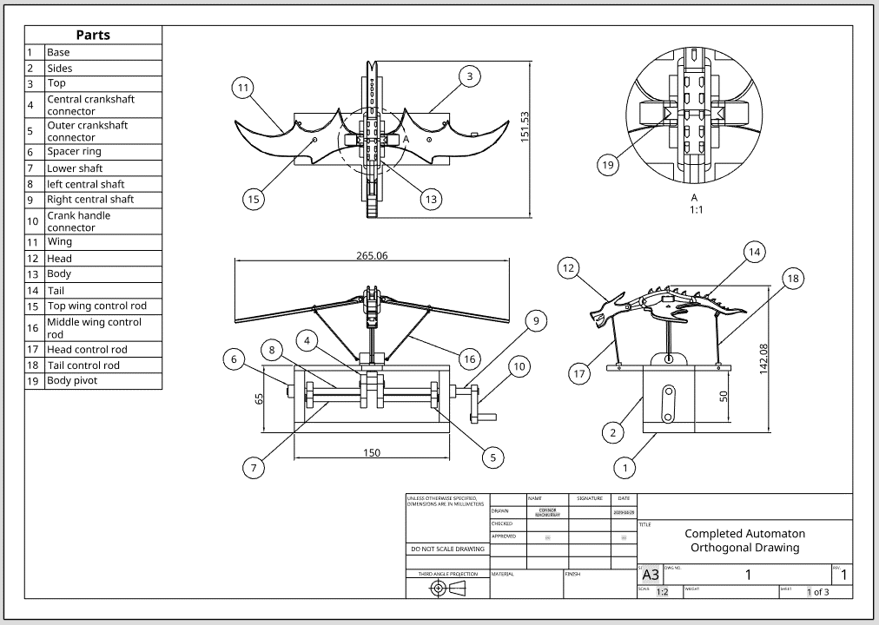
So how do we generate a drawing in Onshape that meets AS1100? First, we need to look at the requirements for AS1100.

AS1100
AS1100 is the Australian Standard for technical drawing and it defines the requirements for technical drawing including mechanical engineering, architectural, engineering survey and structural engineering drawings.
The first part of the standard is AS1100.101 – 1992, which covers the general principles that all technical drawings in Australia need to meet. It also sets out which International Standards (ISO) it is in agreement with. So, before we look at how to set up your drawing sheet in CAD, let us look at what the AS1100 settings should look like.
- The preferred size of drawing sheet should be from the ISO-A series, in other words A4, A3, A2 and so on. The size should be shown somewhere on the drawing, preferably in the right-hand bottom corner of the sheet in a title block.
- The border should be set in 10mm from the edge of the sheet on all sides, apart from if a filing margin is required so that the sheet can be hole punched for filing in a lever arch file, in which case the margin needs to be 20mm on the left hand edge.
- Grid referencing is recommended but not essential on all sheets to allow ease of location of details on the page.
- The preferred system for drawing should be 3rd Angle Projection and this should be either written on the sheet or indicated using the truncated cone image below.
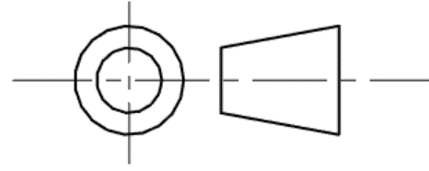
- The dimensional units should be displayed in a prominent location, for example ‘Dimensions in Millimetres’ or other units as appropriate, possibly located in the title block.
- A notice that scaling is not allowed should also be displayed in a prominent location, for example ‘Do Not Scale’, could be shown in the title block.
- The title block should be preferably placed in the lower right-hand corner of the sheet and as well as the previously mentioned details, should include the following information:
  - name of firm, organisation or department
  - title or name of drawing
  - drawing number, which should be located as close to the bottom right corner as possible
  - signature or initials and dates including revision dates
  - the scale used such as 1:10 or other appropriate scale
  - any other information considered relevant.
There are lots of other requirements detailed in AS1100, but not ones that you need to know right now. As such the rest of the CAD package generated settings will be sufficiently close to what is needed for the creation of drawings specified for the automaton project.

Creating a drawing in CAD
To create a drawing, we do it in the same way we might create a part or an assembly, by inserting a new element, which means clicking on the plus sign in the bottom left corner of the screen. This will bring up the insert new element menu and on that menu you can select Create Drawing as shown below.
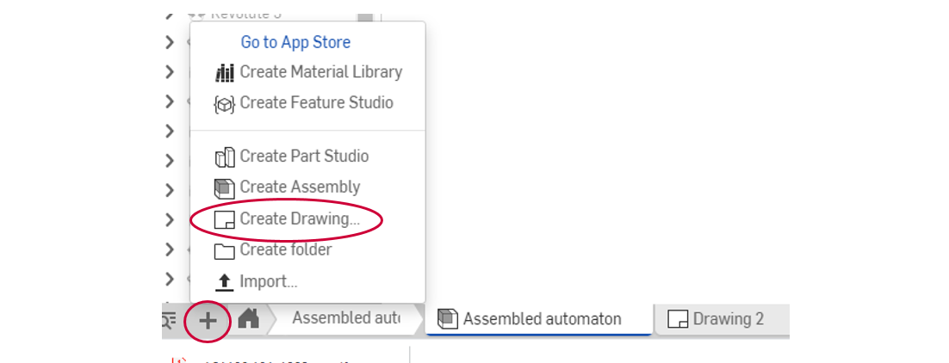
Alternatively while the assembled automaton file is open and on the screen you can right click somewhere around the automaton and a pop up menu will appear giving you the option to create a drawing of the assembled automaton as below.
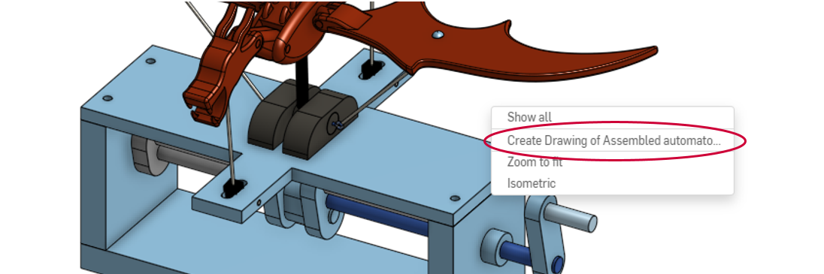
In the first instance, by selecting Insert new element and choosing to Create Drawing as shown on the first image above the pop-up box on the next page will be displayed. If we had created our own templates or there were ones available that met the requirements of AS1100 we could select one of them, however, for this project you are just going to select the custom template option as circled below.
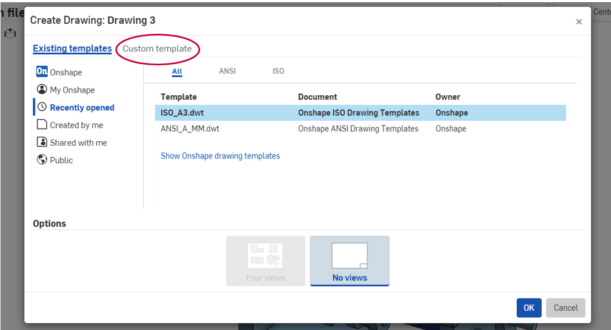
This will then bring up a series of options so that you can customise your own template. Select the options which have been highlighted in blue below, then click on the OK button.
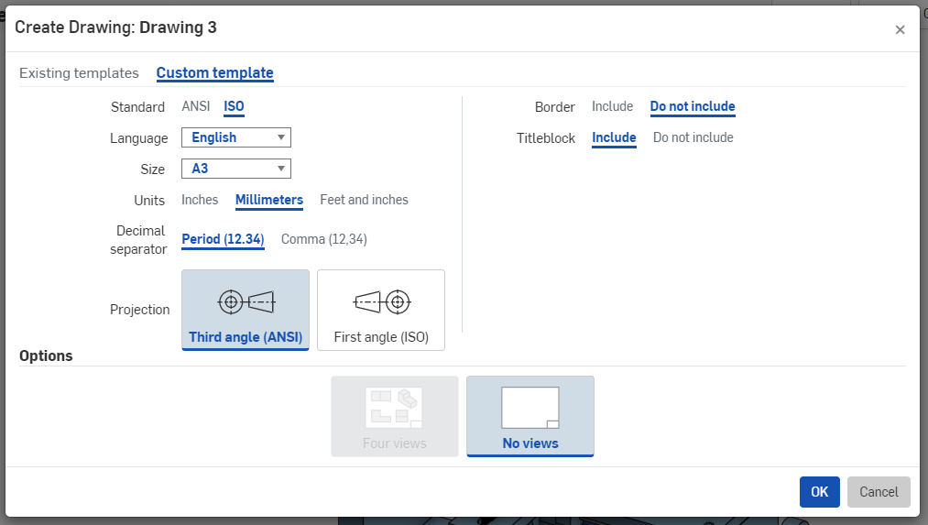
This will then generate a drawing sheet where you will be able to insert views of whichever part, sub assembly or final assembly you choose from the list so that you can add dimensions, call outs, details, annotations and so on.

Selecting the file
The drawing sheet will open with a pop-up menu as circled below.
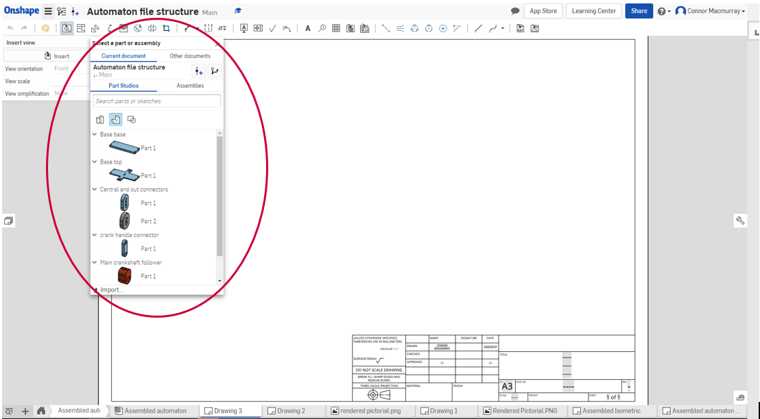
This menu allows you to choose which file you are going to use to generate your drawing, whether it be from the current document you are in, or from a separate document altogether. Then you can choose whether you want it based on a part studio, a part or a sketch, or an assembly of those parts. These options are shown below.
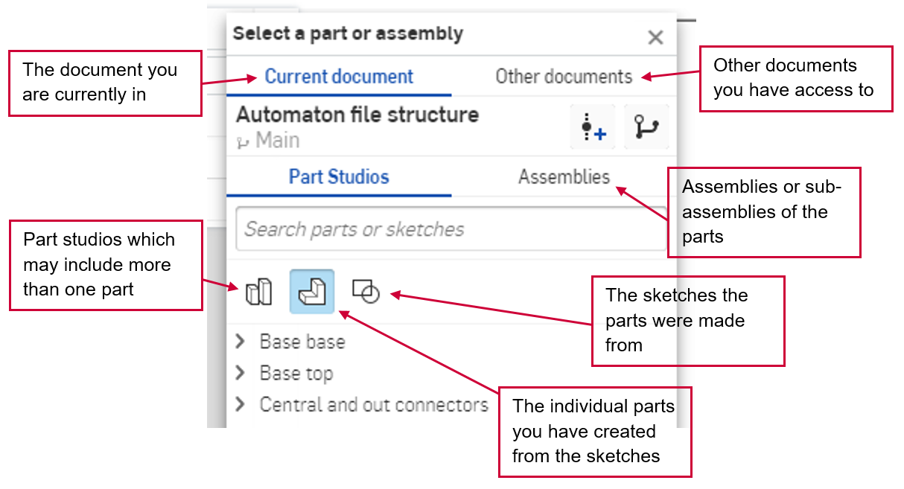
In this instance we want the final assembly, so we will need to click on the assembly tab and then select the correct one from the list.
As you can see below it is easy enough to see which one to choose
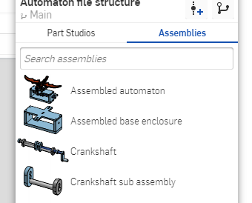
Once you select the assembled automaton another dialogue box auto fills with some information as shown below.
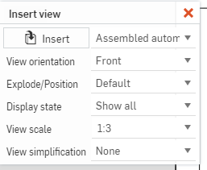
The initial view being inserted will be the front view unless you click on the drop-down arrow and choose another view orientation. The Explode/Position and Display state options are both fixed in this instance and you do not need to know about them now anyway, so we’ll ignore them for this project. Although the view simplification can be adjusted, once again, it is not necessary for what we are doing, so ignore it for now too. That leaves the view scale.
Up until you click on the drawing sheet to place your first view you can change the scale used to display it. Although the default is usually fairly accurate when it comes to fitting it on the page, it is often worth checking to see if a different scale would be better. In this case 1:2 fits nicely in the space.

Generated views
Once you have placed the first view the tool automatically changes from the insert view tool, which is the first tool on the toolbar, to the Projected view tool, which is the second tool on the toolbar, as circled below. The initial view turns brown and a second view is generated off the position of the first view depending on where you move the cursor to.
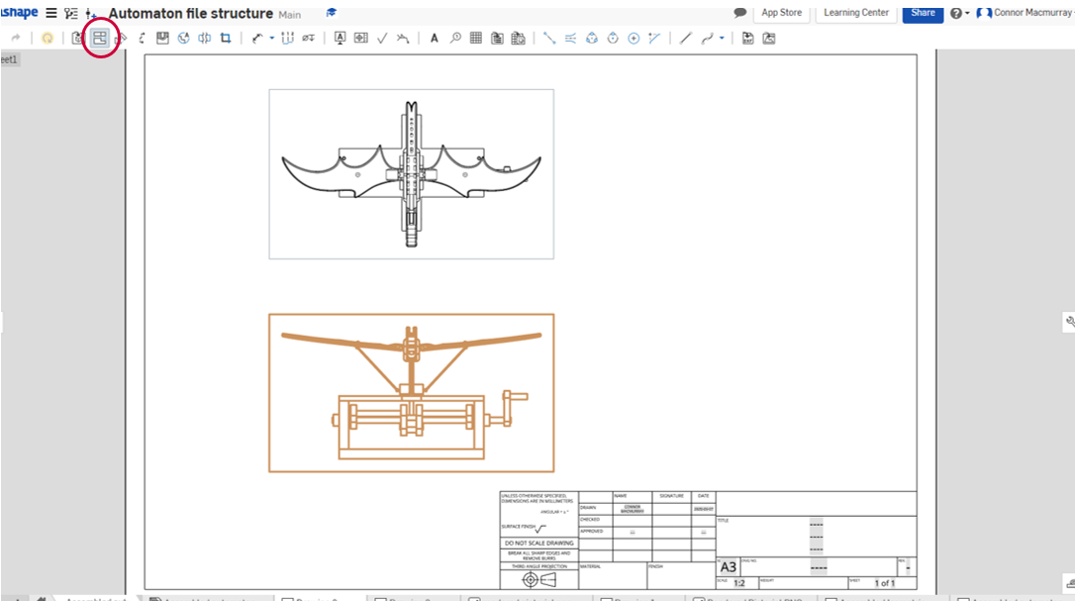
In this case the cursor was moved directly above the front view which then generated the top view, as can be seen drawn with black lines above. Had it been moved to the right it would have generated a right-side view and had it been moved diagonally up and to the right it would generate an isometric projection from that viewpoint.
Each time you generate a Projected View from the original front view, the new view will be constrained so that it lines up perfectly with the front view. For each new view you first need to select the parent view, in this case the front view, then select and place your chosen Projected View. If we were using a different scale such as 1:5 the image below shows all the possible projections off the front view.
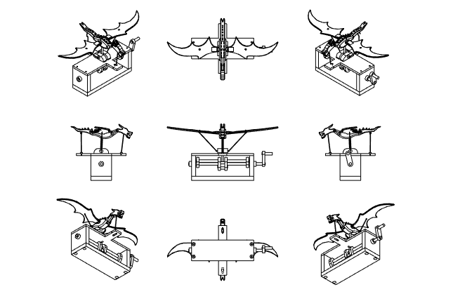
However, for 3rd Angle Projection we only require the front view, right side view and top view, then to add a bit more interest and make it easier for some people to visualise the image you can add a separately scaled isometric view in the top right hand corner of the page.
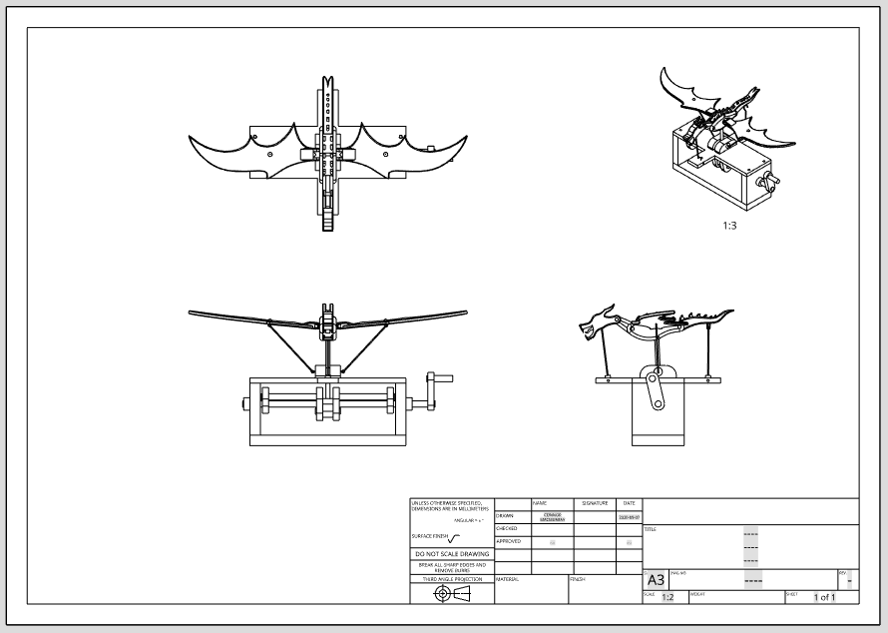
As you can see in the image above the isometric in the corner has been reduced in scale from 1:2 to 1:3, because it is different from the main scale on the sheet this automatically adds the new scale for that view below it. This is done by simply double clicking on the view and then altering the scale in the pop-up box that appears on the left of the screen.

Dimensioning
The next step for this drawing is to add some basic dimensions. There is no way to provide enough dimensions on here to allow someone else to create it from this drawing alone. Rather this drawing is designed to give an overview of the completed automaton and as such an overview of the size. We will however add some dimensions so that you can see the different methods available for doing so.
The dimension tool can be found on the toolbar as shown below.
There are a number of different ways to apply a dimension and if you click on the drop-down arrow next to the dimension tool all of the different options will be available to be selected as shown below.
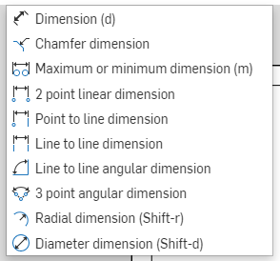
However, by leaving it as just the Dimension (d) setting the program will determine which of the available options you are wanting to use, and for this sort of basic dimensioning, that is perfectly acceptable.
The image below shows the four most commonly used dimensioning techniques.
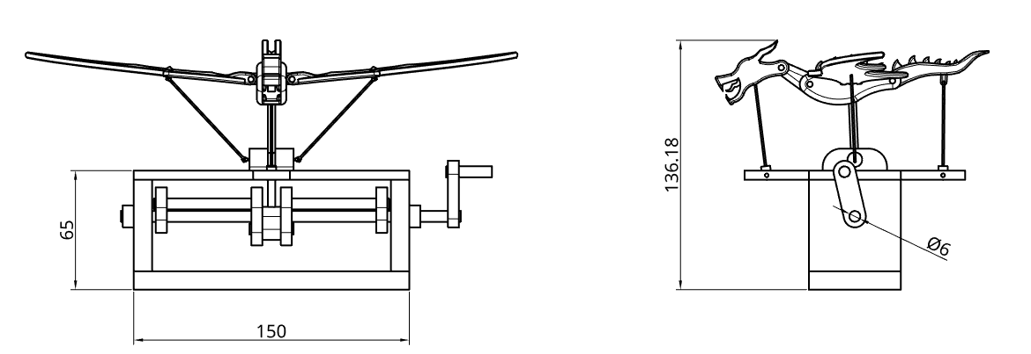
The base length of 150 was generated simply by clicking on that bottom edge then clicking again off the drawing at the distance the dimension line is away from the base. If you clicked further away from the base the resulting dimension line would also be further away. This is the most basic type of dimension.
The next length of 65 is generated by clicking on the horizontal line at the top of the base enclosure and then on the one at the bottom and finally clicking off to the side of the drawing at whatever distance looks similar to the first dimension line. This is referred to as a line to line dimension.
The dimensioning of the circle at 6 is done simply by clicking on the circle and then again off to the side of it, but not on any other line or feature. This generates a diameter dimension. If we had instead selected the curved outside end of the crank it would have generated a radius dimension instead as it is not a complete circle.
The final dimension of 136.18 is generated by clicking on the tip of the dragon’s horn and then on the bottom corner of the base, followed by clicking off the drawing to create the dimension. When the two points are not horizontally or vertically aligned you may end up with a dimension at an angle in which case try dragging the cursor horizontally away from the drawing until it locks into a vertical dimension. This is referred to as a 2-point linear dimension.

Detail view
If instead of the isometric in the corner of the drawing on page 87 you wanted to have a detail drawing of a particular part of the automaton you can simply use the detail tool. It can be found on the toolbar as circled below.
What it allows us to do is generate a view of an area of the drawing, but at a different scale, which allows you to see a greater amount of detail. This is used in drawings to provide the person interpreting them to understand complex areas such as the transition between different parts.
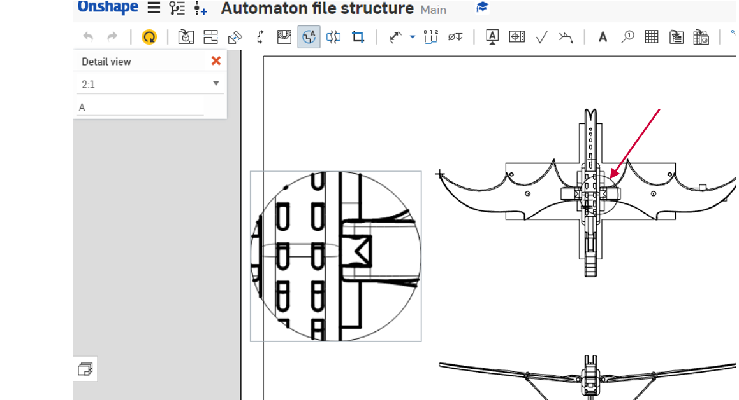
By selecting the detail view tool and drawing a circle over the wing junction (shown with the red arrow) the pop-up box appears in the top left of the screen along with a new detail view as shown. When you change the scale in the pop-up box, the detail view will change in size, simply select the most appropriate scale so that the detail view fits on the page and is not too imposing. If you find the detail view is too big when at the correct scale to be able to see enough information simply redraw the original circle at a smaller size to cover just the area required. Once you are happy with the size of the detail view simply move the cursor to the location on the page where you want it and the view will follow, then click to select its new location. The view will then resolve into finer lines and a scale and detail identifier will appear below it as shown below.
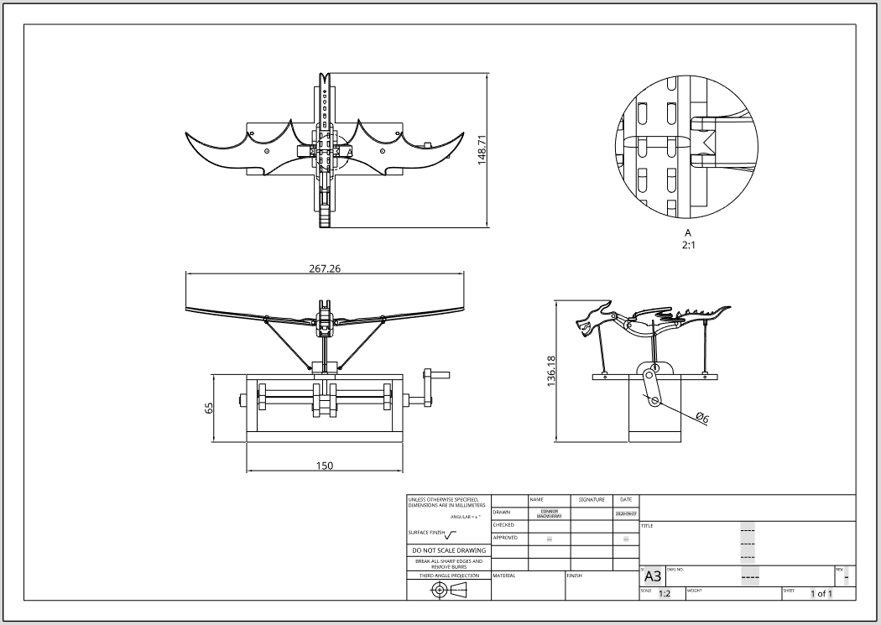
Note that although it is difficult to see in the image above, if you zoom in on your screen, the original circle is now a series of long and short dashes with arrow heads pointing to an A to identify the detail. If you were to add other details the software would automatically identify them as B, C and D and so on.

Callouts
Callouts are used to identify components on a drawing, often in conjunction with a parts list or some other key. For this task you will need to create a numbered parts list, but first we will look at the callouts.
Callouts can be added in a couple of different ways. The first thing to do is to select the callout tool as shown on the toolbar below.
As you move the cursor around you will see an orangey brown circle with four dashes in it that follows wherever you move it. If you hover over the any of the lines of the drawing you will see that they also become highlighted in a golden brown as shown below.
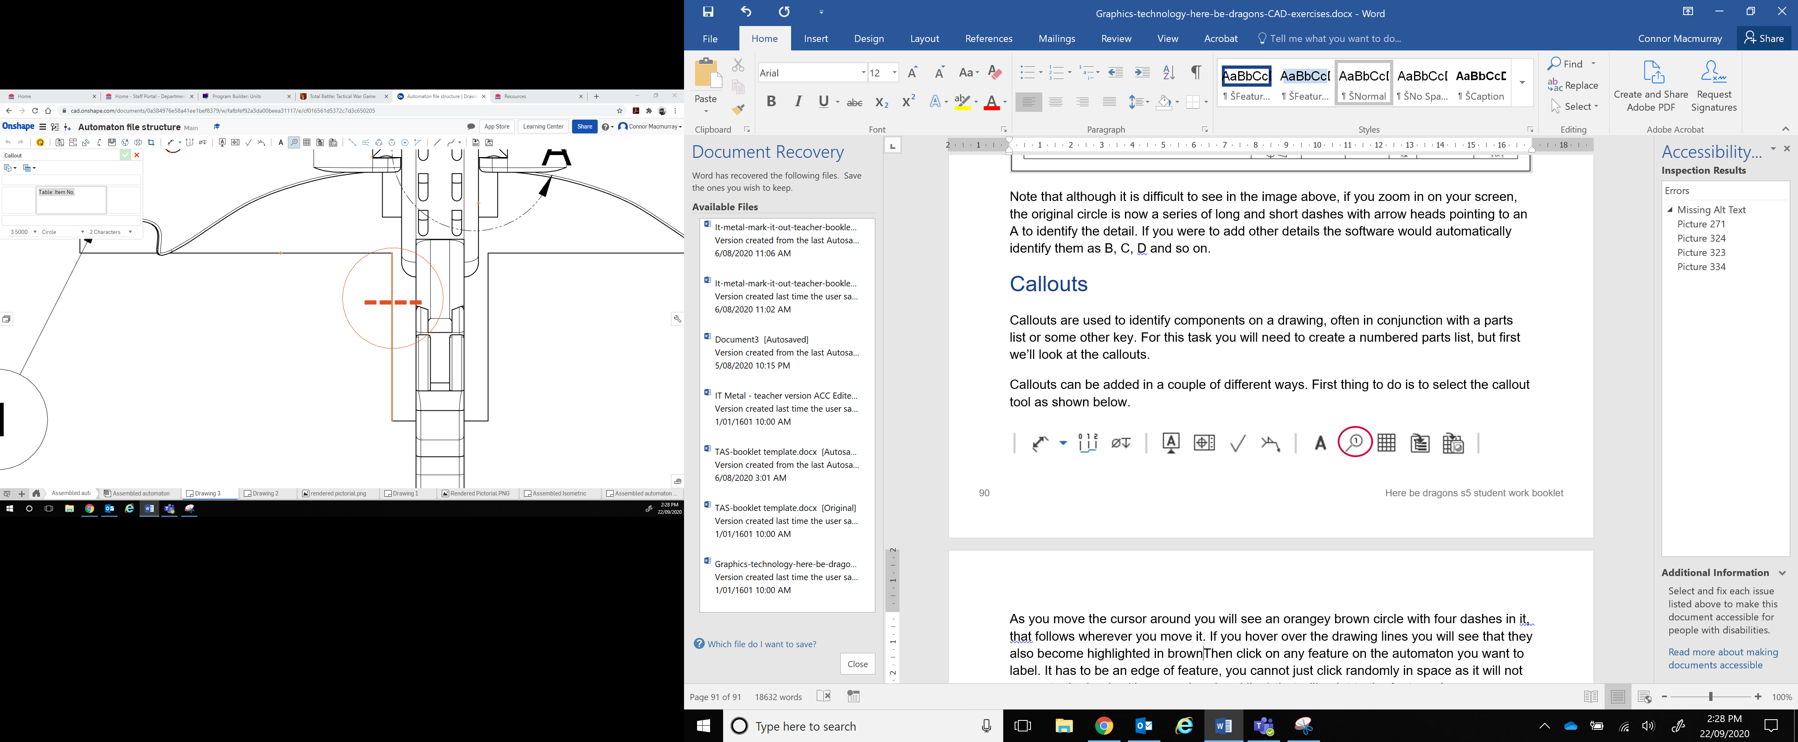
Simply select any feature on the automaton that you want to label by clicking on it, as long as it highlights like the image above. It has to be the edge of a feature; you cannot just click randomly in space as it will not generate the leader (the arrowhead and line) that will point to the feature. Once you have selected the component for the leader to point at, you need to position the callout itself (the circle) wherever you want it, ideally so that it doesn’t distract from the drawing.
This is where the options come in for how you want to create your callouts. At the moment, instead of a letter or number to identify them there is only the four dashes. If you click where you want the callout to be placed, it will end that callout and start a new one. If you are adding a lot of callouts to a drawing this is one option. Once you have them all in place, you will need to come out of the callout tool by hitting the ESC key and then one by one, double click on each callout and use the pop up dialog box to change the dashes to a number or letter to represent that part.
The other option is to label as you go. Once you’ve selected the callout tool, you either click on the component and then before placing it go to the pop up dialog box and change the contents to whatever you want, or you can change the contents first and then click on the component, the order doesn’t really matter. In this case I chose the number 2.
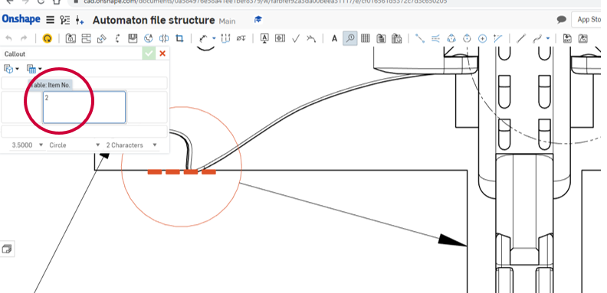
As you move the cursor to where you want to place the callout, the dashes change to that number. The only thing to remember is that before you place each new callout, you need to go back to the dialog box and change the number or letter you have used to the next in your sequence, as otherwise you will end up with multiple callouts with the same value. The image below shows what they might look like when complete.
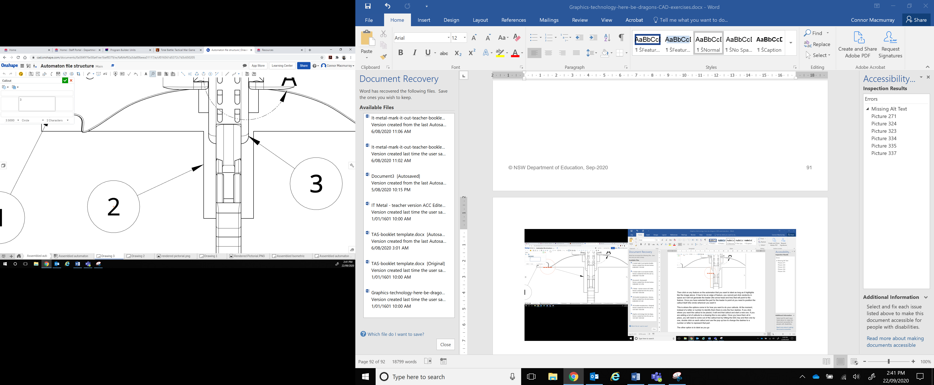

Parts list
A parts list for this project is simply a two-column table, which has been locked to the upper left-hand side of the page. The table tool can be found on the toolbar as shown below.
Once the table tool is selected, a pop-up dialog box will appear as shown in the top left of the screen (enlarged on the right side of the image below for easier viewing). This creates a simple 2x2 table, which can be modified by changing the number of rows or columns required and gives the user options to add title and header rows if required. At the bottom of the dialog box it also allows the user to select the corner that the cursor is connected to for placing. In this case as the table is going in the top left of the page, the top left corner of the table has been selected.
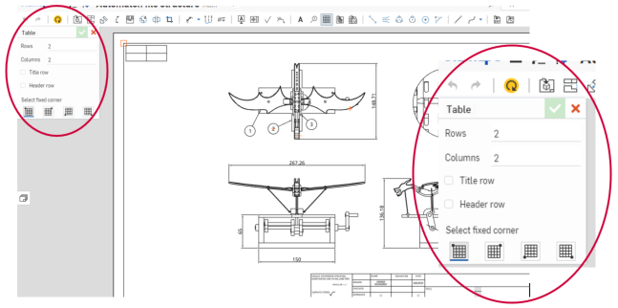
This is why it is a good idea to do the callouts first, as whatever the number of callouts you have done, that is going to be the number of rows plus one extra for the headings. Then select the title row tick box to create an extra merged cell, for the title, across the top and place the table in position on the page.
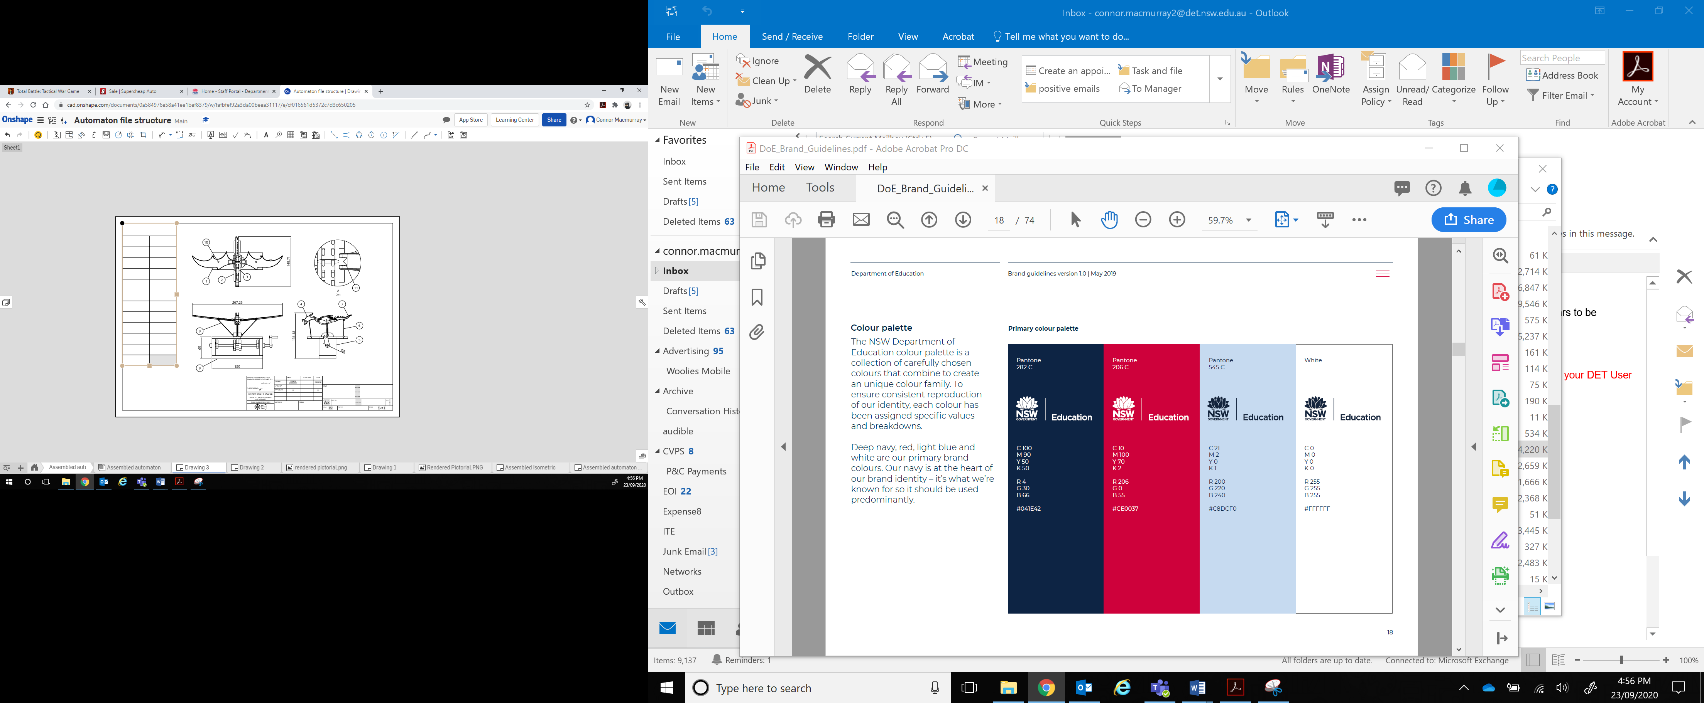
In order to edit the cells, you will need to exit out of the table tool by ticking it off.
The black dot is a grab handle which allows you to move the table elsewhere if you change your mind. As with tables everywhere the cells are resizable to fit your needs. Onshape has a feature whereby it maintains equal cell widths and height if you only grab the outside edge of the table grab handles, shown as beige squares in the image above. If you click on the grab handle on the base and drag it down the table will resize, but instead of just the last cell getting longer all cells maintain the same height with one another, getting equally taller and the same thing happens for the width when using the side grab handle. Of course, if you want different sized columns or rows just use the internal lines to resize them and this will over-ride the uniform measurements.
Once you are happy with your table it is simply a matter of adding the callout numbers in one column and then identifying what they are pointing at in the other. On the next page there is an example of the finished parts list.

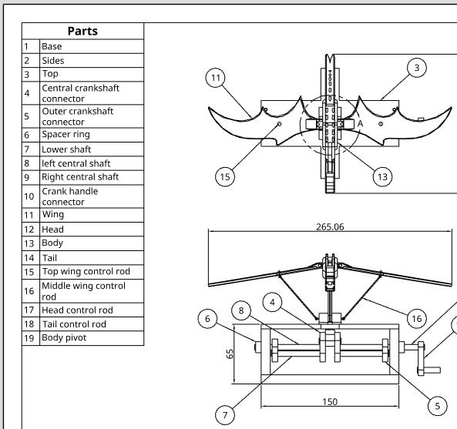
Here you can see that the majority of the components have been identified. On other drawings you might have the materials they are made from or the dimensions of the parts, but in this instance that is not necessary.

Title block
The last thing to finish off your working drawing is to fill out the title block. You can create your own and Onshape allows for the saving of templates including customised title blocks, borders and other features, but for this task the standard title block is sufficient.
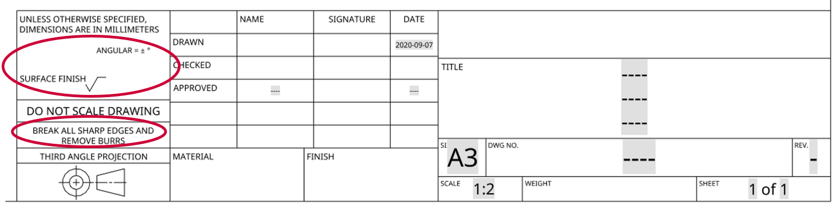
The image above shows what the standard title block looks like, but it will need some bits removed for this drawing and you will need to fill in some other sections. The two sections that are circled above can be selected and deleted as they pertain to metal fabrication.
Once they are gone, it is simply a case of filling in the relevant information in the appropriate place in the rest of the title block. For instance, in the TITLE box unless you have a particularly long title it is best to delete the top and bottom dashes and replace the middle ones with your title, that way it stays centred in the box.
In the DWG NO. box this is where you record the number of your drawing. In industry this might be some code used for a particular job to identify the drawing in relation to the project it is from, rather than just a simple number, but for the purposes of this exercise numbers are fine and this would be 1 as it is the first drawing.
In the REV box it stands for revision and this identifies if the drawing has changed and if so, how many times. This is especially important for any sort of project that is being manufactured, whether it be a toy or an apartment complex, every person involved needs to know what revision they are up to so that the correct thing gets made.
The SHEET box is effectively your page numbering system. It not only allows you to see which drawing you are looking at in a sequence but also how many others there should be, that way it makes it easy to identify if a drawing is missing.
The SIZE and SCALE boxes automatically generate based on the information you have previously provided and the NAME and DATE boxes will also prefill based on your own information and the date the drawing is generated. The name has however been removed for anonymity sakes in the completed title block below.
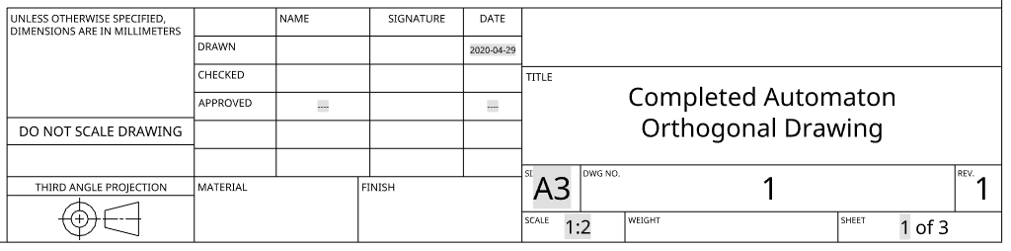

Other drawings
The other drawings required are the isometric and rendered pictorial drawings. In contrast to the orthogonal drawing, these are much simpler. The isometric drawing is shown below.
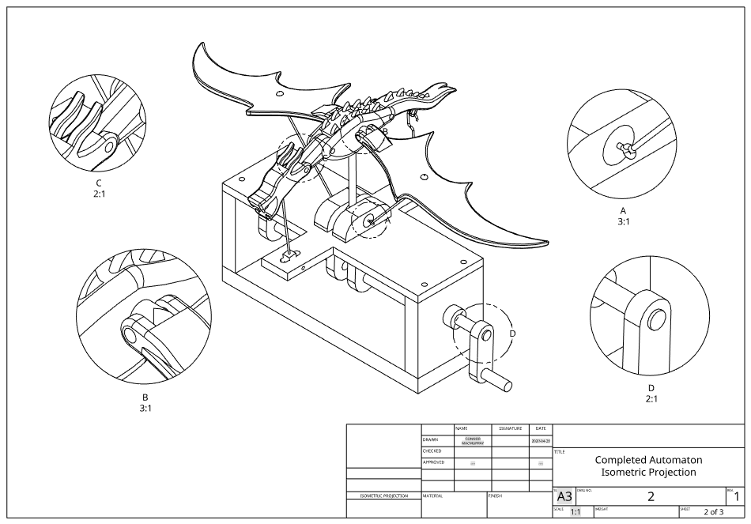
This incorporates four different detail views of varying size and scale and a main isometric projection of the dragon automaton. The main drawing starts off in exactly the same way you did for the orthogonal projection drawing, however this time when you get to the choosing of the initial view you select Isometric from the drop down menu rather than front view, as shown below.
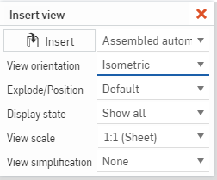
Then you can place the view and add your choice of details, then complete the title block. This time you will also need to remove the circled sections below as they no longer relate to the new drawing.
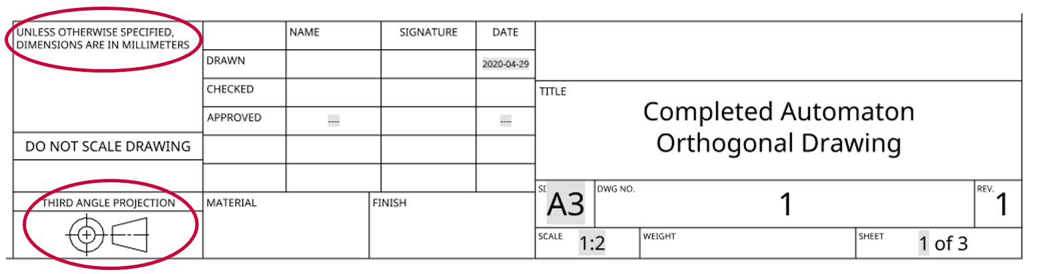
The final drawing the rendered pictorial is all about capturing your dragon in its best position with the parts coloured whatever way you choose. You will need to first pose your automaton and then capture that image using whatever screen capture or snipping software you have available. Here is one possible option below.
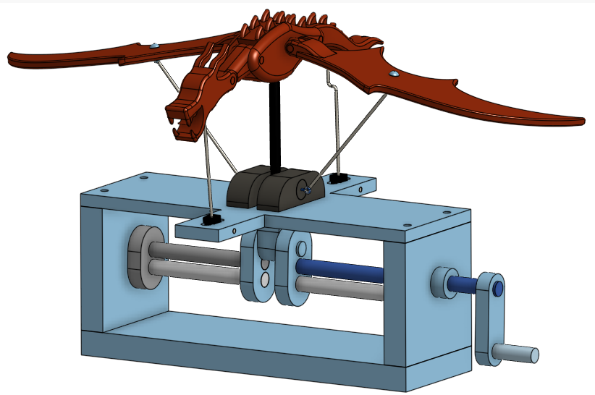
You will need to save it locally to your computer and then import it back into Onshape as an image file using the insert new element menu in the bottom left of the screen. This is the same menu we used to create the drawing, or that we would use to create a part or an assembly. Simply click on the plus sign in the bottom left corner of the screen and this will bring up the insert new element menu and on that menu you can select Import as shown below.
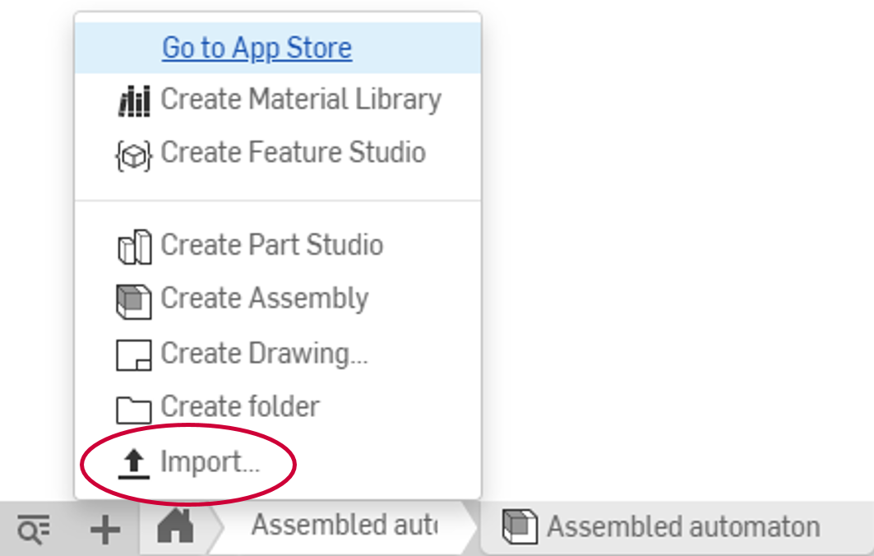
This will then open the file explorer window so that you can locate and select the image file, or for that matter any other type of file you want to upload into your Onshape folder. Once selected a dialog box will appear on the upper right of the screen showing the progress of the upload and then will change to show that the file has been uploaded as shown below.
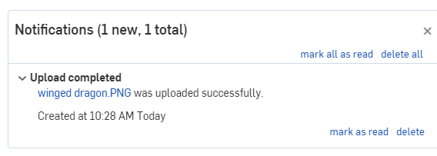
Then it is just a matter of creating a blank drawing as we have done before but instead of inserting a view, you are going to insert an image using the insert image tool, which is located on the far right of the toolbar as shown below.
Then it is just a matter of selecting from the images you have imported, in your case there should only be one, however in the example below there are three to choose from.
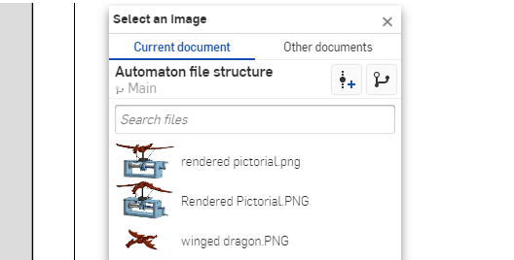
Then you will need to position and size it to best fit on the page and complete the title block in the same way as you did for the isometric projection drawing. An example of the finished drawing is shown below.
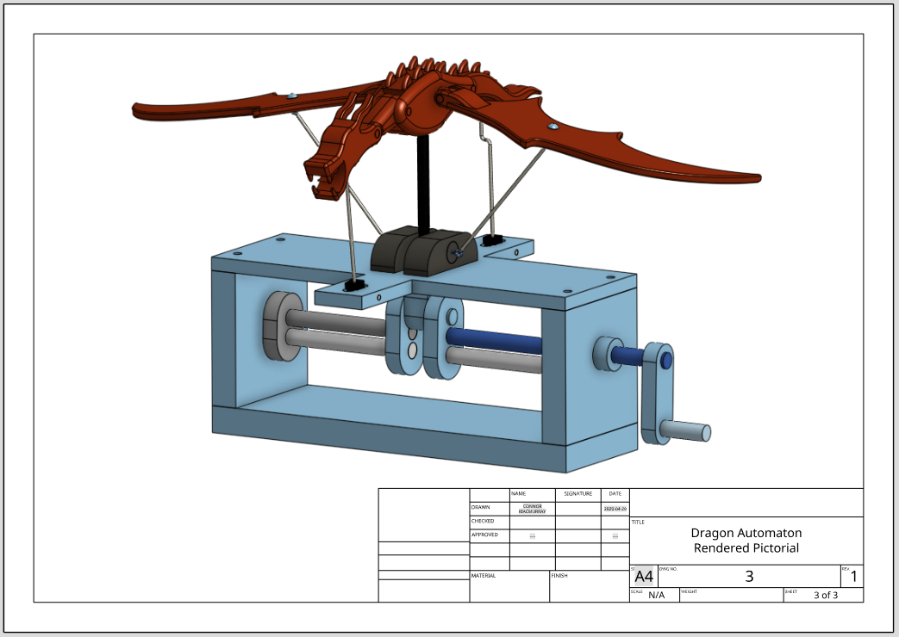
This completes all of the required tasks for the Here be dragon’s unit of work. If you have access to a 3D printer and you have the time to print off the components, you can 3D print some of the components to build a physical dragon automaton. The rods for the crankshaft and the body rod for the dragon can be made from dowel and the head, tail and wing control rods will need to be formed up in a wire thick enough to resist bending under load as the automaton is operated. If you have access to a laser cutter or CNC mill the base enclosure lends itself to those construction methods, or if the bed of the 3D printer is large enough, they can be 3D printed too.

