Earth and Environmental Science – Module 1
Earth’s Resources
Contents
Teaching the Year 11 Modules 3
Course overview 6
Module summary 7
Big ideas 8
Relationship to other modules 9
Core concepts 10
Density 10
Gravity 10
Spheres 10
Cycles 10
Properties 10
Organisational tools 11
Geological time 11
Data 11
Observation 11
Location of geological resources 11
Misconceptions 12
Minecraft is reality 12
Density and mass 12
Weathering and erosion 12
Lithosphere and crust 13
Rocks, minerals and ores 13
Conceptual difficulties 15
Metalanguage 15
Dating 15
Observations of seismic waves provides evidence for layers of the Earth 16
Suggested teaching strategies 17
IQ1-1: How did the compositional layers of the Earth develop? 17
IQ1-2: What are the components of rocks and soils? 18
IQ1-3: How is the age of geological materials determined? 22
IQ1-4: How are non-renewable geological resources discovered and extracted? 24
Appendices 27
Appendix 1 – overflow cans and displacement beakers 27
Appendix 2 – weathering and erosion 28
Appendix 3 – lithosphere and crust 29
Appendix 4 – modelling definition writing 31
Appendix 5 – modelling accretion 32
Appendix 6 – density column 33
Appendix 7 – density and Earth’s layers 34
Appendix 8 – meteorite evidence 37
Appendix 9 – micrometeorites 38
Appendix 10 – Aboriginal and Torres Strait Islander rock and mineral classification 39
Appendix 11 – mineral properties 41
Appendix 12 – mineral dichotomous key 46
Appendix 13 – modelling rocks using food samples 47
Appendix 14 – rock dichotomous key 49
Appendix 15 – soil testing 50
Appendix 16 – geological timeline 55
Appendix 17 – relative dating 58
Appendix 18 – modelling half-life 59
Appendix 19 – radioactive dating game 60
Appendix 20 – renewable versus non-renewable resources 61
Appendix 21 – Australian natural resources 63
References 70

Teaching the Year 11 Modules
The Earth and Environmental Studies Stage 6 Syllabus develops concepts that lead students to a deep understanding of the interconnectedness of the Earth’s systems and the need for humans to manage renewable and non-renewable resources to live sustainably on the Earth. This understanding, together with science inquiry skills, will allow students to apply knowledge from across the modules to:
‘take an informed part in science-based decisions and take appropriate actions that affect their own wellbeing and the wellbeing of the society and the environment’ (Harlen 2010).
Earth and Environmental Science can be best understood through the concept of energy. Students should develop a deep understanding of the concept that energy has driven the formation and changes in the Earth over the millennia. Humans’ needs for energy can be met from renewable and non-renewable resources. These resources maintain life and are used to maintain infrastructure.
In Earth and Environmental Science, like all science disciplines, new evidence can refine views about concepts. This is illustrated in the development of disciplinary ideas such as the formation of the Earth and climate change. New evidence often arises out of the development and use of new technologies. Students need a sound understanding of the role of new technologies in improving the understanding of various concepts in the Year 11 course, including ideas around plate tectonics and global weather patterns.
The understanding of geological and ecological processes has been significantly impacted upon by societal, cultural and economic factors. Students should be provided opportunities to engage in work that allows them to acknowledge these influences.
Students should develop a deep understanding of the impacts of humans on the Earth’s spheres and an appreciation of the importance of sustainability in its various forms. This includes understanding the roles of Aboriginal and Torres Strait Islander peoples in caring for Country and Place.
During the teaching of the Year 11 course, it is expected that students will be provided opportunities to develop all 7 of the Working Scientifically skills. Ideally, these would be embedded into the teaching of the Knowledge and Understanding components of the course, allowing students to develop a sound knowledge of the structure and composition of the Earth and the interactions of the spheres of the Earth. In preparation for the Year 12 course, students in Year 11 could benefit from work that engages them in the following areas:
- Propose questions and hypotheses and design and conduct valid and reliable practical investigations that enable the collection and analysis of data. Teachers should look for opportunities to engage students in these beyond where the syllabus explicitly states the need to conduct a practical investigation.
- Collect and analyse data from primary and secondary sources, including a wide variety of maps, geological time scales, tables and graphs, and determine the data’s accuracy, reliability and validity. Many of the investigations will require students to obtain information from the internet or other sources. Students will benefit from learning how to access and acknowledge valid and reliable sources of information.
- Assess the uses, benefits and limitations of various types of scientific models. Many geological features and processes occur on a very large scale (for example, the types of plate boundaries) or happen over a long time period (for example, magnetic reversals in the sea floor). Models help us to better understand these processes.
- Construct labelled diagrams, flowcharts and other methods of communicating information. This skill is important to develop when students in Year 11 use them to explain processes such as the movement of the Earth’s crust and the flow of water through an ecosystem.
This module guide indicates which Working Scientifically skills are developed in each learning activity, for example, EES11/12-5.
The Year 11 modules do not need to be taught in order. One suggestion is to teach Module 1, then 4, then 2 and 3 together, or you might want to do units themed around water, agriculture and geology.
One fieldwork exercise must be undertaken in Year 11. This could involve an excursion to a museum, environmental education centre, wastewater treatment plant, local landmark or could be a structured lesson on the school grounds.
Depth studies and non-testing assessment tasks form a focus for student interest and allow students to demonstrate their skills, knowledge and understanding in formats other than an examination. Some possible ideas are:
- building models of geological processes
- assessing the impact of introduced species
- assessing the feasibility of recycled water or desalination
- investigating the impacts of a particular agricultural practice
- analysing El Niño or La Niña events.
Presenting information as posters, videos, models (including computer-based models and animations) and leaflets extends students’ communication skills and allows them access to a differentiated curriculum.

Course overview
The Earth and Environmental Science Year 11 course underpins the Earth and Environmental Science Year 12 course. Students are expected to access and apply the concepts developed in Year 11 to Year 12 learning. Students are also expected to draw from knowledge and understanding across modules and apply them to new and unfamiliar situations, using their Working Scientifically skills. The modules and years are not to be seen as standalone entities but rather as interrelated and interdependent.
The Earth and Environmental Science Year 11 course offers insights into the formation and structure of the Earth, the resources available and the impacts of humans utilising these resources.
The major themes, or big ideas, that weave throughout the Year 11 Modules are:
- Heat and density drive global processes.
- The plate tectonic supercycle shapes the Earth.
- Evidence advances the understanding of Earth processes and history.
- Our understanding of Earth processes informs the sustainable use of resources.

Module summary
Module 1 explores the following inquiry questions (IQ):
- IQ1-1: How did the compositional layers of the Earth develop?
- IQ1-2: What are the components of rocks and soils?
- IQ1-3: How is the age of geological materials determined?
- IQ1-4: How are non-renewable geological resources discovered and extracted?
Earth and Environmental Science Stage 6 Syllabus © NSW Education Standards Authority (NESA) for and on behalf of the Crown in right of the State of New South Wales, 2017.
Module 1 is the foundation for every other module in the Stage 6 Syllabus. Students must develop a sound understanding of the key concepts developed here and not just focus on the metalanguage.
For students to see this module’s relevance, it may be best approached by posing questions relating to the big ideas, for example:
- How are Earth’s layers formed?
- What is the Earth made of?
- How can we ‘see’ into the past? What evidence can we use?
- Why are geological resources found in certain places?
- How can we find out about what is inside the Earth? What evidence can we use?

Big ideas
The big ideas are introduced in Module 1:
- Heat and density drive global processes: this began with the early Earth. Heat produces differences in density.
- The plate tectonic supercycle shapes the Earth: the Earth’s structure, including composition of rocks and minerals, and classification of rocks and minerals.
- Evidence advances understanding of Earth processes and history: relative and absolute dating of meteorites provides evidence for the age of the Earth. Knowledge of the internal structure of the Earth is supported by seismic evidence.
- Our understanding of Earth processes informs the sustainable use of resources: the relationship of density to the extraction of geological resources is explored. Technological advancements make it possible to predict the impact of large-scale resource extraction. Aboriginal mining methods are touched on, providing a link to the cross-curriculum priority Aboriginal and Torres Strait Islander histories and cultures.

Relationship to other modules
Module 1 is the foundation for every other module in the Stage 6 Syllabus. A sound knowledge of the Earth’s structure and composition will allow students to understand the structure of tectonic plates and the formations that occur at their boundaries in Module 2.
The movement of plates and transformations in the Earth’s spheres studied in Module 3 arise in part from the energy from the Earth’s interior.
An understanding of the formation and composition of soil is needed to explain the occurrence of soil erosion and soil salinity explored in Module 4.
As students move into Year 12, they learn about how, as the Earth became more stable, the biosphere developed and how this, in turn, changed the composition of the rocks.
The hazards that arise from the movement in plate boundaries are due to the structure of the Earth. A knowledge of this structure is necessary in developing technologies used to monitor earth movements and predict earthquakes and volcanoes.
Changes in the structure of the early Earth contributed to natural variations in climate and the study of rocks can provide evidence of climate variation in the past.
The sustainable use and management of resources investigated in Module 8 builds on the knowledge of the discovery and extraction of geological resources introduced in Module 1.

Core concepts

Density
The physical concept of density is key to understanding the composition of the Earth. Students begin to apply the particle model and density (from Stage 4) to the real world by exploring the development of the Earth’s layers, including the atmosphere, hydrosphere and geosphere.

Gravity
The role of gravity is also central to the development and stratification of Earth’s layers. This is built on from Stages 4 and 5, where mass was a central factor in understanding gravity. Now, density is connected to gravity to build on students’ foundational understanding.

Spheres
The geosphere, atmosphere, hydrosphere and biosphere, and their interactions are key to the Earth and Environmental course. In Module 1, their interaction is explored through learning about the development of rocks and soils. Students have been introduced to the spheres in Stage 4 and Stage 5.

Cycles
The Rock Cycle is used to model how rocks are formed and shows how minerals come together to form specific rocks in igneous, metamorphic and sedimentary processes. Students have been introduced to the Rock Cycle in Stage 4, as well as the water cycle. In Stage 5, students have explored cycles in matter in ecosystems.

Properties
Properties of minerals, rocks and soils are explored to understand how they interact, are used and classified. In Stage 4, students explored the properties of matter, rocks, and metals and non-metals. In Stage 5, students explored the properties of groups of elements. The idea that objects and groups of objects have properties, and these properties are observable and organisable is further developed here through the context of minerals, rocks and soils.

Organisational tools
Students use dichotomous keys to identify and classify minerals, rocks and soils. This allows students to see how properties can be used to identify and classify objects. This builds on skills developed in Stage 4.

Geological time
Geological time is the underlying concept that supports all other concepts here. Developing a foundational understanding (built on Stage 5 learning) is critical to deepening students’ understanding of all other concepts in Earth and Environmental Science. Although discreet, intentional study of the geological timescale is not prescribed here, it is necessary to understand the time frame in which the events discussed take place. Students should at least explore it in relative terms. This can then support the understanding of the importance and role of relative and absolute dating of rocks and meteorites and the Earth’s age.

Data
Data is collected by scientists using observation. Sometimes scientists use tools to extend their senses to make observations into the past. Students should be provided with multiple sources and a variety of data to support the theoretical concepts being explored.

Observation
Tools such as remote sensing and radiometric techniques are used to make observations in Earth and Environmental Science. Due to temporal and spatial constraints, scientists must use tools to assist them to make observations.

Location of geological resources
Geological resources are not found in equal measure across the Earth. The locations of geological resources are tied to the events that occurred in an area and the type of environment(s) that exist (or existed in the past) at a location. Geological resources occur at different depths in the Earth’s crust. This determines the appropriate method of extraction.

Misconceptions

Minecraft is reality
If your students have engaged in Minecraft, they may bring some misconceptions from the game. This video from Geoscience Australia (2:50) addresses some of these.

Density and mass
Students often believe that an object with high density will have a high mass. They may not connect density to volume. This can be addressed through practical learning.
- Basic density experiments with common objects (not necessarily rocks) can be used to demonstrate the role of volume in density. If possible, use overflow cans, also known as displacement beakers (see Appendix 1).
- If density cubes are available, explicitly identify that the cubes have the same volume.
- It can be beneficial to engage students in a discussion of density by constructing a density column. If students are simply given the equipment and brief instructions, a conversation around density can provide a teachable moment.
Ensure students can use the formula for density and can identify that volume can be expressed in litres and cubic centimetres (and their derivatives). Ensure students can record appropriate units of density. EES11/12-4

Weathering and erosion
Students consider these as interchangeable words, linking them to a singular concept and not seeing the differences between them. This is evidenced in VALID Science 8 statewide data.
When exploring the Rock Cycle, check student understanding through class discussion. Clearly present definitions and recheck student understanding throughout the lesson. Weathering is the process of rock degradation through physical, chemical or biological processes, but the weathered rock has not changed locations. Erosion is the transportation of the weathered rock material. The eroded rock has changed locations.
For a suggested learning activity (see Appendix 2).

Lithosphere and crust
Students often consider the lithosphere and crust to be the same.
The terms ‘crust’, ‘mantle’ and ‘core’ refer to distinct layers of the Earth with distinctly different chemical compositions. The crust is the outermost layer of the Earth and is made up of predominantly basalt and granite. The mantle contains more iron and magnesium, and less aluminium and silicon than the crust.
‘Lithosphere’ and ‘asthenosphere’ are terms relating to the physical or mechanical properties of the layers. The lithosphere includes the crust, as well as the solid, brittle part of the mantle, closest to the crust. The lithosphere represents a part of the Earth that is less viscous and more solid, compared to the rest of the mantle. It is based on the behaviour of the material in that part of the Earth rather than aspects of its composition.
The region below the lithosphere is made up of asthenosphere. Here the rocks are at a high temperature and, at times, high pressure. Therefore, they are less rigid and may even be flowing. The asthenosphere remains in a state of continual motion. It is this motion that causes plates of lithosphere to rub against each other.
For a suggested learning activity (see Appendix 3).

Rocks, minerals and ores
Students often do not distinguish between rocks, minerals and ores, believing them to be the same item. Students need explicit teaching that individual minerals have characteristic:
- chemical composition
- atomic arrangement
- properties that are observable.
AND that a rock is a heterogeneous mixture of one or more minerals.
An analogy may be useful here. For example, the ingredients (minerals) in a cake have individual properties and they are combined to make a cake (rock).
An ore is a rock that contains minerals in concentrations that are high enough for economical extraction. For example, bauxite is a rock. As a rock, it does not have a specific composition. It is a mixture of hydrous aluminium oxides, aluminium hydroxides, clay minerals, and insoluble materials such as quartz, hematite, magnetite, siderite and goethite. Bauxite is the most commonly mined aluminium ore.

Conceptual difficulties

Metalanguage
One of the most significant challenges in Module 1 is the large number of new terms students are exposed to and required to use. Classes with English as an additional language or dialect (EAL/D) students will require a greater range of words to be explained and clarified. Students should be explicitly taught the skills necessary to develop a glossary that can be expanded as required.
- Explore with students the different methods of generating glossaries, for example using physical flash cards or utilising one of the many digital flash card apps available (Brainscape, Cram).
- Model for students how to define terms using their own words (see Appendix 4).
- Have students research the etymology of words such as: atmospheric, geologic, hydrologic and biotic (students with diverse language backgrounds may know about etymology and language construction. It could be an opportunity for them to demonstrate these skills).
- Encourage students to use analogies and metaphors when appropriate and include diagrams or images. EES11/12-7
- Create maps, for example, a mind map, to show the relationships between words. Use Venn diagrams to compare words and ideas. Make a list of words with the same prefix. Find examples of similar prefixes that mean different things to discuss differences.

Dating
Students often believe that the age of all material can be determined with carbon-14 (C-14) dating. They may not understand how radioactivity works and why these atoms are present in the materials. The section Dating – determining the age of geological materials, contains a range of activities that can be undertaken.

Observations of seismic waves provides evidence for layers of the Earth
The internal structure of the Earth has never been directly observed. The concept of how the study of seismic waves has allowed us to determine the structure of the Earth’s layers is difficult. This concept underpins the study of volcanoes and earthquakes in Modules 5 and 6.
Compare waves travelling through liquids and solids and link to the concept of density. Explain that if waves are traveling at different speeds through the Earth, then it must contain the layers of different densities.
The inquiry-based lesson, What is inside our Earth?, developed by EarthScope Consortium, leads students through being a seismologist and a theoretician to determine ‘What is beneath our feet?’ This resource provides clear instructions, questioning, data collection and data analysis so students build their own understanding through experience of how seismic waves have been used to ‘observe’ the internal nature of the Earth. EES11/12-1, EES11/12-2, EES11/12-3, EES11/12-4, EES11/12-5, EES11/12-6

Suggested teaching strategies

IQ1-1: How did the compositional layers of the Earth develop?

Modelling the spheres
Building models provides students with the opportunity to visualise the big idea of how heat and density drive global processes and the formation of the geosphere, hydrosphere and atmosphere.
Students model the accretion process using modelling clay or other materials. They calculate the mass of the ‘Earth’ at different intervals of the accretion process and infer greater gravitational potential (see Appendix 5). EES11/12-3

Evidence of Earth’s layers
This concept provides students with the opportunity to visualise the big idea of how heat and density drive global processes with the formation of the Earth’s layers and the evidence we use to determine the layered structure of the Earth.
As discussed under misconceptions, students often confuse mass and density. It is imperative that students have a clear understanding of density. Building a density column is an engaging activity to introduce the concept of density driving layering in the Earth (see Appendix 6). EES11/12-1, EES11/12-2, EES11/12-3, EES11/12-4, EES11/12-5, EES11/12-6

Density of rocks
Students use the displacement technique to determine the density of different rock samples, each representing a different location or layer of the Earth and then hypothesise which rock represents which layer. Differentiated options for this activity are included in Appendix 7. Students can also draw a depth versus density graph from provided data. EES11/12-1, EES11/12-2, EES11/12-3, EES11/12-4, EES11/12-5, EES11/12-6

Evidence of the Earth’s age
Meteorites: observe samples of different types of meteorites (if available). Students describe the physical appearance and collect data to calculate the density of these meteorites to infer where they are located in the Earth now (assuming a molten Earth in its formation). If meteorites are unavailable, use representative samples of rocks, for example, silicate rocks and ferromagnesian rocks (hematite and so on). Relate these to accretion, differentiation and the layers of the Earth. EES11/12-3, EES/12-4, EES11-5, EES11/12-6
Meteorite Evidence: Dr Yuri Amelin, Associate Professor at Australian National University, has been studying meteorites to determine the age of the Earth’s layers. By comparing the chemical composition of meteorites recently fallen to Earth to the chemical composition of the oldest rocks on Earth (which have undergone significant change) it has been determined that significant chemical change had already occurred when these oldest rocks formed. This shows that the layers of Earth are older than the oldest rocks on Earth. Appendix 8 describes an activity where students use this article to synthesise their own answer to ‘When did the compositional layers of the Earth form?’ EES11/12-7
Using the work of Genge et al (2016), students can investigate micro-meteorites on roofs at school or at home (see Appendix 9). EES1/12-1, EES11/12-2, EES11/12-3, EES11/12-4

IQ1-2: What are the components of rocks and soils?

Aboriginal and Torres Strait Islander peoples’ classification of rocks and minerals
Students can observe a range of uses for rocks and minerals by Aboriginal and Torres Strait Islander peoples such as hammer stones, grinding stones, pigments from ochre and flake materials (sharp pieces of stone). Appendix 10 lists a range of video and print resources and some question prompts for a class discussion on how the properties of rocks and minerals relate to their uses. Your local Aboriginal Education Consultative Group (AECG) may be able to provide advice about where specimens can be observed and may be able to provide guest speakers.

Properties of minerals
Looking at the physical properties and composition of minerals leads students into the physical properties and composition of rocks. The major properties to look at should include:
- hardness (using Mohs hardness kits or hardness picks)
- lustre
- colour
- streak (there are opportunities for greater depth of this but will depend on student engagement – could be a possible depth study).
Appendix 11 provides further detail on these tests. EES/12-3, EES11/12-4, EES11/12-5

Mineral classification dichotomous key
Students may need some reminding of the structure of dichotomous keys as they may not have used them since early Stage 4. In Appendix 12, students use the knowledge gained in the previous activity to classify a range of minerals using a dichotomous key. Students can choose between either:
- using observed mineral properties to create their own dichotomous key
- classifying ‘unknown’ minerals using a provided key.
Students should be able to observe and identify common felsic minerals (quartz and muscovite mica) and mafic minerals (olivine, pyroxene, biotite mica and amphibole). EES11/12-4, EES11/12-7

Minerals to rocks
Students should now know that minerals:
- are solid
- occur in nature
- have a specific chemical composition that is arranged in a specific crystalline structure
- are inorganic.
Minerals are the basic building blocks of rocks, just as atoms are the building blocks of molecules. Just like ingredients are mixed together to make a cake, minerals are mixed together to make rocks. This cake analogy can be extended:
Table 1 – use of cake analogy to describe composition and properties of rocks
Characteristic | Cake | Rocks
Composition | A mixture of ingredients – for example, butter, flour, sugar, eggs | A mixture of minerals
Properties | Determined by the properties of the ingredients. For example, sugar will make the cake sweet, beaten egg whites will make the cake light and airy | Determined by the properties of the minerals. For example, quartz is hard and light in colour. Sandstones are made from predominantly quartz, along with small amounts of feldspar, clay and silt. Sandstones are light in colour and are abrasive due to the hard grains of quartz.
The effect of how it is made | A sponge cake and pancakes have the same ingredients but are made differently so they have a different appearance and texture. | How the rock is made will affect its properties. The Rock Cycle describes how rocks are made and how the same minerals can come together but depending on the process that they undergo, form a different rock.
The Science Learning Hub’s Minerals present in granite is an activity where students identify the main minerals present in granite and investigate some of their properties. EES11/12-3, EES11/12-4, EES11/12-5

The Rock Cycle
Students can develop an understanding of sedimentary, metamorphic and igneous processes by modelling the Rock Cycle using familiar materials. Select one of these activities where students apply pressure, then heat and pressure, and then melt the mixture to form each category of rock.
- The Starburst Rock Cycle (PDF 1805 KB) uses lollies (note: Starburst are discontinued in Australia so another taffy-like lolly, such as fruity chews, should be substituted).
- How to Make a Delicious Rock Cycle with Chocolate Rocks uses milk and white chocolate.
- Model the Rock Cycle with Crayons
Students can document their learning in a variety of ways, including making short videos using the lollies, chocolate or crayons to help explain the key processes and associated terms involved in the Rock Cycle. Students should compare the structures of their ‘rocks’ to mineral crystals and grains in samples of igneous, sedimentary and metamorphic rocks. EES11/12-3, EES11/12-6, EES11/12-7

Crystal size versus cooling rates
Students will have observed in the previous activities that the size of crystals in rocks varies between different rocks. Ask the students to propose why this occurs. Students may recall using copper sulphate or alum to make crystals in Year 7. Download the PDF from Geoscience Australia’s Exploring Minerals and Crystals: Teacher Notes and Activities for student activities using salol (page 47) and alum or copper sulphate (page 54). Discussion questions and suggested answers are included. It is important for students to link their experimental results to observations of crystals in extrusive and intrusive igneous rocks and the geological processes that form them. EES11/12-1, EES1/12-3, EES11/12-4, EES11/12-5, EES11/12-6

Composition of rocks
Food samples can again be used to model rocks. In the activity in Appendix 13, students match the food sample and rock samples based on their observable properties. EES11/12-4, EES11/12-5, EES11-6, EES/12-7

Rock classification – dichotomous key
Students apply the concepts learned about mineral properties and classification by extending them to the rocks that make up crustal plates. Appendix 14 is an activity where students observe a selection of common rock samples and identify them using an online dichotomous key. EES11/12-3, EES11/12-4, EES11/12-6

Soil
Students may have the misconception that soil is simply weathered rock. It is important that the interaction of the atmospheric, geologic, hydrologic and biotic processes be a focus when learning about soil formation.
Support and expertise about your local soil types can be obtained by contacting your local Soil Conservation Service or Local Land Service. The officers here may be able to provide a range of soil samples or provide support for an excursion to local sites where students can conduct practical investigations to examine soil types and component materials.
When undertaking the various soil tests, discussion of the following can occur:
- scientific method, including why scientists use the same or similar methods for comparison and reliability
- the validity of the methods used
- the accuracy of results and the variables impacting accuracy (human error and system error)
- the use of soil tests to infer the suitability of soils for particular uses.
Appendix 15 has instructions for activities to determine soil texture, pH and infiltration rate. EES11/12-3, EES11/12-4, EES11/12-5, EES11/12-6

IQ1-3: How is the age of geological materials determined?

Geological Timescale
Students often struggle with the enormity of the numbers associated with the formation of the Earth and the relative timing of events on the geological timescale. While these events are not prescribed in the syllabus until Year 12, it is suggested to introduce them here to give some meaning to the numbers when determining the age of geological materials.
Begin with a class discussion about the use of models in science to explore phenomena that are not easily observable. It should be explicitly taught that models have limitations.
Watch the videos Earth’s Entire History (Visualised on a Football Field) (4:38) and Four Ways to Understand the Earth’s Age – Joshua M Sneideman (3:44).
Students choose one of the models that they found the most useful and explain:
- how it helped them to understand the concept of geological time
- the limitations of the model.
Appendix 16 describes an activity where students develop their own model of the last 65 million years (the Cenozoic era). EES11/12-4, EES11/12-5, EES11/12-6, EES11/12-7

Dating – determining the age of geological materials
Relative dating puts geological samples in chronological order without a specific numerical age being assigned to each sample. The first 2 activities in Appendix 17 look at the relative dating of layers of rocks with no mention of fossils. Students undertake a hands-on activity to visualise the law and then apply this understanding to natural rock strata. The third activity introduces fossils and how their location in the rock strata determines their relative age. EES11/12-6
Absolute dating is assigning a numerical age to a geological or paleontological sample. It relies on the natural radioactive decay of elements such as potassium and carbon to provide a numerical measurement. In Earth and Environmental Science, it is sufficient for students to understand that some elements (called radioactive elements) undergo nuclear decay to become different (called daughter) elements. Students do not need to know about different types of decay or the nuclear physics involved. The time it takes for half of the atoms in a sample of an element to decay is called its half-life. By determining the ratio of the original radioactive element to the daughter element in a sample, the age of the sample can be determined.
An activity using popcorn to model half-life is provided in Appendix 18. EES11/12-3, EES11/12-4, EES11/12-5, EES11/12-6
Another common activity to teach half-life is to use M&M’s, for example Half of life of Candium (PDF 202 KB). By replacing the ‘decayed’ M&M’s with green split peas at each half-life, students can visualise how the proportion of parent atoms to daughter atoms changes. The questions provided with this activity allow students to see the limitations of C-14 dating.
- Fossils are only found in sedimentary rocks.
- Dating fossils older than 70,000 years (the limit for C-14 dating) cannot be done using C-14 dating.
- Dating older fossils is done by absolute dating the igneous or metamorphic rocks in the stratigraphic sequence, using other radioisotopes that can be used for much older rocks, and then estimating the age of the fossils using relative dating.
An excellent explanation of radiometric dating is provided at Dating Rocks and Fossils Using Geologic Methods (Peppe and Deino 2013), under the heading ‘Determining the numerical age of rocks’. This has a table of elements and their half-lives. Ask students which elements would or would not be appropriate for dating rocks. They should be able to see that C-14 is not appropriate, as its half-life is too short compared with geological time and that C-14 is found in living things which are not reliably found in geological settings.
Interactives are available at The Science Learning Hub’s Absolute dating and PhET’s Radioactive Dating Game (see Appendix 19). These activities support students to understand the limitations and applications of carbon-14 and uranium radioisotopes in dating strata. EES11/12-5, EES11/12-6
By applying problem-solving skills, students are encouraged to deduce why relative and absolute dating are needed. Absolute dating includes a quiz for formative assessment.
Extension activity: students use Build an Atom from PhET to see what happens when the nucleus of an atom loses protons and/or neutrons. This shows students that when the number of protons changes, the atom becomes a different element and its stability changes. EES11/12-6
The Guardian article Australian dig finds evidence of Aboriginal habitation up to 80,000 years ago provides an example of how carbon dating has been used to provide evidence of the time when Aboriginal peoples inhabited Australia. Mud wasps used to date aboriginal rock art explains how carbon dating can be used to date Aboriginal rock art.

IQ1-4: How are non-renewable geological resources discovered and extracted?

Aboriginal quarries
If you are able to source a guest speaker from your local AECG, it may be appropriate that this section is covered when discussing methods of classifying rocks and minerals used by Aboriginal and Torres Strait Islander peoples in IQ1-2.
The Fact sheet: Aboriginal quarries, published by the Victorian Government, provides information on Aboriginal quarrying methods. It clearly outlines a person's obligations when observing cultural heritage so provides an opportunity to discuss ethics in the field EES11/12-2
The Use of Coal by Aboriginal People describes how the Awabakal people, of the Lake Macquarie and Newcastle area, used coal.

Non-renewable resources
Activate students’ prior knowledge of the distinction between non-renewable and renewable resources by undertaking a sorting activity in Appendix 20.

Australia’s non-renewable resources
Review the difference between rocks and minerals and now introduce the term ‘ore’: An ore is a rock that contains minerals in concentrations that are high enough for economical extraction. For example, bauxite is a rock. As a rock, it does not have a specific composition. It is a mixture of hydrous aluminium oxides, aluminium hydroxides, clay minerals, and insoluble materials such as quartz, hematite, magnetite, siderite and goethite. Bauxite is the most commonly mined aluminium ore.
Pose the following questions for class discussion:
- How important is mining to Australia?’
- How important is Australia on the world stage?
Appendix 21 provides a sequence of data interpretation activities where students analyse the economic importance of Australia’s non-renewable resources to our own economy and to world production. They also determine the location of minerals, fossil fuels and ores of economic significance. This data was current in 2023. It is suggested that teachers update the data, using the links provided in the document, in later years. By stepping the students through the data, they are then presented with a claim – evidence – reasoning scaffold to write a response to a question about the economic importance of Australia’s non-renewable resources. EES11/12-3, EES11/12-4, EES11/12-5, EES11/12-7

Techniques to discover non-renewable resources
Use the video Direct sampling techniques for year 11 and 12 Earth and Environmental Science students (6:16) from the Research School of Earth Sciences, Australian National University, to model for students how to make notes. These may be best represented as flow chart to show the steps in direct sampling techniques. Teachers could then support students to make notes from the webpage Introduction to Remote Sensing in Mineral Exploration. EES11/12-3

Mining methods
Surface mining, including open pit (or open cut) and strip mining, is best suited to extract minerals that are close to the surface of the Earth. It is also usually a more cost-effective mining method compared to underground mining. Common minerals extracted using surface mining are some of the most mined, including coal, iron and bauxite. There are many videos demonstrating open pit method, including Oresome resources (1:12) (coal) and South Flank iron ore mine tour (3:55). Wirtgen Surface Miner | Bauxit mining in Guinea (3:55) shows strip mining bauxite.
Underground mining: students use the Oresome resources’ Underground Mining fact sheet to draw a flow chart for stope mining, block caving, room and pillar mining and longwall mining.
Oil drilling: a general explanation is provided on HowStuffWorks – The Oil Drilling Process Explained and Esimtech’s – How Does an Oil Rig Work. Students use these sites to prepare a flow chart to represent the process.
Off shore oil drilling: Energy Education’s web page explains the need for offshore drilling and the process is explained in the video How Offshore Oilrigs Work, Float, and Extract Oil (5:07). Again, a flow chart is a suitable way to show the steps involved. EES11/12-7

Appendices

Appendix 1 – overflow cans and displacement beakers
Figure 1 – displacement beaker
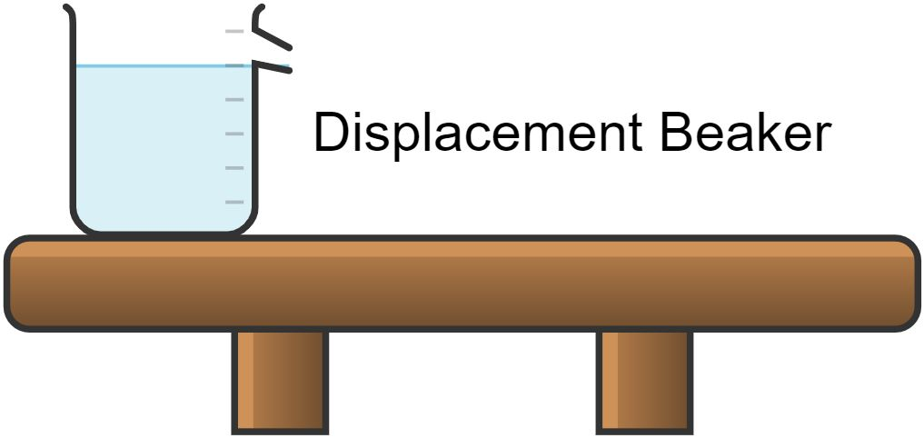
A displacement beaker or overflow can is a cup with a spout. It is filled with water to the bottom of the spout (as seen in Figure 1). A smaller beaker or measuring cylinder is placed below the spout. The object that is having its volume measured is placed into the displacement beaker or overflow can. The volume of water that spills from the displacement beaker or can is collected. The volume of this water is the volume of the object that was placed into the displacement beaker or can. Using this device controls for the limitations of using a measuring cylinder:
- samples are less likely to become stuck inside the beaker
- larger samples, such as rocks and minerals, are able to be used
- more accurate volumes maybe obtained as larger volumes of water can be displaced, collected and measured.

Appendix 2 – weathering and erosion
National Geographic provides a definition and photo slideshow that students could use to compare and contrast weathering and erosion.
Students read and write down the definitions provided and then look at each image and explain why each is an example of either weathering or erosion. Students should draw explicit attention to:
- the transport of material which defines erosion
- the role of weathering in erosion.
Students must be precise with their explanation to distinguish between weathering and erosion when they are so closely tied together. Repetition of the 2 points above is important in cementing the similarities and differences between weathering and erosion.

Appendix 3 – lithosphere and crust
Explore the lithosphere and crust of the Earth explicitly when teaching the layers of the Earth. Use a diagram to show these 2 parts and their connection.
Figure 2 – two different views of the interior of the Earth
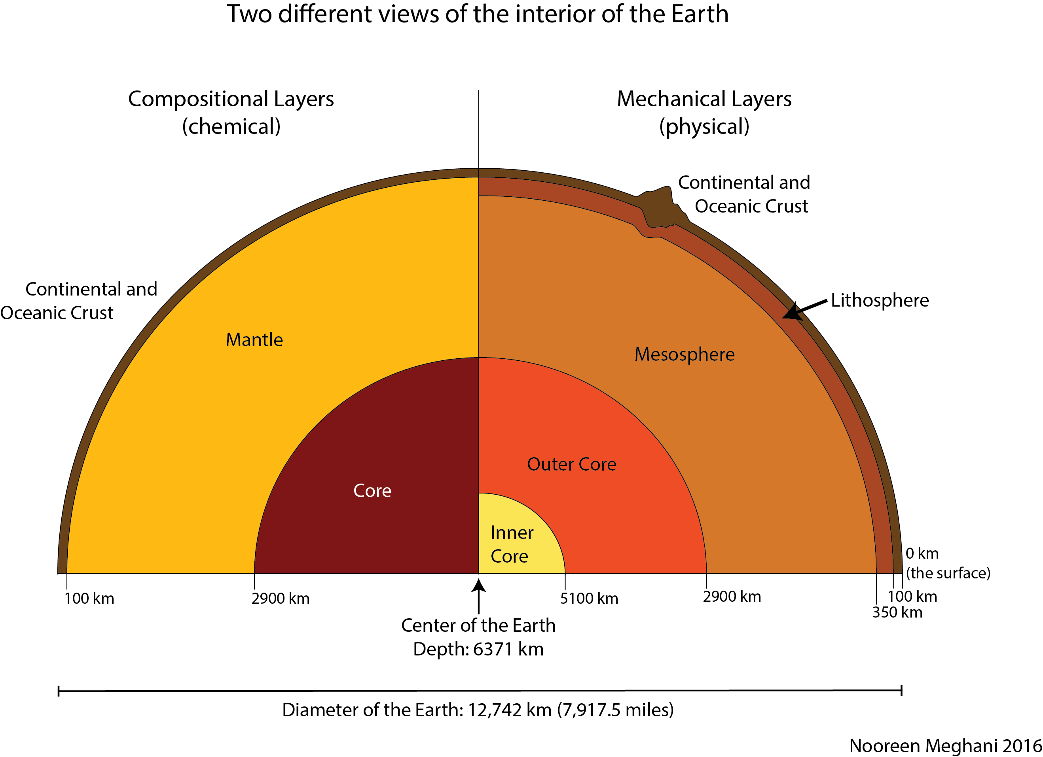
‘Layers of the Earth’ by Noreen Meghani is licensed under CC BY-NC-SA 3.0.
Crust and Lithosphere from National Geographic provide a definition and photo slideshow that students could use to help compare and contrast lithosphere and crust.
Table 2 – students create a table showing the differences between the crust and the lithosphere
Feature | Crust | Lithosphere
Composition | Defined as separate from the mantle and core due to its chemical composition. Dominated by less dense silicate minerals. | Encompasses the solid crust and the uppermost solid part of the mantle. Characterised by its solid composition rather than chemical composition.
Tectonic activity | Tectonic activity is evident at the crust but the mechanism for tectonic activity is driven from below the crust. | Tectonic activity is a feature of the lithosphere. The upper mantle portion of the lithosphere drives the tectonic activity.
Boundaries | The crust-mantle boundary is known as the Mohorovicic discontinuity (Moho). This is where seismic wave velocities change due to the higher density (related to the more dense chemical make-up) of the mantle. | The lithosphere-asthenosphere boundary is characterised by the change in ductility between these 2 layers. The asthenosphere is more ductile (able to stretch and deform under stress) than the lithosphere.
By comparing these aspects of the crust and mantle, students should be able to see that it is the chemical composition that sets the crust apart from the mantle and the solid nature of the lithosphere that sets it apart from the rest of the inner Earth.

Appendix 4 – modelling definition writing
Modelling writing techniques, including writing definitions in your own words, demonstrates to students how a proficient writer organises their ideas into writing. To model this, a teacher should:
- Choose a word associated with the topic, for example: biotic.
- Break the word into its component parts, for example: bio- and -tic.
- Determine what each part means, for example: bio- means life, -tic has no meaning on its own.
- Construct the meaning from the parts, for example: biotic has something to do with life.
- Research the meaning of the word to determine if what the writer has thought is correct, for example: Oxford Learner’s Dictionaries defines biotic as ‘of or related to living things’.
- Find out about synonyms and antonyms, for example: abiotic is the antonym of biotic. According to Oxford Learner’s Dictionaries abiotic means ‘not involving biology or living things’.
- If still not satisfied, dig further. What contexts can the word be used in? Is it commonly used with other words? For example: biotic is often used with the word ‘factors’. A biotic factor is a living part (or previously living or from a living thing, like faeces) of an ecosystem, different from an abiotic factor which is a non-living component of an ecosystem.
- With the information gathered about a word, construct a definition for the word in one’s own words. Examples can be used and synonyms and antonyms referred to. For example: biotic means any living thing or something from a living thing (faeces, bones). Biotic is the opposite of abiotic, which means non-living thing (water, air, light and so on).
By explicitly going through this process, teachers can show students how to break words down, find meaning in parts of the words, form questions to be researched, find answers to the questions and develop a deeper understanding of a word’s meaning.
Modelled writing by the State of Victoria, Department of Education and Training has further details on modelling writing.

Appendix 5 – modelling accretion
Using modelling clay, students can see how a ball of matter can become larger and larger and gain gravitational potential with increased mass.
- Begin with a small ball of modelling clay. Weigh the ball and record its mass.
- Choose another colour of modelling clay and begin adding it in a layer to the outside of the smaller ball. Once the layer is complete, weigh and record the mass again.
- Using another colour of modelling clay, further accrete the modelling clay to the outside of the ball. Once the layer is complete, weigh and record the mass again.
Students need to be prompted to make the link between mass and gravitational potential. With greater mass, the gravitational potential of the ‘body’ increases. This encourages further accretion until the planet forms.

Extension – building links to other spheres
Ask students:
- Does matter continue to accrete? Earth has a substantial amount of gravity that attracts objects to it. Some fall to Earth as meteorites; however, much of the matter attracted to Earth burns up in the atmosphere before it reaches the Earth’s crust.
- Why didn’t accreting matter burn up during the formation of early Earth? Early Earth didn’t have an atmosphere. The atmosphere was formed when the geosphere was very tectonically active.

Appendix 6 – density column
Provide students with a variety of liquids. Substances that could be used include olive oil, other vegetable oil, glycerine, kerosene, maple syrup and water (dyed blue). They can either research the liquid densities or physically measure their densities using volume and mass calculations. Students make a prediction on how the liquids will be layered in their density column and then conduct the experiment by then putting the liquids together and testing their prediction.
Figure 3 – density column
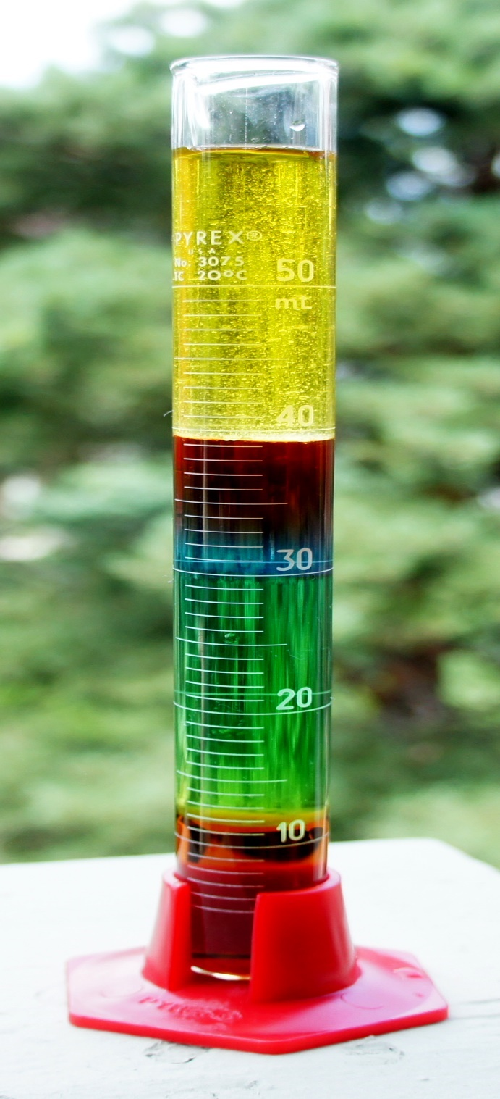
’Another artsy density column’ by Kelvinsong, is licensed under CC BY 3.0.
Relevance: the early Earth was liquid so it was essentially a giant spherical density column with the most dense materials gravitating to the centre of the earth (inner core), then decreasing density moving up through the layers.

Appendix 7 – density and Earth’s layers
Conduct a practical investigation to compare the differences in the density of representative rock samples found in the crust, mantle and core.
- sandstone: crust
- granite: lower crust from magma chamber below continental lithosphere
- basalt: shallow oceanic lithosphere
- gabbro: deep oceanic lithosphere.
Students should be able to:
- use the equation to calculate density
- understand how the unit is derived – by finding the mass in grams and dividing by the volume of the object in litres
- possibly determine a method for investigating density by understanding what they need to know from the equation
$$ρ= \frac{m}{V}$$
$$ρ=density in grams per litre (g/L)$$
$$m=mass in grams (g)$$
$V=volume in litre (L$)
Independent experimentation: students are provided with typical laboratory equipment, including measuring cylinders, overflow cans or displacement beakers, to measure density of rock samples. Students determine the most accurate method for measuring density.
Guided experimentation: students are shown a method to determine density which they perform independently. Students compare using a measuring cylinder (or overflow can or displacement beaker) to using a beaker alone and discuss the most accurate method for determining density.
Extension: students are told the challenge Archimedes was tasked with solving and asked to propose a method. The video How taking a bath led to Archimedes' principle (3:00) from TED-Ed demonstrates this. Students are then asked to relate this to an experiment to determine density of rock samples.
Figure 4 – using a measuring cylinder to determine density
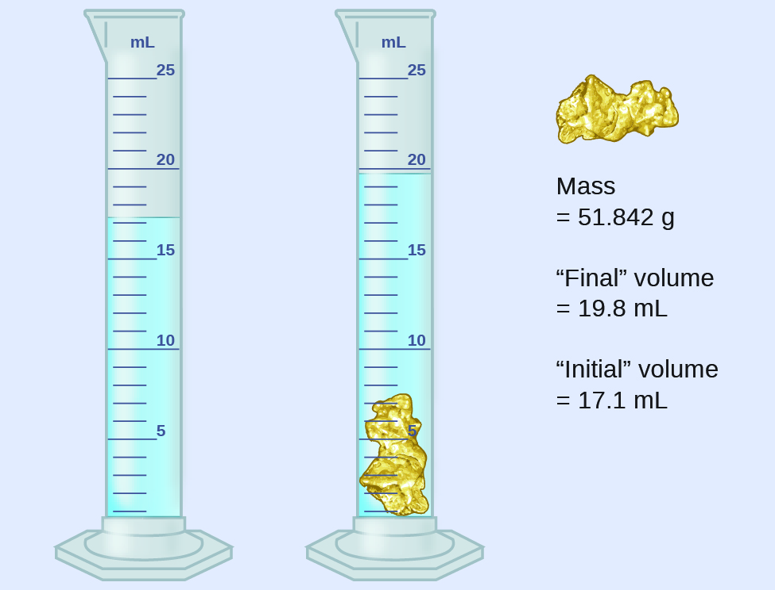
‘CNX Chem 01 04 CylGold’ by OpenStax is licenced under CC-BY-4.0.

Graphing density versus depth
Students can graph the density of each of Earth’s layers and their depth to illustrate the correlation. As with every graphing activity, students should be guided through a discussion of how to best graph the data. Questions to be posed could include:
- What are the dependent and independent variables?
- Is the data categorical?
- Is the data continuous?
- Would you expect the density to change in a linear fashion?
- Does anything interesting strike you about the data presented?
The data presented below has both categorical and continuous data. Students decide how it should be best represented. This offers a good opportunity to discuss the use, benefits and limitations of using a column graph and a line graph. An x-y scatter plot with a line of best fit has been provided below. This illustrates a linear relationship between depth and density. Students can use this graph as evidence of differentiation.
Table 3 – depth and density of Earth’s layers
Layer | Approximate depth (km) | Maximum density (g/cm3)
Crust | 0–100 | 2.9
Upper mantle | 100–410 | 4.4
Inner mantle | 410–2900 | 5.6
Outer core | 2900–5100 | 12.2
Inner core | 5100–centre of Earth | 13.1
Figure 5 – how density of the Earth changes with depth
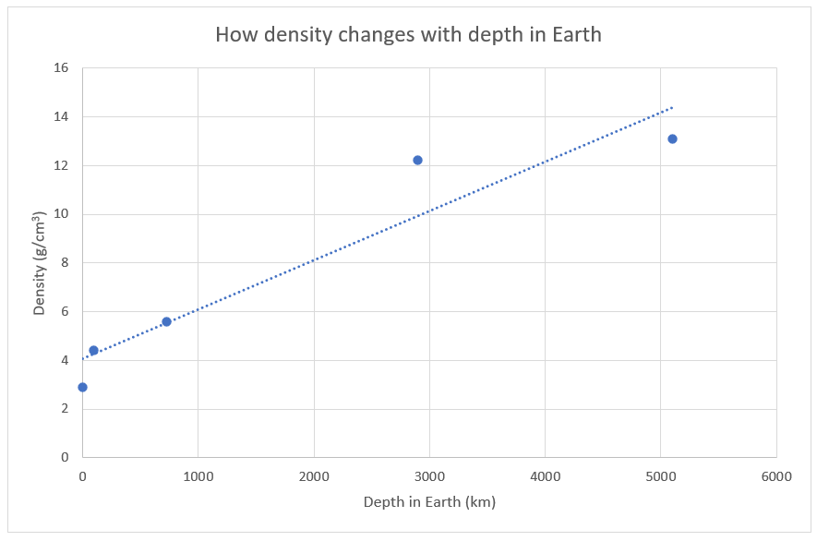

Appendix 8 – meteorite evidence
Dr Yuri Amelin from Australian National University has studied meteorite evidence for the age of Earth’s layers. The article Meteorites key to the story of Earths layers provides a succinct summary of how his work has improved our understanding of the age of Earth’s layers.
This article is easily accessible in terms of reading level for students. They can use this article to synthesise their own answer to ‘When did the compositional layers of the Earth form?’
Students need to be encouraged to bring together their knowledge of the Earth’s layers, density and differentiation and the formation of the geosphere before explaining how meteorites provide evidence for the age of Earth’s layers. A possible scaffold for this could be A Learning and Response Matrix (ALARM).

Appendix 9 – micrometeorites
In 2016, Genge et al. published an article in the scientific journal, Geology, about their research into the prevalence of micrometeorites in urban areas. They estimated micrometeorites would fall at a rate of approximately 2 micrometeorites per m² of roof area per year. They were able to recover an estimated 0.1% of these.
Students could investigate collecting their own micrometeorites by attaching a bagged magnet to the inside of a drainpipe before rain. By searching possible run-off debris, students can analyse iron containing debris with a binocular microscope. Spherical objects that look like mini ball bearings may be objects of extra-terrestrial origin.
Students can analyse the sample by size and extend their measurement skills by using a photocopy of the biological mini-grid slide. The camera on a mobile phone may also be able to see the potential micrometeorites.
Figure 6 – micrometeorites
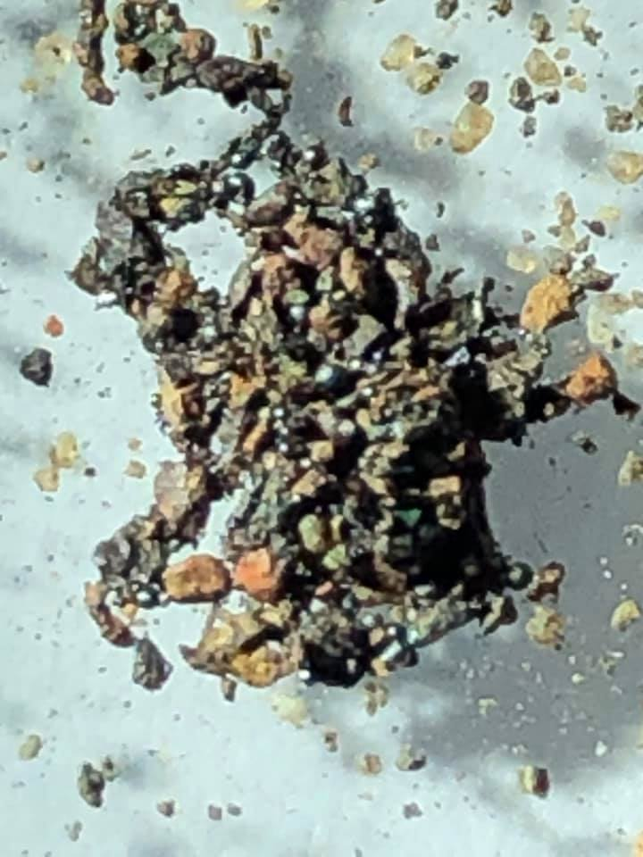

Appendix 10 – Aboriginal and Torres Strait Islander rock and mineral classification
Class discussion can be used to bring together ideas that students already have and to discuss ideas presented in the resources below. If a large class is being taught, discussing a topic can be difficult as some student voices can be lost. Think about forming smaller groups and giving each group different stimulus and/or different questions to prompt their discussion. One student should be a notetaker for the group.
Some possible stimulus material for a class discussion on this topic include:
Defining Moments: Indigenous stone tools (7:27) is a video from the National Museum of Australia’s Defining Moments in Australian History project and shows a small collection of Ngunnawal tools that are over 15,000 years old. Curator Barbara Paulson and Ngunnawal man Wally Bell are interviewed to discuss the tools and their significance to the project.
The following fact sheets have been produced by the Victorian Government and provide information about the resources that Aboriginal people used in their environment and how they used them:
- Fact sheet: Aboriginal flaked stone tools
- Fact sheet: Aboriginal ground-edge axes
- Fact sheet: Aboriginal grinding stones
- Fact sheet: Aboriginal axe-grinding grooves
Both Australian Aboriginal Ochre Painting and Ochre is of the earth provide information on the use, mining, trading and naming of ochres across Australia. These are not scientific texts (although they are informative), so they provide the opportunity for students to explore other types of texts and language, including Aboriginal language.
Teachers should guide students through discussion with prompts like:
- What do you observe about each tool?
- How do you think the tools were made?
- How do you think the tools were used?
- What kind of properties were Aboriginal and Torres Strait Islander peoples looking for when making each of their tools?
- Was any rock able to be made into each of the tools or did they need to find specific types of rock?
- Were the tools valuable? How do you know?
At the end of the discussion, students should have an understanding that Aboriginal and Torres Strait Islander peoples had:
- uses for rocks and minerals
- knowledge for choosing the rocks and minerals for specific purposes based on the properties of rocks and minerals
- knowledge of mining the rocks and minerals
- knowledge of processing the rocks and minerals.
This can all be linked to how we choose, mine and process Earth’s resources today.

Appendix 11 – mineral properties
The University of Auckland provides a clear and easy-to-navigate website on Physical properties used for identifying a mineral. Students can use this website as a more comprehensive and interactive (with hyperlinks) reference about mineral properties. Students can read and summarise the information about each of the following properties:
- hardness
- lustre
- colour
- streak
- transparency
- cleavage or fracture
- specific gravity.
The easiest-to-observe properties are hardness, lustre, colour and streak.
Identifying Minerals by Geoscience Australia, provides a showcase of minerals and their properties, including definitions of those properties. This is a good resource for students to see clear examples of the properties of minerals if those being observed in the laboratory at school are not clear.

Hardness
The hardness of a mineral is determined using the Mohs hardness scale.
Figure 7 – Moh’s scale of hardness
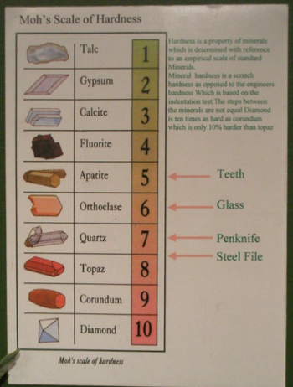
This image has been adapted from Moh's Scale of Hardness by Anne and is licensed under CC BY-NC-ND 2.0.
A mineral of unknown hardness can be firmly scratched across something with a known hardness.

Using a hardness kit
A hardness kit contains the minerals on the Mohs hardness scale, excluding diamond.
- Firmly scratch the unknown mineral with each of the minerals in the hardness kit until the unknown mineral is scratched by a mineral in the hardness kit.
- The hardness of the unknown mineral is between the last mineral that it scratched and the mineral that scratched it.
Example: unknown mineral A scratched fluorite and apatite scratched mineral A, therefore, mineral A has a hardness between 4 and 5.

Using everyday objects
As can be seen on the above picture of Mohs hardness scale, everyday objects have a hardness on the scale too.
- Scratch unknown mineral firmly with fingernail. If the mineral can be scratched by the fingernail, its hardness is less than 2.
- Scratch the unknown mineral with a copper coin. If the mineral can be scratched by the copper coin, its hardness is less than 3.
- Scratch the unknown mineral with a knife or piece of glass. If the mineral can be scratched by a knife or piece of glass, its hardness is less than 5.
- Scratch the unknown mineral with steel. If the mineral can be scratched by steel, its hardness is less than 6.

Lustre
Lustre should be observed using specimens and cannot be observed using a photograph. This is because lustre is a description of how the object reflects light. Some examples of how the lustre of a mineral can be described can be found at the University of Auckland's School of Geography, Geology and Environmental Science.

Streak
Streak is a description of the colour of a mineral when powdered. To test this, a mineral should be rubbed against a streak plate or an unglazed, white porcelain. The colour left after the rub is the streak. It can be very different from the colour that the mineral looks when it is a whole piece of the mineral. Minerals with a hardness greater than 6.5 cannot give a streak as they are harder than porcelain. Many translucent or transparent minerals will give a white, non-determinative streak.

Colour
Colour is a description of the colour of a piece of mineral, rather than powdered. It should be described in terms of primary colours, rather than shades. More than one colour can be attributed to a mineral, such as greenish-brown.
As mentioned by the University of Auckland, colour is not always a reliable property of minerals, as trace impurities in a mineral can change its colour as with quartz (white, colourless, pink, purple, yellow).

Transparency
Transparency is a description of how well light can pass through a mineral. A mineral can be described as:
- transparent: light can easily pass through the mineral
- translucent: light can somewhat pass through the mineral
- opaque: light cannot pass through the mineral.

Cleavage or fracture
Cleavage describes the texture or habit when a piece of the mineral breaks off along a flat planar surface. This is a property related to the crystal lattice structure of the mineral’s atomic structure. Cleavage can be described as:
- perfect: the surface is smooth and shiny
- imperfect: the surface is not smooth
- poor: less regular
- non-existent.
Fracture is a description of how the mineral breaks, except for along a flat planar surface.
- conchoidal: fracture is curved, bowl shaped
- hacky: sharp jagged edges
- uneven: rough and irregular
- fibrous: fibres or splinters.

Specific gravity
Specific gravity is a comparison of an objects mass per cubic centimetre compared to that of water. For the purposes of this, specific gravity and density are nearly the same thing, except that specific gravity does not have units, as it is a relative measure. To find specific gravity of a mineral, find its density (see Appendix 8). To report it as specific gravity, remove the units.

Appendix 12 – mineral dichotomous key

Making a dichotomous key
Students begin by creating their own dichotomous key using a small number of minerals.
- Students should begin by creating 2 groups of minerals based on a property of their choice. This becomes their first question.
- These 2 groups need to be separated into 2 more groups each (4 groups in total). This becomes the next 2 questions.
- This continues until the minerals have been identified.
- Students can then ask other students to identify an ‘unknown’ mineral.

Using a dichotomous key
The Handbook of Mineralogy can be used to demonstrate the thousands of minerals that make up the rocks of Earth. The Mineralogical Society of America has produced an online Mineral Identification Key. This key is dichotomous but results in a large table where the user is required to find the most relevant mineral to identify their unknown. This is a good resource to show students, especially when discussing data collection. The teacher should have the students read the introduction which provides a summary of limitations of the key. Students can use the key to try to identify an unknown.
The class can discuss:
- What are the uses of the key?
- What makes it easy to use?
- What makes it hard to use?
- Why they think they may or may not have success using it to identify their unknown.
This may lead to a discussion of the subjective nature of qualitative data.

Appendix 13 – modelling rocks using food samples
Students are provided with the food samples and describe each sample. Then provide students with the rock samples. By comparing the food samples to the rock samples, students should be able to match the food sample and rock samples together based on their observable properties. If real samples are not available, photos will suffice.
Table 4 – foods that represent rocks
Rock | Representative food sample
Obsidian | Toffee
Pumice | Honeycomb
Granite | Chocolate chip biscuit
Sandstone | Wafer biscuit
Students design a table comparing the food samples to the rocks, assessing the limitations of using these food samples as models to represent these rocks.
Table 5 – similarities and differences between food samples and rocks
Rock food sample pair | Similarities | Differences – limitations
Obsidian and toffee | Obsidian and toffee are both formed when a liquid cools. | Obsidian still contains crystalised minerals which is why it is opaque (except at the edges).  Sugar is an organic compound so does not contain mineral crystals.
Pumice and honeycomb | Both pumice and honeycomb have air bubbles introduced. | The air bubbles in the pumice form when the lava depressurises and the gases escape their dissolution in the liquid.  In the honeycomb, a chemical reaction between the acid in toffee and bicarbonate forms carbon dioxide which makes the air bubbles.
Granite and chocolate chip biscuit | Granite contains large mineral crystals. The chocolate chips in the biscuit, which are representing the large mineral crystals, were added to the biscuit mixture. Would a chocolate chip biscuit be better suited to representing conglomerate?
Sandstone and wafer biscuit | Both contain layers; however, the layers of the wafer are held together with an icing layer. How accurate is this?
Students should construct a dichotomous key to identify each food or rock based on their observable properties. Teachers should ensure they relate the size of mineral crystals to the observable properties, for example, large mineral crystals in granite (chocolate chips in the chocolate chip biscuit), microscopic mineral crystals in obsidian gives a homogenous appearance.
Students are to use risk assessment techniques (see general resources) to manage food in laboratory hazards.

Appendix 14 – rock dichotomous key
The Mineralogical Society of America has published an online Rock Identification Key. This rock key (PDF 574 KB) has also been published as a PDF for printing if computers are not readily available or reliable. Provide students with a selection of rocks listed in the top, right-hand side of the table of contents.
It is important when presenting students with a dichotomous key that they:
- are aware of the procedures to be used to determine the properties of the rocks
- are able to use these procedures
- have access to the rocks identified in the key.
Teachers and/or students can find this information out in the sections ‘Using the Rock Key’ and ‘About the Rock Key’ of the Rock Identification Key.

Appendix 15 – soil testing

Soil texture
Soil texture is the proportion of sand, silt and clay in a soil. Soil texture can be described using a variety of names depending on the percentage of sand, silt and clay. This is shown in the soil texture triangle (below).
Soil texture is important because it determines:
- the amount of water a soil can hold
- the rate of water movement through a soil
- how workable and fertile the soil is.
Figure 8 – soil textural triangle
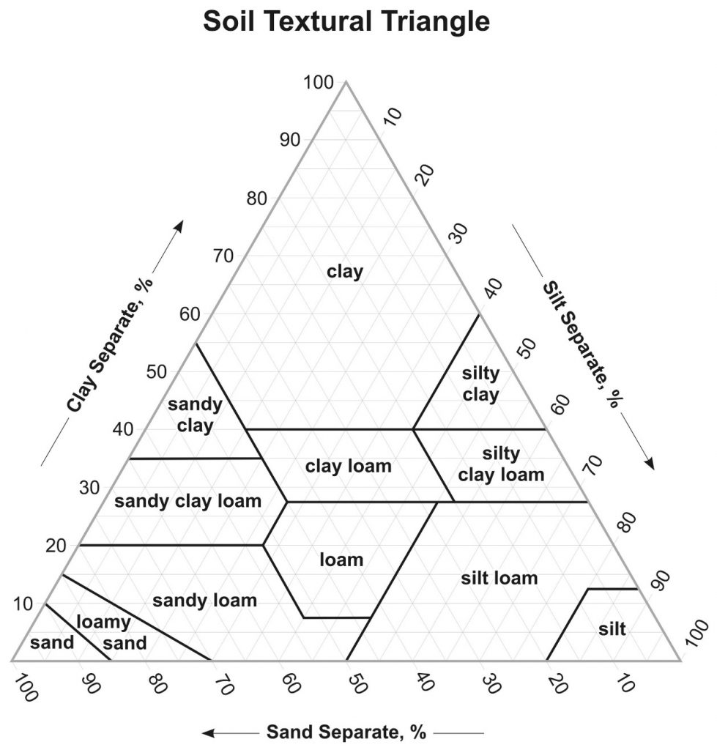
’Soil textural triangle’ by United States Department of Agriculture, Natural Resources Conservation Service (USDA) is licensed under PDM 1.0.

Quantitative testing
Clemson University’s Home and Garden Information Center’s factsheet Soil Texture Analysis ‘The Jar Test’ has a procedure using basic materials and the textural triangle to determine soil texture.

Qualitative testing
Soil texture can be determined qualitatively using the ribboning technique. The NSW Department of Primary Industries has produced a factsheet on the Ribboning technique (PDF 340 KB).
Using the ribboning technique is useful in the field because it is fast and only requires a small amount of water. Once soil texture has been determined using this technique, the soil texture triangle can be used to work backwards to find the possible sand, silt and clay proportions.

Comparing soil texture
Students should complete both the ribboning technique and the jar test to see if they obtain the same or similar results in both tests. They can then discuss validity of the 2 techniques and whether they can be reliably used in isolation or if it is perhaps best to use both techniques to obtain the most accurate results.
To further assess the reliability and accuracy of their soil texture assessment, students can compare the soil texture of their sample to soil data from local council or Land Services (if available).
Students can complete the same method to determine the soil texture of potting mix, sand, clay and other commercially available soil samples.

Further discussion
To extend on the components and processes of soil formation students could:
- explain why soil is not found on the moon
- analyse the role of the spheres on the production of soils.

Soil pH
Students collect a range of soil samples from their local area to test.
Materials (per group):
- white porcelain tile
- craft stick
- 1 tablespoon of a soil sample
- barium sulphate in a shaker bottle
- universal indicator (dropper bottle)
- universal indicator chart.
Method:
- Place 1 tablespoon of the soil sample on the white tile.
- Remove small rocks and organic matter.
- Add 3 to 4 drops of universal indicator to the soil sample.
- Mix with the craft stick.
- Dust with barium sulphate.
- Compare the colour to the universal indicator chart.
Students should sample soils taken from a depth of 10 cm as this is the area from which plant roots will draw water and nutrients. Test the pH of a variety of soils and link the results to the uses of the area the samples were taken from (for example, agriculture, sporting fields and so on). Students can then suggest possible inferences as to the pH of the sample areas (fertiliser, high organic content and so on).
pH can also be tested using a pH probe if one is available. Students can compare the results obtained from the barium sulphate and universal indicator with the pH probe results.
The 2 main laboratory methods used in Australia use calcium chloride or water.
- Soil pH in calcium chloride: this is the standard method of measuring soil pH in all states other than Queensland. An air-dry soil sample is mixed with 5 times its weight of a dilute concentration (0.01M) of calcium chloride (CaCl₂), shaken for one hour and the pH is measured using an electrode. The results are usually expressed as pH(CaCl₂).
- Soil pH in water: distilled water is used in place of 0.01M calcium chloride and results are expressed as pH(w).
The pH(CaCl₂) test is the more accurate of the 2 pH tests, as it reflects what the plant experiences in the soil. The values of pH(CaCl₂) are normally lower than pH(w) by 0.5 to 0.9.
Further information on the importance of soil pH in agriculture can be obtained from the NSW Department of Agriculture, Understanding Soil pH (182 KB).

Infiltration rate
Water infiltration rate is a measure of how quickly water percolates from the surface of the soil into the soil. Students can collect quantitative data on infiltration rate of a variety of soil samples. This should be done on site, as digging up and moving the soil would impact the soil’s natural state of compaction.
Materials:
- water
- 100 mm diameter PVC pipe cut into 200 mm lengths (one end may need to be slightly sharpened)
- watch
- bucket of water
- permanent marker
- ruler
- piece of wood longer than 100 mm
- hammer or mallet.
Method:
- On the outside of the PVC pipe, draw a line 50 mm above the bottom edge. This is how deep the PVC pipe will be driven into the ground.
- On the inside of the PVC pipe, draw a line 90 mm and 100 mm above the bottom edge. This is the depth of the water that will be poured in.
- Drive the PVC pipe 50 mm into the soil to the line drawn on the outside. The piece of wood can be laid across the PVC pipe and hit with the hammer or mallet to assist if the soil is particularly compact or dry.
- Pour water into the PVC pipe up to the 100 mm line. Record the time.
- Record how long it takes to drop to 90 mm.
- Calculate the infiltration rate in mm/min.
Discussion should take place after this test on:
- how this relates to soil compaction
- the effects infiltration rate has on the structure of the soil
- the effect of compaction and infiltration on the overall ‘health’ of the soil.

Appendix 16 – geological timeline
The purpose of these activities is not for students to know the names of the various time periods or when geological and evolutionary events occurred, but to gain an understanding of the span of geological time.

65 million year time line
The Science Learning Hub has created a fun and engaging Toilet roll geologic timescale resource where students create a modified 65 million year timeline on toilet paper. This activity works best in groups of 3 to 4 students. The resource provides coloured call-outs for each significant event and time period. It is suggested not to include the names of the periods at this stage and to replace the New Zealand references with the following events which could be written on sticky notes and placed on the paper at the appropriate place (each sheet represents 130,000 years).
- 45 Myr: Australia completely separated from Antarctica
- 23 Myr: Mount Warning (on NSW–Queensland border) formed
- 2.6 Myr: Great Barrier Reef starts forming
- 2 Myr: earliest humans in Africa
- 60,000 years ago: megafauna first appeared in Australia
- 50,000 years ago: Aboriginal people arrived in Australia
- 11,700 years ago: Tasmania separated from the mainland in the last glacial melt
- 6000 years ago: Australia’s youngest mainland volcano, Mount Gambier (South Australia) last erupted.
There are also 2 critical discussion questions that must be answered:
- If one roll of toilet paper represents 65 million years of geologic time, how many rolls are needed to represent the 4.6 billion years of total geologic time? (Answer: 71 rolls)
- If each roll is 57 m long, what length of toilet paper would you need to represent total geologic time? (Answer: 4047 m). Identify a landmark 4.047 km from your school and compare this with the length representing the last 65 million years.
Note: this resource calls for a 500-sheet roll of toilet paper. Commercial toilet paper suppliers, Scott and Livi, both have 500-sheet toilet paper. Alternatively, multiple rolls of paper may be required for each group.

Full Earth age timeline
Creating this timeline should give students a real perspective of geological time and the relatively short and recent evolution of major vertebrate groups and the insignificant age, yet catastrophic effect, of humans in the evolution and extinction of life. To model the full 4.5 billion years of Earth’s age, students need access to a 50 m length of a school or community playing field.
Materials:
- measuring tape or trundle wheel
- 2 witch’s hats or cones
- skewers
- sticky tape
- event labels for flags (see below).
Method:
- Create a flag for each significant event listed below. Tape an event label to the top of a skewer to be driven into the ground at the appropriate location. Each student or pair of students may be responsible for one or more events. They may make the flag and have to remember when it happened. This step can happen in the classroom.
- Using the school’s or community’s playing field, measure out 50 m using the trundle wheel or measuring tape.
- Mark the beginning of the timeline with a witch's hat and the end with the other witch’s hat.
- Present students with a scale of 1 m = 100 million years.
- Students can work together to place the flags representing important events along the timeline.
- When complete and correct, students should discuss what they notice about geological time including
- how long the Earth had no life
- the apparently exponential increase in life on Earth
- how long it took life to move on to land and the steps needed for this
- relate the formation of the spheres to the periods in geological time (they did not all appear at once)
- the impact humans have had on Earth in the short period of time they have been here.
Event flags could include:
- birth of Earth: 4.5 billion years ago
- core and crust formed: 4500 million years ago
- ocean formed: 4400 million years ago
- first life: 3850 million years ago
- oxygenation of atmosphere: 1500 million years ago
- single celled animals evolved: 700 million years ago
- first vertebrates (fish): 530 million years ago
- first land plants: 400 million years ago
- first land vertebrates: 350 million years ago
- first dinosaurs: 220 million years ago
- dinosaurs extinct: 65 million years ago
- modern humans evolved: 0.13 million years ago.
The events listed above come from Dynamic Earth Education – Geological Timeline (PDF 878 KB). This resource provides brief details and some suggested timeline variations including a paper timeline, string timeline and toilet paper timeline. It is not as comprehensive as the resource from the Science Learning Hub.

Appendix 17 – relative dating
The first 2 activities look at the relative dating of layers of rocks with no mention of fossils. The third activity introduces fossils and how their location in the rock strata determines their relative age.
- Sandwich Stratigraphy (PDF 196 KB) is a simple activity where students model layers of sedimentary rocks, faulting and folding using different types of bread and fillings. EES11/12-6
- In the Science Learning Hub’s Rock layers and relative dating activity, students observe a photo and diagram of a cliff face near Whanganui in New Zealand, complete an interactive and answer questions. Background information for teachers, teacher instructions and student instructions are provided. EES11/12-6
- Students complete the Layers of Time interactive to demonstrate how fossils can be used to determine the relative age of fossils in rock strata. An alternative, more challenging activity is Who’s on First? A Relative Dating Activity EES11/12-6

Appendix 18 – modelling half-life
Students will be familiar with popping popcorn in a microwave. Ask students: ‘Will all the popcorn pop at the same time? Is it random? Does it have a pattern?’
- Each group of students puts 20 popcorn kernels into each of the 20 paper bags. Microwave the first bag for 10 seconds, the second for 20 seconds, through to the twentieth bag for 200 seconds. When the popcorn is cool, students count the number of kernels that have popped in each bag and record appropriately.
- Calculate the percentage of both un-popped kernels and popped popcorns in each bag.
- Combine all groups’ data and calculate the average of un-popped and popped kernels for each time. Discuss why you are going to combine data using the terms ‘error’ and ‘validity’.
- Discuss with students how we would graph the data. Would a line or column graph be appropriate? What should each axis represent? Highlight the terms ‘dependent’ and ‘independent variables’.
- Firstly, plot the curve of percentages of un-popped kernels in all bags. This curve shows the ‘decay’ of ‘parent’ un-popped kernels over time.
- Next, plot percentages of popped popcorns in each bag. As the percentage of ‘parent’ kernels gets smaller over time, what happens to the percentage of ‘daughter’ popcorns?
- The 2 curves should intersect on the graph at the 50% point on the vertical axis. The corresponding point on the horizontal axis is the ‘half-life’ of the popcorn kernels.
- Each group provides one of their samples to another group but does not tell them the time it was heated for. Each group counts the number of un-popped kernels and uses their graph to determine the time it was heated for.
- Discuss the ways in which experimental errors can affect results. How might your experimental popcorn decay system differ from a natural radioactive decay process such as occurring in fossils and volcanic ash layers in ice cores?

Appendix 19 – radioactive dating game
Students can use Radioactive Dating Game from PhET to compare carbon-14 and uranium-238 (U-238) for radioactive dating. Select the last tab on the game, called Dating Game. Use a virtual Geiger counter to measure the percentage of carbon-14 in a variety of objects. This is displayed on a graph, along with the age (shown as time) of each object. When students work their way down the geological profile, they will find that the deeper they go in the profile, carbon-14 is less useful. They then need to measure uranium-238. Students should be asked why there is a difference in the usefulness of C-14 and U-238 to date rocks and relate it back to the half-life of the element.

Appendix 20 – renewable versus non-renewable resources
Activate students’ prior knowledge by providing groups of students with sets of cards. Each card has a resource on it: oil, natural gas, liquified petroleum gas (LPG), coal, uranium, iron, aluminium, gold, lithium, diamond, opal, timber, solar energy, wind, water, geothermal energy, biomass.
Students discuss in groups what distinguishes and renewable from a non-renewable resource and then classify each card into renewable or non-renewable resource.
Have a class discussion to determine features of non-renewable and renewable resources. Some ideas that may be provided are shown below.
Table 6 – comparison of non-renewable resources and renewable resources
Non-renewable resource | Renewable resource
Used up more quickly than it can replace itself (takes billions of years). | Cannot be depleted over time
Is finite or limited | Abundant and unlimited supply
Is extracted from the earth | May be from the Earth or atmosphere
Table 7 – classification of the resources provided
Non-renewable resource | Renewable resource
oil | timber
natural gas | biomass
coal | solar energy
LPG | wind
uranium | water
iron | geothermal energy
gold
lithium
aluminium
diamond
opal
Note: students may suggest that some:
- non-renewable substances can be recycled; however, this does not mean that they are non-renewable
- renewable resources may be limited in certain situations. For example, the supply of fresh, clean water may be limited in a desert situation.

Appendix 21 – Australian natural resources
Provide students with the first 2 columns in the table below. Students insert the data into a spreadsheet, calculate the percentages and design a pie graph to display data. This data was current in January 2024. The next release will be in May 2024.
Table 8 – Australian Industry Employment and IVA data and movements, 2020–21 to 2021–22
Industry | Value added to Australian economy (2021–22) ($) | Percentage contribution to economy (2021–22)
Agriculture, forestry and fishing | 39,616 | 2.54
Mining | 322,061 | 20.62
Manufacturing | 124,196 | 7.96
Electricity, gas and water | 48,615 | 3.11
Construction | 141,325 | 9.05
Wholesale trade | 86,103 | 5.51
Retail trade | 102,064 | 6.53
Accommodation and food services | 45,651 | 2.92
Transport, postal and warehousing | 82,985 | 2.79
Information, media and telecommunications | 43,595 | 2.79
Rental, hiring and real estate services | 100,017 | 6.41
Professional, scientific and technical services | 164,088 | 10.50
Administrative and support services | 78,868 | 5.05
Public administration and safety (private) | 7545 | 0.49
Education and training (private) | 36,259 | 2.32
Health care and social assistance (private) | 124,100 | 7.94
Arts and recreation services | 15,031 | 0.97
Other services | 38,737 | 2.48
Total selected industries | 1,562,032 | 100
‘Australian Industry’ by Australian Bureau of Statistics (ABS) is licensed under CC BY 4.0.
Students access the following graph from the Reserve Bank of Australia Chart Pack: Regions and Industry and select Industry Share of Output.
Figure 9 – industry share of output
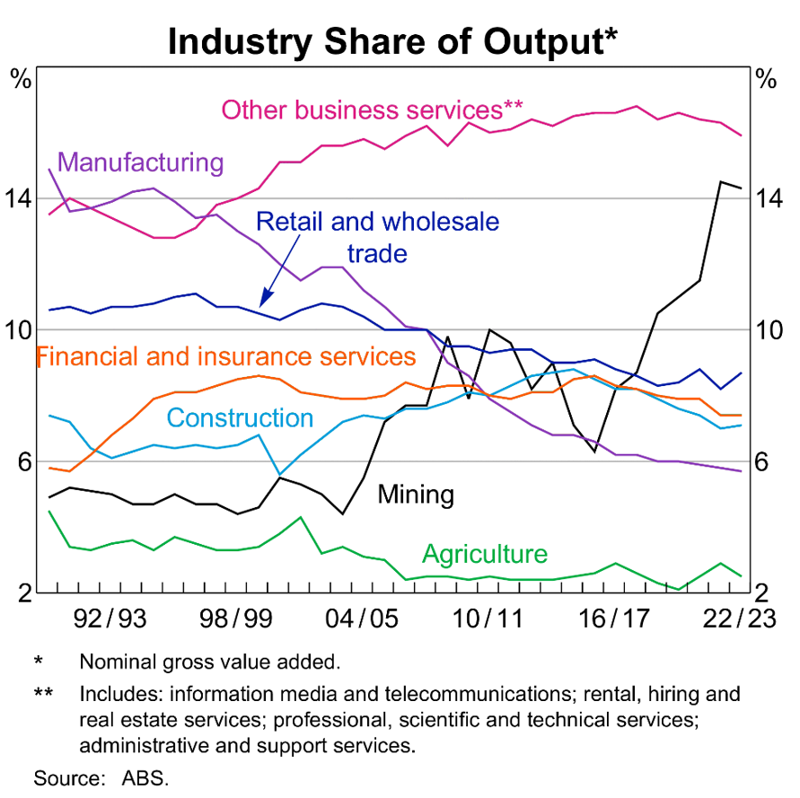
‘Industry Share of Output’ by Australian Bureau of Statistics (ABS) is licensed under CC BY 4.0.
Question
How has the contribution of mining to the Australian output changed over the past 30 years?
Provide students with the table below. This table was the most current available in 2023. It is suggested that teachers access Geoscience Australia after 2023 to ensure the most current data is used.
Table 9 – Australia’s identified mineral resources 2022, world rankings
Commodity | World Ranking for Resources | Share of World Resources | World Ranking for Production | Share of World Production
Antimony | 6 | 7% | 4 | 3%
Bauxite | 3 | 12% | 1 | 27%
Black Coal – Recoverable | 4 | 10% | 3 | 8%
Brown Coal – Recoverable | 2 | 23% | 8 | 4%
Chromium | 0 | 0% | 0 | 0%
Cobalt | 2 | 20% | 3 | 3%
Copper | 2 | 11% | 8 | 4%
Diamond | minor | minor | 0 | 0%
Fluorine | 9 | minor | 0 | 0%
Gold | 1 | 22% | 2 | 10%
Graphite | 8 | 2% | 0 | 0%
Ilmenite | 2 | 23% | 8 | 4%
Iron Ore | 1 | 31% | 1 | 36%
Lead | 1 | 40% | 2 | 11%
Lithium | 2 | 29% | 1 | 53%
Magnesite | 4 | 4% | 5 | 3%
Manganese Ore | 4 | 9% | 3 | 11%
Molybdenum | 6 | 2% | 0 | 0%
Nickel | 1 | 23% | 5 | 6%
Niobium | unknown | unknown | unknown | unknown
Phosphate | 8 | 2% | 13 | 1%
PGE | minor | minor | minor | minor
Potash | 12 | 1% | minor | minor
Rare Earths | 6 | 3% | 4 | 8%
Rutile/titanium | 1 | 63% | 1 | 26%
Scandium | unknown | unknown | 0 | 0%
Silver | 2 | 18% | 5 | 6%
Tantalum | unknown | unknown | 5 | 5%
Thorium | 0 | 0% | n/a | n/a
Tin | 4 | 12% | 8 | 3%
Tungsten | 2 | 15% | minor | minor
Uranium | 1 | 32% | 4 | 8%
Vanadium | 2 | 31% | 0 | 0%
Zinc | 1 | 27% | 3 | 10%
Zircon | 1 | 72% | 1 | 30%
‘World Rankings’ by Commonwealth of Australia (Geoscience Australia) is licensed under CC BY 4.0 LEGAL CODE.
Note:
- ‘Resources’ are commodities that are available to be mined.
- A commodity is ranked if it is determined to be an ‘economic demonstrated resource’ (EDR), meaning it is economically profitable to mine.
- ‘Production’ relates to the amount that is actually mined.
- ‘Minor’ = <1% of global economic resources and/or production, therefore Australia’s ranking unable to be determined.
Questions
- For what commodities does Australia hold the largest percentage of the world’s reserves?
- List the 14 other Australian commodities that are ranked in the top 5 for world economic resources.
- List the commodities for which Australia is the:
- second largest producer
- third largest producer
- fourth largest producer
- fifth largest producer.
- Australia holds the largest reserves of nickel but is the fifth largest producer. Likewise, we hold the largest reserves of uranium but are the fourth largest producer. Why, if Australia holds the largest reserves of a resource, is it not the largest producer?
- Complete the following table using information from the table above and Geoscience Australia’s commodity summaries.
Table 10 – Major Australian commodities 2021
Commodity | Percentage of world resource | Location of major deposits | Number of mines | Export value | Use of commodity
Bauxite
Black coal
Brown coal
Gold
Iron ore
Lead
Lithium
Nickel
Rutile/titanium
Uranium
Zinc
Zircon
Undertake some further research to answer the following questions:
- What is the relationship between rutile and titanium?
- Why are zinc and lead listed together when identifying the location of mines?
In an examination, students are often required to:
- analyse data to make their own conclusion
- evaluate a statement using the data presented.
The claim – evidence – reasoning scaffold supports students to develop an answer to these types of questions.
Table 11 – claim – evidence – reasoning scaffold
- Claim | - Evidence | - Reasoning
State an answer to the question or prompt. | Provide reliable information from experiments, facts or a reliable source that supports the claim. | Explain how the evidence supports the claim.
Helpful hints:  Use key words and ideas from your question as you write your claim. | Suggested sentence starters:  - In this experiment …  - The data shows …  - According to the graph …  - One example from the experiment is …  - One piece of evidence is … | Suggested sentence starters:  - Based on the evidence, it can be concluded that … because …  - The evidence is significant because …  - The evidence supports the claim because …
Students use the claim – evidence – reasoning scaffold to answer one of the following questions.
- Assess the impact of mining on the Australian economy.
- Provide evidence for the claim ‘Mining is an important aspect of the Australian economy’.
- Establish the importance of Australia's non-renewable natural resources to the world.

References
This resource contains NSW Curriculum and syllabus content. The NSW Curriculum is developed by the NSW Education Standards Authority. This content is prepared by NESA for and on behalf of the Crown in right of the State of New South Wales. The material is protected by Crown copyright.
Please refer to the NESA Copyright Disclaimer for more information https://educationstandards.nsw.edu.au/wps/portal/nesa/mini-footer/copyright.
NESA holds the only official and up-to-date versions of the NSW Curriculum and syllabus documents. Please visit the NSW Education Standards Authority (NESA) website https://educationstandards.nsw.edu.au and the NSW Curriculum website https://curriculum.nsw.edu.au.
Earth and Environmental Science Stage 6 Syllabus © NSW Education Standards Authority (NESA) for and on behalf of the Crown in right of the State of New South Wales, 2017.
AECG (Aboriginal Education Consultative Group Inc) (2023) AECG Regions, AECG Website, accessed 8 January 2024.
Amos J (5 February 2020) ‘Mud wasps used to date aboriginal rock art’, BBC News, accessed 10 January 2024.
Anthony JW, Bideaux RA, Bladh KW and Nichols MC (eds) (2003) Handbook of Mineralogy, Mineralogical Society of America, Virginia, accessed 12 January 2024.
ANU (Australian National University) College of Science (14 April 2015) ‘Meteorites Key to the Story of Earths Layers’, ANU College of Science news, accessed 10 January 2024.
ANU Research School of Earth Sciences (16 August 2021) 'Direct sampling techniques for year 11 and 12 Earth and Environmental Science students' [video], Research School of Earth Sciences, YouTube, accessed 10 January 2024.
Arizona-Sonora Desert Museum (2006) Activity 1: Sandwich Stratigraphy (PDF 196KB), Arizona-Sonora Desert Museum, accessed 1 April 2022.
Australian Bureau of Statistics (ABS) (2021–22) Australian Industry, ABS website, accessed 12 January 2024.
Barber M and Scheidle Bartos D (n.d.) ‘Who’s on first? A Relative Dating Activity’, Learning from the Fossil Record, University of California Museum of Paleontology website, accessed 1 April 2022.
BHP (5 February 2021) 'South Flank iron ore mine tour' [video], BHP, YouTube, accessed 10 January 2024.
Bold Learning Solutions (2023) Brainscape [website], accessed 20 March 2023.
Carroll S (n.d.) ‘Ochre is of the Earth (Brown Y and Rings F eds)’, Productions: Ochres, Bangarra Dance Theatre website, accessed 11 January 2024.
Cram.com (2023) Cram [website], accessed 20 March 2023.
Davidson H (20 July 2017) ‘Australian dig finds evidence of Aboriginal habitation up to 80,000 years ago’, The Guardian, accessed 10 January 2024.
DeFranza D (2024) ‘The Oil Drilling Process Explained’, How Stuff Works, accessed 10 January 2024.
Dixie Middle Science (n.d.) Extension: Half-life of Candium: Radioactive Dating Determining Absolute Age (PDF 202 KB), Dixie Middle Science, accessed 1 April 2022.
DPC (Department of Premier and Cabinet) Victoria (2021) Fact sheet: Aboriginal axe-grinding grooves, First Peoples – State Relations website, , accessed 10 January 2024.
DPC Victoria (2021) ‘Fact sheet: Aboriginal flaked stone tools’, Aboriginal places and objects, First Peoples – State Relations website, , accessed 10 January 2024.
DPC Victoria(2021) ‘Fact sheet: Aboriginal grinding stones’, Aboriginal places and objects, First Peoples – State Relations website, , accessed 10 January 2024.
DPC Victoria (2021) ‘Fact sheet: Aboriginal ground-edge axes’, Aboriginal places and objects, First Peoples – State Relations website, , accessed 10 January 2024.
DPC Victoria (2021) ‘Fact sheet: Aboriginal quarries’, Aboriginal places and objects, First Peoples – State Relations website, accessed 10 January 2024.
Dynamic Earth (n.d.) Geological Timeline (Pack 2) (PDF 878 KB), Dynamic Earth, accessed 12 January 2024.
Energy Education (n.d.) Offshore drilling, Energy Education website, accessed 10 January 2024.
Esimtech (24 August 2023) ‘How Does an Oil Rig Work’, Esimtech News, accessed 10 January 2024.
Finio B (2002–24) ‘Model the Rock Cycle with Crayons’, Stem Activities, Science Buddies website, accessed 8 January 2024.
Genge M, Larsen J, van Ginneken M and Suttle M (2016) ‘An urban collection of modern-day large micrometeorites: Evidence for variations in the extraterrestrial dust flux through the Quaternary’, Geology, 45(2):119–122, doi: 10.1130/G38352.1, accessed 8 January 2024.
Geoscience Australia (n.d.) Identifying Minerals (Buffinton K, Blewett S and Breen N eds), Google Arts and Culture website, accessed 12 January 2024.
Geoscience Australia (2014) ‘Exploring Minerals and Crystals: Teacher Notes and Activities’, Commonwealth of Australia, Geoscience Australia, accessed 8 January 2024.
Geoscience Australia (10 August 2020) ‘The Geology of Minecraft’ [video], GeoscienceAustralia, YouTube, accessed 22 December 2023.
Geoscience Australia (2023) ‘Commodity summaries’, Australia's Identified Mineral Resources 2022, Geoscience Australia website, accessed 12 January 2024.
Geoscience Australia (2023) ‘World Rankings’, Australia's Identified Mineral Resources 2022, Geoscience Australia website, accessed 12 January 2024.
Jeffers A (2018) ‘Soil Texture Analysis “The Jar Test”’, Factsheets, Home and Garden Information Center website, accessed 12 January 2024.
Lake B (2000) Understanding Soil pH (PDF 182 KB), NSW Department of Primary Industries, accessed 12 January 2024.
Left Brain Craft Brain (n.d.) How to Make a Delicious Rock Cycle with Chocolate Rocks, Left Brain Craft Brain website, accessed 8 January 2024.
Micander R (2017) The Rock Key (PDF 574 KB), Nevada Bureau of Mines and Geology, accessed 12 January 2024.
Mining Matters (n.d.) Starburst Rock Cycle (PDF 1805 KB), Mining Matters, accessed 8 January 2024.
National Geographic Society (2023) Crust (Evers J ed), National Geographic Education website, accessed 10 January 2024.
National Geographic Society (2023) Lithosphere (Evers J ed), National Geographic Education website, accessed 10 January 2024.
National Geographic Society (2024) Erosion (Evers J ed), National Geographic Education website, accessed 10 January 2024.
National Geographic Society (2024) Weathering (Evers J ed), National Geographic Education website, accessed 10 January 2024.
National Museum of Australia (8 August 2016) 'Defining Moments: Indigenous stone tools' [video], National Museum of Australia, YouTube, accessed 11 January 2024.
Nesbitt S (n.d.) 'Layers of Time: Fossil Game', PaleontOLogy, American Museum of Natural History (AMNH) website, accessed 1 April 2022.
NPR (National Public Radio) (23 November 2016) 'Earth’s Entire History (Visualised on a Football Field)' [video], NPR’s Skunk Bear, YouTube, accessed 10 January 2024.
NSW Department of Planning, Housing and Infrastructure (n.d.) Look up Your Local Land Services Region, Local Land Services website, accessed 10 January 2024.
NSW Department of Primary Industries (2014) Determining soil texture using the ribboning technique (PDF 340 KB), NSW Department of Primary Industries, accessed 12 January 2024.
Oresome Resources (20 February 2018) 'How do we mine coal? (open-cut processes)' [video], Oresome Resources, Oresome Resources website, accessed 10 January 2024.
Oresome Resources (n.d.) ‘Underground Mining fact sheet’, Resources, Oresome Resources website, accessed 10 January 2024.
Oxford University Press (2024) Oxford Learner’s Dictionaries, Oxford University Press website, accessed 10 January 2024.
Peck D (2001) The Rock Identification Key, Mineralogical Society of America website, accessed 10 January 2024.
Peppe DJ and Deino AL (2013) 'Dating Rocks and Fossils Using Geologic Methods', Nature Education Knowledge, 4(10):1, accessed 1 April 2022.
Plante A, Peck D and Von Bargen D (2003) Mineral Identification Key II, Mineralogical Society of America website, accessed 12 January 2024.
Rashotte N (6 November 2019) ‘Introduction to Remote Sensing in Mineral Exploration’, Investing News Network, accessed 10 January 2024.
RBA (Reserve Bank of Australia) (2024) ‘Regions and Industry’, Chart Pack, RBA website, accessed 12 January 2024.
Salata M (7 September 2012) 'How taking a bath led to Archimedes principle' [video], TED-Ed, YouTube, accessed 10 January 2024.
Science Learning Hub – Pokapū Akoranga Pūtaiao (2010) Minerals present in granite, Science Learning Hub website, accessed 8 January 2024.
Science Learning Hub – Pokapū Akoranga Pūtaiao (2011) Absolute dating, Science Learning Hub website, accessed 8 January 2024.
Science Learning Hub – Pokapū Akoranga Pūtaiao (2012) Toilet roll geologic timescale, Science Learning Hub website, accessed 12 January 2024.
Science Learning Hub – Pokapū Akoranga Pūtaiao (2018) Rock layers and relative dating, Science Learning Hub website, accessed 1 April 2022.
Seismological Facility for the Advancement of Geoscience (n.d.) ‘Layered Earth’, Educator Resources, IRIS website, accessed 20 March 2023.
Sherwin M (2013) The Use of Coal by Aboriginal People, People and Place: Coal and Community website, accessed 10 January 2024.
Sneideman J (30 August 2013) 'Four ways to understand the Earth’s age' [video], Ted-Ed, YouTube, accessed 8 January 2024.
Soil Conservation Service (n.d.) Contact the Soil Conservation Service, Soil Conservation Service website, accessed 10 January 2024.
The University of Auckland (2005) ‘Minerals’, Geology: Rocks and Minerals, University of Auckland website, accessed 12 January 2024.
3D Living Studio (21 July 2022) 'How offshore oil rigs work, float and extract oil' [video], 3D Living Studio, YouTube, accessed 10 January 2024.
University of Colorado (2020) ‘Radioactive Dating Game’, PhET (Physics Education Technology) Interactive Simulations, PhET Simulation website, accessed 10 January 2024.
University of Colorado (2023) Build an Atom, PhET Interactive Simulations, PhET Simulation website, accessed 20 March 2023.
Victoria Department of Education (2018) ‘Modelled writing’, Literacy Teaching Toolkit, Victoria Department of Education website, accessed 10 January 2024.
Wirtgen Group (24 April 2019) 'WIRTGEN Surface Miner | Bauxit mining in Guine' [video], Wirtgen Group, YouTube, accessed 10 January 2024.
Woods M, Donovan M, Fitzgerald B and Blaxland High School ALARM Team (n.d.) ‘ALARM = A Learning And Responding Matrix’, Learning Tools, Virtual Library website, accessed 10 January 2024.
Wroth D and Umbagi L (2017) ‘Australian Aboriginal ochre painting’, Japingka Aboriginal Art Articles and Information, accessed 1 January 2024.
© State of New South Wales (Department of Education), 2024
The copyright material published in this resource is subject to the Copyright Act 1968 (Cth) and is owned by the NSW Department of Education or, where indicated, by a party other than the NSW Department of Education (third-party material).
Copyright material available in this resource and owned by the NSW Department of Education is licensed under a Creative Commons Attribution 4.0 International (CC BY 4.0) license.
This license allows you to share and adapt the material for any purpose, even commercially.
Attribution should be given to © State of New South Wales (Department of Education), 2024.
Material in this resource not available under a Creative Commons license:
- the NSW Department of Education logo, other logos and trademark-protected material
- material owned by a third party that has been reproduced with permission. You will need to obtain permission from the third party to reuse its material.
Links to third-party material and websites
Please note that the provided (reading/viewing material/list/links/texts) are a suggestion only and implies no endorsement, by the New South Wales Department of Education, of any author, publisher, or book title. School principals and teachers are best placed to assess the suitability of resources that would complement the curriculum and reflect the needs and interests of their students.
If you use the links provided in this document to access a third-party's website, you acknowledge that the terms of use, including licence terms set out on the third-party's website apply to the use which may be made of the materials on that third-party website or where permitted by the Copyright Act 1968 (Cth). The department accepts no responsibility for content on third-party websites.

The VALID Science 8, 2020 School Item Analysis shows that for Q73, 26.2% of students selected the correct answer, weathering, while 43.95% incorrectly selected erosion. Similarly, in 2019 for the same question, 24.47% selected weathering and 44.49% incorrectly selected erosion.

