Science Stage 4 (Year 8) – sample assessment task
Data science 1
Creation date: 4 September 2025.
Contents
About this assessment task 2
Purpose of the resource 2
When and how to use 2
Assessment task notification 4
Task description 4
Task – analysing scientific data 5
Part A – multiple choice questions (10 marks) 5
Part B – short response questions (25 marks) 12
Evidence base 18

About this assessment task

Purpose of the resource
This assessment task is linked to the content in the Data science 1 program of learning for Year 8 students. It aims to evaluate students' understanding of how scientists use data to model and predict scientific phenomena, as well as their skills in analysing data and information, and problem-solving.

When and how to use
This assessment task should be delivered as a one-hour task during class time after completing the essential question 1: ‘How is data generated, collected and evaluated to ensure its quality and usefulness?’ This essential question is the first of 2 lesson sequences for this focus area. Students work individually to respond to each assessment item under exam conditions.
Note: marking guidelines are provided in Teacher support material. Sample responses are provided in a separate document in the Science statewide staffroom (SWS). NSW Department of Education teachers must be members of the Science SWS to access the file Data science 1 assessment task sample answers. To join, go to Statewide Staffrooms and select ‘Science’.
The Common Grade Scale can be used to report student achievement in both primary and junior secondary years in all NSW schools.
When grading students’ level of achievement in Stage 5, refer to the course performance descriptors. Course performance descriptors provide holistic descriptions of typical achievement at different grade levels in a specific course.

Equipment requirements
To complete this task, students will require the following equipment:
- scientific calculator
- pen and pencil
- ruler.

Assessment task notification
Name of task: analysing scientific data
Type of task: secondary-source data investigation
Weighting: [the weighting of the assessment task is a school-based decision.]
Submission details: [schools complete this section – include any important details about submission, format of the task, word limits, and submission procedures]
Outcomes:
A student:
- explains how data is used by scientists to model and predict scientific phenomena
SC4-DA1-01
- uses data to identify trends, patterns and relationships, and draw conclusions SC4-WS-06
- identifies problem-solving strategies and proposes solutions SC4-WS-07
Science 7–10 Syllabus © NSW Education Standards Authority (NESA) for and on behalf of the Crown in right of the State of New South Wales, 2023.

Task description
You will have one hour to analyse sample datasets and respond to questions.
The task has 2 parts:
- Part A – multiple choice questions (10 marks)
- Part B – short response questions (23 marks).

Task – analysing scientific data
Name: | Class:

Part A – multiple choice questions (10 marks)
Instructions
- Carefully read the stimulus that applies to the questions.
- Circle the correct answer for each of 10 multiple choice questions.
- Each question is worth 1 mark.

Seed germination
Students tested how varying daily water amounts affect the number of seeds (out of 10) that germinate within a 7-day period. They repeated each test 5 times under similar conditions.
Table 1 – seed germination results
Group | Daily water (mL) | Number of seeds germinated
Group | Daily water (mL) | Trial 1 | Trial 2 | Trial 3 | Trial 4 | Trial 5
A | 5 | 5 | 6 | 4 | 6 | 5
B | 10 | 7 | 9 | 8 | 8 | 7
C | 15 | 9 | 8 | 9 | 9 | 10
Source of data: student investigation.

Questions 1 to 3: refer to the information and data in Table 1 – seed germination results.
Question 1: Which statement is BEST supported by the data in the table?
- Seeds watered with 5 mL always fail to germinate.
- Seeds watered with 15 mL have the highest overall numbers of seeds that germinated.
- Seeds watered with 10 mL show the lowest average number of germinations across all trials.
- Seeds watered with more water take longer to germinate.
Question 2: Which conclusion CANNOT be drawn from the data above?
- More water tends to produce a higher germination count (in these trials).
- Trial 3 for Group A had fewer seeds germinate than in Trial 2.
- Daily temperature or sunlight levels might have influenced the results.
- On average, Group C has the highest germination rate.
Question 3: Which of the following statements is supported by the data but requires FURTHER investigation to confirm why it happens?
- Group C’s results showed the highest number of seeds germinated, but the exact reason (for example, water versus other factors) is not fully proven.
- Group A’s seeds never grew because they received no water.
- Group B’s seeds had identical results in every trial.
- All seeds need exactly 15 mL of water per day to germinate.

Dissolving sugar
Students hypothesised that sugar dissolves faster in warmer water. They tested the water at 3 temperatures (10°C, 25°C and 40°C), with 5 trials at each temperature, timing how many seconds (s) it took for one teaspoon of sugar to dissolve completely.
Table 2 – dissolving sugar results
Water temperature (°C) | Time for sugar to dissolve (s)
Water temperature (°C) | Trial 1 | Trial 2 | Trial 3 | Trial 4 | Trial 5
10 | 135 | 130 | 138 | 140 | 132
25 | 85 | 90 | 80 | 88 | 95
40 | 35 | 38 | 32 | 40 | 36
Source of data: student investigation.
Questions 4 and 5: refer to the information and data in Table 2 – dissolving sugar results.
Question 4: Which statement is BEST supported by the data?
- Dissolving time decreases as water temperature increases.
- Sugar dissolves faster in colder water than in warmer water.
- All 5 trials at 25°C had the same dissolution time.
- There is no difference in average dissolving time between any temperatures.
Question 5: Which of the following is NOT a valid conclusion based on the data?
- The results show that sugar generally takes the longest to dissolve at 10°C.
- Water at 25°C results in mid-range dissolving times compared with 10°C and 40°C.
- Water at 40°C yields the fastest dissolving times in these 5 trials.
- All differences are caused only by temperature; no other factors could affect dissolving time.

Frequency histogram
A class of 20 students completed a 10-mark test in science. The frequency histogram below shows the distribution of marks achieved by the students in the class.
Figure 1 – frequency histogram of test scores (/10)
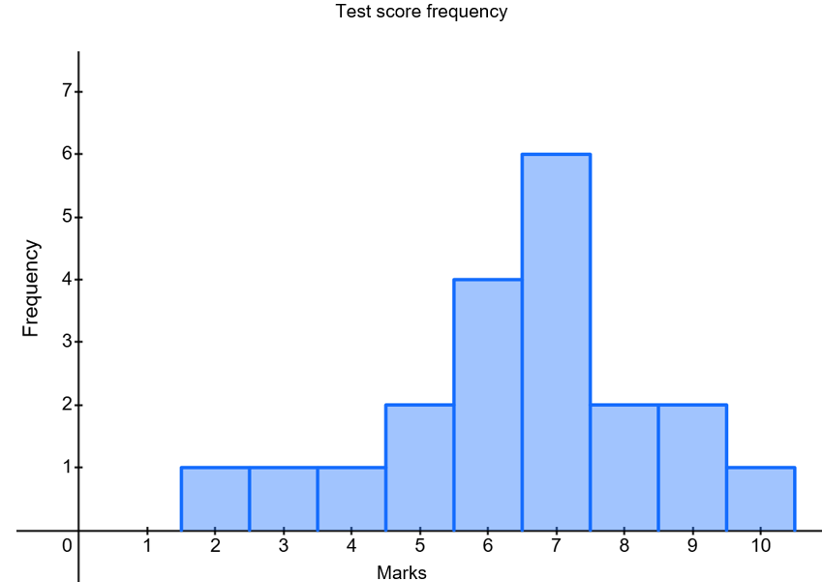
Source of data: student test scores.

Questions 6 to 9: refer to the information and graph in Figure 1 – frequency histogram of test scores.
Question 6: What is the range of marks in the class?
- 2
- 7
- 8
- 10
Question 7: What is the mode of this data?
- 2
- 7
- 8
- 10
Question 8: How many students scored less than 6 marks?
- 2
- 3
- 4
- 5
Question 9: Calculate the mean test score. What is it?
- 7.00
- 7.45
- 6.45
- 10.00

Growth rates of children
Use Figure 2 to complete question 10.
Figure 2 – median stature-for-age (height) of girls 2 to 18 years
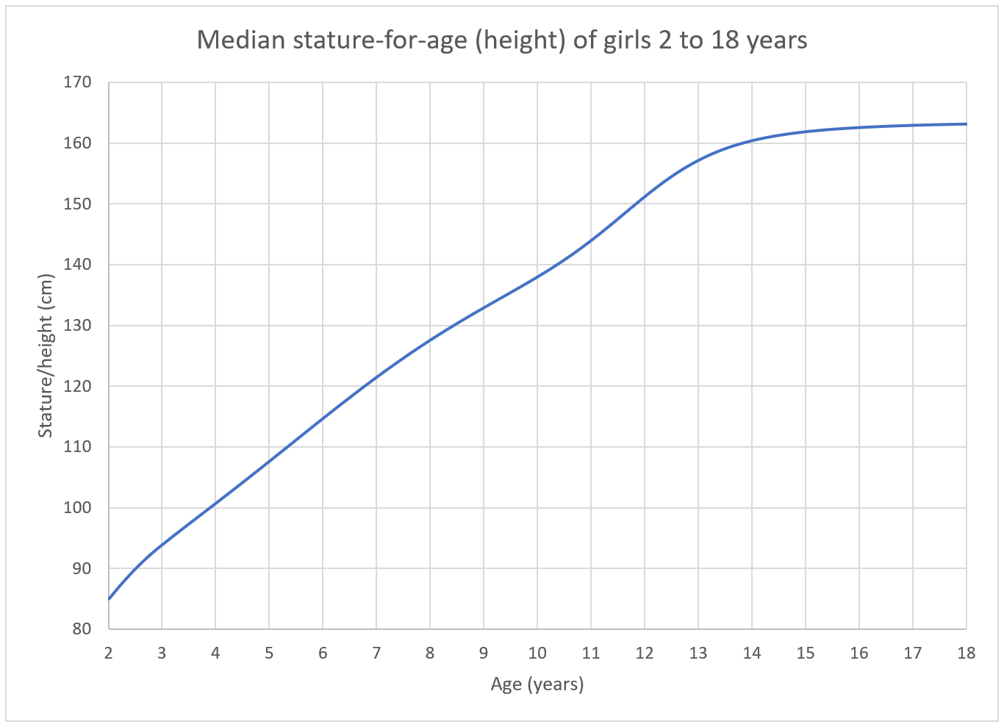
Source: Centers for Disease Control and Prevention (2000).
Question 10: refer to the information and graph in Figure 2 – median stature-for-age (height) of girls 2 to 18 years.
Question 10: Which age range do girls grow the slowest?
- 3 to 6 years
- 7 to 10 years
- 11 to 14 years
- 15 to 18 years

Part B – short response questions (25 marks)
Complete responses to questions 11 to 13 in the spaces provided.

Question 11 – density (9 marks)
A class of 16 students conducted an investigation to measure the density of a piece of quartz. They measured the mass of the quartz using a highly accurate balance. To determine its volume, they dropped the quartz into a measuring cylinder half-filled with water and recorded the change in the water's volume. This process was repeated 5 times, and the average density was then calculated.
All students had quartz pieces of similar sizes and used the same balance. However, 8 students (Group A) used a 25 mL measuring cylinder to measure the quartz’s volume, while the remaining 8 (Group B) used a 100 mL measuring cylinder.
Figure 3 – scale of measuring cylinders
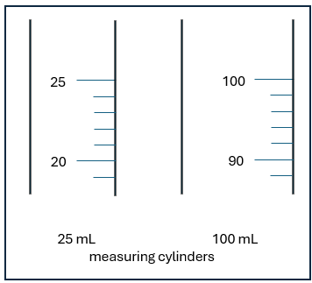
The mean density calculated by each student is shown in Table 3 (below). The true value of the density of quartz is 2.65 g/mL.

Table 3 – mean student result for the quartz density investigation
Student | Group A  Density (g/mL) | Group B  Density (g/mL)
1 | 2.75 | 2.6
2 | 2.70 | 2.4
3 | 2.75 | 2.8
4 | 2.60 | 2.5
5 | 2.70 | 2.6
6 | 2.55 | 2.6
7 | 2.75 | 2.9
8 | 2.70 | 2.5
Source of data: student investigation.
- Calculate the mean density for each group. Show your working. (2 marks)
- Calculate the range for each group. Show your working. (2 marks)
- With reference to the data in the table, identify which group’s results are more reliable and suggest a reason. (3 marks)
- Compare the accuracy of each group’s results. (2 marks)

Question 12 – digital footprint (7 marks)
Betty had been searching for border collie puppies on the internet and noticed that she was now seeing advertisements for dog food in her browser. She wondered if the content of her search might influence the types of advertisements that appear.
- Write a testable question that would test the inference. (1 mark)
- Describe how this question could be tested using data? (3 marks)
- What is a ‘digital footprint’, and what steps can you take to manage yours safely? (3 marks)

Question 13 – asking and answering questions (7 marks)
A student notices that the 2 tomato plants placed near a sunny window have grown taller and have more leaves compared to the 2 tomato plants kept in a shady corner. The plants near the sunny window each have about 13 leaves, while the plants in the shady corner each have about 7 leaves.
Figure 4 – effect of sunlight on tomato plants
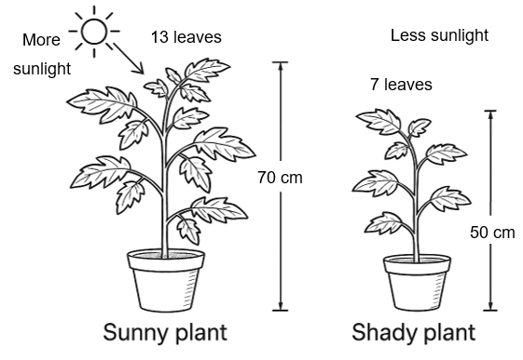
This work has been generated using artificial intelligence. Any copyright subsisting in this work is owned by © State of New South Wales (Department of Education) 2025.

- What inference can you make about the effect of sunlight on plant growth? Support your answer with the student's observations. (3 marks)
- Formulate a testable scientific question based on the student’s observations. (2 marks)
- What measurements or other data would you need to collect to test your question for this investigation? (2 marks)

Evidence base
This resource contains NSW Curriculum and syllabus content. The NSW Curriculum is developed by the NSW Education Standards Authority. This content is prepared by NESA for and on behalf of the Crown in right of the State of New South Wales. The material is protected by Crown copyright.
Please refer to the NESA Copyright Disclaimer for more information https://educationstandards.nsw.edu.au/wps/portal/nesa/mini-footer/copyright.
NESA holds the only official and up-to-date versions of the NSW Curriculum and syllabus documents. Please visit the NSW Education Standards Authority (NESA) website https://educationstandards.nsw.edu.au and the NSW Curriculum website https://curriculum.nsw.edu.au.
Science 7–10 Syllabus © NSW Education Standards Authority (NESA) for and on behalf of the Crown in right of the State of New South Wales, 2023.
Brookhart SM (2018) ‘Appropriate Criteria: Key to Effective Rubrics’, Frontiers in Education, 3(22):1–12, doi:10.3389/feduc.2018.00022, accessed 6 February 2025.
Centers for Disease Control and Prevention (2000) Stature-for-age charts, 2 to 20 years, LMS parameters and selected smoothed stature percentiles in centimeters, by sex and age [data set], National Center for Health Statistics website, accessed 14 October 2025.
CESE (Centre for Education Statistics and Evaluation) (2020). What works best: 2020 update, NSW Department of Education, accessed 18 July 2024.
——(2020) What works best in practice, NSW Department of Education, accessed 18 July 2024.
——(2021) Growth goal setting – what works best in practice, NSW Department of Education, accessed 18 July 2024.
Fisher D and Frey N (1 November 2009) ‘Feed Up, Back, Forward’, ASCD (Association for Supervision and Curriculum Development): Educational Leadership magazine, 67(3), accessed 6 February 2025.
Griffin P (2017) Assessment for Teaching, Cambridge University Press, Port Melbourne, Victoria.
Hattie J and Timperley H (2007) ‘The Power of Feedback’, Review of Educational Research, 77(1): 81–112, doi:10.3102/003465430298487, accessed 15 July 2024
Panadero E and Jonsson A (2013) ‘The use of scoring rubrics for formative assessment purposes revisited: A review’, Educational Research Review, 9:129–144, doi:10.1016/j.edurev.2013.01.002, accessed 6 February 2025.
Sherrington T (2019) Rosenshine’s Principles in Action, John Catt Educational Limited, Melton, Woodbridge.
Wiliam D (2017) Embedded Formative Assessment, 2nd edn, Solution Tree Press, Bloomington, IN.

© State of New South Wales (Department of Education), 2025
The copyright material published in this resource is subject to the Copyright Act 1968 (Cth) and is owned by the NSW Department of Education or, where indicated, by a party other than the NSW Department of Education (third-party material).
Copyright material available in this resource and owned by the NSW Department of Education is licensed under a Creative Commons Attribution 4.0 International (CC BY 4.0) license.

This license allows you to share and adapt the material for any purpose, even commercially.
Attribution should be given to © State of New South Wales (Department of Education), 2025.
Material in this resource not available under a Creative Commons license:
- the NSW Department of Education logo, other logos and trademark-protected material
- material owned by a third party that has been reproduced with permission. You will need to obtain permission from the third party to reuse its material.
Links to third-party material and websites
Please note that the provided (reading/viewing material/list/links/texts) are a suggestion only and implies no endorsement, by the New South Wales Department of Education, of any author, publisher, or book title. School principals and teachers are best placed to assess the suitability of resources that would complement the curriculum and reflect the needs and interests of their students.
If you use the links provided in this document to access a third-party's website, you acknowledge that the terms of use, including licence terms set out on the third-party's website apply to the use which may be made of the materials on that third-party website or where permitted by the Copyright Act 1968 (Cth). The department accepts no responsibility for content on third-party websites.

