Science Stage 4 (Year 8) – Data science 1
Teacher resource book 2 of 2 (TRB2)
2. How do scientific models help us understand and predict real-world events?
Creation date: 4 September 2025.
Contents
Overview 2
Glossary 2
2.1 Scientific inquiries 4
Scientific or nonscientific? 4
2.2 Scientific models 7
What is a scientific model? 7
Strengths and limitations of models 8
2.3 Analysing models 16
Modelling bushfire behaviour 16
Computer-based models 24
2.4 Applications of models 28
Observations, models and theories 28
Modelling an expanding Universe 35
From miasmas to germ theory 44
2.5 Making models – depth study (3 hours) 48
Making models 48
Evidence base 58

Overview
Stage and learning area: Stage 4 Science
Description: this resource complements the Data science 1 program of learning. It aims to serve as a teacher reference, offering practical strategies and ideas to enrich teaching practices and create engaging learning environments. The activities should be adapted to suit the students’ needs.
Duration: while timing will vary based on the mode of delivery, differentiation strategies employed, and class or school context, this series of activities should take approximately 19 hours. Note that Data science 1 has been split into 2 sections in the sample Science Stage 4 – scope and sequence. Part A, corresponding to TRB1 content, is taught at the start of Term 1 Year 8, and Part B, which corresponds to this TRB2 content, is taught at the end of Term 4, Year 8.
Risk management: teachers are advised to undertake a risk assessment before conducting any classroom investigation or experiment. For more information on developing risk assessments, see Risk Assessment – a pre-requisite for risk control.
This resource book elaborates on many of the activities in the Data science 1 sample program of learning. Some activities also reference the Data science 1 slide deck (identified as DA1 PPT throughout this document).

Glossary
Tier 3 words are those that are relevant for subject-specific content. More information is provided in the ‘Vocabulary in context’ document found on the Stage 5 reading – Vocabulary in context page. A glossary containing Tier 3 vocabulary related to the essential questions ‘How can we collect and evaluate the quality of our data?’ and ‘How is data generated, sourced and used in our daily lives?’ has been provided below. The Guide for planning and implementing explicit vocabulary instruction can be used by teachers across all curriculum areas.
Table 1 – glossary of key terms for Data science 1 TRB2
Term | Definition
Community (scientific) | A collaborative network of researchers, students and technicians who work together and exchange knowledge across different fields to improve understanding of the natural world.
Empirical | Based on measurements or direct observations, not on opinion.
Evidence | Valid and/or reliable data that can be used to support a particular theory, hypothesis, idea or conclusion (NESA 2025).
Observation | To see, watch, perceive or notice. Observations can be made using all 5 senses as well as digital and non-digital tools that extend our senses (NESA 2025).
Phenomenon | An observable event or process that occurs in the natural world, such as weather patterns, geological events, astronomical events, or biological processes (NESA 2025).
Question (scientific) | A question that can be answered through observation, evidence and systematic investigation.
Reliability | An extent to which repeated observations and/or measurements taken under identical circumstances will yield similar results (NESA 2025).

2.1 Scientific inquiries
Table 2 – learning intention and success criteria for ‘2.1 Scientific inquiries’
We are learning: | I can:
- how data is used by scientists to explain and predict scientific phenomena. | - describe a key difference between scientific inquiry and nonscientific approaches.

Scientific or nonscientific?
- Display DA1 PPT ‘2.1 Scientific inquiry’ to introduce a quote from Carl Sagan and key definitions for empirical evidence and objective observation.
- Present DA1 PPT ‘2.1 Your personal horoscope’, emphasising that it is personal for students, and get a show of hands who thought that it could be describing them. A Year 8 student might see alignment between a horoscope and their life because horoscopes use vague and general statements that can apply to many people, so they interpret them in a way that fits their own experiences.
- Display DA1 PPT ‘2.1 Horoscopes’ and watch the video Why Horoscopes Feel So Accurate - The Barnum Effect (0:42). Ask students, ‘What is the main claim this clip makes about horoscopes?’ Students are to consider the question, pair with a student next to them to discuss their thoughts, then share their combined thoughts with the class (a Think-Pair-Share activity).
Sample response:
The video claims horoscopes are not scientific because the personality descriptions are so vague that they could match anyone.
It suggests that if you give the same horoscope to an entire class, most people will believe it applies to them, indicating that the horoscope is too general.
- Display DA1 PPT ‘2.1 Testing a claim’ and ask students to consider what data could be collected to test the claim, ‘Your personality is shaped by your zodiac sign (Aries, Taurus, Gemini and so on). That is, the celestial objects in the region of the sky visible when you were born’. Guide a discussion about how this claim could be tested using the following points:
- If horoscopes truly reflect personality, then most students are more likely to choose the personality description written for their own star sign as the one that ‘fits them best’ than they are to pick descriptions for other signs.
- Prediction: students should choose their ‘correct’ description more frequently than chance (around 1 in 12).
- Method: give every student all 12 zodiac personality blurbs (anonymised or shuffled). Students select the personality blurb that best describes them. Data is recorded (students' actual zodiac sign and their chosen personality blurb).
- Measurable outcome: tally how many students’ first‑choice description matches their actual star sign and compare to the expected random rate.
- Complete the cloze exercise DA1 PPT ‘2.1 Scientific and nonscientific ways of knowing’.
- Using DA1 PPT ‘2.1 Scientific or nonscientific?’, categorise the approach used to support each of the claims as either scientific or nonscientific. For sample responses, see Table 3 below.
Table 3 – Are claims scientific or nonscientific?
Claim | Supporting evidence | Scientific/nonscientific
Plants grow faster when given more sunlight | Personal stories from friends and gardeners | Nonscientific
Plants grow faster when given more sunlight | Controlled experiments were conducted to measure plant growth under varying amounts of sunlight | Scientific
Wearing a lucky charm improves your test scores | Personal stories and beliefs are passed down culturally | Nonscientific
Crystals reduce anxiety by emitting special energy | Testimonials, influencer posts and occasional small studies without controls | Nonscientific
Telepathy lets people send thoughts without words | Stories from well-known celebrities (‘I knew you were going to call’) and stage demonstrations. | Nonscientific
Checkpoint: Why do scientists use objective observations and empirical evidence to discover and test knowledge about the natural world?
Sample response:
Scientists rely on objective observations and empirical evidence because these are the most reliable means of building knowledge about the natural world.
- An objective observation is something that anyone can see or measure in the same way under different conditions, thus avoiding personal bias.
- Empirical evidence is information gathered directly through careful observation or experimentation, meaning the data can be verified and replicated by other scientists.
When evidence is both objective and empirical, results can be tested and replicated, helping scientists decide whether a hypothesis should be accepted, revised or rejected.

2.2 Scientific models
Table 4 – learning intentions and success criteria for ‘2.2 Scientific models’
We are learning: | I can:
- to identify how scientific models can be used to explain and predict phenomena | - describe what a scientific model is and provide examples (physical, mathematical, conceptual)  - explain how models are built on data and observations  - discuss the importance of models in predicting future events or outcomes
- to use models to solve problems. | - select a suitable model of the Solar System for a given purpose.

What is a scientific model?
This lesson involves a class discussion about scientific models: What is a scientific model? What are some examples? What is their purpose?
- Show DA1 PPT ‘2.2 Scientific models – definition’ to clarify the definition of scientific models.
- Use slides DA1 PPT ‘2.2 Scientific models (1–3)’ to demonstrate and show examples of the types of scientific models: physical, conceptual and mathematical.
- Use DA1 PPT ‘2.2 The purpose of scientific models’ (1, 2 and 3) to share examples of the 3 main purposes of models.
- To consolidate learning, students complete the Frayer diagram (refer to DA1 PPT ‘2.2 Frayer diagram – scientific models’) to define and outline the key characteristics of scientific models. A sample response is provided in Figure 1.
Figure 1 – Frayer diagram of scientific models
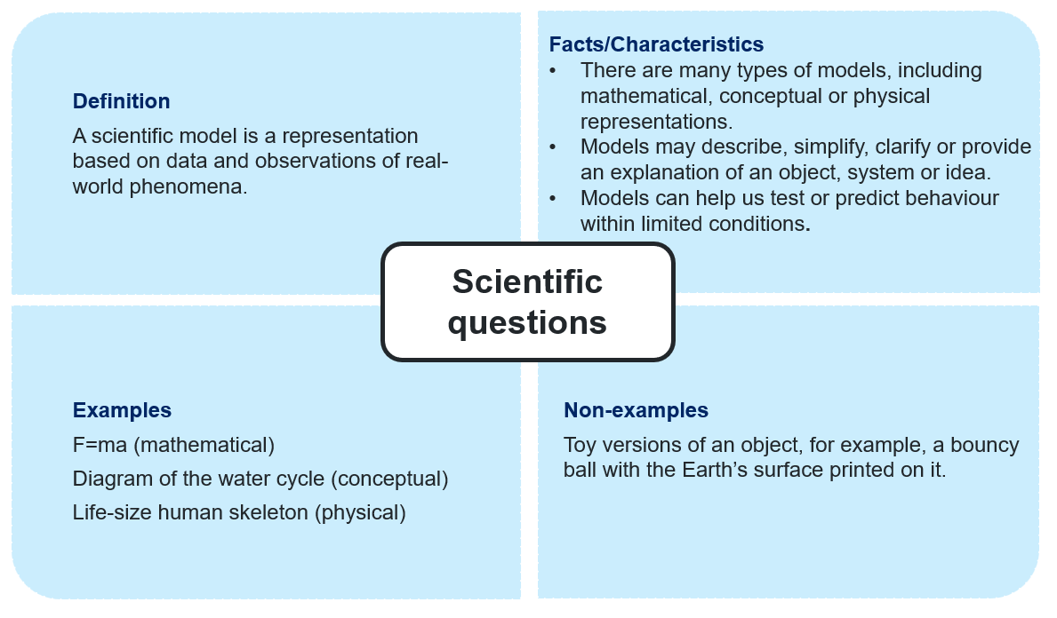

Strengths and limitations of models
- Tell students that all models have limitations, and the choice of an appropriate model is dependent on its purpose.
- Provide students with a copy of the Student resource – strengths and limitations of models and unpack the different types of models:
- Descriptive – accurately representing the key characteristics and features of the phenomenon.
- Explanatory – clearly illustrating how and why the phenomenon occurs, using scientific principles and relationships.
- Predictive – forecasts future events or behaviours of a system under varying conditions.
- Display DA1 PPT ‘2.2 – Limitations of scientific models’ (3 slides) and unpack the 3 models of the Solar System with students. For each model, students identify the purpose of the model (descriptive, explanatory or predictive) and summarise the strengths and limitations of the model. Speaker notes have been provided on each slide to support the discussion.

Sample responses: Student resource – strengths and limitations of models
Model 1
Note: Model 1 is purely descriptive and offers limited insight into explaining or predicting significant phenomena.
Table 5 – model evaluation template
Purpose | Strengths | Limitations
Descriptive | What essential features or parts of the phenomenon/system does this model show?  - It shows the order and relative size of each planet. | What features or details of the real system are missing or oversimplified?  - It does not show the relative distances between planets or describe their orbital motion.
Model 2
Note: Model 2 is purely descriptive and offers limited usefulness in explaining or predicting key phenomena.
Table 6 – model evaluation template
Purpose | Strengths | Limitations
Descriptive | What essential features or parts of the phenomenon/system does this model show?  - The model describes both the relative sizes and the distances between planets. | What features or details of the real system are missing or oversimplified?  - It does not describe the orbital motion of the planets.

Model 3
Note: the first 2 minutes of the video LEGO Orrery - Earth, Moon and Sun (4:33) demonstrate a model that describes the relative motion of the Earth, Moon and Sun. The model can also be used to describe and explain the phases of the Moon and the day-night cycle that occurs every 24 hours.
Table 7 – model evaluation template
Purpose | Strengths | Limitations
Descriptive | What essential features or parts of the phenomenon/system does this model show?  - The relative positions of the Earth, Sun and Moon.  - The time taken for the Earth to orbit the Sun and the Moon to orbit the Earth are close to being in the correct proportions.  - The period of rotation for each object is in correct proportions. | What features or details of the real system are missing or oversimplified?  - The relative size of each object is not in proportion to reality.  - The relative distance between objects is not in proportion to reality.
Explanatory | How does this model help you understand why things happen the way they do?  - It illustrates how the relative positions of the Earth, Moon and Sun influence the amount of the Moon visible each night. | Are there any parts of the explanation that are unclear, incomplete or misleading?  - Since the Sun does not produce light, a torch would need to be added to observe each of the Moon's phases.  - It does not explain why the Moon orbits the Earth.

Student resource – strengths and limitations of models
Scientific models possess one or more properties that enable us to understand or predict real-world phenomena. All models have limitations and we must consider these when determining whether a model suits our purpose. Models may be one or more of the following:
- Descriptive: accurately representing the key characteristics and features of the phenomenon.
- Explanatory: clearly illustrating how and why the phenomenon occurs, using scientific principles and relationships.
- Predictive: forecasts future events or behaviours of a system under varying conditions.
Model evaluation
Use the table below as a template to evaluate each model against its identified purpose(s).
Table 1 – model evaluation template
Purpose | Strengths | Limitations
Descriptive | What essential features or parts of the phenomenon/system does this model show? | What features or details of the real system are missing or oversimplified?
Explanatory | How does this model help you understand why things happen the way they do? | Are there any parts of the explanation that are unclear, incomplete or misleading?
Predictive | What kind of predictions can you make with this model, and how do you know they are valid? | In what situations might the model’s predictions not be accurate or useful?
- For each of the models of our Solar System, identify the main purpose(s) of the model (descriptive, explanatory and/or predictive). Record this in column 1 of each model evaluation table.
- Use the corresponding questions from Table 1 (above) to evaluate the strengths and limitations of each model. Record the strengths and limitations in the evaluation table for each model.
Models of our Solar System
Model 1
Figure 1 – Model 1 of the solar system
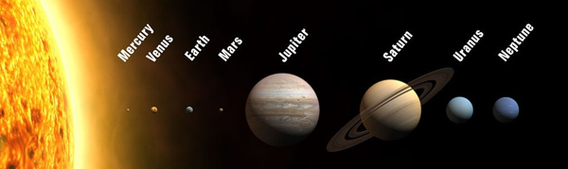
‘File:Planets2013.jpg’ by WP is licensed under CC BY-SA 3.0.
Table 2 – Model 1 evaluation
Purpose | Strengths | Limitations

Model 2
Figure 2 – Model 2 of the solar system
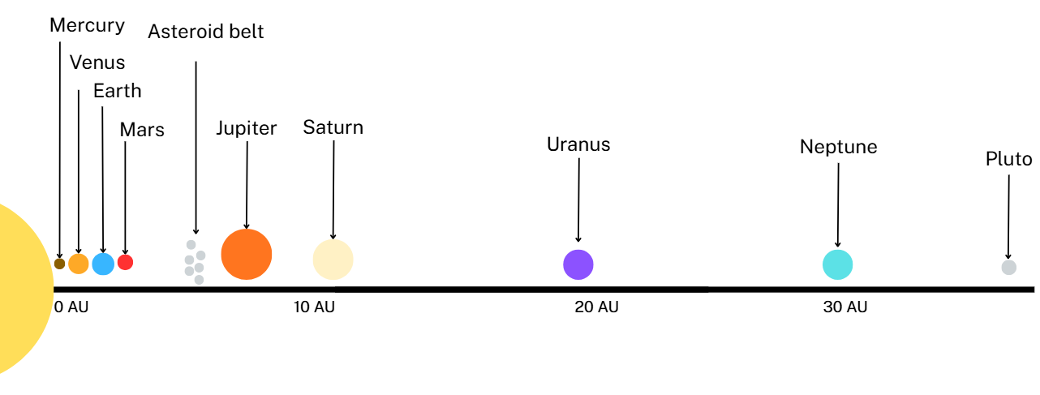
Table 3 – Model 2 evaluation
Purpose | Strengths | Limitations
Model 3
Watch the first 2 minutes of the video LEGO Orrery - Earth, Moon and Sun (4:33) to analyse the LEGO model Solar System being demonstrated.
Is Model 3 descriptive, explanatory and/or predictive? Tick the most appropriate.
☐ Descriptive
☐ Explanatory
☐ Predictive
Table 4 – Model 3 evaluation
Purpose | Strengths | Limitations

2.3 Analysing models
Table 8 – learning intentions and success criteria for ‘2.3 Analysing models’
We are learning: | I can:
- to identify how scientific models can be used to explain and predict phenomena | - propose possible outcomes or predictions based on data generated from a scientific model  - explain how adjusting variables within a model can change its predictions
- how to use data to identify trends and patterns. | - interpret data within a given model to find trends and patterns  - outline the advantages of using computer-based models.

Modelling bushfire behaviour
Equipment
- Coins (one per student)
Instructions
- Tell students that scientists use models to predict bushfire behaviour by simulating how fires spread under different environmental conditions. These models use data about weather (such as wind speed, temperature and humidity), vegetation type and moisture, and landscape features such as slope and aspect. By combining this information, scientists can estimate how quickly a fire might move, where it is most likely to spread and how intense it could become.
- Use the steps in the Student resource – modelling a bushfire to outline how the bushfire model 1 works.
- Students model the movement of a bushfire using the instructions for ‘Bushfire model 1’ in the Student resource – modelling a bushfire.
- Collate a class dataset of the total number of trials it took for the house to burn down in ‘Bushfire model 1’. Use the class dataset to calculate the mean and the range.
- Use the steps in the Student resource – modelling a bushfire to outline how ‘Bushfire model 2’ works.
- Students model the movement of a bushfire using the instructions for ‘Bushfire model 2’ in the Student resource – modelling a bushfire. This model is slightly more complex.
- Collate a class dataset of the total number of trials it took for the house to burn down in ‘Bushfire model 2’. Use the class dataset to calculate the mean and the range.
- Students complete responses to the reflection and evaluation questions in the Student resource – modelling a bushfire.
- Support students to complete the ‘Digging deeper – adapting the model’ section in the Student resource – modelling a bushfire. Encourage students to apply the suggested improvements to refine the model and improve its predictions of fire behaviour. Students could brainstorm other factors that influence the rate or likelihood of a fire spreading and plan how to incorporate them into the model. Consider using a dice or differently shaped or labelled ‘cells’ to represent additional factors. See the sample responses for additional suggestions to support student responses.
Sample responses: Student resource – modelling a bushfire
Sample class data
Note: results will vary between classes – sample data has been provided.
- Bushfire model 1 (single row): mean trials before burnt = 8, range = 1 to 25 trials.
- Bushfire model 2 (5 × 3 grid): mean trials before burnt = 4, range = 1 to 10 trials.
On average, more trials were required in ‘Bushfire model 1’, suggesting that the risk of burning is lower than in ‘Bushfire model 2’.
The range for both simulations included examples in which the house burned the first time. This suggests that fires are unpredictable and even a low-risk situation can escalate into a house fire.
Reflection and evaluation
What is the purpose of this model?
The model allows us to test how a bushfire might spread without using real flames. Each square is like a patch of land, and the coin flip gives a 50% chance that the fire will jump to the next square, so we can practise making and checking predictions safely.
How does this model help explain bushfire behaviour?
Running the simulation a few times revealed a pattern: the house rarely burned along the straight line in the single row model, but on the 3 × 5 grid model, it burned more often because each burning square touches more neighbouring squares to the house. This illustrates why fires spread more rapidly in wide forests than along a narrow strip.
What are the model's strengths and limitations?
Strengths: It enables us to test numerous scenarios quickly, generates measurable data (such as the number of coin flips until the house burns) and incorporates random chance, mirroring real-world weather variations.
Limitations: There is a 50% chance the fire will progress in this model. However, in nature, the probability of fire progression varies with factors such as humidity and temperature. Additionally, the scale of the fire is unrealistic. The spreading of real fires depends on wind, slope and fuel type.
How could the model be improved so that it could make better predictions of a fire's movement?
We could:
- use hexagons instead of squares so the fire can move in 6 possible directions, which would mimic a thick bush better
- add different colours for ‘dense fuel’ or ‘cleared land’ and adjust the spread probability for each
- add ‘barrier’ squares (breaks) to test fire‑break effectiveness
- code the model on a computer so it runs hundreds of trials and graphs the results.
Digging deeper – adapting the model
How can the model be refined to improve its predictions of fire behaviour?
- You could add a fuel load rating of H – Heavy, M – Medium or L – Low to each of the ‘cells’, for example:
Figure 2 – bushfire model with fuel rating
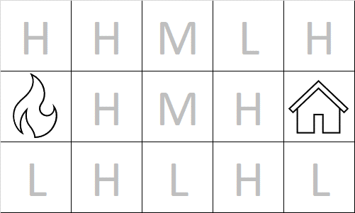
- A roll of the dice would then determine if the fire spreads from the ‘cell’ you are in. Noting that the heavier the fuel load, the greater the chance of the fire spreading. For example, dice rolls of:
- 3 or above for a high fuel load (H) results in the fire spreading
- 4 or above for a medium fuel load (M) results in the fire spreading
- 5 or above for a low fuel load (L) results in the fire spreading.
- This could be repeated for wind speeds for each ‘cell’. For example, S – Strong, M – Moderate, G – Gentle or N – No wind.
What are the limitations of simple and complex models?
Simple models, such as the bushfire coin toss activity, are easy to use and help illustrate basic concepts. However, they miss important details; real fires are affected by factors such as wind, fuel and humidity, not just chance. Complex models incorporate more factors and can provide more accurate predictions, but they are more challenging to understand and often require additional data. Both types of models can be incorrect if key information is missing.

Student resource – modelling a bushfire
In this activity, you will look at how scientists create and test simple models to study bushfire behaviour.

Bushfire model 1
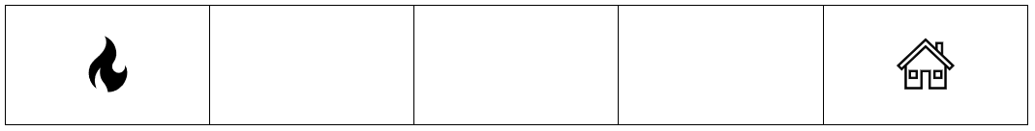
Step 1: predict how many trials will take place before the house burns down.
Step 2: draw 5 adjacent squares with a fire in the first square and a house in the last square, as shown in ‘Bushfire model 1’.
Step 3: starting with the right edge of the first box, flip a coin:
- If heads, the fire spreads – draw fire in the next box to the right. The next coin flip starts from this box.
- If tails, the fire does not spread – put an ‘x’ on that right edge. This is the end of the trial as the fire burns itself out.
Step 4: if the fire spreads, flip the coin again to see if it spreads to the next box.
Step 5: repeat steps 2 to 5 until the house burns down and report how many trials it took.
How many trials did it take until the house burnt down?

Bushfire model 2 – a more complex model
Bushland and forest areas can cover large areas, and fires may spread in multiple directions. In ‘Bushfire model 2’, the fire may take many different paths toward the house.
Bushfire model 2
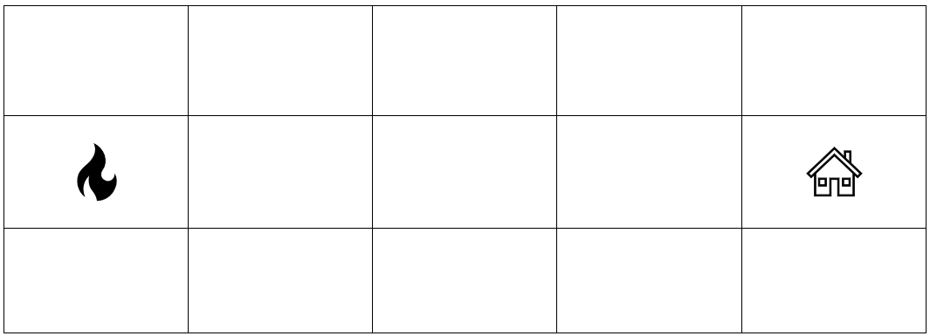
Step 1: predict how many trials will take place before the house burns down.
Step 2: draw 15 squares (5 × 3 squares) with a fire in the first square of the middle row and a house in the last square of the middle row, as shown in ‘Bushfire model 2’ above.
Step 3: decide whether your fire should first move to the box on the right, up or down from the starting fire.
Step 4: flip a coin.
- If heads, the fire spreads – draw fire in the box you selected in Step 2.
- If tails, the fire does not spread – put an ‘x’ on the edge of the box you are in. The fire can no longer move in this direction.
Step 5: look for a new edge (not marked with an ‘x’) for the fire to cross and complete steps 4 and 5 until the fire ‘burns out’ (trapped by x’s) or burns the house down.
Step 6: continue trialling until the house burns down and report how many trials it took.

How many trials did it take until the house burnt down?
Reflection and evaluation
What is the purpose of this model?
How does this model help explain bushfire behaviour?
What are the model’s strengths and limitations?

How could the model be improved so that it could make better predictions of a fire's movement?
Digging deeper – adapting the model
How can the model be refined to improve its predictions of fire behaviour?
What are the limitations of simple and complex models?

Computer-based models
Students use an online fire simulator to explore how factors such as wind speed, temperature and humidity affect the spread of bushfires.
- Introduce computer simulators used to model bushfires DA1 PPT ‘2.3 Computer simulations for bushfires’ (2 slides).
- Share the Student resource – wildfire computer-based model and assist students in navigating to the GridFire website.
- Guide the students to complete the activities and achieve each of the Wildfire game goals.
- Students then respond to each of the reflection questions, using the sample answers to support them in answering the questions.
Dig deeper – how computer models help us predict and manage bushfires
Explore Spark Operational, the newest bushfire simulator designed to support Australian fire agencies, DA1 PPT ‘2.3 Dig deeper – Advanced fire prediction simulators’. Students can research and present information on the additional factors that affect bushfire behaviour, which can be modelled using this tool.
Sample responses: Student resource – wildfire computer-based model
Reflection questions
Which single setting (wind speed, temperature or humidity) made the biggest difference to the size of the fire in your 3 experiments? Explain using data generated in the game.
Wind speed made the biggest difference. When the wind speed was high, it burnt an average of 611 squares, compared to 8 when it was low. That is, the range of values was greatest for changes in wind speed.

Evaluate the quality of the data you collected from GridFire. What are 2 strengths and 2 limitations of the model that could affect the accuracy of your predictions?
Strengths
- The model lets me change one variable at a time so I can determine whether a cause-and-effect relationship exists between them.
- The model records exact numbers (burned cells) and graphs them so I can spot trends.
Limitations
- The model uses a uniform grid. In real life, vegetation is often uneven, causing the fire to spread in a zig‑zag manner.
- The weather remains steady during the whole run, but real bushfires last for hours or days and conditions can change.
Due to these limitations, my predictions are helpful for learning, but they require more detailed data before firefighters can apply them effectively.
Suggest one realistic improvement to the GridFire model that would make its predictions closer to what happens in nature.
Add a ‘wind change’ slider to allow the direction to swing during the run. Sudden wind shifts are common during summer storms and can trap firefighters in hazardous situations. If the model included that, it would teach us how quickly a fire front can pivot and create new danger zones.

Student resource – wildfire computer-based model
What is a simulator?
A simulator is a computer program that replicates how something occurs in the real world. By adjusting the inputs, you can observe how outcomes might vary.
Why do we model bushfires?
Fires spread quickly and change rapidly. Firefighters need to predict where a fire might go before it arrives. Real-life experiments are not practical because we cannot safely ignite large areas to observe the outcomes. Models allow us to test ideas safely. On a computer, we can ask, ‘What if the wind shifts?’ or ‘What if the grass is wetter?’ without any risk.
Instructions
- Navigate to the GridFire website and select ‘Wildfire Lesson and Game’.
- Navigate the pages to learn about the factors affecting bushfire behaviour.
- Play the Wildfire game to achieve each of the goals.
- Respond to each of the reflection questions.
Reflection questions
Which single setting (wind speed, temperature or humidity) made the biggest difference to the size of the fire in your 3 experiments? Explain using data generated in the game.

Evaluate the quality of the data you collected from GridFire. What are 2 strengths and 2 limitations of the model that could affect the reliability of your predictions?
Suggest one realistic improvement to the GridFire model that would make its predictions closer to what happens in nature.

2.4 Applications of models
Table 9 – learning intentions and success criteria for ‘2.4 Applications of models’
We are learning: | I can:
- to explain how data is used to model scientific phenomena | - identify the data and observations that inform the development of a model  - outline how models are refined over time as new evidence is obtained  - recognise the strengths and limitations of a scientific model when proposing or testing solutions
- how to use data to identify patterns and relationships. | - identify a pattern and/or relationship described in a scientific model.

Observations, models and theories
The purpose of this activity is to illustrate how a scientific model evolves and improves as new data become available.
- Present slides 1 to 8 of DA1 PPT ‘2.4 Observations, models and theories’ and read the script, under teacher notes, in each of the slides. The script guides students through a sequence of events, incorporating new observations that led to the development and refinement of the Solar System model. Encourage class discussion on how the model of the universe evolved over time, based on observations and the technologies available at each stage.
Note: the intention is not for students to learn about the timeline of events in the history of astronomy and the astronomers involved, but to show how models are developed and refined.
- Before handing out Student resource – observations, models and theories where students answer questions on the history of the development of the Big Bang theory, read to the class the ‘historic event’ column of the table below. Anecdotes have been provided for each historic event to help tell the story of this development. This will support students' understanding when they engage with reading Article 1 in the Student resource – observations, models and theories.
Table 10 – the development of the Big Bang theory
Historic event | Anecdote
At the beginning of the 20th century, many scientists, including Albert Einstein, believed the Universe was ‘static’. It was neither expanding nor contracting, but steady. | Einstein’s original theory of general relativity predicted an expanding Universe. However, he was so opposed to the idea that he added a fudge factor into his equations, a cosmological constant, so that the model would not suggest an expanding Universe. After the evidence made it clear that the Universe was expanding, he reportedly said that this was one of his greatest regrets.
In the 1910s, astronomer Vesto Slipher studied the spectra of distant galaxies and observed that their light shifted towards the red end of the spectrum. This ‘redshift’ suggested that the galaxies must be moving away at high speeds. The larger the redshift, the faster the galaxies are travelling. | Choose whether to elaborate on the redshift or not, depending on your class.
Also in the 1910s, the American astronomer Henrietta Leavitt discovered a method for measuring the distances between stars. Another American astronomer Edwin Hubble used this method to confirm that the Andromeda Nebula, previously thought to be within the Milky Way, was another galaxy much farther away than initially expected.  By combining the speeds observed from the spectra and using Leavitt’s method for measuring distances, Hubble was able to demonstrate that the rate at which galaxies recede is proportional to their distance from Earth. This provided strong evidence that the Universe is not static but expanding, leading to 2 competing hypotheses.  Other astronomers, such as Fred Hoyle, proposed a steady-state model. This model suggests that the Universe is expanding while maintaining a constant amount of matter by continuously creating new matter. | Hoyle was a very high-profile astronomer who was regularly on the BBC, where he coined the term ‘Big Bang’. He also proposed the panspermia theory.
Scientist Georges Lemaître proposed a model suggesting that the Universe expanded from an extremely hot, concentrated point of energy (a singularity). As it expanded and cooled, energy was converted into matter – mainly hydrogen – which ultimately led to the formation of stars and galaxies.  Hoyle called this the Big Bang model, and the name stuck. He also pointed out that the Big Bang model predicted cosmic background radiation and challenged it, claiming that no such radiation had been detected.  In 1960, scientists Arno Penzias and Robert Wilson detected radiation in space that matched the properties predicted by the Big Bang model, providing further evidence to support it. This model has become the prevailing theory, which is now widely accepted by the scientific community. | The scientists were aiming to measure something else. However, no matter which direction in space they pointed their antenna, they encountered interference. They first thought the interference might have been caused by the pigeon poo that had built up from the flock of pigeons residing on the antenna. Still, even after they ‘relocated’ the pigeons, the interference continued. A closer look showed that it was the Cosmic Microwave Background (CMB).
- Students read Article 1 and answer the questions in the Student resource – observations, models and theories.
Extension: provide students with strong mathematical potential with data to plot a graph of recession velocity versus distance and use it to determine Hubble’s constant. DA1 PPT ‘2.4 Hubble’s law extension activity’ has data to be plotted.
Sample responses: Student resource – observations, models and theories
- What did most scientists believe about the Universe at the start of the 20th century?
It was static. It was not changing.
- What observations led to a revision of the static model of the Universe?
The light from distant galaxies is redshifted, indicating they are moving away.
- Hubble’s law says that the speed at which galaxies are moving away is proportional to their distance from the Earth. Rewrite this statement without using the word proportional.
The farther away galaxies are from Earth, the faster they move.
- The Steady State and Big Bang theory diagrams in Figure 1 represent the Steady State and the Big Bang models of the expanding Universe. Identify which is which and justify your decision.
Steady State model (top): The universe expands, but new matter continuously forms (shown by new dots appearing), so the overall density stays roughly constant over time.
Big Bang model (bottom): The universe expands from a hot, dense starting point. As it expands, galaxies move apart and become less dense, but no new matter is created.
Justification: In the top sequence, the number of dots increases to maintain a steady appearance despite expansion, which aligns with the Steady State theory. In the bottom sequence, the dots spread out with no new ones forming, which matches the Big Bang model, where the universe thins as it expands.
- One of the features of a good model that can lead to a workable theory is that it makes testable predictions. What did the Big Bang model predict that was later discovered by Wilson and Penzias?
Cosmic background radiation.

Student resource – observations, models and theories
Read Article 1 and answer the following questions.
Article 1 – history of the Big Bang theory
At the start of the 20th century, many scientists, including Albert Einstein, believed that the Universe was static, meaning it was neither growing nor shrinking but remaining the same. Einstein even added a special term (called the cosmological constant) to his equations to keep the Universe stable.
But in the 1910s, an astronomer named Vesto Slipher studied the light from distant galaxies. He noticed something strange: the light was redshifted. It had moved toward the red end of the spectrum. This happens when something is moving away from us, kind of like the sound of a siren getting lower as it drives away. This meant that galaxies were moving away from Earth.
Around the same time, an American astronomer named Henrietta Leavitt developed a method to measure distances in space by studying specific types of stars. Her discovery helped other scientists determine the distances of stars and galaxies from Earth.
A few years later, Edwin Hubble used Leavitt’s method to measure the distance to the Andromeda Nebula. People used to think it was part of our Milky Way galaxy, but Hubble showed it was a separate galaxy located far outside our own. That was a huge discovery!
Hubble also studied the redshifts of many galaxies and made another significant discovery: the farther away a galaxy is, the faster it is moving away from us. This became known as Hubble’s law and provided strong proof that the Universe is expanding.
This led to 2 competing ideas about how the Universe works:
- The Steady State model – suggested by Fred Hoyle and others, this idea says that the Universe is expanding, but new matter is always being created so that the overall density stays the same.
- The Big Bang model – suggested by Georges Lemaître, this idea says that the Universe started from a tiny, super-hot, super-dense point. As it expanded and cooled, energy turned into matter (mostly hydrogen), and this led to the formation of stars and galaxies.
Fred Hoyle did not like the Big Bang theory and made fun of it by calling it the ‘Big Bang’ during a radio show in 1949, but the name stuck!
One important prediction of the Big Bang theory was that we should still be able to detect some leftover heat from the early Universe. In 1964, 2 scientists, Arno Penzias and Robert Wilson, accidentally discovered cosmic background radiation while working on a radio antenna. It was exactly the kind of signal the Big Bang theory had predicted.
This discovery provided strong evidence that the Big Bang occurred. Today, it is the most widely accepted explanation for how the Universe began and how it continues to evolve.
- What did most scientists believe about the Universe at the start of the 20th century?
- What observations led to a revision of the static model of the Universe?
- Hubble’s law says that the speed at which galaxies are moving away is proportional to their distance from the Earth. Rewrite this statement without using the word proportional
- The diagrams in Figure 1 represent the steady state and the Big Bang models of the expanding Universe. Identify which is which and justify your decision.
Figure 1 – Steady State vs Big Bang models
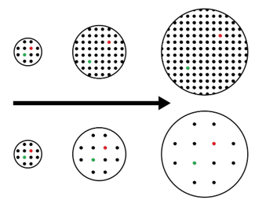
‘Big Bang Steady-state theory’ by Wikipedia is licensed under CC0 1.0.
- One of the features of a good model that can lead to a workable theory is that it makes testable predictions. What did the Big Bang model predict that was later discovered by Wilson and Penzias?

Modelling an expanding Universe
Students conduct a practical investigation to model the expansion of the Universe, using the Student resource – modelling an expanding Universe.
- Take a piece of elastic material and use a marker to indicate the position of Earth at one end.
- Mark the positions of galaxies A, B and C at distances of 20 cm, 60 cm and 100 cm from Earth.
- Secure the position of Earth at 0 cm on a measuring tape or ruler.
- Stretch the elastic material so that Galaxy C moves 10 cm further away and record the new distance between each galaxy and Earth.
The stretching at each step models the passage of time. Over time, the space in between galaxies expands, but the galaxies remain the same size.
- Repeat 4 more times until the elastic has been stretched by 50 cm. DA1 PPT ‘2.4 Modelling an expanding Universe’ demonstrates to students how the model is set up.
Figure 3 – experimental set-up for modelling an expanding Universe
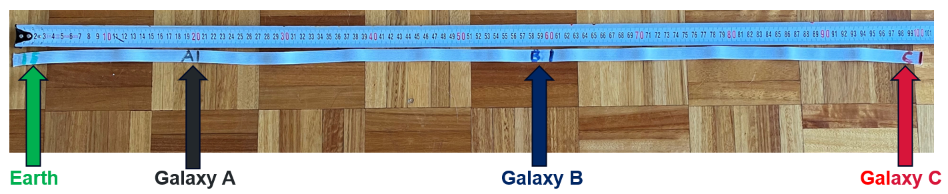
Sample responses: Student resource – modelling an expanding Universe
Table 11 – change in distances of galaxies from Earth (sample)
 | Distance from Earth to galaxy
Stretch number | Galaxy A (cm) | Change (cm) | Galaxy B (cm) | Change (cm) | Galaxy C (cm) | Change (cm)
0 | 20 | – | 60 | – | 100 | –
1 | 22 | 2 | 67 | 7 | 110 | 10
2 | 24.5 | 2.5 | 73.5 | 6.5 | 120 | 10
3 | 26.5 | 2 | 80 | 6.5 | 130 | 10
4 | 29 | 3.5 | 86.5 | 6.5 | 140 | 10
5 | 31 | 2 | 93 | 6.5 | 150 | 10
Plot a line graph of distance from the Earth versus time for each galaxy.
Figure 4 – graph of sample results
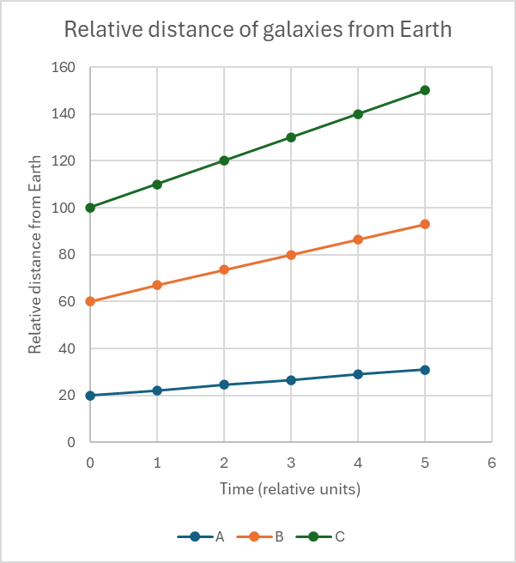
Data source: student investigation
- For each galaxy, calculate the mean change in its distance from the Earth.
$A={(2+2.5+2+3.5+2)}/5=2.2$ cm
$B={(7+6.5+6.5+6.5+6.5)}/5=6.6$ cm
$B={(10+10+10+10+10)}/5=10$ cm
- In this model, what does the distance change per stretch represent?
The rate at which a galaxy is receding (moving away from Earth).
- Make use of the data to discuss the effectiveness of this model in demonstrating Hubble’s law.
The model effectively illustrates the expansion of the Universe, with each galaxy moving farther away from Earth. It also shows that galaxies farther from Earth travel faster. This is illustrated by Galaxy C shifting by an average of 10 cm each time, while Galaxies B and A shift by 6 cm and 2 cm, respectively. This is consistent with Hubble's law.
The limitations of the model include that it is only one-dimensional, whereas the Universe expands in 3 dimensions. The distance moved in each stretch is relatively constant for each galaxy, which should increase as they get further away from Earth. There is a limit to how far galaxies can move due to the material's elasticity, and it is obviously not to scale.
Differentiation: for students requiring additional support for question 3, a scaffold or a cloze passage can be provided as follows:
What the model does well:

Limitations of the model

The model successfully shows the _______________ of the Universe, with each galaxy moving farther away from Earth. It also shows that galaxies farther from Earth move at a greater ____________. This is shown as Galaxy C moves a mean of _____ cm each stretch, while Galaxies B and A move a mean of ___ cm and ______ cm, respectively, each time. This is consistent with _____________ Law.
One limitation of the model is that it is only ______________, whereas the Universe expands in 3 dimensions. Also, the distance moved each stretch is relatively constant for each galaxy; however it should ______________ as they get further away from Earth. There is a limit to how far they can move because of the elasticity of the material, and it is obviously not to _________.
Word bank
one-dimensional, expansion, Hubble’s, increase, scale, speed, 2, 10, 6.

Student resource – modelling an expanding Universe
Instructions
- Take a piece of elastic material and use a marker to indicate the position of Earth at one end.
- Then mark the positions of galaxies A, B and C at distances of 20, 60 and 100 cm from Earth.
- Secure the position of Earth at 0 cm on a measuring tape.
- Stretch the elastic by 10 cm and record the new distance between each galaxy and the Earth.
- Calculate the change in distance from the previous position in cm.
- Repeat 4 more times until the elastic has been stretched to a total of 50 cm.
Figure 1 – experimental set-up for modelling an expanding Universe

Table 1 – change in distances of galaxies from Earth
 | Distance from Earth to galaxy
Stretch number | Galaxy A (cm) | Change (cm) | Galaxy B (cm) | Change (cm) | Galaxy C (cm) | Change (cm)
0 | 20 | 0 | 60 | 0 | 100 | 0
1
2
3
4
5

Plot a line graph of relative distance of galaxies A, B and C from Earth. Place the stretch number on the x-axis and the relative distance from Earth on the y-axis.

Questions
- For each galaxy, calculate the mean change in its distance from the Earth.
- In this model, what does the distance change per stretch represent?
- Make use of the data to discuss the effectiveness of this model in demonstrating Hubble’s law.

From miasmas to germ theory
- Watch the video How a few scientists transformed the way we think about disease - Tien Nguyen (4:39) outlining John Snow’s contribution to the development of germ theory through the use of modelling.
- Students complete questions from the Student resource – From miasmas to germ theory.
Sample responses: Student resource – from miasmas to germ theory
- What did miasma theory suggest caused diseases such as influenza?
Wandering clouds of poisonous vapour.
- Miasma theory seemed able to explain respiratory symptoms, but what symptoms of cholera made Snow think it might be from something else?
Cholera causes severe vomiting and diarrhea, which are symptoms of the digestive system, not the respiratory system.
- How did Snow identify that the source of cholera was a water pump?
He mapped the location of the people in Soho who had died from cholera and found that most of them resided near the water pump. After shutting down the pump, the number of cases declined significantly.
- What other evidence supported Snow’s assertion that the water pump was the source of the disease?
The lady who lived far away from the pump, but had consumed water from it, died of cholera.
The nearby workhouse, which housed hundreds of people, had very few cases of cholera. This workhouse had its own private well.
Snow discovered that the nappies of an infected baby had been thrown into the water near the pump.

- What model was proposed by Snow for the transmission of cholera?
Cholera was transmitted through contaminated water sources.
- What is germ theory?
Disease is caused by microorganisms (germs).
- How did the work of Robert Koch contribute to the development of germ theory?
Koch isolated the suspected cholera-causing bacteria and, through experiments, proved that they caused cholera.

Student resource – from miasmas to germ theory
Watch How a few scientists transformed the way we think about disease - Tien Nguyen (4:39) which outlines John Snow’s contribution to the development of germ theory through the use of modelling, and answer the following questions.
- What did miasma theory suggest caused diseases such as influenza?
- Miasma theory seemed able to explain respiratory symptoms, but what symptoms of cholera made Snow think it might be from something else?
- How did Snow identify that the source of cholera was a water pump?
- What other evidence supported Snow’s assertion that the water pump was the source of the disease?
- What model was proposed by Snow for the transmission of cholera?
- What is germ theory?
- How did the work of Robert Koch contribute to the development of germ theory?

2.5 Making models – depth study (3 hours)
Table 12 – learning intentions and success criteria for ‘2.5 Making models – depth study’
We are learning: | I can:
- how data is used to model scientific phenomena | - select and organise relevant data to develop a simple model  - use the model to explain how or why an observable phenomenon occurs
- how to use data to identify patterns and relationships | - identify a pattern or relationship described in a scientific model
- to propose solutions to problems. | - create a scientific model to explain an observable phenomenon.

Making models
The purpose of this activity is to have students develop a model that explains an observable phenomenon.
- Outline how cause and effect are related in an explanation in DA1 PPT ‘2.5 Explanations’.
- Provide students with examples of phenomena to model DA1 PPT ‘2.5 Observed phenomenon’. The model should:
- be easy to understand and clearly explained
- accurately reflect what scientists know about how the phenomenon works
- use data, observations or examples to support the explanation
- help make predictions or answer questions about the phenomenon.

Note: the slide offers a few suggestions. The suggestion modelled in the sample responses may be challenging without teacher guidance, however, students could be supported by being shown sections of the video Why do buildings fall in earthquakes? - Vicki V. May (4:51). There are simpler examples of models, such as a solar eclipse. This example also provides scope for differentiation, ranging from models that show the moon passing between the Earth and the Sun to those that include the correct ratios of distance and size.
You can allow students to choose, guide the class through one example or let students produce their own. You can generate further ideas by brainstorming with the class.
- Students research their chosen phenomenon and complete the questions in the Student resource – making models.
- Evaluate the model using the criteria provided and suggest how improvements could be made for each criterion. Self-, peer, and/or teacher evaluation could be used.
Sample responses: Student resource – making models
- Describe the observation or phenomenon you are seeking to explain.
In the 1985 Mexico earthquake, more damage was done to buildings ranging from 6 to 15 stories high, while shorter and taller buildings were less affected.
- To explain how or why something happens, you need to relate cause and effect. Identify the cause and effect that you are going to model.
Effect: more damage was done to buildings ranging from 6 to 15 stories high.
Cause: the frequency of vibration was closer to the resonant frequency of these buildings.
- Explain the observation or phenomenon that you are going to model.
More damage was done to buildings ranging from 6 to 15 stories high because the ground shook at a frequency that was closer to the resonant frequency of these buildings.

- Create a model that supports your explanation.
- Insert a photo or diagram of your model.
Figure 5 – a model that demonstrates the effect of earthquakes on building height
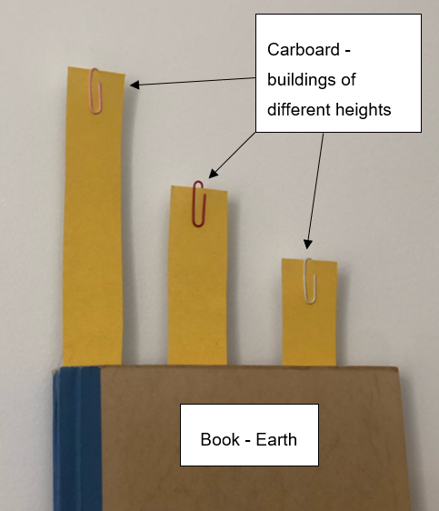
- Describe the main features of your model. Outline what each component represents.
The 3 pieces of cardboard represent buildings of different heights. The shaking of the book represents the earthquake. The tall building swayed most when the book was shaken slowly. The shorter building swayed the most when the book was shaken fast.
- Outline the limitations of your model.
The ‘buildings’ are two-dimensional and can only vibrate in one plane or direction.
They are made of cardboard, which is not a typical building material, and the degree of shaking is exaggerated.

- Record the references used to develop your model.
Table 13 – references used to make the model
Source name | Source location | Date accessed
Why do buildings fall in earthquakes? | TED-Ed YouTube:  https://www.youtube.com/watch?v=H4VQul_SmCg | 15 August 2025
Evaluation
Table 14 – evaluation criteria and feedback
Criteria | Agree/disagree | This criteria of the model could be improved by:
The model is easy to understand and clearly explained | Agree | The different building heights and the use of a book to represent the Earth make it simple to see how shaking affects each building differently. A range of heights could be used to reflect the diversity of buildings.
The model accurately reflects what scientists know about how the phenomenon works | Agree | The model accurately demonstrates that taller buildings experience greater movement during an earthquake because they have longer natural frequencies. It could be improved by showing how building materials or shapes affect stability.
The model uses data, observations or examples to support the explanation | Disagree | The model demonstrates the concept visually but doesn’t include data or movement measurements. Adding numerical data on how much each ‘building’ moves would make it more scientific.
The model helps make predictions or answer a question about the phenomenon | Agree | The model helps predict that taller buildings are more likely to sway or collapse in strong earthquakes compared to gentle earthquakes. It could be improved by testing and recording results under controlled shaking speeds to confirm this.

Student resource – making models
Your task is to investigate the cause of a chosen observation or phenomenon and develop a model that explains how or why it occurs. Keep a record of your sources of information, as you will be required to reference them later.
- Describe the observation or phenomenon you are seeking to explain.
- To explain how or why something happens, you need to relate cause and effect. Identify the cause and effect that you are going to model.
Effect:
Cause:

- Explain the observation or phenomenon that you are going to model.
Create a model that supports your explanation. Your model should
- be easy to understand and clearly explained
- accurately reflect what scientists know about how the phenomenon works
- use data, observations or examples to support the explanation
- help make predictions or answer questions about the phenomenon.
- Insert a photo, diagram or description of your model.

- Describe the main features of your model. Outline what each component represents.
- Outline the limitations of your model.

- Record the references used to develop your model.
Table 1 – references used to make the model
Source name | Source location | Date accessed
Evaluation
Table 2 – evaluation criteria and feedback
Criteria | Agree/disagree | This criteria of the model could be improved by:
The model is easy to understand and clearly explained.
The model accurately reflects what scientists know about how the phenomenon works.
The model uses data, observations, or examples to support the explanation.
The model helps make predictions or answer questions about the phenomenon.

Evidence base
This resource contains NSW Curriculum and syllabus content. The NSW Curriculum is developed by the NSW Education Standards Authority. This content is prepared by NESA for and on behalf of the Crown in right of the State of New South Wales. The material is protected by Crown copyright.
Please refer to the NESA Copyright Disclaimer for more information https://educationstandards.nsw.edu.au/wps/portal/nesa/mini-footer/copyright.
NESA holds the only official and up-to-date versions of the NSW Curriculum and syllabus documents. Please visit the NSW Education Standards Authority (NESA) website https://educationstandards.nsw.edu.au and the NSW Curriculum website https://curriculum.nsw.edu.au.
Science 7–10 Syllabus © NSW Education Standards Authority (NESA) for and on behalf of the Crown in right of the State of New South Wales, 2023.
AITSL (Australian Institute for Teaching and School Leadership Limited) (n.d.) Learning intentions and success criteria [PDF 251 KB], AITSL, accessed 18 July 2024.
Brookhart SM (2018) ‘Appropriate Criteria: Key to Effective Rubrics’, Frontiers in Education, 3(22):1–12, doi:10.3389/feduc.2018.00022, accessed 6 February 2025.
CESE (Centre for Education Statistics and Evaluation) (2020) What works best: 2020 update, NSW Department of Education, accessed 18 July 2024.
——(2020) What works best in practice, NSW Department of Education, accessed 18 July 2024.
——(2021) Growth goal setting – what works best in practice, NSW Department of Education, accessed 6 February 2025.
Fisher D and Frey N (1 November 2009) ‘Feed Up, Back, Forward’, ASCD (Association for Supervision and Curriculum Development): Educational Leadership magazine, 67(3), accessed 18 July 2024.
Griffin P (2017) Assessment for Teaching, Cambridge University Press, Port Melbourne, Victoria.
Hattie J and Timperley H (2007) ‘The Power of Feedback’, Review of Educational Research, 77(1): 81–112, doi:10.3102/003465430298487.
JK Brickworks (27 February 2016) 'LEGO Orrery - Earth, Moon and Sun' [video], JK Brickworks, YouTube, accessed 27 July 2025.
One Minute Logic (18 June 2025) ‘Why Horoscopes Feel So Accurate - The Barnum Effect’ [video], One Minute Logic, YouTube, accessed 27 July 2025.
Panadero E and Jonsson A (2013) ‘The use of scoring rubrics for formative assessment purposes revisited: A review’, Educational Research Review, 9:129–144, doi:10.1016/j.edurev.2013.01.002.
Sherrington T (2019) Rosenshine’s Principles in Action, John Catt Educational Limited, Melton, Woodbridge.
TED-Ed (27 January 2015) 'Why do buildings fall in earthquakes? - Vicki V. May' [video], TED-Ed, YouTube, accessed 27 July 2025.
TED-Ed (21 October 2015) 'How a few scientists transformed the way we think about disease - Tien Nguyen' [video], TED-Ed, YouTube, accessed 27 July 2025.
Wiliam D (2017) Embedded Formative Assessment, 2nd edn, Solution Tree Press, Bloomington, IN.
© State of New South Wales (Department of Education), 2025
The copyright material published in this resource is subject to the Copyright Act 1968 (Cth) and is owned by the NSW Department of Education or, where indicated, by a party other than the NSW Department of Education (third-party material).
Copyright material available in this resource and owned by the NSW Department of Education is licensed under a Creative Commons Attribution 4.0 International (CC BY 4.0) license.

This license allows you to share and adapt the material for any purpose, even commercially.
Attribution should be given to © State of New South Wales (Department of Education), 2025.
Material in this resource not available under a Creative Commons license:
- the NSW Department of Education logo, other logos and trademark-protected material
- material owned by a third party that has been reproduced with permission. You will need to obtain permission from the third party to reuse its material.
Links to third-party material and websites
Please note that the provided (reading/viewing material/list/links/texts) are a suggestion only and implies no endorsement, by the New South Wales Department of Education, of any author, publisher, or book title. School principals and teachers are best placed to assess the suitability of resources that would complement the curriculum and reflect the needs and interests of their students.
If you use the links provided in this document to access a third-party's website, you acknowledge that the terms of use, including licence terms set out on the third-party's website apply to the use which may be made of the materials on that third-party website or where permitted by the Copyright Act 1968 (Cth). The department accepts no responsibility for content on third-party websites.

