Cross module question

Part (a) 3 marks
Beta thalassemia is an inherited blood disorder that reduces the body’s production of haemoglobin. There are three alleles of the B gene: B, B+, and Bo. Combinations of these alleles result in three forms of the disease as shown in the following table.
Disease / phenotype | Genotype | Symptoms and effects
Beta thalassemia major | BoBo | Severe anaemia and enlarged liver and spleen.  The disease usually becomes apparent before 2 years of age.  If not treated, it causes failure to thrive and a shortened life expectancy.  Treatment, involving regular blood transfusions and allows for normal growth and development.
Beta thalassemia intermedia | B+B+  B+Bo | The less severe form.  Becomes apparent later  Causes milder anaemia  Does not require regular blood transfusions.
Beta thalassaemia minor | BB+  BBo | Usually do not have symptoms, but may have some symptoms of anaemia.  In some cases, anaemia is worsened if there is a nutritional deficiency such as with iron, folic acid or vitamin B1.  Carriers have small red blood cells and can be easily detected by a routine blood test.
Normal – no disease | BB | No symptoms
Marco and Laura are planning to have a baby. Marco’s brother Antonio, and his father Francis, suffer from beta thalassemia major. His family eat a diet rich in iron. Marco, his sister Cecily, and his mother Maria, do not have symptoms.
Laura’s sister, Sara, has beta thalassemia intermedia, which has been identified as the B+B+ form. Her mother Francesca, also has the same intermedia form of the disease. Her father, George, has required iron supplementation but Laura has not.

Draw a pedigree showing the inheritance of beta thalassaemia in Marco’s and Laura’s families. Identify the genotype of all members of the family.

Marking criteria
Criteria | Marks
Family pedigree accurately drawn  Key included  All members of the family have phenotypes and genotypes correctly allocated | 3
Family pedigree accurately drawn  Key included  All members of the family have correctly allocated phenotypes  Some members of the family have correctly allocated genotypes | 2
Family pedigree accurately drawn.  Key included  Some members of the family have correctly allocated phenotypes | 1

3 mark answer
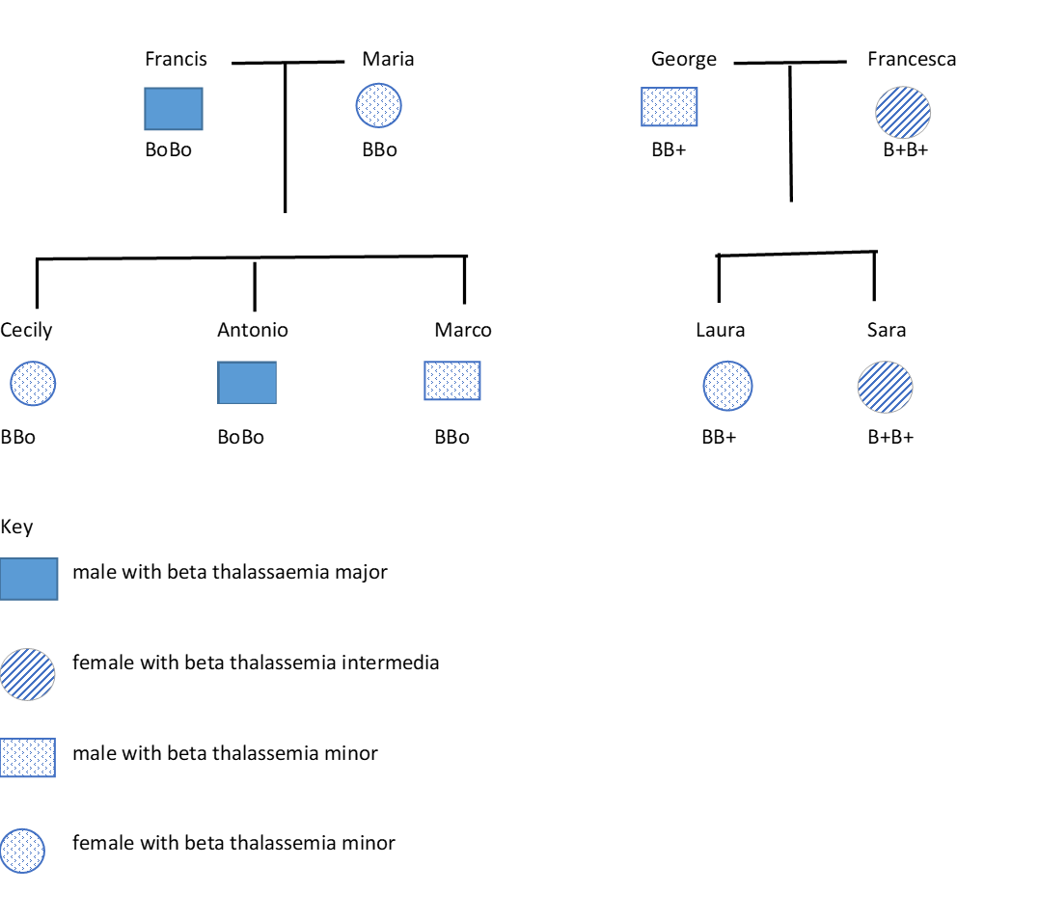

Part (b) 2 marks
Use a Punnett square to determine the probability of Marco and Laura having a baby free from any form of beta thalassemia.

Marking criteria
Criteria | Marks
Correctly drawn Punnett square and correctly identified percentage | 2
Correctly drawn Punnett square  or  Correctly identified percentage | 1

2 mark answer
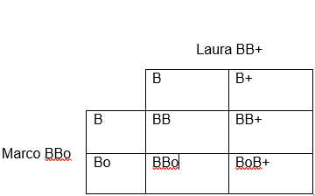
25% chance that their baby will be free of any form of beta thalassemia (BB).

Part (c) 3 marks
Normal haemoglobin molecules are made up of 2 linked pairs of polypeptide chains. There are 2 alpha chains and 2 beta chains.
The haemoglobin B gene codes for the beta chains. The normal base sequence for part of the B gene on the sense strand of chromosome 11 is:
GAG GCC CTG GGC AGG TTG GTA
Using the information in the table below draw a flow chart to show how this section of the B gene is transcribed and translated to produce a portion of a normal beta chain.
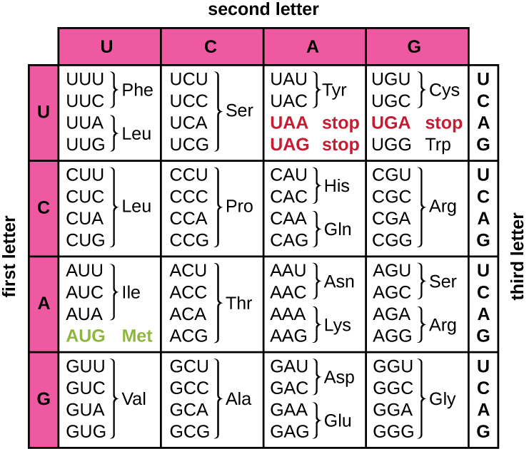
Lumen Microbiology

Marking criteria
Criteria | Marks
Flow chart correctly demonstrates transcription and translation from DNA to polypeptide chain  3 Molecules correctly identified  DNA code is accurately transcribed  mRNA code is accurately translated | 3
Flow chart shows and names the 2 steps from DNA to polypeptide chain  DNA code is accurately transcribed | 2
Flow chart shows and names the 2 steps from DNA to polypeptide chain | 1

3 mark answer

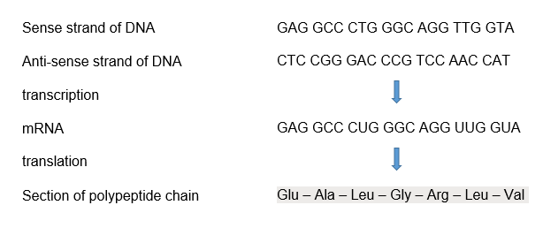

Part (d) 3 marks
The haemoglobin in sufferers of beta thalassaemia major has no normal beta chains. One of the many mutations that can cause beta thalassemia is a single substitution of an adenosine for a thymine in the third codon in the section of the B gene’s base sequence shown above.
Using the information in the table, and with the aid of a flow chart, explain how the substitution in the B gene can result in abnormal haemoglobin.

Marking criteria
Criteria | Marks
Mutated and altered molecules correctly identified in a flow chart  Mutation accurately placed in DNA and mRNA  New AA correctly identified and placed in polypeptide chain  Relates changed polypeptide chain to changed protein structure | 3
Mutated and altered molecules correctly identified in a flow chart  Mutation accurately placed in DNA and mRNA  New AA correctly identified and placed in polypeptide chain | 2
Mutated and altered molecules correctly identified in a flow chart | 1

3 mark answer
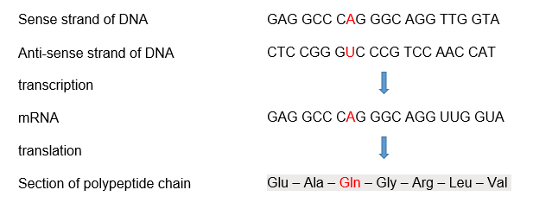
The substitution results in a changed codon and a subsequent changed amino acid in the polypeptide chain. Any change to the amino acid sequence will mean that a different polypeptide chain to the normal B chain is produced. Proteins have very specific structures which are determined by the sequence of amino acids in their polypeptide chains. The altered chain has a different structure that will not fit correctly with the alpha chains. Therefore the haemoglobin molecule will have no normal structure and not function correctly.

2 mark answer
An altered polypeptide chain will mean that the correct beta chain is not produced and therefore the haemoglobin is not correctly formed.
Note: The end statement is a restatement of the information in the question. There is no explanation of why changed polypeptide structure results in changed protein structure.

1 mark answer

Part (e) 3 marks
Propose why a person with the genotype BoBo suffers from thalassemia major, a severe illness with the sufferer requiring regular blood transfusions, while a person with the genotype BB+ or BBo has thalassemia minor and no symptoms of the disease.

Marking criteria
Criteria | Marks
Identifies that BoBo genotype have no beta chain production  Links no beta chain production to need for blood transfusion  Identifies BoB and B+B as producing a mix of normal and no beta chains  Links the production of some beta chains to normal haemoglobin and the lack of symptoms. | 3
Links no beta chain production to need for blood transfusion  Identifies BoB and B+B as producing a mix of normal and no beta chains | 2
Identifies that BoBo genotype have no beta chain production  Identifies BoB and B+B as producing a mix of normal and no beta chains | 1

3 mark answer
A person with thalassemia major has the genotype BoBo. This means they have two copies of the mutated gene and will therefore produce no beta chains. Consequently, the affected person is unable to produce normal haemoglobin and requires blood transfusions to acquire normal RBC.
A person with thalassemia minor has the genotype BoB or B+B. While they have one copy of the mutated gene they also have one copy of the normal gene, so will produce some B chains. This means that some normal haemoglobin and RBC can be produced, however some of the RBC will be smaller, containing haemoglobin with only one B chain rather than two. This will allow them to carry sufficient oxygen and be free of symptoms.

Part (f) 2 marks
Another mutation that causes beta thalassaemia occurs in the non-coding region adjacent to the B gene on chromosome 11.
Explain how a mutation in a non-coding region can affect the production of a protein.

Marking criteria
Criteria | Marks
Describes a role of non-coding regions.  Explains how a mutation will affect this role and consequently protein production | 2
Describes a role of non coding regions.  Or  Identifies that a mutation in a non-coding region can affect a gene in the coding region | 1

2 mark answer
Some non coding regions contain regulatory sequences that promote (switch on) or shut down (switch off) genes. Consequently a mutation in the non coding region could change the function of the regulatory sequence and, for example, switch off the production of protein when it should be switched on.

1 mark answer
The mutation in the non coding region may switch off the gene that codes for the beta chain.

Part (g) 2 marks
An epidemiological study on Beta thalassaemia was conducted by the World Health Organisation (WHO).
Estimated reach of treatment for β thalassaemia in each WHO region
WHO region | Estimated annual transfusion dependent births | % of transfusion dependent patients transfused | Annual deaths because not transfused
African | 1 278 | 2.7 | 1 243
American | 255 | 52.4 | 121
Eastern Mediterranean | 9 053 | 17.8 | 7 443
European | 920 | 15.5 | 780
South East Asian | 9 983 | 9.6 | 9 021
Western Pacific | 4 022 | 2.7 | 3 914
World | 25511 | 11.7 | 22 522
Global epidemiology of haemoglobin disorders and derived service indicators CC BY-NC-SA 3.0 IGO
Draw a graph on the axes below to show if there is a correlation between estimated annual transfusion dependent births and annual deaths because not transfused.

Marking criteria
Criteria | Marks
Axes correctly placed, scaled and labelled  Points accurately plotted on scatter plot.  A line of best fit may be included | 2
Axes correctly placed, scaled and labelled | 1

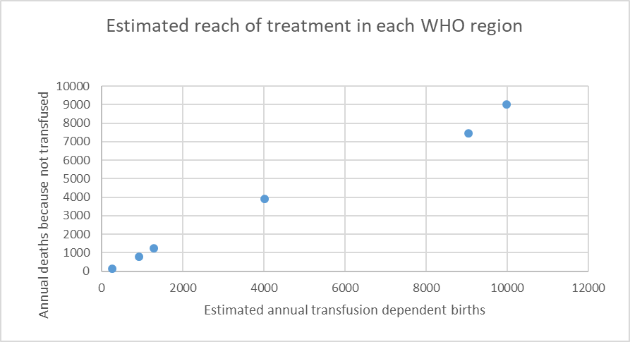

Part (h) 1 mark
Identify one trend shown on the graph.

Marking criteria
Criteria | Mark
Identifies one trend | 1

1 mark answer
As the number of estimated annual transfusion dependent births rises so does the number of annual deaths because not transfused.

Part (i) 5 marks
Assess the need for preventative programs for beta thalassemia. Explain how 3 preventative strategies could reduce the incidence of the disease. In your answer include reference to the information provided throughout the question.

Marking criteria
Criteria | Marks
Provides an assessment of the need for preventative programs  At least two pieces of data are used to justify the need for preventative programs.  Explains how three preventative programs could reduce the incidence of beta thalassemia | 5
Provides an assessment of the need for preventative programs  Explains how three preventative programs could reduce the incidence of beta thalassemia | 4
Provides an assessment of the need for preventative programs  Describes preventative programs that could reduce the incidence of beta thalassemia | 3
Provides an assessment of the need for preventative programs  Identifies preventative programs that could reduce the incidence of beta thalassemia | 2
Identifies a preventative program that could reduce the incidence of beta thalassemia | 1
Note: Assess means to make a judgement of value, quality, outcomes, results or size. In this case it’s size. How big is the need for preventative programs? To make a judgement you need to consider the evidence / data.
Explain means to relate cause and effect; make the relationships between things evident; provide why and/or how. In this case it is ‘provide how’. So you need to describe each program and then say how they will reduce the incidence of the disease.

5 mark answer
Each year there are an estimated 25,511 babies born in the world who have thalassaemia major (transfusion dependent). Most children with thalassaemia are born in low-income countries where transfusion is available for a small fraction of those who need it. (<10%). The need for treatment (transfusion) for beta thalassemia is lifelong. If treatment is not provided the sufferer will die. There are 22,522 transfusion dependent people who die each year because a transfusion is not provided.
People may be carriers of beta thalassemia and be unaware, because they still carry a healthy B allele that will produce sufficient normal haemoglobin. If both parents are carriers of the beta thalassemia allele (Bo) then they have a 25% chance of having baby with beta thalassemia major.
Because of the high incidence, high death rate and significant chance of carrier couples having a child with beta thalassemia it should be a high priority to develop a preventative program that focuses on educating, identifying and supporting carriers of the thalassemia mutation and therefore reduce the incidence of thalassemia major (the homozygous state).
This can be achieved by:
- Education: Population education makes use of mass media, posters, and informational booklets, which can be made available at family planning clinics, marriage registries, and counseling rooms. The essential messages should include the symptoms, management and life expectancy for the homozygous state of thalassemia major. It is important to emphasize that the carrier state can be easily identified (see 2 below) and couples who are both carriers have several reproductive options (see 3 below), thus reducing the incidence of the disease.
- Genetic screening in
- populations where beta thalassemia is occurs widely ( eg SE Asia, Eastern Mediterranean and Western Pacific ).
- Families with a history of beta thalassemia in areas where it is less common ( eg America, Europe and Africa)
Genetic screening allows individuals who are carriers (BBo or BB+), but otherwise healthy, to be detected. This allows people to make informed decisions about their life partner and family planning, reducing the incidence of the disease.
- Genetic counselling: Those people identified as being at risk, through genetic screening, or by having the disease or by having a child with the disease, could be provided with genetic counselling. This is when a trained professional informs a couple of their risk and guides them through the options available in having children so as to reduce the incidence of the disease.
Note: Other examples of preventative strategies could include
- Prenatal diagnosis – this requires genetic testing of the amniotic fluid surrounding the fetus in the first trimester of pregnancy. With the support of a counsellor a couple may choose to terminate a fetus with thalassemia major.
- Preimplantation diagnosis – an 8 cell embryo conceived through in-vitro fertilization could be genetically tested for thalassemia major. Only embryos free from the disease would proceed to implantation,

3 mark answer
Preventative programs are very important because many people die from thalassemia each year.
Three strategies that could be part of the program are:
1. Education uses the press, posters and informational booklets, which can be made available at family planning clinics, marriage registries, and counselling rooms
2. Genetic screening: this determines what alleles a person has for a particular gene.
3. Genetic counselling: is when a trained professional informs a couple of the risk of having a child with the disease.
Note: Describe means to provide characteristics and features. This answer describes the preventative strategies but does not explain how they reduce the incidence of the disease

