Science and Technology – Stage 1 Unit 1 Lesson 5 – plant life cycle
This lesson comes from Stage 1 Unit 1 Lesson 5, where students explore plant growth and the plant life cycle through observations, digital tools and scientific models. In the first 4 lessons in this unit, students explored and observed plant parts and data collection using digital tools. This lesson explores the plant life cycle.

Learner profiles

Evie P.
Girl | Age 8 | Year 2
Autism (uses non-verbal communication) with Global Developmental Delay
Strengths:
- Strong visual memory
- Responds well to pictures and modelling
- Engages well with familiar routines
Evie communicates using a Proloquo AAC app and is currently working at Early Stage 1 outcomes. She understands simple, familiar instructions supported by visuals, repetition and predictable routines.
Evie learns best through highly structured, hands-on experiences and may become overwhelmed by loud noise, unfamiliar people or unexpected changes. She works best in a calm, low-stimulation environment with consistent adult support.

Jin K.
Boy | Age 7 | Year 1
Autism
Strengths:
- Strong factual recall
- Deep interest in science and animals
- Motivated when learning
Jin uses spoken communication and enjoys interacting in structured one-to-one or small group settings. He is working at Stage 1 in some learning areas and benefits from clear, explicit instruction and predictable routines.
Jin can find flexible thinking, group collaboration and unexpected changes challenging, and may become anxious when expectations are unclear. He is highly motivated by science and nature-based topics.

Amani B.
Girl | Age 8 | Year 2
Intellectual disability – moderate
Strengths:
- Warm and eager to participate
- Learns well through hands-on experiences
- Responds positively to encouragement and praise
Amani is a friendly student who uses spoken communication and is working towards access content point levels. She experiences difficulties with reading, writing, memory and abstract thinking, and benefits from learning that is broken into small, concrete steps.
Amani learns best through hands-on activities, repetition and guided support to stay focused and complete tasks.

Multi-tiered approach
The table below illustrates how a multi-tiered approach works together across each phase of the lesson. It shows when universal strategies, targeted differentiation and personalised adjustments can be introduced to ensure all students can access, participate and progress. Resources are introduced in the following phases but may be used throughout the lesson.
Phase | Universal strategies | Targeted differentiation | Personalised learning and support
Beginning the lesson | - Pre-teach key vocabulary (seed, root, stem, leaf, flower).  - Adjustment resource 1 – visual lesson schedule. Also used in Core lesson and Concluding the lesson phases.  - Adjustment resource 2 – visual word bank (3–4 keywords: seed, root, plant, flower). Also used in Core lesson phase. | - Adjustment resource 3 – plant parts picture cards. | Amani  - Adjustment resource 4 – first-then board. Also used in Core lesson and Concluding the lesson phases.  Jin  - Adjustment resource 5 – plant discussion sentence stem cards.  Evie  - Augmentative and Alternative Communication (AAC) device. Also used in Core lesson, Concluding the lesson and Assessment phases.
Core lesson | - Ask one question or give one instruction at a time. Use gesture alongside verbal prompts.  - Provide extra wait time before responses. Also used in Concluding the lesson phase.  - Introduce prompting. Also used in Concluding the lesson phase.  - Closed captions are enabled for video.  - Use real objects.  - Offer headphones. | - Establish a pause-point-name routine.  - Adjustment resource 6 – step-by-step observation task board.  - Adjustment resource 7 – life cycle picture cards. Also used in Concluding the lesson and Optional assessment phases.  - Adjustment resource 11 – three-stage life cycle (adapted resource 14). Also used in Concluding the lesson phase.  - Adjustment resource 13 – question support stem cards. | Evie  - Adjustment resource 10 – simplified labelled plant diagram (leaves, flower, stem, root).  Jin  - Adjustment resource 8 – plant observation worked example.  - Adjustment resource 9 – plant observation sentence starter cards. Also used in Concluding the lesson phase.  - Adjustment resource 12 – colour-coded plant life cycle (adapted resource 14).
Concluding the lesson | Use the adjustments and resources from the lesson. | Use the adjustments and resources from the lesson.
Assessment | Evidence of learning using support adjustments and resources from the lesson. | Evidence of learning using support adjustments and resources from the lesson. | Jin  Adjustment resource 14 – life cycle partially completed worked example.

Overview
Lesson duration: 60 minutes
In this lesson, students learn to identify and describe the key stages in a scientific model of a plant life cycle and pose questions about it.
Prior learning:
- examine flowers, fruit, leaves, roots and stems of plants and describe their purpose
- recognise that data can be collected through observation, and that it can be represented as descriptions and images
Key vocabulary: seed, root, stem, leaf, flower, grow, germination, seedling, mature plant, flowering plant
Lesson preparation: if the optional assessment is to be used for this lesson, prepare sets of cards from Resource 15 – plant life cycle match.

Beginning the lesson
Duration: 10 minutes
The table below contains a suggested learning intention and success criteria.
Syllabus | Learning intention and success criteria
ST1-SCI-01, ST1-PQU-01, ST1-DAT-01  Investigations of changes provide knowledge and understanding  Living things change over time  - Recognise that data can be collected through observation, testing and research, and that it can be represented as descriptions, diagrams, graphs, images and tables  - Describe the changes in a plant as it grows using data and scientific models | Students are learning:  - that plants change as they grow.  Students can:  - use a scientific model and data to describe the changes in a plant as it grows  - collect data through observation using images.
Syllabus  (working at Early Stage 1) | Evie – personalised learning intentions and success criteria
STE-SCI-01, STE-PQU-01  Observations and questions spark curiosity  Living things have characteristics that help them survive in their environment  - Identify and use tools to aid and extend sensory observations  - Examine flowers, fruit, leaves, roots and stems of plants and describe their purpose  - Follow a series of steps to record, save and retrieve data | Students are learning:  - that plants have different parts that change as they grow.  Evie can:  - identify (pointing, gesture, AAC) flowers, fruit, leaves, roots and stems on a plant model, image or real plant  - use tools and supports (for example, magnifier, pictures, AAC, visual prompts) to make and share observations about plants  - follow supported steps to record, save or retrieve plant observations using pictures, symbols, AAC or digital supports.
Syllabus  (working towards Early Stage 1) | Amani – personalised learning intentions and success criteria
Working towards STE-SCI-01, STE-PQU-01  Observations and questions spark curiosity  Access content points  - Explore features of plants and animals  - Identify parts of plants and animals  - Participate in multisensory observations of familiar environments  - Engage with digital technologies | Students are learning:  - that plants have different parts that change as they grow.  Amani can:  - explore and describe features of plants using supported discussions, prompts and observations  - identify and name parts of plants (for example, flower, leaf, stem, root, fruit) with support  - use digital technologies with support to explore and respond to plant learning.
Explain the learning intention and refer to it throughout the lesson, making connections to prior learning. Unpack the success criteria and ensure students understand the learning goals.
The following steps activate prior knowledge of vocabulary to describe parts of a plant.
Universal strategies
- Display Adjustment resource 1 – visual lesson schedule and follow these steps:
- focus on key vocabulary
- watch a video
- observe plant parts
- reflect.
- Display Resource 1 – images of plants used in Lesson 1. Students turn and talk to retrieve vocabulary about parts of a plant.
Universal strategies
Pre-teach key vocabulary (seed, root, stem, leaf, flower) using Adjustment resource 2 – visual word bank.
Differentiated questions/prompts
- Tell me one part of a plant you can see.
Targeted differentiation
- Use Adjustment resource 3 – plant parts picture cards for matching activity. Teacher to say and/or show a plant part and student finds the matching picture and word. Accept pointing, matching or AAC responses.
Personalised learning and support
- Amani – show Adjustment resource 4 – first-then board. Teacher says, ‘First learn plant words. Then look at the plant.’
- Jin – provide Adjustment resource 5 – plant discussion sentence stem cards on desk. Teacher says, ‘This is the ___.’
- Identify those plant parts on the images in Resource 1 – images of plants.
- Check for understanding of each word by asking all students to say the name of each part of the plant as you point to it.
Universal strategies
- Ask one question at a time. Use gesture alongside verbal prompts.
- Provide extra wait time before responses.
Differentiated questions/prompts
- Can you show me the leaf on this plant?
- Show me a picture of a flower.
Targeted differentiation
- Allow student to respond verbally by pointing to Adjustment resource 3 – plant parts picture cards.
Personalised learning and support
- Evie – limit vocabulary to 3–4 familiar words using AAC device and/or Adjustment resource 3 – plant parts picture cards. Encourage Evie to physically select and hand over the correct card, allowing extra wait time for processing.
- Assess students’ readiness to move to the Core lesson or reteach vocabulary to describe parts of a plant.
Universal strategies
- Point to Adjustment resource 1 – visual lesson schedule and name the next step before transitioning.
Personalised learning and support
- Amani – update Adjustment resource 4 – first-then board: ‘First look at our plant. Then watch a video.’

Core lesson
Duration: 45 minutes
Note: it is a common misconception in young students that plants get their food from the soil, rather than producing food in the leaves.

Steps

Plant observations
- Display the number of days since the seed growing activity started.
- Students observe their plant growing kits and capture and store an image using a digital device. Remind students to name the image they store as ‘Day x’.
Universal strategies
- Give one instruction at a time and wait for completion before giving the next instruction.
Prompt: you are looking for 3 things: height, colour and any new plant parts.
Prompt: What do you see? Has it changed?
Accept verbal responses.
Targeted differentiation
- Place Adjustment resource 6 – step-by-step observation task board which shows the following steps on student’s desk:
Step 1. Observe plant
Step 2. Take photo
Step 3. Name image
Step 4. Save image.
Personalised learning and support
- Evie – use Adjustment resource 7 – life cycle picture cards to focus on key changes. Accept pointing or AAC to name the image.
- Jin – model the routine first using Adjustment resource 8 – plant observation worked example.
- Share and discuss any changes that students observe.
Personalised learning and support
- Jin – provide Adjustment resource 9 – plant observation sentence starter cards on desk to support him with the discussion.
- Display an image of one student’s plant and, if visible, identify the seed, root, stem and leaf.
Universal strategies
- Point to Adjustment resource 1 – visual lesson schedule and name the next step before transitioning.
Targeted differentiation
- Use Adjustment resource 2 – visual word bank (root, stem, leaf) alongside the displayed image. Ask one question at a time.
Personalised learning and support
- Evie – use Adjustment resource 10 – simplified labelled plant diagram (flower, stem, leaves) to support Evie’s observation. Accept pointing, matching or AAC.

Plant life cycle
- Explain that to help observe slow changes, photographers use time-lapse photography to capture images at set intervals.
- Remind students about time-lapse photography from Lesson 3. View and discuss the text and video from Time-Lapse Photography (2:31).
Universal strategies
- Point to Adjustment resource 1 – visual lesson schedule and state that the video will be 2 minutes and 31 seconds.
- Ensure closed captions are enabled. Support student sensory needs by adjusting the volume of the video and classroom lights.
- Offer headphones to students, including Evie, to support sensory needs.
Prompt: look for one thing you noticed.
Differentiated questions/prompts
- What did you see?
- Show me the flower/stem/leaf on this picture.
Targeted differentiation
- Establish a pause-point-name routine at each stage.
Personalised learning and support
- Evie – provide relevant vocabulary visuals to Evie’s AAC and pre-teach the term ‘time-lapse photography’ before watching the video.
- Amani – update Adjustment resource 4 – first-then board: ‘First watch the video. Then share what we saw.’
- View a time-lapse video of a seedling growing, such as the I Grew Radish from Seed to Harvest (3:25). Ask students to identify parts of the plant.
Universal strategies
- Ensure closed captions are enabled. Support student sensory needs by adjusting the volume of the video and classroom lights.
- If possible, watch the video at least twice, pausing after each stage of the life cycle.
Prompt: watch for the moment the seed changes.
Targeted differentiation
- Provide Adjustment resource 11 – three-stage life cycle (adapted resource 14) with single word labels (seed – seedling – flowering plant) to follow as student watches the video.
Personalised learning and support
- Evie – use Adjustment resource 7 – life cycle picture cards during the video. Accept pointing or AAC.
- Jin – provide personal copy of Adjustment resource 12 – colour-coded plant life cycle (adapted resource 14) to match stages as they appear.
- Display Resource 14 – plant life cycle.
- Read the labels: seed, germination, seedling, mature plant and flowering plant.
Universal strategies
- Introduce vocabulary in short chunks.
Targeted differentiation
- Provide Adjustment resource 11 – three-stage life cycle visual (adapted resource 14) with single word labels (seed – seedling – flowering plant).
- Use Adjustment resource 7 – life cycle picture cards and simple definitions.
- Check for understanding by pointing to each label for students to read aloud. Provide feedback or correction where necessary.
Targeted differentiation
- Focus on recognising and sequencing 3 key stages (seed – seedling – flowering plant) using Adjustment resource 7 – life cycle picture cards.
- Explain that plant growth is slow and gradual. It can be difficult to observe changes as they happen. The diagram on Resource 14 – plant life cycle is a scientific model of the main stages of the plant life cycle.
- Identify and describe the main stages of plant growth:
- Seeds have a protective coat. Inside is an embryo and the energy the plant needs to grow. An embryo is the part of the seed that holds the undeveloped leaves, stem and roots of a plant. The rest of the seed protects the embryo and stores reserves of food for the developing plant.
- Germination is when the seed begins to grow. You can observe a short root and then the first leaf. To germinate, seeds need oxygen, water, sunlight and the right temperature.
- A seedling is a young plant. It grows towards sunlight and makes its own food using sunlight, water and carbon dioxide from the air.
- A mature plant has roots, stems and leaves. Roots get nutrients from the soil. The stems carry nutrients and water to the leaves. The leaves use sunlight, water and carbon dioxide from the air to make food.
- A flowering plant is ready to reproduce. Plants rely on animals such as insects and birds to move pollen between plants. The plant can then make seeds.
- New seeds can start the life cycle again.
Universal strategies
- Break plant growth into one stage at a time. Use concrete language and real objects. Check understanding after each stage before moving to the next.
Targeted differentiation
- Hold up Adjustment resource 7 – life cycle picture cards at each stage.
Personalised learning and support
- Jin – provide personal copy of Adjustment resource 12 – colour-coded plant life cycle (adapted resource 14).
Note: some plants are non-flowering, like algae, ferns and mosses. They reproduce by forming and dispersing spores.
- View a different time-lapse video of a seedling growing, such as Growing Tomatoes From Seed (5:17).
- Pause the video at each stage of the plant cycle. Check for understanding by selecting students to share their knowledge and understanding of the plant life cycle including how plants produce fruit.
Universal strategies
- Point to Adjustment resource 1 – visual lesson schedule and name the next step before transitioning.
Targeted differentiation
- Pause at key stages. Use Adjustment resource 7 – life cycle picture cards to identify each stage.
Personalised learning and support
- Evie – identify stages with Adjustment resource 7 – life cycle picture cards or AAC.
- Jin – provide personal copy of Adjustment resource 12 – colour-coded plant life cycle (adapted resource 14).
- Provide feedback on students’ ability to share knowledge and understanding of the changes in a plant as it grows.
Note: as students work towards the outcome ST1-PQU-01, guide students to ask questions based on observations and information. Later units provide opportunities for students to pose questions to investigate cause and effect.
- Students pose questions about the plant life cycle. If required, model questions such as:
- Do all plants have the same life cycle?
- What is the shortest/longest plant life cycle?
- Is a seed alive before it grows? How could you tell?
- How do seeds move from one place to another?
- What happens if there is too much or not enough water or sunlight?
Targeted differentiation
- Provide Adjustment resource 13 – question support stem cards on student’s desk: ‘What happens if …?/ Why does …?/ How do …?’
Personalised learning and support
- Evie can pose questions using her AAC device.
- Record student questions and ask students if they are able to answer any of the questions. Provide feedback on student responses, as required.
- Record student questions for display and answering in later lessons.

Differentiation
The table below identifies some starting points for differentiation.
Additional scaffolding | Extending and challenging
Students cannot use a scientific model and data to describe the changes in a plant as it grows.  - Provide students with Resource 14 – plant life cycle. While viewing the video, Growing Tomatoes From Seed (5:17), support students to link each image in the resource to the relevant part of the video. | Students can use a scientific model and data to describe the changes in a plant as it grows.  - Provide students with a copy of Resource 14 – plant life cycle. Students describe the differences between the images on the resource and the content from the video Growing Tomatoes From Seed (5:17)

Assessment
What to look for
- Can students use a scientific model and data to describe the changes in a plant as it grows? ST1-SCI-01, ST1-PQU-01, ST1-DAT-01
- Can students collect data through observation using images? ST1-SCI-01, ST1-PQU-01, ST1-DAT-01
Universal strategies
- State explicit criteria: ‘Name the stages and describe one change.’
- Record evidence via photos, pointing, and individual picture cards for matching or sequencing.
Personalised learning and support
Evie
- Can Evie identify plant parts (for example, flower, fruit, leaves, roots, stem) using pointing, gesture or AAC when exploring models, images or real plants? STE-SCI-01, STE-PQU-01
- Can Evie use tools and supports to make observations about plants and respond to questions or share observations using picture match, AAC, gesture or other communication methods? STE-SCI-01, STE-PQU-01
- Can Evie follow supported steps to photograph, record, save and retrieve information about plants using digital technologies? STE-SCI-01, STE-PQU-01
Amani
- Can Amani explore features of plants and talk about what she notices during supported observations? STE-SCI-01, STE-PQU-01
- Can Amani identify and name plant parts (for example, flower, leaves, roots, stem, fruit) using prompts, models, images or real plants? STE-SCI-01, STE-PQU-01
- Can Amani participate in observations and use digital technologies with support to photograph, record, save or retrieve information about plants? STE-SCI-01, STE-PQU-01

Concluding the lesson
Duration: 5 minutes
- Refer to the learning intention and success criteria to support students in clarifying their thinking and to make connections.
- Display Resource 14 – plant life cycle. Connect the resource with the seed growing activity. Students turn and talk to answer:
- What stage in the plant life cycle is your seed up to?
- What stage came before that?
- What stage do you expect to come next?
- We did not use soil in our activity. Where is the plant getting its energy from? (The seed, and from energy made in the leaves from sunlight, water and carbon dioxide.)
Universal strategies
- Point to Adjustment resource 1 – visual lesson schedule. Revisit success criteria together.
- Allow extra wait time before sharing.
Targeted differentiation
- Use Adjustment resource 11 – three-stage life cycle (adapted resource 14) (seed – seedling – plant).
- Using Adjustment resource 7 – life cycle picture cards, student points to answer the following differentiated questions:
Is it still a seed?
Is it a seed or seedling?
Is it a flower?
Personalised learning and support
- Jin – provide Adjustment resource 9 – plant observation sentence starter cards on desk.
- Evie – support Evie to identify what stage her plant is up to through matching, pointing or AAC.
- Amani – close lesson with Adjustment resource 4 – first-then board: ‘First we finished Science. Then [next activity].’

Optional assessment
Provide students with a set of cards from Resource 15 – plant life cycle match. Students sequence the images and labels. Photograph students’ sequences.
This task provides evidence of student learning aligned to the success criteria. It assesses students’ ability to use a scientific model and data to describe the changes in a plant as it grows.
Targeted differentiation
- Using Adjustment resource 7 – life cycle picture cards, students sequence 3 stages (seed – seedling – flowering plant) with adult guidance. Scribe labels for students to place.
Personalised learning and support
- Jin – provide Adjustment resource 14 – life cycle partially completed worked example

Adjustment resource 1 – visual lesson schedule
Lesson part |  | What we are doing | Done
1 |  | Look at plants.  What can you see on your plant? | ☐
2 | 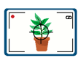 | Take a photo.  Photograph your plant. Name it Day __. | ☐
3 |  | Watch a video.  Watch a time-lapse of a plant growing. | ☐
4 | 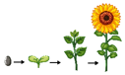 | Life cycle  Seed Seedling Plant Flower | ☐
5 |  | Match the cards.  Put the life cycle cards in the right order. | ☐
6 |  | All done!  Pack up. Great work today! | ☐

Adjustment resource 2 – visual word bank
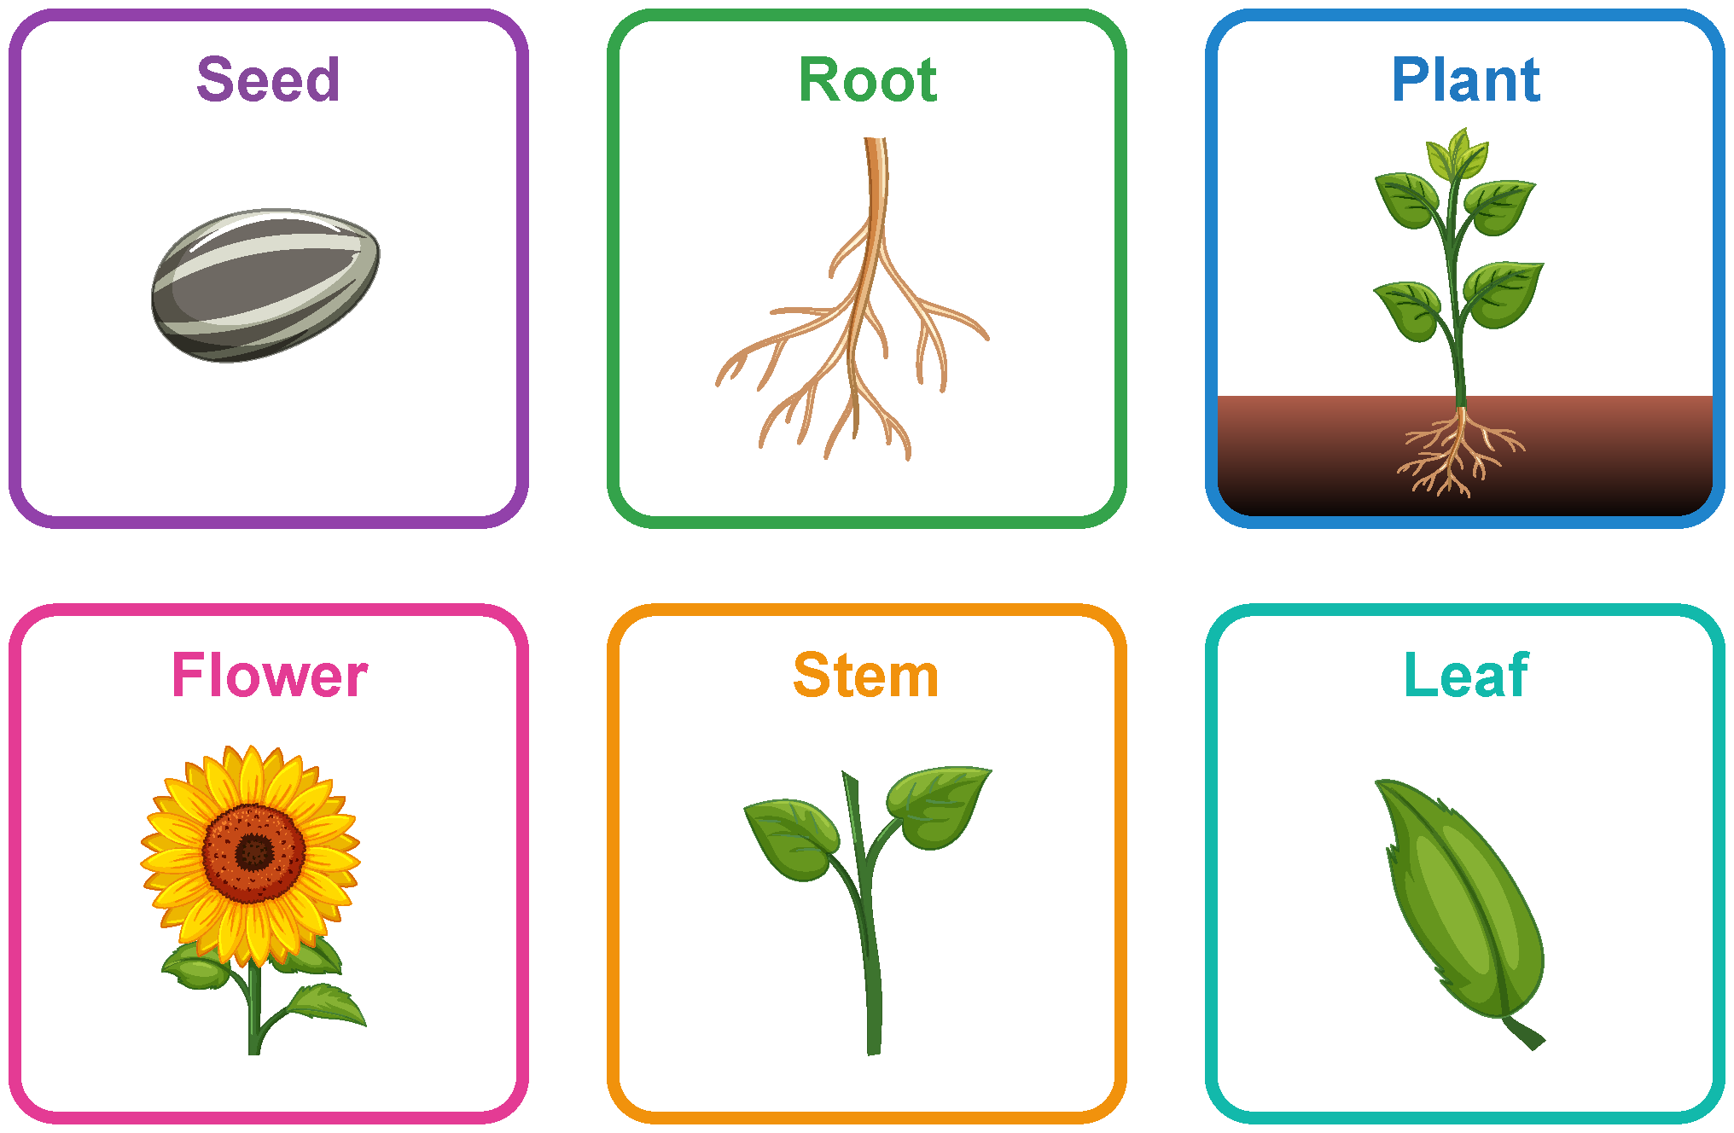

Adjustment resource 3 – plant parts picture cards
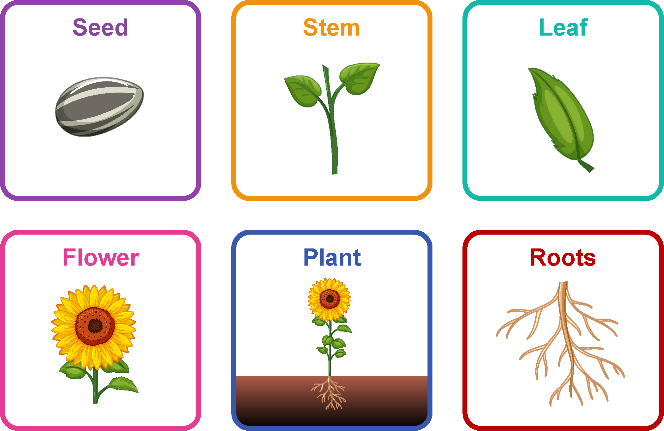

Adjustment resource 4 – first-then board
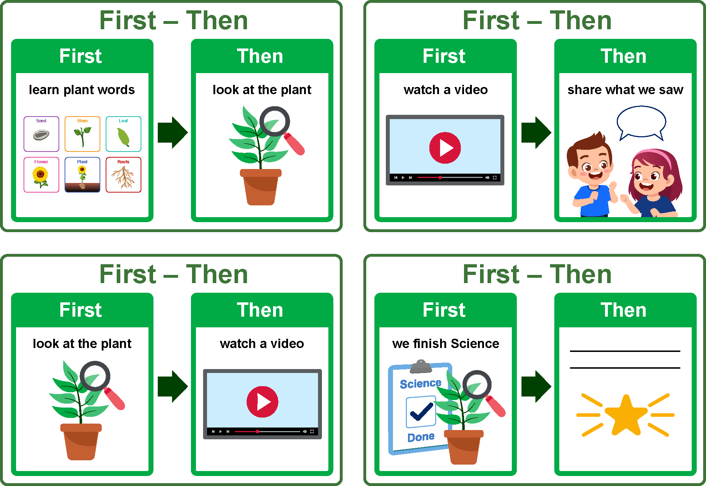

Adjustment resource 5 – plant discussion sentence stem cards
I see …  I see a ____.  I can see ____.  There is a ____. | 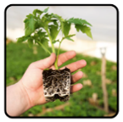 | It is a …  It is a ____.  It looks like a ____.  This part is a ____. | 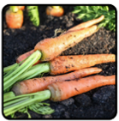

It does …  It helps the plant ____.  It is used for ____.  It helps by ____. | 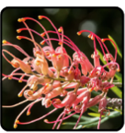 | It feels/looks …  It feels ____.  It looks ____.  It is ____ (colour/size). | 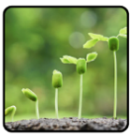

I think …  I think it is a ____.  I think the plant needs it to ____.  I think it is important because ____. | 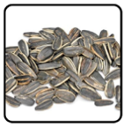 | My partner said …  My partner said it is a ____.  My partner thinks it helps the plant ____.  We both think ____. | 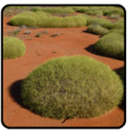

Adjustment resource 6 – step-by-step observation task board
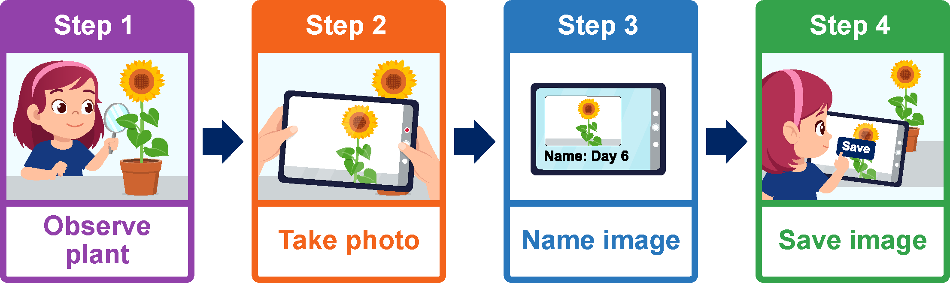

Adjustment resource 7 – life cycle picture cards
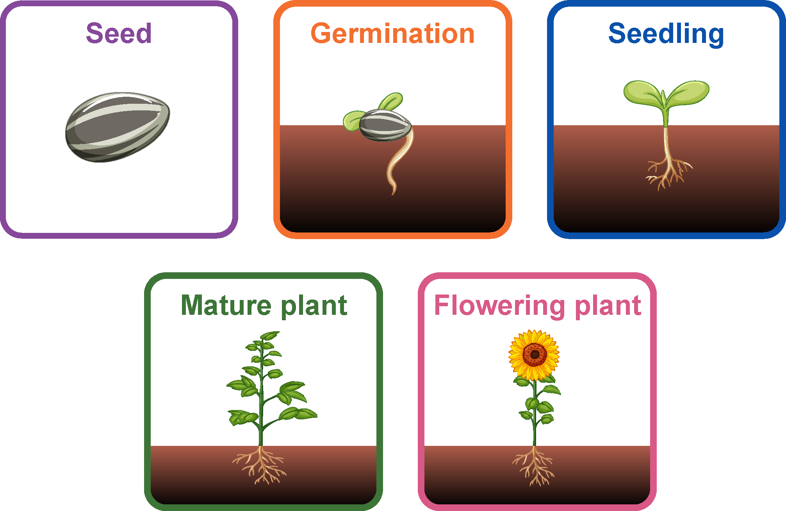

Adjustment resource 8 – plant observation worked example
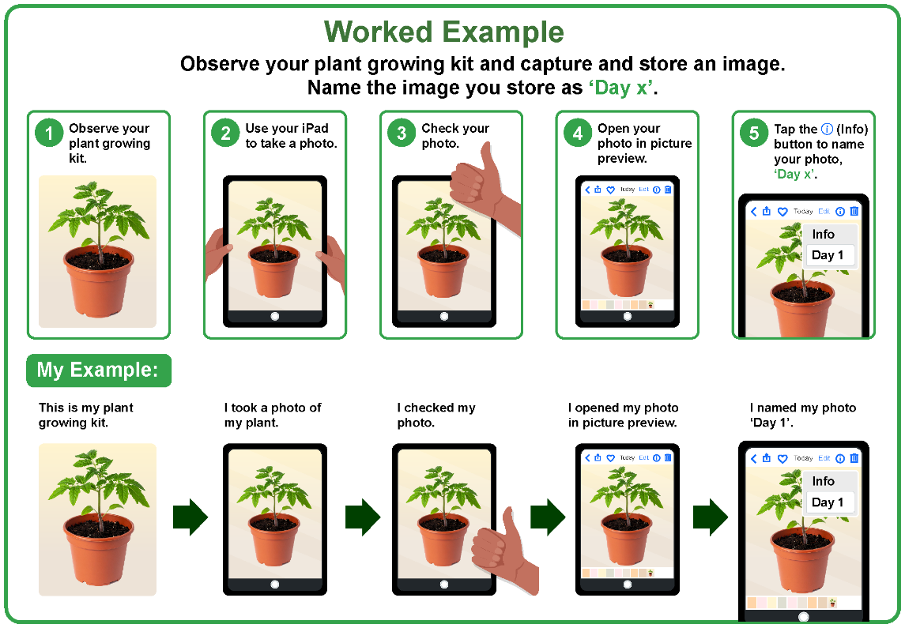

Adjustment resource 9 – plant observation sentence starter cards
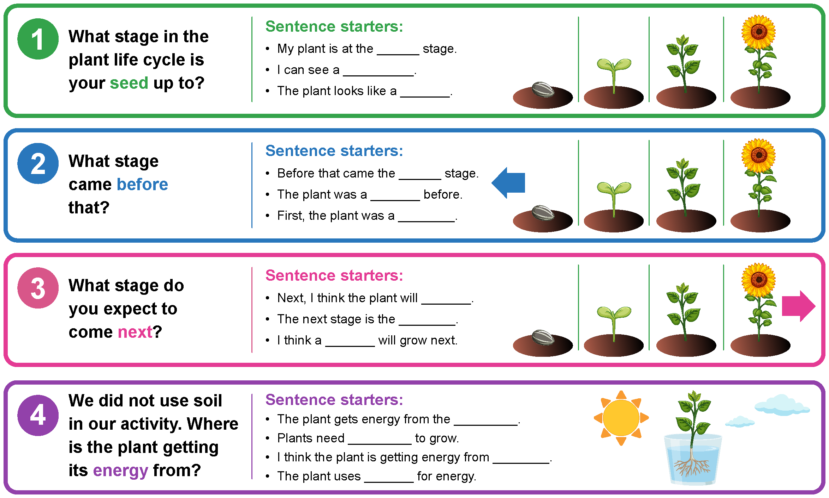

Adjustment resource 10 – simplified labelled plant diagram
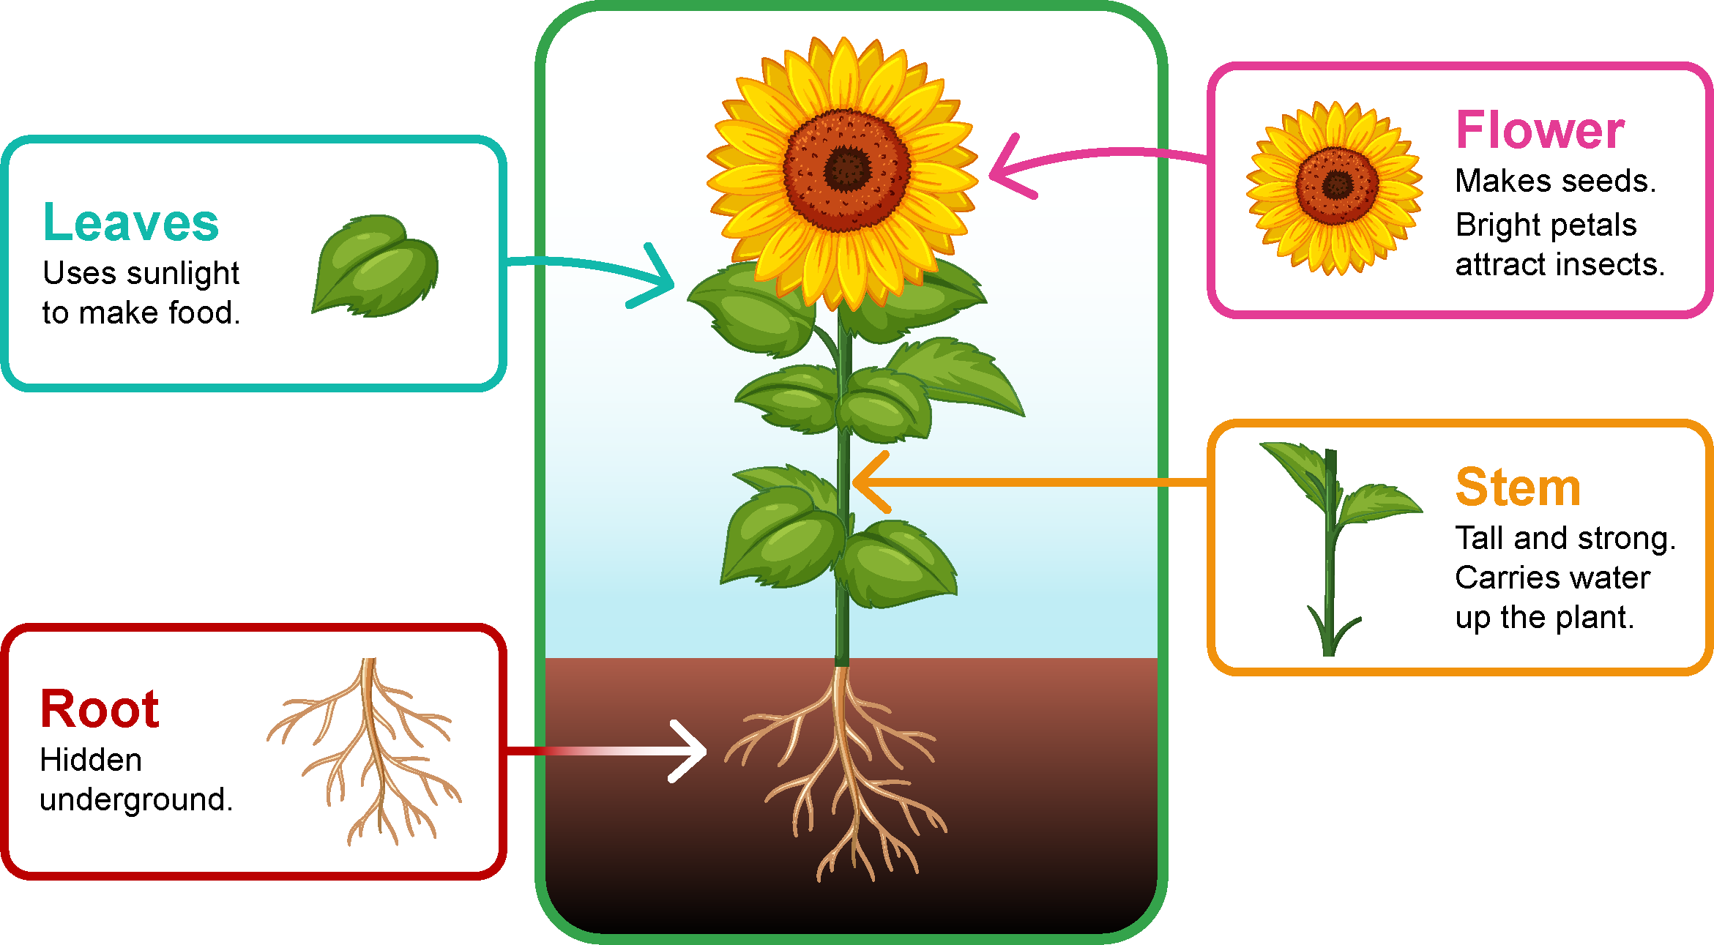

Adjustment resource 11 – three-stage life cycle (adapted resource 14)
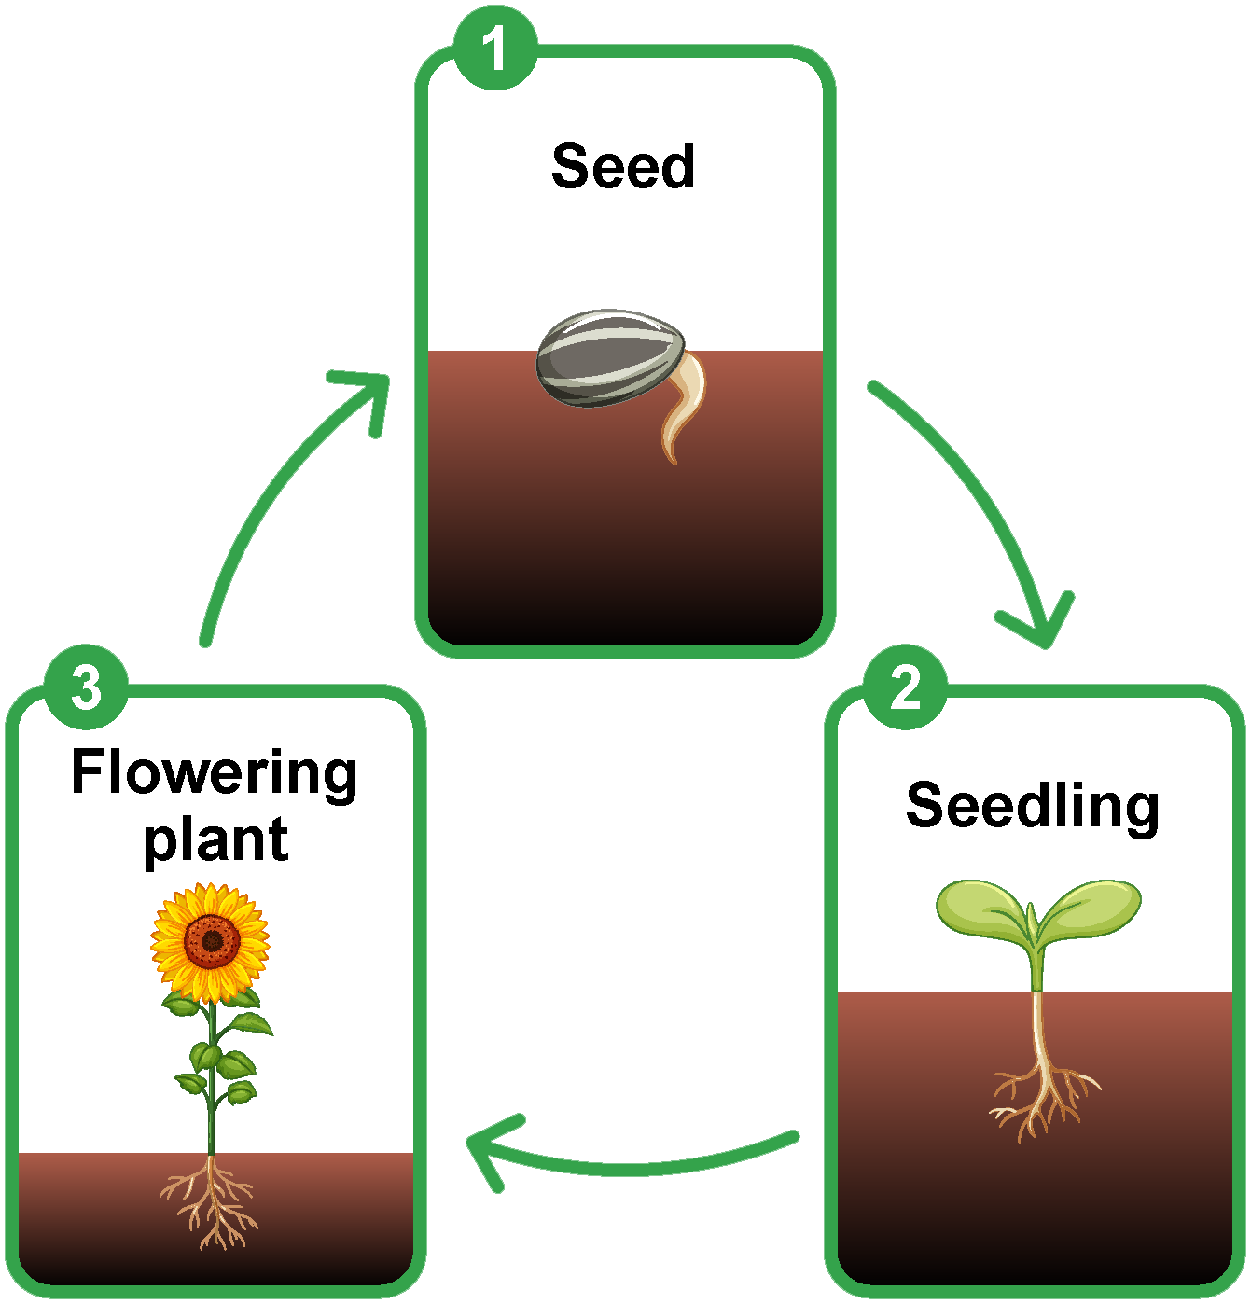

Adjustment resource 12 – colour-coded plant life cycle (adapted resource 14)
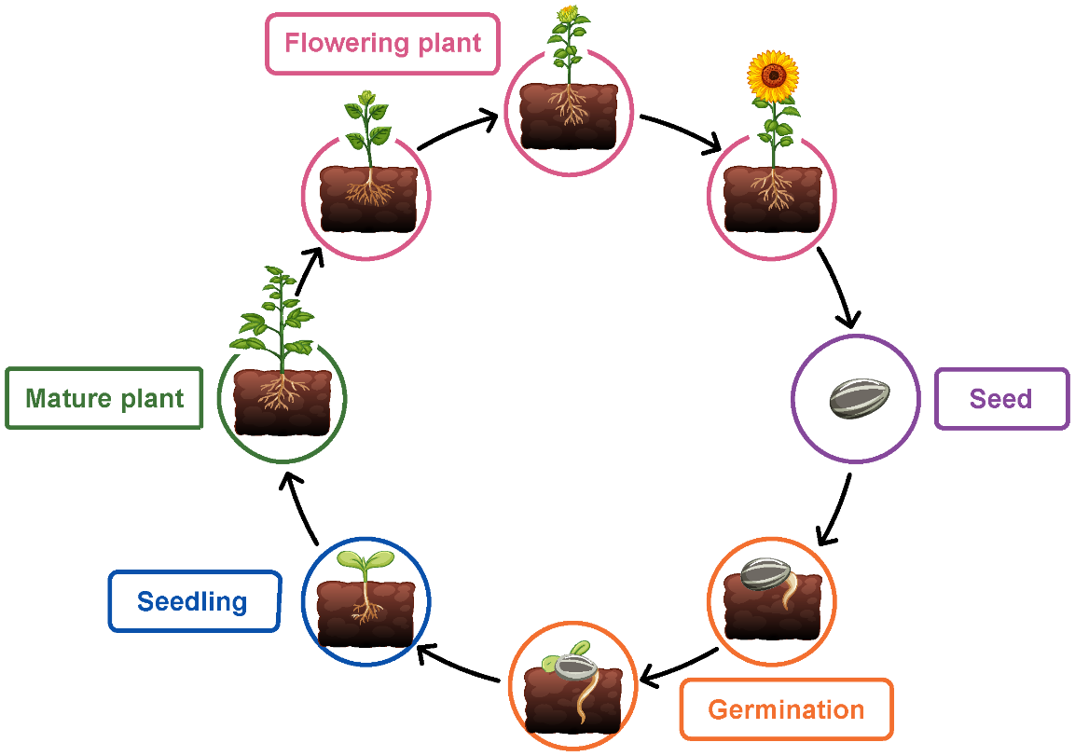

Adjustment resource 13 – question support stem cards
 | 1. What does the plant need to survive and grow?
 | 2. What happens after _____?
 | 3. Why does the plant need to _____?
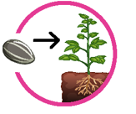 | 4. How does a _____ grow into a _____?
 | 5. What comes before ____?

Adjustment resource 14 – life cycle partially completed worked example
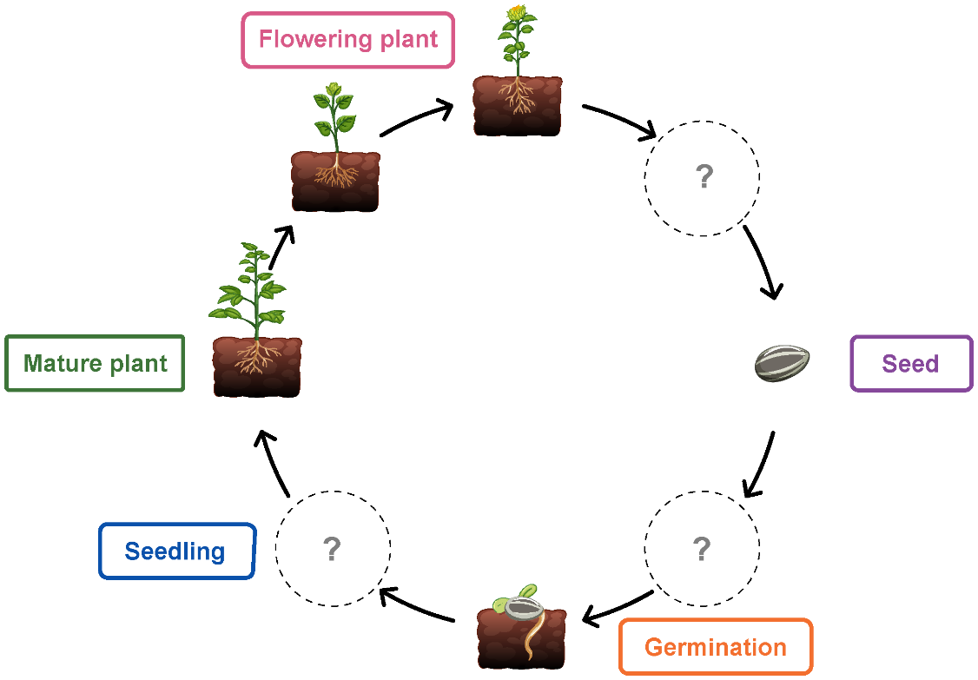

Resource 1 – images of plants
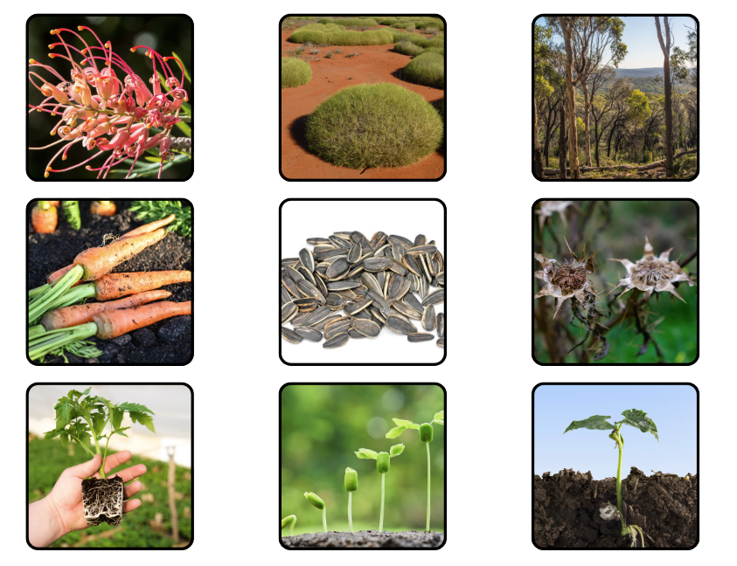

Resource 14 – plant life cycle
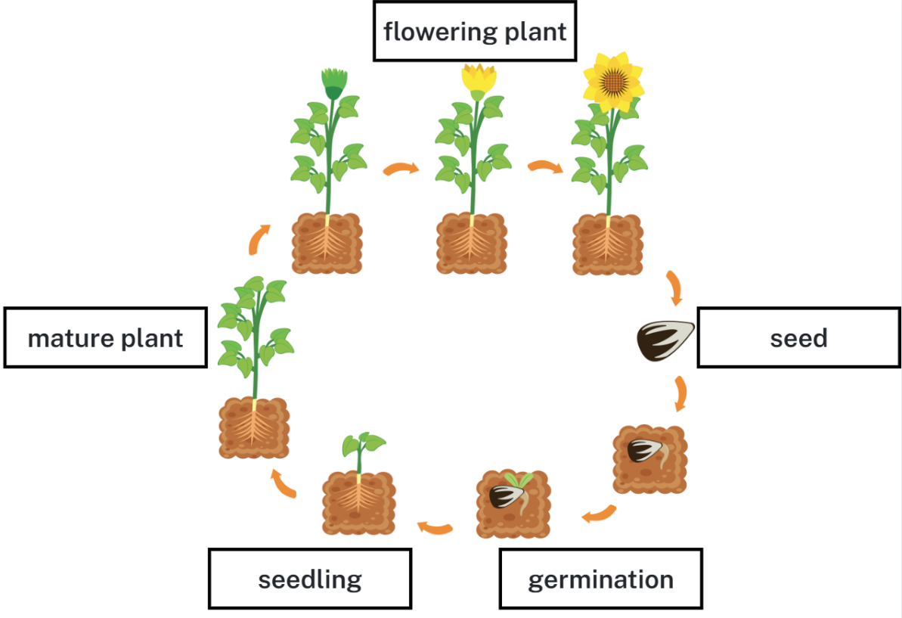

Resource 15 – plant life cycle match
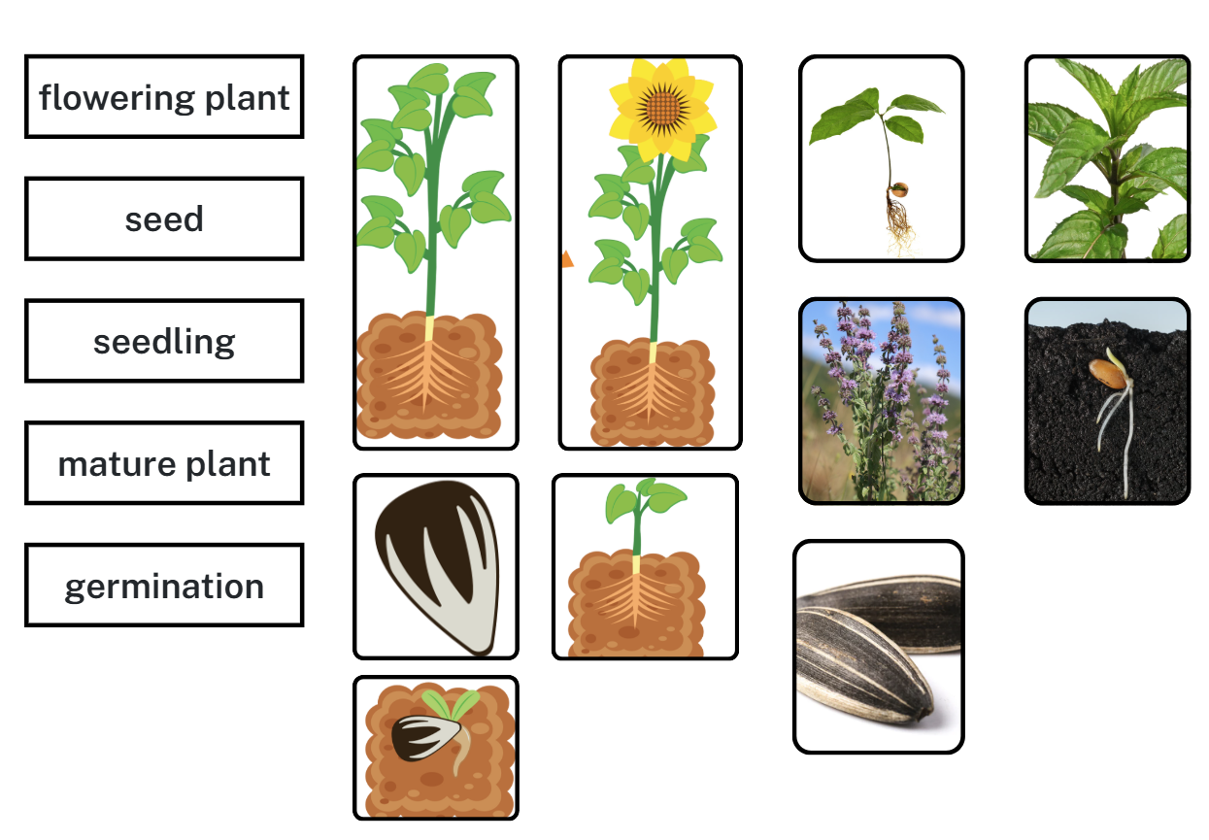

References
This resource contains NSW Curriculum and syllabus content. The NSW Curriculum is developed by the NSW Education Standards Authority (NESA). This content is prepared by NESA for and on behalf of the Crown in right of the State of New South Wales. The material is protected by Crown copyright.
Please refer to the NESA Copyright Disclaimer for more information https://www.nsw.gov.au/education-and-training/nesa/copyright.
NESA holds the only official and up-to-date versions of the NSW Curriculum and syllabus documents. Please visit NESA https://www.nsw.gov.au/education-and-training/nesa and NSW Curriculum https://curriculum.nsw.edu.au.
Science and Technology K–6 Syllabus © NSW Education Standards Authority (NESA) for and on behalf of the Crown in right of the State of New South Wales, 2024.

© State of New South Wales (Department of Education), 2026
The copyright material published in this resource is subject to the Copyright Act 1968 (Cth) and is owned by the NSW Department of Education or, where indicated, by a party other than the NSW Department of Education (third-party material).
Copyright material available in this resource and owned by the NSW Department of Education is licensed under a Creative Commons Attribution 4.0 International (CC BY 4.0) license.

This license allows you to share and adapt the material for any purpose, even commercially.
Attribution should be given to © State of New South Wales (Department of Education), 2026.
Material in this resource not available under a Creative Commons license:
- the NSW Department of Education logo, other logos and trademark-protected material
- material owned by a third party that has been reproduced with permission. You will need to obtain permission from the third party to reuse its material.
Links to third-party material and websites
Please note that the provided (reading/viewing material/list/links/texts) are a suggestion only and implies no endorsement, by the New South Wales Department of Education, of any author, publisher, or book title. School principals and teachers are best placed to assess the suitability of resources that would complement the curriculum and reflect the needs and interests of their students.
If you use the links provided in this document to access a third-party's website, you acknowledge that the terms of use, including licence terms set out on the third-party's website apply to the use which may be made of the materials on that third-party website or where permitted by the Copyright Act 1968 (Cth). The department accepts no responsibility for content on third-party websites.

