PDHPE Year 10 – decoding reels of health information
Teaching and learning program
Contents
About this resource 3
Overview 3
Syllabus outcomes 4
Content 4
Focus area – Safe, active and healthy lifestyle choices 4
Focus area – Respectful relationships 5
Related support materials 6
Teacher notes 6
Learning sequence 1 – health messages 8
Learning sequence 2 – What shapes health messages? 24
Learning sequence 3 – becoming a digital health detective 42
Learning sequence 4 – taking control of your feed – practical digital wellbeing skills 55
Learning sequence 5 – creating credible digital health content 70
Appendix 1 – unpacking key vocabulary in context – teacher support 77
Appendix 2 – deconstructing health messages – think-aloud teacher support 81
Appendix 3 – deconstructing health messages– guided practice worksheet 83
Appendix 4 – Learning sequence 1 – formative assessment worksheet 86
Appendix 5 – introducing the Invisible Architecture Framework – teacher support 89
Appendix 6 – analysing health messages – think-aloud teacher support 92
Appendix 7 – analysing health messages – guided practice worksheet 97
Appendix 8 – What makes health information trustworthy? 100
Appendix 9 – assessing the trustworthiness of health messages – teacher-led worked example 107
Appendix 10 – assessing the trustworthiness of health messages– guided practice 110
Appendix 11 – skills carousel station cards 113
Appendix 12 – strategies to manage my feed worksheet 119
Appendix 13 – curate my clicks worksheet 124
Appendix 14 – Learning sequence 5 – checking for understanding activity 129
Appendix 15 – short-form media content planner 133
Appendix 16 – short-form media plan – peer feedback template 142
Program feedback 146
Support and alignment 147
References 148

About this resource
This teaching and learning program has been developed to assist teachers in NSW Department of Education schools to create learning experiences that are contextualised to their students’ needs, interests and abilities for the Personal Development, Health and Physical Education 7–10 Syllabus (NESA 2024). It provides an example of one way to approach programming through a conceptual lens. Teachers are encouraged to take an adopt and adapt approach to the learning activities outlined in this program.

Overview
Description: in this teaching and learning program, students learn how digital technologies shape their understanding of personal health and wellbeing. Using a strengths-based approach, they build their health and digital literacy as they investigate online health information sources and develop the skills needed to make informed, health-promoting decisions. Students evaluate the accuracy, credibility and trustworthiness of online content and apply this analysis to make more positive, considered choices. They examine how algorithms personalise and curate digital feeds, influencing the health messages they encounter and the attitudes and decisions that follow. Throughout the teaching and learning program, students strengthen their ability to engage with digital health information confidently, critically and responsibly to support safe and positive online environments.
Duration: approximately 9.5 hours.
Explicit teaching: explicit teaching strategies are embedded in this resource. Further information on these strategies can be found on the Explicit teaching strategies webpage.
Assessment: suggested formative assessment strategies are outlined throughout this teaching and learning program.

Syllabus outcomes
A student:
- designs, implements and evaluates plans to enhance safety, health and participation in lifelong physical activity PH5-SHP-01
- analyses the interrelationship between contextual factors, attitudes and behaviours to promote safety, health and wellbeing PH5-SHW-01
- evaluates the effectiveness and suitability of health information, products and support services for improved individual and community safety, health and wellbeing PH5-IPS-01
Personal Development, Health and Physical Education 7–10 Syllabus © NSW Education Standards Authority (NESA) for and on behalf of the Crown in right of the State of New South Wales, 2024.

Content

Focus area – Safe, active and healthy lifestyle choices
Enhancing wellbeing through healthy lifestyles
- Analyse how social, cultural and economic factors influence health behaviours
- Examine sources of nutritional information and investigate factors that influence food choices and habits
- Examine perceptions of mental health and body image and consider how these influence health and wellbeing
Managing risk and enhancing safety
- Investigate contextual factors that influence risk-taking behaviours and decision-making, and assess their impact on safety, health and wellbeing
Thinking critically to enhance health and wellbeing
- Develop and apply criteria to assess health information, products and services, and propose actions that may assist young people to select credible sources of information and advice
- Critique health information, services and media messaging about relationships, lifestyle choices, health decisions and behaviours
- Evaluate the accessibility and reliability of relevant health information, products and services available to young people

Focus area – Respectful relationships
Keeping safe and being respectful online
- Analyse how interactions in online environments can impact self-esteem, self-worth, identity and reputation
- Evaluate a range of strategies that contribute to a safe, inclusive and positive online user experience
Applying self-management and interpersonal skills to enhance respectful relationships
- Examine and refine interpersonal skills and actions to take greater responsibility for the safety, health and wellbeing of themselves and others

Related support materials
This teaching and learning program aligns with the following support materials:
- student-facing PowerPoint – PDHPE Year 10 – decoding reels of health information – slide deck
- PDHPE Stage 5 (Years 9–10) – sample scope and sequence.
All resources associated with this program can be found on the Planning, programming and assessing PDHPE 7–10 webpage.

Teacher notes
This teaching and learning program contains content that addresses potentially controversial issues and diverse perspectives on sensitive topics. The activities and resources in this program form part of the learning entitlement outlined by NESA in the Personal Development, Health and Physical Education 7–10 Syllabus (2024) and are designed to encourage critical thinking, foster respectful dialogue and promote understanding among students.
The NSW Department of Education’s Controversial issues in schools procedures provide a framework for how schools manage these topics in a way that is age-appropriate and aligned to the curriculum.
Teachers are expected to support student engagement by creating a supportive learning environment, respecting the diverse views, values and experiences of all students, and by approaching discussions in an impartial manner that is free from harassment or discrimination. Content should be tailored to suit the unique needs of students, and delivered in a way that supports their wellbeing. For additional guidance on creating a supportive learning environment, please refer to the NSW Department of Education’s Learning environment resources.
Teachers should use strategies to avoid public disclosures and should be aware of their mandatory reporting requirements. Teachers must review, before use, all teaching and learning resources and extra-curricular activities and associated materials that are referenced, distributed or shown to students. All educational content and materials from external providers, contractors, volunteers and visitors that are reasonably likely to contain controversial issues must be reviewed and approved by the school principal before delivery.
Where appropriate and in accordance with the principal’s professional judgement, parents and carers should be informed in advance about PDHPE programs that may include topics considered sensitive or controversial within the school community. This allows them the opportunity to raise any concerns with the most appropriate school staff. Each school will determine when and how they inform and consult with their school community. Sample information letters are available to assist in communicating with your school community about teaching and learning initiatives.
For any questions or assistance with this resource, please contact the PDHPE Secondary Curriculum team by emailing PDHPEcurriculum@det.nsw.edu.au.

Learning sequence 1 – health messages
Note: the section ‘Health messages’ in the PowerPoint – PDHPE Year 10 – decoding reels of health information – slide deck can be used to support Learning sequence 1. The duration of this learning sequence is approximately 2 hours.
Table 1 – teaching and learning program
Outcomes and content | Teaching and learning activities
Outcome  PH5-IPS-01  Content  Focus area – Safe, active and healthy lifestyle choices  Enhancing wellbeing through healthy lifestyles  - Analyse how social, cultural and economic factors influence health behaviours  - Analyse the interrelated nature of the dimensions of health and the influence they have on the health and wellbeing of the individual and the community  Thinking critically to enhance health and wellbeing  - Critique health information, services and media messaging about relationships, lifestyle choices, health decisions and behaviours | Learning intention  We are learning to:  - identify different sources of health information and explain how messages are conveyed for specific purposes.  Success criteria  I can:  - identify a range of sources that communicate health information  - describe explicit and implicit health messages communicated through a range of sources  - explain how health messages may shape people’s beliefs, attitudes or decisions.  Tuning in – what influences our health?  Display the question: What influences our health?  Ask students to spend one minute individually listing as many influences as they can. Prompt them to think broadly about people, places and groups.  Students then share their ideas with a partner and combine lists.  Invite pairs to contribute ideas to a class discussion. Record students’ responses on the board and cluster into emerging categories, such as family, peers, school, community groups, advertising, movies/TV, music/games and online content/short-form media. Where needed, the teacher can add a category to ensure the intended scope is covered.  Note: short-form media refers to highly constructed videos that are between 5 to 60 seconds in length and designed to be shared across a variety of online platforms. Examples of short-form media include televisions that show ads at petrol stations, YouTube Shorts, and other social media platforms, such as TikTok and Instagram Reels.  Explain that health is not shaped by one thing. It is influenced by many people, places and messages around us. Some of these influences are part of everyday life, and some are more deliberately created to shape what we think, value or do.  Graffiti walk – what influences our health?  Use the categories generated in the brainstorm as the basis for the graffiti walk stations.  Create stations by placing large sheets of paper around the room labelled: Family, Peers, School, Community groups, Advertising, Movies/TV, Music/Games and Online content/short-form media.  Explain that students will explore parts of their lives and community that influence what they see, hear and do each day, and how these influences communicate messages about health, even when ‘health’ isn’t mentioned. Explain that their task will be to add examples of any beliefs, behaviours, routines, images, stereotypes, advice or slogans that are relevant for each station. Encourage students to consider both positive and negative examples.  Model the task using the ‘community groups’ station. Identify groups students may belong to and record examples of positive messages, routines or expectations (for example, teamwork, belonging, commitment, respecting others, supporting teammates). Also identify potential pressures or stereotypes that may be reinforced in these settings (for example, gender expectations, playing through pain, pressure not to let the team down). Explain that students will identify similar messages, routines, images and expectations at each station.  Note: you may also like to provide 2 or 3 prompt questions to guide students’ thinking at each station. Some examples may include:  Family station  - What routines or habits are common in your family?  - What is encouraged?  - What is discouraged?  Advertising station  - What products or ideas do you see promoted often?  - What lifestyles or images appear frequently?  Online content/short-form media  - What trends or themes appear repeatedly?  - What posts or creators appear often?  Divide students into small groups of 3 to 4, with each group starting at a different station.  Students record their ideas on the paper provided at the station.  Every 5 minutes, groups rotate to the next station and repeat the process.  Move around the stations and pose the following questions:  - What is encouraged or discouraged in this setting?  - What messages, routines or behaviours appear often?  - What beliefs or expectations can be seen?  - Which influences feel like part of everyday life?  - Which influences seem more deliberately created to shape an audience?  Once students have completed all stations, give them time to complete another lap and re-read each sheet.  Ask the students to find a partner and discuss the following questions:  - What ideas appear more than once?  - Which areas seem to strongly shape what people think or do?  Pause between each question to discuss responses as a class.  Everyday influence or deliberately constructed message?  Explain to students that some influences happen through everyday relationships and routines, like family habits or peer expectations. Other influences are more deliberately created using words, images, music, editing or performance to make people think, feel or act in certain ways.  Read the following examples to the class, one at a time:  - a parent encouraging a child to eat breakfast  - a coach saying ‘push through the pain’  - an influencer posting a reel on a new supplement they take  - a government sun safety poster  - a TV show repeatedly presenting a certain body type as desirable.  Pause between each example, and ask students to select a gesture to indicate whether they think the example is:  - mostly an everyday influence – hands on hips  - mostly a deliberately constructed message – hands on head.  Debrief by drawing out that both can influence health, but some sources are especially curated, planned and designed for an audience. Explain that students will focus on health messages that are intentionally constructed to influence beliefs, attitudes and decisions.  What counts as health information?  Student pairs from the previous activity are allocated evenly across the stations from the previous ‘Graffiti walk – what influences our health?’ activity.  Students review the graffiti sheet they have been assigned and circle and annotate any examples that suggest:  - beliefs or ideas  - behaviours or routines  - images or stereotypes.  Explain to students that many of the examples they have identified are not just influences – they also communicate messages about health. These messages can shape how people think, how they feel about themselves and the choices they make. Some messages are direct and easy to spot, while others are implied through images, behaviour or context.  Definitions:  - Explicit health information – an explicit message is a message that is clear, direct and openly stated. It tells the audience exactly what to think, feel or do.  - Implicit health message – an implicit message is not stated directly, but is suggested, implied or shown through images, actions or context. The audience has to infer the meaning.  - Infer – to infer means to work out something that isn’t said directly by using clues, evidence or hints.  Display the definitions of explicit and implicit health messages (refer to slide 9 in the PowerPoint PDHPE Year 10 – decoding reels of health information – slide deck). Unpack the definitions using some examples. Examples may include:  - Explicit health information  - Get at least 60 minutes of physical activity every day.  - Wear sunscreen when you are outside to protect your skin.  - Vaping harms your lungs and health. Don’t vape.  - Implicit health message  - A social media post showing friends laughing while playing sport after school (suggests being active is fun and socially rewarding).  - A fitness influencer posting before-and-after gym photos (implies exercise improves health and appearance).  - An advertisement showing a group choosing water while studying together (suggests choosing healthier drink options).  In their pairs, students return to their assigned graffiti sheet, and complete the following:  - place an ‘E’ next to examples of explicit health messages  - place an ‘I’ next to examples of implicit health messages.  Pose the following questions for students to discuss in their pairs:  - Why could implicit messages – those suggested through images, stories or behaviour – be influential?  - Can something be about health even if it never refers to health directly?  Pause between each question to discuss responses as a class.  Pose the following questions to the students for a class discussion:  - What are these examples communicating about health?  - Have you ever considered that these are sources of health information?  Use the examples provided to reinforce that, in general, health messages:  - come from many sources  - are influenced by a range of factors including media  - can be both explicit and implicit in nature  - can shape our beliefs, our behaviours and the choices we make.  Emphasise that health information isn’t just answers to questions we may seek about health, but it includes messages that are communicated via a range of sources that may have some influence over our health perceptions and decisions.  Health messages are constructed – literacy skills for reading  Explain that health information can come from many parts of life, including family, peers and community. Highlight that some sources, particularly advertising, entertainment media and online content, are carefully constructed, edited and shared for a purpose. Explain that these are the types of health messages students will now deconstruct more closely.  Display the following statement on the board (refer to slide 11 in the PowerPoint PDHPE Year 10 – decoding reels of health information – slide deck): ‘Health messages don’t just appear. Someone constructs them – chooses the words, images, music and people, for a purpose’.  Highlight or underline the words constructs and purpose. Explain that students will use word knowledge and context clues to work out what these words mean in the statement.  Guide students to annotate the statement by posing questions such as:  - What base word do you notice inside the word constructs?  - What other words does construct make you think of?  - What is being constructed in this statement?  - Which words in the sentence help explain what constructs means?  - What does the phrase ‘chooses the words, images, music and people’ suggest about how a message is made?  - Where have you heard the word purpose before?  - In this sentence, what comes just before the word purpose?  - What does that part of the sentence suggest about why the message was created?  - If something is done for a purpose, what does that tell us about the creator’s choices?  Ask students to discuss their ideas with a partner. Refer to Appendix 1 – unpacking key vocabulary in context – teacher support, if needed. Invite students to share their suggested meanings for the words ‘constructs’ and ‘purpose’. Record key words from student responses on the board and annotate the statement to highlight useful word parts and context clues. Use these responses to guide the class towards clear, student-friendly definitions. Confirm that, in this context:  - constructs means to put something together intentionally by selecting certain elements  - purpose means the reason something is made or done, or what a creator wants to achieve.  Ask students to record the final definitions.  Reinforce that students can work out unfamiliar words by looking at familiar word parts, using nearby clues in the sentence and thinking about how the word is being used in context.  Deconstructing health messages – modelled example  Explain that we will now look at a sample health message and detect how it has been constructed, and for what purpose.  Display slide 12 in the PowerPoint PDHPE Year 10 – decoding reels of health information – slide deck, showing a print-style advertisement depicting young people engaging in physical activity and drinking an energy drink.  Model an analysis of the health messaging in the ad using the following cognitive strategy sequence:  - I notice …  - I wonder …  - I connect …  - I infer …  - I analyse …  Refer to Appendix 2 – deconstructing health messages – think-aloud teacher support for further guidance if needed.  Note: a think-aloud is used here to explicitly model how students move from noticing what is directly shown in an advertisement to questioning, connecting, inferring and concluding about the message and its purpose. This supports students to see how meaning is constructed and prepares them for the guided practice that follows. For more information on ‘think-alouds’ see the ‘modelling’ technique guide for the explicit teaching strategy of gradual release of responsibility.  Deconstructing health messages – guided practice  Explain that students will now apply the same cognitive strategy sequence to a different advertisement.  Note: for increased engagement, teachers may wish to source a relevant print ad to use as stimulus for this activity or ask students to bring in a print ad or screenshot of a digital ad they have seen. However, a different sample advertisement has been provided on slide 13 in the PowerPoint PDHPE Year 10 – decoding reels of health information – slide deck.  Ask students to get into their pairs from earlier in the lesson.  Distribute a copy of Appendix 3 – deconstructing health messages – guided practice worksheet to each student.  Explain that students will now apply the same cognitive strategy sequence to a different advertisement from the one used in the modelled example.  In pairs, students use the worksheet to deconstruct the health message in the new stimulus advertisement, using the notice, wonder, connect, infer and conclude cognitive strategy prompts.  Move around the room and ask questions to prompt thinking, including:  - What do you notice first? Why do you think that stands out?  - What do you think was chosen on purpose in this ad?  - What effect might this have on the audience?  - What might the creator want someone to think, feel or do?  - What part of the image helps you infer that?  - How might someone interpret this differently?  Monitor student responses during the activity to check for understanding and decide whether students are ready to continue with greater independence, require further guided support or need key ideas clarified before moving on.  Reconvene the students and call on pairs to share their thoughts on the following questions:  - What was one explicit message you identified?  - What was one implicit message you inferred?  - What is one possible purpose behind the message?  Advertising message – independent written response  Ask students to complete a short, written response to the following question: ‘Explain how one message in an advertisement you looked at today could shape a young person’s beliefs, attitudes or decisions.’  Remind students to refer to one message from the advertisement explored in the guided practice and explain how that message could influence the audience. Refer to Appendix 4 – Learning sequence 1 – formative assessment worksheet for a sample response scaffold and sentence starters, if needed.  After students have completed their response, collect the worksheet for formative assessment.  Formative assessment:  Outcome  - analyses the interrelationship between contextual factors, attitudes and behaviours to promote safety, health and wellbeing PH5-SHW-01  Use the independent written responses completed in the previous activity to assess the extent to which students have met the Learning sequence 1 success criteria: ‘Explain how health messages may shape people’s beliefs, attitudes or decisions’.  Teachers use this information to confirm accurate application of knowledge, check for misconceptions and plan for any additional teaching and learning activities to support student understanding.
Adjustments, evaluation and registration
[Classroom teacher to complete.]

Learning sequence 2 – What shapes health messages?
Note: the section ‘What shapes health messages?’ in the PowerPoint – PDHPE Year 10 – decoding reels of health information – slide deck can be used to support Learning sequence 2. The duration of this learning sequence is approximately 2 hours.
Table 2 – teaching and learning program
Outcomes and content | Teaching and learning activities
Outcomes  PH5-SHW-01, PH5-IPS-01  Content  Focus area – Safe, active and healthy lifestyle choices  Enhancing wellbeing through healthy lifestyles  - Analyse how social, cultural and economic factors influence health behaviours  - Examine perceptions of mental health and body image and consider how these influence health and wellbeing  Managing risk and enhancing safety  - Investigate contextual factors that influence risk-taking behaviours and decision-making, and assess their impact on safety, health and wellbeing  Thinking critically to enhance health and wellbeing  - Critique health information, services and media messaging about relationships, lifestyle choices, health decisions and behaviours  Focus area – Respectful relationships  Keeping safe and being respectful online  - Analyse how interactions in online environments can impact self-esteem, self-worth, identity and reputation | Learning intention  We are learning to:  - evaluate the influence of short-form media on shaping health messages.  Success criteria  I can:  - identify design features used in short-form media  - explain how design features shape the meaning of a health message  - analyse how trends, platform systems and contextual factors influence the health messages people see  - describe how these messages could influence a young person’s beliefs, self-perception or decisions.  Introduction to short-form media  Link to Learning sequence 1 by revisiting that health messages come from a range of sources and may be communicated explicitly or implicitly. Explain that this sequence focuses on short-form media as a common and influential source of health information for young people.  Display slide 16 in the PowerPoint PDHPE Year 10 – decoding reels of health information – slide deck, showing an introduction to short-form media and how it can shape health messages.  Explain that short-form media refers to short videos, usually 5 to 60 seconds long, found across a variety of platforms. Examples of short-form media include televisions that show ads at petrol stations, YouTube Shorts, and other social media platforms such as TikTok and Instagram Reels.  Highlight that short-form media is deliberately constructed, influencing:  - what we think ‘healthy’ looks like  - how we see ourselves or others  - what behaviours feel normal or desirable  - what content we see next (via algorithms).  Emphasise the importance of understanding how short-form media shapes health messages – because they are short, the creator has to choose every element carefully.  Short-form media – check for understanding  Ask the following questions one at a time, using a mix of cold-call, pair-share and whole-class responses to check for student understanding:  - What makes a video short-form?  - Teacher prompts if needed: How long are the videos usually? Where do people usually see them?  - Expected understanding: Short-form videos are usually brief, often around 5 to 60 seconds, designed to be watched quickly or viewed one after another, and commonly appear on platforms such as YouTube, TikTok and Instagram.  - Why might content creators use bright colours and quick transitions?  - Teacher prompts if needed: What effect do these features have? Why is holding attention important for short-form media?  - Expected understanding: These features are used to capture attention quickly, maintain viewer interest and encourage continued watching. Platform systems often reward content that keeps viewers engaged.  - How could these features influence how a young person sees themselves, presents themselves online or is viewed by others?  - Teacher prompts if needed: What might these features make someone think or feel about themselves? How might they shape ideas about health, lifestyle, identity or reputation?  - Expected understanding: These features can make ideas, behaviours or appearances seem more appealing, normal or desirable. They can shape beliefs, reinforce expectations, influence self-perception and affect how young people present themselves online or believe they need to be seen by others.  Note: if students cannot answer or responses suggest limited understanding, revisit the relevant prior learning, clarify key concepts through brief modelling or guided explanation, and check for understanding again before moving on.  What grabs your attention? Think Pair Share  Distribute a copy of the Think Pair Share template to each student.  Have students record the question ‘When you watch short-form media, what grabs your attention?’ on the top of their Think Pair Share template.  Ask students to consider the question posed and record their thinking in the ‘My thoughts’ column of the template.  Arrange students into pairs and ask them to share their thoughts with each other. Encourage students to record responses that are similar or different in the ‘My partner’s thoughts’ column of the template.  Ask each group to select 2 things to share back in the class and record these in the ‘What we will share’ column of the template.  Reconvene the class and call on student pairs to share 2 examples of what grabs their attention in short-form media.  Extend student thinking by posing the following questions for a class discussion:  - How could these features influence someone’s ideas about health?  - What expectations might these features create?  - What makes certain content appear more often for some people but not others?  What shapes what we see?  Definition: Contextual factors – contextual factors are the things around you that influence the choices you make about your health.  Explain that this activity focuses on contextual factors that shape how health messages are created, shared and interpreted in short-form media.  Introduce social, cultural and economic factors as contextual factors that can shape how health messages are created, shared and interpreted in short-form and print media.  Label 3 areas of the room: Social, Cultural and Economic.  Read aloud a series of examples related to health, lifestyle or wellbeing messages in short-form media.  Pause after each example and invite students to move to the area of the room that best represents the contextual factor they think is most strongly influencing the message. Select a few students and ask them to explain their choice.  Examples for the room walk may include:  - a creator uses a trending sound because it is popular and more likely to be shared widely  - a fitness reel receives thousands of likes and comments praising a certain body shape  - a young person starts following a morning routine because their friends are posting similar content  - a video suggests that being healthy means looking slim, toned and always confident  - a wellness post uses soft lighting, neutral colours and calm music to create a ‘clean’ and balanced lifestyle aesthetic  - a reel implies that girls should focus on being slim and boys should focus on building muscle  - a creator promotes a supplement and includes a discount code for followers  - a short video is labelled as a paid partnership with a drink brand  - a post promotes a wellness routine that includes products or memberships that may be too expensive for many young people  - a creator posts a gym transformation video that reflects body ideals, attracts likes and comments, and includes branded activewear.  Use the discussion to clarify the meaning of each category and reinforce that some examples may reflect more than one contextual factor. Reinforce that:  - social factors include popularity, likes, comments, peer norms and trends  - cultural factors include body ideals, wellness aesthetics, gendered expectations and mental health messaging  - economic factors include products promoted, sponsorship, paid partnerships and cost barriers.  Conclude by reinforcing that contextual factors shape both the messages that are created and the way audiences respond to them.  Note: examples in this activity increase in complexity, moving from clear-cut examples aligned to a single contextual factor to examples that overlap across more than one contextual factor. Use student movement and responses throughout the room walk to check for understanding, clarify misconceptions and consolidate learning.  Algorithms  Definition: Algorithm – the coding a platform uses to decide what content to show you.  Introduce the concept of algorithms and indicate that they are tools that decide what content appears in a user’s feed.  Display slide 18 in the PowerPoint PDHPE Year 10 – decoding reels of health information – slide deck, showing a definition of algorithms and how they shape what appears in a user’s feed. Explain that online platforms collect information about how people use them, such as what they pause on, like, share or watch more than once. Clarify that algorithms use this information to decide what content is shown in a user’s feed. Explain that this is not just about making a feed feel personal or relevant – algorithms are also designed to keep people watching, bring them back to the platform and create more opportunities for advertising, sponsorship and paid promotion. This means that a feed often shows content that grabs attention and supports the platform’s business goals, rather than content that is accurate, realistic or supportive of health and wellbeing. For example, posts that use trending audio, fast-paced editing or popular aesthetics may be pushed more often because they are commercially useful, without considering whether repeated exposure to these messages is accurate, balanced or supportive of wellbeing. Over time, this can shape what users come to see as normal, desirable or worth copying.  Pose the following questions to the students for a class discussion:  - Who might benefit from algorithms showing users more of the content they are likely to engage with?  - How might algorithms benefit different groups, such as content creators, advertisers and consumers?  - What risks might algorithms present for a young person’s self-esteem, self-worth, sense of identity or reputation?  Draw out that algorithms may benefit content creators by increasing reach and engagement, advertisers by helping target audiences more effectively, and consumers by showing content that feels relevant, entertaining or personally appealing. Also draw out risks, such as pressure to look or present oneself a certain way, fear of judgement, reputational harm from sharing or engaging with particular content, constant comparison, repeated exposure to narrow ideas about health or beauty, or feeling ‘not good enough’, and how this may impact mental health, body image and wellbeing.  Emphasise that it is important to understand the influence of algorithms when analysing short-form media, as platform systems can shape both what content people see and what messages become normalised over time.  The invisible architecture framework  Definitions:  - Architecture – the hidden structure or design that shapes something.  - Norms – the common behaviours, ideas or expectations that a group sees as normal or acceptable.  - Implicit cultural expectations – the unspoken ideas about how people are expected to look, act or live.  Note: unpack the definitions of words such as architecture, norms and implicit cultural expectations in context throughout the following activities.  Display slide 20 in the PowerPoint PDHPE Year 10 – decoding reels of health information – slide deck, showing an infographic explaining how algorithms shape short-form media feeds. Use the infographic to summarise that short-form media is influenced by social, cultural and economic factors, as well as platform systems such as algorithms. Explain that these influences are often layered in the background, including user actions, creator choices, trends and norms, and platform business goals.  Introduce the Invisible Architecture Framework as a framework that helps students look beyond what a message says on the surface. Explain that the framework can help them understand why a message looks the way it does, what influences sit behind it and how it can shape someone’s identity, decisions or wellbeing.  Display slide 21 in the PowerPoint PDHPE Year 10 – decoding reels of health information – slide deck.  Explain each layer of the framework using examples students can recognise.  Note: refer to Appendix 5 – introducing the Invisible Architecture Framework – teacher support for a more detailed unpacking of each layer.  Analysing health messages – modelled example  Using the same thinking routine from the previous learning sequence (I notice, I wonder, I connect, I infer and I analyse), in combination with the Invisible Architecture Framework, students analyse how and why a health message has been constructed in a short-form video.  Display a storyboard of a short-form social media video showing a ‘get ready with me’ style morning routine. A sample storyboard has been provided on slide 22 in the PowerPoint PDHPE Year 10 – decoding reels of health information – slide deck, and an accompanying think-aloud teacher support guide can be found in Appendix 6 – analysing health messages – think-aloud teacher support.  Note: a think-aloud is used to model how students move beyond describing a short-form media message to analysing how creator choices, community trends, platform systems and contextual factors work together to shape meaning and influence.  Explain that the storyboard represents a short-form social media video similar to content commonly shared on platforms such as TikTok or Instagram, and that although these videos may appear casual or authentic, they are often carefully constructed to influence viewers.  Note: for increased engagement, teachers may wish to source a relevant short-form media clip to use as stimulus for this activity. If selecting an alternative short-form media clip, choose one that includes:  - a health or wellbeing-related behaviour, such as breakfast preparation, smoothie making, stretching, journalling or routine-based self-care  - aesthetic design features, such as clean backgrounds, bright lighting, text overlays or trending audio  - implied expectations about health, lifestyle or routine  - visible products, brands or consumables linked to wellbeing.  Using the think-aloud technique, model the analysis of the health messages represented in the storyboard using the following cognitive strategy sequence:  - I notice …  - I wonder …  - I connect …  - I infer …  - I analyse … (using the invisible architecture framework to support deeper analysis).  After the modelled think-aloud, pose the following questions for discussion in pairs, small-groups or as a whole-class:  - What is this video suggesting about what being healthy looks like?  - What messages could be inferred about lifestyle, routine, appearance or wellbeing?  - How do the visuals, editing, products or tone help shape those messages?  - Why might these messages appeal to viewers?  - Who might benefit from the way this video has been constructed?  Ask students to complete a short, written reflection in response to the storyboard. For example, ‘Explain one health message communicated in the video and outline how the video has been designed to influence the viewer.’ In your response, refer to at least one design choice and one possible benefit to the creator, platform or brand.  Invite a few students to share their responses. Use student responses to check for understanding and draw out that the message is not only about breakfast, but that it may also communicate ideas about lifestyle, image, organisation, consumption or what is considered desirable or worth copying. Highlight that visible products, links or brand placement may suggest that the creator, platform or advertiser benefits when viewers engage with or purchase from the content.  Analysing health messages – guided practice (pairs)  Display another storyboard for a short-form social media video showing a ‘What I eat in a day’ nutrition-style video. Refer to slide 23 in the PowerPoint PDHPE Year 10 – decoding reels of health information – slide deck for a sample storyboard.  Note: for increased engagement, teachers may wish to source a relevant short-form media clip as an alternative or additional stimulus. Select clips carefully to ensure they are appropriate for the class context and support critical analysis of health messages rather than endorsement of harmful or misleading behaviours.  Explain that ‘What I eat in a day’ videos are a common social media trend. These videos typically present a sequence of meals or snacks and position food choices as part of a healthy or aspirational lifestyle. However, they may also promote diet trends, wellness products, supplements or commercial partnerships.  Before beginning the analysis, pose the following question to the class:  - If viewers believe the message in this video, who might benefit?  Invite a few responses from the class to surface possible influences such as influencers, brands, platforms or viewers seeking health advice.  Remind students that when analysing health messages online it is important to consider both the visible message and the hidden influences shaping the content.  Ask students to work with their partner from earlier in the learning sequence or allocate new pairs if required.  Distribute Appendix 7 – analysing health messages – guided practice worksheet to each student.  Explain that students will now apply the same thinking routine to a different short-form media example from the one used in the modelled analysis.  Students use the worksheet to analyse the health message in the storyboard by completing the following cognitive sequence: I notice …, I wonder …, I connect …, I infer … and I analyse …  Remind students that the ‘I analyse’ section should move beyond description and consider the hidden influences shaping the message, including: creator choices, community trends, platform systems and contextual factors.  Move around the room and use questioning to prompt deeper thinking:  - Is this a creator choice or a wider trend?  - What health behaviour is being promoted?  - What cultural expectation is influencing this message?  - Where do you see the platform shaping the message?  - Is there any sign of product promotion or commercial intent?  - What might a viewer start to believe after seeing this?  Support students to justify their ideas using evidence from the storyboard panels, text overlays and visible products.  Use student responses, particularly in the ‘I analyse’ section, to check whether students are moving beyond description and are ready to apply the Invisible Architecture Framework with greater independence. Provide further guided support or clarify key ideas where needed before moving on.  Select 2 to 3 pairs to share their responses with the class. Guide discussion towards how the storyboard communicates both a visible health message and hidden influences that shape how the message is constructed.  Conclude by reinforcing that short-form health content can be engaging and persuasive, but it should still be questioned for accuracy, balance, credibility and commercial influence.  Note: this activity provides opportunities for students to practise interpersonal skills such as active listening, turn-taking, perspective-taking and expressing ideas respectfully.  Invisible architecture exit ticket  Students complete an exit ticket by responding to the following sentence stems:  - One thing I learned about how health messages are shaped is …  - One layer of the Invisible Architecture Framework I will look for next time is … because …  After students have completed their responses, collect the exit tickets for formative assessment.  Formative assessment:  Outcome  - analyses the interrelationship between contextual factors, attitudes and behaviours to promote safety, health and wellbeing PH5-SHW-01  Use the exit ticket completed in the previous activity to assess the extent to which students have met the Learning sequence 2 success criteria:  - explain how design features shape the meaning of a health message  - analyse how trends, platform systems and contextual factors influence the health messages people see.  Teachers use this information to confirm accurate application of knowledge, check for misconceptions, plan for any additional teaching and learning activities to support student understanding.
Adjustments, evaluation and registration
[Classroom teacher to complete.]

Learning sequence 3 – becoming a digital health detective
Note: the section ‘Becoming a digital health detective’ in the PowerPoint – PDHPE Year 10 – decoding reels of health information – slide deck can be used to support Learning sequence 3. The duration of this learning sequence is approximately 1.5 hours.
Table 3 – teaching and learning program
Outcomes and content | Teaching and learning activities
Outcomes  PH5-SHW-01, PH5-IPS-01  Content  Focus area – Safe, active and healthy lifestyle choices  Enhancing wellbeing through healthy lifestyles  - Analyse how social, cultural and economic factors influence health behaviours  - Examine perceptions of mental health and body image and consider how these influence health and wellbeing  Managing risk and enhancing safety  - Investigate contextual factors that influence risk-taking behaviours and decision-making, and assess their impact on safety, health and wellbeing  Thinking critically to enhance health and wellbeing  - Critique health information, services and media messaging about relationships, lifestyle choices, health decisions and behaviours  Focus area – Respectful relationships  Keeping safe and being respectful online  - Analyse how interactions in online environments can impact self-esteem, self-worth, identity and reputation | Learning intention  We are learning to:  - evaluate the credibility of health messages in short-form media.  Success criteria  I can:  - identify features that make a health message seem credible or misleading  - apply the RECAP strategy to assess a health message  - explain how online interactions and health messaging can influence people’s wellbeing.  Constructed health messages – what makes health information trustworthy?  Explain that in the previous learning sequence, students analysed how short-form media health messages are constructed. They examined design features, trends, algorithms and contextual factors using the Invisible Architecture Framework. Inform students that today they will shift from analysing how a message is made to evaluating whether the health information it communicates is trustworthy.  Arrange students into small groups.  Distribute a copy of Appendix 8 – What makes health information trustworthy? to each student.  Direct students to read the summary of features that can make health information seem trustworthy or questionable.  Individually, students:  - review the information on trustworthy and questionable health information  - read each health message  - place a tick next to statements they think seem trustworthy  - place a question mark next to statements they think seem questionable  - record a short reason for each decision.  Students discuss the following within their small groups:  - one message they thought was trustworthy and why  - one message they doubted and why  - any messages they disagreed on  - what features made some messages sound trustworthy  - whether it was always easy to tell.  Pose the following questions for a whole-class discussion:  - What makes a health message seem trustworthy?  - What can make health information seem questionable?  - Why might young people be more likely to trust some online health messages?  - How might social or cultural beliefs influence whether someone trusts a message?  - How might body image beliefs affect the way someone interprets health information?  - Is it always easy to tell whether health information is trustworthy?  Students complete the Independent reflection section of the worksheet.  Reinforce the take-away message that not all health information online is equally trustworthy. Explain that being critical does not mean rejecting everything. It means slowing down, asking questions and considering whether a message is realistic, balanced and supported by trustworthy evidence.  Introduction to the RECAP strategy for assessing health information  Display the RECAP strategy (refer to slide 29 in the PowerPoint PDHPE Year 10 – decoding reels of health information – slide deck).  Explain to students that when they see a health message about food, exercise, sleep, stress or a wellness hack, they can use the RECAP strategy to help judge whether the information is trustworthy.  Unpack each component of the RECAP strategy using simple examples:  - R – Red flags: Are there warning signs? Can I see big promises, instant results, miracle cures or extreme before-and-after pictures?  - E – Expertise: Who made or shared this message? Do they have relevant health qualifications or expertise?  - C – Credible evidence: Is there evidence to support the message? Does it refer to reputable organisations, research or guidelines?  - A – Accuracy and balance: Is the message realistic, fair and balanced? Does it acknowledge that results can vary? Does it avoid exaggeration?  - P – Purpose: Why was this made? Is it designed to share information, sell a product or gain followers?  Pose the following questions to students:  - In your own words, what does RECAP help you do?  - Which part of RECAP do you think will be the easiest for you? Which part might be the hardest?  - How can likes or follower numbers influence whether people think a message is trustworthy?  Ask a range of students to share their ideas. Use student responses to confirm accurate understanding and address misconceptions.  Extending thinking – continuum activity  Establish a continuum across the room using 2 opposite ends, such as strongly agree and strongly disagree.  Read aloud one statement at a time and ask students to move to the point on the continuum that best reflects their position. Pause after each statement to allow students time to decide where they stand.  Statements may include:  - Some messages we see online can be untrustworthy, even if they appear very professional.  - People are more likely to ignore red flags when the information confirms what they already believe.  - The RECAP framework is a useful tool for evaluating health information on social media.  - Without a framework like RECAP, people cannot reliably judge online health information.  After each statement, invite selected students from different points on the continuum to explain their thinking. Encourage students to refer to features of short-form media, examples discussed in class and the RECAP framework in their justification.  Provide opportunities for students to reposition themselves on the continuum after hearing alternative viewpoints, new reasoning or teacher clarification. Use the discussion to reinforce that professional presentation does not always indicate credibility, that people may trust messages for emotional or personal reasons, and that frameworks such as RECAP can support safer and more informed decision-making online.  Assessing the trustworthiness of health messages – teacher-led worked example  Display a short-form media clip presenting journalling as a mental health strategy (refer to Appendix 9 – assessing the trustworthiness of health messages – teacher-led worked example for a sample short-form media clip, if needed).  Play the clip once through and ask students to identify the overall message it communicates about journalling and mental health.  Explain that the class will now work through the RECAP strategy together to evaluate how trustworthy the message is. Clarify that the purpose of this activity is to model how each part of RECAP can be used to make a judgement about a health message.  Play the clip again, pausing briefly as needed. Guide students through each part of the RECAP strategy using prompting questions such as:  - R – Red flags: What warning signs do you notice? Does the message seem too simple or polished?  - E – Expertise: Who created or shared this message? What evidence of expertise is visible?  - C – Credible evidence: Does the clip refer to research, health advice or reputable organisations?  - A – Accuracy and balance: Is the message realistic and balanced? Does it acknowledge that different strategies work for different people?  - P – Purpose: Why was this message made? Is it mainly to inform, inspire, entertain or gain engagement?  Record key ideas from student responses on the board, and use teacher explanation to clarify, extend or refine the class evaluation. Draw out that journalling may be presented as a reasonable wellbeing strategy, but the clip may also simplify the message, provide limited visible evidence and prioritise engagement through aesthetic presentation.  Pose the following questions to extend student thinking:  - What personal contexts, such as stress level, financial access or family beliefs about mental health, might influence whether someone believes or tries this message?  - If a person does not experience the same benefits from journalling, how might this affect how they see themselves as someone who is coping or not coping?  Use the class discussion to model an evaluative conclusion. Explain that journalling may be a reasonable wellbeing strategy, but the clip is simplified, highly polished and provides limited expertise, evidence and balance. Reinforce that the message may be judged as partly trustworthy because the strategy itself may be helpful, but the clip should still be read critically.  Note: refer to Appendix 9 – assessing the trustworthiness of health messages – teacher-led worked example for a detailed worked example aligned to the sample video provided.  Assessing the trustworthiness of health messages – guided practice (pairs)  Allocate students into pairs.  Distribute a copy of Appendix 10 – assessing the trustworthiness of health messages – guided practice to each student.  Inform students that they will now practise using the RECAP strategy with a partner to assess the trustworthiness of a different short-form media health message from the one examined in the teacher-led worked example.  Select a short-form media clip that is contextually relevant to the class and suitable for guided practice.  What to look for when selecting a clip:  - Choose a short-form media clip that communicates a clear health message or implied claim related to topics such as exercise, food, sleep, stress, supplements, skincare or a wellness routine.  - Clips that are short and easy to replay, and include exaggerated, persuasive techniques that provide scope for students to apply the RECAP strategy.  - Avoid clips that are overly complex, highly technical or inappropriate for the age group.  Note: when selecting digital resources for classroom use, teachers should ensure materials are relevant to learning outcomes, age-appropriate, accurate, accessible and provide opportunities for critical analysis. Resources must align with NSW Department of Education policies, including those on copyright, privacy and digital citizenship. For comprehensive guidance, refer to the NSW Department of Education’s Policy library.  In pairs, students assess the short-form media clip using the RECAP strategy and scaffolded prompts to assess the trustworthiness of the message.  Circulate and pose probing questions such as:  - What red flags have you noticed? What made that a red flag for you?  - Were you able to identify the creator’s qualifications or expertise? Why might this affect how trustworthy the message seems?  - Do you think this message is realistic and balanced? What tells you that?  - What might happen if lots of people believed or acted on this message? Who benefits from that?  Monitor student responses during the activity to check for understanding and decide whether students are ready to continue with greater independence, require further guided support or need key ideas clarified before moving on.  Invite pairs to share one part of their RECAP analysis with the class.  Pose the following question to students:  - Based on RECAP, how trustworthy did your group judge this message to be overall? What was your main reason?  In pairs, students discuss their judgement using prompts such as:  - This message seems more trustworthy because …  - One red flag we identified was …  - The creator does or does not show expertise because …  - The purpose of the message affects how trustworthy it seems because …  Reconvene for a whole-class discussion and ask students to share their responses.  Pose the following questions to extend student thinking:  - What messages about health, appearance or wellbeing is this clip reinforcing?  - How might this message affect different young people in different ways?  - Why might an algorithm keep showing this type of clip to someone?  - How could repeated exposure shape their beliefs, decision-making or risk-taking?  - What might someone do after seeing this message, and what risks could follow if the information is incomplete, oversimplified or misleading?  Trustworthy health messages – independent written response  Ask students to complete a short, written response to the following prompts:  - One feature that can make a health message more trustworthy is …  - One way misleading health messages could impact someone’s wellbeing, identity or safety is …  After students have completed their responses, collect the written responses for formative assessment.  Formative assessment:  Outcome  - evaluates the effectiveness and suitability of health information, products and support services for improved individual and community safety, health and wellbeing PH5-IPS-01  Use the independent written response completed in the previous activity to assess the extent to which students have met the Learning sequence 3 success criteria of: ‘identify features that make a health message seem credible or misleading’.  Teachers use this information to confirm accurate application of knowledge, check for misconceptions and plan for any additional teaching and learning activities to support student understanding.
Adjustments, evaluation and registration
[Classroom teacher to complete.]

Learning sequence 4 – taking control of your feed – practical digital wellbeing skills
Note: the section titled ‘Taking control of your feed – practical digital wellbeing skills’ in the PowerPoint – PDHPE Year 10 – decoding reels of health information – slide deck can be used to support Learning sequence 4. The duration of this learning sequence is approximately 2 hours.
Table 4 – teaching and learning program
Outcomes and content | Teaching and learning activities
Outcomes  PH5-IPS-01, PH5-SHP-01  Content  Focus area – Safe, active and healthy lifestyle choices  Enhancing wellbeing through healthy lifestyles  - Analyse how social, cultural and economic factors influence health behaviours  - Examine sources of nutritional information and investigate factors that influence food choices and habits  - Examine perceptions of mental health and body image and consider how these influence health and wellbeing  - Explain the connection between nutrition, mental health, physical activity and wellbeing, and propose ways these can be enhanced using a balanced lifestyle approach  Managing risk and enhancing safety  - Investigate contextual factors that influence risk-taking behaviours and decision-making, and assess their impact on safety, health and wellbeing  Thinking critically to enhance health and wellbeing  - Develop and apply criteria to assess health information, products and services, and propose actions that may assist young people to select credible sources of information and advice  - Critique health information, services and media messaging about relationships, lifestyle choices, health decisions and behaviours  Focus area – Respectful relationships  Keeping safe and being respectful online  - Analyse how interactions in online environments can impact self-esteem, self-worth, identity and reputation  - Evaluate a range of strategies that contribute to a safe, inclusive and positive online user experience  Applying self-management and interpersonal skills to enhance respectful relationships  - Examine and refine interpersonal skills and actions to take greater responsibility for the safety, health and wellbeing of themselves and others | Learning intention  We are learning to:  - use practical strategies to manage our digital environments so that online health content supports our wellbeing.  Success criteria  I can:  - identify when online health content affects my thoughts, body image or wellbeing  - identify practical strategies to create a healthier and safer digital environment  - apply techniques to reset or curate my feed to avoid harmful or misleading content  - choose protective digital behaviours that support safer decision-making online.  Note: the scenarios provided in this lesson sequence use contemporary examples of health-related content commonly encountered in short-form media across a variety of health contexts. As digital trends, language and online behaviours can change over time, teachers are encouraged to review the scenarios and use professional judgement to determine whether these examples remain current, relevant and appropriate for their students and school context. Where needed, teachers should adapt, update or replace the scenarios with more contextually relevant examples.  Algorithm influence recap  Recap the earlier learning about how algorithms and platform systems shape what people see online in short-form media. Explain that this lesson builds on that learning by exploring how repeated exposure to similar content can influence thoughts, feelings and behaviour over time, and how young people can respond in ways that support healthier and safer digital spaces.  Why my feed looks the way it does  Note: this activity extends earlier learning about algorithms by showing how repeated digital content exposure can shape what a person feels, starts to believe and may choose to do.  Remind students that the content they see online is not random. Revisit the idea that algorithms respond to what people watch, pause on, re-watch, like, comment on or share. Explain that this activity focuses on what can happen when the same types of messages appear repeatedly over time.  Display the following scenario on the board:  - Ethan watched one ‘ab workout’ video all the way through, just out of curiosity. The next day, he got 5 more. By the end of the week, his entire feed made him feel like everyone else was fitter and more disciplined.  Arrange students into small groups and ask them to discuss the following questions:  - What messages might Ethan start believing?  - How might Ethan start feeling about himself?  - How is Ethan being positioned by his feed?  - How could these feelings influence his behaviour or confidence?  Reconvene the group and guide a whole-class discussion. Summarise that:  - algorithms shape feeds  - repeated content can influence feelings, beliefs and habits  - people can accidentally reinforce harmful cycles through pausing, re-watching or engaging.  Explain that when a person keeps seeing the same type of message repeatedly, their feed can begin to present this content as though it is normal, common or expected. Introduce the term ‘echo chamber’ and explain that this describes a digital environment where similar messages, ideas or content are repeated so often that they can start to shape what a person believes, notices or values.  Provide students with examples, such as:  - Example 1 – body image and appearance  - A person watches a few posts about ‘summer bodies’ and appearance trends.  - Soon their feed is filled with similar images and messages.  - It can start to feel like looking a certain way is normal or expected.  - Example 2 – food choices and health habits  - A person pauses on a few ‘healthy routine’ or ‘what I eat in a day’ posts.  - Soon their feed is filled with polished meals, routines and food advice.  - It can start to feel like being healthy should always look organised, controlled and perfect.  Students turn and talk to a partner in response to the following questions:  - How could Ethan’s feed become an echo chamber?  - Why might this be harmful for his wellbeing or self-worth?  Reconvene the class and invite students to share their thinking. Guide discussion to reinforce that repeated exposure to similar content can narrow what a person sees online and influence how they think, feel and respond. Explain that recognising these patterns is an important step in learning how to manage digital environments in ways that protect wellbeing.  A balanced lifestyle approach and online content  Explain that online health content often presents one behaviour, habit or appearance as the key to being healthy. Reinforce that wellbeing is not shaped by one thing in isolation, instead, nutrition, mental health, physical activity and wellbeing are connected and can influence one another in different ways.  Display the following prompt on the board: ‘How are nutrition, mental health, physical activity and wellbeing connected?’  Ask students to think of one example of how changing one element could affect one or more of the others. Encourage them to think about everyday situations young people might experience.  Provide examples of sentence starters to support discussion:  - If a person is not eating well, then they might feel … which could affect …  - If a person is stressed or overwhelmed, they might … which could affect …  - If a person is regularly active, this could support … and lead to …  - If one part of wellbeing is neglected, it could affect …  Ask students to share their example with a partner. Use student responses to clarify, extend and reinforce key connections. Responses could include: nutrition can influence energy, concentration and mood; physical activity can support mental health and wellbeing; mental health can influence motivation, participation, food choices and daily routines; wellbeing is strengthened when these areas are supported in balanced and realistic ways, rather than through extreme, narrow or pressure-based messages.  Arrange students into small groups of 3 to 4. Provide each group with one of the following scenarios:  - A young person skips meals and feels tired, irritable and less motivated to be active.  - A young person is physically active most days but is feeling overwhelmed, stressed and not sleeping well.  - A young person becomes focused on eating ‘perfectly’ after seeing health content online and begins to feel anxious about food choices.  - A young person starts walking with a friend after school and notices improvements in mood, energy and connection.  Ask students to discuss the following questions in their groups:  - What connections can you identify between nutrition, mental health, physical activity and wellbeing in your scenario?  - Which element or area seems most affected?  - How could this affect other aspects of the person’s health and wellbeing?  - What would a more balanced lifestyle approach look like in this situation?  - What is one realistic action that could enhance wellbeing?  Invite each group to share one example of a connection they identified and one strategy that reflects a balanced lifestyle approach.  Summarise that balanced lifestyle approaches focus on realistic, supportive and sustainable habits. They do not rely on perfection, restriction or extreme routines. Reinforce that when analysing online health content, it is important to notice whether messages support wellbeing in a balanced way or promote narrow, unrealistic or harmful expectations.  Skills carousel – strategies to take control of my digital wellbeing  Explain that recognising unhelpful patterns in online health content is an important first step, but young people also need practical strategies to respond. Reinforce that if repeated content can shape a feed and create an echo chamber, then learning how to interrupt that cycle can support safer, healthier decisions online.  Set up 5 stations around the room. Each station represents one practical digital wellbeing strategy students can use immediately (refer to Appendix 11 – skills carousel station cards for sample station activities).  Distribute a copy of Appendix 12 – strategies to manage my feed worksheet to each student.  Arrange students into 5 groups and assign each group a starting station.  Students rotate through the stations, discussing the scenario, identifying how the strategy could support wellbeing, and completing their worksheet as they go.  After all stations have been completed, reconvene students and pose the following questions:  - Which strategy feels easiest for you to apply today? Why?  - Which strategy might protect wellbeing the most? What tells you that?  - Which strategy would be most effective in creating a safer online experience? Why?  - Which strategy would be most effective in making online environments more inclusive or supportive? Why?  - How might different strategies be more useful in different situations?  - What surprised you about how much control you actually have?  Students turn to the person next to them and share their answers.  Lead a whole-class discussion, using student reflections as a stimulus to clarify understanding and invite a range of perspectives from across the class.  Curate my clicks – scenario analysis (modelled example)  Note: this activity uses tanning lines as a contemporary example of an emerging online health-related trend. As health trends, digital content and associated language can change over time, teachers should use professional judgement to determine whether this example remains current, relevant and appropriate for their context and replace if needed. The purpose of this example is to support discussion and analysis of the factors that shape health attitudes, choices and perceptions.  Distribute a copy of Appendix 13 – curate my clicks worksheet to each student.  Display ‘Scenario 1 – Riley and tanning line content’ on the board (refer to slide 37 in the PowerPoint PDHPE Year 10 – decoding reels of health information – slide deck). The scenario reads:  - Riley’s feed has recently become filled with videos highlighting ‘perfect tanning lines,’ beach body shots and captions such as ‘summer-ready’ and ‘earned my stripes’. Many of the videos show lean bodies with sharp tan lines. Lately, Riley notices that:  - they compare their body and appearance to every creator they see  - they feel pressure to achieve a similar look  - they avoid swimming or going to the beach with friends because they do not feel confident about how their body looks in comparison  - they know that scrolling through this content makes them feel worse, but because they pause, re-watch and engage with these videos, their feed keeps showing more of the same trend every day.  Model unpacking the scenario by completing the following:  - read the scenario aloud  - unpack key elements such as  - risks  - social and cultural influences  - identity and self-worth impact  - decision-making influences  - model a conclusion such as  - I notice that Riley is not being told directly to change their body, but the repeated images and captions still send a message. I can see that Riley is being positioned to compare themselves with what they see. That might lead to feelings like pressure, inadequacy or self-doubt. Those feelings could then influence behaviour, such as avoiding social situations or feeling tempted to copy unsafe behaviours. I also notice that the algorithm is reinforcing the pattern because Riley keeps pausing and re-watching. That tells me one helpful strategy would be to reset and retrain the feed by muting, unfollowing and engaging with more diverse and supportive content.  Ask students to identify actionable strategies that could help Riley, drawing upon strategies from the previous activity, including:  - resetting or retraining the algorithm  - muting or unfollowing pressuring content  - curating a more diverse and supportive feed  - recognising when content affects mood or confidence  - protecting identity and wellbeing online.  Curate my clicks – scenario analysis (guided practice)  Allocate students into pairs.  Inform students that they will now practise analysing a scenario and selecting a strategy to support the character’s wellbeing.  Students select from the scenarios included in Appendix 13 – curate my clicks worksheet, and complete the following:  - Read the selected scenario.  - Discuss and respond to the questions posed in the worksheet, including  - What health messages are being received?  - How might this affect mental health, body image, identity or self-worth?  - What contextual factors like algorithms, peer pressure, culture, trends, sponsorship or social norms are at play?  - What unsafe behaviours, habits or beliefs might develop?  - Which strategy from the previous activity could help the most? Why?  - What specific steps could the character take to improve their feed TODAY?  Circulate and pose the following probing questions:  - What would you say to them if they were your friend?  - Which strategy from our stations would help the most? Why?  - What part of this situation is in their control?  - How does the algorithm keep this going?  Reconvene the group and summarise the key points from the activity, including:  - Online trends don’t need to give advice to influence how people think, feel or behave.  - Algorithms can quickly reinforce narrow ideas and create echo chambers.  - Feeling worse after seeing content is a signal to take action, not a personal failure.  - Young people have control through practical strategies that protect wellbeing and identity.  Digital wellbeing action plan  Ask students to complete a written response to the following questions:  - What is one type of online content or pattern that could negatively affect a young person’s wellbeing?  - What is one strategy that can help create a more balanced digital environment?  - Explain how this strategy could support wellbeing, self-worth, safety or decision-making online.  - What is one action someone could take this week to put this into practice?  After students have completed their responses, collect the written responses for formative assessment.  Invite students from across the class to share one action that could make digital spaces more supportive of wellbeing. Cold call 3 to 5 students to share one action.  Formative assessment:  Outcome  - evaluates the effectiveness and suitability of health information, products and support services for improved individual and community safety, health and wellbeing PH5-IPS-01  Use the independent written response completed in the previous activity to assess the extent to which students have met the Learning sequence 4 success criteria:  - identify practical strategies to create a healthier and safer digital environment  - choose protective digital behaviours that support safer decision-making online.  Teachers use this information to confirm accurate application of skills, check for misconceptions and plan for any additional teaching and learning activities to support student understanding.
Adjustments, evaluation and registration
[Classroom teacher to complete.]

Learning sequence 5 – creating credible digital health content
Note: the section ‘Creating credible digital health content’ in the PowerPoint – PDHPE Year 10 – decoding reels of health information – slide deck can be used to support Learning sequence 5. The duration of this learning sequence is approximately 2 hours.
Table 5 – teaching and learning program
Outcomes and content | Teaching and learning activities
Outcomes  PH5-IPS-01, PH5-SHP-01  Content  Focus area – Safe, active and healthy lifestyle choices  Enhancing wellbeing through healthy lifestyles  - Analyse how social, cultural and economic factors influence health behaviours  - Examine perceptions of mental health and body image and consider how these influence health and wellbeing  Thinking critically to enhance health and wellbeing  - Develop and apply criteria to assess health information, products and services, and propose actions that may assist young people to select credible sources of information and advice  - Critique health information, services and media messaging about relationships, lifestyle choices, health decisions and behaviours  Focus area – Respectful relationships  Keeping safe and being respectful online  - Analyse how interactions in online environments can impact self-esteem, self-worth, identity and reputation | Learning intention  We are learning to:  - apply our knowledge and skills to create credible, inclusive digital health content that promotes wellbeing.  Success criteria  I can:  - apply the RECAP strategy to guide the creation of a trustworthy health message  - design a digital health post that is inclusive, realistic and supportive of wellbeing  - justify my design choices using knowledge of credibility, context, algorithms and audience impact  - explain how my content supports individual and community health and wellbeing.  Introduction  Reiterate to students that across the program, they have learned to:  - identify health messages  - analyse how they are constructed  - evaluate the trustworthiness of health information using the RECAP strategy  - manage their digital environments to support wellbeing.  Invisible architecture and RECAP – check for understanding  Distribute a copy of Appendix 14 – Learning sequence 5 – checking for understanding activity worksheet to each student. Explain that this is a short retrieval task to help them recall the key ideas they will need for the design activity.  Instruct students to complete the worksheet independently. They must:  - match each layer of the Invisible Architecture Framework to its correct description  - complete the RECAP acronym by writing what each letter stands for when analysing health messages.  As students work, circulate to monitor participation, check for errors and identify any common misconceptions.  After students have completed the task, display slides 43 to 45 in the PowerPoint PDHPE Year 10 – decoding reels of health information – slide deck, and review the answers with the class. Use a combination of cold call, whole-class response and teacher explanation to check for understanding. For example, ask:  - Which layer focuses on the choices made by the creator?  - What does the letter ‘R’ in RECAP stand for?  - Which part of RECAP helps us judge whether a message is believable and supported?  Have students self-correct their responses in a different coloured pen. Briefly clarify any misconceptions, reteach any items that many students found challenging and reinforce the key vocabulary students will need for the next task.  Design a credible digital health post  Explain to students that they will design a mock-up for a short-form digital health post that:  - promotes a positive, realistic health behaviour or message  - is appropriate for young people  - avoids harmful or misleading claims  - supports wellbeing, inclusion and safety.  Display the design brief on the screen (refer to slide 46 in the PowerPoint PDHPE Year 10 – decoding reels of health information – slide deck) and distribute a copy of Appendix 15 – short-form media content planner to each student. Guide students through an overview of the requirements of their health message.  Students work individually or in pairs to complete the design mock-up, which covers:  - content design  - credibility checks (using RECAP)  - wellbeing impact.  As students work, circulate and use questioning to drive deeper thinking:  - What is the main message you want your audience to take away?  - How have you made sure this message is realistic and supportive rather than idealised or pressure-based?  - What evidence, credentials or trustworthy information would support this post?  - How might an algorithm amplify this message, and could that amplification be helpful or harmful?  - How have you made your message inclusive for a range of young people and experiences?  Short-form media plan – peer feedback  Invite students to swap their design mock-up and planner with another student or pair. Explain that the purpose of peer feedback is to help strengthen the message, so it is more credible, inclusive, realistic and supportive of wellbeing.  Distribute Appendix 16 – short-form media plan – peer feedback template to each student. Instruct students to review their peer’s design and provide feedback using the checklist and sentence stems provided.  Remind students that effective feedback should be kind, specific, linked to the design criteria and focused on helping the creator improve the message.  Ask students to provide:  - one strength in the design  - one suggestion to strengthen credibility, inclusion or wellbeing impact  - one question that encourages the creator to think more deeply about their choices.  After feedback is exchanged, provide time for students to read the feedback and make one purposeful refinement to their design mock-up or justification. Reinforce that creators often revise health messages to make them safer, clearer and more supportive for audiences.  Invite 2 to 3 individuals or pairs to share the following with the class:  - the core message in their design  - one deliberate choice they made to ensure credibility or inclusion.  Pose the following question prompts to the students for a reflective discussion:  - What responsibility do we have when creating health content?  - How is creating a message different from analysing one?  Reinforce that being health literate includes what we share, not just what we consume.  Formative assessment:  Outcome  - evaluates the effectiveness and suitability of health information, products and support services for improved individual and community safety, health and wellbeing PH5-IPS-01  Use the short-form media content planner and RECAP justification completed in the previous activities to assess the extent to which students have met the Learning sequence 5 success criteria:  - apply the RECAP strategy to guide the creation of a trustworthy health message  - design a digital health post that is inclusive, realistic and supportive of wellbeing  - justify my design choices using knowledge of credibility, context, algorithms and audience impact.  Use student submissions to confirm accurate application of knowledge and skills, check for misconceptions and plan any additional teaching and learning needed to support understanding.
Adjustments, evaluation and registration
[Classroom teacher to complete.]

Appendix 1 – unpacking key vocabulary in context – teacher support
Teacher displays the statement: ‘Health messages don’t just appear. Someone constructs them – chooses the words, images, music and people, for a purpose.’
Explain that students will use word knowledge and context clues to work out the meaning of the words ‘constructs’ and ‘purpose’.
Teacher highlights or underlines the words ‘constructs’ and ‘purpose’ in the statement.
Unpacking key vocabulary in context – constructs
Step | Instructions or questions to pose to students | Possible student responses
Highlight the word | - Highlight or underline the word constructs in the statement. | - N/A
Prompt students to notice the base word | - What base word do you notice inside the word constructs? | - Construct
Prompt students to connect to familiar words | - What other words does construct make you think of? | - Construction, build, constructed
Prompt students to use context clues | - What is being constructed in this statement?  - Which words in the sentence help explain what constructs means?  - What does the phrase ‘chooses the words, images, music and people’ suggest about how a message is made? | - The message, health messages, something being made  - Chooses the words, images, music and people  - It is put together, it is planned, parts are chosen, it is made on purpose
Record and annotate student responses | - Record key words from student responses on the board, such as construct, construction, build, put together, choose and message.  - Annotate the statement to highlight useful word parts and context clues. | - Build, make, create, put together, planned
Co-construct the definition | - Explain that, in this sentence, constructs does not mean building something physical. It means putting a message together by choosing certain elements. | - It means making the message, putting it together, choosing parts of it
Confirm the final definition | - Confirm the definition:  - Constructs – to put something together intentionally by selecting certain elements. | - N/A
Unpacking key vocabulary in context – purpose
Step | Instructions or questions to pose to students | Possible student responses
Highlight the word | - Highlight or underline the word purpose in the statement. | - N/A
Prompt students to connect to prior word knowledge | - Where have you heard the word purpose before? | - What is the purpose? Purpose of the task, done on purpose
Prompt students to use context clues | - In this sentence, what comes just before the word purpose?  - What does that part of the sentence suggest about why the message was created?  - If something is done for a purpose, what does that tell us about the creator’s choices? | - For a purpose, chooses the words, images, music and people  - It was made for a reason, it was planned, the creator wanted something  - They chose it on purpose, there was a reason, they wanted an effect, they wanted people to think something
Record and annotate student responses | - Record key words from student responses on the board, such as reason, goal, why, creator and wants to achieve.  - Annotate the statement to highlight useful word parts and context clues. | - Reason, why, goal, aim, what they want
Co-construct the definition | - Explain that, in this sentence, purpose refers to the reason the message was created and what the creator wants to achieve. | - Why it was made, the reason for it, what the creator wants
Confirm the final definition | - Confirm the definition:  - Purpose – the reason something is made or done, or what a creator wants to achieve. | - N/A
Final definitions (for students to record)
Constructs – make or put something together on purpose by choosing certain words, images, sounds or people.
Purpose – the reason something is created; what the creator wants the audience to think, feel or do.

Appendix 2 – deconstructing health messages – think-aloud teacher support
Explain that a think-aloud helps make reading and thinking visible by showing how to work out the meaning and purpose of a message. Use this appendix to support modelled deconstruction of the sample advertisement, if needed.
Think-aloud teacher support
Step | Instructions
Step 1 – I notice … | Explain that the first step is to notice what can be seen directly in the image. Draw attention to the 3 young athletes, who appear happy, energetic and confident. Highlight that they are playing different sports, including tennis, basketball and soccer. Note that they are all drinking from energy drink cans, that the cans are bright and colourful with the labels clearly facing the viewer, and that the headline ‘Boost your game’ is shown in large, bold text. Also highlight the gold medal worn by the student in the centre and the bright colours and lighting, which make the image feel exciting and powerful.
Step 2 – I wonder … | Explain that the next step is to ask questions about the choices made in the image. Prompt students to consider why the advertisement uses young athletes, why the athletes appear happy and successful while drinking the product, and whether the drink is being connected to sport performance or winning.
Step 3 – I connect … | Explain that this step involves linking what can be seen in the image to what is already known. Connect the image to common advertising techniques, such as using successful or attractive people to make a product more appealing. Link the gold medal to ideas of achievement and winning, and connect the slogan ‘Boost your game’ to the idea of improving performance or doing better in sport.
Step 4 – I infer … | Explain that this step involves working out the message that is being suggested, even if it is not stated directly. Draw out that the advertisement may be suggesting the drink gives athletes more energy, links the drink with sport success and high performance, and encourages young people to believe the product will help them perform better in sport.
Step 5 – I conclude … | Explain that the final step is to draw the thinking together and identify the purpose of the message. Highlight that the advertisement is trying to persuade young people to buy the drink by linking the product to success, confidence and winning in sport. Reinforce that, even though the advertisement does not directly claim the drink improves performance, the implicit message is that drinking it will help boost performance and support success.

Appendix 3 – deconstructing health messages– guided practice worksheet
Use this worksheet to analyse a different advertisement from the one used in the modelled example. Consider each step below to support you to analyse a constructed health message.
Constructed: something that is put together or built intentionally by selecting certain elements for a purpose.
Step | Questions to consider | Answer the ‘questions to consider’ in the space provided below
Step 1 – I notice … | Write down what you can see directly.  - What do you notice about the people in the image?  - What do you notice about the colours, lighting or background?  - What do you notice about how the product is shown?  - What do the characters look like?
Step 2 – I wonder … | Record any questions that come to mind.  - Why do you think the creator chose to show these specific details?  - What do you think the setting is supposed to make the audience feel?  - Is the image trying to suggest something indirectly?
Step 3 – I connect … | Link what you see to things you already know.  - What does this image remind you of?  - What do you already know about advertising that helps you understand this image?  - What trends or patterns does this image connect to?  - Where have you seen similar messages before?
Step 4 – I infer … | Identify meanings that are suggested, not directly stated.  - What is the image trying to tell the audience without saying it directly?  - What is the product being linked to?  - Who are the characters meant to represent?  - What does the creator want the audience to believe?
Step 5 – I conclude … | Final reflection  - One explicit message in this ad is …  - One implicit message in this ad is …  - This message might influence a young person by …

Appendix 4 – Learning sequence 1 – formative assessment worksheet
Learning intention
We are learning to:
- identify different sources of health information and explain how messages are conveyed for specific purposes.
Success criteria
I can:
- explain how health messages may shape people’s beliefs, attitudes or decisions
Instructions
Use the sentence starters below to demonstrate your understanding against the highlighted success criteria by answering the following question:
Explain how one message in an ad you looked at today could shape a young person’s beliefs, attitudes or decisions.
This message might influence a young person by …
The creator may have constructed this message to …
The purpose of this message seems to be …
This could affect someone’s choices because (consider how it may shape people’s beliefs, attitudes or decisions) …

Appendix 5 – introducing the Invisible Architecture Framework – teacher support
Use this appendix to support introduction of the Invisible Architecture Framework and provide examples and prompting questions for each layer, if needed.
Sample script
Layer | Instructions
Layer 1 – creator choice | Explain that creator choices are the deliberate decisions made to attract attention and shape how a message feels.  Examples may include colours and filters, fast transitions, upbeat or trending audio, text overlays, and particular angles, poses or expressions. Highlight that these choices can make a message feel exciting, aesthetic, urgent, healthy or aspirational.  Ask: What is one creator choice you notice often in short-form media?
Layer 2 – community trends | Explain that community trends are the popular styles, looks or ideas that many people copy online. Examples may include:  - wellness aesthetic morning routines  - gym culture or workout trends  - the ‘glow up’ transformation format  - diet culture trends  - beauty or body ideals.  Highlight that these trends can shape social and cultural expectations about what being healthy, fit or successful should look like.  Ask: Which trends do you think influence how creators present health or lifestyle content?
Layer 3 – platform systems | Explain that platform systems influence what content is shown, repeated and promoted. Highlight that algorithms often boost content that attracts attention, such as:  - videos using trending sounds  - short, fast-paced clips  - aesthetic visuals  - content similar to what you paused on or engaged with.  Reinforce that the platform plays an active role in shaping which messages people see most often.  Ask: Why might a platform show someone more of one type of health content than another?
Layer 4 – contextual factors | Explain that contextual factors are the influences outside the platform that shape how a message is interpreted and how it may affect different people. These may include:  - social influences such as peer norms, popularity and comparison  - cultural influences such as body ideals, gender expectations and wellness trends  - economic influences such as sponsored products, expensive routines and brand partnerships.  Ask: What is one example of a health message shaped by social, cultural or economic factors?
Reinforce that when analysing a short-form health message, students should look across all 4 layers: what the creator chose, what trends shaped the message, how the platform promoted it and what broader contextual factors may be influencing how the message is interpreted.

Appendix 6 – analysing health messages – think-aloud teacher support
Note: the following think-aloud sample script has been prepared in response to the short-form media storyboard which is displayed on slide 22 in the PowerPoint PDHPE Year 10 – decoding reels of health information – slide deck.
Think-aloud teacher support
Step | Instructions
Step 1 – I notice … | Explain that the first step is to notice what can be seen directly in the storyboard.  Draw attention to details such as the neat kitchen bench, clear breakfast cups, ingredients being added step-by-step, close-up shots of oats, a pink yoghurt-style mixture and fresh strawberries, the unique chopping board, and the finished breakfast looking colourful, fresh and appealing.  Highlight that the content is short, smooth and satisfying to watch, and that everything looks organised, clean and carefully presented.
Step 2 – I wonder … | Explain that the next step is to ask questions about the choices made in the storyboard.  Prompt students to consider why the creator presents the breakfast in such a neat and aesthetic way, whether the creator wants the audience to see the breakfast as healthy, easy and desirable, why the storyboard focuses on the look and process of making the food rather than explaining nutrition directly, and whether the creator may also be encouraging viewers to buy the products being used.
Step 3 – I connect … | Explain that this step involves connecting what can be seen in the storyboard to what is already known about short-form media.  Link the storyboard to other short-form videos that present routines, meal preparation or ‘what I eat’ content in an aesthetic way.  Connect it to wellness content that makes healthy habits look simple, attractive and part of an organised lifestyle. Also connect it to product-linked creator content, such as restock-style or shopping-linked videos, where lifestyle content and product promotion are blended together.
Step 4 – I infer … | Explain that this step involves working out the message being suggested, even if it is not stated directly.  Draw out that the storyboard may suggest the breakfast is a good choice for everyday life, that healthy eating is easy, attractive and achievable, and that being organised, preparing breakfast and using this kind of product are part of a healthy lifestyle.  Also highlight that the creator may want viewers to buy the breakfast cup or related products through linked shopping channels, which could benefit the creator financially.
Step 5 – I analyse … | Explain that the final step is to analyse the health message more deeply using the Invisible Architecture Framework.  Layer 1 – creator choice  Highlight the following:  - The creator uses close-up shots, soft lighting and a clean kitchen setting to make the breakfast look appealing.  - The step-by-step preparation makes the routine seem simple and satisfying.  - The breakfast cup and tools are shown clearly, which helps the products stand out as part of the routine.  - These choices do not just shape the health message, but they may help market the products being used.  Layer 2 – community trends  Highlight the following:  - The storyboard reflects popular short-form trends like meal prep, restock videos and aesthetic routines.  - It reflects wellness-style content that presents healthy habits as tidy, enjoyable and visually pleasing.  - It also fits the wider ‘Amazon finds’ or product-linked creator trend, where lifestyle content and shopping content are blended together.  Layer 3 – platform systems  Highlight the following:  - This kind of content is short, visually satisfying and easy to watch, which makes it likely to hold attention.  - Platforms often promote content that is aesthetic, calming and repeatable because people pause on it and watch it through.  - The algorithm may show more of this kind of content to people who already engage with food, routine, wellness or shopping videos.  Layer 4 – contextual factors  Highlight the following:  - Socially, the storyboard may influence what young people think a ‘good’ breakfast or ‘healthy routine’ should look like.  - Culturally, it connects with ideas that healthy lifestyles are organised, attractive and part of a balanced routine.  - Economically, this is a major factor: the creator has a linked shopping site and Amazon storefront, and Amazon labels that storefront ‘Earns Commissions’. That means the message may be shaped not only by health ideas, but also by the possibility of earning money from purchases.  - This can influence which products are shown, how positively they are presented and why they are made to look desirable.
Reinforce that the message is not only about breakfast. It also communicates ideas about lifestyle, image and consumption. Explain that the storyboard suggests the breakfast routine is healthy, attractive and worth copying, while also potentially encouraging viewers to buy the products shown. Highlight that this matters because the creator may benefit financially if viewers purchase through linked products or storefronts.

Appendix 7 – analysing health messages – guided practice worksheet
Short-form social media videos often appear casual or authentic, but they are usually carefully constructed. Creators make deliberate choices about what they show, how they present it and how audiences may respond.
Use the storyboard to analyse a different short-form media example from the one used in the modelled analysis. Move through each step of the thinking routine and use evidence from the visuals, text overlays, products and platform features to support your ideas.
Use the thinking routine to analyse the health message
Step | Instructions
Step 1 – I notice … | What stands out first? Notice the foods, drinks, products, visuals, text, colours, setting, facial expressions, camera focus or platform features.
Step 2 – I wonder … | What questions does this raise? Think about health claims, missing information, who created it, why it was made or whether anything is being promoted.
Step 3 – I connect … | Prompt: What does this remind you of in real life, online, advertising, influencer culture, trends or other health content you have seen?
Step 4 – I infer … | What message might the creator be communicating about health, food, appearance, lifestyle or behaviour? What might viewers start to believe after seeing this?
Step 5 – I analyse … | Layer 1 – creator choice  What choices has the creator made about what to show and how to present it?  Layer 2 – community trends  What social media, food or wellness trends might be influencing this message?  Layer 3 – platform systems  How do platform features such as likes, captions, hooks or ‘link in bio’ shape the message?  Layer 4 – contextual factors  What broader influences might be shaping the message, such as culture, marketing or commercial intent?

Appendix 8 – What makes health information trustworthy?
Every day, we see health messages online. These might appear in videos, reels, posts, ads, podcasts or influencer content. Some health information is trustworthy and based on evidence. Other messages are designed to sell products, attract attention or persuade people quickly.
Learning to tell the difference matters because health information can influence our choices about food, exercise, sleep, body image, supplements, wellbeing and help-seeking.
Trustworthy health information is usually:
- based on evidence or expert advice
- realistic, balanced and not exaggerated
- clear about who created it
- not trying to pressure you with fear or unrealistic promises
- consistent with what reliable health organisations and professionals say.
Questionable health information often:
- promises quick fixes or instant results and uses dramatic language like ‘guaranteed’, ‘miracle’ or ‘one simple trick’
- leaves out important facts or risks
- is connected to selling a product, plan or program.
First impressions
Read each health message below.
Put:
- a tick next to statements that seem trustworthy
- a question mark next to statements that seem questionable.
Then complete the final column with a short reason for your decision.
Health message | ✓ or ? | Why do you think that?
Walking for 30 minutes most days can improve heart health over time.
This one drink burns belly fat while you sleep.
Doing this one stretch every morning fixes back pain instantly.
Getting enough sleep supports mood, concentration and recovery.
You should cut out all carbs if you want to be healthy.
Energy drinks are a safe way for teenagers to boost performance every day.
Drinking water regularly helps the body function properly.
A supplement promoted by an influencer works because it helped them.
Regular physical activity can support both physical and mental wellbeing.
Detox teas remove toxins from your body and make you healthy fast.
Health advice is more trustworthy when it is supported by qualified experts and evidence.
Drinking red wine is good for your health.
Building healthy habits usually takes time, not instant fixes.

Group discussion
Discuss the following as a group:
- One message you thought was trustworthy and why.
- One message you doubted and why.
- Any messages your group disagreed on.
- What features made some messages sound trustworthy.
- Whether it was always easy to tell.
Independent reflection
Answer the questions below in full sentences.
What makes a health message seem trustworthy to you?

What can make a health message seem questionable?
Why might young people be more likely to trust some online health messages?
How might social or cultural beliefs influence whether someone trusts a message?
How might body image beliefs affect the way someone interprets health information?
Is it always easy to tell whether health information is trustworthy? Explain your thinking.
The take-away message
Not all health information online is equally trustworthy. Some messages are helpful and evidence-based. Others are persuasive, oversimplified or misleading.
Being critical does not mean rejecting everything. It means slowing down, asking questions and looking carefully at whether the message is realistic, balanced and supported by trustworthy evidence.
In the next activity, you will learn a strategy called RECAP to help you evaluate health information more systematically.

Appendix 9 – assessing the trustworthiness of health messages – teacher-led worked example
Use this appendix to support the teacher-led worked example for assessing the trustworthiness of a health message using the RECAP strategy.
Display a short-form media clip presenting journalling as a mental health strategy. For example, the 10 journal prompts for mental health (0:25) clip on YouTube.
Play the clip once through and ask students to identify the overall message it communicates about journalling and mental health.
Explain that the class will now work through the RECAP strategy together to evaluate how trustworthy the message is. Prompt students to consider:
- What is this clip encouraging me to believe?
- How do I know whether that message is trustworthy?
Play the clip again, pausing briefly as needed.
Assessing the trustworthiness of health messages: teacher-led worked example
Step | Instructions
R | Red flags  Explain that the first step is to look for warning signs. Prompt students to consider whether the message sounds too simple, appears highly polished or suggests that the strategy works easily for everyone. Highlight that the calm, aesthetic and positive presentation may make the message feel trustworthy straight away. Draw out that one possible red flag is that journalling is presented as simple and universally helpful without showing any limits or complications. Reinforce that this does not automatically make the message false, but it does mean it should be examined more closely.
E | Expertise  Explain that the next step is to consider who created or shared the message and what evidence of expertise is visible. Prompt students to consider whether the creator is speaking as a health professional or as someone sharing a personal routine or idea. Highlight that the clip shows a creator sharing journalling prompts or a journalling routine, but does not clearly show relevant mental health qualifications. Reinforce that the creator may have personal experience or interest, but expertise cannot be confirmed from the clip alone.
C | Credible evidence  Explain that this step focuses on whether the clip refers to research, health advice or reputable organisations. Prompt students to consider whether the clip explains why journalling might help or whether it relies mainly on routine and visual persuasion. Highlight that the clip does not present direct evidence on screen and instead relies on prompts, routine and calming presentation. Explain that while journalling may be supported by broader evidence, the clip itself provides limited visible credible evidence.
A | Accuracy and balance  Explain that this step requires students to judge whether the message is realistic, accurate and balanced. Prompt students to consider whether the clip shows journalling as one possible strategy rather than a complete answer, and whether it acknowledges that different strategies work for different people. Highlight that the general idea of journalling as a wellbeing strategy may be reasonable, but the clip is not very balanced because it does not show that journalling may help some people more than others, that it is one strategy among many, or that some people may need support beyond self-help strategies. Reinforce that the message may be partly accurate, but not fully balanced.
P | Purpose  Explain that the final step is to consider why the message was made. Prompt students to consider whether the purpose is mainly to inform, inspire, entertain or gain engagement, and whether the creator may also be building a personal brand or audience. Highlight that the clip appears to share a wellbeing idea, but is also designed in a way that attracts attention and engagement through calm visuals, short format and polished presentation. Reinforce that this does not automatically make the message untrustworthy, but it does suggest that the purpose includes influence and engagement as well as information.
Can I trust this message? | Use the class discussion to model an evaluative conclusion. Explain that journalling may be a reasonable wellbeing strategy, but the clip is simplified, highly polished and provides limited expertise, evidence and balance. Reinforce that the message may be judged as partly trustworthy because the strategy itself may be helpful, but the clip should still be read critically.

Appendix 10 – assessing the trustworthiness of health messages– guided practice
Use this worksheet to assess a different short-form media health message from the one examined in the teacher-led worked example.
Assessing the trustworthiness of health messages
Step | Consider
R | Red flags: Are there warning signs? Does this sound too simple? Does it make the strategy seem like it works easily for everyone?  Sentence stems: One red flag I notice is …
E | Expertise: Who made or shared this? What do I know about their qualifications? Are they speaking as a health professional, or just as a creator sharing an idea?  Sentence stems: The creator appears to be …, but I can/cannot see evidence of expertise because …
C | Credible evidence: Does the clip mention research, health advice or reputable organisations? Does it explain why the strategy might help? Or is it mainly based on personal routine and visual persuasion?  Sentence stems: The message includes/does not include credible evidence because …
A | Accuracy and balance: Is the message realistic? Does it acknowledge that different strategies work for different people? Does it show this as one possible option rather than a complete answer?  Sentence stems: The information is partly accurate because …, but it is/is not balanced because …
P | Purpose: Why was this made? Is it mainly to inform, inspire, entertain or gain engagement? Could the creator also be building a personal brand, promoting a product or gaining followers?  Sentence stems: The purpose of this message appears to be … This affects how trustworthy it seems because …
Can I trust this message?
Sentence stem: This message is trustworthy/partly trustworthy/not very trustworthy because …

Appendix 11 – skills carousel station cards
Set up 5 stations around the room. Each station teaches one practical digital wellbeing strategy students can use immediately.
The 5 stations are:
- Station 1 – resetting the algorithm
- Station 2 – curating a wellbeing-supportive feed
- Station 3 – managing comparison and emotional triggers
- Station 4 – protecting identity, safety and reputation online
- Station 5 – digital detox

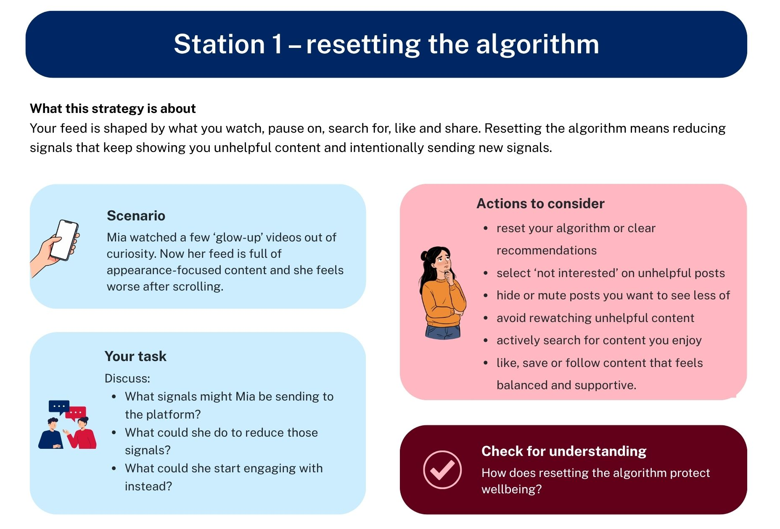
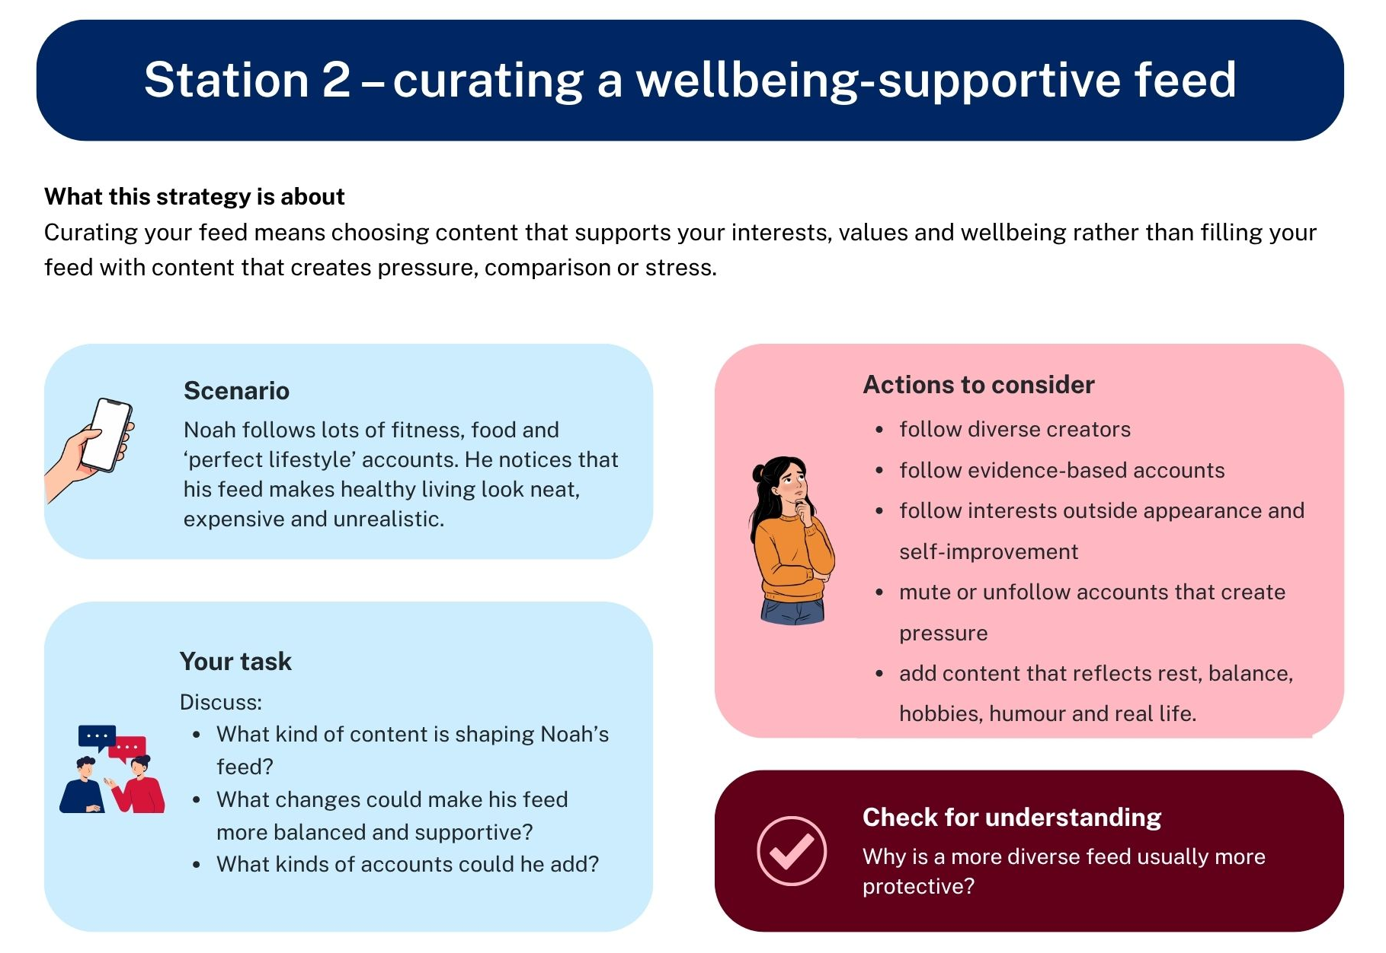
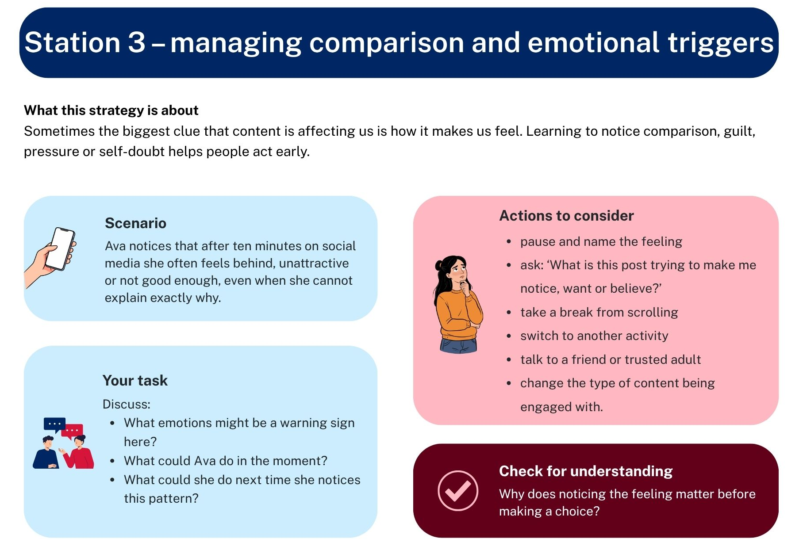
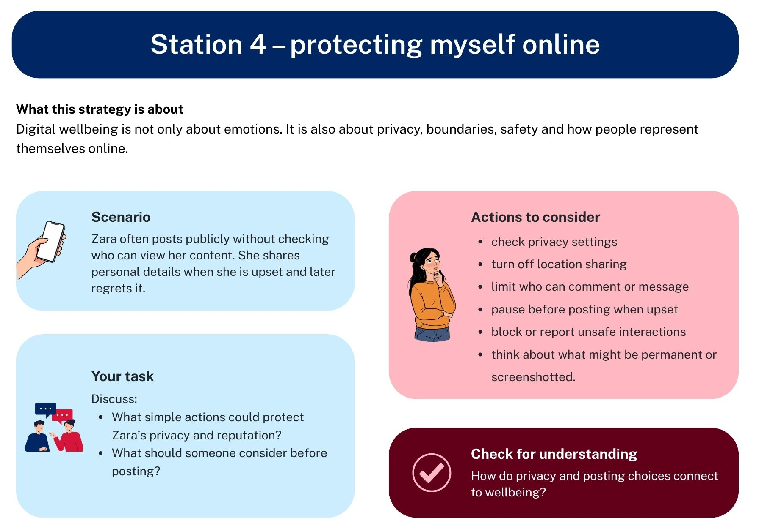
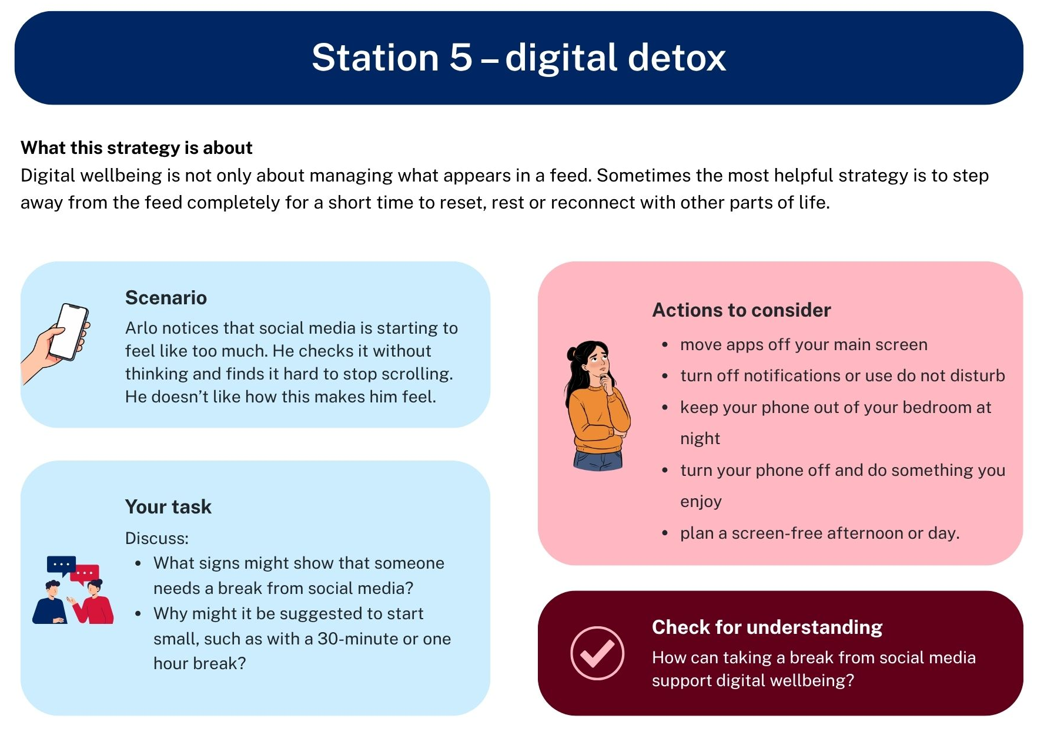

Appendix 12 – strategies to manage my feed worksheet
As you rotate through each station, complete the tables below.
Station 1 – resetting the algorithm | Student response
What problem is this strategy helping with?
What platform actions could help?
One step I could take today:
Check for understanding | Student response
How could this protect someone’s wellbeing?
Station 2 – curating a wellbeing-supportive feed |  | Student response
What problem is this strategy helping with?
What changes could make a feed more balanced?
One step I could take today:
Check for understanding |  | Student response
How could this protect someone’s wellbeing?
Station 3 – managing comparison and emotional triggers |  |  | Student response
What feelings can act as warning signs?
What could someone do in the moment?
One step I could take today:
Check for understanding |  |  | Student response
How could this protect someone’s wellbeing?

Station 4 – protecting myself online | Student response
What risks is this strategy helping with?
What actions could reduce these risks?
One step I could take today:
Check for understanding | Student response
How could this protect someone’s wellbeing, identity or safety?

Station 5 – digital detox | Student response
What risks is this strategy helping with?
What actions could reduce these risks?
One step I could take today:
Check for understanding | Student response
How could this protect someone’s wellbeing, identity or safety?

Appendix 13 – curate my clicks worksheet
Read your scenario carefully. Then answer the questions below.
Part A – understand the scenario
What messages is the character receiving?
How might the character start to feel after repeated exposure to this content?
How could those feelings influence self-worth, decisions, habits or behaviour?
What contextual factors are shaping this situation?
Think about algorithms, peer pressure, trends, sponsorship, culture, social norms or repeated exposure. What risks, unsafe beliefs or unhealthy patterns may develop?

Part B – recommend action
Which strategy from the skills carousel would help the most? (Tick ONE from the list below.)
- Resetting the algorithm
- Curating a wellbeing supportive feed
- Managing comparison and emotional triggers
- Protecting myself online
Why is this the most appropriate strategy?
What are 2 specific steps the character could take today?
What would you say to this person if they were your friend?
Scenario 1 – Riley and tanning line content (modelled in class)
Riley’s feed has recently become filled with videos highlighting ‘perfect tanning lines’, beach body shots and captions such as ‘summer-ready’ and ‘earned my stripes’. Many of the videos show lean bodies with sharp tan lines. Lately, Riley notices that they compare their body and appearance to every creator they see, feel pressure to achieve a similar look, and avoid swimming or going to the beach with friends because they do not feel confident about how their body looks in comparison. Riley knows that scrolling through this content makes them feel worse, but because they pause, re-watch and engage with these videos, their feed keeps showing more of the same trend every day.

Scenario 2 – unrealistic mental health fixes
Sienna’s feed has started showing lots of posts with captions like ‘heal your anxiety in 7 days’, ‘just do this one morning routine’ and ‘if you were disciplined, you’d feel better by now’. At first, the content seemed motivating, but now Sienna feels frustrated and inadequate because real life does not improve as quickly as the videos suggest. Sienna has started believing that struggling means they are doing wellbeing ‘wrong’.

Scenario 3 – high-risk gym challenge culture
Jay watched a few gym challenge videos and now keeps getting posts that promote extreme routines, ‘no excuses’ language and pushing through pain. The content makes Jay feel like taking rest days means being lazy. Jay has started copying workouts that are not right for their age or experience and feels pressure to keep going even when tired or sore.

Scenario 4 – highly curated healthy routine echo chamber
Alyssa’s feed is filled with ‘healthy morning routine’, ‘what I eat in a day’ and ‘clean lifestyle’ content. The posts are polished, calm and persuasive. Over time, Alyssa starts to feel that being healthy should always look organised, controlled and perfect. She notices that she feels guilty when her meals, routines or family life do not look like the content she sees online. She has started to judge her own choices against those posts, even though they do not reflect her real life.

Appendix 14 – Learning sequence 5 – checking for understanding activity
Complete this task independently. This is a short retrieval activity to help you recall the key ideas you will need for the next activities in the lesson.
Part A – Invisible Architecture Framework
Match the layer to the correct description by joining a solid line between them.
Layer |  | Description
- Creator choice |  | The wider influences that shape how a message is interpreted, such as age, culture, identity, current issues or life experience.
- Community trends |  | The features of the platform that influence what people see, repeat and engage with, such as algorithms, autoplay, likes and recommendations.
- Platform trends |  | The deliberate choices made when constructing a message, such as images, music, captions, editing, wording and tone.
- Contextual factors |  | The social norms, popular ideas or online trends that shape what is seen as normal, desirable or worth sharing.

Part B – RECAP strategy
Write what each letter in RECAP stands for when analysing health messages.
What is the letter in the acronym? | What does the letter stand for?
R
E
C
A
P

Part C – quick application
Read the statement below and answer the questions.
Example post:
‘Do this one morning routine every day to feel happier, healthier and more confident fast.’
Which layer of the Invisible Architecture Framework is most obvious in this example?
What is one reason this message should be checked carefully before trusting it?
Which part of RECAP would help you test whether this message is trustworthy?
Self-check and correct
Use the class review to check your answers. Correct any mistakes in a different coloured pen.
One thing I remembered well:
One thing I need to keep working on:

Appendix 15 – short-form media content planner
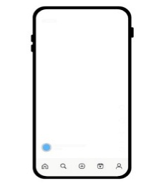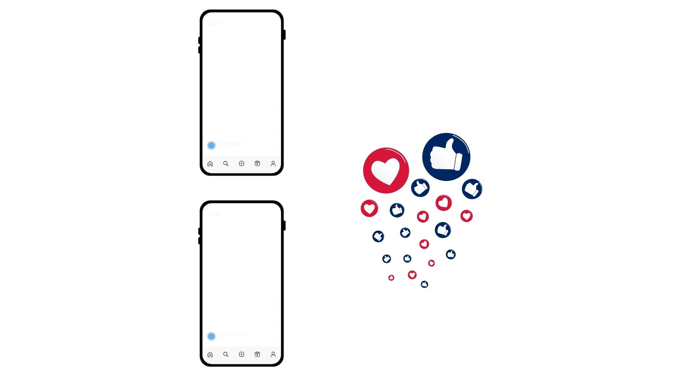 You are creating a mock-up for a short-form digital health post for a youth audience.
Your post must:
- promote a positive and realistic health behaviour, attitude or message
- be appropriate for young people
- avoid harmful, exaggerated or misleading claims
- support wellbeing, inclusion and safety.
Your post should be:
- credible
- inclusive and supportive
- intentional in its language, visuals and message.

Part A – choose your focus
Select one health topic for your post.
☐ movement for wellbeing | ☐ balanced approaches to nutrition
☐ stress management strategies | ☐ digital wellbeing habits
☐ body confidence and self-acceptance | ☐ other: __________________________
Who is your intended audience? Tick the one that applies.
☐young people my age | ☐mixed youth audience
☐younger teenagers | ☐other: __________________________
Write your message in one sentence.
What do you want your audience to think, feel or do after seeing your post?
Part B – building a trustworthy health message using the RECAP strategy
Use the RECAP strategy to help design a trustworthy and responsible health message.
R – Red flags
Tick the elements you will keep in mind when designing your message.
☐ no ‘instant results’ claims | ☐ no guilt or shame-based language
☐ no extreme promises | ☐ no misleading health claims
☐ no body comparisons or pressure | ☐ other: __________________________
R – Red flags
What language, visuals or claims did you avoid to reduce red flags?
E – Expertise
How will you avoid pretending to be an expert while still being persuasive?
C – Credible evidence
What general health knowledge, trusted advice or guidance will this message align with? For example, balance, moderation, wellbeing over appearance, healthy habits, support-seeking.
A – Accuracy and balance
How does your message show that health looks different for different people?
How have you made sure the message is realistic and supportive rather than idealised or pressure-based?
P – Purpose
What is the purpose of your message?
☐ inform | ☐ promote safer choices
☐ support | ☐ improve wellbeing
☐ encourage | ☐ other: __________________________
Part C – algorithms and repeated exposure
If this post were shown many times by an algorithm, what effect could it have on young people?
Could that effect be helpful, harmful or both? Explain.
What have you done to reduce any possible harm?

Part D – create your mock-up
Use the space below to sketch or draft your post across 6 frames. Label the key features in the rectangles or add in any additional notes.
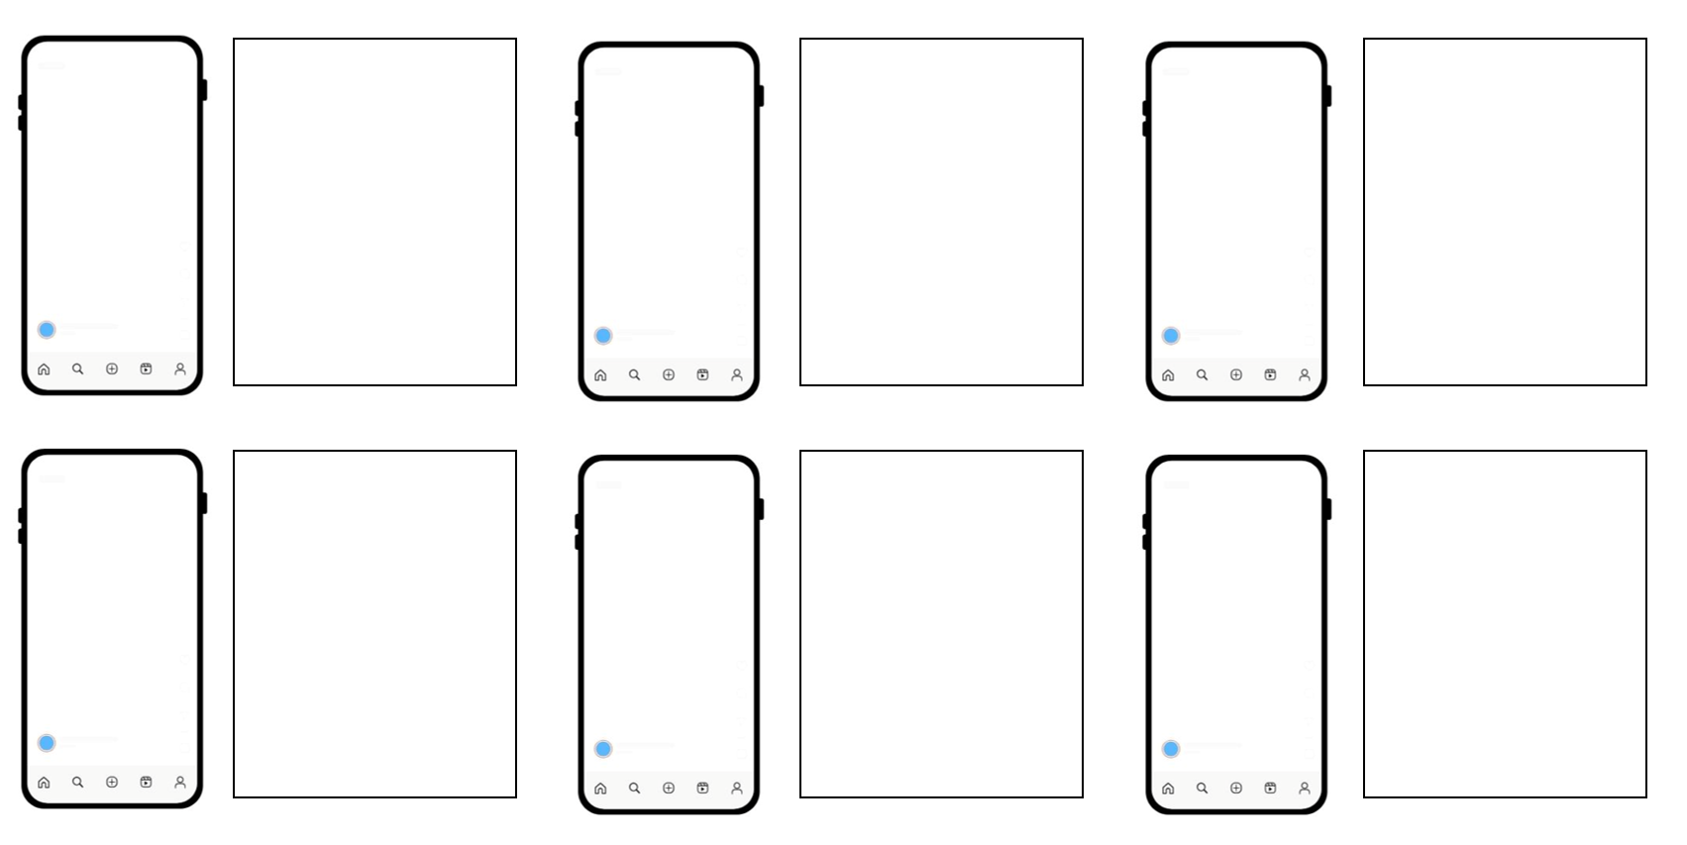

Part E – justification of health message design
Use the RECAP strategy to explain the health message design.
Use these sentence starters if helpful:
- One red flag I avoided was … because …
- I did not claim expertise because …
- This message is credible because it aligns with …
- I made sure the message was balanced by …
- The purpose of this message is …, which influenced my choices by …

Appendix 16 – short-form media plan – peer feedback template
Peer feedback
This feedback template will help you give constructive feedback on your peer’s short-form media health message plan.
This task shows how well the creator can:
- create a trustworthy health message
- think about how health content affects people
- make responsible and inclusive choices online
- explain why they made those choices.
Instructions
- Read and view your peer’s short-form media content planner.
- Review each criteria statement below.
- Place a tick in the column that best matches the design.
- Use your responses to give one strength, one suggestion and one thoughtful question.
Peer feedback checklist
Element | Not yet | Mostly | Yes
The health message is clear and easy to understand.
The message is appropriate for the audience.
The message avoids exaggeration, quick fixes or misleading claims.
The message feels realistic, supportive and not pressure-based.
The message is inclusive of different people, experiences or needs.
The language, visuals and tone appear intentional and fit the purpose of the message.
The design shows credibility by using the RECAP strategy.
The message would still support wellbeing if seen repeatedly in a digital feed.
One strength of the content plan is:
One thing the creator(s) could do to strengthen this even further is:
One question I want the creator(s) to think about is:
Feedback sentence starters:
- A strength of your message is ...
- Your message feels supportive because …
- One way to make this more credible could be …
- You could make this more inclusive by …
- You could make the message clearer by …
- I wonder whether this post would still feel helpful if …
Original creator to complete
Final reflection
After reading the feedback above, select one piece of feedback to implement in your design mock-up or justification.
The one change I will make is:
This change will improve my design because:


Program feedback
We value your feedback. If you use this teaching and learning program in your faculty and school context, please complete the PDHPE 7–10 resource evaluation form. If you have further comments or suggestions, please email PDHPEcurriculum@det.nsw.edu.au.

Support and alignment
Resource evaluation and support: all curriculum resources are prepared through a rigorous process. Resources are periodically reviewed as part of our ongoing evaluation plan to ensure currency, relevance and effectiveness. For additional support or advice, or to provide feedback, contact the PDHPE Secondary Curriculum team by emailing PDHPEcurriculum@det.nsw.edu.au.
Differentiation: further advice to support Aboriginal and/or Torres Strait Islander students, students learning English as an additional language or dialect (EAL/D), students with a disability and/or additional needs and high potential and gifted students can be found on the Planning, programming and assessing 7–12 webpage. This includes the Inclusion and differentiation advice 7–10 webpage.
Assessment: further advice to support formative assessment is available on the Planning, programming and assessing 7–12 webpage. This includes the Classroom assessment advice 7–10. For summative assessment tasks, the Assessment task advice 7–10 webpage is available.
Explicit teaching: further advice to support explicit teaching is available on the Explicit teaching webpage. This includes the CESE Explicit teaching – Driving learning and engagement webpage.
Consulted with: Curriculum and subject matter experts
Alignment to system priorities and/or needs: School Excellence Policy, Our Plan for NSW Public Education
Alignment to the School Excellence Framework: this resource supports the School Excellence Framework elements of curriculum (curriculum provision) and effective classroom practice (lesson planning, explicit teaching).
Alignment to Australian Professional Standards for Teachers: this resource supports teachers to address Proficient Teacher Standard Descriptors 2.1.2, 2.2.2, 2.3.2, 2.5.2, 3.1.2, 3.2.2, 3.3.2, 4.4.2.
Creation date: 10 March 2026

References
This resource contains NSW Curriculum and syllabus content. The NSW Curriculum is developed by the NSW Education Standards Authority (NESA). This content is prepared by NESA for and on behalf of the Crown in right of the State of New South Wales. The material is protected by Crown copyright.
Please refer to the NESA Copyright Disclaimer for more information https://www.nsw.gov.au/education-and-training/nesa/copyright.
NESA holds the only official and up-to-date versions of the NSW Curriculum and syllabus documents. Please visit NESA https://www.nsw.gov.au/education-and-training/nesa and NSW Curriculum https://curriculum.nsw.edu.au.
Personal Development, Health and Physical Education 7–10 Syllabus © NSW Education Standards Authority (NESA) for and on behalf of the Crown in right of the State of New South Wales, 2024.
Consumer Healthcare Products Australia (2022) Australia’s digital ‘health literacy’ dilemma, Consumer Healthcare Products Australia website, accessed 15 December 2025.
eSafety Commissioner (n.d.) The eSafety Guide, eSafety Commissioner website, accessed 15 December 2025.
——(2025) An unfair fight – how algorithms are shaping our adolescents, eSafety Commissioner website, accessed 10 March 2026.
——(2025) Recommender systems and algorithms – position statement, eSafety Commissioner website, accessed 10 March 2026.

© State of New South Wales (Department of Education), 2026
The copyright material published in this resource is subject to the Copyright Act 1968 (Cth) and is owned by the NSW Department of Education or, where indicated, by a party other than the NSW Department of Education (third-party material).
Copyright material available in this resource and owned by the NSW Department of Education is licensed under a Creative Commons Attribution 4.0 International (CC BY 4.0) license.

This license allows you to share and adapt the material for any purpose, even commercially.
Attribution should be given to © State of New South Wales (Department of Education), 2026.
Material in this resource not available under a Creative Commons license:
- the NSW Department of Education logo, other logos and trademark-protected material
- material owned by a third party that has been reproduced with permission. You will need to obtain permission from the third party to reuse its material.
Links to third-party material and websites
Please note that the provided (reading/viewing material/list/links/texts) are a suggestion only and implies no endorsement, by the New South Wales Department of Education, of any author, publisher, or book title. School principals and teachers are best placed to assess the suitability of resources that would complement the curriculum and reflect the needs and interests of their students.
If you use the links provided in this document to access a third-party's website, you acknowledge that the terms of use, including licence terms set out on the third-party's website apply to the use which may be made of the materials on that third-party website or where permitted by the Copyright Act 1968 (Cth). The department accepts no responsibility for content on third-party websites.

