PDHPE Year 8 – territory tactics
Teaching and learning program
Contents
About this resource 3
Overview 3
Syllabus outcomes 4
Content 4
Focus area – Movement skills and strategies 4
Focus area – Health and wellbeing through physical activity 5
Related support materials 6
Teacher notes 6
Learning sequence 1 – revisiting and extending territory game concepts 7
Learning sequence 2 – basketball basics 22
Learning sequence 3 – basketball scoring 38
Learning sequence 4 – basketball tactics 49
Learning sequence 5 – touch football basics 65
Learning sequence 6 – tactics in touch football 79
Appendix 1 – tactical concepts 92
Appendix 2 – teacher assessment (self-management and interpersonal skills) 93
Appendix 3 – chest, bounce and overhead passing 94
Appendix 4 – dribbling checklist and feedback 96
Appendix 5 – BEEF shooting checklist and feedback 97
Appendix 6 – self-assessment (tactical concepts) 98
Appendix 7 – peer assessment (tactical concepts) 99
Appendix 8 – teacher assessment (tactical concepts) 100
Program feedback 101
Support and alignment 102
References 103

About this resource
This teaching and learning program has been developed to assist teachers in NSW Department of Education schools to create learning experiences that are contextualised to their students’ needs, interests and abilities for the Personal Development, Health and Physical Education 7–10 Syllabus (NESA 2024). It provides an example of one way to approach programming through a conceptual lens. Teachers are encouraged to take an adopt and adapt approach to the learning activities outlined in this program.

Overview
Description: this teaching and learning program helps students develop and refine movement skills and strategies across a range of territory games. It focuses on tactical awareness and confident decision-making during gameplay. Through basketball and touch football, students compare tactics across games, reflect on their contribution to team performance and consider how tactical thinking supports success.
Duration: approximately 9.5 hours.
Explicit teaching: explicit teaching strategies are embedded in this resource. Further information on these strategies can be found on the Explicit teaching strategies webpage.
Assessment: suggested formative assessments have been outlined within this teaching and learning program.

Syllabus outcomes
A student:
- transfers movement skills and concepts for use in a range of dynamic movement environments PH4-MSS-01
- demonstrates how strategies and actions can be transferred to solve movement challenges PH4-MSS-02
- refines and applies self-management and interpersonal skills to manage complex situations PH4-SMI-01
Personal Development, Health and Physical Education 7–10 Syllabus © NSW Education Standards Authority (NESA) for and on behalf of the Crown in right of the State of New South Wales, 2024.

Content

Focus area – Movement skills and strategies
Enhancing and valuing movement
- Practise and refine fundamental and specialised movement skills in predictable and dynamic situations
- Demonstrate how to enhance balance, power and accuracy in movement contexts
- Participate in movement activities that demonstrate and transfer similar skills and strategies to different forms of gameplay, including target, net and court, striking and fielding, and territory games
- Apply and transfer movement concepts in a range of movement contexts
- Create and perform movement sequences that solve movement problems, including creating, using and defending space, and achieving and retaining possession
- Implement attacking and defending strategies and predict their effectiveness in different situations
- Evaluate decisions and actions when solving movement challenges
- Provide and apply feedback to improve body control, coordination, skill execution and strategy
Applying self-management and interpersonal skills to movement
- Recognise and apply attitudes and behaviours that encourage enjoyable, ethical, respectful and inclusive movement experiences
- Assess the effectiveness of teamwork, cooperation, problem-solving and personal responsibility when involved in team building, initiative games and other forms of physical activity
- Apply strategies to enhance resilience and perseverance during physical activity to manage challenging or unfamiliar movements
- Provide and respond to verbal, physical or situational cues to enhance communication, performance and team cohesion

Focus area – Health and wellbeing through physical activity
Participating safely
- Explain and apply specific warm-up and cool-down activities to a range of physical activities
- Demonstrate and explain how protective equipment and environmental and individual factors can influence safety during physical activity

Related support materials
This teaching and learning program aligns with the following support materials:
- PDHPE Years 7–8 – sample scope and sequence.
All resources associated with this program can be found on the Planning, programming and assessing PDHPE 7–10 webpage.

Teacher notes
This teaching and learning program builds on students’ learning in the Year 7 – mastering space in territory games program. Students apply and adapt territory tactics with a stronger focus on decision-making, personal responsibility and how their actions contribute to team success. Learning moves beyond participation to tactical thinking in dynamic, small-sided games that focus on creating space, supporting play, maintaining possession and defending space.
This teaching and learning program is part of a learning sequence from Stage 4 into Stage 5 PDHPE. It connects with the Year 9 – the real MVPs – behind the scenes in sport program and the Year 10 – own the zone program, where students analyse performance in more detail and apply tactics in more complex situations. While activities and sports can be adapted to suit student needs and school contexts, any adjustments should maintain the focus on transferable tactical concepts and the progression of learning from Year 7 to Year 10.

Learning sequence 1 – revisiting and extending territory game concepts
Note: the duration of this learning sequence is approximately 1.5 hours.
Table 1 – teaching and learning program
Outcomes and content | Teaching and learning activities
Outcomes  PH4-MSS-01, PH4-SMI-01  Content  Focus area – Movement skills and strategies  Enhancing and valuing movement  - Practise and refine fundamental and specialised movement skills in predictable and dynamic situations  - Participate in movement activities that demonstrate and transfer similar skills and strategies to different forms of gameplay, including target, net and court, striking and fielding, and territory games  - Create and perform movement sequences that solve movement problems, including creating, using and defending space, and achieving and retaining possession  Applying self-management and interpersonal skills to movement  - Recognise and apply attitudes and behaviours that encourage enjoyable, ethical, respectful and inclusive movement experiences  - Assess the effectiveness of teamwork, cooperation, problem-solving and personal responsibility when involved in team building, initiative games and other forms of physical activity  - Apply strategies to enhance resilience and perseverance during physical activity to manage challenging or unfamiliar movements  - Provide and respond to verbal, physical or situational cues to enhance communication, performance and team cohesion | Learning intentions  We are learning to:  - apply safe, inclusive and respectful behaviours, and demonstrate interpersonal skills that contribute to effective teamwork and team success  - transfer and apply territory game strategies to create, use and defend space, maintain possession and support play in new movement experiences.  Success criteria  I can:  - demonstrate respectful, inclusive and encouraging behaviours that support safe and successful participation  - implement effective strategies to create, use and defend space and identify how to maintain possession and support play in territory games.  Introduction – revisiting territory concepts  Note: this activating prior knowledge activity is designed to connect learning from the PDHPE Year 7 – mastering space in territory games – practical program.  Activate prior knowledge about territory games by posing the following class discussion questions:  - What are examples of territory games?  - Why are these classified as territory games?  - How did you create and use space in Year 7 territory games?  - How did you stop the opposition from succeeding?  - What else is required for team success? (For example, communication.)  Reinforce that tactics are the choices players make to help the team succeed. Also emphasise that interpersonal skills, including how players communicate, include others and respond respectfully during play, are also essential for team success.  Note: use Appendix 2 – teacher assessment (self-management and interpersonal skills) to support ongoing formative assessment during gameplay activities across the remainder of Learning sequence 1.  Focus observations on students’ communication, collaboration, personal responsibility and respectful participation to gather evidence of progress towards the success criteria, provide feedback and inform next steps for teaching.  Warm-up – crossover tag  Mark out a playing area approximately the size of a basketball court.  At each baseline, place one empty bucket (a large tub or crate is ideal) and one hoop with a range of small items that can be easily transported in students’ hands, such as beanbags or tennis balls. Ensure there are more items available than the number of students.  Allocate students into 2 teams.  Assign each team half of the playing area.  Explain the rules of the game to students:  - Each student begins with an item they have collected from their hoop in their hand.  - Each team starts in their own defending territory (safe zone).  - Players cannot be tagged in their safe zone.  - On a signal (such as a teacher’s whistle), players attempt to cross into the opposition’s territory and reach the baseline to put their item in the empty bucket.  - Once in the opposition’s territory, defenders may tag them.  - If tagged, players must return to their own baseline before trying again.  - When players successfully reach the opposition’s baseline, they put their item in the bucket, run around the court to collect another item from their own team’s hoop to try and transport it over.  - Students can only transport one item at a time.  - The first team with all items transferred to the bucket at the opposite end wins.  After the first round, pose the following question to the students for a class discussion:  - What makes a game enjoyable?  Prompt students to think about the best game or sport lesson they have been part of and what people did to make it enjoyable and fair. Examples may include following rules, encouraging teammates, fair play and giving everyone a chance. Highlight that these behaviours are choices players make that demonstrate their self-management and interpersonal skills.  Ask students to turn and talk with a partner to commit to one thing they will try to do in the next round of crossover tag to demonstrate self-management or interpersonal skills and make the game enjoyable.  Commence round 2 of crossover tag.  At the end of the round, pose the following questions to the students as a turn and talk or class discussion:  - How did you demonstrate improved self-management or interpersonal skills in that round?  - What did you do when something didn’t go your way?  - How did you contribute to making the game fair and enjoyable for others?  Commence round 3 of crossover tag.  At the end of the round, pose the following questions to the students as a class discussion:  - How can an individual’s attitude affect gameplay?  - Can a team be successful without communication or respect? Why or why not?  - How do your actions impact your team’s performance?  During the discussion, emphasise the importance of respect, fairness, resilience and a willingness to improve and highlight any examples observed during gameplay. Emphasise how this helped the game run fairly, strengthened teamwork and supported participation.  Explain to students that inclusion refers to ensuring everyone has equal access and opportunities to participate. Ask students to provide examples of inclusive behaviours. Responses may include passing to all teammates, encouraging participation, adjusting play to include others, avoiding negative talk or exclusion.  Commence round 4 (final round) of crossover tag.  At the conclusion of this round, bring the class together and invite students to share examples of when they:  - supported a teammate  - responded positively when something did not go their way.  Classifying tactical concepts  Explain to students that you will call out different tactical concepts. They will be required to classify these as either attacking, defending or teamwork tactics.  Students form a line across the court or playing area and for each concept, students select one of the following options to indicate their response:  - Step forward – attack.  - Step backwards – defence.  - Remain in place – teamwork.  Read out a tactical concept, for example, changing speed or direction to get free (refer to Appendix 1 – tactical concepts for additional sample statements). Provide students with time to think and take up their position. For each tactical concept, select students to explain how it supports success in gameplay.  Repeat this for a range of tactical concepts.  Maintaining possession – attacking advantage  Note: it is recommended to use a basketball or touch football as the game ball, as these sports are the key areas of focus in future learning sequences.  Allocate students into groups of 8.  Mark out a 10 metre by 10 metre playing area for each group.  In each group, allocate 3 students with one colour braid, 3 students with a different colour braid and 2 students to have no braid.  Explain the rules of the game:  - The 2 players without braids are always on the attacking team, so the game is always 5 attackers and 3 defenders.  - The aim of the game is to make 5 consecutive passes within your team.  - Players cannot run with the ball.  - Defenders must stay at least one metre away from the player with the ball.  - Players cannot take the ball from another player’s hands.  - Attackers pass the ball to maintain possession.  - If the ball is dropped, possession changes.  Note: adjust team numbers, the size of the playing area and the number of passes to be made to ensure the game is appropriately challenging for the skill level of your students.  After a period of play, circulate to each game and pause to pose the following questions as a discussion:  - Where did you move to create space?  - How did communication help your team?  - Did everyone get involved in the play?  - How did you adjust to include all players?  Introduce the following rules:  - the ball can be held for a maximum of 5 seconds  - even teams – 4 attackers and 4 defenders.  Note: students who are unable to participate can be assigned a role to stay involved in the lesson. Roles may include:  - Referee – enforce the rules of the game.  - Coach – provide feedback to players throughout gameplay, such as ‘move into space once you have passed the ball’.  - Stationary passer – a passing option for the team on the outside of the playing area.  After a period of play with the new rules, circulate to each game and pause to ask students the following questions for a discussion:  - How did the time limit on holding the ball change how you played?  - Did your team still communicate and include everyone?  - How did you help your team keep possession of the ball?  - How did you prevent an attacker from receiving a pass?  End ball  Mark out a rectangular playing area 40 metres by 20 metres. Use markers to create a 5 metre end zone at each end for scoring. A basketball or netball court is ideal for this game.  Figure 1 – set-up for end ball  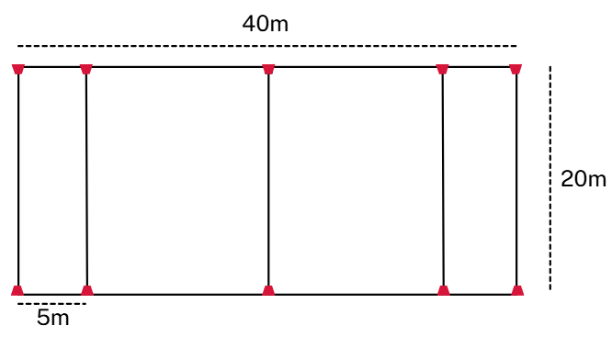  Note: if possible, maximise student engagement by running 2 or 3 consecutive games. This increases student activity and can allow for differentiation and encourage participation by grouping students according to their ability.  Allocate students into 2 teams.  Assign each team half of the playing area.  Explain the rules of end ball to students:  - Students pass the ball to their team mates to try and advance it to their allocated end zone.  - Play begins at halfway.  - Players cannot run with the ball.  - Players must stay one metre away from the player with the ball.  - Players cannot steal the ball out of other players’ hands.  - If the ball goes out, it is handed over to the other team to throw in from the sideline.  - Teams score a point by passing the ball to a player who must catch it on the full in their end zone.  - After a point, the ball is handed to the opposition who begins play from the edge of that end zone.  Pause the game after 5 minutes to engage students in a class discussion to explain their understanding of how to create and defend space. For example:  - How can you create space when your team has the ball?  - How can you support the player with the ball?  - What helps a team maintain possession?  - How can defenders protect space and stop the other team from advancing?  Recommence play.  Observe play and pause the game at appropriate points to pose questions about the strategies and tactics students are using. Questions may include:  - Who is creating space for others? How are they doing this?  - How does communication support your team?  - When should you pass quickly and when should you hold the ball for longer?  - How are you helping your team keep the ball?  - How are you working together to reduce space in defence?  Introduce the following rules:  - Once the ball is in the attacking half, teams cannot pass it backwards over the halfway line.  - All players must touch the ball before a point can be scored.  Consider swapping the type of equipment used, for example, if using a basketball, swap to a touch football.  Pause the game after 5 minutes and pose the following questions as part of a class discussion:  - What changes occurred with these new rules?  - How did this impact passing, support and defensive positions?  - How did the new rules change your teamwork?  - Did your communication improve or break down? Why?  - How did the rule focused on inclusion impact your success?  Recommence play for a final 5 minutes.  Formative assessment:  Outcome  - refines and applies self-management and interpersonal skills to manage complex situations  PH4-SMI-01  Use observations recorded in Appendix 2 – teacher assessment (self-management and interpersonal skills) to gauge the extent to which students have met the Learning sequence 1 success criteria of: ‘communicate with teammates using clear verbal, physical or situational cues’ and ‘show respectful, inclusive and encouraging behaviours that help everyone participate safely and successfully’.  Use the observations to inform any further teaching and learning activities.
Adjustments, evaluation and registration
[Classroom teacher to complete.]

Learning sequence 2 – basketball basics
Note: the duration of this learning sequence is approximately 2 hours.
Table 2 – teaching and learning program
Outcomes and content | Teaching and learning activities
Outcomes  PH4-MSS-01, PH4-MSS-02  Content  Focus area – Health and wellbeing through physical activity  Participating safely  - Explain and apply specific warm-up and cool-down activities to a range of physical activities  Focus area – Movement skills and strategies  Enhancing and valuing movement  - Practise and refine fundamental and specialised movement skills in predictable and dynamic situations  - Apply and transfer movement concepts in a range of movement contexts  - Create and perform movement sequences that solve movement problems, including creating, using and defending space, and achieving and retaining possession  - Evaluate decisions and actions when solving movement challenges  - Provide and apply feedback to improve body control, coordination, skill execution and strategy  Applying self-management and interpersonal skills to movement  - Provide and respond to verbal, physical or situational cues to enhance communication, performance and team cohesion | Learning intentions  We are learning to:  - apply basketball rules, passing and dribbling skills to participate safely and effectively in gameplay  - apply tactics to create, use and defend space, and maintain possession in small-sided games.  Success criteria  I can:  - follow basketball rules to participate safely and fairly in gameplay  - dribble, pass and move with control in predictable and dynamic situations  - use tactics to create space, support teammates, keep possession and defend in small-sided games.  Introduction  Explain to students that they will focus on the sport of basketball to develop their understanding of territory game tactics.  Warm-up – emu  Use guided questioning to introduce and build their understanding of the purpose of warm-ups. Prompts may include:  - What is a warm-up?  - Why is it important to warm up before physical activity?  - If you are preparing for a gymnastic routine, would passing and dribbling a basketball be suitable warm-up activities? Explain your reasoning.  This game requires a playing area approximately the size of a basketball court.  For game rules and set-up, refer to the Yulunga Traditional Indigenous Games ‘Emu’ resource.  After 5 minutes of play, regroup students and ask them to form a single line.  Conclude the warm-up by modelling dynamic flexibility movements that are relevant for basketball, such as high knees, butt kicks and arm circles, for students to perform. Make explicit links between these movements and basketball-specific movements.  Pukamitjal  This game requires a playing area approximately the size of a basketball court.  For game rules and set-up, refer to the Yulunga Traditional Indigenous Games ‘Pukamitjal’ resource.  Organise students into groups of 6.  Provide each group with a ball and 8 markers.  Each group sets up the playing area by creating 2 parallel lines of markers, positioned 10 metres apart.  Figure 2 – set-up for modified game – Pukamitjal  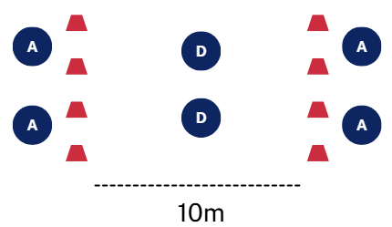  Nominate 2 defenders from each group to stand in the middle between the marker lines and the remaining 4 stand outside of the markers.  Explain that the aim of the game is to maintain possession of the ball by passing it over or around defenders who are standing in the middle.  If defenders gain possession of the ball, players swap positions with the attackers.  To progress this activity so students are under pressure when passing, introduce a rule that the attacking players must step past the marker before they pass the ball.  Commence gameplay.  After 5 minutes, pause play and pose the following questions for discussion:  - What was the safest passing option you had? Why?  - What caused you to lose possession?  - How did pass accuracy and timing affect your success?  - When was it better to pass early versus holding the ball longer?  Passing under pressure  Demonstrate the correct technique for a chest, bounce and overhead pass to the class.  Note: refer to Appendix 3 – chest, bounce and overhead passing for a breakdown of specific steps for chest, bounce and overhead passes.  Students are allocated into groups of 4.  Provide students with 4 markers to set up a 6 metre by 6 metre playing area. Players can move freely within the space.  Assign one defender in each group. The remaining 3 students are attackers.  Figure 3 – set-up for passing under pressure  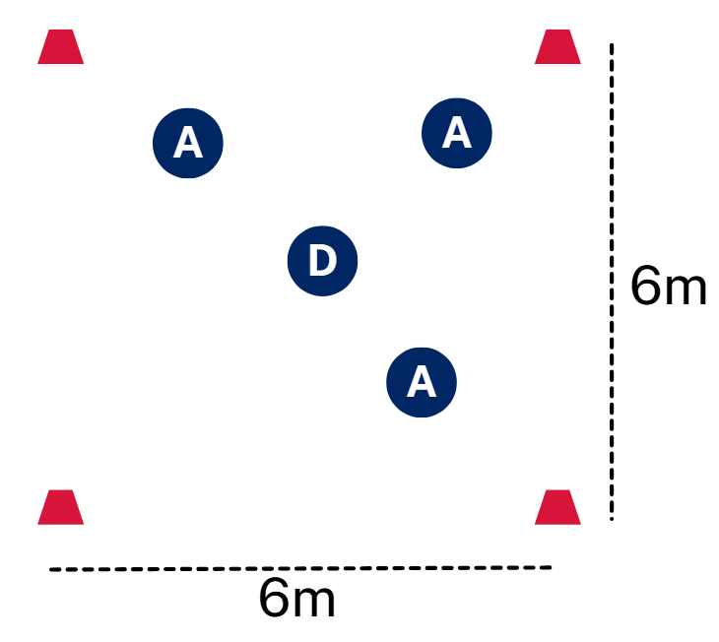  Attackers pass the ball to one another to maintain possession and prevent the defender from obtaining the ball. After each pass, attackers must run around one of the markers before they are able to receive the ball again.  If the defender gains possession, the attacker who made the pass becomes the defender. Alternatively, rotate the defender after one minute of play.  After a period of play, pose the following questions for discussion:  - Which passes did you select during the game and why?  - How did your selected pass help maintain possession?  - How did the defender affect your decision?  - How did you create space away from the defender?  - What made it easier or harder to keep possession?  Maintaining possession – even teams  Allocate students into 4 teams.  Provide each team with a set of braids.  Allocate 2 teams to play in one half of a basketball court (or equivalent playing area) and the other 2 teams to play in the other half.  Explain the rules to students:  - The aim of the game is to make 5 consecutive passes within your team.  - Players cannot run with the ball.  - Defenders must stay at least one metre away from the player with the ball.  - Players cannot take the ball from another player’s hands.  - Attackers pass the ball to maintain possession.  - If the ball is dropped or goes out of bounds, possession changes (a bounce pass is still allowable).  - Players cannot pass the ball to the player who passed it to them.  After 5 minutes of gameplay, pose the following questions for discussion:  - Where did you move to receive the ball?  - What happens if everyone stands still?  - How many passing options did the ball carrier have?  - How did you move into a position to support the person with the ball?  Introduce the following basketball rule:  - Players can come within one metre of the person with the ball, however there is no contact, including pushing, holding or hitting another player.  Provide students with time to discuss tactics, then recommence play.  After 5 minutes, pause the game and pose the following questions for discussion:  - When defending, how did your team force an error and gain possession?  - How could you stop attackers from getting free?  - When defending, were you watching the player, the ball or both?  Dribble battle  For this game use a netball court, or a basketball court divided into thirds.  Provide each student with a basketball.  All students begin in one third of the court dribbling their basketball. Allow students to build confidence while dribbling and avoiding other players. Challenge them to go as fast as they can, while maintaining control. Use teaching cues such as keep your eyes up.  After 1 to 2 minutes pause the dribbling. Provide any dribbling technique tips from what you have observed. Recommence the activity for another 1 to 2 minutes.  Pause the dribbling, students will now dribble their ball within the third while trying to knock other students’ balls out of the area.  If a student’s ball goes outside of the third, they are knocked out of that third and they start the same game in the next third. Likewise, if they get knocked out of the second third they move to the last third. Students do not get knocked out of the last third; however, they continue to move around the third practising dribbling.  Note: as students play the game, observe their technique and provide relevant, targeted technique feedback including:  - Stance – knees bent, feet shoulder-width apart and ball held to the side of the body.  - Stationary – dribble with finger pads, ball stays below waist and eyes up (do not look at the ball).  - Moving – walk while dribbling, change hands smoothly, keep control while moving.  - Protection – turn body slightly to shield the ball and use non-dribbling arm for balance (not pushing).  - Change of direction – slow down, then change direction and dribble low and controlled.  After 5 to 10 minutes of play, pause the game and pose the following questions for discussion:  - What are the main challenges in this game?  - Why do we dribble in basketball? (Suggested answers include: to progress up the field or to beat a player.)  - What strategies did you use to improve your success in this game?  Introduce and explain the following rules in basketball:  - Dribbling – you cannot run while holding the ball so you must dribble the ball to move with it.  - Carrying or travelling – taking more than 2 steps without dribbling is not allowed.  - Double dribble – once you stop dribbling, you must pass or shoot. You cannot start dribbling again.  Optional activity – dribbling  Note: if students require further support in developing dribbling skills this activity may be selected.  Divide students into groups of 3 to 5.  Provide each group with a ball and a copy of Appendix 4 – dribbling checklist and feedback.  Students take turns practising dribbling and complete the dribbling checklist and feedback sheet.  As this is happening, move between groups and provide concurrent feedback to students.  At the conclusion of the activity, pose the following questions for discussion:  - Why is keeping your head up important for decision-making?  - How does dribbling help you escape a defender?  - What was the area you identified for improvement?  Maintaining possession – with dribbling  Allocate students back into 4 teams and direct them to play the ‘maintaining possession’ game from earlier in the lesson; however, introduce that students are allowed to dribble.  Note: during this game, you may like to provide opportunities for students to give peer feedback to a partner about dribbling skills using Appendix 4 – dribbling checklist and feedback.  After 3 minutes, pause the game and ask students to reflect on their performance using questions such as:  - Was it easier to maintain possession of the ball now that you were able to dribble? Why or why not?  - What feedback did you receive from a peer?  Continue play for an additional 3 minutes before moving on to the next activity.  Bucketball  Note: this game builds on the skills of the previous game by introducing a direction of play and a mechanism for scoring.  Keep students in 4 teams.  In each half of a basketball court, place one bucket (or alternatively milk crates or empty bins) halfway along the sideline, and the other in line with it on the opposite sideline. These are the scoring targets for the game.  Figure 4 – set-up for modified game – bucketball  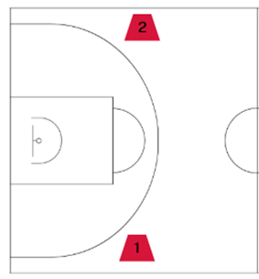  Explain the rules of the game:  - Teams must make 3 passes before attempting to score.  - No double dribbling or travelling.  - A point is scored when the ball lands in the bucket.  - Players must stay one metre away from the bucket.  - If the ball goes outside the court lines, possession is given to the other team.  - After a point is scored, the other team gets the ball and commences play from the bucket.  Note: if students are still developing their skills in attack, begin this game with uneven team numbers that advantage the attacking team (see Learning sequence 1 – revisiting and extending territory concepts, ‘Maintaining possession – attacking advantage’ activity).  After 3 minutes, pause play and pose questions to students to explore strategic decision-making, such as:  - How did having a direction of play and a goal affect where you stand?  - How did having a direction of play and a goal affect how you attacked and tried to create space?  - How did having a direction of play and a goal affect how you defended?  Introduce a 3-second time limit for players holding the ball.  Provide teams with time to discuss tactics, then rotate teams and recommence play.  Pause play after 3 minutes and pose the following questions for discussion:  - How did the time limit change your decisions?  - Did your team pass quicker or move differently? Why?  Increase the playing size to a full basketball court while keeping the same team sizes if possible.  Provide teams with time to discuss tactics, then rotate teams and recommence play.  After 5 minutes, pause play and ask the following questions:  - How did having more space impact your decisions?  - How did having more space impact defensive positioning? Did you mark a player or a space?  Formative assessment:  Outcome  - transfers movement skills and concepts for use in a range of dynamic movement environments  PH4-MSS-01  Use Appendix 8 – teacher assessment (tactical concepts) to assess students’ progress towards transferring movement skills and territory game tactics and concepts in basketball.
Adjustments, evaluation and registration
[Classroom teacher to complete.]

Learning sequence 3 – basketball scoring
Note: the duration of this learning sequence is approximately 1 hour.
Table 3 – teaching and learning program
Outcomes and content | Teaching and learning activities
Outcomes  PH4-MSS-01, PH4-MSS-02  Content  Focus area – Movement skills and strategies  Enhancing and valuing movement  - Practise and refine fundamental and specialised movement skills in predictable and dynamic situations  - Demonstrate how to enhance balance, power and accuracy in movement contexts  - Create and perform movement sequences that solve movement problems, including creating, using and defending space, and achieving and retaining possession  - Provide and apply feedback to improve body control, coordination, skill execution and strategy  Applying self-management and interpersonal skills to movement  - Assess the effectiveness of teamwork, cooperation, problem-solving and personal responsibility when involved in team building, initiative games and other forms of physical activity  - Provide and respond to verbal, physical or situational cues to enhance communication, performance and team cohesion | Learning intentions  We are learning to:  - practise and refine basketball shooting skills by applying balance, power and accuracy in predictable and dynamic situations  - apply tactics to create and defend space, maintain possession and support play in small-sided games.  Success criteria  I can:  - demonstrate balance, power and accuracy when shooting in predictable and dynamic situations  - use feedback to improve my shooting technique and performance  - use tactics to create and defend space, maintain possession and support play in small-sided games.  Warm-up – bucketball  Set up this game as per the Bucketball activity in Learning sequence 2.  Prior to playing, pose the following questions to support students to recall the rules of the game:  - Can players guard the bucket?  - What happens if the ball goes out of the playing area?  - How does a team score a point in bucketball?  Conduct a think-pair-share with the following questions to reconnect students with the learning from the previous lesson:  - What was something you learned or was reinforced about dribbling techniques in our last lesson?  - When would you use a bounce pass in a game of basketball?  - When is it valuable to be able to dribble in a game of basketball?  Commence play.  Pause play after 5 minutes to pose the following questions for discussion:  - In bucketball, you were aiming for a bucket on the ground to score a point. What are the differences between this and a basketball hoop?  - We are about to change this rule. How do you think this will change the game?  - What are the key challenges you think you will face when we use the basketball hoop?  Half-court basketball with modified scoring  Students remain in the same teams from the previous activity.  Explain the rules of the game:  - The game starts with a pass from the halfway line.  - One point is scored when the ball hits the backboard or rim.  - Two points are scored when a successful goal is scored through the basket.  - After a goal is scored, the other team restarts play from the half-way line.  - When the defending team gains possession through a rebound, steal or turnover, they must pass or dribble the ball to the halfway line before they can score.  Note: if students are still developing their skills in attacking and shooting, begin this game with uneven team numbers that advantage the attacking team (see the Maintaining possession - attacking advantage activity in Learning sequence 1). This can be achieved through one player leaving the court when their team becomes the defending side and returning to play once their team gets the ball back to halfway.  Pause play after 5 minutes to pose the following questions for discussion:  - How did your team create opportunities to shoot?  - How did players shoot? Did they use 2 hands or one? Did they bend their knees?  - Where did you aim for when shooting?  Basketball skills stations  Provide a demonstration of good shooting technique. Call out the key features identified in Appendix 5 – BEEF shooting checklist and feedback.  Divide students into 3 groups.  Set up the following 3 stations.  - Station 1 – dribbling relay.  Figure 5 – set-up for skills in isolation – dribbling relay station  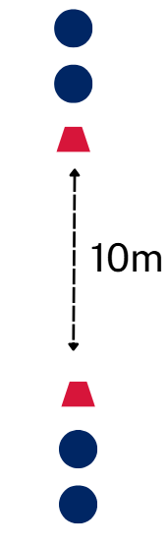  - Students form 2 lines facing each other, 10 metres apart.  - Place a marker in front of each line to show the starting position.  - Students dribble the ball and pass to the next person in the line.  - To add complexity, encourage students to practise dribbling in different ways such as fast, alternating hands or shielding the ball.  - Station 2 – follow your pass.  Figure 6 – set-up for skills in isolation – follow your pass station  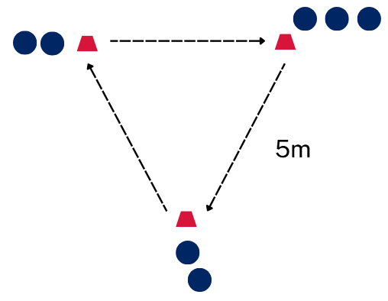  - Set up 3 markers in a triangle, with each marker 5 metres apart.  - Place 2 students at each marker, with additional students lined up behind one marker.  - The first student passes to the front student at the next marker, then follows the pass and joins the back of that line.  - Continue the pattern so students pass and move in the same direction around the triangle.  - To add complexity, encourage students to alternate the types of passes they make between chest, overhead and bounce passes.  - Station 3 – around the world.  Figure 7 – set-up for skills in isolation – around the world station  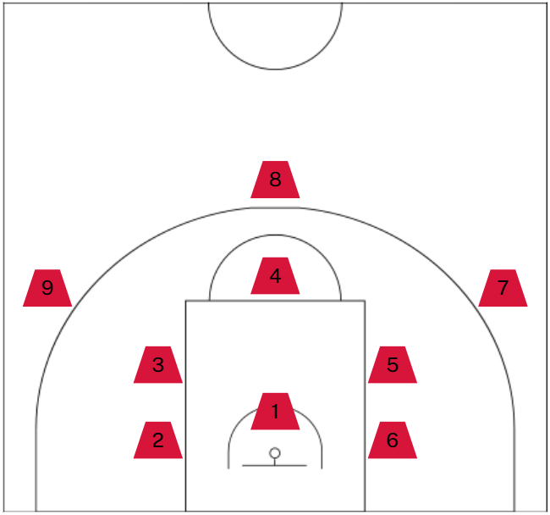  - Distribute Appendix 5 – BEEF shooting checklist and feedback to each student.  - Place a series of markers around the key and arc to show different shooting positions, see Figure 7 for an example.  - Students begin at marker one and take a shot from each position in order.  - After each shot, they move to the next marker and continue around the court.  - Students also complete a self-assessment or peer assessment using the checklist.  Assign each group a station.  As students complete each station, circulate and pose the following station-specific questions:  - Station 1 – dribbling relay station  - How did you stay balanced while dribbling at speed?  - When would you use each type of dribbling in a game?  - Station 2 – follow your pass station  - Where did you move after passing?  - Were you balanced when you received a pass?  - When would you use each type of pass in a game?  - Station 3 – shooting – around the world station  - Which positions were easier to score from? Why?  - What helped you stay balanced?  - How did you need to change your body movement when you were further from the ring to get more power?  Note: provide specific and targeted feedback to students on their shooting technique by referring to biomechanical principles embedded in the following BEEF key points:  - Balance – feet shoulder width apart, knees bent.  - Eyes – focus on the target (front of rim or backboard square).  - Elbow – shooting elbow under the ball, pointing to the target.  - Follow through – wrist flick, fingers down, hold your finish.  Half-court basketball with modified scoring 2  Allocate students into 4 teams to play another round of half-court basketball.  Use the same rules and scoring system but add in 3 points awarded for a shot outside of the 3-point line on the court.  After 5 minutes of play, pose the following questions for discussion:  - How did your team create space for a shot?  - How did you decide whether to shoot or not?  Distribute a copy of Appendix 6 – self-assessment (tactical concepts) to each student.  Explain each of the listed concepts that they will reflect on at the end of this activity.  Provide teams with time to discuss tactics, then rotate teams and recommence play.  After 5 minutes, rotate teams and play a final game.  Provide time for students to complete the tactical concepts self-assessment worksheet.  Invite students to share one strength or area for improvement related to either their movement or technique.  Formative assessment:  Outcome  - transfers movement skills and concepts for use in a range of dynamic movement environments  PH4-MSS-01  Use Appendix 8 – teacher assessment (tactical concepts) to assess students’ progress towards transferring movement skills and territory game tactics and concepts in basketball.
Adjustments, evaluation and registration
[Classroom teacher to complete.]

Learning sequence 4 – basketball tactics
Note: the duration of this learning sequence is approximately one hour and 30 minutes.
Table 4 – teaching and learning program
Outcomes and content | Teaching and learning activities
Outcomes  PH4-MSS-01, PH4-MSS-02,  PH4-SMI-01  Content  Focus area – Movement skills and strategies  Enhancing and valuing movement  - Practise and refine fundamental and specialised movement skills in predictable and dynamic situations  - Apply and transfer movement concepts in a range of movement contexts  - Create and perform movement sequences that solve movement problems, including creating, using and defending space, and achieving and retaining possession  - Implement attacking and defending strategies and predict their effectiveness in different situations  - Evaluate decisions and actions when solving movement challenges  - Provide and apply feedback to improve body control, coordination, skill execution and strategy  Applying self-management and interpersonal skills to movement  - Provide and respond to verbal, physical or situational cues to enhance communication, performance and team cohesion | Learning intentions  We are learning to:  - apply attacking and defensive basketball tactics to defend space, support play, maintain possession and create space  - provide and apply constructive feedback to improve tactical decision-making in territory games.  Success criteria  I can:  - defend space by limiting attacking options through effective defensive positioning  - create attacking opportunities by moving into space and supporting teammates effectively  - implement feedback to improve tactical decision-making in territory games.  Warm-up one – golden child  Divide the class into 2 even teams.  The shooting team stands in a line behind the free throw line. The running team, stands in a line behind the marker on the outside of the sideline.  Figure 8 – set-up for warm-up – golden child  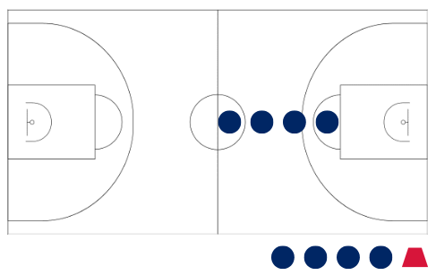  Explain the rules of the game:  - The first student in the running team starts behind the marker and runs around the outside of the court.  - While the runner is completing their lap, students in the shooting team take turns to score a basket.  - If the shooting team scores they shout ‘Stop!’ When this happens, the current runner needs to freeze on the spot.  - If the runner completes a lap and returns to the end of the line before a basket is scored, they score one point and the next runner begins.  - The last runner in the line is designated the ‘golden child’. As they run their lap, they can tag any frozen teammates to unfreeze them, allowing them to finish the lap.  - Any runner who completes the lap scores a point for their team.  Once all students on the running team have had a turn, the shooting team swaps to become the runners and another round is completed.  At the end of this game, explain to students the learning intentions for this lesson sequence. In basketball, teams create scoring opportunities by moving defenders, attacking the key and spacing the court. We are learning to apply basketball skills and tactics to defend space, maintain possession, support play and create space effectively in gameplay.  Warm-up 2 – person-to-person tag  Allocate students into pairs.  Explain the rules of the game:  - Students must stay within the lines of a full basketball court.  - On the teachers call, students play ‘scissors, paper, rock’ with their partner.  - The student who wins must follow their partner around as closely as possible while their partner tries to get away from them.  - On the teacher’s signal, such as a whistle, students must freeze where they are standing.  - If the chasing student can reach out and tag their partner without moving their feet, they win a point. If they are not able to, the other student wins a point.  Play several rounds of this game.  Ask students the following questions:  - What made it difficult to stay close to your partner when you were chasing them?  - What strategies did you use to keep an eye on your partner but also not run into other students playing the game?  - One defensive strategy in basketball is ‘person to person’, which is like the game that was just played. What could be some advantages and disadvantages of this strategy?  Maintaining possession – defensive focus  Divide students into groups of 6 (3 attackers and 3 defenders).  Set up a 10 metre by 10 metre playing area.  Use the rules of the ‘Maintaining possession’ game from Learning sequence 1.  Explain to students that scoring will now also reward defensive play. Teams will still receive one point for making 5 consecutive passes; however, if defenders prevent a successful pass from being made and cause a turnover, they receive one point.  After 5 minutes of play, pose the following questions as a class discussion:  - Where should you position yourself to prevent the other team from making successful passes?  - What made it difficult for attackers to get free?  Zone defence  Students are to remain in the same groups of 6 (3 attackers and 3 defenders).  Using the previous 10 metre by 10 metre playing area, mark out 3 zones on the playing area and use a hoop to replicate the basket.  Figure 9 – set-up for defensive tactics in isolation – zone defence  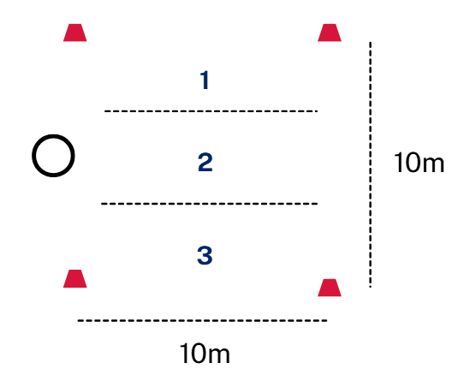  Allocate each defender to one of the 3 zones. Defenders must stay in their zone, but attackers can move anywhere.  Attackers aim to score a point by making 3 consecutive passes and then passing the ball to an attacking player who is standing in the hoop and catches the ball on the full.  If defenders prevent a pass, they receive one point.  Reset after each attempt and swap roles once the defenders have a total of 3 points.  Once all students have had a turn as a defender, ask the following questions:  - How did you protect the space near the hoop?  - What were the benefits of this formation?  - What made this formation challenging?  - When would a zone defensive structure be used versus person-to-person?  Half-court basketball – defensive formations  Divide students into 4 teams.  Provide each team with different coloured braids.  Prompt students to recall the rules of half-court basketball and the scoring systems. Refer to Learning sequence 3 – basketball scoring as required.  Explain that in this activity, students are to implement person-to-person defence.  Allow time for students to select a player to defend.  Commence gameplay.  After 5 minutes, pause play and ask questions such as:  - Where did you position yourself to prevent your player from receiving a pass?  - What made it difficult for attackers to get free?  - What are the risks with this type of defensive strategy?  Explain to students they will now implement zone defence.  Allow time for teams to allocate players to an area to defend and discuss tactics, then recommence play.  After 5 minutes, pause play and ask questions such as:  - How did you protect the space near the basket?  - When should you step forward to defend versus stay in your zone?  - How did your team move together when the ball moved?  - Which defensive tactic made it harder for the attackers? Why?  Attacking tactics in basketball  Activate prior knowledge through a class discussion by posing the following questions:  - In our tagging game earlier, how did changing speed or direction help you avoid being tagged?  - How is this similar to getting free in basketball?  - How do you create space in basketball?  - How do you maintain possession of the ball?  Passing triangles  Divide students into groups of 4. Assign one person in each group to be a defender, while the remaining students in the group are attackers (3 attackers and 1 defender).  Set up a 4 metre by 4 metre square marked out with markers for each group.  Each attacking player begins at a marker, and the defender is in the middle of the square.  Attacking players can only pass to other players who are standing at a marker that is next to theirs (passes cannot be made diagonally across the square).  The attacking players aim to make as many passes as possible while the defender attempts to intercept their pass.  Figure 10 – set-up for passing triangles  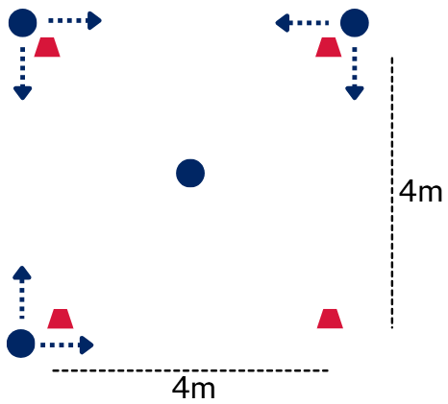  Pause play and rotate the defending player periodically.  Circulate to each group and pause play to pose the following questions:  - Once you pass the ball, what do you need to do next?  - Why is it difficult for the defender to intercept the ball and disrupt play during this game?  - How can this strategy be used in a game of basketball?  Increase the playing area for each group and explain that they no longer need to be standing at a marker to receive the ball.  Provide teams with time to discuss tactics, then recommence play.  After a period of play, pose the following questions for discussion:  - Where did you need to move when you were attacking to help your team?  - What else did you need to do in attack to ensure success in the game?  - What was the safest passing option?  Implementing tactics – on court off court  Note: this activity is a modified version of the ‘Maintaining possession’ game and works best on a basketball court.  On the basketball court or similar space, place a marker on each sideline at the halfway line.  Divide students into 2 teams.  Select 6 players from each team to take the court.  The remaining team members line up on an allocated side of the court behind the marker. These players wait to rotate onto the court during the game.  Figure 11 – set-up for implementing tactics – on court off court  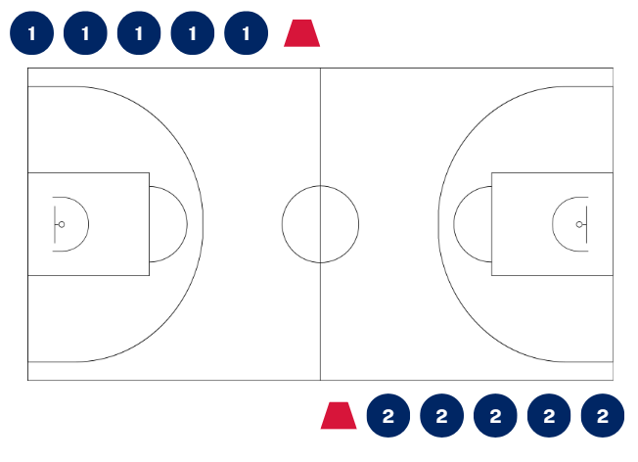  Explain the following modified rules:  - The aim of the game is to advance the ball down the court using passes and successfully shoot a goal in the basketball ring.  - Teams must make 5 passes before they take a shot.  - When a player makes a pass, they are to run off the court and join the back of their team’s line on the sideline.  - The player at the front of the line then takes the court. They are now considered ‘active’ in the game and need to support their team by moving into space or creating space immediately.  - Once a team scores a goal, all 6 players on the court are substituted and join the back of their team’s line on the sideline and the next 6 players in the line take the court.  - When a goal is scored, the opposition collects the ball and performs a throw-in from the baseline where the goal was just scored.  - Instruct students to implement person-to-person defence.  After 5 minutes of play, pause the game and ask the following questions:  - What do you think the purpose of this game is? (Explain to students that one of the key things it develops is movement off the ball. It is teaching you to find space, contribute to your team and then move again.)  - What does it indicate to you about your performance if you are quickly entering and exiting the court?  Provide teams with time to discuss tactics, then recommence play.  After 5 minutes, stop play and pose the following question:  - What made it hard for defenders to implement person-to-person defence?  Instruct students to implement zone defence.  Provide teams with time to discuss tactics, then recommence play.  After 5 minutes, stop play and pose the following question:  - Which defensive tactic was best to implement for this game? Why?  Basketball  For this game, use standard basketball rules and scoring systems.  If you have 2 courts available, allocate students into 4 teams to play 2 games concurrently. Alternatively, allocate students into 3 teams with the non-playing team practising skills activities during their bye.  Set up a round robin with 5 minute rounds.  A maximum of 6 players take the court for each team. Additional players complete Appendix 7 – peer assessment (tactical concepts) for their teammates during the game they are subbed off.  As opportunities arise, pause the game(s) and unpack or highlight the following sport-specific tactical concepts when demonstrated by students:  - Create space by passing then moving into space towards the basket.  - Support play by providing options for the ball carrier by drawing or dodging a defender.  - Retain possession through controlled dribbling and accurate passing.  - Defend space by marking players or a zone.  Rotate teams until each student has had the opportunity to complete the peer assessment.  Conclude the lesson by posing the following questions for a class discussion:  - How did your team create scoring opportunities?  - How did you successfully maintain possession?  - How did defenders reduce attacking space?  - How did supporting play improve your team performance?  - When was it best to pass, dribble or shoot?  - What interpersonal skills were important to ensure team success while you were playing?  Formative assessment:  Outcome  - transfers movement skills and concepts for use in a range of dynamic movement environments  PH4-MSS-01  Use Appendix 8 – teacher assessment (tactical concepts) to assess students’ progress towards transferring movement skills and territory game tactics and concepts in basketball.
Adjustments, evaluation and registration
[Classroom teacher to complete.]

Learning sequence 5 – touch football basics
Note: the duration of this learning sequence is approximately 2 hours.
Table 5 – teaching and learning program
Outcomes and content | Teaching and learning activities
Outcomes  PH4-MSS-01, PH4-MSS-02,  PH4-SMI-01  Content  Focus area – Movement skills and strategies  Enhancing and valuing movement  - Practise and refine fundamental and specialised movement skills in predictable and dynamic situations  - Apply and transfer movement concepts in a range of movement contexts  - Evaluate decisions and actions when solving movement challenges  - Provide and apply feedback to improve body control, coordination, skill execution and strategy  Applying self-management and interpersonal skills to movement  - Assess the effectiveness of teamwork, cooperation, problem-solving and personal responsibility when involved in team building, initiative games and other forms of physical activity  - Provide and respond to verbal, physical or situational cues to enhance communication, performance and team cohesion  Focus area – Health and wellbeing through physical activity  Participating safely  - Demonstrate and explain how protective equipment and environmental and individual factors can influence safety during physical activity | Learning intentions  We are learning to:  - apply touch football rules and skills to participate safely and effectively in gameplay  - apply tactics to create, use and defend space, support play and maintain possession in small-sided games.  Success criteria  I can:  - follow touch football rules to participate safely and fairly in gameplay  - pass and play the ball with control in predictable and dynamic situations  - use tactics to create space, support teammates, keep possession and defend in small-sided games.  Warm-up – rats and rabbits  Ask students to find a partner.  Partners form a line and stand back-to-back, ensuring they have one foot touching.  Allocate one line of students as ‘rabbits’ and the other ‘rats’.  Mark out a ‘safe’ line about 10 to 15 metres behind each team.  Figure 12 – set-up for warm-up – rats and rabbits  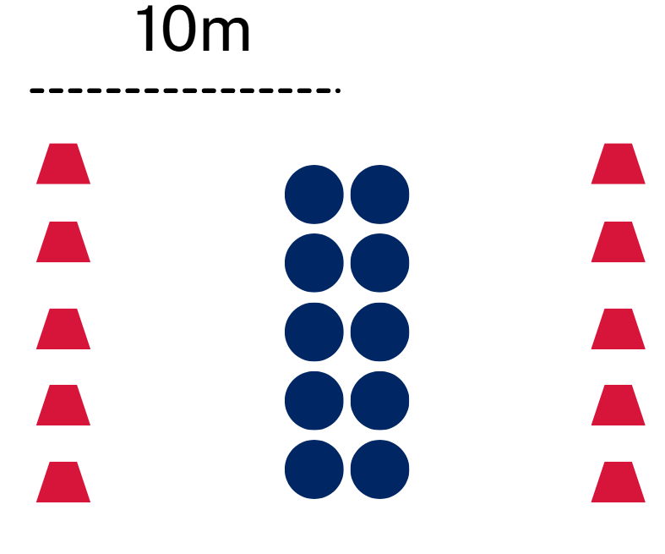  Call out either ‘rats’ or ‘rabbits’.  If ‘rats’ are called, the rats must turn and run to their safe line and the rabbits attempt to tag the rats before they reach the line.  If ‘rabbits’ are called, the rabbits run and the rats try to tag them.  Players score a point for tagging their partner.  After a few rounds, ask students to find a new partner and repeat.  Note: students must be travelling in the same direction to make a tag. They cannot simply swing their arm around and tag their partner.  Offside ball tag  Note: the Yulunga Traditional Indigenous Games ‘Kabi kabi buroinjin’ resource could be used as an alternate game for this activity.  Mark out a playing area approximately 40 metres by 20 metres. Include a 5 metre try zone at each end.  Figure 13 – set-up for offside ball tag  Divide students into 2 even teams.  Explain the rules of the game:  - Teams try to score by reaching the try line with the ball.  - The attacking team has 3 tags to reach the try line.  - A tag occurs when a defender touches the ball carrier with 2 hands.  - After a tag, the ball carrier must stop and pass the ball to a teammate.  - The first pass after a tag must go backwards.  - After the first pass, the ball may be passed in any direction.  - If the attacking team is tagged 3 times, possession goes to the other team.  - If the ball is dropped, intercepted or goes out of bounds, possession changes.  - Defenders must stand one metre away from the ball carrier after a tag occurs.  After 5 minutes, pause gameplay and pose the following questions:  - Where did you position yourself to support your team to succeed in attack?  - Were the best passing options longer or shorter? Why?  - What defensive strategy did your team use?  Provide teams with a few minutes to discuss tactics before recommencing play.  At the conclusion of the game, explain to students that in touch football, the ball can only be passed backwards in attack.  Touch football skills  Note: for some students, playing with an oval ball and passing backwards are new skills that may not have been addressed and taught in PDHPE lessons. The following activities may be used to introduce students to these skills.  Explain and demonstrate the following touch football skills:  - spiral pass  - pop or flick pass  - play the ball  - ball scoop.  Note: refer to the Touch Football Australia – Beginners’ Hub for short skill tip videos to support understanding of these skills.  Allocate students into groups of 3.  Set up the following activities:  - Stationary passing.  Figure 14 – set-up for stationary passing drill  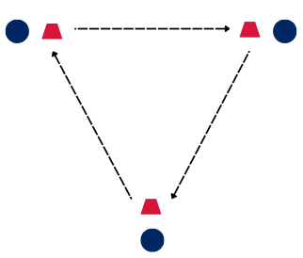  - Students stand at a marker and pass to one another.  - Encourage students to pass both ways.  - Passing on the run.  Figure 15 – set-up for passing on the run drill set up  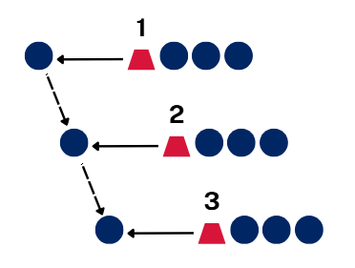  - Set students up in 3 to 5 staggered parallel lines.  - The student at the front of the line at one end begins with the ball.  - On the teacher’s cue, all students begin to run straight ahead and pass the ball down the line, ensuring they remain behind the player passing the ball.  Note: for an alternative activity, refer to the Playing for Life activity card, ‘Pass and run’.  - Play the ball and dummy half.  Figure 16 – player positioning for play the ball and dummy half drill  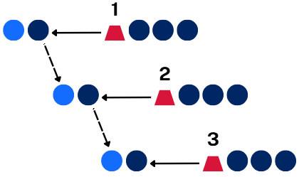  - Use the same set-up and starting cue as the previous activity.  - In this activity, 2 students run forward with the front student holding the ball.  - The front student ‘plays the ball’ by placing the ball on the ground and stepping over it.  - The student behind them collects the ball and passes it to the front student of the next line.  - Repeat down the line.  Pose the following questions to the students for class discussion:  - How can you make your passes easier to catch?  - Why is accuracy important for maintaining possession?  Note: having all groups complete the same drill at the same time allows time to pause and give whole-class feedback if similar errors arise.  Modified touch football 4 versus 4  Allocate students into groups of 9.  Mark out playing areas for each group, approximately 20 metres by 15 metres (adjust the width according to skill level). Include a 5 metre try zone at each end.  Within each group of 9, divide students into 2 smaller groups of 4, with one person allocated as the referee. Students will take turns to rotate as referee to enforce the rules of the game.  Explain the following touch football rules:  - The attacking team has 6 touches to score.  - A touch is made when a defender lightly touches the ball carrier with their hand.  - After a touch, the attacker performs a play-the-ball.  - The ball must be passed backwards or sideways, never forward.  - Defenders must retreat 7 metres from where the touch was made to get ‘onside’ before attempting to make the next touch.  - A try is scored when a player places the ball on or over the try line.  - The dummy half cannot score.  - If the ball is passed forward or goes out of bounds, possession changes.  - Whoever scores a try becomes the referee for the next period of play.  Distribute a copy of Appendix 6 – self-assessment (tactical concepts) to each student and explain each of the listed concepts that they will reflect on at the end of this activity.  Commence play.  Pause play after 5 minutes, use a turn and talk questioning strategy by posing the following questions to students:  - How did you move to get away from defenders? What was similar or different to basketball?  - What was the best position to be in to receive a pass? What was similar or different to basketball?  - With such small team numbers, what did you need to do to ensure you could succeed in attack?  - How did communication help your team?  Provide teams with time to discuss tactics, then recommence play.  After 5 minutes, regroup students and ask the following questions:  - How did you position yourself after making a touch?  - How did your team stop the attackers from scoring?  - Did your team use more of a person-to-person or zone approach?  Introduce continuous touch rules. Including:  - unlimited tags  - change-over when the ball is dropped or a try is scored.  Commence play.  After 5 minutes, pause play and ask questions to reveal specific tactics. Questions may include:  - What strategies did you use in attack to maintain possession and advance the ball?  - When was it better to pass instead of run?  - What strategies did you use in defence to cause a turnover or prevent the other team from advancing or scoring?  Recommence play.  After a period of play, pause the games and provide time for students to complete the tactical concepts self-assessment worksheet Appendix 6 – self-assessment (tactical concepts).  Conduct a whole-class discussion for students to discuss the similarities and differences between the tactics they implemented in basketball and those in touch football.  Formative assessment:  Outcome  - transfers movement skills and concepts for use in a range of dynamic movement environments  PH4-MSS-01  Use Appendix 8 – teacher assessment (tactical concepts) to assess students’ progress towards transferring movement skills and territory game tactics and concepts in touch football.
Adjustments, evaluation and registration
[Classroom teacher to complete.]

Learning sequence 6 – tactics in touch football
Note: the duration of this learning sequence is approximately one hour and 30 minutes.
Table 6 – teaching and learning program
Outcomes and content | Teaching and learning activities
Outcomes  PH4-MSS-01, PH4-MSS-02,  PH4-SMI-01  Content  Focus area – Movement skills and strategies  Enhancing and valuing movement  - Practise and refine fundamental and specialised movement skills in predictable and dynamic situations  - Participate in movement activities that demonstrate and transfer similar skills and strategies to different forms of gameplay, including target, net and court, striking and fielding, and territory games  - Apply and transfer movement concepts in a range of movement contexts  - Create and perform movement sequences that solve movement problems, including creating, using and defending space, and achieving and retaining possession  - Implement attacking and defending strategies and predict their effectiveness in different situations  - Evaluate decisions and actions when solving movement challenges  - Provide and apply feedback to improve body control, coordination, skill execution and strategy  Applying self-management and interpersonal skills to movement  - Provide and respond to verbal, physical or situational cues to enhance communication, performance and team cohesion | Learning intentions  We are learning to:  - apply defensive and attacking touch football tactics to defend space, support play, maintain possession and create space  - recognise similarities and differences between touch football and basketball tactics.  Success criteria  I can:  - create attacking opportunities through accurate passing, quick play-the-ball and moving into space  - defend space by limiting attacking options through line defence  - identify similarities and differences between touch football and basketball tactics.  Warm-up – all-in tag  Refer to the Playing for Life Activity Card – ‘All-in Tag’ and explain the rules of the game to students.  Highlight that in both touch football and basketball, attackers create space by moving away from defenders and towards the extremities of the playing area. Defenders work together to reduce the space that attackers have available.  Commence play.  After 5 minutes, pause and ask students the following questions for a class discussion:  - What made it difficult to find space?  - How did changing your direction help you avoid getting tagged?  Students engage in the same modified touch football game from the previous learning sequence. Refer to Learning sequence 5 for game rules and set-up. Introduce a new rule that 3 passes must be made before a team can score.  Commence games.  After 5 minutes of play, ask questions such as:  - How did your team create space differently in basketball?  - How is supporting the ball carrier similar in both games?  - Why is quick passing important in both sports?  - How does defending space look different in touch football and basketball?  Line defence warm-up  Arrange students into pairs and assign each pair a number (for example, ‘Pair 1’, ‘Pair 2’).  Set up 2 parallel lines of markers, positioned 10 metres apart. Place markers in the middle at the 5 metre mark as well.  One student from each pair stands behind a marker on one line, with their partner standing behind the marker directly opposite on the other line. Continue until all pairs are positioned facing their partner.  Figure 17 – set-up for defensive tactics in isolation  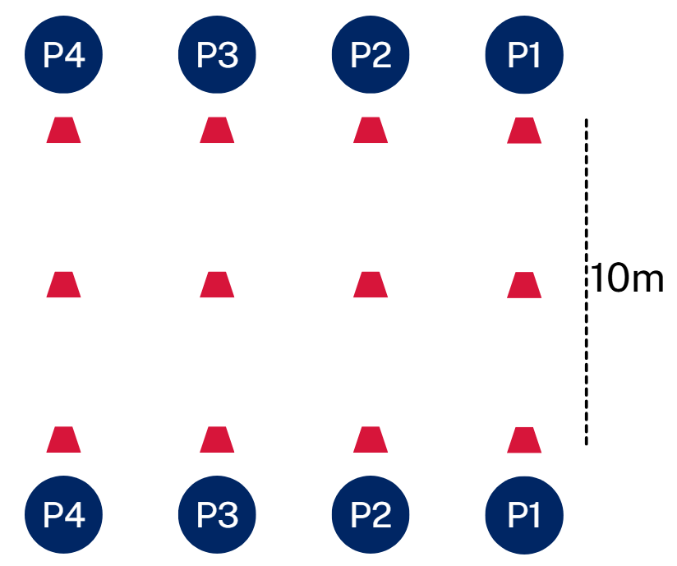  Call out a number, for example, ‘3’. Students in Pair 3 run towards the middle markers with the aim of being the first to pick up the marker. Occasionally, call ‘all’ for all pairs to run to the middle markers.  Note: remind students to keep their eyes up when collecting a cone to avoid a head clash.  Players retreat to their starting position by running or walking backwards.  After a few numbers are called out, introduce running on the spot while waiting for numbers to be called.  After all students have had a few turns, draw students’ attention to line defence and pose the following questions:  - Why is it important to get back into line quickly in touch football?  - How does moving up together help defend space?  - How is this different to defending in basketball?  Shooter: a defender who moves out of the line to make an early touch on the ball carrier before they can pass.  Explain the role of a shooter by outlining how they:  - leave the defensive line to apply pressure  - aim to make the touch early and stop forward movement  - quickly retreat into the defensive line  - allow teammates to slide across and cover the space created.  Defensive advantage – shooting practise  Arrange students into groups of 9.  Mark out playing areas for each group, approximately 20 metres by 15 metres. Include a 5 metre try zone at each end.  Allocate 4 attackers and 5 defenders in each group.  Explain the rules of the game:  - Attackers start with the ball and attempt to advance towards the try line.  - One defender is designated the ‘shooter’. The shooter  - moves forward quickly to tag the ball carrier  - calls out ‘up’ to communicate  - After the touch  - the shooter must recover quickly into the line  - other defenders slide across to cover space  - attackers reset with a play-the-ball and continue.  Rotate the shooter role regularly as well as attacking and defending roles.  Regroup and ask students the following questions:  - What might happen if more than one player shoots?  - When should you shoot and when should you hold the line?  - What happens if the shooter doesn’t recover quickly?  Recommence play for 5 minutes for students to continue practising this strategy.  Attacking tactics  Allocate students into groups of 3 or 5.  Set up the following drills:  - Draw and pass.  Figure 18 – player movement for draw and pass drill  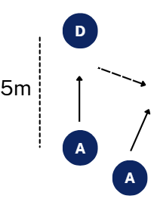  - The attacker with the ball runs straight at the defender.  - The second attacker runs in support (slightly behind and to the outside).  - The ball carrier must draw the defender before passing.  - The support player catches and runs into space.  - Rotate roles.  - Quick play the ball and receive (‘quickie’).  Figure 19 – diagram for quickie drill  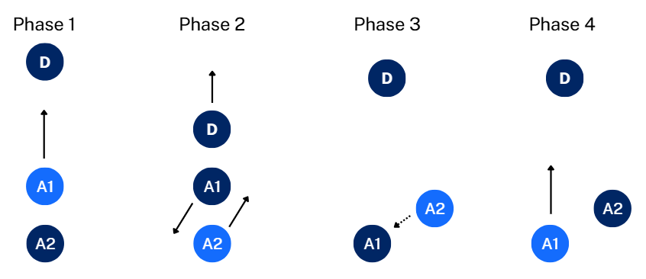  - Ball carrier (A1) runs straight forward with the supporting player (A2) behind them ready to act as dummy half.  - Defender (D) makes a controlled touch and begins running backwards.  - A1 plays the ball and A2 scoops the ball up as dummy half.  - A1 steps to one side and backwards while A2 steps to the other side and ahead of A1.  - A2 quickly makes a short pass to A1.  - A1 runs towards the defender and A2 follows closely to act as dummy half for the next touch.  - Rotate roles.  - Wrap around.  Figure 20 – player movement for wrap around drill  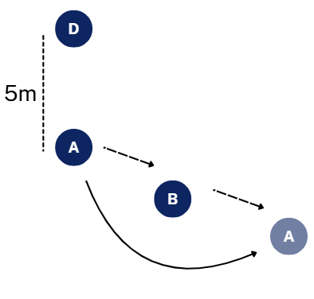  - Player A passes to Player B.  - Player B draws the defender.  - Player A immediately runs around (wraps) behind Player B.  - Player B passes back to Player A in the space.  - Player A continues running forward.  - Rotate positions.  As students complete the activities, pose the following questions:  - Draw and pass – How did you commit the defender? When was the best time to pass?  - Quick play the ball and receive – Why is speed important here? How did quick play give an attacking advantage?  - Wrap around – Where was the space after your pass? How did your movement support the next play?  Touch football  Allocate students into 3 teams and remind students of touch football rules.  Provide students with a copy of Appendix 7 – peer assessment (tactical concepts).  Assign one of the 3 teams as an observing team. Assign them a classmate to observe and complete the peer assessment.  The remaining 2 teams play a game of touch football. Commence play.  As opportunities arise, pause gameplay and discuss and unpack the following sport-specific tactical concepts. How to:  - create space by passing then moving into space to receive the ball again and stretch the defence  - support play by positioning yourself behind or beside the ball carrier to provide safe passing options after each touch and prevent forward passes  - maintain possession through controlled passing and quick play-the-ball, allowing your team to maintain momentum and avoid turnovers  - defend space by maintaining a flat defensive line and moving forward together, limiting attacking options and preventing line breaks.  Provide students with time to discuss and plan tactics as a team, and rotate teams until each team has had the opportunity to complete the peer assessment.  Facilitate a class discussion to conclude the lesson by posing the following questions:  - Which tactics did you find most effective in attack and defence?  - How are tactics in touch football and basketball similar?  - What is the biggest tactical difference between the 2?  - How can tactics from these 2 sports transfer to other sports you know?  Formative assessment:  Outcome  - transfers movement skills and concepts for use in a range of dynamic movement environments  PH4-MSS-01  Use Appendix 8 – teacher assessment (tactical concepts) to assess students’ progress towards transferring movement skills and territory game tactics and concepts in touch football.
Adjustments, evaluation and registration
[Classroom teacher to complete.]

Appendix 1 – tactical concepts
Attack | Defence | Teamwork
Changing speed or direction to get free | Staying between the attacker and the scoring area | Calling for the ball when in space
Using width and depth to stretch the defence | Intercepting | Encouraging others and staying positive
Passing to a teammate in space rather than straight to them | Applying pressure to force rushed decisions | Giving teammates information
Moving away from the ball to pull a defender out of position | Anticipating passes rather than reacting late | Making decisions that benefit the team, not just the individual
Creating space | Minimising space | Cooperation
Supporting the ball carrier | Marking | Communication

Appendix 2 – teacher assessment (self-management and interpersonal skills)
Criteria | Consistently | Mostly | Sometimes | Occasionally | Rarely
Demonstrates consistent effort and active involvement throughout gameplay
Responds positively to mistakes and quickly re-engages in play
Listens and responds appropriately to teammates and feedback
Works collaboratively with others
Demonstrates sportsmanship in both success and challenge
Takes responsibility for own actions and decisions
Supports others to play through communication and guidance

Appendix 3 – chest, bounce and overhead passing
Aspect | Chest | Bounce | Overhead
Body positioning | - Feet shoulder-width apart  - One foot slightly in front (split stance)  - Knees slightly bent for balance  - Weight on balls of feet (ready to move)  - Core engaged, chest facing target | - Feet shoulder-width apart  - Slight forward step  - Knees bent (lower centre of gravity)  - Body leans slightly forward | - Feet shoulder-width apart  - Step forward with opposite foot to dominant hand  - Knees slightly bent  - Body upright but slightly leaning forward
Arm action | - Ball held at chest, elbows out but relaxed  - Hands on side of ball, fingers spread  - Extend arms forward and snap wrists | - Push ball downward with both hands  - Arms extend toward the floor  - Wrists snap and fingers point down | - Ball held above forehead (not behind head)  - Elbows slightly bent  - Extend arms forward and snap wrists forward
Cues | - Step, push, snap, thumbs down  - Step towards target for power and accuracy | - Low, step, push down, follow through  - Aim for the ball to bounce two-thirds of the way to your teammate | - High, step, extend, snap  - Keep pass flat and controlled

Appendix 4 – dribbling checklist and feedback
Criteria | Consistently | Sometimes | Not yet
Uses finger pads, not palm
Keeps ball below waist height
Keeps eyes up (not looking at ball)
Maintains control while moving
Protects the ball with body position
One strength:
One area for improvement:

Appendix 5 – BEEF shooting checklist and feedback
Criteria | Consistently | Sometimes | Not yet
Balance – feet shoulder width apart, knees bent
Eyes – focus on the target (front of rim or backboard square)
Elbow – shooting elbow under the ball, pointing to the target
Follow-through – wrist flick, fingers down, hold your finish
One strength:
One area for improvement:

Appendix 6 – self-assessment (tactical concepts)
Criteria | Consistently | Sometimes | Not yet
I moved immediately after passing to get into a new space
I changed speed or direction to get away from my defender
I positioned myself behind or beside the ball carrier to receive a pass
I adjusted my position based on where the ball and defenders were
I made safe passes to maintain possession
I kept control of the ball when under defensive pressure
I stayed between my opponent and the basket or try line
I maintained my defensive position instead of chasing the ball
One strength:
One area for improvement:

Appendix 7 – peer assessment (tactical concepts)
Criteria | Consistently | Sometimes | Not yet
The player created space by moving quickly after passing
The player used change of direction to lose a defender
The player supported play by staying or moving to a position for a pass
The player adjusted their position to help the ball carrier
The player selected safe passing options
The player helped the team keep possession of the ball
The player defended space by staying goal side
The player maintained their defensive position and did not chase the ball
One strength:
One area for improvement:

Appendix 8 – teacher assessment (tactical concepts)
Criteria | Consistently | Mostly | Sometimes | Few times | Rarely
Uses the depth and width of a playing area to create space
Passes the ball first time to optimise movement into space
Draws a defender towards them before passing the ball
Positions themselves to create advantage and maintain possession
Maintains possession of the ball under pressure
Varies intensity of movement to evade an opponent or create indecision in defence
Positions themselves to minimise space and passing options
Adjusts defensive positioning in response to attacking play


Program feedback
We value your feedback. If you use this teaching and learning program in your faculty and school context, please complete the PDHPE 7–10 resource evaluation form. If you have further comments or suggestions, please email PDHPEcurriculum@det.nsw.edu.au.

Support and alignment
Resource evaluation and support: all curriculum resources are prepared through a rigorous process. Resources are periodically reviewed as part of our ongoing evaluation plan to ensure currency, relevance and effectiveness. For additional support or advice, or to provide feedback, contact the PDHPE Secondary Curriculum team by emailing PDHPEcurriculum@det.nsw.edu.au.
Differentiation: further advice to support Aboriginal and/or Torres Strait Islander students, students learning English as an additional language or dialect (EAL/D), students with a disability and/or additional needs and high potential and gifted students can be found on the Planning, programming and assessing 7–12 webpage. This includes the Inclusion and differentiation advice 7–10 webpage.
Assessment: further advice to support formative assessment is available on the Planning, programming and assessing 7–12 webpage. This includes the Classroom assessment advice 7–10. For summative assessment tasks, the Assessment task advice 7–10 webpage is available.
Explicit teaching: further advice to support explicit teaching is available on the Explicit teaching webpage. This includes the CESE Explicit teaching – Driving learning and engagement webpage.
Consulted with: PDHPE subject matter experts.
Alignment to system priorities and/or needs: School Excellence Policy, Our Plan for NSW Public Education
Alignment to the School Excellence Framework: this resource supports the School Excellence Framework elements of curriculum (curriculum provision) and effective classroom practice (lesson planning, explicit teaching).
Alignment to Australian Professional Standards for Teachers: this resource supports teachers to address Proficient Teacher Standard Descriptors 1.1.2, 1.2.2, 2.1.2, 2.2.2, 2.3.3, 3.1.2, 3.2.2, 3.3.2.
Creation date: 30 March 2026

References
This resource contains NSW Curriculum and syllabus content. The NSW Curriculum is developed by the NSW Education Standards Authority (NESA). This content is prepared by NESA for and on behalf of the Crown in right of the State of New South Wales. The material is protected by Crown copyright.
Please refer to the NESA Copyright Disclaimer for more information https://www.nsw.gov.au/education-and-training/nesa/copyright.
NESA holds the only official and up-to-date versions of the NSW Curriculum and syllabus documents. Please visit NESA https://www.nsw.gov.au/education-and-training/nesa and NSW Curriculum https://curriculum.nsw.edu.au.
Personal Development, Health and Physical Education 7–10 Syllabus © NSW Education Standards Authority (NESA) for and on behalf of the Crown in right of the State of New South Wales, 2024.
ASC (Australian Sports Commission) (n.d.) Playing for Life, ASC website, accessed 5 February 2026.
——(n.d.) Yulunga Traditional Indigenous Games, ASC website, accessed 5 February 2026.
FIBA Basketball (21 September 2022) ‘091 MB Teaching Lay ups’ [video], FIBA Basketball, YouTube, accessed 12 March 2026.
Touch Football Australia (TFA) (n.d.) Beginners’ Hub, TFA website, accessed 5 February 2026.
© State of New South Wales (Department of Education), 2026
The copyright material published in this resource is subject to the Copyright Act 1968 (Cth) and is owned by the NSW Department of Education or, where indicated, by a party other than the NSW Department of Education (third-party material).
Copyright material available in this resource and owned by the NSW Department of Education is licensed under a Creative Commons Attribution 4.0 International (CC BY 4.0) license.

This license allows you to share and adapt the material for any purpose, even commercially.
Attribution should be given to © State of New South Wales (Department of Education), 2026.
Material in this resource not available under a Creative Commons license:
- the NSW Department of Education logo, other logos and trademark-protected material
- material owned by a third party that has been reproduced with permission. You will need to obtain permission from the third party to reuse its material.
Links to third-party material and websites
Please note that the provided (reading/viewing material/list/links/texts) are a suggestion only and implies no endorsement, by the New South Wales Department of Education, of any author, publisher, or book title. School principals and teachers are best placed to assess the suitability of resources that would complement the curriculum and reflect the needs and interests of their students.
If you use the links provided in this document to access a third-party's website, you acknowledge that the terms of use, including licence terms set out on the third-party's website apply to the use which may be made of the materials on that third-party website or where permitted by the Copyright Act 1968 (Cth). The department accepts no responsibility for content on third-party websites.

