PDHPE Year 8 – safety matters – navigating risk and responsibility
Teaching and learning program
Contents
About this resource 3
Overview 3
Syllabus outcomes 5
Content 5
Focus area – Safe, active and healthy lifestyle choices 5
Focus area – Respectful relationships 7
Related support materials 7
Teacher notes 8
Learning sequence 1 – rewind – revisiting risk, responsibility and safety 9
Learning sequence 2 – understanding drugs and alcohol 21
Learning sequence 3 – let’s clear the air – vaping and e-cigarettes 41
Learning sequence 4 – click with care – staying safe online 62
Learning sequence 5 – health promotion and young people 85
Summative assessment task 97
Appendix 1 – Frayer model template 98
Appendix 2 – contextual factors statements 100
Appendix 3 – role-play scenarios 101
Appendix 4 – drug use triangle scenarios 102
Appendix 5 – feel versus real statements 103
Appendix 6 – persuasive techniques 104
Appendix 7 – drug or substance use short story 105
Appendix 8 – vaping worksheet 106
Appendix 9 – email/letter template 108
Appendix 10 – vaping legalities statements 110
Appendix 11 – vape images 111
Appendix 12 – vaping scenarios 112
Appendix 13 – pressure scenarios 113
Appendix 14 – PMI worksheet 114
Appendix 15 – deepfakes worksheet 115
Appendix 16 – campaign review scaffold 118
Appendix 17 – sentence starters 120
Program feedback 122
Support and alignment 123
References 124

About this resource
This teaching and learning program has been developed to assist teachers in NSW Department of Education schools to create learning experiences that are contextualised to their students’ needs, interests and abilities for the Personal Development, Health and Physical Education 7–10 Syllabus (NESA 2024). It provides an example of one way to approach programming through a conceptual lens. Teachers are encouraged to take an adopt and adapt approach to the learning activities outlined in this program.

Overview
Description: in this teaching and learning program, students build on their knowledge and understanding from the Year 7 program Safety never takes a holiday. They explore strategies to support safe decision-making in challenging or potentially unsafe situations, particularly when confronted with risk-taking behaviours.
Students investigate the role of protective behaviours and harm-minimisation strategies in fulfilling their responsibilities and promoting safety for themselves and others across various contexts, including road safety, the effects of alcohol and other drugs, and online engagement.
Students will critically analyse contextual factors that may influence decision-making and assess the level of risk in a variety of scenarios.
Duration: approximately 9.5 hours.
Explicit teaching: explicit teaching strategies are embedded in this resource. Further information on these strategies can be found on the Explicit teaching strategies webpage.
Assessment: suggested formative assessment opportunities and strategies are outlined throughout the teaching and learning program, and the program is also aligned to the PDHPE Year 8 – safety matters – navigating risk and responsibility – sample assessment task notification.

Syllabus outcomes
A student:
- refines and applies self-management and interpersonal skills to manage complex situations PH4-SMI-01
- assesses the influence of contextual factors on attitudes and behaviours to propose strategies that enhance safety, health and wellbeing
PH4-SHW-01
- investigates and uses health information, products and support services to propose strategies that enhance safety, health and wellbeing
PH4-IPS-01
Personal Development, Health and Physical Education 7–10 Syllabus © NSW Education Standards Authority (NESA) for and on behalf of the Crown in right of the State of New South Wales, 2024.

Content

Focus area – Safe, active and healthy lifestyle choices
Managing risk and enhancing safety
- Investigate risk-taking, challenging and unsafe scenarios and create plans or responses to enhance safety for themselves and others
- Explain how contextual factors can influence decision-making and risk-taking in offline and online environments
- Devise and practise protective behaviours and strategies to manage and mitigate risk in a range of contexts
- Explain how harm-minimisation strategies such as making informed decisions, being assertive, distancing or encouraging someone to seek help can improve safety, health and wellbeing
- Assess emergency situations and demonstrate strategies that enhance the safety of themselves and others, including communicating clearly when giving information to emergency services
- Classify drugs and describe the short-term and long-term effects of drug use on safety, health and wellbeing
- Examine the risk and protective factors that can influence the use and effects of alcohol and other drugs
Thinking critically to enhance health and wellbeing
- Outline the role of health promotion and health literacy in enhancing health and wellbeing
- Access and assess information, resources and services that support young people to seek help and manage relevant health and safety issues
- Investigate the reliability and credibility of health information from various sources
- Analyse health information, products and services to plan preventative action and healthy practices
- Create written texts to explain and advocate for aspects of safety, health and wellbeing for a range of audiences
- Use subject-specific language to communicate concepts of physical activity, safety, health and wellbeing

Focus area – Respectful relationships
Keeping safe and being respectful online
- Understand rights, responsibilities and social implications of communicating online
- Understand rights, responsibilities and social implications of taking or sharing information, images and videos online
- Assess and demonstrate strategies to regulate screen time and enhance safety and enjoyment in the digital environment
- Identify and practise protective strategies to prevent and manage power imbalances online, including cyberbullying, abuse, grooming, sexual extortion, image-based abuse and negative social interactions
- Explain the impact online content can have on perceptions, behaviours and attitudes

Related support materials
This teaching and learning program aligns with the following support materials:
- student-facing PowerPoint – PDHPE Year 8 – safety matters – navigating risk and responsibility – slide deck
- assessment task – PDHPE Year 8 – safety matters – navigating risk and responsibility – sample assessment task notification
- PDHPE Years 7–8 – sample scope and sequence.
All resources associated with this program can be found on the Planning, programming and assessing PDHPE 7–10 webpage.

Teacher notes
This teaching and learning program contains content that addresses potentially controversial issues and diverse perspectives on sensitive topics. The activities and resources in this program form part of the learning entitlement outlined by NESA in the Personal Development, Health and Physical Education 7–10 Syllabus (2024) and are designed to encourage critical thinking, foster respectful dialogue and promote understanding among students.
The NSW Department of Education’s Controversial issues in schools procedures provides a framework for how schools manage these topics in a way that is age-appropriate and aligned to the curriculum.
Teachers are expected to support student engagement by creating a supportive learning environment, respecting the diverse views, values and experiences of all students, and by approaching discussions in an impartial manner that is free from harassment or discrimination. Content should be tailored to suit the unique needs of students, and delivered in a way that supports their wellbeing. For additional guidance on creating a supportive learning environment, please refer to the NSW Department of Education’s Learning environment resources.
Teachers should use strategies to avoid public disclosures and should be aware of their mandatory reporting requirements. Teachers must review, before use, all teaching and learning resources and extra-curricular activities and associated materials that are referenced, distributed or shown to students. All educational content and materials from external providers, contractors, volunteers and visitors that are reasonably likely to contain controversial issues must be reviewed and approved by the school principal before delivery.
Where appropriate, and in accordance with the principal’s professional judgement, parents and carers should be informed in advance about PDHPE programs that may include topics considered sensitive or controversial within the school community. This allows them the opportunity to raise any concerns with the most appropriate school staff. Each school will determine when and how they inform and consult with their school community. Sample information letters are available to assist in communicating with your school community about teaching and learning initiatives.
For any questions or assistance with this resource, please contact the PDHPE Secondary Curriculum team at PDHPEcurriculum@det.nsw.edu.au.

Learning sequence 1 – rewind – revisiting risk, responsibility and safety
Note: the section ‘Rewind – revisiting risk, responsibility and safety’ in the PowerPoint – PDHPE Year 8 – safety matters – navigating risk and responsibility – slide deck can be used to support Learning sequence 1. The duration of this learning sequence is approximately 1.5 hours.
Table 1 – teaching and learning program
Outcomes and content | Teaching and learning activities
Outcomes  PH4-SMI-01, PH4-SHW-01  Content  Focus area – Safe, active and healthy lifestyle choices  Managing risk and enhancing safety  - Investigate risk-taking, challenging and unsafe scenarios and create plans or responses to enhance safety for themselves and others  - Explain how contextual factors can influence decision-making and risk-taking in offline and online environments  - Devise and practise protective behaviours and strategies to manage and mitigate risk in a range of contexts  - Explain how harm-minimisation strategies such as making informed decisions, being assertive, distancing or encouraging someone to seek help can improve safety, health and wellbeing  - Assess emergency situations and demonstrate strategies that enhance the safety of themselves and others, including communicating clearly when giving information to emergency services  Thinking critically to enhance health and wellbeing  - Create written texts to explain and advocate for aspects of safety, health and wellbeing for a range of audiences  - Use subject-specific language to communicate concepts of physical activity, safety, health and wellbeing | Learning intentions  We are learning to:  - deepen and extend prior learning about risk, responsibility and safety  - strengthen our understanding of how contextual factors influence decision-making  - apply our knowledge of risk, responsibility and safety to a range of realistic scenarios.  Success criteria  I can:  - identify and explain risks in different situations  - explain how contextual factors influence decisions and actions  - propose and justify strategies that enhance safety and wellbeing.  Frayer rotations – revisiting key terminology  Initiate a whole-class discussion to reintroduce the key terms from Year 7, including:  - risk  - responsibility  - safety  - protective behaviours  - harm minimisation.  Use questioning to drive student thinking:  - What do you remember about each of these terms from last year?  - How do these terms connect with one another? For example, how might responsibility influence risk, or how might safety relate to protective behaviours?  - How do these concepts work together to help people make good choices?  Set up a series of 5 ‘Frayer stations’ around the room. At each station, place a large Frayer model template related to one of the key terms. See Appendix 1 – Frayer model template for a sample.  Divide students into small groups and assign each group to a starting station.  Students work collaboratively to complete all 4 sections of the Frayer template. Explain that they should be drawing on their prior knowledge from Year 7, and that it is okay if they are unsure of some ideas at this stage.  Note: if further explanation of the Frayer model is required, consider:  - Definition (What does this term mean? How would you explain this in your own words?)  - Characteristics (What are the key features of this term? How would someone recognise this if they saw it happening?)  - Examples (What does this look like in real life? Does it look different in different contexts?)  - Non-examples (What is not an example of this term? What would make this a non-example?).  Instruct groups to rotate clockwise to the next station. At each new station, students review the 4 sections of the Frayer template and:  - add new ideas or information  - challenge or make corrections and suggestions for improvement where necessary.  Continue the rotations until all groups have had the opportunity to contribute to each station. Students then return to their original station.  Each group reviews and discusses the additional contributions that have been made to their Frayer template and make any final adjustments or additions to their work as necessary.  Facilitate a whole-class discussion to consolidate students’ understanding of each term. Have one representative from each group share their Frayer model with the class.  Use open-ended questioning to shape the discussion. Encourage students to see the connection between the terms, as well as how their learning has progressed since Year 7 and how they may be able to apply their learning by providing explicit examples. Questions may include:  - Which term do you feel more confident with this year compared to last year? Why is that?  - How might understanding these concepts change the way you think about your own behaviour?  - Does understanding the connections between these terms help you make better decisions? How so?  Note: use this discussion as an opportunity to clarify and address any misconceptions that have emerged.  Contextual influences on decision-making – ‘Which factor am I?’  Ask students to reflect on their prior learning on risk and responsibility, and the range of factors that influence our decision-making in risky scenarios.  Use questioning to draw out student understanding of the personal, social, emotional and environmental factors. For example:  - What do we mean by personal factors? Can someone give an example from their own life?  - What about social factors? How can the people around us influence our decisions?  Students ‘turn and talk’ with a partner to discuss their ideas. Invite students to share their thoughts with the class.  Key terms:  - Personal factors refer to individual characteristics such as age, gender and previous experiences.  - Social factors include societal norms and expectations, and influences from our peers, friends and family.  - Emotional factors are the feelings and emotional dispositions which influence our thinking, such as excitement, stress and anxiety.  - Environmental factors include considerations such as the physical location and our proximity to support and resources.  Designate each of the 4 corners of the room to one of the 4 contextual factors – personal, social, emotional and environmental.  Read a series of statements that reflect different contextual factors (see Appendix 2 – contextual factors statements).  For each statement that you read, ask students to move to the corner of the room that represents the factor they think is being described.  Once students have moved to their chosen corner of the room, give them some time to discuss their thoughts with others in the same corner to develop a shared point of view.  Ask students from each corner to explain their choice. Encourage them to justify their thinking:  - What is it about this situation that makes you think it’s related to that category of influence?  - Could there be more than one factor influencing this decision? Do you think this is something that happens often?  - Does everyone in your corner group feel the same way? Were your reasons different?  Encourage debate between students from different corners of the room and allow students to shift corners if they change their opinions based on the discussion.  Repeat this process for each scenario.  Facilitate a whole-class discussion to consolidate understanding. Questions can include:  - Which factors were the easiest or hardest to identify?  - Did any statements make you think about more than one factor at the same time?  - How do these contextual factors work together to influence the choices we make? Give an example.  Formative assessment:  Outcome  - refines and applies self-management and interpersonal skills to manage complex situations  PH4-SMI-01  Student engagement, responses and contributions throughout the ‘Which factor am I?’ activity can be used to assess their ability to consider different perspectives and adapt their thinking based on new information. This activity also provides insight into students’ ability to reflect on their personal assumptions, communicate respectfully and evaluate how different beliefs and behaviours may influence safety.  Role-play scenarios – learning into action  Note: it is suggested that you tailor the risk scenarios to suit the unique needs and context of your class. Ensure the scenarios are varied in nature, relevant to the focus areas of road safety and water safety and include details of specific contextual factors influencing the decision-making of the characters. See Appendix 3 – role-play scenarios for examples.  Divide the class into small groups of approximately 4 to 5 students. Provide each group with a role-play scenario card.  Emphasise to students that the purpose of the activity is to look for ways to apply their learning, including identifying risks, proposing protective behaviours and harm minimisation strategies and navigating the various factors that influence decision-making.  In their groups, students:  - identify the risks present in the scenario  - decide on appropriate protective behaviours or harm-minimisation strategies  - consider the contextual factors that might influence their decisions  - determine how they would respond if something went wrong.  Allow time for students to discuss their scenario and plan their role-play.  Each group is to perform their role-play. The role-play should demonstrate:  - how risks are identified and managed  - how protective behaviours or harm-minimisation strategies can be applied  - how to navigate the contextual factors influencing their decisions  - how to respond safely if a problem occurs, including calling for help and emergency first aid actions.  After each role-play, lead a brief discussion which encourages reflection and deeper thinking:  - What risks did this group identify? Are there others you think they should have included?  - Which protective behaviours or harm-minimisation strategies were most effective?  - How did they navigate the various influences on their decision-making?  - What did their emergency response involve? How did they decide when to intervene and call for help?  Written reflection – introduction to conjunctions  Explain to students that strong reflections don’t just describe what happened. They also explore why and how things happened.  Introduce conjunctions as a word or short phrase we can use in a sentence to join ideas together such as ‘because’. They can help us to connect ideas and provide reasons to help substantiate our thinking. Emphasise the important role of conjunctions in supporting our responses when we are asked ‘why’ things happen.  Note: for more information on conjunctions as a grammatical tool, visit the Writing in Secondary Grammar Guide and search for Conjunctions under ‘Word level’.  Model the difference between a simple and more sophisticated response that uses a conjunction to explore cause and effect. For example:  - We moved away from the road.  - We moved away from the road because we saw that there was lots of traffic approaching.  With a show of hands, ask students which response better explains the ‘why’, or the thinking behind the decision. Ask some students to explain their preference, and the role of the conjunction in adding depth to the response.  Working individually, students develop a short, written response to the following prompt:  - Reflect on your group’s performance in the role-play activity. What did your group do well when identifying and managing risks, and why was this effective?  Display some sample conjunctions on the board for students to use as a word bank as they respond to the ‘why’ part of the question. Examples include therefore, because, as a result and consequently.  Ask students to highlight their use of conjunctions in their finished response.  Formative assessment:  Outcome  - assesses the influence of contextual factors on attitudes and behaviours to propose strategies that enhance safety, health and wellbeing PH4-SHW-01  Student written responses can be collected and used to evaluate their purposeful use of grammatical features when creating written texts. Further, the contents of their response will allow teachers to gauge the student’s level of understanding of risk, responsibility and safety, including their ability to apply protective behaviours and respond to contextual factors in order to promote the safety, health and wellbeing of themselves and others.
Adjustments, evaluation and registration
[Classroom teacher to complete.]

Learning sequence 2 – understanding drugs and alcohol
Note: the section ‘Understanding drugs and alcohol’ in the PowerPoint – PDHPE Year 8 – safety matters – navigating risk and responsibility – slide deck can be used to support Learning sequence 2. The duration of this learning sequence is approximately 2 hours.
Table 2 – teaching and learning program
Outcomes and content | Teaching and learning activities
Outcomes  PH4-SMI-01, PH4-SHW-01,  PH4-IPS-01  Content  Focus area – Safe, active and healthy lifestyle choices  Managing risk and enhancing safety  - Investigate risk-taking, challenging and unsafe scenarios and create plans or responses to enhance safety for themselves and others  - Explain how contextual factors can influence decision-making and risk-taking in offline and online environments  - Devise and practise protective behaviours and strategies to manage and mitigate risk in a range of contexts  - Explain how harm-minimisation strategies such as making informed decisions, being assertive, distancing or encouraging someone to seek help can improve safety, health and wellbeing  - Classify drugs and describe the short-term and long-term effects of drug use on safety, health and wellbeing  - Examine the risk and protective factors that can influence the use and effects of alcohol and other drugs  Thinking critically to enhance health and wellbeing  - Access and assess information, resources and services that support young people to seek help and manage relevant health and safety issues  - Create written texts to explain and advocate for aspects of safety, health and wellbeing for a range of audiences  - Use subject-specific language to communicate concepts of physical activity, safety, health and wellbeing | Learning intentions  We are learning to:  - develop an understanding of different classifications of drugs and other substances  - understand how various factors can influence the effects and potential harm of drug use  - identify suitable protective behaviours and harm-minimisation strategies in situations involving substance use.  Success criteria  I can:  - describe the different classifications of drugs and provide relevant examples  - explain how various factors can influence the effects and potential harm of drug use  - apply suitable protective behaviours and harm-minimisation strategies in a range of situations.  Drug classifications mind map  Display the following definition of drugs on the board:  - Drugs are substances, other than food or water, that alter the way the body functions. ‘They can affect the way your brain works, how you feel and behave, your understanding and your senses.’  Note: this definition comes from the from Australian Government Department of Health, Disability and Ageing’s What are drugs? (2019) webpage.  Begin by explaining that substances, whether legal or illegal, can be grouped into different classifications (stimulants, depressants or hallucinogens) based on how they affect the body and mind, and that understanding these classifications is important because it helps empower young people to more effectively recognise risks, make safe decisions and respond appropriately if things go wrong.  Key terms:  - Depressants slow down the function of the central nervous system.  - Hallucinogens affect your senses and change the way you see, hear, taste, smell or feel things.  - Stimulants speed up the function of the central nervous system.  Divide the class into 6 small groups.  Assign each group to one of the classifications. This will mean that 2 groups are working on each classification.  Provide each group with a large piece of A3 paper, and ask them to construct a mind map for their substance classification that includes:  - a clear, concise definition and description of the classification  - at least 5 specific examples of substances that fit under the classification. For each example, students should also include well-known ‘slang’ or ‘street’ names for the substance and provide an indication as to whether it is legal or illegal, and any restrictions that may apply (for example, if a substance is age restricted or prescription only).  Explain to students that some drugs, because of the effects they have on the body, may fit into multiple classifications. For example, a drug like cannabis can appear in all 3 categories.  Note: students can engage in independent research using reputable resources such as the Australian Government’s Department of Health, Disability and Ageing’s Types of drugs webpage to help inform their responses. Teachers can use this as an opportunity to facilitate a discussion regarding the reliability and credibility of sources. Prompt discussion with the question:  - How do we know we’re using a reliable and credible source when looking for additional information?  Once the initial mind maps are complete, the 2 groups working on the same classification come together to compare their work. The groups are to:  - discuss and correct any differences or contradictions in their work  - merge their ideas to create a combined mind map which they can present to the class.  Each ‘combined’ group then presents their work to the class. Ensure that each group provides a clear definition and description of the classification and several relevant examples.  Note: for continuity of learning across the program, ensure that students are including ‘nicotine’ on their mind maps as one of the examples for the stimulant category.  Bring the class back together for a short reflection and discussion. Use open-ended questions to shape the discussion:  - Why is it important to understand classifications of substances when thinking about safety and risk?  - Did anything surprise you about the examples or legal status of different substances?  - How could this knowledge help you make safer choices or support others in the future?  Have each group swap their completed mind map with a group that worked on a different classification of substance.  Using valid and reliable information sourced via independent research, each group adds a section that outlines the short-term and long-term effects for each of the specific drug examples listed on their mind map.  Have each group swap their mind maps one final time so that they now are working with the classification they have not yet examined.  Each group undertakes a final ‘proofread’ of the completed mind maps, checking for accurate definitions and descriptions, valid examples, relevant short and long-term effects and any opportunities. ‘Proofreaders’ can make corrections or suggest additions and amendments using a different coloured pen or sticky notes.  Each mind map is returned to the original ‘combined’ group that developed the initial definition and examples.  Allow time for them to review the feedback, discuss the suggested changes and make any final revisions.  Invite each group to share their finalised mind maps with the class and lead a discussion which highlights the key short-term and long-term effects of the various substances:  - What is the difference between a stimulant, depressant and hallucinogen?  - Someone has taken a substance, and they now appear very relaxed and drowsy. Which classification of drug do you think this is most likely to represent?  - A drug can only fit into one classification or category. Is this true or false?  Dimensions of health – activating prior knowledge  Note: students will use their knowledge of the dimensions of health to revisit and extend upon their drug-classification mind maps from the previous activity.  Draw 5 columns on the board and label each one with a different dimension of health (physical, social, emotional, mental and spiritual).  Pose the following questions to the class:  - What do we remember about the 5 dimensions of health?  - How would you explain each dimension to a friend? Can you think of an example for each one?  Before asking for responses, have students ‘turn and talk’ to the person next to them and discuss their thoughts. Encourage students to think back to their learning on the dimensions of health from Year 7.  Bring the class back together and work through each dimension one at a time. Invite pairs to share their thinking, including their definitions and examples.  Summarise and record their responses in the relevant column on the board.  Note: clarify and refine student responses to ensure each dimension has a clear and accurate definition and a range of relevant examples. Address any misconceptions as they arise.  Mind map – continued  In their groups from the previous activities, students make a small annotation for each of the short-term and long-term effects that specifies the dimension(s) of health being impacted.  Example: a long-term effect of amphetamine use is tooth decay and heart damage, which would relate to the physical dimension of health.  Encourage students to justify their thinking by being prepared to explain why they have categorised each effect under a particular dimension of health, and how they believe that effect impacts that area of health.  Note: for continuity of learning across the program, ensure that students are considering the short-term and long-term effects of ‘nicotine’ as part of this activity.  Move around the room and use questioning to challenge and deepen student thinking:  - Why do you think this effect fits under that dimension? Could someone else interpret this differently?  - Could it influence any other areas of health? How so?  - Do you think that this would eventually lead to other consequences across the other dimensions?  Ask student groups from across the class to share their work and the thinking behind examples of how they categorised specific short and long-term effects.  Pose the following questions as part of the discussion and wrap-up:  - Which dimension of health do we think is most commonly impacted by substance use?  - Why is it important to consider more than just the physical impacts?  - How could understanding these impacts influence the decisions people make?  Note: use this discussion as an opportunity to highlight the interrelated nature of the dimensions of health and reinforce to students that one choice can have multiple and ongoing effects across different areas of a person’s health and wellbeing.  Drug use triangle – ‘We do’  Introduce the drug use triangle to students as a model used to understand how different factors influence the effects and potential level of harm experienced when drugs are used.  Note: a suitable drug use triangle resource can be accessed via the Alcohol and Drug Foundation website.  Display an image of a drug use triangle on the board, and explain that the triangle consists of 3 components:  - Individual or personal factors, such as age, experience, personality, weight, food intake and expectations.  - Environmental factors, such as a person’s location, who they are with, the occasion, adult supervision, time of day and temperature.  - Drug or substance factors, such as the type of drug, amount used, purity or strength, and the timeframe of usage.  Outline to students that the effects or level of potential harm is not determined by just one of these factors. Instead, it is the interaction between all 3 elements that influences the outcome.  Display a short substance use scenario on the board. For example:  - Anna is at her friend’s 16th birthday party, and she notices that several of the older teenagers are drinking. They offer some of their drink to Anna and tell her not to worry as it’s not very strong. Anna has never had alcohol before but has always been curious about drinking. Feeling confident, she decides to have a small drink. She takes a small sip and enjoys it and doesn’t feel any negative impacts. She decides to have a few more drinks over the next 30 minutes, mixing it up with some wine and spirits. The music is really loud by now and lots of people are crowding around her on the dancefloor. All the adults at the party are outside supervising the pool area, so no one is paying close attention to what’s happening inside.  Lead a class discussion and analysis of the scenario. As part of the class discussion, facilitate a ‘think aloud’ as you work to answer the following questions:  - Who is using the substance and what do we know about some of the individual factors at play, such as their age, experience and mood?  - What substance is involved? How much has Anna had, and how strong do we think it is?  - Where is Anna, and who is around her? Does what we know about the environment influence our thinking around the level of potential harm?  Note: for more information on the ‘think aloud’ routine, refer to the ‘modelling’ technique guide for the explicit teaching strategy of gradual release of responsibility.  Introduce the traffic light system as a scale to rank risk and harm:  - green – low risk  - orange – medium risk  - red – high risk.  Lead a class discussion and ask students to make a judgement about Anna’s situation using the traffic light system. Encourage them to explain their reasoning, using the elements of the drug use triangle to support their response.  Model a written justification on the board which captures the thinking and consensus of the class. For example:  - I believe this situation is an orange, medium risk. This is because Anna is inexperienced with alcohol and has now had multiple drinks of different type and strength. Her mood was confident and curious, rather than hesitant and careful. The environment is also crowded and the adults are outside, which means that there is limited adult supervision. As a result, her risk of harm is increased because people may not notice when she starts to feel the effects.  Remind students of the purpose of conjunctions in providing a clear link between ideas in a written response, particularly when we are justifying an idea and exploring the ‘why’ behind their thinking.  Ask for a student volunteer to highlight the conjunctions present in the sample response on the board.  Prompt the class with the following questions:  - What job are these words doing?  - How do these words help show the thinking behind the risk rating?  Drug use triangle – ‘You do’  Note: preparation of simple scenarios or stories are required for this activity. NSWEduChat can be used to assist with the development of suitable stimulus material. Visit the Prompt library for more guidance on generating effective outputs.  Provide each student with a short scenario related to drug use. See Appendix 4 – drug use triangle scenarios for suggested examples.  Working individually, students analyse their scenario using the drug use triangle and assign a level of risk and potential harm according to the traffic light rating system.  They then prepare a short, written justification for their decision. Encourage students to keep their responses specific and concise, using conjunctions to link between their judgements and evidence from the scenario which supports their thinking.  Note: sentence scaffolds which include conjunctive clauses can also be provided to assist students. For example:  - This situation is a [green/orange/red] risk, because …  - One individual factor which increases the risk of harm is …, which can lead to …  - A key factor related to the substance itself is … As a result …  - The environment the person is in also contributes to the risk, which means that …  As students work on their responses, move around the room and use questioning to drive and extend student thinking:  - Which factor has the biggest influence on the potential level of harm in this scenario?  - How are the 3 sides of the drug use triangle interacting in this instance?  - If we made a change to one factor, would that be enough to alter your risk rating? Why?  Formative assessment:  Outcomes  - refines and applies self-management and interpersonal skills to manage complex situations  PH4-SMI-01  - assesses the influence of contextual factors on attitudes and behaviours to propose strategies that enhance safety, health and wellbeing PH4-SHW-01  Students’ written responses can be collected and used to evaluate the effectiveness of their written communications and persuasive capabilities, including the use of conjunctions as a grammatical feature. Teachers can assess their ability to make and substantiate clear judgements about the influence of various factors on the level of risk and potential harm experienced by an individual in different contexts.  ‘Feel versus real’ – substance use and young people in Australia  Explain to students that as they learn about and engage more with the topic of drugs and alcohol, they will often be considering and responding to statistics, situations or examples involving young people, and that this focus can sometimes create a misunderstanding or misrepresentation of how common substance use is. The way young people perceive substance use is often different from reality, and these perceptions can ultimately influence our decision-making.  Read a series of statements aloud that relate to young people and substance use. See Appendix 5 – feel versus real statements for suggested examples.  Note: the accuracy and currency of the statistics provided in Appendix 5 will need to be reviewed periodically as they are subject to change following publication.  Ask students to stand up. For each statement, students decide whether they think it is true, and hold a half squat, or false, and balance on one leg.  After each statement has been read out and students have made their decision, invite them to explain why they chose their position.  Once the full list of statements has been heard and discussed, bring the group back together and reflect as a class:  - Which statements were the most difficult to respond to? Why?  - Why might people assume that substance use is more common than it really is?  - How could this information help you or the people you know make safer choices?  Note: throughout the activity, reinforce strengths-based messaging by highlighting that many young people are already making safe and healthy choices. Draw particular attention to the idea that not engaging in substance use is common and normal, and use the evidence and statistics to challenge the popular assumption that ‘everyone is doing it’.  Rewrite the narrative – persuasive writing task  Display the following fictional quote on the board:  - ‘It seems like every teenager is drinking and using drugs these days. Schools are full of kids experimenting with alcohol, vapes or even more serious substances. If you’re a parent, it’s almost impossible to keep up!’  Explain to students that, at times, the views of the media and perspectives of those in society can sometimes exaggerate or misrepresent young people’s behaviour, particularly around risk behaviours like drug and substance use, and that being able to critically respond to these claims is an important skill.  Have students consider the fictional quote displayed on the board and develop a short persuasive response that challenges the claims made, explains why they are misleading or incorrect, and promotes a clear and strengths-based account of the choices most young people are already making.  Note: for more specific guidance on persuasive writing techniques, refer to Appendix 6 – persuasive techniques. Sentence stems can also be provided to assist students in the development of their texts. For example:  - The claim that young people are drinking and using drugs is misleading because …  - The statistics show that …  - Most young people make responsible choices by …  - To conclude, it’s important that we recognise …  Formative assessment:  Outcomes  - refines and applies self-management and interpersonal skills to manage complex situations  PH4-SMI-01  - assesses the influence of contextual factors on attitudes and behaviours to propose strategies that enhance safety, health and wellbeing PH4-SHW-01  Student responses to the persuasive writing task can be used to assess their ability to apply the self-management and interpersonal skills of communication, self-awareness, advocacy and social awareness in a written text. This includes their ability to consider a stimulus and develop a persuasive text which uses evidence to substantiate a point of view and promote a strengths-based message.  Application of learning – short stories  Divide the class into small groups of 3 to 4 students. Provide each group with a short story or case study that involves a young person and a drug or substance use situation.  Note: short stories can be purposefully developed for this activity or sourced from a suitable newspaper article or media outlet. Ensure the stories are varied in nature, relevant to the focus areas for the program of learning and include details of specific contextual factors influencing the decision-making of the characters. Refer to Appendix 7 – drug or substance use short story for an example.  In their groups, students analyse their stimulus and complete the following:  - Identify the personal, social, emotional and environmental factors which they can see as having influenced the decision-making of the characters in the story.  - Suggest at least 5 protective behaviours or harm-minimisation strategies that could be used in this situation (for example, being assertive and saying no, not attending the event and so on).  - Explain when it would be appropriate to call for help, how this could be done and who could be contacted for support (for example, a parent or carer, teacher, health professional, support organisation and so on).  - Provide details of any first aid response that might be required.  Bring the class back together and provide time for each group to present their thinking to the class.  Have students briefly summarise their scenario, highlight the key contextual factors that influenced the decision-making in the scenario, the protective behaviours and harm-minimisation strategies that they feel could have limited or avoided the risk of harm and what they did when it was time to intervene and call for help.  Engage the class in a final discussion and reflection:  - What was one protective behaviour or harm-minimisation strategy you heard today that you hadn’t considered before?  - As young people, how might factors like peer pressure and inexperience make it difficult to make safe decisions in situations like these? Can we do anything to overcome this?  - What does taking responsibility for your own safety and the safety of others look like in situations like this?
Adjustments, evaluation and registration
[Classroom teacher to complete.]

Learning sequence 3 – let’s clear the air – vaping and e-cigarettes
Note: the section ‘Let’s clear the air – vaping and e-cigarettes’ in the PowerPoint – PDHPE Year 8 – safety matters – navigating risk and responsibility – slide deck can be used to support Learning sequence 3. The duration of this learning sequence is approximately 2.5 hours.
Table 3 – teaching and learning program
Outcomes and content | Teaching and learning activities
Outcomes  PH4-SMI-01, PH4-SHW-01,  PH4-IPS-01  Content  Focus area – Safe, active and healthy lifestyles  Managing risk and enhancing safety  - Investigate risk-taking, challenging and unsafe scenarios and create plans or responses to enhance safety for themselves and others  - Explain how contextual factors can influence decision-making and risk-taking in offline and online environments  - Devise and practise protective behaviours and strategies to manage and mitigate risk in a range of contexts  - Explain how harm-minimisation strategies such as making informed decisions, being assertive, distancing or encouraging someone to seek help can improve safety, health and wellbeing  - Examine the risk and protective factors that can influence the use and effects of alcohol and other drugs  Thinking critically to enhance health and wellbeing  - Access and assess information, resources and services that support young people to seek help and manage relevant health and safety issues  - Create written texts to explain and advocate for aspects of safety, health and wellbeing for a range of audiences  - Use subject-specific language to communicate concepts of physical activity, safety, health and wellbeing | Learning intentions  We are learning to:  - understand what vapes are, including their ingredients and key components  - examine the short-term and long-term health effects of vaping across the dimensions of health  - explore influences on vaping behaviour in young people, including peers, media and advertising  - identify suitable protective behaviours and harm-minimisation strategies in situations involving vaping.  Success criteria  I can:  - describe what vapes are, including their ingredients and key components  - explain the short-term and long-term health effects of vaping across the dimensions of health  - analyse the influence of peers, media and advertising on young people’s decisions about vaping  - apply effective protective behaviours and harm-minimisation strategies in situations associated with vaping.  Introduction to vaping – What do we already know?  Initiate a whole-class discussion that introduces vaping as the focus for learning.  Encourage students to draw upon what they have seen, heard or experienced in their own lives previously as they respond to some prompting questions:  - What is a vape or e-cigarette? How would you explain it to someone?  - What do you think is inside a vape?  - Do you think vaping is harmless, harmful or somewhere in between? Why is that?  - Where do you think young people’s ideas or beliefs about vaping come from? Do you think their understanding is generally accurate? Why?  Introduce the activating prior knowledge (KWLH) activity to the class and distribute individual copies of the template to each student.  Students work individually to complete the ‘K’ and ‘W’ columns of the chart:  - In the ‘K’ column, students record what they believe they already know about vaping, including definitions, how it works, ingredients and any assumptions or information they have heard previously.  - In the ‘W’ column, students record what they would like to learn, including any questions or curiosities they may have.  Explain that the ‘L’ (What did I learn?) and ‘H’ (How can I learn more?) sections will be completed at the end of the lesson.  Vaping – discussion stations  Set up a series of ‘discussion stations’ around the room. At each station, place a piece of A3 paper with 2 columns labelled ‘What is in a vape?’ and ‘How does a vape work?’  Divide students into small groups of 3 to 4. Each group begins at a different station and discusses the questions while recording their ideas on the sheet of paper provided.  After a few minutes, rotate the groups to the next discussion station and have them repeat the process, using their own knowledge, experiences and understanding to add or respond to the ideas that were recorded by the previous group.  At the final station, each group is to review all recorded responses and develop a short summary that captures what they believe to be the key ideas for each question.  Invite each group to share their summaries. Lead a whole-class discussion which highlights the common themes or patterns in student thinking and clarifies any obvious misconceptions.  Display each of the completed A3 sheets around the room to make student thinking visible for the next activity.  Refining our thinking about vaping  Explain to students that while the previous activity helped to reach somewhat of a consensus around what the class currently thinks and believes, it is important to test these ideas against accurate and reliable sources of health information.  View the ABC’s Do you really know what’s in a vape? | 7.30 (7:15) video, which provides an overview of vaping, including commentary on the physical design of vapes, the ingredients, usage patterns among young people and long and short-term health effects of vaping.  Facilitate a brief whole-class discussion on the nature and contents of the video. Use open-ended questions to prompt engagement and deeper thinking:  - Did anything in the video surprise you or challenge what we already thought about vaping?  - The researcher in the video explained how vapes work. How did this align with our thinking from the previous activity?  - What substances or chemicals did the video mention are present in vapes? Why might they be harmful?  Provide each student with a blank vaping worksheet. See Appendix 8 – vaping worksheet.  Explain to students that they will now consolidate and extend their understanding of vaping by reviewing the A3 ‘vaping – discussion station’ group worksheets from the previous activity, the 7.30 video and any additional credible sources of information, as they respond to the questions on the worksheet.  Note: as a starting point, encourage students to use the information available via NSW Health’s Vaping resources hub, the University of New South Wales’ What’s really inside vapes? We pulled them apart to find out and the University of Newcastle’s Vaping webpages to help inform their responses.  Students ‘turn and talk’ with a partner to share their completed worksheet responses. Encourage them to discuss the similarities and differences in their answers, and to clarify any misconceptions or points of confusion.  Bring the class back together for a whole-class discussion and reflection:  - Knowing what you know now, what misconceptions about vaping do you think are most common among young people?  - How might knowing what’s in a vape and how it works influence the decisions young people make?  - Why do you think it’s important for people your age to have access to credible, valid and reliable health information?  - How do we know that sources are accurate and reliable when we are looking for health information?  Short-term and long-term effects of vaping  Drawing on their existing knowledge, learning from the previous activities and information sourced through their own research, students work independently to brainstorm at least 6 short and long-term effects of vaping.  Note: encourage students to consider effects across all dimensions of health, not just physical.  Bring the class back together and ask students to share their thinking. Clarify any misconceptions or discrepancies as they arise.  Explain that the focus of the learning will now shift to a comparison between vaping and smoking cigarettes.  Students ‘turn and talk’ to discuss the following question:  - Do you think vaping is more or less harmful than smoking?  Ask students to share and contribute their responses to a broader class-discussion. Prompt the discussion with targeted questioning:  - What factors might influence people’s perceptions of smoking versus vaping?  - Would you be confident in explaining your thinking to a younger student? Why or why not?  - What information would you need to make a fair comparison between the 2?  Following the same process as earlier, students work independently to brainstorm at least 6 short and long-term effects of smoking.  Students draw a Venn diagram, labelling one circle ‘vaping’ and the other circle as ‘smoking’.  Students compare the short and long-term effects of vaping and smoking that they have brainstormed and heard discussed by others in the class, and complete their Venn diagram. Any shared effects should be recorded in the overlapping section of the Venn diagram.  Bring the class back together and invite students to share the key similarities that they identified. Reinforce that while there may often be discrepancies in the perceptions of smoking and vaping among young people, both vaping and smoking can have extremely harmful effects in both the short and long-term.  Students complete a short, individual written reflection to the following prompt:  - Based on what you’ve learned, how do the risks of vaping compare to smoking?  Note: encourage students to consider the role and purpose of conjunctions in shaping their comparisons. Consider providing some short examples to support their planning:  - Vaping is often seen as less harmful, although it still contains dangerous chemicals that can damage the lungs.  - Similarly, vaping can also damage the lungs in the same way as smoking cigarettes.  - Because smoking is more widely researched, the risks associated with vaping are sometimes less understood by young people.  - Therefore, both vaping and smoking pose significant health risks.  What is addiction?  Display the following definition of addiction on the board:  - ‘Addiction is when you have a strong physical or mental need or urge to do something. It is a dependence on a substance or activity, even if it harms you. Signs of addiction may include cravings, losing control of your behaviour, spending too much time on the habit and neglecting your responsibilities.’  Note: this definition comes from HealthDirect’s What is addiction? (2025) webpage.  Explain that addiction is a serious and complex health issue, and that a person’s experience of addiction can be influenced by many different factors, whether they be social, biological, environmental or otherwise.  Pose the following question to students:  - What does addiction look, sound and feel like?  Students ‘turn and talk’ with a partner to discuss their initial thoughts and complete a Y-Chart in response to the overarching question.  Invite a few groups to share one or 2 key points from each section of their Y-chart. Ask students to explain their reasoning for the ideas they included and to share any interesting thoughts or perspectives that emerged during the discussion.  Discuss the definition with the class and ask each pair to consider how the definition compares with their original ideas. Questions to drive deeper thinking could include:  - What parts of this definition really stand out to you? Why is that?  - What does the definition tell us about why an addiction is more complex than just ‘making a choice’?  - Do you think that having an understanding of addiction could help young people make safer decisions?  Nicotine – email/letter to a friend  Outline to students that while vaping devices vary, many contain nicotine, which is one of the most addictive substances in the world.  View the Royal Children’s Hospital’s Your questions on nicotine answered by RCH experts Dr Moya Vandeleur and Dr Connie Chong (1:08) video, which explores the short and long-term dangers associated with nicotine use.  Display the following prompt on the board:  - A friend reaches out to you and says they’ve started vaping occasionally with their older cousin. They mention that they recently heard something on the news about nicotine addiction and the risks of vaping for young people, and they’re starting to feel unsure. They ask you what you think and whether they should be worried.  Working individually, students write a response to their friend that draws upon their learning from earlier in the program, the information in the video, and their own research about vaping and nicotine addiction. See Appendix 9 – email/letter template for a template to assist students in formatting their response.  Note: students can engage in independent research using reputable resources such as the NSW Health’s Nicotine addiction - Fact sheet for young people resource and the Department of Health, Disability and Ageing’s Nicotine is addictive webpage to help inform their responses.  Bring the class together for a final wrap-up and reflection. Invite students to share parts of their response with the class. Prompt student thinking with open-ended questions:  - Which part of your letter do you feel is going to be the most valuable for your friend? Why is that?  - What sources of information did you use to make sure your response was accurate?  - How did you make sure your advice was supportive rather than judgmental? How could you use these skills in the future?  Formative assessment:  Outcomes  - assesses the influence of contextual factors on attitudes and behaviours to propose strategies that enhance safety, health and wellbeing PH4-SHW-01  - investigates and uses health information, products and support services to propose strategies that enhance safety, health and wellbeing PH4-IPS-01  Student responses to the ‘letter to a friend’ activity can be used to assess their ability to create written texts, apply their health literacy skills in realistic scenarios and propose evidence-informed strategies that can enhance the safety, health and wellbeing of others.  Laws and legalities – brainstorm  Direct the discussion towards the topic of vaping laws and legalities in New South Wales.  Facilitate a class brainstorm using a Think-Pair-Share approach where students first reflect individually, then discuss their ideas with a partner and finally share with the class. Encourage students to consider aspects such as:  - where vapes can be legally sold or purchased  - age restrictions and requirements for buying or using vapes  - advertising and marketing regulations  - any other restrictions or rules they are aware of.  Record all student contributions on the board. Explain to students that they will revisit their thinking as a class later in the lesson.  Laws and legalities – debate  Clearly identify 3 distinct spaces across the classroom to represent the following views: ‘too strict’, ‘about right’ and ‘not strict enough’.  Explain to students that you are about to read out a series of laws and regulations that apply to vaping across New South Wales. See Appendix 10 – vaping legalities statements for an example.  After each statement is read, students move to the space in the classroom that best represents their view. Select a representative from each corner to share their group’s thoughts with the whole class. Consider targeted questioning to drive deeper and more critical thought:  - Why did you choose that response?  - What factors do you think might have influenced your choice? Think about the influence of your own experiences, family, knowledge and so on.  - Does everyone in the group feel the same way? Were your reasons different?  Encourage discussion and debate between students from different corners of the room. For example, you can ask students in the ‘too strict’ space why they might feel differently to those in the ‘not strict enough’ space. Allow students to shift corners if they change their opinions based on the discussion.  Engage students in a whole-class discussion to consolidate their thinking:  - Has anyone changed their position after hearing other perspectives?  - Did you feel influenced by where your friends went? How did you handle that?  - What responsibility do we have in understanding and following these laws?  Direct the students back to the original brainstorming recorded on the board. Lead the class through the process of reviewing their initial thinking, and categorise each of their contributions as either accurate, partially accurate or inaccurate.  Facilitate a brief reflection as a whole-class discussion or ‘turn and talk’ in partners:  - Considering what we know now, how would you rate your level of knowledge and understanding from the original brainstorm?  - Why do you think there are so many misconceptions about vaping laws?  - Where do you think most young people get their information about vaping laws? How reliable are those sources?  Formative assessment:  Outcome  - refines and applies self-management and interpersonal skills to manage complex situations  PH4-SMI-01  Student responses and contributions during the debate activity can be used to assess students’ ability to consider different perspectives and sources of information and adapt their thinking accordingly. This activity also provides insight into students’ ability to make and substantiate judgements, reflect on their personal assumptions and communicate respectfully.  Packaging unpacked – influence and appeal  Gather a range of vaping product images for students to examine regarding influence and appeal. Examples should show bright colours, appealing flavour names and sleek or discreet designs. See Appendix 11 – vape images for an example.  Note: suitable product images can be sourced via an online image search. Ensure that the images chosen for the activity include bright colours, appealing flavour names, creative fonts and other advertising cues to support meaningful comparison and discussion.  Explain to students that the common packaging and product design elements of non-therapeutic vapes are carefully created to appeal to particular audiences and influence the decision-making of consumers, including young people.  Display the sample vaping packages on the board.  Ask students to observe the images and write a short response to the following questions:  - What design features really stand out to you?  - Who do you think this product is designed to appeal to? Why?  - Would you say that this product looks harmless or risky? What makes you think that?  Note: remind students of the role of conjunctions in developing their responses, especially when asked ‘why’, or to substantiate their judgements and show clear reasoning to support their thinking.  When their responses are complete, students circle or highlight the conjunctions in their response to show how they have linked ideas and developed their reasoning.  Students form pairs and discuss a summary of their response with their partner. They consider the similarities and differences in how they interpreted the packaging and design features.  Bring the class together to discuss their thinking. Prompt with questions such as:  - Why do you think these products are designed in this way?  - How might this kind of design influence a young person’s decision-making? Do you think it would be different if the packaging was designed to clearly show the health risks or legalities of vaping?  Packaging unpacked – vaping versus cigarettes  Explain to students that packaging and advertisements for products considered ‘risky’, such as vapes or cigarettes, are often regulated by laws and policies as part of a government’s focus on health promotion.  Unpack for students that, in the past, cigarettes were often sold using branded packaging and large-scale advertising campaigns that made products more visually appealing and normalised. In contrast, they are now regulated with plain packaging laws, mandated health warnings and restrictions on advertising or promotions.  Display the sample vaping packages from the previous activity on the board alongside examples of modern plain cigarette packaging with health warnings.  Note: suitable ‘plain packaging’ cigarette product images can be sourced via an online image search.  Ask students to consider the contrast between the images and what impact the visuals of each may have on the decisions and actions of young people. Use questioning to facilitate a whole-class discussion and reflection:  - What are the main differences that you notice between the vape packaging and plain cigarette packaging?  - Why do you think governments introduced plain packaging laws and advertising restrictions for cigarettes?  - The same packaging and advertising restrictions for cigarettes are also in place for vapes. What could happen if these restrictions are not followed or are ignored?  - How might various influences, such as online advertising or social media, make it harder to enforce these restrictions?  Vaping decision-making scenarios – ‘We do, you do’  Show students a fictional scenario related to vaping. For example:  - At lunch, a group of older students from the football team offer Sam a vape. When Sam says he’s not sure, one of them replies ‘Everyone tries it eventually, don’t be boring.’ They tell Sam it’s just flavoured water and there’s nothing to worry about.  Note: preparation of simple scenarios or stories are required for this activity. NSWEduChat can be used to assist with the development of suitable stimulus material. Visit the Prompt library for more guidance on generating effective outputs.  Ask students to share their initial thinking in a whole-class discussion:  - What parts of this situation feel risky?  - What pressures or influences might Sam be experiencing in the moment?  - What could Sam do to keep himself safe in this situation?  Model the process of analysing and responding to the scenario. Using a ‘think aloud’ approach, highlight key elements in the scenario, such as peer pressure and the older student’s misconceptions about vaping.  Model a proposed potential response for Sam that explicitly identifies protective behaviours and harm-minimisation strategies. Examples could include an assertive refusal or finding an excuse to leave the situation.  Provide each student in the class with their own vaping scenario. Refer to Appendix 12 – vaping scenarios for samples. Some students will be working on the same scenario as others in the class.  Students read their assigned scenario and independently develop a short, written response to the following questions:  - What parts of this situation feel risky?  - What pressures or influences is this person likely experiencing?  - What protective behaviours or harm-minimisation strategies could be used to reduce or avoid the risk in this situation?  Students pair up or form small groups with other students who worked on the same scenario. In their groups, students compare their responses, discuss the similarities and any differences in their thinking, and then collaborate to develop a group response to the 3 questions.  Have a representative from each group share their scenario and their analysis with the class. Ask students to justify their thinking and explain why they selected particular strategies or behaviours as a response.  Use questioning to support deeper thinking and discussion:  - What made your scenario particularly risky? Which influence do you think had the greatest impact, and why?  - Did your perspective change after the discussion with others who had worked on the same scenario? What ideas were the most convincing or persuasive?  - Do you believe these strategies could be used in real life? How realistic are they? Talk me through your thinking.  Activating prior knowledge – revisited  Ask students to revisit their activating prior knowledge (KWLH) charts from earlier and complete the ‘L’ (What did I learn?) and ‘H’ (How can I learn more?) columns.  Have students review and compare their ‘W’ (What do I want to learn?) and ‘L’ (What did I learn?) columns and share any remaining curiosities or questions that they have about the work.  Note: student responses in the ‘W’ column may necessitate further learning activities specific to your context.
Adjustments, evaluation and registration
[Classroom teacher to complete.]

Learning sequence 4 – click with care – staying safe online
Note: the section ‘Click with care – staying safe online’ in the PowerPoint – PDHPE Year 8 – safety matters – navigating risk and responsibility – slide deck can be used to support Learning sequence 4. The duration of this learning sequence is approximately 2 hours.
Table 4 – teaching and learning program
Outcomes and content | Teaching and learning activities
Outcomes  PH4-SMI-01, PH4-SHW-01  Content  Focus area – Respectful relationships  Keeping safe and being respectful online  - Understand rights, responsibilities and social implications of communicating online  - Understand rights, responsibilities and social implications of taking or sharing information, images and videos online  - Assess and demonstrate strategies to regulate screen time and enhance safety and enjoyment in the digital environment  - Identify and practise protective strategies to prevent and manage power imbalances online, including cyberbullying, abuse, grooming, sexual extortion, image-based abuse and negative social interactions  - Explain the impact online content can have on perceptions, behaviours and attitudes  Focus area – Safe, active and healthy lifestyle choices  Thinking critically to enhance health and wellbeing  - Create written texts to explain and advocate for aspects of safety, health and wellbeing for a range of audiences  - Use subject-specific language to communicate concepts of physical activity, safety, health and wellbeing | Learning intentions  We are learning to:  - understand the connection between our online and offline lives  - examine the principles of consent and responsibility when sharing digital content  - develop strategies to keep ourselves and others safe in a variety of online situations.  Success criteria  I can:  - explain how online behaviours can impact our relationships and wellbeing in real life  - apply the principles of consent and responsibility when deciding what is appropriate to share online  - propose and justify strategies to keep myself and others safe in different online situations.  Being online – sticky-note brainstorm  Divide the board into 2 columns, and label one column ‘What I spend most of my time doing online is …’, and the other column ‘My favourite online activity is …’  Provide each student with 2 sticky notes.  Students record one idea for each prompt on a separate sticky note and then place them on the board under the appropriate heading.  Note: you may choose to model a few examples before students begin. For example, ‘completing homework online’, ‘messaging friends from school’, ‘playing online games’ or ‘watching videos’.  Guide the class through a review of the responses and facilitate a class discussion that explores some of the common responses, general trends or any surprising answers (for example, similarities or differences between what students spend the most time doing, versus what they enjoy doing most):  - What are the most common ways people in our class spend time online? Do you think this would be the same for most young people?  - Do we tend to spend more time on things we enjoy, or things we feel we need to do? Why might that be?  - What does this tell us about how linked ‘being online’ is with our everyday lives?  Transition the discussion towards the idea that our online activities are closely connected to our real, ‘offline’ lives:  - Do any of these activities exist completely separately from real life, or are they all connected in some way?  - Do you think young people consider their online and offline lives as separate, or are they usually mixed together?  - How might something you do online affect what happens in real life? Is this something most people think about?  ‘Online’ to ‘Real life’ – continuum discussion  Draw a continuum on the board, with ‘Online’ at one end and ‘Real life’ at the other.  Explain to students that this activity is designed to test the links between their online and offline lives.  Using the sticky note responses from the previous activity, lead a ‘think aloud’ to place each response along the continuum based on how closely they each relate to the student’s offline, or ‘real’ lives. Encourage students to identify where they feel it belongs along the continuum and justify their thinking:  - Where would this fit on our continuum?  - Is this something that just stays online, or does it connect to real life? Why?  - What makes something feel more ‘online’ or more ‘real life’?  Once each of the sticky note responses has been put in position on the continuum, guide students to reflect on the process and consider both the positive and negative aspects of the connections they have highlighted:  - How does being online help us in our real lives? For example, think about what it means for your schoolwork, your friendships and your own hobbies or interests.  - What are some potential risks to consider when our online and offline lives are so closely connected?  - What are some things we can do to make sure our online actions don’t negatively affect us in real life?  Students work individually to complete a short, written reflection to the following prompts:  - One benefit of our online and offline lives being connected is …  - One risk I need to be aware of when using online spaces is …  - One way I can make sure my online actions don’t negatively impact me in real life is …  Video and image sharing – peer-teaching jigsaw and gallery walk  Initiate a whole-class discussion which introduces the concept of video and image sharing and consent as a way for young people to understand the responsibilities and consequences attached to digital spaces.  Note: consent and respectful online behaviours were also explored in the Year 8, Term 2 ‘Connecting with kindness and compassion’ teaching and learning program.  Students ‘turn and talk’ with a partner and consider the following question:  - What responsibilities come with taking and sharing videos and photos of other people?  Ask pairs to share their responses in a broader class-discussion, recording their key points and ideas on the board.  Divide students into ‘home’ groups of 5. Each member of the group is required to research and become an ‘expert’ on a different focus question related to sharing videos and photos:  - What are the benefits and risks of video and photo sharing?  - What is consent and do I need it to share videos and photos?  - Why is consent important for sharing videos and photos?  - What should I do if someone shares my photo or video without consent?  - What tips can young people follow for sharing videos and photos?  Students focusing on the same question are grouped to engage in their research together.  Students can access the eSafety Commissioner’s Consent for sharing photos and videos and Photo and video sharing webpages as a starting point for their research.  Note: students may wish to look beyond the eSafety Commissioner’s website for further information. As such, it may be necessary to discuss with students the health literacy skills needed to select appropriate sources.  Each student then returns to their home groups as an ‘expert’ on their question. Students take turns teaching and sharing their understanding of their assigned focus question, working with their peers to establish a shared understanding of consent, responsibility and image sharing.  Provide each group with a blank piece of A3 paper.  Using the 5 focus questions as separate headings, each group is to develop a short summary of their key findings. Once complete, have students display their work at various ‘stations’ around the room.  Provide each student with some sticky notes. Students circulate around the room to review the other groups’ responses. At each station, students use their sticky notes to add any extra details or suggestions that might have been overlooked for each question.  Bring the class together for a whole-class discussion to consolidate their learning. Use guiding questions to shape the discussion:  - In your own words, how would you explain the responsibilities we have to others when we take, share or repost videos and images online?  - Which potential consequences of sharing videos and images do you think are most serious?  - Did you see any examples or tips for responsible, protective behaviours that you hadn’t considered before?  - How can understanding the potential consequences of image sharing help young people make more responsible choices online?  Responding to pressure scenarios  Explain to students that, at times, young people may experience pressure online to share videos, images or personal content, and that developing safe response strategies and protective behaviours is an important part of staying in control in online spaces.  Ask students to contribute as many ideas as possible for how a person could respond if they are being pressured online to send an image or do something they are not comfortable with.  Note: examples could include blocking and deleting the contact, leaving the chat, refusing assertively, reporting the user and telling a trusted adult.  Record student responses on the board. As the students share their ideas, group their responses into categories such as:  - communication strategies (saying no, setting boundaries)  - protective actions (blocking, leaving chats, adjusting privacy settings)  - reporting actions (reporting users or accounts)  - help-seeking strategies (talking to a trusted adult or friend).  Divide the class into small groups of 3 to 4 students. Provide each group with a pressure scenario. See Appendix 13 – pressure scenarios for examples.  In their groups, students read their scenario and develop a written response to the following prompts:  - What is happening in this scenario?  - How might this person be feeling?  - What could they do to respond safely and stay in control?  Note: for the third question, encourage students to draw on the brainstormed strategies displayed on the board and to consider a combination of responses rather than a single action.  Have each group join with another to discuss their responses. Encourage students to compare their approaches, identify similarities and differences in how each group responded to the scenario and provide feedback and suggestions for other potential strategies.  Bring the class back together for a whole-class discussion. Invite a few groups to share key insights or strategies that stood out during their discussions:  - What makes a response effective or ineffective when dealing with pressure online?  - Why might some strategies work better in certain situations more than others?  - How can we use our learning here to help ourselves and others?  What to do when things escalate  Note: teachers should use their professional judgement in considering the age, needs and contexts of their students when introducing content related to ‘sextortion’ and the sharing of explicit images.  Explain to students that while it is important to know how to respond to pressure to send images or engage in behaviours we aren’t comfortable with online, situations can sometimes escalate if someone continues to push boundaries or if an image is shared.  Pose the following questions to the class as part of a broader discussion:  - What might happen if someone gives in to pressure and sends an image they later regret?  - How might they feel afterwards, and what might they be worried about?  Explain that if someone has shared an image, such as a compromising or explicit photo of themselves or a friend, and they feel uncomfortable or out of control, there are steps they can take to reduce harm and get support.  Watch the eSafety Commissioner’s Adelaide’s story: Seeking help when things go wrong online (2:08) video to prompt student thinking.  Facilitate a class discussion and reflection on the video stimulus:  - What stood out to you in Adelaide’s story?  - What were some of the challenges or pressures she experienced online?  - Do you think her experiences would be common or uncommon among young people her age?  - Why might it be difficult for someone to ask for help in a situation like this?  Note: guide students to identify that feelings, such as embarrassment, fear, shame or worry about judgement, can be major barriers to seeking support, even when help is available.  Pose the following question to the class and ask students to share their thoughts:  - Where could someone go for help or support if something went wrong online or they felt pressured, threatened or unsafe?  Record student contributions on the board, and group them into categories, such as trusted adults, school supports, friends and online services.  Working individually, students develop a short, written reflection which addresses the following questions:  - Who are the adults you could talk to if something online made you uncomfortable?  - What school-based supports are available to students in these situations?  - What online services could young people access for advice and guidance?  Sextortion  Display a simple definition of the term ‘sextortion’ on the board for students to consider:  - ‘Sexual extortion or ‘sextortion’ is a form of blackmail where someone threatens to share a nude or sexual image or video of you unless you give in to their demands.’  Note: this definition comes from the eSafety Commissioner’s Dealing with sexual extortion (2026) webpage.  Explain that sextortion is a serious form of online harm where someone is threatened, blackmailed or manipulated using a sexual or intimate image, or the threat of sharing one, to control their behaviour or force them to comply with demands.  Divide the board into 3 sections. Write the following questions, one per section, and provide space to compile responses:  - How can young people be blackmailed or ‘sextorted’?  - What should someone do if they are being threatened or blackmailed over an image online?  - Where can young people go for help and support?  Working in pairs, students research each question and develop a response for each question.  Bring the class together to discuss their thinking. Ask pairs from across the room to share their responses.  Add their ideas to the appropriate space on the board as part of a shared class list of strategies and support options.  Note: students can engage in independent research using reputable resources such as the eSafety Commissioner’s Dealing with sexual extortion and I’m being pressured to send nudes webpages to help inform their responses.  Review the contributions of the class and group similar ideas together, helping to build a structured and organised summary. Encourage students to consider protective behaviours and harm-minimisation strategies:  - What are the most important things someone can do to stay in control when they feel pressured online?  - Why is it important not to respond to threats or to try and manage the situation alone?  - What are some warning signs that an online interaction could be moving towards ‘grooming’ or manipulation?  - Why is it important to know about support options before you actually need them?  The intelligence is artificial! – PMI  Begin with a ‘show-of-hands’ activity which captures student’s existing experiences with, and knowledge of, artificial intelligence (AI). Read a series of statements to the class and ask students to raise their hand if it’s something that applies to them, or that they agree with. For example:  - I have used AI before today.  - I have seen AI tools on websites or in apps.  - I think AI is something that is becoming more common in everyday life.  - I think AI can be helpful for different tasks.  - I think AI might have some risks or downsides  - I have seen AI-generated images, videos or content online.  Explain that AI tools are becoming increasingly common across many aspects of everyday life, such as medicine, entertainment and education. However, like any technology, there are both benefits and potential risks that need to be considered.  Provide students with a PMI table (Plus, Minus, Interesting) and ask them to complete each column individually, drawing on their existing knowledge and understanding of AI and its uses and impacts. See Appendix 14 – PMI worksheet.  Students form small groups of 3 to 4. Within their groups, students take turns sharing their PMI responses and explaining the thinking behind their decisions. Each group must identify one ‘Plus’, one ‘Minus’ and one ‘Interesting’ point that they feel is most representative of their collective thoughts.  Bring the class back together and draw a large PMI table on the board. As groups share their selected points, record them under the corresponding heading.  Ask students via a show of hands to make an on-balanced judgement as to whether they believe AI has more potential upside (‘Plus’) or downside (‘Minus’). Call on some students from across the class to justify their thinking.  Facilitate a brief class discussion using questions such as:  - What influenced your decision when deciding whether AI is more of a benefit or a potential risk?  - Is it possible for something to be both a benefit and a risk at the same time? If so, what does that mean for our responsibilities as end-users?  Value statements  Explain to students that the way we assess risk is often shaped by our personal experiences, values and what we know, and that different people may see the same situation very differently. Emphasise that AI is increasingly being used in ways that are not always obvious, particularly when it comes to creating, altering and presenting information, and that this raises important questions about trust and responsibility when it comes to generative technology.  Draw a simple continuum line on the board, with one end labelled ‘Helpful’ and the other labelled ‘Problematic’.  Read out a series of examples and ask students to indicate where they would place each one along the continuum. For example:  - A student uses an AI tool to generate a summary of a topic for homework instead of reading the information themselves.  - A student uses AI to help them brainstorm ideas for an assignment but writes the final response in their own words.  - A person uses AI to create an image that looks real but did not actually happen.  - A person uses lots of personal details about themselves to create a speech for school captain.  As each statement is discussed and students determine their response, ask them to justify their thinking with clear reasoning.  Conclude the activity with a short reflective discussion that transitions into the next activity. Suggested questions include:  - Did we always agree on whether a particular use of AI was helpful or problematic?  - What seems to shift an example from being helpful to problematic?  - What skills might we lose if we always use AI to do the thinking for us?  - Whose responsibility is it to make sure that AI is being used appropriately and responsibly?  - What happens to personal information that we put into AI software?  Conclude the activity by using student responses to highlight that much of the discussion has focused on trust, accuracy and responsibility when using AI-generated content, and that this raises an important question about how we can tell what is real and what is not in an online environment where content can be created or altered so easily.  Deepfake trends and challenges – guided research  Introduce and explain the term ‘deepfake’:  - ‘A deepfake is a digital photo, video or audio file of a real person that has been edited to create an extremely realistic but false depiction of them doing or saying something that they did not actually do or say.’  Note: this definition comes from the NSW Government’s Protect from deepfakes (2026) webpage.  Emphasise that deepfakes can often involve real people and can be used in ways that are misleading or harmful, particularly when content is taken out of context or completely fabricated.  Note: it is important to highlight to students that it is a crime in New South Wales to create, share, or threaten to share, sexually explicit images, videos or audio of someone without their consent. This includes content that has been digitally altered or generated by artificial intelligence.  Provide each student with a blank deepfakes worksheet. Refer to Appendix 15 – deepfakes worksheet.  Working individually, students respond to the questions on the worksheet using information gathered from valid and reliable online sources of information.  Note: students can engage in independent research using reputable resources such as the eSafety Commissioner’s Deepfake trends and challenges and the NSW Government’s Protect from deepfakes webpages to help inform their responses.  Set up 5 stations around the room, each with a large sheet of A3 paper. Label each station using one of the following guiding questions:  - What are deepfakes?  - How are deepfakes created?  - What are the potential risks and harms?  - What are the signs to look out for?  - How can young people protect themselves?  Divide students into 5 equal groups. Each group begins at a different station and discusses the question while recording their collective ideas, drawn from the individual research activity, on the sheet of paper provided.  After a set time, students rotate to the next station and repeat the process, adding any additional information, until they have contributed to all 5 stations.  At the final station, students reflect on the responses of the rest of the class and develop a short summary which captures and refines the key points that have been contributed.  Bring the class back together and facilitate a whole-class discussion to consolidate their learning:  - Why can deepfakes be difficult to identify, even for people who are careful online?  - How can we train ourselves to be more critical of what we see online?  - What responsibilities do people have when creating, sharing or reacting to content that could be fake?  - What steps can we take to protect ourselves and others from being the targets of deepfake content?  Exit ticket – using modality as a persuasive tool  Explain to students that effective persuasive writing does more than just state an opinion. It can shape how a reader thinks about a particular issue or topic, and can encourage them to make a decision, take action or change their behaviours.  Introduce ‘modality’ as a grammatical tool that can help us to articulate the urgency or likelihood of something happening, as well as the level of certainty or importance we want attached to our ideas and arguments.  Model the difference between a basic statement and one that uses modality to strengthen its persuasiveness. For example:  - Deepfakes are harmful.  - Deepfakes can be harmful and should be taken seriously. We must take action to reduce their impact.  Highlight ‘can’, ‘should’ and ‘must’ as the examples of modality in the second point. Prompt a discussion around how these modal words are influencing the tone and urgency of the statement:  - Which word sounds the most certain or urgent or definite: can, should or must?  - If ‘must’ was replaced with ‘may need to’, what impact would it have on the message we’re trying to send?  - Should we vary our use of modality when writing persuasively? Or do you think it is best to stick with stronger words like ‘must’?  Working individually, students develop a short, written response to the following prompt:  - Deepfakes do more harm than good.  Explain to students that they are writing a persuasive response, so they need to take a clear position and support it with reasons. Encourage them to consider their use of modal words when looking to persuade the reader of their point of view.  Display a modality word bank on the board to support students’ writing. Examples include may, could, should, must, are likely to, can and might.  Additionally, remind students about their use of conjunctions to help link ideas and show reasoning to support their perspectives.  Note: for more information on modality as a grammatical tool, visit the Writing in Secondary Modality fundamentals page.  Bring the class back together and facilitate a short, reflective class discussion. Invite some students to share their responses, with a focus on the modality in their word choices. Questions could include:  - What modal words did you use?  - Did you choose stronger or weaker language at different points in your response? Why?  - Now that you are reading it again, can you see opportunities to improve the quality and persuasiveness of your response with different language choices? Where?  Formative assessment:  Outcomes  - refines and applies self-management and interpersonal skills to manage complex situations  PH4-SMI-01  - assesses the influence of contextual factors on attitudes and behaviours to propose strategies that enhance safety, health and wellbeing PH4-SHW-01  Student responses to the exit ticket task can be collected and used to assess each student’s use of modality and conjunctions as grammatical tools. The contents of student responses can also be used to facilitate an assessment of their understanding of what deepfakes are and the potential risks and impacts of generative AI content.
Adjustments, evaluation and registration
[Classroom teacher to complete.]

Learning sequence 5 – health promotion and young people
Note: the section ‘Health promotion and young people’ in the PowerPoint – PDHPE Year 8 – safety matters – navigating risk and responsibility – slide deck can be used to support Learning sequence 5. The duration of this learning sequence is approximately 1.5 hours.
Table 5 – teaching and learning program
Outcomes and content | Teaching and learning activities
Outcomes  PH4-IPS-01, PH4-SHW-01,  PH4-SMI-01  Content  Focus area – Safe, active and healthy lifestyle choices  Thinking critically to enhance health and wellbeing  - Outline the role of health promotion and health literacy in enhancing health and wellbeing  - Investigate the reliability and credibility of health information from various sources  - Analyse health information, products and services to plan preventative action and healthy practices  - Create written texts to explain and advocate for aspects of safety, health and wellbeing for a range of audiences  - Use subject-specific language to communicate concepts of physical activity, safety, health and wellbeing | Learning intentions  We are learning to:  - define and understand the concept of health promotion  - explore the role of health promotion initiatives in supporting the health of young people  - determine the characteristics of effective health promotion initiatives.  Success criteria  I can:  - outline what health promotion is and explain its purpose  - describe how health promotion initiatives support the health of young people  - assess the effectiveness of a health promotion initiative and propose suggested improvements.  Defining health promotion – connecting prior learning  Write the term ‘health promotion’ on the board.  Pose the following questions for students as a ‘turn and talk’:  - What does the term ‘health’ mean to you?  - If something is being ‘promoted’, what is happening?  - Putting those 2 concepts together, what do you think ‘health promotion’ means?  Invite pairs to share their thinking. Highlight the key points and similarities between definitions across the class. Responses can be recorded on the board to form a class list.  Write the following definition of health promotion on the board:  - ‘Health promotion is about enabling individuals and communities to improve their health and wellbeing. It goes beyond treating illnesses and focuses instead on the role of education and other preventative measures in helping reduce health risks.’  Note: this definition comes from Victoria University’s What is health promotion in public health? (2025) webpage.  Explain to students that health promotion can involve a wide range of activities, from health awareness campaigns to public policies, that create supportive environments and conditions for good health.  Note: to create a link to prior learning, students can be directed to consider their work on smoking and vape product packaging from the previous learning sequence as an example of health promotion in action.  Engage students in a whole-class discussion, using questioning to drive deeper thinking:  - What are 2 examples of health promotion strategies we discussed previously in relation to vaping and smoking?  - Is it better to prevent health problems or treat them after they occur? Why?  - If health promotion is about awareness campaigns, laws and policy, who do we think has the greatest level of responsibility for it?  - Why is it important for governments to be involved in health promotion?  - Do individuals also have a responsibility? If so, what does that look like?  Note: it’s important to emphasise to students that health promotion is not just the responsibility of one group alone. It is a coordinated approach to supporting good health where governments and organisations create policies and programs, while individuals also play a role in making healthier choices.  Barriers to the effectiveness of health promotion brainstorm  Redirect the discussion by explaining to students that although health promotion aims to improve health outcomes and encourage positive behavioural change for all, it is not always equally effective for everyone. Many factors can influence whether health promotion messages and campaigns are effective, particularly among young people.  Pose the following question to the class:  - What factors might prevent young people from making healthy choices, even when they know what is good for them?  Facilitate a class brainstorm on the question above using a Think-Pair-Share approach where students can reflect individually, then discuss with a partner and finally share with the class.  Note: if needed, prompt students to consider a range of influences, including:  - peers and friends  - time and cost  - lifestyle behaviours and habits  - level of knowledge and understanding  - cultural beliefs or social expectations  - motivation and personal interest.  Explain to students that these factors are known as barriers to the effectiveness of health promotion and can reduce the effectiveness of health promotion strategies or make it harder for individuals to act on health messages that are presented to them.  Divide students into small groups of 3. As a group, they select 3 of the identified barriers from the brainstorm and respond to the following prompts for each one:  - How could this factor influence young people’s health decisions?  - Why might this factor make a health promotion initiative less effective or impactful?  Consolidate student thinking through a facilitated class discussion:  - Are all barriers relevant to all young people? What challenges does this present for those responsible for developing health promotion initiatives?  - How might health promotion strategies be designed to overcome some of these barriers?  Working individually, students develop a written response to the following:  - Explain what a barrier to effective health promotion is. Describe 2 barriers that affect young people and explain how these barriers can impact the effectiveness of health promotion initiatives.  Remind students of the purpose of modality in showing how likely something is to happen, such as the likelihood of a barrier impacting the effectiveness of an initiative (for example, can, may, will, could), and the purpose of conjunctions in providing a clear link between ideas in a written response, particularly when showing cause and effect, justifying an idea or exploring the ‘why’.  Campaign critique – ‘We do’  Note: set the scene for the activity by explaining to students that the effectiveness of a health promotion initiative is not always determined by external factors such as peer influence or motivation. At times, one of the primary barriers to effective health promotion is the nature and design of the health promotion initiative itself.  Introduce the review scaffold to students as a tool which will guide them through the process of analysing a health promotion initiative or campaign. See Appendix 16 – campaign review scaffold.  Display the scaffold and talk through each section:  - initiative/campaign details  - target audience and purpose  - strengths  - limitations  - improvements.  Note: highlight the guiding questions that have been included for each element and how students can use the questions to shape and direct their thinking as they engage in their own analysis.  Provide each student with a blank campaign review scaffold. Explain to students that they are going to work as a class to co-construct their analysis of a health promotion initiative or campaign so that students can later apply the same process independently.  Provide an overview of the selected health promotion initiative that will be used as the class example. Display the initiative on the board and distribute the webpage links so that all students can refer to it throughout the activity.  Note: examples include the eSafety Commissioner’s Be an eSafe Kid campaign or the Cancer Institute NSW’s ‘Every Vape is a Hit to Your Health’ campaign.  Using the ‘think aloud’ technique to model your thinking, begin with the first section of the scaffold: ‘initiative/campaign details’. Prompt students to contribute their own ideas as you unpack each question, and guide them through the process of developing and recording a response on their own analysis scaffold:  - What is the name of this initiative or campaign?  - Who is responsible for it (for example, government department, private company)?  Use questioning to draw out their thinking:  - How do you know who is responsible for this initiative? What clues or indicators should we be looking for?  - Why might this type of organisation be responsible for health promotion?  Move onto the ‘target audience and purpose’ section and lead students through the process of responding to the guiding questions:  - Who is the initiative/campaign aimed at?  - What issue is the initiative/campaign trying to address?  - To what extent is this issue relevant to young people? How do you know?  Discussion questions to drive deeper thinking could include:  - What do you think the main purpose or goal of this initiative is?  - Is the focus on education and skills, providing information or creating awareness? How can you tell?  Repeat the process for the ‘strengths’ and ‘limitations’ sections. Work through this section alongside the students, prompting and refining responses as a class:  - What does the initiative/campaign do well?  - Will the approach of the initiative/campaign connect with young people?  - Do you think young people will understand the messaging?  - Are there issues with the way this initiative/campaign is being delivered?  Discussion prompts to draw out more critical thought could include:  - What aspects of this initiative are effective in communicating its message?  - How well does this initiative cater to the needs and interest of young people? Is it presented via a platform that is relevant?  Finish the analysis process with the ‘improvements’ section. Lead students through the process of responding to the following guiding questions from the review scaffold:  - What changes would you make to improve this initiative?  - To what extent would these changes improve the effectiveness of the initiative? Why?  Challenge students to justify their thinking:  - How would your changes help overcome the limitations you identified?  - To what extent do you think your improvements would make the message more engaging or more effective for young people?  Working individually, students develop a written response to the following prompt:  - Evaluate the effectiveness of the health promotion initiative you have just analysed. In your response, you should:  - describe the target audience and purpose of the initiative  - explain at least one strength and one limitation of the initiative  - suggest one or more improvements and explain how these would increase the effectiveness of the health promotion initiative.  Note: sentence starters can be provided to assist students in the development of their response. Explain to students that these sentence starters include examples of both modal language and conjunctions, which will help in giving clear and purposeful structure to their response. See Appendix 17 – sentence starters.  Remind students that they should use their guided question responses from the co-constructed analysis process as evidence to support their evaluation.  Formative assessment:  Outcomes  - refines and applies self-management and interpersonal skills to manage complex situations  PH4-SMI-01  - investigates and uses health information, products and support services to propose strategies that enhance safety, health and wellbeing PH4-IPS-01  Responses to the written response component of the ‘Campaign critique’ task can be collected and used to make judgements regarding each student’s ability to engage critically with a health promotion initiative, including their understanding of its purpose and target audience, their capacity to identify and justify strengths and limitations, and their ability to propose realistic improvements that enhance the initiative’s effectiveness.
Adjustments, evaluation and registration
[Classroom teacher to complete.]

Summative assessment task
The summative assessment task in the PDHPE Year 8 – safety matters – navigating risk and responsibility – sample assessment task notification has been developed to assess students’ understanding of the content covered within this teaching and learning program. This assessment task can be accessed on the Planning, programming and assessing PDHPE 7–10 webpage.

Appendix 1 – Frayer model template
Key term: [teacher to provide]
Definition | Characteristics
[student to complete] | [student to complete]
Examples | Non-examples
[student to complete] | [student to complete]

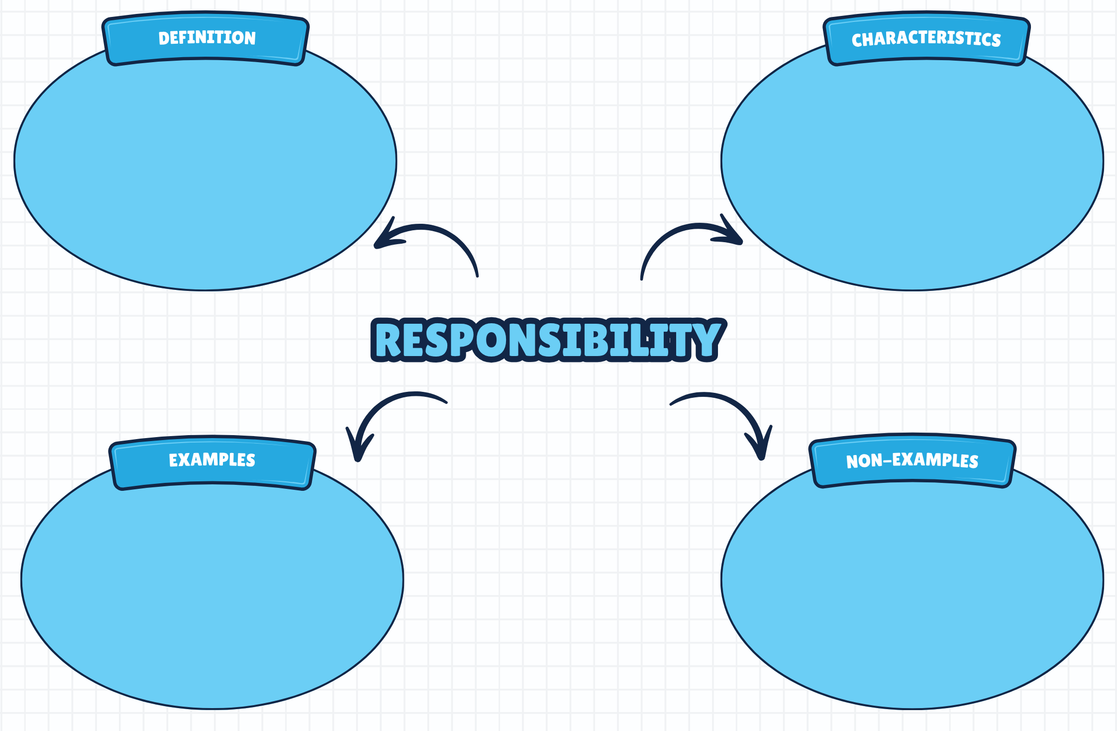

Appendix 2 – contextual factors statements
- You see a post online about a viral ‘prank challenge’ at school. You decide to take part with your friends, even though it could get you in trouble.
- You are riding your scooter home from training. The path you normally take is uneven and you know it will have puddles and be quite slippery after some recent rain. You’re in a bit of a rush and decide to continue anyway.
- You are surfing at a beach you haven’t visited before. The waves are bigger than usual, and your friends want to go further out beyond the breakers. You don’t want to seem scared, so you paddle out with them.
- You are a passenger in a car where friends are distracting the driver with jokes and loud music. You’re a bit worried about what’s happening but decide not to speak up.
- You notice your younger sibling heading into the water without an adult. You grab a board and join them, thinking you can help keep them safe while also enjoying the water.
- You are waiting at a pedestrian crossing with friends. Suddenly, they decide to run across the road against the lights and call for you to follow. You decide to run as well, crossing quickly without waiting for the light.
- A friend asks you to share a photo of your homework so they can copy it. You don’t want to let them down, so you send it without questioning it.
- You’re at the local pool with friends, and they are all jumping from a high diving board. You’re a bit anxious about jumping from the diving board and decide just to stick to the lower diving board instead.

Appendix 3 – role-play scenarios
You are hanging out near some rocks at the edge of the water with a group of friends. A few older teenagers nearby are jumping into the ocean and encouraging others to do the same. One of your friends climbs up and is about to jump, but you’re not sure how deep the water is or what’s under the surface.
You are in the car with a group of friends at night. The driver has just got their licence and is playing loud music while people in the back are joking around and moving between seats. The car is approaching a busy intersection, and the driver keeps glancing back to talk to everyone instead of focusing on the road.
You are riding your bike with a group of friends around your local area. Some of your friends aren’t wearing helmets and are doing tricks on the road. One friend rides out onto the street without really checking for cars, while others follow behind.
You and a couple of friends stay at the beach after most people have left. The lifeguards have packed up for the day, but the water still looks calm. One friend suggests going back in for a quick swim before leaving. The sun is starting to go down, and it’s much quieter than earlier.
You are waiting for the bus home from school when it starts raining. Your friend rides past on their e-scooter and offers you a ride. There’s only one helmet, and the footpath is busy with pedestrians. Your friend suggests riding on the road instead to go faster.
You and your friends have just finished eating lunch at the beach. A few people want to jump straight back into the water, even though others suggest waiting. One friend runs in quickly and starts swimming out, while another follows more slowly.

Appendix 4 – drug use triangle scenarios
Sophie is sleeping over at a friend Alex’s place for her 15th birthday. That evening, Alex’s older brother and some of his friends are having a small campfire in the backyard. They invite Sophie and Alex down to join them, and Sophie notices that they are smoking cannabis. Sophie has never tried it before but is curious. One of the brother’s friends offers her a small amount, saying it’s not very strong and no one will ever find out. Sophie takes a tiny puff and feels relaxed straight away. When Sophie says she can’t really feel anything, the group encourages her to take another puff so that she can feel it properly.
Ethan is in Year 8 and just started at a new school. He was quite popular at his last school but hasn’t made many new friends yet. During lunch, some of the boys from his year group invite him to the toilets and offer him some of their nicotine vape. Ethan has never used a vape before and isn’t sure how it will affect him. The bathroom is crowded with lots of students coming and going, and he feels nervous about being caught. His new classmates encourage him to try it quickly so no one notices, and he wonders if this will help him fit in.
Olivia just turned 17 and is headed to a concert with her friends. When she gets inside, one of them offers her a small dose of the hallucinogen LSD. She tells her friend she’s not interested as she’s heard that LSD is often mixed up with other drugs and might be stronger or give a different effect than what’s expected. Her friend tells her to stop being lame, and that there’s nothing to worry about because she got it from her older cousin. Olivia is nervous but takes a small amount, knowing that she’s with a group of friends who are experienced with the substance. The venue is dark and crowded, and there’s loud music. Olivia feels excited but slightly anxious about how she will react. No adults are present.
Jake, 14, has a big basketball tournament after school. He’s feeling a bit tired after last period, so he stops in at the corner shop and buys 2 energy drinks. His coach has told him before that they’re great for staying alert. Jake drinks them in quick succession and heads to the tournament. He hasn’t had much caffeine before and is starting to feel a bit restless. The gym is crowded, noisy and hot, and his teammates are all busy getting ready for the game.

Appendix 5 – feel versus real statements
Statement | True or false
Most 14 to 17-year-olds in Australia have consumed alcohol in the past 12 months. | False. Only 31% of 14 to 17-year-olds in Australia had consumed alcohol in the past 12 months, meaning the majority did not.
Most people under the age of 17 are vaping regularly. | False. Among people aged 14 to 17, only 9.7% are currently using e-cigarettes.
The majority of young people aged 14 to 17 have never used an illicit drug in their lifetime. | True. Only 18.8% of people aged 14 to 17 have used an illicit drug in their lifetime.
Young men aged 14 to 17 are less likely to have used an illicit drug in the past 12 months when compared to young women in the same age bracket. | True. 10% of young men aged 14 to 17 have used an illicit drug in the past 12 months, compared to 17% of young women aged 14 to 17.
When young people drink, they are more likely to drink at levels considered risky. | False. Just 5.5% of people aged 14 to 17 are consuming alcohol at levels considered risky.
This information has been adapted from ‘Young people’s use of alcohol, tobacco, e-cigarettes and other drugs’ from the Australian Institute of Health and Welfare and is licensed under CC BY 4.0.

Appendix 6 – persuasive techniques
Persuasive – to convince, influence or motivate the audience to act, feel or buy
Technique | Purpose | Example
Overall structure | Present a clear and cohesive argument | Clear introduction, body paragraphs and conclusion. The idea is introduced clearly and sustained throughout.
Facts and statistics | Provide evidence and credibility | Numbers, percentages, comparisons, tables, charts.
Emotive language | Appeal to a reader’s feelings and perceptions | Words with strong positive or negative connotations (for example, life-changing, heartbreaking, vile, unacceptable).
Rhetorical questions | Have the reader consider and agree with your point | ‘How long can we continue to ignore our own health?’
Authoritative tone | Shows ownership and confidence in the argument | Created with the imperative verb form (for example, ‘Save the dolphins!’) and high modality language (for example, ‘must’ or ‘will’ as opposed to ‘should’ or ‘might’).
Repetition | Make ideas memorable | Repeating words, slogans or key phrases.

Appendix 7 – drug or substance use short story
Fifteen-year-old Nina was at her friend Ella’s birthday party. Most of their friends from school were there, plus some older kids that Nina didn’t recognise. The party was being held at Ella’s house while her parents were out for dinner. The music was loud, and the living room was crowded.
Nina had never tried alcohol before, but a few of the older kids at the party were drinking and offered her a sip of a fruity cocktail. ‘It’s not very strong, don’t worry,’ one of them said.
Feeling curious and wanting to fit in, Nina took a small sip. It tasted great!
She smiled and immediately felt relaxed as the older kids invited her to hang out with them. The room was noisy and bustling, and she noticed her other friends laughing and having fun. ‘This is brilliant,’ she thought to herself.
After a few minutes, she decided that she felt okay and wanted to have another drink. Soon, a third followed. Nina was now mixing the fruity cocktail with some cider she found in the fridge.
As time passed, Nina began to feel unwell. Her head spun, her vision blurred and she felt really dizzy.
She stumbled towards the kitchen to get some water. She was dazed and confused, struggling to keep her balance.
Ella saw her and ran over immediately. ‘Nina! Have you been drinking? Tell me what you’ve had!’
Nina tried to reply, but her words came out all muddled up. She felt her stomach turn violently, and before she could get any words out, she vomited onto the floor. She doubled over, too weak to stand properly.

Appendix 8 – vaping worksheet
Use the information from the video and your own research to answer the following questions.
What is a vape or e-cigarette? Use your own words to explain.
What is in a vape? Include at least 3 specific examples of chemicals and substances commonly found in vapes.
How does a vape work? Outline the role of key parts, including the battery, heating element and pressure sensor, and how they work together to create vapour.
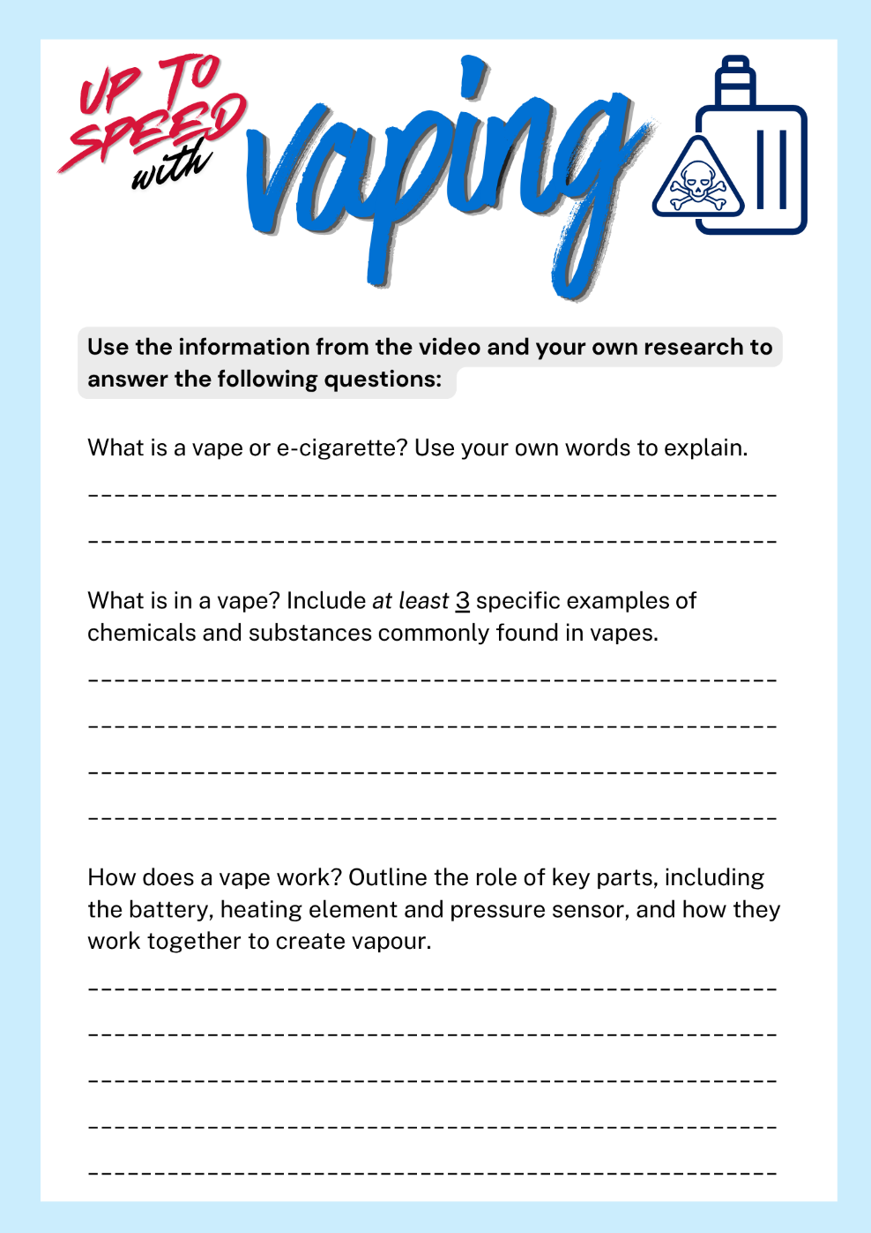

Appendix 9 – email/letter template
[Your Name]
[Class/Year]
[Date]
[Recipient’s name]
[Recipient’s contact details – for example, email address or phone number]

Dear [insert recipient’s name here],

[Introduce yourself and explain the purpose of your letter.]
[Provide a clear explanation of what nicotine is and why it can be addictive.]
[Outline the nature and significance of nicotine addiction for young people, using relevant facts and statistics.]
[Unpack some practical next steps and advice in the form of protective behaviours and harm-minimisation strategies.]
[Suggest sources of further help and information, such as a parent or trusted adult, teacher or government website.]

[Give a concluding statement or paragraph which summarises the key points of your letter. Reinforce what your advice is, or what actions you are expecting to see in response.]

Yours sincerely,
[Your name]

Appendix 10 – vaping legalities statements
Statements for this activity could include:
- Vapes and vaping products, regardless of whether they contain nicotine or not, can only be sold in a pharmacy for the purpose of helping people quit smoking or manage nicotine dependence.
- It is illegal for tobacconists, vape shops and convenience stores to sell any type of vaping product.
- Across New South Wales, vaping is banned in all areas where smoking is banned.
- People under 18 years of age need a prescription to purchase therapeutic vapes in New South Wales.
- People who need therapeutic vapes with a higher concentration of nicotine than 20 mg/mL also need a prescription, regardless of their age.
- Flavours are restricted to unflavoured, mint, menthol and tobacco.
- Vapes must adhere to plain pharmaceutical packaging standards. This means they must be grey, black or white to reduce the appeal to young people.
- Advertising of vapes is banned. The ban covers all media platforms, including social media, as well as other forms of advertising, promotion and sponsorship.
- The manufacture, possession and sale of non-therapeutic vapes and disposable vapes is banned.

Appendix 11 – vape images
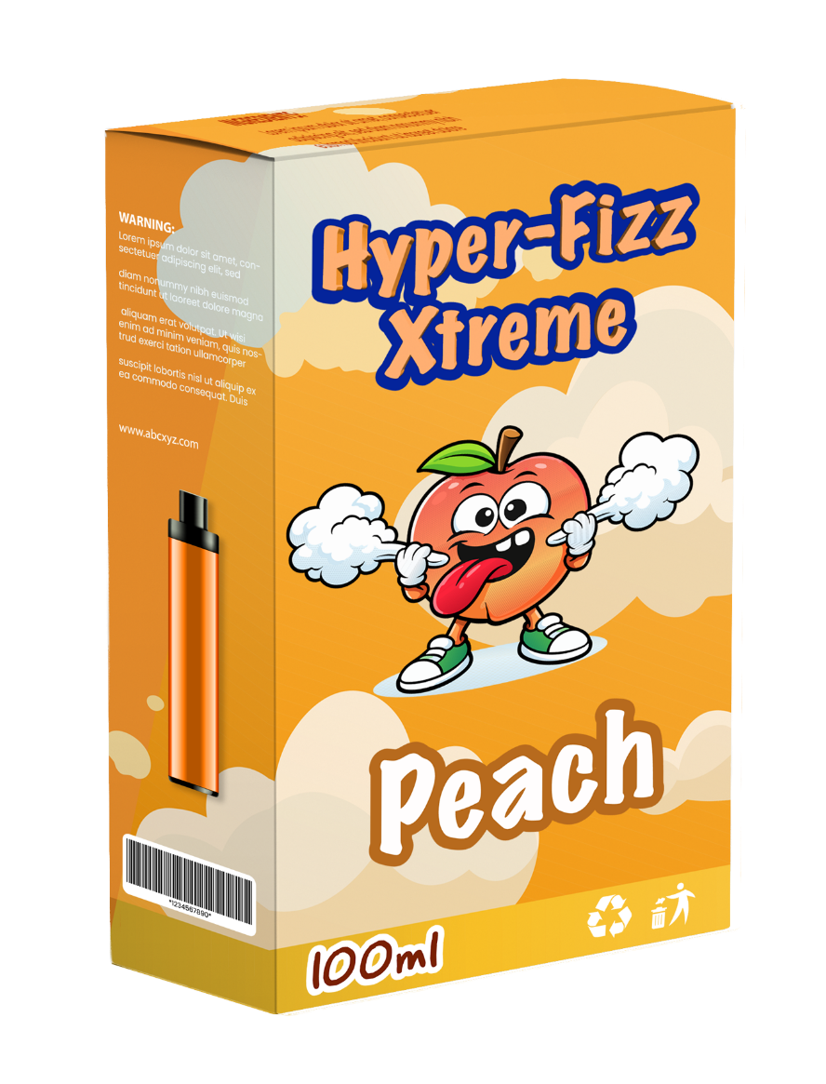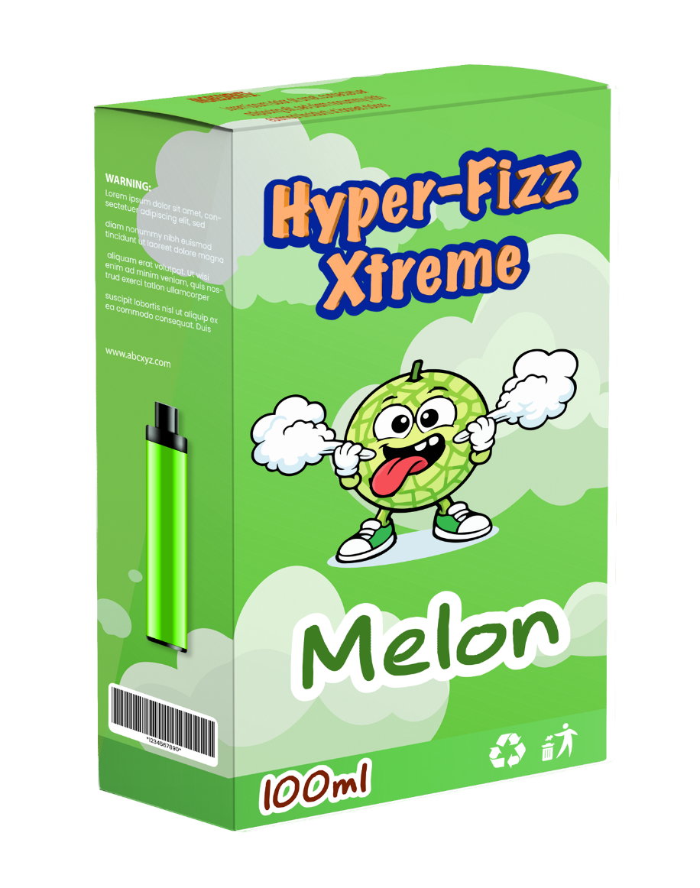

Appendix 12 – vaping scenarios
Zach sees a message in his footy group chat saying someone has brought vapes to school and is offering them after class. Several people respond with laughing emojis and ‘I’m in.’ Zach ignores the messages at first, but then someone sends a messaging saying ‘Zach, are you keen or what?’
Samika is at a weekend birthday party. An older cousin she looks up to is vaping and says, ‘Everyone in high school does this. It helps you relax. Just take a puff.’ Samika feels unsure but doesn’t want to seem immature. ‘It’s just lolly flavoured air, Samika. Do you really think air can hurt you?’ her cousin asks.
Miles is walking home from school with his mates when they pass an older student from another school that Miles knows. The older student asks Miles if he wants to buy a vape, saying, ‘I’ve got heaps, no one will know. Share it with your friends if you want. It’s not addictive anyway.’
During a school lunch break, Ravi is hanging out behind the canteen with a group of friends. One of them pulls out a vape and says, ‘It’s just flavoured water apparently. My older sister says nothing bad will happen, and all the kids her age are doing it. Do you want to try?’ The others are watching to see what Ravi will do.

Appendix 13 – pressure scenarios
In a group chat, people are joking and daring each other to send silly photos of themselves. Someone tags you and says, ‘Your turn now, don’t back out.’
You’ve been chatting regularly to someone in an older year group. They message you after school saying they’ve had a really bad day and feel upset. After chatting for a bit, they say, ‘Can you send me a photo? It would make me feel better.’
Someone you know online messages you asking for a ‘cute’ photo. You aren’t really sure what they want, and when you say no, they reply: ‘If you were a real friend, you would send it.’
You’ve been talking to someone online for a while and get along well. One day, they ask you to send a photo you’re not comfortable sharing. When you hesitate, they reply, ‘I’ve told you stuff about me, why won’t you trust me?’
A person you’ve been chatting to online keeps asking for a picture of you. You’ve already said ‘no’ on multiple occasions, but they continue asking over several days and bring it up every time you talk.

Appendix 14 – PMI worksheet
Plus | Minus | Interesting
[students to complete] | [students to complete] | [students to complete]

Appendix 15 – deepfakes worksheet
Use your own knowledge and information gathered from reliable online sources to answer the following.
In your own words, explain the term ‘deepfake’.
How are deepfakes created?
What are the potential risks or harms associated with deepfakes?
What are the signs of a deepfake, and how can young people protect themselves from being targeted?

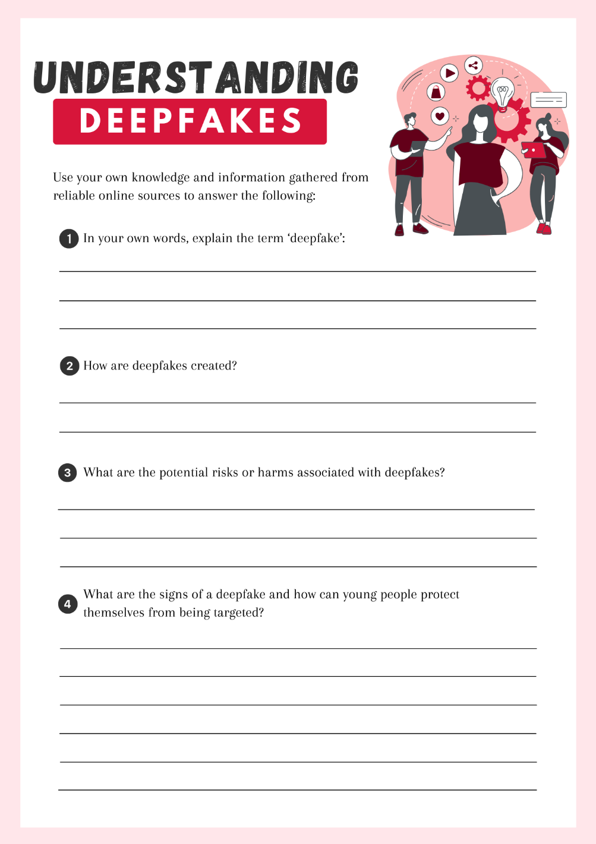

Appendix 16 – campaign review scaffold
Section | Notes/Ideas
Initiative/campaign details | - What is the name of the initiative/campaign?  - Who is responsible for it? (Private organisation, government and so on.)
Target audience and purpose | - Who is the initiative/campaign aimed at?  - What issue is the initiative/campaign trying to address?  - To what extent is this issue relevant to young people? How do you know? (Consider the available evidence and statistics that could inform your thinking.)  - What is the main purpose or goal of the initiative/campaign?
Strengths | - What does the initiative/campaign do well?  - Will the approach of the initiative/campaign connect with young people? (For example, social media, TV advertisements, print media, school education programs.)  - Is the messaging clear and easy to understand?  - Are the visuals appealing?
Limitations | - Is there anything that isn’t clear?  - Do you think young people will understand the messaging?  - Is it likely to change or influence their behaviours?  - Are there issues with the way this initiative/campaign is being delivered?
Improvements | - What changes would you make?  - How could the responsible agency or organisation go about implementing that change?  - To what extent would this improve the quality of the initiative/campaign?

Appendix 17 – sentence starters
Strengths:
- One strength of this campaign is …
- I feel that this initiative works well because …
- A key feature that makes this initiative so effective is …
- This approach is likely to engage young people because …
Limitations/weaknesses:
- One limitation of the campaign is …
- A potential barrier to its success is …
- I believe that … is not the best way to engage young people.
- Some aspects of the campaign may be confusing for the audience, such as … This is because …
- Young people’s response to this campaign may be influenced by …
- Various factors, such as peer pressure and social media, could affect how this campaign is received, because …
Improvements/recommendations:
- One way to improve the campaign would be to ...
- This change could be implemented by …, and would help by …
- To make the campaign more effective, you must …
- This change would make a significant difference to young people by …
- We could enhance the quality of the initiative by doing …, ultimately better supporting young people’s safety, health and wellbeing more directly.


Program feedback
We value your feedback. If you use this teaching and learning program in your faculty and school context, please complete the PDHPE 7–10 resource evaluation form. If you have further comments or suggestions, please email PDHPEcurriculum@det.nsw.edu.au.

Support and alignment
Resource evaluation and support: all curriculum resources are prepared through a rigorous process. Resources are periodically reviewed as part of our ongoing evaluation plan to ensure currency, relevance and effectiveness. For additional support or advice, or to provide feedback, contact the PDHPE Secondary Curriculum team by emailing PDHPEcurriculum@det.nsw.edu.au.
Differentiation: further advice to support Aboriginal and/or Torres Strait Islander students, students learning English as an additional language or dialect (EAL/D), students with a disability and/or additional needs and high potential and gifted students can be found on the Planning, programming and assessing 7–12 webpage. This includes the Inclusion and differentiation advice 7–10 webpage.
Assessment: further advice to support formative assessment is available on the Planning, programming and assessing 7–12 webpage. This includes the Classroom assessment advice 7–10. For summative assessment tasks, the Assessment task advice 7–10 webpage is available.
Explicit teaching: further advice to support explicit teaching is available on the Explicit teaching webpage. This includes the CESE Explicit teaching – Driving learning and engagement webpage.
Consulted with: Curriculum and subject matter experts.
Alignment to system priorities and/or needs: School Excellence Policy, Our Plan for NSW Public Education
Alignment to the School Excellence Framework: this resource supports the School Excellence Framework elements of curriculum (curriculum provision) and effective classroom practice (lesson planning, explicit teaching).
Alignment to Australian Professional Standards for Teachers: this resource supports teachers to address Proficient Teacher Standard Descriptors 2.1.2, 2.2.2, 2.3.2, 2.5.2, 3.1.2, 3.2.2, 3.3.2, 4.4.2.
Creation date: 2 July 2026

References
This resource contains NSW Curriculum and syllabus content. The NSW Curriculum is developed by the NSW Education Standards Authority (NESA). This content is prepared by NESA for and on behalf of the Crown in right of the State of New South Wales. The material is protected by Crown copyright.
Please refer to the NESA Copyright Disclaimer for more information https://www.nsw.gov.au/education-and-training/nesa/copyright.
NESA holds the only official and up-to-date versions of the NSW Curriculum and syllabus documents. Please visit NESA https://www.nsw.gov.au/education-and-training/nesa and NSW Curriculum https://curriculum.nsw.edu.au.
Personal Development, Health and Physical Education 7–10 Syllabus © NSW Education Standards Authority (NESA) for and on behalf of the Crown in right of the State of New South Wales, 2024.
Alcohol and Drug Foundation (n.d.) ‘Drug triangle’, LDAT Program Modules, Alcohol and Drug Foundation website, accessed 12 November 2025.
Australian Government Department of Health, Disability and Ageing (2019) What are drugs?, Australian Government Department of Health, Disability and Ageing website, accessed 12 November 2025.
——(2021) Types of drugs, Australian Government Department of Health, Disability and Ageing website, accessed 12 November 2025.
——(2024) Nicotine is addictive, Australian Government Department of Health, Disability and Ageing website, accessed 1 December 2025.
Australian Institute of Health and Welfare (2024) Young people’s use of alcohol, tobacco, e-cigarettes and other drugs, Australian Institute of Health and Welfare website, accessed 28 November 2025.
——(2026) Health promotion and health protection, Australian Institute of Health and Welfare website, accessed 4 December 2025.
eSafety Commissioner (2026) Consent for sharing photos and videos, eSafety Commissioner website, accessed 2 December 2025.
——(2026) Dealing with sexual extortion, eSafety Commissioner website, accessed 2 December 2025.
——(2026) Deepfake trends and challenges – position statement, eSafety Commissioner website, accessed 2 December 2025.
——(2026) I’m being pressured to send nudes, eSafety Commissioner website, accessed 2 December 2025.
——(2026) Photo and video sharing, eSafety Commissioner website, accessed 2 December 2025.
eSafety Office (15 June 2022) ‘Adelaide’s story: Seeking help when things go wrong online’ [video], eSafety Office, Vimeo, accessed 2 December 2025.
HealthDirect (2025) What is addiction?, HealthDirect website, accessed 4 December 2025.
NSW Government (n.d.) Protect from deepfakes, NSW Government website, accessed 2 December 2025.
NSW Health (2025) Nicotine addiction - Fact sheet for young people, NSW Health website, accessed 1 December 2025.
Park M (2024) What’s really inside vapes? We pulled them apart to find out, UNSW Sydney Newsroom, accessed 27 November 2025.
University of Newcastle Australia (n.d.) Vaping, University of Newcastle Australia website, accessed 27 November 2025.
Victoria University (2025) What is health promotion in public health? Victoria University website, accessed 4 December 2025.
© State of New South Wales (Department of Education), 2026
The copyright material published in this resource is subject to the Copyright Act 1968 (Cth) and is owned by the NSW Department of Education or, where indicated, by a party other than the NSW Department of Education (third-party material).
Copyright material available in this resource and owned by the NSW Department of Education is licensed under a Creative Commons Attribution 4.0 International (CC BY 4.0) license.

This license allows you to share and adapt the material for any purpose, even commercially.
Attribution should be given to © State of New South Wales (Department of Education), 2026.
Material in this resource not available under a Creative Commons license:
- the NSW Department of Education logo, other logos and trademark-protected material
- material owned by a third party that has been reproduced with permission. You will need to obtain permission from the third party to reuse its material.
Links to third-party material and websites
Please note that the provided (reading/viewing material/list/links/texts) are a suggestion only and implies no endorsement, by the New South Wales Department of Education, of any author, publisher, or book title. School principals and teachers are best placed to assess the suitability of resources that would complement the curriculum and reflect the needs and interests of their students.
If you use the links provided in this document to access a third-party's website, you acknowledge that the terms of use, including licence terms set out on the third-party's website apply to the use which may be made of the materials on that third-party website or where permitted by the Copyright Act 1968 (Cth). The department accepts no responsibility for content on third-party websites.

