Minimum spanning trees
Students learn about the terminology associated with paths and spanning trees. They learn to use Prim's and Kruskal's algorithms to find the minimum spanning tree and solve problems that require a minimum spanning tree.

Learning intention
- To be able to solve problems involving a minimum spanning tree.

Success criteria
- I can define the terms ‘path’, ‘tree’, ‘spanning tree’ and ‘minimum spanning tree’.
- I can identify a path and a tree within a network.
- I can draw a minimum spanning tree.
- I can use a minimum spanning tree to solve problems.

Outcomes
A student:
- develops understanding and fluency in mathematics through exploring and connecting mathematical concepts, choosing and applying mathematical techniques to solve problems, and communicating their thinking and reasoning coherently and clearly MAO-WM-01
- solves problems involving time and location in practical contexts MST-11-06
- applies network techniques to solve network problems MST-11-07
Mathematics Standard 11–12 Syllabus © NSW Education Standards Authority (NESA) for and on behalf of the Crown in right of the State of New South Wales, 2024.

Associated numeracy outcomes
A student:
- applies numerical reasoning and mathematical thinking to clarify, efficiently solve and communicate solutions to problems N6-1.2
- chooses and applies efficient strategies to analyse and solve everyday problems involving metric relationships, distance and length, area, volume, time, mass, capacity and temperature N6-2.2
- chooses and applies efficient strategies to analyse and solve everyday problems involving location, space and design N6-2.5
Numeracy Stage 6 (CEC) Syllabus © NSW Education Standards Authority (NESA) for and on behalf of the Crown in right of the State of New South Wales, 2021.

Content

Networks, paths and trees
Network concepts
- Solve problems involving network diagrams in a variety of practical contexts
Shortest paths and spanning trees
- Define and use the network terminology: path, tree, spanning tree and minimum spanning tree
- Determine the minimum spanning tree of a network with weighted edges, using any method
- Use minimum spanning trees to solve minimal connector problems
Mathematics Standard 11–12 Syllabus © NSW Education Standards Authority (NESA) for and on behalf of the Crown in right of the State of New South Wales, 2024.

Table 1: lesson summary
Section | Summary of activity | Teaching strategies | Teaching points
Activating prior knowledge | Students are introduced to Jaq’s travel-vlogger scenario, where they want to plan a tour of 4 Italian cities. Students generate a network diagram showing all possible connections before recording the possible touring orders. | Class discussion  Visibly random groups of 3  Vertical non-permanent surfaces  Gallery walk | This activity helps students to understand that the arrangement of vertices in a network is flexible. Students develop the idea of a path through a network.
Connecting learning | Students predict which route might have the shortest distance, then use slide 4 of the PowerPoint Minimum spanning trees to add the distances to their network. They calculate and compare route lengths and discuss if this scenario would change if Jaq used the times from slide 5 as a measure of efficiency. Students then find the minimum spanning tree using Appendix A. | Turn‑and‑talk  Visibly random groups  Vertical non‑permanent surfaces  Pose-Pause-Pounce-Bounce  Gallery walk | These activities help students connect with the idea that distances influence route efficiency. Students intuitively understand how to minimise total cost laying the conceptual groundwork for minimum spanning trees.
Releasing responsibility | Students define terminology using slides 7–8 and then use Appendix B to identify scenarios as paths, or trees. Students watch videos on Kruskal’s (bit.ly/KruskalAlgorithm) and Prim’s (bit.ly/PrimsAlgroithm) algorithms, and have guided practice in Appendix C, supported by slides 9–12. They apply both algorithms independently before moving to Appendix D using variation theory and recording their notes in Appendix E. | Worked examples (Your turn)  Notes to future forgetful selves | Students formalise their understanding of minimum spanning trees by learning about 2 algorithms and understand that different methods can produce the same minimum spanning tree.
Independent practice | Students revisit the ‘Approaching questions scaffold’ using slide 14 before completing Appendix F independently, checking their solutions. |  | Independent practice encourages students to think deeper about their approach to questions.

Activity structure
Please use the associated PowerPoint Minimum spanning trees to display images in this lesson.

Activating prior knowledge
- Read the following scenario to students.
Jaq is a travel vlogger who gets a special deal at a small hotel chain for promoting them in his vlogs. The chain has 4 hotels in Italy: Milan, Naples, Parma and Rome. Jaq wants to plan a trip that visits all 4 cities only once. He does not mind where he starts and does not need to start and end in the same city.
- Assign students to visibly random groups of 3 (bit.ly/visiblegroups) on vertical non-permanent surfaces (bit.ly/VNPSstrategy) and ask students to draw a network diagram showing the 4 cities and all of the connections between them.
- Ask students to mark or record the different orders that Jaq could visit the cities.
- Conduct a gallery walk (bit.ly/DLSgallerywalk) for students to compare solutions and discuss similarities and differences.
- Students return to their boards to refine their network diagrams and orders based on insights from the gallery walk if necessary.
There are 24 solutions but only 12 distinct pictures/orders as the routes could be travelled in either direction. For example, R–M–P–N creates the same picture as N–P–M–R just travelled in the opposite direction.

Connecting learning
- Display slide 4 of the PowerPoint, which shows the distances between the towns from the ‘Activating Prior Knowledge’ activity.
- In their groups of 3, ask students to turn and talk about what they predict will be the most efficient route for the tour and why this might be important to Jaq.
- Choose some groups to explain their reasoning to the class.
By minimising the distance, Jaq would be minimising the time and cost of the tour.
- Have students label the distances on their network diagrams and calculate the total lengths of each route.
Teachers may wish to limit the number of calculations by having students calculate the distance of the routes students predicted were the minimum.
- Students compare their results with a neighbouring group, justifying why their choice of route is most efficient for Jaq.
- Display slide 5, showing the time it takes to travel between towns.
- Students use this information to consider if this changes their choice of route.
- Read the following scenario to students.
The hotel in Milan that Jaq features in their vlog is located near the Seveso River and in a recent storm the river flooded the town. After everyone was safe, the streets were left very muddy and impassable. Seeing an opportunity, Jaq offered to help clear the flooded streets for a fee of $500 per paver.
- Hand out Appendix A ‘Muddy Milan’ in a plastic sleeve to each group. Allow students time to identify the most cost-efficient way of clearing the streets so that each building can be accessed.
- Have students perform a gallery walk to compare their solutions to other groups.
- Use the Pose-Pause-Pounce-Bounce questioning strategy (PDF 557 KB) (bit.ly/posepausepouncebounce) to compare students’ solutions and methods. Suggested prompts include:
- Who had the minimum distance?
- What method did you use to determine the minimum distance?
If students use either Prim’s or Kruskal’s method, then indicate that their method has a name.

Releasing responsibility
- Display slides 7 and 8 which show the definitions of path, tree, spanning tree and minimum spanning tree.
- Using a Think-Pair-Share, have students decide if the ‘Activating prior knowledge’ activity was a tree, spanning tree or minimum spanning tree. Then have them consider the Muddy Milan task and identify what type of tree they created there as well.
Draw out in the discussion that the ‘Activating prior knowledge’ activity where Jaq was choosing a route to visit all 4 towns, was creating multiple spanning trees. Choosing the minimum length to visit all 4 towns was finding the minimum spanning tree. Additionally, in the Muddy Milan scenario, connecting all the buildings created a spanning tree. It became a minimum spanning tree once the goal was to connect the building for the cheapest cost.
A path tells you ‘how’ to go, a tree tells you how things are connected.
- Distribute Appendix B ‘Sorting activity’ to pairs of students and have them categorise each of the cards as either paths, trees or spanning trees.
- Have them compare their answers with another pair, and if they disagree, they should come to a consensus.
- Show the video ‘Kruskal’s algorithm in 2 minutes’ (1:48) (bit.ly/KruskalAlgorithm)
Note the syllabus does not explicitly state a particular method to use when determining the minimum spanning tree.
The term cycle is mentioned in the Mathematics 7–10 Syllabus and the Kruskal’s algorithm video uses the term cycle. A cycle is where a path returns to a vertex. Students are not required to learn this definition.
- Ask students to indicate if their method for solving the Muddy Milan activity was like Kruskal’s algorithm.
- Hand out Appendix C ‘Prim’s and Kruskal’s algorithms’ and instruct students step by step how to complete Question 1 to find the minimum spanning tree using Kruskal’s algorithm, highlighting each edge of the network diagram from smallest to largest.
Slide 9 displays Kruskal’s algorithm highlighting an edge with each animation.
- Students complete Question 2 of the appendix on their own and compare their solution with a neighbour.
- In a class discussion, ask students which edge they used to connect vertex G and if it made a difference to the length of the minimum spanning tree.
- Using a Think-Pair-Share, have students discuss how they know an edge is not required for the minimum spanning tree.
Students should identify that an edge that returns to a vertex that is already connected in the tree, is not required in the minimum spanning tree.
- Display slide 10 which shows the solution for Question 2.
The minimum spanning tree could use I–G or H–G as both have the length of 8. The length of the minimum spanning tree remains the same.
- Show the video ‘Prim’s algorithm in 2 minutes’ (2:16) (bit.ly/PrimsAlgroithm).
- Ask students to indicate if their method for solving the Muddy Milan activity was like Prim’s algorithm.
- Direct students to Appendix C and instruct students step by step how to complete Question 3 using Prim’s algorithm, ensuring students are highlighting each edge of the network diagram.
Slide 11 displays Prim’s algorithm highlighting an edge with each animation, starting from Port Adelaide.
- Students complete Question 4 of the appendix and compare their solution with a neighbour, noting which vertex they started at.
- Display slide 12 which shows the solution and ask students, with the correct answer, which vertex they started from. Establish with students that it does not matter which vertex you start from.
- Distribute Appendix D ‘Minimum spanning trees’ to pairs of students. This activity uses variation theory (variationtheory.com/introduction) to find the minimum spanning tree.
- In a class discussion about both algorithms, ask students which method was the student’s preference and why?
- Students create notes to their future forgetful selves (bit.ly/notestofutureself) using Appendix E ‘Glossary of terms and conditions’. Students should record their preferred method in the notes column.
Appendix E contains space to add notes about the shortest path which will be introduced in Lesson 5.

Independent practice
- Display slide 14 to remind students how to use the ‘Approaching questions scaffold’.
- Hand out Appendix F ‘HSC-style questions’.
- Students work individually and check their solutions with a partner.

Assessment and differentiation

Suggested opportunities for differentiation
Activating prior knowledge
- Support students by handing out a sheet with 4 fixed dots labelled MPRN for the vlogger activity.
- To support students ask them what strategy they will use to organise their routes, so they do not miss any.
- To challenge students, choose another town in Italy such as Luca, so the network diagram has 5 vertices.
- To challenge students, ask them to describe their strategy for listing routes.
Connecting learning
- To support students, limit the number of routes for which they calculate the distance.
- To support students, eliminate one or more of the buildings in the Muddy Milan scenario.
- Challenge students by making a constraint, such as the bridge is down between I and J so that street cannot be cleared.
Releasing responsibility
- Support students by supplying them with a partially completed minimum spanning tree.
- Support students by distributing Appendix E earlier in the lesson.
- Challenge students by requiring a change in units on the weighted edges in Appendix D.
Independent practice
- Support students with scaffolded or faded questions for Appendix F.
- Challenge students by asking for a justification of edge selection in a select question from Appendix F.

Suggested opportunities for assessment
Activating prior knowledge
- Take a photo of vertical non-permanent surfaces as evidence of students’ ability to find many routes.
- Review students’ list of routes for completeness.
Connecting learning
- Observe and give feedback to students during discussions to assess understanding of the definition of a spanning tree.
- Assess student understanding of minimum spanning trees while they are answering questions in the Pose-Pause-Pounce-Bounce.
Releasing responsibility
- Collect Appendix D as evidence of learning of how to find the minimum spanning tree.
Independent practice
- Collect Appendix F as evidence of learning of how to find the minimum spanning tree.
- Observe and give feedback to students during discussions when comparing solutions from Appendix F.

Appendix A

Muddy Milan
It costs $500 per paver to repair a street. Find the most cost-effective way to connect all houses.
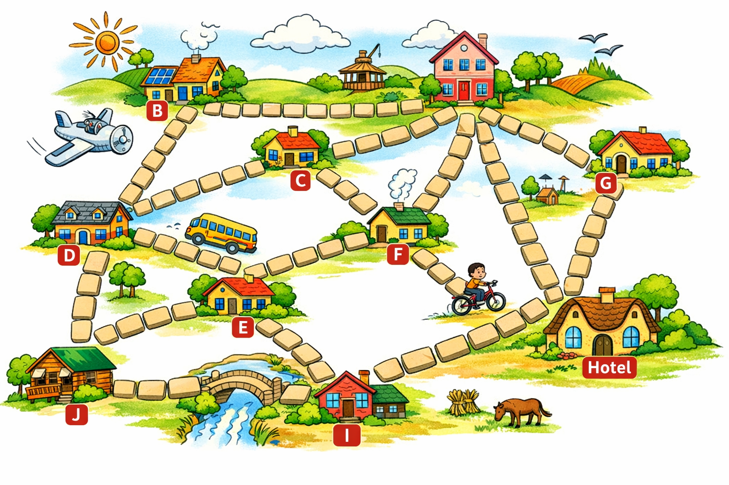

Appendix B

Sorting activity
Identify each of the following scenarios as an example of a path, tree, spanning tree, minimum spanning tree or as being none of these. Justify your answers.
- A delivery driver plans a route visiting 5 houses in a straight sequence without revisiting any house.
- A set of hiking trails connects several campsites. You can walk between any 2 campsites, and there are no circular walking loops.
- A school wants to install cables so that every classroom is connected, for the cheapest possible cost.
- A council wants to connect towns with roads at the lowest possible total cost, ensuring all towns are connected and no unnecessary roads are built.
- A tourist walks from one landmark to another, sometimes revisiting places along the way.
- A network connects six computers, but one computer is not connected to the others.
- A rail network connects all stations with no loops, but there are multiple branching lines.
- A student traces a route through a maze from entrance to exit without revisiting any junction.
- An electrician connects all houses in a street using the least amount of wiring possible, ensuring every house has power.
- A farmer needs to connect all water tanks on the property using pipes. There are several possible ways to connect them without loops, but the farmer chooses the layout that uses the least total length of pipe.

Appendix C

Prim’s and Kruskal’s algorithms

Kruskal’s
Question 1
Find the length of the minimum spanning tree using Kruskal’s algorithm
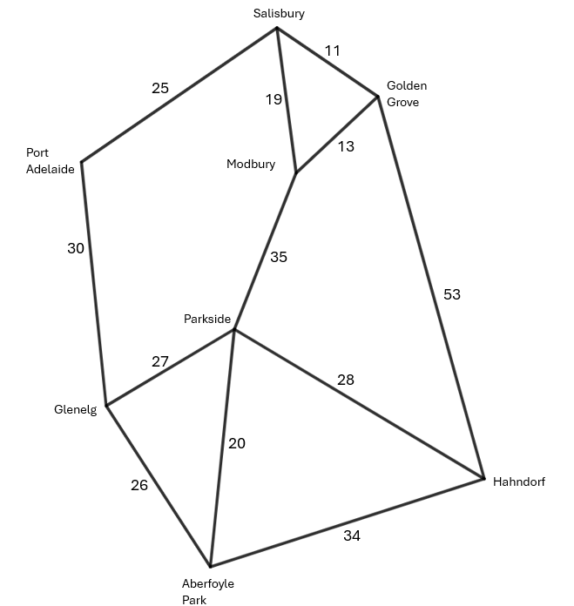
Question 2
Find the length of the minimum spanning tree using Kruskal‘s algorithm.
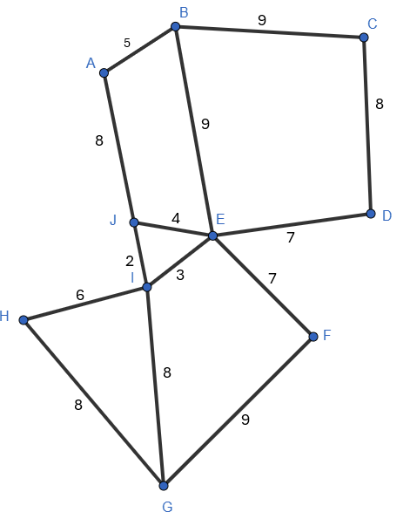

Prim’s
Question 3
Find the length of the minimum spanning tree using Prim’s algorithm.
Question 4
Find the length of the minimum spanning tree using Prim’s algorithm.
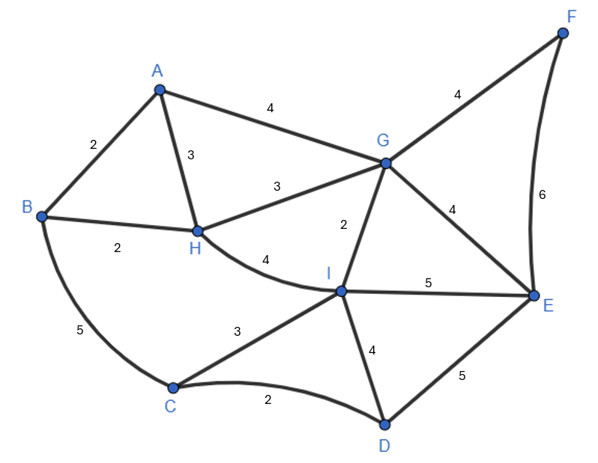

Appendix D

Minimum spanning trees
Use a highlighter to mark the minimum spanning tree and calculate the minimum distance.
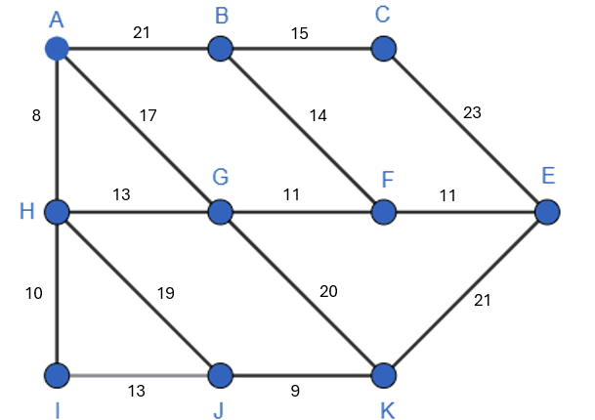 | 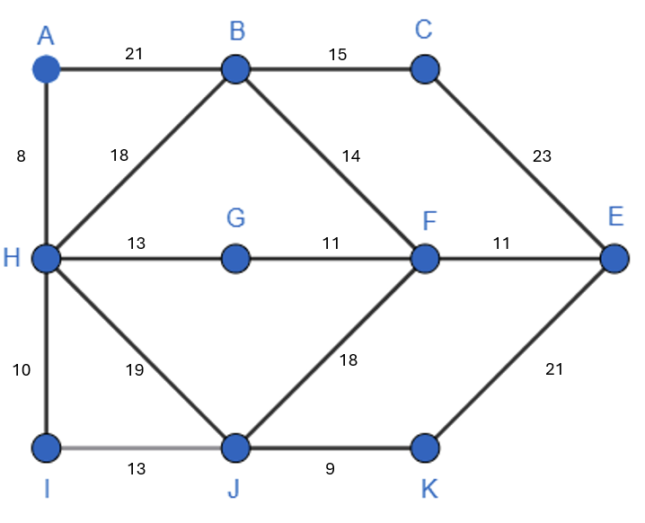
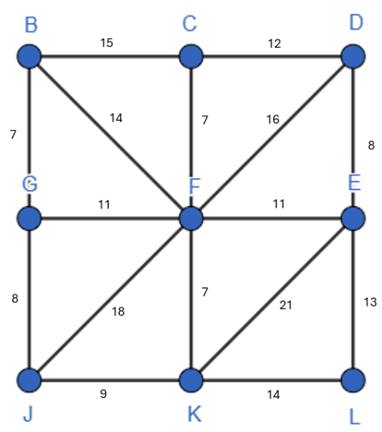 | 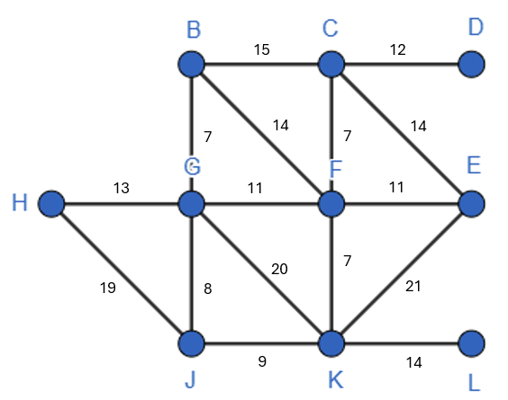
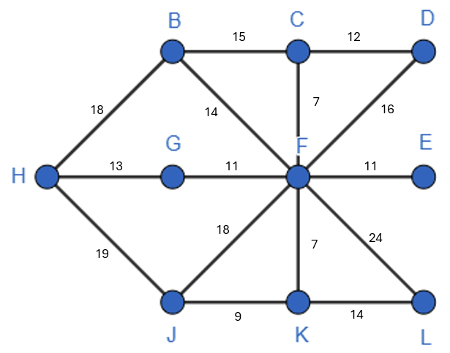 | 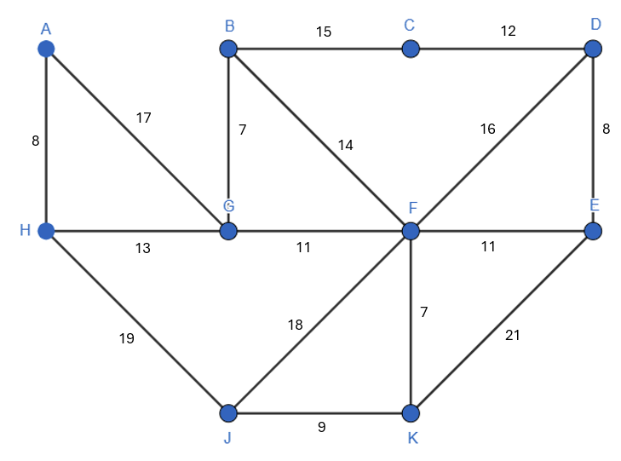

Appendix E

Glossary of terms and conditions
Term | Network | Definition | Notes
Path
Tree
Spanning tree
Minimum spanning tree
Shortest path | 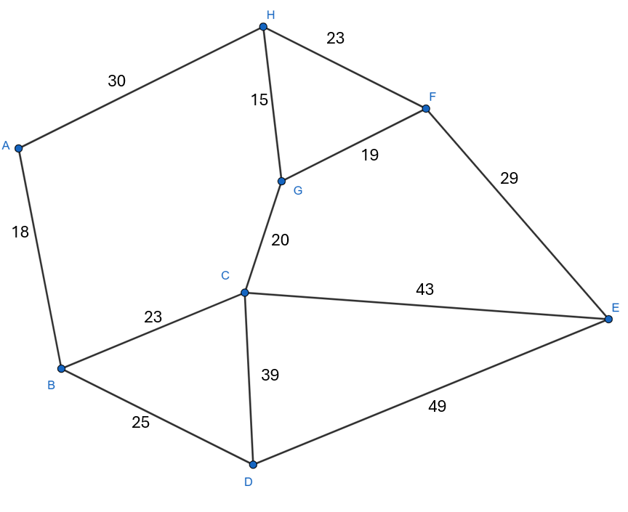

Appendix F

HSC-style questions
Question 1
The network diagram below shows the distance (in kilometres) between capital cities. A company wants to connect all the main data centres in the cities but avoid unnecessary extra links.
- Draw the minimum spanning tree and find its length.
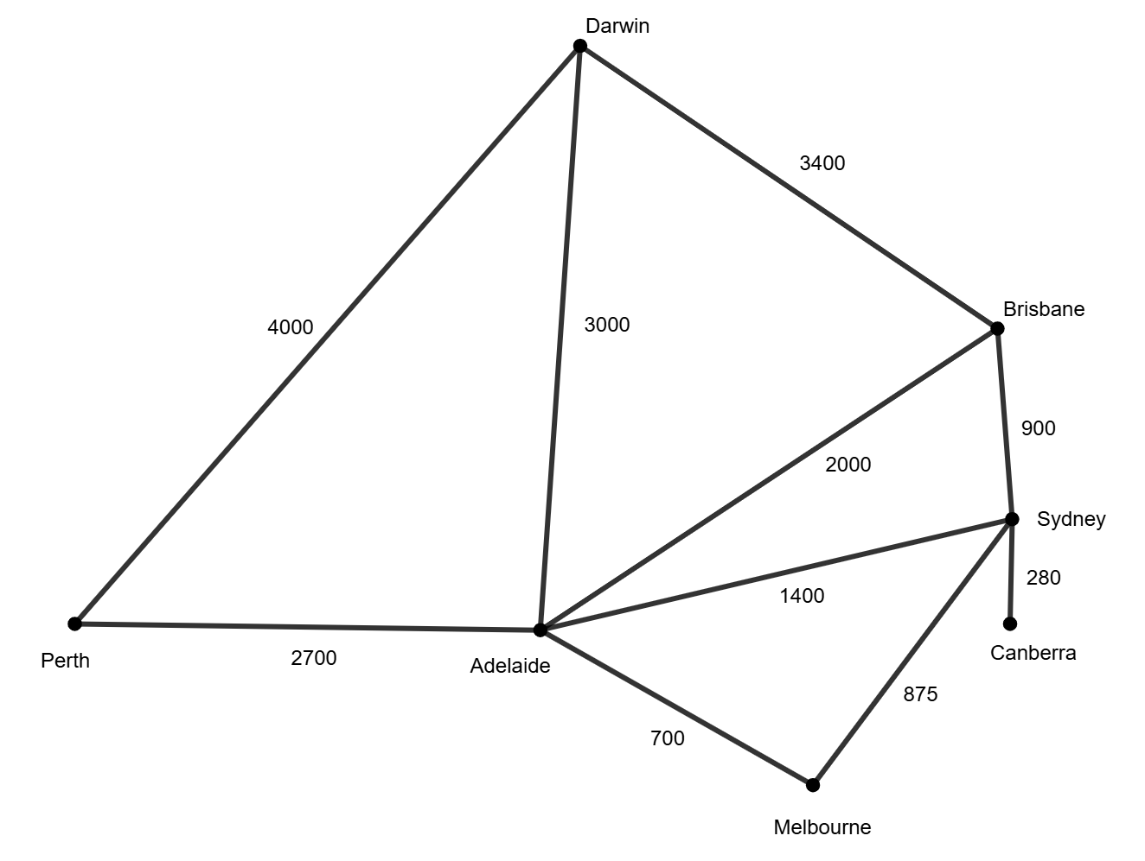

Question 2
The network diagram below shows the distance between Townsville and some of the islands in the pacific. A small company wants to establish a network to efficiently transport goods and facilitate communication between Townsville and the islands. The edges represent the cost of connecting the locations.
- Show how you could connect all the islands and Townsville using the minimum possible total cost to make trade and communication efficient.
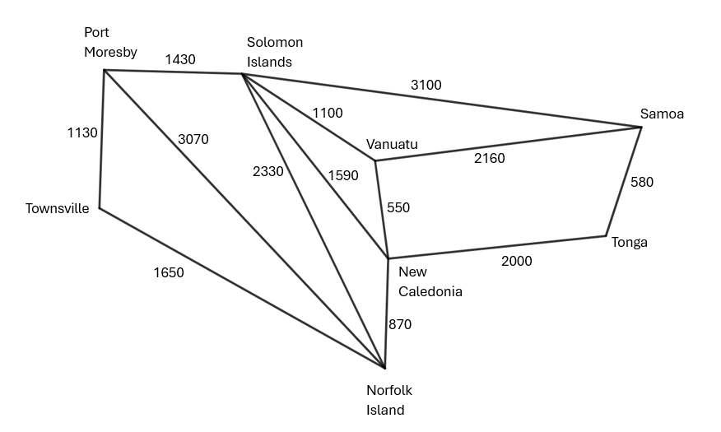
- What is the minimum cost for all the locations to be connected?

Question 3
The network diagram below shows the time taken between each town in minutes for a fast-food delivery service.
- Mark the minimum spanning tree on the network diagram and find its total time.
- Mark the fastest route to travel from Daltown to Cooktown. Is the fastest route part of the minimum spanning tree?
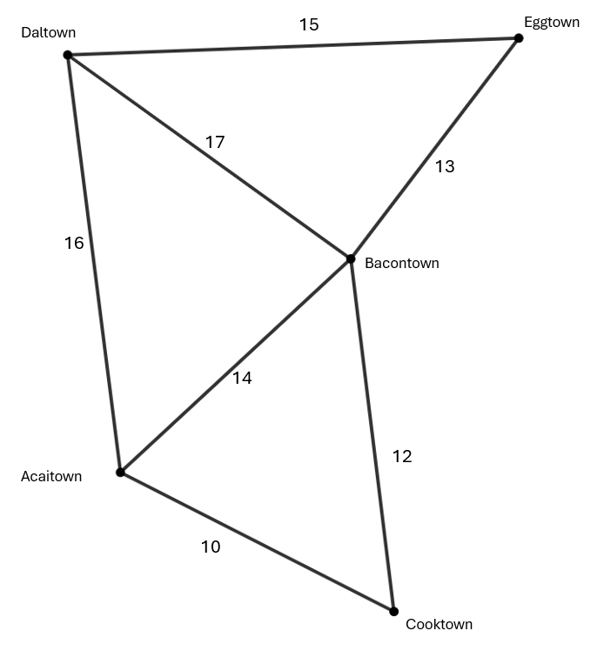

Question 4
The diagram shows a network with weighted edges that represent the cost in $1000s to connect the town with electrical power.
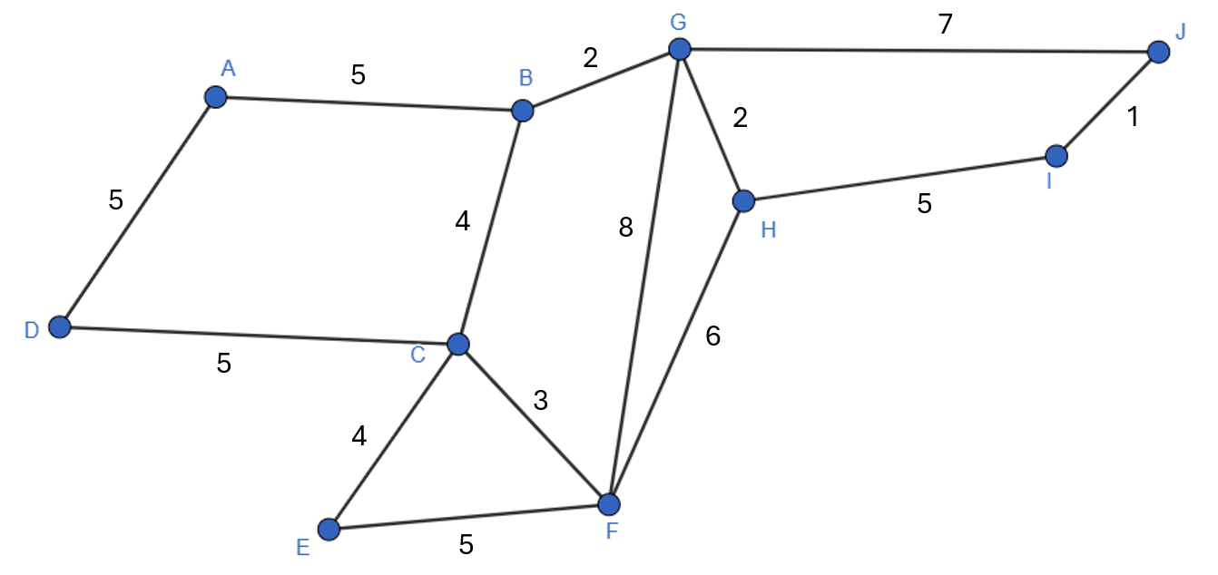
- Draw a minimum spanning tree for this network diagram and determine its weight.
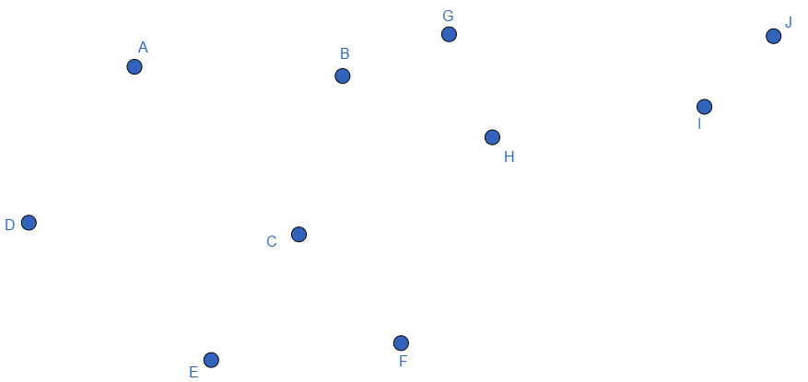
- Is it possible to find another minimum spanning tree for this network diagram with the same weight? Give a reason for your answer.

Question 5
This network diagram represents the walking tracks in a national park connecting the points as shown. The number on the edge represents the time, in minutes, that a runner takes to run along each track.
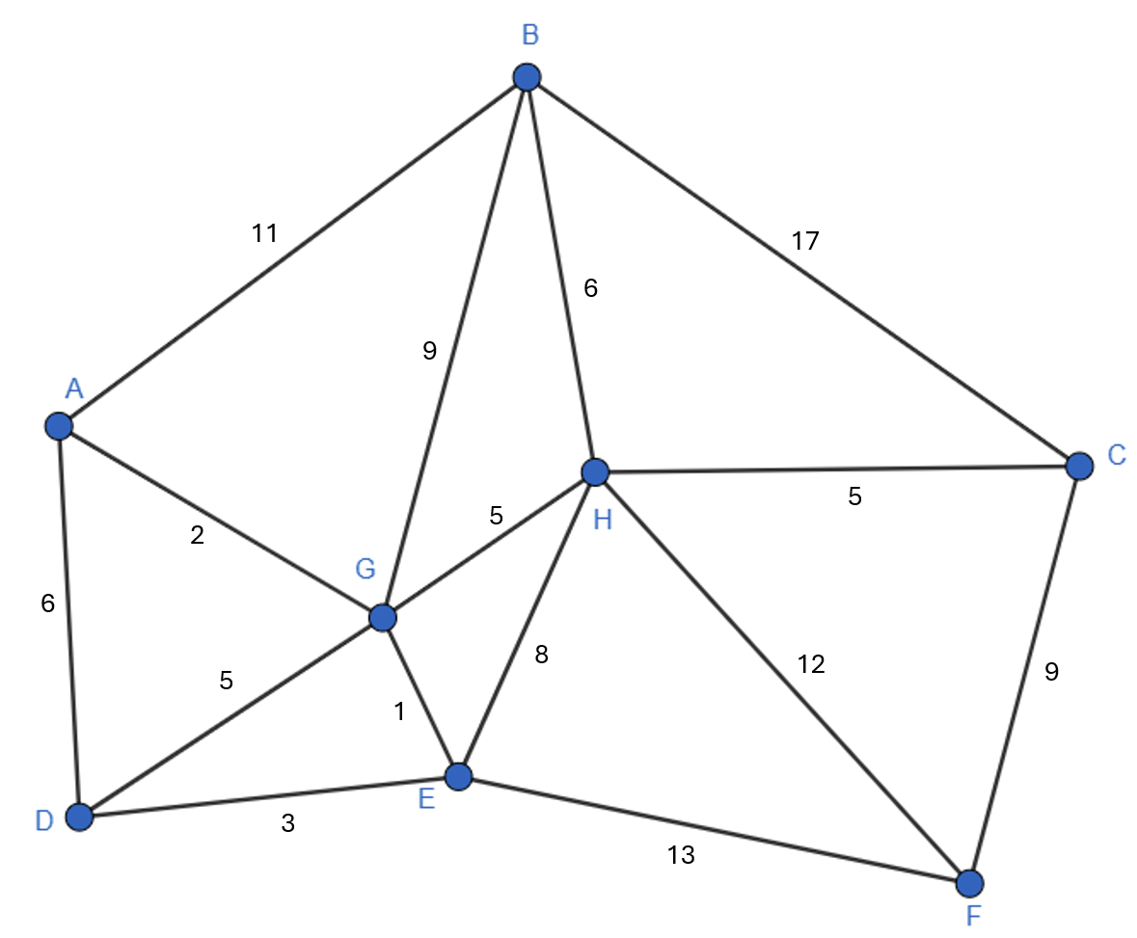
- Which path could a runner take to run from point C to point D in the quickest time?
- Below is a spanning tree of the network shown in the previous diagram. Is it a minimum spanning tree? Give a reason for your answer.
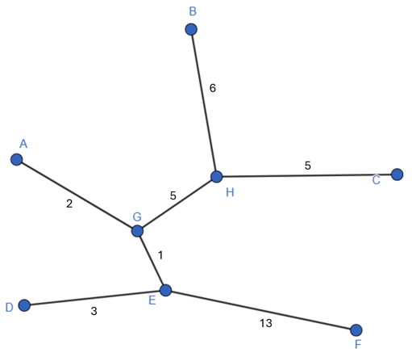

Sample solutions

Connecting learning – Italy
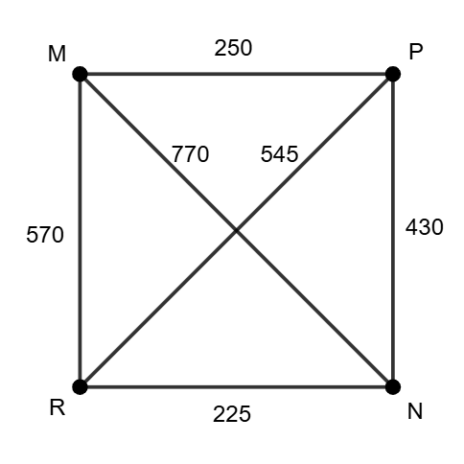
 |  | 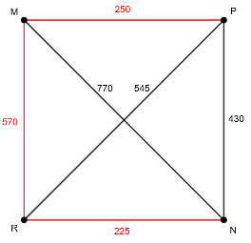 | 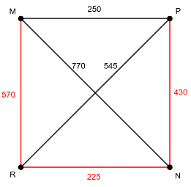  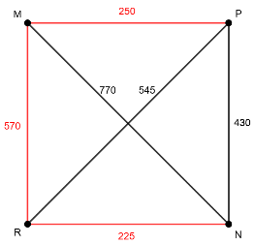  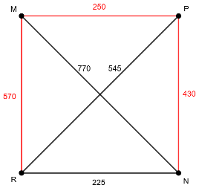
1250 km | 605 km | 1045 km | 1225 km
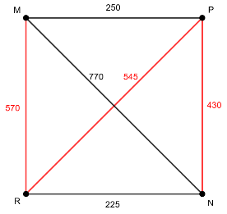 | 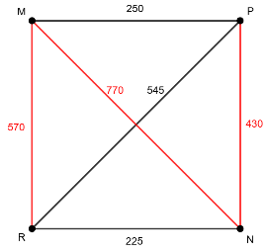 | 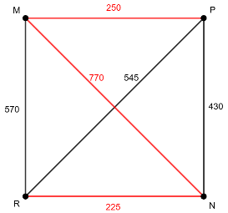 | 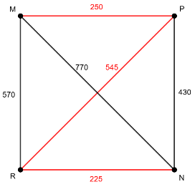
1545 km | 1770 km | 1245 km | 1020 km
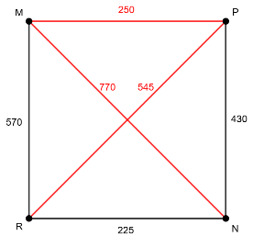 | 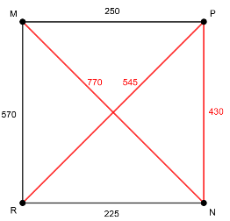 | 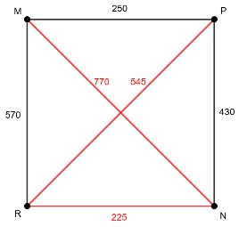 | 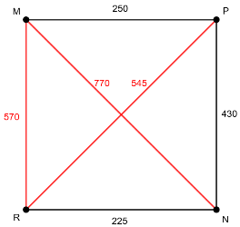
1565 km | 1745 km | 1540 km | 1885 km

Appendix A – muddy Milan
This is one solution from Muddy Milan. An alternate solution is using F–A instead of C–A.
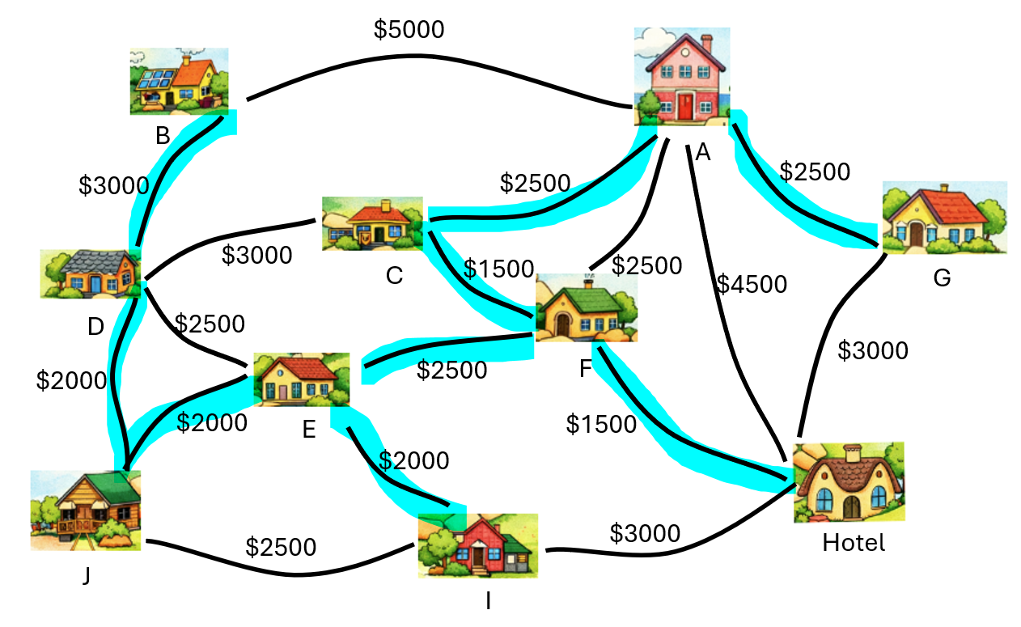

Appendix B – sorting activity
Identify each of the following scenarios as an example of a path, tree, spanning tree, minimum spanning tree or as being none of these. Justify your answers.
- A delivery driver plans a route visiting five houses in a straight sequence without revisiting any house. (Path – no repeated vertices.)
- A set of hiking trails connects several campsites. You can walk between any 2 campsites, and there are no circular walking loops. (Tree – connected but doesn’t say ALL campsites.)
- A school wants to install cables so that every classroom is connected. (Spanning tree – connects all vertices.)
- A council wants to connect towns with roads at the lowest possible total cost, ensuring all towns are connected and no unnecessary roads are built. (Minimum spanning tree – connects all vertices for minimum cost.)
- A tourist walks from one landmark to another, sometimes revisiting places along the way. (Not a path or a tree – vertices are revisited.)
- A network connects six computers, but one computer is not connected to the others. (Not a tree – one computer is not connected. The computers that are connected could be their own tree.)
- A rail network connects all stations with no loops, but there are multiple branching lines. (Spanning tree – includes all stations.)
- A student traces a route through a maze from entrance to exit without revisiting any junction. (Path – no repeated vertices or junctions.)
- An electrician connects all houses in a street using the least amount of wiring possible, ensuring every house has power. (Minimum spanning tree – connects all houses with minimum wiring.)
- A farmer needs to connect all water tanks on the property using pipes. There are several possible ways to connect them without loops, but the farmer chooses the layout that uses the least total length of pipe. (Minimum spanning tree – connects all water tanks with minimum amount of piping.)

Appendix D – minimum spanning trees
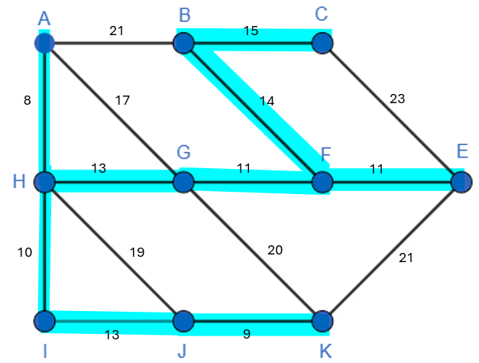 | 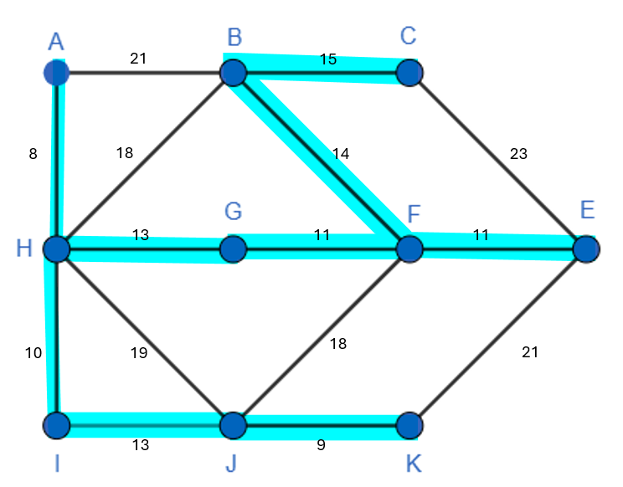
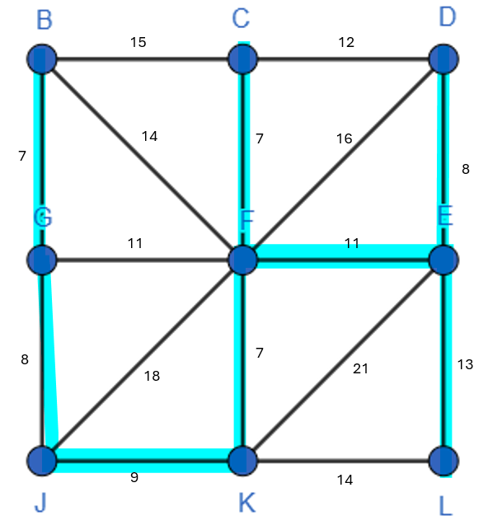 | 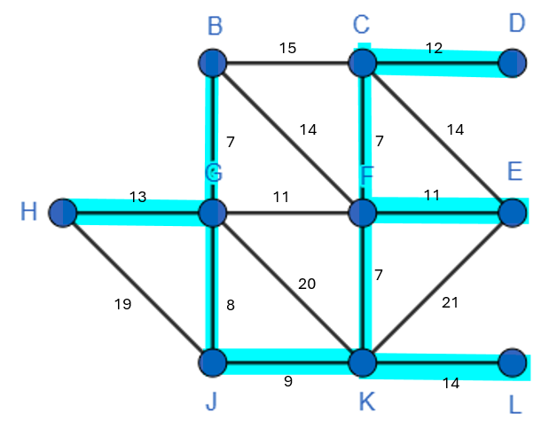
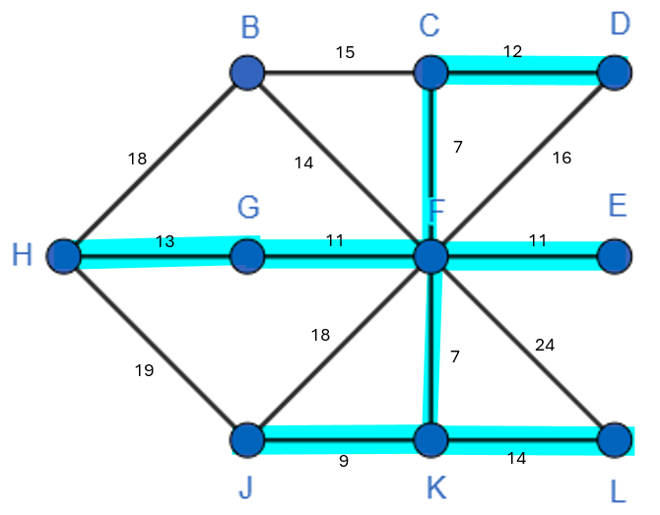 | 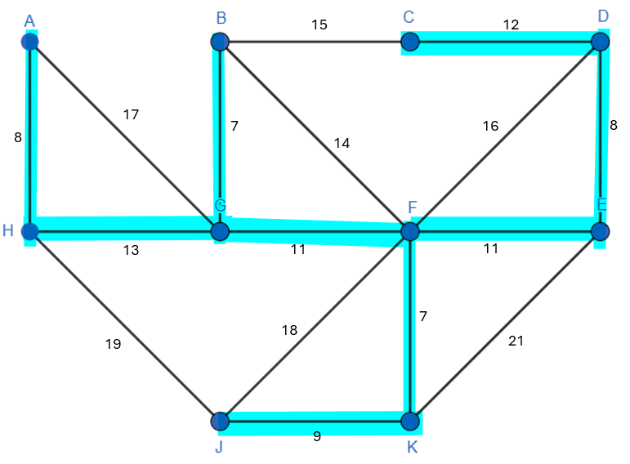

Appendix E – glossary of terms and conditions
Term | Picture | Definition | Notes
Path | 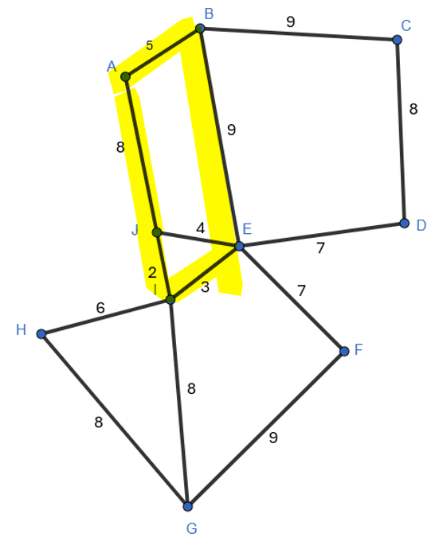 | It is a route through a network diagram in which all the edges and all the vertices are different. | A path is a route from one vertex to another.
Tree | 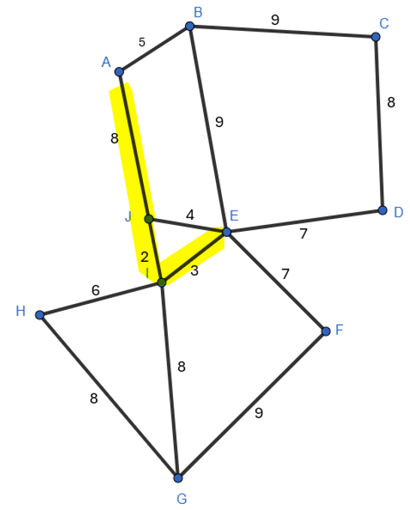 | A tree is an undirected network in which any 2 vertices are connected by exactly one path. | A tree has connected vertices but, doesn’t need all vertices connected.
Spanning tree | 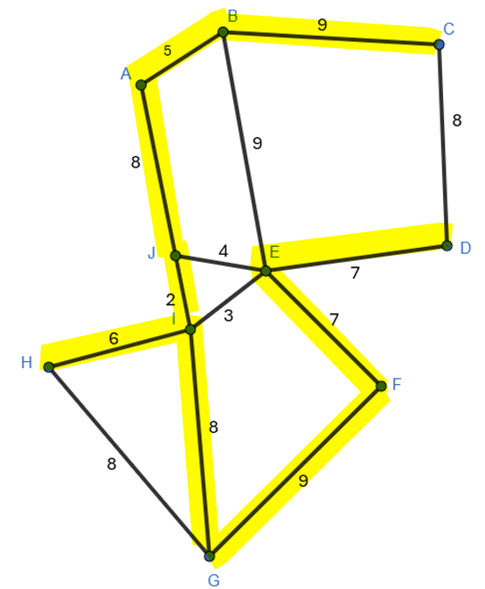 | A spanning tree of an undirected network diagram is a tree that includes all the vertices of the original network connected, but not necessarily all the edges of the original network diagram. A network can have many different spanning trees. | A spanning tree connects all vertices once. There are lots of spanning trees in a network
Minimum spanning tree | 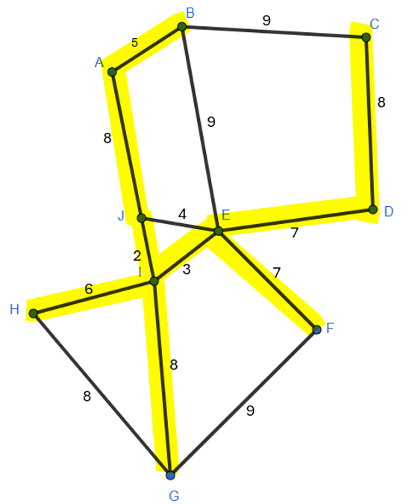 | A tree of minimum length in a connected, undirected network. It connects all the vertices together with the minimum total weighting for the edges. | A minimum spanning tree connects all vertices by the smallest edges. Can use Prim’s, Kruskal’s or logic to choose the smallest edges.
Shortest path |  | To be completed in Lesson 5

Appendix F – HSC-style questions
Question 1

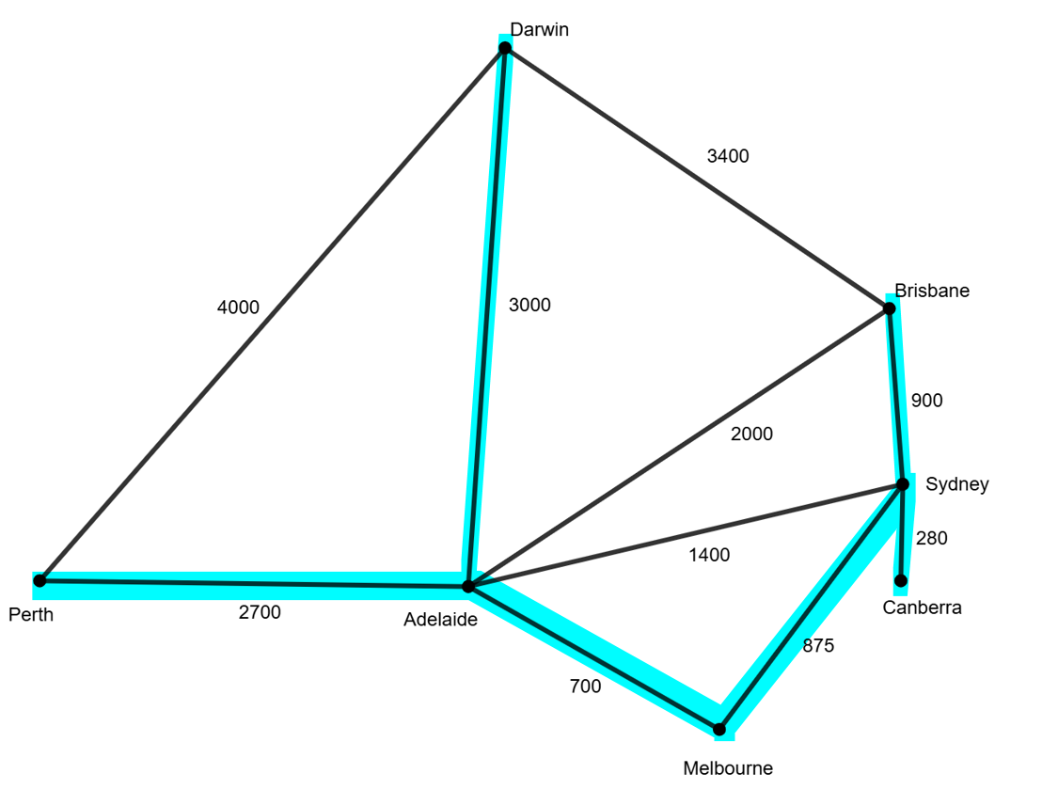
Length of minimum spanning tree is $2700+3000+700+875+280+900=8455$km
Question 2

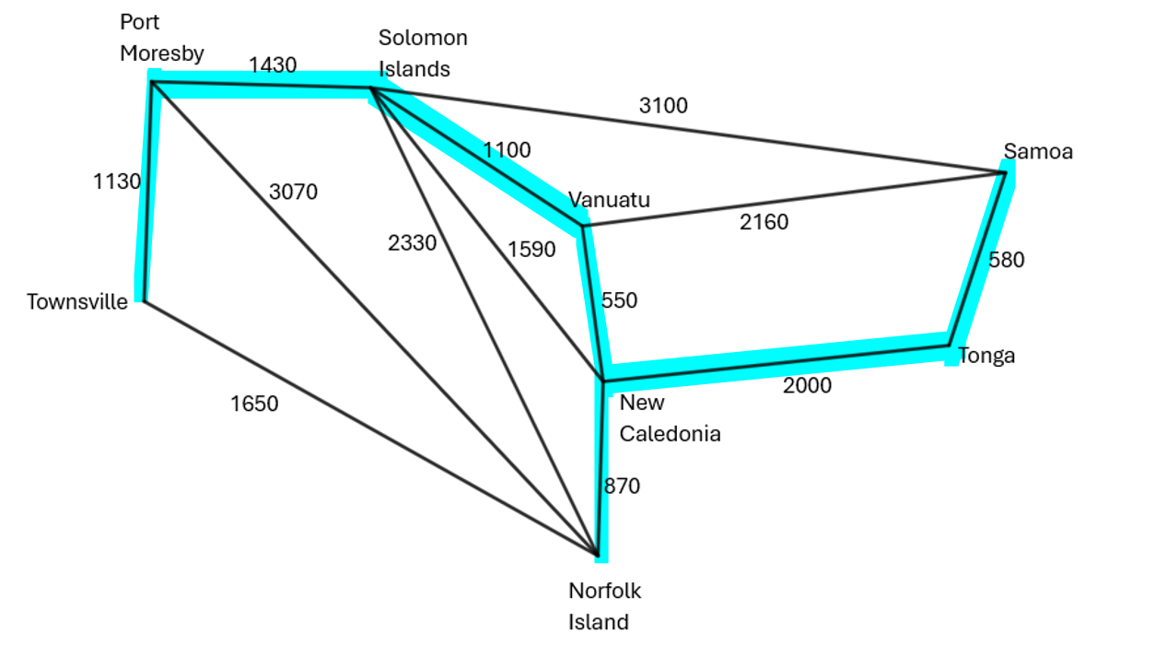

Minimum cost is $1130+1430+1100+550+870+2000+580=\$7660$

Question 3

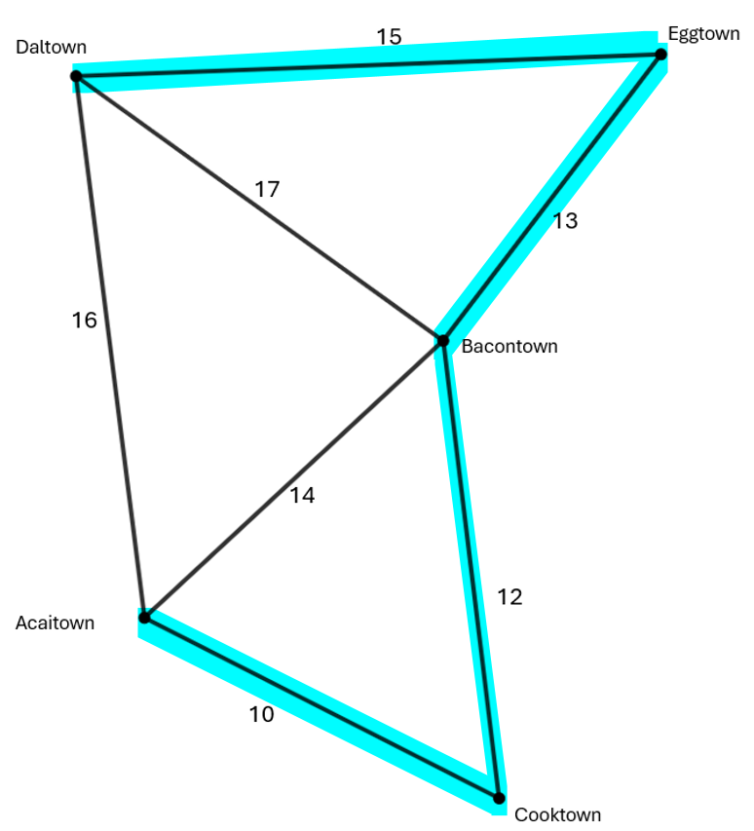
Length of minimum spanning tree = 50 minutes

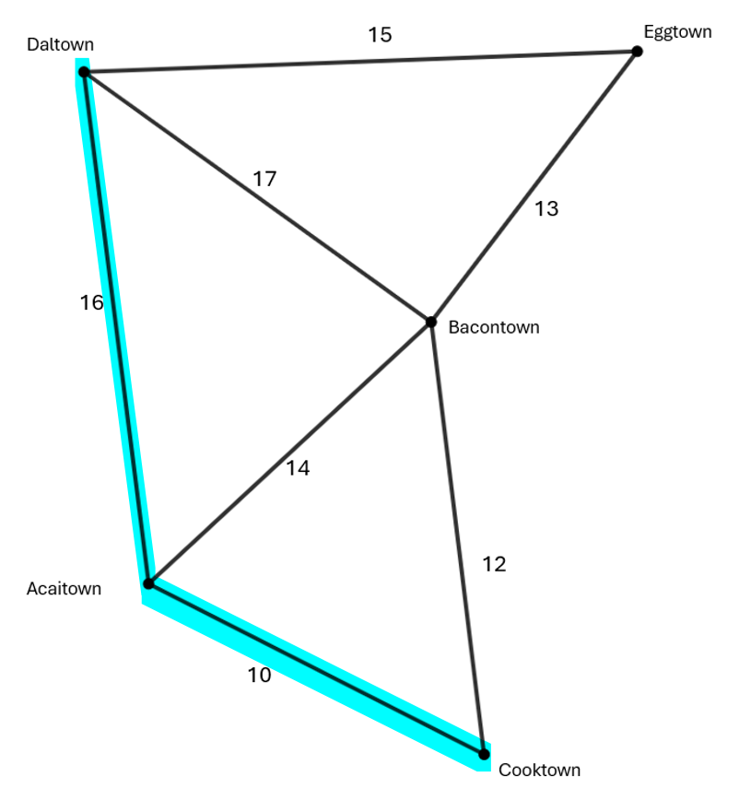
No the fastest route is not part of the minimum spanning tree.

Question 4
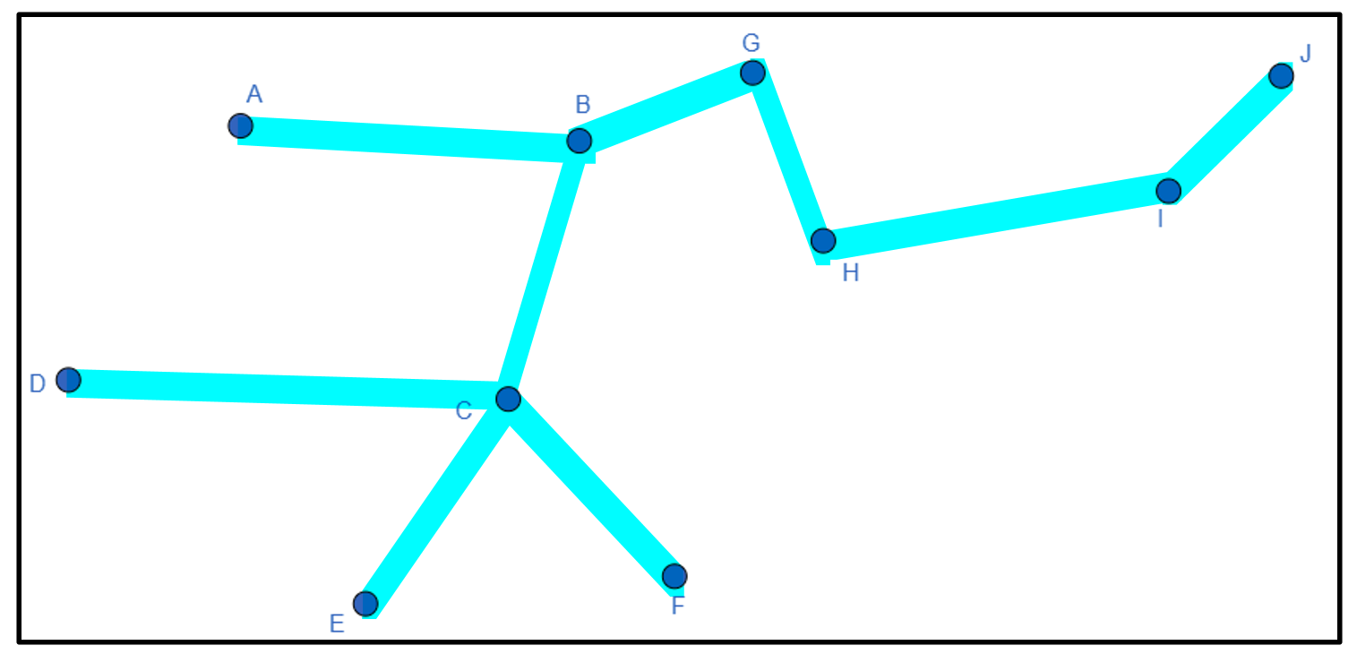
- Length of minimum spanning tree $=$ $31 000.
- Yes, A and D need to be connected to the tree but all 3 lines A–B, A–D, C–D are the same length. Any 2 of the lines create a correct solution.
Question 5
- C–H–G–D
- No, this is not a minimum spanning tree. The reason is that C–F should connect F to the network instead of E–F.

References
This resource contains NSW Curriculum and syllabus content. The NSW Curriculum is developed by the NSW Education Standards Authority (NESA). This content is prepared by NESA for and on behalf of the Crown in right of the State of New South Wales. The material is protected by Crown copyright.
Please refer to the NESA Copyright Disclaimer for more information https://www.nsw.gov.au/education-and-training/nesa/copyright.
NESA holds the only official and up-to-date versions of the NSW Curriculum and syllabus documents. Please visit NESA https://www.nsw.gov.au/education-and-training/nesa and NSW Curriculum https://curriculum.nsw.edu.au.
Mathematics Standard 11–12 Syllabus © NSW Education Standards Authority (NESA) for and on behalf of the Crown in right of the State of New South Wales, 2024.
Numeracy Stage 6 (CEC) Syllabus © NSW Education Standards Authority (NESA) for and on behalf of the Crown in right of the State of New South Wales, 2021.

© State of New South Wales (Department of Education), 2026
The copyright material published in this resource is subject to the Copyright Act 1968 (Cth) and is owned by the NSW Department of Education or, where indicated, by a party other than the NSW Department of Education (third-party material).
Copyright material available in this resource and owned by the NSW Department of Education is licensed under a Creative Commons Attribution 4.0 International (CC BY 4.0) license.

This license allows you to share and adapt the material for any purpose, even commercially. Attribution should be given to © State of New South Wales (Department of Education), 2026.
Material in this resource not available under a Creative Commons license:
- the NSW Department of Education logo, other logos and trademark-protected material
- material owned by a third party that has been reproduced with permission. You will need to obtain permission from the third party to reuse its material.
Links to third-party material and websites
Please note that the provided (reading/viewing material/list/links/texts) are a suggestion only and implies no endorsement, by the New South Wales Department of Education, of any author, publisher, or book title. School principals and teachers are best placed to assess the suitability of resources that would complement the curriculum and reflect the needs and interests of their students.
If you use the links provided in this document to access a third-party's website, you acknowledge that the terms of use, including licence terms set out on the third-party's website apply to the use which may be made of the materials on that third-party website or where permitted by the Copyright Act 1968 (Cth). The department accepts no responsibility for content on third-party websites.

