Constructing networks from a map
Students learn to construct network diagrams to represent information from a map and compare networks to determine if they represent the same information. Students solve problems using information presented in a map or network.

Learning intentions
- To understand how networks are used to model real-world situations.
- To be able to use information from a map to construct a network diagram.

Success criteria
- I can compare 2 networks and explain whether they represent the same information.
- I can construct a weighted network diagram from a map.
- I can construct a directed network diagram from a map.
- I can analyse a network diagram to solve problems.

Outcomes
A student:
- develops understanding and fluency in mathematics through exploring and connecting mathematical concepts, choosing and applying mathematical techniques to solve problems, and communicating their thinking and reasoning coherently and clearly MAO-WM-01
- solves problems involving time and location in practical contexts MST-11-06
- applies network techniques to solve network problems MST-11-07
Mathematics Standard 11–12 Syllabus © NSW Education Standards Authority (NESA) for and on behalf of the Crown in right of the State of New South Wales, 2024.

Associated numeracy outcomes
A student:
- applies numerical reasoning and mathematical thinking to clarify, efficiently solve and communicate solutions to problems N6-1.2
- chooses and applies efficient strategies to analyse and solve everyday problems involving metric relationships, distance and length, area, volume, time, mass, capacity, and temperature N6-2.2
- chooses and applies efficient strategies to analyse and solve everyday problems involving location, space, and design N6-2.5
Numeracy Stage 6 (CEC) Syllabus © NSW Education Standards Authority (NESA) for and on behalf of the Crown in right of the State of New South Wales, 2021.

Content

Networks, paths, and trees
Network concepts
- Examine circumstances in which networks are used in a variety of real-world applications
- Construct a network diagram to represent information from a given table or map, showing weighted and directed edges
- Solve problems involving network diagrams in a variety of practical contexts
Mathematics Standard 11–12 Syllabus © NSW Education Standards Authority (NESA) for and on behalf of the Crown in right of the State of New South Wales, 2024.
Table 1: lesson summary
Section | Summary of activity | Teaching strategies | Teaching points
Activating prior knowledge | Students create a class network based on desired travel destinations, using sticky notes to represent vertices and connections to represent edges. They explore how networks can be redrawn without changing the information they represent and discuss how to determine whether 2 networks are equivalent. | Class discussion | Constructing a network from familiar, personal data helps students internalise core terminology and consider network equivalence. Students can then apply terminology to maps and diagrams in more abstract contexts.
Connecting learning | Students interpret a theme park map in Appendix A and slide 4 of the PowerPoint to create multiple network diagrams. They compare the groups’ representations, analyse features and justify their reasoning through discussion and questioning. | Visibly random groups of 3  Vertical non‑permanent surfaces  Notice and Wonder  Gallery walk  Pose-Pause-Pounce-Bounce | Constructing and comparing networks from a shared map builds deep understanding of structure, equivalence, and representation.
Releasing responsibility | Slide 6 and Appendix B show 4 networks and students determine the one network which is different. Students compare a map and a network using slide 7, to analyse the error in the network. Students create a series of networks to consider the minimum number of edges required for a connected network. Slide 8 shows a map of NSW and students create the network and complete problem-solving questions using Appendix C to apply their understanding of vertices, edges, direction and weight. Students create notes on how to create a network from a map. | Turn and talk  Visibly random groups of 3  Vertical non‑permanent surfaces  Incorrect worked example  Gallery walk  Notes to future forgetful selves | Comparing, correcting, and constructing networks builds students’ confidence in recognising structure, applying terminology, and transferring learning to real-world contexts.
Independent practice | Students use slide 10 to guide their approach to HSC-style questions in Appendix D, working in pairs to apply network concepts such as vertices, edges and degree. They compare solutions with peers and refine their notes to consolidate understanding. | Approaching questions scaffold  Peer feedback | Students use a structured approach to unpacking what the question is asking. They build the procedural fluency, metacognition and exam literacy needed for success in senior mathematics.

Activity structure
Please use the associated PowerPoint Constructing networks from a map to display images in this lesson.

Activating prior knowledge
- Hand out one sticky note to each student.
- Ask students to write their name on the top of the sticky note and 5 destinations they would love to visit if money was no barrier.
- Select one student to put their sticky note on the board and read out their 5 destinations.
- From the remaining students, select a student who has a location in common with the first student to place their sticky note on the board and draw a line joining the 2.
- Continue adding sticky notes and joining students who share a location in common until a network is developed. If new matching destinations are added that match existing sticky notes, lines can be drawn to increase the complexity of the network.
- Conduct a class discussion to draw out students’ understanding of vertices, edges and the degree of a vertex. Suggested prompts include:
- What do the edges represent in this network?
- What does each vertex represent in this network?
- How many students share a destination in common with the first student? What helps us to find this quickly?
Vertices represent each student and their destinations. Edges are used to show connections between students who have a destination in common. The number of edges or destinations connecting to the first student is the degree of the vertex. This activity shows students in the class who wish to visit the same destinations.
- Move one of the sticky notes to a different position on the board and redraw the edges.
- Continue the discussion using the following prompts.
- How does the network change if a vertex is moved to a different position?
- How could we tell if 2 networks represent the same or different information?

Connecting learning
- Display slide 4 of the PowerPoint, which displays the theme park in Appendix A ‘Theme park’ and have students discuss what they notice and wonder (bit.ly/noticewonderstrategy) about the map.
Students may notice that there are no measurements on the map and wonder if the map is to scale.
- Assign students to visibly random groups of 3 (bit.ly/visiblegroups) at vertical non-permanent surfaces (bit.ly/VNPSstrategy).
- Distribute Appendix A and ask groups to discuss what features of the map are important before creating 3 visually different network diagrams representing the theme park on their vertical non-permanent surfaces.
- Have students conduct a gallery walk (bit.ly/DLSgallerywalk) to view and compare the different network diagrams, analysing if they represent the same information.
- Whilst students are at vertical non-permanent surfaces use the Pose-Pause-Pounce-Bounce questioning strategy (PDF 557 KB) (bit.ly/posepausepouncebounce), to ask students about features of their networks.
- Are your diagrams to scale?
- What were the multiple routes from the paddle boats to the gift shop?
- Which locations can be travelled to from the gift shop?
- How could we represent the route followed at the haunted house?
- How could you represent, on a network diagram, the route of a person who revisited an attraction?
The Haunted house route has direction; therefore, it is a directed edge which is indicated by an arrow. Directed and weighted edges were defined in Lesson 1 – introduction to networks.
A loop can represent revisiting an attraction.
- Select 2 of the correct but visually differently networks from the groups. Continue the discussion by asking students how they know both are correct. What features make them correct?

Releasing responsibility
- Hand out Appendix B to each group and display slide 6. Using a turn and talk (bit.ly/classroomtalkmoves) in their groups of 3, ask students to determine which network is different.
Encourage the use of a highlighter to help determine which connections in the network are the same.
- In a class discussion, use prompts such as:
- How can you determine whether 2 networks represent the same information?
- Why does the network in the top right differ from the others?
Networks are the same if they have the same number of vertices and the edges have the same connections.
The top right image differs as it has an additional edge from C to E.
- Display slide 7 which shows a map with the correct connections and a network with some incorrect connections.
- In their groups, have students discuss how the networks differ.
- In a class discussion, ask students to share the errors they found and how the network could be corrected.
Students should be considering the number of vertices, the connections and the degree of each vertex.
There are extra edges between Dublin and Manchester and between London and Glasgow.
There is a missing edge between Glasgow and Edinburgh.
Drawing straight lines is not an error.
- Continuing in their groups of 3 at the vertical non-permanent surfaces, have students draw the following network diagrams and discuss with a neighbouring group similarities and differences.
- 5 vertices and 5 edges
- 5 vertices and 4 edges
- 5 vertices and 3 edges
- 6 vertices and 7 edges
- Use the following prompts in a Pose-Pause-Pounce-Bounce to deepen their understanding of connected network diagrams and edges.
- What is special about the network with 5 vertices and 3 edges?
- What is the minimum number of edges in a network diagram with 6 vertices, for all vertices to be connected?
- What do you notice about the vertex with the highest degree in the connected network diagrams you have drawn?
- Predict the minimum number of edges needed to connect a network diagram with 9 vertices.
- Display slide 8 which shows a map of NSW.
- Continuing in their groups of 3, have students draw a network to represent the various ways to travel between Yass and Tamworth.
- Have students conduct a gallery walk to view and compare the similarities and differences in network diagrams, analysing if they represent the same information.
- Distribute Appendix C ‘Yass to Tamworth’ to pairs of students. The appendix shows a map of NSW from Yass to Tamworth with the travel time on the edges. Ask students to answer the questions in the appendix.
- Students are to create notes to their future forgetful selves (bit.ly/notestofutureself) on how to construct a network from a map.
Notes should include the number of vertices, checking the edges are connecting the same vertices, and checking for any missing or extra edges.

Independent practice
- Display slide 10 to remind students how to use the Approaching questions scaffold.
- Distribute Appendix D ‘HSC-style questions’ to pairs of students for them to complete.
Teachers may wish to stop students to discuss the strategies they used to identify the vertices and degree of edges in Question 2.
- Have students compare their solutions with another pair.
- Students should make refinements to their notes if necessary.

Assessment and differentiation

Suggested opportunities for differentiation
Activating prior knowledge
- Depending on the size of your class, you could use a demonstration with up to 10 students while the other students draw the network.
- You may wish to adapt which 5 items are placed on the sticky notes.
- This task could be conducted outside, where students and their sticky notes represent the vertices, and chalk or string is used to represent the edges between students with the same places.
- For larger classes, this activity could be conducted in groups of 5 or 6.
- This task could be displayed in a digital tool to show that the network remains the same when vertices are moved.
Connecting learning
- Teachers could prompt students to consider what on the map would represent vertices and what would represent edges prior to students creating their network
- Support students by supplying a partially completed network or place the vertices as a starting point.
- To challenge students, introduce an extra ride for the theme park with additional edges.
Releasing responsibility
- To support students, you may wish to remove one of the correct options from slide 6.
- Students could create their own isomorphic diagrams as a challenge.
- Support students by supplying them with a partial network with the vertices labelled.
- To challenge students, make additional edges to join other smaller towns like Lithgow or Boorowa to the network.
Independent practice
- Support students by scaffolding questions with partial solutions.
- Have students work independently.

Suggested opportunities for assessment
Activating prior knowledge
- Observe student responses during the sticky note activity to assess their ability to identify vertices and edges and recognise connections between locations.
Connecting learning
- Observe student network diagrams on the vertical non-permanent surfaces to assess accuracy in constructing networks from real‑world data and correct interpretation of the map
- Listen to student responses during the gallery walk as they explain and justify their network to assess reasoning, justification and ability to communicate how and why connections were made.
Releasing responsibility
- Observe and provide feedback on the language used when discussing and explaining the incorrect worked example.
- Collect Appendix B and C as evidence of learning to assess students’ ability to critique reasoning and independent application of solving problems.
Independent practice
- Collect Appendix D as evidence of learning to assess students’ ability to apply the Approaching Questions scaffold and solve network problems independently.
- Listen to students’ language when they are comparing solutions from Appendix D to assess their capacity to justify methods, compare strategies and articulate mathematical reasoning.

Appendix A

Theme park
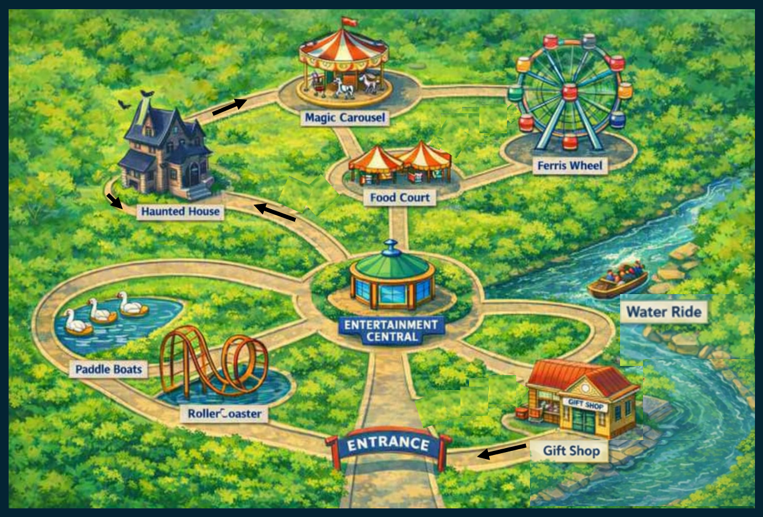

Appendix B

Which one is different?
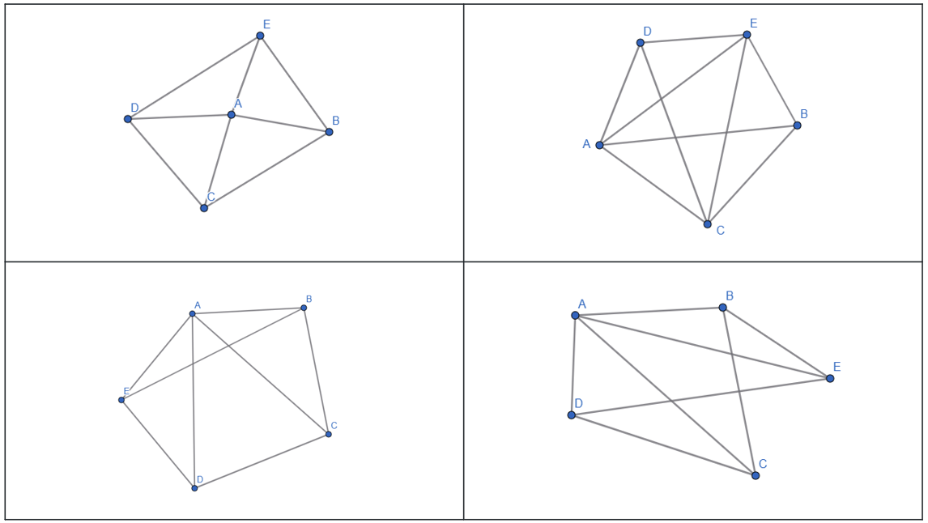

Appendix C

Yass to Tamworth
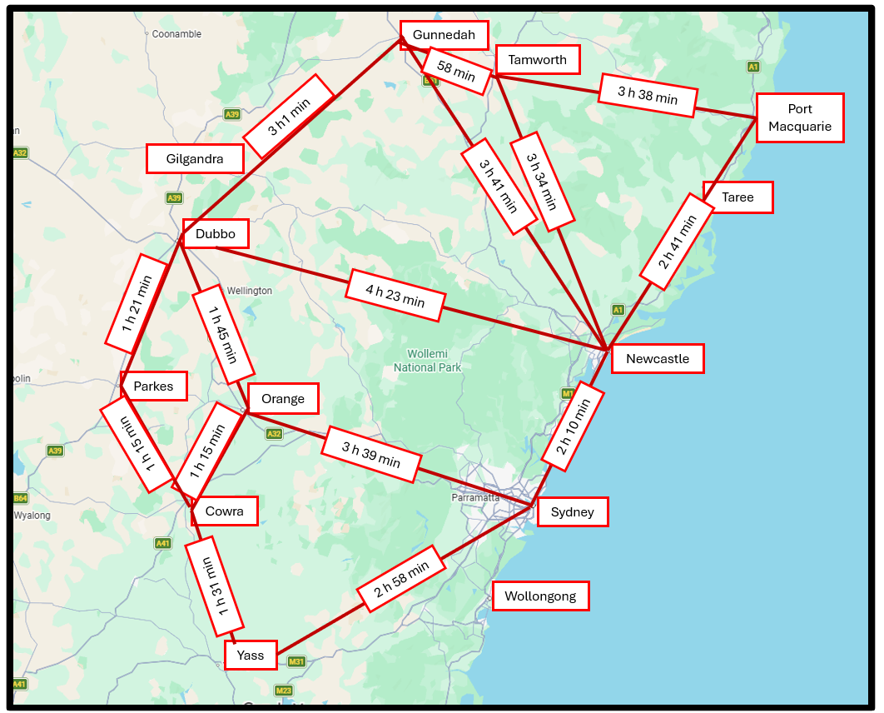
Source Google maps (March 2026): Map data © Google https://www.google.com/maps.
- Add weightings to your network diagram. What do they represent?
- Which 2 towns are 5 hours and 8 minutes apart?
- Which edge in this network would take the longest time? Why might knowing this be important?
- List all the different routes you could take from Yass to Tamworth.
- Highlight the route from Yass to Tamworth that you think might be quickest and calculate how long the trip would be.

Appendix D

HSC-style questions
Question 1
Two schools are competing in a lawn bowls competition. Each school has 3 players. Each player must play all 3 players from the other school once.
Draw a network diagram to represent the games played.
Question 2
The map shows the borders of the states of Australia.
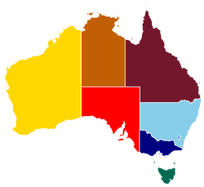
‘Australia States Map - Colours with White Borders’ by DavidEye is licensed under CC-BY-SA-4.0.
In the network diagram below, the vertices represent the states and the borders between states are represented as edges.
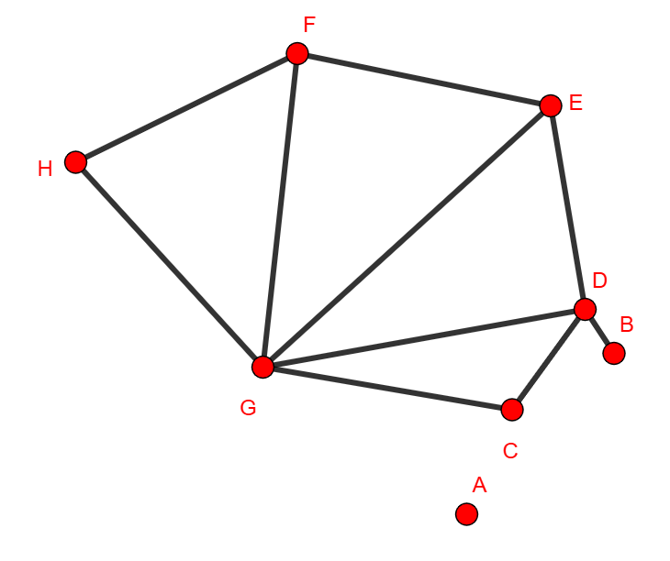
- Which letter represents the vertex of Adelaide?
- What is the degree of the vertex for Queensland?
Question 3
The holiday park at Ranville is divided into camping areas labelled A to E on the map below. A lake which is situated in the holiday park is shaded on the map.
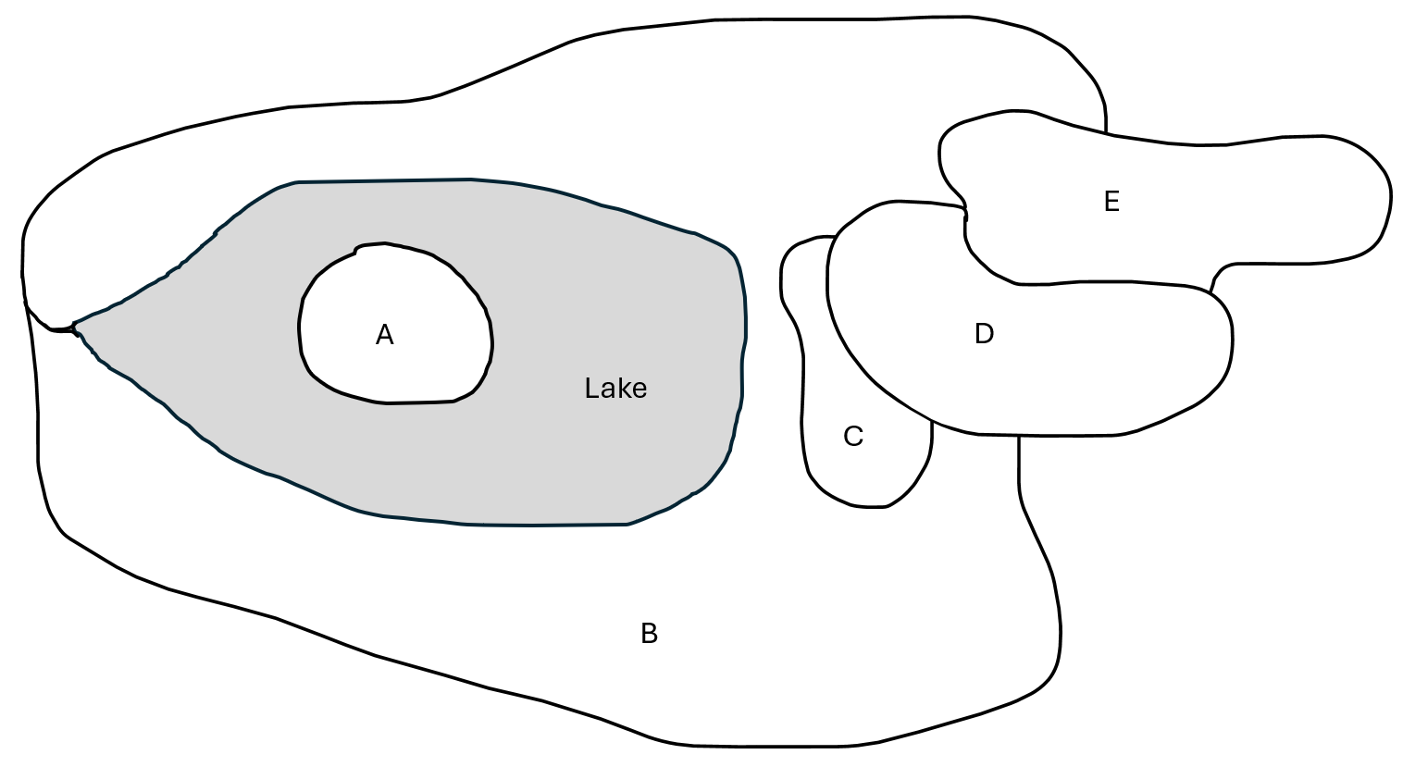
A network diagram is created that lists the number of borders between each area. It has been started but is not finished.
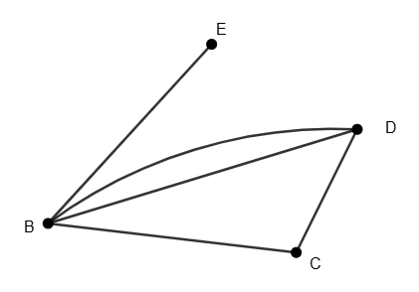
- Draw the missing items onto the network.
- Explain why the degree of A is zero.

Question 4
A national park provides a network diagram on top of their mud map of their walking trails and zip line. Place the following information on the network diagram as follows:
- Visitor centre (V) to Campsite (C) is 20 minutes.
- Visitor centre to Lookout (L) is 30 minutes.
- Visitor centre to Waterfall (W) is 50 minutes.
- Lookout to Waterfall is 10 minutes.
- Waterfall has a zip line which only travels one way to the campsite in 5 minutes.
- Campsite to the Swimming hole (S) is 15 minutes.
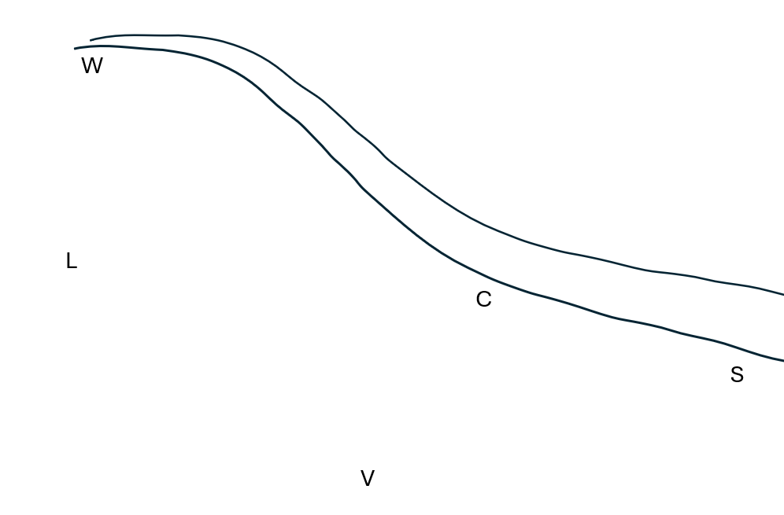

Sample solutions

Appendix A – theme park
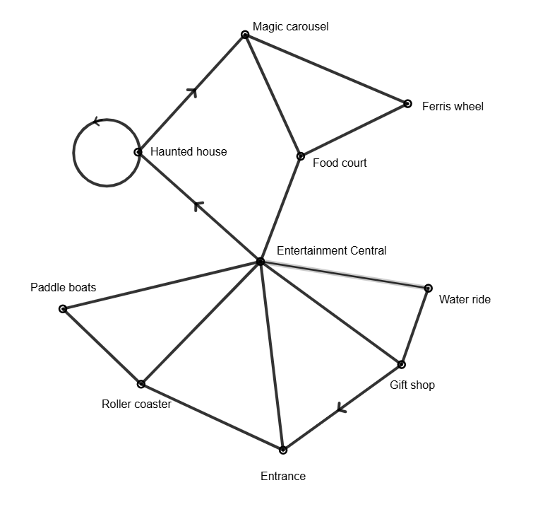

Appendix C – Yass to Tamworth
- See network diagram. The edges represent the time it takes between towns (vertices).
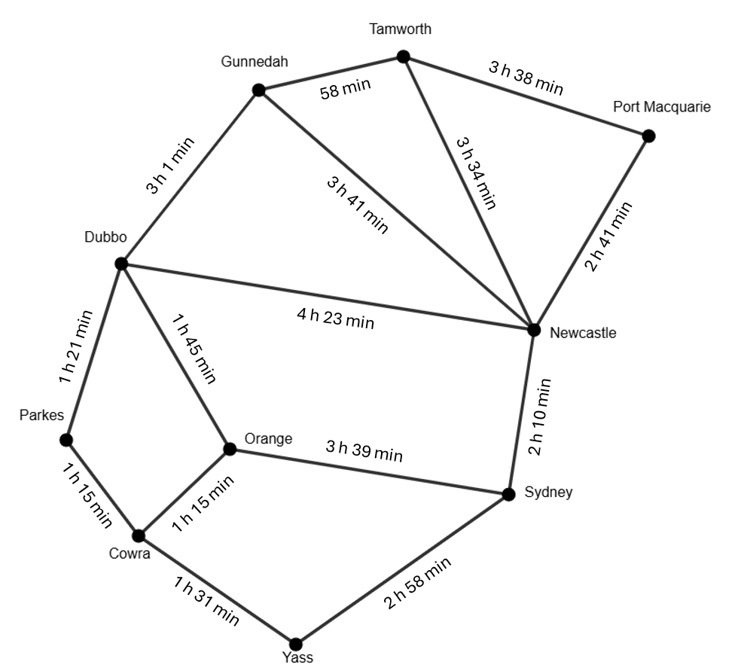
- Yass → Newcastle $=$5 hours 8 minutes.
- Dubbo → Newcastle $=$ 4 hours 23 minutes. It is important to have enough fuel to make it between towns and to have adequate rest breaks.
- Listed here are some solutions.
- Yass → Sydney → Newcastle → Tamworth
- Yass → Sydney → Newcastle → Port Macquarie → Tamworth
- Yass → Sydney → Orange → Dubbo → Tamworth
- Yass → Cowra → Orange → Dubbo → Tamworth
- Yass → Cowra → Parkes → Dubbo → Tamworth
- Yass → Sydney → Newcastle → Gunnedah → Tamworth
- Yass → Cowra → Parkes → Dubbo → Tamworth.
- Yass → Cowra → Parkes → Dubbo → Tamworth. Time: 7 hours 8 minutes

Appendix D – HSC-style questions
Question 1
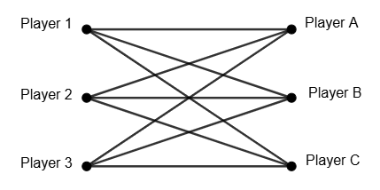
Question 2
- G
- 3
Question 3

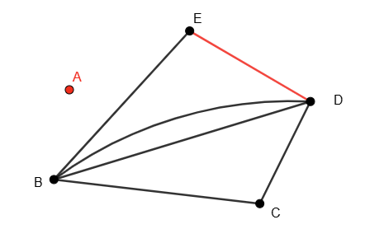
- The degree of A is zero as there are no camping areas that border A.
Question 4
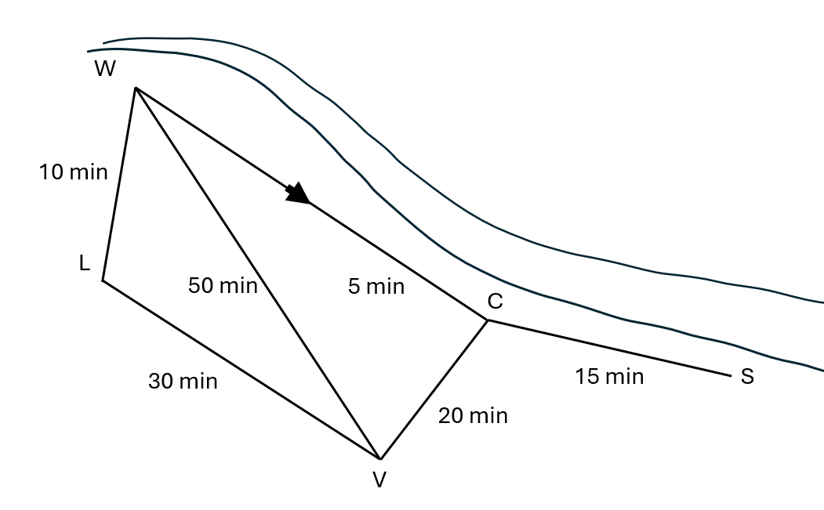

References
This resource contains NSW Curriculum and syllabus content. The NSW Curriculum is developed by the NSW Education Standards Authority (NESA). This content is prepared by NESA for and on behalf of the Crown in right of the State of New South Wales. The material is protected by Crown copyright.
Please refer to the NESA Copyright Disclaimer for more information https://www.nsw.gov.au/education-and-training/nesa/copyright.
NESA holds the only official and up-to-date versions of the NSW Curriculum and syllabus documents. Please visit NESA https://www.nsw.gov.au/education-and-training/nesa and NSW Curriculum https://curriculum.nsw.edu.au.
Mathematics Standard 11–12 Syllabus © NSW Education Standards Authority (NESA) for and on behalf of the Crown in right of the State of New South Wales, 2024.
Numeracy Stage 6 (CEC) Syllabus © NSW Education Standards Authority (NESA) for and on behalf of the Crown in right of the State of New South Wales, 2021.

© State of New South Wales (Department of Education), 2026
The copyright material published in this resource is subject to the Copyright Act 1968 (Cth) and is owned by the NSW Department of Education or, where indicated, by a party other than the NSW Department of Education (third-party material).
Copyright material available in this resource and owned by the NSW Department of Education is licensed under a Creative Commons Attribution 4.0 International (CC BY 4.0) license.

This license allows you to share and adapt the material for any purpose, even commercially. Attribution should be given to © State of New South Wales (Department of Education), 2026.
Material in this resource not available under a Creative Commons license:
- the NSW Department of Education logo, other logos and trademark-protected material
- material owned by a third party that has been reproduced with permission. You will need to obtain permission from the third party to reuse its material.
Links to third-party material and websites
Please note that the provided (reading/viewing material/list/links/texts) are a suggestion only and implies no endorsement, by the New South Wales Department of Education, of any author, publisher, or book title. School principals and teachers are best placed to assess the suitability of resources that would complement the curriculum and reflect the needs and interests of their students.
If you use the links provided in this document to access a third-party's website, you acknowledge that the terms of use, including licence terms set out on the third-party's website apply to the use which may be made of the materials on that third-party website or where permitted by the Copyright Act 1968 (Cth). The department accepts no responsibility for content on third-party websites.

