Grouped data
This lesson develops students’ understanding of how and why datasets are grouped. Students explore the process of organising large datasets into grouped frequency tables, calculating class centres and summary statistics and using spreadsheets to display and analyse the data. They interpret histograms and cumulative frequency graphs to estimate measures such as the median and apply these skills to compare road-safety data and justify real-world decisions.
Students will need at least one digital device per pair to interact with the Grouped data spreadsheet during this lesson. This spreadsheet is protected with password: Mathematics

Learning intentions
- To understand how grouped data can be used to organise, summarise and describe large datasets.
- To be able to interpret and compare statistical information to make and justify decisions.

Success criteria
- I can complete grouped data frequency tables with and without using digital tools.
- I can use a spreadsheet to calculate measures of centre and spread for large datasets.
- I can interpret cumulative frequency histograms and polygons and use these displays to estimate the median.

Outcomes
A student:
- develops understanding and fluency in mathematics through exploring and connecting mathematical concepts, choosing and applying mathematical techniques to solve problems, and communicating their thinking and reasoning coherently and clearly MAO-WM-01
- displays and analyses datasets using summary statistics and graphical representations
MST-11-08
Mathematics Standard 11–12 Syllabus © NSW Education Standards Authority (NESA) for and on behalf of the Crown in right of the State of New South Wales, 2024.

Associated numeracy outcomes
A student:
- recognises and applies functional numeracy concepts in practical situations, including personal and community, workplace and employment, and education and training contexts N6-1.1
- chooses and applies efficient strategies to analyse and solve everyday problems involving data, graphs, tables, statistics and probability N6-2.3
- chooses and uses appropriate technology to analyse and solve problems, represent information and communicate solutions in a range of practical contexts N6-3.2
Numeracy Stage 6 (CEC) Syllabus © NSW Education Standards Authority (NESA) for and on behalf of the Crown in right of the State of New South Wales, 2021.

Content

Display and interpret grouped and ungrouped data
- Recognise and explain why some datasets need to be grouped to allow for appropriate representation and analysis
- Use a spreadsheet to organise and represent data using appropriate graphs
- Represent a numerical dataset as either a frequency distribution table or a cumulative frequency distribution table and graph the associated histogram with polygon, both with and without using digital tools

Measures of centre and spread
- Describe the mean, median and mode as measures of centre and calculate their values for a dataset in graphical form and tabular form, using a scientific calculator and other digital tools
- Use a spreadsheet to analyse data including calculating measures of centre and spread
Mathematics Standard 11–12 Syllabus © NSW Education Standards Authority (NESA) for and on behalf of the Crown in right of the State of New South Wales, 2024.

Table 1: lesson summary
Section | Summary of activity | Teaching strategies | Teaching points
Activating prior knowledge | Students participate in the ‘Find my friend’ activity (Appendix A) to revise finding the mean of 2 numbers. Using mini whiteboards, they calculate means for given pairs and discuss how this skill links to finding class centres later in the lesson.  Students then analyse the same dataset presented as raw data, an ungrouped frequency table and a grouped frequency table (slides 4–6 of the PowerPoint Grouped data). Through guided discussion, they compare the clarity of each representation and consider the advantages and limitations of grouping large datasets. | Mini whiteboards  Think-Pair-Share  Notice and wonder | This section builds on students’ existing understanding of the mean and prepares them for the concept of class centres. Students begin to recognise why large datasets are often grouped for clarity and that there is a trade-off between precision and ease of interpretation.
Connecting learning | Students learn how class centres and $fx$ values are calculated and apply this knowledge to a grouped frequency table (slides 8–10). They identify modal and median classes and recognise that the mean calculated from grouped data is an approximation. Students complete Appendix B to practise calculating measures of centre and spread for grouped data. Using real NSW traffic crash data (slide 11), they then explore how grouped data is applied in context. Using the spreadsheet, students calculate measures of centre and spread, organise data into a grouped frequency table, and generate histograms, observing how tables and graphs update dynamically. | Think-Pair-Share  Notice and wonder  Turn and talk  Mini whiteboards | The focus is on developing conceptual understanding of grouped data structures and how class centres, frequency, cumulative frequency and $fx$ are connected. Students build fluency while strengthening their understanding of why grouping is useful and how approximations arise when working with grouped data.
Releasing responsibility | Students compare the original website histogram with the histogram generated in the spreadsheet (slide 13), identifying similarities, differences and effectiveness. Attention then shifts to cumulative frequency histograms. Using guided questioning, students explain why cumulative frequency graphs always increase and how they can be used to estimate the median. The teacher models estimating the median using a cumulative frequency histogram and polygon (slide 14), before students independently practise estimating medians using Appendix D. | Mini whiteboards  Pose-Pause-Pounce-Bounce | Students are supported to connect cumulative frequency tables and graphs to summary statistics, particularly the median
Independent practice | Students use NSW data to complete a grouped frequency table, generating a cumulative frequency histogram. Students then use the table and graphs to find the statistics for NSW drivers. They then compare the NSW results to those for all of Australia and decide which age groups should be targeted in safe driving campaigns, justifying their recommendations using the statistics and graphs. |  | This activity provides opportunities for students to apply their understanding of grouped data, measures of centre and histograms in an authentic road safety context. Students use statistical reasoning, spreadsheet tools and graphical evidence to make and justify recommendations.

Activity structure
Please use the associated PowerPoint Grouped data to display images in this lesson.

Activating prior knowledge
- Inform the class that they will play a game called ‘Find my friend’. Students each take a card (from Appendix A ‘Find my friend’ Game 1) with a number between 1 and 100 written on it.
- Ask students to move around the room to find the classmate whose card pairs with theirs to create a mean of 50. The cards are pre-designed so that each number has a matching partner (for example the number in Box 1 pairs with the number in Box 2, and so on).
- Students take a new card (from Appendix A ‘Find my friend’ Game 2) and repeat the process from Game 1. This game they are looking for a pair to make a mean of 37.5.
- Students take a new card (from Appendix A ‘Find my friend’ Game 3) to try and create a mean as close to 50 as possible, the pair whose numbers have a mean closest to 50 will be declared the winner (note that the cards in Game 3 do not match to create a mean of 50).
- Students could use mini whiteboards (bit.ly/miniwhiteboards) to demonstrate their understanding. The teacher can call out various pairs of numbers and ask students to find the mean between them and have them display their responses on their whiteboards.
- Display slide 4 from the PowerPoint. Give students a moment to consider the provided information. Animate the slide and have students consider the self-explanation prompts in a Think-Pair-Share (bit.ly/thinkpairsharestrategy).
Students could note that the data would be easier to analyse if the scores were in ascending order. They may also note that placing the data into a frequency distribution table would be helpful, however it would create a very large table which may be difficult to read.
- Display slide 5 and give students a moment to consider the data provided.
- Animate and consider the self-explanation prompts on the slide using a Think-Pair-Share for students to discuss their ideas about whether a frequency table improves the clarity of the data and what further changes might make it easier to interpret.
- Display slide 6 and give students a moment to consider the data provided. Animate and consider the self-explanation prompts on the slide and ask students what they notice and wonder (bit.ly/noticewonderstrategy) about the same data being placed into a grouped frequency table.
Students might notice that the data is much easier to read as there is much less to look at. They may also notice that the number of cars have been grouped into even classes, but they also may wonder if the data is less exact and would create errors when finding statistics.
- Ask students to recall how they calculate the mean from a frequency table. In a Think-Pair-Share, have students discuss potential challenges when applying this strategy to the frequency table on slide 6.
Students created an $fx$ column in their frequency table in Lesson 5 – standard deviation, of this unit. Students should share that they wouldn’t know what to multiply the frequency by since there is no singular number in the score column, but a range of scores.

Connecting learning
Students have previously worked with grouped data in Lesson 5 – frequency polygons of Unit 1 – getting healthy, where they saw why data is grouped, how this affects precision and how polygons help compare distributions. They also learned about cumulative frequency in Lesson 4 – cumulative frequency of Unit 1 – getting healthy, constructing cumulative tables and polygons for ungrouped data, identifying medians and quartiles and comparing when cumulative displays are more useful than simple frequency tables or histograms.

Class centres
- Explain to students that an extra column can be created in grouped data frequency tables called the ‘class centre’. This is the middle value of the class and for grouped data, the $fx$ column is found by multiplying the class centre by the frequency.
Students may need some examples, such as the class centre of a class from 1–10 is found by finding the average of the lower- and upper-class limits, $\frac{1+10}{2}=5.5$. Students may need to be reminded of how they found the average of 2 numbers in the ‘Find my friend’ activity.
- Display slide 8 of the PowerPoint which shows grouped data in a frequency distribution table. In a Think-Pair-Share, ask students to find the missing values.
Teachers may wish to print the table from slide 8 and have students complete the class centres and $fx$ columns on the printout. The completed table can be viewed on slide 9.
- Display slide 10 and explain that for grouped data, finding the modal and median classes uses the same method as finding the mode and median in ungrouped data. Highlight that using class centres results in the mean being an approximation rather than an exact value. Have students identify the modal class, median class and mean on their mini whiteboards, then animate the slide to reveal the solutions.
- Distribute Appendix B ‘Grouped data’ for students to complete in their pairs.

Using a spreadsheet to calculate measures of centre and spread from ungrouped data
- Display slide 11 showing traffic crash data from Transport NSW and ask students what they notice and wonder about the information displayed.
Students might notice that the intervals are not evenly spaced and that the last group does not have an end point. They may notice that the data appears to be negatively skewed. They may wonder how they would find the class centre for the 70+ group.
- Provide students with a digital copy of the Grouped data spreadsheet.
There are instructions in Appendix C ‘Save a local copy of a file’ on how to provide students with access to a spreadsheet file. Displaying the spreadsheet Grouped data for students to view and follow along is highly recommended.
- In pairs, direct students to the ‘Accident data’ tab in the spreadsheet and explain that this is the raw data from the table and histogram they saw on slide 11. Ask students, ‘Without counting, can you tell me how many numbers are in the list? How do you know?’.
Some students may be able to tell you that the data starts at row 8 and ends at row 519 so there are 512 numbers. Others may know the =COUNT formula which counts the number of cells from where the data begins to where it ends.
- In cell D9, ask students to find the median of the data using the formula =MEDIAN(B8:B519).
- In cell D10, ask students to find the mode of the data using the formula =MODE(B8:B519).
- In cell D11, ask students to find the mean of the data using the formula =AVERAGE(B8:B519).
- In cell D12, ask students to find the standard deviation of the data using the formula =STDEV.P(B8:B519).
- Inform students that there was a typo in cell B519 and rather than the value being 99 it should have been 88. Have students make the adjustment and observe the 4 calculations recalculating.
- Ask students to discuss: What are the advantages of using a spreadsheet to find measures of centre and spread?
The following section of the lesson is where the teacher will model to students how to organise the data into a table on the spreadsheet. Provide time after each step for students to complete this in their own copy of the spreadsheet.

Using a spreadsheet to organise grouped data
- Explain to students that they will now use the Grouped data tab to organise the data from the Accident data tab into a grouped frequency distribution table, as seen in Figure 1. Display the Grouped data tab on the screen and direct students to follow along on their own screens.
- Conduct a class discussion to consolidate the 4 column headings: class centre, frequency, cumulative frequency and $fx$.
- In pairs, ask students to discuss:
- What data will go into each of the columns in the table?
- What does the number in cell G6 represent and where did it come from?
- Ask students to turn and talk to discuss how they might use the spreadsheet to calculate class centres from the frequency table.
Students may suggest calculating each class centre individually and typing the solution into the cell or they may suggest using a formula with numbers such as =(15+24)/2 or with cell referencing such as =(C6+E6)/2.
- Explain to students that the ‘AVERAGE’ function can be used to find the class centre. Model to students how to use this function by entering =AVERAGE(C6:E6) formula into cell F6 to calculate the class centre.
- Explain to students that they are going to copy this formula down the column to populate every class centre. Model to students how to then select and drag down to cell F13.
To do this, drag the formula from F6 to cell F13, by selecting cell F6, then moving the cursor to the small square at the bottom-right corner of the cell until a small black cross appears.
Figure 1: grouped data tab with class centres
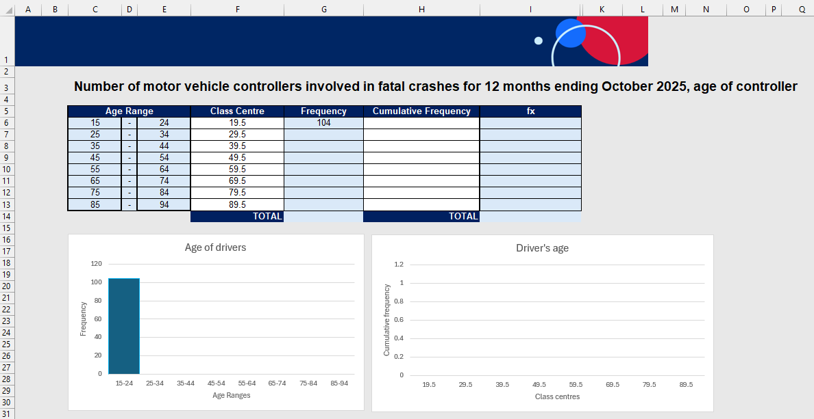
Using a spreadsheet to find the frequency
- Model to students by selecting cell G6, how to use a formula to retrieve information from the previous tab on the frequency of fatalities for each age range. Have students select cell G6 and then drag down to cell G13, this will display the frequencies for each age range.
- Ask students to turn and talk to discuss how they could find the total for the Frequency column in cell G14, using a spreadsheet formula.
Students may suggest individually adding the cells together using a formula similar to =G6+G7+G8+… or they may know the ‘SUM’ function on a spreadsheet.
- Explain to students that the ‘SUM’ function can be used to add cells in a range. Model to students how to use this function by entering =SUM(G6:G13) formula into cell G14 to calculate the total for the Frequency column. As students complete this column, the respective frequency graph will display below the spreadsheet, as seen in Figure 2.
Figure 2: grouped data with frequency
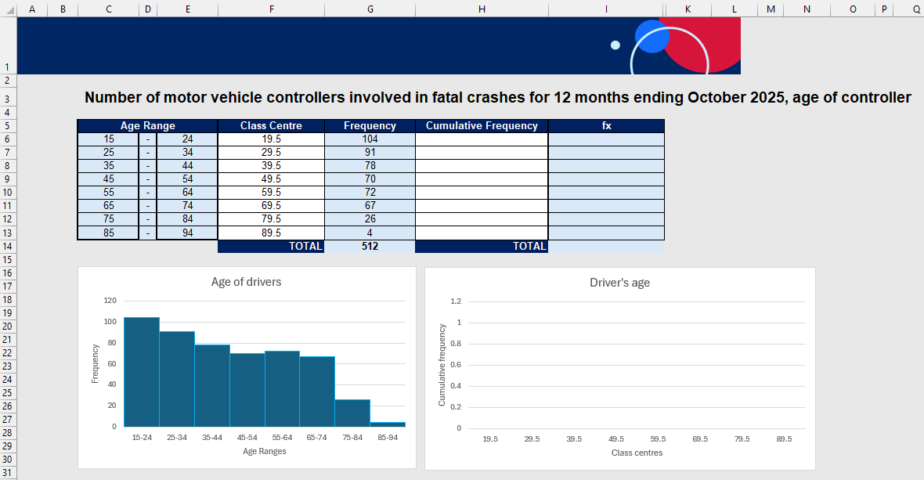

Using a spreadsheet to find the cumulative frequency
- Model to students how to complete the cumulative frequency column by first copying the value from cell G6 into cell H6 by using the formula =G6 in cell H6.
This is a good opportunity for teachers to discuss why the frequency and the cumulative frequency begin with the same number. This consolidates the understanding of cumulative frequency for students and solidifies it is not just a process of adding the next number each time.
- Explain to students that we want to add the frequency for 15–24 and 25–34 together and ask if they can determine a formula that can calculate this. Encourage them to use cell references in their explanation.
- Model for students how to input the formula =H6+G7 into cell H7. Explain to students that for each consecutive cell in the spreadsheet, we want to add the next cell from the frequency column. Ask students if they can recall how this might be done, rather than individually doing a new formula for each cell.
- Ask students what they notice and wonder about the frequency and cumulative frequency columns in the table and their respective graphs.
Students should notice that the cumulative frequency table values are always increasing and that the final value in the cumulative frequency column is the same as the total in the frequency column. They should also notice that the graph of the cumulative frequency histogram appears as the numbers are filled in.
Figure 3: grouped data with cumulative frequencies
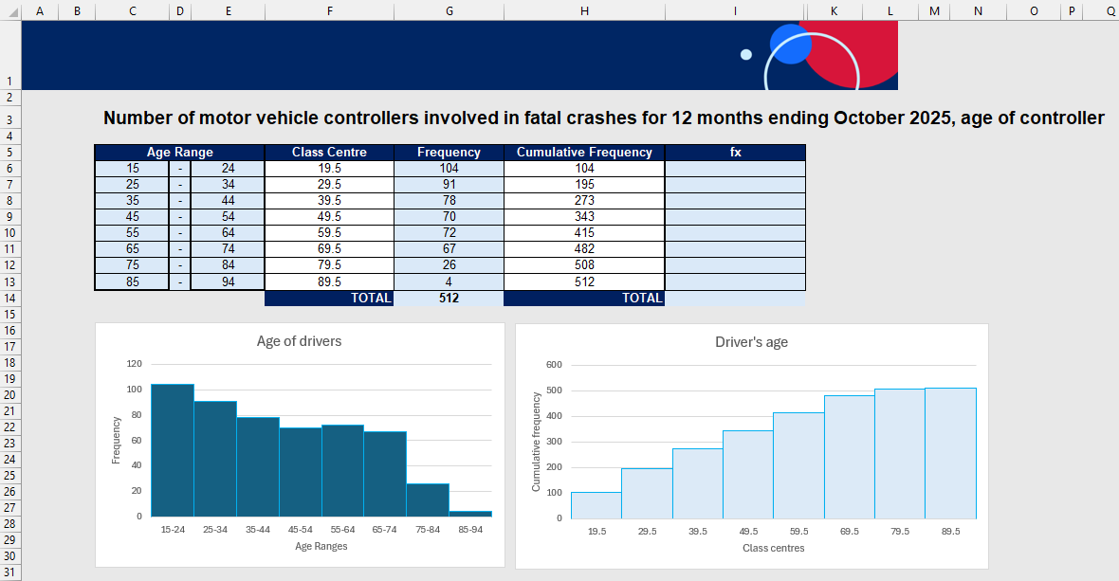

Using a spreadsheet to find $fx$
- Model to students how to complete the $fx$ column by first creating a formula to multiply class centres and frequencies. Model for students how to input the formula =F6*G6 into cell I6.
- Model to students how to highlight cell I6 and drag the bottom right-hand corner down to cell I13.
- Model to students how to use the SUM function by entering =SUM(I6:I13) formula into cell I14 to calculate the total for the $fx$ column.
- Students are to use mini whiteboards to find the mean and modal class from the table. Check student understanding by having students reveal their answers.

Releasing responsibility
- Display slide 13 of the PowerPoint, showing the original website histogram alongside the one created in the spreadsheet. Explain that both represent the same data, then have students work in pairs to list 3 key differences. Each group then shares which graph they believe presents the information more effectively and why.
- Explain to students that they will now focus on the cumulative frequency histogram. Use the Pose-Pause-Pounce-Bounce questioning strategy (PDF 557 KB) (bit.ly/posepausepouncebounce) to check for understanding of cumulative frequency graphs. The following are some suggested prompts:
- Why is the graph always increasing?
- How could we use the cumulative frequency graph to find the median?
- Display slide 14, which is the same cumulative frequency histogram created in the spreadsheet. Explain to students, we can use a cumulative frequency histogram and polygon to estimate the median for grouped data. We first need to draw the polygon which connects to the top right-hand corner of each column in the histogram. Animate the polygon.
- Animate the slide twice to show an arrow across and an arrow down, to show that the median is greater than 39.5 but less than 44 (where the column ends). Conclude by stating that a good estimation for this median would be 42.
- Distribute Appendix D, and have students find the median of each of the cumulative frequency histograms provided.

Independent practice
- Direct students to the ‘Regional data’ tab of the spreadsheet. Inform them that approximately 36% of the New South Wales population live outside of Sydney. The NSW government want to know which age ranges to target in advertising campaigns for safe driving in regional, rural and remote areas of NSW.
- In pairs students should complete the table which will generate a cumulative frequency histogram.
- Ask students to use the information from the table and graphs to find the modal class, mean and median ages of drivers outside of Sydney who were involved in fatal accidents in NSW in 2025.
- By comparing the results and graphs of drivers outside of Sydney to all of NSW, which age group(s) would you recommend the NSW government target with their advertising campaign in regional, rural and remote NSW and why?

Assessment and differentiation

Suggested opportunities for differentiation
Activating prior knowledge
- Students may benefit from revising their knowledge of measures of centre and spread with ungrouped data using existing resources.
- Extend students by asking them to suggest alternative class intervals and predict how this might affect the shape of the histogram or polygon.
Connecting learning
- Extend students by asking them to compare 2 different sets of class intervals for the same data and discuss which representation communicates patterns more clearly.
Releasing responsibility
- Provide sentence starters or note-making scaffolds for students who need support when interpreting histograms and polygons.
- Challenge students by providing an incomplete grouped frequency table and asking them to determine the missing values or identify possible errors in the data.
Independent practice
- Students who want an additional challenge could compare the grouped data representation with the ungrouped raw data to decide which representation is more appropriate and why.

Suggested opportunities for assessment
Activating prior knowledge
- Listen to student justifications for why data is grouped and identify any misconceptions about why grouping is used.
- Use mini whiteboards to quickly check students can recognise which group a particular data value belongs to.
Connecting learning
- Monitor student calculations of class centres and $fx$ values to check procedural accuracy.
- Ask students to describe the shape of the distribution using the histogram or polygon and use these responses to assess understanding of symmetry, skew or clustering.
Releasing responsibility
- Review student notes to check their understanding of grouped data, class centres and cumulative frequencies.
- Observe student reasoning as they estimate the median from the cumulative frequency graph to assess understanding of how grouped data connects to summary statistics.
Independent practice
- Review completed grouped frequency tables, histograms and polygons as evidence of learning.
- Use targeted individual questioning while students work independently to check their interpretation of the graphs and their ability to justify conclusions.
- A short exit slip could ask students to identify the median group, estimate the median and explain in one sentence why grouping data is useful.

Appendix A

Find my friend
Game 1
5 | 95 | 9 | 91 | 12 | 88
17 | 83 | 21 | 79 | 24 | 76
28 | 72 | 33 | 67 | 35 | 65
39 | 61 | 41 | 59 | 47 | 53
Game 2
3 | 72 | 6 | 69 | 9 | 66
14 | 61 | 17 | 58 | 22 | 53
25 | 50 | 26 | 49 | 30 | 45
32 | 43 | 33 | 42 | 36 | 39
Game 3
5 | 7 | 11 | 14 | 15 | 19
22 | 27 | 31 | 34 | 37 | 43
52 | 55 | 60 | 65 | 67 | 72
77 | 80 | 88 | 90 | 91 | 99

Appendix B

Grouped data
- Use the following dataset to complete the grouped frequency distribution table below.
12 | 12 | 14 | 16 | 18 | 19 | 20
21 | 21 | 24 | 25 | 26 | 26 | 26
27 | 27 | 27 | 27 | 28 | 29 | 29
30 | 31 | 31 | 31 | 32 | 33 | 33
33 | 33 | 34 | 36 | 36 | 37 | 38
40 | 44 | 45 | 48 | 48 | 50 | 51
52 | 55 | 56

Class | Class Centre | Frequency | Cumulative Frequency | $$f$$
11–20
 |  | $$Σf =$$ |  | $Σfx =$
- Using the table above, find the:
- mean
- modal class
- median class
- standard deviation

Appendix C

Save a local copy of a file
How to save a local copy of an Excel spreadsheet

File sharing and saving
- Save the Excel file Grouped data in a place where students can easily access the file. This could be done through Google Classroom, by sharing a OneNote link, or by emailing students a copy of the document.
- Have students open the document on their own device.
- Instruct students to select the File tab and then Save a Copy.
Figure 1: Save a Copy screenshot
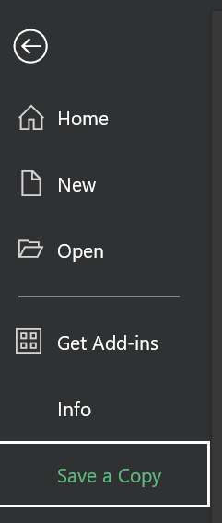
- Students can save the document in their individual OneDrive by selecting this option.
Figure 2: save to OneDrive screenshot
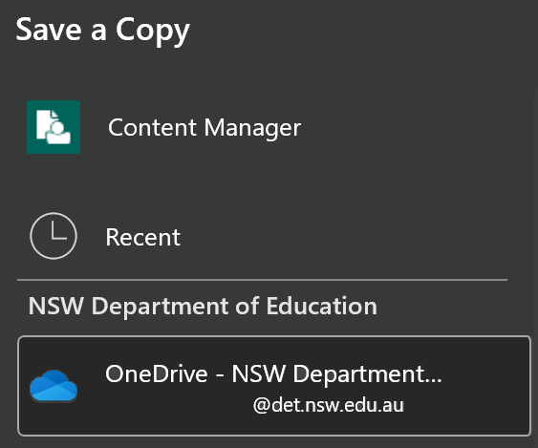
- Best practice would be to keep the file name the same. Students can then select Save and a copy will be stored on their OneDrive.
Figure 3: save with the same file name screenshot
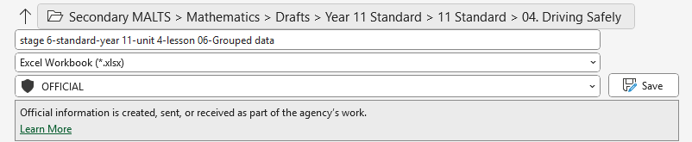

Appendix D

Medians
For each of the cumulative frequency histograms shown, find an estimate for the median.

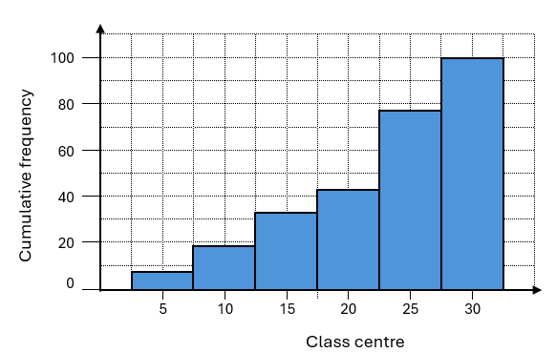

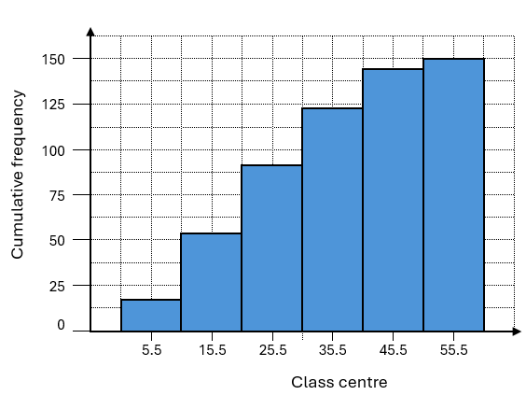

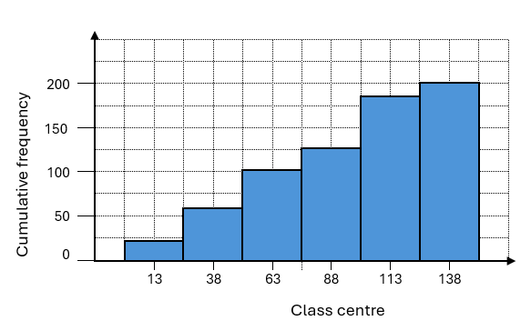
Sample solutions

Appendix B – grouped data
- Use the following dataset to complete the grouped frequency distribution table below.
12 | 12 | 14 | 16 | 18 | 19 | 20
21 | 21 | 24 | 25 | 26 | 26 | 26
27 | 27 | 27 | 27 | 28 | 29 | 29
30 | 31 | 31 | 31 | 32 | 33 | 33
33 | 33 | 34 | 36 | 36 | 37 | 38
40 | 44 | 45 | 48 | 48 | 50 | 51
52 | 55 | 56

Class | Class Centre | Frequency | Cumulative Frequency | $$fx$$
11–20 | 15.5 | 7 | 7 | 108.5
21–30 | 25.5 | 15 | 22 | 382.5
31–40 | 35.5 | 14 | 36 | 497
41–50 | 45.5 | 5 | 41 | 227.5
51–60 | 55.5 | 4 | 45 | 222
 |  | $Σf =$45 |  | $Σfx =$ 1437.5
- Using the table above, find the:
- mean $\frac{1437.5}{45}=31.9\dot{4}$
- modal class $=21-30$
- median class $31-40$ (as the 23rd score is in this interval class)
- standard deviation $=11.38$ (2 d.p)

Appendix D – medians

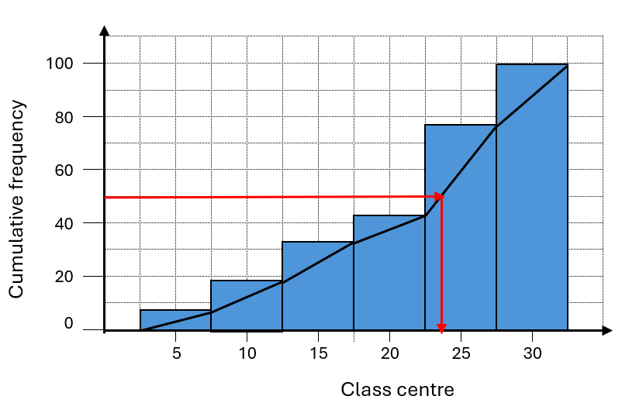
Median $≈23.5$

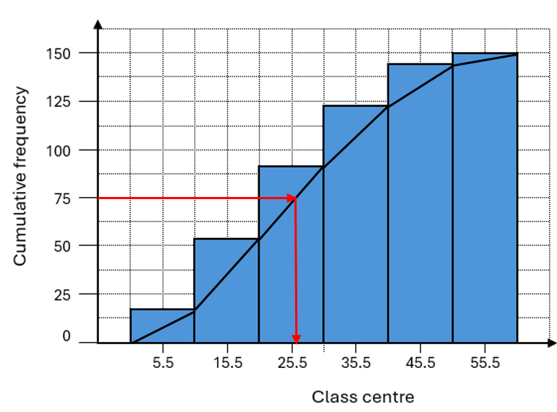
Median $≈26$

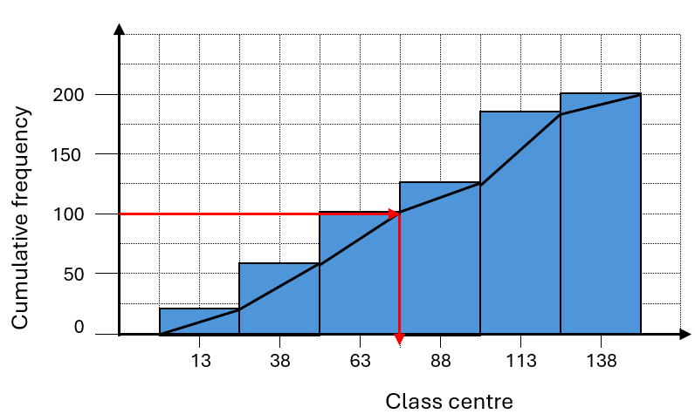
Median $≈\frac{63+88}{2}=75.5$

References
This resource contains NSW Curriculum and syllabus content. The NSW Curriculum is developed by the NSW Education Standards Authority (NESA). This content is prepared by NESA for and on behalf of the Crown in right of the State of New South Wales. The material is protected by Crown copyright.
Please refer to the NESA Copyright Disclaimer for more information https://www.nsw.gov.au/education-and-training/nesa/copyright.
NESA holds the only official and up-to-date versions of the NSW Curriculum and syllabus documents. Please visit NESA https://www.nsw.gov.au/education-and-training/nesa and NSW Curriculum https://curriculum.nsw.edu.au.
Mathematics Standard 11–12 Syllabus © NSW Education Standards Authority (NESA) for and on behalf of the Crown in right of the State of New South Wales, 2024.
Numeracy Stage 6 (CEC) Syllabus © NSW Education Standards Authority (NESA) for and on behalf of the Crown in right of the State of New South Wales, 2021.

© State of New South Wales (Department of Education), 2026
The copyright material published in this resource is subject to the Copyright Act 1968 (Cth) and is owned by the NSW Department of Education or, where indicated, by a party other than the NSW Department of Education (third-party material).
Copyright material available in this resource and owned by the NSW Department of Education is licensed under a Creative Commons Attribution 4.0 International (CC BY 4.0) license.

This license allows you to share and adapt the material for any purpose, even commercially.
Attribution should be given to © State of New South Wales (Department of Education), 2026.
Material in this resource not available under a Creative Commons license:
- the NSW Department of Education logo, other logos and trademark-protected material
- material owned by a third party that has been reproduced with permission. You will need to obtain permission from the third party to reuse its material.
Links to third-party material and websites
Please note that the provided (reading/viewing material/list/links/texts) are a suggestion only and implies no endorsement, by the New South Wales Department of Education, of any author, publisher, or book title. School principals and teachers are best placed to assess the suitability of resources that would complement the curriculum and reflect the needs and interests of their students.
If you use the links provided in this document to access a third-party's website, you acknowledge that the terms of use, including licence terms set out on the third-party's website apply to the use which may be made of the materials on that third-party website or where permitted by the Copyright Act 1968 (Cth). The department accepts no responsibility for content on third-party websites.

