Linear modelling
Students will revisit representations of linear models as a graph and an equation, identifying the gradient and 𝑦-intercept from both. They will then solve problems in various contexts using those representations.
Students will need at least one digital device per pair to interact with the Desmos Calculator (desmos.com/calculator) during the ‘Activating prior knowledge’ section of this lesson.

Learning intentions
- To be able to model linear relationships.
- To be able to interpret the features of linear relationships in a variety of contexts.

Success criteria
- I can determine the 𝑦-intercept and gradient from the equation of a straight line.
- I can construct a straight-line graph from an equation.
- I can identify the 𝑦-intercept of the graph of a straight line.
- I can identify the gradient of the graph of a straight line.
- I can represent a scenario with an equation or a graph of a straight line.

Outcomes
A student:
- develops understanding and fluency in mathematics through exploring and connecting mathematical concepts, choosing and applying mathematical techniques to solve problems, and communicating their thinking and reasoning coherently and clearly MAO-WM-01
- selects and applies algebraic techniques to solve problems involving equations and formulas MST-11-01
- models and interprets linear relationships to solve problems and make predictions in practical contexts MST-11-02

Associated numeracy outcomes
A student:
- recognises and applies functional numeracy concepts in practical situations, including personal and community, workplace and employment, and education and training contexts N6-1.1
- applies numerical reasoning and mathematical thinking to clarify, efficiently solve and communicate solutions to problems N6-1.2
- chooses and applies efficient strategies to analyse and solve everyday problems involving money and finance N6-2.4
- chooses and applies appropriate numeracy operations and techniques to analyse and resolve everyday situations N6-2.6
Numeracy Stage 6 (CEC) Syllabus © NSW Education Standards Authority (NESA) for and on behalf of the Crown in right of the State of New South Wales, 2021.

Content

Formulas and equations
- Substitute numbers into linear and non-linear algebraic expressions, equations and formulas

Linear relationships

Linear modelling
- Determine the 𝑦-intercept and gradient of a straight line given in graphical form
- Determine the equation of a straight line of the form $y=mx+c$ where 𝑚 is the gradient and 𝑐 is the 𝑦-intercept
- Determine the 𝑦-intercept and gradient from the equation of a straight line
- Construct a straight-line graph, with and without using graphing applications
- Model linear relationships and interpret the features of those relationships in a variety of contexts, noting that the 𝑦-intercept is the vertical intercept and the gradient is the rate of change
- Interpolate and extrapolate from a linear model in a practical context
- Identify and describe the limitations of a linear model in a practical context
Mathematics Standard 11–12 Syllabus © NSW Education Standards Authority (NESA) for and on behalf of the Crown in right of the State of New South Wales, 2024.

Table 1: lesson summary
Section | Summary of activity | Teaching strategies | Teaching points
Activating prior knowledge | Display slide 4 from the PowerPoint Linear modelling, which activates prior knowledge of linear equations, tables of values, gradient and the $y$-intercept, and ask students to identify the lie. Use slide 5 to activate prior knowledge of graphs and linear equations. Distribute Appendix A for pairs of students to match graphs with their equation, with students to graph the unmatched equations by hand and check them using a digital device. | Two Truths and a Lie  Pose-Pause-Pounce-Bounce | Reinforce understanding of gradient and the $y$-intercept in a linear equation and the relationship between linear equations and their graphical representations, encouraging use of mathematical language to describe features such as gradient and $y$-intercept.
Connecting learning | Introduce a real-world linear modelling scenario involving the cost of installing a pool on slide 7. Students complete Appendix B, interpreting the gradient as the rate of change and $y$-intercept as the fixed cost. Slide 8 shows a graph from a different company. Students are asked to determine the equation of the graph, then return to the original scenario on slide 9, which has been altered, and reflect on how this change affects the graph. Students complete Appendix C to consider the limitations of linear models. They are shown definitions of interpolation and extrapolation on slide 10 and asked to consider how they used them to answer questions in Appendix C. | Pose-Pause-Pounce-Bounce | Clarify the meaning of the gradient as the variable rate of change and the $y$-intercept as the fixed starting cost.  Develop skills in interpreting graphs and deriving equations from graphical information.
Releasing responsibility | Display slides 12–19 which contain 2 worked examples and 2 questions. The first presents a scenario where students draw a graph and answer a related question. The second provides data for students to draw a graph, find the equation and use it to answer a question. Students are asked to consider limitations of a linear model and why extrapolation may not be appropriate. They compare 2 catering companies’ pricing models, using an equation and a graph, and decide which is more affordable for different event sizes, considering how the initial cost and rate of change affect the final cost. | Think-Pair-Share  Pose-Pause-Pounce-Bounce | Apply skills of graphing linear models and deriving equations.  Develop critical thinking by comparing different linear models in real-world contexts.  Highlight the significance of the initial cost, $y$-intercept, and rate of change, gradient, in interpreting and comparing costs.
Independent practice | Distribute Appendix D for students to work in pairs to graph the data, determine the equation of the straight line and answer questions. For question 1, they use a Desmos activity ‘Appendix D sliders’ (bit.ly/appendixD-sliders). For question 2, students use ‘Appendix D sliders 2’ (bit.ly/appendixD-sliders2). |  | Consolidate students’ ability to construct and interpret linear models in context.

Activity structure
Please use the associated PowerPoint Linear modelling to display images in this lesson.

Activating prior knowledge
- Display slide 4 from the PowerPoint, which contains a Two Truths and a Lie (bit.ly/twotruthsoneliestrategy) activity and ask students to identify the lie.
The graph does not pass through the point $(3, 7)$ therefore, this is the lie.
- Use the Pose-Pause-Pounce-Bounce questioning strategy (PDF 557 KB) (bit.ly/posepausepouncebounce) to discuss the activity. Useful question prompts may include:
- What did you know that helped you identify a truth?
- How did you identify the lie?
- What other statements could we make about the equation?
- Display slide 5 and ask students to hold up their fingers to match the numbered answer they believe is correct.
The equation of the function could only be $y=-2x+3$.
- Generate a class discussion to discuss gradient and the $y$-intercept, encouraging students to explain how they made their decision.
Students could be encouraged use a digital device and a graphing application, such as Desmos Calculator (desmos.com/calculator), to draw the graphs of each equation on the same Cartesian plane, noting the characteristics of each equation and its graph.

- Distribute a copy of Appendix A ‘Match the graph’ to pairs of students and ask them to match the correct equation with each graph.
Monitor the methods used by students when matching the equations to the graphs. If students are consistently substituting coordinate values into the equations, encourage them to consider another method of matching the graphs with an equation.
If students are having difficulty matching the graphs, suggest they use a table of values to help them.
- Use the Pose-Pause-Pounce-Bounce questioning strategy to discuss how students knew which equation matched each graph. Useful question prompts may include:
- What features of the graphs matched its equation?
- How can we find the gradient and $y$-intercept from a graph of a straight line?
- How can we determine the gradient and $y$-intercept from the equation of a straight line?
- How could we match the equation to the graph when there are no values on the axes?
Students may have identified that there were potentially 2 equations that matched the numberless graphs. Once the other graphs were matched, one of the options for each graph was removed.
Students should be familiar with graphing equations of the form $y=mx+c$ by using the gradient and the $y$-intercept and determining the equation of a graph using the $y$-intercept and gradient from the Stage 5 Linear relationships B outcome MA5-LIN-C-02.
In Stage 5 Unit 6 – constant rates of change, students examined the gradient, $y$-intercept and the equation of a straight line.
In Lesson 7 – what’s the line of Stage 5 Unit 6, students identified the gradient and $y$-intercept of the graph of a straight line to create the equation of the line.
- Ask students to continue working in their pairs to draw a graph for each of the 4 remaining equations.
The remaining equations should be $y=-2x-1, y=-2x+1, y=-x$ and $y=x+1$.
- Continuing in their pairs, have them construct each of these 4 equations on their digital device using a graphing application, such as Desmos Calculator (desmos.com/calculator), to check the accuracy of their graphs.
- Use the Pose-Pause-Pounce-Bounce questioning strategy to discuss the technique students used to draw the graphs. Useful question prompts may include:
- How did you know where to draw the graph?
- How might a table of values be useful to draw the graph?
- How did you use the equation to draw the graph?
- How can we draw the graphs without adding numbers to the axes?
Students might suggest that they can use the $y$-intercept to know where the graph intercepts the $y$-axis.
A table of values can be used to locate points that lie on the line.
The gradient and the $y$-intercept can be determined from the equation when it’s written in the form of $y=mx+c$.
The value of the $y$-intercept shows whether the graph intercepts the $y$-axis above, below or through the origin. The value of the gradient indicates which way the graph is sloping and the steepness of the graph.

Connecting learning
- Display slide 7 from the PowerPoint and ask students to read the scenario.
Jo is the manager of Pool Bright, a pool installation company. When potential customers enquire about the cost of installing a pool, Jo tells them that an approximate cost can be found by multiplying the length of the pool by $3000 and adding $10 000.
- Use the Pose-Pause-Pounce-Bounce questioning strategy to check for understanding of the scenario. A useful question prompt may include:
- How would we calculate the cost of a pool with a length of $3 \text{m}$?
The cost of a $3$m pool would be $\$10 000+3×\$3 000$, for a total cost of $19 000.
- Distribute a copy of Appendix B ‘Cost of a pool’ to pairs of students. Ask them to complete the table of values using the information from the scenario, draw a graph showing the approximate cost of building a pool and use the graph to answer the questions below it.
- Ask student pairs to compare their graphs with another pair and discuss the answers to the questions.
- Use the Pose-Pause-Pounce-Bounce questioning strategy to check for understanding of linear models. Useful question prompts may include:
- How could you explain what the rate of change is in this scenario?
- Why is the gradient the rate of change?
- Why do we call the $y$-intercept the vertical intercept?
- How is the vertical intercept useful in a linear model?
Students should be familiar with the rate of change from Unit 2 – show me the money, when solving problems involving direct variation.
The rate of change might be described as ‘for every metre of length of the pool, the cost increases by $3 000’. The gradient is the rate of change because the slope of the line shows how fast or slow the change is.
The $y$-intercept is called the vertical intercept because it intercepts the $y$-axis, which is the vertical axis. The vertical intercept is useful because it shows the value when $x=0$.
- Display slide 8, which shows the graph of the cost of constructing a standard pool from a different pool installation company, Aqua Pools.
- Click to animate the slide to reveal the first prompt asking what the point on the $y$-axis represents. Use a class discussion to ensure that students understand that the point is the $y$-intercept, then click to animate the slide to show the value of the $y$-intercept.
- Click to animate the slide to reveal a prompt asking how the gradient can be determined. Provide students with some thinking time and an opportunity to discuss, then click to animate the slide to reveal how the gradient is calculated. Discuss how students need to select points that are on the line, which can include the $y$-intercept, to determine the rise and run, then click to animate the slide to reveal the calculation of the gradient.
- Click to animate the slide to reveal a prompt asking students how they would create the equation of the line in the form $y=mx+c$. Have a discussion which encourages students to link the $y$-intercept and gradient to the variables $m$ and $c$ in the equation, then animate the slide to reveal the equation.
- Display slide 9, which shows a new version of the original scenario on slide 7, and ask students to read it.
The cost of materials to install the pools has increased and Jo, the manager of Pool Bright, needs to pass the costs on to the customer.
Potential customers are now told that an approximate cost can be found by multiplying the length of the pool they’d like by $4000 and adding $10 000.
- Ask students to look at the graph they drew in Appendix B. Ask them to make a table of values for the new scenario and then draw the new graph on the existing grid.
- Use the Pose-Pause-Pounce-Bounce questioning strategy to discuss how the graph changed with the new price structure. Useful question prompts may include:
- How did the graph change for the new scenario?
- How has the rate of change been affected?
- Did the vertical intercept change?
Students should identify that the gradient of the line would become steeper and the $y$-intercept would stay the same.
Students should be linking gradient with rate of change, so should recognise that the rate of change has also increased.
- Distribute a copy of Appendix C ‘Pool leak’ and ask students to complete the activity in pairs.
- Display slide 10 and ask students to read the information.
- Use the Pose-Pause-Pounce-Bounce questioning strategy to unpack the definitions using the scenario from Appendix C. Useful question prompts may include:
- When you interpolated from the graph to estimate the water depth at 10:00 am, how reliable do you think the estimate would be?
- When you extrapolated from the graph to predict what time the pool started leaking, what assumptions are you making?
- Why do you think there is a point when the linear model no longer accurately describes what happens in the pool? What does this tell us about the limitations of linear models?
- What assumptions about the rate of water loss are we making when we interpolate or extrapolate using a straight line?
Students should recognise that 10:00 am is between the 2 data points, therefore the estimate is likely to be reliable.
Students should recognise that estimating when the water leak started by extrapolating the graph they are assuming the rate has remained the same, which may not be true.
Students should recognise that the rate of change of the depth is not likely to remain constant. A linear model does not reflect this.
Students should understand that they are assuming the rate of change remains constant when they interpolate or extrapolate form a linear model.

Releasing responsibility
- Use slides 12–19 from the PowerPoint to show worked examples of modelling and interpreting a linear relationship using the Worked examples (Your turn) method (bit.ly/supportingstrategies).
- Remaining on slide 19, use the Pose-Pause-Pounce-Bounce questioning strategy to highlight the limitations of a linear model. Useful question prompts may include:
- Can you explain why the rate of change in temperature might not follow a linear model as the samples get closer to room temperature?
- As the samples get closer to room temperature, say around $20°C$, what do you think might happen to the warming rate?
- Can you explain why it’s not appropriate to extrapolate the linear model to predict the temperature of the samples after 72 hours?
Students might suggest that as the samples approach room temperature, the rate of change is not the same and would not represent a linear model.
They may suggest that the warming rate of the samples slows.
Students should recognise that after 72 hours, the samples would have passed boiling point and would likely not be suitable for use in the lab.
- Read the below scenario and display slide 20 which contains related information.
Two catering companies offer pricing for event catering based on the number of guests:
Cooee Catering provides an equation to calculate the total cost for any number of guests.
Dinkum Catering presents a graph estimating costs for different guest numbers.
Nae is hosting a party for 60 guests. Dan is hosting an event for 40 people.
They both want to select the more affordable caterer for their event.
- Use a Think-Pair-Share (bit.ly/thinkpairsharestrategy) for students to decide which company Nae and Dan should choose to get the cheaper deal and how they can easily decide.
Students may recognise that the initial cost of $1500 versus $500 means that with fewer guests, the Cooee Catering is more expensive. However, Dinkum Catering is more expensive per person, so the cost increases more rapidly as the number of guests increases.
For Nae with 60 guests, Cooee Catering would cost $3900 and Dinkum Catering would cost approximately $4100. For Dan with 40 guests, Cooee Catering would cost $3100 and Dinkum Catering would cost approximately $2900.
Students could identify that either converting the equation into a graph or the graph into an equation would aid comparison.
- Use the Pose-Pause-Pounce-Bounce questioning strategy to compare the different representations of the linear models and consider the advantages of each representation. Useful question prompts may include:
- What are the advantages of using a graph to represent a linear model?
- What are the advantages of using an equation to represent a linear model?
- What are the disadvantages of the models?
- Can you explain why you prefer one model over the other?
Students might suggest that a graph allows them to gain an overview of the data and to easily identify multiple points along the line for comparison.
They may suggest that an equation allows an exact value to be calculated.
Students may suggest that an approximation is often needed when using a graph and that with an equation, each time a new variable needs to be considered, a new calculation is needed.

Independent practice
- Distribute Appendix D ‘Linear modelling problems’ to pairs of students and ask them to use a digital device to graph the equations using a suitable graphing application, such as Desmos Calculator (desmos.com/calculator), and solve the problems.
In the second question, students are asked to input y1~mx1+b into the input bar. The ~ symbol is on the top left of the keyboard.
Teachers may need to clarify with students that ‘b’ is the $y$-intercept.
- Ask pairs of students to share and compare their solutions with another pair before sharing their solutions with the class.

Assessment and differentiation

Suggested opportunities for differentiation
Activating prior knowledge
- Start with fewer equations and graphs for some students, then gradually increase the number as confidence grows.
- Provide scaffolded hints or partially completed tables for students needing extra support.
- Scaffold the matching process by prompting students to consider if the gradient in the equation matches the steepness of the graph and if the $y$-intercept is correctly identified.
- Remind students of visual cues by highlighting or annotating the equations and graphs to help students focus on relevant features.
- Ask students to create their own Two Truths and a Lie for peers or to modify existing examples to make new lies/truths.
- Ask students to explain how changes in the equation (for example, increasing gradient, changing $y$-intercept) affect the graph.
- Use tables of values as another representation for some equations, asking students to match tables, equations and graphs.
- Challenge advanced students to create their own equations and graphs to challenge peers.
Connecting learning
- Students may benefit from having the scenario broken down into smaller steps (for example, first identify the fixed cost, then the cost per metre) before graphing.
- Offer varying complexity of scenarios (for example, different cost structures) for students working at different levels.
- Some students may benefit from having access to an anchor chart which reminds them what ‘gradient’ and ‘$y$-intercept’ mean.
- Use visuals and step-by-step guided questions for students needing more support.
- Extend students by asking them to compare the 2 pool companies using equations, graphs and interpretations (for example, at what pool length is one company cheaper?).
Releasing responsibility
- Students may benefit from being provided with a scaffold to complete the Your turn questions.
- Provide worked examples with step-by-step guidance to support students.
- Encourage higher-level students to explain reasoning or create alternative examples.
- Challenge students to find the ‘break-even’ point. At what number of guests does one caterer become cheaper than the other?
- Ask students to consider what happens if the number of guests changes or if other costs are added.
Independent practice
- Encourage use of digital tools to scaffold graphing for all students.
- Provide students with the scaffold using ‘Appendix D sliders’ (bit.ly/appendixD-sliders) to complete Appendix D, where they can use sliders to determine the equation of a line.
- Extend students by providing scenarios with more challenging numbers, negative gradients or different contexts.
- Encourage students to use both graph and equation for predictions and to compare outcomes.
- Pair students strategically to encourage peer support and challenge.
- Ask students to explain the limitations of their predictions or discuss what the graph would look like outside the given scenario.

Suggested opportunities for assessment
Activating prior knowledge
- Use mini whiteboards (bit.ly/miniwhiteboards) for students to indicate their choice of the lie and a brief justification, allowing for a quick visual check of understanding.
- Teachers can observe discussions and the graph matching activity to formatively assess student understand.
- Check accuracy of graph-equation matching and students' explanations during Pose-Pause-Pounce-Bounce questioning.
- Present a mismatched pair and ask students to identify and correct the mistake, explaining their reasoning.
- Monitor the discussion for use of precise mathematical language.
- After completing the activity, ask students to rate their confidence in matching equations to graphs and note any uncertainties.
Connecting learning
- Review completed tables and graphs for accuracy and understanding of rate of change and intercept.
- Ask students to explain what each part of the equation represents in context, checking for understanding of gradient and $y$-intercept.
- Have students annotate their graphs with labels for gradient and $y$-intercept or write a brief explanation of each.
- Circulate to see how students approach finding values from the graph and equation, noting use of mathematical language and reasoning.
- Ask students to describe in a sentence how an increase in the cost per metre would change the graph, ensuring they mention the gradient.
- Use student responses during Think-Pair-Share and questioning to formatively assess comprehension.

Releasing responsibility
- Use questioning to assess students’ ability to interpret models and understand limitations.
- Have students write a brief paragraph or bullet points explaining which factors influenced their decision.
- Use an informal poll (hands up, sticky notes) to see which caterer they think each person from the scenario should select, then discuss misconceptions.
- Collect written responses or notes during worked examples as evidence of understanding.
Independent practice
- Use completed Appendix D problems to assess students’ ability to apply concepts independently.
- Ask students to write or present a brief explanation of their graph and equation, and how these relate to the scenario.
- Monitor student responses for accuracy of graph, correct equation, valid prediction and clear explanation of meaning in context.
- Use peer and self-assessment through sharing and discussion of solutions to identify misconceptions.

Appendix A

Match the graph
Match each of the 8 graphs with an equation from the list below by writing the equation on the graph and explaining how you know they match.
- $y=x$ | - $y=2x+1$ | - $y=2-x$
- $y=2x-2$ | - $y=-2x-1$ | - $y=2x$
- $y=-x-1$ | - $y=-2x+1$ | - $y=x-1$
- $y=x+2$ | - $y=-x$ | - $y=x+1$

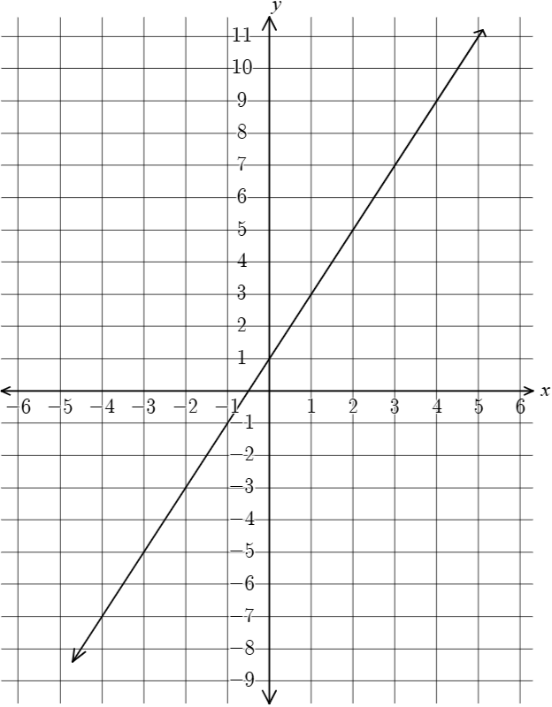 | 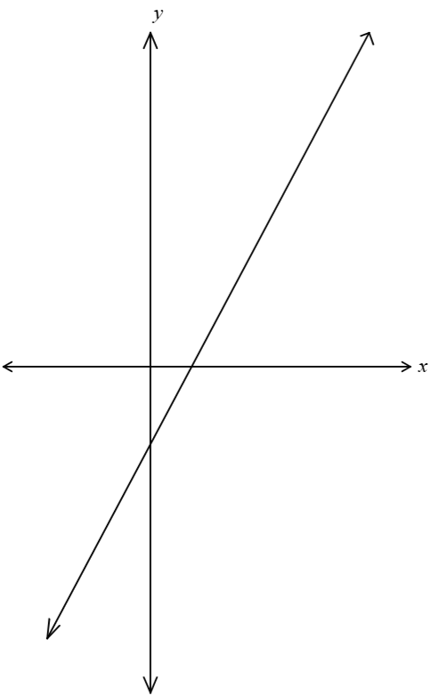

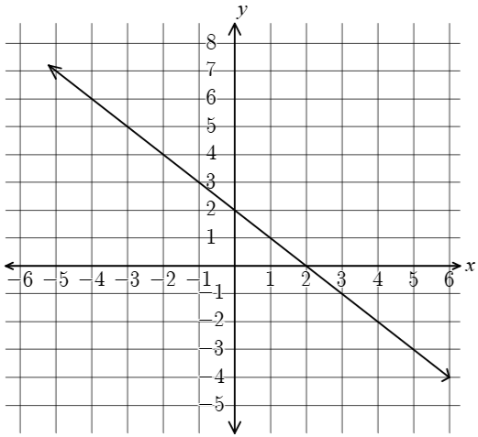 | 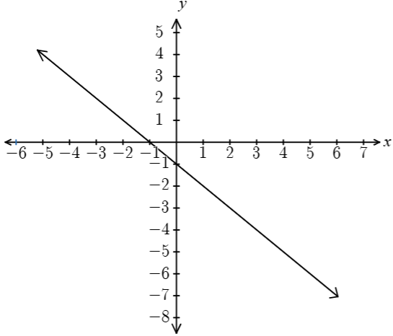
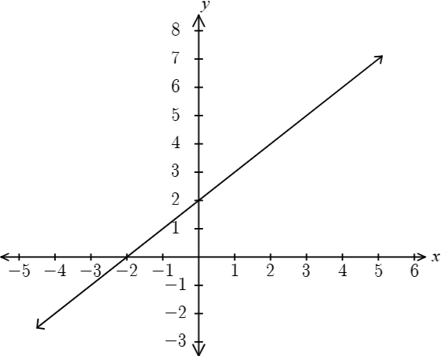 | 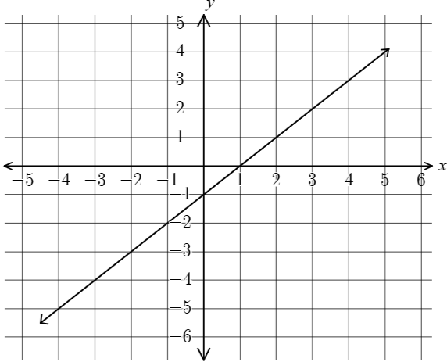
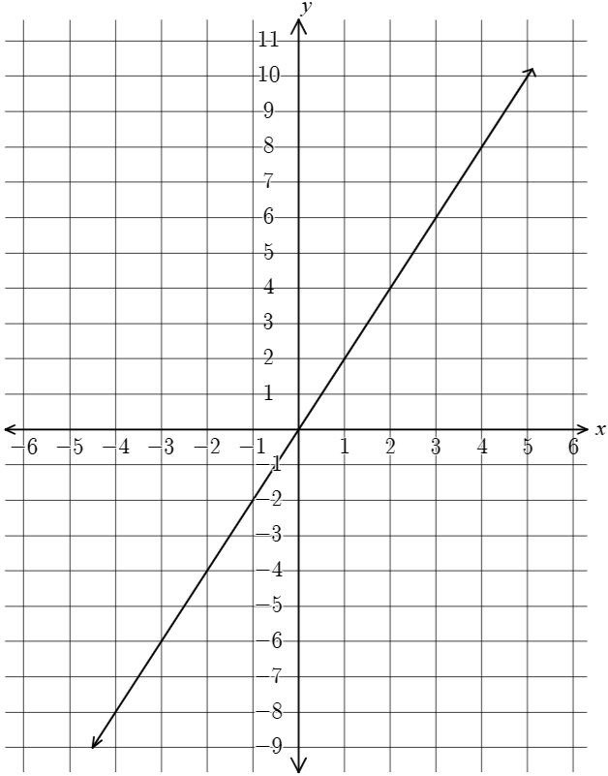 | 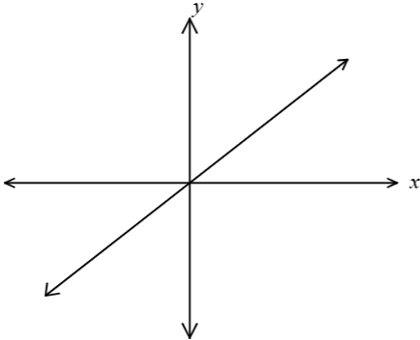

Appendix B

Cost of a pool
Jo is the manager of Pool Bright, a pool installation company. When potential customers enquire about the cost of installing a pool, Jo tells them that an approximate cost can be found by multiplying the length of the pool by $3000 and adding $10 000.
- By first completing this table of values, graph the relationship between length and cost from $l=0$ to $l=12$.
$$l$$ | $$2$$ | $$4$$ | $$6$$
$$C$$
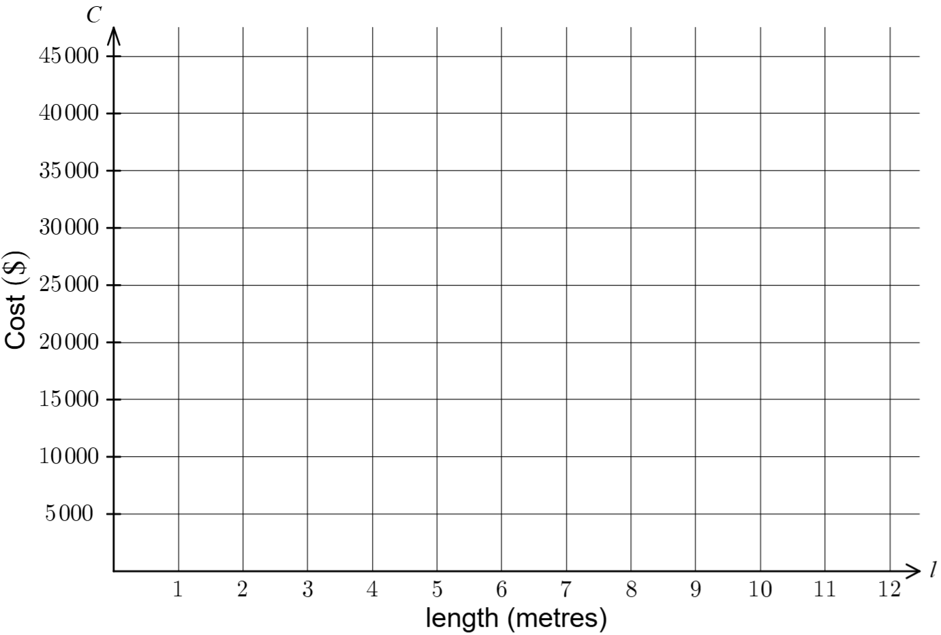
- What is the gradient and $y$-intercept of the line?
- Shan and Kai would like to have a 5-m-long pool built in their backyard. How much would the pool approximately cost?
- Blaise and Jesse have budgeted to spend $38 000 on their pool. What is the maximum length of pool they can have?

Appendix C

Pool leak
Sarah discovered her pool was leaking when she walked outside at 8:00 am on Tuesday morning. The plumber asked Sarah the rate of the leak but isn’t available until Wednesday morning. Sarah measured the pool depth – at 9:00 am, it was 183 cm, and at 11:00 am, the depth was 171 cm.
- Plot the points on the graph and draw a line to show the depth of water in the pool over time.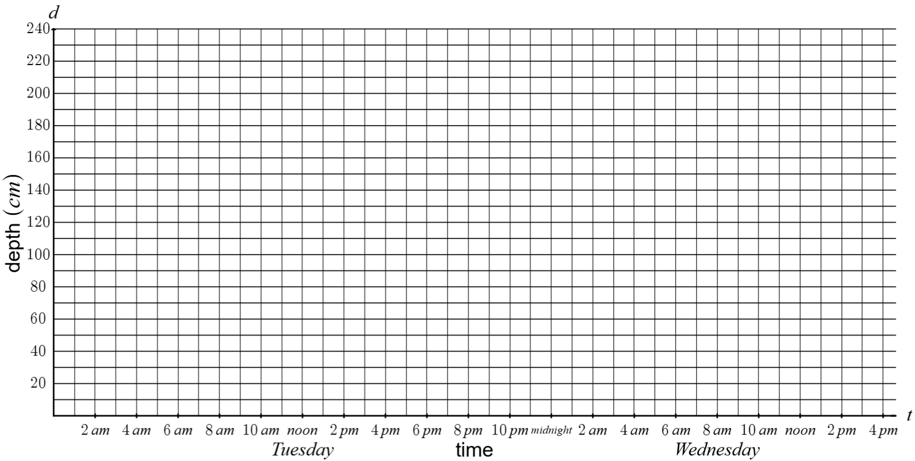
- Use the graph to estimate the depth of the water at 10:00am.
- Use the graph to estimate the rate of change of the depth of the water per hour.
- The normal depth of the water in the pool is 220 cm. Use the graph to estimate what time the pool started leaking.
- Use the graph to predict the approximate time, if the leak continued, the pool would be empty.

Appendix D

Linear modelling problems
- A 3D printing team is making custom parts for a robotics competition. After upgrading their printer, the number of parts produced increases steadily each day. On day 1, the team has completed 10 parts. By day 4, they have completed 28 parts.
- Navigate to ‘Appendix D sliders’ (bit.ly/appendixD-sliders) and complete the table of values to show the relationship between the number of days $\left(x\right)$ and the number of parts $\left(y\right).$
- Use the sliders to extend the equation of the line.
- Use the graphing calculator to determine the rate of change of parts produced each day and write the equation for the total number of parts $\left(y\right)$ produced after $x$ days.
- Use your equation to determine the number of parts that will be completed after 10 days.
- Explain why it is not appropriate to extrapolate the linear model to predict the number of parts completed after 30 days.
- A company manufactures aquariums with a fixed height of 45 cm and a fixed width of 60 cm. The length of the aquarium $\left(l\right)$ varies depending on customer needs. Each aquarium includes a removable glass lid.
The company wants to model how the total glass surface area $(S)$ changes as the length $(l)$ changes.
- Navigate to ‘Appendix D sliders 2’ (bit.ly/appendixD-sliders2) and fill in the table of values to graph the relationship between the length of the aquarium $(l)$ and the surface area $\left(S\right)$.
$$l$$ | $$40$$ | $$60$$ | $$80$$
$$S$$ | 13 800 | 18 000 | 22 200
- Type the expression y1~mx1+b into the input bar to extend the line.
- Use the graph to interpolate, to determine the length of the aquarium when the surface area is around $20 000 {\text{cm}}^{\text{2}}$.
- Use the graph to extrapolate the surface area when the length is 200 cm.
- Explain the limitations of the model by explaining why it’s not appropriate to use the linear model to predict the surface area of a tank with a length of 10 cm.

Sample solutions

Appendix A – match the graph
- $y=2x+1$ (2) | - $y=2x-2$ (4)
- $y=2-x$ (3) | - $y=-x-1$ (7)
- $y=x+2$ (10) | - $y=x-1$ (9)
- $y=2x$ (6) | - $y=x$ (1)

Appendix B – cost of a pool

$l$ | $$2$$ | $$4$$ | $$6$$
$$C$$ | 16 000 | 22 000 | 28 000
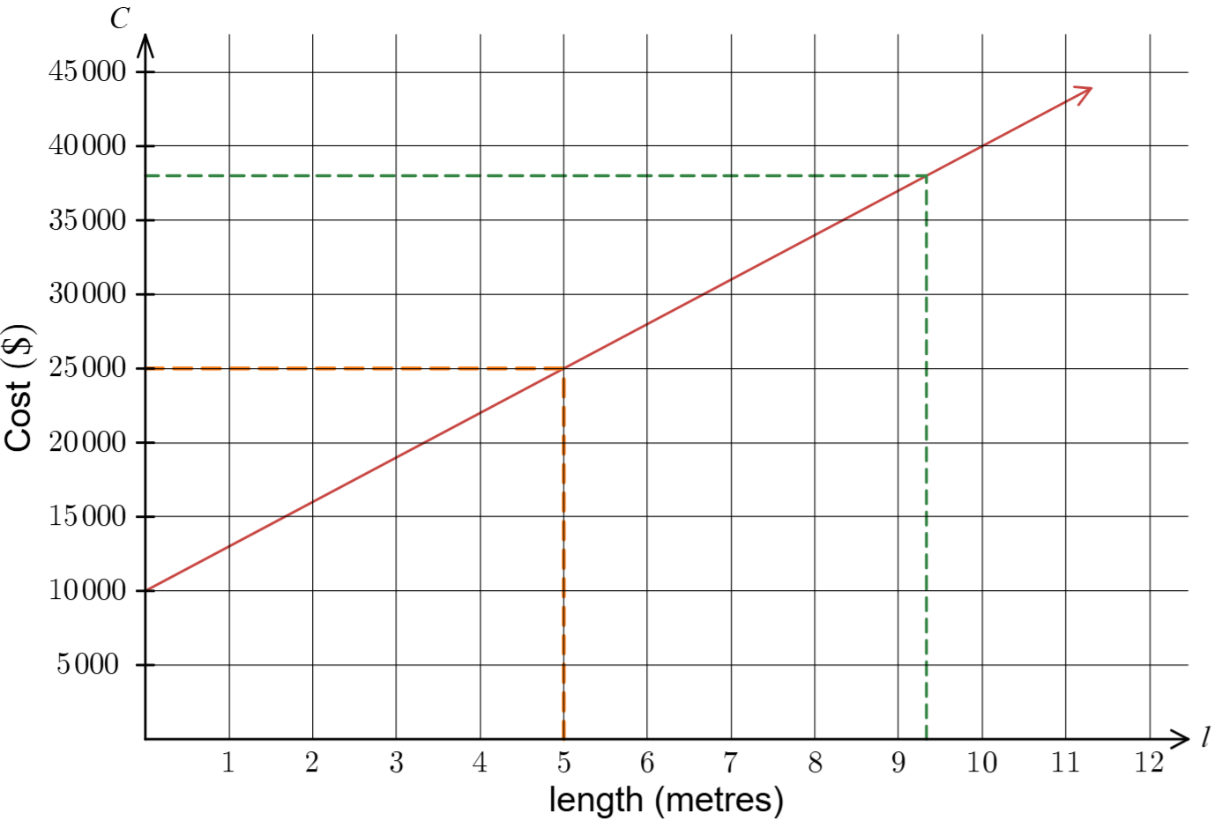
- Gradient: $\left(0,10 000\right), (5,25 000)$
$$m=\frac{25 000-10 000}{5-0} \\ =\frac{15 000}{5} \\ =3000$$
The gradient is 3 000, the $y$-intercept is 10 000.
- From the graph, the cost of a 5-metre-long pool would be approximately $25 000.
- For $38 000, the pool would be approximately $9.3 \text{m}$.

Appendix C – pool leak

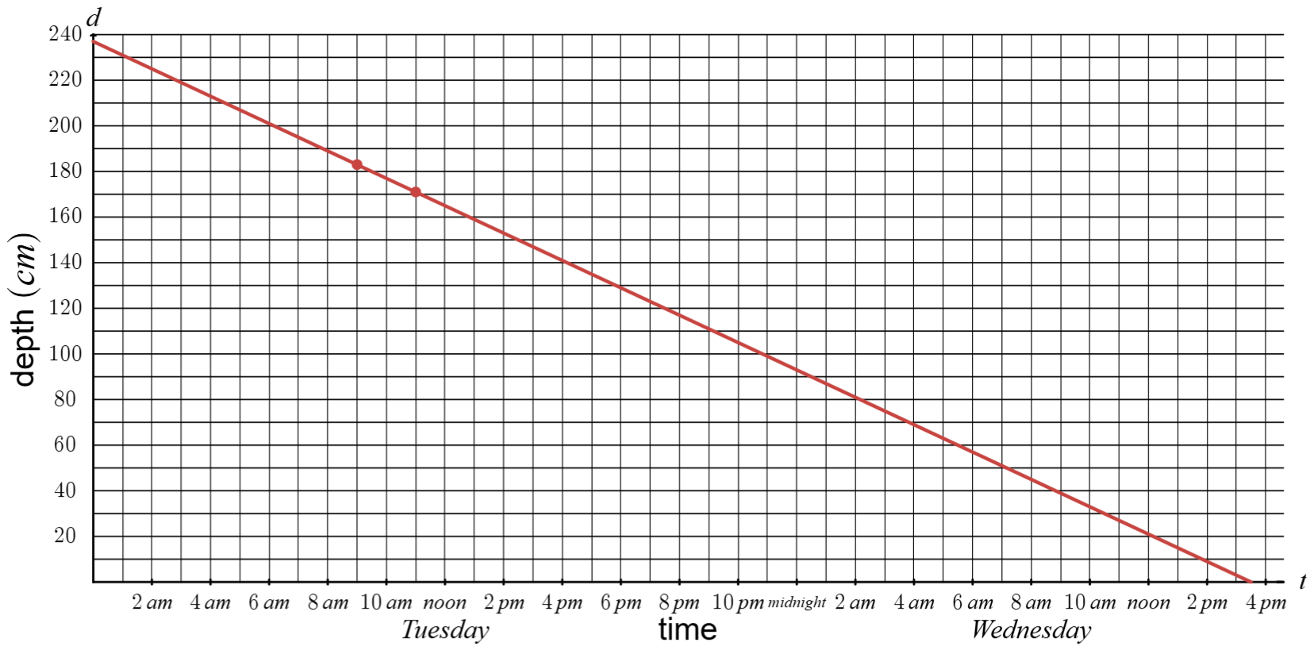
- At 10:00 am the water was approximately 177 cm deep.
- The rate of change of the depth of the water is −6, it’s going down about 6 cm every hour.
- The water started leaking at approximately 2:45 am.
- The pool will be empty at approximately 3:30 pm the next afternoon.

Appendix D – linear modelling problems

$$x$$ | $$1$$ | $$4$$
$$y$$ | 10 | 28

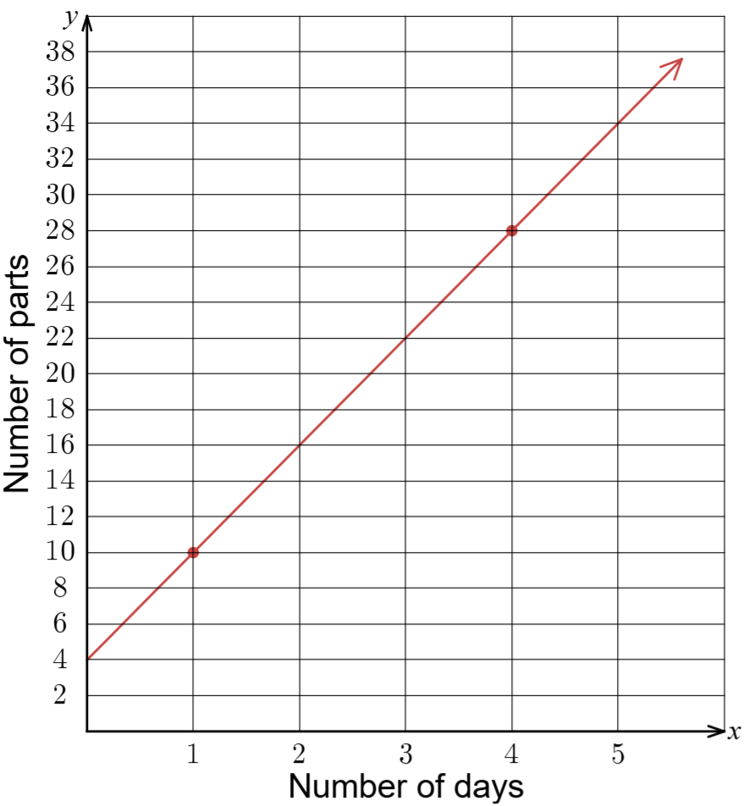
- Rate of change:
$$m=\frac{28-10}{4-1} \\ =\frac{18}{3} \\ =6$$
Equation:
$$y=6x+4$$
- After 10 days, number of parts is 64.
- There are other factors which could influence production, including that the competition may have ended, the machine needs servicing, material is unavailable. The value of 30 days is outside the dataset, so extrapolating is not reliable.

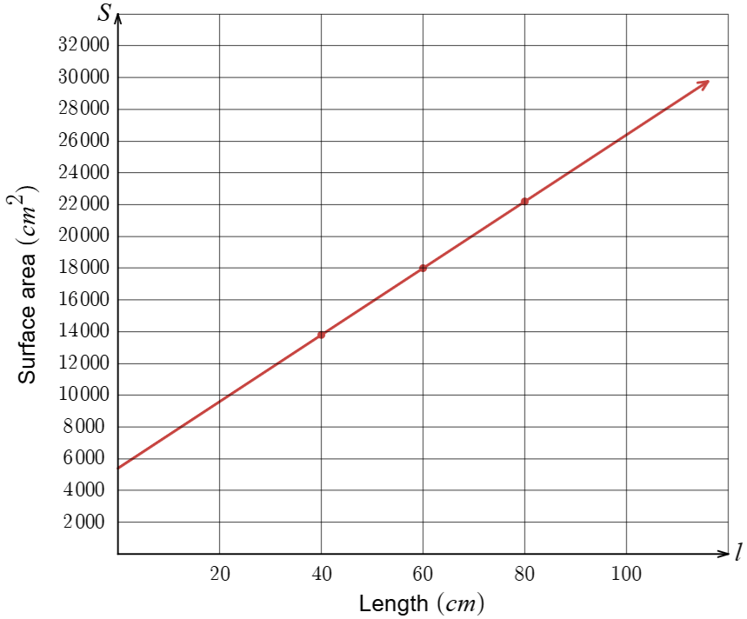
- The aquarium would be $70 \text{cm}$ in length when the tank has a surface area of $20 000 {\text{cm}}^{\text{2}}$.
- When $l=200$, $S=47 400$.
- A tank with a length of 10 cm may not be structurally possible as it is too small, so the model may not work in that context.

References
This resource contains NSW and syllabus content. The NSW Curriculum is developed by the NSW Education Standards Authority (NESA). This content is prepared by NESA for and on behalf of the Crown in right of the State of New South Wales. The material is protected by Crown copyright.
Please refer to the NESA Copyright Disclaimer for more information https://www.nsw.gov.au/education-and-training/nesa/copyright.
NESA holds the only official and up-to-date versions of the NSW Curriculum and syllabus documents. Please visit NESA https://www.nsw.gov.au/education-and-training/nesa and NSW Curriculum https://curriculum.nsw.edu.au.
Mathematics Standard 11–12 Syllabus © NSW Education Standards Authority (NESA) for and on behalf of the Crown in right of the State of New South Wales, 2024.
Numeracy Stage 6 (CEC) Syllabus © NSW Education Standards Authority (NESA) for and on behalf of the Crown in right of the State of New South Wales, 2021.

© State of New South Wales (Department of Education), 2026
The copyright material published in this resource is subject to the Copyright Act 1968 (Cth) and is owned by the NSW Department of Education or, where indicated, by a party other than the NSW Department of Education (third-party material).
Copyright material available in this resource and owned by the NSW Department of Education is licensed under a Creative Commons Attribution 4.0 International (CC BY 4.0) license.

This license allows you to share and adapt the material for any purpose, even commercially.
Attribution should be given to © State of New South Wales (Department of Education), 2026.
Material in this resource not available under a Creative Commons license:
- the NSW Department of Education logo, other logos and trademark-protected material
- material owned by a third party that has been reproduced with permission. You will need to obtain permission from the third party to reuse its material.
Links to third-party material and websites
Please note that the provided (reading/viewing material/list/links/texts) are a suggestion only and implies no endorsement, by the New South Wales Department of Education, of any author, publisher, or book title. School principals and teachers are best placed to assess the suitability of resources that would complement the curriculum and reflect the needs and interests of their students.
If you use the links provided in this document to access a third-party's website, you acknowledge that the terms of use, including licence terms set out on the third-party's website apply to the use which may be made of the materials on that third-party website or where permitted by the Copyright Act 1968 (Cth). The department accepts no responsibility for content on third-party websites.

