Pythagoras’ theorem
Students use building frames for structures to review Pythagoras’ theorem and use it to move to independently finding the perimeter of composite shapes involving arc lengths and finding missing sides using Pythagoras’ theorem.

Learning intention
- To know how to use Pythagoras’ theorem to find a missing side of a right-angled triangle.

Success criteria
- I can explain what side the hypotenuse is.
- I can substitute numbers into Pythagoras’ theorem.
- I can calculate the length of the hypotenuse using Pythagoras’ theorem.
- I can solve an equation to calculate a missing side of a right-angled triangle.
- I can calculate the perimeter of shapes involving triangles.

Outcomes
A student:
- develops understanding and fluency in mathematics through exploring and connecting mathematical concepts, choosing and applying mathematical techniques to solve problems, and communicating their thinking and reasoning coherently and clearly MAO-WM-01
- selects and applies algebraic techniques to solve problems involving equations and formulas MST-11-01
- solves problems involving measurement in practical contexts MST-11-05

Associated numeracy outcomes
A student:
- recognises and applies functional numeracy concepts in practical situations, including personal and community, workplace and employment, and education and training contexts N6-1.1
- applies numerical reasoning and mathematical thinking to clarify, efficiently solve and communicate solutions to problems N6-1.2
- determines whether an estimate or an answer is reasonable in the context of a problem, evaluates results and communicates conclusions N6-1.3
- chooses and applies appropriate operations with whole numbers, familiar fractions and decimals, percentages, rates and ratios to analyse and solve everyday problems N6-2.1
- chooses and applies efficient strategies to analyse and solve everyday problems involving metric relationships, distance and length, area, volume, time, mass, capacity and temperature N6-2.2
Numeracy Stage 6 (CEC) Syllabus © NSW Education Standards Authority (NESA) for and on behalf of the Crown in right of the State of New South Wales, 2021.

Content

Formulas and equations
- Substitute numbers into linear and non-linear algebraic expressions, equations and formulas
- Evaluate the subject of a formula, given the value of other pronumerals in the formula
- Apply given formulas to solve problems in a variety of contexts

Applications of measurement

Perimeter, area and volume
- Solve practical problems requiring the calculation of perimeters and areas of triangles, rectangles, parallelograms, trapeziums, circles, sectors of circles and composite shapes in a variety of contexts
- Apply Pythagoras’ theorem to solve problems involving right-angled triangles
Mathematics Standard 11–12 Syllabus © NSW Education Standards Authority (NESA) for and on behalf of the Crown in right of the State of New South Wales, 2024.

Table 1: lesson summary
Section | Summary of activity | Teaching strategies | Teaching points
Retrieval practice | Students complete the Starting Points Maths activity ‘Pythagoras’ (bit.ly/hypotenuse-activity). |  | Students recall what a hypotenuse is and what triangles would be considered right-angled.
Activating prior knowledge | Use slide 4 of the PowerPoint Pythagoras’ theorem to show the frame of a house to discuss how we can tell it is at $90°$.  Students draw right-angled triangles and label the sides and the right angle before using slide 5 to display Pythagoras’ theorem. Students cross-reference the formula with the Mathematics Standard 1 and 2 – HSC reference sheet and determine how that document can be used to assist them. Students then label their right-angled triangles before using slides 6–7 to check their understanding of finding missing sides and completing Appendix A. | Pose-Pause-Pounce-Bounce  Mini whiteboards  Incorrect worked examples | This section provides multiple opportunities for teachers to check students’ ability to find missing sides using Pythagoras’ theorem before highlighting mistakes that are commonly made by HSC students in exams.
Connecting learning | Use slide 9 to discuss how to find the missing side in a trapezium before students complete Appendix B. | Think-Pair-Share  Visibly random groups  Vertical non-permanent surfaces | Students move their knowledge to other shapes where they can use Pythagoras’ theorem to find unknown lengths.
Releasing responsibility | Students discuss strategies to find right-angled triangles in shapes and then write notes using Appendix C. | Pose-Pause-Pounce-Bounce  Visibly random groups  Vertical non-permanent surfaces  Four quadrant notes | Students communicate their mathematical thinking on strategies used in solving Pythagoras’ theorem problems and summarise their learning.
Independent practice | Students practise questions on calculating the perimeter of composite shapes from an existing source. A recommended question set is ‘Area and Perimeter of Sectors with Pythagoras Theorem Practice Grid’ which can be found on the Dr Austin Maths webpage ‘Perimeter and Area’ (bit.ly/sectors-and-pythagoras). |  | Students apply their knowledge to find perimeters of composite shapes.

Activity structure
Please use the associated PowerPoint Pythagoras’ theorem to display images in this lesson.

Retrieval practice
- Have students complete the Starting Points Maths activity ‘Pythagoras’ (bit.ly/hypotenuse-activity) in pairs.
This task tests students’ understanding of the hypotenuse. Students could be encouraged to write down a sentence justifying their choice.
- On mini whiteboards (bit.ly/miniwhiteboards) ask students to draw a right-angled triangle and label the right angle, the hypotenuse and the shorter sides.
- Ask a non-volunteer student: ‘How do we know which side is the hypotenuse?’

Activating prior knowledge
- Display slide 4 of the PowerPoint, which shows a frame of a house. Ask students how a carpenter could ensure that this wall is standing at $90°$ to the ground.
- Click to animate the slide to show measurements, taken by the carpenter, in the bottom left corner.
- Use the Pose-Pause-Pounce-Bounce questioning strategy (PDF 557 KB) (bit.ly/posepausepouncebounce) to ask students why the carpenter would be doing this and what the numbers 3, 4 and 5 relate to on a right-angled triangle?
Students should recognise the measurements as the first Pythagorean triad, indicating the use of Pythagoras’ theorem.
A carpenter checks if a frame is square to ensure corners are exactly 90°, which is crucial for strength, stability and a proper fit. If a frame isn’t square, doors and windows may not close properly, and the overall structure can be uneven or on a slant.
- Display slide 5 of the PowerPoint, which displays Pythagoras’ theorem.
- Ask students to review the Mathematics Standard 1 and 2 – HSC reference sheet and ask them if they can find Pythagoras’ theorem on it.
Pythagoras’ theorem is not a standalone formula on the Mathematics Standard 1 and 2 – HSC reference sheet. Students may notice that Pythagoras’ theorem can be seen as the first part of the cosine rule when finding an unknown side, which is the second from the bottom on the left.
- On their mini whiteboard, ask each student to label the sides of their right-angled triangle with $a$, $b$ and $c$.
- Ask non-volunteer students to share how they decided what pronumeral went on each side.
Students should explain that the hypotenuse is the longest side and is always labelled $c$. Where $a$ and $b$ can be either of the shorter sides.
- Display slide 6. On their mini whiteboards, ask students to find the size of the hypotenuse of a right-angled triangle that has shorter sides of 60 mm and 80 mm.
This activity shows if students can substitute numbers into a formula and solve for the unknown. The hypotenuse is 100 mm.
- Display slide 7. On their mini whiteboards, ask students to find the size of the missing side of a right-angled triangle that has sides 60 mm and a hypotenuse of 80 mm.
The shorter side is approximately 52.915 mm.
- Check for understanding using the incorrect worked examples (bit.ly/incorrectworkedexamples) in Appendix A ‘Incorrect worked examples’.
- Use the Pose-Pause-Pounce-Bounce questioning strategy to discuss common misconceptions and how you can avoid them.

Connecting learning
- Display slide 9, which shows the blueprint of the front of a house.
- In a Think-Pair-Share (bit.ly/thinkpairsharestrategy) ask students: ‘Given you know the height of each side of the frame, how could you calculate the length of wood needed for the roof when building the frame?’
Students should realise that they can subtract one parallel side from the other to find the height of the triangle and then apply Pythagoras’ theorem. The roof would be the hypotenuse and the base of the triangle would be the width of the house.
- Click to animate the slide to reveal the right-angled triangle in the trapezium.
- Ask students to calculate the missing side and display their answers on their mini whiteboards.
- Assign students to visibly random groups of 3 (bit.ly/visiblegroups) at vertical non-permanent surfaces (bit.ly/VNPSstrategy) and distribute Appendix B ‘Pythagoras’ theorem’ for students to discuss how they would find the lengths of sides in right-angled triangles and then follow their method to perform the calculations.
- Students pair with another group to compare answers and solution methods.

Releasing responsibility
- Use a Pose-Pause-Pounce-Bounce questioning strategy to initiate the sharing of ideas and strategies to complete Appendix B. Some suggested prompts include:
- Can you explain how you found a right-angled triangle in these shapes?
- How did you decide where the hypotenuse, base and height would be?
- Continuing in their groups of 3, ask students to complete Four quadrant notes to their future forgetful selves (bit.ly/supportingstrategies) from Appendix C ‘Four quadrant notes’ on a vertical non-permanent surface.
Encourage students to use correct terminology, such as substitute and formula.

Independent practice
Students are to practise questions on calculating the perimeter of composite shapes from an existing source.
A recommended question set is ‘Area and Perimeter of Sectors with Pythagoras Theorem Practice Grid’ which can be found on the Dr Austin Maths webpage ‘Perimeter and Area’ (bit.ly/sectors-and-pythagoras) which has students find the perimeter of composite shapes that involve using arc lengths and Pythagoras’ theorem.

Assessment and differentiation

Suggested opportunities for differentiation
Activating prior knowledge
- Provide a diagram of the frame with key terms labelled (hypotenuse, right angle) for students who may struggle with identifying these characteristics.
- Have students identify the errors in the incorrect worked examples rather than providing why they are incorrect.
- If available, use anonymised student work samples to use for incorrect worked examples so they are relevant to the mistakes students in your class may make.
Connecting learning
- Challenge students to find missing lengths in harder diagrams such as Don Steward’s ‘triple triangle lengths’ (bit.ly/triple-triangle-lengths).
Releasing responsibility
- Provide a word bank for students from non-English speaking backgrounds with words such as hypotenuse, perpendicular, formula, substitute and square root.
- Allow voice notes or diagrams for students who find written explanations challenging.
- Challenge students to find the lengths in missing three-dimensional shapes, such as the slant height of a square pyramid or the diagonal in a rectangular prism.
Independent practice
- Provide simpler composite shapes first, focusing only on straight edges, then introduce arcs.
- Give a choice between completing a smaller number of challenging problems or more routine problems for fluency.

Suggested opportunities for assessment
Retrieval practice
- Listen for students correctly identifying the numbers as a Pythagorean triple.
- Review students’ responses to the Starting Points Maths activity for their understanding of identifying a hypotenuse.
Activating prior knowledge
- Observe responses during Pose-Pause-Pounce-Bounce to assess prior knowledge of the theorem and vocabulary use.
- Review mini-whiteboard work for correct substitution and calculation using Pythagoras’ theorem.
- Collect Appendix A for student understanding of applying Pythagoras’ theorem.
Connecting learning
- Check answers from Appendix B and have students explain their reasoning, not just give a solution.
Releasing responsibility
- Collect or quickly review notes to see if students can:
- correctly state the formula
- label diagrams accurately
- give clear steps without major errors.
Independent practice
- Mark a small sample of each student’s work early to catch and correct recurring mistakes.
- Have students swap and peer-check one question, writing feedback on whether the method is correct or needs adjustment.

Appendix A

Incorrect worked examples
Each of the following students has tried to solve a question that involves Pythagoras’ theorem, but something went wrong. All images are not to scale.

Student working
- Rohan incorrectly answered the following question. His working is below:
Find the missing side in a right-angled triangle.
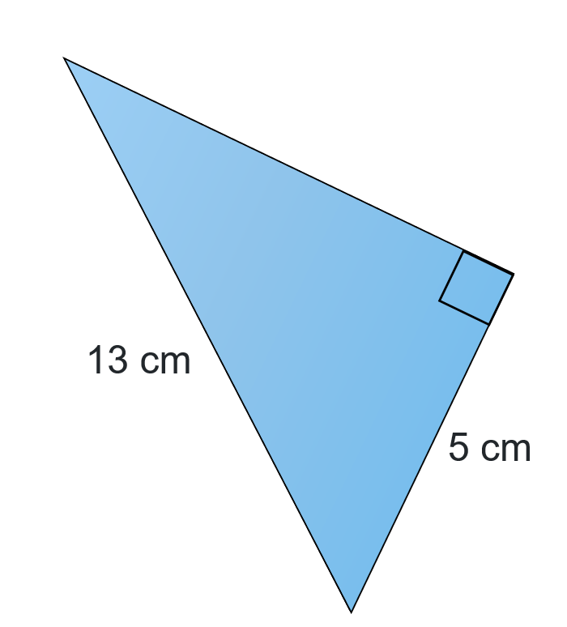
$$c^{2}={13}^{2}+5^{2} \\ =169+25 \\ =194$$
$$c=\sqrt{194} \\ ≈14 cm$$
Rohan substituted incorrectly. Explain what mistake he made and find the correct solution.

- Tika incorrectly found the length for one of the shorter sides of a right-angled triangle.
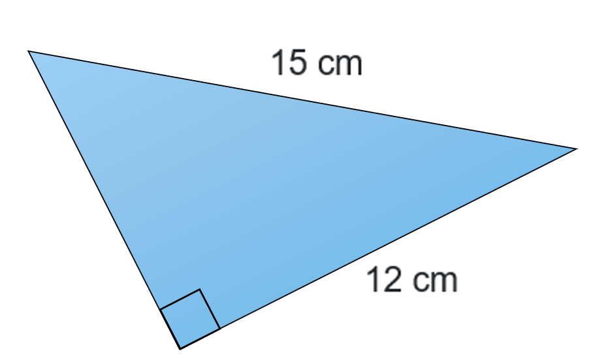
$${15}^{2}={12}^{2}+b^{2} \\ {15}^{2}-{12}^{2}=b^{2}$$
$$225-144=81 cm$$
Tika forgot to find the square root of her result when finding the length.
- How could Tika know that her answer is unreasonable?
- Calculate the length of the side.
- Jonah incorrectly calculated the length of the missing side on this triangle.
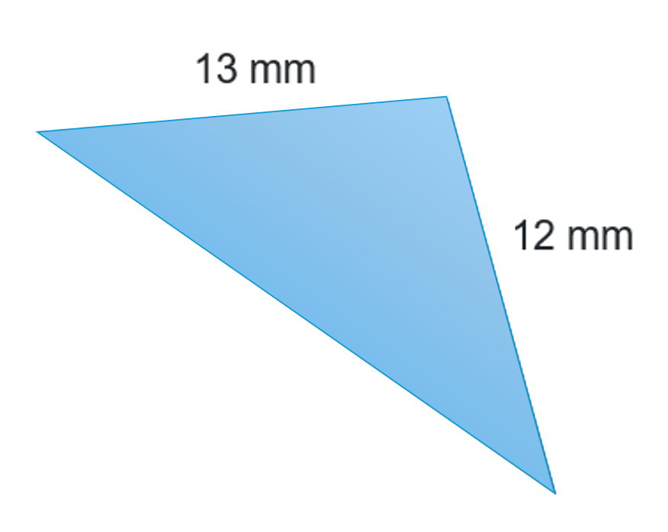
$$c^{2}={13}^{2}+{12}^{2} \\ =313$$
$$c=\sqrt{313} \\ =17.6918… \\ ≈17.7 mm$$
Jonah applied Pythagoras’ theorem to a non-right-angled triangle. How do we know if a triangle is right-angled?

Appendix B

Pythagoras’ theorem
- Calculate the perpendicular height of the following steel rod to provide specifications for the hole it is to fit into.
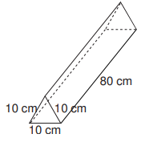
- Calculate the length of material required for the frame of this object.
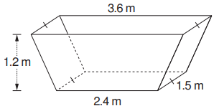
- Calculate the distance around this property to determine the amount of material needed to fence it. All measurements are in kilometres.
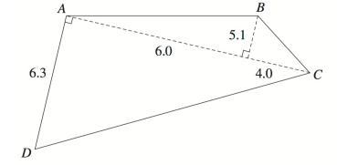
- A carpenter needs to replace the wood in the top of this frame, as it has rotted. Given the measurements, calculate the length of the wood needed (k).
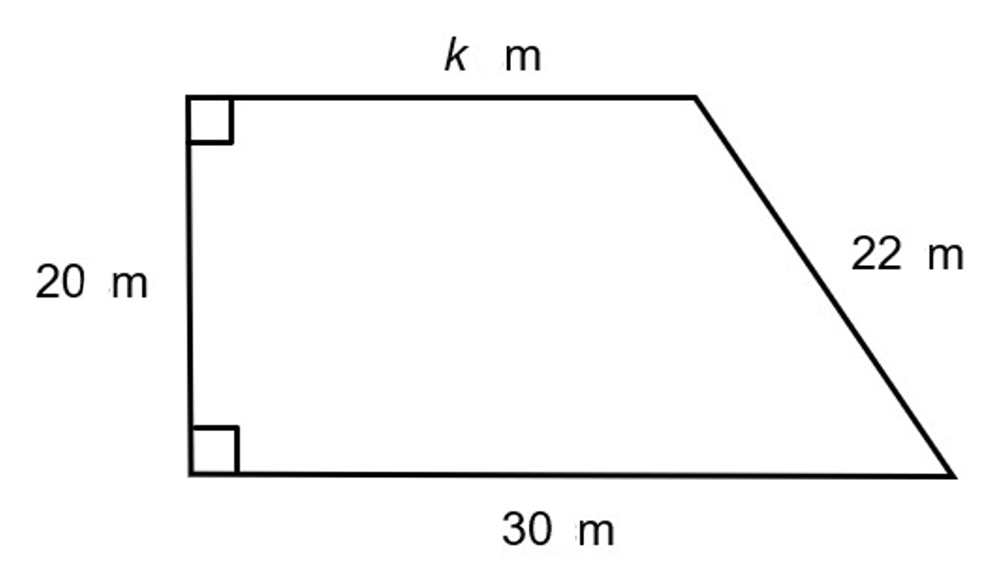
- Calculate the length of material needed to create a boardwalk around this irregularly shaped pond. All measurements are in metres.
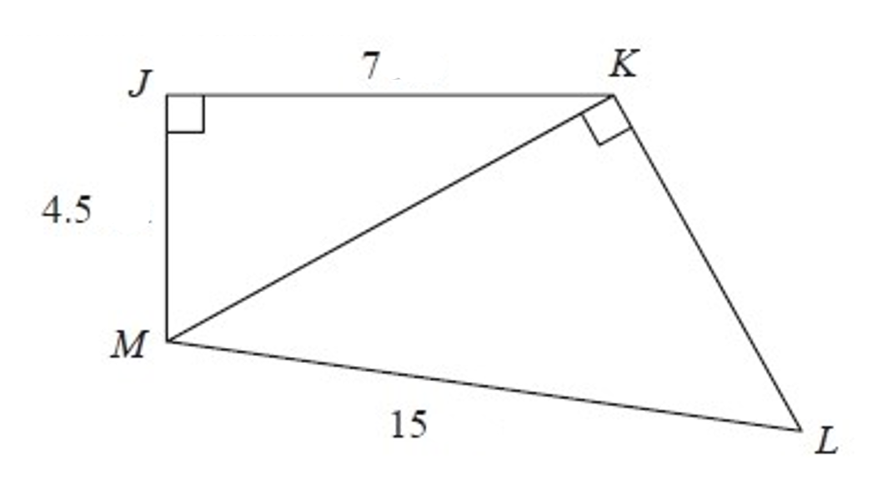

Appendix C

Four quadrant notes
Example 1  Calculate the length of the unknown side.  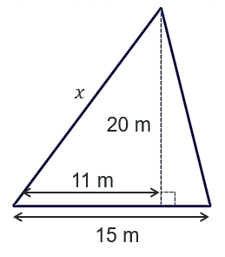  $$c^{2}=a^{2}+b^{2} \\ {\boxed{}}^{2}={\boxed{}}^{2}+{\boxed{}}^{2} \\ {\boxed{}}^{2}=\boxed{} \\ \boxed{}=√\boxed{} \\ \boxed{}≈\boxed{}$$ | Example 2  Calculate the length of the perpendicular height.  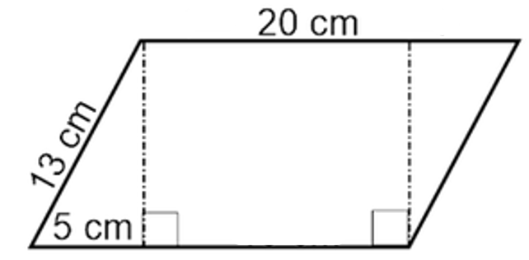
Things to remember | Example 3

Sample solutions

Appendix A – incorrect worked examples
- Rohan substituted the hypotenuse as a shorter side into the Pythagoras’ theorem formula.
$${13}^{2}=b^{2}+5^{2} \\ 169=b^{2}+25 \\ 144=b^{2} \\ \sqrt{144}=b \\ 12=b$$
- Tika:
- We would expect the length to be shorter than the hypotenuse, which was 15 cm.
- $\sqrt{81}=9$The length is 9 cm.
- A triangle should show that it is right-angled by having a square or 90$°$ labelled on the diagram. The question could also state that the triangle is right-angled.
We may also know if a triangle is right-angled if all 3 of its sides satisfy Pythagoras’ theorem.

Appendix B – Pythagoras’ theorem
- ${10}^{2}=5^{2}+h^{2}$$${10}^{2}-5^{2}=h^{2}$$
$$75=h^{2}$$
$$h=\sqrt{75} \\ =8.6602… \\ ≈8.7 cm$$
- Finding the slant height:
$$3.6-2.4=1.2 \\ \frac{1.2}{2}=0.6$$
$${1.2}^{2}={0.6}^{2}+h^{2}$$
$${1.2}^{2}-{0.6}^{2}=h^{2}$$
$$1.08=h^{2}$$
$$h=\sqrt{1.08} \\ =1.039… \\ ≈1.04$$
Finding the lengths of a frame:
$$\left(1.04×4\right)+\left(3.6×2\right)+\left(2.4×2\right)+\left(1.5×4\right)=22.16 m$$
- Each of the answers has been rounded to 2 decimal places.
Length AB:
$$AB^{2}={6.0}^{2}+{5.1}^{2} \\ =62.01 \\ AB=\sqrt{62.01} \\ =7.87 km$$
Length BC:
$$BC^{2}={5.1}^{2}+{4.0}^{2} \\ =42.01$$
$$BC=\sqrt{42.01} \\ =6.48 km$$
Length DC:
$${DC^{2}=10}^{2}+{6.3}^{2} \\ =139.69$$
$$DC=\sqrt{139.69} \\ =11.82 km$$
Total perimeter: $6.3+7.87+6.48+11.82=32.47 km$

- ${22}^{2}={20}^{2}+b^{2}$
$${22}^{2}-{20}^{2}=b^{2} \\ 84=b^{2} \\ b=\sqrt{84} \\ ≈9.17$$
$$k=30-9.17 \\ =20.83$$
- $7^{2}+{4.5}^{2}=69.25$
$$KM=\sqrt{69.25} \\ =8.3216… \\ =8.32$$
$${15}^{2} =69.25+KL^{2} \\ {15}^{2}-69.25=KL^{2} \\ 155.75=KL^{2}$$
$$KL=\sqrt{155.75} \\ =12.4799… \\ ≈12.48$$
The boardwalk will be $7+4.5+15+12.48=38.98 m$.

Appendix C – four quadrant notes
Example 1  Calculate the length of the unknown side.  $$c^{2}=a^{2}+b^{2} \\ x^{2}={20}^{2}+{11}^{2} \\ x^{2}=521 \\ x=\sqrt{521} \\ x≈22.83 m$$ | Example 2  Calculate the length of the perpendicular height.  $$c^{2}=a^{2}+b^{2} \\ {13}^{2}=5^{2}+h^{2} \\ 169=25+h^{2} \\ 144=h^{2} \\ h=\sqrt{144} \\ =12 cm$$

References
This resource contains NSW Curriculum and syllabus content. The NSW Curriculum is developed by the NSW Education Standards Authority. This content is prepared by NESA for and on behalf of the Crown in right of the State of New South Wales. The material is protected by Crown copyright.
Please refer to the NESA Copyright Disclaimer for more information https://educationstandards.nsw.edu.au/wps/portal/nesa/mini-footer/copyright.
NESA holds the only official and up-to-date versions of the NSW Curriculum and syllabus documents. Please visit the NSW Education Standards Authority (NESA) website https://educationstandards.nsw.edu.au/ and the NSW Curriculum website https://curriculum.nsw.edu.au/.
Mathematics Standard 11–12 Syllabus © NSW Education Standards Authority (NESA) for and on behalf of the Crown in right of the State of New South Wales, 2024.
Numeracy Stage 6 (CEC) Syllabus © NSW Education Standards Authority (NESA) for and on behalf of the Crown in right of the State of New South Wales, 2021.
© State of New South Wales (Department of Education), 2025
The copyright material published in this resource is subject to the Copyright Act 1968 (Cth) and is owned by the NSW Department of Education or, where indicated, by a party other than the NSW Department of Education (third-party material).
Copyright material available in this resource and owned by the NSW Department of Education is licensed under a Creative Commons Attribution 4.0 International (CC BY 4.0) license.

This license allows you to share and adapt the material for any purpose, even commercially.
Attribution should be given to © State of New South Wales (Department of Education), 2025.
Material in this resource not available under a Creative Commons license:
- the NSW Department of Education logo, other logos and trademark-protected material
- material owned by a third party that has been reproduced with permission. You will need to obtain permission from the third party to reuse its material.
Links to third-party material and websites
Please note that the provided (reading/viewing material/list/links/texts) are a suggestion only and implies no endorsement, by the New South Wales Department of Education, of any author, publisher, or book title. School principals and teachers are best placed to assess the suitability of resources that would complement the curriculum and reflect the needs and interests of their students.
If you use the links provided in this document to access a third-party's website, you acknowledge that the terms of use, including licence terms set out on the third-party's website apply to the use which may be made of the materials on that third-party website or where permitted by the Copyright Act 1968 (Cth). The department accepts no responsibility for content on third-party websites.

