Modelling bivariate data using a spreadsheet
Students learn how to find the least-squares regression line using a spreadsheet and use it to make predictions.
Students will need at least one digital device per pair to interact with the Modelling bivariate data using a spreadsheet during this lesson.

Learning intention
- To be able to construct a least-squares regression line for bivariate datasets using a spreadsheet.

Success criteria
- I can construct a scatter plot using a spreadsheet.
- I can explain how to find a least-squares regression line using a spreadsheet and display its equation.
- I can explain when it is best to use a line of best fit instead of a least-squares regression line.

Outcomes

Mathematics Standard 2 outcomes
A student:
- develops understanding and fluency in mathematics through exploring and connecting mathematical concepts, choosing and applying mathematical techniques to solve problems, and communicating their thinking and reasoning coherently and clearly MAO-WM-01
- analyses bivariate datasets using statistical processes MST-12-S2-08

Associated Mathematics Standard 1 outcomes
A student:
- develops understanding and fluency in mathematics through exploring and connecting mathematical concepts, choosing and applying mathematical techniques to solve problems, and communicating their thinking and reasoning coherently and clearly MAO-WM-01
- displays and interprets bivariate datasets to solve problems and make predictions
MST-12-S1-06
Mathematics Standard 11–12 Syllabus © NSW Education Standards Authority (NESA) for and on behalf of the Crown in right of the State of New South Wales, 2024.

Associated Numeracy outcomes
A student:
- recognises and applies functional numeracy concepts in practical situations, including personal and community, workplace and employment, and education and training contexts
N6-1.1
- applies numerical reasoning and mathematical thinking to clarify, efficiently solve and communicate solutions to problems N6-1.2
- determines whether an estimate or an answer is reasonable in the context of a problem, evaluates results and communicates conclusions N6-1.3
- chooses and applies efficient strategies to analyse and solve everyday problems involving data, graphs, tables, statistics and probability N6-2.3
- chooses and applies appropriate numeracy operations and techniques to analyse and resolve everyday situations N6-2.6
- chooses and uses appropriate technology to analyse and solve problems, represent information and communicate solutions in a range of practical contexts N6-3.2
Numeracy Stage 6 (CEC) Syllabus © NSW Education Standards Authority (NESA) for and on behalf of the Crown in right of the State of New South Wales, 2021.

Content

Mathematics Standard 2

Scatter plots and lines of best fit
- Use a spreadsheet to construct a scatter plot and the least-squares regression line for a bivariate dataset
- Examine lines of best fit to make predictions and recognise limitations of interpolation and extrapolation for bivariate datasets within a variety of contexts

Mathematics Standard 1

Scatter plots and lines of best fit
- Examine lines of best fit to make predictions and recognise limitations of interpolation and extrapolation for bivariate datasets within a variety of contexts
Mathematics Standard 11–12 Syllabus © NSW Education Standards Authority (NESA) for and on behalf of the Crown in right of the State of New South Wales, 2024.

Table 1: lesson summary
Section | Summary of activity | Teaching strategies | Teaching points
Activating prior knowledge | Students discuss the relationship between violent video games and youth crime. They analyse the scatter plot on slide 4 of the PowerPoint by describing the association and interpreting the gradient and intercepts. | Think-Pair-Share | Emphasise interpretation of form, direction and strength of association, and link the gradient and intercepts to contextualise meaning in bivariate data.
Connecting learning | Students recreate the scatter plot from slide 4 using the provided dataset in the Modelling bivariate data using a spreadsheet file. They then calculate the correlation coefficient, generate a least-squares regression line, and investigate the impact of adding new data points including outliers. | Notice and wonder | The aim is to develop an understanding of least-squares regression lines, including how they are generated using technology and how outliers influence the model and its suitability.
Releasing responsibility | Students discuss how an outlier affects a line of best fit and a least-squares regression line, and how this might influence predictions made from the data. They then use slide 6 to summarise how to use a spreadsheet to create a least-squares regression line, before creating notes on this and how to decide when a least-squares regression line may be unreliable. | Pose-Pause-Pounce-Bounce  Notes to future forgetful selves | Reinforce the selection of appropriate models for interpolation and extrapolation, highlighting the impact of outliers on least-squares.
Independent practice | Students select a dataset from the spreadsheet and complete Appendix B, analysing relationships in context. |  | The focus is on applying the interpretation of correlation and regression models in context, evaluating relationships and justifying conclusions using statistical reasoning.

Activity structure
Please use the associated PowerPoint Modelling bivariate data using a spreadsheet to display images in this lesson.

Activating prior knowledge
- Initiate a class discussion by posing the following question:
Does playing violent video games increase the rate of violent crime among youths who play them?
Students can comment on whether they agree or disagree with the statement and justify why.
Students may benefit from discussing the independent and dependent variables, and whether there is another variable that could be driving the change in these 2 variables. They should also consider why this relationship may exist to justify their position.
- Display slide 4 which shows a scatter plot showing youth violent crime rates compared with video game revenue.
- In a Think-Pair-Share (bit.ly/thinkpairsharestrategy), ask students to discuss the relationship between youth crime rates and video game revenue. Students should be encouraged to justify their answers with:
- the form, strength and direction of the association, approximating the correlation coefficient
- what the gradient, $y$-intercept and $x$-intercept represent in the given context.
This dataset shows that an increase in video game revenue is associated with less youth crime.
Students should recognise it is a moderate, negative, linear association. The gradient would be the change in crime rate given each additional billion dollars of video game revenue. The $y$-intercept is the expected crime rate when no video games are sold and the $x$-intercept is the amount of video game revenue needed for the crime rate to be zero.

Connecting learning
- With a device between each pair of students, provide the class with the spreadsheet Modelling bivariate data using a spreadsheet.
There are instructions on how to distribute a spreadsheet in Appendix A ‘Save a local copy of a file’.
- Ask students to navigate to the tab ‘Video games–violence’, which shows the dataset for the scatter plot on slide 4.
- Have students find the correlation coefficient by typing in the formula =CORREL(A3:A21,B3:B21) into cell G2 and compare this value to their previous estimation.
The syllabus does not specifically require students to find Pearson’s correlation coefficient using a spreadsheet, the content point only refers to using a scientific calculator. Rather than typing out A3:A21 and B3:B21, students can use their mouse to highlight this range of cells.
- Ask students to use spreadsheet functions to create a scatter plot for the dataset, then compare their result with the scatter plot on slide 4 to check their accuracy.
Students learnt how to create scatter plots using spreadsheets in Lesson 2 – creating scatter plots using spreadsheets.
Students should also be reminded to label their axes and scatter plot appropriately.
- Explain to students that a spreadsheet can display a least-squares regression line and calculate its equation.
- Ask students to select their scatter plot, then the + symbol to display a menu. (See Figure 1 below.) Students should then select the checkbox next to Trendline to display the least-squares regression line.
Figure 1: Chart menu in Microsoft Excel
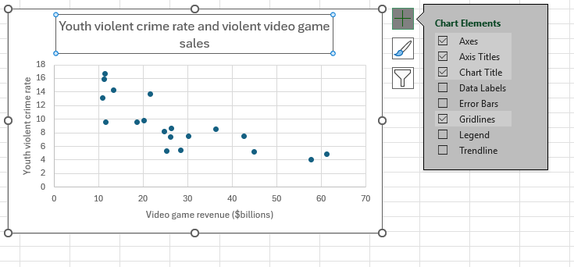
- To display the equation of the least-squares regression line, ask students to:
- select the arrow next to Trendline
- select More Options…
- select the checkbox next to Display Equation on chart.
- Using the equation of the least-squares regression line, ask students to calculate when the youth violent crime rate would be zero.
Students should get an equation for the least-squares regression line of $y=-0.1965x+14.631$. The value when the youth violent crime rate is zero is when there is approximately $74.46 billion generated in video game revenue.
- Pose the following scenario to students:
Jeremiah said he saw a statistic claiming that when $60 billion in video game revenue was generated, the youth violent crime rate in America was 17 per 1000 youths.
- Ask students to add this data to the table of values in their spreadsheet: that is, when the video game revenue is 60, the youth violent crime rate is 17. They should then create a second scatter plot that includes this additional data point and add a trendline with its equation.
- In pairs, have students discuss what they notice and wonder (bit.ly/noticewonderstrategy).
Students may notice that the least-squares regression line has shifted. It now has more points below it than above and a smaller gradient. They may wonder what ordered pair may be added to create a least-squares regression line that no longer appropriately reflects the relationship between the 2 variables.
- Challenge students to adjust the value of the point $(60, 17)$ to create a least-squares regression line that no longer appropriately reflects the relationship between the 2 variables.
If students create a data point that is an outlier, the least-squares regression line will no longer sit close to the overall pattern of the dataset. To see an example, suggest changing the value of $(60, 17)$ to $(60, 60)$ on the spreadsheet.
- Initiate a class discussion to share examples and compare how different points affected the position of the regression line. Prompt students to describe what makes these points different from the rest of the data and how they influence the trendline.
Students should recognise that these points stand out from the overall pattern of the data and significantly influence the position of the regression line.
Reinforce that such points are called outliers, which are data values that are unusually high or low compared to the rest of the dataset.

Releasing responsibility
- Have students create notes to their future forgetful selves (bit.ly/notestofutureself) about:
- how to generate a least-squares regression line and display its equation using a spreadsheet
- how to decide when a least-squares regression line may be unreliable.

Independent practice
- Students select one of the following bivariate datasets to investigate.
- Hours studied and test scores
- Hours of exercise and resting heart rate
- Screen time and hours of sleep
- The gestation of a baby and their weight at birth
- Distance driven and amount of fuel used.
Each of these themes has a corresponding tab in the Modelling bivariate data using a spreadsheet file, which contains a bivariate dataset.
- Distribute Appendix B ‘Bivariate report’. Ask students to navigate to their selected tab in the spreadsheet and complete the report by following the instructions provided.

Assessment and differentiation

Suggested opportunities for differentiation
Activating prior knowledge
- Provide sentence stems, for example, ‘I agree/disagree because …’ to support students justifying their position.
- Allow students to work with a partner to discuss ideas before sharing with the class.
Connecting learning
- Provide a step-by-step scaffold for creating a scatter plot and adding a trendline in Excel to support students following the process.
- Support students by focusing on interpreting the least-squares regression line before introducing the impact of adding new data points or outliers.
- Extend students by asking them to justify how and why an outlier affects the least-squares regression line.
Releasing responsibility
- Provide a scaffold or template for the notes to support students organising their ideas.
- Extend students by asking them to include examples or contexts to justify when each linear model is more appropriate.
Independent practice
- Provide a scaffold or structure for the bivariate report to support students organising their investigation and responses.

Mathematics Standard 1 adjustments and considerations
Mathematics Standard 1 students do not need to complete any work on creating a least-squares regression line using a spreadsheet. As this is the basis of this lesson, this lesson could be removed if you have a standalone Mathematics Standard 1 class.
Alternatively, if you have a combined Mathematics Standard 1 and 2 class, you could modify this lesson for Mathematics Standard 1 students by supplying them with the spreadsheet Modelling bivariate data using a spreadsheet – solutions to complete questions about interpolating and extrapolating using the line of best fit from the Independent practice section of the lesson.

Suggested opportunities for assessment
Activating prior knowledge
- Observe student responses during discussion to assess their ability to describe association using form, direction and strength.
Connecting learning
- Observe students constructing scatter plots and least-squares regression lines to assess correct use of Excel tools and data representation.
- Ask students to explain how adding a new data point affects the least-squares regression line to assess their understanding of outliers and model sensitivity.
Releasing responsibility
- Review students’ notes to assess their understanding of how to generate and interpret a least-squares regression line.
Independent practice
- Review bivariate reports to assess students’ ability to construct, interpret and evaluate regression models in context.

Appendix A

Save a local copy of a file
How to save a local copy of an Excel spreadsheet.

File sharing and saving
- Save the Excel file Modelling bivariate data using a spreadsheet in a place where students can easily access the file.
This could be done through Google Classroom, by sharing a OneNote link or by emailing students a copy of the document.
- Have students open the document on their own digital device.
- Instruct students to select the File tab and then Save a Copy.
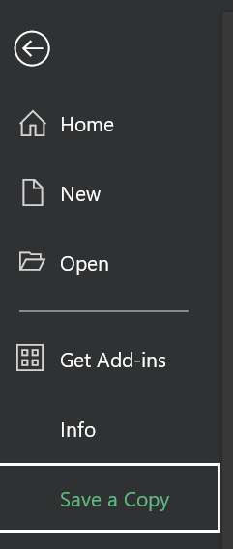
- Students can save the document in their individual OneDrive by selecting this option.
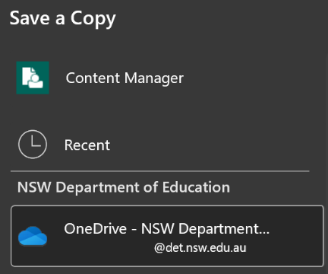
- Best practice would be to keep the file name the same. Students can then select Save and a copy will be stored on their OneDrive.

Appendix B

Bivariate report
- State your independent and dependent variables.
- Explain how you determined which variable is independent and which is dependent, using the context of the data.
- Create a scatter plot and include a least-squares regression line.
- Describe the form of the association.
- Find the value of the correlation coefficient.
- Explain what the correlation coefficient means for this association and how it affects the reliability of the least-squares regression line.
- Do you think the relationship between the variables may be described as causal? Justify your reasoning.
- State the equation of the least-squares regression line.
- What do the gradient and $y$-intercept mean in this context?
- What are some limitations of this model?
- Use the least-squares regression line to interpolate a value and comment on the reliability of your prediction.
- Use the least-squares regression line to extrapolate a value and comment on the reliability of your prediction.

Sample solutions

Appendix B – bivariate report
The graphs and correlation coefficients for each of the datasets can be found in the Modelling bivariate data using a spreadsheet – solutions spreadsheet. A completed sample solution for ‘Hours studied–test score’ tab can be found below.
- Independent variable: Hours of study
Dependent variable: Test score (%)
- Hours of study is the independent variable because it is the factor that can be controlled or changed by the student. Test score depends on how much a student studies, so it is the dependent variable.

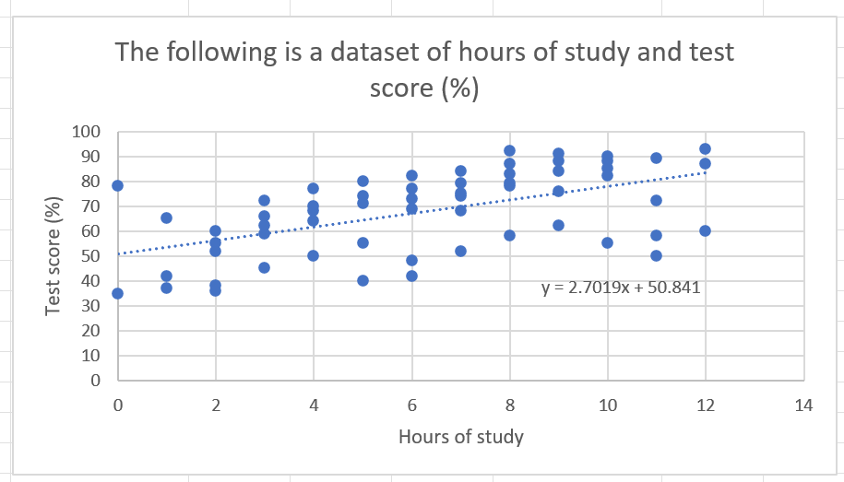

- The association is approximately linear with a positive direction, but there is noticeable scatter around the trend. This indicates that while a linear model is appropriate, it does not perfectly represent the relationship.
- $r≈0.55$ (correct to 2 decimal places).
- The correlation coefficient indicates a moderate positive linear relationship between hours of study and test score. This means as study hours increase, test scores tend to increase. However, the relationship is not strong, as there is noticeable variation in scores for the same study time. Because the correlation is only moderate, the least-squares regression line provides a reasonable but not highly reliable model for prediction.
- The relationship may be described as partially causal, as increasing study time can improve understanding and lead to higher test scores. However, the relationship is not purely causal because other factors, such as prior knowledge, study quality, motivation and test conditions, can also influence performance. This is supported by the moderate correlation and the variation in scores for the same number of study hours.
- $y=2.7019+50.841$.
- Gradient: for each additional hour of study, the test score is predicted to increase by approximately 2.7 data points.
$y$-intercept: when a student studies 0 hours, the model predicts a test score of about 51%. This is reasonable in context, as some students may achieve moderate results without studying.
- This model has several limitations that affect its reliability:
- The correlation is only moderate, so predictions are not highly precise.
- There is significant variation in scores for the same number of study hours.
- The model does not account for other influencing factors such as ability or study methods.
- There are outliers that do not follow the overall trend.
- The linear model may not fully represent the relationship.
- If a student studies for 6 hours:
$$y = 2.7019\left(6\right)+50.841 \\ ≈67.05$$
Predicted test score $≈67.05\%$.
Reliability: this is reasonably reliable because 6 hours is within the data range. However, due to the moderate correlation and variation in the data, the actual score may differ.
- If a student studies for 15 hours:
$$y=2.7019\left(15\right)+50.841 \\ ≈91.4\%$$
Predicted test score $≈ 91.4\%$.
Reliability: this is unreliable because 15 hours is outside the data range which means the prediction is an extrapolation. The model assumes the relationship continues beyond the observed data, which may not be valid.

References
This resource contains NSW Curriculum and syllabus content. The NSW Curriculum is developed by the NSW Education Standards Authority. This content is prepared by NESA for and on behalf of the Crown in right of the State of New South Wales. The material is protected by Crown copyright.
Please refer to the NESA Copyright Disclaimer for more information https://educationstandards.nsw.edu.au/wps/portal/nesa/mini-footer/copyright.
NESA holds the only official and up-to-date versions of the NSW Curriculum and syllabus documents. Please visit the NSW Education Standards Authority (NESA) website https://educationstandards.nsw.edu.au/ and the NSW Curriculum website https://curriculum.nsw.edu.au/.
Mathematics Standard 11–12 Syllabus © NSW Education Standards Authority (NESA) for and on behalf of the Crown in right of the State of New South Wales, 2024.
Numeracy Stage 6 (CEC) Syllabus © NSW Education Standards Authority (NESA) for and on behalf of the Crown in right of the State of New South Wales, 2021.

© State of New South Wales (Department of Education), 2026
The copyright material published in this resource is subject to the Copyright Act 1968 (Cth) and is owned by the NSW Department of Education or, where indicated, by a party other than the NSW Department of Education (third-party material).
Copyright material available in this resource and owned by the NSW Department of Education is licensed under a Creative Commons Attribution 4.0 International (CC BY 4.0) license.

This license allows you to share and adapt the material for any purpose, even commercially. Attribution should be given to © State of New South Wales (Department of Education), 2026.
Material in this resource not available under a Creative Commons license:
- the NSW Department of Education logo, other logos and trademark-protected material
- material owned by a third party that has been reproduced with permission. You will need to obtain permission from the third party to reuse its material.
Links to third-party material and websites
Please note that the provided (reading/viewing material/list/links/texts) are a suggestion only and implies no endorsement, by the New South Wales Department of Education, of any author, publisher, or book title. School principals and teachers are best placed to assess the suitability of resources that would complement the curriculum and reflect the needs and interests of their students.
If you use the links provided in this document to access a third-party's website, you acknowledge that the terms of use, including licence terms set out on the third-party's website apply to the use which may be made of the materials on that third-party website or where permitted by the Copyright Act 1968 (Cth). The department accepts no responsibility for content on third-party websites.

