Five-number summary
Students learn to calculate and interpret the five-number summary.
Students will need at least one digital device per pair to interact with Desmos or GeoGebra during this lesson.

Learning intention
- To be able to calculate and interpret the five-number summary from numerical data or graphical representations.

Success criteria
- I can identify and calculate the minimum value, quartiles and maximum value of a dataset displayed in a variety of ways.
- I can explain how cumulative frequency graphs are used to find quartiles.

Outcomes
A student:
- develops understanding and fluency in mathematics through exploring and connecting mathematical concepts, choosing and applying mathematical techniques to solve problems, and communicating their thinking and reasoning coherently and clearly MAO-WM-01
- displays and analyses datasets using summary statistics and graphical representations
MST-11-08

Content

Quartiles and interquartile range
- Determine the five-number summary from a set of numerical data or graphical representation

Five-number summary and box plots
- Determine quartiles from datasets displayed in histograms and dot plots, and represent these datasets as a box plot
Mathematics Standard 11–12 Syllabus © NSW Education Standards Authority (NESA) for and on behalf of the Crown in right of the State of New South Wales, 2024.

Table 1: lesson summary table
Section | Summary of activity | Teaching strategies | Teaching points
Activating prior knowledge | Use slide 5 of the PowerPoint five-number summary to display the raw data of 2 classes competing in the NSW Premier’s Sporting Challenge. Students discuss which class is doing ‘better’ considering measures of centre and spread. Use slides 6–10 to explore common misconceptions and errors when finding the median and quartiles, before students calculate the five-number summaries for the 2 classes. | Turn and talk  Incorrect worked examples  Think-Pair-Share  Pose-Pause-Pounce-Bounce  Visibly random groups of 3  Vertical non-permanent surfaces | Understanding and calculating the five-number summary (minimum, $Q_{1}$, median, $Q_{3}$, maximum).  Recognising and addressing common pitfalls in median and quartile calculations.
Connecting learning | Use slide 12 to introduce data for 2 additional classes displayed as a histogram and frequency table. Students discuss strategies for finding five-number summaries with non-list data and attempt to calculate the five-number summaries for the additional 2 classes. Use slide 13 showing data for a fifth class displayed in a cumulative frequency histogram and polygon. Students find the five-number summary and then compare and contrast how the different formats affected the way they found the 5 numbers. | Visibly random groups of 3  Vertical non-permanent surfaces | Interpreting data representations beyond lists. Strategies for finding medians and quartiles from frequency tables, frequency histograms and cumulative frequency histograms and polygon.
Releasing responsibility | Use slides 15–18 to model worked examples of five-number summary calculation from frequency histograms and tables before students review their earlier solution methods. Facilitate a class discussion to compare methods for different data formats. Use slide 19 to display and discuss finding the five-number summary from a cumulative frequency polygon. Distribute pre-cut and shuffled cards from Appendix A for students to match followed by a class discussion to deepen understanding of matching criteria. | Worked examples (Your turn)  Think-Pair-Share  Pose-Pause-Pounce-Bounce  Visibly random groups of 3  Vertical non-permanent surfaces | Understanding cumulative frequency polygons for quartile calculation. Critical evaluation of matching summary statistics with graphs.
Independent practice | Students are introduced to the ‘Approaching questions scaffold’ on slide 21 and then answer an HSC style question on slide 22. Students engage in a gallery walk and class discussion to compare solutions and reasoning. | Think-Pair-Share  HSC style question  Visibly random groups of 3  Vertical non-permanent surfaces  Gallery walk  Pose-Pause-Pounce-Bounce | Creating and interpreting parallel box plots digitally. Students apply the ‘Approaching questions scaffold’ to find a missing value from a dataset given the quartiles.

Activity structure
Please use the associated PowerPoint Five-number summary to display images in this lesson.

Activating prior knowledge
- Display slide 4 of the PowerPoint which shows the statistical investigation process. Explain that this lesson will focus on stages 3 and 4 of the process.
- Read the following scenario to students and use slide 5 of the PowerPoint to display the data for students.
Two classes are competing in the NSW Premier’s Sporting Challenge by tracking and recording their physical activity over a 10-week period as they aim to be active more often.
The data shows how many minutes of physical activity each person recorded for Week 1. Which class is doing better?
Class A
60, 280, 280, 280, 280, 300, 300, 300, 300, 300, 300, 300, 320, 320, 500
Class B
140, 160, 180, 200, 220, 240, 260, 280, 300, 320, 340, 360, 380, 400, 420
- Ask students to turn and talk (bit.ly/classroomtalkmoves) to discuss which class seems to be doing ‘better’ and why. Encourage them to think about measures of centre and spread. Some prompts could include:
- What measures tell us about typical values?
- What measures tell us about variation or consistency?

Doing ‘better’ could indicate several things and is intentionally left open to student interpretation. Interpretations include higher mean or median, less variation, highest individual achievement, greatest total sum or fewer lower values.
Students could calculate mean, median, range or other measures. Class A data consists of a tight cluster with a couple of extreme values that are a lot higher or lower than the other results. Class B data has a greater spread with no extreme values.
- Use slides 6–10 to identify common errors and misconceptions when calculating the median and quartiles by using the incorrect examples (bit.ly/incorrectworkedexamples) and self-explanation prompts. Give students a few moments to review each incorrect example before clicking to animate the slide for the self-explanation prompts to appear. Students should discuss the prompts using a Think-Pair-Share (bit.ly/thinkpairsharestrategy).
The NESA glossary defines a five (5)-number summary as ‘A method for summarising a dataset using 5 statistics: the minimum value, the lower quartile, the median, the upper quartile and the maximum value’. (NESA 2024)
The NESA glossary defines quartiles as ‘The values that divide an ordered dataset into 4 (approximately) equal parts. There are 3 quartiles. The first, the lower quartile ($Q_{1}$), divides off (approximately) the lower 25% of data values. The second quartile ($Q_{2}$) is the median. The third quartile, the upper quartile ($Q_{3}$), divides off (approximately) the upper 25% of data values’. (NESA 2024)
The five-number summary was originally taught in Stage 5 Lesson 4 – four equal groups of Unit 8 – making decisions.
Slide 5: models a student forgetting to reorder data in ascending order.
Slide 6: models a student not finding the average of the middle 2 values when there is an even number of data points in a set.
Slide 7: models a student calculating the median by finding the average of the minimum and maximum.
Slide 8: models a student including the median when calculating quartile 1 from a dataset with an odd number of scores.
Slide 9: models a student not including the middle values when calculating the quartiles from a dataset with an even number of scores.
- Use the Pose-Pause-Pounce-Bounce questioning strategy (PDF 557 KB) (bit.ly/posepausepouncebounce) to guide students to reflect critically on the following question: What strategies can help you to avoid these common mistakes when creating a five-number summary?
Encourage students to always start by ordering their data from smallest to largest. Remind them to carefully determine whether the dataset has an odd or even number of values, so they know when to average middle numbers for the median and how to correctly calculate quartiles, especially whether to include or exclude the median. Suggest using a simple step-by-step checklist to follow each time. Prompt students to explain their reasoning clearly and double-check their calculations to catch errors early.
- Assign students to visibly random groups of 3 (bit.ly/visiblegroups) at vertical non-permanent surfaces (bit.ly/VNPSstrategy).
- Redisplay slide 5 and have students determine the five-number summary for both Class A and Class B.
Class A: Minimum = 60, $Q_{1}$ = 280, Median ($Q_{2}$) = 300, $Q_{3}$ = 300, Maximum = 500
Class B: Minimum = 140, $Q_{1}$ = 200, Median ($Q_{2}$) = 280, $Q_{3}$ = 360, Maximum = 420
The five-number summaries should be left on the vertical non-permanent surfaces for later use.

Connecting learning
- Explain to students that there are 2 more classes, Class C and Class D, which are also participating in the challenge.
- Use slide 12 of the PowerPoint to display the data. Class C data is shown in a histogram and Class D data is presented as a frequency table.
- Continuing in their groups of 3, encourage students to discuss strategies for finding the five-number summary when data is not presented as a list. Some prompts could include:
- How does the histogram help you find the quartiles?
- What strategies could you use to find the five-number summary using the frequency table?
Students might suggest extracting the data from the graph and table as a dataset before finding the quartiles. Students might also suggest using cumulative frequency to help find the quartiles.
- Ask groups to analyse the data representations and to calculate the five-number summary for each class.
- A final class joins the challenge. Their results, displayed as a cumulative frequency histogram and polygon are shown on slide 13. Ask groups to find the five-number summary of this new group, Class E.
- Facilitate a class discussion comparing the five-number summaries across all 5 classes to highlight how different data representations (list, histogram, frequency table and cumulative frequency histogram) can be used to find the same summary statistics. Some prompts could include:
- How did the different formats affect the way you found the median and upper and lower quartiles?
- Which format did you find easier or more challenging to work with?
- Looking at the five-number summaries, how might these summaries help us understand which class is performing better or differently in the Premier’s Sporting Challenge?
Students are explicitly shown how to find the five-number summary from a cumulative frequency graph in the Releasing responsibility section of the lesson. Students could be given time to adjust their answers for Classes A–E after completing the worked examples, and the class discussion could follow.

Releasing responsibility
Bring the class together and use slides 15–18 of the PowerPoint to model finding a five-number summary from a frequency histogram and frequency table using the Worked examples (Your turn) method (bit.ly/supportingstrategies).
Click to animate the Worked example slides to display the self-explanation prompts and Your turn slides for solutions.
Students may benefit from extra practice calculating the five-number summary using numerical datasets or various graphical representations available in existing resources.
- Facilitate a class discussion to compare the methods that groups used to calculate the five-number summaries for Classes C and D to the methods modelled. Discuss the advantages and disadvantages of any correct methods.
Class C: Minimum = 300, $Q_{1}$ = 320, Median ($Q_{2}$) = 340, $Q_{3}$ = 360, Maximum = 400
Class D: Minimum = 200, $Q_{1}$ = 280, Median ($Q_{2}$) = 280, $Q_{3}$ = 320, Maximum = 380
The five-number summaries should be left on the vertical non-permanent surfaces for later use.
- Use slide 19 to display an example of a five-number summary for a cumulative frequency histogram and polygon. Allow students time to observe the image and discuss the prompts using a Think-Pair-Share. Guide students to understand the process for finding each of the values in the five-number summary.
The minimum and maximum values can be read easily from the horizontal axis. To find the quartiles, draw a horizontal line marking off 25%, 50% and 75% of the data (for example, at positions 10, 20 and 30). The points at which these horizontal lines intersect with the cumulative frequency polygon (ogive) will give a value for each of the quartiles.
Teachers will need to help students unpack why $Q_{3}=7.5.$Students need to realise that the horizontal line for $Q_{3}$ at 30, hits the cumulative frequency polygon at the point in between the 7 and 8 columns. This is equivalent to the thirtieth value being a 7 and the thirty-first value being an 8 in a list of data, so $Q_{3}$ will fall halfway between these values.
- Use the Pose-Pause-Pounce-Bounce questioning strategy to discuss the question: How does this help in calculating the quartiles for large datasets?
Students should identify that displaying data in the cumulative frequency graph makes it easier to read off the quartiles, rather than having to order a large number of values into a list and then count to divide it up into quartiles.
- Students may benefit from extra practice calculating the five-number summary using cumulative frequency graphs available in existing resources.
- After returning students to their workspaces, distribute Appendix A ‘Card sort’ to each pair of students.
The cards should be cut prior to the lesson and shuffled as the activity is already in matching order.
- Instruct students to match each ‘graph’ card to the corresponding ‘five-number summary’ card.
- Use the Pose-Pause-Pounce-Bounce questioning strategy to discuss as a class:
- Which cards were easier to match up?
- What made them easier to match up?
- Did any cards have the same value as more than one other card?
- What additional values were used to determine which cards correctly match together?
- Students may benefit from additional practice from an existing resource, particularly finding five-number summaries where values fall between 2 data values.

Independent practice
- Use slide 21 to unpack the ‘Approaching questions scaffold’ with students.
The ‘Approaching questions scaffold’ offers students a structured scaffold to approach questions. Each stage is accompanied by an icon that corresponds to different aspects of the process.
- Assign students to new visibly random groups of 3 at vertical non-permanent surfaces.
- Display the following HSC style question on slide 22 for students to complete.
Burt's watch has tracked the number of hours he slept each night for the last 7 nights (rounded to the nearest whole number).
7, 6, 8, 7, 5, 9, …
His watch display was not large enough to show the last record, but it told him the median ($Q_{2}$) is 7 hours. He was also able to see that $Q_{1}$ is 6 hours and $Q_{3}$ is 8 hours.
Find possible values for the missing piece of data and justify your answer mathematically.
From this, students can reason:
- ordering gives 5, 6, 7, 7, 8, 9, ? – the missing piece of data could be in various positions
- for $Q_{2}$ = 7, the 4th value must remain as 7
- for $Q_{1}$ = 6, the first 3 values must give a median of 6
- for $Q_{3}$ = 8, the last 3 values must give a median of 8.
Valid solutions: 6, 7 or 8.
- Students complete a gallery walk (bit.ly/DLSgallerywalk) of each other’s solutions. Ask them to observe if the other groups shared any similarities with their approach and which groups had differences. Some suggested prompts include:
- What assumptions were made?
- Which solution paths were most efficient or clear?
- Could we explain our thinking algebraically?
- Check for understanding by using the Pose-Pause-Pounce-Bounce questioning strategy to discuss:
- Was there any variety in solutions?
- What approaches did other groups take to arrive at their solution?

Assessment and differentiation

Suggested opportunities for differentiation
Activating prior knowledge
- Provide a step-by-step calculation guide or checklist to find a five-number summary for students needing more structure.
- For the incorrect worked examples, extend students beyond explaining why an incorrect method fails to also propose a corrected version.
Connecting learning
- Encourage students to begin by listing the data as raw data for students needing more structure.
- Use a variety of prompts to guide group discussions based on students’ understanding and readiness.
Releasing responsibility
- If students are unable to move forward, provide hints for Appendix A. For example, highlight values for students to focus on.
Independent practice
- Students could be challenged to find all solutions for the HSC style question.
- The HSC style question could be altered to allow students to consider part hours for the number of hours of sleep. For instance, 8.5 or 7.25.
- Extend students to create their own question like the HSC style question on slide 21 to challenge their peers.

Suggested opportunities for assessment
Activating prior knowledge
- Monitor pair and group discussions to assess understanding of calculating quartiles.
- Review group-calculated five-number summaries for accuracy and reasoning.
- Use mini whiteboards for the incorrect worked examples for students to correct misconceptions live.
Connecting learning
- While students work in groups, circulate and ask probing questions about their strategies for finding medians and quartiles from the histogram and frequency table. Take notes on their reasoning, identifying misconceptions or gaps.
Releasing responsibility
- Call on students to explain one step in a worked example.
- Observe group justifications and any potential misconceptions during the card sort.
Independent practice
- Use various prompts during group and class discussions to probe depth of understanding and identify misconceptions.

Appendix A

Card sort
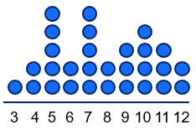 | $$Minimum = 3 \\ Q_{1} = 5 \\ Median = 7 \\ Q_{3} = 10 \\ Maximum = 12$$
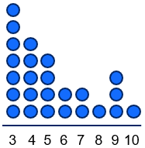 | $$Minimum = 3 \\ Q_{1} = 3 \\ Median = 5 \\ Q_{3} = 7 \\ Maximum = 10$$
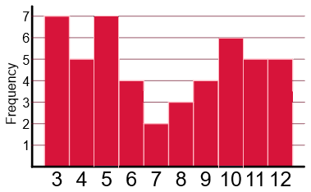 | $$Minimum = 3 \\ Q_{1} = 4.5 \\ Median = 7 \\ Q_{3} = 10 \\ Maximum = 12$$
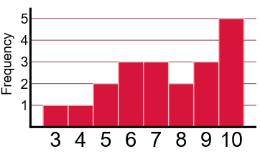 | $$Minimum = 3 \\ Q_{1} = 6 \\ Median = 7.5 \\ Q_{3} =9.5 \\ Maximum = 10$$
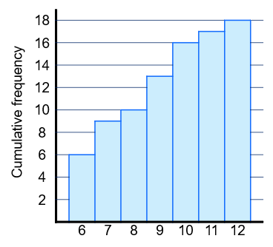 | $$Minimum = 6 \\ Q_{1} = 6 \\ Median = 7.5 \\ Q_{3} =10 \\ Maximum = 12$$
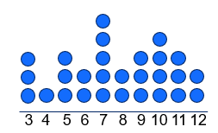 | $$Minimum = 3 \\ Q_{1} = 5.5 \\ Median = 7.5 \\ Q_{3} =10 \\ Maximum = 12$$
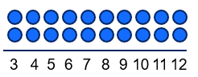 | $$Minimum = 3 \\ Q_{1} = 5 \\ Median = 7.5 \\ Q_{3} =10 \\ Maximum = 12$$
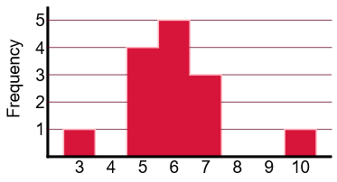 | $$Minimum = 3 \\ Q_{1} = 5 \\ Median = 6 \\ Q_{3} =7 \\ Maximum = 10$$
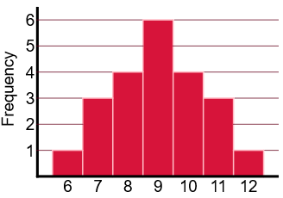 | $$Minimum = 6 \\ Q_{1} = 8 \\ Median = 9 \\ Q_{3} =10 \\ Maximum = 12$$
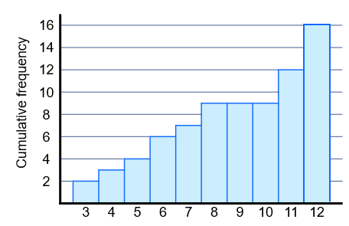 | $$Minimum = 3 \\ Q_{1} = 5.5 \\ Median =8 \\ Q_{3} =11.5 \\ Maximum = 12$$

References
This resource contains NSW Curriculum and syllabus content. The NSW Curriculum is developed by the NSW Education Standards Authority. This content is prepared by NESA for and on behalf of the Crown in right of the State of New South Wales. The material is protected by Crown copyright.
Please refer to the NESA Copyright Disclaimer for more information https://educationstandards.nsw.edu.au/wps/portal/nesa/mini-footer/copyright.
NESA holds the only official and up-to-date versions of the NSW Curriculum and syllabus documents. Please visit the NSW Education Standards Authority (NESA) website https://educationstandards.nsw.edu.au/ and the NSW Curriculum website https://curriculum.nsw.edu.au/.
Mathematics Standard 11–12 Syllabus © NSW Education Standards Authority (NESA) for and on behalf of the Crown in right of the State of New South Wales, 2024.

© State of New South Wales (Department of Education), 2025
The copyright material published in this resource is subject to the Copyright Act 1968 (Cth) and is owned by the NSW Department of Education or, where indicated, by a party other than the NSW Department of Education (third-party material).
Copyright material available in this resource and owned by the NSW Department of Education is licensed under a Creative Commons Attribution 4.0 International (CC BY 4.0) license.

This license allows you to share and adapt the material for any purpose, even commercially.
Attribution should be given to © State of New South Wales (Department of Education), 2025.
Material in this resource not available under a Creative Commons license:
- the NSW Department of Education logo, other logos and trademark-protected material
- material owned by a third party that has been reproduced with permission. You will need to obtain permission from the third party to reuse its material.
Links to third-party material and websites
Please note that the provided (reading/viewing material/list/links/texts) are a suggestion only and implies no endorsement, by the New South Wales Department of Education, of any author, publisher, or book title. School principals and teachers are best placed to assess the suitability of resources that would complement the curriculum and reflect the needs and interests of their students.
If you use the links provided in this document to access a third-party's website, you acknowledge that the terms of use, including licence terms set out on the third-party's website apply to the use which may be made of the materials on that third-party website or where permitted by the Copyright Act 1968 (Cth). The department accepts no responsibility for content on third-party websites.

