Solving simultaneous equations algebraically – part 2
Students learn how to solve simultaneous linear equations using algebraic methods in the context of organising a music festival. They firstly use bar models and then translate these into algebraic methods, using equations in the form $ax+by=c$.

Learning intention
- To be able to solve pairs of simultaneous linear equations using algebraic methods.

Success criteria
- I can represent a pair of simultaneous linear equations using a bar model.
- I can solve a pair of simultaneous linear equations using algebraic methods.
- I can choose an appropriate method to solve a pair of simultaneous linear equations.
- I can interpret the solution in the context of the problem.

Outcomes

Mathematics Standard 2 outcomes
A student:
- develops understanding and fluency in mathematics through exploring and connecting mathematical concepts, choosing and applying mathematical techniques to solve problems, and communicating their thinking and reasoning coherently and clearly MAO-WM-01
- represents the relationships between quantities algebraically and graphically to solve problems and make predictions in practical contexts MST-12-S2-01
Mathematics Standard 11–12 Syllabus © NSW Education Standards Authority (NESA) for and on behalf of the Crown in right of the State of New South Wales, 2024.

Associated Numeracy outcomes
A student:
- recognises and applies functional numeracy concepts in practical situations, including personal and community, workplace and employment, and education and training contexts N6-1.1
- applies numerical reasoning and mathematical thinking to clarify, efficiently solve and communicate solutions to problems N6-1.2
- determines whether an estimate or an answer is reasonable in the context of a problem, evaluates results and communicates conclusions N6-1.3
- chooses and applies appropriate operations with whole numbers, familiar fractions and decimals, percentages, rates and ratios to analyse and solve everyday problems N6-2.1
- chooses and applies appropriate numeracy operations and techniques to analyse and resolve everyday situations N6-2.6
Numeracy Stage 6 (CEC) Syllabus © NSW Education Standards Authority (NESA) for and on behalf of the Crown in right of the State of New South Wales, 2021.

Content

Mathematics Standard 2
Simultaneous linear equations
- Solve a pair of simultaneous linear equations using graphical and algebraic methods
- Solve practical problems that involve simultaneous linear equations
Mathematics Standard 11–12 Syllabus © NSW Education Standards Authority (NESA) for and on behalf of the Crown in right of the State of New South Wales, 2024.

Table 1: lesson summary
Section | Summary of activity | Teaching strategies | Teaching points
Activating prior knowledge | Using slide 4 of the PowerPoint Solving simultaneous equations algebraically – part 2, students interpret the equations in context and attempt to solve the pair of simultaneous equations. The graph is animated to discuss the meaning of the point of intersection. | Think-Pair-Share | Surface students' existing strategies before introducing a new algebraic method. Ensure students can connect the equations and graph to the given context.
Connecting learning | Use Appendix A to compare solution strategies. Students then complete a banner task (Appendix B). End the task by highlighting the limitations of their existing methods. | Worked examples – comparison  Pose-Pause-Pounce-Bounce  Visibly random groups of 3  Vertical non-permanent surfaces  Banner task | Students should build their understanding of different solution methods for solving simultaneous equations. Bar models assist with conceptual understanding.
Releasing responsibility | Using slides 6–9, model the worked examples. Slides 10–11 are used to connect the algebraic solution to graphical representations. Slide 12 introduces students to the method of adding equations to solve. Students then complete Appendix C as notes. | Worked examples (Your turn)  Notes to future forgetful selves | Students are introduced to another method of solving; however, emphasis is placed on the fact that they do not have to use this method and may instead use substitution. Have students check their solution through substitution into the equations.
Independent practice | Use slide 14 to remind students of the ‘Approaching questions’ scaffold. Students complete Appendix D. |  | Encourage students to use a method of their choosing and to communicate their answers in context.

Activity structure
Please use the associated PowerPoint Solving simultaneous equations algebraically – part 2 to display images in this lesson.

Activating prior knowledge
- Verbally pose the following scenario:
Organisers of a music festival have determined a total of 1500 attendees. The venue allocates space in 2 areas: General admission (standing area) and the seated area.
The venue only has 2400 m² of useable floor space. Safety standards require an allocation of space, with each general admission attendee using 1 m² and each seated attendee using 2 m².
- Use slide 4 of the PowerPoint to display further details, including 2 equations that describe the scenario.
- In a Think-Pair-Share (bit.ly/thinkpairsharestrategy), have students interpret what each equation represents in the context of the festival, linking the mathematical relationships to the total number of attendees and the venue floor space requirements.
Students should recognise that $x+y=1500$ represents the total number of attendees, while
$x+2y=2400$ represents the total floor space used by the 2 ticket areas.
- In pairs, ask students to attempt to solve the pair of simultaneous linear equations using a method of their choice.
Allow time for productive struggle. Students may choose to graph the 2 equations, use bar models or rearrange the equations to make $x$ or $y$ the subject and solve algebraically. Students learned how to solve a pair of simultaneous linear equations of the form $y=mx+c$ algebraically in Lesson 7 – solving simultaneous linear equations algebraically – part 1.
- Animate slide 4 to display the graph of the 2 equations so students can compare the graphical solution with the methods they may have used to attempt to solve the equations.
- Discuss as a class what the point of intersection represents in this context.
Students should recognise that the point of intersection identifies the number of general admission attendees and seated attendees that satisfy both conditions at the same time: a total of 1500 attendees and 2400 m² of floor space used.

Connecting learning
- Provide students with Appendix A ‘Worked example – comparison’ (bit.ly/supportingstrategies). In pairs, students examine and discuss 2 different methods for solving a pair of simultaneous linear equations: a bar model and an algebraic approach.
- Use the Pose-Pause-Pounce-Bounce questioning strategy (bit.ly/P-P-P-B) to facilitate a class discussion about the 2 methods. Emphasise that both the bar model and algebraic approach are valid ways to solve the same pair of simultaneous linear equations, and that students should choose the method that makes the most sense to them. Some suggested prompts include:
- Which method makes the most sense to you and why?
- Why might the equation have been rearranged in the algebraic method?
- Is that the only way the equation could have been rearranged?
- Why are the bar models different lengths, and how do they connect to the equations?
Students have not yet been introduced to solving by elimination. This method will be explored in the ‘Releasing Responsibility’ section of the lesson. However, if students are already familiar with it, they may use any method they are confident using.
- Assign students to visibly random groups of 3 (bit.ly/visiblegroups) at vertical non-permanent surfaces (bit.ly/VNPSstrategy).
- Use Appendix B ‘Banner task’ as the set of questions for a banner task activity (bit.ly/supportingstrategies) on solving a pair of simultaneous linear equations using bar models.
- Conclude the activity by giving groups a question from Set 5 that includes a negative value.
The bar model becomes increasingly difficult to use when either $a$ or $b$ are negative value(s) for the equation $ax+by=c$. Students may also find making $x$ or $y$ the subject challenging in Set 3. Allow time for productive struggle only.

Releasing responsibility
- If a group of 3 students successfully used bar models or algebraic methods to solve a pair of simultaneous linear equations from Set 3, 4 or 5, gather the class at the group’s vertical non-permanent surface to work through and discuss their solution.
- Explain to the class that there is an alternate algebraic method that can be used to solve pairs of simultaneous linear equations, which does not require rearranging an equation.
- Use slides 6–9 to model an alternate algebraic method using the Worked examples (Your turn) method (bit.ly/supportingstrategies).
NESA’s teaching advice states that when solving a pair of simultaneous linear equations algebraically, either the substitution or elimination method can be used. Students should be encouraged to use the method they are most confident using. For each of the worked examples shown on slides 6–9, show an alternate algebraic method. That is, make $x$ or $y$ the subject and solve.
- Use slides 10–11 to conceptually unpack what the solution to the previous 2 worked examples represents in relation to the 2 equations. Students should understand that the solution is the values for $x$ and $y$ that satisfy both equations, as well as the point of intersection when the 2 equations are graphed.
- Students may benefit from completing further practice questions where the pair of simultaneous linear equations are of the form $ax+by=c$, and the questions can be solved by subtracting the equations or using substitution.
- Slide 12 contains a worked example where the simultaneous linear equations can be solved by adding the equations together. Use this example when students are ready to extend their understanding of this method. Animate the slide to display the self-explanation prompts.
Demonstrate how the same pair of equations can be solved by rearranging one equation and using substitution, so students can compare the 2 approaches.
- Distribute Appendix C ‘Strategies for solving simultaneous equations.’ Students are to use 4 different methods to solve a given pair of equations. Students should be encouraged to annotate their work to act as notes to their future forgetful selves (bit.ly/notestofutureself), noting their preferred method for solving.

Independent practice
- Use slide 14 to remind students of the ‘Approaching questions scaffold’ and encourage students to use this as well as their annotated notes to solve the questions in this section.
- Distribute Appendix D ‘Contextual problems’ for students to independently solve simultaneous linear equations using a method of their choice. The first question is the initial problem shown in the ‘Activating prior knowledge’ section of this lesson. Students should:
- identify what each variable represents in context
- solve the pair of simultaneous linear equations
- interpret the solution in relation to the scenario
- compare their method with a partner, discussing similarities and differences in their approaches.

Assessment and differentiation

Suggested opportunities for differentiation
Activating prior knowledge
- Provide partially completed bar models for students requiring support.
- Ask confident students to justify why the point of intersection satisfies both conditions simultaneously.
Connecting learning
- Encourage students requiring support to focus on Set 1 and Set 2 questions in Appendix B before progressing.
- Challenge advanced students to explain limitations of bar models when negative values occur.
Releasing responsibility
- Continue allowing students to solve using substitution if elimination is too challenging.
- Use worked examples with direct subtraction before introducing examples requiring addition.
- Extend advanced students by having them compare the efficiency of substitution and elimination across multiple examples.
Independent practice
- Allow students to choose their preferred solution method.
- Extend confident students by requiring them to solve using 2 methods and compare efficiency.

Mathematics Standard 1 adjustments and considerations
Mathematics Standard 1 students do not need solve a pair of simultaneous linear equations using algebraic methods. As this is the basis of this lesson, this lesson could be removed if you have a standalone Mathematics Standard 1 class.
Alternatively, if you have a combined Mathematics Standard 1 and 2 class, you could modify this lesson for Mathematics Standard 1 students by providing them with Cartesian planes or allowing graphical applications to be used when solving problems.

Suggested opportunities for assessment
Activating prior knowledge
- Listen to Think–Pair–Share discussions to assess understanding of what each equation, variable and the point of intersection represents.
Connecting learning
- Use Pose-Pause-Pounce-Bounce responses to assess conceptual understanding.
- Review completed banner task solutions and explanations.
Releasing responsibility
- Ask students to justify why adding or subtracting eliminates a variable.
- Review annotations on Appendix C.
Independent practice
- Collect Appendix D responses to assess students' ability to:
- define variables
- form or interpret equations
- solve accurately
- interpret solutions in context.
- Listen to partner discussions comparing methods.

Appendix A

Worked example – comparison
Solve the pair of simultaneous equations:
$$x+y=1500$$
$$x+2y=2400$$
Method 1: bar models | Method 2: algebraic method
Convert equations to bar models:  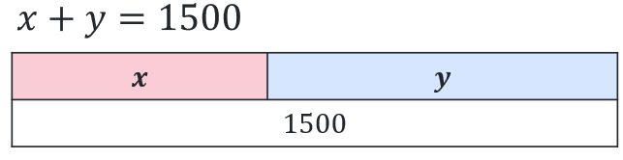  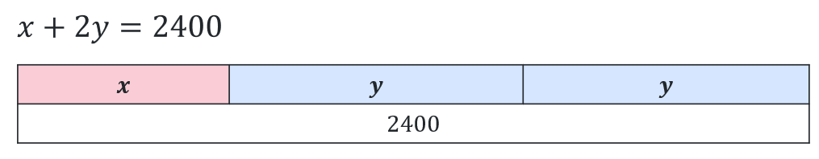 | $$x+y=1500$$  $$x+2y=2400$$
Compare and combine the equations:  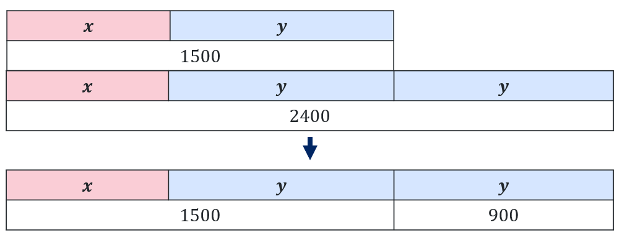 | $$x+y=1500 \\ x+y+y=2400 \\ x+y+y=1500+900$$
Solve for 1 variable:   | $$\left(1500\right)+y=1500+900 \\ y=900$$
Solve for the 2nd variable:  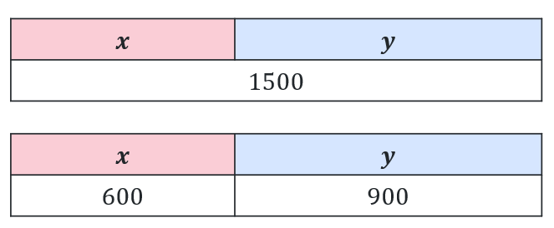 | $$x+y=1500 \\ x+900=1500 \\ x=1500-900 \\ x=600$$
Answer the question:  $x=600$ and $y=900$ | $x=600$ and $y=900$

Appendix B

Banner task
Set 1
- $x+y=10$ and $x+2y=16$ $(4, 6)$
- $x+y=12$ and $2x+y=17$ $(5, 7)$
- $x+y=8$ and $3x+y=14$ $(3, 5)$
- $x+y=20$ and $x+4y=36$ $\left(\frac{44}{3},\frac{16}{3}\right)$
Set 2
- $2x+y=13$ and $x+3y=14$ $(5, 3)$
- $4x+y=22$ and $x+5y=15$ $(5, 2)$
- $2x+3y=17$ and $x+4y=16$ $(4, 3)$
- $2x+y=7$ and $x+2y=5$ $(3, 1)$
Set 3
- $2x+y=11$ and $3x+5y=27$ $(4, 3)$
- $x+4y=18$ and $5x+3y=39$ $(6, 3)$
- $x+2y=14$ and $3x+4y=34$ $(6, 4)$
- $3x+y=13$ and $2x+7y=41$ $\left(\frac{50}{19},\frac{97}{19}\right)$
Set 4
- $2x+3y=19$ and $3x+5y=31$ $(2, 5)$
- $3x+4y=24$ and $5x+2y=26$ $(4, 3)$
- $4x+2y=18$ and $3x+4y=22$ $\left(\frac{14}{5},\frac{17}{5}\right)$
Set 5
- $x-y=5$ and $2x+y=13$ $(6, 1)$
- $2x-y=7$ and $x+3y=7$ $(4, 1)$
- $3x-2y=5$ and $x+y=5$ $(3, 2)$

Appendix C

Strategies for solving simultaneous equations
Bar model method  Solve the pair of simultaneous equations:  $$5x-y=14$$  $$2x+y=7$$ | Graphical method
Algebraic method 1 | Algebraic method 2

Appendix D

Contextual problems
- A music festival can have a maximum of 1500 attendees.
The venue has 2400 m² of useable floor space.
Safety standards require each general admission attendee $(x)$ to be allocated 1 m² and each seated attendee $(y)$ to be allocated 2 m².
The pair of equations is used to represent the scenario.
$x+y=1500$
$$x+2y=2400$$
Determine the number of general admission attendees and seated attendees that satisfies both conditions at the same time.
- At a sporting event, 2 different meal deals are sold:
- a standard meal containing 1 burger and 1 drink
- a deluxe meal containing 2 burgers and 1 drink.
During one lunch period 160 meal deals were sold. A total of 240 burgers were used altogether.
Let the number of standard meals sold be $x$ and the number of deluxe meals sold be $y$.
The situation can be represented by the equations:
$$x+y=160$$
$$x+2y=240$$
Determine the number of each meal deal sold. Interpret your solution in context.
- At a major sporting finals event, a merchandise stall sells:
- supporter packs containing 2 scarves and 1 cap
- premium packs containing 1 scarf and 3 caps.
By the end of the event 2100 scarves were sold and 2700 caps were sold altogether. Let $s$ be the number supporter packs sold and $p$ be the number of premium packs sold.
The situation can be represented by the equations:
$$2s+p=2100$$
$$s+3p=2700$$
Determine the number of supporter packs and premium packs sold. Interpret your solution in context.

Sample solutions

Appendix C – strategies for solving simultaneous equations
Bar model method  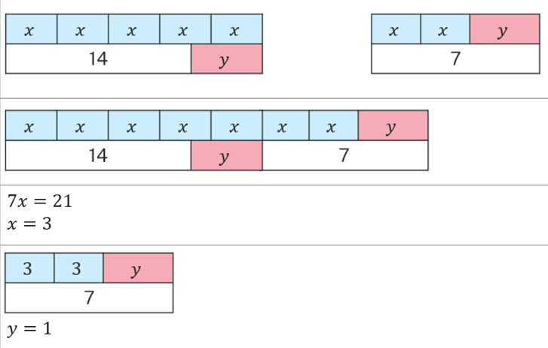  Solve the pair of simultaneous equations:  $$5x-y=14$$  $$2x+y=7$$  $$∴x=3, y=1$$ | Graphical method  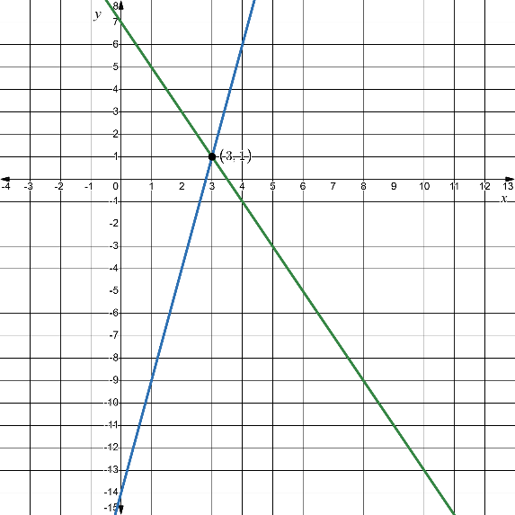  $$∴x=3, y=1$$
Algebraic method 1  $5x-y=14$ (1)  $2x+y=7$ (2)  Rearrange (2): $y=7-2x$  Substitute into (1):  $$5x-(7-2x)=14 \\ 5x-7+2x=14 \\ 7x-7=14 \\ 7x=21 \\ x=\frac{21}{7} \\ x=3$$  Substitute into (2):  $$2(3)+y=7 \\ y=1$$  $$∴x=3, y=1$$ | Algebraic method 2  $5x-y=14$ (1)  $2x+y=7$ (2)  $$\left(1\right)+(2)$$  $$5x+2x=14+7 \\ 7x=21 \\ x=\frac{21}{7} \\ x=3$$  Substitute into (2):  $$2(3)+y=7 \\ y=1$$  $$∴x=3, y=1$$

Appendix D – contextual problems
- $x+y=1500$ (1)$x+2y=2400$ (2)
$\left(2\right)-\left(1\right)$ :
$$2y-y=2400-1500 \\ y=900$$
Substitute into (1):
$$x+900=1500 \\ x=600$$
$∴$ There are 600 general admission attendees and 900 seated attendees.
- $x+y=160$ (1)$x+2y=240$ (2)
$$\left(2\right)-\left(1\right):$$
$$2y-y=240-160 \\ y=80$$
Substitute into (1):
$$x+80=160 \\ x=80$$
$∴$ There were 80 standard meal deals and 80 deluxe meal deals sold.

- $2s+p=2100$ (1)
$s+3p=2700$ (2)
$\left(2\right)×2$:
$2s+6p=5400$ (3)
$2s+p=2100$ (1)
$\left(3\right)-(1)$:
$$6p-p=5400-2100 \\ 5p=3300 \\ p=660$$
Substitute into (1):
$$2s+660=2100 \\ 2s=2100-660 \\ 2s=1440 \\ s=\frac{1440}{2} \\ s=720$$
$∴$ 720 supporter packs and 660 premium packs were sold.

References
This resource contains NSW Curriculum and syllabus content. The NSW Curriculum is developed by the NSW Education Standards Authority (NESA). This content is prepared by NESA for and on behalf of the Crown in right of the State of New South Wales. The material is protected by Crown copyright.
Please refer to the NESA Copyright Disclaimer for more information https://www.nsw.gov.au/education-and-training/nesa/copyright.
NESA holds the only official and up-to-date versions of the NSW Curriculum and syllabus documents. Please visit NESA https://www.nsw.gov.au/education-and-training/nesa and NSW Curriculum https://curriculum.nsw.edu.au.
Mathematics Standard 11–12 Syllabus © NSW Education Standards Authority (NESA) for and on behalf of the Crown in right of the State of New South Wales, 2024.
Numeracy Stage 6 (CEC) Syllabus © NSW Education Standards Authority (NESA) for and on behalf of the Crown in right of the State of New South Wales, 2021.

© State of New South Wales (Department of Education), 2026
The copyright material published in this resource is subject to the Copyright Act 1968 (Cth) and is owned by the NSW Department of Education or, where indicated, by a party other than the NSW Department of Education (third-party material).
Copyright material available in this resource and owned by the NSW Department of Education is licensed under a Creative Commons Attribution 4.0 International (CC BY 4.0) license.

This license allows you to share and adapt the material for any purpose, even commercially. Attribution should be given to © State of New South Wales (Department of Education), 2026.
Material in this resource not available under a Creative Commons license:
- the NSW Department of Education logo, other logos and trademark-protected material
- material owned by a third party that has been reproduced with permission. You will need to obtain permission from the third party to reuse its material.
Links to third-party material and websites
Please note that the provided (reading/viewing material/list/links/texts) are a suggestion only and implies no endorsement, by the New South Wales Department of Education, of any author, publisher, or book title. School principals and teachers are best placed to assess the suitability of resources that would complement the curriculum and reflect the needs and interests of their students.
If you use the links provided in this document to access a third-party's website, you acknowledge that the terms of use, including licence terms set out on the third-party's website apply to the use which may be made of the materials on that third-party website or where permitted by the Copyright Act 1968 (Cth). The department accepts no responsibility for content on third-party websites.

