Solving simultaneous equations algebraically – part 1
Students learn how to solve simultaneous linear equations using algebraic methods in the context of organising a major sporting finals event. They first use bar models and then translate these into algebraic methods, with equations in the form $y=mx+c$.

Learning intention
- To be able to solve pairs of simultaneous linear equations using algebraic methods.

Success criteria
- I can represent a pair of simultaneous equations using a bar model.
- I can use a bar model to solve a pair of simultaneous equations.
- I can solve simultaneous equations algebraically.
- I can verify and interpret the solution in the context of a problem.

Outcomes

Mathematics Standard 2 outcomes
A student:
- develops understanding and fluency in mathematics through exploring and connecting mathematical concepts, choosing and applying mathematical techniques to solve problems, and communicating their thinking and reasoning coherently and clearly MAO-WM-01
- represents the relationships between quantities algebraically and graphically to solve problems and make predictions in practical contexts MST-12-S2-01
Mathematics Standard 11–12 Syllabus © NSW Education Standards Authority (NESA) for and on behalf of the Crown in right of the State of New South Wales, 2024.

Associated Numeracy outcomes
A student:
- recognises and applies functional numeracy concepts in practical situations, including personal and community, workplace and employment, and education and training contexts N6-1.1
- applies numerical reasoning and mathematical thinking to clarify, efficiently solve and communicate solutions to problems N6-1.2
- determines whether an estimate or an answer is reasonable in the context of a problem, evaluates results and communicates conclusions N6-1.3
- chooses and applies appropriate numeracy operations and techniques to analyse and resolve everyday situations N6-2.6
Numeracy Stage 6 (CEC) Syllabus © NSW Education Standards Authority (NESA) for and on behalf of the Crown in right of the State of New South Wales, 2021.

Content

Mathematics Standard 2
Simultaneous linear equations
- Solve a pair of simultaneous linear equations using graphical and algebraic methods
- Solve practical problems that involve simultaneous linear equations
Mathematics Standard 11–12 Syllabus © NSW Education Standards Authority (NESA) for and on behalf of the Crown in right of the State of New South Wales, 2024.

Table 1: lesson summary
Section | Summary of activity | Teaching strategies | Teaching points
Retrieval practice | Using slide 4 of the PowerPoint Solving simultaneous equations algebraically – part 1, students analyse incorrect examples. | Incorrect examples | Emphasise that identifying and correcting errors develops students' ability to monitor their own algebraic work and reduces mistakes when solving simultaneous equations later in the lesson.
Activating prior knowledge | Using slide 6, students interpret the graph, discuss the meaning of the gradient and intersection in context. They estimate the coordinates of the point of intersection. | Pose-Pause-Pounce-Bounce | The purpose of this section is to connect students’ prior knowledge of graphical solutions to the need for algebraic solutions, as graphs can lack accuracy. Reinforce that the gradient represents the rate of change in context.
Connecting learning | Using slide 8, students solve simultaneous equations using a bar model and compare their solution with a worked example. Students then complete a banner task using Appendix A. Slide 9 can be used as a partial solution for set 3. | Think-Pair-Share  Visibly random groups of 3  Vertical non-permanent surfaces  Banner task | This section builds conceptual understanding before introducing algebraic methods. Highlight the limitations of bar models, particularly when negative values are involved, to create a need for algebraic methods.
Releasing responsibility | Students compare bar model and algebraic approaches using Appendix B before looking at worked examples on slides 11–12. Use slides 13–14 to return to a previous problem for students to solve algebraically. Students then complete Appendix C, annotating it as notes. | Worked example – comparison  Worked example (Your turn)  Faded examples  Notes to future forgetful selves | The purpose of this section is to transition students from concrete representations to formal algebraic methods. Emphasise that because both equations equal $y$, the expressions can be set equal. Draw out the efficiency and precision of algebraic methods compared to graphical methods.
Independent practice | Use slide 16 to discuss the meaning of the variables, gradients, intercepts and point of intersection. Animate slide 16 to discuss changes to the scenario before students complete Appendix D. |  | The purpose of this section is to deepen understanding of how changes to linear equations affect simultaneous solutions. Encourage students to justify predictions and solutions using both algebraic reasoning and contextual understanding.

Activity structure
Please use the associated PowerPoint Solving simultaneous equations algebraically – part 1 to display images in this lesson.

Retrieval practice
- Display slide 4, which shows 5 incorrect examples related to algebraic manipulation and solving equations.
- In pairs, have students explain why each solution is incorrect and work together to determine the correct answer.
- As a class, discuss each incorrect example by selecting non-volunteer students to describe the error and explain the correction needed.
The purpose of this activity is to consolidate students’ understanding of the Stage 5 Algebraic techniques A outcome MA5-ALG-C-01 and the Year 11 Formulas and equations outcome
MST-11-01. It is designed to address common misconceptions prior to students solving simultaneous equations algebraically.

Activating prior knowledge
- Verbally present the scenario:
At a major sporting finals event, 2 revenue streams are being tracked over time. Food outlets and merchandise stands both generate income at steady rates during the event.
Students were introduced to cost and revenue that can be represented by linear equations in Lesson 06 – break-even point.
- Display slide 6, which shows the graphical representation of the scenario.
- Use the Pose-Pause-Pounce-Bounce questioning strategy (bit.ly/P-P-P-B) to consolidate students’ understanding of simultaneous equations solved graphically, with a focus on interpreting the gradient as a rate and explaining the meaning of the point of intersection in context. Some suggested prompts include:
- What does the gradient of each line represent in this context?
- Can you explain what the point of intersection tells us?
- Are the merchandise or food outlets more valuable to the club in the early stages of the event? How do you know?
Emphasise that the gradient of each line represents the revenue per minute and that the point of intersection shows when both quantities are equal and one situation begins to overtake the other.
- As a class, discuss what the point of intersection is in this scenario, noting that the exact value cannot be determined precisely from the graph alone. Record a few student estimates as they will revisit this scenario later in the lesson.
The solution is $(7, 350)$, although this cannot be accurately seen from the graph. Students should recognise that we need another method of solving simultaneous equations. Previously, students have learnt to use graphical methods and spreadsheets to solve simultaneous equations, in Lesson 5 – solving simultaneous equations graphically and Lesson 6 – break-even point.

Connecting learning
- Display slide 8, which displays 2 equations to be solved simultaneously:
$y=5x$ and $y=2x+21$
- Animate the slide to show 2 bar models representing each of the equations. In a Think-Pair-Share (bit.ly/thinkpairsharestrategy), have students use the bar models to solve the simultaneous equations.
Bar models were used to solve simultaneous equations in Year 9 Unit 6 – constant rates of change in Lesson 13 – simultaneous shopping and Lesson 14 – sums and differences.
- Provide students time to work through the problem using bar models, recognising that this approach is accessible to most students. Then animate the slide to show a possible solution using the bar models.
- Assign students to visibly random groups of 3 (bit.ly/visiblegroups) at vertical non-permanent surfaces (bit.ly/VNPSstrategy).
- Use Appendix A ‘Banner task’ to run a banner task activity (bit.ly/supportingstrategies) on solving simultaneous equations using bar models.
- Conclude the activity by giving groups a question from Set 3 that includes a negative value.
The bar model becomes increasingly difficult to use when $m$ or $c$ is a negative value for the equation $y=mx+c$. Allow time for productive struggle only.
- Slide 9 can be used to model how a bar model can represent a question from Set 3 and a partial solution. However, the focus of this lesson is on progressing students towards solving simultaneous equations algebraically.

Releasing responsibility
- Return students to their workspaces and distribute Appendix B ‘Worked example – comparison’ (bit.ly/supportingstrategies).
- In pairs, have students discuss the 2 methods shown for solving simultaneous equations, that is, bar models and algebraic methods. Ask students to compare the approaches and use the bar model to make sense of the algebraic steps.
- Use slides 11–12 to model how to solve simultaneous equations of the form $y=mx+c$ algebraically using the Worked examples (Your turn) strategy (bit.ly/supportingstrategies). Students should be encouraged to compare the bar model to the algebraic method if they need support.
- Display slide 13, which returns students to the ‘Activating prior knowledge’ graph that they estimated the point of intersection for. Ask students to solve the 2 equations provided simultaneously using a method of their choosing and to compare this answer to their initial estimate. The algebraic solution can be displayed using slide 14.
- Initiate a class discussion to highlight that graphical methods can sometimes be limiting, as graphs may not be drawn to scale or may not allow for precise values to be read accurately. Emphasise that, at times, bar models and algebraic methods provide more reliable and exact solutions.
- Distribute Appendix C ‘Faded worked examples’ (bit.ly/fadedexamplesstrategy) for students to complete.
- Have students annotate either Appendix B ‘Worked examples – comparison’ or Appendix C ‘Faded examples’ to act as notes to their future forgetful selves (bit.ly/notestofutureself).

Independent practice
- Display slide 16, which shows the graph, along with the equations, outlining the food outlet revenue compared to the merchandise revenue.
- Initiate a class discussion to revisit and interpret what each variable in the equations and the point of intersection represents in the context of food outlet versus merchandise revenue.
Students should recall that the gradients, 50 and 20, represent rates of revenue over time. This is $50 per minute for merchandise and $20 per minute for food outlets. The value 210 represents the pre-order of food purchased prior to the major sporting finals event.
The point of intersection represents the time when both revenue streams generate the same income during the event.
- Animate slide 16 to display an adjustment to the scenario. In a Think-Pair-Share, ask students to complete the question that accompanies the adjustment.
Students may choose to use the graph to answer this question or adjust the equation and solve algebraically. Both methods are valid and should be discussed as a class.
- Distribute Appendix D ‘Investigating changes’ which asks students to determine how different adjustments affect the time at which the 2 revenue streams generate equal income, and whether this time increases or decreases. For each adjustment students will:
- make a prediction, explaining to their partner their reasoning
- adjust the equations to suit the change in scenario and solve the equations
- answer the question about whether this change increases or decreases the time it takes for both revenues to generate the same income.
For each adjustment, students must return to the original equations before applying the change. Each scenario is treated independently and does not carry over from previous changes.

Assessment and differentiation

Suggested opportunities for differentiation
Activating prior knowledge
- Provide students with a copy of the graph annotated with the gradient and intercept values to support interpretation.
- Prompt students who require support with questions such as, ‘What does the graph tell us when $x=0$?’ and ‘Which line is increasing more quickly?’
Connecting learning
- Provide partially completed bar models for students requiring support.
- Extend students by asking them to explain how the bar model could be converted into an algebraic method.
- Challenge students to predict why negative gradients or intercepts make bar models less effective.
Releasing responsibility
- Challenge students to compare the efficiency and limitations of graphical, bar model and algebraic approaches.
Independent practice
- Students could use a graphing application to support them in Appendix D.
- Challenge students to explain their findings using the meaning of gradient and intercept rather than relying solely on calculations.

Mathematics Standard 1 adjustments and considerations
Mathematics Standard 1 students do not need to solve a pair of simultaneous linear equations using algebraic methods. As this is the focus of this lesson, this lesson could be removed if you have a standalone Mathematics Standard 1 class.
Alternatively, if you have a combined Mathematics Standard 1 and 2 class, you could modify this lesson for Mathematics Standard 1 students by providing them with Cartesian planes or allowing graphical applications to be used when solving problems.

Suggested opportunities for assessment
Activating prior knowledge
- Listen to student responses during Pose-Pause-Pounce-Bounce to assess understanding of gradient and intercept in context.
- Observe whether students correctly interpret the point of intersection as the solution to both equations.
Connecting learning
- Listen for explanations linking the equal quantities in the bar model to the point of intersection.
- Use the Set 3 negative value questions to identify students beginning to recognise limitations of the model.
Releasing responsibility
- Listen to pair discussions comparing bar models and algebraic methods.
- Observe whether students can explain why substituting one equation into another works.
Independent practice
- Assess the accuracy and justification of student predictions before calculations begin.
- Review completed Appendix D responses to determine whether students can connect algebraic solutions with changes in context.

Appendix A

Banner task
The following are pairs of simultaneous equations for students to solve as a banner task.
Set 1
- $y=4x$ and $y=x+18$ $x=6, y=24$
- $y=6x$ and $y=2x+20$ $x=5, y=30$
- $y=5x$ and $y=2x+14$ $x=4\frac{2}{3}, y=23\frac{1}{3}$
- $y=7x$ and $y=3x+21$ $x=5.25, y=36.75$
Set 2
- $y=2x+5$ and $y=x+17$ $x=12, y=29$
- $y=3x+8$ and $y=x+20$ $x=6, y=26$
- $y=5x+10$ and $y=2x+22$ $x=4, y=30$
- $y=6x+12$ and $y=3x+21$ $x=3, y=30$
Set 3
- $y=2x$ and $y=12-x$ $x=4, y=8$
- $y=3x$ and $y=15-2x$ $x=3, y=9$
- $y=4x$ and $y=20-x$ $x=4, y=16$
- $y=2x+1$ and $y=10-x$ $x=3, y=7$
- $y=x+3$ and $y=12-2x$ $x=3, y=6$
- $y=3x-9$ and $y=7-x$ $x=4, y=3$
- $y=4x-1$ and $y=5-x$ $x=1.2, y=3.8$

Appendix B

Worked example – comparison
Solve the equations simultaneously:
$$y=5x$$
$$y=2x+21$$
Method 1: Bar models | Method 2: Algebraic method
Convert equations to bar models:  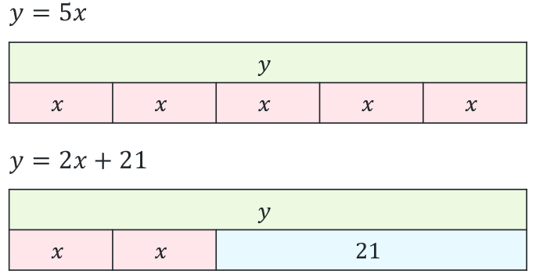 | $$y=5x \\ y=2x+21$$
Compare and combine the equations:  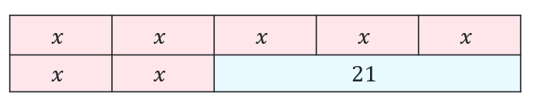 | $$5x=2x+21$$
Solve for 1 variable:  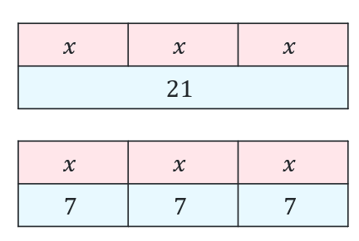 | $$5x-2x=21 \\ 3x=21 \\ x=\frac{21}{3} \\ x=7$$
Solve for the 2nd variable:  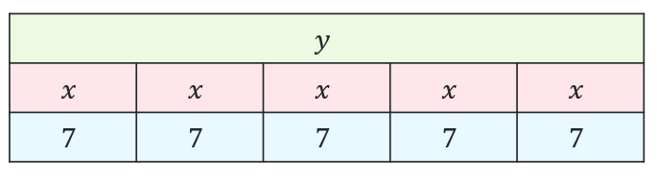 | $$y=5x \\ =5×7 \\ =35$$
Answer the question:  $x=7$ and $y=35$ | $x=7$ and $y=35$

Appendix C

Faded examples
Solve each pair of simultaneous linear equations using algebraic methods.
Steps | Question 1 | Question 2 | Question 3 | Question 4
Pair of simultaneous equations. | $$y=6x \\ y=2x+20$$ | $$y=3x+8 \\ y=x+20$$ | $$y=3x \\ y=15-2x$$ | $$y=3x-9 \\ y=7-x$$
Compare and combine the equations. | $$6x=2x+20$$ | $$3x+8=x+20$$ | $$3x=15-2x$$
Solve for 1 variable. | $$6x-2x=20 \\ 4x=20 \\ x=\frac{20}{4} \\ x=5$$ | $$3x-x=20-8 \\ 2x=12$$
Solve for the 2nd variable. | $$y=6x \\ y=6×5 \\ y=30$$
Answer the question and check solution. | $$∴x=5, y=30$$

Appendix D

Investigating changes
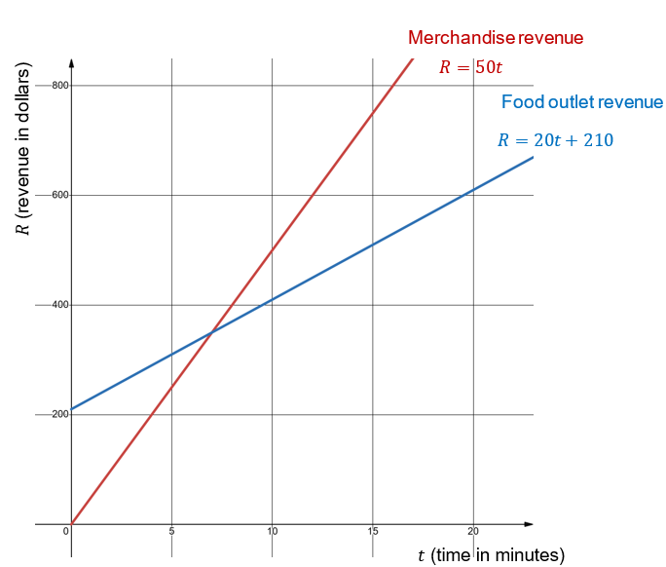
Investigate how adjustments to the scenario affect the time when both revenue streams generate the same revenue. For each adjustment:
- make a prediction about whether the time will increase or decrease, explaining why
- always return to the original equations first
- apply the change for that scenario only
- solve the new system
- decide whether the time increases or decreases compared to the original situation.
Adjustments:
- Merchandise revenue increases to $60 per minute.
- Food outlet revenue increases to $40 per minute.
- Merchandise now includes $150 pre-orders before the event.
- Merchandise and food outlet revenue both increase to $60 per minute.
- Merchandise revenue decreases to $40 per minute, while the food outlet revenue increases to $60 per minute.

Sample solutions

Appendix C – faded examples
Steps | Question 1 | Question 2 | Question 3 | Question 4
Pair of simultaneous equations. | $$y=6x \\ y=2x+20$$ | $$y=3x+8 \\ y=x+20$$ | $$y=3x \\ y=15-2x$$ | $$y=3x-9 \\ y=7-x$$
Compare and combine the equations. | $$6x=2x+20$$ | $$3x+8=x+20$$ | $$3x=15-2x$$ | $$3x-9=7-x$$
Solve for 1 variable. | $$6x-2x=20 \\ 4x=20 \\ x=\frac{20}{4} \\ x=5$$ | $$3x-x=20-8 \\ 2x=12 \\ x=\frac{12}{2} \\ x=6$$ | $$3x+2x=15 \\ 5x=15 \\ x=\frac{15}{5} \\ x=3$$ | $$3x+x=7+9 \\ 4x=16 \\ x=\frac{16}{4} \\ x=4$$
Solve for the 2nd variable. | $$y=6x \\ y=6×5 \\ y=30$$ | $$y=x+20 \\ y=6+20 \\ y=26$$ | $$y=3x \\ y=3×3 \\ y=9$$ | $$y=7-x \\ y=7-4 \\ y=3$$
Answer the question and check solution. | $$∴x=5, y=30$$ | $$∴x=6, y=26$$ | $$∴x=3, y=9$$ | $$∴x=4, y=3$$

Appendix D – investigating changes
Original:
Food outlet: $R=50t$
Merchandise: $R=20t+210$
Solution: $t=7, R=\$350$. The time when both revenue streams generate the same revenue is after 7 minutes.
- Merchandise revenue increases to $60 per minute.
Prediction: The time will decrease. If revenue increases, this increases the gradient, making the merchandise line steeper, meaning the point of intersection occurs earlier in time.
New equations to solve:
Merchandise: $R=60t$
Food outlet: $R=20t+210$
Solve the pair of simultaneous equations:
$$60t=20t+210 \\ 60t-20t=210 \\ 40t=210 \\ t=\frac{210}{40} \\ t=5.25$$
$$R=60×5.25 \\ =315$$
$∴$ The time will decrease, from 7 minutes to 5.25 minutes.
- Food outlet revenue increases to $40 per minute.
Prediction: The time will increase. If the revenue per minute increases, this increases the gradient, making the food outlet line steeper, meaning the point of intersection occurs later in time.
New equations to solve:
Merchandise: $R=50t$
Food outlet: $R=40t+210$
Solve the pair of simultaneous equations:
$$50t=40t+210 \\ 50t-40t=210 \\ 10t=210 \\ t=\frac{210}{10} \\ t=21$$
$$R=50×21 \\ =1050$$
$∴$ The time will increase, from 7 minutes to 21 minutes.
- Merchandise now includes $150 pre-orders before the event.
Prediction: The time will decrease. If merchandise includes pre-orders, the $y$-intercept will change from 0 to 150, meaning the line moves up. This will mean that the lines will intersect earlier.
New equations to solve:
Merchandise: $R=50t+150$
Food outlet: $R=20t+210$
Solve the pair of simultaneous equations:
$$50t+150=20t+210 \\ 50t-20t=210-150 \\ 30t=60 \\ t=\frac{60}{30} \\ t=2$$
$$R=50×2 \\ =100$$
$∴$ The time will decrease, from 7 minutes to 2 minutes.
- Both merchandise and food outlet revenue increase to $60 per minute.
Prediction: There will be no time. The lines will not cross as the gradients will be equal, so the lines will be parallel.
New equations to solve:
Merchandise: $R=60t$
Food outlet: $R=60t+210$
Solve the pair of simultaneous equations:
$$60t=60t+210 \\ 60t-60t=210 \\ 0=60$$No solution.
$∴$ There will be no time where the revenue streams are the same.
- Merchandise revenue decreases to $40 per minute, while the food outlet revenue increases to $60 per minute.
Prediction: The time will increase. If merchandise revenue decreases, this reduces the gradient of the merchandise line, meaning it rises more slowly. This causes the point of intersection to occur later in time. Increasing the food outlet revenue also increases its gradient, further shifting the intersection to occur at a larger time value.
New equations to solve:
Merchandise: $R=40t$
Food outlet: $R=60t+210$
Solve the pair of simultaneous equations:
$$40t=60t+210 \\ 40t-60t=210 \\ -20t=210 \\ t=\frac{210}{-20} \\ t=-10.5$$
No solution. Time cannot be negative.
$∴$ There will be no time where the revenue streams are the same.

References
This resource contains NSW Curriculum and syllabus content. The NSW Curriculum is developed by the NSW Education Standards Authority (NESA). This content is prepared by NESA for and on behalf of the Crown in right of the State of New South Wales. The material is protected by Crown copyright.
Please refer to the NESA Copyright Disclaimer for more information https://www.nsw.gov.au/education-and-training/nesa/copyright.
NESA holds the only official and up-to-date versions of the NSW Curriculum and syllabus documents. Please visit NESA https://www.nsw.gov.au/education-and-training/nesa and NSW Curriculum https://curriculum.nsw.edu.au.
Mathematics Standard 11–12 Syllabus © NSW Education Standards Authority (NESA) for and on behalf of the Crown in right of the State of New South Wales, 2024.
Numeracy Stage 6 (CEC) Syllabus © NSW Education Standards Authority (NESA) for and on behalf of the Crown in right of the State of New South Wales, 2021.

© State of New South Wales (Department of Education), 2026
The copyright material published in this resource is subject to the Copyright Act 1968 (Cth) and is owned by the NSW Department of Education or, where indicated, by a party other than the NSW Department of Education (third-party material).
Copyright material available in this resource and owned by the NSW Department of Education is licensed under a Creative Commons Attribution 4.0 International (CC BY 4.0) license.

This license allows you to share and adapt the material for any purpose, even commercially. Attribution should be given to © State of New South Wales (Department of Education), 2026.
Material in this resource not available under a Creative Commons license:
- the NSW Department of Education logo, other logos and trademark-protected material
- material owned by a third party that has been reproduced with permission. You will need to obtain permission from the third party to reuse its material.
Links to third-party material and websites
Please note that the provided (reading/viewing material/list/links/texts) are a suggestion only and implies no endorsement, by the New South Wales Department of Education, of any author, publisher, or book title. School principals and teachers are best placed to assess the suitability of resources that would complement the curriculum and reflect the needs and interests of their students.
If you use the links provided in this document to access a third-party's website, you acknowledge that the terms of use, including licence terms set out on the third-party's website apply to the use which may be made of the materials on that third-party website or where permitted by the Copyright Act 1968 (Cth). The department accepts no responsibility for content on third-party websites.

