Solving simultaneous equations graphically
Students learn how to solve simultaneous linear equations graphically in the context of comparing wedding floral packages. They build on their understanding of distance–time graphs, connect equations to real situations and identify the point of intersection in the context of practical problems.
Students will need at least one digital device per pair to interact with Amplify Classroom during this lesson.

Learning intentions
- To be able to represent and solve pairs of linear equations graphically.
- To understand how the point of intersection relates to solutions in real-world contexts.

Success criteria
- I can graph a linear equation.
- I can identify and interpret the point of intersection of 2 linear equations from a graph.
- I can explain what the point of intersection represents in a real-world context.

Outcomes

Mathematics Standard 2 outcomes
A student:
- develops understanding and fluency in mathematics through exploring and connecting mathematical concepts, choosing and applying mathematical techniques to solve problems, and communicating their thinking and reasoning coherently and clearly MAO-WM-01
- represents the relationships between quantities algebraically and graphically to solve problems and make predictions in practical contexts MST-12-S2-01

Associated Mathematics Standard 1 outcomes
A student:
- develops understanding and fluency in mathematics through exploring and connecting mathematical concepts, choosing and applying mathematical techniques to solve problems, and communicating their thinking and reasoning coherently and clearly MAO-WM-01
- represents and interprets the relationships between quantities in algebraic and graphical forms MST-12-S1-01
Mathematics Standard 11–12 Syllabus © NSW Education Standards Authority (NESA) for and on behalf of the Crown in right of the State of New South Wales, 2024.

Associated Numeracy outcomes
A student:
- recognises and applies functional numeracy concepts in practical situations, including personal and community, workplace and employment, and education and training contexts
N6-1.1
- applies numerical reasoning and mathematical thinking to clarify, efficiently solve and communicate solutions to problems N6-1.2
- determines whether an estimate or an answer is reasonable in the context of a problem, evaluates results and communicates conclusions N6-1.3
- chooses and applies appropriate operations with whole numbers, familiar fractions and decimals, percentages, rates and ratios to analyse and solve everyday problems N6-2.1
- chooses and applies efficient strategies to analyse and solve everyday problems involving data, graphs, tables, statistics and probability N6-2.3
- chooses and applies efficient strategies to analyse and solve everyday problems involving money and finance N6-2.4
- chooses and applies appropriate numeracy operations and techniques to analyse and resolve everyday situations N6-2.6
- chooses and uses appropriate technology to access, organise and interpret information in a range of practical personal and community, workplace and employment, and education and training contexts N6-3.1
- chooses and uses appropriate technology to analyse and solve problems, represent information and communicate solutions in a range of practical contexts N6-3.2
Numeracy Stage 6 (CEC) Syllabus © NSW Education Standards Authority (NESA) for and on behalf of the Crown in right of the State of New South Wales, 2021.

Content

Mathematics Standard 2
Simultaneous linear equations
- Graph two linear equations and identify the point of intersection, with and without using graphing applications
- Solve a pair of simultaneous linear equations using graphical and algebraic methods
- Solve practical problems that involve simultaneous linear equations

Associated Mathematics Standard 1
Simultaneous linear equations
- Graph two linear equations using a table of values or a graphing application and identify the point of intersection
- Solve a pair of simultaneous linear equations by finding the point of intersection of their graphs, with and without graphing applications
- Determine and interpret the point of intersection of two linear graphs in a variety of practical contexts
Mathematics Standard 11–12 Syllabus © NSW Education Standards Authority (NESA) for and on behalf of the Crown in right of the State of New South Wales, 2024.

Table 1: lesson summary
Section | Summary of activity | Teaching strategies | Teaching points
Activating prior knowledge | Students match linear equations to graphs on slides 4–7 of the PowerPoint Solving simultaneous equations graphically, justifying their reasoning. Use these slides to consolidate the gradient and $y$-intercept in the equation to its graphical representation. Use slide 8 to summarise how to graph straight lines. | Pose-Pause-Pounce-Bounce  Think-Pair-Share | This section consolidates students’ prior knowledge from Year 11 in preparation for interpreting intersections as solutions. Reinforce how the table of values, equation and graph are connected.
Connecting learning | Students analyse a distance–time graph using slide 10, discussing key features such as speed, starting position and intersection. On slide 11, students relate the equations and graph to the given context. Using the Amplify activity (https://bit.ly/Distancetimegraph) students investigate how changing equations affects graphs and points of intersection. | Think-Pair-Share  Pose-Pause-Pounce-Bounce | Students connect graphical representations to real-world contexts, building an understanding of the point of intersection. Reinforce how changes in the gradient and $y$-intercept change the graph and the point of intersection.
Releasing responsibility | Use slides 13–14 to revisit the scenario to define the point of intersection. Slides 15–18 model how to solve pairs of simultaneous equations graphically, with students using Appendix A. Students complete Appendix B. | Worked examples (Your turn)  Notes to future forgetful selves | Formalise the intersection as the solution to simultaneous equations. Reinforce that these values satisfy each equation when substituted into it.
Independent practice | Students complete Appendix C using slide 20, then use slides 21–23 to review marker feedback, the solution and marking criteria. Students analyse Appendix D, using the marking criteria to award marks and suggest improvements. |  | Focus on applying marking criteria to justify decisions, interpreting the point of intersection correctly and communicating reasoning clearly using mathematical language. Reinforce accurate graph construction and responding directly to the question.

Activity structure
Please use the associated PowerPoint Solving simultaneous equations graphically to display images in this lesson.

Activating prior knowledge
- Use slides 4–7 of the PowerPoint to display 4 sets of multiple-choice questions involving linear graphs and equations. In pairs, students are to identify which graph could represent the given equation and justify their reasoning to their partner.
- Use the Pose-Pause-Pounce-Bounce questioning strategy (bit.ly/P-P-P-B) to facilitate a class discussion about how students identified the correct graph and the point. Possible prompts may include:
- How did you know whether the line should have a positive or negative gradient?
- How did you identify the $y$-intercept?
- What features helped you eliminate incorrect graphs?
- How can we check whether a point lies on a line?
Guide students to connect features of the equation to features of the graph. For example, the coefficient of $x$ indicates the gradient, and substituting values can help students identify points that lie on the graph and sketch key features (such as whether the $y$-values are positive or negative) and eliminate incorrect options. Encourage students to explain how these features helped them make their selection.
- Display slide 8 to consolidate and summarise common methods for graphing linear equations, discussing how the most efficient method may depend on the form of the equation, including:
- using a table of values
- finding the $x$and $y$-intercepts
- using the gradient-intercept method for equations in the form $y=mx+c$.

Connecting learning
- Display slide 10, showing the following scenario:
A florist has 2 delivery vans transporting floral arrangements to a wedding venue.
- Van A leaves the florist warehouse and travels towards the venue.
- Van B left earlier from another delivery location and is already partway along the route when tracking begins.
- Animate slide 10 to show the distance–time graph. In a Think-Pair-Share, ask students to discuss what the graph shows in context. Some possible prompts may include:
- How do you know which van is travelling faster?
- How do you know which van reaches the wedding venue first?
- When are both vans the same distance from the florist warehouse?
Students have interpreted distance–time graphs in Lesson 4 – distance–time graphs. Guide students to connect the steepness of the graph to speed and recognise that a horizontal line represents a van that has stopped travelling. Guide students to identify the point where the 2 lines meet.
- Display slide 11 showing the distance–time graph for the part of the journey between 0 and 8 minutes, along with the corresponding equations. Students continue to work with their partner to:
- Match each equation to a van.
- Explain what the gradient and $y$-intercept represent in context.
- Identify the coordinates of the point where the graphs intersect and interpret its meaning in the context of the journey.
- Have students substitute $x=4$ into both equations and solve for $y$.
- Facilitate a class discussion about the relationship between the values found by substitution and the point where the graphs intersect. Possible prompts may include:
- How does this connect to the graph?
- Why might both equations produce the same value of $y$?
Highlight that when students substitute $x=4$ into both equations, both equations give $y=5$. This happens because the point (4, 5) is where the 2 lines meet on the graph. In context, this represents the time and distance when both vans are the same distance from the florist warehouse.
- With at least one device per pair of students, assign the Amplify Classroom activity ‘Distance–time graph (https://bit.ly/Distancetimegraph) for students to complete screens 1–2 only. Explain to students that the sliders can be used to change the gradient and $y$-intercept of each line.
- Allow students time to freely adjust the sliders and discuss what they notice about how the equations, graphs and point of intersection change.
Before completing this activity, you will need to set up an Amplify Classroom (bit.ly/createamplifyclassroom) and use the pacing feature to restrict students to screens 1–2.
The sliders allow students to change the equations and see the effect on the graph. Guide students to connect the gradient to the speed of the van and the $y$-intercept to the distance from the florist warehouse when timing begins. Encourage students to focus on what changes in the equation, what changes on the graph and what this means in context.
- Remove the pacing feature to allow students to complete the remaining screens and investigate how changing the gradient and $y$-intercept affects the graphs, equations and the point where the 2 lines meet.
As students adjust the sliders, the point of intersection may move outside the visible graphing window. Clarify that this does not mean the lines have no point of intersection. Ask, ‘Will the 2 lines always intersect? How do you know?’ Students should recognise that lines with different gradients will intersect, although the intersection may be off-screen. Parallel lines have the same gradient and different intercepts, so they do not intersect.
- Use the Pose-Pause-Pounce-Bounce questioning strategy to facilitate a class discussion about students’ findings. Possible prompts include:
- How did changing the equations affect the point of intersection? What changes made it occur later? What changes made it occur earlier?
- What do you notice about the graphs when both vans start at the warehouse?
Guide students to recognise that changing the gradient changes the speed of the van and changing the $y$-intercept changes the starting distance from the warehouse. Emphasise that the point where the 2 lines intersect changes when either the speed or starting distance changes.

Releasing responsibility
- Display slide 13 which shows the distance–time graph from the earlier scenario. Ask students to identify the point where the two graphs meet, explain what this coordinate is called and what it represents in context. Animate the slide to display this information.
Explain that the point where the 2 graphs meet is called the point of intersection. Reinforce that in this example, the point of intersection is (4, 5), meaning both vans are 5 km from the florist warehouse after 4 minutes. It may be worth mentioning that the vans are not necessarily in the same place at this point in time. Explain that the 2 equations are called simultaneous equations because they are considered at the same time. The point of intersection is the solution to the simultaneous equations because it lies on both graphs and satisfies both equations.
- Display slide 14 to show students the different ways that finding the point of intersection can be asked.
Explain that these phrases are all asking students to find the coordinate where both equations have the same $x$- and $y$-values. Unpack the contextual wording by explaining that ‘when are they the same distance?’ means finding the time when both vans have the same distance from the florist warehouse.
- Use slides 15-18 to model worked examples of solving simultaneous equations graphically using the Worked examples (Your turn) method (bit.ly/supportingstrategies). Distribute Appendix A ‘Worked examples blank graph’ for each individual student to use to answer the Worked examples – Your turn questions.
- Facilitate a class discussion about strategies that support accurate graphing when solving simultaneous equations graphically. Possible prompts may include:
- What helped you graph each line accurately?
- How can you check your point of intersection is correct?
- What mistakes should we try to avoid when solving simultaneous equations graphically?
Guide students to identify strategies such as drawing straight lines with a ruler, using a table of values or gradient and $y$-intercept to graph each line, choosing a suitable scale, identifying the point of intersection carefully and checking the solution by substituting the coordinates into both equations.
- Provide each student with a copy of Appendix B ‘Notes to future forgetful selves.’ Students use the table and worked example to annotate the process and create notes to their future forgetful selves (bit.ly/notestofutureself), summarising how to graph straight lines and solve simultaneous equations graphically.

Independent practice
- Use slide 20 to display the ‘Approaching questions scaffold’ and remind students of the steps they can follow to approach an unfamiliar question.
- Distribute Appendix C ‘HSC question’ and have students complete the past HSC question.
- Display slide 21 which shows HSC marker feedback and allow time for students to adjust their solution if needed, particularly their answers for part ‘d’.
- Slide 22 can be used to display the solution for students and slide 23 to show the marking criteria for students to analyse.
- As a class discuss slides 21–22, emphasising key information that students need to include in their solutions to receive full marks.
- In pairs have students analyse 2 sample responses in Appendix D ‘Sample responses’, using slide 23 to award marks. Students should discuss:
- Is the point of intersection interpreted correctly?
- Does the response answer the question?
- Is the solution clear?
- What improvements would you make to this response?
Encourage students to use the marking criteria to justify their decisions. Highlight the importance of accurate graph construction and communicating reasoning clearly using mathematical language.

Assessment and differentiation

Suggested opportunities for differentiation
Activating prior knowledge
- Slide 7 could be printed for students to support their future skills of graphing linear equations.
- Extend students by asking them to predict the equation of each of the incorrect responses for slides 4–6.
Connecting learning
- Provide sentence starters such as ‘Van A is faster because …’
- Offer guided prompts linking graph features to context (speed = gradient).
- Support students during the Amplify task by asking them to adjust one slider at a time and explain what changes in the equation, graph and context.
Releasing responsibility
- Offer pre-plotted points for students needing support, focusing on interpretation.
- Extend students by removing scaffolds and requiring justification of accuracy.
Independent practice
- The sample responses section of the activity could be completed as a whole class analysis.

Mathematics Standard 1 adjustments and considerations
The syllabus content in this lesson is relatively similar for both Mathematics Standard 2 and Mathematics Standard 1, with some content points worded slightly differently. The lesson can be completed as is and adjustments made if necessary.

Suggested opportunities for assessment
Activating prior knowledge
- Use questioning to check understanding of gradient and intercept relationships.
- Listen for correct justification language (not just correct answers).
Connecting learning
- Monitor Think–Pair–Share responses for correct interpretation of graphs.
- Check that students can match equations to vans correctly.
- Observe students during the Amplify task to assess whether they can explain how changing the gradient or y-intercept affects the graphs and the point of intersection.
Releasing responsibility
- Ask students to explain the meaning of intersection in context.
- Review Appendix B annotations for conceptual understanding.
Independent practice
- Collect Appendix C to assess students’ understanding when answering the question themselves, as well as the feedback they provided for the sample response.

Appendix A

Worked examples blank graph
Your turn – question 1
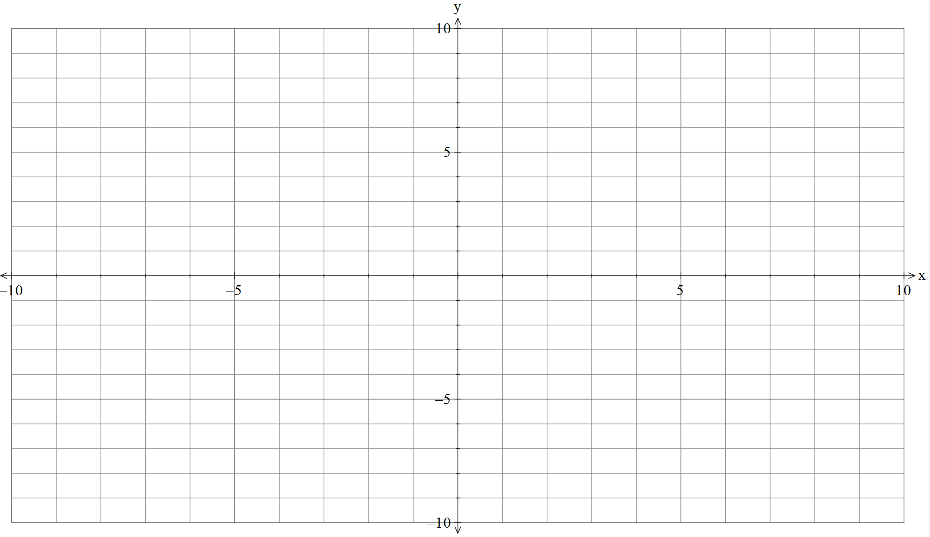
Your turn – question 2

Appendix B

Notes to future forgetful selves
Graphing straight lines
Method | What do I do? | Notes
Table of values | Substitute different $x$-values into the equation to find $y$-values. Plot the points and draw a straight line through them.
Intercepts | Find where the line crosses the $x$-axis and $y$-axis. Plot both intercepts and draw the line.
Gradient-intercept | Use $y=mx+c$. Start at the $y$-intercept, then use the gradient to find another point.

Solving simultaneous equations graphically
What do I do? | Notes
Graph both equations on the same axes using a method of your choice.
Find the point where the 2 lines intersect.
Check the question for the required format of the solution:
- ordered pair $(x,y)$
- just the $x$ value
- just the $y$ value.
Check the solution by substituting the $x$-value into both equations.

Appendix C

HSC question
This is Question 21 from the Mathematics Standard 2 HSC exam 2023 (NESA 2023).
Electricity provider $A$ charges 25 cents per kilowatt hour (kWh) for electricity, plus a fixed monthly charge of $40.
- Complete the table showing Provider $A$’s monthly charges for different levels of electricity usage.
Electricity used in a month (kWh) | 0 | 400 | 1000
Monthly charge ($) | 40 |  | 290

- Provider $B$ charges 35 cents per kWh, with no fixed monthly charge. The graph shows how Provider $B$’s charges vary with the amount of electricity used in a month.
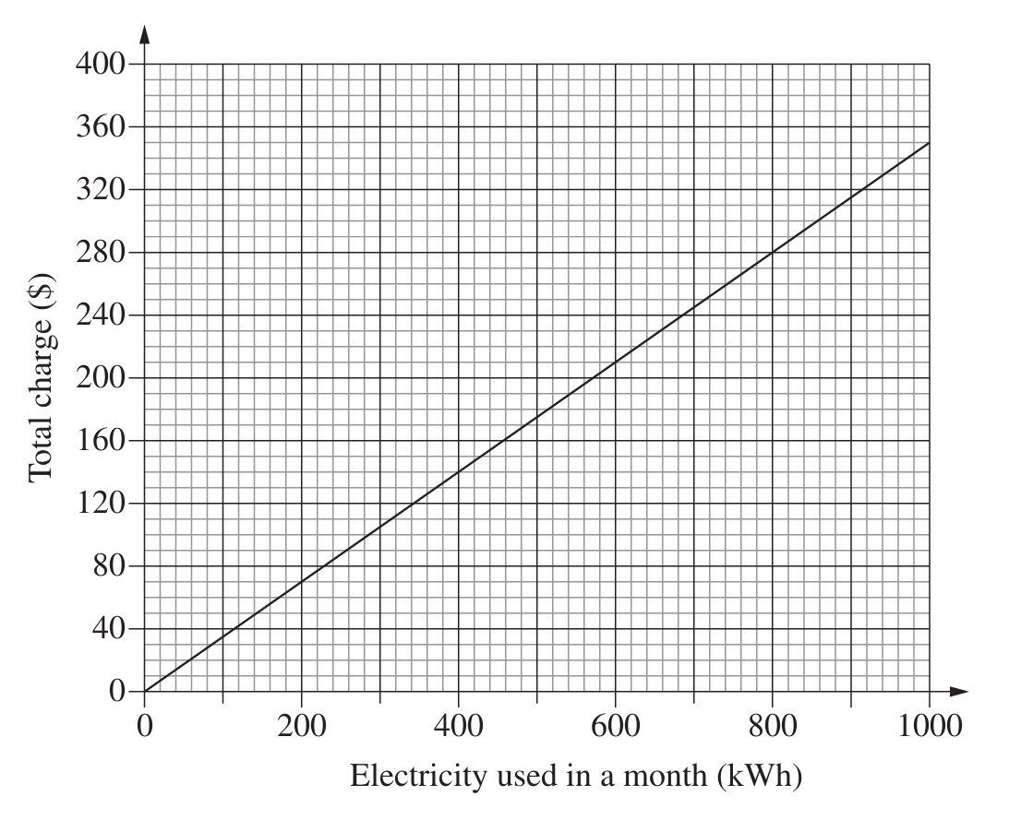
On the grid provided, graph Provider $A$’s charges from the table in part (a).
- Use the 2 graphs to determine the number of kilowatt hours per month for which Provider $A$ and Provider $B$ charge the same amount.
- A customer uses an average of 800 kWh per month. Which provider, $A$ or $B,$ would be the cheaper option and by how much?

Appendix D

Sample responses
Sample response 1
Electricity provider $A$ charges 25 cents per kilowatt hour (kWh) for electricity, plus a fixed monthly charge of $40.
- Complete the table showing Provider $A$’s monthly charges for different levels of electricity usage.
Electricity used in a month (kWh) | 0 | 400 | 1000
Monthly charge ($) | 40 | 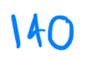 | 290

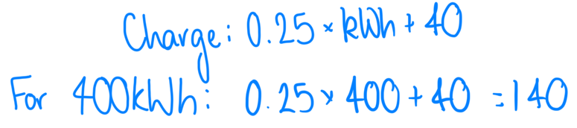
- Provider $B$ charges 35 cents per kWh, with no fixed monthly charge. The graph shows how Provider $B$’s charges vary with the amount of electricity used in a month.
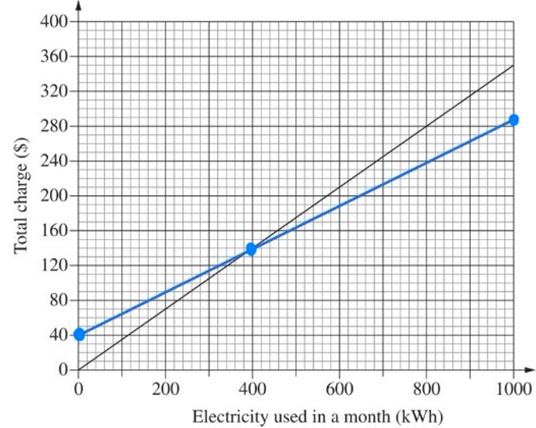
On the grid provided, graph Provider $A$’s charges from the table in part (a).
- Use the 2 graphs to determine the number of kilowatt hours per month for which Provider $A$ and Provider $B$ charge the same amount.

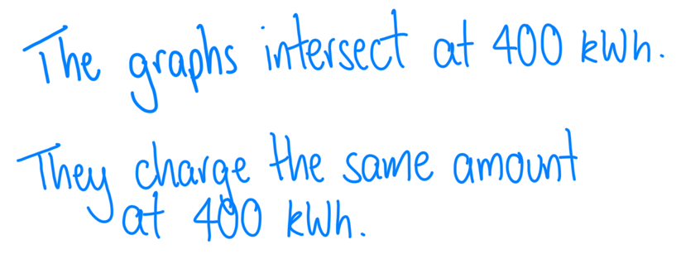

- A customer uses an average of 800 kWh per month. Which provider, $A$ or $B,$ would be the cheaper option and by how much?
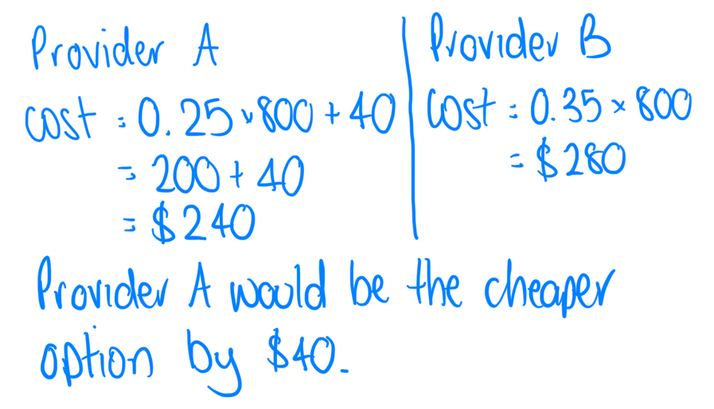
Sample response 2
Electricity provider $A$ charges 25 cents per kilowatt hour (kWh) for electricity, plus a fixed monthly charge of $40.
- Complete the table showing Provider $A$’s monthly charges for different levels of electricity usage.
Electricity used in a month (kWh) | 0 | 400 | 1000
Monthly charge ($) | 40 |  | 290
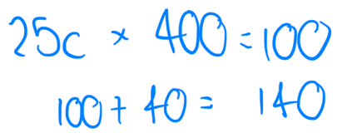
- Provider $B$ charges 35 cents per kWh, with no fixed monthly charge. The graph shows how Provider $B$’s charges vary with the amount of electricity used in a month.
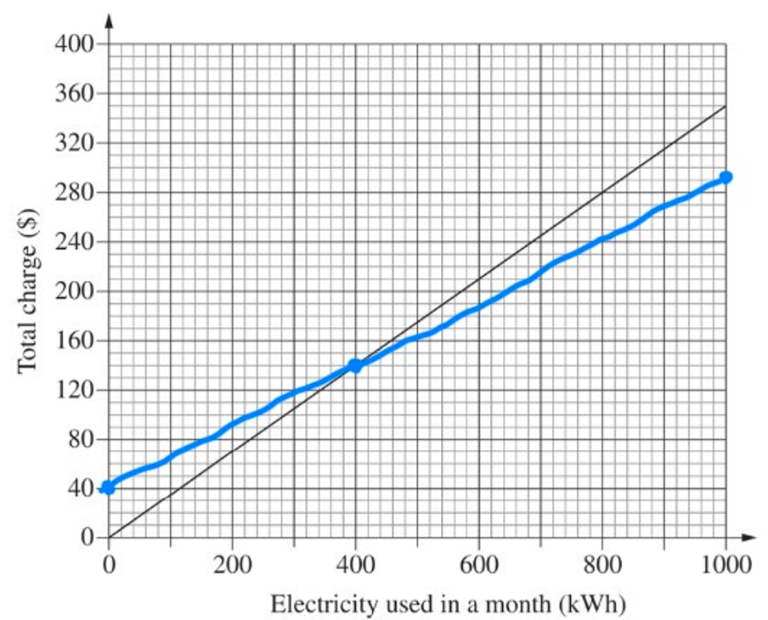
On the grid provided, graph Provider $A$’s charges from the table in part (a).

- Use the 2 graphs to determine the number of kilowatt hours per month for which Provider $A$ and Provider $B$ charge the same amount.
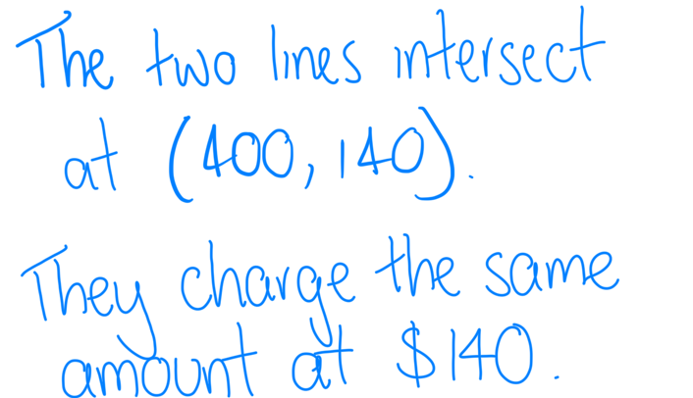

- A customer uses an average of 800 kWh per month. Which provider, $A$ or $B,$ would be the cheaper option and by how much?
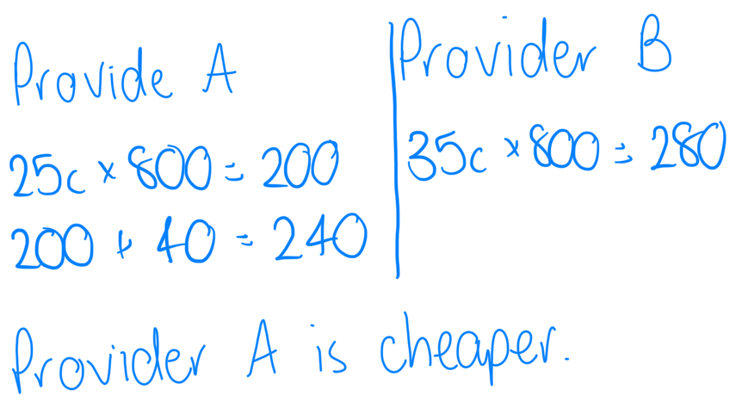

Sample solutions

Appendix C – HSC question

Electricity used in a month (kWh) | 0 | 400 | 1000
Monthly charge ($) | 40 | 140 | 290

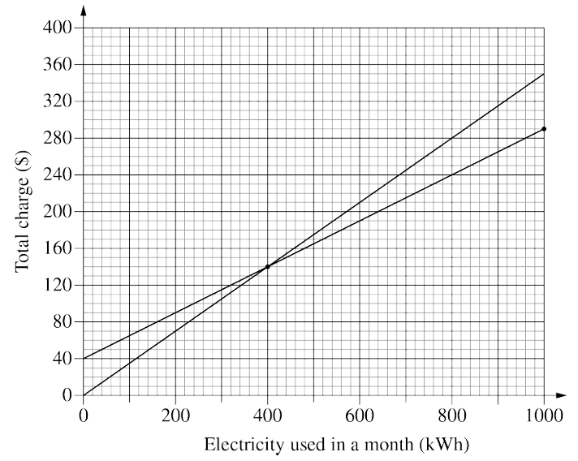 (NESA, 2023)
- They charge the same amount at 400 kWh.
- Provider B at 800 kWh charges $280. Provider A at 800 kWh charges $240.
$∴$ Provider A would be the cheaper option by $40.

References
This resource contains NSW Curriculum and syllabus content. The NSW Curriculum is developed by the NSW Education Standards Authority (NESA). This content is prepared by NESA for and on behalf of the Crown in right of the State of New South Wales. The material is protected by Crown copyright.
Please refer to the NESA Copyright Disclaimer for more information https://www.nsw.gov.au/education-and-training/nesa/copyright.
NESA holds the only official and up-to-date versions of the NSW Curriculum and syllabus documents. Please visit NESA https://www.nsw.gov.au/education-and-training/nesa and NSW Curriculum https://curriculum.nsw.edu.au.
Mathematics Standard 11–12 Syllabus © NSW Education Standards Authority (NESA) for and on behalf of the Crown in right of the State of New South Wales, 2024.
Numeracy Stage 6 (CEC) Syllabus © NSW Education Standards Authority (NESA) for and on behalf of the Crown in right of the State of New South Wales, 2021.
NESA (NSW Education Standards Authority) (2023) Mathematics Standard 2 HSC exam 2023, HSC exam papers, NESA website, accessed 3 August 2026.

© State of New South Wales (Department of Education), 2026
The copyright material published in this resource is subject to the Copyright Act 1968 (Cth) and is owned by the NSW Department of Education or, where indicated, by a party other than the NSW Department of Education (third-party material).
Copyright material available in this resource and owned by the NSW Department of Education is licensed under a Creative Commons Attribution 4.0 International (CC BY 4.0) license.

This license allows you to share and adapt the material for any purpose, even commercially. Attribution should be given to © State of New South Wales (Department of Education), 2026.
Material in this resource not available under a Creative Commons license:
- the NSW Department of Education logo, other logos and trademark-protected material
- material owned by a third party that has been reproduced with permission. You will need to obtain permission from the third party to reuse its material.
Links to third-party material and websites
Please note that the provided (reading/viewing material/list/links/texts) are a suggestion only and implies no endorsement, by the New South Wales Department of Education, of any author, publisher, or book title. School principals and teachers are best placed to assess the suitability of resources that would complement the curriculum and reflect the needs and interests of their students.
If you use the links provided in this document to access a third-party's website, you acknowledge that the terms of use, including licence terms set out on the third-party's website apply to the use which may be made of the materials on that third-party website or where permitted by the Copyright Act 1968 (Cth). The department accepts no responsibility for content on third-party websites.

