Trigonometry in three dimensions further problems
Students work with 3-dimensional trigonometry problems involving bearings. They interpret information presented in written form and diagrams, identifying key details, angles and relationships within the scenario. Students then apply structured strategies to solve these problems.

Learning intentions
- To understand how to interpret information from both diagrams and written descriptions to identify key details and relationships.
- To be able to solve 3-dimensional trigonometry problems involving bearings.

Success criteria
- I can identify and classify 2-dimensional triangles within a 3-dimensional scenario.
- I can interpret written descriptions and match them to diagrammatic representations.
- I can select and apply the correct trigonometric method to find unknown sides or angles.
- I can justify my reasoning and explain the steps I take to solve a problem.

Outcomes
A student:
- develops understanding and fluency in mathematics through exploring and connecting mathematical concepts, choosing and applying mathematical techniques to solve problems, and communicating their thinking and reasoning coherently and clearly MAO-WM-01
- solves problems in three dimensions using trigonometry and simplifies expressions, proves results and solves problems involving compound angles using trigonometric identities
ME1-11-03

Content

Trigonometry in three dimensions
- Interpret information about a 3-dimensional context given in diagrammatical form
- Interpret information about a 3-dimensional context given in written form
- Apply trigonometry to solve problems in three dimensions where a diagram is given
Mathematics Extension 1 11–12 Syllabus © NSW Education Standards Authority (NESA) for and on behalf of the Crown in right of the State of New South Wales, 2024.

Table 1: lesson summary
Section | Summary of activity | Teaching strategies | Teaching points
Activating prior knowledge | Students firstly use the Mathematics Extension 1 – HSC reference sheet to identify relevant trigonometric formulas before completing Appendix A. |  | The purpose of this activity is to recall how to solve problems involving bearings.
Connecting learning | Students head outside to physically model a 3-dimensional trigonometry problem using a tall structure. Two students initially stand due west and due south of the structure before moving to be on bearings of $040°$ and $190°$, each time discussing the 2-dimensional triangles they can visualise. Use slides 4–5 of the PowerPoint Trigonometry in three dimensions further problems to connect diagrams and written descriptions of what students did outside. Students then complete Appendix B to match written scenarios with diagrams. | Visibly random groups of 3  Vertical non-permanent surfaces | The purpose of this section is to help students visualise 3-dimensional trigonometry by physically acting out and modelling the triangles of problems that involve bearings. Students then connect the modelling they did with diagrams and written descriptions.
Releasing responsibility | Model solving 3-dimensional questions involving bearings using slides 7–12 before creating a checklist of key considerations when solving problems. Students then complete the questions from Appendix B. | Worked examples (Your turn)  Visibly random groups of 3  Vertical non-permanent surfaces  Notes to future forgetful selves | The purpose of this section is to consolidate strategies for approaching 3-dimensional trigonometry problems. Teachers should emphasise labelling sides and angles, visualising top-down views and choosing the correct trigonometric method.
Independent practice | Students apply their understanding to more complex questions using Appendix C. | Approaching questions scaffold | Students may need support in solving these questions, particularly question 2, which involves a ‘show that’.

Activity structure
Please use the associated PowerPoint Trigonometry in three dimensions further problems to display images in this lesson.

Activating prior knowledge
- Direct students to revisit their Mathematics Extension 1 – HSC reference sheet (NESA 2024).
- Initiate a class discussion to identify all formulas that relate specifically to non-right-angled triangles.
- Distribute Appendix A ‘Bearings question’ and have students work independently through the problem.
- Once students have completed the question, ask them to pair up. In pairs, students compare their working and solutions. If answers differ, prompt them to reason and agree on a correct solution, justifying their reasoning.
Solutions have been provided in the ‘Sample solutions’ section.

Connecting learning
- Take students outside to an area with a tall structure such as a flagpole or tall tree.
- Ask 2 students to position themselves due west and due south of the tall structure, ensuring that each student is a slightly different distance from the tall structure. Ask each student to act out the angle of elevation to the top of the structure using their arms.
The purpose of positioning students due west and due south is to create right-angled triangles. If true north is unclear or the school layout is constrained, select a reference direction to represent north.
- Invite the class to estimate each angle of elevation. Encourage discussion around which angle appears steeper and why.
- Facilitate a class discussion about what measurements could be taken to help determine the height of the structure.
Students should recognise that they could find the distance from the 2 students to the base of the tall structure using a tape measure and the 2 angles of elevation using a protractor or clinometer. Students could measure the distances and angles if the equipment is available and use it to confirm calculations. However, the purpose of this activity is to create a visual for students to recall when presented with 3-dimensional trigonometric problems involving bearings.
- Extend the discussion by asking students to consider how they would find the distance between the 2 students.
Students should recognise that the angle between west and south is $90°$, forming a right-angled triangle.
- Ask 2 different students to stand at bearings of $040°$ and $190°$ from the tall structure, again ensuring that each student is a slightly different distance from the tall structure.
- Have each student act out the angle of elevation to the top of the tall structure using their arms and invite the class to estimate these angles.
- Prompt students to think again about what measurements they would need to calculate the height of the structure.
Students should acknowledge that the triangles are still right-angled.
- Extend the discussion by asking how they might determine the distance between the 2 students without measuring, given their bearings.
Students should recognise that they need to find the angular distance between the 2 students then the cosine rule to find the distance.
- Return to the classroom and use slides 4–5 of the PowerPoint to show students the written description and the corresponding diagram of what they just did outside.
- Facilitate a class discussion comparing the diagrammatic and written forms. Ask students which representation is easier to interpret and have them identify the 2-dimensional triangles within the diagrams that correspond to what they physically modelled outside. Emphasise how this helps them connect their spatial experience with visual and textual information for 3-dimensional trigonometry problems.
- Assign students to visibly random groups of 3 (bit.ly/visiblegroups) at vertically non-permanent surfaces (bit.ly/VNPSstrategy).
- Distribute Appendix B ‘Card matching activity’ to each group and have them work together to match the written scenario with its corresponding diagram.
- Once groups are confident their matches are correct, have them construct the relevant 2-dimensional labelled triangles needed to solve the problem.
Students are not solving these problems yet.
The cards in Appendix B are intentionally not pre-matched so they can be handed out as a single sheet for students to cut and organise themselves.

Releasing responsibility
- Use slide 7 to remind students of the ‘Approaching questions scaffold’ that should be used to solve 3-dimensional trigonometric problems.
- Use slides 8–12 to model worked examples of applying trigonometry to solve problems in three dimensions using the Worked examples (Your turn) method (bit.ly/supportingstrategies).
Note that the NESA syllabus content point, ‘apply trigonometry to solve problems in three dimensions where a diagram is given,’ states that the diagram is to be given. However, there is also a content point, ‘interpret information about a 3-dimensional context given in written form’.
- Initiate a class discussion to summarise key considerations when approaching 3-dimensional trigonometric problems. As the discussion progresses, draft a checklist of steps that could be followed when solving these problems.
A suggested checklist may include:
Identify and draw separately all the 2-dimensional triangles.
Identify and label angles and sides on the 2-dimensional triangles.
Visualise a top-down view to see the layout, identifying further 2-dimensional triangles.
Determine if each triangle is right-angled or not to ensure the correct strategy is used.
- Have students return to their groups of 3 to solve the problems from Appendix B using the drafted checklist.
- Students are to create notes to their future forgetful selves (bit.ly/notestofutureself) using a question from Appendix B. Students scaffold the solution by identifying key considerations and steps taken to solve the problem.
- Students may benefit from completing further practice questions applying trigonometry to solve problems in three dimensions where a diagram is provided.

Independent practice
- Return to slide 7 to remind students of the ‘Approaching questions scaffold’ to use when solving the following problems.
- Distribute Appendix C ‘Solving 3-dimensional problems’ for students to complete.
Students can complete this activity individually, in pairs or in groups of 3 at vertical non-permanent surfaces. This decision will depend on how ready the class is to take on more challenging problems.
Students may find question 2 challenging as it is a ‘show that’ question. This question could be scaffolded as a whole-class activity.

Assessment and differentiation

Suggested opportunities for differentiation
Activating prior knowledge
- Students may need scaffolded steps to complete Appendix A.
- Students could be provided with a more challenging bearings question.
Connecting learning
- Students may benefit from physically modelling more scenarios with given dimensions to connect their understanding with the diagram.
- Students could be challenged to introduce a third student when physically modelling to visualise more triangles in a 3-dimensional problem.
Releasing responsibility
- To support students, providing guidance on which 2-dimensional triangle to solve first may assist them.
Independent practice
- Provide guided hints or partially completed triangles for students needing support.

Suggested opportunities for assessment
Activating prior knowledge
- Students’ final solutions can be collected to check their understanding and to be used as feedback on their setting out.
Connecting learning
- Observe groups as they match cards when completing Appendix B for accuracy and provide feedback if needed.
Releasing responsibility
- Review students’ use of their checklist when solving Appendix B problems, providing feedback on whether they have forgotten a key consideration.
Independent practice
- Check accuracy of calculations and correct identification of triangles.

Appendix A

Bearings question
A yacht race follows the triangular course shown in the diagram. The length of the course from $A$ to $B$ is $2.4 \text{km}$ on a true bearing of$042°$.
At $B$, the course changes direction. The course from $B$ to $C$ is $3.1 \text{km}$, and the angle $∠ABC = 68°.$
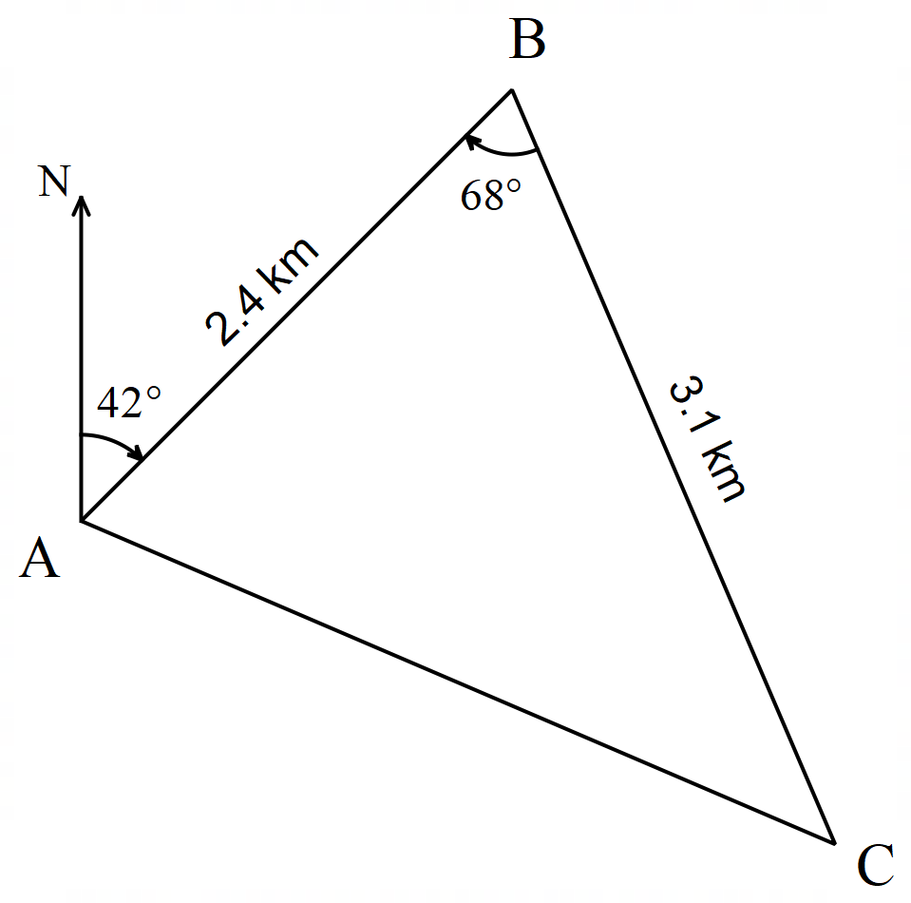
- What is the bearing of C from B?
- What is the distance from C to A?
- The area inside this triangular course is set as a ‘no-go’ zone for other boats while the race is on. What is the area of this ‘no-go’ zone?

Appendix B

Card matching activity
A drone, $D$, hovers directly above a point on the ground. Student A stands 48 m east of the point and Student B stands on a bearing of ${140}^{∘}$ from the same point. The angle of elevation from A to the drone is ${18}^{∘}$ and from B it is ${30}^{∘}$. Find the distance between the 2 students. | 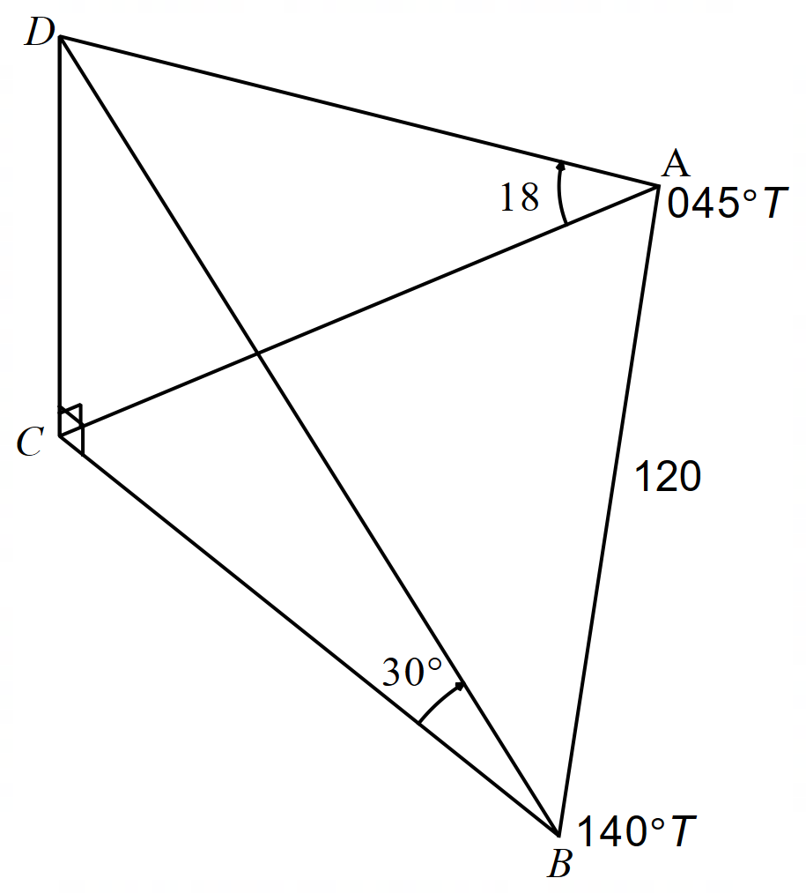
A drone hovers above a point on the ground. Student A stands 80 m away on a bearing of ${045}^{∘}$ and student B stands 48 m away on a bearing of ${310}^{∘}.$ The angle of elevation from A is ${18}^{∘}$ and from B is ${30}^{∘}$. Calculate the distance between the 2 students. | 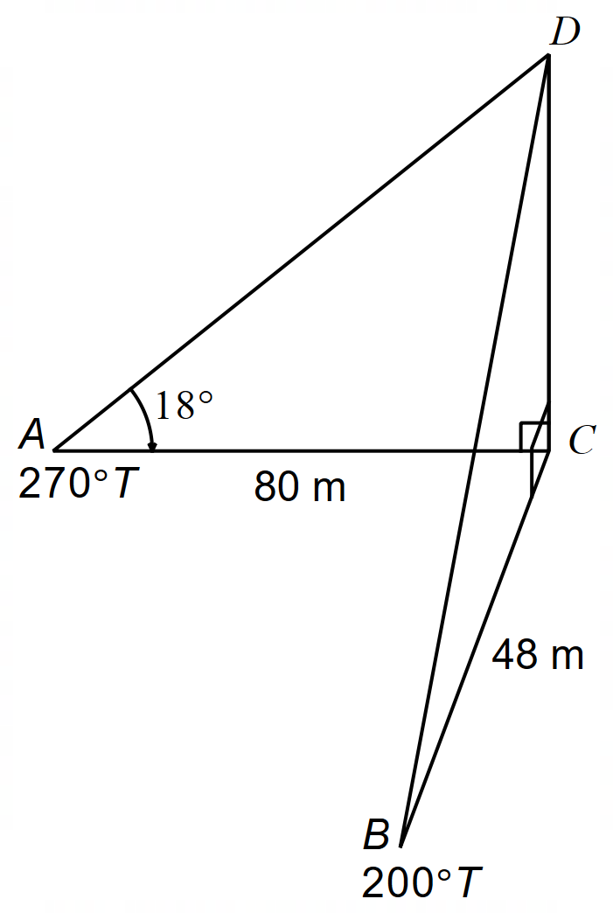
A cliff rises vertically from the coastline. A boat is anchored 80 m from the base of the cliff on a bearing of ${270}^{∘}$. A second boat is anchored 48 m from the base on a bearing of ${200}^{∘}$. The angle of elevation from the first boat is ${18}^{∘}$. Find the angle of elevation from the second boat. | 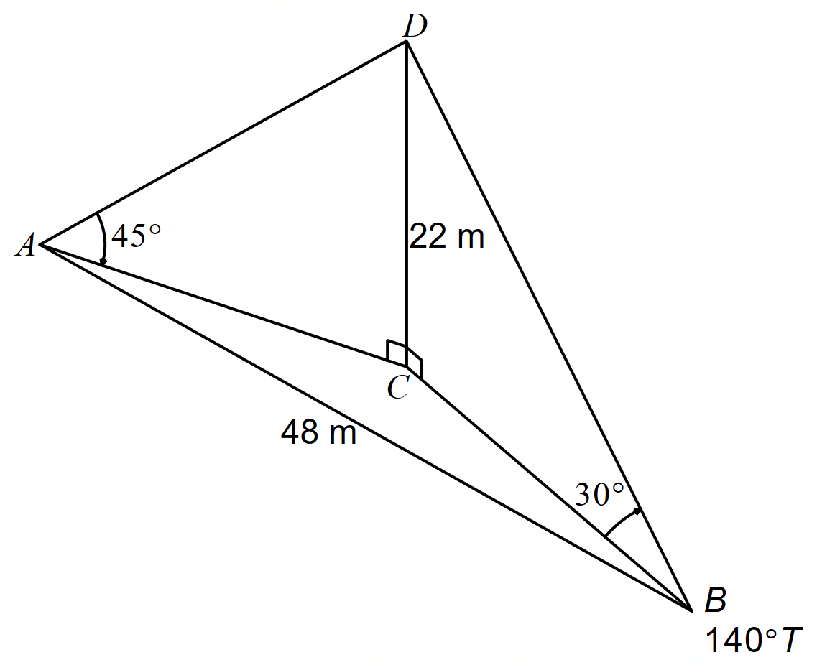
A communications tower, 22 m tall, stands at point C. Two technicians, $A$ and $B$, are positioned on the ground, each measuring the angle of elevation to the top of the tower. Their angles of elevation are 45$°$ and $30°$ respectively. The second technician, $B,$ is standing on a bearing of $140°T$ from the tower. If the first technician, $A$, is 48 m away from the second technician, determine the bearing of the first technician from the tower. | 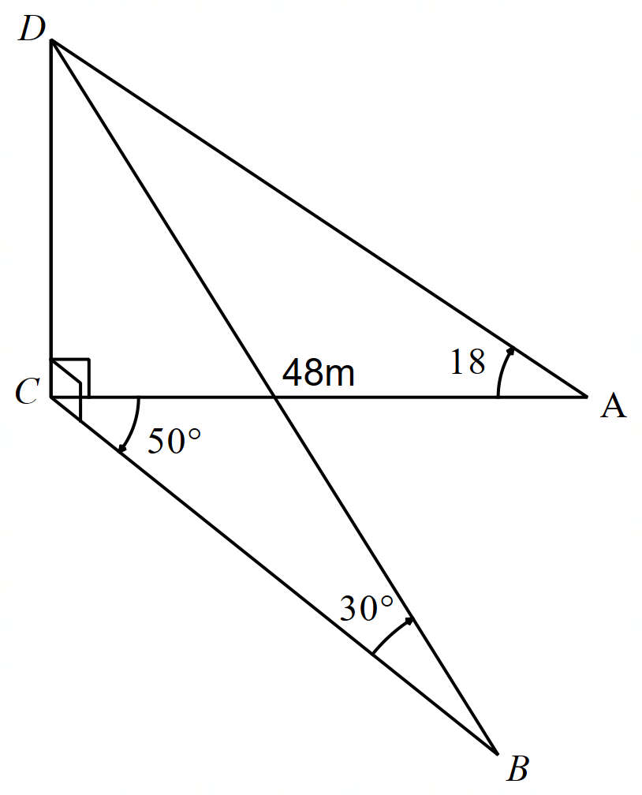
A helicopter hovers above a rescue boat. Two observers on the shore stand 120 m apart, with one observer on a bearing of ${045}^{∘}$ from the boat and the other on a bearing of ${140}^{∘}$. Their angles of elevation to the helicopter are ${18}^{∘}$and ${30}^{∘}$. Find the height of the helicopter. | 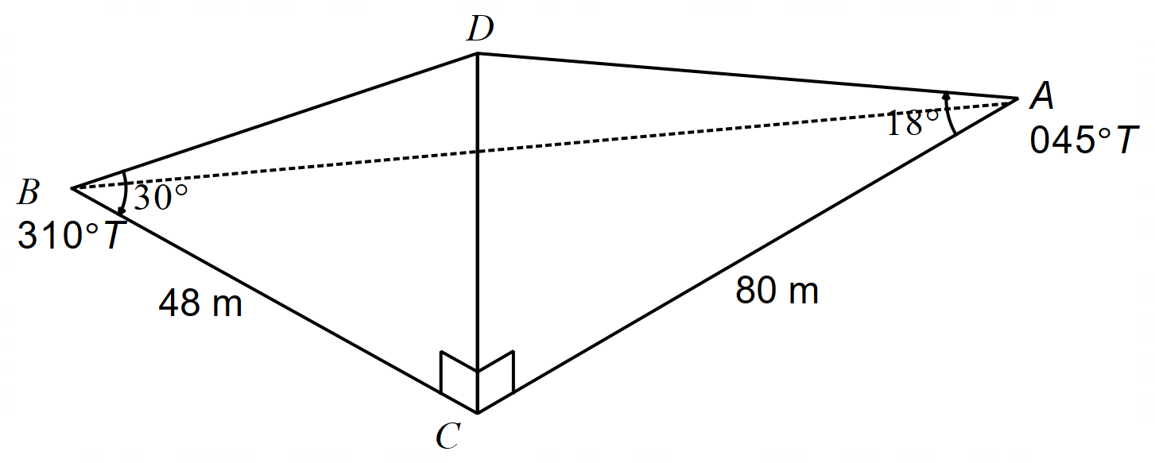

Appendix C

Solving 3-dimensional problems
- Two hikers, Liam and Sophie, are on different bushwalking tracks in a national park. They’re trying to meet up at a lookout platform perched high on a cliff.
From Liam’s position, the lookout has a bearing of $264°$ and the angle of elevation to the platform is $17°$. From Sophie’s position, the lookout has a bearing of $298°$ and the angle of elevation to the platform is $26°$.
The lookout platform is 900 m above the valley floor.
Find the distance and bearing of Liam from Sophie’s position, assuming they are at the same vertical height.
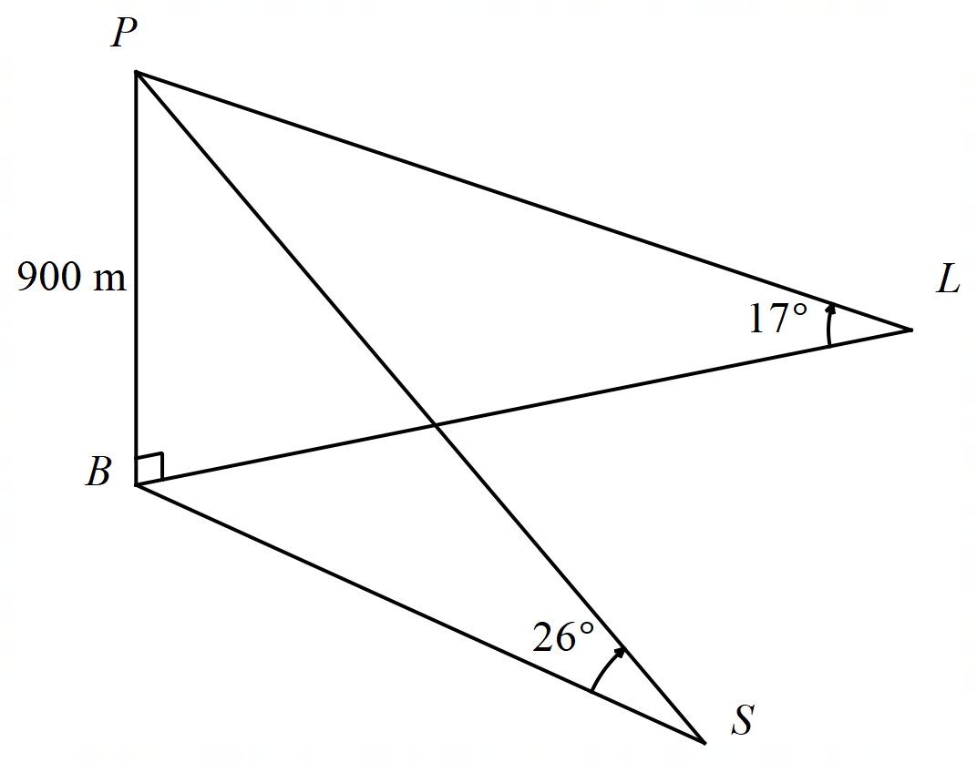
- A wildlife researcher is standing at point $C$ on a flat grassland in Kakadu National Park. Point $D$ is 1500 m due north of $C$.
A tall observation tower stands at point $T$, rising vertically from the ground, such that point $T$ is due west of $C$.
The angle of elevation to the top of the tower from $C$ and $D$ is $19°$ and $14°$, respectively.
Let the height of the tower be $h$ metres.
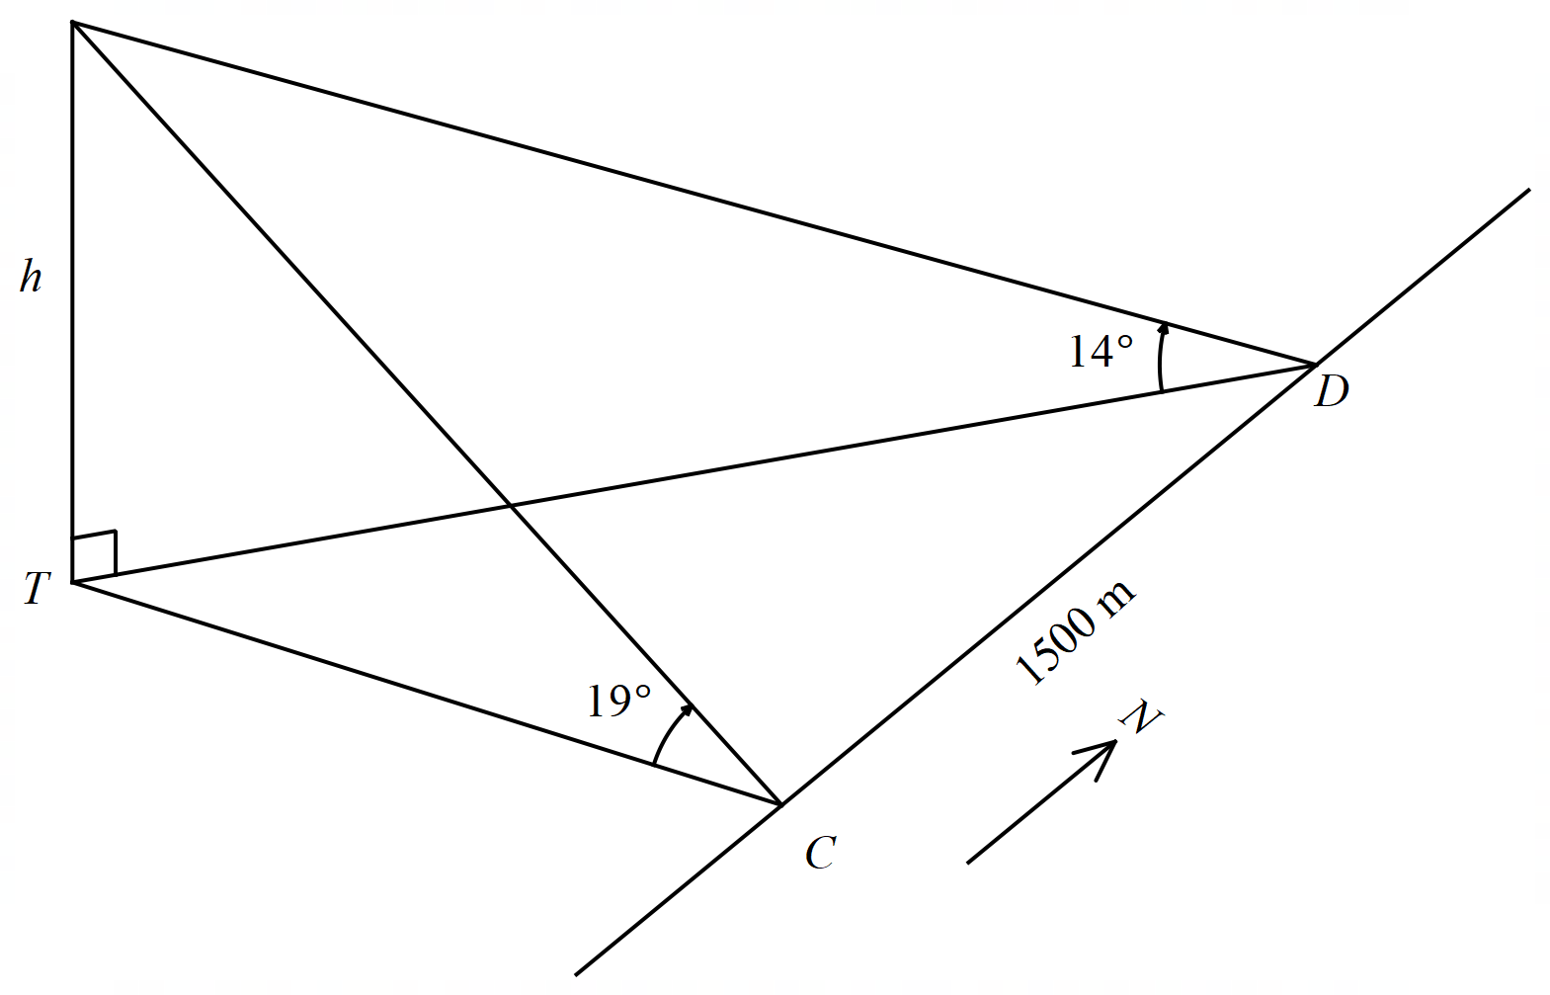
- Show that $CT=h\cot{19°}.$
- Hence, find the value of $h$.

Sample solutions

Appendix A – bearings question

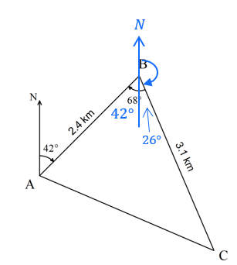
Use alternate angles to find $42°$.
$$68-42=26°$$
$$180°-26°=154°$$
- $c^{2}=a^{2}+b^{2}-2ab\cos{C}$
$$AC^{2}={2.4}^{2}+{3.1}^{2}-2×2.4×3.1×\cos{68°} \\ =9.79… \\ AC=\sqrt{9.795…}$$
$=3.1$ km (correct to 1 decimal place)
- $A=\frac{1}{2}ab\sin{C}$
$$A=\frac{1}{2}×2.4×3.1×\sin{68°}$$
$=3.45 \text{k}{\text{m}}^{\text{2}}$ (correct to 2 decimal places)

Appendix B – card matching activity
A drone hovers directly above a point on the ground. Student A stands 48 m east of the point, and Student B stands on a bearing of ${140}^{∘}$from the same point. The angle of elevation from A to the drone is ${18}^{∘}$, and from B it is ${30}^{∘}$. Find the distance between the 2 students.

$$\tan{18°}=\frac{DC}{48} \\ DC=48×\tan{18°} \\ =15.598… \\ ≈16 m$$

$$\tan{50°}=\frac{16}{BC} \\ BC=\frac{16}{\tan{30°}} \\ =27.712… \\ ≈28 m$$
$$c^{2}=a^{2}+b^{2}-2abcos C \\ ={48}^{2}+{28}^{2}-2×48×28×\cos{50°} \\ =1360.186… \\ c=36.880… \\ ≈37 m$$

A helicopter hovers above a rescue boat. Two observers on the shore stand 120 m apart, with one observer on a bearing of ${045}^{∘}$ from the boat and the other on a bearing of ${140}^{∘}$. Their angles of elevation to the helicopter are ${18}^{∘}$and ${30}^{∘}$. Find the height of the helicopter.
$$\tan{18°}=\frac{CD}{AC} \\ AC=\frac{CD}{\tan{18°}} \\ \tan{30°=\frac{CD}{BC}} \\ BC=\frac{CD}{\tan{30°}}$$
$$c^{2}=a^{2}+b^{2}-2abcos C \\ {120}^{2}={\left(\frac{CD}{\tan{30°}}\right)}^{2}+{\left(\frac{CD}{\tan{18°}}\right)}^{2}-2×\left(\frac{CD}{\tan{30°}}\right)×\left(\frac{CD}{\tan{18°}}\right)×\cos{95°} \\ {120}^{2}={\left(CD\right)}^{2}\left[\frac{1}{\tan^{2}{30°}}+\frac{1}{\tan^{2}{18°}}-2×\frac{1}{\tan{30° }}×\frac{1}{\tan{18°}}×\cos{95°}\right] \\ {120}^{2}={\left(CD\right)}^{2}×13.40… \\ {\left(CD\right)}^{2}=\frac{{120}^{2}}{13.40} \\ CD=1 074.519… \\ ≈1 075 m$$

A cliff rises vertically from the coastline. A boat is anchored 80 m from the base of the cliff on a bearing of ${270}^{∘}$. A second boat is anchored 48 m from the base on a bearing of ${200}^{∘}$. The angle of elevation from the first boat is ${18}^{∘}$. Find the angle of elevation from the second boat.
$$\tan{18°}=\frac{DC}{80} \\ DC=80×\tan{18°} \\ =25.993… \\ ≈26 m \\ \tan{∠DBC}=\frac{26}{48} \\ ∠DBC=28.442… \\ ≈28°$$

A communications tower, 22 m tall, stands at point C. Two technicians, $A$ and $B$, are positioned on the ground, each measuring the angle of elevation to the top of the tower. Their angles of elevation are 45$°$ and $30°$ respectively. The second technician, $B,$ is standing on a bearing of $140°T$ from the tower. If the first technician, $A$, is 48 m away from the second technician, determine the bearing of the first technician from the tower.

$$\tan{30°}=\frac{22}{CB} \\ CB=\frac{22}{\tan{30°}} \\ =22\sqrt{3} \\ \tan{45°}=\frac{22}{AC} \\ AC=\frac{22}{\tan{45°}} \\ =22 m$$
$$\cos{c}=\frac{{22}^{2}+{\left(22\sqrt{3}\right)}^{2}-{48}^{2}}{2×22×22\sqrt{3}} \\ C=102.678… \\ ≈103°$$
$$\text{bearing of} A is 140-103=037°T \text{or} \\ 140+103=243°T$$
From the diagram, the bearing of A is $243°T$.

A drone hovers above a point on the ground. Student A stands 4 stands 80 m away on a bearing of ${045}^{∘}$ and student B stands 48 m away on a bearing of ${310}^{∘}$. The angle of elevation from A is ${18}^{∘}$, and from B is ${30}^{∘}$. Calculate the distance between the 2 students.
$$∠BCA=50+45 \\ =95° \\ c^{2}=a^{2}+b^{2}-2ab\cos{C} \\ ={48}^{2}+{80}^{2}-2×48×80×\cos{95°} \\ =9373.356… \\ c=96.816… \\ =97 m$$

Appendix C – solving 3-dimensional problems
- Find the distance and bearing of Liam from Sophie’s position, assuming they are at the same vertical height.
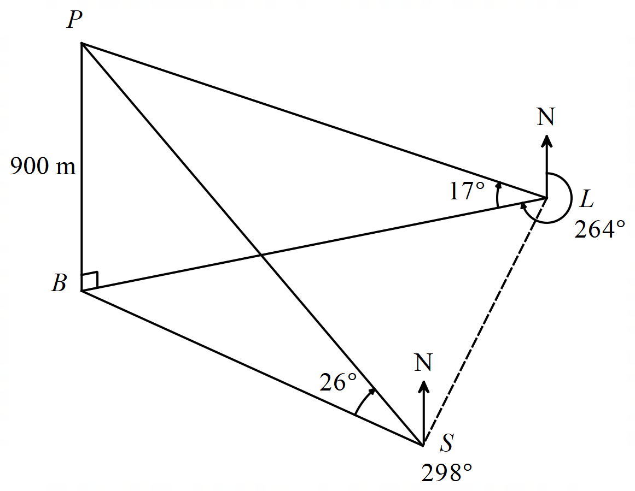
$$\tan{17°}=\frac{900}{BL} \\ BL=\frac{900}{\tan{17°}}$$
$$\tan{26°}=\frac{900}{BS} \\ BS=\frac{900}{\tan{26°}}$$
The bearing from $L$ to $B$ is $264°$, $∴$ the bearing from $B$ to $L=180-\left(360-264\right)=84°$.
The bearing from $S$ to $B$ is $298°, ∴$ the bearing from $B$ to $S=180-\left(360-298\right)=118°$.
$$∠LBS=118-84=34°$$
$$c^{2}=a^{2}+b^{2}-2ab\cos{C} \\ LS^{2}=BL^{2}+BS^{2}-2×BL×BS×\cos{(}∠LBS) \\ ={\left(\frac{900}{\tan{17°}}\right)}^{2}+{\left(\frac{900}{\tan{26°}}\right)}^{2}-2×\frac{900}{\tan{17°}}×\frac{900}{\tan{26°}}×\cos{34°} \\ =3 064 043.727… \\ LS=\sqrt{3 064 043.727…} \\ =1750\text{ (to the nearest metre)}$$
$$\frac{\sin\left(∠LSB\right)}{BL}=\frac{\sin\left(∠LBS\right)}{LS} \\ \frac{\sin\left(∠LSB\right)}{\frac{900}{\tan{17°}}}=\frac{\sin\left(34°\right)}{1750} \\ \sin\left(∠LSB\right)=\frac{900×\sin\left(34°\right)}{1750×\tan{17°}} \\ =0.9406… \\ \text{Related }∠=\sin^{-1}{0.9406…} \\ =70° 10’ \text{(to the nearest minute)}$$
Using the diagram, $∠LSB$ is obtuse. $∴∠LSB=180-70° 10’=109°50'$
Bearing $=298°+109°{50}^{'}=407°50'$
$$407°{50}^{'}-360°=47°50'$$
$∴$ Distance between them is 261 m and bearing of Liam from Sophie’s position is $47°{50}^{'}T.$

- Show that $CT=h\cot{19°}.$
$$\tan{19°}=\frac{h}{CT} \\ CT=h÷\tan{19°} \\ =h×\frac{1}{\tan{19°}} \\ =h\cot{19°}$$
- Hence, find the value of $h$.
$$\text{Similarly, }DT=h\cot{14°}$$
Since $C$ is due east of $T$, $∆DCT$ is right-angled.
$$∴DT^{2}=CT^{2}+CD^{2} \\ {\left(h\cot{14°}\right)}^{2}={\left(h\cot{19°}\right)}^{2}+{1500}^{2} \\ h^{2}\cot^{2}{14°}-h^{2}\cot^{2}{19°}={1500}^{2} \\ h^{2}\left(\cot^{2}{14°}-\cot^{2}{19°}\right)={1500}^{2} \\ h^{2}=\frac{{1500}^{2}}{\left(\cot^{2}{14°}-\cot^{2}{19°}\right)} \\ h=\sqrt{\frac{{1500}^{2}}{\left(\frac{1}{\tan^{2}{14°}}-\frac{1}{\tan^{2}{19°}}\right)}} \\ h=542.26 \text{m (correct to 2 decimal places)}$$

References
This resource contains NSW Curriculum and syllabus content. The NSW Curriculum is developed by the NSW Education Standards Authority (NESA). This content is prepared by NESA for and on behalf of the Crown in right of the State of New South Wales. The material is protected by Crown copyright.
Please refer to the NESA Copyright Disclaimer for more information https://www.nsw.gov.au/education-and-training/nesa/copyright.
NESA holds the only official and up-to-date versions of the NSW Curriculum and syllabus documents. Please visit NESA https://www.nsw.gov.au/education-and-training/nesa and NSW Curriculum https://curriculum.nsw.edu.au.
Mathematics Extension 1 11–12 Syllabus © NSW Education Standards Authority (NESA) for and on behalf of the Crown in right of the State of New South Wales, 2024

© State of New South Wales (Department of Education), 2026
The copyright material published in this resource is subject to the Copyright Act 1968 (Cth) and is owned by the NSW Department of Education or, where indicated, by a party other than the NSW Department of Education (third-party material).
Copyright material available in this resource and owned by the NSW Department of Education is licensed under a Creative Commons Attribution 4.0 International (CC BY 4.0) license.

This license allows you to share and adapt the material for any purpose, even commercially. Attribution should be given to © State of New South Wales (Department of Education), 2026.
Material in this resource not available under a Creative Commons license:
- the NSW Department of Education logo, other logos and trademark-protected material
- material owned by a third party that has been reproduced with permission. You will need to obtain permission from the third party to reuse its material.
Links to third-party material and websites
Please note that the provided (reading/viewing material/list/links/texts) are a suggestion only and implies no endorsement, by the New South Wales Department of Education, of any author, publisher, or book title. School principals and teachers are best placed to assess the suitability of resources that would complement the curriculum and reflect the needs and interests of their students.
If you use the links provided in this document to access a third-party's website, you acknowledge that the terms of use, including licence terms set out on the third-party's website apply to the use which may be made of the materials on that third-party website or where permitted by the Copyright Act 1968 (Cth). The department accepts no responsibility for content on third-party websites.

