Double angle formulas
Students develop an understanding of double angle relationships by linking them to previously learned sum and difference expansion formulas. They apply these relationships to rewrite and simplify trigonometric expressions, building foundations for future problem-solving and proofs.

Learning intentions
- To understand how double angle formulas are connected to the sum and difference expansion formulas.
- To be able to apply the formulas to solve problems.

Success criteria
- I can use the sum expansion formulas to derive the double angle formulas.
- I can use double angle formulas to solve problems.
- I can choose efficient strategies to simplify expressions and justify my approach.

Outcomes
A student:
- develops understanding and fluency in mathematics through exploring and connecting mathematical concepts, choosing and applying mathematical techniques to solve problems, and communicating their thinking and reasoning coherently and clearly MAO-WM-01
- solves problems in three dimensions using trigonometry and simplifies expressions, proves results and solves problems involving compound angles using trigonometric identities
ME1-11-03

Content

Further trigonometric identities
- Derive the double angle formulas $\sin{2A=2\sin{A}\cos{B},\cos{2A=\cos^{2}{A}-\sin^{2}{A}=2\cos^{2}{A}-1}=1-2\sin^{2}{A}}$ and $\tan{2A=\frac{2\tan{A}}{1-\tan^{2}{A}}}$
- Use the double angle formulas to solve problems and prove results
Mathematics Extension 1 11–12 Syllabus © NSW Education Standards Authority (NESA) for and on behalf of the Crown in right of the State of New South Wales, 2024.

Table 1: lesson summary
Section | Summary of activity | Teaching strategies | Teaching points
Activating prior knowledge | Students engage with true/false statements on slide 4 of the PowerPoint Double angle formulas to test their understanding of exact values and trigonometric reasoning. | Think-Pair-Share | The purpose of this activity is to challenge students’ assumptions and expose gaps in their understanding of trigonometric relationships. Teachers should emphasise reasoning using exact values.
Connecting learning | Students derive the double angle formulas starting with $\sin{2A}$, then $\cos{2A}$ and $\tan{2A}$ using sum and difference identities, supported by slides 6–7. Multiple forms of $cos2A$ are explored using slide 8. Students then build up to deriving a generalised formula for $\sin^{2}{nx}$ and $\cos^{2}{nx}$ using slide 9. | Vertical non-permanent surfaces  Visibly random groups of 3  Gallery walk | The focus is on constructing new identities from prior knowledge, reinforcing connections between formulas. It is important students understand how to derive the formulas as they are not on the HSC reference sheet.
Releasing responsibility | Students apply double angle formulas to find exact values using worked examples on slides 11–12, with slide 13 analysing an alternate method to the ‘Your turn’ question. Students complete Appendix A, making notes on how to derive the formulas shown on slide 9 and 14. | Pose-Pause-Pounce-Bounce  Worked examples (Your turn)  Think-Pair-Share  Notes to future forgetful selves | Teachers should emphasise that multiple methods may exist and that efficiency matters in problem-solving. Careful attention should be given to algebraic structure, especially when forming and solving quadratic equations in trigonometric contexts.
Independent practice | Students independently apply double angle formulas in more complex problems using slides 16–18. |  | The purpose of this activity is consolidation and transfer of learning to unfamiliar contexts as well as revising prior knowledge of polynomials and parametric equations.

Activity structure
Please use the associated PowerPoint Double angle formulas to display images in this lesson.

Activating prior knowledge
- Display slide 4 of the PowerPoint which shows 3 statements.
- In a Think-Pair-Share (bit.ly/thinkpairsharestrategy), have students decide whether each statement is true or false and justify their reasoning.
The slide can be animated to show the exact value triangles that students should be encouraged to use in their reasoning. In their explanations, students should reference the exact values of the relevant ratios in each statement.
All 3 statements are false.
- Animate slide 4 to display an additional statement for students to consider, justifying their reasoning.
- Explain that they will now develop the formula for $\sin{2A}$ to investigate, as well as the formulas for $\cos{2A}$ and $\tan{2A}$.

Connecting learning
- Have students recall the sum and difference expansion formulas using their Mathematics Extension 1 – HSC reference sheet (NESA 2024).
- Assign students to visibly random groups of 3 (bit.ly/visiblegroups) at vertical non-permanent surfaces (bit.ly/VNPSstrategy).
- Display slide 6, showing the expansion formula for $\sin{(A+B)}$ and a prompt asking students how it could be used to derive a formula for $\sin{2A}$.
- In their groups, have students manipulate and discuss the identity to derive the double angle formula for $\sin{2A}$, clearly justifying each step in their reasoning.
- Have students compare their working with other groups by completing a gallery walk (bit.ly/DLSgallerywalk).
- Animate slide 6 to show how the formula $\sin{2A=2\sin{A}\cos{A}}$ is derived.
The following section (steps 7–11) has students deriving both $\cos{2A}$ and $\tan{2A}$ in their groups. Alternatively, half of the groups could derive $\cos{2A}$ and the other half could derive $\tan{2A}$ and present their findings to the class.
- Instruct students in their groups to do the same for cosine, using $\cos{(A+B)}$ to derive $\cos{2A}$. The sum expansion formula for cosine can be displayed by animating slide 6.
- Once students have had time to derive the formula and compare their working to other groups, animate slide 6 to show how the formula $\cos{2A=\cos^{2}{A}-\sin^{2}{A}}$ is derived.
- Allow time for students to repeat the process to derive the formula for $\tan{2A}$.
- Have students complete a gallery walk, viewing the methods other groups used to derive the formula for $\tan{2A}$.
- Initiate a class discussion on the methods groups used to derive $\tan{2A}$.
Students may have let $B=A$ in $\tan{(A+B)}$ or they may have used $\tan{2A}=\frac{\sin{2A}}{\cos{2A}}$. Students may need some prompting to consider the second method.
- Display slide 7 which shows the 2 strategies side by side. Use the self-explanation prompt on the slide to compare the strategies in a class discussion.
- Explain that there can often be multiple ways to derive a formula and multiple ways to express a formula. Tell students that the double-angle formula for cosine can be written in 3 equivalent forms.
- Ask students, in their groups at their vertical non-permanent surfaces, to use their knowledge of identities to develop the 2 alternative forms of $cos⁡2A$.
Students may need some prompting to consider how the formula can be written in terms of $\cos^{2}{A}$ only or $\sin^{2}{A}$ only.
- Use slide 8 to show the solutions for the 2 alternative forms of $cos⁡2A$, comparing them with their own derivations. The solutions are animated for a slow reveal.
- Display slide 9 which shows students how to derive an expression for $\sin^{2}{x}$, using
$\cos{2x}=\cos^{2}{x}-\sin^{2}{x}$. Use the self-explanation prompt to unpack the solution.
- Animate slide 9 to reveal 2 additional questions for students to complete collaboratively.
- As students start to work through these questions, animate the final question for students to complete which requires them to write a generalised version for $\sin^{2}{nx}$ and $\cos^{2}{nx}$.
The activity on slide 9 has been included following syllabus Teaching advice for Further trigonometry. It is worth noting that, for now, this is just further practice manipulating the formulas, with more extensive use coming in Year 12 Extension 1 content.

Releasing responsibility
- Use the Pose-Pause-Pounce-Bounce questioning strategy (PDF 557KB) (bit.ly/posepausepouncebounce) to discuss the uses of the double angle formulas. A suggested prompt could include:
- Would we need the double angle formulas to find exact ratios when $A=30°, 45°$ or $60°$? Why or why not?
- For which angles would these formulas be helpful to find exact values for?
Students should recognise that we do not need to use the double angle formulas when
$A={30}^{∘},{45}^{∘}$, or ${60}^{∘}$, because this would give angles of ${60}^{∘},{90}^{∘}$, and ${120}^{∘}$. The exact ratios for these angles can already be determined using other methods, such as exact value triangles, the unit circle or angles of any magnitude. The double angle formulas are more useful for finding exact values of angles that are not easily obtained using these methods, such as $15°$ or $75°$.
- Use slides 11–12 to model worked examples of how the double angles formulas can be used to find exact values, using the Worked examples (Your turn) method (bit.ly/supportingstrategies).
For the solutions, students may prefer for each trigonometric quadratic equation to be rewritten in the form $u^{2}+2u-1=0$ (slide 10), by letting $u=\tan{22.5°}$ and $u^{2}+2\sqrt{3}u-1=0$ (slide 11), by letting $u=\tan{\frac{π}{12}}.$
- Animate slide 12 to reveal a prompt asking the class if the double angle formula was the only way to solve this question.
Students should recall that the difference expansion formula also could have been used since $\frac{π}{12}=\frac{π}{3}-\frac{π}{4}$.
- In a Think-Pair-Share, have students find the exact value of $\tan{\frac{π}{12}}$ using the formula $\tan\left(A-B\right)=\frac{\tan{A}-\tan{B}}{1+\tan{A}\tan{B}}$.
- Use slide 13 to show the alternative solution using the formula for $\tan{(A-B)}$ and use the self-explanation prompts to discuss each method.
Students may suggest that using the difference expansion formula is more efficient, as it produces a single solution directly and avoids the need to apply the quadratic formula. It is important to explain that this only works since $\frac{π}{12}$ is the difference of two exact ratio angles, if we can’t get the angle using sum or difference of 2 exact value angles then it is not usable.
- Use slide 14 to summarise the 3 double angle formulas, including the different versions for $\cos{2A}$.
- Refer students to their Mathematics Extension 1 – HSC reference sheet, highlighting that the double angle formulas are not included and therefore will need to be derived or recalled independently.
- Distribute Appendix A ‘Reference sheet notes – double angle formulas’ for students to complete, acting as notes to their future forgetful selves (bit.ly/notestofutureself) on deriving the double angles formulas.
- Students may benefit from completing further practice questions from an existing resource on applying the double angle formulas to solve problems.

Independent practice
- Use slide 16 to provide further problems requiring students to apply the double angle formulas in combination with parametric and polynomial concepts.
Students can complete this activity individually, in pairs or in groups of 3 at vertical non-permanent surfaces. This decision will depend on how ready the class is to take on more challenging problems.
- Solutions have been provided on slide 17–18.

Assessment and differentiation

Suggested opportunities for differentiation
Activating prior knowledge
- Some students may be supported by providing them with sentence starters. For example, ‘Using the value of $\sin{30°}=$… we know that …’
- Students could be extended to create their own true or false statements involving exact triangles.
Connecting learning
- To support students in deriving $\sin{2A}$, a scaffold can be provided. For example, ‘Start with $\sin{(A+A)}$.’
- Students could be challenged to derive all 3 forms of $\cos{2A}$ without prompts and justify why they are equivalent.
- Extend students by asking them to derive expressions for $\sin^{2}{nx}$ and $\cos^{2}{nx}$ independently before showing the worked example.
Independent practice
- Provide scaffolding for the solutions to support students.

Suggested opportunities for assessment
Activating prior knowledge
- Use student responses and reasoning to the true or false activity to assess any misconceptions.
Connecting learning
- The discussion comparing the 2 methods for $\tan{2A}$ should be used to assess students’ understanding of previously learned sum and difference expansion formulas.
Releasing responsibility
- Use the self-explanation prompts in the Worked example (Your turn) to assess whether students can explain each algebraic step.
Independent practice
- Students can self-assess using the solutions provided.

Appendix A

Reference sheet notes – double angle formulas
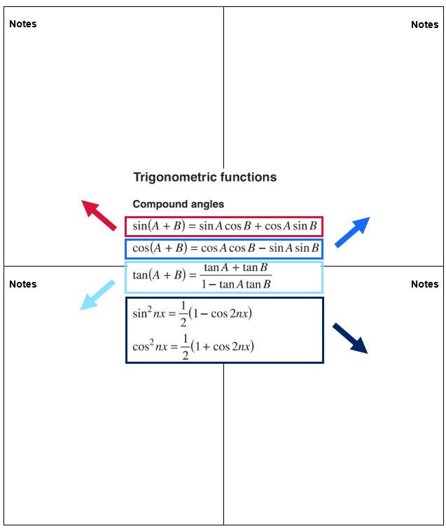

References
This resource contains NSW Curriculum and syllabus content. The NSW Curriculum is developed by the NSW Education Standards Authority (NESA). This content is prepared by NESA for and on behalf of the Crown in right of the State of New South Wales. The material is protected by Crown copyright.
Please refer to the NESA Copyright Disclaimer for more information https://www.nsw.gov.au/education-and-training/nesa/copyright.
NESA holds the only official and up-to-date versions of the NSW Curriculum and syllabus documents. Please visit NESA https://www.nsw.gov.au/education-and-training/nesa and NSW Curriculum https://curriculum.nsw.edu.au.
Mathematics Extension 1 11–12 Syllabus © NSW Education Standards Authority (NESA) for and on behalf of the Crown in right of the State of New South Wales, 2024.

© State of New South Wales (Department of Education), 2026
The copyright material published in this resource is subject to the Copyright Act 1968 (Cth) and is owned by the NSW Department of Education or, where indicated, by a party other than the NSW Department of Education (third-party material).
Copyright material available in this resource and owned by the NSW Department of Education is licensed under a Creative Commons Attribution 4.0 International (CC BY 4.0) license.

This license allows you to share and adapt the material for any purpose, even commercially. Attribution should be given to © State of New South Wales (Department of Education), 2026.
Material in this resource not available under a Creative Commons license:
- the NSW Department of Education logo, other logos and trademark-protected material
- material owned by a third party that has been reproduced with permission. You will need to obtain permission from the third party to reuse its material.
Links to third-party material and websites
Please note that the provided (reading/viewing material/list/links/texts) are a suggestion only and implies no endorsement, by the New South Wales Department of Education, of any author, publisher, or book title. School principals and teachers are best placed to assess the suitability of resources that would complement the curriculum and reflect the needs and interests of their students.
If you use the links provided in this document to access a third-party's website, you acknowledge that the terms of use, including licence terms set out on the third-party's website apply to the use which may be made of the materials on that third-party website or where permitted by the Copyright Act 1968 (Cth). The department accepts no responsibility for content on third-party websites.

