Circle parametric form
Students connect the unit circle and the parametric equations of a circle before examining how changes to $x=\cos{θ}\text{and} y=\sin{θ}$ affect the Cartesian equation.
Students will need at least one digital device per pair to interact with Amplify Classroom during this lesson.

Learning intention
- To understand how circles can be represented as parametric equations.

Success criteria
- I can link the parametric equations for a circle to the unit circle.
- I can convert the parametric equations for a circle to Cartesian form.
- I can graph a circle expressed as a pair of parametric equations.

Outcomes
A student:
- develops understanding and fluency in mathematics through exploring and connecting mathematical concepts, choosing and applying mathematical techniques to solve problems, and communicating their thinking and reasoning coherently and clearly MAO-WM-01
- solves problems involving inequalities, functions and their inverses, graphical relationships between functions, and parametric equations ME1-11-01

Content

Parametric form of a function or relation
- Recognise that a curve may be represented by two parametric equations that give $x$ and $y$ as functions of a parameter and that the curve may also have a Cartesian equation in $x$ and $y$
- Express linear and quadratic functions and circles in parametric form
- Convert linear and quadratic functions and circles from parametric form to Cartesian form
- Graph linear and quadratic functions and circles expressed in parametric form
Mathematics Extension 1 11–12 Syllabus © NSW Education Standards Authority (NESA) for and on behalf of the Crown in right of the State of New South Wales, 2024.

Table 1: lesson summary
Section | Summary of activity | Teaching strategies | Teaching points
Activating prior knowledge | Use slide 4 of the PowerPoint Circle parametric form to present 3 different questions related to circles. Students are to sketch the graph and identify the radius and origin. |  | This lesson assumes students have studied the equation of a circle in Mathematics Advanced.
Connecting learning | Use the Amplify Classroom activity (bit.ly/Parametric_circles) and slide 6 to link the right-angled triangle to the parametric equations $x=cos⁡θ$and $y=sin⁡θ$. Students explore how changing the radius of a circle affects its parametric equations and determine how to adjust the equations to translate the circle’s centre. | Think-Pair-Share | This lesson assumes students have not studied Pythagorean identities in Mathematics Advanced and establishes that $x=cos⁡θ$and $y=sin⁡θ$ before determining that $\sin^{2}{θ}+\cos^{2}{θ}=1$.
Releasing responsibility | Use slides 8–9 to model a worked example of eliminating the parameter before applying the process independently (Appendix A). Use slide 10 to allow students to work backwards from the Cartesian circle equation to parametric equations before using Appendix B to create Four quadrant notes. | Worked examples (Your turn)  Variation theory  Visibly random groups of 3  Vertical non-permanent surfaces  Notes to future forgetful selves
Independent practice | Use slides 12–13 to apply the Approaching questions scaffold to a HSC-style problem before attempting further HSC-style questions in Appendix C. |  | Students apply their knowledge to HSC-style questions.

Activity structure
Please use the associated PowerPoint Circle parametric form to display images in this lesson.

Activating prior knowledge
- Display the equations on slide 4 of the PowerPoint and have students sketch the graph, identifying the radius and origin.
- Animate the slide to reveal the solution.
- Continue to animate the slide to reveal 2 more questions and their solutions.
Students are familiar with graphing circles from Unit 2 – Lesson 4 – circles and semicircles and Unit 4 – Lesson 6 – further circles.

Connecting learning
- With at least one device per pair, assign the Amplify Classroom activity ‘Circles in parametric form’ (bit.ly/Parametric_circles) for students to work through screens 1–4.
Before completing this activity, you will need to set up an Amplify Classroom (bit.ly/createamplifyclassroom). Teachers may wish to use the pacing tool to restrict students from viewing screens until appropriate.
Amplify Classroom provides opportunities for immediate feedback as well as tailored feedback from the teacher as students progress.
Students will need to type ‘sin theta’ to enter $\sin{θ}$ into Desmos and ‘sin ^ 2 theta’ to enter $\sin^{2}θ$.
- Display slide 6 of the PowerPoint to reveal the 2 parametric equations of a circle and the Cartesian equation of a circle.
- In a Think-Pair-Share (bit.ly/thinkpairsharestrategy) have students discuss how they used Pythagoras’ theorem to write an equation in terms of $θ$.
Students’ studied Pythagorean identities in Mathematics Advanced Year 11 – Unit 7 – Lesson 9 – Pythagorean identities.
- Release screen 5 of the Amplify Classroom activity, and allow students time to consider the changes to the parametric equations if the radius of the circle changes.
Students should conclude that the hypotenuse changes the radius of the circle and that the parametric equations must be scaled accordingly. For example, if the hypotenuse is $r$, then the radius of the circle is $r$ and the parametric equations become $x=r\cos{θ}$ and $y=r\sin{θ}.$
- Students do not study transformations of trigonometric graphs until Year 12, but they have already explored transformations of circles and other functions. Teachers should draw on this prior knowledge to support students in making connections between familiar transformations and the new trigonometric cases.
- Release screens 6–7 and allow students time to consider what adjustments need to be made to the parametric equations to translate the centre of the circle from $\left(0,0\right)$ to another point on the Cartesian plane.
Students should conclude that shifting the centre of the circle requires adding horizontal and vertical translations to the parametric equations. For example, to shift the centre to $(h, k)$ the parametric equation for $x$will be $x=\cos{θ}+h$ and for $y, y=\sin{θ}+k.$

Releasing responsibility
- Use slides 8–9 to model a worked example of converting parametric equations into a Cartesian equation using the Worked examples (Your turn) method (bit.ly/supportingstrategies). Animate the slides to reveal self-explanation prompts and the worked solution.
- Distribute Appendix A ‘Eliminate the parameter’ and have students eliminate the parameter to create the Cartesian equation.
Teachers might like to discuss question 3 and how it differs to the other questions. Students could be encouraged to create tables of values to explore the starting point and direction of travel for each graph.
- Assign students to visibly random groups of 3 (bit.ly/visiblegroups) at vertical non-permanent surfaces (bit.ly/VNPSstrategy).
- Display slide 10 which revisits the equations of the circle from the ‘Activating prior knowledge’ section of the lesson.
- Allow groups time to work backwards, putting each of the Cartesian equations into parametric form.
- Animate the slide to reveal the solutions one at a time.
- Distribute Appendix B ‘Four quadrant notes’ (bit.ly/supportingstrategies) for students to write notes to their future forgetful selves (bit.ly/notestofutureself).

Independent practice
- Use slide 12 of the PowerPoint to review the key steps of the Approaching questions scaffold. Reinforce to students how it supports multi-mark HSC-style reasoning.
- Display slide 13 and allow students time to collaborate with a partner to apply the Approaching question scaffold to solve the problem. Display slide 14 to reveal the worked solution.
- Distribute Appendix B ‘HSC-style questions’ and have students attempt to answer the questions.
- Once students have completed their attempts, have them join with another student to compare solutions, discuss differences and negotiate corrections where needed.

Assessment and differentiation

Suggested opportunities for differentiation
Activating prior knowledge
- Students may benefit from revising the equation of a circle or how to complete the square to solve a quadratic equation.
- Students could be extended by exploring circles with irrational radii or centres that are not integer values.
Connecting learning
- Students may benefit from revising right-angled trigonometry prior to this activity.
- Invite students to create a new parametric representation of the same circle (for example, using $x=cos⁡(2θ)$, $y=sin⁡(2θ)$) and compare how the motion differs while the Cartesian equation remains unchanged.
Releasing responsibility
- Provide a faded worked example for the questions from Appendix A, with the first rearrangement step already shown. This will help students to focus on the logic of eliminating the parameter rather than focusing on the algebraic setup.
- Ask students to work backwards from the Cartesian equation before revealing the solution on slide 10. Students should predict a possible parametric form and justify their choice.
Independent practice
- Offer a worked example with colour-coded steps that match the Approaching questions scaffold, so students can visually track how the scaffold structures multi-mark reasoning before attempting the HSC-style questions in Appendix B.
- Challenge students to solve the question on slide 13 using 2 different approaches and compare which method produces the most efficient reasoning.

Suggested opportunities for assessment
Activating prior knowledge
- Check students’ solutions to assess their ability to find the centre and radii of a circle.
Connecting learning
- Review students’ Pythagoras-based derivations to check whether they can independently recognise how the identity ${sin⁡}^{2}θ+{cos⁡}^{2}θ=1$emerges from the geometry.
- Listen to Think-Pair-Share discussions to gauge how confidently students can explain how scaling the triangle affects the radius and how the parametric equations adjust accordingly.
Releasing responsibility
- Listen to group discussions to gauge students’ reasoning as they convert the Cartesian circle equations back into parametric form.
- Review students’ Four quadrant notes to evaluate how well they can summarise the process for their ‘future forgetful selves,’ revealing their conceptual grasp of the link between parametric and Cartesian forms.
Independent practice
- Observe students as they apply the Approaching question scaffold to the problem on slide 13 to assess how well they structure multi-step reasoning.
- Review students’ responses to Appendix B to evaluate accuracy, clarity of working and their ability to justify each step.

Appendix A

Eliminate the parameter
Convert the following pairs of parametric equations into a Cartesian equation.
- $x=3cos{θ}, y=3sin{θ}$
- $x=\sqrt{3}cos{θ}, y=\sqrt{3}\sin{θ}$
- $y=\sqrt{3}cos{θ}, x=\sqrt{3}\sin{θ}$
- $x=\sqrt{3}cos{θ}+1, y=\sqrt{3}\sin{θ}$
- $x=\sqrt{3}cos{θ}, y=\sqrt{3}\sin{θ}+1$
- $x=\sqrt{3}cos{θ}-1, y=\sqrt{3}\sin{θ}-2$
- $x=1-\sqrt{3}cos{θ}, y=2+\sqrt{3}\sin{θ}$
- $x=\frac{3}{2}cos{θ}, y=\frac{3}{2}\sin{θ}$
- $x=(\sqrt{3}+1)cos{θ}, y=(\sqrt{3}+1)\sin{θ}$

Appendix B

Four quadrant notes
Example 1  Find the Cartesian equation for the following parametric equations, then sketch the curve.  $$x=4\cos{θ} , y=4\sin{θ}$$  $$\frac{x}{4}=\cos{θ}…\left(1\right) \\ \frac{y}{4}=\sin{θ}…\left(2\right)$$  $$\sin^{2}{θ}+\cos^{2}{θ}=1$$ | Example 2  Find the Cartesian equation for the following parametric equations, then sketch the curve.  $$x=2\cos{θ}-3 , y=2\sin{θ}+1$$
Things to remember | Example 3

Appendix C

HSC-style questions
Question 1
- Show that $x=a+r\sin{θ}$ and $y=b+r\cos{θ}$ define a circle with centre $(a,b)$ and radius $r$.
- Hence, sketch a graph of the curve $x=1+2\sin{θ}$ and $y=-3+2\cos{θ}.$
Question 2
A circle with centre at the origin and radius of 2 has parametric equations $x=2\cos{t}$and $y=2\sin{t}$.
By considering translations, write the parametric equations when this circle is shifted left 1 unit and down 3.
Question 3
A circle has the parametric equations $x=4\cos{t}-2$and $y=4\sin{t}+3$. What translations are needed for the circle to have a centre at the origin?

Sample solutions

Appendix A – eliminate the parameter
- $x=3 cos{θ}, y=3 sin{θ}$
$$\frac{x}{3}=\cos{θ},\frac{y}{3}=\sin{θ} \\ \sin^{2}{θ}+\cos^{2}{θ}=1 \\ {\left(\frac{y}{3}\right)}^{2}+{\left(\frac{x}{3}\right)}^{2}=1 \\ y^{2}+x^{2}=9$$
- $x=\sqrt{3} cos{θ}, y=\sqrt{3}\sin{θ}$
$$\frac{x}{\sqrt{3}}=\cos{θ},\frac{y}{\sqrt{3}}=\sin{θ} \\ \sin^{2}{θ}+\cos^{2}{θ}=1 \\ {\left(\frac{y}{\sqrt{3}}\right)}^{2}+{\left(\frac{x}{\sqrt{3}}\right)}^{2}=1 \\ y^{2}+x^{2}=3$$
- $y=\sqrt{3} cos{θ}, x=\sqrt{3}\sin{θ}$
$$\frac{y}{\sqrt{3}}=\cos{θ},\frac{x}{\sqrt{3}}=\sin{θ} \\ \sin^{2}{θ}+\cos^{2}{θ}=1 \\ {\left(\frac{x}{\sqrt{3}}\right)}^{2}+{\left(\frac{y}{\sqrt{3}}\right)}^{2}=1 \\ y^{2}+x^{2}=3$$
- $x=\sqrt{3} cos{θ}+1, y=\sqrt{3}\sin{θ}$
$$\frac{x-1}{\sqrt{3}}=\cos{θ},\frac{y}{\sqrt{3}}=\sin{θ} \\ \sin^{2}{θ}+\cos^{2}{θ}=1 \\ {\left(\frac{y}{\sqrt{3}}\right)}^{2}+{\left(\frac{x-1}{\sqrt{3}}\right)}^{2}=1 \\ y^{2}+{(x-1)}^{2}=3$$

- $x=\sqrt{3} cos{θ}, y=\sqrt{3}\sin{θ}+1$
$$\frac{x}{\sqrt{3}}=\cos{θ},\frac{y-1}{\sqrt{3}}=\sin{θ} \\ \sin^{2}{θ}+\cos^{2}{θ}=1 \\ {\left(\frac{y-1}{\sqrt{3}}\right)}^{2}+{\left(\frac{x}{\sqrt{3}}\right)}^{2}=1 \\ {(y-1)}^{2}+x^{2}=3$$
- $x=\sqrt{3 }cos{θ}-1, y=\sqrt{3}\sin{θ}-2$
$$\frac{x+1}{\sqrt{3}}=\cos{θ},\frac{y+2}{\sqrt{3}}=\sin{θ} \\ \sin^{2}{θ}+\cos^{2}{θ}=1 \\ {\left(\frac{y+2}{\sqrt{3}}\right)}^{2}+{\left(\frac{x+1}{\sqrt{3}}\right)}^{2}=1 \\ {(y+2)}^{2}+{(x+1)}^{2}=3$$
- $x=1-\sqrt{3 }cos{θ}, y=2+\sqrt{3}\sin{θ}$
$$\frac{1-x}{\sqrt{3}}=\cos{θ},\frac{y-2}{\sqrt{3}}=\sin{θ} \\ \sin^{2}{θ}+\cos^{2}{θ}=1 \\ {\left(\frac{y-2}{\sqrt{3}}\right)}^{2}+{\left(\frac{1-x}{\sqrt{3}}\right)}^{2}=1 \\ {(y-2)}^{2}+{(1-x)}^{2}=3$$
- $x=\frac{3}{2} cos{θ}, y=\frac{3}{2}\sin{θ}$
$$\frac{2x}{3}=\cos{θ},\frac{2y}{3}=\sin{θ} \\ \sin^{2}{θ}+\cos^{2}{θ}=1 \\ {\left(\frac{2y}{3}\right)}^{2}+{\left(\frac{2x}{3}\right)}^{2}=1 \\ y^{2}+x^{2}=\frac{9}{4}$$

- $x=\left(\sqrt{3}+1\right) cos{θ}, y=\left(\sqrt{3}+1\right)\sin{θ}$$$\frac{x}{\sqrt{3}+1}=\cos{θ},\frac{y}{\sqrt{3}+1}=\sin{θ} \\ \sin^{2}{θ}+\cos^{2}{θ}=1 \\ {\left(\frac{y}{\sqrt{3}+1}\right)}^{2}+{\left(\frac{x}{\sqrt{3}+1}\right)}^{2}=1 \\ y^{2}+x^{2}={\left(\sqrt{3}+1\right)}^{2}$$

Appendix B – Four quadrant notes
Example 1  Find the Cartesian equation for the following parametric equations, then sketch the curve.  $$x=4\cos{θ} , y=4\sin{θ}$$  $$\frac{x}{4}=\cos{θ}…\left(1\right) \\ \frac{y}{4}=\sin{θ}…\left(2\right)$$  $$\sin^{2}{θ}+\cos^{2}{θ}=1 \\ {\left(\frac{y}{4}\right)}^{2}+{\left(\frac{x}{4}\right)}^{2}=1 \\ y^{2}+x^{2}=16$$  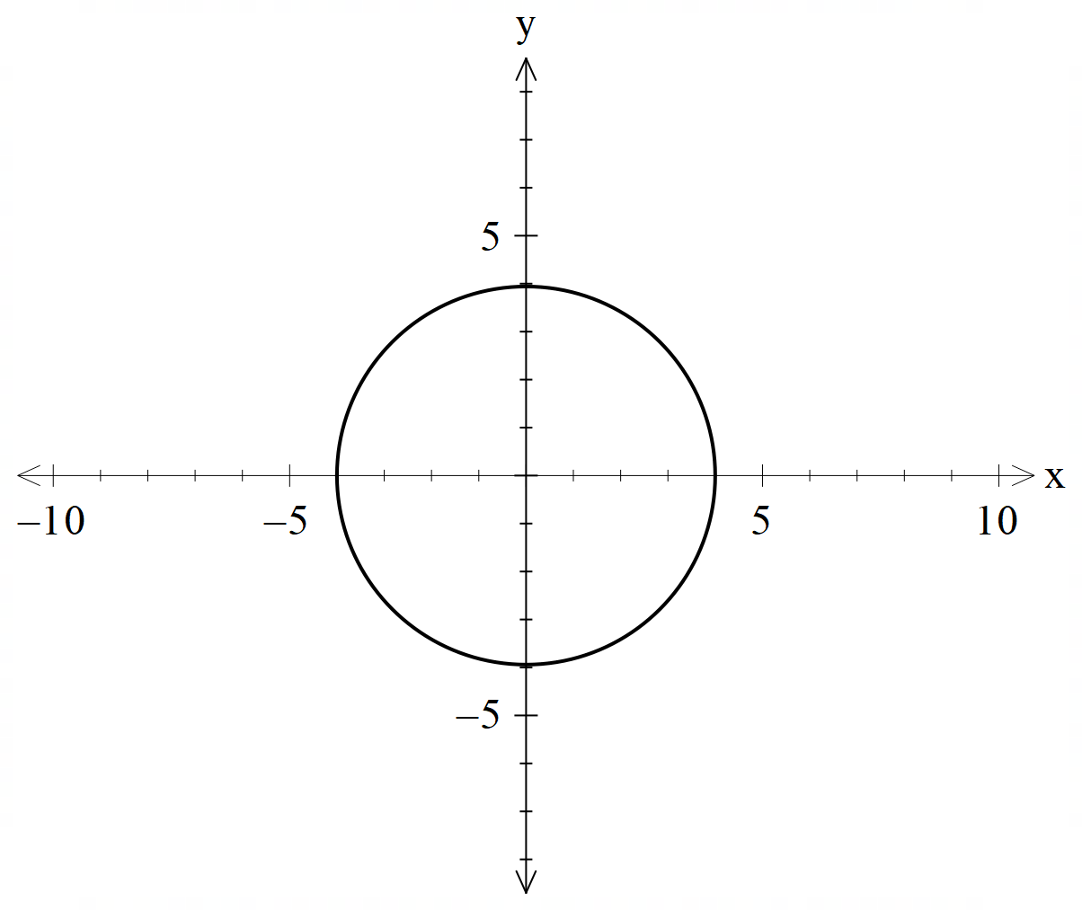 | Example 2  Find the Cartesian equation for the following parametric equations, then sketch the curve.  $$x=2\cos{θ}-3 , y=2\sin{θ}+1$$  $$\frac{x+3}{2}=\cos{θ}…\left(1\right) \\ \frac{y-1}{2}=\sin{θ}…\left(2\right)$$  $$\sin^{2}{θ}+\cos^{2}{θ}=1 \\ {\left(\frac{y-1}{2}\right)}^{2}+{\left(\frac{x+3}{2}\right)}^{2}=1 \\ {(y-1)}^{2}+({x+3)}^{2}=4$$  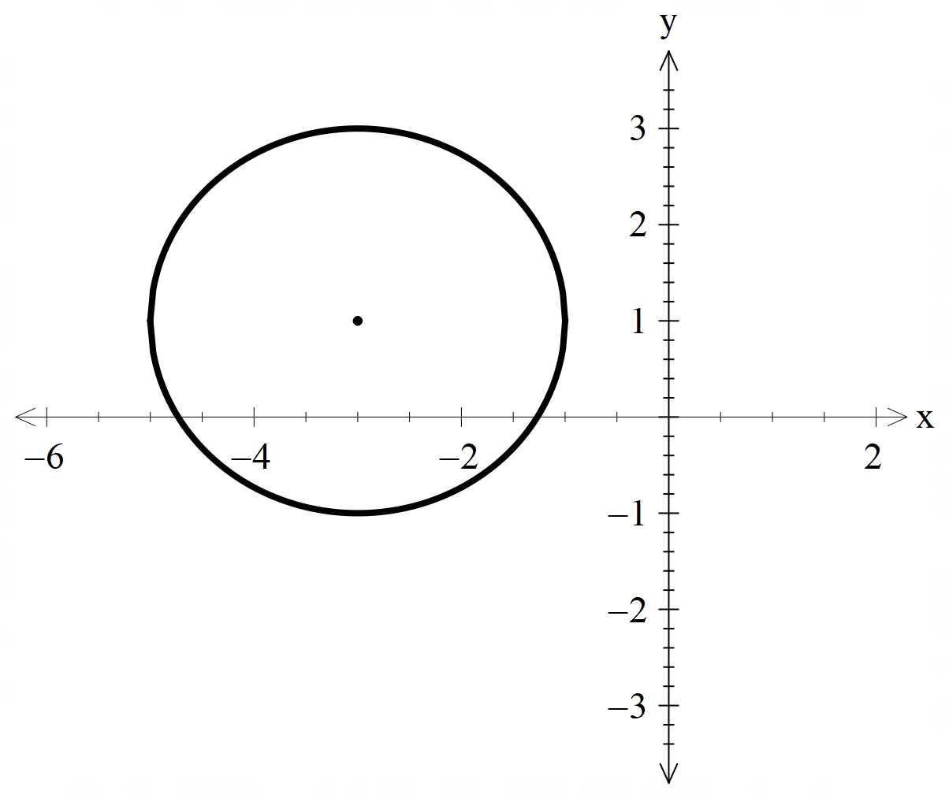

Appendix C – HSC-style questions
Question 1

$$x=a+r\sin{θ} \\ \frac{x-a}{r}=\sin{θ} \\ y=b+r\cos{θ} \\ \frac{y-b}{r}=\cos{θ} \\ \sin^{2}{θ}+\cos^{2}{θ}=1 \\ {\left(\frac{x-a}{r}\right)}^{2}+{\left(\frac{y-b}{r}\right)}^{2}=1 \\ {\left(x-a\right)}^{2}+{\left(y-b\right)}^{2}=r^{2}$$
This is a circle with centre $(a,b)$ and radius.

- If $x=1+2\sin{θ}$, then $r=2$ and $a=1$.
If $y=-3+2\cos{θ, }$ then $b=-3$
$$∴{\left(x-1\right)}^{2}+{\left(y+3\right)}^{2}=4$$
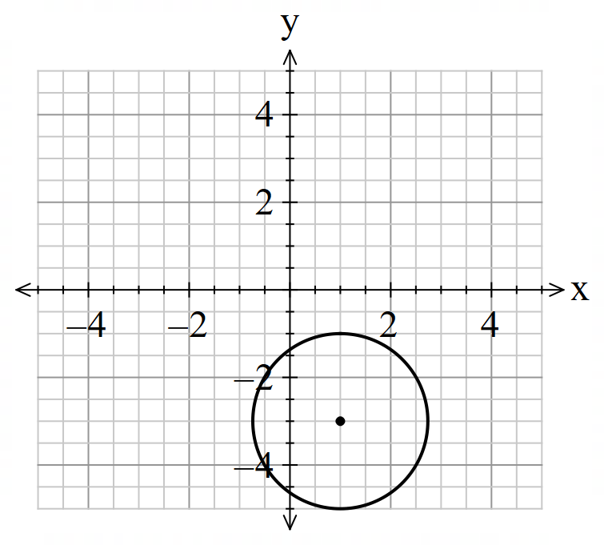
Question 2
Shifting left 1 means subtracting 1 from all $x$-coordinates.
$$∴x=2\cos{t}-1 \\ \frac{x+1}{2}=\cos{t}$$
Shifting down 3 means subtracting 3 from all $y$-coordinates.
$$∴y=2\sin{t}-3 \\ \frac{y+3}{2}=\sin{t}$$
Since $\sin^{2}{t}+\cos^{2}{t}=1$$${\left(\frac{y+3}{2}\right)}^{2}+{\left(\frac{x+1}{2}\right)}^{2}=1 \\ {\left(y+3\right)}^{2}+{\left(x+1\right)}^{2}=4$$
The circle has the same radius but has now moved left 1 and down 3.
Question 3
$$x=4\cos{t}-2 \\ \frac{x+2}{4}=\cos{t} \\ y=4\sin{t}+3 \\ \frac{y-3}{4}=\sin{t} \\ \cos^{2}{t}+\sin^{2}{t}=1 \\ {\left(\frac{x+2}{4}\right)}^{2}+{\left(\frac{y-3}{4}\right)}^{2}=1$$
The centre of the circle is $\left(-2,3\right).$ To move the centre of the circle to (0,0) the following translation is required: horizontal: right 2, vertical: down 3.

References
This resource contains NSW Curriculum and syllabus content. The NSW Curriculum is developed by the NSW Education Standards Authority (NESA). This content is prepared by NESA for and on behalf of the Crown in right of the State of New South Wales. The material is protected by Crown copyright.
Please refer to the NESA Copyright Disclaimer for more information https://www.nsw.gov.au/education-and-training/nesa/copyright.
NESA holds the only official and up-to-date versions of the NSW Curriculum and syllabus documents. Please visit NESA https://www.nsw.gov.au/education-and-training/nesa and NSW Curriculum https://curriculum.nsw.edu.au.
Mathematics Extension 1 11–12 Syllabus © NSW Education Standards Authority (NESA) for and on behalf of the Crown in right of the State of New South Wales, 2024.

© State of New South Wales (Department of Education), 2026
The copyright material published in this resource is subject to the Copyright Act 1968 (Cth) and is owned by the NSW Department of Education or, where indicated, by a party other than the NSW Department of Education (third-party material).
Copyright material available in this resource and owned by the NSW Department of Education is licensed under a Creative Commons Attribution 4.0 International (CC BY 4.0) license.

This license allows you to share and adapt the material for any purpose, even commercially. Attribution should be given to © State of New South Wales (Department of Education), 2026.
Material in this resource not available under a Creative Commons license:
- the NSW Department of Education logo, other logos and trademark-protected material
- material owned by a third party that has been reproduced with permission. You will need to obtain permission from the third party to reuse its material.
Links to third-party material and websites
Please note that the provided (reading/viewing material/list/links/texts) are a suggestion only and implies no endorsement, by the New South Wales Department of Education, of any author, publisher, or book title. School principals and teachers are best placed to assess the suitability of resources that would complement the curriculum and reflect the needs and interests of their students.
If you use the links provided in this document to access a third-party's website, you acknowledge that the terms of use, including licence terms set out on the third-party's website apply to the use which may be made of the materials on that third-party website or where permitted by the Copyright Act 1968 (Cth). The department accepts no responsibility for content on third-party websites.

