Linear and quadratic parametric form
Students are introduced to linear and quadratic parametric form through examples, before connecting parametric and Cartesian forms by eliminating the parameter both graphically and algebraically.
Students will need at least one digital device per pair to interact with Amplify Classroom during this lesson.

Learning intention
- To understand how linear and quadratic functions can be represented as parametric equations.

Success criteria
- I can convert a pair of linear parametric equations to a Cartesian equation.
- I can convert a pair of quadratic parametric equations to a Cartesian equation.
- I can graph parametric equations in parametric form.
- I can graph parametric equations after converting them to Cartesian form.

Outcomes
A student:
- develops understanding and fluency in mathematics through exploring and connecting mathematical concepts, choosing and applying mathematical techniques to solve problems, and communicating their thinking and reasoning coherently and clearly MAO-WM-01
- solves problems involving inequalities, functions and their inverses, graphical relationships between functions, and parametric equations ME1-11-01

Content

Parametric form of a function or relation
- Recognise that a curve may be represented by two parametric equations that give $x$ and $y$ as functions of a parameter and that the curve may also have a Cartesian equation in $x$ and $y.$
- Express linear and quadratic functions and circles in parametric form
- Convert linear and quadratic functions and circles from parametric form to Cartesian form
- Graph linear and quadratic functions and circles expressed in parametric form
Mathematics Extension 1 11–12 Syllabus © NSW Education Standards Authority (NESA) for and on behalf of the Crown in right of the State of New South Wales, 2024.

Table 1: lesson summary
Section | Summary of activity | Teaching strategies | Teaching points
Retrieval practice | Students solve the 2 pairs of simultaneous equations shown on slide 4 of the PowerPoint Linear and quadratic parametric form. The solutions are shown on slide 5. |  | Solving simultaneous equations closely mirrors the steps used when eliminating the parameter in parametric equations and so prepares students for the new learning.
Activating prior knowledge | Students explore exchange rates by interpreting 2 linear relationships and using a shared parameter (AUD) to build a direct conversion between USD and EUR. They apply the same idea to motion, using time as the linking parameter to connect horizontal and vertical equations and determine unknown values. | Pose-Pause-Pounce-Bounce  Think-Pair-Share | Students revisit linear and quadratic functions using a context to introduce a parameter.
Connecting learning | Students use the Amplify activity (bit.ly/linear_quadratic_parametric) to explore linear and quadratic parametric functions graphically before seeing the link between the graph and the equation. Students discover that the graph is not the most efficient way of finding the Cartesian equation. |  | Teachers may need to explain the phrase ‘eliminating the parameter’.
Releasing responsibility | Use slides 7–8 to model converting parametric equations into a Cartesian equation. Students then compare 2 methods for finding the Cartesian equation, discussing what is similar and different using Appendix A to practise and Appendix B to write notes. | Worked example – Your turn  Variation theory  Four quadrant notes | Students discover that it does not matter which parametric equation you use to make the parameter the subject.
Independent practice | Students use the Approaching questions scaffold to unpack the HSC question from slide 12 before practising HSC-style questions from Appendix C. | Think-Pair-Share | The HSC-style questions use a wide range of contexts to extend students.

Activity structure
Please use the associated PowerPoint Linear and quadratic parametric form to display images in this lesson.

Retrieval practice
- Display slide 4 of the PowerPoint and have students solve the pairs of equations.
- Display slide 5 to reveal the 2 solutions.
Solving simultaneous equations is very similar to the process of converting parametric equations into Cartesian form, which will be explored in this lesson.

Activating prior knowledge

Linear
- Ask students to look up today’s exchange rates for:
- Australian dollar (AUD) to US dollar (USD)
- Australian dollar (AUD) to Euro (EUR).
Alternatively, provide them with the following rates 1 AUD = 0.71 USD and 1 AUD = 0.61 EUR.
- Use a Think-Pair-Share (bit.ly/thinkpairsharestrategy) for students to discuss what the exchange rate means in everyday language and how each relationship would look on a graph.
- Pose the question: ‘If we can convert Australian dollars (AUD) to US dollars (USD) and Australian dollars (AUD) to euros (EUR), how could we convert directly between US dollars (USD) and euros (EUR)?’
- Allow students time to use their knowledge of exchange rates to try to establish a direct link between USD and EUR.
- Use the Pose-Pause-Pounce-Bounce questioning strategy (PDF 557 KB) (bit.ly/posepausepouncebounce) to check for understanding. Possible prompting questions could include:
- How did you find an equation converting US dollars to euros?
- Is 0.71 USD = 0.61 EUR? Why or why not?
- How many euros is 1 USD worth?
- How many US dollars is 1 Euro worth?
- Explain to students that the Australian dollar acts as a parameter or a link to build a conversion between US dollars and euros.

Quadratic
- Pose the following scenario to students:
A tennis ball is thrown and its motion is described using the following equations, where $t$is time in seconds.
Horizontal distance: $x=18t$
Vertical distance: $y=10t-5t^{2}$
- Tell students that the ball has travelled 36 metres horizontally. Have them use this information, and the 2 parametric equations, to find the vertical height at that moment.
When $x=36, t=2$ and $y=0$.
- Have students consider how they would find the horizontal distance if the vertical height was 4 metres. Students do not have to find the horizontal distance.
Students will need to substitute $y=4$ and solve for $t$ before substituting into the horizontal equation. This creates 2 answers.
- Have students in a Think-Pair-Share transfer their understanding from the linear example to quadratics by identifying the parameter that links horizontal and vertical distance.

Connecting learning
- With at least one device per pair, assign the Amplify Classroom activity ‘Linear and quadratic parametric form’ (bit.ly/linear_quadratic_parametric) to students.
Before completing this activity, you will need to set up an Amplify Classroom (bit.ly/createamplifyclassroom). Teachers may wish to use the pacing tool to restrict students from viewing screens until appropriate.
Amplify Classroom provides opportunities for immediate feedback as well as tailored feedback from the teacher as students progress.
- Have students work through screens 1–5.
- Introduce the phrase ‘eliminate the parameter’ and explain that eliminating the parameter means rewriting the relationship without the parameter. That is, expressing the equation directly in terms of $x$ and $y$.
- Extend the pacing to include screens 6–9, allowing students time to complete the activities involving quadratic parametric equations. Students will need pen and paper to attempt to find the equation of the quadratic on screen 9 and to be able to compare this to the equation found using an algebraic approach.
- In a class discussion, have students share what they have learned from the Amplify Classroom activity regarding connections between parametric equations and Cartesian equations.
Students should have discovered that determining the Cartesian equation directly from a graph is not always accurate or straightforward, and that the parametric equations share the same underlying characteristics as the Cartesian form. For example, linear parametric equations typically produce linear Cartesian equations.

Releasing responsibility
- Use slides 7–8 to model a worked example of converting parametric equations into a Cartesian equation using the Worked examples (Your turn) method (bit.ly/supportingstrategies). Animate the slides to reveal self-explanation prompts and the worked solution.
- Display slide 9 and have students compare the 2 methods for converting parametric equations into a Cartesian equation.
- In a Think-Pair-Share, have students discuss what is the same and what is different about the 2 approaches.
Students should recognise that both methods lead to the same solution. In each case, they make $t$the subject and substitute it into the other equation; the only difference is which equation they rearranged, which can make the algebra easier or harder.
- Distribute Appendix A ‘Eliminate the parameter’ and have students create Cartesian equations from parametric equations. Appendix A uses variation theory (variationtheory.com/introduction).
- Have students complete Four quadrant notes to their future forgetful selves (bit.ly/supportingstrategies) using Appendix B ‘Four quadrant notes’.

Independent practice
- Remind students of the Approaching questions scaffold using slide 11 of the PowerPoint.
- Display the HSC-style question from slide 12 and ask students to discuss with a partner how they would approach this question.
Unpack in the discussion that the parametric equations must be converted into a Cartesian equation. Students should be encouraged to re-read the question once they have both Cartesian equations, as this helps them understand the final steps. Students should recognise that the word ‘intersect’ signals the use of simultaneous equations.
- Allow students time to complete the HSC-style question from slide 12 before revealing the solutions by animating the slide.
- Distribute Appendix C ‘HSC-style questions’ to each student and have them work through the problems using the Approaching questions scaffold to assist them.

Assessment and differentiation

Suggested opportunities for differentiation
Retrieval practice
- Some students may benefit from revising the substitution method for solving simultaneous equations.
- Extend students who are ready by asking them to find the intersection of 2 quadratic equations or to work with equations where not all solutions are valid.
Activating prior knowledge
- Students may benefit from working through linear examples before progressing to quadratic examples in all sections of the lesson.
- You may choose currencies that are more familiar or relevant to your students instead of using USD and EUR.
- The tennis-ball scenario can be physically demonstrated to help students visualise the motion described by the parametric equations.
Connecting learning
- Some students may benefit from revisiting how to find the equation of a parabola when given its $x$-intercepts and vertex.
- The tennis-ball path can be adjusted to a simpler or more complex quadratic depending on the readiness of your students.
Releasing responsibility
- Provide a partially scaffolded template showing where to isolate $t$ and where to substitute it, helping students follow the structure of eliminating the parameter.
- Show a worked linear example before introducing the quadratic example.
- Encourage students to annotate Appendix A with meaningful cues (for example, ‘this is the horizontal equation’, ‘this is the vertical equation’) to strengthen understanding of how the parameter links the 2 equations.
- Extend students using Appendix A by asking them to predict the shape or features of the Cartesian equation before eliminating the parameter, then check their prediction against the result.
Independent practice
- Provide a partially scaffolded solution of the HSC-style question, showing where to isolate $t$and where to substitute, supporting students who need help structuring the algebra.
- Add highlighting and annotations to slide 12 to support students to unpack the question.
- Ask students to predict the nature of the Cartesian equation before eliminating the parameter, then check their prediction against the final result.

Suggested opportunities for assessment
Retrieval practice
- Solutions to the 2 questions can be used to assess a student’s ability to apply the substitution method when solving simultaneous equations.
Activating prior knowledge
- Listen to discussions and explanations to assess how well students understand the role of the parameter in linking the equations.
Connecting learning
- Responses in the Amplify Classroom activity can be used to assess how well students recognise the connection between parametric equations and their corresponding Cartesian forms.
- This task also provides an opportunity to assess a student’s ability to determine the equation of a parabola when given its $x$-intercepts and vertex.
Releasing responsibility
- Use responses to Appendix A to assess a student’s ability to convert linear and quadratic parametric equations to Cartesian equations.
Independent practice
- Responses during the Think-Pair-Share reveal how well students can identify the need to convert parametric equations into a Cartesian equation.
- Observing how students use the Approaching questions scaffold in Appendix C provides insight into their ability to structure multi-step HSC-style reasoning.
- Responses to HSC-style questions could be collected as an exit ticket to assess students’ ability to convert linear and quadratic parametric equations to Cartesian equations.

Appendix A

Eliminate the parameter
Find the Cartesian equation for the following parametric equations, then sketch the curve.
- $x=t, y=t-1$
- $x=2t, y=t-1$
- $x=2t-5, y=t-1$
- $x=2t-5, y=3t-1$
- $x=t, y=t^{2}$
- $x=t+1, y=t^{2}$
- $x=4t+1, y=t^{2}$
- $x=4t+1, y=3t^{2}$
- $x=4t+1, y=-3t^{2}$
- $x=4t+1, y=1-3t^{2}$

Appendix B

Four quadrant notes
Example 1  Find the Cartesian equation for the following parametric equations, then sketch the curve.  $$x=4t , y=3t-1$$  $$x=4t…\left(1\right) \\ y=3t-1…\left(2\right) \\ t=\frac{x}{4}…\left(1\right)$$  Substitute (1) into (2). | Example 2  Find the Cartesian equation for the following parametric equations, then sketch the curve.  $$x=4t , y=3t^{2}-1$$
Things to remember | Example 3

Appendix C

HSC-style questions
Question 1
A curve has parametric equations $x=\frac{t}{3}$ and $y=4t^{2}$. Find the Cartesian equation for the curve.
Question 2
Sketch the Cartesian equation described by the following parametric equations:
$$x=t-3 \\ y=t^{2}-t$$
Question 3
Find the Cartesian equation described by the following parametric equations:
$$x=3t+6 \\ y=2t^{2}+t$$
Question 4
The variable point $(4t, 3t^{2})$ lies on a parabola. Find the Cartesian equation for the parabola.
Question 5
The parametric equations of a graph are $x=1-\frac{2}{t}$ and $y=1+\frac{2}{t}$. Show that the Cartesian equation is linear with a gradient of $-1$.

Sample solutions

Appendix A – eliminate the parameter
- $x=t, y=t-1$  $$x=t…\left(1\right) \\ y=t-1…\left(2\right) \\ \left(1\right) into \left(2\right) \\ y=\left(x\right)-1 \\ y=x-1$$ | 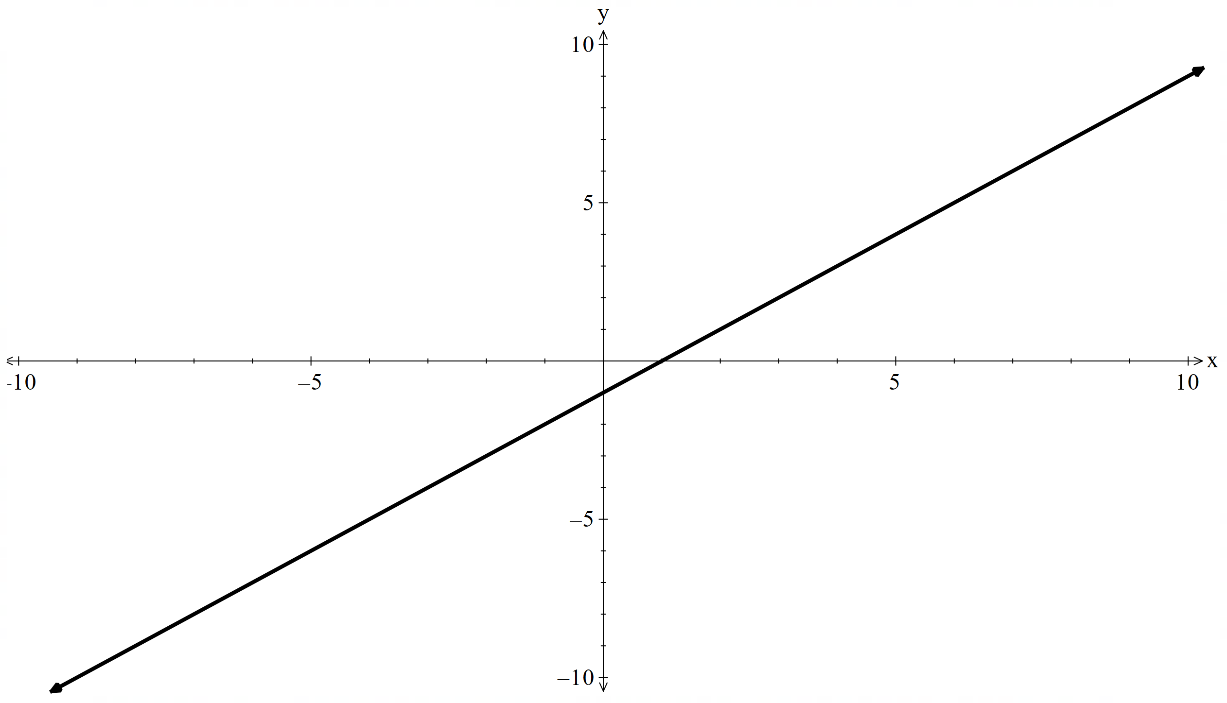
- $x=2t, y=t-1$  $$x=2t…\left(1\right) \\ y=t-1…\left(2\right) \\ t=\frac{x}{2} \\ \left(1\right) into \left(2\right) \\ y=\left(\frac{x}{2}\right)-1 \\ y=\frac{x}{2}-1$$ | 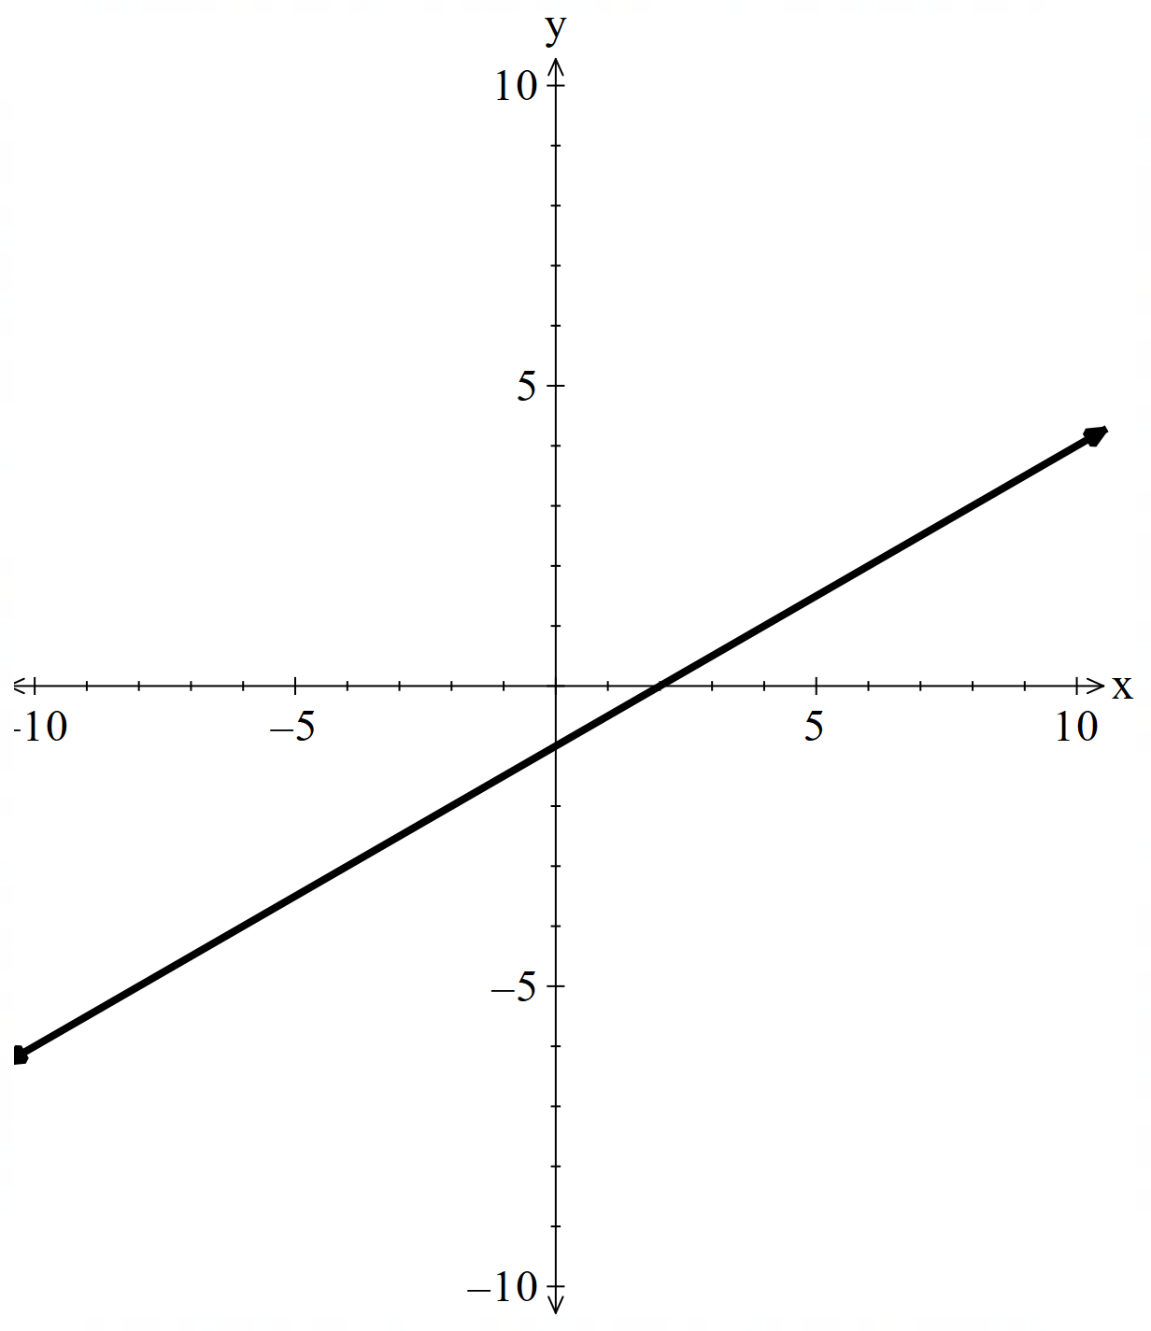
- $x=2t-5, y=t-1$  $$x=2t-5…\left(1\right) \\ y=t-1…\left(2\right) \\ t=\frac{x+5}{2} \\ \left(1\right) into \left(2\right) \\ y=\left(\frac{x+5}{2}\right)-1 \\ y=\frac{x}{2}+\frac{5}{2}-1 \\ y=\frac{x}{2}+\frac{3}{2}$$ | 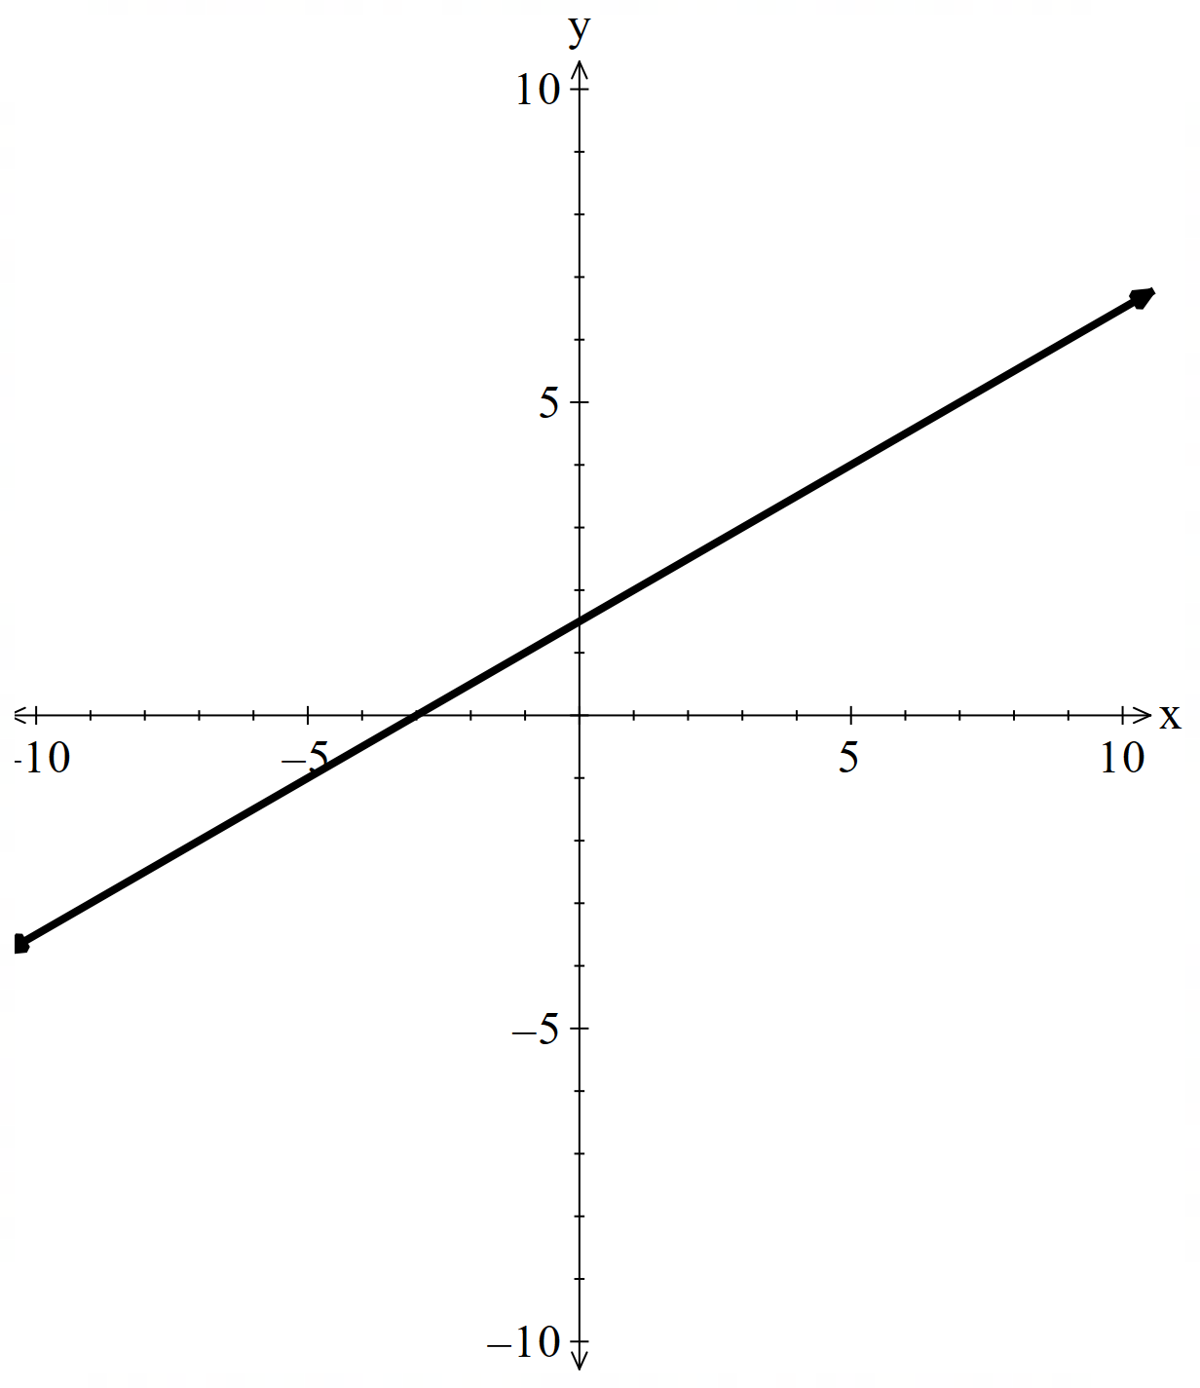
- $x=2t-5, y=3t-1$  $$x=2t-5…\left(1\right) \\ y=3t-1…\left(2\right) \\ t=\frac{x+5}{2} \\ \left(1\right) into \left(2\right) \\ y=3\left(\frac{x+5}{2}\right)-1 \\ y=\frac{3x}{2}+\frac{15}{2}-1 \\ y=\frac{3x}{2}+\frac{13}{2}$$ | 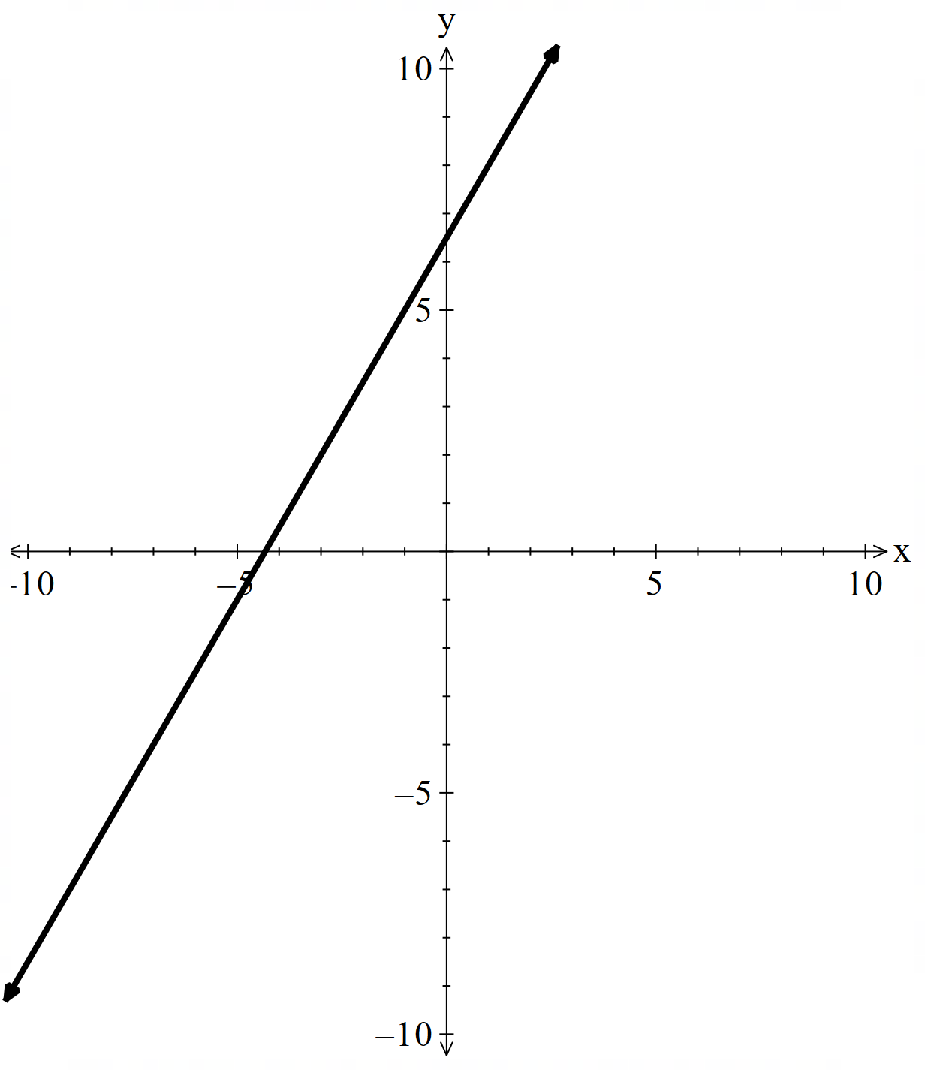
- $x=t, y=t^{2}$  $$x=t…\left(1\right) \\ y=t^{2}…\left(2\right) \\ \left(1\right) into \left(2\right) \\ y=x^{2}$$ | 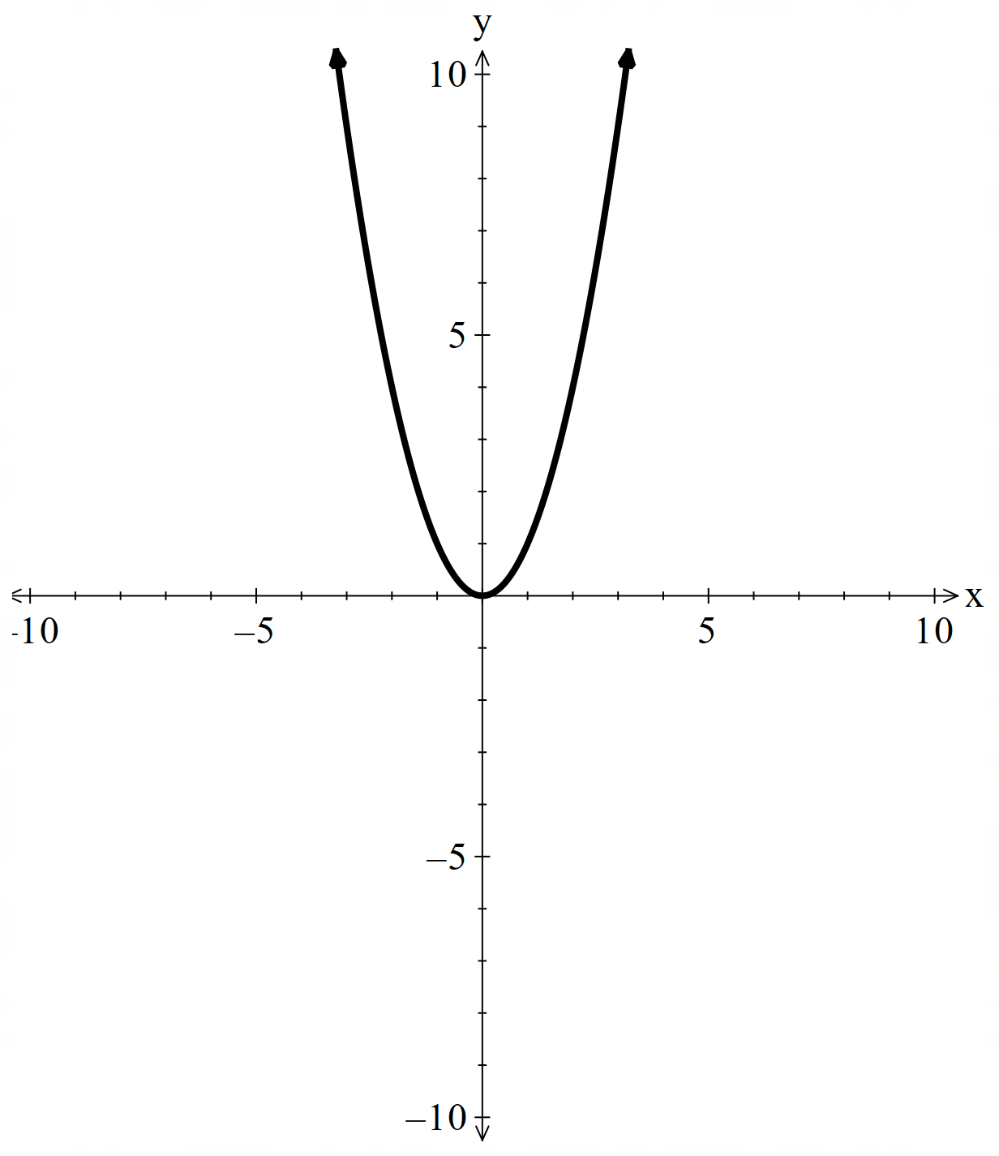
- $x=t+1, y=t^{2}$  $$x=t+1…\left(1\right) \\ y=t^{2}…\left(2\right) \\ t=x-1…(1) \\ \left(1\right) into \left(2\right) \\ y={(x-1)}^{2}$$ | 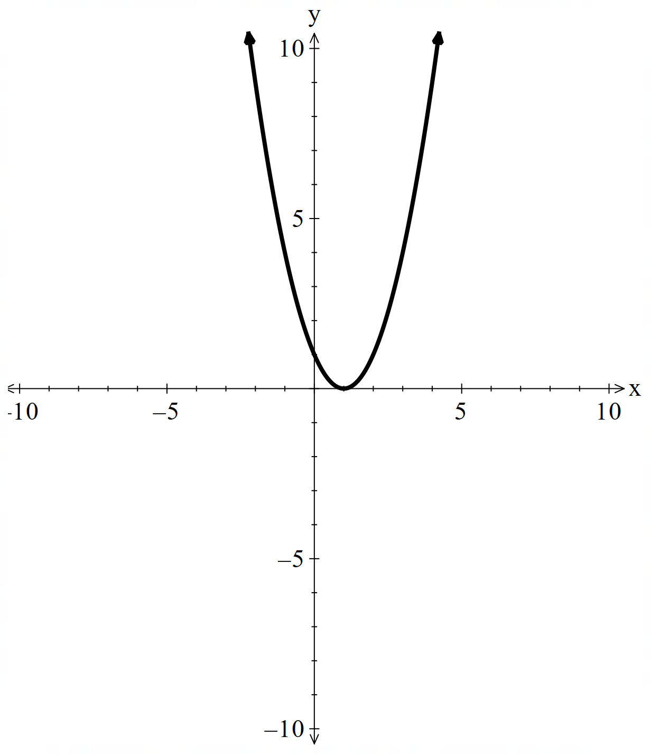
- $x=4t+1, y=t^{2}$  $$x=4t+1…\left(1\right) \\ y=t^{2}…\left(2\right) \\ t=\frac{x-1}{4}…\left(1\right) \\ \left(1\right) into \left(2\right) \\ y={\left(\frac{x-1}{4}\right)}^{2} \\ y=\frac{1}{16}{\left(x-1\right)}^{2}$$ | 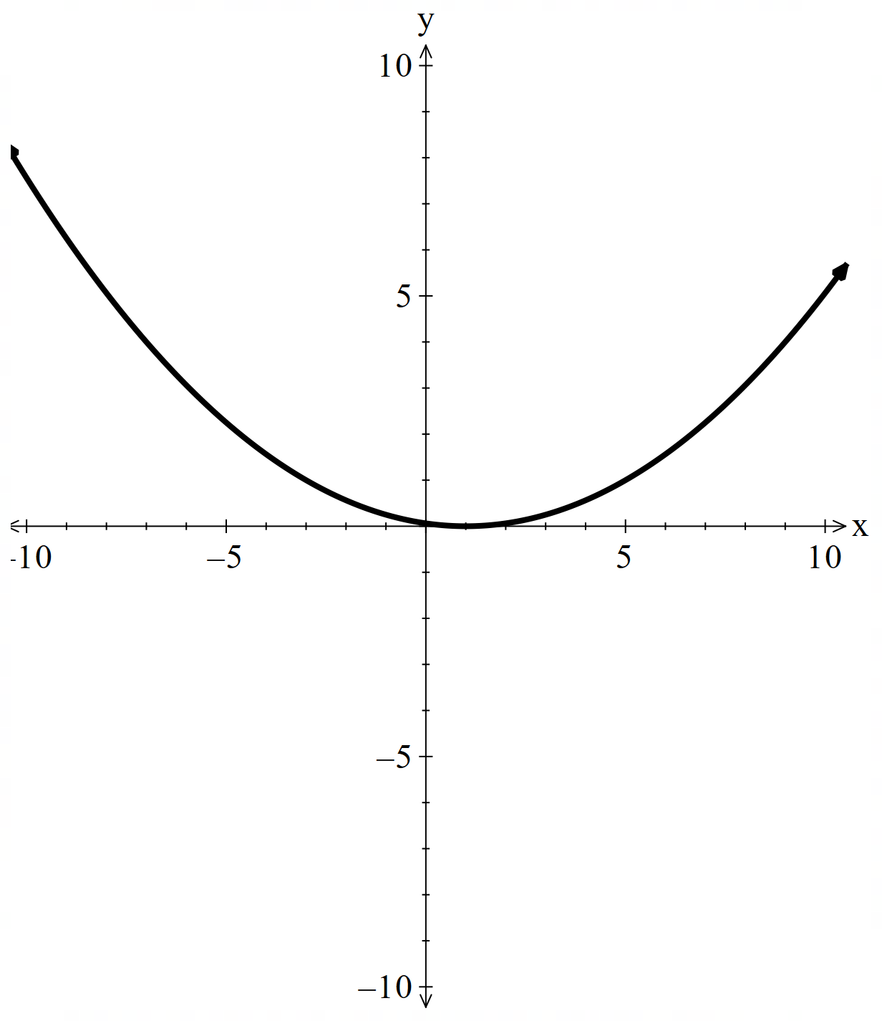
- $x=4t+1, y=3t^{2}$  $$x=4t+1…\left(1\right) \\ y={3t}^{2}…\left(2\right) \\ t=\frac{x-1}{4}…\left(1\right) \\ \left(1\right) into \left(2\right) \\ y=3{\left(\frac{x-1}{4}\right)}^{2} \\ y=\frac{3}{16}{\left(x-1\right)}^{2}$$ | 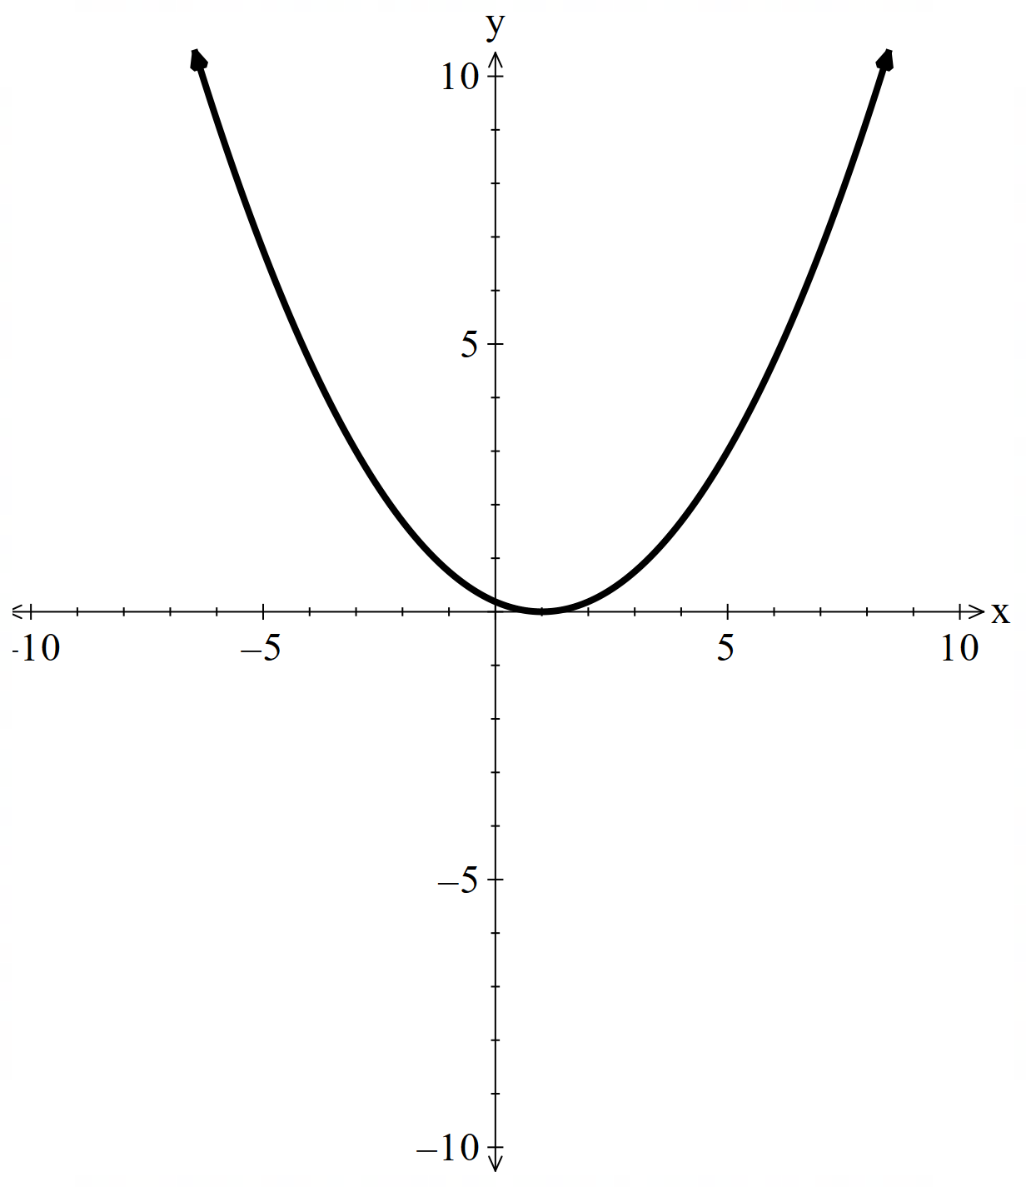
- $x=4t+1, y=-3t^{2}$  $$x=4t+1…\left(1\right) \\ y={-3t}^{2}…\left(2\right) \\ t=\frac{x-1}{4}…\left(1\right) \\ \left(1\right) into \left(2\right) \\ y=-3{\left(\frac{x-1}{4}\right)}^{2} \\ y=\frac{-3}{16}{\left(x-1\right)}^{2}$$ | 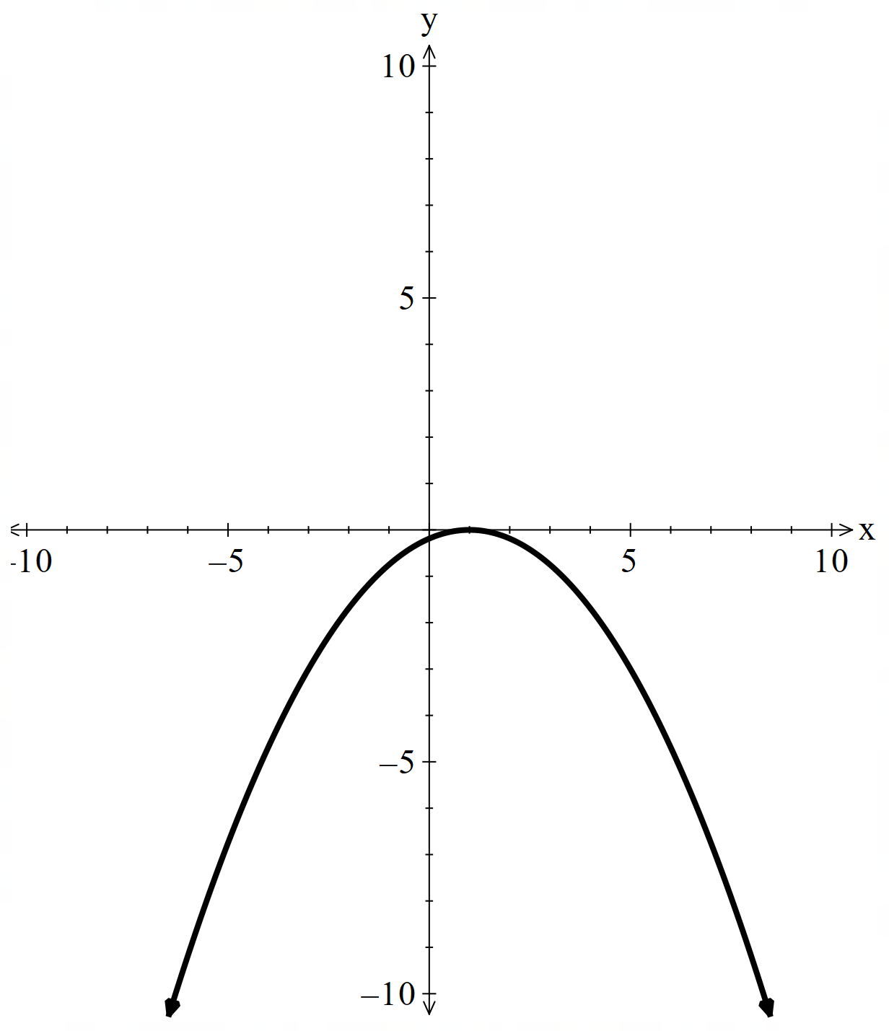
- $x=4t+1, y=1-3t^{2}$  $$x=4t+1…\left(1\right) \\ y={1-3t}^{2}…\left(2\right) \\ t=\frac{x-1}{4}…\left(1\right) \\ \left(1\right) into \left(2\right) \\ y=1-3{\left(\frac{x-1}{4}\right)}^{2} \\ y=1-\frac{3}{16}{\left(x-1\right)}^{2}$$ | 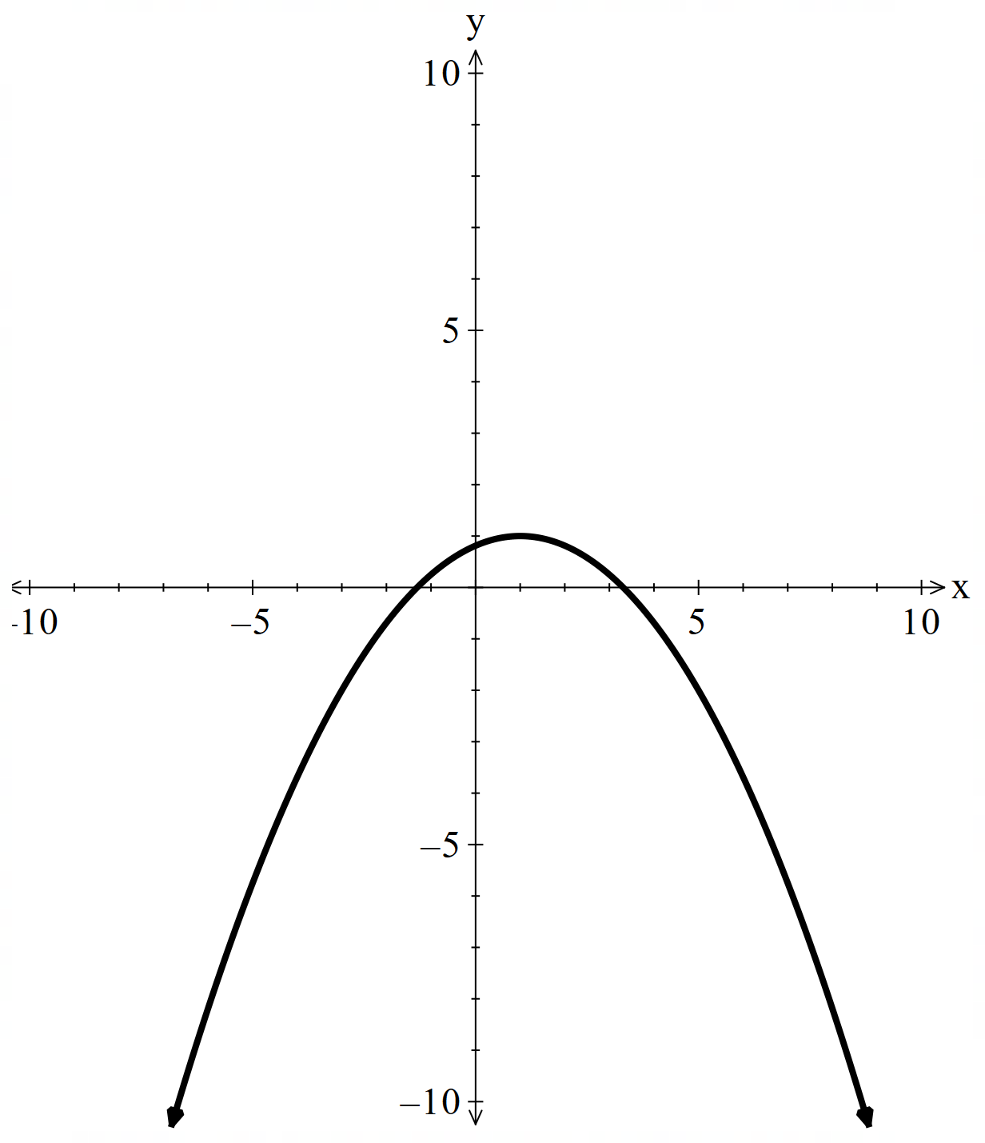

Appendix B – Four quadrant notes
Example 1  Find the Cartesian equation for the following parametric equations, then sketch the curve.  $$x=4t , y=3t-1$$  $$x=4t…\left(1\right) \\ y=3t-1…\left(2\right) \\ t=\frac{x}{4}…\left(1\right)$$  Substitute (1) into (2)  $$y=3\left(\frac{x}{4}\right)-1 \\ y=\frac{3x}{4}-1$$  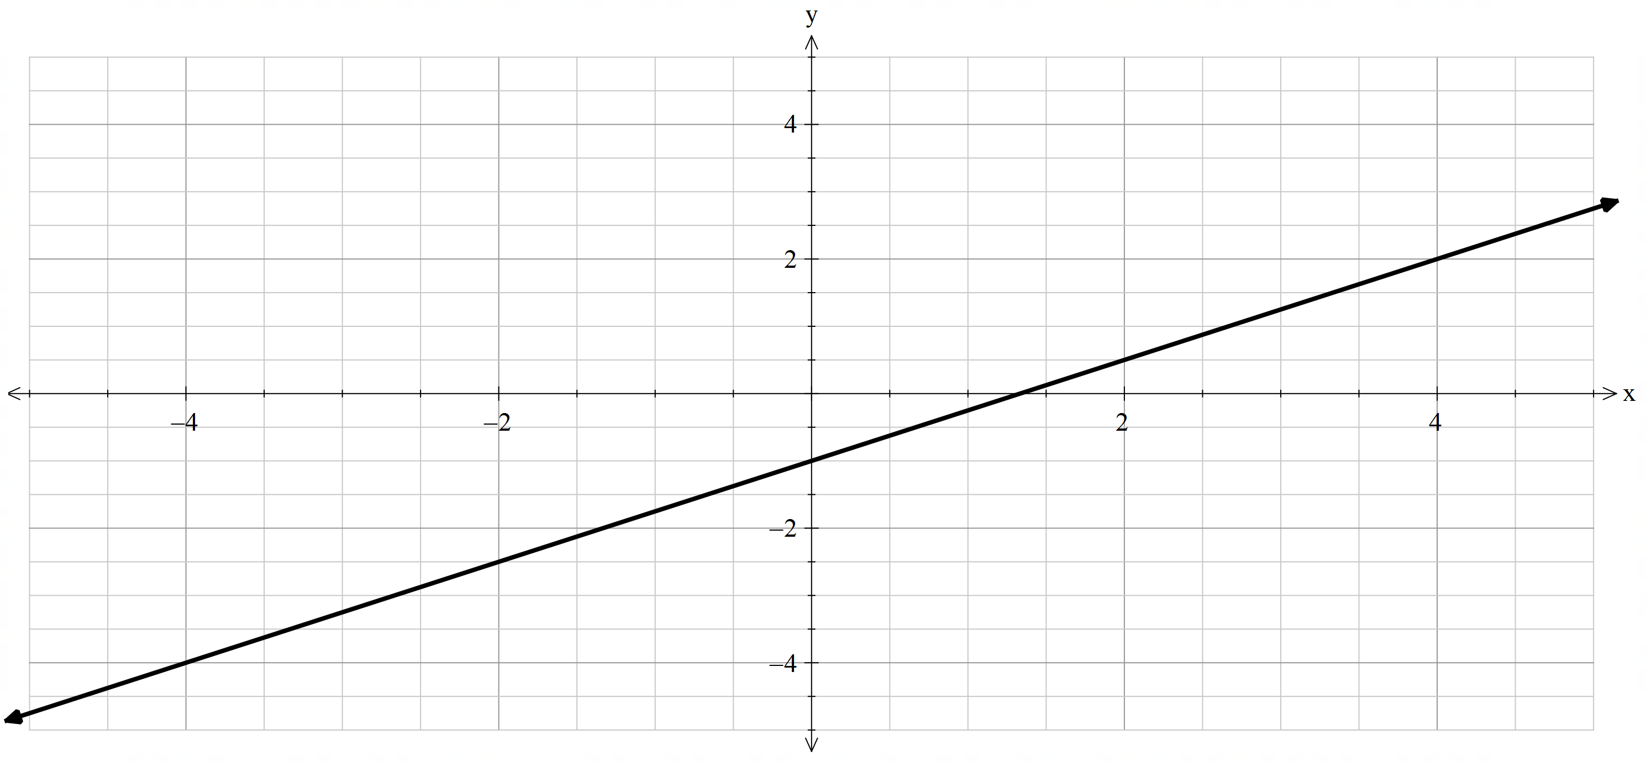 | Example 2  Find the Cartesian equation for the following parametric equations, then sketch the curve.  $$x=4t , y=3t^{2}-1$$  $$x=4t…\left(1\right) \\ y=3t^{2}-1…\left(2\right) \\ t=\frac{x}{4}…\left(1\right)$$  Substitute (1) into (2)  $$y=3{\left(\frac{x}{4}\right)}^{2}-1 \\ y=\frac{3x^{2}}{16}-1$$  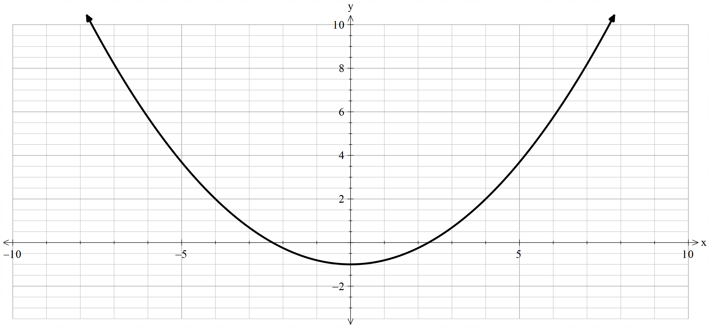

Appendix C – HSC-style questions
Question 1
A curve has parametric equations $x=\frac{t}{3}$ and $y=4t^{2}$. Find the Cartesian equation for the curve.
$$x=\frac{t}{3}…\left(1\right) \\ y=4t^{2}…\left(2\right) \\ 3x=t…\left(1\right)$$
Substitute (1) into (2)
$$y=4{\left(3x\right)}^{2} \\ y=36x^{2}$$
Question 2
Sketch the Cartesian equation described by the parametric equations.
$$x=t-3 \\ y=t^{2}-t$$
$$x=t-3…\left(1\right) \\ y=t^{2}-t…\left(2\right) \\ t=x+3…\left(1\right)$$
Substitute (1) into (2)
$$y={\left(x+3\right)}^{2}-\left(x+3\right) \\ y=\left(x+3\right)\left(x+3-1\right) \\ =\left(x+3\right)\left(x+2\right)$$
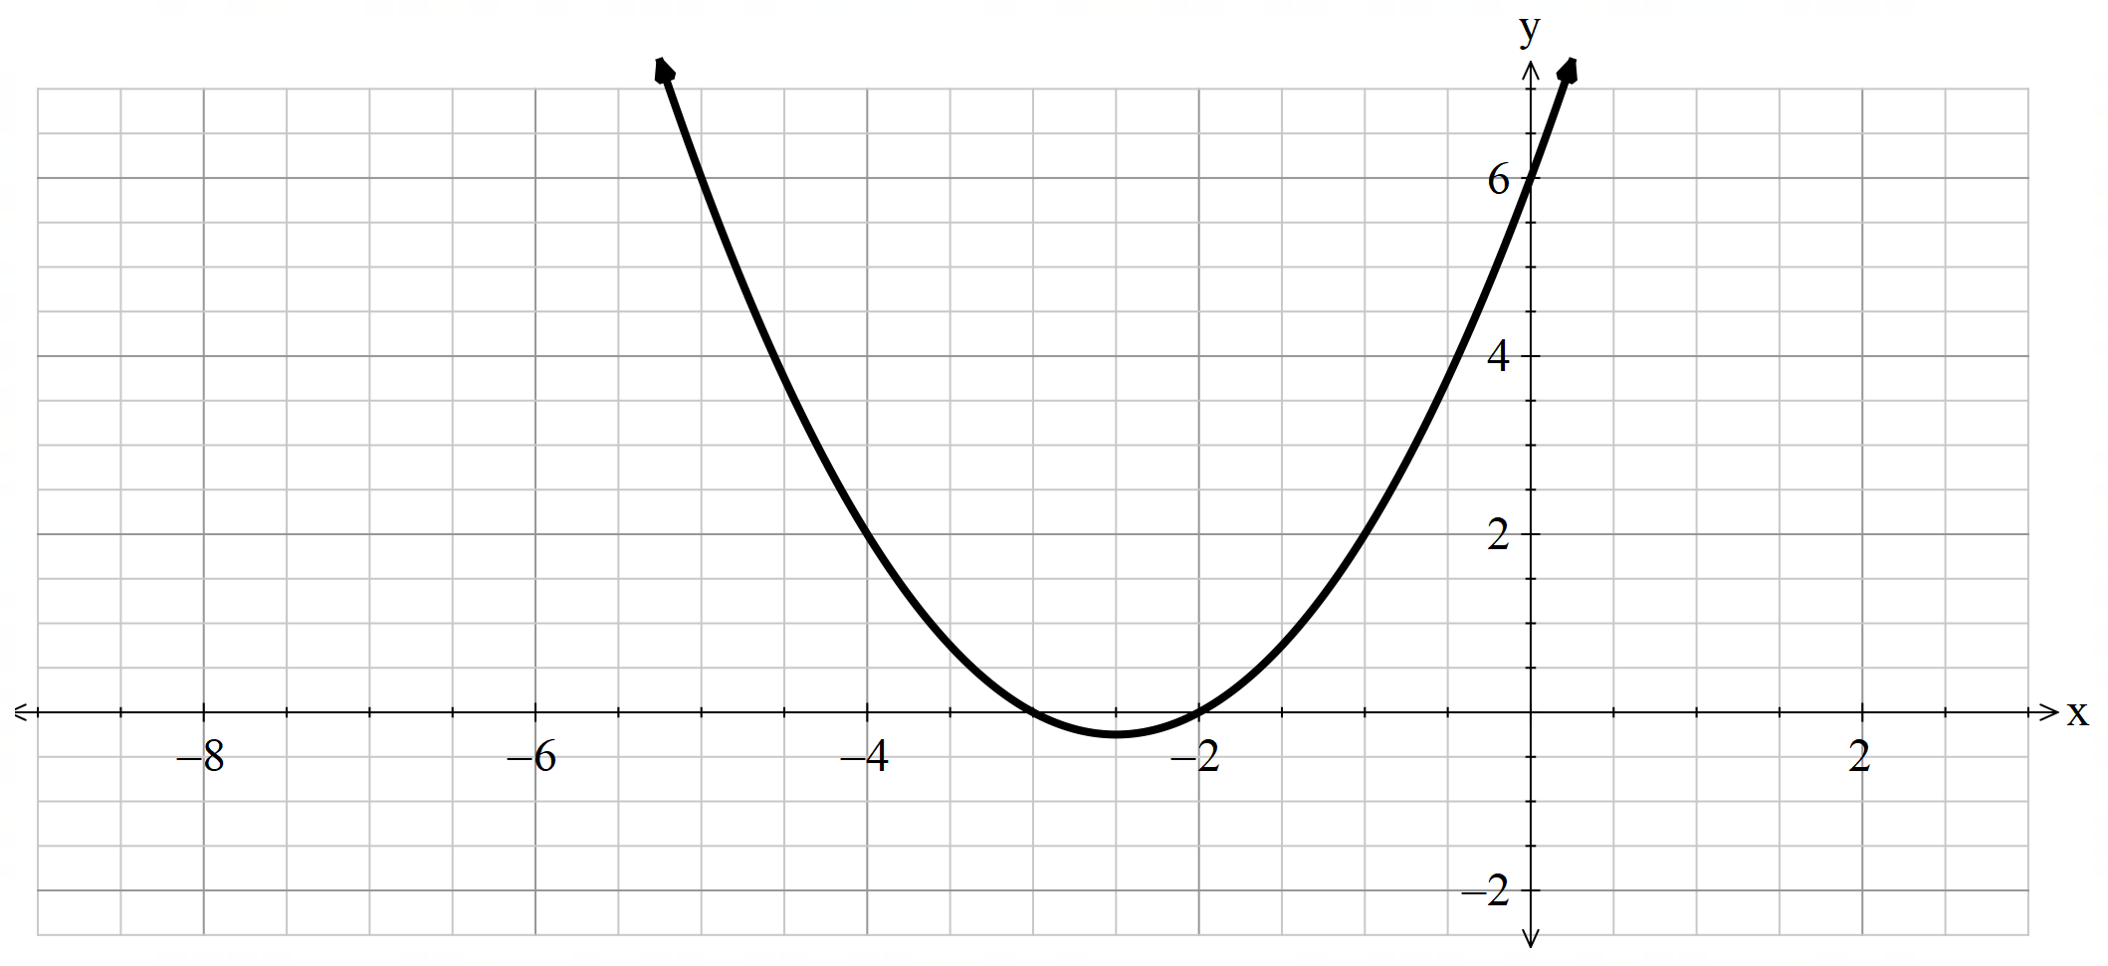
Question 3
Find the Cartesian equation described by the parametric equations.
$$x=3t+6…\left(1\right) \\ y=2t^{2}+t…\left(2\right) \\ \frac{x-6}{3}=t…\left(1\right)$$
Substitute (1) into (2)
$$y=2{\left(\frac{x-6}{3}\right)}^{2}+\frac{x-6}{3} \\ =\frac{2\left(x^{2}-12x+36\right)}{9}+\frac{x-6}{3} \\ =\frac{2\left(x^{2}-12x+36\right)}{9}+\frac{3\left(x-6\right)}{9} \\ =\frac{2x^{2}-21x+54}{9}$$
Question 4
The variable point $(4t, 3t^{2})$ lies on a parabola. Find the Cartesian equation for the parabola.
$$x=4t…\left(1\right) \\ y=3t^{2}…\left(2\right) \\ t=\frac{x}{4}…\left(1\right)$$
Substitute (1) into (2)
$$y=3{\left(\frac{x}{4}\right)}^{2} \\ =\frac{3x^{2}}{16}$$
Question 5
The parametric equations of a graph are $x=1-\frac{2}{t}$ and $y=1+\frac{2}{t}$. Show that the Cartesian equation is linear with a gradient of $-1$.
$$x=1-\frac{2}{t}…\left(1\right) \\ y=1+\frac{2}{t}…\left(2\right) \\ x-1=-\frac{2}{t} \\ t=-\frac{2}{x-1}…\left(1\right)$$
Substitute (1) into (2)
$$y=1+\frac{2}{-\frac{2}{x-1}} \\ y=1+\frac{2}{1}×\frac{x-1}{-2} \\ =1-\left(x-1\right) \\ ∴y=2-x$$
$$∴m=-1$$

References
This resource contains NSW Curriculum and syllabus content. The NSW Curriculum is developed by the NSW Education Standards Authority (NESA). This content is prepared by NESA for and on behalf of the Crown in right of the State of New South Wales. The material is protected by Crown copyright.
Please refer to the NESA Copyright Disclaimer for more information https://www.nsw.gov.au/education-and-training/nesa/copyright.
NESA holds the only official and up-to-date versions of the NSW Curriculum and syllabus documents. Please visit NESA https://www.nsw.gov.au/education-and-training/nesa and NSW Curriculum https://curriculum.nsw.edu.au.
Mathematics Extension 1 11–12 Syllabus © NSW Education Standards Authority (NESA) for and on behalf of the Crown in right of the State of New South Wales, 2024.

© State of New South Wales (Department of Education), 2026
The copyright material published in this resource is subject to the Copyright Act 1968 (Cth) and is owned by the NSW Department of Education or, where indicated, by a party other than the NSW Department of Education (third-party material).
Copyright material available in this resource and owned by the NSW Department of Education is licensed under a Creative Commons Attribution 4.0 International (CC BY 4.0) license.

This license allows you to share and adapt the material for any purpose, even commercially. Attribution should be given to © State of New South Wales (Department of Education), 2026.
Material in this resource not available under a Creative Commons license:
- the NSW Department of Education logo, other logos and trademark-protected material
- material owned by a third party that has been reproduced with permission. You will need to obtain permission from the third party to reuse its material.
Links to third-party material and websites
Please note that the provided (reading/viewing material/list/links/texts) are a suggestion only and implies no endorsement, by the New South Wales Department of Education, of any author, publisher, or book title. School principals and teachers are best placed to assess the suitability of resources that would complement the curriculum and reflect the needs and interests of their students.
If you use the links provided in this document to access a third-party's website, you acknowledge that the terms of use, including licence terms set out on the third-party's website apply to the use which may be made of the materials on that third-party website or where permitted by the Copyright Act 1968 (Cth). The department accepts no responsibility for content on third-party websites.

