Introduction to parametric form
Students are introduced to parameters through architectural design, giving them a concrete way to see how parameters can be used to influence the shape and curves of structures. The lesson builds a clear foundation of what a parameter is and where the parametric form is used.
Students will need at least one digital device per pair to interact with Amplify Classroom during this lesson.

Learning intention
- To understand how a common parameter links 2 equations to generate points and graphs in Cartesian form.

Success criteria
- I can explain what a parameter is.
- I can identify a parameter in a pair of parametric equations.
- I can explain how a common parameter generates corresponding $(x,y)$ pairs.
- I can graph a pair of parametric equations on a Cartesian plane.

Outcomes
A student:
- develops understanding and fluency in mathematics through exploring and connecting mathematical concepts, choosing and applying mathematical techniques to solve problems, and communicating their thinking and reasoning coherently and clearly MAO-WM-01
- solves problems involving inequalities, functions and their inverses, graphical relationships between functions, and parametric equations ME1-11-01

Content

Parametric form of a function or relation
- Recognise that a curve may be represented by two parametric equations that give $x$ and $y$ as functions of a parameter and that the curve may also have a Cartesian equation in $x$ and $y.$
Mathematics Extension 1 11–12 Syllabus © NSW Education Standards Authority (NESA) for and on behalf of the Crown in right of the State of New South Wales, 2024.
Table 1: lesson summary
Section | Summary of activity | Teaching strategies | Teaching points
Activating prior knowledge | Use slides 4–6 of the PowerPoint Introduction to parametric form to show students curved forms of modern buildings, leading into an explanation that architects use parametric form to design such structures. | Think-Pair-Share  Notice and wonder | This section aims to spark interest in parametric curves and why they are important.
Connecting learning | Use the Amplify activity (bit.ly/parametric-intro), screens 1–6, for students to see how combining 2 equations with a common value creates unique designs. Students compare the misleading ‘ice-cream = (sunscreen)²’ relationship with the temperature-driven parametric pair on slide 8, using questioning to recognise that temperature is the underlying parameter linking both variables. | Think-Pair-Share  Pose-Pause-Pounce-Bounce | Through discussion and animation, students establish that eliminating the temperature parameter creates the Cartesian relationship, clarifying that the 2 products respond to temperature rather than causing changes in each other.
Releasing responsibility | Use slide 10 to define a parameter before students complete Appendix A, generating a table of values and plotting the corresponding points. This connects the 2 separate parametric equations into a single Cartesian relationship. | Think-Pair-Share | Students recognise that $x$and $y$are described independently but share the same parameter, meaning all $(x,y)$ pairs lie on one Cartesian plane.
Independent practice | Students create tables of values and plot the resulting graphs for 3 different pairs of parameters (slide 12). The resulting graphs are all the same, leading to a discussion about why we use parameters. | Think-Pair-Share | This section highlights that a parameter does not change the curve; it gives meaning to the $x$-value and the $y$-value at a particular point on the curve. Teachers should link back to the ‘ice-cream, sunscreen’ example to help students further understand this concept.

Activity structure
Please use the associated PowerPoint Introduction to parametric form to display images in this lesson.

Activating prior knowledge
- Display slides 4–6 of the PowerPoint to show 3 modern buildings from around the world.
- Have students complete a Think-Pair-Share (bit.ly/thinkpairsharestrategy) in which they discuss what they notice and wonder (bit.ly/noticewonderstrategy) about the 3 buildings.
Students may notice that the buildings include curved surfaces rather than traditional rectangular-prism structures and they may wonder how architects design or construct such shapes.
- Explain to students that architects use a mathematical technique called parametric form to design these kinds of curved buildings.

Connecting learning
- With at least one device per pair, assign the Amplify Classroom activity ‘Introduction to parametric form’ (bit.ly/parametric-intro) for students to work through screens 1–6.
Before completing this activity, you will need to set up an Amplify Classroom (bit.ly/createamplifyclassroom). Teachers may wish to use the pacing tool to restrict students from viewing screens until appropriate.
- Discuss as a class the benefits of combining 2 equations with a common variable to make one graph.
Students should conclude that different shapes and patterns can be created from already existing graphs.
- Tell students that they are going to look at a simpler example to help build their understanding of parametric form and the idea of a parameter.
- Read the following scenario to students. The equation can be displayed using slide 8.
The owners of a convenience store noticed that for every degree the temperature rises above $35° \text{C}$, ice-cream sales and sunscreen sales increase. They find that the relationship between ice-cream and sunscreen sales is ice-cream sales = (sunscreen sales)².
- Use the Pose-Pause-Pounce-Bounce questioning strategy (PDF 557 KB) (bit.ly/posepausepouncebounce) to help students understand the scenario. Prompting questions could include:
- If the store sells 5 bottles of sunscreen, how many ice-creams do we expect them to sell?
- If the store sells 16 ice-creams, how many bottles of sunscreen do we expect them to sell?
- Do ice-cream sales cause sunscreen sales or vice versa?
- Is there another variable that the sales of ice-cream and sunscreen depend on?
5 bottles of sunscreen = 25 ice-creams, 16 ice-creams = 4 bottles of sunscreen. The algebraic relationship suggests that sunscreen sales directly change the demand for ice-cream. This is misleading because temperature influences sales of both products, rather than the products influencing each other.
- Continue the story by reading the scenario below. The equations can be displayed by animating slide 8.
The convenience store owner looked at the sales of ice-cream and sunscreen separately and how temperature affects each and found the following relationships:
sunscreen = temperature – 35
ice-cream = (temperature – 35)²
- Use the Pose-Pause-Pounce-Bounce questioning strategy to help students understand these relationships. Possible prompting questions include:
- If it is 39$° C$, how many bottles of sunscreen are sold?
- If it is 39$° C$, how many ice-creams are sold?
- Has the relationship between ice-creams and sunscreens changed? How can you tell?
- What causes both ice-cream and sunscreen sales to increase?
A temperature of 39$° C$ will result in the sale of 4 bottles of sunscreen and 16 ice-creams. These values match those obtained previously because the same temperature value has been used in both relationships. Temperature determines the sales of both products. The sales of sunscreen and ice-cream are not causing changes in each other; rather, they are both changing in response to temperature.
- Use a Think-Pair-Share for students to discuss the difference between the first equation (ice-cream sales = (sunscreen sales)²) and the second pair of equations (sunscreen = temperature – 35, ice-cream = (temperature – 35)²).
We want students to establish that when temperature is eliminated, a new relationship is created directly between sunscreen sales and ice-cream sales. This relationship is different from the original relationships because it no longer describes how temperature affects each product individually.

Releasing responsibility
- Use slide 10 to display the definition of a parameter. Have students consider the definition and use it to identify the parameter in the convenience store scenario.
Students should recognise that temperature is the parameter.
- Distribute Appendix A ‘Linking parametric form to Cartesian form’ to each student. Have students complete the table of values and plot the points on the provided axes.
- In a Think-Pair-Share, have students consider which values of $T$ are not valid for this scenario and how this would affect the Cartesian equation.
During the discussion, emphasise that parametric equations describe the $x$- and $y$-values separately in terms of a common parameter. Because the equations share the same parameter, each value of the parameter generates a corresponding $(x,y)$ pair that lies on the Cartesian graph.

Independent practice
- Display slide 12 of the PowerPoint, which shows 3 different pairs of parametric equations.
- Ask students to construct a table of values for each pair and then plot the resulting points on a Cartesian plane.
- Have students find the domain and range for each graph.
- Using a class discussion, prompt students to identify what stayed the same across all 3 tables and what changed.
In the discussion, draw out that while the parameter does not change the curve, it changes the domain and range of the graph.

Assessment and differentiation

Suggested opportunities for differentiation
Activating prior knowledge
- The buildings can be replaced with examples of unique architectural designs from your local area.
Connecting learning
- Challenge students to predict how the graph will change before revealing the Cartesian graph.
Releasing responsibility
- Provide a partially completed table of values so students can focus on recognising how the shared parameter generates matching $(x,y)$ pairs rather than focusing only on substitution.
- Offer a guided prompt such as ‘What does $t$represent in both equations?’ to help students make a conceptual link before attempting to form the Cartesian equation.
- Challenge students to predict the Cartesian equation before plotting the points, then verify whether the plotted pattern matches their expectation.
Independent practice
- Challenge students to determine which parts of the curve are traced when the domain of $t$is restricted, for example, if $t≥0$ or has the domain [$-1,1]$. Have students justify their reasoning.
- Invite students to design a new pair of parametric equations that still produce the same Cartesian curve, then verify it by constructing a table and plotting.
- Provide a partially completed table of values.
- Give students a blank Cartesian grid with a few anchor points already plotted. They use their table to fill in the missing points, reducing cognitive load while reinforcing the link between the table and the graph.

Suggested opportunities for assessment
Connecting learning
- Observe students’ reasoning during the Amplify Classroom activity to assess how well they recognise the role of the parameter in generating different designs.
- Use the Think-Pair-Share discussion to gauge students’ ability to articulate the benefits of introducing a parameter and how it changes the behaviour of a graph.
Releasing responsibility
- Observe students’ table-of-values work to assess whether they understand that both equations generate coordinated $(x,y)$pairs through the same parameter.
- Listen to Think-Pair-Share discussions to gauge how confidently students can articulate the process of linking the 2 parametric equations into a single Cartesian equation.
- Review students’ final Cartesian equations and plotted graphs to check their accuracy in eliminating the parameter and recognising the resulting relationship.
Independent practice
- Listen to student contributions during the class discussion to assess students’ conceptual understanding by listening for statements that identify the role of the parameter.

Appendix A

Linking parametric form to Cartesian form
Let $x$ represent sunscreen sales and $y$represent ice-cream sales. The 2 equations below show how each quantity changes with respect to the temperature.
$$x=T-35 \\ y={\left(T-35\right)}^{2}$$
Complete the table of values, then use your results to plot the relationship between $x$and $y$.
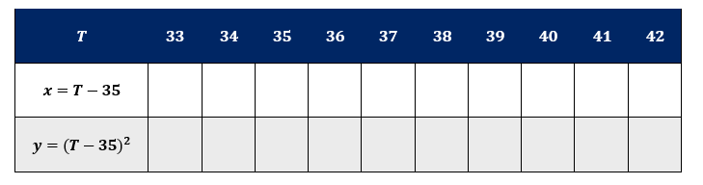
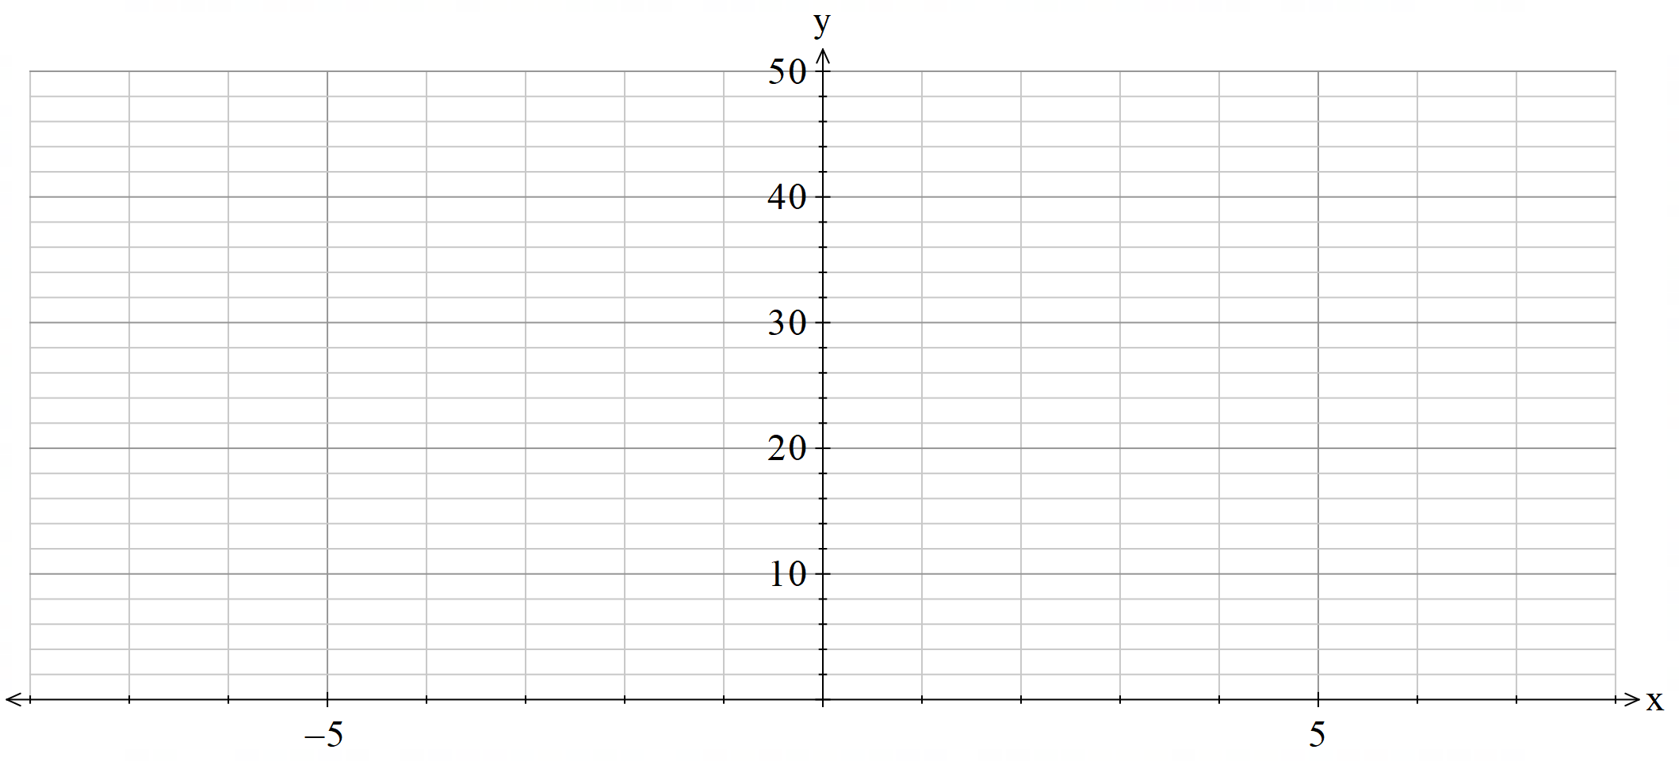
What is the domain and range?

Sample solutions

Appendix A – linking parametric form to Cartesian form
$$T$$ | $$33$$ | $$34$$ | $$35$$ | $$36$$ | $$37$$ | $$38$$ | $$39$$ | $$40$$ | $$41$$ | $$42$$
$$x=T-35$$ | $$-2$$ | $$-1$$ | $$0$$ | $$1$$ | $$2$$ | $$3$$ | $$4$$ | $$5$$ | $$6$$ | $$7$$
$$y={\left(T-35\right)}^{2}$$ | $$4$$ | $$1$$ | $$0$$ | $$1$$ | $$4$$ | $$9$$ | $$16$$ | $$25$$ | $$36$$ | $$49$$

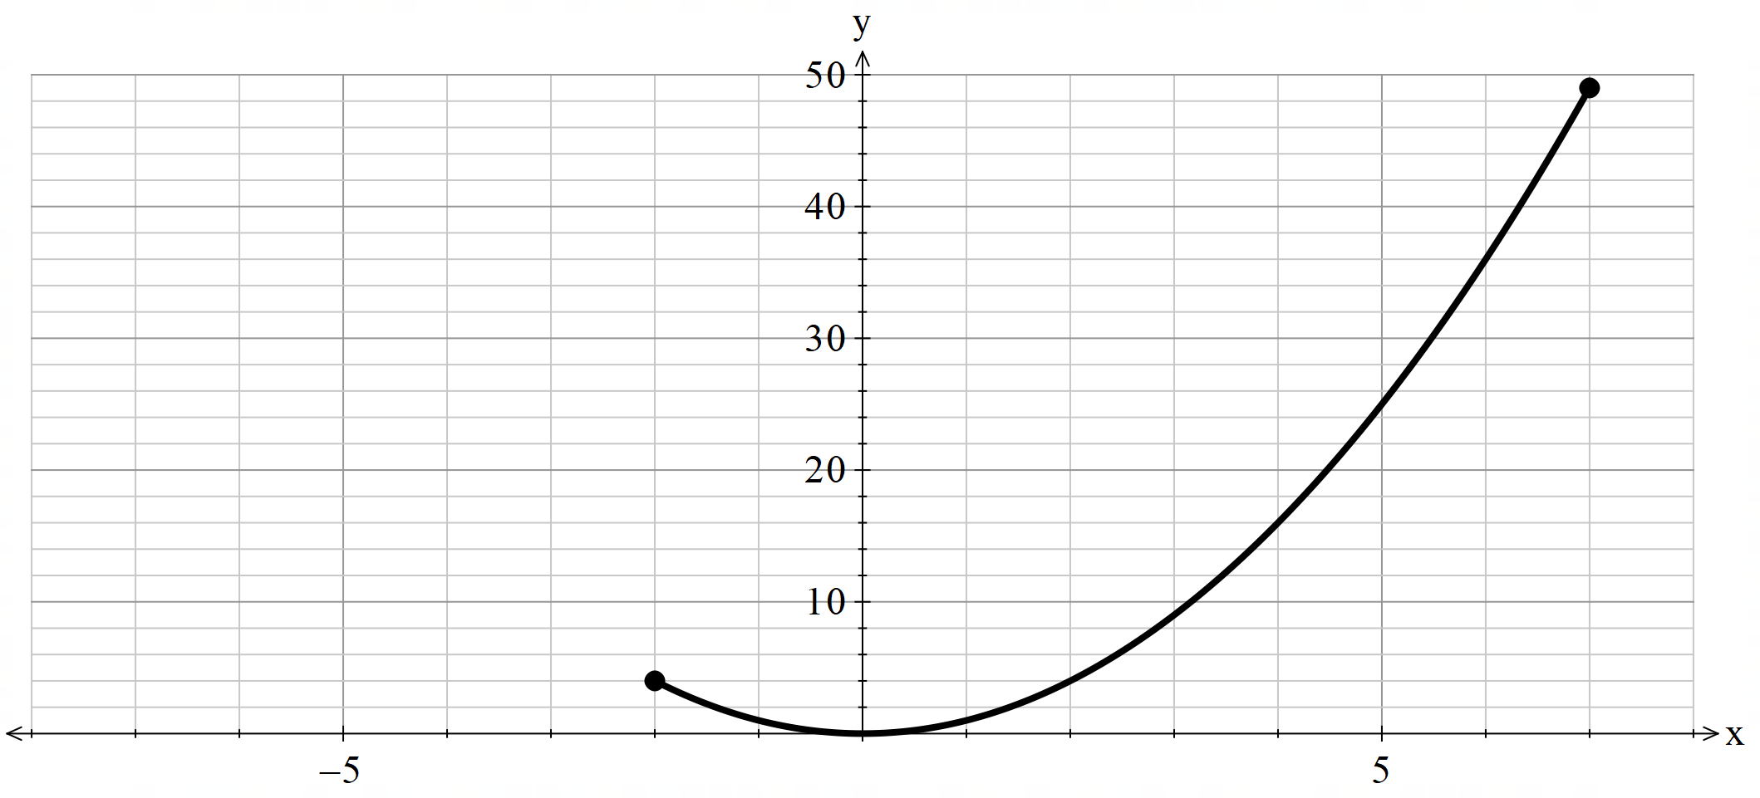
Domain $-2≤x≤7$, Range $4≤y≤49$

Independent practice
$$t$$ | $$-3$$ | $$-2$$ | $$-1$$ | $$0$$ | $$1$$ | $$2$$ | $$3$$
$$x=t$$ | $$-3$$ | $$-2$$ | $$-1$$ | $$0$$ | $$1$$ | $$2$$ | $$3$$
$$y=t^{2}$$ | $$9$$ | $$4$$ | $$1$$ | $$0$$ | $$1$$ | $$4$$ | $$9$$
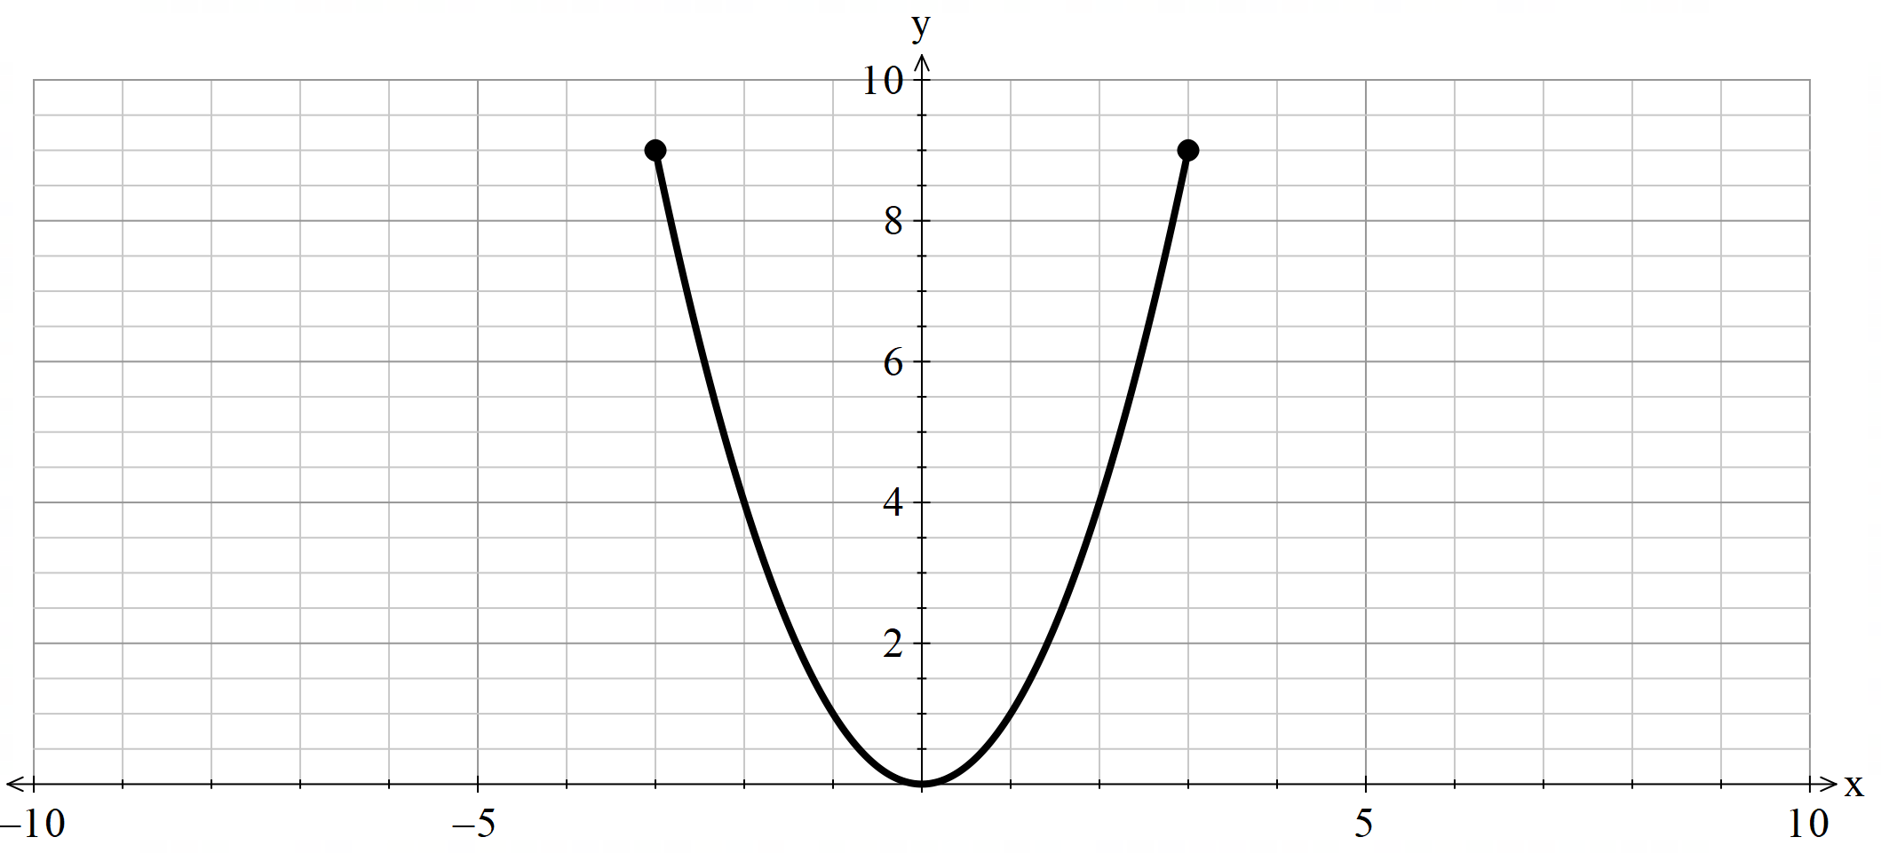
Domain $-3≤x≤3$, Range $0≤y≤9$

$$t$$ | $$-3$$ | $$-2$$ | $$-1$$ | $$0$$ | $$1$$ | $$2$$ | $$3$$
$$x=2t$$ | $$-6$$ | $$-4$$ | $$-2$$ | $$0$$ | $$2$$ | $$4$$ | $$6$$
$$y=4t^{2}$$ | $$36$$ | $$16$$ | $$4$$ | $$0$$ | $$4$$ | $$16$$ | $$36$$
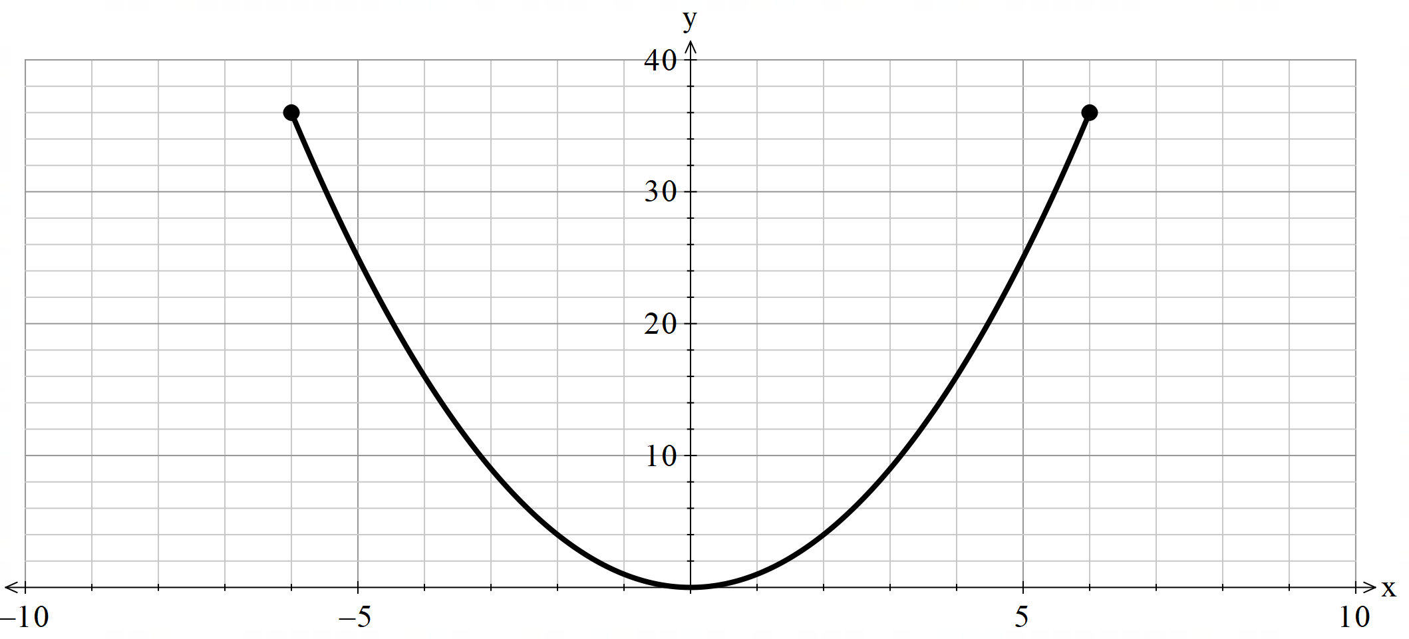
Domain $-6≤x≤6$, Range $0≤y≤36$

$$t$$ | $$-3$$ | $$-2$$ | $$-1$$ | $$0$$ | $$1$$ | $$2$$ | $$3$$
$$x=\sqrt{t}$$ | $$-$$ | $$-$$ | $$-$$ | $$0$$ | $$1$$ | $$\sqrt{2}$$ | $$\sqrt{3}$$
$$y=t$$ | $$-3$$ | $$-2$$ | $$-1$$ | $$0$$ | $$1$$ | $$2$$ | $$3$$
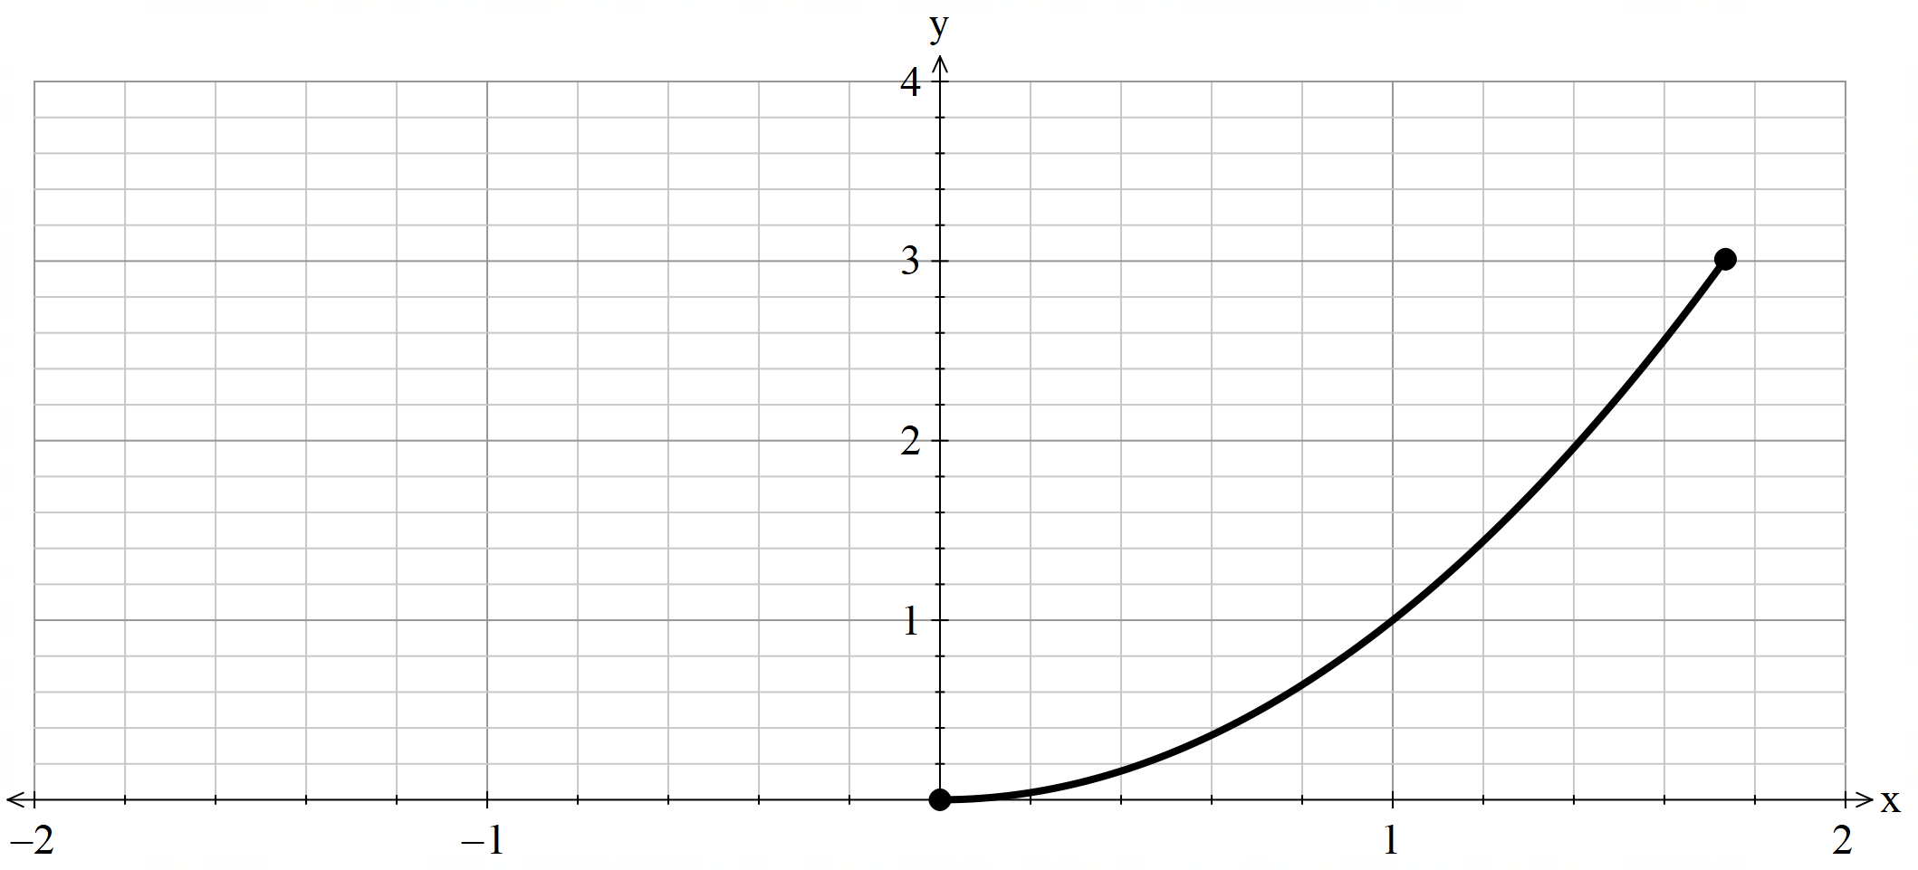
Domain $0≤x≤\sqrt{3}$ , Range $0≤y≤3$

References
This resource contains NSW Curriculum and syllabus content. The NSW Curriculum is developed by the NSW Education Standards Authority (NESA). This content is prepared by NESA for and on behalf of the Crown in right of the State of New South Wales. The material is protected by Crown copyright.
Please refer to the NESA Copyright Disclaimer for more information https://www.nsw.gov.au/education-and-training/nesa/copyright.
NESA holds the only official and up-to-date versions of the NSW Curriculum and syllabus documents. Please visit NESA https://www.nsw.gov.au/education-and-training/nesa and NSW Curriculum https://curriculum.nsw.edu.au.
Mathematics Extension 1 11–12 Syllabus © NSW Education Standards Authority (NESA) for and on behalf of the Crown in right of the State of New South Wales, 2024.

© State of New South Wales (Department of Education), 2026
The copyright material published in this resource is subject to the Copyright Act 1968 (Cth) and is owned by the NSW Department of Education or, where indicated, by a party other than the NSW Department of Education (third-party material).
Copyright material available in this resource and owned by the NSW Department of Education is licensed under a Creative Commons Attribution 4.0 International (CC BY 4.0) license.

This license allows you to share and adapt the material for any purpose, even commercially. Attribution should be given to © State of New South Wales (Department of Education), 2026.
Material in this resource not available under a Creative Commons license:
- the NSW Department of Education logo, other logos and trademark-protected material
- material owned by a third party that has been reproduced with permission. You will need to obtain permission from the third party to reuse its material.
Links to third-party material and websites
Please note that the provided (reading/viewing material/list/links/texts) are a suggestion only and implies no endorsement, by the New South Wales Department of Education, of any author, publisher, or book title. School principals and teachers are best placed to assess the suitability of resources that would complement the curriculum and reflect the needs and interests of their students.
If you use the links provided in this document to access a third-party's website, you acknowledge that the terms of use, including licence terms set out on the third-party's website apply to the use which may be made of the materials on that third-party website or where permitted by the Copyright Act 1968 (Cth). The department accepts no responsibility for content on third-party websites.

