Gradient and the direction vector
Students explore how to use vectors to represent straight lines in both two and three dimensions (2D and 3D) and the vector equation of a line $r=a+λb$. They connect the vector equation of a line with the gradient–intercept form in 2D and learn to convert between them.
Students will need at least one digital device per pair to interact with Amplify and GeoGebra during this lesson.

Learning intentions
- To understand how vectors can be used to represent straight lines.
- To understand the relationship between vector and Cartesian equations of lines.

Success criteria
- I can define the direction vector of a line.
- I can write the vector equation of a line.
- I can convert between the gradient–intercept and vector equations of lines in 2D.

Outcomes
A student:
- develops understanding and fluency in mathematics through exploring and connecting mathematical concepts, choosing and applying mathematical techniques to solve problems, and communicating their thinking and reasoning coherently and clearly MAO-WM-01
- uses vectors to model lines and curves, solve problems, and prove results involving geometry and coordinate geometry ME2-12-02
Mathematics Extension 2 11–12 Syllabus © NSW Education Standards Authority (NESA) for and on behalf of the Crown in right of the State of New South Wales, 2024.

Content

Vector equations of lines and curves
- Define the direction vector of a straight line and identify that a straight line through two points $P$ and $Q$ has $\vec{PQ}$ as a possible direction vector in both two dimensions and three dimensions
- Establish the relationship between the gradient, $m$, of a straight line in two dimensions and its direction vector
- Examine and use $r=a+λb$ as the vector equation of a straight line in two dimensions and three dimensions to solve problems, where $r$ is the position vector of a point on the line, $a$ is the position vector of a particular point on the line, $b$ is a direction vector of the line and $λ$ is a scalar parameter
- Express a line in two dimensions given in gradient-intercept form ($y=mx+c)$ as a vector equation, and vice versa
Mathematics Extension 2 11–12 Syllabus © NSW Education Standards Authority (NESA) for and on behalf of the Crown in right of the State of New South Wales, 2024.

Table 1: lesson summary
Section | Summary of activity | Teaching strategies | Teaching points
Retrieval practice | Use slide 4 to remind students of the definitions of position and displacement vectors. Use slides 5–7 of the PowerPoint Gradient and the direction vector to revise the introduction of vectors and equations in parametric form. | Think-Pair-Share | The introduction of vector and parametric equations are Extension 1 content.
Activating prior knowledge | Students complete Appendix A where they find the equations of lines before discussing how to use points and gradients to find lines. | Pose-Pause-Pounce-Bounce | Activate prior knowledge of lines, points and gradients, as well as position and direction vectors.
Connecting learning | Students complete screens 1–5 of the Amplify Classroom activity (bit.ly/GradientDirectionVector), before discussing the gradient and the direction vector. They then complete the activity. String and a corner of the classroom are used as a 3D axis to model a position and direction vector in 3D. Students complete lesson 1 of the GeoGebra book (bit.ly/Linesandcurves) and discuss the gradient and direction vectors in 2D and 3D. | Pose-Pause-Pounce-Bounce | Build understanding of $r=a+λb$ in 2D using the familiar $y=mx+c$, before seeing it in 3D. Draw out the connection between the direction vector and the gradient, as well as the position vector and a point on the line.
Releasing responsibility | Use slide 9 to define the vector equation of a line and slide 10 to show the vectors section of the reference sheet. Use slides 11–14 to model converting between forms of the equation of a line. Students complete Appendix B. | Worked examples (Your turn)  Frayer diagram | Students consolidate learning with formal definitions. Model converting between vector and Cartesian forms of the equation of a line.
Independent practice | Use slide 16 for students to compare finding equations using parameter elimination. Use slide 17 to give additional questions to use with Appendix A. Students complete Appendix C. | Variation theory  Worked examples – comparison  Pose-Pause-Pounce-Bounce | Students find the equations of a line using alternate techniques. Students compare the direction of lines.

Activity structure
Please use the associated PowerPoint Gradient and the direction vector to display images in this lesson.

Retrieval practice
- In a Think-Pair-Share (bit.ly/thinkpairsharestrategy) have students describe the difference between a position vector and displacement vector. Display slide 4 to remind students of the definitions.
- Display slide 5 of the PowerPoint and have students answer the questions to check for student understanding of vector addition, subtraction and notation.
- Display slide 6 to reveal the solutions.
- Display slide 7 and ask students to complete the question on the parametric form of an equation. Animate the slide to show the solution.

Activating prior knowledge
- Distribute Appendix A ‘Points and lines’ for students to complete.
- Discuss, as a class, students’ responses to the questions at the bottom of Appendix A using the Pose-Pause-Pounce-Bounce questioning strategy (bit.ly/P-P-P-B).
Emphasise to students, that the $y$-intercept is a point on the line, so gradient-intercept form and point-gradient form both involve the direction of the line and a starting point.
Students may be familiar with treating the point-gradient form as an intermediate step in finding the gradient-intercept form, rather than a form of the equation of a line. Teachers may wish to write both forms on the board so students can compare them.

Connecting learning
- With at least one digital device per pair, assign the Amplify Classroom activity ‘Gradient and the direction vector’ (bit.ly/GradientDirectionVector). Have students work through screens
1–5, where they will be introduced to the vector equation of a line.
Before completing this activity, you will need to set up an Amplify Classroom (bit.ly/createamplifyclassroom). Teachers may wish to use the pacing feature to restrict students from viewing screens until appropriate.
Amplify Classroom provides the opportunity for immediate feedback as well as tailored feedback from the teacher as students progress.
- Use the Pose-Pause-Pounce-Bounce questioning strategy to discuss the connection between the direction of the vector and the gradient of the line through the point. Possible prompting questions include:
- How is the gradient of the line related to the $x$ and $y$-components of the vector?
- What type of function is traced out by the point $r$ as the value of $λ$ changes?
- Return students to the Amplify activity and remove the pacing for students, allowing them to complete the remaining screens.
- Use the Pose-Pause-Pounce-Bounce questioning strategy to connect the gradient-intercept, or point-gradient and vector forms of the equation of a line. Possible prompting questions include:
- How are the direction vector and gradient similar?
- How are the $y$-intercept, point, in point-gradient form and the position vector similar?
In both the gradient-intercept, point-gradient and vector equations of a line, there is both a direction and a starting point.

Three dimensions
- Using 2 pieces of string, have students model a 3D line.
- Model a set of 3-dimensional (3D) axes using the edges of the classroom, with the origin in one corner.
- The first piece of string will model the position vector. One end can be tied or held at the origin by a student, with the other end held by another student.
- Two students will hold the second string to model the direction vector.
- Demonstrate positions along the line corresponding to different values of the parameter, including negative values.
For example, for the line $r=\left(\begin{matrix}2 \\ 3 \\ 1\end{matrix}\right)+λ\left(\begin{matrix}1 \\ 1 \\ 0\end{matrix}\right)$, the position vector is 2 m and 3 m away from the corresponding horizontal perpendicular walls and 1 m off the ground. The direction vector then has a gradient of one in the $x$-$y$ plane, meaning it points at an angle of 45$°$ from either wall and is parallel to the ground. Adjust components of the direction vector one-by-one for students to see the effect of individual changes.
- Use the Pose-Pause-Pounce-Bounce questioning strategy to discuss the model of the line in 3D. Possible prompting questions include:
- How can we change the position of the line?
- How can we change the direction of the line?
- What are the similarities and differences between the line in 2D and 3D?
Moving the position vector changes where the line is and changing the direction vector, changes which direction the line points in.
- Have students access the GeoGebra book ‘Extension 2 – Unit 2 – Vector equations of lines and curves’ (bit.ly/Linesandcurves). Have students use the Table of Contents to navigate to ‘Lesson 1: Gradient and the direction vector’ and complete activities 1 to 3.
This GeoGebra book contains the activities for all lessons in Unit 2 – Vector equations of lines and curves.
Students investigate the vector equation of a line in 3D. They start with a line through the origin where they adjust the parameter. Then they adjust a line with fixed direction, that moves only in the $z$ direction before finally exploring a vector with a fixed direction vector where students can move the position vector to any point.
- Discuss with students the similarities and differences between the 2D and 3D vector forms of the equation of a line. Possible prompting questions include:
- What is the same in 2D and 3D? What is different?
- What advantages and disadvantages does the vector equation of a line have when compared with the point-gradient form of the line?
The vector equation of a line naturally extends to higher dimensions: The form of the vector equation is the same in both 2D and 3D.
There is no parameter in the point-gradient form of a line, allowing easy comparison of the $x$- and $y$-components.

Releasing responsibility
- Display slide 9 and have students consider the vector equation of a straight line and ask them to consider the self-explanation prompts.
$r$ changes as the parameter $λ$ changes, whereas $a$ is a fixed point.
The vector form of the equation of a line is the same in 2D and 3D, however the vectors $r, a$and$b$ will be either 2D-vectors or 3D-vectors respectively.
$b$ tells us the direction of the line, similar to the gradient in the equation $y=mx+c$. $a$ gives the position of the line, similar to the constant $c$. $λ$ increases as the point moves along the line, similar to $x$.
- Ask students to find the vector equation of a line on the NESA Mathematics Extension 2 – HSC reference sheet. Display slide 10 to show students its location.
- Use slides 11–14 to model worked examples of converting between Cartesian and vector forms of the equation of a line in 2D, using the Worked examples (Your turn) method (bit.ly/supportingstrategies).
- Students may benefit from completing questions from an existing resource to practise converting between forms of the equation of a line in 2D.
- Have students complete Appendix B ‘Frayer diagram’ (bit.ly/frayerdiagram) as evidence of learning.

Independent practice
- Display slide 16 and ask students to compare the 2 solution methods.
- Lead a discussion comparing the 2 solution methods using the Pose-Pause-Pounce-Bounce questioning strategy. Possible prompting questions include:
- Why do the methods work?
- Which method do you prefer and why?
- Display slide 17 and ask students to complete the questions using Appendix A. Animate the slide to reveal the solutions.
- Have students complete Appendix C ‘Variation theory’ which draws student attention to scalar multiples of the direction vector (variationtheory.com/introduction/).

Assessment and differentiation

Suggested opportunities for differentiation
Retrieval practice
- Support students with the concepts of position vectors and displacement vectors using simplified examples, such as positions and displacements along the $x$-axis.
- Students may need to be reminded that to find the vector from A to B, they need to subtract the starting point from the endpoint.
- Support students with targeted prompts like ‘eliminate the parameter t’ or ‘rearrange an equation to make t the subject’ to guide them from parametric to Cartesian form.
Activating prior knowledge
- Challenge students to list the different forms of the equation of a straight line that they know and compare the information immediately accessible in each form.
Connecting learning
- The 3D practical activity can be adapted for students to attempt individually using a pen or ruler as the line and adjusting its position and direction.
- Challenge students to consider that, when time is used as the parameter, the vector equation of a line can model and track an object’s position along the line over time.
Releasing responsibility
- Support students by adapting the solutions to provide sentence starters in the Frayer diagram.
- Challenge students to consider what would happen if the parameter was restricted to a range of values, that is, it would form a line segment, and how that would affect the Cartesian equation.
Independent practice
- Challenge students to compare converting between vector and Cartesian equations of lines using the gradient-point method shown in the worked examples, with the parameter elimination used on slide 16.
- In Appendix C, support students by asking whether the second direction vector can be written as a scalar multiple of the first direction vector.

Suggested opportunities for assessment
Retrieval practice
- Use students’ responses to the Think-Pair-Share to check for understanding of position and direction vectors.
- Use the student’s answers to the questions on slide 5 to assess their understanding of basic vector calculations.
- Use the student’s answers to the questions on slide 7 to assess their understanding of converting equations in parametric form to Cartesian form.
Activating prior knowledge
- Review students’ solutions to Appendix A to check for understanding of finding an equation of a straight line using both gradient-intercept form and point-gradient form
Connecting learning
- Formatively assess student understanding of the position and direction vectors of a line using their responses to the activity in the Amplify teacher dashboard.
Releasing responsibility
- Assess student understanding of the vector equations of lines using their completed Frayer diagrams.
Independent practice
- Assess student understanding of the direction vector using their responses to Appendix C.

Appendix A

Points and lines
- Write the equation of the line through A with a $y$-intercept of 7 that will collect the most stars.
- Find the equation of the line through the point $B(6,5)$ that will collect the most stars.
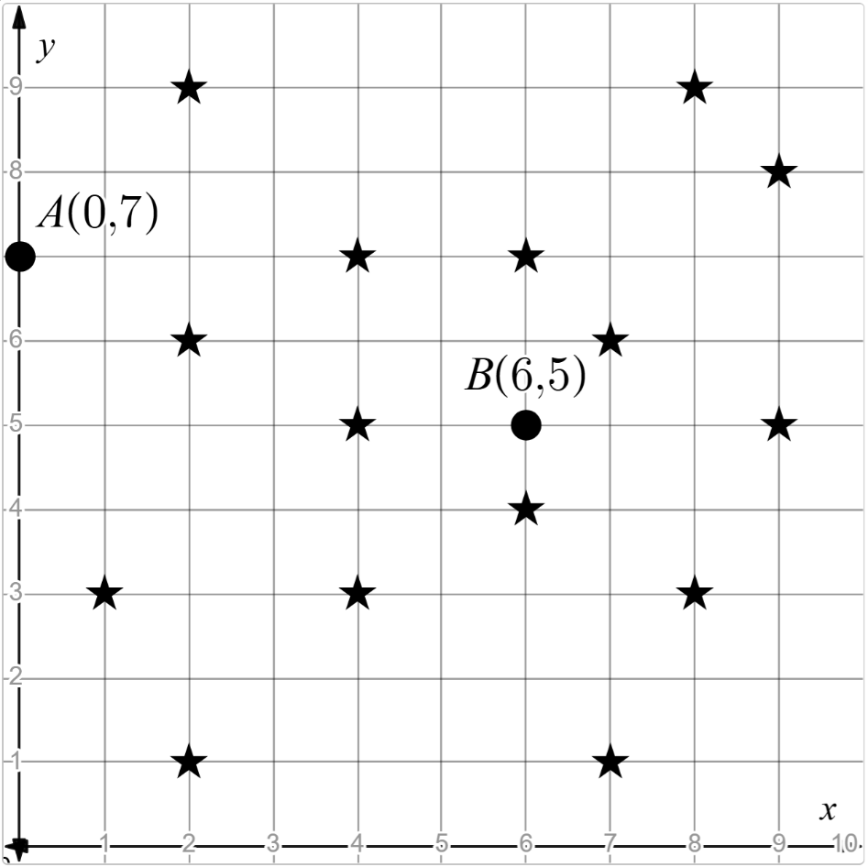
Line through $A$:

Line through $B$:

- What is the gradient of the 2 lines that you found?
Line through A: Line through B:

- What are the similarities and differences between the gradient-intercept and point-gradient forms of the equation of a line?

Appendix B

Frayer diagram
Definition | Characteristics  Vector equation of a line:  $$r=a+λb$$
Examples | Non-examples

Appendix C

Variation theory
For each of the pairs of lines below, state whether they are the same line and justify your answer.
Line 1 | Line 2 | Same line? | Reasoning
$$r=\left(\begin{matrix}1 \\ 1 \\ 1\end{matrix}\right)+λ\left(\begin{matrix}2 \\ 2 \\ 2\end{matrix}\right)$$ | $$s=\left(\begin{matrix}1 \\ 1 \\ 1\end{matrix}\right)+μ\left(\begin{matrix}2 \\ 2 \\ 2\end{matrix}\right)$$
$$r=\left(\begin{matrix}1 \\ 1 \\ 1\end{matrix}\right)+λ\left(\begin{matrix}1 \\ 0 \\ 0\end{matrix}\right)$$ | $$s=\left(\begin{matrix}1 \\ 1 \\ 1\end{matrix}\right)+μ\left(\begin{matrix}0 \\ 1 \\ 0\end{matrix}\right)$$
$$r=\left(\begin{matrix}1 \\ 1 \\ 1\end{matrix}\right)+λ\left(\begin{matrix}1 \\ 1 \\ 1\end{matrix}\right)$$ | $$s=\left(\begin{matrix}1 \\ 1 \\ 1\end{matrix}\right)+μ\left(\begin{matrix}2 \\ 2 \\ 2\end{matrix}\right)$$
$$r=\left(\begin{matrix}1 \\ 1 \\ 1\end{matrix}\right)+λ\left(\begin{matrix}2 \\ 2 \\ 2\end{matrix}\right)$$ | $$s=\left(\begin{matrix}1 \\ 1 \\ 1\end{matrix}\right)+μ\left(\begin{matrix}-2 \\ 2 \\ 2\end{matrix}\right)$$
$$r=\left(\begin{matrix}1 \\ 1 \\ 1\end{matrix}\right)+λ\left(\begin{matrix}2 \\ 2 \\ 2\end{matrix}\right)$$ | $$s=\left(\begin{matrix}1 \\ 1 \\ 1\end{matrix}\right)+μ\left(\begin{matrix}-2 \\ -2 \\ -2\end{matrix}\right)$$

Sample solutions

Appendix A – points and lines
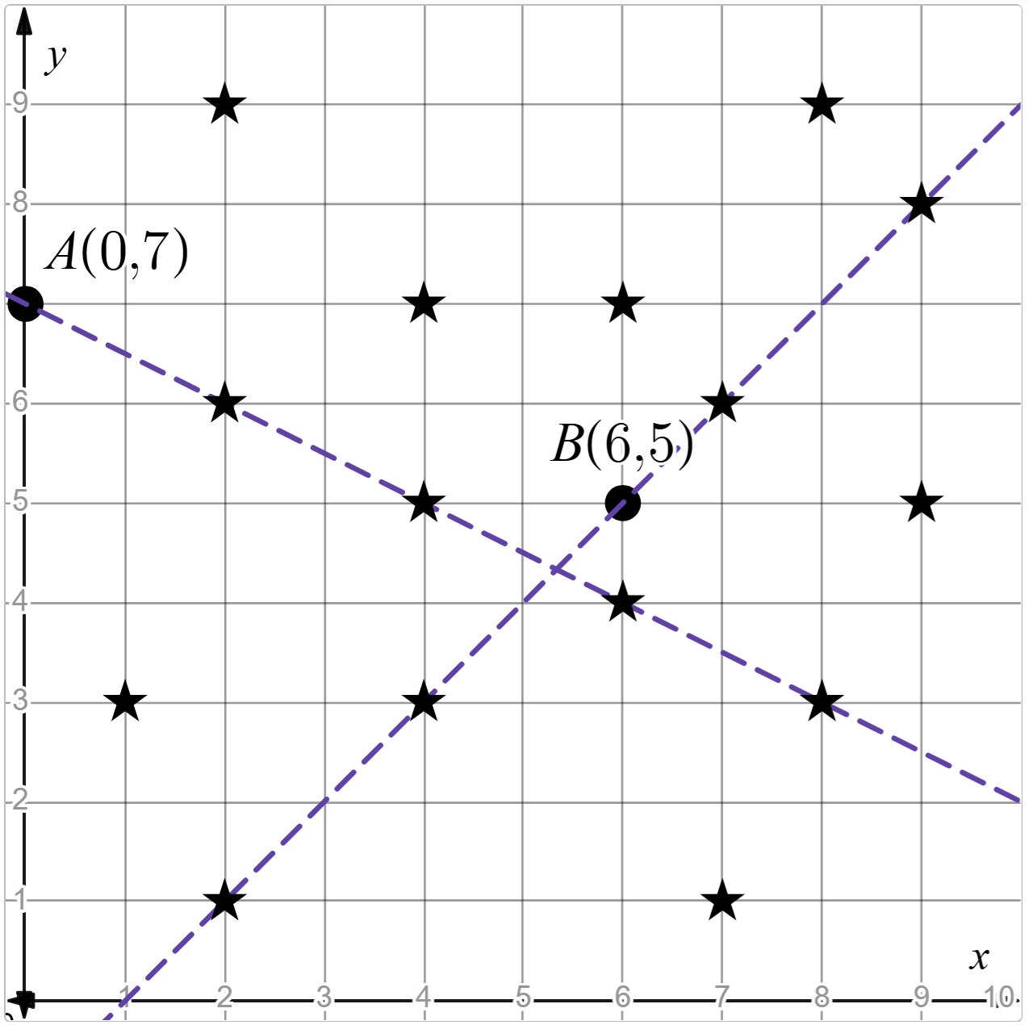
- Line through A: $y=-\frac{1}{2}x+7$.
- Line through B: $y-5=\left(x-6\right)$
$$y-5=x-6 \\ y=x-1$$
- Gradient through A: $-\frac{1}{2}$ Gradient through B: 1

- Possible answer: Both forms of the equation of a line use a point and a gradient.

Appendix B – Frayer diagram
Definition  A vector equation of a line describes the position of every point on a line using a position vector and a direction vector. | Characteristics  Vector equation of a line:  $$r=a+λb$$  $r$ is the position vector of a general point on the line.  $λ$ is a parameter.  $a$ is the position vector of a specific point on the line.  $b$ is the direction vector of the line.
Examples  $$r=(1,2)+λ(3,4)$$  $$r=\left(\begin{matrix}0 \\ 1 \\ 2\end{matrix}\right)+λ\left(\begin{matrix}3 \\ 4 \\ 5\end{matrix}\right)$$ | Non-examples  $y=mx+b$  A point $\left(2,3\right)$, or vector $\left(2,3\right)$  A pair of parametric equations $x\left(t\right)=3t$; $y\left(t\right)=t-1$

Appendix C – variation theory
For each of the pairs of lines below, state whether they are same line and justify your answer.
Line 1 | Line 2 | Same line? | Reasoning
$$r=\left(\begin{matrix}1 \\ 1 \\ 1\end{matrix}\right)+λ\left(\begin{matrix}2 \\ 2 \\ 2\end{matrix}\right)$$ | $$s=\left(\begin{matrix}1 \\ 1 \\ 1\end{matrix}\right)+μ\left(\begin{matrix}2 \\ 2 \\ 2\end{matrix}\right)$$ | Yes | The position vector and direction vector are the same.
$$r=\left(\begin{matrix}1 \\ 1 \\ 1\end{matrix}\right)+λ\left(\begin{matrix}1 \\ 0 \\ 0\end{matrix}\right)$$ | $$s=\left(\begin{matrix}1 \\ 1 \\ 1\end{matrix}\right)+μ\left(\begin{matrix}0 \\ 1 \\ 0\end{matrix}\right)$$ | No | The direction vectors are different, so the lines point in different directions
$$r=\left(\begin{matrix}1 \\ 1 \\ 1\end{matrix}\right)+λ\left(\begin{matrix}1 \\ 1 \\ 1\end{matrix}\right)$$ | $$s=\left(\begin{matrix}1 \\ 1 \\ 1\end{matrix}\right)+μ\left(\begin{matrix}2 \\ 2 \\ 2\end{matrix}\right)$$ | Yes | The position vector is the same.  The direction vectors are scalar multiples of each other and therefore point in the same direction.
$$r=\left(\begin{matrix}1 \\ 1 \\ 1\end{matrix}\right)+λ\left(\begin{matrix}2 \\ 2 \\ 2\end{matrix}\right)$$ | $$s=\left(\begin{matrix}1 \\ 1 \\ 1\end{matrix}\right)+μ\left(\begin{matrix}-2 \\ 2 \\ 2\end{matrix}\right)$$ | No | The direction vectors are different, so the lines point in different directions
$$r=\left(\begin{matrix}1 \\ 1 \\ 1\end{matrix}\right)+λ\left(\begin{matrix}2 \\ 2 \\ 2\end{matrix}\right)$$ | $$s=\left(\begin{matrix}1 \\ 1 \\ 1\end{matrix}\right)+μ\left(\begin{matrix}-2 \\ -2 \\ -2\end{matrix}\right)$$ | Yes | The position vector is the same.  The direction vectors are scalar multiples of each other and therefore point in the same direction.

References
This resource contains NSW Curriculum and syllabus content. The NSW Curriculum is developed by the NSW Education Standards Authority (NESA). This content is prepared by NESA for and on behalf of the Crown in right of the State of New South Wales. The material is protected by Crown copyright.
Please refer to the NESA Copyright Disclaimer for more information https://www.nsw.gov.au/education-and-training/nesa/copyright.
NESA holds the only official and up-to-date versions of the NSW Curriculum and syllabus documents. Please visit NESA https://www.nsw.gov.au/education-and-training/nesa and NSW Curriculum https://curriculum.nsw.edu.au.
Mathematics Extension 2 11–12 Syllabus © NSW Education Standards Authority (NESA) for and on behalf of the Crown in right of the State of New South Wales, 2024.

© State of New South Wales (Department of Education), 2026
The copyright material published in this resource is subject to the Copyright Act 1968 (Cth) and is owned by the NSW Department of Education or, where indicated, by a party other than the NSW Department of Education (third-party material).
Copyright material available in this resource and owned by the NSW Department of Education is licensed under a Creative Commons Attribution 4.0 International (CC BY 4.0) license.

This license allows you to share and adapt the material for any purpose, even commercially. Attribution should be given to © State of New South Wales (Department of Education), 2026.
Material in this resource not available under a Creative Commons license:
- the NSW Department of Education logo, other logos and trademark-protected material
- material owned by a third party that has been reproduced with permission. You will need to obtain permission from the third party to reuse its material.
Links to third-party material and websites
Please note that the provided (reading/viewing material/list/links/texts) are a suggestion only and implies no endorsement, by the New South Wales Department of Education, of any author, publisher, or book title. School principals and teachers are best placed to assess the suitability of resources that would complement the curriculum and reflect the needs and interests of their students.
If you use the links provided in this document to access a third-party's website, you acknowledge that the terms of use, including licence terms set out on the third-party's website apply to the use which may be made of the materials on that third-party website or where permitted by the Copyright Act 1968 (Cth). The department accepts no responsibility for content on third-party websites.

