The logarithmic function
Students will learn how to graph the logarithmic function by reflecting the graph of the exponential function in the line $y=x$ and by plotting points. They will then apply graph transformations to the graph of the logarithmic function.
Students will need at least one digital device per pair to interact with Amplify Classroom during this lesson.

Learning intention
- To be able to graph logarithmic functions.

Success criteria
- I can reflect exponential functions in the line $y=x$.
- I can identify the features of the graphs of logarithmic functions.
- I can define a natural logarithm.

Outcomes
A student:
- develops understanding and fluency in mathematics through exploring and connecting mathematical concepts, choosing and applying mathematical techniques to solve problems, and communicating their thinking and reasoning coherently and clearly MAO-WM-01
- applies exponential and logarithmic laws to simplify expressions, solve equations and prove results MAV-11-07
- analyses graphs of exponential and logarithmic functions outcome MAV-11-08

Content

Logarithmic functions
- Define the natural logarithm $\ln{a}=\log_{e}{a}$
- Graph the logarithmic function $y=\log_{a}{x}$ for $a>0$ and $a≠1$
- Use graphing applications to identify the graphs of $y=a^{x}$ and $y=\log_{a}{x}$ as reflections of each other in the line $y=x$, in cases where $a>1$ and $0<a<1$
Mathematics Advanced 11–12 Syllabus © NSW Education Standards Authority (NESA) for and on behalf of the Crown in right of the State of New South Wales, 2024.

Table 1: lesson summary
Section | Summary of activity | Teaching strategies | Teaching points
Activating prior knowledge | Students compare graphs on slide 4 of the PowerPoint The logarithmic function. They justify their reasoning and discuss similarities and differences between the graphs. | Which one doesn’t belong?  Think-Pair-Share | Identify and justify distinguishing features of graphs.
Connecting learning | Students complete Appendix A in pairs, giving instructions to draw reflections of graphs in the line $y=x$. Students then complete screens 1–13 of the Amplify activity (bit.ly/LogFunctions). Using slide 6 of the PowerPoint, students discuss the features of logarithmic graphs, including the asymptote, domain, range and behaviour and how the value of the base affects the shape of the graph. Students then complete the card sort activity on screen 14, with an option to instead use Appendix B, to classify logarithmic values. Slide 7 is used to generate a discussion about the shape of logarithmic graphs and Slide 8 is used to connect the graphs of $y=a^{x}$and $y={log⁡}_{a}x$. | Think-Pair-Share  Pose-Pause-Pounce-Bounce | Explain logarithmic functions as reflections of exponential functions and describe their key graphical features.
Releasing responsibility | Students are shown the logarithm notation used on calculators for base 10 and base $e$ on slide 10. The teacher models transformations of logarithmic functions using worked examples on slides 11–14. Students create notes and then practise graphing transformations using Appendix C. | Worked examples (Your turn)  Notes to future forgetful selves | Identify notation for logarithms and apply transformations to logarithmic graphs.
Independent practice | Students answer conceptual questions about a logarithmic model of perceived loudness on slides 16–17. Students then complete an exit ticket identifying the correct graph representing a transformation on slide 18. | Think-Pair-Share | Interpret logarithmic relationships and identify transformed logarithmic graphs.

Activity structure
Please use the associated PowerPoint The logarithmic function to display images in this lesson.

Activating prior knowledge
- Display slide 4 of the PowerPoint, which contains 4 graphs for a Which one doesn’t belong? (talkingmathwithkids.com/wodb-about) activity. In a Think-Pair-Share (bit.ly/thinkpairsharestrategy), have students justify why each of the graphs doesn’t belong.
Teachers might ask students to decide why one of the graphs does not belong or ask them to find a reason why each graph does not belong.
Students might suggest that:
- A has graphs that intersect twice
- B is straight lines only
- C is only one graph
- D is reflected in the $x$-axis, while the others are reflected over $y=x$.

Connecting learning
- Distribute a copy of Appendix A ‘Describe the reflection’ to pairs of students, giving one student page A and the other student page B. Ask them not to show each other what is on their page and to follow the instructions to complete the activity.
Students should recognise that they need to reverse coordinates to communicate where the reflected graph should be drawn.
They may also recognise that the domain and range are reversed.
- When students have completed the activity, use a Think-Pair-Share for students to compare their graphs and discuss how the reflected graphs are different from the original graph.
- With at least one device per pair of students, assign the Amplify Classroom activity ‘Graphing the logarithmic function’ (bit.ly/LogFunctions), and ask students to complete screens 1–13
Before completing this activity, you will need to set up an Amplify Classroom (bit.ly/createamplifyclassroom). Use the pacing feature to restrict students to screens 1–13.
Use the teacher tips and sample responses in the Amplify Classroom activity to guide discussion and monitor for understanding of the relationship between exponential and logarithmic functions and graphs.
- Display slide 6, which shows the graphs of logarithmic functions with base values between 0 and 1 and greater than 1. Use the Pose-Pause-Pounce-Bounce questioning strategy to check for understanding of how the value of the base affects the shape of the logarithmic graph. Useful question prompts may include:
- How does the graph of the curve change as the value of $a$ changes?
- How would you describe the graph of the logarithmic function when the value of the base is greater than 1?
- How would you describe the graph of the logarithmic function when the value of the base is between 0 and 1?
For the graph of $y=\log_{a}{x}$, when $a>0$:
- It has a vertical asymptote at $x=0$.
- As $x→0, y→-∞$.
- As $x→∞, y→∞$ at a decreasing rate.
- Domain: $x>0$. Range: all real $y$.
For the graph of $y=\log_{a}{x}$, when $a<0$:
- It has a vertical asymptote at $x=0$.
- As $x→0, y→∞$.
- As $x→∞, y→-∞$ at a decreasing rate.
- Domain: $x>0$. Range: all real $y$.
- Ask students to return to the Amplify Classroom activity and complete the card sort activity on screen 14.
A copy of the card sort activity can be located in Appendix B ‘Card sort’.
- Display slide 7, which shows the graphs of $y=\log_{a}{x}$ and $y=a^{x}$ and discuss the link between the value of the logarithms on the sorted cards and the shape of the graphs using the prompts on the slide.
- Display slide 8, which shows the graphs of $y=\log_{e}{x}$ and $y=e^{x}$ and use a Think-Pair-Share to discuss how the graphs are the same and how they differ from the previous graphs.
Students should recognise that the shapes of the curves are the same and the curves are reflected in the line $y=x$ which is also the same for other pairs of exponential and logarithmic functions.
They should recognise that the equations have a base $e$, which is different to the previous curves that only had bases with rational numbers. Students may need to be reminded that $e$ represents a numerical value and will behave accordingly.

Releasing responsibility
- Display slide 10, which contains information about the notation used on a calculator for logarithms with base 10 and base $e$ and ask students to read the information on the screen.
- Ask students to use the information on the slide to try out the ‘log’ and ‘ln’ buttons on their calculator, ensuring they understand how to calculate logarithms with base 10 and base $e$.
Students may have already used their calculator with logarithms in lessons 1–3 of this unit.
Newer calculators may have the ability to calculate values of logarithms which have a base other than $e$ and 10.
If students have a calculator with this functionality, teachers could ask students to compare and evaluate using the reflection of an exponential graph with creating a table of values and plotting points to graph a logarithmic function.
- Use slides 11–14 of the PowerPoint to model worked examples of transformations of the logarithmic function using the Worked examples (Your turn) method (bit.ly/supportingstrategies).
Students should be encouraged to draw the graphs, identifying key points including the intercepts.
- Students are to create notes to their future forgetful self (bit.ly/notestofutureself) on how to graph logarithmic functions. They may benefit from being encouraged to consider including notes on:
- reflecting the graph of an exponential function in the line $y=x$
- the domain, range and asymptotes of the exponential and logarithmic functions
- the features of a logarithmic function
- the definition of a natural logarithm.
- Distribute a copy of Appendix C ‘Graphing transformations’ to students and ask them to complete the activity in pairs.

Independent practice
- Display slide 16 and use a Think-Pair-Share to answer the questions. The solutions are on slide 17.
- Display slide 18 which contains an exit ticket question and ask students to determine which graph represents the transformation but wait until everyone is ready to share their answer.
- When students are ready, ask them to hold up one, 2 or 3 fingers to indicate which graph they believe represents the transformation.
Graph 1 shows a horizontal dilation of $\frac{1}{2}$ and a translation of 2 units to the right.
A horizontal dilation of $\frac{1}{2}$ means replace $x$ with $2x$: $y=\ln{(2x)}$.
Translate 2 units to the right means replace $x$ with $x-2$: $y=\ln{(2(x-2))}$.
$$y=\ln\left(2\left(x-2\right)\right) \\ =\ln\left(2x-4\right)$$
It is a logarithmic curve:
- vertical asymptote at $x=2$domain: $x>2$
- increasing slowly to the right
- compressed horizontally compared with $y=ln⁡(x)$.
- Use a class discussion to share how they knew and to address any misconceptions.

Assessment and differentiation

Suggested opportunities for differentiation
Activating prior knowledge
- Challenge students to identify a reason why each graph doesn’t belong.
- Provide extra support to students by drawing their attention to specific features of the graphs.
Connecting learning
- Some students may benefit from using a semi-transparent reflection tool, such as a geomirror, to see the reflected graphs.
- Suggest to students who are experiencing difficulty with describing the reflections to rotate the page so the line $y=x$ is horizontal or vertical.
- When distributing Appendix A for describing reflections, provide students who need extra help with partially completed coordinate tables or guiding questions.
- Extend students to explore algebraic expressions representing the reflections or to generalise how domain and range are transformed under reflections.
Releasing responsibility
- Provide step-by-step instructions or calculator guides for students unfamiliar with using ‘log’ or ‘ln’ and other logarithm or exponential button functions.
- Extend students by asking them to draw transformations of logarithmic functions with bases between 0 and 1.
- Challenge students to compare graphs with different bases using graphing calculators or software, and to explain the implications of base changes.
Independent practice
- Provide hints or partially worked examples for students needing extra assistance with transformation questions.
- Extend students by asking them to create their own transformed logarithmic functions and describe their effects graphically to a partner.

Suggested opportunities for assessment
Activating prior knowledge
- Listen to students’ Think-Pair-Share discussions to assess their ability to identify and justify features that differentiate the graphs.
- Invite students to share explanations with the class to gauge diverse understandings and provide immediate feedback.
Connecting learning
- Monitor pairs’ completion of Appendix A and their discussions to check understanding of coordinate reversal, domain and range changes.
- Use Pose-Pause-Pounce-Bounce questioning during Amplify Classroom activities and class discussions (slides 6 and 7) to assess understanding of reflections, logarithmic function properties and effects of base values on graphs.
- Gather and discuss students’ reasoning about the link between logarithmic values and graph shapes after the card sort activity.
- During the Think-Pair-Share on slide 8, listen for students’ ability to articulate similarities and differences between graphs of different bases.
Releasing responsibility
- Use observations during worked examples to identify where students need clarification or extension.
- Review student work on Appendix C ‘Graphing transformations’ to check accuracy in plotting and understanding of key features.
Independent practice
- Use the Think-Pair-Share on slide 17 to check students’ conceptual understanding of transformations before moving on.
- Implement the exit ticket question on slide 19 as a quick formative check.

Appendix A

Describe the reflection

Page A
Take turns to provide instructions to your partner so that they will draw the reflection of your graphs with the line $y=x$ as the axis of symmetry.
You might find it easier to draw the reflection of your graphs before you try to describe it.
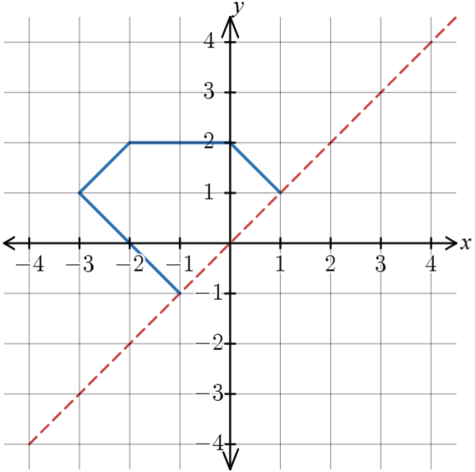 | 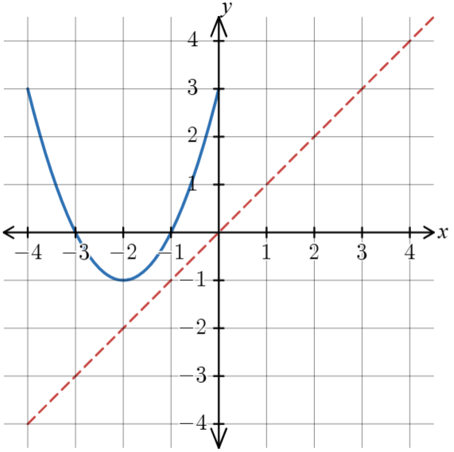
Follow your partner’s instructions to draw the reflection of their graphs on the number planes below.
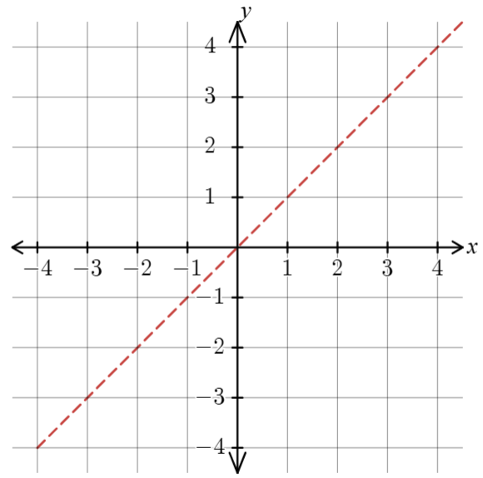

Page B
Take turns to provide instructions to your partner so that they will draw the reflection of your graphs reflected in the line $y=x$.
You might find it easier to draw the reflection of your graphs before you try to describe them.
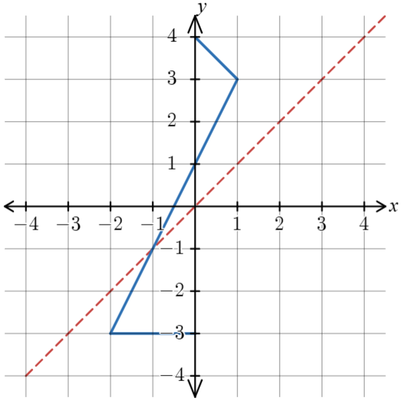 | 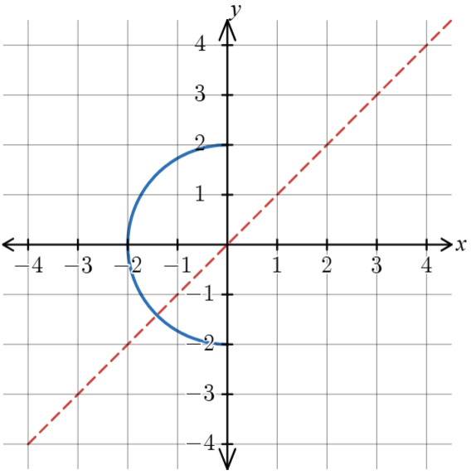
Follow your partner’s instructions to draw the reflection of their graphs on the number planes below.

Appendix B

Card sort
Sort the cards into the following categories: $y<0, 0<y<1, y=0, y=1, y>1.$
$$y=\log_{10}\left(1\right)$$ | $$y=\log_{5}\left(5\right)$$ | $$y=\log_{3}\left(9\right)$$
$$y=\log_{5}\left(2\right)$$ | $$y=\log_{2}\left(\sqrt{2}\right)$$ | $$y=\log_{\frac{1}{2}}\left(2\right)$$
$$y=\log_{10}\left(100\right)$$ | $$y=\log_{2}\left(\frac{1}{4}\right)$$ | $$y=2\log_{2}\left(1\right)$$
$$y=\log_{2}{(0.5)}$$ | $$y=-\log_{10}{(0.1)}$$ | $$y=\log_{8}\left(2\right)$$
$$y=\log_{5}\left(\sqrt{5}\right)$$ | $$y=\log_{3}\left(1\right)$$ | $$y=\log_{2}\left(2\right)$$
Category cards:
$$y<0$$ | $$0<y<1$$ | $$y=0$$

$$y=1$$ | $$y>0$$

Appendix C

Graph transformations
Draw the graphs of the following equations on the Cartesian planes provided.
- $y=\log_{2}\left(x\right)+2$  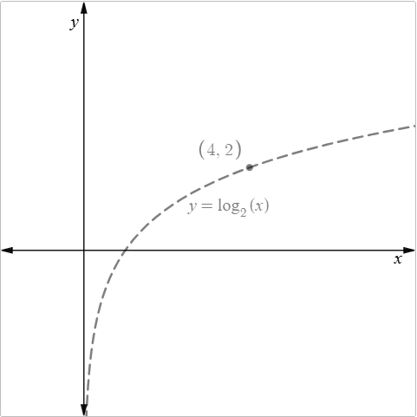 | - $y=\log_{3}\left(x\right)-3$  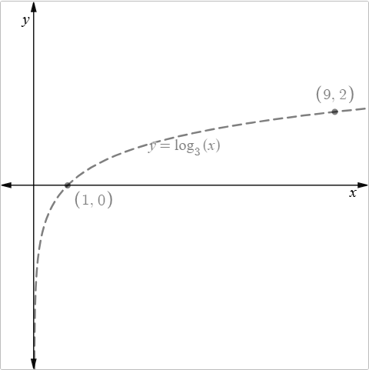
- $y=2\log_{e}\left(x\right)$  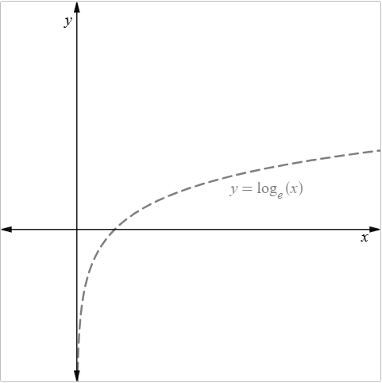 | - $y=-\log_{10}\left(x\right)$  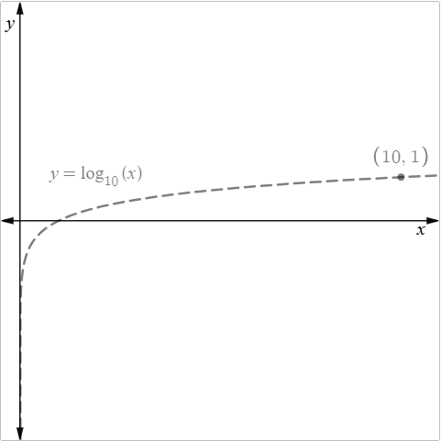

- $y=\log_{2}\left(2x\right)$  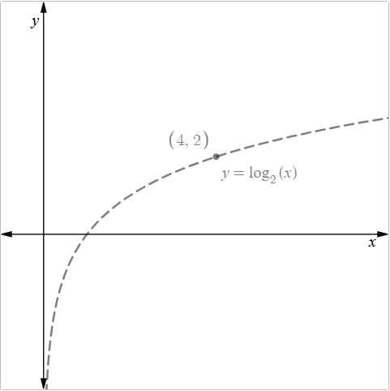 | - $y=\log_{3}\left(3x\right)$  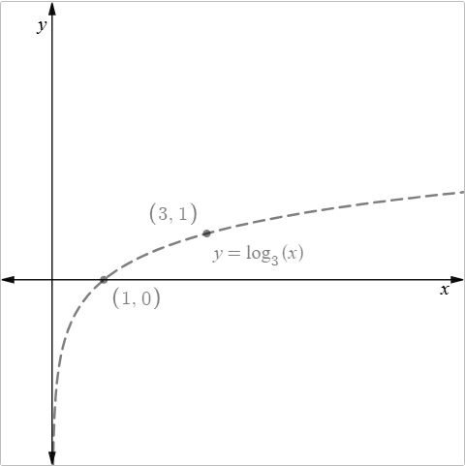
- $y=\log_{5}\left(\frac{x}{3}\right)$  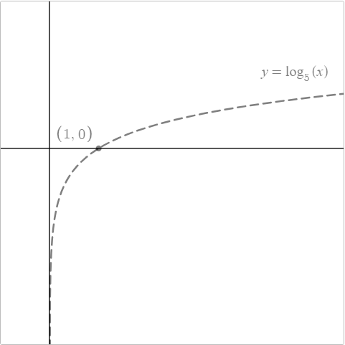 | - $y=3\log_{e}\left(x\right)$  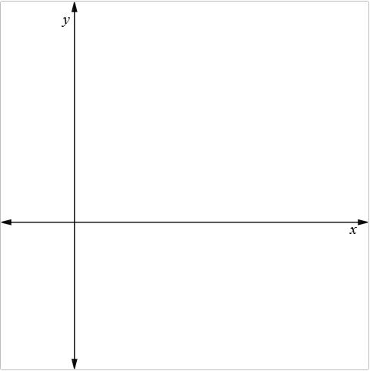

- $y={\text{log}}_{2}{(x-1)}$  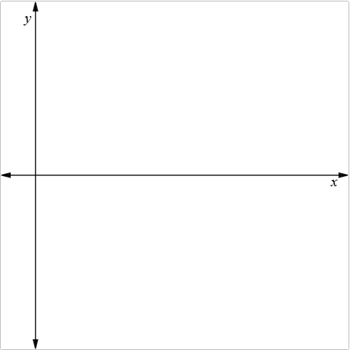 | - $y={\text{log}}_{2}{(x+2)}$  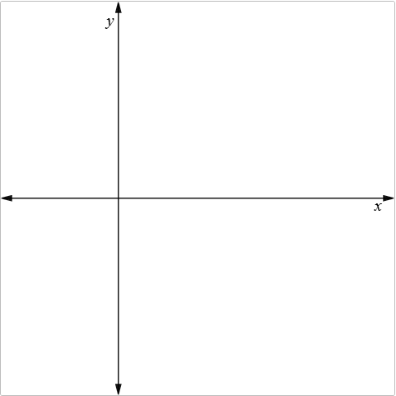

- $y=2\log_{2}\left(x\right)+1$  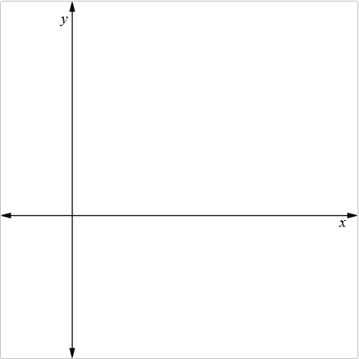 | - $y=-\log_{3}\left(2x\right)-2$  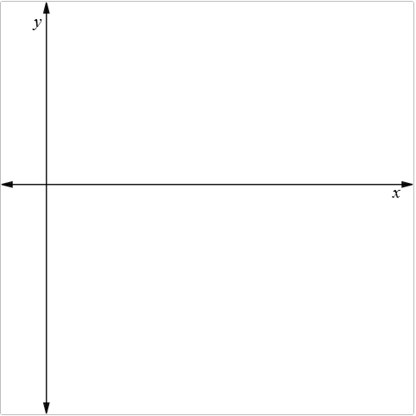

Sample solutions

Appendix A – describe the reflection
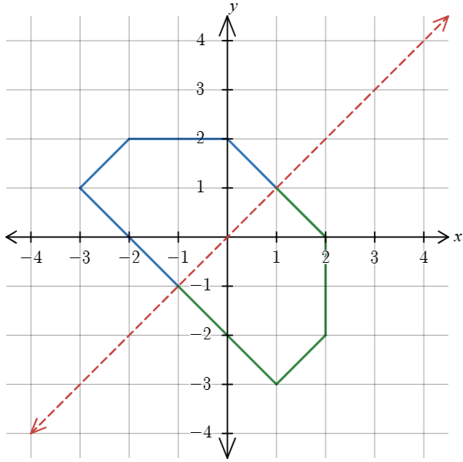 | 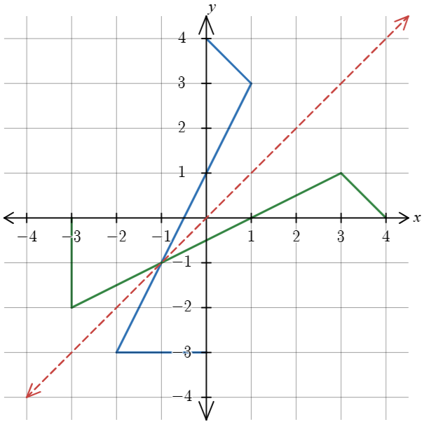
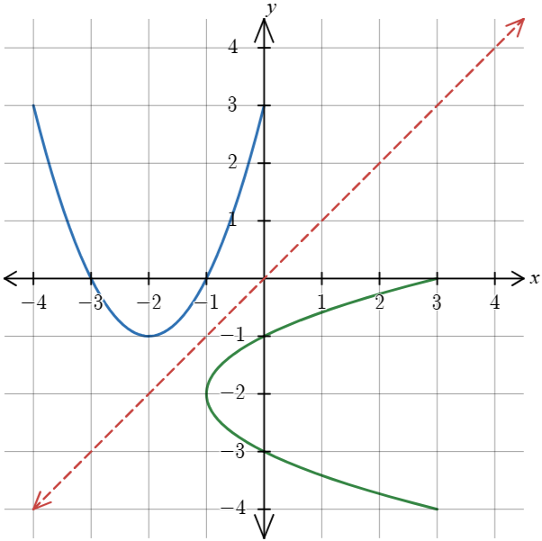 | 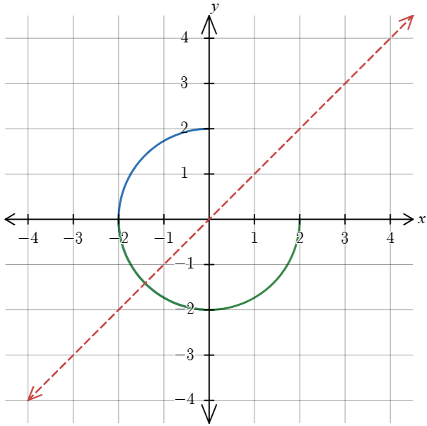  *The reflection and the original curve overlap in quadrant 3.

Appendix B – card sort
$$y<0$$ | $$y=0$$ | $$0<y<1$$ | $$y=1$$ | $$y>0$$
$$y=\log_{2}\left(\frac{1}{4}\right)$$ | $$y=\log_{10}\left(1\right)$$ | $$y=\log_{2}\left(\sqrt{2}\right)$$ | $$y=\log_{2}\left(2\right)$$ | $$y=\log_{3}\left(9\right)$$
$$y=\log_{2}{(0.5)}$$ | $$y=\log_{3}\left(1\right)$$ | $$y=\log_{5}\left(\sqrt{5}\right)$$ | $$y=\log_{5}\left(5\right)$$ | $$y=\log_{5}\left(2\right)$$
$$y=\log_{\frac{1}{2}}\left(2\right)$$ | $$y=2\log_{2}\left(1\right)$$ |  | $$y=-\log_{10}{(0.1)}$$ | $$y=\log_{10}\left(100\right)$$
 |  |  |  | $$y=\log_{8}\left(2\right)$$

Appendix C – graph transformations
- $y=\log_{2}\left(x\right)+2$  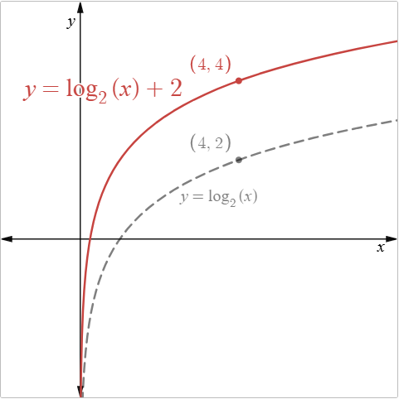 | - $y=\log_{3}\left(x\right)-3$  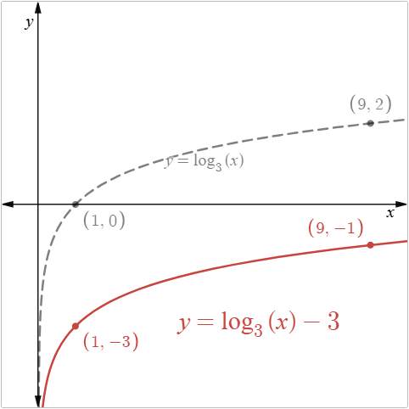
- $y=2\log_{e}\left(x\right)$  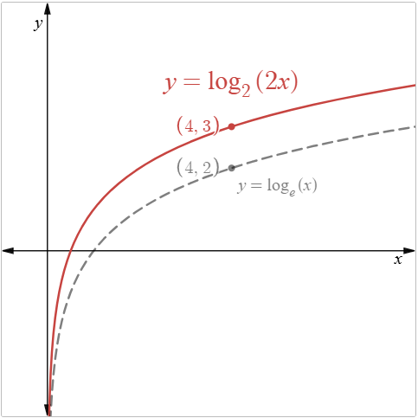 | - $y=-\log_{10}\left(x\right)$  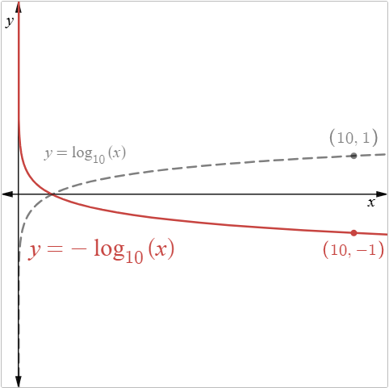

- $y=\log_{2}\left(2x\right)$  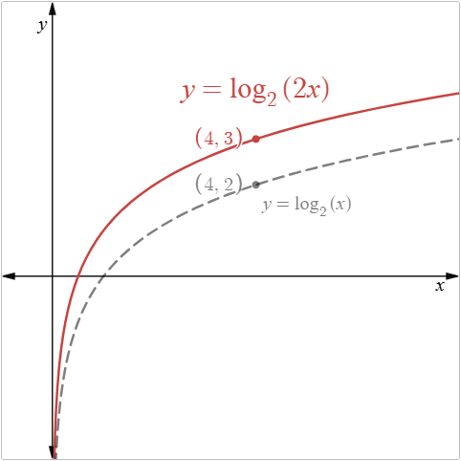 | - $y=\log_{3}\left(3x\right)$  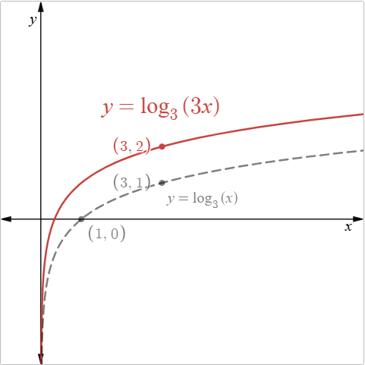
- $y=\log_{5}\left(\frac{x}{3}\right)$  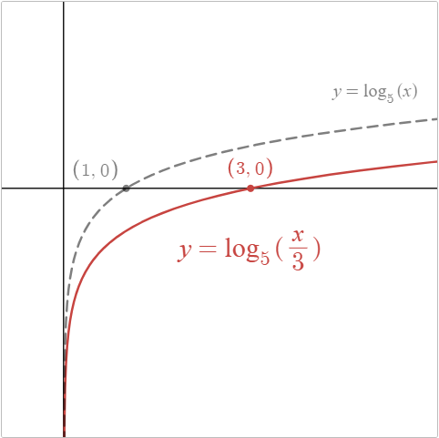 | - $y=3\log_{e}\left(x\right)$  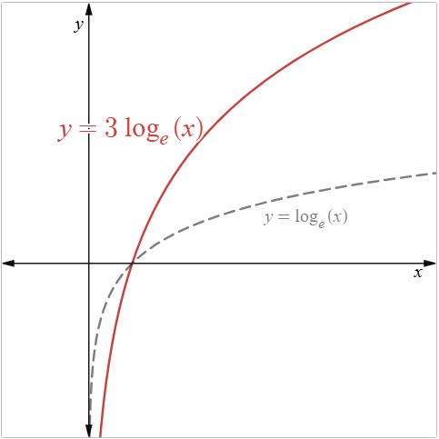
- $y={\text{log}}_{2}{(x-1)}$  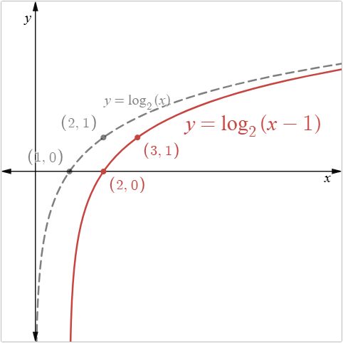 | - $y={\text{log}}_{2}{(x+2)}$  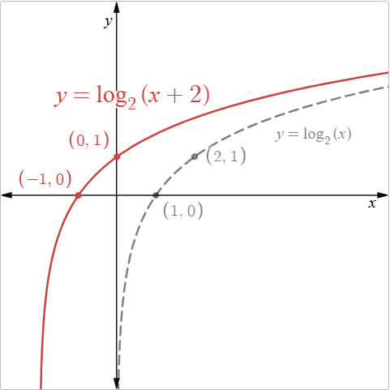
- $y=2\log_{2}\left(x\right)+1$  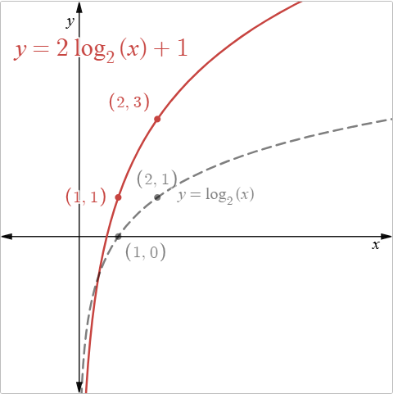 | - $y=-\log_{3}\left(2x\right)-2$  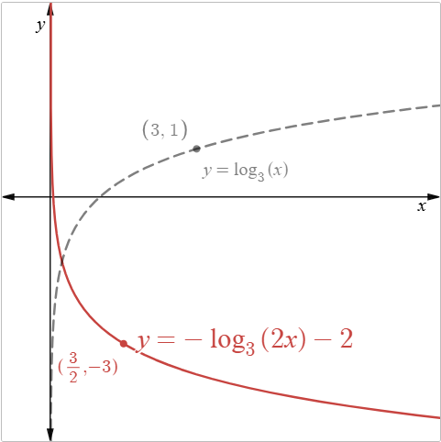

References
This resource contains NSW Curriculum and syllabus content. The NSW Curriculum is developed by the NSW Education Standards Authority (NESA). This content is prepared by NESA for and on behalf of the Crown in right of the State of New South Wales. The material is protected by Crown copyright.
Please refer to the NESA Copyright Disclaimer for more information https://www.nsw.gov.au/education-and-training/nesa/copyright.
NESA holds the only official and up-to-date versions of the NSW Curriculum and syllabus documents. Please visit NESA https://www.nsw.gov.au/education-and-training/nesa and NSW Curriculum https://curriculum.nsw.edu.au.
Mathematics Advanced 11–12 Syllabus © NSW Education Standards Authority (NESA) for and on behalf of the Crown in right of the State of New South Wales, 2024.

© State of New South Wales (Department of Education), 2026
The copyright material published in this resource is subject to the Copyright Act 1968 (Cth) and is owned by the NSW Department of Education or, where indicated, by a party other than the NSW Department of Education (third-party material).
Copyright material available in this resource and owned by the NSW Department of Education is licensed under a Creative Commons Attribution 4.0 International (CC BY 4.0) license.

This license allows you to share and adapt the material for any purpose, even commercially. Attribution should be given to © State of New South Wales (Department of Education), 2026.
Material in this resource not available under a Creative Commons license:
- the NSW Department of Education logo, other logos and trademark-protected material
- material owned by a third party that has been reproduced with permission. You will need to obtain permission from the third party to reuse its material.
Links to third-party material and websites
Please note that the provided (reading/viewing material/list/links/texts) are a suggestion only and implies no endorsement, by the New South Wales Department of Education, of any author, publisher, or book title. School principals and teachers are best placed to assess the suitability of resources that would complement the curriculum and reflect the needs and interests of their students.
If you use the links provided in this document to access a third-party's website, you acknowledge that the terms of use, including licence terms set out on the third-party's website apply to the use which may be made of the materials on that third-party website or where permitted by the Copyright Act 1968 (Cth). The department accepts no responsibility for content on third-party websites.

