Mixed trigonometry
Students develop a flowchart to assist them when finding lengths or angles of triangles. They then practise using their flowcharts to solve problems.

Learning intention
- To be able to apply a range of trigonometric rules to solve different types of problems.

Success criteria
- I can identify whether a problem involves a right-angled triangle or a non-right-angled triangle and select the appropriate trigonometric rule.
- I can determine when the sine rule or the cosine rule is more appropriate in non-right-angled triangles.
- I can accurately solve trigonometric problems using a variety of rules and methods.

Outcomes
A student:
- develops understanding and fluency in mathematics through exploring and connecting mathematical concepts, choosing and applying mathematical techniques to solve problems, and communicating their thinking and reasoning coherently and clearly MAO-WM-01
- applies trigonometry to solve problems involving geometric shapes MAV-11-04

Content

Trigonometry and measure of angles
Trigonometry with acute angles
- Apply trigonometry to solve problems involving right-angled triangles in two dimensions, true and compass bearings, and angles of elevation and depression
Trigonometry with angles of any magnitude
- Apply the sine rule, cosine rule and formula for the area of a triangle to solve problems where angles are measured in degrees, or degrees and minutes
Mathematics Advanced 11–12 Syllabus © NSW Education Standards Authority (NESA) for and on behalf of the Crown in right of the State of New South Wales, 2024.

Table 1: lesson summary
Section | Summary of activity | Teaching strategies | Teaching points
Activating prior knowledge | Use slide 4 of the PowerPoint Mixed trigonometry to present questions involving both right-angled and non-right-angled trigonometry. | Same Surface, Different Deep | To reveal students’ existing strategies for solving triangle problems.
Connecting learning | Use slide 6 to display the Approaching questions scaffold. Have students develop a flowchart that helps them to plan how to answer a trigonometry question. | Visibly random groups of 3  Vertical non-permanent surfaces  Gallery walk  Assessing and advancing questions | Students could start their flowchart by separating right-angled triangles from non-right-angled triangles, or determining whether they are finding a side or an angle.
Releasing responsibility | Use Appendix A to have students practise using their flowcharts on simple trigonometry problems before annotating additional notes. | Notes to future forgetful selves | Students test their flowcharts and refine them as necessary.
Independent practice | Use Appendix B to give students exposure to unscaffolded, multi-step trigonometry problems. |  | Students may benefit from working in pairs to discuss and compare solution approaches.

Activity structure
Please use the associated PowerPoint Mixed trigonometry to display images in this lesson.

Activating prior knowledge
- Display slide 4 of the PowerPoint and allow students time to complete the Same Surface, Different Deep (bit.ly/S_S_D_D) activity.
- Discuss with students the similarities between the questions. Sample solutions have been provided.

Connecting learning
- Display slide 6 to show the Approaching questions scaffold and draw students’ attention to the ‘Plan’ phase.
- Discuss with students the strategies they used to solve the problems from the ‘Activating prior knowledge’ section. Some suggested prompts include:
- Did you add information to the diagrams?
- How did you identify the steps needed?
- What formulas did you use?
- Facilitate a class discussion by asking students what challenges they might face when solving problems involving triangles, particularly in the ‘Plan’ phase.
- Assign students to visibly random groups of 3 (bit.ly/visiblegroups) at vertical non-permanent surfaces (bit.ly/VNPSstrategy).
- Instruct students to create a flowchart to break down the ‘Plan’ phase by outlining key questions they would ask themselves when solving problems involving triangles and trigonometry.
- Use the following assessing and advancing questions (bit.ly/supportingstrategies) to assess student understanding and further student thinking while making their flowcharts.
Table 2: assessing and advancing questions
Assessing questions | Advancing questions
What information in the triangle helps you decide which rule to use? | How could you group triangle problems based on the information given?
If you need to find an angle or side, what methods are available? | How could you turn your decision process into a clear step-by-step flowchart?
What information is needed to use the sine rule? What information is needed to use the cosine rule? | How could you refine your first decision point so it works for all non-right-angled triangle problems?
How do you decide whether the sine rule or cosine rule is appropriate? | What other methods would you need to include for right-angled triangles?
Students could start their flowchart by separating right-angled triangles from non-right-angled triangles, or state whether they are finding a side or an angle. Students should also consider formulas where the angle must be in radians, as well as other formulas from their Mathematics Advanced – HSC reference sheet.
- Have students conduct a gallery walk (bit.ly/DLSgallerywalk) to view each group’s flowchart.
- Have each student create their own flowchart using information from any of the group flowcharts.

Releasing responsibility
- Distribute Appendix A ‘Mixed triangles’ to pairs of students.
- Have students use their flowchart to identify which rule to use for each triangle, then find the value of $x$ in each triangle to confirm they have chosen the correct rule.
- Have students revisit their flowchart and add any additional notes to their future forgetful selves (bit.ly/notestofutureself).

Independent practice
- Distribute Appendix B ‘HSC-style questions’ and have students work through the problems.
Unlike the questions in Appendix A, these questions have multiple steps. Students may like to work in pairs to discuss and compare solution approaches.

Assessment and differentiation

Suggested opportunities for differentiation
Activating prior knowledge
- Provide scaffolded steps such as ‘Identify the known angle’, ‘Write the area formula’, ‘Substitute values’, ‘Rearrange for the unknown’. This reduces cognitive load and keeps attention on the method rather than the algebra.
- Pre-label sides, angles and ratios so students focus on selecting the correct trigonometry or area formula rather than decoding the diagram.
- Ask students to consider more complex examples, such as: if the area is $k\sqrt{3}$, express BD in terms of $k$.
Connecting learning
- Support students by providing a partially completed flowchart template.
- Encourage the use of diagrams and colour coding for rule selection.
- Challenge students to include multiple solution pathways in their flowchart.
Releasing responsibility
- Model the solution to one triangle from Appendix A, explicitly narrating how the flowchart leads to the correct rule.
- Ask students to add branches to their flowcharts for ambiguous sine rule cases, missing opposite pairs, or when rearranging is required before applying a rule.
- Challenge students to solve one triangle using 2 different methods and evaluate which is more efficient and why.
Independent practice
- Support students by offering a lightly scaffolded version of one question with the first step already identified.
- Provide a completed HSC-style solution and ask students to compare it with their own approach to identify missing steps.
- Have students create their own multi-step triangle problem that requires a specific sequence of rules.

Suggested opportunities for assessment
Activating prior knowledge
- Assess students’ ability to apply right-angled and non-right-angled trigonometry to find unknown sides and angles.
- Assess students’ accuracy in selecting and justifying the appropriate trigonometric rule for a given triangle.
- Assess students’ fluency in using exact values, calculator methods and algebraic rearrangement when solving trigonometric problems.
Connecting learning
- Students could provide peer feedback on flowcharts using sticky notes to identify a strength and ask a clarifying question.
- Assess students’ ability to identify the key information in a triangle that determines which trigonometric rule is appropriate.
- Assess students’ accuracy in constructing a logical decision pathway that distinguishes between right-angled triangles and non-right-angled triangles.
Releasing responsibility
- Assess students’ ability to identify the appropriate rule by checking whether they correctly use their flowchart for each triangle.
- Assess procedural accuracy by looking for correct substitution, correct rearranging, and correct use of exact values or calculator methods.
- Assess clarity of decision-making by looking for clear, actionable notes that show students understand the logic behind their flowchart.
Independent practice
- Assess students’ ability to interpret a worded trigonometry problem and construct an accurate diagram that represents all given information.
- Assess students’ ability to apply an appropriate sequence of trigonometric rules to solve multi-step problems involving non-right-angled triangles.

Appendix A

Mixed triangles
Identify which rule to use for each triangle, then find the value of $x$ in each triangle.
A  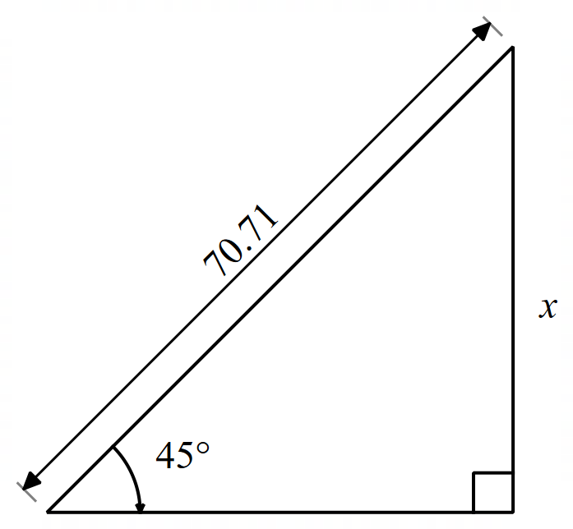 | B  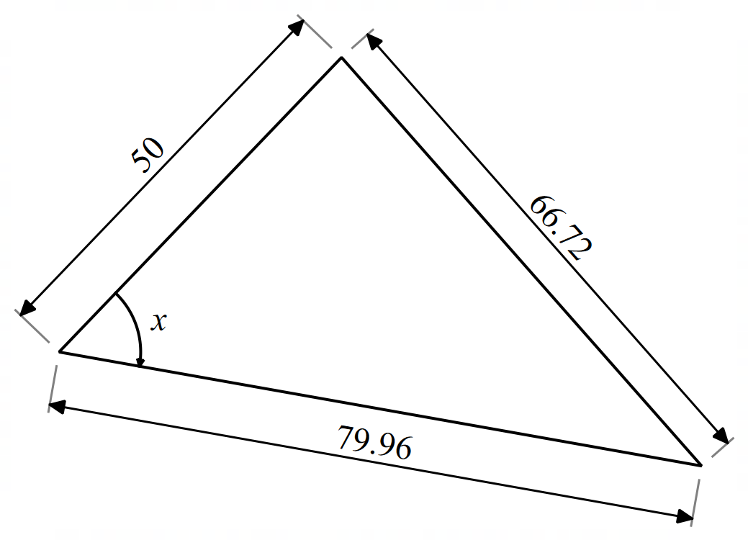 | C  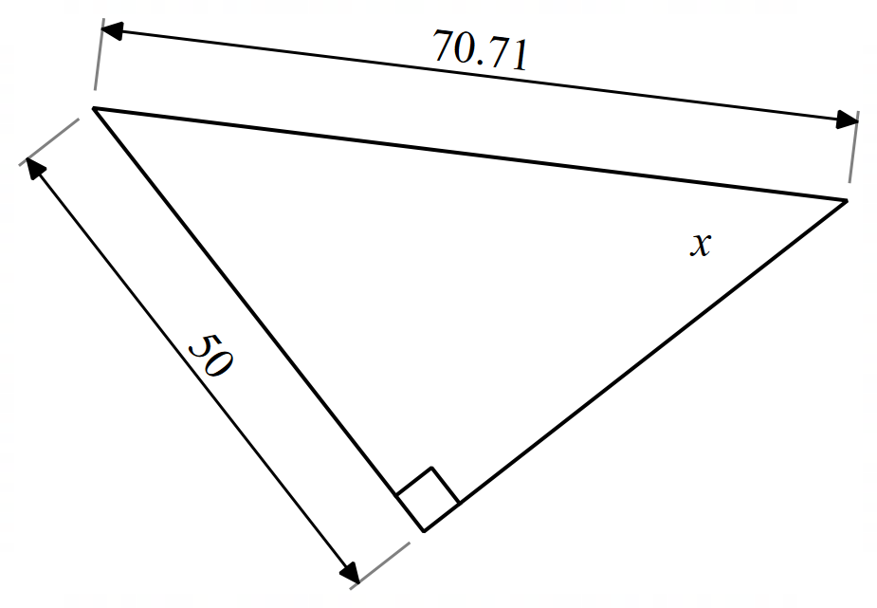
D  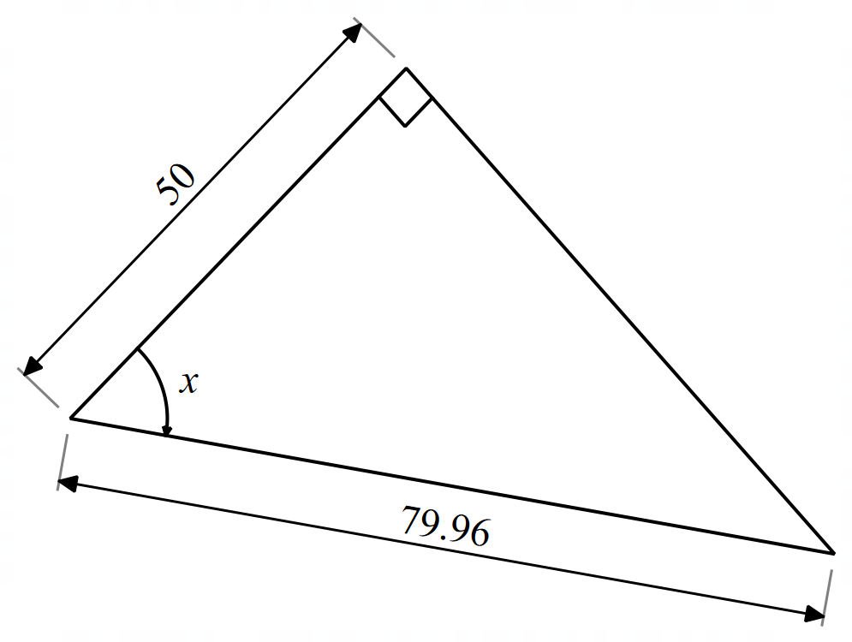 | E  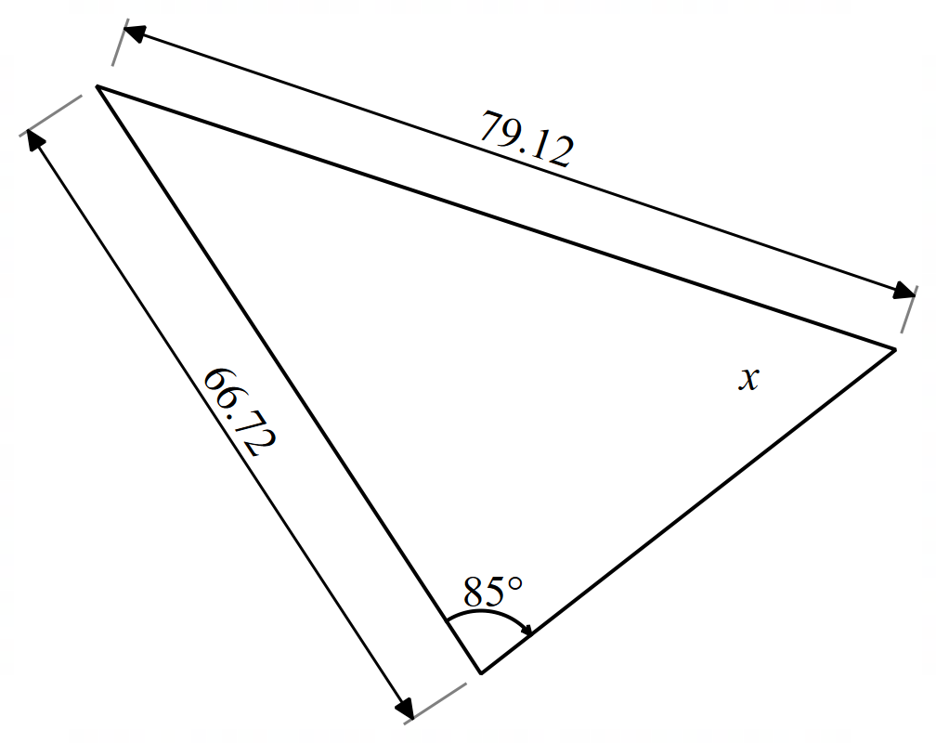 | F  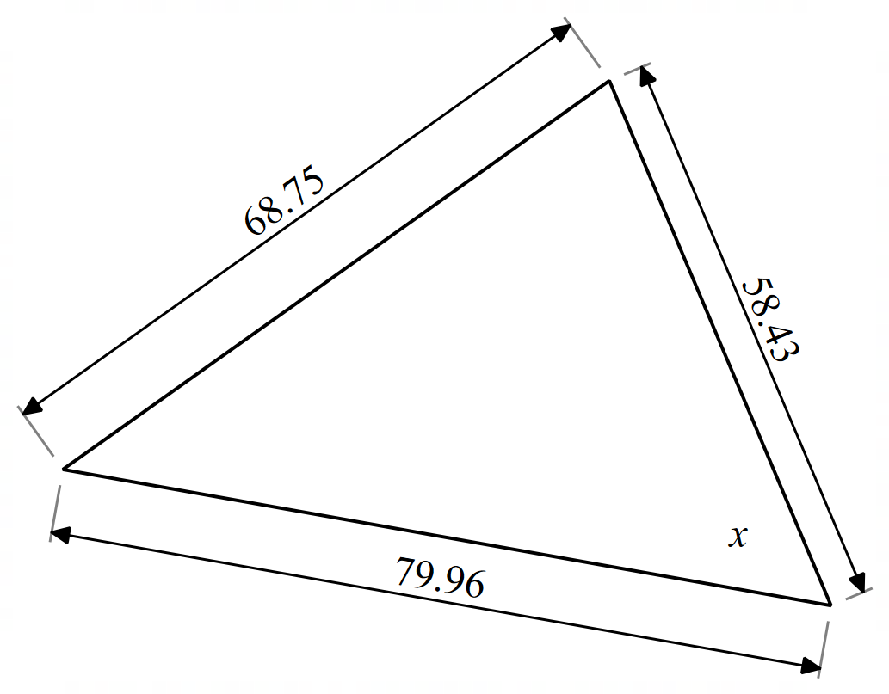
G  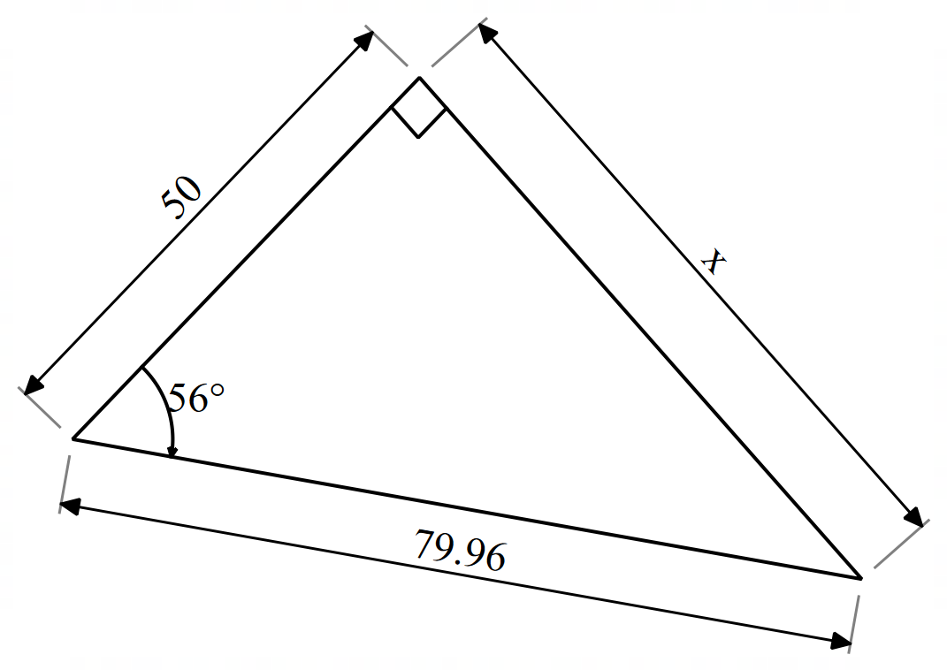 | H  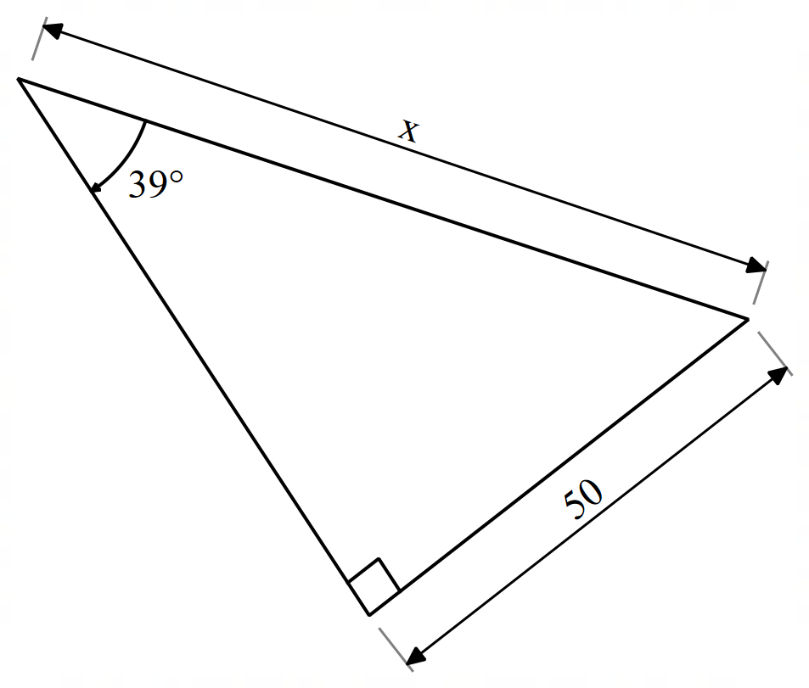 | I  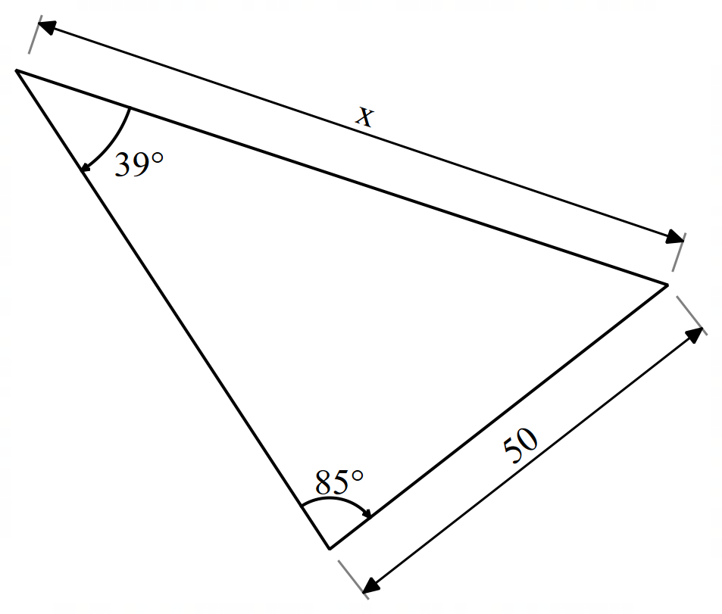
J  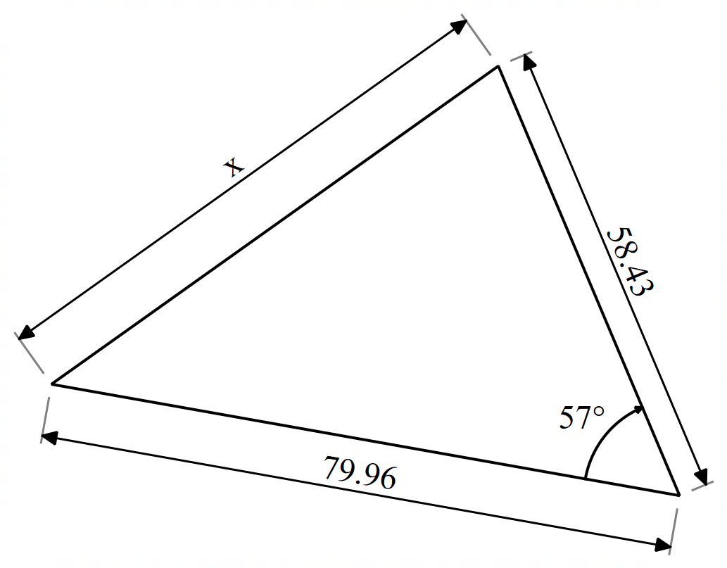 | K  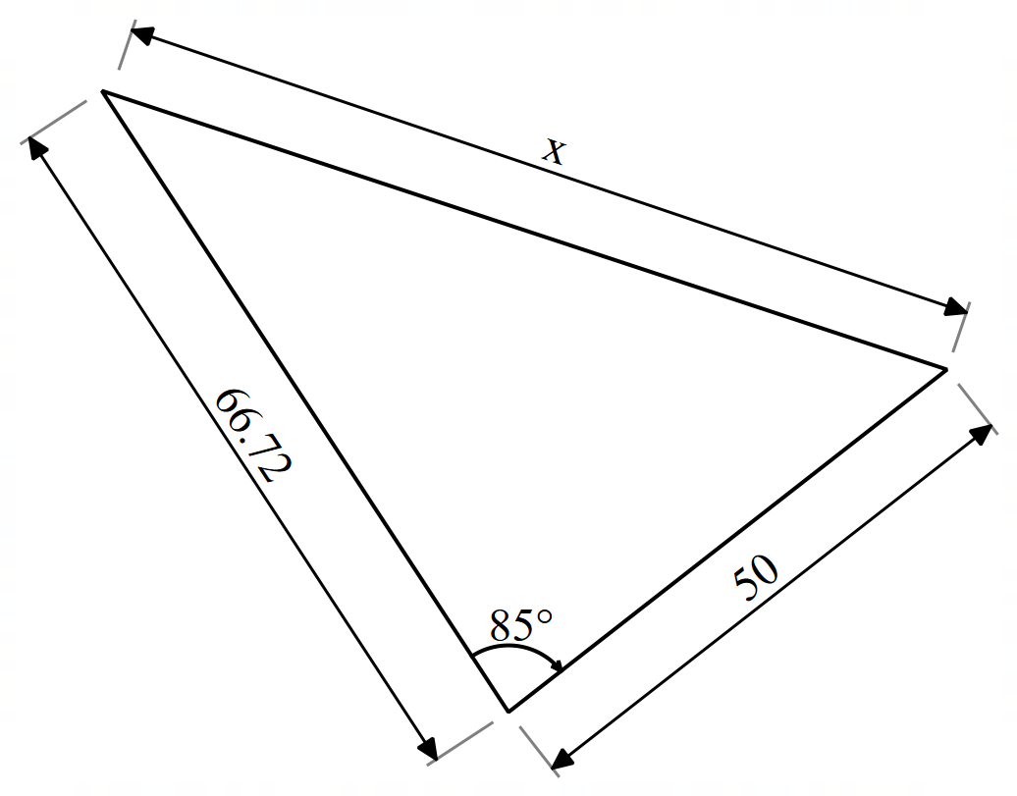 | L  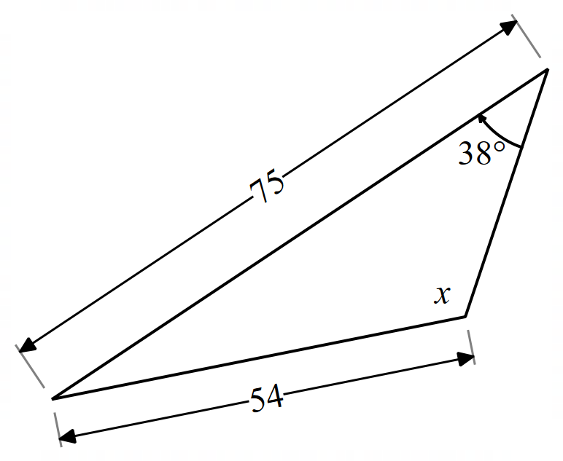
M  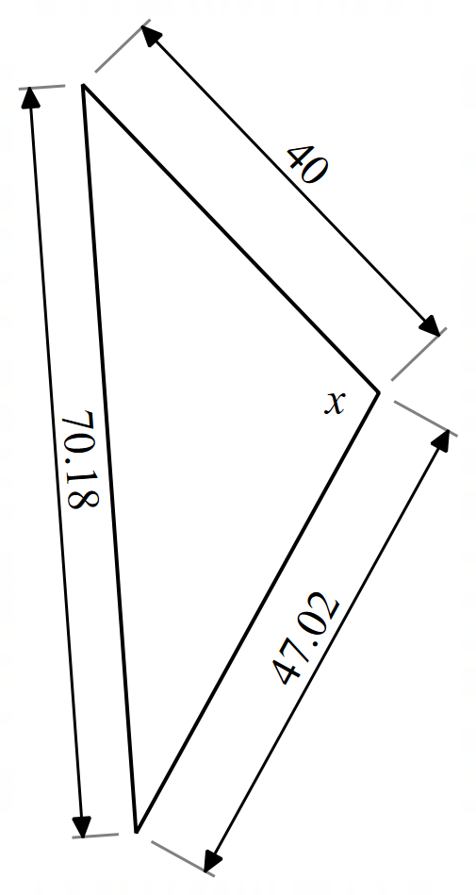 | N  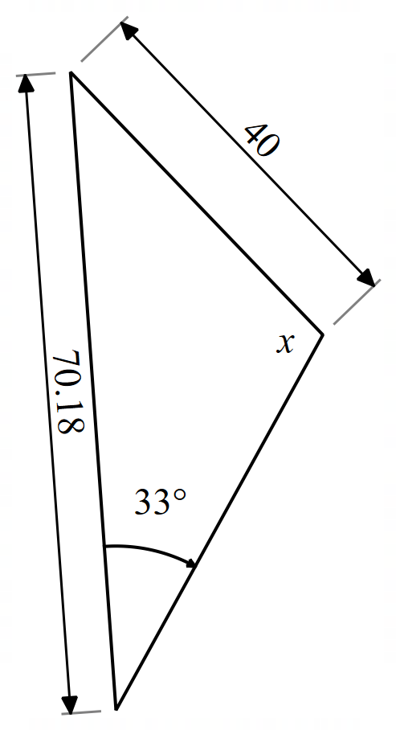 | O  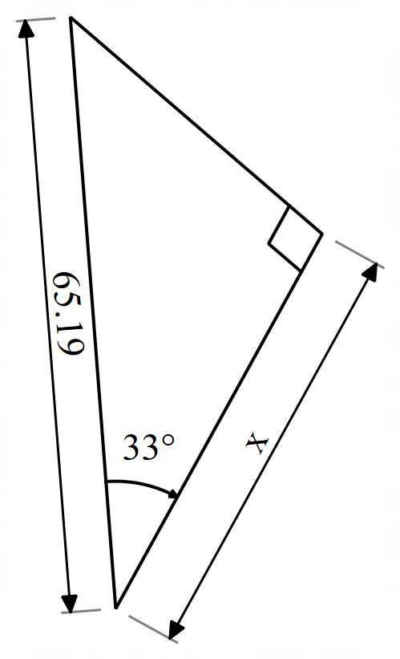

Appendix B

HSC-style questions
Question 1
Find the value of $x$ in the following diagram.
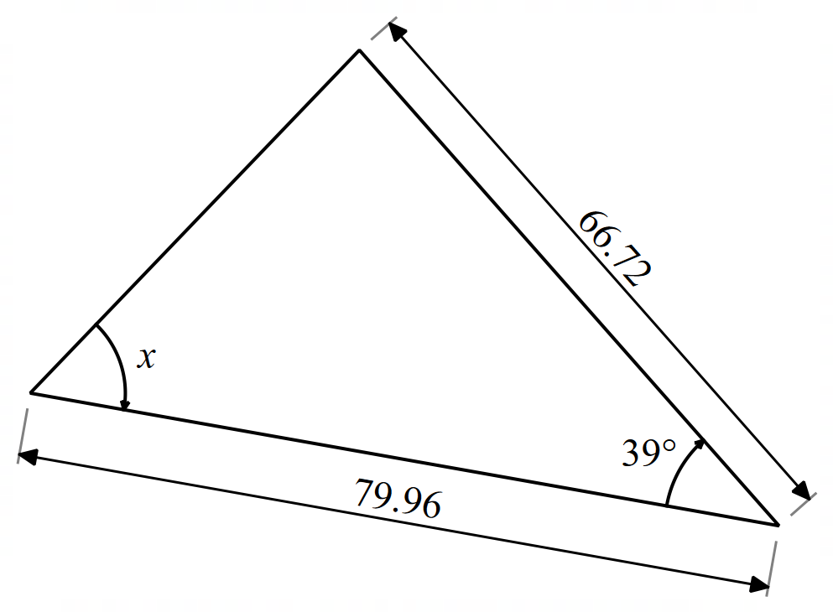
Question 2
Find the value of $x$ in the following diagram.
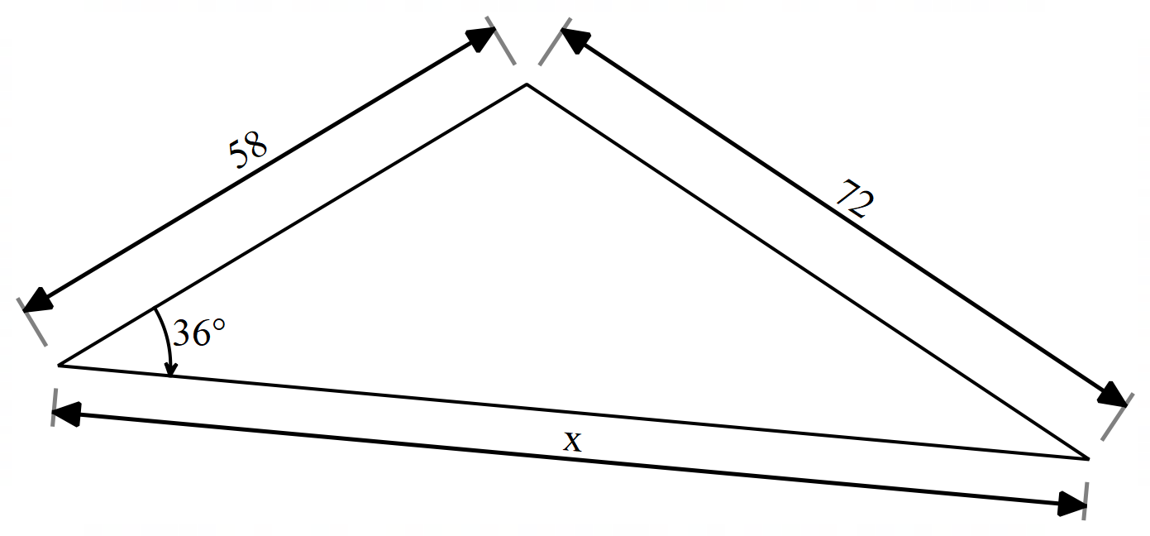
Question 3
A tower stands on level ground. From point $P$, the angle of elevation to the top $T$is ${44}^{∘}$.
A second point $Q$ is 25 m closer to the tower than $P$ and has an angle of elevation to the top $T$ of ${57}^{∘}$. Find the height of the tower to the nearest metre.
Question 4
In triangle $MNP$, $MN=23\text{ cm}$, $NP=17\text{ cm}$, and $∠MNP={112}^{∘}$. Point $Q$lies on side $MP$such that $MQ=14\text{ cm}$. Find the length $NQ$.
Question 5
Show that the shaded area in the following diagram is $137 cm^{2}$.
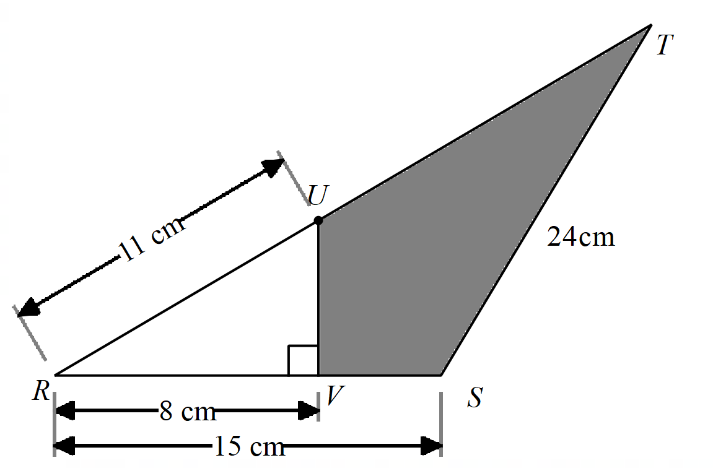
Question 6
In the following diagram, a satellite tower $T$ is 15 km from a weather station in the national park. The distance from the weather station to a fire tower $F$ is 18 km and $∠ FTW=60°$. Let the distance $FT$ be $x$ kilometres.
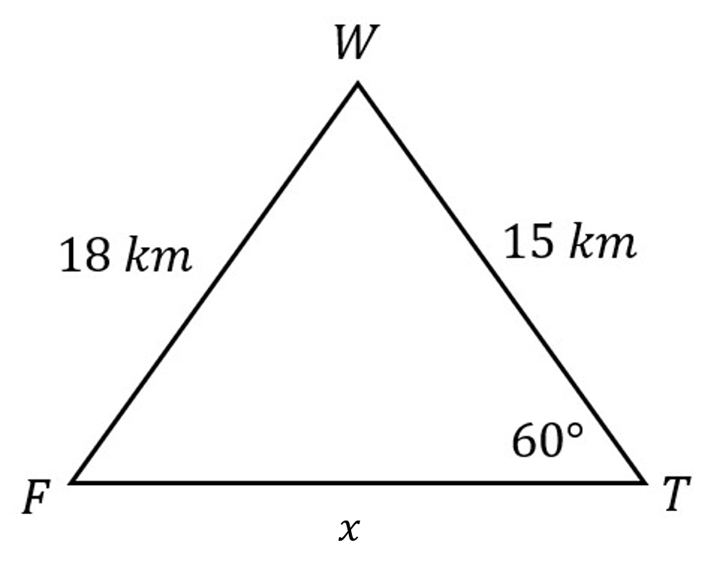
- Use the cosine rule to show that $x^{2}-15x-99=0$.
- Find the distance of $FT$ correct to the nearest kilometre and explain why there is only one solution in this context.
Question 7
Find the exact value of $x$ in the following diagram.
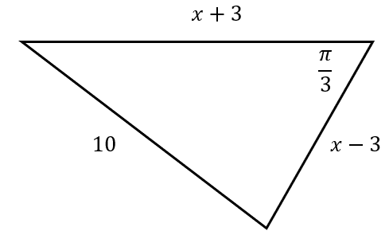
Question 8
A surveyor measures 2 sides of a triangular paddock as 90 m and 120 m.
The angle between the shorter side and the unknown side is 30°.
Using the following diagram, find the length of the third side to the nearest metre.
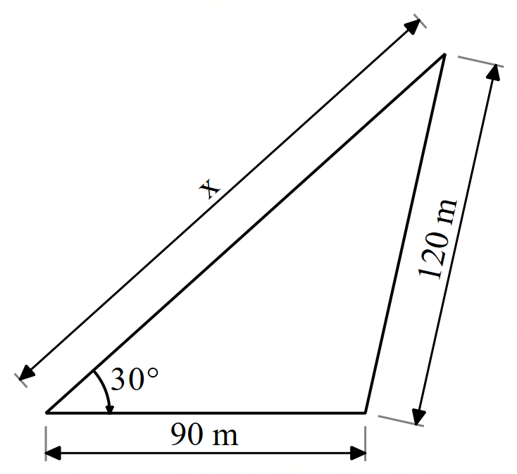
Question 9
In triangle $DEF$, side $d=14$cm, side $e=11$ cm, and $∠DEF=26°$.
Find the lengths of side $f$, correct to one decimal place.

Sample solutions

Same Surface, Different Deep (slide 4 of the PowerPoint)
$△ADB$is isosceles $∴AD=BD$Let $x$ be the equal sides of the isosceles triangle.  $$A=\frac{1}{2}ab\sin{C} \\ 8\sqrt{3}=\frac{1}{2}×x^{2}×\sin{120°} \\ 8\sqrt{3}=\frac{1}{2}×x^{2}×\frac{\sqrt{3} }{2} \\ 32=x^{2} \\ x=\sqrt{32} \\ =4\sqrt{2}$$ | $$\frac{BD}{\sin{30°}}=\frac{8\sqrt{3}}{\sin{140°}} \\ BD=\frac{8\sqrt{3}}{\sin{140°}}×\sin{30°} \\ =10.778… \\ ≈11 cm$$
$$CD = 5cm \\ \cos{60°}=\frac{5}{BD} \\ \frac{1}{2}=\frac{5}{BD} \\ BD=10 cm$$ | $$\sin{30°}=\frac{BC}{8\sqrt{3}} \\ BC=8\sqrt{3}×\sin{30°} \\ =4\sqrt{3}$$

Appendix A – mixed triangles
A  $$\sin{45°}=\frac{x}{70.71} \\ x=70.71×\sin{45°} \\ =49.999… \\ ≈50$$ | B  $$\cos{x}=\frac{{50}^{2}+{79.96}^{2}-{66.72}^{2}}{2×50×79.96} \\ =0.555533… \\ x=56.2525… \\ ≈56°$$ | C  $$\sin{x}=\frac{50}{70.71} \\ x=45.0005… \\ ≈45°$$
D  $$\cos{x}=\frac{50}{79.96} \\ x=51.294… \\ ≈51°$$ | E  $$\frac{\sin{x}}{66.72}=\frac{\sin{85°}}{79.12} \\ \sin{x}=\frac{\sin{85°}}{79.12}×66.72 \\ x=57.147… \\ ≈57°$$ | F  $$\cos{x}=\frac{{58.43}^{2}+{79.96}^{2}-{68.75}^{2}}{2×58.43×79.96} \\ x=57.0589… \\ ≈57°$$
G  $$\sin{56°}=\frac{x}{79.96} \\ x=79.96×\sin{56°} \\ =66.289… \\ ≈66$$ | H  $$\sin{39°}=\frac{50}{x} \\ x=\frac{50}{\sin{39°}} \\ =79.450… \\ ≈79$$ | I  $$\frac{x}{\sin{85°}}=\frac{50}{\sin{39°}} \\ x=\frac{50}{\sin{39°}}×\sin{85°} \\ =79.148… \\ ≈79$$
J  $$c^{2}={79.96}^{2}+{58.43}^{2} \\ -2×79.96×58.43×\cos{57}° \\ =4718.49095 \\ c=68.691… \\ ≈69$$ | K  $$c^{2}={50}^{2}+{66.72}^{2} \\ -2×50×66.72×\cos{85}° \\ =6370.055… \\ c=79.812… \\ ≈80$$ | L  $$\frac{\sin{x}}{75}=\frac{\sin{38°}}{42} \\ \sin{x}=\frac{\sin{38°}}{54}×75 \\ x=58.769… \\ ≈59° or 121°$$
M  $$\cos{x}=\frac{{40}^{2}+{47.02}^{2}-{70.18}^{2}}{2×40×47.02} \\ x=107.2321… \\ ≈107°$$ | N  $$\frac{\sin{x}}{70.18}=\frac{\sin{33°}}{40} \\ \sin{x}=\frac{\sin{33°}}{40}×70.18 \\ x=72.856… \\ ≈73° \text{or} 107°$$ | O  $$\cos{33°}=\frac{x}{65.19} \\ x=65.19×cos{33°} \\ =54.672… \\ ≈55$$

Appendix B – HSC-style questions

Question 1
$$c^{2}={66.72}^{2}+{79.96}^{2}-2×66.72×79.96×\cos{39°} \\ =2553.119… \\ c=50.528… \\ ≈50.53$$
$$\frac{\sin{x}}{66.72}=\frac{\sin{39°}}{50.53} \\ \sin{x}=\frac{\sin{39°}}{50.53}×66.72 \\ x=56.197… \\ ≈56°$$
Question 2
$$\frac{\sin{θ}}{58}=\frac{\sin{36°}}{72} \\ \sin{θ}=\frac{\sin{36°}}{72}×58 \\ θ=28.261… \\ ≈28° \\ ∴∠x=116°$$
$$x^{2}={58}^{2}+{72}^{2}-2×58×72×\cos{116°} \\ =12209.275… \\ x=110.495… \\ ≈110$$

Question 3
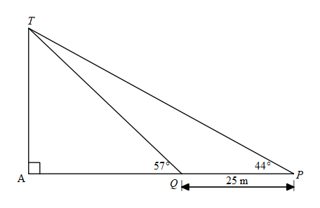
$$∠PQT=123° \\ ∠QTP=13°$$To find side TQ
$$\frac{TQ}{\sin{44°}}=\frac{25}{\sin{13°}} \\ TQ=\frac{25}{\sin{13°}}×\sin{44°} \\ =77.201… \\ ≈77 \text{m}$$
To find height of tower AT
$$\sin{57°}=\frac{AT}{77} \\ AT=\sin{57°}×77 \\ =64.5776… \\ ≈65 \text{m}$$

Question 4
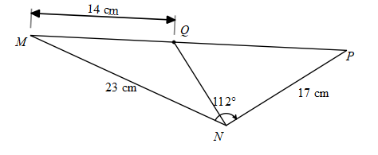
Find PQ using triangle NMP:
$${PQ}^{2}={23}^{2}+{17}^{2}-2×23×17×\cos{112°} \\ =1110.942… \\ x=33.330… \\ ≈33 \text{cm}$$
Find $∠NMP$ using triangle NMP:
$$\frac{\sin{M}}{17}=\frac{\sin{112°}}{33} \\ \sin{M}=\frac{\sin{112°}}{33}×17 \\ M=28.531… \\ ≈28°$$Find NQ using triangle NMQ:
$${NQ}^{2}={23}^{2}+{14}^{2}-2×23×14×\cos{28°} \\ =156.381… \\ NQ=12.505… \\ ≈12.5 \text{cm}$$

Question 5
$$\cos{R}=\frac{8}{11} \\ R=\cos^{-1}\left(\frac{8}{11}\right) \\ =43.341… \\ ≈43°$$
$$Area \left(∆VUR\right)=\frac{1}{2}ab\sin{C} \\ =\frac{1}{2}×11×8×\sin{43°} \\ =30.007… \\ ≈30 cm^{2} \\ \frac{\sin{T}}{15}=\frac{\sin{43°}}{24} \\ \sin{T}=\frac{\sin{43°}}{24}×15 \\ T=25.229… \\ ≈25° \\ ∴∠S=180-25-43 \\ =112°$$
$$Area \left(∆RST\right)=\frac{1}{2}ab\sin{C} \\ =\frac{1}{2}×15×24×\sin{112°} \\ =166.893… \\ ≈167 cm^{2} \\ Total Area=167- 30 \\ =137 cm^{2}$$
Question 6
a.
$${18}^{2}={15}^{2}+x^{2}-2\left(15\right)\left(x\right)\cos{60°} \\ 324=225+x^{2}-30x\left(\frac{1}{2}\right) \\ 0=x^{2}-15x-99$$
b.
$$x=\frac{15±\sqrt{{\left(-15\right)}^{2}-4\left(1\right)\left(-99\right)}}{2} \\ =\frac{15±\sqrt{225+396}}{2} \\ =\frac{15±\sqrt{621}}{2} \\ =\frac{15±3\sqrt{69}}{2} \\ =19.59…or-4.959… \\ ≈20 or-5$$The distance is 20 km as distance cannot be negative.
Question 7
$${10}^{2}={\left(x+3\right)}^{2}+{\left(x-3\right)}^{2}-2\left(x+3\right)\left(x-3\right)\cos{\frac{π}{3}} \\ 100=x^{2}+6x+9+x^{2}-6x+9-2\left(x^{2}-9\right)\left(\frac{1}{2}\right) \\ 100=2x^{2}+18-x^{2}+9 \\ 100=x^{2}+27 \\ 73=x^{2} \\ x=±\sqrt{73}$$
$x=\sqrt{73}$ as a distance cannot be negative.

Question 8
$$\frac{\sin{θ}}{90}=\frac{\sin{30°}}{120} \\ \sin{θ}=\frac{90\sin{30°}}{120} \\ θ=\sin^{-1}\left(\frac{90\sin{30°}}{120}\right) \\ ≈22° \\ \frac{x}{\sin{128°}}=\frac{120}{\sin{30°}} \\ x=\frac{120}{\sin{30°}}×\sin{128°} \\ =189.122… \\ ≈189 m$$
Question 9
$$\frac{\sin{D}}{14}=\frac{\sin{26°}}{11} \\ \sin{D}=\frac{14\sin{26°}}{11} \\ D=\sin^{-1}\left(\frac{14\sin{26°}}{11}\right) \\ D≈34°$$
Or the ambiguous angle $180-34=146°∠EDF=34° or 146°$
Angle sum of a triangle is $180°$.
$180-26-34=120°$ or $180-26-146=8°$
$∠EFD=120°$ or $8°$
First solution with $∠EFD=120°$
$$f^{2}={14}^{2}+{11}^{2}-2\left(14\right)\left(11\right)\cos{120°} \\ =471 \\ f≈21.7$$
Second solution with $∠EFD=8°$
$$f^{2}={14}^{2}+{11}^{2}-2\left(14\right)\left(11\right)\cos{8°} \\ ≈11.997… \\ f≈3.5$$

References
This resource contains NSW Curriculum and syllabus content. The NSW Curriculum is developed by the NSW Education Standards Authority (NESA). This content is prepared by NESA for and on behalf of the Crown in right of the State of New South Wales. The material is protected by Crown copyright.
Please refer to the NESA Copyright Disclaimer for more information https://www.nsw.gov.au/education-and-training/nesa/copyright.
NESA holds the only official and up-to-date versions of the NSW Curriculum and syllabus documents. Please visit NESA https://www.nsw.gov.au/education-and-training/nesa and NSW Curriculum https://curriculum.nsw.edu.au.
Mathematics Advanced 11–12 Syllabus © NSW Education Standards Authority (NESA) for and on behalf of the Crown in right of the State of New South Wales, 2024.

© State of New South Wales (Department of Education), 2026
The copyright material published in this resource is subject to the Copyright Act 1968 (Cth) and is owned by the NSW Department of Education or, where indicated, by a party other than the NSW Department of Education (third-party material).
Copyright material available in this resource and owned by the NSW Department of Education is licensed under a Creative Commons Attribution 4.0 International (CC BY 4.0) license.

This license allows you to share and adapt the material for any purpose, even commercially.
Attribution should be given to © State of New South Wales (Department of Education), 2026.
Material in this resource not available under a Creative Commons license:
- the NSW Department of Education logo, other logos and trademark-protected material
- material owned by a third party that has been reproduced with permission. You will need to obtain permission from the third party to reuse its material.
Links to third-party material and websites
Please note that the provided (reading/viewing material/list/links/texts) are a suggestion only and implies no endorsement, by the New South Wales Department of Education, of any author, publisher, or book title. School principals and teachers are best placed to assess the suitability of resources that would complement the curriculum and reflect the needs and interests of their students.
If you use the links provided in this document to access a third-party's website, you acknowledge that the terms of use, including licence terms set out on the third-party's website apply to the use which may be made of the materials on that third-party website or where permitted by the Copyright Act 1968 (Cth). The department accepts no responsibility for content on third-party websites.

