The ambiguous case
Students investigate the ambiguous case of the sine rule where multiple angle solutions are possible and learn how to check if both angles are viable solutions for a given triangle.
Students will need at least one digital device per pair to interact with GeoGebra during this lesson.
The learning intention and success criteria should be shared with students later in the learning episode.

Learning intention
- To know when the ambiguous case of the sine rule applies.

Success criteria
- I can identify when multiple solutions are possible for an unknown angle.
- I can explain why the ambiguous case occurs.
- I can apply the sine rule to solve problems that produce 2 valid solutions.

Outcomes
A student:
- develops understanding and fluency in mathematics through exploring and connecting mathematical concepts, choosing and applying mathematical techniques to solve problems, and communicating their thinking and reasoning coherently and clearly MAO-WM-01
- applies trigonometry to solve problems involving geometric shapes MAV-11-04

Content

Trigonometry and measure of angles
Trigonometry with angles of any magnitude
- Use graphing applications or geometric construction to examine the ambiguous case of the sine rule, in which there are two possible solutions for an angle, and the condition for it to arise
- Apply the sine rule, cosine rule and formula for the area of a triangle to solve problems where angles are measured in degrees, or degrees and minutes
Mathematics Advanced 11–12 Syllabus © NSW Education Standards Authority (NESA) for and on behalf of the Crown in right of the State of New South Wales, 2024.

Table 1: lesson summary
Section | Summary of activity | Teaching strategies | Teaching points
Activating prior knowledge | Students compare 2 triangles from slide 3 of the PowerPoint The ambiguous case with identical side lengths but different angles. Reveal the learning intention and success criteria on slide 4. | Think-Pair-Share | This activity is designed to spark curiosity and encourage students to investigate why two different angle measures can result in the same side length.
Connecting learning | Introduce the ambiguous case by referencing slide 3. Students then investigate it using Appendix A and GeoGebra (bit.ly/ambiguous_case). Discuss with students the link between the unit circle, the graph of the sine curve and the ambiguous case. | Pose-Pause-Pounce-Bounce | When the known angle is acute and the opposite side is shorter than the adjacent side but still long enough to form 2 different triangles, the sine rule gives 2 possible angle values, resulting in 2 possible triangles.
Releasing responsibility | Using slide 6, students learn the ambiguous case of the sine rule before using slide 7 to contrast an example with a non-example. Students then complete Appendix B, applying the sine rule to find all valid angles, before annotating their solutions to create notes. | Think-Pair-Share  Faded examples  Notes to future forgetful selves | The non-example on slide 7 is invalid because the obtuse angle ($148°$) combined with $42°$ exceeds $180°$, so no triangle can exist.
Independent practice | Use Approaching questions scaffold on slide 9 for students to reference as they complete HSC-style questions in Appendix C. |  | Students apply their understanding to more complex questions, including a bearings question.

Activity structure
Please use the associated PowerPoint The ambiguous case to display images in this lesson.

Activating prior knowledge
- Display slide 3 of the PowerPoint and ask students to find the unknown side in both triangles.
- Animate the slide to reveal the solutions.
- Using a Think-Pair-Share (bit.ly/thinkpairsharestrategy), ask students to discuss what they notice about their solutions and why this might be possible.
Both triangles have the same side lengths but different angles.
- Display slide 4 to reveal the learning intention and success criteria. Explain to students that during this lesson they will be investigating why 2 different angles produce the same side length.

Connecting learning
- Display slide 3 again and ask students what they notice about the 2 angles that are opposite the unknown side.
Students should notice that the angles are supplementary. One of the angles is obtuse and one is acute.
- Explain to students that this is known as the ambiguous case of the sine rule and that they will be investigating it further using GeoGebra.
- In pairs, have students navigate to the interactive GeoGebra activity ‘Use the Sine Rule to calculate the unknown angle’ (bit.ly/ambiguous_case).
- Distribute Appendix A ‘The ambiguous case’ and ask students to complete steps 1 and 2 for the existing triangle in the GeoGebra activity. If students have already moved any sliders, they will need to reset the triangle by refreshing the browser page.
Explain that the circle shows the 2 possible sides opposite the known angle as radii, illustrating that both are equal in length.
- Have students’ complete steps 3–6 in Appendix A. Students should test different angles to complete the table.
- Facilitate a class discussion to draw out the key ideas from students’ explorations. Use the GeoGebra activity to model each case to help students visualise.
Some guiding questions could include:
- What happened when the side opposite the known angle was shorter than the adjacent side? Did anyone see 2 triangles?
- What happened when the side opposite the known angle was longer than or equal to the adjacent side? How many triangles were there then?
- How did your observations differ when the known angle was acute compared with when it was obtuse? Did anyone find 2 triangles with an obtuse angle? Why might that be?
Students should begin to recognise that 2 triangles are possible when the side opposite the known angle is shorter than but not ‘too short’ compared to the adjacent side and this can only occur for acute angles. Students should also notice that when 2 triangles can be formed, the 2 possible angles sum to $\text{180}°.$
- Use the Pose-Pause-Pounce-Bounce questioning strategy (bit.ly/P-P-P-B) to guide students toward connecting these angles to the unit circle and understanding why both angles produce the same sine value. Prompt students to consider:
- Where does each angle lie on the unit circle?
- Where does each angle lie on the sine curve?
- Is the sine function positive or negative in each of these 2 quadrants?

Releasing responsibility
- Use slide 6 to explain the ambiguous case of the sine rule, in which there are 2 possible solutions for an angle.
- Display slide 7 which shows an example and a non-example (bit.ly/nonexamplesstrategy). In a Think-Pair-Share have students discuss why the second example is a non-example.
While the working indicates that each triangle has 2 possible angle solutions, the angle of $148°$ combined with $42°$ exceeds $180°$. Therefore, the triangle does not exist for the obtuse angle in the second triangle.
- Distribute Appendix B ‘Faded examples’ (bit.ly/fadedexamplesstrategy) and have students determine the size of angle $C$.
- Have students annotate their faded examples to create notes to their future forgetful selves (bit.ly/notestofutureself) about the ambiguous case and the sine rule.

Independent practice
- Display slide 9 to review the key steps of the Approaching questions scaffold.
- Distribute Appendix C ‘HSC-style questions’ and have students complete the 3 HSC-style questions. Encourage students to reference the Approaching questions scaffold to help them reflect on their answers.

Assessment and differentiation

Suggested opportunities for differentiation
Activating prior knowledge
- To enable students, use cues such as ‘Which angle is opposite the unknown side?’ to guide decision-making.
Connecting learning
- Encourage students to use the GeoGebra activity by exploring one changing condition at a time.
- Extend students by asking them to relate the ambiguity to the unit circle and the sine function in quadrants 1 and 2.
- Challenge students to express the ‘not too short’ condition algebraically. That is, $h<a<b$where $h=b\sin{A}$.
Releasing responsibility
- Enable students by providing a structured angle-checking scaffold. For example, give students a simple rule-based prompt for slide 7: ‘Add the given angles → if the sum exceeds 180°, the triangle cannot exist.’
- Challenge students to generalise the ambiguous case condition algebraically.
Independent practice
- Remind students to consider ambiguous case conditions before calculating angles and encourage them to sketch both possible triangles if appropriate.
- Ask students to design their own question that produces 2 triangles.

Suggested opportunities for assessment
Activating prior knowledge
- Students’ ability to find a side using the sine rule can be assessed in this section.
Connecting learning
- Circulate and check whether students correctly identify that the 2 angles sum to $180°$.
- Ask pairs to verbally explain one condition, such as why an obtuse given angle can never produce 2 triangles.
Releasing responsibility
- During the Think-Pair-Share, listen for whether students can articulate why the obtuse angle fails in the second example.
- Use students’ notes to their future forgetful selves as a formative assessment of conceptual understanding and misconceptions.
Independent practice
- Collect students’ responses to one of the HSC-style questions as an exit ticket for this lesson.

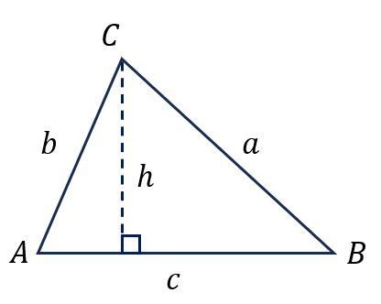
Appendix A

The ambiguous case
Use GeoGebra (bit.ly/ambiguous_case) to explore when 2 different triangles can be made with the same given angle and sides.
- Start with the Known angle as an acute angle ($A$), $55°$ and Known sides $10.2$ and $8.7$ respectively.
- Select Show Ambiguous Case and look carefully. How many triangles do you see?
- Repeat for different lengths of side $b$, which is adjacent to angle $A$, using the top slider.
- Change the Known angle to another acute angle and investigate what happens as you change the Known sides.
- Choose an obtuse angle for $A$, the Known angle and repeat the previous steps.
- Record your observations in the table below.
Angle $A$ | Side $a$ opposite $A$ | Side $b$ adjacent to $A$ | Number of triangles | Notes
$$55°$$ | $$8.7$$ | $$10.2$$
$$55°$$ | $$8.7$$
$$55°$$ | $$8.7$$

Appendix B

Faded examples
Find all possible values for $∠C$.
In triangle ABC, $AB=15cm, BC=9cm$ and $∠A=25°$ | In triangle ABC, $AB=15cm, BC=19cm$ and $∠A=35°$ | In triangle ABC, $AB=9 cm, BC=5cm$ and $∠A=25°$ | In triangle ABC, $AB=9 cm, BC=15cm$ and $∠A=25°$
Possible diagram  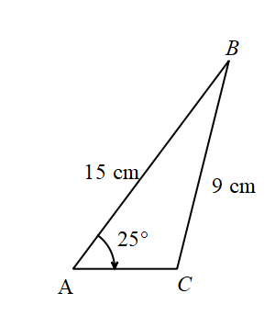 | Possible diagram | Possible diagram | Possible diagram
$$\frac{\sin{C}}{c}=\frac{\sin{A}}{a} \\ \frac{\sin{C}}{15}=\frac{\sin{25°}}{9} \\ \sin{C}=\frac{\sin{25°}}{9}×15 \\ =0.70436…$$
$$C=44.778… \\ ≈45° or \left(180-45\right)° \\ ≈45° or 135°$$ | $$C=27.924… \\ ≈28° or \left(180-28\right)° \\ ≈28° or 152°$$
Triangle with acute angle  $$45°, 25°,110°$$ | Triangle with acute angle  $$28°, 35°,117°$$
Triangle with obtuse angle  $$135°, 25°,20°$$ | Triangle with obtuse angle  $$152°+35°>180°$$ | Triangle with obtuse angle  $$130°, 25°,25°$$
$$∴∠C=45° and 135°$$ | $$∴∠C=28°$$ | $$∴∠C=50° and 130°$$

Appendix C

HSC-style questions
Question 1
In triangle $XYZ$, $y=6 cm$, $z=8 cm$ and angle $Y=37°$.
Find all possible values for the angle $Z$ to the nearest degree.
Question 2
$DEF$ is a triangle where $e=28 cm$, $f=17 cm$ and angle $F=32°$.
Find all possible values for the perimeter.
Question 3
Josh and Ben leave home (H) and ride 10 km on a bearing of $100°T$to a lookout (L). They then continue 6 km on a bearing of $254°T$to a creek (C).
- Show that $∠HLC=26°$.
- Determine their distance and the bearing they must travel to get home.
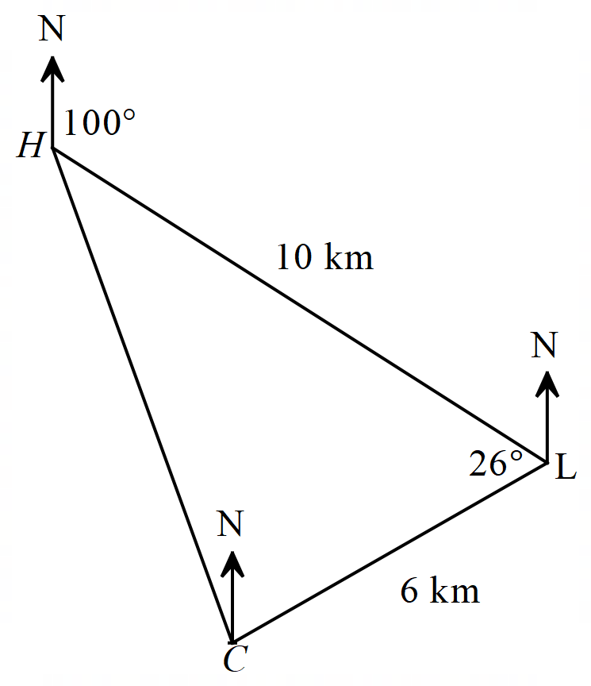

Sample solutions

Appendix A – the ambiguous case
For the first row, the number of triangles will be 2 and the 2 possible angles sum to $\text{180}°.$
Values in the remaining rows will vary depending on students’ choices.

Appendix B – faded examples
Find all possible values for $∠C$.
In triangle ABC, $AB=15cm, BC=9cm$ and $∠A=25°$ | In triangle ABC, $AB=15cm, BC=19cm$ and $∠A=35°$ | In triangle ABC, $AB=9 cm, BC=5cm$ and $∠A=25°$ | In triangle ABC, $AB=9 cm, BC=15cm$ and $∠A=25°$
Possible diagram | Possible diagram  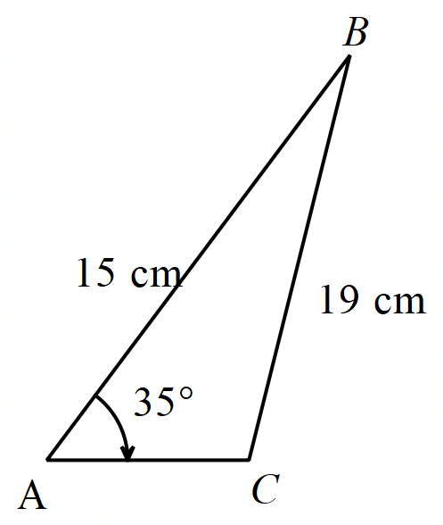 | Possible diagram  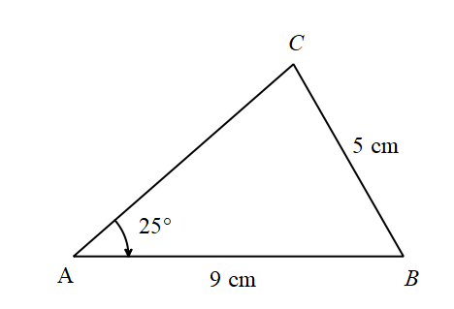 | Possible diagram  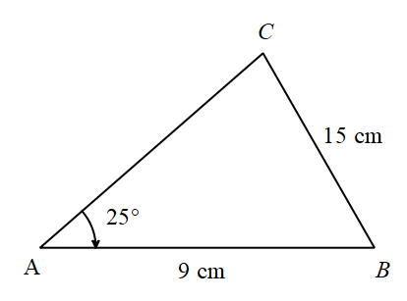
$$\frac{\sin{C}}{c}=\frac{\sin{A}}{a} \\ \frac{\sin{C}}{15}=\frac{\sin{25°}}{9} \\ \sin{C}=\frac{\sin{25°}}{9}×15 \\ =0.70436…$$ | $$\frac{\sin{C}}{c}=\frac{\sin{A}}{a} \\ \frac{\sin{C}}{15}=\frac{\sin{35°}}{19} \\ \sin{C}=\frac{\sin{35°}}{19}×15 \\ =0.4528…$$ | $$\frac{\sin{C}}{c}=\frac{\sin{A}}{a} \\ \frac{\sin{C}}{9}=\frac{\sin{25°}}{5} \\ \sin{C}=\frac{\sin{25°}}{5}×9 \\ =0.76071…$$ | $$\frac{\sin{C}}{c}=\frac{\sin{A}}{a} \\ \frac{\sin{C}}{9}=\frac{\sin{25°}}{15} \\ \sin{C}=\frac{\sin{25°}}{15}×9 \\ =0.25357…$$
$$C=44.778… \\ ≈45° or \left(180-45\right)° \\ ≈45° or 135°$$ | $$C=27.924… \\ ≈28° or \left(180-28\right)° \\ ≈28° or 152°$$ | $$C=49.527… \\ ≈50° or \left(180-50\right)° \\ ≈50° or 130°$$ | $$C=14.688… \\ ≈15° or \left(180-15\right)° \\ ≈15° or 165°$$
Triangle with acute angle  $$45°, 25°,110°$$ | Triangle with acute angle  $$28°, 35°,117°$$ | Triangle with acute angle  $$50°, 25°,105°$$ | Triangle with acute angle  $$15°, 25°,140°$$
Triangle with obtuse angle  $$135°, 25°,20°$$ | Triangle with obtuse angle  $$152°+35°>180°$$ | Triangle with obtuse angle  $$130°, 25°,25°$$ | Triangle with obtuse angle  $$165°+25°>180°$$
$$∴∠C=45° and 135°$$ | $$∴∠C=28°$$ | $$∴∠C=50° and 130°$$ | $$∴∠C=15°$$

Appendix C – HSC-style questions
Question 1
$$\frac{\sin{Z}}{z}=\frac{\sin{Y}}{y} \\ \sin{Z=\frac{z\sin{Y}}{y}} \\ =8×\frac{\sin{37°}}{6}≈0.802420$$
$$Z_{1}=\sin^{-1}{(0.802420})≈53° \\ Z_{2}=180°-Z_{1}≈127°$$
Triangle with $Z_{1}$ has angles $53°, 37°, 90°∴Z_{1}=53°$
Triangle with $Z_{2}$ has angles $127°, 37°, 16°∴Z_{2}=127°$
Question 2
To find the perimeter, we would need the length of the side opposite angle $D$. To find this length using the sine rule, we need the measure of angle $D$ first.
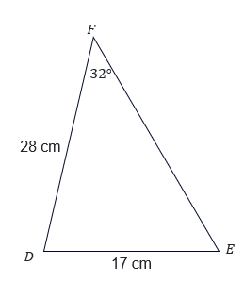
Using sine rule:
$$\frac{\sin{E}}{28}=\frac{\sin{32°}}{17} \\ \sin{E=}\frac{28\sin{32°}}{17} \\ =0.873… \\ E=\sin^{-1}\left(0.873…\right) \\ ≈61°$$
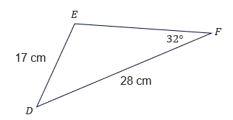
Ambiguous case:$$E_{2}=180°-61° \\ =119°$$This gives us 2 possible triangles and hence, 2 possible measures for angle $D$.
$$D_{1}=180°-32°-61°=87°$$
$$D_{2}=180°-32°-119°=29°$$
Using these values to find the length opposite angle $D$:

$$\frac{d_{1}}{\sin{87.2°}}=\frac{17}{\sin{32°}} \\ d_{1}=\frac{17\sin{87.2°}}{\sin{32°}} \\ ≈32 cm \\ \frac{d_{2}}{\sin{28.8°}}=\frac{17}{\sin{32°}} \\ d_{2}=\frac{17\sin{28.8°}}{\sin{32°}} \\ ≈15 cm$$
The 2 possible perimeters are:
$$P_{1}=28+17+32=77 cm$$
$$P_{2}=28+17+15=60 cm$$
Question 3

$∠HLN=180°-100°=80°$ (cointerior angles in parallel lines)
$∠NLC=254°$ (bearing)
$∠HLC=360°-254°-80°=26°$ (revolution of a circle)

Distance HC
$$HC^{2}=6^{2}+{10}^{2}-2×6×10×\cos{26°} \\ =28.1447… \\ HC=5.305… \\ ≈5.3 km$$
Bearing of H from C
$$\frac{\sin{∠HCL}}{10}=\frac{\sin{26°}}{5.3} \\ \sin{∠HCL}=\frac{\sin{26°}}{5.3}×10 \\ ∠HCL=55.803… \\ ≈56° or 124°$$
Since the bearing of C from L is $254°$ the angle between north and L at C is $74°, ∴∠HCL=124°$.
$∠NCH=124°-74°=50°,$
$∴bearing of H from C=360°-50°=310°T$

References
This resource contains NSW Curriculum and syllabus content. The NSW Curriculum is developed by the NSW Education Standards Authority (NESA). This content is prepared by NESA for and on behalf of the Crown in right of the State of New South Wales. The material is protected by Crown copyright.
Please refer to the NESA Copyright Disclaimer for more information https://www.nsw.gov.au/education-and-training/nesa/copyright.
NESA holds the only official and up-to-date versions of the NSW Curriculum and syllabus documents. Please visit NESA https://www.nsw.gov.au/education-and-training/nesa and NSW Curriculum https://curriculum.nsw.edu.au.
Mathematics Advanced 11–12 Syllabus © NSW Education Standards Authority (NESA) for and on behalf of the Crown in right of the State of New South Wales, 2024.

© State of New South Wales (Department of Education), 2026
The copyright material published in this resource is subject to the Copyright Act 1968 (Cth) and is owned by the NSW Department of Education or, where indicated, by a party other than the NSW Department of Education (third-party material).
Copyright material available in this resource and owned by the NSW Department of Education is licensed under a Creative Commons Attribution 4.0 International (CC BY 4.0) license.

This license allows you to share and adapt the material for any purpose, even commercially.
Attribution should be given to © State of New South Wales (Department of Education), 2026.
Material in this resource not available under a Creative Commons license:
- the NSW Department of Education logo, other logos and trademark-protected material
- material owned by a third party that has been reproduced with permission. You will need to obtain permission from the third party to reuse its material.
Links to third-party material and websites
Please note that the provided (reading/viewing material/list/links/texts) are a suggestion only and implies no endorsement, by the New South Wales Department of Education, of any author, publisher, or book title. School principals and teachers are best placed to assess the suitability of resources that would complement the curriculum and reflect the needs and interests of their students.
If you use the links provided in this document to access a third-party's website, you acknowledge that the terms of use, including licence terms set out on the third-party's website apply to the use which may be made of the materials on that third-party website or where permitted by the Copyright Act 1968 (Cth). The department accepts no responsibility for content on third-party websites.

