Graphing trigonometric functions
Students use the unit circle to evaluate sine, cosine and tangent for multiples of $90°$, exploring when ratios are undefined, then graph the trigonometric functions $y=\sin{x}$, $y=\cos{x}$ and $y=\tan{x}$.
Students will need at least one digital device per pair to interact with applets during this lesson.

Learning intentions
- To understand how trigonometric ratios behave at multiples of $90°$.
- To be able to graph and describe trigonometric functions.

Success criteria
- I can evaluate $\sin{θ},\cos{θ}$ and $\tan{θ}$ at multiples of $90°$.
- I can explain why some trigonometric ratios are undefined.
- I can explain the connection between the unit circle and the graphs of trigonometric functions.
- I can describe the graph of a trigonometric function using the terms domain, range, intercepts, amplitude and period.
- I can draw the graph of a trigonometric function over one or more periods.

Outcomes
A student:
- develops understanding and fluency in mathematics through exploring and connecting mathematical concepts, choosing and applying mathematical techniques to solve problems, and communicating their thinking and reasoning coherently and clearly MAO-WM-01
- applies trigonometry to solve problems involving geometric shapes MAV-11-04

Content

Trigonometry with angles of any magnitude
- Use the definitions $\cos{θ}=\frac{x}{r}$, $\sin{θ}=\frac{y}{r}$ and $\tan{θ}=\frac{y}{x}$, to evaluate $\sin{θ}$, $\cos{θ}$ and $\tan{θ}$where $θ$is a multiple of $90°$, and identify the values of $θ$ for which these ratios are undefined
- Establish and use the results $\cos{(-θ)}=\cos{θ}$, $\sin\left(-θ\right)=-\sin{θ}$ and$\tan\left(-θ\right)=-\tan{θ}$

Radians
- Graph $y=\sin{x}$, $y=\cos{x}$ and $y=\tan{x}$ over domains given in degrees or radians, showing intercepts with the $x$-axis and $y$-axis and any asymptotes, determine their domains and ranges, and period and amplitude where appropriate, and whether each is even or odd or neither
Mathematics Advanced 11–12 Syllabus © NSW Education Standards Authority (NESA) for and on behalf of the Crown in right of the State of New South Wales, 2024.

Table 1: lesson summary
Section | Summary of activity | Teaching strategies | Teaching points
Activating prior knowledge | Students complete Appendix A, also available on slide 4 of the PowerPoint Graphing trigonometric functions, using exact values and angles of any magnitude. They then plot graphs of $y=\sin{x}$, $y=\cos{x}$ and $y=\tan{x}$ and compare and discuss how they determined the shape and features of the graphs. | Think-Pair-Share  Turn and Talk | The purpose of this section is to connect prior understanding of exact values and angles of any magnitude to the graphical behaviour of trigonometric functions.
Connecting learning | Students use the unit circle to determine values of sine, cosine and tangent at multiples of ${90}^{°}.$ Using Appendix B, students investigate zero and undefined values, asymptotes and the effect of the unit circle on graph features. | Think-Pair-Share  Pose-Pause-Pounce-Bounce | The aim is to develop an understanding of how unit circle values determine the key features of trigonometric graphs, including intercepts, asymptotes, amplitude and period.
Releasing responsibility | Use the PhET applet ‘Trig tour’ (bit.ly/trig-tour) and slides 6–7 to investigate symmetry, amplitude and period in trigonometric graphs. Students annotate Appendix A and create notes to their future forgetful selves summarising graph features and properties. | Think-Pair-Share  Notes to future forgetful selves | Reinforce connections between the unit circle and trigonometric graphs, supporting students to identify and describe key graphical features and their symmetry properties.
Independent practice | Students complete a banner task from Appendix C to apply their knowledge of angles of any magnitude to angles that are multiples of ${90}^{°}.$ Students then complete Appendix D and compare responses with another group to justify and refine their reasoning. | Banner task  Visibly random groups of 3  Vertical non-permanent surfaces | The focus is on applying understanding of trigonometric graphs and their features in real-world contexts and communicating mathematical reasoning clearly.

Activity structure
Please use the associated PowerPoint Graphing trigonometric functions to display images in this lesson.

Activating prior knowledge
- Distribute Appendix A ‘Trigonometric graphs’ to each student.
The table can also be found on slide 4 of the PowerPoint.
- In a Think-Pair-Share (bit.ly/thinkpairsharestrategy), ask students to use their knowledge of exact values and angles of any magnitude to complete the table.
- Preferably using a pencil, ask students to use the table of values to plot points to create graphs for $y=\sin{x}$, $y=\cos{x}$and$y=\tan{x.}$
Angles that are multiples of $90°$ have deliberately not been included in the table of values at this point. They will become a focus of this lesson.
The axes provided extend into negative values of $x.$ Students only need to focus on the angles that have been provided in the table of values at this point in the lesson.
- Encourage pairs to compare their graphs with those of students seated near them.
- Using a Turn and Talk (bit.ly/classroomtalkmoves), pairs discuss with another pair how they used the plotted points to complete their graphs. Questions to consider include:
- How did they know what happened to the graph in between points?
- How did they know how high or how low their graph would go?
- What other angles would they like to have included in their table of values to help draw their graphs?
Students should identify that including the angles $0°, 90°, 180°, 270° \text{and} 360°$ would have assisted them to determine the shape and maximum and minimum heights of the graph.

Connecting learning

Angles at multiples of $90°$
- Ask students to draw a unit circle in their workbooks, marking the origin, radius and axes.
- Have students mark the points where the circle meets the axes and label the angle and coordinates for each point.
Students should label $0° \left(1, 0\right), 90° \left(0, 1\right), 180° \left(-1, 0\right), 270° (0, -1)$ and $360° (1, 0)$.
- Using a Think-Pair-Share, ask students what they notice about the $x$ and $y$ values of the coordinates.
Students should notice that $x$ and $y$ values are all either -1, 0 or 1.
- Ask students to evaluate $\cos{θ=\frac{x}{r}}$, $\sin{θ}=\frac{y}{r}$ and $\tan{θ}=\frac{y}{x}$ for $0°, 90°, 180°, 270°$ and $360°$ and to consider any patterns they notice.
The definitions $\cos{θ}=\frac{x}{r}$, $\sin{θ}=\frac{y}{r}$ and $\tan{θ}=\frac{y}{x}$ were developed in Lesson 5 – angles of any magnitude. Students should determine zero and undefined values emerging at these angles.
- Facilitate a class discussion around the patterns noticed using the Pose-Pause-Pounce-Bounce questioning strategy (PDF 557 KB) (bit.ly/posepausepouncebounce). Prompting questions could include:
- Why do $\sin{θ}$ and $\cos{θ}$ equal zero for certain angles?
- When is $\tan{θ}$ undefined and why?
- What is $\tan{80°}?$ What is $\tan{89°}$?
- How would we show that $\tan{θ}$ is undefined on a graph?
Guide students to reason that $\sin{θ=\frac{y}{r}}$ is equal to zero when $y=0$, $\cos{θ=\frac{x}{r}}$ is equal to zero when $x=0$ and $\tan{θ}=\frac{y}{x}$ is undefined when $x=0$.
When graphing reciprocal functions in Unit 2 – introduction to functions and Unit 4 – graph transformations, students learnt that when the denominator in a function is zero, it creates an asymptote on the graph.
- Ask students to add these new values to their graphs of $y=\sin{x}$, $y=\cos{x}$and$y=\tan{x}$ and to refine the shape of their graphs as necessary.

Exploring the graphs
- In pairs, ask students to complete Appendix B ‘Exploring trigonometric graphs.’
During this activity, students will adjust the radius of the circle to see its effect on the amplitude of the graphs. Students do not study trigonometric graph transformations until Year 12.
- Once completed, ask students to combine with a nearby pair to discuss any differences in their answers and to reach a consensus.

Releasing responsibility
- Display the PhET applet ‘Trig tour’ (bit.ly/trig-tour). Select the checkbox for Labels and drag the red point around the circle, going beyond $360°$ and into negative values to trace each of the graphs.
- Discuss the features of each graph and the answers to the questions from Appendix B. Sample answers are provided in the ‘Sample solutions’.
Draw students’ attention to the symmetry of the graphs and in particular highlight that
$\cos{(-θ)}=\cos{θ}$, $\sin{(-θ)}=-\sin{θ}$ and $\tan{(-θ)}=-\tan{θ}$.
- Use slides 6–7 to show the definitions of amplitude and period.
- In a Think-Pair-Share ask students to determine the amplitude and period for the graphs of $y=\sin{x}$ and $y=\cos{x}$ justifying their responses using the unit circle.
Students should recognise that the amplitude is 1 and the period is $360°$. Teachers could also direct students to consider how the radius of the unit circle is connected to the amplitude.
- In a Think-Pair-Share, ask students if the graph of $y=\tan{x}$ has an amplitude and a period; if so, what are they?
Students should recognise that the graph of $y=\tan{x}$ does not have an amplitude as its range extends from $(-∞,∞)$. It does have a period of $180°$.
- Ask students to annotate the graphs drawn in Appendix A with these definitions in their own words and label these features on their graphs.
Teachers may like to provide students with a new copy of the axes from Appendix A, if students’ previous attempt at drawing the graphs was incorrect or not accurate.
- Have students add further annotations to their graphs such as extending the graphs into the negative domain, labelling the intercepts, the domain and range or any additional notes to their future forgetful selves (bit.ly/notestofutureself).

Independent practice
- Assign students to visibly random groups of 3 (bit.ly/visiblegroups) on vertical non-permanent surfaces (bit.ly/VNPSstrategy).
- Have students complete a banner task (bit.ly/supportingstrategies) using questions from Appendix C ‘Banner task’ without using their calculators. Students should solve the angle of any magnitude questions using the unit circle and verify their answers by drawing a graph, where possible.
- Working in their groups, have students attempt the questions from Appendix D ‘Real world trigonometric problems’.
- Encourage groups to share their answers with another group and, if answers differ, come to a consensus.

Assessment and differentiation

Suggested opportunities for differentiation
Activating prior knowledge
- Provide a partially completed table of values to support students recalling exact values and angles of any magnitude.
- Extend students by providing them with angles beyond the domain of $0°≤θ≤360°$.
Connecting learning
- Students may benefit from creating the graphs of the sine and cosine function using concrete materials, as seen in the Stage 5 – Elective unit – Lesson 8 – graphing using the unit circle.
- Provide guiding prompts, for example: ‘What happens when $x=0$?’ or ‘Why is $\tan{θ}$undefined?’ to support students in identifying patterns at multiples of $90°$.
- Support students by focusing on sine and cosine before extending to tangent and undefined values.
- Challenge students to explain how undefined values of tangent create asymptotes on the graph.
Releasing responsibility
- Provide prompts directing students to identify key graph features before solving real-world problems.
- Support students by encouraging them to annotate graphs with intercepts, amplitude, period and asymptotes before interpreting contexts.
- Extend students by asking them to explain how graph features influence the interpretation of real-world situations.
Independent practice
- Support students by adjusting the numbers used in the banner task or by providing a scaffolded response for students to follow.
- Working in groups, students can support each other with any unknown vocabulary.

Suggested opportunities for assessment
Activating prior knowledge
- Observe student responses to assess their ability to evaluate trigonometric expressions and plot points accurately.
- Ask students to justify the shape and features of their graphs using exact values and graph behaviour.
Connecting learning
- Observe student responses during discussions to assess whether they can identify patterns and undefined values at multiples of $90°$.
- Ask students to explain why tangent is undefined for certain angles to assess their understanding of asymptotes and trigonometric definitions.
Releasing responsibility
- Review student annotations to assess their understanding of amplitude, period and symmetry.
- Ask students to explain why $y=\tan{x}$ has a period but no amplitude.
Independent practice
- Review student responses to assess their ability to interpret trigonometric graphs in real-world contexts.
- Ask students to justify their reasoning using features such as amplitude, period and intercepts.

Appendix A

Trigonometric graphs
$$x$$ | $$30°$$ | $$60°$$ | $$120°$$ | $$150°$$ | $$210°$$ | $$240°$$ | $$300°$$ | $$330°$$
$$\sin{x}$$
$$\cos{x}$$
$$\tan{x}$$

$$y=\sin{x}$$
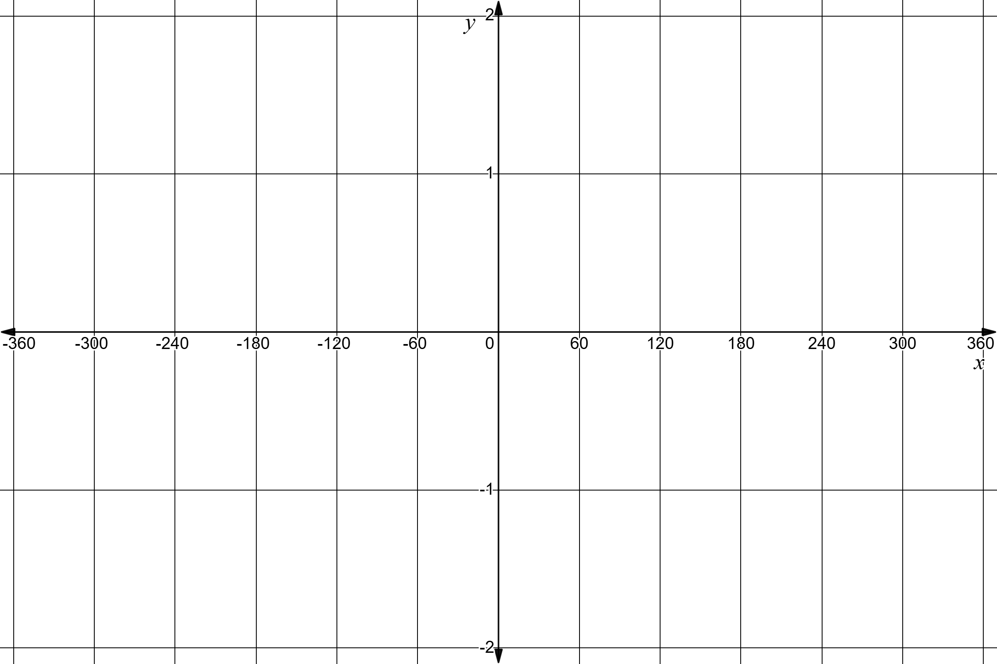

$$y=\cos{x}$$

$$y=\tan{x}$$

Appendix B

Exploring trigonometric graphs

Graph of $y=\sin{x}$
Navigate to the GeoGebra applet ‘Graphing the sine function with the unit circle’
(bit.ly/graphing-sine) and use the ‘Drag me’ point to trace the graph of $y=\sin{x}$. Use the graph to answer the following questions.
- What are the horizontal and vertical axes measuring?
- What are the $x$- and $y$-intercepts of the graph? How do these connect to the unit circle?
- What would the shape of the graph be for negative angles or angles beyond $360°$?
- What is the domain and range of the graph?
- Is the graph an odd or even function?
- Where is sine positive in the unit circle and how does this connect to the graph?
Select the Change radius option and use the slider to change the radius to 2. Use the purple dot again to drag the point around the circle to create a second graph.
- What effect, if any, does increasing the radius of the circle to 2 have on the shape of the graph?

Graph of $y=\cos{x}$
Navigate to the GeoGebra applet ‘Graphing the cosine function with the unit circle’
(bit.ly/graphing-cosine) and use the ‘Drag me’ point to trace the graph of $y=\cos{x}$. Use the graph to answer the following questions.
- What are the horizontal and vertical axes measuring?
- What are the $x$- and $y$-intercepts of the graph? How do these connect to the unit circle?
- What would the shape of the graph be for negative angles or angles beyond $360°$?
- What is the domain and range of the graph?
- Is the graph an odd or even function?
- Where is cosine positive in the unit circle and how does this connect to the graph?
- How is the cosine graph similar and different from the sine graph?
Select the Change radius option and use the slider to change the radius to 0.5. Use the purple dot again to drag the point around the circle to create a second graph.
- What effect, if any, does decreasing the radius of the circle to 0.5 have on the shape of the graph?

Graph of $y=\tan{x}$
Navigate to the GeoGebra applet ‘Graphing the tangent function with the unit circle’ (https://bit.ly/graphing-tan) and use the ‘Drag me’ point to trace the graph of $y=\cos{x}$. Use the graph to answer the following questions.
- What are the horizontal and vertical axes measuring?
- What is happening at $90°$ and 27$0°$ ?
- What are the $x$- and $y$-intercepts of the graph? How do these connect to the unit circle?
- What would the shape of the graph be for negative angles or angles beyond $360°$?
- What is the domain and range of the graph?
- Is the graph an odd or even function?
- Where is tangent positive in the unit circle and how does this connect to the graph?

Appendix C

Banner task
- $\sin{390°}$
- $\sin{1080°}$
- $\tan{585°}$
- $\cos{(-1080°})$
- $\tan{990°}$
- $\sec{600°}$
- $\operatorname{cosec}{750°}$
- $\sin{1170°}$
- $\tan\left(-2700°\right)$
- $\cot{675°}$
- $\operatorname{cosec}{450°}$
- $\sec\left(-810°\right)$
- $\sin{1140°}$
- $\cos{(-810°)}$
- $\operatorname{cosec}{450°}$

Appendix D

Real-world trigonometric problems
- A Ferris wheel rotates such that the height of a passenger above the ground is modelled by $y=cos⁡x$, where:
- $x$ is the angle of rotation in degrees
- $y$ is the relative height.
- At what value of $x$ is the passenger at the highest point? What is this height?
- At what value of $x$ is the passenger at the lowest point? What is this height?
- At what values of $x$ is the passenger at mid-height? What is this height?
- Explain how the graph shows that the motion is repeating.
- The height of the sun in the sky, starting at sunrise, is modelled by a trigonometric graph.
- Which function ($\sin{x}$ or $\cos{x}$) would best model this situation? Explain your choice.
- Why would $y=\tan{x}$ be an inappropriate model for this context?
- Describe what happens to the height of the sun between sunrise and midday using your chosen graph.
- A cyclist’s pedal position can be modelled using trigonometric functions.
- Which graph would best model smooth circular motion? Explain why.
- Which graph would be unsuitable for modelling this motion? Justify your answer.
- One graph starts at a maximum value. Identify the function and explain your reasoning.

- A signal strength is modelled by $y=tan⁡x$, where:
- $x$ is an angle in degrees
- $y$ represents signal intensity.
- What happens to the signal strength as $x$ approaches $90°$ ?
- Why is the signal not defined at $x=90°$?
- Identify another value of $x$ where the signal is undefined.
- Describe how the pattern of the graph repeats.

Sample solutions

Appendix A – trigonometric graphs
$$x$$ | $$30°$$ | $$60°$$ | $$120°$$ | $$150°$$ | $$210°$$ | $$240°$$ | $$300°$$ | $$330°$$
$$\sin{x}$$ | $$\frac{1}{2}$$ | $$\frac{\sqrt{3}}{2}$$ | $$\frac{\sqrt{3}}{2}$$ | $$\frac{1}{2}$$ | $$-\frac{1}{2}$$ | $$-\frac{\sqrt{3}}{2}$$ | $$-\frac{\sqrt{3}}{2}$$ | $$-\frac{1}{2}$$
$$\cos{x}$$ | $$\frac{\sqrt{3}}{2}$$ | $$\frac{1}{2}$$ | $$-\frac{1}{2}$$ | $$-\frac{\sqrt{3}}{2}$$ | $$-\frac{\sqrt{3}}{2}$$ | $$-\frac{1}{2}$$ | $$\frac{1}{2}$$ | $$\frac{\sqrt{3}}{2}$$
$$\tan{x}$$ | $$\frac{\sqrt{3}}{3}$$ | $$\sqrt{3}$$ | $$-\sqrt{3}$$ | $$-\frac{\sqrt{3}}{3}$$ | $$\frac{\sqrt{3}}{3}$$ | $$\sqrt{3}$$ | $$-\sqrt{3}$$ | $$-\frac{\sqrt{3}}{3}$$

$$y=\sin{x}$$
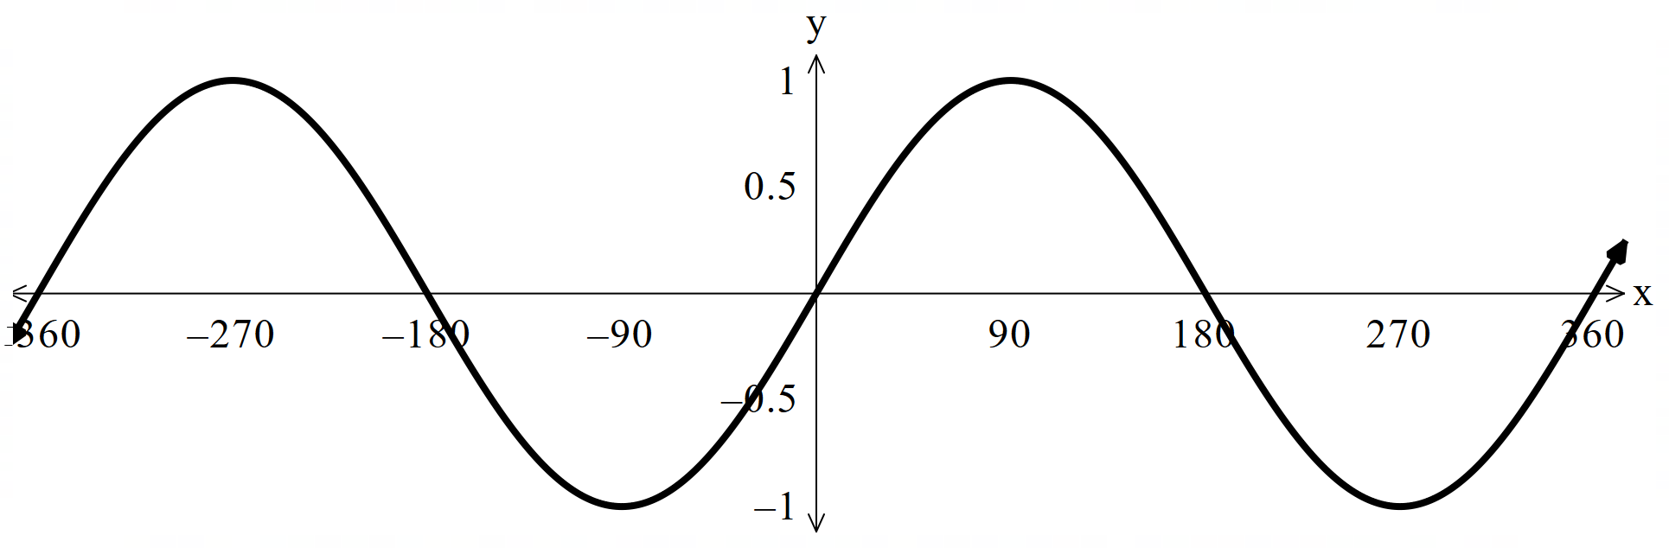
$$y=\cos{x}$$
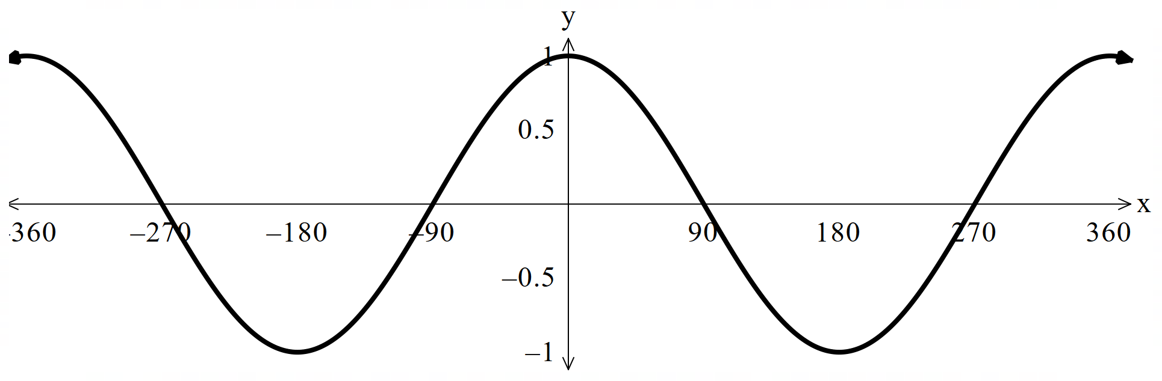
$$y=\tan{x}$$
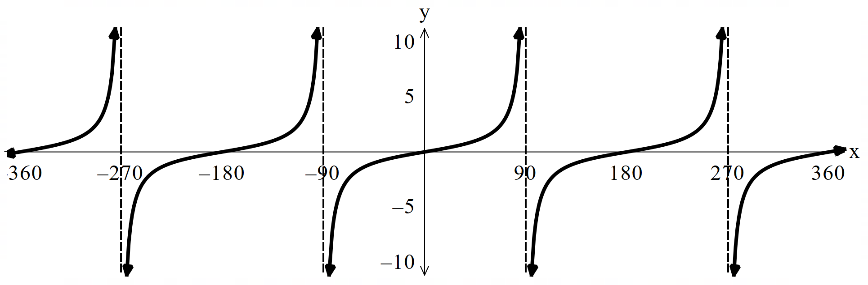

Appendix B – exploring trigonometric graphs

Graph of $y=\sin{x}$
- The $x$-axis represents the angle in degrees, and the $y$-axis represents the value $\sin{θ}$.
- $y$-intercept: $y=0$, $x$-intercepts: $180°$ and $360°$. These represent the horizontal radiuses of the unit circle.
- The shape is cyclical and would repeat beyond $360°$ and below $0°$ for negative numbers.
- Domain: all real values. Range: [-1,1].
- The graph is odd as it has rotational symmetry around the origin and$\sin{(-θ)}=-\sin{θ}$.
- Sine is positive in quadrants 1 and 2 of the unit circle which connects to between $0°$ and $180°$ in the graph where it is above the $x$-axis.
- Increasing the radius of the circle increases the maximum and minimum values of the graph to 2 and -2.

Graph of $y=\cos{x}$
- The $x$-axis represents the angle in degrees and the $y$ axis represents the value $\cos{θ}$.
- $y$-intercept: $y=0$, $x$-intercepts: $90°$ and $270°$. These represent the vertical radiuses of the unit circle.
- The shape is cyclical and would repeat beyond $360°$ and below $0°$ for negative numbers.
- Domain: all real values. Range: [-1,1].
- The graph is even as it is symmetrical around the $y$-axis and $\cos{(-θ)}=\cos{θ}$.
- Cosine is positive in quadrants 1 and 4 of the unit circle, which connects to between $0°$ and $90°$, and $270°$ and $360°$ in the graph where it is above the $x$-axis.
- The sine and cosine graphs have the same shape, but the cosine graph has been translated $90°$to the right.
- Decreasing the radius of the circle decreases the maximum and minimum values of the graph to 0.5 and -0.5.

Graph of $y=\tan{x}$
- The $x$-axis represents the angle in degrees and the $y$ axis represents the value $\tan{θ}$.
- The value of $\tan{θ}$ is undefined and so there are asymptotes.
- $y$-intercept: $y=0$, $x$-intercepts: $0°$, $180°$ and $360°$. These represent the length of the tangent to the circle at those points.
- The shape is cyclical and would repeat beyond and below $0°$ for negative numbers.
- Domain: all real values excluding $90°$ and $270°$. Range: (-$∞$,$∞$).
- The graph is odd as it has rotational symmetry around the origin and $\tan{(-θ)}=-\tan{θ}$.
- Tangent is positive in quadrants 1 and 3 of the unit circle, which connects to between $0°$ and $90°$, and $180°$ and $270°$ in the graph where it is above the $x$ axis.

Appendix C – banner task
Expression | Related angle | Quadrant | Exact value
$$\sin{390°}$$ | $$(30°)$$ | 1 | $$\frac{1}{2}$$
$$\sin{1080°}$$ | $$(0°)$$ | — | 0
$$\tan{585°}$$ | $$(45°)$$ | 3 | 1
$$\cos{(-1080°})$$ | $$(0°)$$ | — | $$1$$
$$\tan{990°}$$ | $$(270°)$$ | — | Undefined
$$\sec{600°}$$ | $$(60°)$$ | 3 | $$\frac{2}{\sqrt{3}}$$
$$\operatorname{cosec}{750°}$$ | $$(30°)$$ | 1 | 2
$$\sin{1170°}$$ | $$(90°)$$ | — | $$1$$
$$\tan\left(-2700°\right)$$ | $$(180°)$$ | — | $$0$$
$$\cot{675°}$$ | $$(45°)$$ | 4 | 1
$$\operatorname{cosec}{450°}$$ | $$(90°)$$ | — | $$1$$
$$\sec\left(-810°\right)$$ | $$(90°)$$ | — | $$0°$$
$$\sin{1140°}$$ | $$(60°)$$ | 1 | $$\frac{\sqrt{3}}{2}$$
$$\cos{(-810°)}$$ | $$(-90°)$$ | — | 0
$$\operatorname{cosec}{450°}$$ | $$(90°)$$ | — | $$1$$

Appendix D – real-world trigonometric problems

At $x=0°$, $y=\cos{0^{°}=1.}$
This represents the passenger being at the maximum height, that is, the top of the Ferris wheel.

The passenger is at the lowest point when $y=-1$, which occurs at $x=180°$.
This corresponds to the bottom of the Ferris wheel.

The passenger is at mid-height when $y=0$, which occurs at $x=90°$ and $x=270°$.
These positions represent the passenger being halfway between the top and bottom of the wheel.

The graph repeats its pattern every ${360}^{∘}$, showing that the motion is periodic.
This reflects the continuous rotation of the Ferris wheel, where the passenger returns to the same position after one full turn.

The sine function$, y=\sin{x}$, would best model this situation.
This is because it starts at zero, increases to a maximum, and then decreases, which reflects the sun rising, reaching its highest point at midday, and then setting.

The tangent function is inappropriate because it has asymptotes, meaning the value becomes undefined at certain points.
This does not match the continuous and smooth motion of the sun across the sky.

Between sunrise and midday, the height of the sun increases steadily from zero to a maximum value.
On the graph of$y=\sin{x}$, this corresponds to the interval from $x=0°$ to $x=90°$ , where the function rises smoothly.

The sine or cosine graph would best model smooth circular motion because they are continuous, smooth, and periodic.
They represent regular up-and-down motion that matches the movement of pedals.

The tangent graph would be unsuitable because it has vertical asymptotes where the function is undefined.
This creates breaks in the graph that do not reflect continuous physical motion.

The cosine function,$y=\cos{x}$, starts at a maximum value when $x=0°$.
This is because$\cos{0°}=1$, indicating the highest point at the start.

As $x$ approaches $90°$, the value of $\tan{x}$ increases rapidly without bound.
This means the signal strength becomes extremely large.

The signal is not defined at $x=90°$ because $\tan{x=\frac{\sin{x}}{\cos{x}}}$, and $\cos{90°=0}$.
Division by zero is undefined, so the graph has a vertical asymptote at this value.

Another value where the signal is undefined is $x=270°$ , since $\cos{270°=0}$. This also results in a vertical asymptote.

The graph repeats every $180°$, showing that the pattern is periodic.
Each section between asymptotes has the same shape, indicating a repeating signal pattern.

References
This resource contains NSW Curriculum and syllabus content. The NSW Curriculum is developed by the NSW Education Standards Authority (NESA). This content is prepared by NESA for and on behalf of the Crown in right of the State of New South Wales. The material is protected by Crown copyright.
Please refer to the NESA Copyright Disclaimer for more information https://www.nsw.gov.au/education-and-training/nesa/copyright.
NESA holds the only official and up-to-date versions of the NSW Curriculum and syllabus documents. Please visit NESA https://www.nsw.gov.au/education-and-training/nesa and NSW Curriculum https://curriculum.nsw.edu.au.
Mathematics Advanced 11–12 Syllabus © NSW Education Standards Authority (NESA) for and on behalf of the Crown in right of the State of New South Wales, 2024.
NESA (NSW Education Standards Authority (2024) ‘Glossary’, Mathematics syllabuses, NESA website, accessed 22 January 2026.
© State of New South Wales (Department of Education), 2026
The copyright material published in this resource is subject to the Copyright Act 1968 (Cth) and is owned by the NSW Department of Education or, where indicated, by a party other than the NSW Department of Education (third-party material).
Copyright material available in this resource and owned by the NSW Department of Education is licensed under a Creative Commons Attribution 4.0 International (CC BY 4.0) license.

This license allows you to share and adapt the material for any purpose, even commercially.
Attribution should be given to © State of New South Wales (Department of Education), 2026.
Material in this resource not available under a Creative Commons license:
- the NSW Department of Education logo, other logos and trademark-protected material
- material owned by a third party that has been reproduced with permission. You will need to obtain permission from the third party to reuse its material.
Links to third-party material and websites
Please note that the provided (reading/viewing material/list/links/texts) are a suggestion only and implies no endorsement, by the New South Wales Department of Education, of any author, publisher, or book title. School principals and teachers are best placed to assess the suitability of resources that would complement the curriculum and reflect the needs and interests of their students.
If you use the links provided in this document to access a third-party's website, you acknowledge that the terms of use, including licence terms set out on the third-party's website apply to the use which may be made of the materials on that third-party website or where permitted by the Copyright Act 1968 (Cth). The department accepts no responsibility for content on third-party websites.

