Using bearings in trigonometry
Students use a real-life rescue operation scenario to revise true bearings and solve problems using trigonometry.

Learning intention
- To know how to use trigonometry to solve real-world problems involving right-angled triangles, bearings, and angles of elevation or depression.

Success criteria
- I can interpret and use true bearings.
- I can form and solve right-angled triangle problems using trigonometric ratios.
- I can interpret angles of elevation and depression in context.
- I can justify solutions using appropriate diagrams and reasoning.

Outcomes
A student:
- develops understanding and fluency in mathematics through exploring and connecting mathematical concepts, choosing and applying mathematical techniques to solve problems, and communicating their thinking and reasoning coherently and clearly MAO-WM-01
- applies trigonometry to solve problems involving geometric shapes MAV-11-04

Content

Trigonometry and measure of angles
Trigonometry with acute angles
- Apply trigonometry to solve problems involving right-angled triangles in two dimensions, true and compass bearings, and angles of elevation and depression
Mathematics Advanced 11–12 Syllabus © NSW Education Standards Authority (NESA) for and on behalf of the Crown in right of the State of New South Wales, 2024.

Table 1: lesson summary
Section | Summary of activity | Teaching strategies | Teaching points
Retrieval practice | Students identify whether given angles could represent true bearings using slide 4 of the PowerPoint Using bearings in trigonometry, then explain their reasoning. They practise finding true bearings using a Variation Theory activity on slide 5 or Appendix A and discuss solutions. | Pose-Pause-Pounce-Bounce  Variation Theory | Reinforce key conventions of bearings and address common misconceptions through variation and student explanation.
Activating prior knowledge | Students interpret a bushwalking rescue scenario using slide 7 and construct and refine diagrams representing true bearings and angles of elevation and depression. They then use a gallery walk to compare approaches. | Visibly random groups of 3  Vertical non-permanent surfaces  Gallery walk | Emphasise accurate representation of bearings from North and angles of elevation and depression. Draw on prior knowledge from Stage 5 to consolidate spatial understanding.
Connecting learning | Students analyse correct diagrams on slide 9, discuss common errors, justify why a right angle exists at X and apply angle relationships to refine diagrams. They then determine which point is closest to the bushwalker, with solutions reviewed on slides 10–11. | Visibly random groups of 3  Vertical non-permanent surfaces | Develop accurate interpretation of bearings and angle relationships, including correct placement of angles of depression and understanding that reciprocal bearings differ.
Releasing responsibility | Students evaluate an incorrect worked example on slide 13 to identify and correct the misplacement of an angle, then consolidate learning by writing notes to their future forgetful selves including annotated diagrams. | Think-Pair-Share  Note to future forgetful selves | Reinforce the use of clear diagrams to support reasoning, addressing common misconceptions in bearings problems.
Independent practice | Students apply the ‘Approaching questions scaffold’ on slide 15 to complete Appendix B in pairs, then exchange work for peer marking and feedback. |  | Applying bearings and angle of elevation and depression concepts to solve problems accurately and justify solutions using appropriate reasoning.

Activity structure
Please use the associated PowerPoint Using bearings in trigonometry to display images in this lesson.

Retrieval practice
- Display slide 4 of the PowerPoint and ask students to put their hands on their heads if the number given could be a true bearing, or on their hips if they believe it cannot. Use the animations on the slide to reveal the answers and the next question.
- Use the Pose-Pause-Pounce-Bounce (PDF 557KB) (bit.ly/posepausepouncebounce) questioning strategy during the activity for students to explain why they have chosen ‘yes’ or ‘no’.
Some possible questioning prompts could include:
- What do you notice about the numbers that are true bearings?
- What is stopping the others from being classified as true bearings?
- How could you describe a true bearing using these examples?
True bearings are measured clockwise from North and written with 3 digits. They are represented using whole numbers.
- Display slide 5 or provide Appendix A ‘Calculating true bearings’ to pairs of students. Students complete the Variation Theory (variationtheory.com/introduction) activity finding the true bearing of point B from point A for each diagram.
Students will need to take care as not all diagrams are in the correct orientation.
- Animate the slide to reveal the answers and discuss any difficulties.
Sample solutions are also provided in this document.

Activating prior knowledge
- Read the following scenario to students and animate slide 7 to show the important information from the scenario.
A bushwalker (X) has triggered an emergency beacon in a remote national park.
Rescue headquarters has the following information:
- The rescue helicopter (H) is hovering directly above a base (B).
- The bearing from the base (B) to the emergency beacon (X) is 050$°$T.
- A fire tower (T) is 8 km away from the base (B) on a bearing of 110°T.
- A person at the top of the fire tower spots the beacon and records that it is on a bearing of 320$°$T.
- The fire tower reports the angle of elevation to the helicopter as 5°.
- The helicopter pilot reports an angle of depression of 12° to the beacon.
- Tell students that rescuers need to know which is closer to the bushwalker – the helicopter pilot, the base or the person at the fire tower.
- Assign students to visibly random groups of 3 (bit.ly/visiblegroups) at vertical non-permanent surfaces (bit.ly/VNPSstrategy).
- Ask students to draw a diagram to represent the information they know about the scenario.
Students could be prompted to draw separate diagrams for each dot point, before trying to combine them into the one diagram.
- Students go on a gallery walk (bit.ly/DLSgallerywalk) to view other groups’ diagrams. Students should then return to their own diagram and make any adjustments they feel are necessary.
Students should be familiar with angles of elevation and depression, and true and compass bearings from the Stage 5 Core outcome MA5-TRG-C-02.
If students are still developing their understanding of angles of elevation and depression it is advised they complete activities from Stage 5 Unit 9 – Lesson 2 – slope seekers.

Connecting learning
- Display slide 9, which shows diagrams of the information in the scenario.
- Discuss any common issues that you noticed while groups were drawing their diagrams.
Common errors might include: angles of depression placed incorrectly, not measuring bearings from North, not realising that the bearing of X from B is different to the bearing of B from X.
- Draw students’ attention to the right angle at X. Unpack with students how they know that this angle is a right angle.
Remind students of alternate angles on parallel lines or complementary angles to help determine unknown angles within bearings diagrams.
- Ask students to make any necessary adjustments to their own diagrams.
- Students should now work in their groups to find who is closer to the bushwalker – the helicopter pilot, the base or the person at the fire tower.
Students may need to be prompted that the ‘distance from helicopter (H) to bushwalker (X)’ is referring to the diagonal distance and not the horizontal distance.
- Use slides 10–11 to display solutions.

Releasing responsibility
- Display the incorrect worked example on slide 13. Use a Think-Pair-Share (bit.ly/thinkpairsharestrategy) for students to discuss the error that has been made and to calculate the correct answer.
Students should identify that the angle $θ$ has been placed incorrectly. This is a very common misconception. The correct angle of depression is ${76.505…}^{o}$
- Ask students to write notes to their future forgetful selves (bit.ly/notestofutureself) on bearings and angles of elevation and depression. Encourage them to include diagrams to aid their explanations.
This lesson focuses on the use of true bearings. If students require practice solving trigonometry problems involving compass bearings, questions could be sourced from an existing resource.

Independent practice
- Display slide 15 and remind students of the ‘Approaching questions scaffold’.
- Distribute Appendix B ‘HSC-style questions’ to pairs of students.
- Students complete the questions in pairs, then swap work with another pair for marking and feedback.
Sample solutions have been provided.

Assessment and differentiation

Suggested opportunities for differentiation
Retrieval practice
- Allow students to Think-Pair-Share before voting in the bearings identification activity.
- Extend students by asking them to justify why an incorrect value cannot be a true bearing or to correct it.
- Support students by focusing on interpreting one diagram at a time, particularly when the orientation is not standard.
Activating prior knowledge
- A structured information organiser could be provided for the scenario. For example:
Objects B, H, T, X
Distances: 8 km
Bearings: 050°T, 110°T, 320°T
Angles: $5°$ elevation, $12°$ depression
- Teachers could colour code the information in the scenario.
- Teachers could provide partially completed diagrams for students to finish.
- By working in groups of 3, students are providing support for each other.
Connecting learning
- Provide a scaffold outlining the order that students will need to find information.
- Challenge students to find an alternative way to solve the problem.
Releasing responsibility
- Students could be presented with the incorrect diagram beside a correct diagram to focus on the differences.
- Challenge students to explain why the incorrect angle seems reasonable.
- Challenge students to create another incorrect example that could trick someone else.
- Encourage students to always draw a horizontal line before marking in angles of depression.
- Challenge students to explain why angles of elevation and depression are equal.
- Provide sentence starters to assist students with their notes:
- A true bearing is …
- An angle of depression is …
- Common mistakes are …
- To avoid these, I will …
Independent practice
- Encourage students to use the ‘Approaching questions scaffold’ to plan how they will solve each question.
- Students could complete the HSC-style questions individually or in groups of 3 depending upon their level of readiness.
- Challenge students to solve each question using more than one method.
- Students can be challenged to create their own HSC-style question.

Suggested opportunities for assessment
Retrieval practice
- The true bearings identification activity provides immediate feedback for the teacher on students’ understanding of bearings.
- Listen for conceptual understanding versus guessing through use of language.
- Use a hinge question mid-task on slide 5: ‘If the diagram is rotated, does the bearing change?’
- Collect one example from each student and sort into: correct method and correct answer, correct method with an error, incorrect method.
Activating prior knowledge
- The activity shows students’ understanding and skills of right-angled trigonometry from Stage 5 Core.
- Check for confusion between ‘bearing to’ versus ‘bearing from’.
- Use the gallery walk to highlight strengths of different diagrams.
Connecting learning
- Listen to student conversations as they are solving the problem to check for understanding of bearings and angles of elevation and depression.
Releasing responsibility
- Collect students’ notes to assess their understanding of bearings and angles of elevation and depression.
- During the Think-Pair-Share, listen for students identifying placement error versus calculation error.
Independent practice
- Choose one HSC-style question for students to submit as an exit ticket

Appendix A

Calculating true bearings
Find the true bearing of point B from point A.
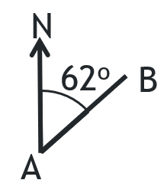 | 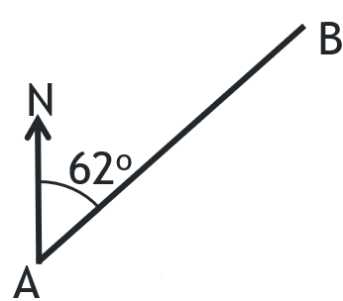 | 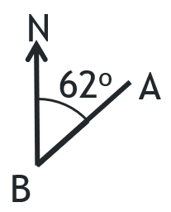
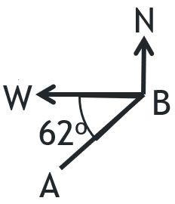 | 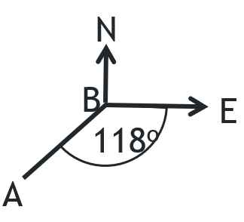 | 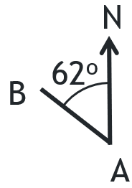
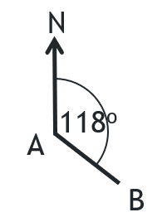 | 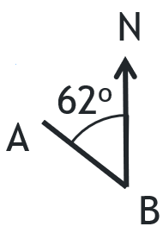 | 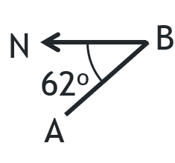
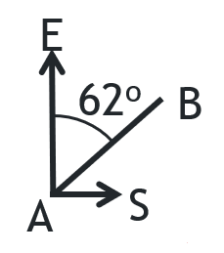 | 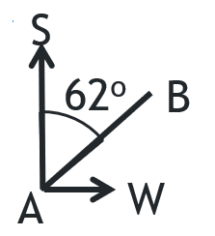 | 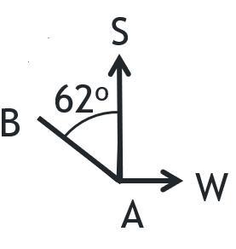

Appendix B

HSC-style questions
Question 1
A bushwalker leaves a campsite and walks 3.2 km on a bearing of 060°T to reach a lookout.
From the lookout, they walk 4.5 km on a bearing of 150°T to a river.
- Find the distance from the campsite to the river.
- Find the true bearing of the campsite from the river.
Question 2
A rescue drone is hovering directly above a point on the ground. From a point 80 m away, the angle of elevation to the drone is 32°.
- Find the height of the drone.
- Another observer is 120 m away from the same point directly below the drone.
Find the angle of elevation from this second observer.
Question 3
A plane is flying at a constant height of 1500 m. An emergency airstrip lies ahead on a straight path. When the airstrip is first sighted, the angle of depression is 18°.
- Find the horizontal distance from the plane to the airstrip at this moment.
- After flying closer, the angle of depression becomes 35°.
How far has the plane travelled horizontally between these 2 observations?
Question 4
Two observers are monitoring a helicopter.
- Observer A sees the helicopter on a bearing of 040°T.
- Observer B is 600 m due east of A and sees the helicopter on a bearing of 320°T.
The helicopter is flying at a constant height of 900 m.
- Find the horizontal distance from A to the point directly below the helicopter.
- The pilot of the helicopter observes the same angle of depression to each observer. Explain why this is possible.

Sample solutions

Appendix A – calculating true bearings
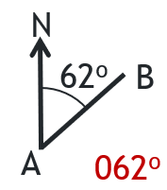 | 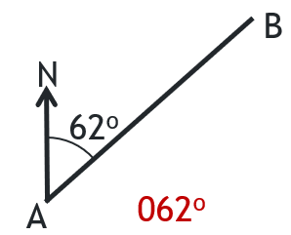 | 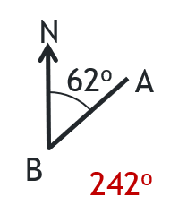
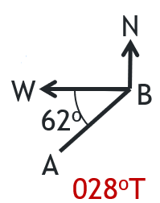 | 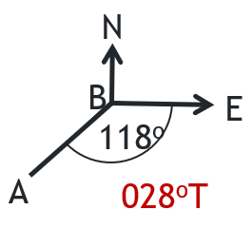 | 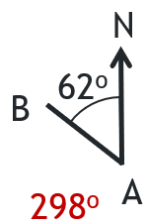
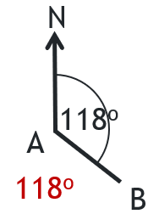 | 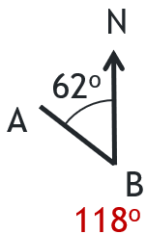 | 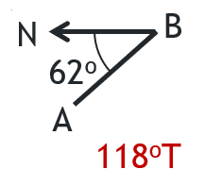
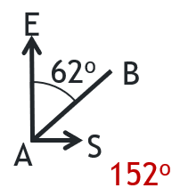 | 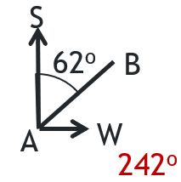 | 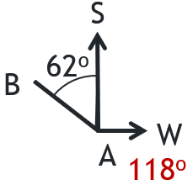

Appendix B – HSC-style questions
Question 1
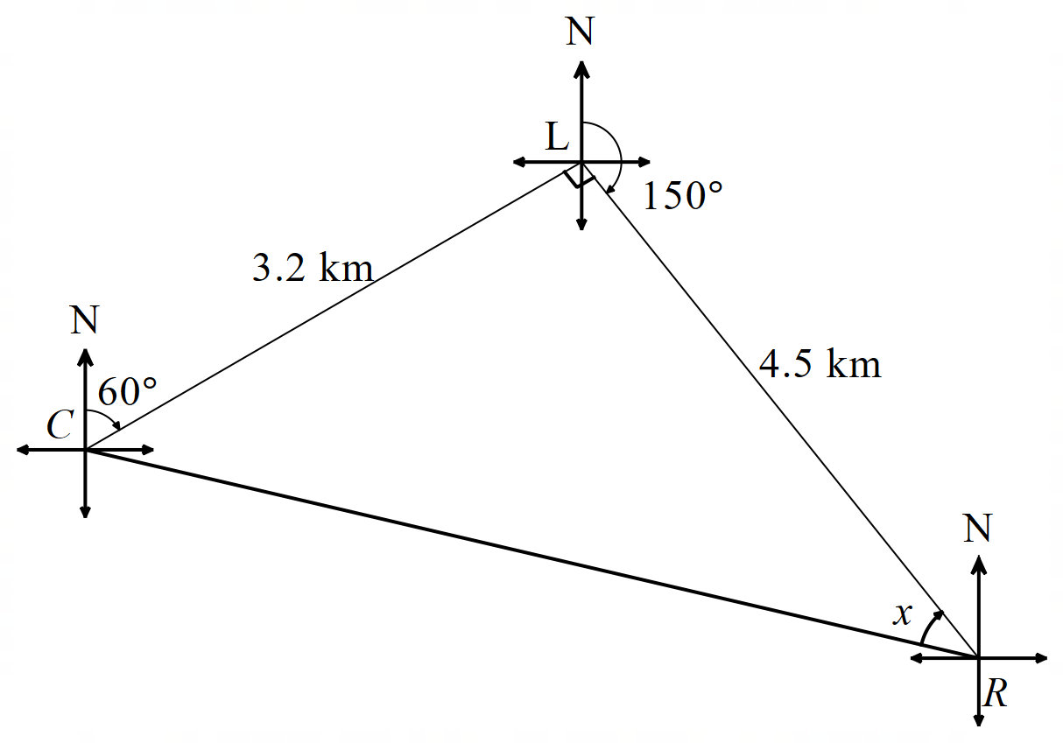
- $∆CLR$is a right-angled triangle.
$$c^{2}=a^{2}+b^{2} \\ ={3.2}^{2}+{4.5}^{2} \\ c=\sqrt{30.49} \\ =5.52177… \\ ≈5.5 km$$

$$\tan{x}=\frac{3.2}{4.5} \\ x=\tan^{-1}\left(\frac{3.2}{4.5}\right) \\ =35.4170… \\ ≈35°$$
Bearing of C from R $=360°-30°-35°=295°T$.
Question 2
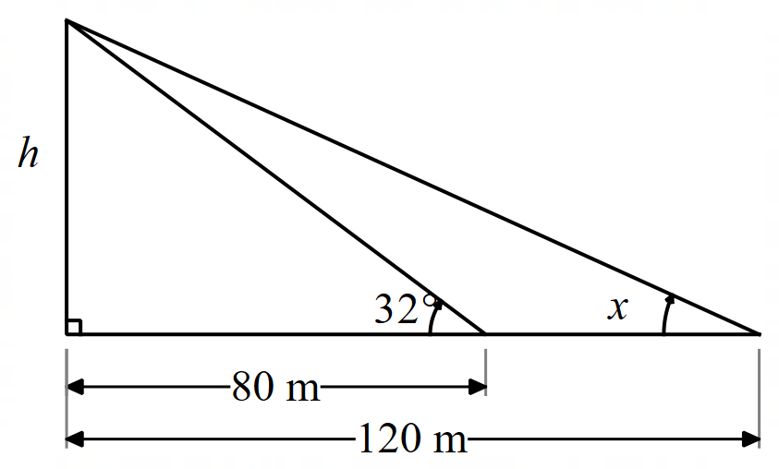

$$\tan{32°}=\frac{h}{80} \\ h=80\tan{32°} \\ =49.9895… \\ ≈50 m$$

$$\tan{x}=\frac{50}{120} \\ x=\tan^{-1}{\frac{50}{120}} \\ x=22.6198… \\ ≈23°$$

Question 3

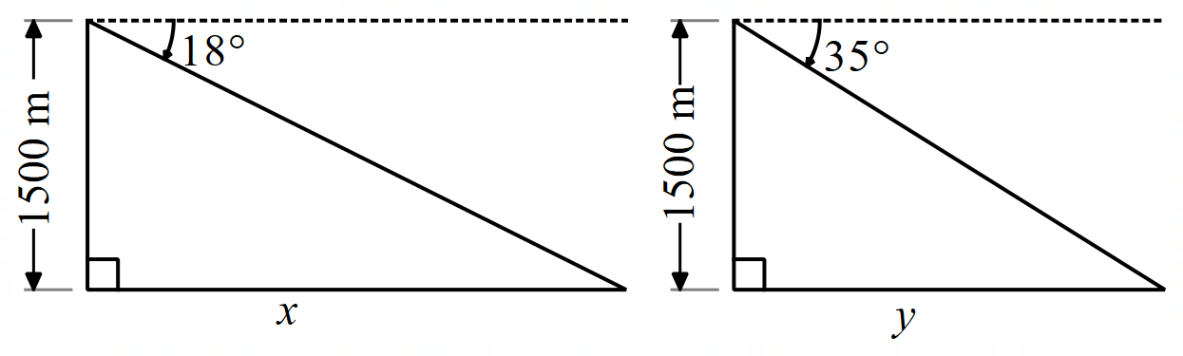

$$\tan{18°}=\frac{1500}{x} \\ x=\frac{1500}{\tan{18°}} \\ x=4616.525… \\ ≈4617 km$$

$$\tan{35°}=\frac{1500}{y} \\ y=\frac{1500}{\tan{35°}} \\ x=2142.222… \\ ≈2142 km$$
The plane has travelled $4617-2142=2475 \text{km}$between observations.

Question 4
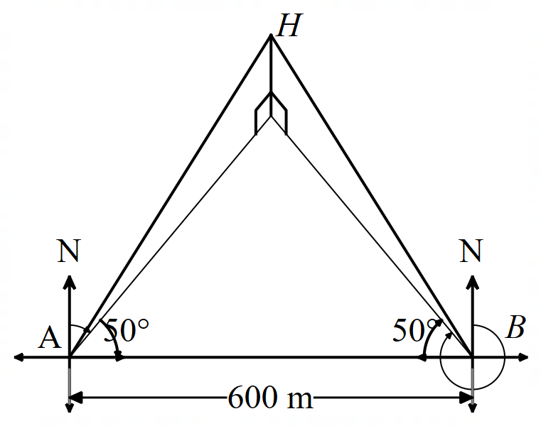
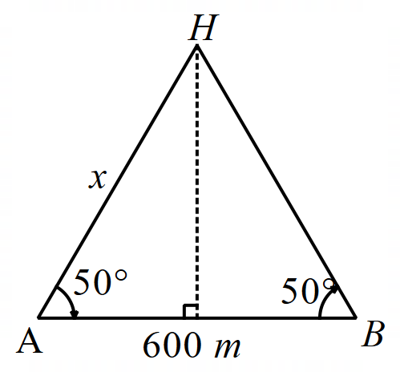

$$\cos{50}=\frac{300}{x} \\ x=\frac{300}{\cos{50}} \\ =466.7171… \\ ≈467 \text{m}$$
- $∆AHB$ is isosceles with sides $AH$ and $BH$ equal. This will create 2 congruent triangles making the angle of elevation; hence, angle of depression is the same for both observers.

References
This resource contains NSW Curriculum and syllabus content. The NSW Curriculum is developed by the NSW Education Standards Authority (NESA). This content is prepared by NESA for and on behalf of the Crown in right of the State of New South Wales. The material is protected by Crown copyright.
Please refer to the NESA Copyright Disclaimer for more information https://www.nsw.gov.au/education-and-training/nesa/copyright.
NESA holds the only official and up-to-date versions of the NSW Curriculum and syllabus documents. Please visit NESA https://www.nsw.gov.au/education-and-training/nesa and NSW Curriculum https://curriculum.nsw.edu.au.
Mathematics Advanced 11–12 Syllabus © NSW Education Standards Authority (NESA) for and on behalf of the Crown in right of the State of New South Wales, 2024.

© State of New South Wales (Department of Education), 2026
The copyright material published in this resource is subject to the Copyright Act 1968 (Cth) and is owned by the NSW Department of Education or, where indicated, by a party other than the NSW Department of Education (third-party material).
Copyright material available in this resource and owned by the NSW Department of Education is licensed under a Creative Commons Attribution 4.0 International (CC BY 4.0) license.

This license allows you to share and adapt the material for any purpose, even commercially.
Attribution should be given to © State of New South Wales (Department of Education), 2026.
Material in this resource not available under a Creative Commons license:
- the NSW Department of Education logo, other logos and trademark-protected material
- material owned by a third party that has been reproduced with permission. You will need to obtain permission from the third party to reuse its material.
Links to third-party material and websites
Please note that the provided (reading/viewing material/list/links/texts) are a suggestion only and implies no endorsement, by the New South Wales Department of Education, of any author, publisher, or book title. School principals and teachers are best placed to assess the suitability of resources that would complement the curriculum and reflect the needs and interests of their students.
If you use the links provided in this document to access a third-party's website, you acknowledge that the terms of use, including licence terms set out on the third-party's website apply to the use which may be made of the materials on that third-party website or where permitted by the Copyright Act 1968 (Cth). The department accepts no responsibility for content on third-party websites.

