Modelling optimisation
Students explore optimisation through a practical modelling activity, using calculus to determine an optimal outcome. They develop a structured approach by defining variables, creating functions, considering domain restrictions, identifying maximum and minimum stationary points and interpreting solutions in context.

Learning intention
- To be able to solve optimisation problems by using calculus.

Success criteria
- I can define variables within the context of a problem.
- I can create a function to represent the relationship between variables.
- I can identify and justify appropriate domain restrictions based on the context of the problem.
- I can interpret my solution in context and explain whether it represents the optimal outcome.

Outcomes
A student:
- develops understanding and fluency in mathematics through exploring and connecting mathematical concepts, choosing and applying mathematical techniques to solve problems, and communicating their thinking and reasoning coherently and clearly MAO-WM-01
- applies calculus to graph functions and model and solve problems involving optimisation, rates of change and motion in a line MAV-12-06

Content

Optimisation
- Model optimisation problems in a variety of contexts by defining variables, noting domain restrictions if necessary, and establishing functions to represent the relationship between variables
- Solve optimisation problems by using calculus to find local and global maxima and minima of differentiable functions, checking discontinuities of $f'(x)$ and endpoints of the domain if applicable
- Formulate conclusions to optimisation problems by evaluating solutions given the constraints of the domain
Mathematics Advanced 11–12 Syllabus © NSW Education Standards Authority (NESA) for and on behalf of the Crown in right of the State of New South Wales, 2024.

Table 1: lesson summary
Section | Summary of activity | Teaching strategies | Teaching points
Retrieval practice | Using slide 4 of the PowerPoint Modelling optimisation, students complete an activity. An optional error analysis activity in Appendix A using optimisation-style problems is available for extra skill practice. |  | Students need to interpret written information and translate it into algebraic expressions for dimensions before creating a volume function. This supports the later modelling task, where students will need to create a function from the dimensions of a box.
Activating prior knowledge | Students create a popcorn container from A4 paper by cutting squares of side length $x$from each corner using Appendix B. Slides 6–7 guide students in creating the container and slide 8 is used to record and compare group volumes. Students use their results to estimate which value of $x$ gives the greatest volume. | Visibly random groups of 3  Vertical non-permanent surfaces  Pose-Pause-Pounce-Bounce | Practical trials help students recognise the relationship between the variable $x$ and the resulting volume. The largest tested volume may not be the true maximum, so a mathematical model is needed to find a more accurate optimal value.
Connecting learning | Students develop the volume function for the A4 box, use Desmos (https://bit.ly/A4papergraph) to explore the graph and domain, then apply calculus to find the maximum volume as shown in slides 10–13. They then extend the model to an A3 piece of paper and compare the result with the original A4 model as displayed in slides 14–17. | Vertical non-permanent surfaces  Visibly random groups of 3  Think-Pair-Share  Gallery walk  Class discussion  Pose-Pause-Pounce-Bounce | Students need to define variables, create a function, restrict the domain, differentiate, solve for stationary points and justify the maximum. Domain restrictions must be interpreted in context, not treated only as algebraic limits.
Releasing responsibility | Slides 19–22 are used to model an optimisation problem. Students complete the related question using the scaffold in Appendix C, then create their own optimisation notes in Appendix D. | Worked examples (Your turn)  Scaffolded notes | Students are supported to move from a modelled solution to completing a similar problem with a scaffold. The structure helps students focus on the key stages of optimisation: defining variables, stating the domain, creating a function, differentiating, solving, justifying and interpreting the result in context.
Independent practice | Students read the HSC-style optimisation relay questions on slides 24–26 and discuss the structure of the questions. Students then complete each question using a relay activity. Groups complete different parts of shared solutions, rotate to review and continue another group’s work, then return to their original response to check and refine the solution. | Notice and wonder  Group relay  Vertical non-permanent surfaces  Visibly random groups of 3  Gallery walk  Peer feedback | HSC-style optimisation questions often build across parts. Earlier ‘show that’ results are usually intended to support later differentiation, justification and interpretation. Reviewing and continuing another group’s solution supports mathematical communication, error checking and clear solution structure.

Activity structure
Please use the associated PowerPoint Modelling optimisation to display images in this lesson.

Retrieval practice
- Display slide 4 of the PowerPoint and instruct students to find an expression for the volume of the prism which is displayed.
- Animate the slide to display the solution.
Students who need more practice finding algebraic expressions for various shapes, may wish to complete the optional ‘Error Analysis’ activity. Distribute Appendix A ‘Error analysis’. Students need to find the error in the worked solution and then continue with the correct solution.

Activating prior knowledge
- Assign students to visibly random groups of 3 (bit.ly/visiblegroups). Explain that each group will use a single sheet of A4 paper (21 cm x 30 cm) to construct an open popcorn container, with the aim of maximising its volume.
- Ask students what dimensions they think the container should have to maximise its volume.
- Display slide 6 from the PowerPoint, which shows examples of containers that can be formed from an A4 sheet of paper. Ask students to consider whether the examples change or refine their initial prediction.
- Display slide 7, which shows how students will need to cut their paper and use Appendix B ‘Corner cut off values’ to allocate each group a different value of $x$. To save printing, students can just be told their value of $x$ and write it on their mini whiteboards.
Depending on class size, each group may need to create more than one box. Ensure, at a minimum, that $x=3$cm$, x=4$ cm and$x=5$cm are used. The teacher may wish to demonstrate creating a box, using $x=1$cm for the corner values. The teacher can also demonstrate how to calculate the volume of the container.
- In their groups, students construct the popcorn container using their allocated value of $x$. Students may share roles in measuring, cutting, folding and checking dimensions.
- Once they have created their container, direct the groups to work at vertical non-permanent surfaces (bit.ly/VNPSstrategy) to calculate the volume of their container.
Students remain in these groups for Connecting learning, where they will use the results of the practical activity to develop and optimise the volume function.
- Display slide 8 and as each group completes the calculation, add the calculation and volume to complete the table.
Some classes may prefer to have groups draw the table on the vertical non-permanent surfaces.
- Use the Pose-Pause-Pounce-Bounce questioning strategy (bit.ly/P-P-P-B) to initiate a class discussion on the optimal value of $x$ to create the largest possible volume. Possible prompts include:
- What value of $x$ maximised the volume? How do you know?
- Is this the actual maximum?
- How could we be more accurate?
Students should realise that to be more accurate, differentiation can be used to find a maximum stationary point. To do this, we need to create an equation for the volume of the container.
Some classes may wish to use bags of popcorn to provide a hands-on comparison. Filling each container with popcorn can help students visualise and compare their capacities.

Connecting learning
- Continuing to work in their groups, at their vertical non-permanent surface, students create a formula that can be used to find the volume of a container, made from an A4 piece of paper, for any length of $x.$
Initiate a class discussion about the formulas created and highlight any common errors or misconceptions that can be seen from the formulas the class created.
- Display slide 10 showing the length, width and height of the box, then animate to reveal the formula $V=x(30-2x)(21-2x)$.
- Display the Desmos activity ‘A4 paper optimisation’ (https://bit.ly/A4papergraph). Explain to students that the dotted graph that appears is the graph of $V=x\left(21-2x\right)\left(30-2x\right)$ which they now know is the formula for the volume of their boxes. This graph appears with no restrictions.
Initiate a class discussion about restricting the domain, within the context of making the box.
Students should realise that to cut the paper, $x$ must be a positive value so therefore $x>0.$ The students should also realise that any value of $x$ greater than $10.5$ cm would not be possible as we are cutting from both sides, so therefore $0<x<10.5$ is the domain.
- On the Desmos screen, toggle on graph 2, to display the graph in the restricted domain.
- Discuss with the class that we previously found the maximum volume to be close to 4. Toggle on row 3 and move the purple coordinate along the graph to highlight the maximum value is slightly larger than 4.
- In their groups, and then reporting to the class, have students discuss how they can find the exact location of the maximum stationary point using calculus.
Students should discuss the need to use differentiation to find the stationary point and show that it is a maximum and then use this value of $x$ to find the maximum volume.
- Students work in their groups at their vertical non-permanent surfaces to find the maximum stationary point using differentiation.
- Select 2 groups to share their solution with the class. Use questioning to compare the approaches taken, address any errors and highlight the key steps in identifying and justifying the maximum.
- Display slides 11 and 12 to reveal the solution.
- Have students draw a conclusion around what the optimised value of $x$ (length of cutout) is and what maximum volume the container will hold. Animate slide 12 to reveal the maximum volume.
- Display slide 13 to confirm the solution on the graph.
- Display slide 14 and have students read the scenario.
- Using the Pose-Pause-Pounce-Bounce questioning strategy, initiate a conversation with students regarding Fred’s statement, ‘A3 paper has twice the area of A4 paper, therefore if we make a box using A3 paper, it will hold double the volume of popcorn.’ Some question prompts may include:
- Do you think it will hold double the volume of popcorn?
- What would stay the same in our model, what would change?
- How could we find the new value of $x$that gives the maximum volume?
- Students continue to work in their groups, at their vertical non-permanent surface, to find the maximum volume of popcorn that an A3 piece of paper can create when made into a rectangular prism.
- Conduct a gallery walk (bit.ly/DLSgallerywalk) such that students can give and receive feedback on their solutions.
- Display slides 15–17 to reveal the solution and graph.

Releasing responsibility
- Use slides 19–22 to model a worked example of an optimisation problem using the Worked examples (Your turn) method (bit.ly/supportingstrategies). Appendix C ‘Your turn’ should be handed out to students for the ‘Your turn’ question as it provides scaffolding for students to follow.
- Distribute Appendix D, ‘Notes for optimisation problems’. Each student has an individual copy and creates their own notes; however, students can continue working in their groups to help each other.

Independent practice
- Display slides 24–26 and have students briefly read each question, asking students to consider what they notice and wonder (bit.ly/noticewonderstrategy) about the style, structure and information provided in each question.
Students may notice that each question is split into 3 parts and begins by asking them to establish or verify a result before using it in later parts. They may also notice that key formulas or expressions are provided, which can help guide the direction of the solution. Students may wonder why they are asked to ‘show that’ rather than simply find an answer, how the earlier parts support the later optimisation, and how marks might be allocated across the different parts of the question.
- Explain to the class that they will now be working through HSC-style optimisation questions, using the activity below.
- Students return to their previous groups of 3 at vertical non-permanent surfaces.
- Ask students to refer to the notes created in Appendix D. Remind students that these notes should be used to help them structure their solutions.
- Use slide 24 to display question 1.
- Allow enough time for groups to complete part i of the question, focusing on defining variables, identifying relevant relationships and creating the required function.
- When time is called, each group rotates clockwise to the next group’s solution.
- Groups review the solution in front of them, compare it with their own, and can ask the previous group clarifying questions if needed.
- Allow further time for groups to complete part ii at their new vertical non-permanent surface, working on from the partially completed solution left by the previous group.
- When time is called, rotate clockwise again.
- Groups review the solution in front of them and complete part iii of the question, including any required optimisation, justification and interpretation in context.
- When the question is complete, groups rotate back to their original solution. They review the completed response, check for accuracy and make any necessary corrections or additions.
- Facilitate a class discussion or gallery walk to identify correct reasoning, common errors and efficient solution methods.
- Repeat this process for Question b on slide 25 and Question c on slide 26.
- Some groups may benefit from assessing and advancing questions if they are finding the question challenging. Some suggested questions include:
Question a
- Assessing questions
- What measurements stay the same when the sector is folded to form the cone?
- In the cone diagram, how are the radius, height and slant height related?
- Advancing questions
- If the slant height is 10 cm and the radius is $x$ cm, what expression could you write for the height using Pythagoras?
- Once you have the height in terms of $x$, where can you substitute it to create a volume function involving only $x$?
Question b
- Assessing questions
- What surfaces make up the total surface area of a closed cylinder?
- Which relationship in the question gives you a connection between $r$ and $h$?
- Advancing questions
- Can you write an equation for the total surface area using $2πr^{2}+2πrh=96π$?
- What would you need to make the subject to obtain the expression required in part i?
Question c
- Assessing questions
- The formula for $C$ gives a cost in dollars per hour. What additional information do you need to turn this into a total cost for the journey?
- If the drone travels 60 km at $v$ km/h, how long will the journey take?
- Advancing questions
- What expression represents the travel time in hours, in terms of $v$?
- If total cost is cost per hour $×$number of hours, what expression could you form using $C=120+8v+0.5v^{2}$?
This activity encourages students to use their structured optimisation notes while also exposing them to different approaches to the same problem. Reviewing and continuing another group’s solution supports mathematical communication, critical analysis and error-checking, while helping students recognise the importance of each step in the optimisation process.
Solutions have been provided in the sample solutions section.

Students may benefit from completing more practice questions utilising an existing resource.

Assessment and differentiation

Suggested opportunities for differentiation
Retrieval practice
- Provide students with a partially completed correction scaffold that identifies the step before and after the error, supporting students to focus on the mathematical reasoning rather than rewriting the full solution.
- Extend confident students by asking them to explain why the original error is mathematically incorrect and to create a similar incorrect worked solution for another group to analyse.
Activating prior knowledge
- Provide a volume calculation scaffold for students requiring additional support, prompting them to identify the height, length and width before substituting.
- Extend confident groups by asking them to predict a more precise value of $x$ that may produce a larger volume than those tested and justify their prediction using the class results.
Connecting learning
- Use the discussion during the Desmos activity to provide verbal feedback on domain restrictions and graph interpretation.
- Provide students requiring additional support with a partially completed diagram or formula frame, such as $V=x(___-2x)(___-2x)$, to support them in developing the A4 volume function.
Releasing responsibility
- Allow students to use Appendix C as a step-by-step checklist, with prompts for defining variables, stating the domain, creating the function, differentiating and interpreting the result.
- Extend confident students by gradually removing the scaffold during the ‘Your turn’ question or asking them to justify the minimum using more than one method, such as the second derivative and boundary behaviour.
Independent practice
- Provide focused prompts so that each group can concentrate on one aspect of the solution, such as establishing the function, applying calculus, justifying or interpreting the answer.
- Extend students by asking them to identify alternative approaches, check endpoints or boundary behaviour, or explain how a graph would support the calculus-based conclusion.

Suggested opportunities for assessment
Retrieval practice
- Review students’ volume expressions to assess whether they can translate written relationships between dimensions into algebraic expressions.
- Use targeted questioning as the solution is revealed to assess whether students can identify and explain errors in substitution, expansion or simplification.
Activating prior knowledge
- Observe the construction and volume calculations to assess whether students can connect the corner cut-out value to the resulting height, length and width of the container.
- Listen to responses during the Pose-Pause-Pounce-Bounce discussion to assess whether students recognise that the practical trials provide an estimate rather than proof of the maximum volume
Connecting learning
- Use responses during the Desmos discussion to assess whether students can determine an appropriate domain and explain its restrictions in the context of physically constructing the box.
- During the VNPS work and gallery walks, assess whether students can create the volume function, differentiate, solve for relevant stationary points and justify that the selected point gives the maximum volume.
Releasing responsibility
- Monitor students’ completion of Appendix C to assess which stages of the optimisation process they can complete independently after the modelled example.
- Review the notes students create in Appendix D to assess whether they can identify the essential stages of an optimisation solution and explain what must be checked at each stage.
Independent practice
- Use the group rotations to assess whether students can read, evaluate and continue another group’s mathematical reasoning while identifying missing steps or errors.
- Review each group’s final corrected response to assess whether students can produce a complete HSC-style solution that establishes the function, applies calculus, justifies the optimum and interprets the answer in context.

Appendix A

Error analysis
For each question, find where the error has occurred and then continue to complete the problem with the correct solution.
Question 1
A soft drink can has a volume of $375 cm^{3}$.
Show that the height of the can may be expressed using $\frac{375}{πr^{2}}$ and, therefore, show that the formula for the surface area of the can may be found using $A=2πr^{2}+\frac{750}{r}$.
$$πr^{2}h=375 \\ h=\frac{375}{πr^{2}}$$
$$A=2πr^{2}+2πrh \\ =2πr^{2}+2πr\left(\frac{375}{πr}\right) \\ =2πr^{2}+2πr\left(\frac{375}{πr}\right) \\ =2πr^{2}+750$$

Question 2
A landscaper plans to build a rectangular garden bed with length $y$ m, width $x$ m and an area of $960{\text{ m}}^{2}$. She uses an existing brick wall as one side of the garden. Timber edging is needed for the remaining 3 sides and to divide the garden into 5 equal rectangular sections, as shown.
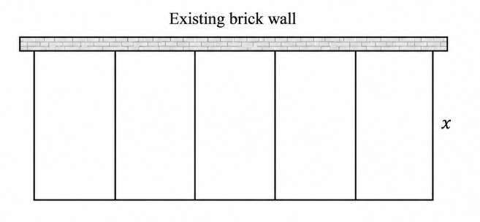
Let the total length of timber edging required be $L$ metres.
Show that $L=6x+\frac{960}{x}$.
Let the wall $=y$.
$$A=960$$
$$5xy=960$$
$$y=\frac{960}{5x}$$
$$y=\frac{192}{x}$$
$$L=6x+y$$
$$∴L=6x+\frac{192}{x}$$

Question 3 (2006 HSC)
A cone is inscribed in a sphere of radius $a$, centred at $O$. The height of the cone is $x$ and the radius of the base is $r$, as shown in the diagram.
Show that the volume, $V$, of the cone is given by $V=\frac{1}{3}π(2ax^{2}-x^{3})$.
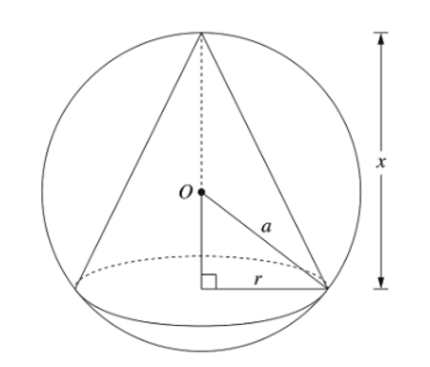
$$V=\frac{1}{3}πr^{2} h$$
Using Pythagoras’ theorem
$$x^{2}+r^{2}=a^{2}$$
$$r^{2}=a^{2}-x^{2}$$
$$V=\frac{1}{3} π(a^{2}-x^{2} )x$$
$$V=\frac{1}{3} π(a^{2} x-x^{3})$$

Appendix B

Corner cut off values
From each corner of your A4 paper, cut a corner with a value of $x=2$cm | From each corner of your A4 paper, cut a corner with a value of $x=3$cm
From each corner of your A4 paper, cut a corner with a value of $x=4$cm | From each corner of your A4 paper, cut a corner with a value of $x=5$cm
From each corner of your A4 paper, cut a corner with a value of $x=6$cm | From each corner of your A4 paper, cut a corner with a value of $x=7$cm
From each corner of your A4 paper, cut a corner with a value of $x=8$cm | From each corner of your A4 paper, cut a corner with a value of $x=9$cm

Appendix C

Your turn
A farmer wants to create a rectangular paddock beside a straight river. The river will form one side of the paddock, so fencing is only needed for the other 3 sides.
The paddock must have an area of 2400 m².
Let $x$ be the width of the paddock, measured perpendicular to the river.
- Show that the total length of fencing, $L$, is given by $L = 2x +\frac{2400}{x}$.
- Show that $\frac{dL}{dx} =\frac{2\left(x^{2}- 1200\right)}{x^{2}}$.
- Prove that the minimum amount of fencing is used when the length of the paddock is twice its width.
Draw a diagram.
Define the variables.
State the domain.
Create a function.
Differentiate the function.
Make the derivative equal to zero and solve.
Determine whether the point gives a maximum or minimum.
Check endpoints or boundary values.
Interpret the answer in context.

Appendix D

Notes for optimisation problems
In your group, use the popcorn box problems to create a method that would help your future self, solve a different optimisation problem.
What did we do? | What should I remember?
Draw a diagram
Define the variable
State the domain
Create a function
Differentiate the function
Make the derivative equal to zero and solve
Determine whether the point gives a maximum or minimum
Check endpoints or boundary values
Interpret the answer in context
Add a reminder note for your future forgetful selves: Which step do you think you are most likely to forget or rush in an optimisation problem?

Sample solutions

Appendix A – error analysis
For each question, find where the error has occurred and then continue to complete the problem with the correct solution.
Question 1
A soft drink can has a volume of $375 \text{c}{\text{m}}^{\text{3}}$.
Show that the height of the can may be expressed using $\frac{375}{πr^{2}}$ and, therefore, show that the formula for the surface area of the can may be found using $A=2πr^{2}+\frac{750}{r}$.
$$πr^{2}h=375 \\ h=\frac{375}{πr^{2}}$$
$$A=2πr^{2}+2πrh \\ =2πr^{2}+2πr\left(\frac{375}{πr^{2}}\right) \\ =2πr^{2}+\frac{750πr}{πr^{2}} \\ A=2πr^{2}+\frac{750}{r}$$

Question 2
A landscaper plans to build a rectangular garden bed with length $y$ m, width $x$ m and an area of $960{\text{ m}}^{2}$. She uses an existing brick wall as one side of the garden. Timber edging is needed for the remaining 3 sides and to divide the garden into 5 equal rectangular sections, as shown.
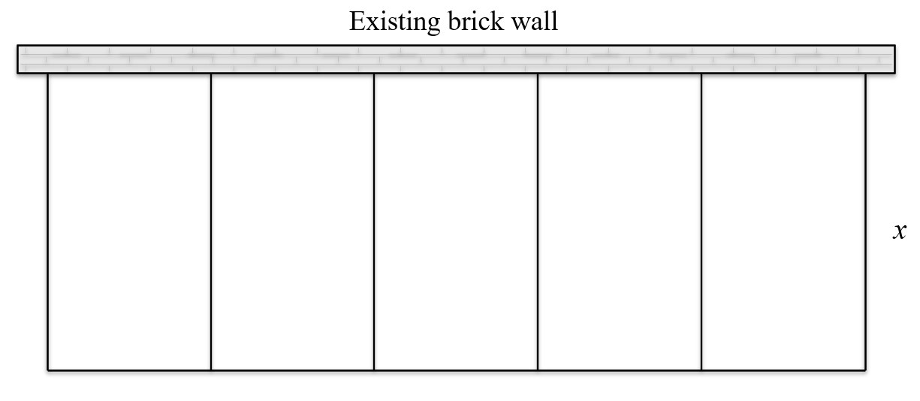
Let the total length of timber edging required be $L$ metres.
Show that $L=6x+\frac{960}{x}$.
Let the wall $=y$.
$$A=960$$
$$xy=960$$
$$y=\frac{960}{x}$$
$$y=\frac{960}{x}$$
$$L=6x+y$$
$$∴L=6x+\frac{960}{x}$$

Question 3 (2006 HSC)
A cone is inscribed in a sphere of radius $a$, centred at $O$. The height of the cone is $x$ and the radius of the base is $r$, as shown in the diagram.
Show that the volume, $V$, of the cone is given by $V=\frac{1}{3}π(2ax^{2}-x^{3})$.
$$V=\frac{1}{3}πr^{2} h$$
Using Pythagoras’ theorem
$$({x-a)}^{2}+r^{2}=a^{2}$$
$$r^{2}=a^{2}-{(x-a)}^{2}$$
$$r^{2}=a^{2}-(x^{2}-2ax+a^{2})$$
$$r^{2}=2ax-x^{2}$$
$$V=\frac{1}{3} π(2ax-x^{2} )x$$
$$V=\frac{1}{3} π(2ax^{2}-x^{3} )$$

Appendix C – Your turn
Draw a diagram.
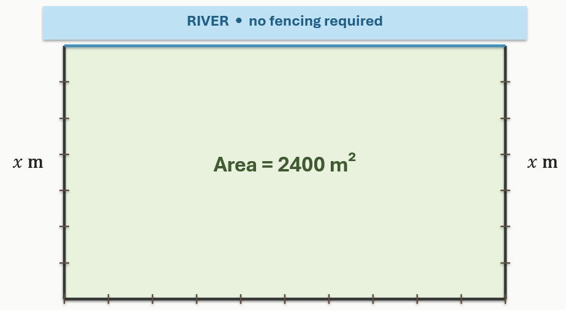
Define the variables.
Let $x$be the width of the paddock, measured perpendicular to the river.
Let $y$ be the length of the paddock, measured along the river.
Let $L$ be the total length of fencing required.
State the domain.
Since $x$ represents a length, $x>0$.
The paddock must have an area of 2400 m², so $xy=2400$.
This means $x$ can be any positive value, so the domain is $x>0$.
Create a function.
The area of the paddock is 2400 m² so $xy=2400$.
Rearrange to make $y$ the subject, $y=\frac{2400}{x}$.
Since the paddock is beside a river, fencing is only needed for 3 sides.
So $L=2x+y$
Substitute $y=\frac{2400}{x}$
$$L=2x+\frac{2400}{x}$$

Differentiate the function.
Rewrite the function using index notation $L=2x+2400x^{-1}$
Differentiate $\frac{dL}{dx}=2-2400x^{-2}$
$$\frac{dL}{dx}=2-\frac{2400}{x^{2}}$$
$$\frac{dL}{dx}=\frac{2x^{2}}{x^{2}}-\frac{2400}{x^{2}}$$
$$\frac{dL}{dx}=\frac{2\left(x^{2}-1200\right)}{x^{2}}$$
Make the derivative equal to zero and solve.
$$\frac{2\left(x^{2}-1200\right)}{x^{2}}=0$$
Since the denominator cannot be zero, solve the numerator:
$$2(x^{2}-1200)=0$$
$$x^{2}-1200=0$$
$$x^{2}=1200$$
$$x=\sqrt{1200}$$
$$x=20\sqrt{3}$$
Since $x$ represents a length, $x$ must be positive.
So $x=20\sqrt{3}$
Determine whether the point gives a maximum or minimum.
$$\frac{d^{2}L}{dx^{2}}=4800x^{-3}$$
$$\frac{d^{2}L}{dx^{2}}=\frac{4800}{x^{3}}$$
When $x=20\sqrt{3}$, $x$ is positive.
Therefore $\frac{d^{2}L}{dx^{2}}>0$ so the stationary point is a minimum.
Check endpoints or boundary values.
The domain is $x>0$.
As $x$ gets very close to 0, the term $\frac{2400}{x}$becomes very large, so the fencing length becomes very large.
As $x$ becomes very large, the term $2x$ becomes very large, so the fencing length also becomes very large.
Therefore, the minimum occurs at the stationary point
Interpret the answer in context.
The width of the paddock is $x=20\sqrt{3}$.
Using $y=\frac{2400}{x}$
$y=\frac{2400}{20\sqrt{3}}$
$$y=\frac{120}{\sqrt{3}}$$
$$y=40\sqrt{3}$$
So, the dimensions are:
Width: $20\sqrt{3}$m
Length: $40\sqrt{3}$m
Since $40\sqrt{3}=2(20\sqrt{3})$ the length is twice the width.
Therefore, the minimum amount of fencing is used when the length of the paddock is twice its width.

Slides 24–26 – optimisation relay solutions
Question a
    - $V=\frac{1}{3}πr^{2}h$ radius $=x$
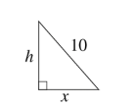
${10}^{2}=h^{2}+x^{2}$
$$h=\sqrt{100-x^{2}}$$
$$V=\frac{1}{3}πx^{2}\sqrt{100-x^{2}}$$

    - $V=\frac{1}{3}πx^{2}\sqrt{100-x^{2}}$
$u=\frac{1}{3}πx^{2}$ $v={\left(100-x^{2}\right)}^{\frac{1}{2}}$
$\frac{du}{dx}=\frac{2}{3}πx$ $\frac{dv}{dx}=\frac{1}{2}×-2x×{\left(100-x^{2}\right)}^{-\frac{1}{2}}$
$=-\frac{x}{\sqrt{100-x^{2}}}$
$$\frac{dV}{dx}=-\frac{πx^{3}}{3\sqrt{100-x^{2}}}+\frac{2πx\sqrt{100-x^{2}}}{3}$$
$$=\frac{-πx^{3}+2πx(100-x^{2})}{3\sqrt{100-x^{2}}}$$
$$=\frac{-πx^{3}+200πx-2πx^{2}}{3\sqrt{100-x^{2}}}$$
$$=\frac{200πx-3πx^{2}}{3\sqrt{100-x^{2}}}$$
$$=\frac{πx(200-3x^{2})}{3\sqrt{100-x^{2}}}$$

    - $\frac{πx(200-3x^{2})}{3\sqrt{100-x^{2}}}=0$
$$πx\left(200-3x^{2}\right)=0$$
$x=0$ (not a solution as $x>0)$
$$200-3x^{2}=0$$
$$3x^{2}=200$$
$x=±\sqrt{\frac{200}{3}}$ ($x=-\sqrt{\frac{200}{3}}$not a solution as $x>0)$
$$x$$ | $$8$$ | $$\frac{10\sqrt{2}}{3}$$ | $$9$$
$$\frac{dV}{dx}$$ | $$11.17$$ | $$0$$ | $$-92.97$$
$$∴x=\sqrt{\frac{200}{3}}$$
$$x=\frac{10\sqrt{2}}{\sqrt{3}}$$

$∴$Maximum at $x=\frac{10\sqrt{2}}{\sqrt{3}}$
$$l=rθ$$
$$2πx=10θ$$
$$θ=\frac{πx}{5}$$
$$∴θ=\frac{π}{5}×\frac{10\sqrt{6}}{3}$$
$$θ=\frac{2π\sqrt{6}}{3}$$
Question b

$$SA = 2πr² + 2πrh$$
$$2πr² + 2πrh = 96π$$
$$r² + rh = 48$$
$$rh = 48 - r²$$
$$h =\frac{48-r^{2}}{r}$$

$$V = πr²h$$
$$V = πr² × \frac{48-r^{2}}{r}$$
$$V = \frac{πr^{2}(48-r^{2})}{r}$$
$$V = πr(48 - r²)$$

$$V = πr(48 - r²)$$
$$V = 48πr - πr³$$
$$\frac{dV}{dr} = 48π - 3πr²$$
$$48π - 3πr^{2}=0$$
$$48π = 3πr²$$
$$16 = r²$$
$$r = 4$$
Since $r$ is a radius, $r$ must be positive, so $r = 4$.
$$\frac{d^{2}V}{dr^{2}}=-6πr$$
When$r = 4:$
$$\frac{d^{2}V}{dr^{2}}=-24π$$
Since this is negative, the stationary point gives a maximum.
Substitute$r = 4$ into the volume formula:
$$V = πr(48 - r²)$$
$$V = π(4)(48 - 4²)$$
$$V= 4π(48 - 16)$$
$$V = 4π(32)$$
$$V = 128π$$
Therefore, the maximum possible volume of the cylindrical container is $128π$ cm³.
Question c

$$C = 120 + 8v + 0.5v²$$
$time =\frac{60}{v}$
The total cost is found by multiplying the cost per hour by the time taken:
$$T = C × time$$
$$T = \left(120 + 8v + 0.5v^{2}\right)×\frac{60}{v}$$
$$T = 120 ×\frac{60}{v} + 8v ×\frac{60}{v} + 0.5v^{2}×\frac{60}{v}$$
$$T =\frac{7200}{v} + 480 + 30v$$
$$T =\frac{7200}{v} + 30v + 480$$

$$T =\frac{7200}{v} + 30v + 480$$
$$T = 7200v⁻¹ + 30v + 480$$
$$\frac{dT}{dv} = -7200v⁻² + 30$$
$$\frac{dT}{dv} = -\frac{7200}{v^{2}}+30$$

$$-\frac{7200}{v^{2}}+ 30 = 0$$
$$30 =\frac{7200}{v^{2}}$$
$$30v² = 7200$$
$$v² = 240$$
$v = ±\sqrt{240}$, since $v$ represents speed, $v$ must be positive.
$$v = 4\sqrt{15}$$
$$\frac{d^{2}T}{dv^{2}} =\frac{14400}{v^{3}}$$
As $v=4\sqrt{15}, \frac{d^{2}T}{dv^{2}} > 0,$ so this stationary point gives a minimum.
Therefore, the speed that will minimise the total cost is:
$v = 4\sqrt{15}$ km/h
$v ≈15.5$ km/h.

References
This resource contains NSW Curriculum and syllabus content. The NSW Curriculum is developed by the NSW Education Standards Authority (NESA). This content is prepared by NESA for and on behalf of the Crown in right of the State of New South Wales. The material is protected by Crown copyright.
Please refer to the NESA Copyright Disclaimer for more information https://www.nsw.gov.au/education-and-training/nesa/copyright.
NESA holds the only official and up-to-date versions of the NSW Curriculum and syllabus documents. Please visit NESA https://www.nsw.gov.au/education-and-training/nesa and NSW Curriculum https://curriculum.nsw.edu.au.
Mathematics Advanced 11–12 Syllabus © NSW Education Standards Authority (NESA) for and on behalf of the Crown in right of the State of New South Wales, 2024.
Mathematics Advanced 2018 HSC paper © NSW Education Standards Authority (NESA) for and on behalf of the Crown in right of the State of New South Wales, 2018.
Mathematics Advanced 2006 HSC paper © NSW Education Standards Authority (NESA) for and on behalf of the Crown in right of the State of New South Wales, 2006.

© State of New South Wales (Department of Education), 2026
The copyright material published in this resource is subject to the Copyright Act 1968 (Cth) and is owned by the NSW Department of Education or, where indicated, by a party other than the NSW Department of Education (third-party material).
Copyright material available in this resource and owned by the NSW Department of Education is licensed under a Creative Commons Attribution 4.0 International (CC BY 4.0) license.

This license allows you to share and adapt the material for any purpose, even commercially. Attribution should be given to © State of New South Wales (Department of Education), 2026.
Material in this resource not available under a Creative Commons license:
- the NSW Department of Education logo, other logos and trademark-protected material
- material owned by a third party that has been reproduced with permission. You will need to obtain permission from the third party to reuse its material.
Links to third-party material and websites
Please note that the provided (reading/viewing material/list/links/texts) are a suggestion only and implies no endorsement, by the New South Wales Department of Education, of any author, publisher, or book title. School principals and teachers are best placed to assess the suitability of resources that would complement the curriculum and reflect the needs and interests of their students.
If you use the links provided in this document to access a third-party's website, you acknowledge that the terms of use, including licence terms set out on the third-party's website apply to the use which may be made of the materials on that third-party website or where permitted by the Copyright Act 1968 (Cth). The department accepts no responsibility for content on third-party websites.

