Global maximum and global minimum
This lesson develops students’ understanding of global maximum and global minimum values of functions. Students explore how global maxima and minima differ from local maxima and minima, and learn that the largest or smallest value of a function depends on the domain being considered. They investigate how endpoints and discontinuities can influence where global maxima and minima occur and build a systematic process for identifying these values.

Learning intention
- To be able to determine the global maximum and global minimum values of a function in a domain.

Success criteria
- I can define a global maximum and global minimum of a function.
- I can identify all relevant points to test for global maximum and global minimum.
- I can distinguish between local and global maxima and minima.

Outcomes
A student:
- develops understanding and fluency in mathematics through exploring and connecting mathematical concepts, choosing and applying mathematical techniques to solve problems, and communicating their thinking and reasoning coherently and clearly MAO-WM-01
- applies calculus to graph functions and model and solve problems involving optimisation, rates of change and motion in a line MAV-12-06

Content

Optimisation
- Define a global maximum of a function $f(x)$ to be a point $P\left(a,f\left(a\right)\right)$ on the graph where $f\left(x\right)≤f(a)$, for all $x$ in the domain, and define a global minimum similarly
- Examine whether any discontinuities or endpoints of the domain on which $f(x)$ is being considered are points of maxima or minima
Mathematics Advanced 11–12 Syllabus © NSW Education Standards Authority (NESA) for and on behalf of the Crown in right of the State of New South Wales, 2024.

Table 1: lesson summary
Section | Summary of activity | Teaching strategies | Teaching points
Activating prior knowledge | Use slides 4–5 of the PowerPoint Global maximum and minimum for students to identify and compare maximum values in different graphical representations, then connect these ideas to a contextual scenario involving a hiker to introduce local and global maxima. | Think-Pair-Share  Which one doesn’t belong?  Pose-Pause-Pounce-Bounce | Draw attention to the distinction between local and global maxima and how these can occur at stationary points or endpoints. Support students to connect intuitive descriptions of highest and lowest points with formal mathematical terminology.
Connecting learning | Use Appendix A and slide 7 for students to identify maximum and minimum points across a 2-day hiking scenario, classify local extrema, and compare these with the overall maximum and minimum values. |  | Highlight the distinction between maximum/minimum points and local maximum/minimum points. Draw attention to the role of stationary points in identifying local extrema and support students to compare local and overall extrema across a domain.
Releasing responsibility | Use slides 9–10 and Appendix A to introduce and apply the definitions of global maximum and global minimum. Use Appendix B for students to classify global and local minimum and maximum points before using slides 11–13 and Appendix C to model determining the global maximum and global minimum from a function. Using Appendix A as a scaffold, students create notes on global maximum and minimum points. | Pose-Pause-Pounce-Bounce  Worked examples (Your turn)  Notes to future forgetful selves | Highlight the distinction between local and global extrema. Draw attention to the locations where global maximum and minimum points may occur, including stationary points, endpoints and points of discontinuity. Support students to apply a systematic process for determining global extrema and consolidate key ideas through note-making.
Independent practice | Use Appendix D for students to identify errors in worked solutions, explain the misconception and rewrite the correct solution. | Turn and talk | Reinforce the process for determining global maximum and minimum points algebraically. Support students to identify common errors, justify corrections and evaluate the validity of mathematical reasoning.

Activity structure
Please use the associated PowerPoint Global maximum and minimum to display images in this lesson.

Activating prior knowledge
- Display slide 4 from the PowerPoint and in a Think-Pair-Share (bit.ly/thinkpairsharestrategy) ask students to consider which one doesn’t belong (bit.ly/w_o_d_b) based on stationary points and minimum and maximum values.
Students may identify the following features to justify why each graph does not belong:
- Graph A has a stationary point that is a local maximum.
- Graph B has a stationary point that is a local minimum.
- Graph C has 2 stationary points, one a local minimum and one a local maximum.
- Graph D is a piecewise function with a stationary point that is a local maximum.
Let students use intuitive language as well as local maximum and minimum before formally defining the terms in the ‘Releasing responsibility’ section.
- Display slide 5 and read the following scenario to students.
A hiker follows a walking track that climbs up a hill to a lookout and then descends before rising again, eventually ending on a plateau where they set up camp.
- Use the Pose-Pause-Pounce-Bounce (bit.ly/P-P-P-B) questioning strategy to have students consider some of the mathematical features of the graph from slide 5 and the scenario. Some possible prompts include:
- What was the highest point the hiker reached?
- What mathematical term could we use to name the lookout?
Students should recognise from the scenario and the diagram that the highest point is the plateau, where the hiker made camp, and that the top of the hill could be called a stationary point representing a local maximum.

Connecting learning
- Explain to students that the hiker from Activating prior knowledge activity has taken 2 days to complete the hike and distribute Appendix A ‘Hiking trip’ for students to see both days’ travel.
- Provide time for students to work through the questions in Appendix A, consider local maximum and minimum points and compare them with the maximum and minimum altitude the hiker reached each day and overall.
- Display slide 7 which displays the overall hike and labels the local maximum and minimum points. Lead a discussion around the differences between these points and the maximum and minimum altitude that the hiker reached.

Releasing responsibility
- Display slide 9 which shows the definitions of ‘global maximum’ and ‘global minimum’ from the NESA Glossary and syllabus.
- Provide time for students to label the global maximum and global minimum on the graph of the overall trip in Appendix A.
- Display slide 10 to show students the labelled overall hiking trip.
Emphasise to the students that the global maximum in Appendix A is labelled at the endpoint.
- Distribute Appendix B ‘Labelling maximums and minimums’ for students to complete.
- Have students compare their completed Appendix B with a peer and discuss if there are any differences.
- Use a Pose-Pause-Pounce-Bounce questioning strategy to consolidate student learning of how to determine where possible global maximum and minimum points occur. Some possible prompts include:
- Do all functions have a global maximum and global minimum?
- When a function has a global maximum or global minimum, where might it be located?
- What is the difference between the global maximum and local maximum?
Students should recognise that global maximums and minimums occur in a restricted domain and may occur at stationary points, end points or points of discontinuities.
- Use slides 11–13 and Appendix C ‘Worked example’ to model how to algebraically determine global maximum and minimum points using a Worked example (Your turn) method (bit.ly/supportingstrategies).
- Use an existing resource for students to practise determining the global maximum and global minimum algebraically and graphically.
- Use Appendix A as a scaffold for students to complete notes to their future forgetful selves (bit.ly/notestofutureself).

Independent practice
- Distribute Appendix D ‘Incorrect worked solutions’ for students to identify the error.
- Have students turn and talk (bit.ly/classroomtalkmoves) to explain the error with a partner.
- Provide time for students to write the correct solution for each question in Appendix D.

Assessment and differentiation

Suggested opportunities for differentiation
Activating prior knowledge
- Support students by having them identify where the maximum and minimum values are for each graph and then have them consider what they notice about each.
- Support students by reminding them of the terms ‘local maximum’, ‘local minimum’ and ‘horizontal point of inflection’ when considering the hiker scenario.
Connecting learning
- Extend students by having them identify and describe all the local maxima and minima and then consider what the global maximum and global minimum would be.
Releasing responsibility
- Support students by having them label the local maximum and local minimum in Appendix B before labelling the global maximum and global minimum.
Independent practice
- Support students by reminding them what points needs to be checked when confirming global maximum and global minimum points.

Suggested opportunities for assessment
Activating prior knowledge
- Monitor student responses to check for understanding of classifying local maximum points.
Connecting learning
- Students have opportunities to contribute to, and hear from, a pair and the whole class during discussions around the different minimum and maximum points on the graph. These function as opportunities for self and peer reflection on their understanding of global minimum and maximum points.
Releasing responsibility
- Teachers could ask students to explain and justify their strategy for determining where they labelled the global maximum and global minimum points in Appendix B.
- Student responses to the self-explanation prompts during worked examples provide an opportunity to assess student reasoning on what points need to be checked when determining the global maximum and global minimum.
- Monitor student responses in the ‘Your turn’ section to check for understanding of how to determine the global maximum and global minimum.
Independent practice
- Students will demonstrate their working mathematically skills in discussions and justifications around determining the errors in Appendix D.

Appendix A

Hiking trip
Day 1
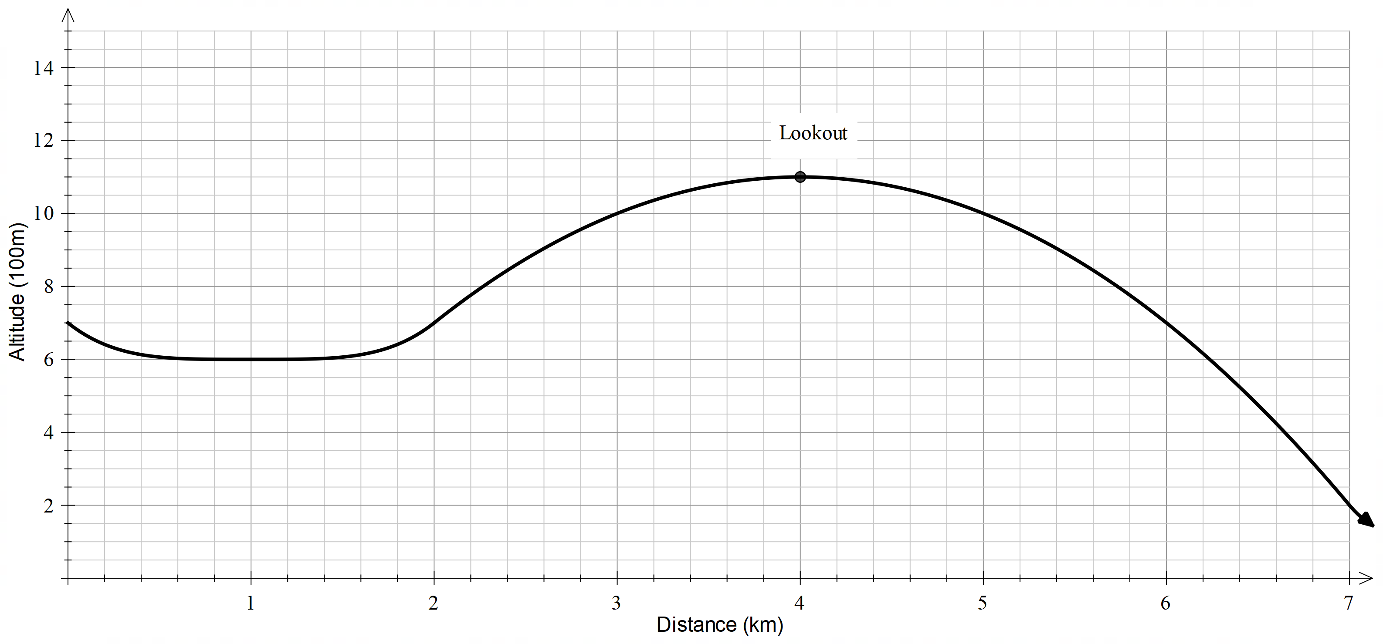
- What is the local maximum of day 1?
- What is the local minimum of day 1?
- How does this compare with the maximum and minimum altitude the hiker reached?

Day 2
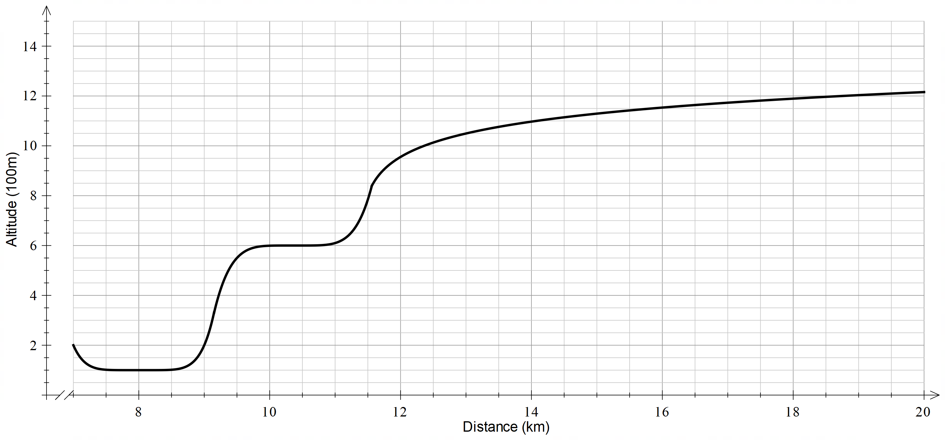
- Is there a local maximum for day 2?
- What was the local minimum of day 2?
- How does this compare with the maximum and minimum altitude the hiker reached on
day 2?
Overall trip
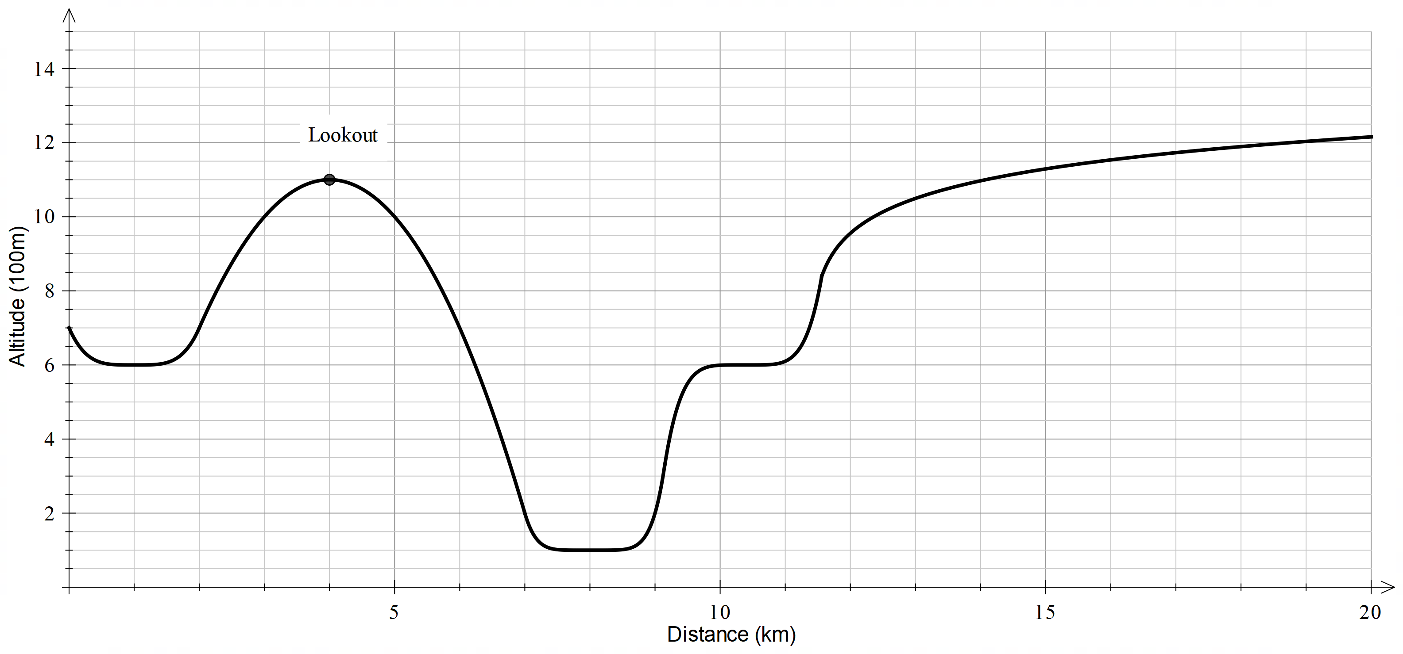
- What was the minimum altitude of the hiker?
- What was the maximum altitude of the hiker?
- Compare these points with the local maximum and local minimums. What does this mean in the context of the hiker?

Appendix B

Labelling maximums and minimums
For each graph, label the global maximum with an $A$ and the global minimum with a $B$ as well as any local maximums with $a$ and local minimums with $b$.
$$f\left(x\right)=x^{3}-3x, -1.9≤x≤1.9$$  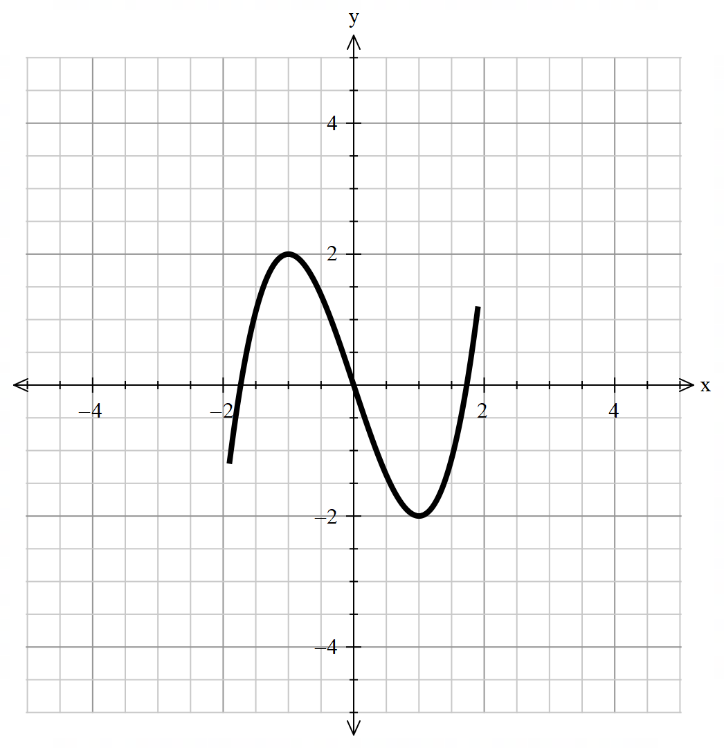 | $$f\left(x\right)=x^{2}, -2≤x≤1$$  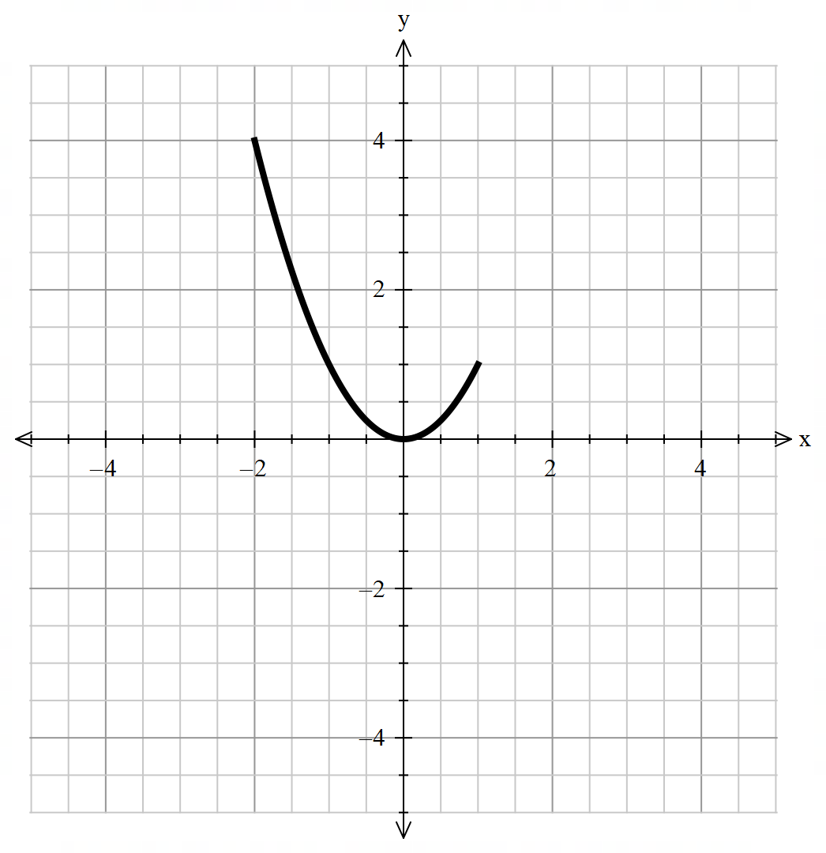
$$f\left(x\right)=-{\left(x-1\right)}^{2}+4, 0≤x≤3$$  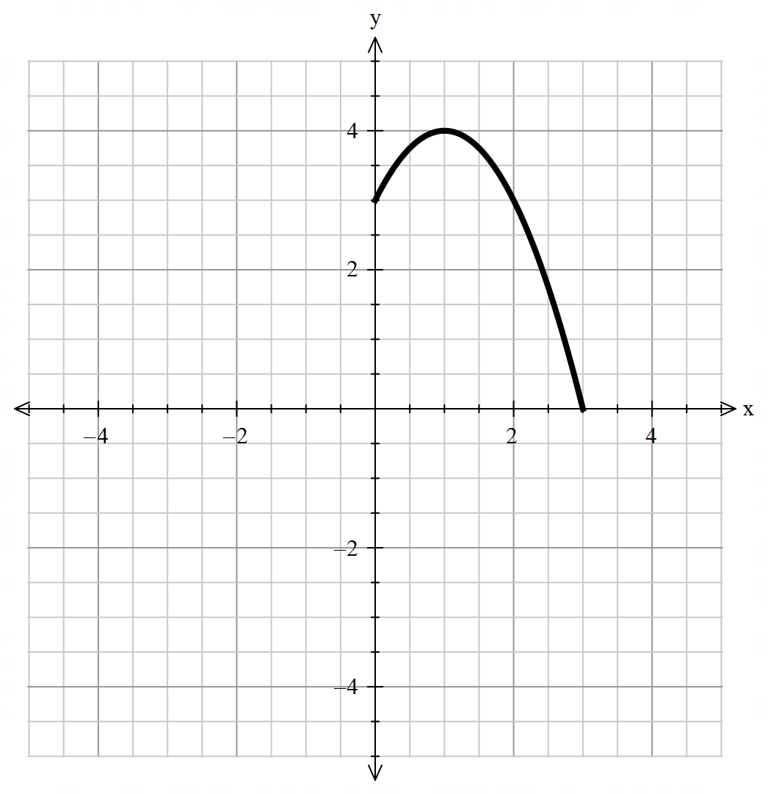 | $$f\left(x\right)=x^{3}-3x$$  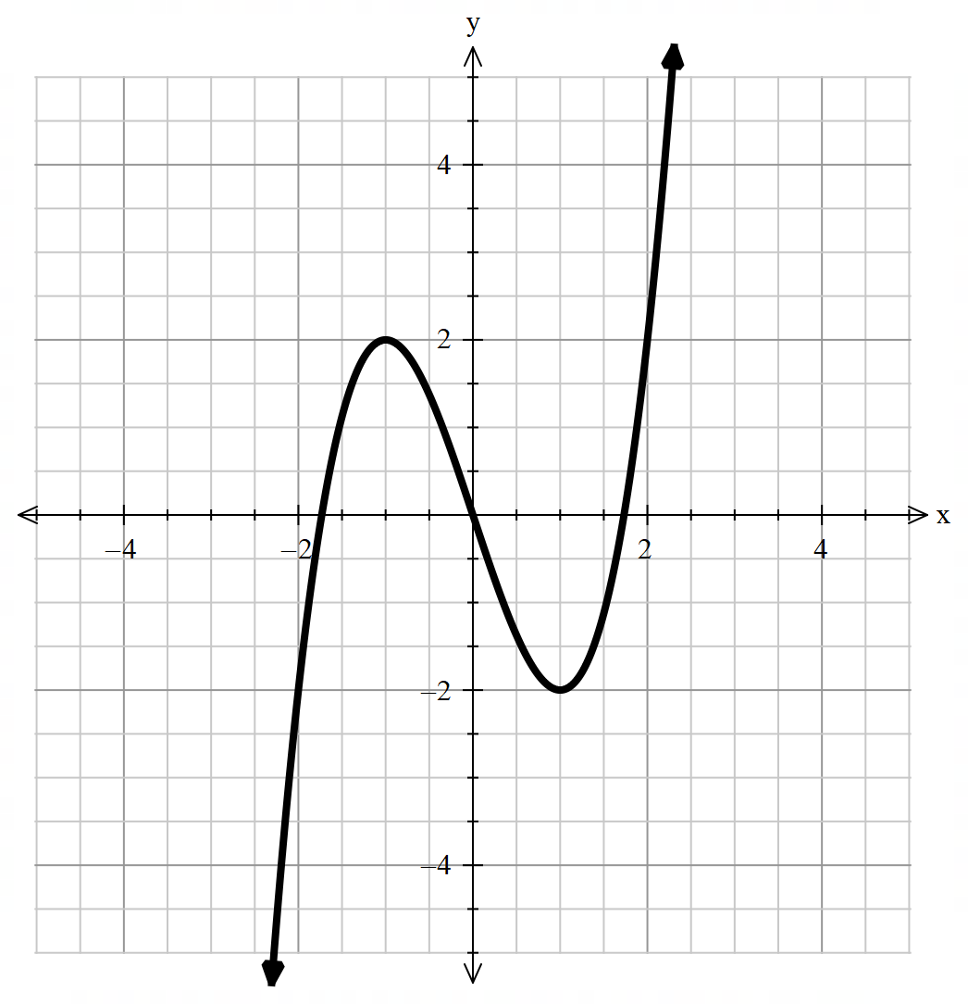
$$f\left(x\right)=\left\{\begin{aligned}-2x-1, -3≤x<0.5 \\ x^{3}+\frac{3}{2}x^{2}-\frac{9}{4}x-\frac{15}{8}, 0.5≤x<1.5 \\ -{\left(x-3\right)}^{2}+4, 1.5≤x<5\end{aligned}\right.$$  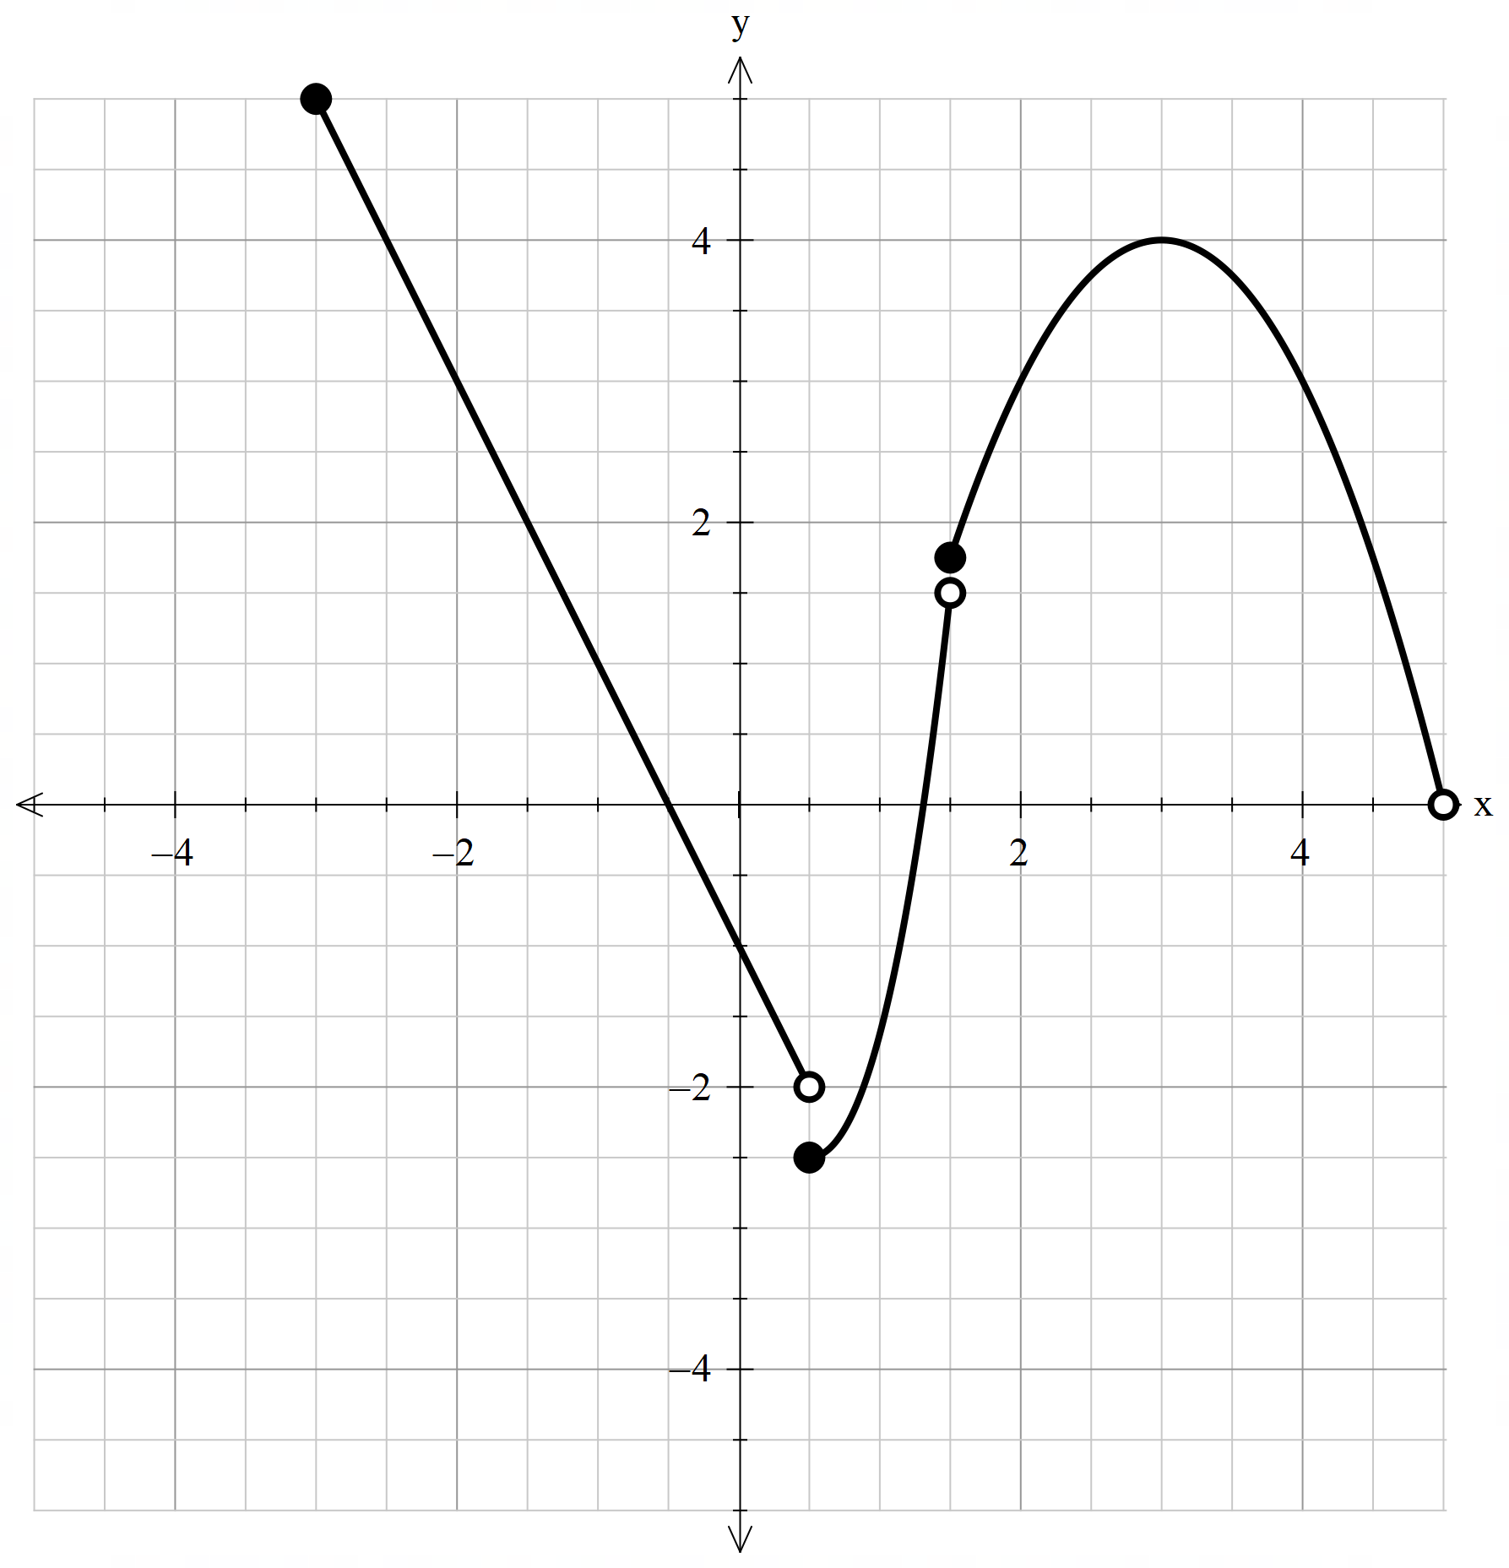 | $$f\left(x\right)=\left|\frac{3}{4}x+2\right|, x≥-4$$  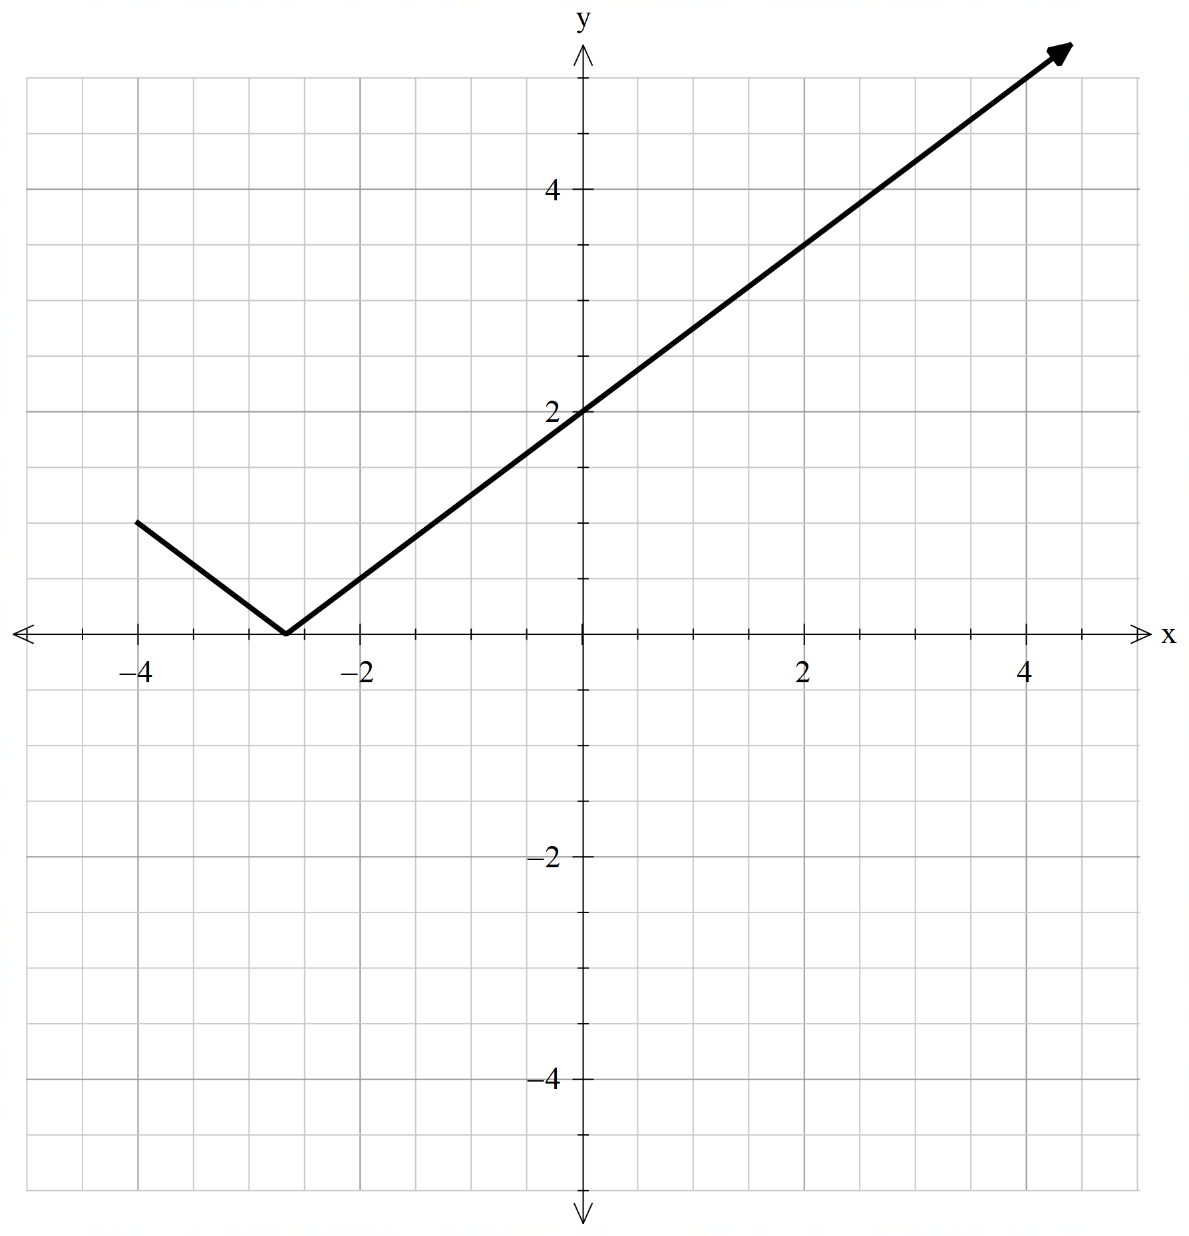
$$f\left(x\right)=\frac{2x-1}{x+1}, -4≤x≤4$$  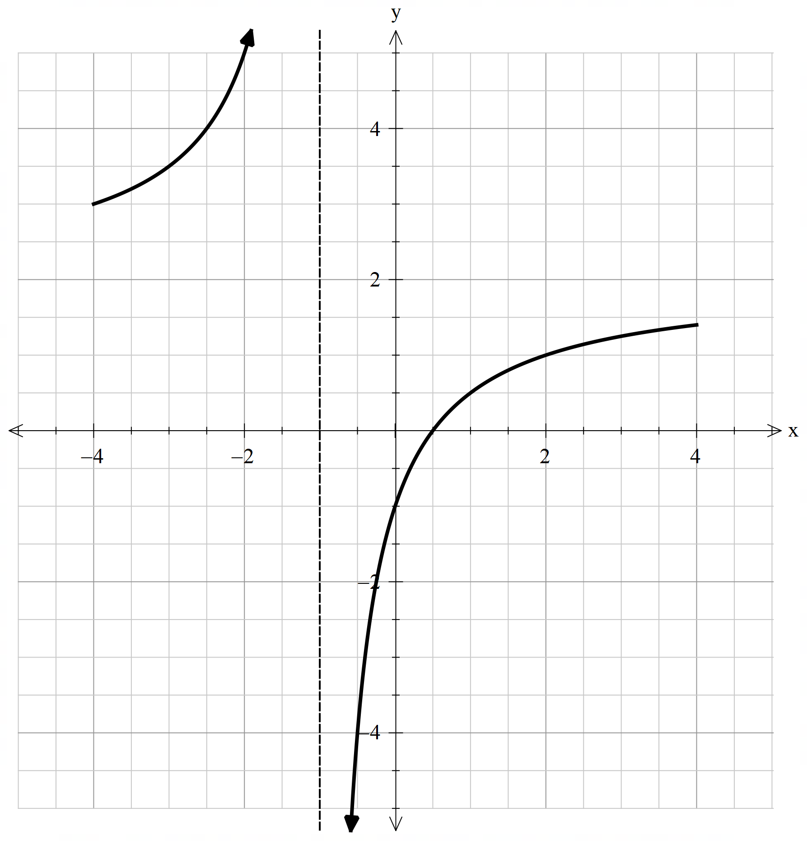 | $$f\left(x\right)=\frac{x^{2}+1}{x+1}, -1<x≤3$$  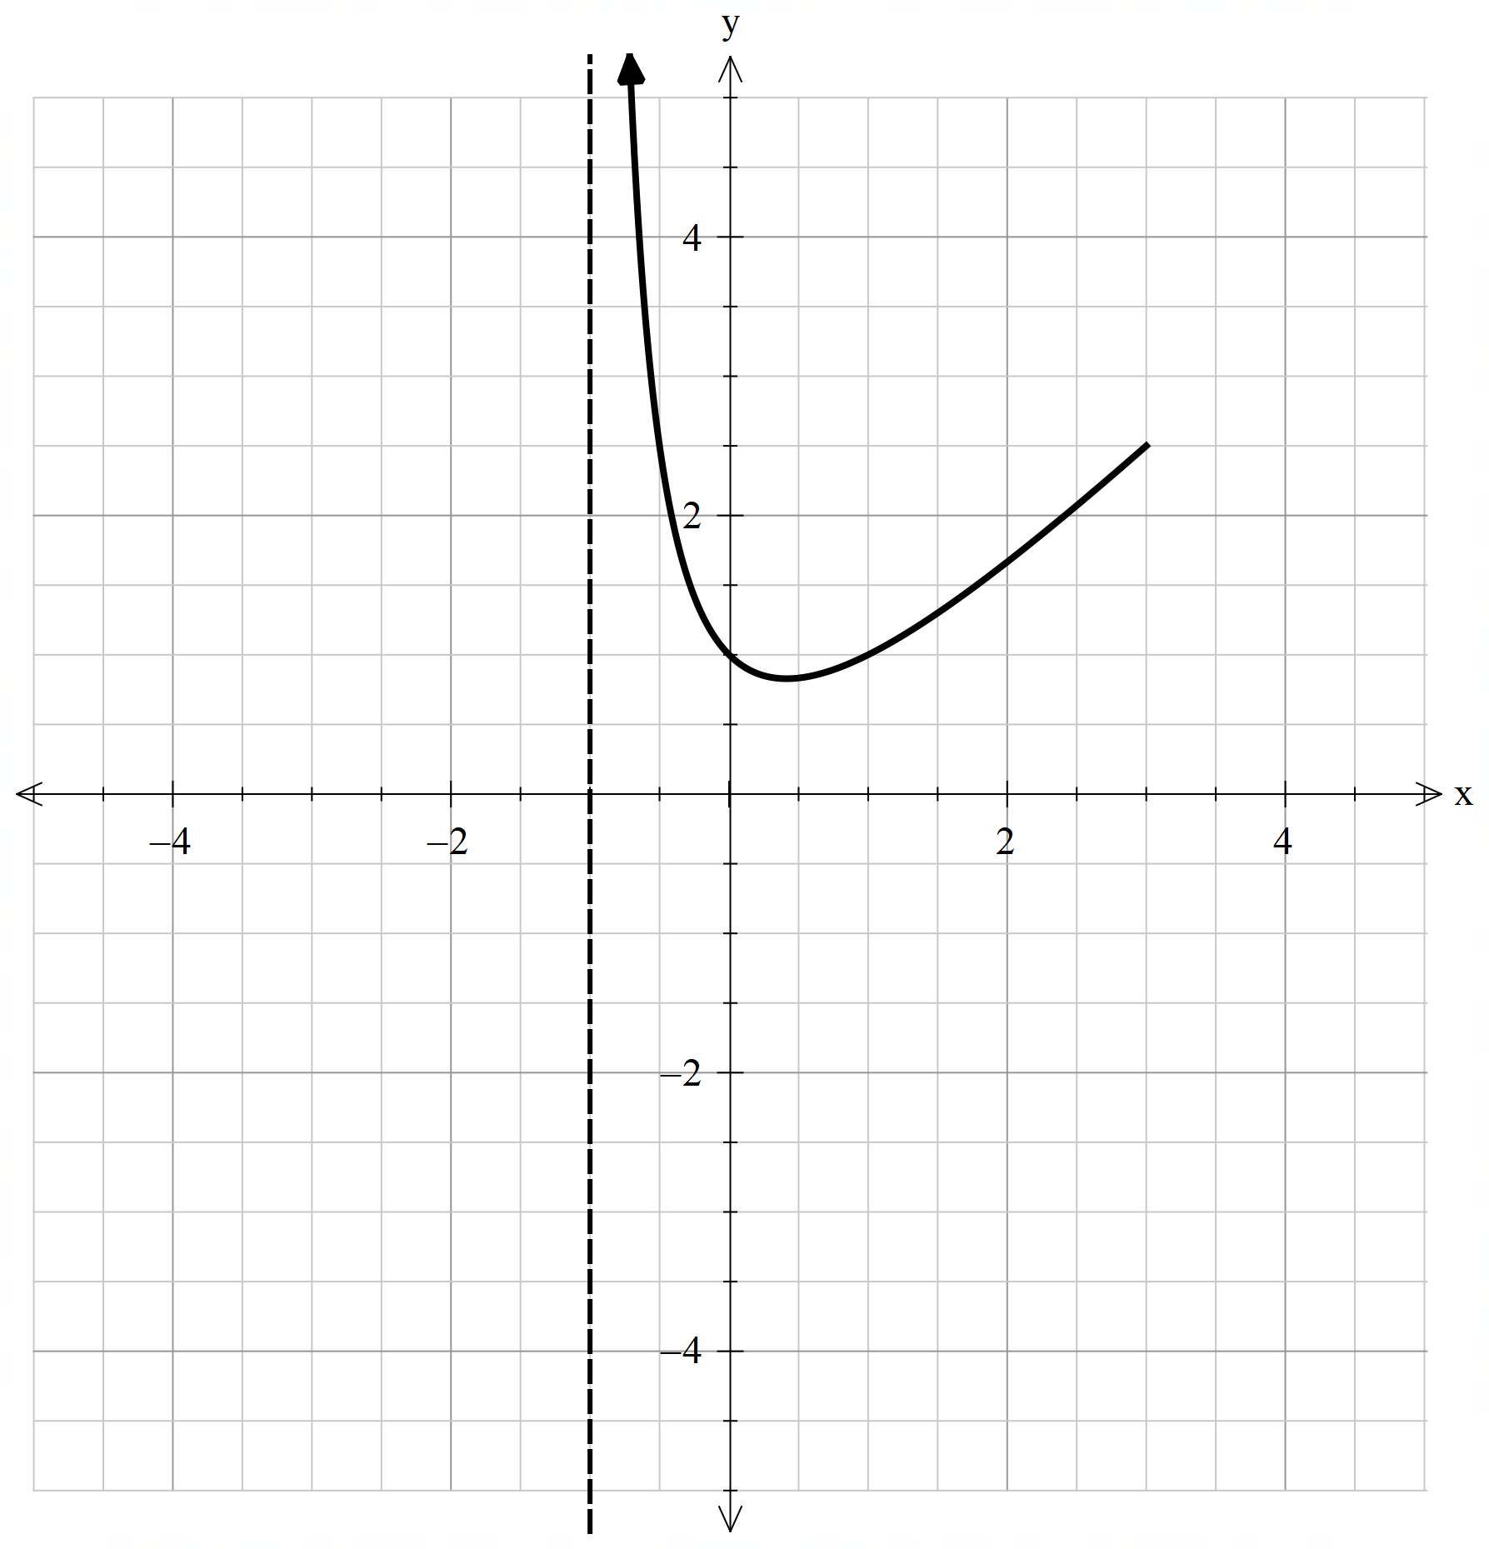

Appendix C

Worked example
Graph the function $f(x)=xe^{-x}$ on the domain $-1≤x≤4$ to determine the global minimum and maximum points.
Solution:
Find stationary points and determine their nature
$$f^{'}\left(x\right)=e^{-x}-xe^{-x} \\ =e^{-x}\left(1-x\right) \\ f^{''}\left(x\right)={-e}^{-x}\left(1-x\right)-e^{-x} \\ =e^{-x}\left(x-2\right) \\ \text{When }f^{'}\left(x\right)=0 \\ x=1 \\ f^{''}\left(1\right)=e^{-1}\left(1-2\right)<0 →\text{local max} \\ \text{When }f^{''}\left(x\right)=0 \\ x=2$$
$$x$$ | $$1$$ | $$2$$ | $$3$$
$$f^{''}\left(x\right)$$ | $$<0$$ | $$0$$ | $$>0$$
$∴\left(1,e^{-1}\right) \text{is} \text{a} \text{local} \text{maximum} \text{and} \left(2,e^{-2}\right) \text{is} \text{a} \text{point} \text{of} \text{inflection}.$
Check the behaviour of the function:
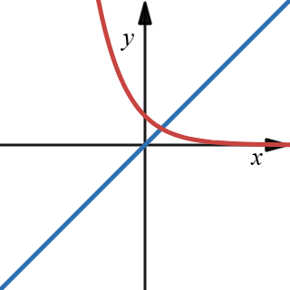
$$x$$ | $$-1$$ | $$-0.5$$ | $$0$$
$$f(x)$$ | $$≈-2.72$$ | $$≈-0.82$$ | $$0$$
When $x<0, f\left(x\right)<0.$
$$x$$ | $$3$$ | $$3.5$$ | $$4$$
$$f(x)$$ | $$≈0.15$$ | $$≈0.11$$ | $$≈0.07$$
When $x>0, f\left(x\right)>0.$
Draw the function and determine global maximum and global minimum:
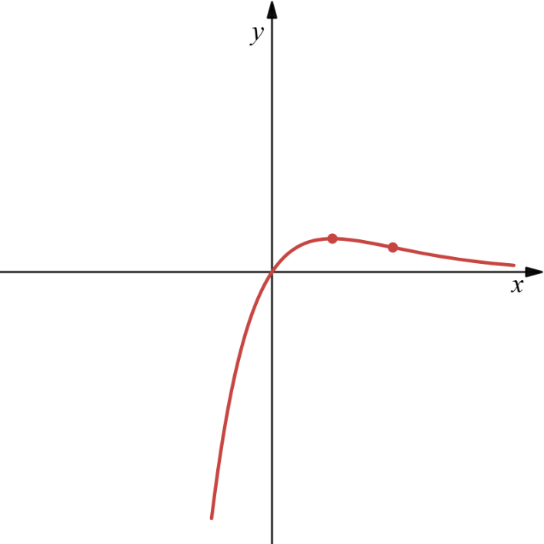
By inspecting the graph: global maximum at stationary point $(1,e^{-1})$ and global minimum at endpoint $(-1,-e)$.

Appendix D

Incorrect worked solutions
For each question, determine where the error occurred.
Question and incorrect solution | Error | Correct solution/visual representation
$$f\left(x\right)=x^{2}-4x+1, 0≤x≤5$$
Incorrect solution:
$$f^{'}\left(x\right)=2x-4 \\ x=2 \\ f\left(2\right)=-3$$
$$∴\text{global minimum is at} \left(2,-3\right). \\ \text{Since the parabola is concave up, there }$$$\text{is} \text{no global maximum}$.

$$f\left(x\right)=\frac{x+2}{x-1}, -2≤x≤4$$
Incorrect solution:
$$f^{'}\left(x\right)=\frac{\left(x-1\right)-(x+2)}{{\left(x-1\right)}^{2}} \\ =-\frac{3}{{\left(x-1\right)}^{2}}$$
Since $f^{'}\left(x\right)≠0$, there are no stationary points.
Check endpoints:
$$f\left(-2\right)=0 \\ f\left(4\right)=2$$$∴$ global minimum at $(-2,0)$ and global maximum at $(4,2)$.

$$f\left(x\right)=x^{2}e^{x}, -3≤x≤1$$
Incorrect solution:
$$f^{'}\left(x\right)=3x^{2}-6x \\ 3x\left(x-2\right)=0 \\ x=0,2 \\ f\left(0\right)=2 \\ f\left(2\right)=2^{3}-3{\left(x\right)}^{2}+2 \\ =-2 \\ f^{'}\left(x\right)=2xe^{x}+x^{2}e^{x} \\ =xe^{x}\left(x+2\right) \\ f^{'}\left(x\right)=0 \text{when} x=0 \text{or}-2 \\ f^{''}\left(x\right)=e^{x}\left(x^{2}+2x\right)+\left(2x+2\right)e^{x} \\ =e^{x}\left(x^{2}+4x+2\right) \\ f^{''}\left(0\right)=2→\text{local} \text{minimum} \\ f^{''}\left(-2\right)<0→\text{local maximum} \\ f\left(0\right)=0 \\ f\left(-2\right)=4e^{-2} \\ ∴\text{global minimum at} \left(0,0\right) \\ \text{and global maximum at} (-2,4e^{-2})$$
$$f\left(x\right)=x-\ln{x}, 0.2≤x≤4$$
Incorrect worked solution:
$$f^{'}\left(x\right)=1-\frac{1}{x} \\ f^{'}\left(x\right)=0 \text{when} x=1 \\ f^{''}\left(x\right)=\frac{1}{x^{2}} \\ f^{''}\left(1\right)=1>0→\text{local minimum} \\ f\left(1\right)=1-\ln{1} \\ =1 \\ ∴\text{global minimum as} \left(1,1\right).$$As there are no other stationary points the function has no global maximum.

$$f\left(x\right)=\sin{x}+\cos{x}, 0≤x≤2π$$
Incorrect worked solution:
$$f^{'}\left(x\right)=\cos{x}-\sin{x} \\ \cos{x}-\sin{x}=0 \\ \cos{x}=\sin{x} \\ \tan{x}=1 \\ x=\frac{π}{4} \\ f\left(\frac{π}{4}\right)=\frac{1}{\sqrt{2}}+\frac{1}{\sqrt{2}} \\ =\sqrt{2}$$
Check endpoints.
$$f\left(0\right)=1 \\ f\left(2π\right)=1$$
$∴$ global maximum is $\left(\frac{π}{4},\sqrt{2}\right)$ and global minimums at $(0,1)$ and $(2π,1)$.

Sample solutions

Appendix A – hiking trip
- Local minimum is 600 m.
- Local maximum is 1100 m.
- The maximum altitude the hiker reached on day 1 is also 1100 m, but the minimum altitude the hiker reached on Day 1 is 200 m.
- There is no local maximum for day 2 as the hiker continued to climb all day.
- Local minimum is 100 m.
- The local minimum is the same as the minimum altitude. The maximum altitude reached is 1200 m.
- Minimum altitude is 100 m.
- Maximum altitude is 1200 m.
- The minimum altitude is also a local minimum but the maximum altitude is not a local maximum. It occurs at the end point.

Appendix B – labelling maximums and minimums
$$f\left(x\right)=x^{3}-3x, -1.9≤x≤1.9$$  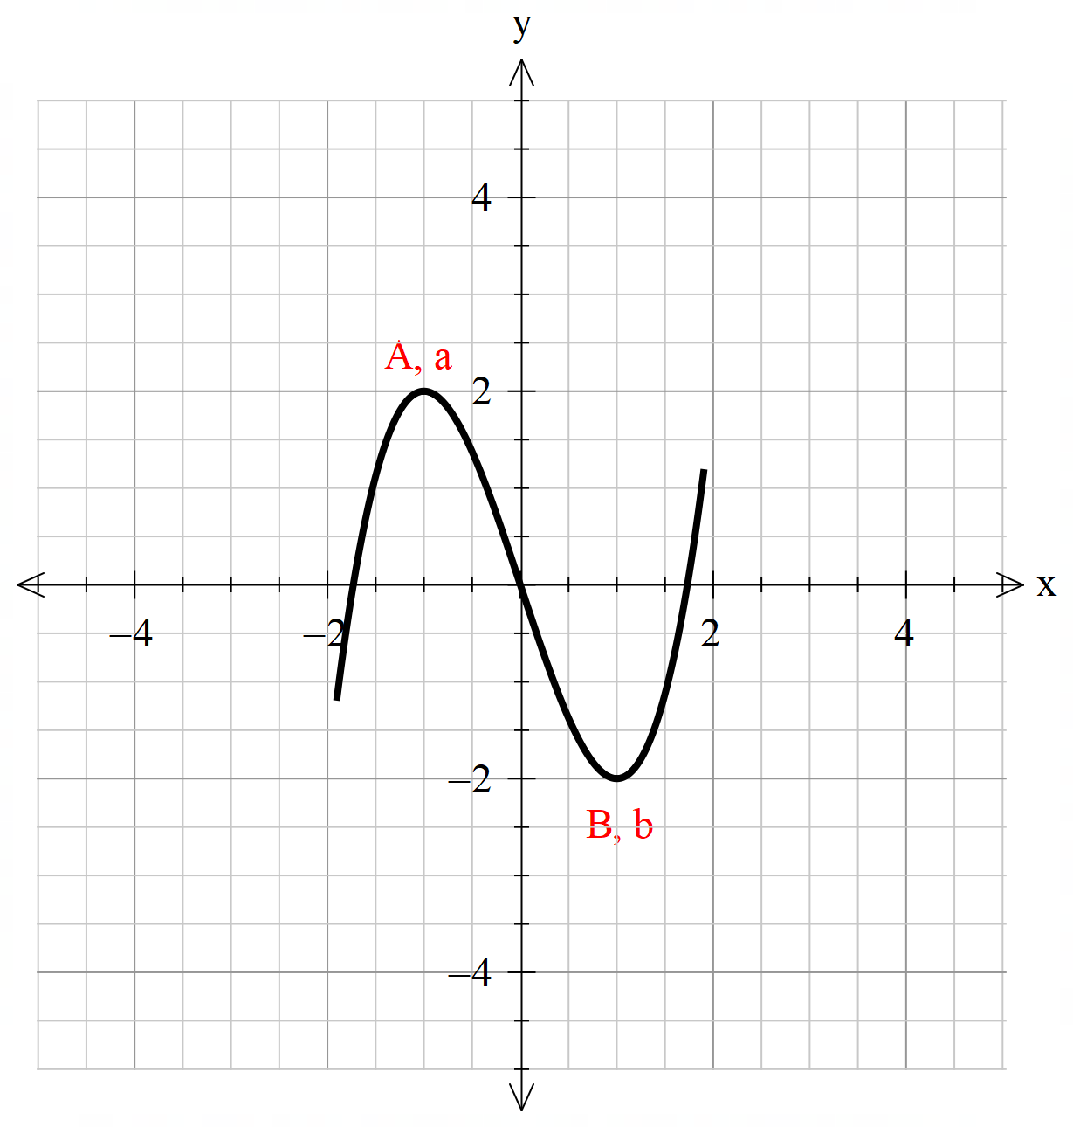 | $$f\left(x\right)=x^{2}, -2≤x≤1$$  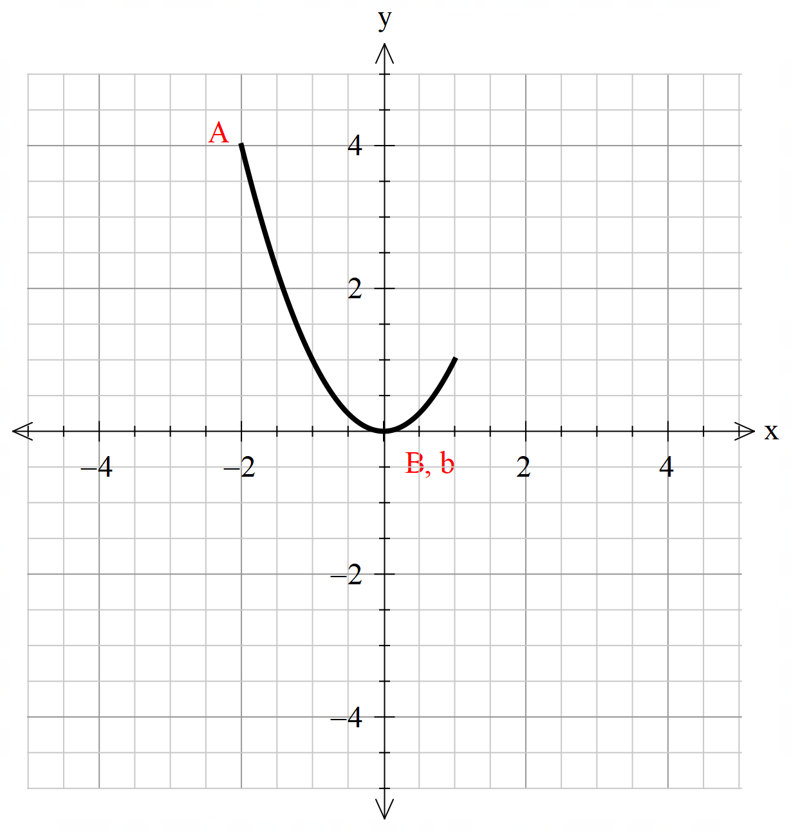
$$f\left(x\right)=-{\left(x-1\right)}^{2}+4, 0≤x≤3$$  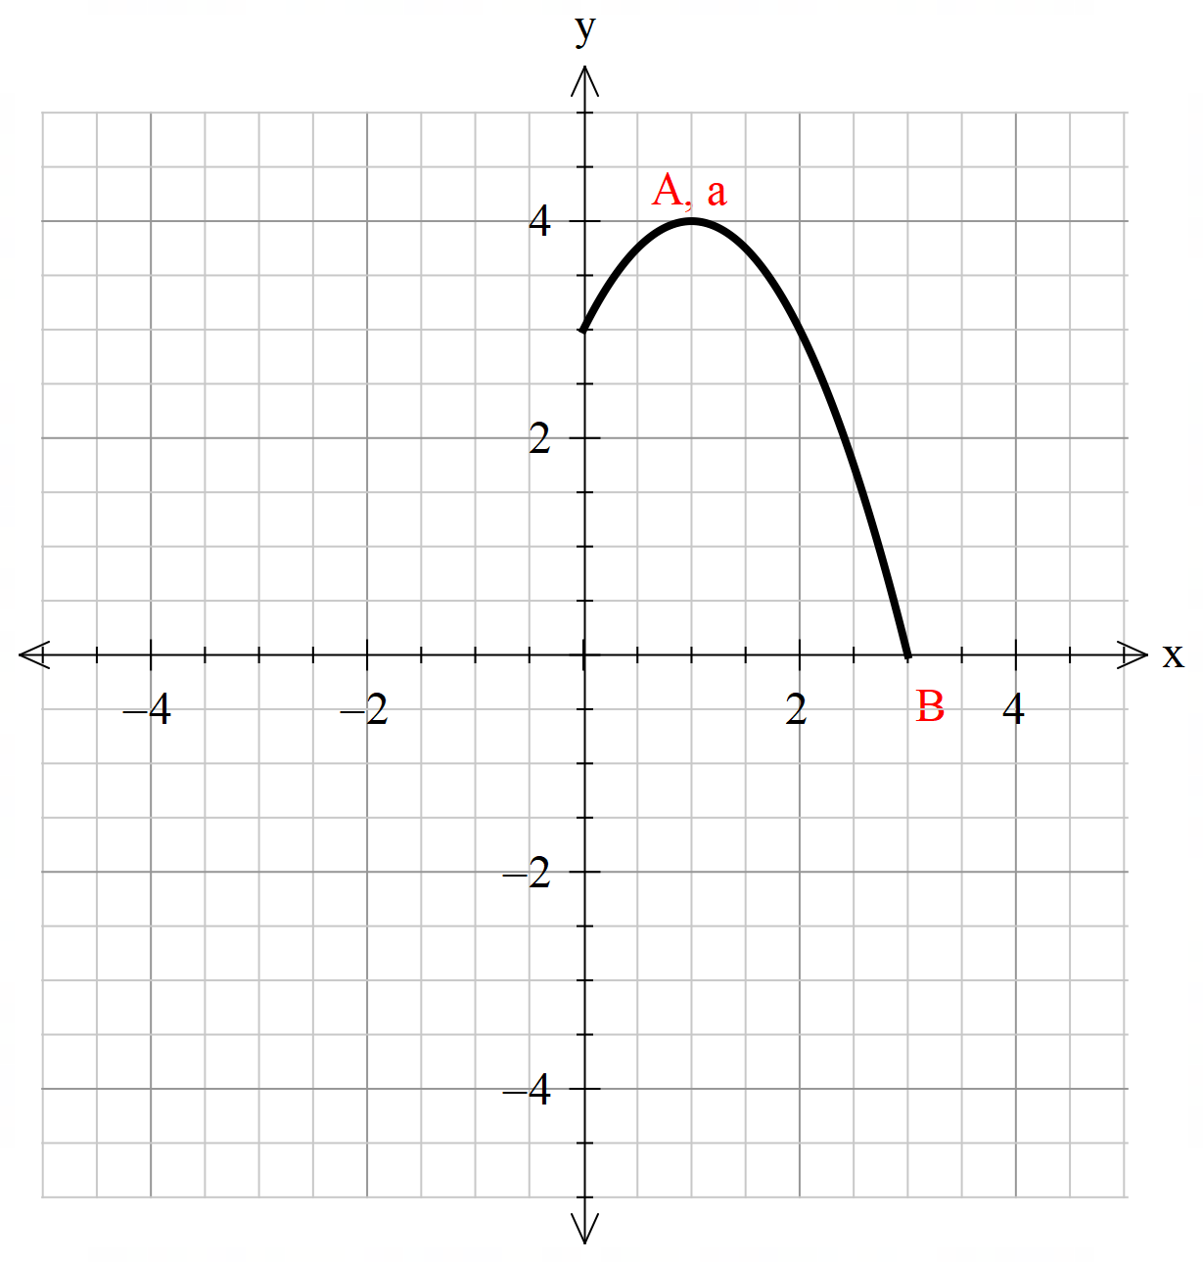 | $$f\left(x\right)=x^{3}-3x$$  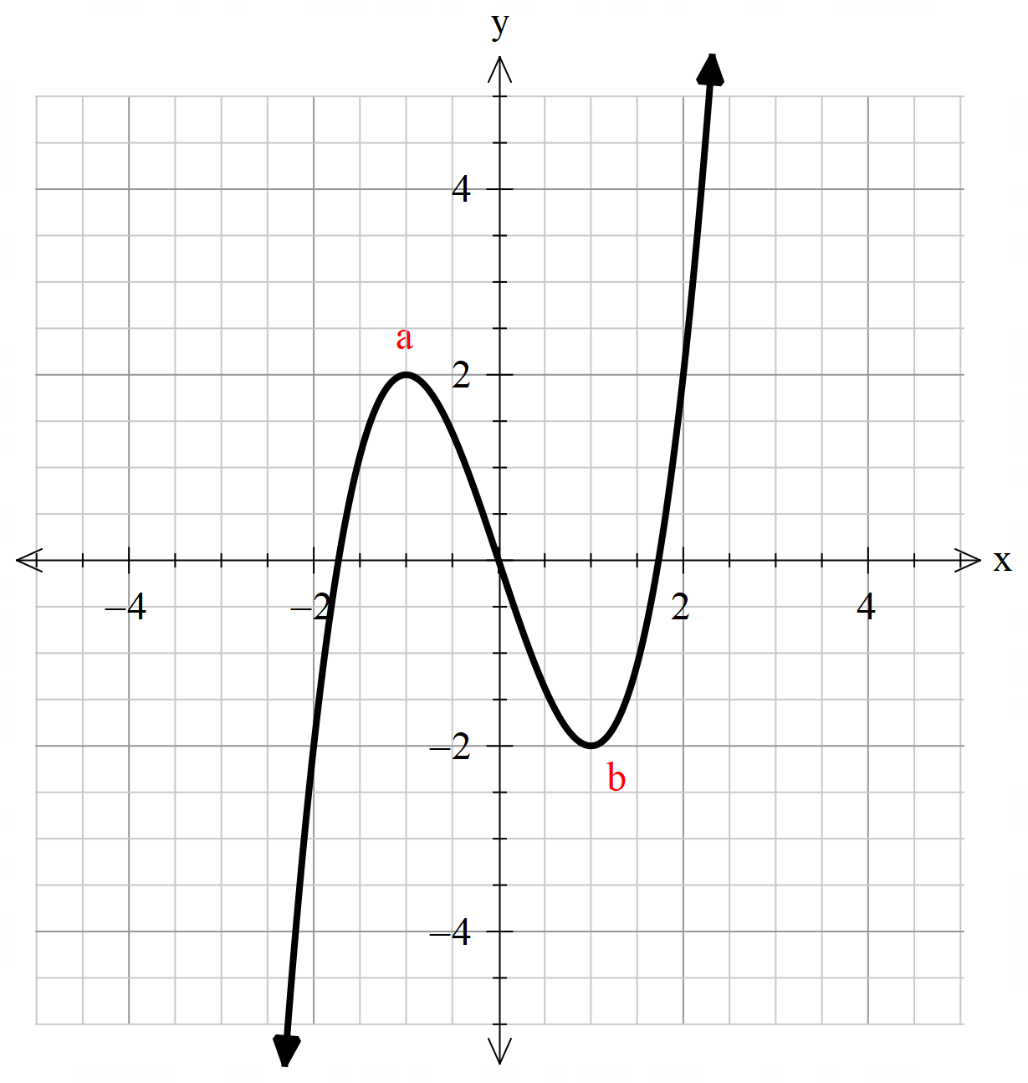
$$f\left(x\right)=\left\{\begin{aligned}-2x-1, -3≤x<0.5 \\ x^{3}+\frac{3}{2}x^{2}-\frac{9}{4}x-\frac{15}{8}, 0.5≤x<1.5 \\ -{\left(x-3\right)}^{2}+4, 1.5≤x<5\end{aligned}\right.$$  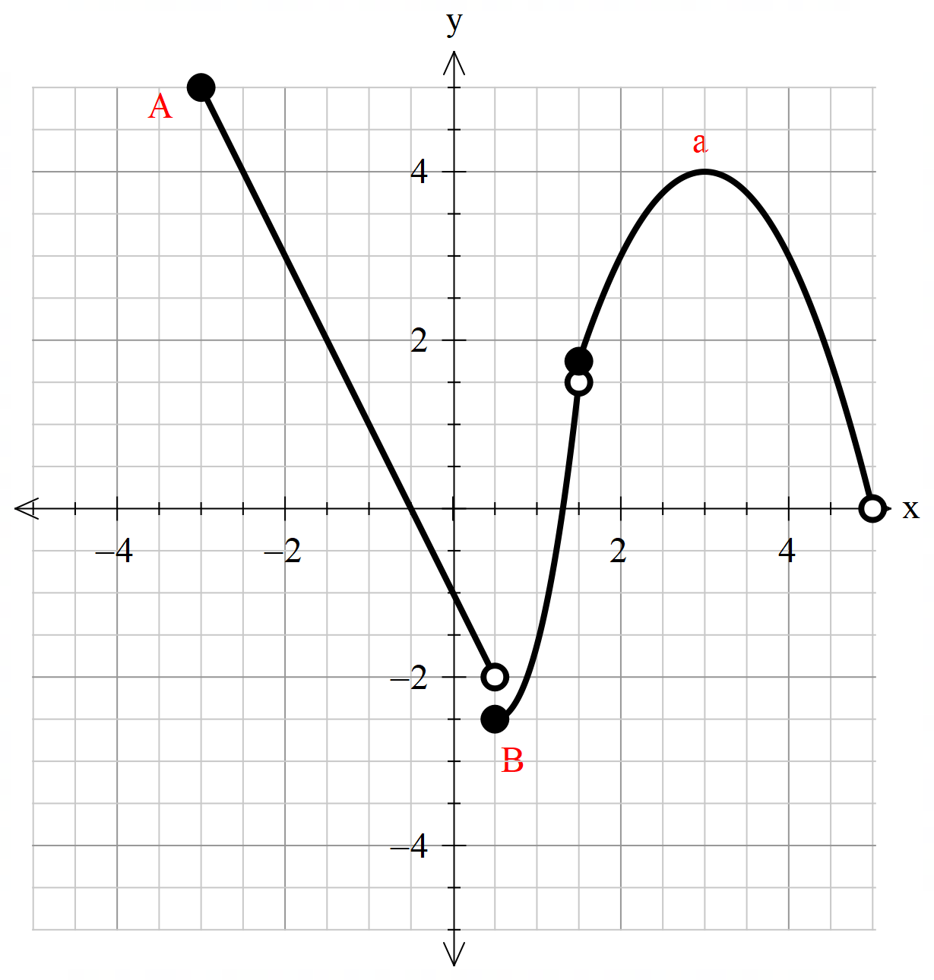 | $$f\left(x\right)=\left|\frac{3}{4}x+2\right|, x≥-4$$  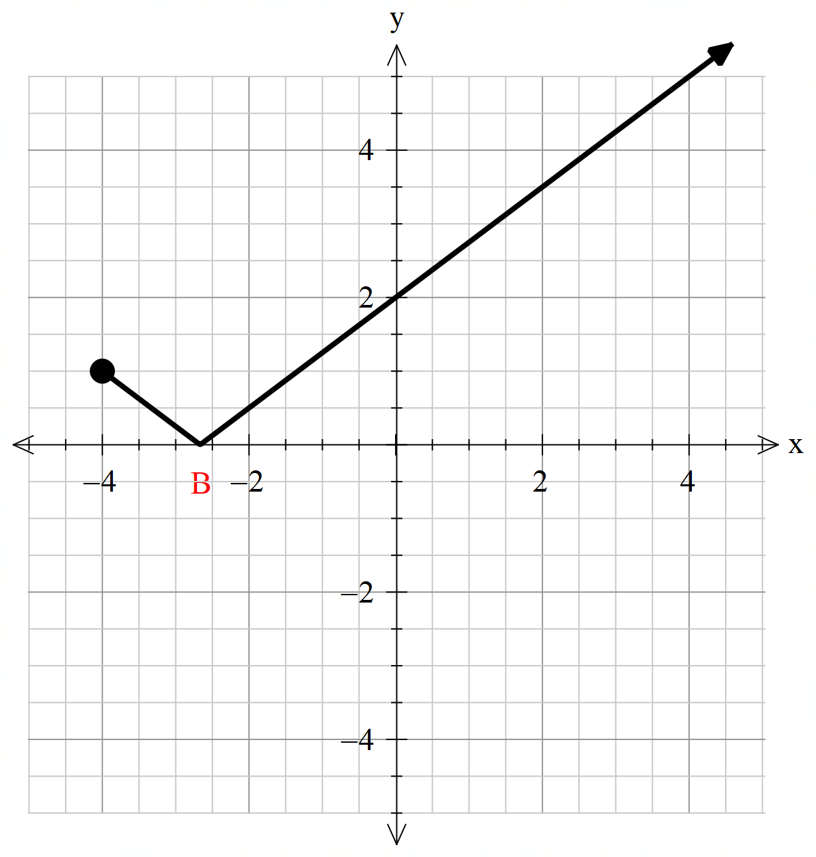
$$f\left(x\right)=\frac{2x-1}{x+1}, -4≤x≤4$$  No global or local maximum or minimum | $$f\left(x\right)=\frac{x^{2}+1}{x+1}, -1<x≤3$$  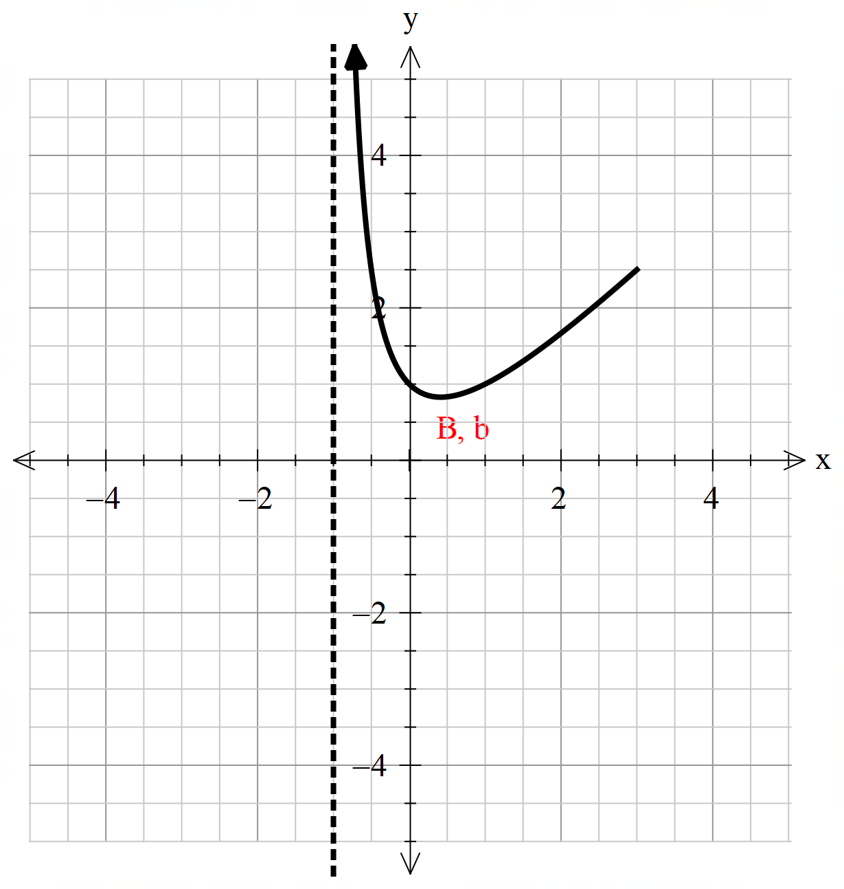

Appendix D – incorrect worked solutions
Question and incorrect solution | Error | Correct solution/visual representation
$$f\left(x\right)=x^{2}-4x+1, 0≤x≤5$$  Incorrect solution:  $$f^{'}\left(x\right)=2x-4 \\ x=2 \\ f\left(2\right)=-3$$  $$∴\text{global minimum is at} \left(2,-3\right). \\ \text{Since the parabola is concave up, there }$$$\text{is} \text{no global maximum}$. | The endpoints were ignored. | Check endpoints and discontinuity:  $$f\left(0\right)=1 \\ f\left(5\right)=6$$  Compare endpoints, discontinuities and stationary points.  $$\left(0,1\right), \left(2,-3\right), \left(5,6\right)$$$∴$ global minimum at $(2,-3)$ and global maximum at $(5, 6)$.  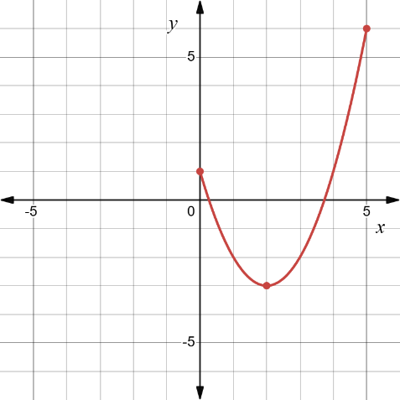
$$f\left(x\right)=\frac{x+2}{x-1}, -2≤x≤4$$  Incorrect solution:  $$f^{'}\left(x\right)=\frac{\left(x-1\right)-(x+2)}{{\left(x-1\right)}^{2}} \\ =-\frac{3}{{\left(x-1\right)}^{2}}$$  Since $f^{'}\left(x\right)≠0$, there are no stationary points.  Check endpoints:  $$f\left(-2\right)=0 \\ f\left(4\right)=2$$$∴$ global minimum at $(-2,0)$ and global maximum at $(4,2)$. | Did not consider the function as it approaches the asymptote $x=1$. | As $x→1$ from the left hand side, $f\left(x\right)→-∞$ and as $x→1$ from the right hand side, $f\left(x\right)→∞$.  $∴$ no global minimum or maximum.  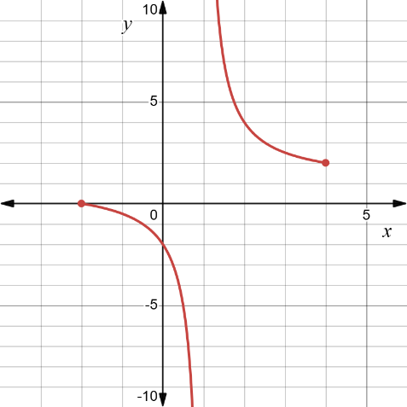
$$f\left(x\right)=x^{2}e^{x}, -3≤x≤1$$  Incorrect solution:  $$f^{'}\left(x\right)=3x^{2}-6x \\ 3x\left(x-2\right)=0 \\ x=0,2 \\ f\left(0\right)=2 \\ f\left(2\right)=2^{3}-3{\left(x\right)}^{2}+2 \\ =-2 \\ f^{'}\left(x\right)=2xe^{x}+x^{2}e^{x} \\ =xe^{x}\left(x+2\right) \\ f^{'}\left(x\right)=0 \text{when} x=0 \text{or}-2 \\ f^{''}\left(x\right)=e^{x}\left(x^{2}+2x\right)+\left(2x+2\right)e^{x} \\ =e^{x}\left(x^{2}+4x+2\right) \\ f^{''}\left(0\right)=2→\text{local} \text{minimum} \\ f^{''}\left(-2\right)<0→\text{local maximum} \\ f\left(0\right)=0 \\ f\left(-2\right)=4e^{-2} \\ ∴\text{global minimum at} \left(0,0\right) \\ \text{and global maximum at} \left(-2,4e^{-2}\right).$$ | The endpoints were ignored. | Check endpoints:  $$f\left(-3\right)=9e^{-3} \\ f\left(1\right)=e$$  Compare endpoints and stationary points.  $$\left(-3,9e^{-3}\right), \left(-2,4e^{-2}\right),(0,0) \left(1,e\right)$$  $∴$ global minimum at $(0,0)$ and global maximum at $(1,e)$.  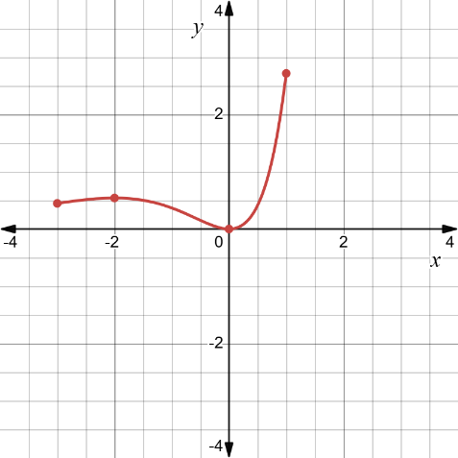
$$f\left(x\right)=x-\ln{x}, 0.2≤x≤4$$  Incorrect worked solution:  $$f^{'}\left(x\right)=1-\frac{1}{x} \\ f^{'}\left(x\right)=0 \text{when} x=1 \\ f^{''}\left(x\right)=\frac{1}{x^{2}} \\ f^{''}\left(1\right)=1>0→\text{local minimum} \\ f\left(1\right)=1-\ln{1} \\ =1 \\ ∴\text{global minimum as} \left(1,1\right).$$As there are no other stationary points the function has no global maximum. | The endpoints were ignored. | Check endpoints:  $$f\left(0.2\right)=0.2-\ln{0.2} \\ ≈1.8 \\ f\left(4\right)=4-\ln{4} \\ ≈2.6$$  Compare endpoints and stationary points.  $$\left(0.2,1.8\right), \left(1,1\right), (4,2.6)$$  $∴$ global minimum at $(1,1)$ and global maximum at $(4,2.6)$.  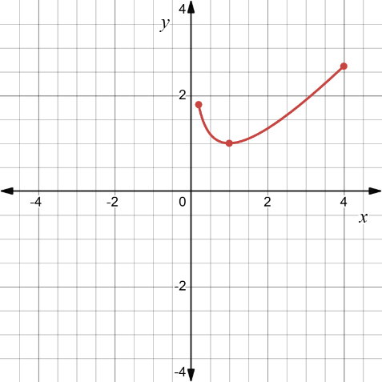
$$f\left(x\right)=\sin{x}+\cos{x}, 0≤x≤2π$$  Incorrect worked solution:  $$f^{'}\left(x\right)=\cos{x}-\sin{x} \\ \cos{x}-\sin{x}=0 \\ \cos{x}=\sin{x} \\ \tan{x}=1 \\ x=\frac{π}{4} \\ f\left(\frac{π}{4}\right)=\frac{1}{\sqrt{2}}+\frac{1}{\sqrt{2}} \\ =\sqrt{2}$$  Check endpoints.  $$f\left(0\right)=1 \\ f\left(2π\right)=1$$  $∴$ global maximum is $\left(\frac{π}{4},\sqrt{2}\right)$ and global minimums at $(0,1)$ and $(2π,1)$. | Did not consider other solutions for $\tan{x}=1$ in the domain. | Solve $\tan{x}=1$ for $0≤x≤2π$.  $$\tan{x} \text{is positive in quadrant 1 and 3.} \\ \tan{x}=1 \\ x=\frac{π}{4},π+\frac{π}{4} \\ =\frac{π}{4},\frac{5π}{4} \\ f\left(\frac{5π}{4}\right)=-\frac{1}{\sqrt{2}}-\frac{1}{\sqrt{2}} \\ =-\sqrt{2}$$  Compare stationary points and endpoints.  $$\left(0,1\right), \left(\frac{π}{4},\sqrt{2}\right), \left(\frac{5π}{4},-\sqrt{2}\right), \left(2π, 1\right)$$  $∴$ Global maximum at $\left(\frac{π}{4},\sqrt{2}\right)$ and global minimum at $\left(\frac{5π}{4},-\sqrt{2}\right)$.  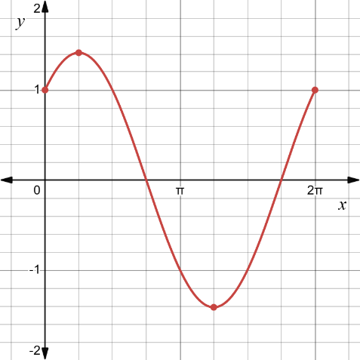

References
This resource contains NSW Curriculum and syllabus content. The NSW Curriculum is developed by the NSW Education Standards Authority (NESA). This content is prepared by NESA for and on behalf of the Crown in right of the State of New South Wales. The material is protected by Crown copyright.
Please refer to the NESA Copyright Disclaimer for more information https://www.nsw.gov.au/education-and-training/nesa/copyright.
NESA holds the only official and up-to-date versions of the NSW Curriculum and syllabus documents. Please visit NESA https://www.nsw.gov.au/education-and-training/nesa and NSW Curriculum https://curriculum.nsw.edu.au.
Mathematics Advanced 11–12 Syllabus © NSW Education Standards Authority (NESA) for and on behalf of the Crown in right of the State of New South Wales, 2024.

© State of New South Wales (Department of Education), 2026
The copyright material published in this resource is subject to the Copyright Act 1968 (Cth) and is owned by the NSW Department of Education or, where indicated, by a party other than the NSW Department of Education (third-party material).
Copyright material available in this resource and owned by the NSW Department of Education is licensed under a Creative Commons Attribution 4.0 International (CC BY 4.0) license.

This license allows you to share and adapt the material for any purpose, even commercially. Attribution should be given to © State of New South Wales (Department of Education), 2026.
Material in this resource not available under a Creative Commons license:
- the NSW Department of Education logo, other logos and trademark-protected material
- material owned by a third party that has been reproduced with permission. You will need to obtain permission from the third party to reuse its material.
Links to third-party material and websites
Please note that the provided (reading/viewing material/list/links/texts) are a suggestion only and implies no endorsement, by the New South Wales Department of Education, of any author, publisher, or book title. School principals and teachers are best placed to assess the suitability of resources that would complement the curriculum and reflect the needs and interests of their students.
If you use the links provided in this document to access a third-party's website, you acknowledge that the terms of use, including licence terms set out on the third-party's website apply to the use which may be made of the materials on that third-party website or where permitted by the Copyright Act 1968 (Cth). The department accepts no responsibility for content on third-party websites.

