Graphing functions with calculus
Students extend their graphing skills to include reciprocal, exponential, logarithmic and trigonometric functions. They analyse the behaviour of functions near asymptotes, discontinuities and as $x→±∞$, using derivative information and key graphical features to justify accurate graphs.

Learning intention
- To understand how asymptotes, discontinuities and end behaviour influence the shape of functions.

Success criteria
- I can identify important features of functions, including asymptotes, discontinuities, stationary points and end behaviour.
- I can justify the behaviour of a graph near asymptotes and as $x→±∞$.
- I can accurately draw the graph of a function.

Outcomes
A student:
- develops understanding and fluency in mathematics through exploring and connecting mathematical concepts, choosing and applying mathematical techniques to solve problems, and communicating their thinking and reasoning coherently and clearly MAO-WM-01
- applies calculus to graph functions and model and solve problems involving optimisation, rates of change and motion in a line MAV-12-06

Content

Turning points, inflections and graphing
- Graph a function by determining local maxima and minima and points of inflection, horizontal and non-horizontal, considering any even or odd symmetry, the domain, any vertical asymptotes or other discontinuities, and where applicable, the behaviour of a function as
$$x→±∞$$
Mathematics Advanced 11–12 Syllabus © NSW Education Standards Authority (NESA) for and on behalf of the Crown in right of the State of New South Wales, 2024.

Table 1: lesson summary
Section | Summary of activity | Teaching strategies | Teaching points
Activating prior knowledge | Use slides 4–9 from the PowerPoint Graphing functions with calculus for students to identify functions from graphical clues and compare the characteristics of trigonometric and polynomial graphs. | Mini whiteboards | Draw attention to key graphical features of trigonometric functions, including symmetry, intercepts and overall behaviour. Support students to identify similarities and differences between trigonometric and polynomial functions in preparation for developing formal graphical representations.
Connecting learning | Use slides 11–14 for students to investigate the features of $y=xe^{x}$, using information from related functions, graphical features and tables of values to construct and refine a graph of the function. | Visibly random groups  of 3  Vertical non-permanent surfaces  Gallery walk  Pose-Pause-Pounce-Bounce  Notice and wonder | Draw connections between the equation of a function and its graphical features, including asymptotes, intercepts, stationary points, end behaviour and concavity. Support students to use multiple representations, including known graphs and tables of values, to make and refine predictions about the shape of a graph. Highlight that tables of values can support graphing but may not provide sufficient information to accurately represent all key features of a function.
Releasing responsibility | Use slides 16–19 to model the process of graphing functions with calculus before using Appendix A for students to apply the process to a new function. Slide 20 can be used to display the graph for Appendix A before students create notes. | Worked examples (Your turn)  Notes to future forgetful selves | Draw attention to the sequence of information used to construct a graph, including asymptotes, intercepts, turning points, end behaviour and concavity. Support students to apply a systematic process when graphing functions and use self-explanation prompts to justify their reasoning.
Independent practice | Use slide 21 to review the Approaching questions scaffold before students complete HSC-style questions in Appendix B. Use a class discussion to compare strategies and approaches used to answer the questions. | Pose-Pause-Pounce-Bounce | Reinforce the application of graphing functions with calculus in HSC-style questions. Support students to select appropriate graphical features and reasoning when constructing solutions and justify the methods used to answer unfamiliar problems.

Activity structure
Please use the associated PowerPoint Graphing functions with calculus to display images in this lesson.

Activating prior knowledge
- Provide students with a mini whiteboard (bit.ly/miniwhiteboards) and display slides 4–8 from the PowerPoint. Repeatedly animate each slide to reveal 5 clues, pausing after each clue for students to discuss and predict the function. After the fifth clue, reveal the function.
- Display slide 9, which shows a graph of each of the functions and a graph of a cubic function.
- Ask students what is the same and what is different when comparing the graphs.
Students might compare the shape of the graphs, the symmetry of the graphs, which graphs pass through the origin and the behaviour of the graphs.

Connecting learning
- Assign students to visibly random groups of 3 (bit.ly/visiblegroups) at vertical non-permanent surfaces (bit.ly/VNPSstrategy) and ask students to graph the function $y=xe^{x}$.
- Before students have time to complete the graph, use a gallery walk (bit.ly/DLSgallerywalk) for students to look at the approaches used by other groups. Ask students to return to their own vertical surfaces and make any necessary refinements to their graphs.
- Once students have finished, or made significant progress towards completing the graph, use the Pose-Pause-Pounce-Bounce questioning strategy (bit.ly/P-P-P-B) to discuss the strengths and weaknesses of their approach. Possible question prompts may include:
- Which features of the graph were easy to identify?
- Which features of the graph were harder to determine?
Students may suggest that they could find the stationary points, points of inflection and the $y$-intercept. They may suggest that finding asymptotes and identifying the behaviour of the graph was more challenging.
- Display slide 11, which has 2 tables of values for the function $y=xe^{x}$, and use a notice and wonder strategy (bit.ly/noticewonderstrategy) to generate a discussion about the usefulness of tables of values to graph complex functions.
Students might notice that the first table shows a significant increase in values of $y$ for small values of $x$, which means the graph has a steep gradient for $x>0$ and the second table shows that as $x$ decreases, the $y$-values approach $0$. They may wonder how they can know these things without using a table of values and if it’s easier to sketch the entire graph using a table of values.
- Display slide 12 and use the Pose-Pause-Pounce-Bounce questioning strategy for students to consider how the graphs of $y=x$ and $y=e^{x}$ could help graph the function $y=xe^{x}$. Some possible prompts may include:
- How does considering the values of $y=x$ and $y=e^{x}$ when $x>0$ help us understand where the graph of $y=xe^{x}$ will lie?
- How does considering the values of $y=x$ and $y=e^{x}$ when $x<0$ help us understand where the graph of $y=xe^{x}$ will lie?
- How does the behaviour of $y=e^{x}$ as $x→-∞$, help us predict what will happen to $y=xe^{x}$ as $x→-∞$.
- Provide time for students to return to their graph and discuss within their group of 3 if they would adjust their graph using the graphs of $y=x$ and $y=e^{x}$ and the tables of values.
- Display slide 13, which shows the graph of the function $y=xe^{x}$, and ask students to compare it to their graph, identifying and discussing discrepancies if needed.

Releasing responsibility
- Display slides 15–18 to display a worked example before distributing Appendix A ‘Your turn’ for students to complete a scaffolded question using the Worked example (Your turn) strategy (bit.ly/supportingstrategies).
- Display slide 19 which shows the completed graph for Appendix A.
- Ask students to annotate their solution to create notes to their future forgetful selves (bit.ly/notestofutureself).

Independent practice
- Display slide 21, which contains the Approaching questions scaffold and use it to generate a discussion about what they need to consider when answering HSC-style questions.
- Distribute Appendix B ‘HSC-style questions’ and ask students to answer the questions.
- Use a Pose-Pause-Pounce-Bounce questioning strategy to discuss the questions, focusing on strategies they found useful and challenges they encountered when answering the questions.

Assessment and differentiation

Suggested opportunities for differentiation
Activating prior knowledge
- Provide students with a list of possible function types (polynomial, exponential, reciprocal, logarithmic and trigonometric) to help them identify the functions from the clues.
- Challenge students to justify their predictions after each clue and explain which graphical features helped them identify the function.
Connecting learning
- Provide students with a graphing checklist that identifies the features to consider when graphing a function.
- Challenge students to compare the usefulness of different forms of information (asymptotes, turning points, concavity and tables of values) in constructing an accurate graph and justify which provides the greatest insight into the shape of the function.
Releasing responsibility
- Support student understanding by placing them in groups so they can discuss the answers to the self-explanation prompts before sharing with the class.
- Challenge students to identify similarities and differences between the graphs of $y=\frac{\ln{x}}{x}$ and $y=x\ln{x}$ and explain how the equations contribute to these differences.
Independent practice
- Encourage students to annotate the HSC-style questions by identifying the graphical features they need to determine before beginning the graph.
- Ask students to graph using only selected information (for example, stationary points and asymptotes) and then evaluate the limitations of their graph compared with one produced using all available information.

Suggested opportunities for assessment
Activating prior knowledge
- Monitor students' predictions during the clue activity to assess their ability to recognise key features of common function families.
- Use responses during the discussion of slide 9 to assess students’ understanding of similarities and differences between polynomial, exponential, reciprocal, logarithmic and trigonometric graphs.
Connecting learning
- Use mini whiteboard graphs throughout slides 11–13 to assess students’ ability to interpret graphical information and revise their predictions as new information becomes available.
- Listen to student explanations during class discussions to assess whether they can explain how asymptotes, stationary points, concavity and end behaviour influence the shape of a graph.
- Compare students’ final graphs of $y=xe^{x}$ with the revealed graph to identify misconceptions about the role of different graphical features.
Releasing responsibility
- Monitor students’ discussion of the worked example to assess their ability to interpret and communicate information obtained through calculus.
- Review students’ graphs of $y=x\ln{x}$ and their annotations to assess whether they can use derivative information and other graphical features to construct an accurate graph.
- Review students’ notes to their future forgetful selves to assess their understanding of the graphing process and the purpose of each feature considered during graph construction.
Independent practice
- Use questioning during the HSC-style questions to assess students’ ability to select appropriate graphing strategies and justify their decisions.
- Analyse student responses to identify whether they can determine and apply key graphical features, including asymptotes, stationary points, intervals of increase and decrease, and concavity.
- Use class discussion to assess students’ ability to evaluate the effectiveness of different graphing approaches and communicate mathematical reasoning.

Appendix A

Your turn
Graph the function $y=x\ln{x}$.
Solution:
Find stationary points and determine nature.

Find points of inflection.

Consider the behaviour of the function.
Graph $y=x$ and $y=\ln{x}$ on the Cartesian plane.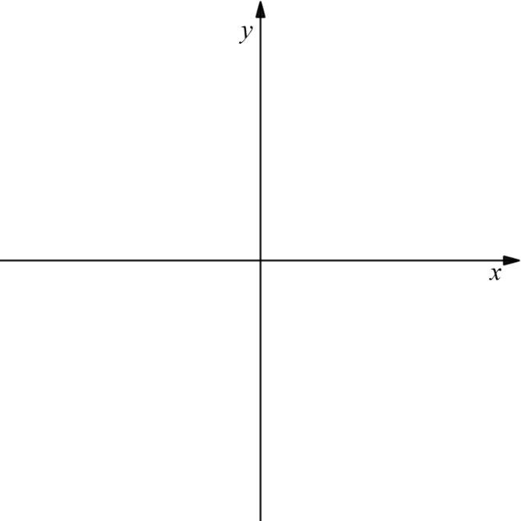
Consider small values of $x$.
$$x$$
$$y$$

Consider large values of $x$.
$$x$$
$$y$$
Draw the graph.

Appendix B

HSC-style questions
- Find the stationary points of the function $f\left(x\right)=\frac{x^{2}}{e^{x}}$ and consider their nature.
- Consider the function $y=x^{2}e^{x}$.
- Find the stationary points and determine their nature.
- Find any point(s) of inflection.
- Graph the function.
- Consider the function $y=\frac{\sin\left(x\right)}{x}$.
- Show that the function is an even function.
- Explain why there are an infinite number of stationary points.
- Draw the graph of the function for $-2π≤x≤2π$.

Sample solutions

Appendix A – Your turn
Graph the function $y=x\ln{x}$.
Solution:
Find stationary points and determine nature.
$$y^{'}=\ln{x}+x×\frac{1}{x} \\ =\ln{x}+1 \\ y^{''}=\frac{1}{x}$$Let $y^{'}=0$
$$\ln{x}+1=0 \\ \ln{x}=-1 \\ x=e^{-1}$$Substitute $x=e^{-1}$ into $y^{''}$
$$y^{''}=\frac{1}{e^{-1}} \\ =e>0→\text{local minimum}$$
Substitute $x=e^{-1}$ into $y$
$$y=e^{-1}×\ln{e^{-1}} \\ =-e^{-1}$$
Find points of inflection.
Let $y^{''}=0→$ undefined.
$∴$ no points of inflection. $y=x\ln{x}$ is always concave up.
Consider the behaviour of the function.
Graph $y=x$ and $y=\ln{x}$ on the Cartesian plane.
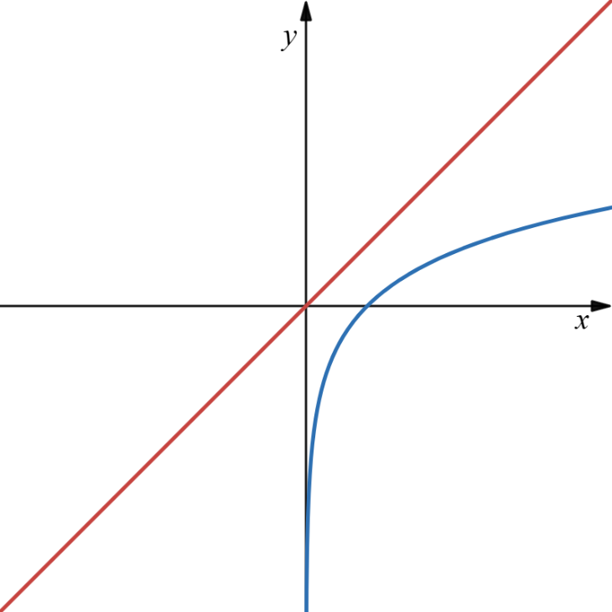
From the graphs of $y=x$ and $y=\ln{x}$, for $x<0$, $y=x\ln{x}$ is undefined.
When $0<x<1$, $y=x$ is positive while $y=\ln{x}$ is negative. Thus $y=x\ln{x}$ will be negative.
When $x>1$, both $y=x$ and $y=\ln{x}$ are positive so $y=x\ln{x}$ will be positive.
At $x=1$, the $x$-intercept for $y=\ln{x}$, $x\ln{x}=0$.

Consider small values of $x$
$$x$$ | $$0.2$$ | $$0.02$$ | $$0.002$$
$$y$$ | $$≈-0.32$$ | $$≈-0.08$$ | $$≈-0.01$$
Consider large value of $x$
$$x$$ | $$2$$ | $$5$$ | $$10$$
$$y$$ | $$≈1.39$$ | $$≈8.05$$ | $$≈23.03$$
Draw the graph.
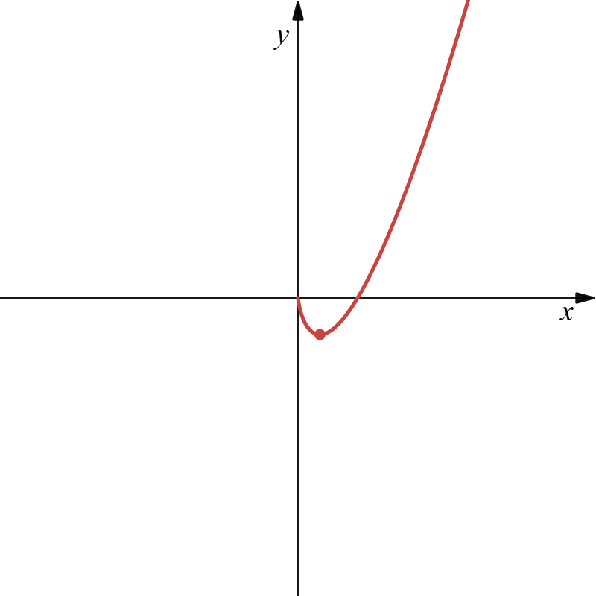

Appendix B – HSC-style questions
- Find the stationary points of the function $f\left(x\right)=\frac{x^{2}}{e^{x}}$ and consider their nature.
$$f\left(x\right)=\frac{x^{2}}{e^{x}} \\ f^{'}\left(x\right)=\frac{2xe^{x}-x^{2}e^{x}}{e^{2x}} \\ =\frac{x\left(2-x\right)}{e^{x}} \\ \text{Let} f^{'}\left(x\right)=0 \\ \frac{x\left(2-x\right)}{e^{x}}=0 \\ ∴x=0, 2 \\ f\left(0\right)=0 \\ f\left(2\right)=\frac{4}{e^{2}} \\ ∴\text{stationary points at} \left(0,0\right) \text{and} \left(2,\frac{4}{e^{2}}\right) \\ f^{''}\left(x\right)=\frac{\left(2-2x\right)e^{x}-\left(2x-x^{2}\right)e^{x}}{e^{2x}} \\ =\frac{2-2x-2x+x^{2}}{e^{x}} \\ =\frac{x^{2}-4x+2}{e^{x}}$$$f^{''}\left(0\right)=2>0, ∴$ concave up$$f^{''}\left(2\right)=\frac{4-8+2}{e^{2}}$$$=-\frac{2}{e^{2}}<0, ∴$ concave down$$∴\left(0,0\right) \text{is a local minimum and} \left(2,\frac{4}{e^{2}}\right) \text{is a local maximum. }$$
- Consider the function $y=x^{2}e^{x}$.
- Find the stationary points and determine their nature.
$$y=x^{2}e^{x} \\ y^{'}=2xe^{x}+x^{2}e^{x} \\ y^{'}=xe^{x}(2+x)$$
Stationary points occur when $y^{'}=0$
$e^{x}≠0$ for all real $x$
$xe^{x}=0$ or $x+2=0$
$∴x=0$ or $x=-2$
When$x=0, y=0^{2}e^{0}$
When $x=-2, y={\left(-2\right)}^{2}e^{-2}$
$∴$ stationary points occur at $\left(0,0\right)$ and $(-2,\frac{4}{e^{2}})$.
$$y^{'}=xe^{x}\left(2+x\right) \\ y^{'}=e^{x}\left(2x+x^{2}\right) \\ y^{''}=e^{x}\left(x^{2}+2x\right)+e^{x}\left(2x+x\right) \\ y^{''}=e^{x}(x^{2}+4x+2)$$
at$x=0, y^{''}=e^{0}\left(0^{2}+4\left(0\right)+2\right)=2>0, ∴$ concave up
$∴(0,0)$ is a local minimum.
at$x=-2, y^{''}=e^{-2}\left({\left(-2\right)}^{2}+4\left(-2\right)+2\right)=-2e^{-2}$ $<0, ∴$ concave down
$∴(-2,\frac{4}{e^{2}} )$ is a local maximum.
- Find any point(s) of inflection.
Let $y^{''}=0$
$$e^{x}\left(x^{2}+4x+2\right)=0 \\ e^{x}≠0, ∴x^{2}+4x+2=0$$
Use quadratic formula
$$x=\frac{-4±\sqrt{4^{2}-4\left(1\right)\left(2\right)}}{2}$$
$$x=\frac{-4±\sqrt{8}}{2}$$
$$x=-2±\sqrt{2}$$
Now find the corresponding $y$-values.
$$\text{For} x=-2-\sqrt{2} \\ y=(-2-\sqrt{2})^{2}e^{-2-\sqrt{2}} \\ \text{For} x=-2+\sqrt{2} \\ y=(-2+\sqrt{2})^{2}e^{-2+\sqrt{2}}$$So, the possible points of inflection are:
$\left(-2-\sqrt{2},(-2-\sqrt{2})^{2}e^{-2-\sqrt{2}}\right)$ and $\left(-2+\sqrt{2},(-2+\sqrt{2})^{2}e^{-2+\sqrt{2}}\right)$
$$x$$ | $$-4$$ | $$-2-\sqrt{2}$$ | $$-3$$ | $$-2+\sqrt{2}$$ | $$-0.2$$
$$\frac{d^{2}y}{dx^{2}}$$ | $$+$$ | $$0$$ | $$-$$ | $$0$$ | $$+$$
Concavity changes on either side of both points, therefore both $\left(-2-\sqrt{2},(-2-\sqrt{2})^{2}e^{-2-\sqrt{2}}\right)$ and $\left(-2+\sqrt{2},(-2+\sqrt{2})^{2}e^{-2+\sqrt{2}}\right)$ are points of inflection.
- Graph the function.
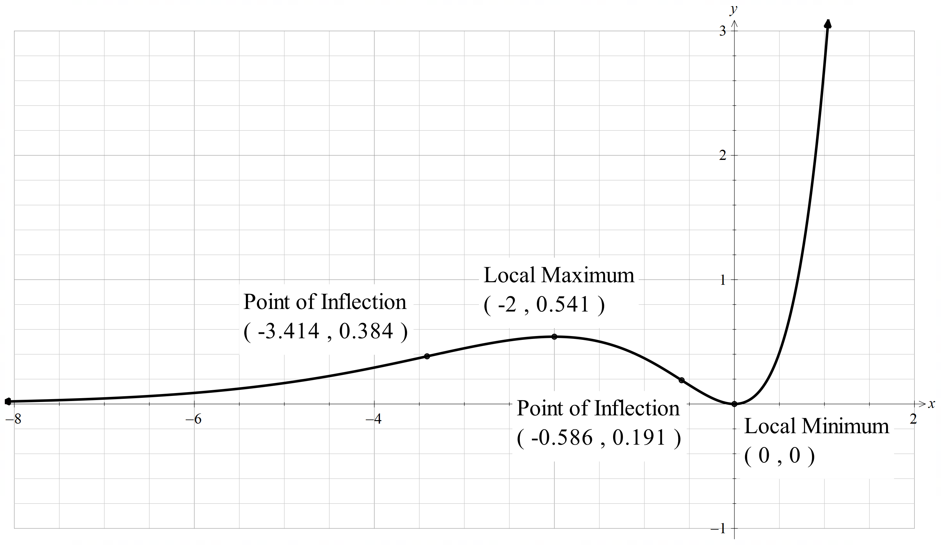

- Consider the function $y=\frac{\sin\left(x\right)}{x}$.
- Show that the function is an even function.
$$\text{Let} f\left(x\right)=\frac{\sin{x}}{x} \\ f\left(-x\right)=\frac{\sin\left(-x\right)}{-x} \\ =\frac{-\sin{x}}{-x} \\ =\frac{\sin{x}}{x} \\ =f\left(x\right) \\ ∴y=\frac{\sin\left(x\right)}{x}\text{ is an even function}\text{.}$$
- Explain why there are an infinite number of stationary points.
$$f^{'}\left(x\right)=\frac{x\cos{x}-\sin{x}}{x^{2}} \\ \text{Let} f^{'}\left(x\right)=0 \\ \frac{x\cos{x}-\sin{x}}{x^{2}}=0 \\ x\cos{x}-\sin{x}=0 \\ x\cos{x}=\sin{x} \\ x=\frac{\sin{x}}{\cos{x}} \\ x=\tan{x}$$
Consider the graphs of $y=x$ and $y=\tan{x}$, there are an infinite number of points of intersection. Therefore, there an infinite number of stationary points.
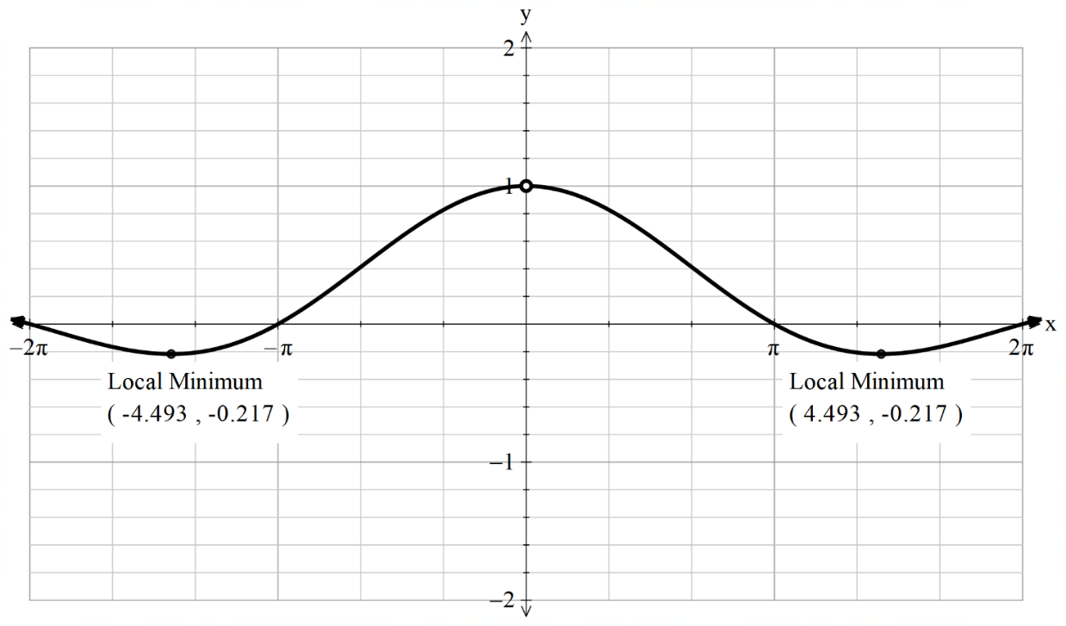
- Draw the graph of the function for $-2π≤x≤2π$.
$$\text{For}-2π≤x≤2π, x≠0, \text{consider} 0<x≤2π \text{due to y being an even function.}$$$\text{Find stationary points by considering the graph of} y=x \text{and} y=\tan{x}$.$2\text{ points of intersection. One at} 0 \text{and one between} π and 2π$.$$\text{As} x→0, y→1 \\ \text{As} x→∞, y→0$$

References
This resource contains NSW Curriculum and syllabus content. The NSW Curriculum is developed by the NSW Education Standards Authority (NESA). This content is prepared by NESA for and on behalf of the Crown in right of the State of New South Wales. The material is protected by Crown copyright.
Please refer to the NESA Copyright Disclaimer for more information https://www.nsw.gov.au/education-and-training/nesa/copyright.
NESA holds the only official and up-to-date versions of the NSW Curriculum and syllabus documents. Please visit NESA https://www.nsw.gov.au/education-and-training/nesa and NSW Curriculum https://curriculum.nsw.edu.au.
Mathematics Advanced 11–12 Syllabus © NSW Education Standards Authority (NESA) for and on behalf of the Crown in right of the State of New South Wales, 2024.

© State of New South Wales (Department of Education), 2026
The copyright material published in this resource is subject to the Copyright Act 1968 (Cth) and is owned by the NSW Department of Education or, where indicated, by a party other than the NSW Department of Education (third-party material).
Copyright material available in this resource and owned by the NSW Department of Education is licensed under a Creative Commons Attribution 4.0 International (CC BY 4.0) license.

This license allows you to share and adapt the material for any purpose, even commercially. Attribution should be given to © State of New South Wales (Department of Education), 2026.
Material in this resource not available under a Creative Commons license:
- the NSW Department of Education logo, other logos and trademark-protected material
- material owned by a third party that has been reproduced with permission. You will need to obtain permission from the third party to reuse its material.
Links to third-party material and websites
Please note that the provided (reading/viewing material/list/links/texts) are a suggestion only and implies no endorsement, by the New South Wales Department of Education, of any author, publisher, or book title. School principals and teachers are best placed to assess the suitability of resources that would complement the curriculum and reflect the needs and interests of their students.
If you use the links provided in this document to access a third-party's website, you acknowledge that the terms of use, including licence terms set out on the third-party's website apply to the use which may be made of the materials on that third-party website or where permitted by the Copyright Act 1968 (Cth). The department accepts no responsibility for content on third-party websites.

