Introducing graphing with calculus
Students develop the skills required to graph functions by combining algebraic techniques with graphical interpretation. They analyse key features including stationary points, concavity and symmetry.

Learning intention
- To understand how features of a function and its derivatives can be used to determine the shape and behaviour of its graph.

Success criteria
- I can identify important graphical features of a function.
- I can use $f^{'}\left(x\right)$ and $f^{''}\left(x\right)$ to determine the behaviour and concavity of a function.
- I can use calculus to draw the graph of a function.

Outcomes
A student:
- develops understanding and fluency in mathematics through exploring and connecting mathematical concepts, choosing and applying mathematical techniques to solve problems, and communicating their thinking and reasoning coherently and clearly MAO-WM-01
- applies calculus to graph functions and model and solve problems involving optimisation, rates of change and motion in a line MAV-12-06

Content

Turning points, inflections and graphing
- Graph a function by determining local maxima and minima and points of inflection, horizontal and non-horizontal, considering any even or odd symmetry, the domain, any vertical asymptotes or other discontinuities, and where applicable, the behaviour of a function as $$x→±∞$$
Mathematics Advanced 11–12 Syllabus © NSW Education Standards Authority (NESA) for and on behalf of the Crown in right of the State of New South Wales, 2024.

Table 1: lesson summary
Section | Summary of activity | Teaching strategies | Teaching points
Retrieval practice | Students complete the odd and even function activity in Appendix A and use slide 4 from the PowerPoint Introducing graphing with calculus to identify graphical symmetry and justify algebraically why a function is even or odd. |  | Recall the graphical and algebraic properties of odd and even functions so that symmetry can be used as a feature when graphing functions.
Activating prior knowledge | Use slides 6–8 for students to review key concepts related to stationary points, points of inflection and concavity before identifying the information required to graph a function. | Two truths and a lie  Think-Pair-Share  Pose-Pause-Pounce-Bounce | Consolidate understanding of the calculus concepts that provide information about the shape and behaviour of a graph.
Connecting learning | Use slide 10 for students to construct a graph from calculus features and compare approaches through a gallery walk. | Assessing and advancing questions  Visibly random groups of 3  Vertical non-permanent surfaces  Gallery walk | Develop a systematic process for graphing functions by connecting algebraic techniques, derivative information and graphical features.
Releasing responsibility | Use slides 11–15 to explicitly model the graphing process, apply the process to a second function, independently graph functions with calculus, compare graphs with worked solutions and create notes summarising the graphing process. | Pose-Pause-Pounce-Bounce  Notes to future forgetful selves | Support students to apply a systematic process when graphing functions and justify the sequence of steps used. Draw attention to how the first and second derivatives contribute different information about the graph and how multiple features combine to produce an accurate graph.
Independent practice | Students use the scaffold on slide 17 to complete the HSC-style graphing questions in Appendix B and then compare their solutions with the graphs shown on slide 18. |  | Demonstrate the ability to use calculus and algebraic features to construct and justify accurate graphs of functions.

Activity structure
Please use the associated PowerPoint Introducing graphing with calculus to display images in this lesson.

Retrieval practice
- Distribute a copy of Appendix A ‘Odd and even functions’ to students and ask them to use the information to complete the graphs.
- Display slide 4 which shows the graph of $y=x^{2}$ and ask students how they know, from looking at the graph, it is the graph of an even function. Then, ask students how they can prove it is an even function, algebraically.
- Animate the slide to show the algebraic proof that the function is even.
- Animate the slide again to reveal the graph of $y=x|x|$ and ask students how they know it is an odd function and how they can prove it algebraically.
- Animate the slide to reveal the proof.
Students should be able to recall that the graph of an even function is symmetrical about the $y$-axis and the graph of an odd function has $180°$ rotational symmetry.
- Animate the slide again to reveal a prompt for students to consider why it can be useful to know if a function is odd or even.
Students should recognise that by knowing if a function is odd or even, they can identify features of the graph more easily.

Activating prior knowledge
- Display slide 6 and use a Think-Pair-Share (bit.ly/thinkpairsharestrategy) for students to decide which statement (bit.ly/twotruthsoneliestrategy) is the lie, justifying their decision.
Encourage students to share how they can identify the lie and how they know the remaining statements are true. Useful discussion points may include:
- A stationary point may be a maximum or minimum turning point or a horizontal point of inflection, which all occur when $f’(x)=0$.
- A point of inflection may occur when $f"(x)=0$, but it will only be a point of inflection if the concavity on either side of the point changes.
- The sign of $f”(x)$ is used to determine concavity. When $f”(x)>0$, the curve is concave up and when $f”(x)<0$, the curve is concave down.
- Animate the slide to reveal which statement is the lie.
- Display slide 7 and use a Think-Pair-Share for students to match the features of the function with its name.
Click to animate slide 7 to show the answers.
- Display slide 8 and use the Pose-Pause-Pounce-Bounce questioning strategy (bit.ly/P-P-P-B) to have students consider how they could graph the function. Some possible prompts include:
- How many stationary points could there be?
- Can we quickly locate the intercepts?
- What information can be obtained from the first derivative?
- What information can be obtained from the second derivative?
Teachers may need to provide time for students to attempt to find the $x$ and $y$-intercepts, highlighting that whilst the $y$-intercept can be found quite quickly, the $x$-intercepts are not always easy to find and are not always necessary.

Connecting learning
- Assign students to visibly random groups of 3 (bit.ly/visiblegroups) at vertical non-permanent surfaces (bit.ly/VNPSstrategy) and instruct them to draw a Cartesian plane.
- Display slide 10 which shows the stationary points, point of inflection and $y$-intercept for the function students considered at the end of the previous section.
- Provide time for students to verify the nature of the stationary points, plot the points on a Cartesian plane and then draw the graph.
- Circulate throughout the classroom and use assessing and advancing questions (bit.ly/supportingstrategies) to monitor understanding and extend student thinking. Some suggestions are provided in Table 2 below.
Table 2: assessing and advancing questions
Assessing questions | Advancing questions
What points do you know so far? | What other points could you find?
What do you know about the shape of the graph? | How could you find out more about the shape of the graph?
How have you used the first derivative? | How could information from the first derivative help you refine your graph?
How have you used the second derivative? | How could the second derivative help you justify the shape of the graph between stationary points?
- Using a gallery walk (bit.ly/DLSgallerywalk) have students observe the similarities and differences between each group’s graph before returning to their work and making any necessary adjustments.

Releasing responsibility
- Display slide 11 which shows a video of how students may have graphed the function.
As the video plays, teachers may wish to explain the graphing process.
- Plotting the $y$-intercept.
- Plotting the stationary points and their feature as a local minimum or maximum.
- Connecting the points together to graph the function.
- Display slide 12 which shows a new function.
- Provide time for students to find the key features and graph the function on their vertical non-permanent surfaces.
- Click to animate slide 12 to show the solution and a prompt. Provide time for students to consider and answer the prompt.
- Use the Pose-Pause-Pounce-Bounce questioning strategy to consolidate student understanding of how to graph functions. Some possible prompts include:
- Do we need to find all the intercepts for a function? Why/why not?
- Aside from the intercepts, why are only stationary points and points of inflection sufficient for drawing a graph?
- How could knowing if a function is odd or even help to draw the graph or check for accuracy?
- Display slide 14 and have students independently, in their workbooks, select one of the 2 functions and draw the graph with the aid of the provided prompts.
- Display slide 15, which shows the graphs of the 2 functions, and use the Pose-Pause-Pounce-Bounce questioning strategy to discuss the functions and the process used to identify features necessary to draw the graphs. Useful question prompts may include:
- Why are some steps more useful to complete earlier in the process of graphing a function?
- How do some pieces of information provide greater insight into the overall shape of the graph?
- Ask students to create notes to their future forgetful selves (bit.ly/notestofutureself) explaining the process to draw a graph or create a list of steps of how they would graph a function and the information they would look for at each step.

Independent practice
- Display slide 17 and revise the Approaching questions scaffold.
- Distribute a copy of Appendix B ‘HSC-style questions’ and ask students to complete it either individually or in pairs.
- Display slide 18, which contains the completed graphs.
- Discuss the solutions, providing students with an opportunity to identify successes and challenges whilst answering the questions.

Assessment and differentiation

Suggested opportunities for differentiation
Activating prior knowledge
- Provide students with a set of true statements about stationary points, concavity and points of inflection and ask them to justify why the remaining statement must be the lie.
- Challenge students to create an additional false statement that would be plausible enough to be included in the activity and explain why it is false.
Connecting learning
- Provide a scaffolded checklist of features (intercepts, stationary points, concavity and points of inflection) for students who require support organising the graphing process.
- Extend students by asking them to rank the features in order of usefulness for creating the graph and justify their reasoning.
- Students could compare how the process of graphing a function might change if the function were quartic rather than cubic.
Releasing responsibility
- Extend students by asking them to identify which features could be omitted while still producing an accurate graph and which features are essential.
- Ask students to justify which pieces of information provide the greatest insight into the overall shape of the graph and explain why some features are more useful than others when graphing a function.
- Challenge students to predict how the graph would change if one feature was altered, such as changing the location of a stationary point. Then, ask them to justify their reasoning.
Independent practice
- Allow students to select from the HSC-style questions based on confidence, beginning with functions whose intercepts are easily found before progressing to functions requiring more interpretation.
- Challenge students to construct the graph before completing all calculations and then refine their graph as additional features are determined, comparing how their understanding develops throughout the process.

Suggested opportunities for assessment
Activating prior knowledge
- Listen to student justifications during the ‘Two truths and a lie’ discussion to assess whether students can distinguish between stationary points, points of inflection and concavity.
- Assess students’ contributions during the Think-Pair-Share discussion about what information is needed to graph a function, looking for recognition of symmetry, intercepts, stationary points and concavity.
Connecting learning
- Monitor work at vertical non-permanent surfaces to assess whether students can connect algebraic information to graphical features and use calculus strategically rather than as a sequence of disconnected procedures.
- Observe group discussions and graph construction to assess students’ ability to interpret and communicate information about the features of a function.
Releasing responsibility
- Use students’ notes to their future forgetful selves to assess whether they can articulate a coherent process for graphing a function using calculus.
Independent practice
- Assess students’ reasoning during discussion of the HSC-style questions by asking them to justify how specific features influenced the final graph.
- Use the completed HSC-style questions to assess students’ ability to combine algebraic techniques, first derivative analysis, second derivative analysis and graphical interpretation into a complete graph of a function.

Appendix A

Odd and even functions
- The following diagram shows an incomplete graph of an even function.
Draw the remaining section of the graph.
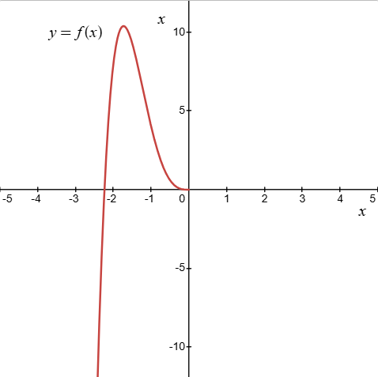
- The following diagram shows an incomplete graph of an odd function.
Draw the remaining section of the graph.

Appendix B

HSC-style questions
- Consider the curve $y=-2x^{3}+3x^{2}-2$.
- Find the stationary points of the curve and determine their nature.
- Graph the curve, labelling the stationary points.
- Hence or otherwise, find the values of $x$ for which $\frac{dy}{dx}$ is positive.
- A function $f\left(x\right)$ is defined by $f\left(x\right)=3x^{2}-x^{3}$.
- Graph the curve, showing the stationary points, the point of inflection and the $x$ and $y$-intercepts.
- For what values of $x$ is the graph of $y=f(x)$ concave down?
- Consider the curve $y=x^{4}-2x^{3}$.
- Find the stationary points of the curve and determine their nature.
- Given that the point $(1,-1)$ lies on the curve, show that it is a point of inflection.
- Graph the curve, showing the stationary points, the point of inflection and the $x$ and $y$-intercepts.

Sample solutions

Appendix A – odd and even functions
- Even function:
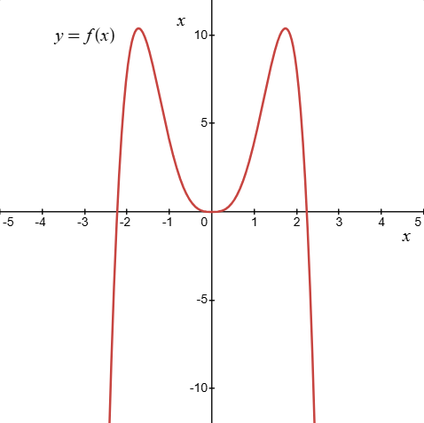
- Odd function:
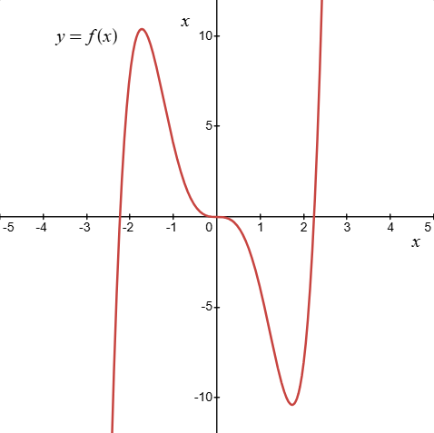

Appendix B – HSC-style questions
- $y=-2x^{3}+3x^{2}-2$.
- Stationary points:
$$y'=-6x^{2}+6x$$
Let $y'=0$,
$$-6x^{2}+6x=0 \\ -6x\left(x-1\right)=0$$
$$∴x=0, x=1$$
$$y"=-12x+6$$
Let $x=0, y"=6>0, ∴$ concave up.
Let $x=1, y"=-6<0, ∴$ concave down.
Let $x=0, y=-2$
$∴$ A minimum turning point occurs at $(0,-2)$.
Let $x=1,$
$$y=-2{(1)}^{3}+3{\left(1\right)}^{2}-2 \\ =-1$$
$∴$ A maximum turning point occurs at $(1,-1)$.

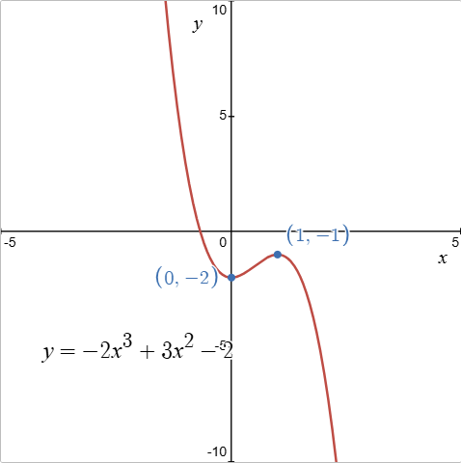
- $\frac{dy}{dx}>0$ for $0<x<1$

- $f\left(x\right)=3x^{2}-x^{3}$.
  - Stationary points:
$$f^{'}\left(x\right)=6x-3x^{2}$$
Let $f^{'}\left(x\right)=0$
$$6x-3x^{2}=0$$
$$3x\left(2-x\right)=0$$
$$∴x=0, x=2$$
Determine their nature:
$$f"(x)=6-6x \\ f"(0)=6-6(0)>0→\text{ local minimum}$$
$$f"(2)=6-6(2)<0→ \text{local maximum}$$
Coordinates:
$$f\left(0\right)=0$$
$∴$ A minimum turning point occurs at $(0,0)$.
$$f\left(2\right)=3{\left(2\right)}^{2}-{\left(2\right)}^{3} \\ =4$$
$∴$ A maximum turning point occurs at $(2,4)$.
Points of inflection:
Let $f"(x)=0,$
$$6-6x=0 \\ x=1$$
$$f\left(1\right)=3{\left(1\right)}^{2}-{\left(1\right)}^{3} \\ =2$$
Test concavity at $x=\frac{1}{2}$, $x=\frac{3}{2}$
$$x$$ | $$x=\frac{1}{2}$$ | $$x=1$$ | $$x=\frac{3}{2}$$
$$f"(x)$$ | $$>0$$  concave up | $$=0$$ | $$<0$$  concave down
Change in concavity occurs at $x=1$.
A point of inflection occurs at $(1,2)$.
Intercepts:
$y$-intercept occurs at $(0,0)$
Let $y=0$,
$$3x^{2}-x^{3}=0$$
$$x^{2}\left(3-x\right)=0$$
$$∴x=0, x=3$$
$x$-intercepts at $\left(0,0\right)$, $\left(3,0\right)$
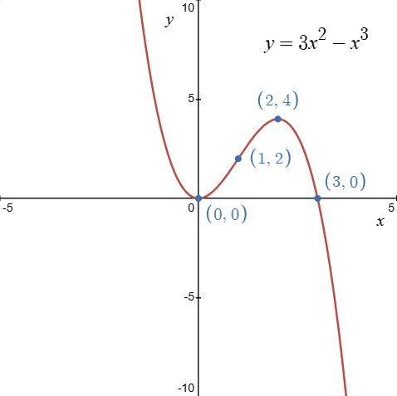
- $f(x)$ is concave down when $x>1$.

- $y=x^{4}-2x^{3}$.
- Stationary points:
$$y^{'}=4x^{3}-6x^{2}$$
Let $y^{'}=0$,
$$4x^{3}-6x^{2}=0$$
$$2x^{2}\left(2x-3\right)=0$$
$$∴x=0, x=\frac{3}{2}$$
Determine their nature:
$$y"={12x}^{2}-12x$$
Let $x=0, y"=0, ∴$ possible horizontal point of inflection.
Let $x=\frac{3}{2}, y"=12{(\frac{3}{2})}^{2}-12(\frac{3}{2})>0, ∴$ concave up.
Test concavity for $x=0$ as $x=-\frac{1}{2}$ and $x=\frac{1}{2}$.
$$x$$ | $$x=-\frac{1}{2}$$ | $$x=0$$ | $$x=\frac{1}{2}$$
$$y"$$ | $$>0$$  concave up | $$=0$$ | $$<0$$  concave down
Coordinates:
Let $x=0, y=0$
$∴$ A horizontal point of inflection occurs at $(0,0)$.
Let $x=\frac{3}{2}$,
$$y={\left(\frac{3}{2}\right)}^{4}-2{\left(\frac{3}{2}\right)}^{3} \\ =-\frac{27}{16}$$
$∴$ A minimum turning point occurs at $(\frac{3}{2},-\frac{27}{16})$.
- Point of inflection:
Test concavity for $x=1$ at $x=\frac{1}{2}$ and $x=\frac{3}{2}$
$$x$$ | $$x=\frac{1}{2}$$ | $$x=1$$ | $$x=\frac{3}{2}$$
$$y"$$ | $$<0$$  concave down | $$=0$$ | $$>0$$  concave up
Change in concavity occurs, $∴$ point of inflection at $x=1$.
Point of inflection at $(1,-1)$
- Intercepts:
$y$-intercept: $(0,0)$
$x$-intercept, let $y=0$,
$$x^{4}-2x^{3}=0 \\ x^{3}\left(x-2\right)=0$$
$$x=0, x=2$$
$∴x$-intercepts occur at $\left(0,0\right), (2,0)$
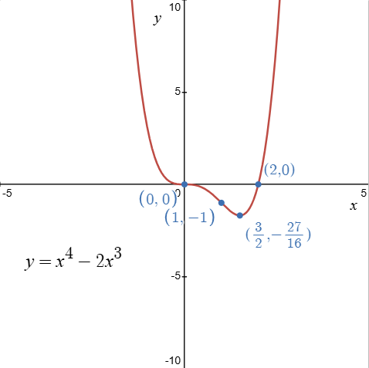

References
This resource contains NSW Curriculum and syllabus content. The NSW Curriculum is developed by the NSW Education Standards Authority (NESA). This content is prepared by NESA for and on behalf of the Crown in right of the State of New South Wales. The material is protected by Crown copyright.
Please refer to the NESA Copyright Disclaimer for more information https://www.nsw.gov.au/education-and-training/nesa/copyright.
NESA holds the only official and up-to-date versions of the NSW Curriculum and syllabus documents. Please visit NESA https://www.nsw.gov.au/education-and-training/nesa and NSW Curriculum https://curriculum.nsw.edu.au.
Mathematics Advanced 11–12 Syllabus © NSW Education Standards Authority (NESA) for and on behalf of the Crown in right of the State of New South Wales, 2024.

© State of New South Wales (Department of Education), 2026
The copyright material published in this resource is subject to the Copyright Act 1968 (Cth) and is owned by the NSW Department of Education or, where indicated, by a party other than the NSW Department of Education (third-party material).
Copyright material available in this resource and owned by the NSW Department of Education is licensed under a Creative Commons Attribution 4.0 International (CC BY 4.0) license.

This license allows you to share and adapt the material for any purpose, even commercially. Attribution should be given to © State of New South Wales (Department of Education), 2026.
Material in this resource not available under a Creative Commons license:
- the NSW Department of Education logo, other logos and trademark-protected material
- material owned by a third party that has been reproduced with permission. You will need to obtain permission from the third party to reuse its material.
Links to third-party material and websites
Please note that the provided (reading/viewing material/list/links/texts) are a suggestion only and implies no endorsement, by the New South Wales Department of Education, of any author, publisher, or book title. School principals and teachers are best placed to assess the suitability of resources that would complement the curriculum and reflect the needs and interests of their students.
If you use the links provided in this document to access a third-party's website, you acknowledge that the terms of use, including licence terms set out on the third-party's website apply to the use which may be made of the materials on that third-party website or where permitted by the Copyright Act 1968 (Cth). The department accepts no responsibility for content on third-party websites.

