The second derivative and stationary points
Students investigate how the second derivative can be used to classify stationary points as local maxima, local minima or horizontal points of inflection. Through graphical and algebraic representations, students connect the sign of the second derivative to the behaviour of a function at stationary points.
Students will need at least one digital device per pair to interact with Amplify Classroom during this lesson.

Learning intention
- To understand how the second derivative can be used to classify stationary points.

Success criteria
- I can interpret the sign of the second derivative.
- I can classify stationary points using the second derivative.
- I can identify when the second derivative test is inconclusive and explain why the first derivative test is needed.

Outcomes
A student:
- develops understanding and fluency in mathematics through exploring and connecting mathematical concepts, choosing and applying mathematical techniques to solve problems, and communicating their thinking and reasoning coherently and clearly MAO-WM-01
- applies calculus to graph functions and model and solve problems involving optimisation, rates of change and motion in a line MAV-12-06

Content

Turning points, inflections and graphing
- Use repeated differentiation to find second derivatives of a function $y=f(x)$, denoting them by $f^{''}\left(x\right)$ or $\frac{d^{2}y}{dx^{2}}$ or $y^{''}$
- Interpret the second derivative $y''$ as the gradient function of the first derivative $y'$, and deduce that if $y'' > 0$ the curve is concave up and if $y'' < 0$ the curve is concave down
- Use the second derivative to classify a stationary point as a local maximum, local minimum or a horizontal point of inflection
Mathematics Advanced 11–12 Syllabus © NSW Education Standards Authority (NESA) for and on behalf of the Crown in right of the State of New South Wales, 2024.

Table 1: lesson summary
Section | Summary of activity | Teaching strategies | Teaching points
Activating prior knowledge | Students use screens 1–2 of the Amplify Classroom activity (bit.ly/secderandsp) to revisit determining the nature of stationary points using the first derivative. | Pose-Pause-Pounce-Bounce | Draw attention to the relationship between the sign of the first derivative and the nature of a stationary point. Use student responses to identify misconceptions before introducing the second derivative test.
Connecting learning | Extend the pacing of the Amplify Classroom activity to screen 8 to allow students to investigate the relationship between the second derivative and the nature of stationary points. | Pose-Pause-Pounce-Bounce | Draw connections between the sign of the second derivative and the classification of stationary points. Support students to relate the value of the second derivative to the concavity of a graph.
Releasing responsibility | Use Appendix A and slides 4–6 of the PowerPoint The second derivative and stationary points to compare the first and second derivative tests for classifying stationary points. Use Appendix B for students to create notes before returning to the Amplify Classroom activity for students to investigate cases where $f^{'}\left(x\right)=0$ and $f^{''}\left(x\right)=0$ and consolidate conditions for a horizontal point of inflection. | Worked examples (comparison)  Pose-Pause-Pounce-Bounce  Think-Pair-Share  Notes to future forgetful selves | Draw comparisons between the first and second derivative tests, including advantages and limitations of each method. Highlight that the second derivative test is inconclusive when $f^{''}\left(x\right)=0$ and that the first derivative may be required to determine the nature of the stationary point. Support students to connect graphical and algebraic representations when classifying stationary points.
Independent practice | Students practise determining the nature of stationary points using an existing resource before refining their notes and completing Appendix C as an exit ticket. | Exit ticket | Reinforce the use of the second derivative test. Support students to identify when the second derivative is sufficient and when additional information may be required.

Activity structure
Please use the associated PowerPoint The second derivative and stationary points to display images in this lesson.

Retrieval practice
Students need to be able to differentiate a variety of functions such as polynomials, exponentials, logarithms and trigonometric functions. You may wish to use an existing resource to practise these skills prior to beginning the activities in this lesson.

Activating prior knowledge
- With at least one device per pair, assign the Amplify Classroom activity ‘The second derivative and stationary points’ (bit.ly/secderandsp) for students to complete screens 1–2.
Before completing this activity, you will need to set up an Amplify Classroom (bit.ly/createamplifyclassroom).
Amplify Classroom provides the opportunity for immediate feedback as well as tailored feedback from the teacher as students’ progress.
- Use the Pose-Pause-Pounce-Bounce questioning strategy (bit.ly/P-P-P-B) to check for student understanding of how to determine the nature of stationary points using a table of values for the first derivative.
Students learned how to determine the nature of a stationary point using the first derivative in Lesson 2 – the first derivative and stationary points.
Teachers may wish to use the teacher dashboard to review student responses to screen 2 to help them to identify any misconceptions.

Connecting learning
- Extend the pacing of the Amplify Classroom activity to screens 3–8.
- While students are on screen 8 of the Amplify Classroom activity, use the Pose-Pause-Pounce-Bounce questioning strategy to consolidate student learning from the Amplify Classroom activity. Some possible prompts include:
- What do you notice about the sign of the second derivative at a local minimum?
- What does a positive value of $f''(a)$ tell us about the shape of the graph near $x=a$?
- When the function has a horizontal point of inflection, what is the value of the second derivative? What is happening to the function at that point?
Screen 9 is used in the ‘Releasing responsibility’ section of the lesson to consider the scenario where $f^{''}\left(x\right)=0$ and $f^{'}\left(x\right)=0$ but the point is not a horizontal point of inflection.

Releasing responsibility
- Display slide 4 of the PowerPoint to summarise the sign of the second derivative for stationary points along with a prompt for students to discuss.
- Use Appendix A ‘Worked example comparison’ to show students how either the first derivative or second derivative can be used to help determine the nature of stationary points using the Worked examples (comparison) method (bit.ly/supportingstrategies).
A reduced version of Appendix A is also available on slide 5.
- Display slide 6 for students to use the first derivative to determine the nature of the stationary points.
Click to animate slide 6 to display the worked solution.
- Display slide 7 for students to use the second derivative to determine the nature of the stationary points.
Click to animate slide 7 to display the worked solution.
- Use the Pose-Pause-Pounce-Bounce questioning strategy to have students consider why they wish to use either the first or second derivative. Some possible prompts include:
- Why might using the second derivative be simpler than just using the first derivative?
- When may it not be possible to just use the second derivative?
- What are some of the advantages of each strategy?
Students should recognise that using the first derivative requires testing more points, while the second derivative only requires the stationary points.
- Distribute Appendix B ‘Stationary points and the second derivative’ for students to complete the table and create notes to future forgetful selves (bit.ly/notestofutureself).
- Have students return to screen 9 of the Amplify Classroom to consider the case when students also need to check the first derivate to determine if a point is a horizontal point of inflection.
- Display slide 8 and in a Think-Pair-Share (bit.ly/thinkpairsharestrategy) ask students to consider how the graph of the first derivative can support them in determining the nature of the stationary point when the second derivative is 0.
Students can see from the graph of the first derivative that the sign of the first derivative changes from negative to positive which indicates that the point $x=0$ is a local minimum.
Students should examine functions where $f^{''}\left(x\right)=0$ at a stationary point and use the first derivative to determine its nature, including cases where the point is and is not a point of inflection.
The special case of the second derivate is studied further in Lesson 5 – the secondary derivative and points of inflection.
- Have students return to Appendix B and add notes about the conditions for a horizontal point of inflection.

Independent practice
- Use an existing resource for students to practise determining the nature of stationary points from the second derivative.
- Have students return to Appendix B and add any additional notes they feel necessary.
- Distribute Appendix C ‘HSC-style question’ for students to complete as an exit ticket (bit.ly/exitticketstrategy).

Assessment and differentiation

Suggested opportunities for differentiation
Activating prior knowledge
- The Amplify Classroom teacher dashboard features such as ‘Snapshots view’ can be used to support students identifying stationary points before determining their nature.
- Extend students by having them explain why the horizontal point of inflection is a stationary point despite not being a local maximum or minimum.
Connecting learning
- Adjust the Amplify Classroom activity pacing to focus on local maximum and local minimum before considering the horizontal point of inflection.
- Extend students by having them consider and generalise the sign of the second derivative before completing screen 8.
Releasing responsibility
- Support students by having them practise determining the nature of stationary points using only the second derivative before comparing both methods.
- Extend students by having them consider when $f^{''}\left(x\right)=0$ is not a sufficient condition to determine the nature of a stationary point graphically.
Independent practice
- Support students by having them work with a partner to discuss the sign of the first and second derivatives at key points before completing Appendix C independently.

Suggested opportunities for assessment
Activating prior knowledge
- Monitor student responses to class discussions and student responses to the Amplify Classroom activity to monitor understanding of how to use the first derivative to classify stationary points.
Connecting learning
- Facilitate class discussions and observe students’ reasoning and justification when explaining the relationship between the sign of the second derivative and the nature of stationary points.
Releasing responsibility
- Review students’ notes to future forgetful selves to check their understanding of how to determine the nature of stationary points using either the first or second derivative.
Independent practice
- Monitor student responses to the exit ticket to check understanding of using the first and second derivatives to classify stationary points.

Appendix A

Worked example comparison
For $f\left(x\right)=x+\frac{4}{x}$, find the stationary points and determine their nature.
Determine stationary points:
$$f\left(x\right)=x+4x^{-1}$$
$$f^{'}\left(x\right)=1-\frac{4}{x^{2}} \\ 1-\frac{4}{x^{2}}=0 \\ \frac{4}{x^{2}}=1 \\ x^{2}=4 \\ x=±2$$
When $x=-2$, $y=-2+\frac{4}{-2}$
$$=-4$$
When $x=2$, $y=2+\frac{4}{2}$
$$=4$$
$∴\text{stationary} \text{points at} \left(-2,-4\right) \text{and} (2, 4)$.
Determine their nature:
Method 1: use first derivative table of values.  $$f^{'}\left(x\right)=1-\frac{4}{x^{2}}$$  $$f^{'}\left(-3\right)=\frac{5}{9}>0 \\ f^{'}\left(-1\right)=-3<0 \\ f^{'}\left(1\right)=-3<0 \\ f^{'}\left(3\right)=\frac{5}{9}>0$$  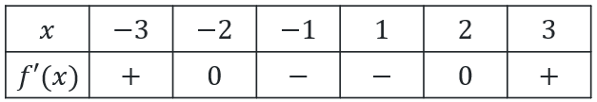  local max local min | Method 2: use second derivative.  $$f^{'}\left(x\right)=1-\frac{4}{x^{2}}$$  $$f^{''}\left(x\right)=\frac{8}{x^{3}} \\ f^{''}\left(-2\right)=-1<0→\text{local max} \\ f^{''}\left(2\right)=1>0→\text{local min}$$

$∴(-2,-4)$ is a local maximum and $\left(2,4\right)$ is a local minimum.

Appendix B

Stationary points and the second derivative
Complete the following table by drawing a graph that shows the relationship between the information in the column heading and row heading.
$$\frac{dy}{dx}=0$$
$$\frac{d^{2}y}{dx^{2}}>0$$
$$\frac{d^{2}y}{dx^{2}}<0$$
$$\frac{d^{2}y}{dx^{2}}=0$$

Appendix C

HSC-style question
The diagram shows points $A, B, C$ and $D$ on the graph $y=f(x)$.
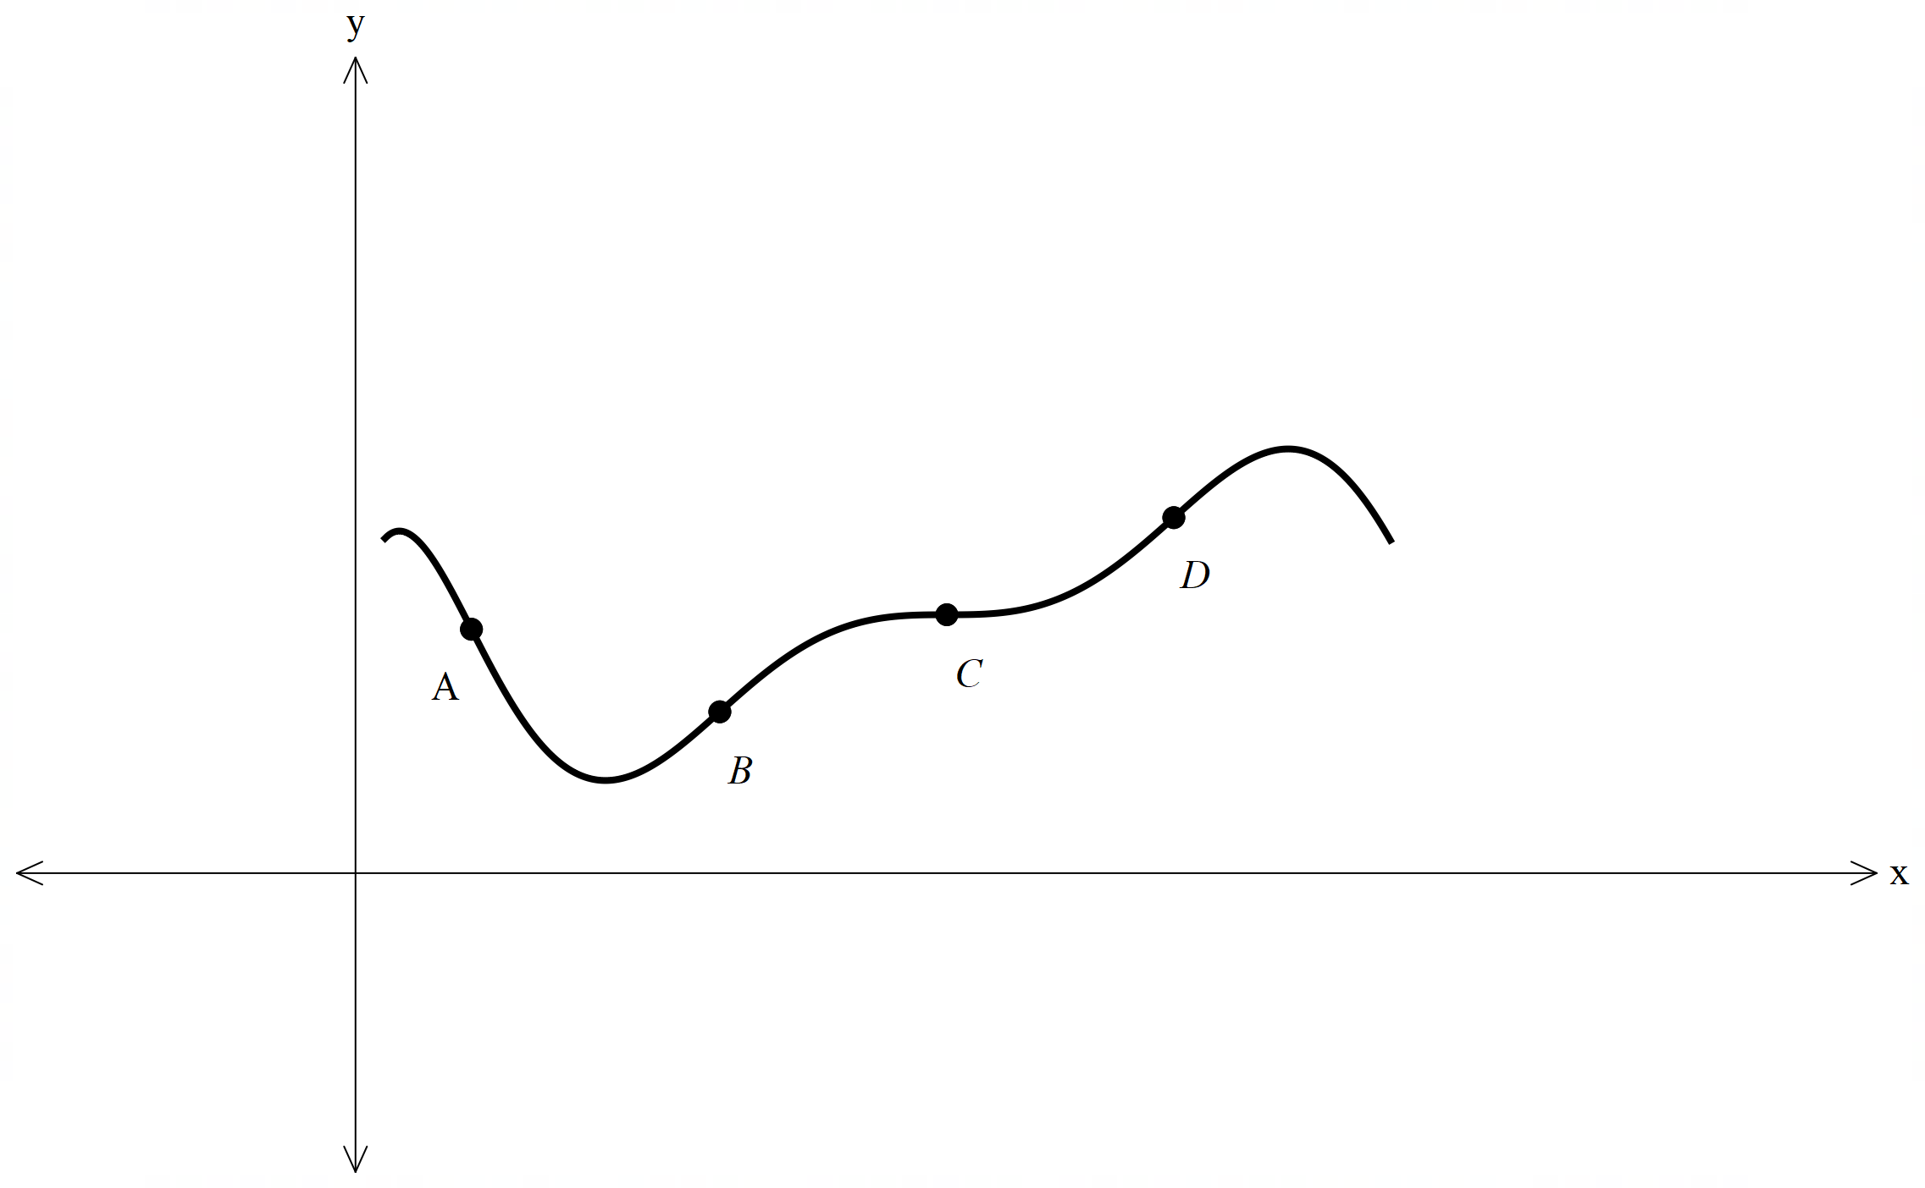
Explain which point on the graph is $f^{'}\left(x\right)=0$ and $f^{''}\left(x\right)=0$.

Sample solutions

Appendix B – stationary points and the second derivative
 | $$\frac{dy}{dx}=0$$
$$\frac{d^{2}y}{dx^{2}}>0$$ | 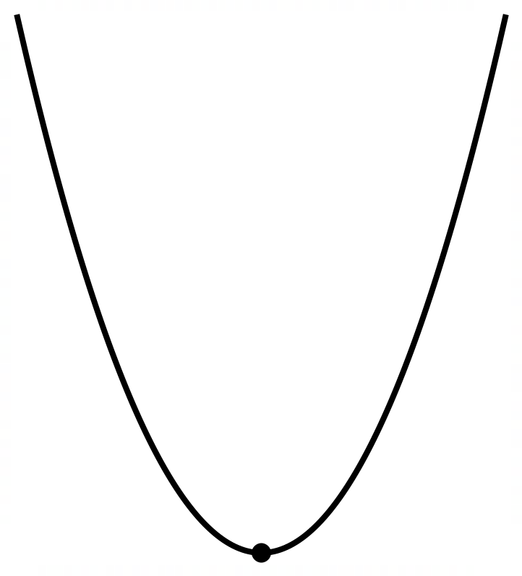
$$\frac{d^{2}y}{dx^{2}}<0$$ | 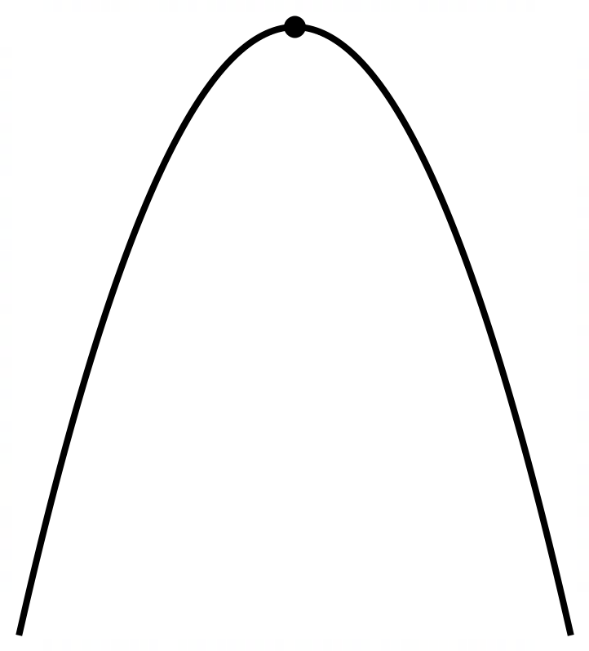
$$\frac{d^{2}y}{dx^{2}}=0$$ | 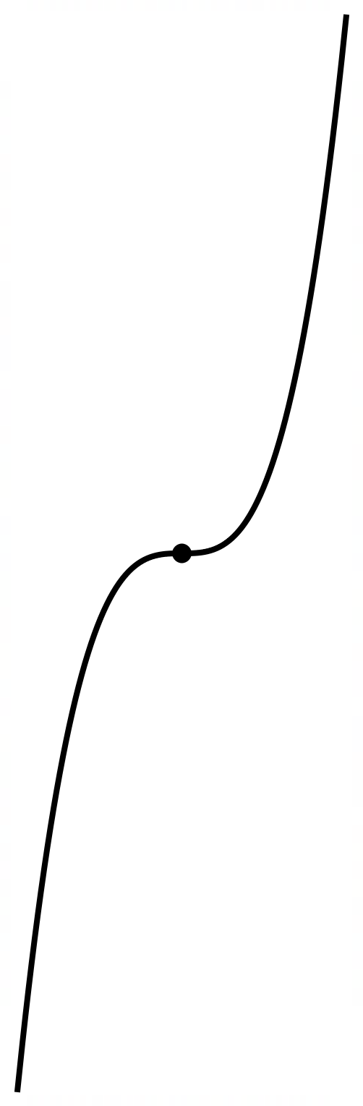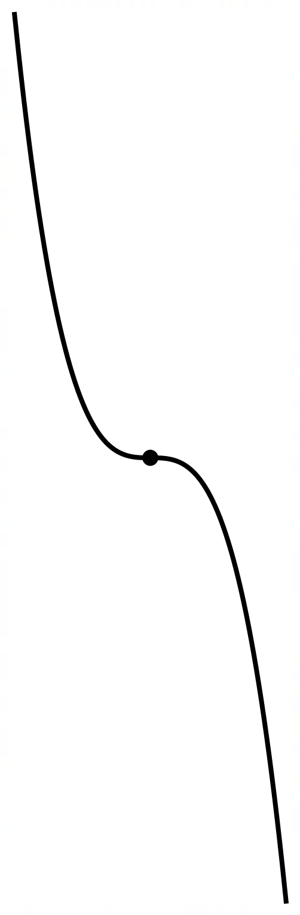

Appendix C – HSC-style question
Point C. The graph has a horizontal tangent at C, so $f^{'}(x)=0$. The concavity also changes at C, so it is a horizontal point of inflection and $f^{''}(x)=0$.

References
This resource contains NSW Curriculum and syllabus content. The NSW Curriculum is developed by the NSW Education Standards Authority (NESA). This content is prepared by NESA for and on behalf of the Crown in right of the State of New South Wales. The material is protected by Crown copyright.
Please refer to the NESA Copyright Disclaimer for more information https://www.nsw.gov.au/education-and-training/nesa/copyright.
NESA holds the only official and up-to-date versions of the NSW Curriculum and syllabus documents. Please visit NESA https://www.nsw.gov.au/education-and-training/nesa and NSW Curriculum https://curriculum.nsw.edu.au.
Mathematics Advanced 11–12 Syllabus © NSW Education Standards Authority (NESA) for and on behalf of the Crown in right of the State of New South Wales, 2024.

© State of New South Wales (Department of Education), 2026
The copyright material published in this resource is subject to the Copyright Act 1968 (Cth) and is owned by the NSW Department of Education or, where indicated, by a party other than the NSW Department of Education (third-party material).
Copyright material available in this resource and owned by the NSW Department of Education is licensed under a Creative Commons Attribution 4.0 International (CC BY 4.0) license.

This license allows you to share and adapt the material for any purpose, even commercially. Attribution should be given to © State of New South Wales (Department of Education), 2026.
Material in this resource not available under a Creative Commons license:
- the NSW Department of Education logo, other logos and trademark-protected material
- material owned by a third party that has been reproduced with permission. You will need to obtain permission from the third party to reuse its material.
Links to third-party material and websites
Please note that the provided (reading/viewing material/list/links/texts) are a suggestion only and implies no endorsement, by the New South Wales Department of Education, of any author, publisher, or book title. School principals and teachers are best placed to assess the suitability of resources that would complement the curriculum and reflect the needs and interests of their students.
If you use the links provided in this document to access a third-party's website, you acknowledge that the terms of use, including licence terms set out on the third-party's website apply to the use which may be made of the materials on that third-party website or where permitted by the Copyright Act 1968 (Cth). The department accepts no responsibility for content on third-party websites.

