Trigonometric functions and modelling
Students apply their understanding of graph transformations to solve trigonometric problems that model periodic phenomena and compare these strategies with other problem-solving strategies.

Learning intentions
- To be able to solve equations involving trigonometric function transformations.
- To be able to model and solve problems involving periodic phenomena.

Success criteria
- I can solve transformed trigonometric equations within specified domains.
- I can model periodic phenomena using transformations of the trigonometric functions.
- I can interpret solutions of transformed trigonometric functions in context.

Outcomes
A student:
- develops understanding and fluency in mathematics through exploring and connecting mathematical concepts, choosing and applying mathematical techniques to solve problems, and communicating their thinking and reasoning coherently and clearly MAO-WM-01
- uses algebraic and graphical techniques to analyse trigonometric functions MAV-12-01
- models, analyses and solves practical problems involving functions and their transformations MAV-12-02

Content

Transformations of trigonometric functions
- Solve equations and graphical problems involving transformations of the trigonometric functions $f\left(x\right)=\sin{x}$, $f\left(x\right)=\cos{x}$ or $f\left(x\right)=\tan{x}$, using graphing applications or otherwise, within a specified domain

Modelling with functions
- Model and solve practical problems involving functions and their transformations, within the scope of the Mathematics Advanced course, using graphical and algebraic techniques
- Model and solve problems involving periodic phenomena using transformations of the trigonometric functions $f\left(x\right)=\sin{x}$, $f\left(x\right)=\cos{x}$ or $f\left(x\right)=\tan{x}$, without the use of calculus
Mathematics Advanced 11–12 Syllabus © NSW Education Standards Authority (NESA) for and on behalf of the Crown in right of the State of New South Wales, 2024.

Table 1: lesson summary
Section | Summary of activity | Teaching strategies | Teaching points
Activating prior knowledge | Use slide 4 of the PowerPoint Trigonometric functions and modelling to present a transformed trigonometric function problem and have students solve algebraically, then use slides 5–6 to review the worked solution. | Mini whiteboards  Turn and talk | Reinforce solving transformed trigonometric equations algebraically and interpreting solutions in context.
Connecting learning | Use Appendix A and slide 8 to identify and sketch transformations of the trigonometric function from the ‘Activating prior knowledge’ section, then use slides 9–10 to apply these transformations to solve the problem and interpret solutions in context. | Think-Pair-Share  Mini whiteboards  Pose-Pause-Pounce-Bounce | Emphasise how transformations can be used to determine solutions through key points. Highlight links between algebraic solutions and graphical representations, and the role of context in interpreting solutions.
Releasing responsibility | Use slides 12–14 to model and compare algebraic and graphical solution methods, then use slides 15–20 for students to apply each method, and Appendix B to consolidate strategies. | Worked examples –comparison  Think-Pair-Share  Pose-Pause-Pounce-Bounce  Notes for future forgetful selves | Emphasise comparison of algebraic and graphical methods and when each is efficient. Support students to select and apply appropriate strategies and plan solutions using key features and representations.
Independent practice | Use slide 22 for students to complete an HSC-style question using the Approaching questions scaffold, then share and refine responses before applying their preferred method to additional problems. |  | Emphasise structured problem-solving and selection of appropriate methods. Support students to justify solutions and refine responses through comparison.

Activity structure
Please use the associated PowerPoint Trigonometric functions and modelling file to display images in this lesson.

Activating prior knowledge
- Display slide 4 of the PowerPoint which shows a transformed trigonometric function problem.
- Distribute mini whiteboards (bit.ly/miniwhiteboards) and provide time for students to algebraically solve the problem.
Students may wish to solve parts of the problem by applying graph transformations. Encourage students to complete the problem algebraically as they will compare both methods in the lesson.
- Have students check their answers with a peer and discuss if there are any differences.
- Display slides 5 and 6 to show the worked solution and some self-explanation prompts.

Connecting learning
- Hand out Appendix A ‘$y=\sin{x}$’ to students in a plastic sleeve and display slide 8 which shows the equation from the ‘Activating prior knowledge’ problem.
- Ask students in a Think-Pair-Share (bit.ly/thinkpairsharestrategy) to identify all the transformations applied to the function and to sketch the function on the axes in Appendix A.
The function has a vertical and horizontal dilation by a factor of $0.6$ and $\frac{π}{6}$ respectively as well as a vertical translation of $1.2$ units upwards.
- Click to animate slide 8 to show the questions from the ‘Activating prior knowledge’ section and ask students to consider how their sketch can support them in finding the solutions.
- On their mini whiteboards, provide time for students to solve the problem using transformations.
- Display slide 9 which shows the solution using transformations. Use the Pose-Pause-Pounce-Bounce questioning strategy (PDF 557KB) (bit.ly/posepausepouncebounce) to initiate a class discussion around how to use transformations to solve the problem. Some possible prompts include:
- How were the vertical and horizontal transformations applied to key points on the graph of $y=\sin{x}$?
- Could the solutions be determined directly from the graph?
- How could the sketch of $y=\sin{x}$ support your solutions?
Students may realise that solutions could be read from a graph if it is drawn accurately. Accurate sketches are hard to achieve, however, applying transformations to key points is possible.
- Display slide 10 which shows a context for the problem that students have been working on. Ask students to consider their answer in the context of the problem and adjust their answers accordingly.
Students should notice that for part a., the question is the same, however for the other parts, they need to convert the value of $t$ into a time after $6$ am so that the answers are:
- 12 hours
- 2 pm
- between 7 am and 11 am.

Releasing responsibility
- Use slides 12–14, to model another problem using the Worked examples – comparison method (bit.ly/supportingstrategies). In a Think-Pair-Share, animate slides 13 and 14 and have students answer the self-explanation prompts before asking them to consider the advantages of each method and which method they prefer.
Appendix B ‘Worked example comparison’ has both slides side by side and can be given as a handout to support students in their discussion.
Students should be aware of both methods as either method can be applied to solve a variety of trigonometric problems.
- Display slide 15 for students to complete the Your turn question by solving the problem algebraically. A worked solution is shown on slides 16 and 17.
- Display slide 18 for students to complete the Your turn question by solving the problem using graph transformations. A worked solution is shown on slides 19 and 20.
- Using Appendix B, have students write notes to their future forgetful selves (bit.ly/notestofutureself) about how they can solve trigonometric problems using either method.
Students may need to interpret low and high tide as the maximum and minimum values, the time interval between 2 successive low tides as the period, and depth of water as at least one metre meaning $d≥1$. Students may suggest that the cosine graph may help them to determine the solution.

Independent practice
- Display slide 21 to revise the Approaching questions scaffold.
- Display the HSC-style question on slide 22 and allow pairs time to plan how they will solve the problem using the steps from the Approaching questions scaffold.
- Use the Pose-Pounce-Bounce-Pounce questioning strategy to identify any gaps in student understanding and planning. Some possible prompts include:
- What are the key terms in the problem?
- What visual representation may support you to approach the problem?
- What steps may be required to start the problem?
- Provide time for students to complete the question from slide 22 using the solve and check prompts in the Approaching questions scaffold.
- Have students share their solution with a partner and discuss if their answer or method differs.
- Students are to use an existing resource to practise solving trigonometry problems using their preferred method.

Assessment and differentiation

Suggested opportunities for differentiation
Activating prior knowledge
- Support students by asking prompting questions such as, ‘How can we determine the period using the horizontal dilation factor?’
- Extend students by asking them to consider what would happen to their answers if a reflection across the $y$-axis were added to the function.
Connecting learning
- Use prompting questions to support students to identify the transformations that have been applied to the function and how they may affect key points.
- Extend students by asking them to consider what would happen if the order of the vertical transformations were swapped. Ask students to reason why it doesn’t matter when the horizontal dilation is applied.
Releasing responsibility
- Adjust the questions in the Worked example (Your turn) based on student readiness to apply multiple transformations.
- Extend students by asking them to justify if they can apply graph transformations to solve problems other than trigonometric problems and discuss when it may be an advantage to use this method over an algebraic solution.
Independent practice
- Teachers may wish students to use both methods to solve trigonometric problems when practising from an existing resource.

Suggested opportunities for assessment
Activating prior knowledge
- Monitor student responses on mini whiteboards to quickly gauge individual understanding and identify misconceptions around how to solve trigonometric problems algebraically.
Connecting learning
- A Think-Pair-Share provides students with the opportunity to reflect on their understanding of identifying graph transformations from a function.
- Monitor responses in class discussions to check for students’ understanding of how sketches can support student responses and how graph transformations can be applied to key points to solve trigonometric problems.
Releasing responsibility
- Student responses to the self-explanation prompts during worked examples provide an opportunity to assess student reasoning of how both algebraic and graphical techniques are used to solve trigonometric problems.
- Monitor student responses in the Your turn section to check for student understanding of both methods of solving trigonometric problems.
- Review students’ notes to future selves for understanding of how to apply graph transformations onto key points to solve problems.

Appendix A

$$y=\sin{x}$$

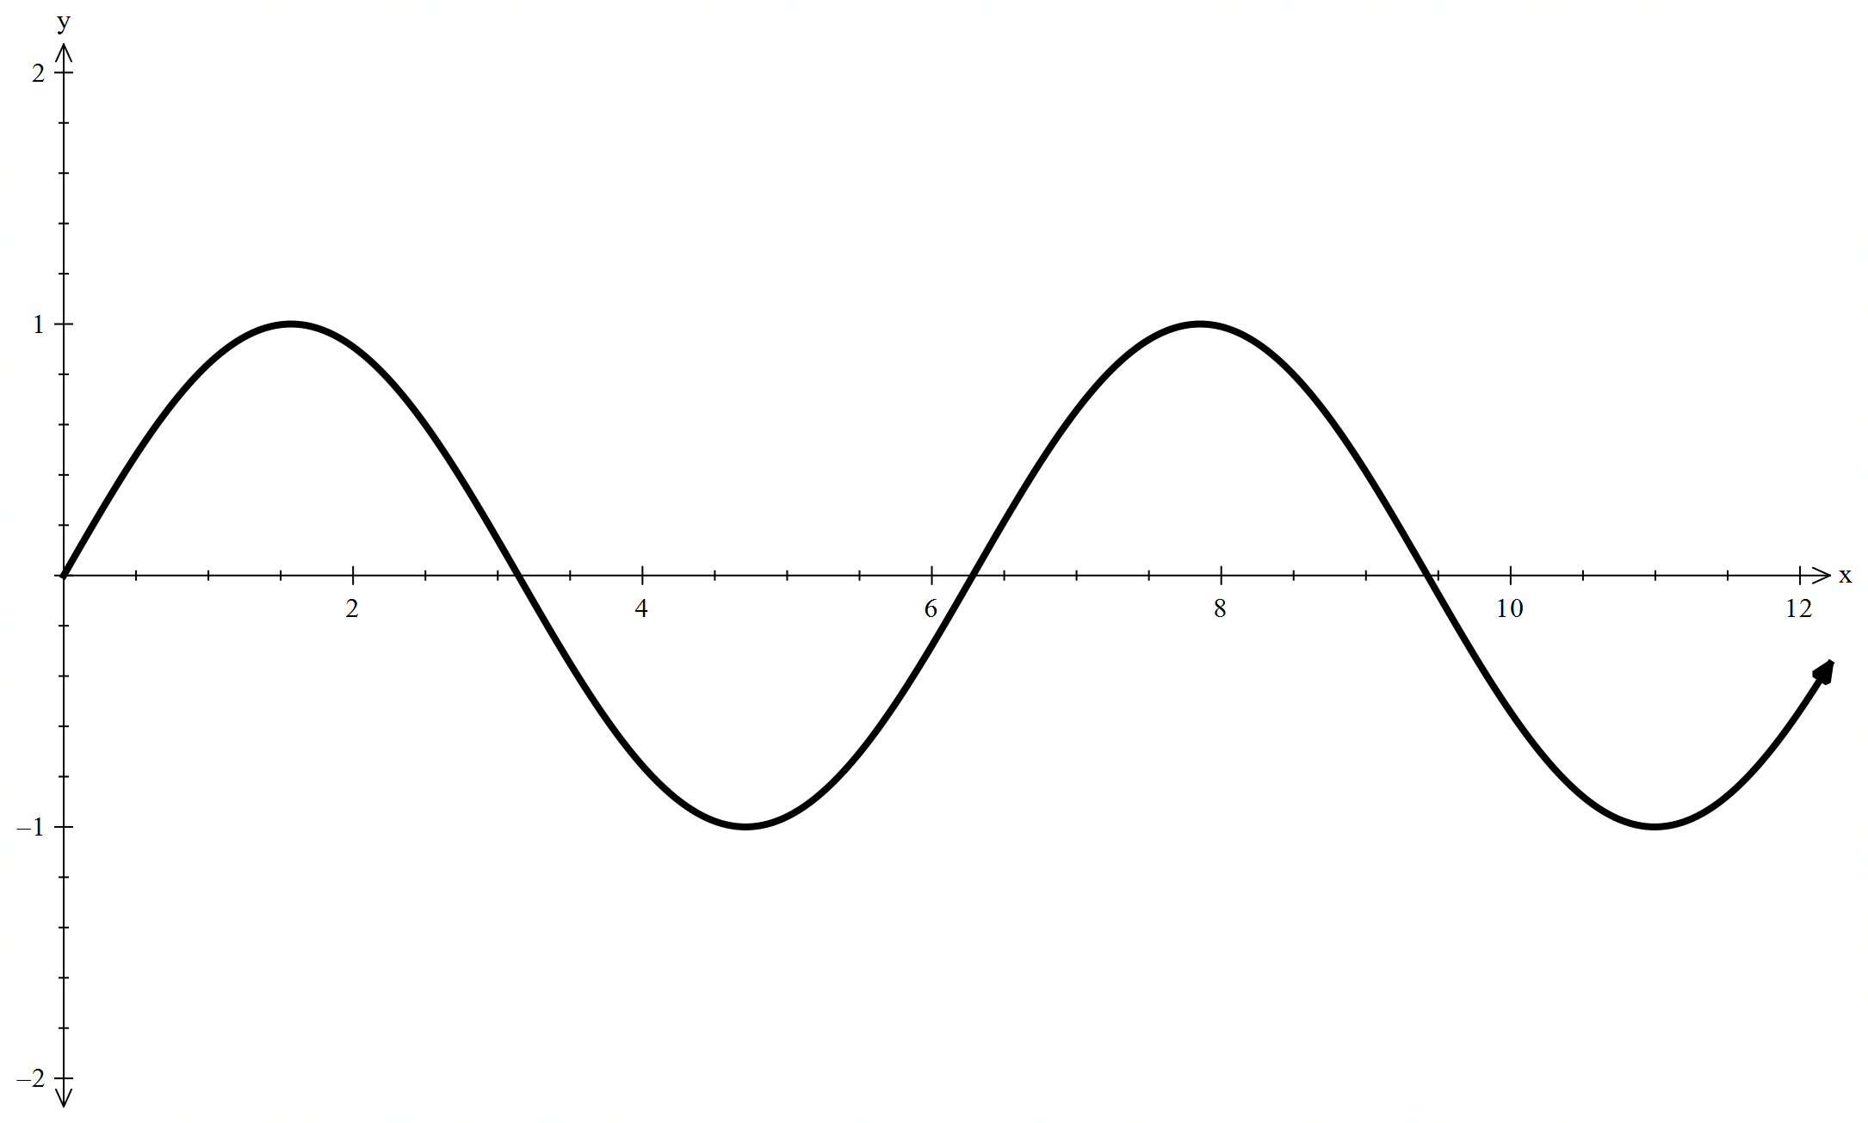

Appendix B

Worked example comparison
$$θ=15\tan\left(\frac{π}{12}t+\frac{π}{2}\right), 0<t<12$$
Algebraic solution
$$\text{Domain:}0<t<12→\frac{π}{2}<\frac{π}{12}t+\frac{π}{2}<\frac{3π}{2} \\ -15=15\tan\left(\frac{π}{12}t+\frac{π}{2}\right) \\ \tan\left(\frac{π}{12}t+\frac{π}{2}\right)=-1 \\ \frac{π}{12}t+\frac{π}{t}=\frac{3π}{4} \\ \frac{π}{12}t=\frac{π}{4} \\ ∴t=3 \\ 15=15\tan\left(\frac{π}{12}t+\frac{π}{2}\right) \\ \tan\left(\frac{π}{12}t+\frac{π}{2}\right)=1 \\ \frac{π}{12}t+\frac{π}{2}=\frac{5π}{4} \\ \frac{π}{12}t=\frac{3π}{4} \\ ∴t=9 \\ ∴\text{the camera operates for} 6 \text{seconds.}$$

Graph transformation solution
$$\text{Let} y=\tan{x} \\ θ=15\tan\left(\frac{π}{12}t+\frac{π}{2}\right) \\ =15\tan\left(\frac{π}{12}\left(t+6\right)\right) \\ \text{-} \text{Vertical dilation factor of} 15 \\ \text{-} \text{Horizontal dilation factor of}\frac{12}{π} \\ \text{-} \text{Move left by} 6 \text{units} \\ \text{When} θ=-15 \\ -15→-1 \\ \tan{x}=-1 \\ x=-\frac{π}{4} \\ -\frac{π}{4}→-3→3 \\ \text{When} θ=15 \\ \tan{x}=1 \\ x=\frac{π}{4} \\ \frac{π}{4}→3→9$$$∴t\text{he camera operates for} 6\text{ seconds.}$

Sample solutions

Slide 22 – HSC-style question

$$\text{Low tide:}d=1.4-0.8 \\ =0.6 \text{m} \\ \text{High tide:}d=1.4+0.8 \\ =2.2 \text{m}$$

$$\text{Period}=\frac{2π}{\frac{4π}{25}} \\ =\frac{25}{2}$$
- $$\text{Let} y=\cos{x} \\ \text{-} \text{Vertical dilation of} 0.8 \\ \text{-} \text{Reflection across} y\text{-axis} \\ \text{-} \text{Up by} 1.4 \text{units} \\ \text{- Horizontal dilation of} \frac{25}{4π} \\ d≥1→x≤\frac{1}{2} \\ \cos{x}=\frac{1}{2} \\ x=\frac{π}{3} \text{or}\frac{5π}{3} \\ \frac{π}{3}≤x≤\frac{5π}{3} \\ \frac{5π}{3}-\frac{π}{3}=\frac{4π}{3} \\ t=\frac{4π}{3}×\frac{25}{4π} \\ =\frac{25}{3} \\ =8 \text{hours and} 20 \text{minutes}\text{.}$$

References
This resource contains NSW Curriculum and syllabus content. The NSW Curriculum is developed by the NSW Education Standards Authority (NESA). This content is prepared by NESA for and on behalf of the Crown in right of the State of New South Wales. The material is protected by Crown copyright.
Please refer to the NESA Copyright Disclaimer for more information https://www.nsw.gov.au/education-and-training/nesa/copyright.
NESA holds the only official and up-to-date versions of the NSW Curriculum and syllabus documents. Please visit NESA https://www.nsw.gov.au/education-and-training/nesa/copyright and NSW Curriculum https://curriculum.nsw.edu.au.
Mathematics Advanced 11–12 Syllabus © NSW Education Standards Authority (NESA) for and on behalf of the Crown in right of the State of New South Wales, 2024.

© State of New South Wales (Department of Education), 2026
The copyright material published in this resource is subject to the Copyright Act 1968 (Cth) and is owned by the NSW Department of Education or, where indicated, by a party other than the NSW Department of Education (third-party material).
Copyright material available in this resource and owned by the NSW Department of Education is licensed under a Creative Commons Attribution 4.0 International (CC BY 4.0) license.

This license allows you to share and adapt the material for any purpose, even commercially. Attribution should be given to © State of New South Wales (Department of Education), 2026.
Material in this resource not available under a Creative Commons license:
- the NSW Department of Education logo, other logos and trademark-protected material
- material owned by a third party that has been reproduced with permission. You will need to obtain permission from the third party to reuse its material.
Links to third-party material and websites
Please note that the provided (reading/viewing material/list/links/texts) are a suggestion only and implies no endorsement, by the New South Wales Department of Education, of any author, publisher, or book title. School principals and teachers are best placed to assess the suitability of resources that would complement the curriculum and reflect the needs and interests of their students.
If you use the links provided in this document to access a third-party's website, you acknowledge that the terms of use, including licence terms set out on the third-party's website apply to the use which may be made of the materials on that third-party website or where permitted by the Copyright Act 1968 (Cth). The department accepts no responsibility for content on third-party websites.

