Mathematics Advanced Stage 6 (Year 11) – sample assessment task
Graph transformations
Contents
About this resource 2
Outcomes being assessed 3
Task description 3
Part A – using mathematics to create shapes 4
Part B – creating a Logo 6
Part C – How well can mathematics be used to create art? 7
Submission details 8
Due date 8
What you will submit 8
Submission process 8
Non-completion of the task 8
Marking guidelines 9
References 12

About this resource
This document is Part 2 of an assessment package designed to assess the outcomes from Unit 4 – graphing transformations of the Department of Education’s Stage 6 Year 11 sample scope and sequence.

Outcomes being assessed
A student:
- develops understanding and fluency in mathematics through exploring and connecting mathematical concepts, choosing and applying mathematical techniques to solve problems, and communicating their thinking and reasoning coherently and clearly MAO-WM-01
- uses functions and relations to model, analyse and solve problems MAV-11-02
- analyses and solves algebraic and graphical problems involving transformations of functions and relations MAV-11-03
Mathematics Advanced 11–12 Syllabus © NSW Education Standards Authority (NESA) for and on behalf of the Crown in right of the State of New South Wales, 2024.

Task description
Type of task: Creative design
Suggested weighting: 20%
In this task, you will explore how mathematical equations can be used to create precise and scalable digital art. You will use a range of functions to design your own vector-style logo.
You will begin by writing equations with restricted domains and ranges to recreate given shapes, before applying these skills to design an original logo made entirely from mathematical curves and functions. Finally, you will reflect on how effectively mathematics can be used to create art by analysing the strengths and limitations of your design.

Part A – using mathematics to create shapes
Digital images are made up of a number of tiny pixels, each one a different colour. These images are called raster or bitmap images. One of the big problems with these types of images, is that if you want to enlarge the image, it ends up looking blurry with jagged edges.
Graphic design companies ask for your artwork and logo files to be in a vector format. Vector images are made up of points, lines and curves that are defined by mathematical equations. The main advantage of Vector graphics is that they can be made as large as you like and they remain crisp and clear. Vector images are also easily edited, as you can manipulate each element individually, and they occupy very little disk space.
More information on the website ‘Mathematics of Vector Art’ (https://www.intmath.com/vectors/math-vector-art.php).
For each of the following shapes:
- Write equations that accurately generate the shape when combined.
- Justify how you chose your equations (what methods did you use)?
- State the domain and/or range restrictions used to form the shape.
Shape | Equation(s) | Justify your equations | Domain restriction | Range restriction
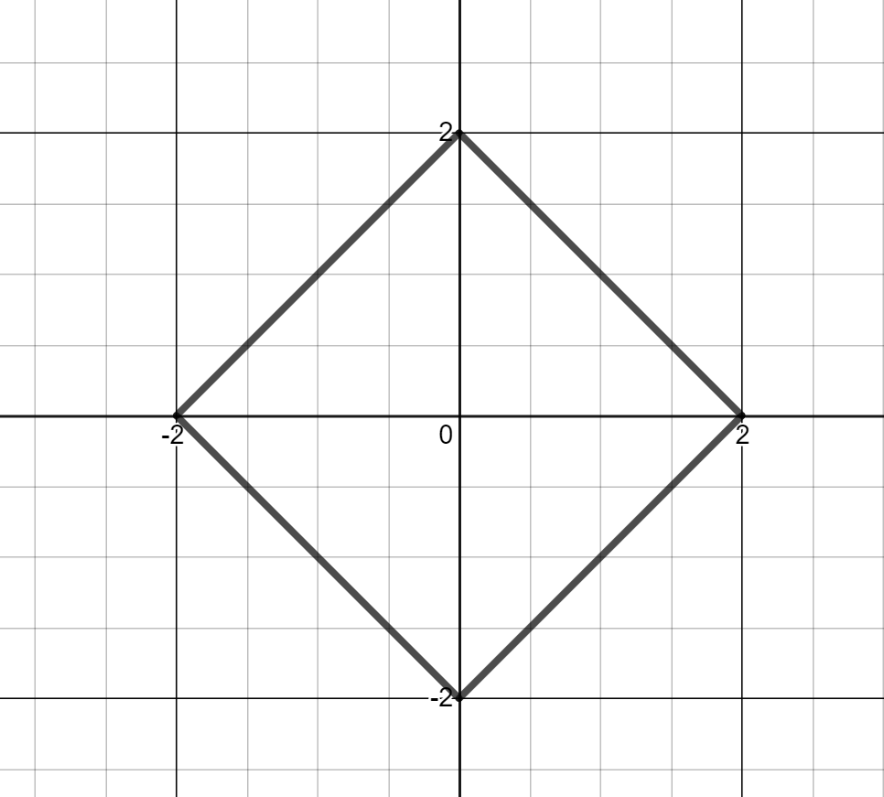
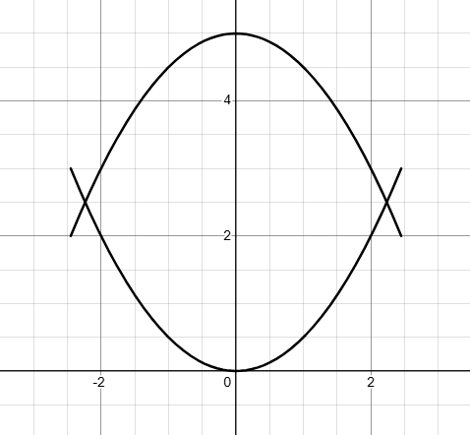
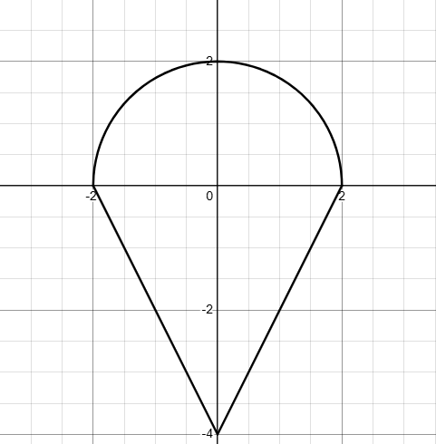
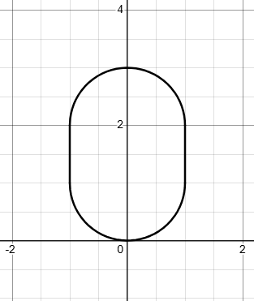

Part B – creating a Logo
As discussed in Part A, professional logos are created in vector format, meaning they are defined by mathematical equations rather than pixels. This allows them to be sharp, scalable and easily edited. Designers use restrictions to crop, transformations to shift and dilate, and grids to ensure their logos are balanced and visually effective. They are a combination of artistic creativity and mathematical precision.
You have been commissioned to design a digital logo for a startup company. The logo will be used across a range of social media, websites, packaging, letterheads and signage. To ensure it meets professional standards, it must be constructed entirely from mathematical functions and relations.
Using a graphing program such as Desmos (Desmos | Graphing Calculator), you will design your logo by selecting and combining functions and relations, and applying your understanding of transformations and restricting domain and range to create an original, effective visual design.
You must include at least 5 different types of functions (or relations) such as linear functions, circles, semicircles, quadratic and cubic functions, absolute value functions, piecewise-defined functions, reciprocal functions or exponential functions and use mathematical reasoning to decide how each contributes to your final design. Your logo must contain a minimum of 8 distinct equations, including the appropriate domain and range for each equation.
Your logo does not need to include words or letters, but you can incorporate them if you wish.
- Include a copy of your logo to submit with your assessment (you may wish to get rid of any grid lines or axis).
- Use a table like the one below to list the equations of all your functions or relations. Justify why you picked your specific equations and state the domain and/or range restrictions used. It is recommended that you use subheadings to represent the different parts of your logo.
Equation | Justification | Domain restriction | Range restriction
- Include another copy of your logo which includes grid lines and the $x$and $y$ axis. Indicate which equation belongs to which section of your logo. It is recommended that you use colours or symbols to represent the different parts of your logo.

Part C – How well can mathematics be used to create art?
Using your work from Parts A and B, write a 300–400-word reflection that responds to the driving question: ‘How well can mathematics be used to create art?’
In your response:
- Analyse how the mathematical choices you made shaped your final design, explaining the strengths of using functions and relations to construct and colour your logo.
- Discuss any limitations or challenges you encountered such as accuracy, restrictions of certain functions or relations, or difficulties with transformations and justify how these affected your final artwork.
- Clearly communicate your reasoning, show how you explored and connected mathematical ideas, and evaluate how effectively mathematics supported your creative goals.

Submission details

Due date
[insert date here] at [insert time here]. Note: all components are due on the same day.

What you will submit
- Table for Part A showing the equations for each shape, justification and domain and/or range restrictions.
- A copy of your logo design.
- A table listing equations of all functions/relations, along with a justification and any domain and/or range restrictions.
- An annotated, version of your logo, indicating which equation is connected to each section of your logo.
- 300–400-word reflection answering Part C.

Submission process
- {School to insert their submission process}

Non-completion of the task
- {School to insert their process for non-completion of a task}

Marking guidelines
Table 1 – student-facing rubric
Criteria | Working towards developing | Developing | Developed | Well developed | Highly developed
Knowledge of functions and relations, identifying graph types, and determining domain and range.  (MAV-11-02) | Demonstrates emerging understanding of functions and relations. Identifies some graphs such as linear or quadratic and attempts to describe domain or range. Uses some functions or relations to represent shapes. | Demonstrates developing understanding of the difference between functions and relations. Identifies several graph types and determines domain and range for some functions and relations when modelling shapes. | Demonstrates sound understanding of functions and relations and identifies a variety of graph types. Determines an appropriate domain and range for most functions and relations used in the design. | Demonstrates strong understanding of functions and relations and accurately classifies a wide variety of graph types. Determines and applies domain and range effectively to construct intended graphical features within the design. | Demonstrates a highly developed understanding of functions and relations, confidently distinguishing between them and accurately identifying a wide variety of graph types. Determines and applies domain and range strategically to model and construct precise graphical features.
Knowledge transformations, correct terminology, recognising order of transformations, and writing transformed equations  (MAV-11-03) | Demonstrates emerging understanding of transformations. Identifies some translations or reflections in graphs and attempts to write equations representing transformed functions or relations. | Describes transformations of functions using some correct terminology such as translations or reflections. Writes equations representing simple transformations. | Applies transformations including translations, reflections and dilations to construct graphs. Writes equations representing transformed functions and relations and recognises how the order of transformations affects the final graph. | Analyses and applies sequences of transformations including reflections, dilations and translations to construct shapes. Writes accurate equations that represent these transformations and explains the effect of transformation order. | Demonstrates a highly developed understanding of transformations by strategically applying sequences of reflections, dilations and translations. Writes precise equations that model these transformations and clearly explains how the order of transformations affects the graphical outcome.
Working mathematically (MAO-WM-01) | Provides a basic reflection with some reference to the mathematical work completed. Identifies some mathematical choices and draws simple conclusions with emerging awareness of their reasonableness or limitations. Uses some mathematical notation, representations and terminology to communicate ideas. | Describes mathematical choices made in constructing shapes and the logo. Identifies at least one strength or limitation of using equations and functions. Draws some conclusions and uses generally appropriate mathematical notation and representations to communicate reasoning. | Analyses mathematical decisions made in constructing shapes and the logo, explaining how functions, relations and transformations contributed to the design. Identifies strengths and limitations with reasonable justification. Communicates reasoning clearly using appropriate mathematical notation, terminology and representations. | Provides a clear and well-reasoned evaluation of how mathematical techniques shaped the final artwork. Explains how functions, relations, transformations and restrictions supported the design. Draws logical conclusions about the effectiveness of mathematics for creating art using accurate and purposeful mathematical communication. | Provides a justified and insightful evaluation of how mathematical concepts, techniques and reasoning shaped the final design. Demonstrates strong evidence of exploring and connecting mathematical ideas throughout the task and communicates reasoning coherently and precisely using accurate mathematical notation, terminology and representations.

References
This resource contains NSW Curriculum and syllabus content. The NSW Curriculum is developed by the NSW Education Standards Authority (NESA). This content is prepared by NESA for and on behalf of the Crown in right of the State of New South Wales. The material is protected by Crown copyright.
Please refer to the NESA Copyright Disclaimer for more information https://www.nsw.gov.au/education-and-training/nesa/copyright.
NESA holds the only official and up-to-date versions of the NSW Curriculum and syllabus documents. Please visit NESA https://www.nsw.gov.au/education-and-training/nesa and NSW Curriculum https://curriculum.nsw.edu.au.
Mathematics Advanced 11–12 Syllabus © NSW Education Standards Authority (NESA) for and on behalf of the Crown in right of the State of New South Wales, 2024.

© State of New South Wales (Department of Education), 2026
The copyright material published in this resource is subject to the Copyright Act 1968 (Cth) and is owned by the NSW Department of Education or, where indicated, by a party other than the NSW Department of Education (third-party material).
Copyright material available in this resource and owned by the NSW Department of Education is licensed under a Creative Commons Attribution 4.0 International (CC BY 4.0) license.

This license allows you to share and adapt the material for any purpose, even commercially.
Attribution should be given to © State of New South Wales (Department of Education), 2026.
Material in this resource not available under a Creative Commons license:
- the NSW Department of Education logo, other logos and trademark-protected material
- material owned by a third party that has been reproduced with permission. You will need to obtain permission from the third party to reuse its material.
Links to third-party material and websites
Please note that the provided (reading/viewing material/list/links/texts) are a suggestion only and implies no endorsement, by the New South Wales Department of Education, of any author, publisher, or book title. School principals and teachers are best placed to assess the suitability of resources that would complement the curriculum and reflect the needs and interests of their students.
If you use the links provided in this document to access a third-party's website, you acknowledge that the terms of use, including licence terms set out on the third-party's website apply to the use which may be made of the materials on that third-party website or where permitted by the Copyright Act 1968 (Cth). The department accepts no responsibility for content on third-party websites.

