# Where are the bees?

Students look at the relationship between variables to determine what might be causing the disappearance of bees.

## Visible learning

### Learning intention

* To be able to model and analyse data involving 2 numerical variables.

### Success criteria

* I can describe the relationship between 2 variables.
* I can draw a line of best fit by eye.
* I can explain the limitations of a model.
* I can justify the conclusions that I draw from a model.

### Syllabus outcomes

A student:

* develops understanding and fluency in mathematics through exploring and connecting mathematical concepts, choosing and applying mathematical techniques to solve problems, and communicating their thinking and reasoning coherently and clearly **MAO-WM-01**
* displays and interprets datasets involving bivariate data **MA5-DAT-C-02**
* graphs and interprets linear relationships using the gradient/slope-intercept form   
  **MA5-LIN-C-02**

[Mathematics K–10 Syllabus](https://curriculum.nsw.edu.au/learning-areas/mathematics/mathematics-k-10-2022/overview) © NSW Education Standards Authority (NESA) for and on behalf of the Crown in right of the State of New South Wales, 2022.

Table 1: lesson summary

|  |  |  |  |
| --- | --- | --- | --- |
| Section | Summary of activity | Teaching strategies | Teaching points |
| Launch | Students watch the video ‘The Death of Bees Explained – Parasites, Poison and Humans’ (6:12). ([bit.ly/where_are_the_bees](https://bit.ly/where_are_the_bees)) up to the 1:32 mark. Students brainstorm other animals that are extinct or at risk of extinction. | Think-Pair-Share  Pose-Pause-Pounce-Bounce | Introduce students to threatened species and the decline in the bee population. |
| Explore | Students work in pairs to create a model of the data in Appendix A by drawing a scatter plot and line of best fit. Slide 3 of the PowerPoint Where are the bees outlines the steps. | Collaboration  Pose-Pause-Pounce-Bounce | Students revise their knowledge of association, lines of best fit, and linear equations. |
| Summarise | Students analyse their models of the bee data to draw conclusions. Prompting questions are on slide 5.  Students compare their results and conclusions with those of other pairs. | Collaboration  Pose-Pause-Pounce-Bounce | Students interpret their model within its context to draw conclusions, acknowledging its limitations. |
| Apply | Students watch the remaining segment of the video ‘The death of bees explained – Parasites, Poison and Humans’.  They can then create an infographic or report to share their results. |  | Students persuade an audience of their findings. |

## Activity structure

This task has been adapted from Don Steward’s Median activity ‘bee aware’ ([bit.ly/medianbeeaware](https://bit.ly/medianbeeaware)).

Please use the associated PowerPoint *Where are the bees?* (WATB PPT)to display images in this lesson.

### Launch

1. Explain to students that colonies of honeybees are dying all over the world at a fast rate. This has very serious consequences for biodiversity and agriculture. Honeybees pollinate the flowers of plants, so without the bees, 80% of plants are likely to disappear.
2. Show the video ‘The Death of Bees Explained – Parasites, Poison and Humans’ (6:12). ([bit.ly/where_are_the_bees](https://bit.ly/where_are_the_bees)) up to the 1:32 mark.
3. Using a Think-Pair-Share ([bit.ly/thinkpairsharestrategy](https://bit.ly/thinkpairsharestrategy)), ask students if they can think of any other animals that are extinct or at risk of becoming extinct.
4. Use a Pose-Pause-Pounce-Bounce questioning strategy (PDF 557 KB) ([bit.ly/posepausepouncebounce](https://bit.ly/posepausepouncebounce)) for pairs to share their lists.

Some examples that students might have heard of include the dodo bird and thylacine (Tasmanian tiger).

Animals that are critically endangered include the black rhino, orangutans, Sumatran elephants and the Sunda tiger.

1. Inform the students that they will be analysing data to identify which variable may be the primary contributor to the decline in bee populations.

### Explore

1. Display slide 3 of the PowerPoint (WATB PPT) which lists the instructions below.
2. Distribute Appendix A ‘Bee data’ to pairs of students. For each set of data in Appendix A, students are to:

* explain which variable is the independent variable
* draw a scatter plot
* describe the relationship formed by the variables, if any
* draw a line of best fit by eye, if appropriate
* find the equation for the line of best fit
* explain what the gradient and $y$-intercept of the line of best fit represent
* describe any limitations of their models.

If students have access to technology, they may choose to use programs such as Desmos or spreadsheets to draw their scatter plots and lines of best fit.

1. Use a Pose-Pause-Pounce-Bounce questioning strategy for pairs to share anything interesting they have discovered during their exploration.

Teachers should ensure students are using mathematical language when explaining their findings. This would be a good opportunity to revisit the meaning of the gradient and $y$-intercept within a context and limitations of linear models.

### Summarise

1. Display slide 5 from the PowerPoint (WATB PPT) which lists the questions below.
2. Pairs of students are to draw conclusions from their analysis of the bee data. At a minimum, they should address the questions:

* When does the data suggest that bee colonies will die out?
* Does the data support a claim that increasing the number of bees would increase food production?
* Is there any association between the sample size and the number of mites?
* Is there any association between the number of standing guards and the number of hovering guards in a colony?

1. Combine each pair of students with another pair.
2. Pairs compare their results and conclusions.
3. Use a Pose-Pause-Pounce-Bounce questioning strategy to allow pairs to share their conclusions and justify their reasoning.

### Apply

1. Show students the remaining segment of the video ‘The Death of Bees Explained – Parasites, Poison and Humans’ (6:12) ([bit.ly/where_are_the_bees](https://bit.ly/where_are_the_bees)).
2. Inform students that they will use the website ‘Canva’ ([canva.com](https://www.canva.com/)) or a similar program to create an infographic or report to share their results and conclusions.
3. Use a Think-Pair-Share for pairs to discuss who the audience of their infographic might be; what they will be trying to persuade them of, if the data they have is sufficient and if not, what other data could they source.
4. Use a Pose-Pause-Pounce-Bounce for pairs to share their thoughts and for the class to come to a consensus regarding who the audience will be, the purpose of the infographic, and if more data is required.

## Assessment and differentiation

### Suggested opportunities for differentiation

**Explore and Summarise**

* To not overwhelm students, they could be provided with one dataset at a time to analyse or choose only one dataset to analyse.
* Students could be provided with scatter graphs and lines of best fit already drawn, to interpolate and extrapolate data.
* Challenge students by providing them with more raw data about bees. Data can be found at the CSIRO website ([bit.ly/HoneyBeeData](https://bit.ly/HoneyBeeData)) ([bit.ly/WorldBee-Day](https://bit.ly/WorldBee-Day)).
* Challenge students to draw as many conclusions as they can from their models.

**Apply**

* When creating their infographic, students can be supported by providing a template in which they can place their graphs and conclusions.
* Students can be supported by providing sentence stems to prompt findings and conclusions.

### Suggested opportunities for assessment

* This learning episode could be used as a summative assessment to test student understanding of this unit of learning.
* Teachers could observe students’ scatter plots, lines of best fit and equations of lines as formative assessment.
* Students could submit their infographic or report as evidence of Working mathematically. Students will need to communicate their results in their infographic and explain their reasoning.

## Appendix A

### Bee data

#### The number of honey-producing bee colonies in the USA

Table 2: the number of honey-producing bee colonies in USA (× 1 000 000) for certain years

|  |  |
| --- | --- |
| Year | Number of bee colonies |
| 1960 | 5 |
| 1964 | 4.7 |
| 1969 | 4.4 |
| 1974 | 4.2 |
| 1978 | 4.1 |
| 1982 | 4.3 |
| 1987 | 3.3 |
| 1992 | 3.1 |
| 1997 | 2.7 |
| 2002 | 2.6 |
| 2007 | 2.4 |

#### The number of bee visits affects the number of seeds a plant produces

Table 3: number of bee visits per 5-minute intervals

|  |  |
| --- | --- |
| Average honeybee visits/5 minutes | Number of onion seeds per umbel |
| 2.2 | 50 |
| 4 | 450 |
| 6 | 600 |
| 4.5 | 200 |
| 2.4 | 320 |
| 3.6 | 240 |
| 3.2 | 220 |
| 8 | 800 |
| 3.4 | 200 |
| 7 | 600 |

#### Varroa mites attach honeybees

Table 4: the number of mites in a sample of bees

|  |  |
| --- | --- |
| Estimated bees per sample | Number of mites in the sample |
| 450 | 23 |
| 500 | 26 |
| 405 | 21 |
| 270 | 18 |
| 360 | 25 |
| 390 | 11 |
| 450 | 11 |
| 360 | 15 |
| 300 | 15 |

#### Standing guards versus hovering guards

Table 5: number of bees standing guard and the number of hovering bee guards per colony

|  |  |
| --- | --- |
| Number of standing guards | Number of hovering guards |
| 18 | 3 |
| 22 | 4 |
| 30 | 7 |
| 4 | 1 |
| 15 | 4 |
| 50 | 8 |
| 5 | 2 |
| 12 | 2 |
| 10 | 3 |
| 18 | 1 |

## Sample solutions

### Appendix A – bee data

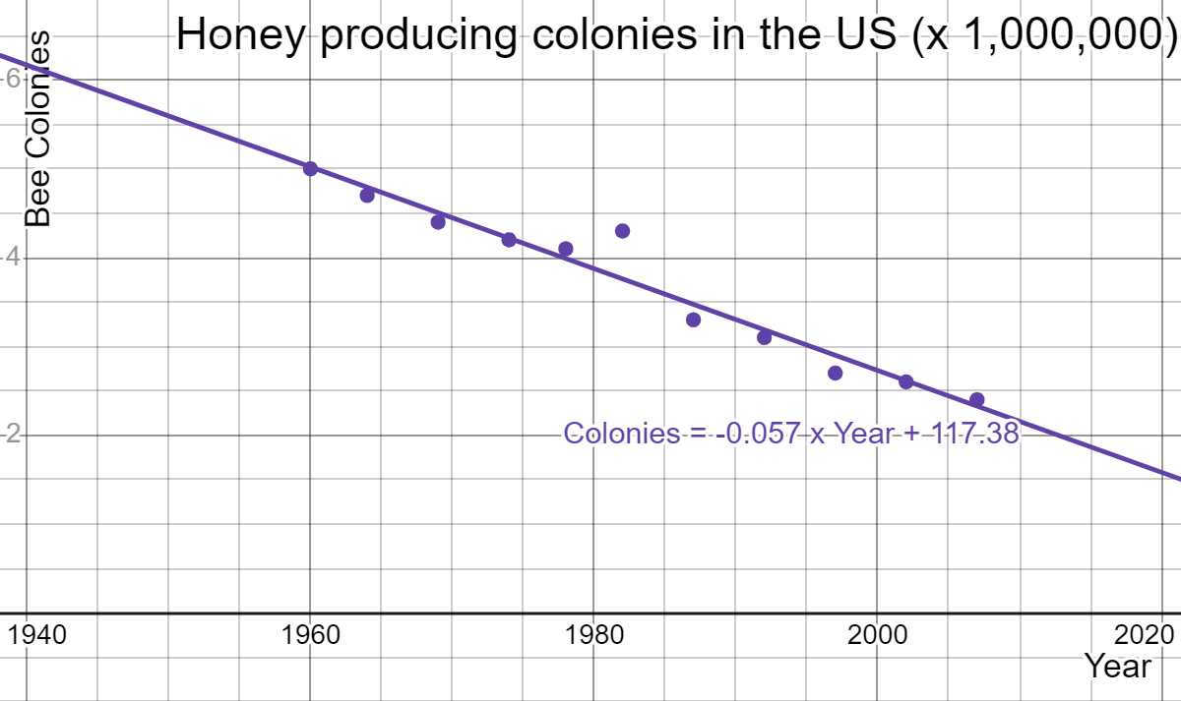

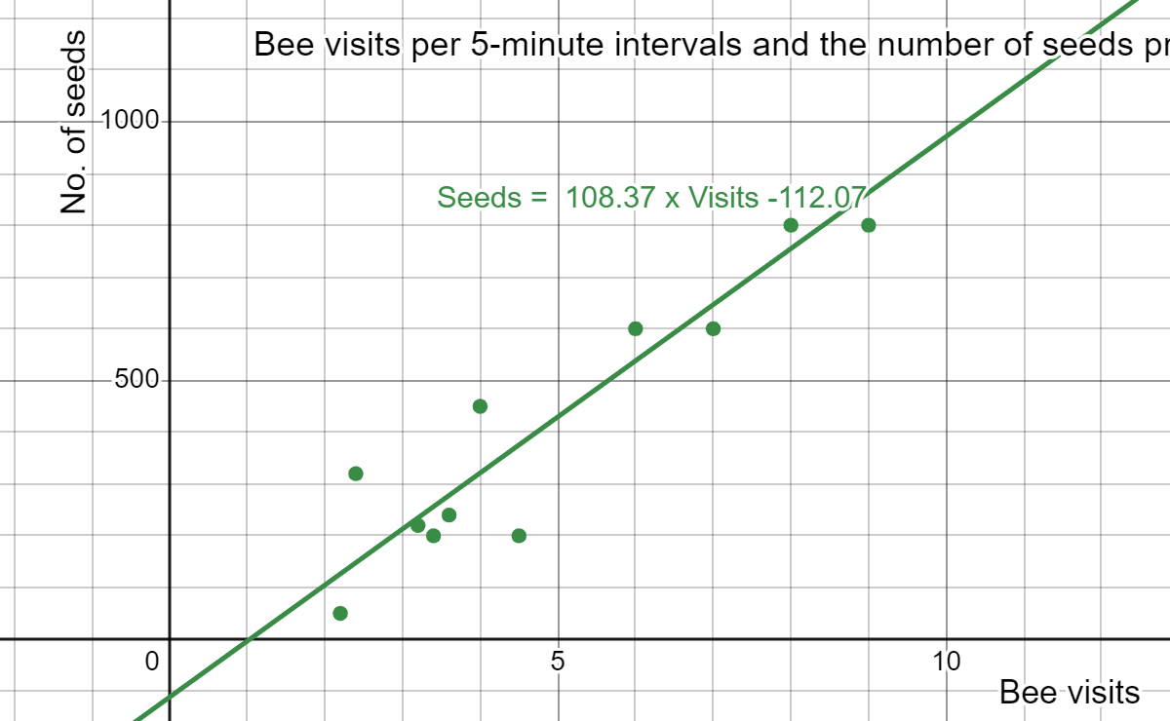

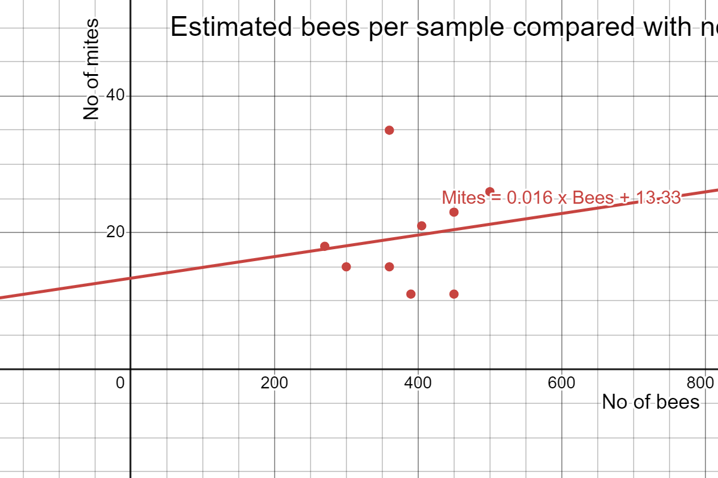

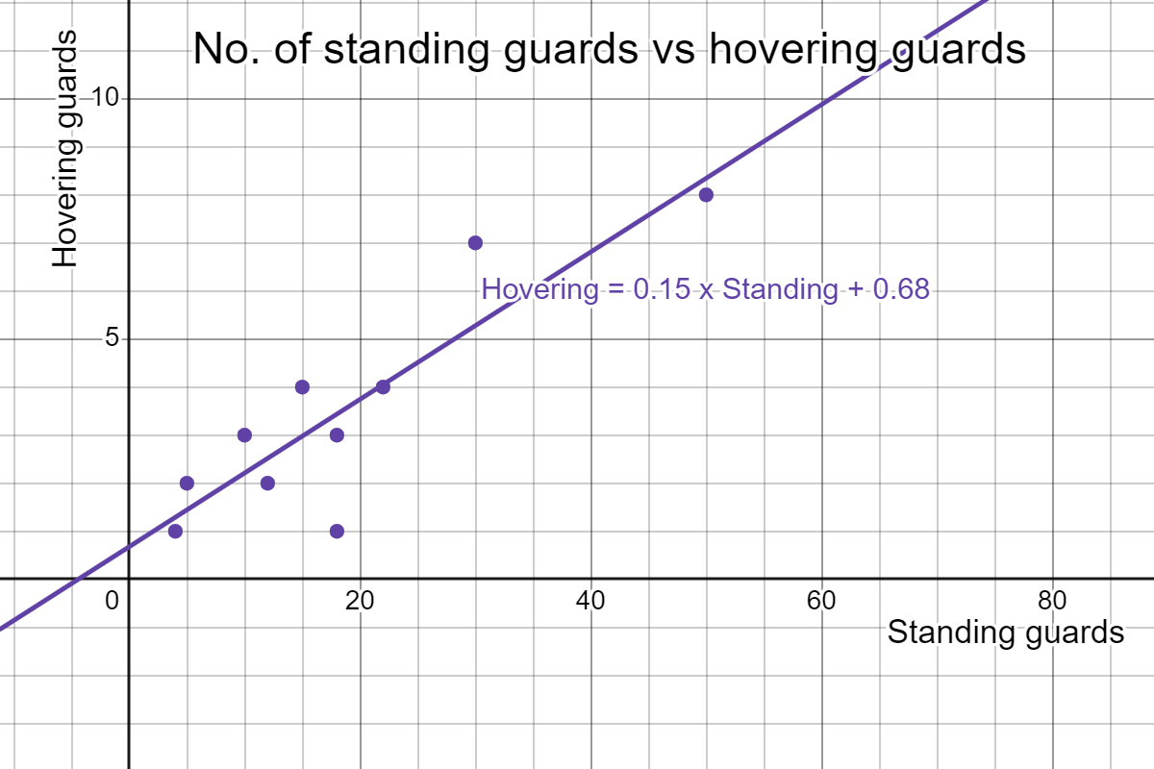

## References

This resource contains NSW Curriculum and syllabus content. The NSW Curriculum is developed by the NSW Education Standards Authority. This content is prepared by NESA for and on behalf of the Crown in right of the State of New South Wales. The material is protected by Crown copyright.

Please refer to the NESA Copyright Disclaimer for more information [https://educationstandards.nsw.edu.au/wps/portal/nesa/mini-footer/copyright](https://aus01.safelinks.protection.outlook.com/?url=https%3A%2F%2Feducationstandards.nsw.edu.au%2Fwps%2Fportal%2Fnesa%2Fmini-footer%2Fcopyright&data=05%7C01%7CCaitlin.Pace1%40det.nsw.edu.au%7C9c2c1a9f59c94d2df30708dafa7edb23%7C05a0e69a418a47c19c259387261bf991%7C0%7C0%7C638097720042599463%7CUnknown%7CTWFpbGZsb3d8eyJWIjoiMC4wLjAwMDAiLCJQIjoiV2luMzIiLCJBTiI6Ik1haWwiLCJXVCI6Mn0%3D%7C3000%7C%7C%7C&sdata=BzQh0UsffVZE3eO22b2Xba3p0VMOBZSHfS21FGHXtZM%3D&reserved=0).

NESA holds the only official and up-to-date versions of the NSW Curriculum and syllabus documents. Please visit the NSW Education Standards Authority (NESA) website <https://educationstandards.nsw.edu.au/> and the NSW Curriculum website <https://curriculum.nsw.edu.au/>.

[Mathematics K–10 Syllabus](https://curriculum.nsw.edu.au/learning-areas/mathematics/mathematics-k-10-2022/overview) © NSW Education Standards Authority (NESA) for and on behalf of the Crown in right of the State of New South Wales, 2022.

Steward D (2 January 2014) ‘[bee aware’](https://donsteward.blogspot.com/2013/12/bee-aware.html), Don Steward, accessed 7 November 2024.

**© State of New South Wales (Department of Education), 2024**

The copyright material published in this resource is subject to the *Copyright Act 1968* (Cth) and is owned by the NSW Department of Education or, where indicated, by a party other than the NSW Department of Education (third-party material).

Copyright material available in this resource and owned by the NSW Department of Education is licensed under a [Creative Commons Attribution 4.0 International (CC BY 4.0) license](https://creativecommons.org/licenses/by/4.0/).

[](https://creativecommons.org/licenses/by/4.0/)

This license allows you to share and adapt the material for any purpose, even commercially.

Attribution should be given to © State of New South Wales (Department of Education), 2024.

Material in this resource not available under a Creative Commons license:

* the NSW Department of Education logo, other logos and trademark-protected material
* material owned by a third party that has been reproduced with permission. You will need to obtain permission from the third party to reuse its material.

**Links to third-party material and websites**

Please note that the provided (reading/viewing material/list/links/texts) are a suggestion only and implies no endorsement, by the New South Wales Department of Education, of any author, publisher, or book title. School principals and teachers are best placed to assess the suitability of resources that would complement the curriculum and reflect the needs and interests of their students.

If you use the links provided in this document to access a third-party's website, you acknowledge that the terms of use, including licence terms set out on the third-party's website apply to the use which may be made of the materials on that third-party website or where permitted by the *Copyright Act 1968* (Cth). The department accepts no responsibility for content on third-party websites.