# Doll bungee

Students will conduct an experiment by creating a simulated bungee system and using it to launch a small plastic doll. Students will aim to determine the minimum number of elastic bands necessary to make the doll's bungee experience safe.

## Visible learning

### Learning intention

* To know how to create and use mathematical models.

### Success criteria

* I can use collected data to construct a scatter plot.
* I can generate a line of best fit from a scatter plot.
* I can extrapolate information from a mathematical model.
* I can recognise the limitations of a mathematical model.

### Syllabus outcomes

A student:

* develops understanding and fluency in mathematics through exploring and connecting mathematical concepts, choosing and applying mathematical techniques to solve problems, and communicating their thinking and reasoning coherently and clearly **MAO-WM-01**
* displays and interprets datasets involving bivariate data **MA5-DAT-C-02**
* graphs and interprets linear relationships using the gradient/slope-intercept form **MA5-LIN-C-02**

[Mathematics K–10 Syllabus](https://curriculum.nsw.edu.au/learning-areas/mathematics/mathematics-k-10-2022/overview) © NSW Education Standards Authority (NESA) for and on behalf of the Crown in right of the State of New South Wales, 2022.

Table 1: lesson summary

|  |  |  |  |
| --- | --- | --- | --- |
| Section | Summary of activity | Teaching strategies | Teaching points |
| Launch | Students watch the video ‘Nevis Bungy - Queenstown, New Zealand’ (1:02) ([bit.ly/NevisBungy](https://bit.ly/NevisBungy)). They then discuss some considerations about the jump. | Notice and wonder | Students get inspired and interested by the idea of bungee jumping. |
| Explore | Students conduct an experiment to gather bivariate data using a doll with rubber bands attached to the feet, dropping from a height with rubber bands progressively added. Students complete Appendix A. Students predict how many bands would be needed to have the doll drop as close to but without passing 400 cm. | Visibly random groups of 3  Vertical non-permanent surfaces | Students gather data by experimenting but also predicting the number of bands. |
| Summarise | Students draw a scatter plot (Appendix B) before drawing a line of best fit for that data. Students determine the equation for the line of best fit before extrapolating data to determine the accuracy of their prediction from the explore section. | Visibly random groups of 3  Vertical non-permanent surfaces  Gallery walk | Students apply previous knowledge of plotting points in a scatter plot, constructing lines of best fit and determining equations of those lines. |
| Apply | Students change one element of the experiment and recollect the data, plot data and determine a new model. Students then consider the changes between the 2 models considering the changes that were made. | Visibly random groups of 3  Vertical non-permanent surfaces  Gallery walk | Students perform the experiment again but change one element and observe how that modification changes the model. |

## Activity structure

### Launch

1. Show students the video ‘Nevis Bungy - Queenstown, New Zealand’ (1:02) ([bit.ly/NevisBungy](https://bit.ly/NevisBungy)), which shows an example of people bungee jumping in Queenstown, New Zealand.
2. Explain to students that the aim of the bungee jump is to almost reach the bottom (which could be ground or water surface) without touching it when the cable is fully extended.
3. Ask students what they notice and wonder ([bit.ly/noticewonderstrategy](https://bit.ly/noticewonderstrategy)) about the bungee experience.

Students might notice the distance that the people fall or how close to the bottom they reach.

Students might wonder:

* How do they work out how long the cable should be?
* Could the cable be too short?
* Is there an optimal length for the best ‘springback’?
* Does the size (height and weight) of the jumper affect the length of the cable used?
* What if the cable loses elasticity?
* Does the age of the cable affect the safety of the cable?

### Explore

1. Explain to students that they will create their own simulation of a bungee jump by connecting a series of rubber bands to simulate the cable and using a small plastic doll as the bungee jump subject.
2. Assign students into visibly random groups of 3 ([bit.ly/visiblegroups](https://bit.ly/visiblegroups)) at vertical non-permanent surfaces ([bit.ly/VNPSstrategy](https://bit.ly/VNPSstrategy)).
3. Show students an example of the rubber band they will use and ask them to predict the minimum number of rubber bands they would need to allow the doll to fall 400 cm. Have students record their estimates in their workbooks.

#### Equipment

* Large number of rubber bands, at least 15–20 per group (all the same size and type)
* Measuring tapes
* Masking tape
* Small plastic dolls, around 25–30 cm long (one for each group of 3)
* A large piece of paper like butcher’s paper or at least 2–3 A3 sheets of paper per group. This is to make marks on for measuring the bounce
* One copy of Appendix A ‘Data collection’ per group
* One A3 copy of Appendix B ‘Scatter plot’ in a plastic sleeve per group

#### Method

1. Distribute the equipment to the visibly random groups of 3.
2. Tape a large piece of paper, or multiple pieces end-to-end, to a wall so they go up about 180 cm (or as high up as can be comfortably held). Draw a line on the top of the paper where the doll will jump from (line marker).

Figure 1: doll at line marker

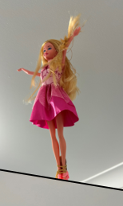

1. Show students how to wind the rubber band around the doll's leg so that further bands can be looped through and attached to her feet. Also, show students how a slipknot can be used for additional bands by pulling a band underneath a loop (Figure 2 below) and hooking one end through the other (Figure 3 below).
2. Attach an elastic band to the doll’s feet.

Figure 2: doll’s feet with rubber bungee attached

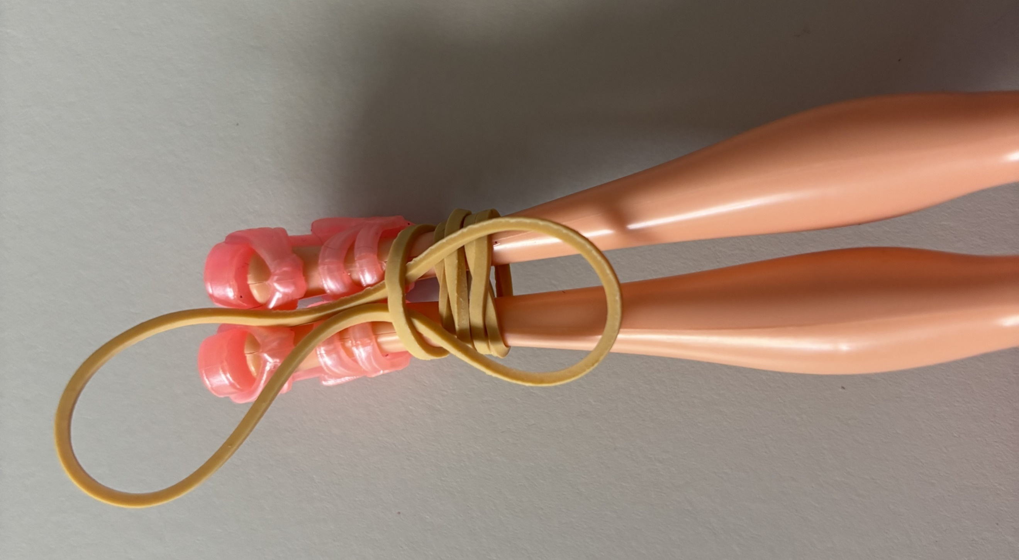

1. Loop an elastic band through the last band, connecting it to the previous ones.

Figure 3: rubber band looped through

A doll's feet tied together with a loop connected.



1. Hold the end of the rubber band at the line marker with one hand and allow the doll to jump ‘drop’ with the other. Have a partner mark on the paper the lowest point the doll reaches on this jump (the bottom of the first bounce).
2. Measure the distance from the start line to the lowest point she reaches in centimetres and record the distance on Appendix A ‘Data collection’.

Figure 4: doll's drop being measured

A doll bouncing along side a tape measure.



1. Attach another rubber band and repeat the process of steps 5 to 7.
2. Continue adding rubber bands and recording the drop distance until you have completed the table.

Figure 5: doll dropping on multiple bands

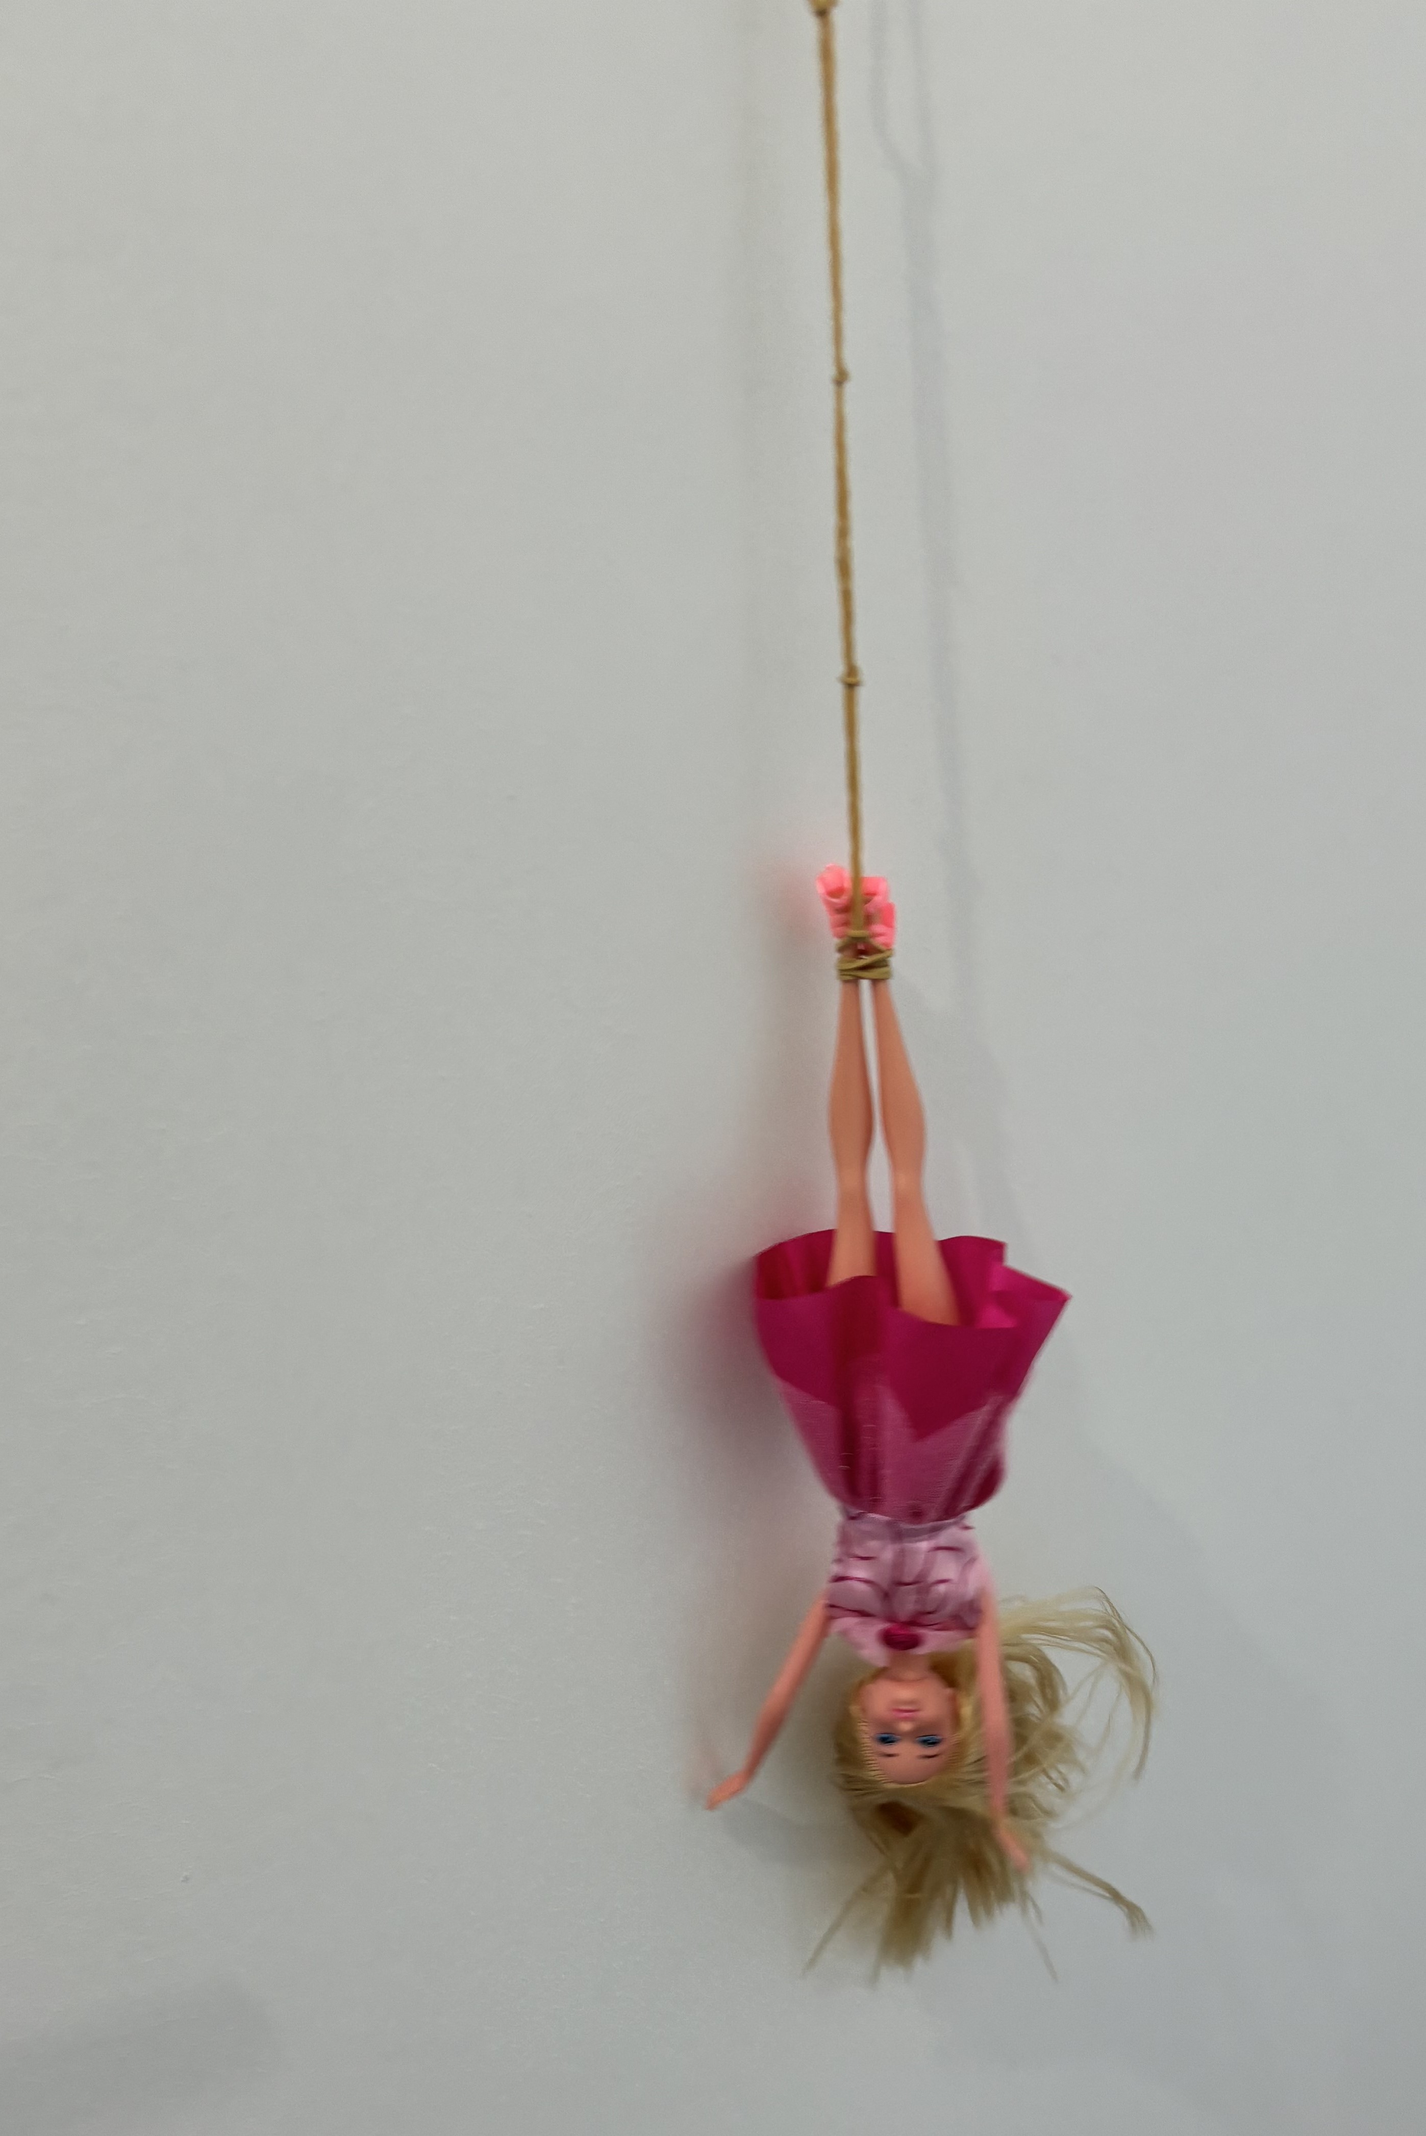

You may like to repeat each jump and measure the average of the jumps for each level.

### Summarise

1. By continuing to work in visibly random groups of 3, have students discuss what the dependent and independent variables would be for this experiment.
2. On the vertical non-permanent surfaces, use the A3 copy of Appendix B ‘Scatter plot’ with 2 clear plastic sleeves with adhesive putty and get students to draw a scatter plot from the data collected, making sure they label the horizontal axis with the independent variable and the vertical axis with the dependent variable.

Place the graph in one clear sleeve and the questions in the other.

1. Sketch a line of best fit by eye and determine the equation of that line.

Students have learned about lines of best fit in Lesson 3 – lines of best fit from this unit.

1. Students are to do a gallery walk ([bit.ly/DLSgallerywalk](https://bit.ly/DLSgallerywalk)) of the graphs. Ask the students to look at what was similar and what was different in their graphs to other groups.
2. In their groups of 3, students are to complete the following questions from Appendix B using a set of data from above:

* What is the slope of your equation and what does it represent in this model?
* What is the $y$-intercept and what does it represent in this model?
* Based on this model what would be the maximum number of rubber bands so that the doll could safely jump from 400 cm? How accurate were the guesses of people in your group?
* How accurate do you think your model for the doll’s bungee jump is? What could be some limitations of this model?
* Could this model be used for other dolls or be extrapolated for humans? Justify your answer.

Answers to the last question may be:

No, because humans have different weights, and the rubber bands would not support the weight of humans.

No, because dolls are different sized and made from different materials so their weight will be different.

1. In a class discussion, students should compare the model’s prediction of the maximum number of elastic bands to see how it compares with their own estimates and how it compares to other students.

### Apply

1. Students are to repeat the above experiment, but this time replace one variable of the experiment and see how this affects the results.

* Examples of things that can be changed include
* Different style of doll (either larger or smaller).
* Different-sized rubber bands, both diameter of band and width of rubber.
* Different types of bands, for example, elastic rather than rubber bands.
* Equipment for Apply activity
* Different-sized dolls of the same style
* 15–20 different sized rubber bands – diameter of band and width
* Different material in the band, for example, elastic rather than rubber.

1. In their group, students discuss what is different between the 2 models and what is the same.

## Assessment and differentiation

### Suggested opportunities for differentiation

**Launch**

* A notice and wonder strategy is used, where there is no correct answer so that all students can participate in the discussion.

**Explore**

* There are no correct answers during the prediction of the number of bands and all students should be encouraged to participate and share their thoughts and reasoning.
* The experiment is conducted as a group of 3 so students can seek assistance from peers if required.

**Summarise**

* Students could be provided with pre-gathered data to draw the scatter plot from.
* Students can be given the axes with a scale pre-marked.

**Apply**

* Students should be challenged to make connections with prior knowledge on association from previous units. For example, connections to equations of straight lines.
* Students should be challenged to draw as many conclusions as they can about the comparison of the models.

### Suggested opportunities for assessment

**Explore**

* The process of collecting data, including the determining of the dependent and independent variables could be used for assessment.

**Summarise**

* The scatter plot, and model produced, along with any conclusions can be collected and used as a summative assessment.

**Apply**

* The second model could also be collected and used as a summative assessment, along with any comparisons drawn in comparing this model to the previous one.

## Appendix A

### Data collection

|  |  |
| --- | --- |
| Number of elastic Bands (*x*) | Jump distance in centimetres (*y*) |
| 2 |  |
| 3 |  |
| 4 |  |
| 5 |  |
| 6 |  |
| 7 |  |
| 8 |  |
| 9 |  |
| 10 |  |
| 11 |  |
| 12 |  |
| 13 |  |
| 14 |  |
| 15 |  |

## Appendix B

### Scatter plot

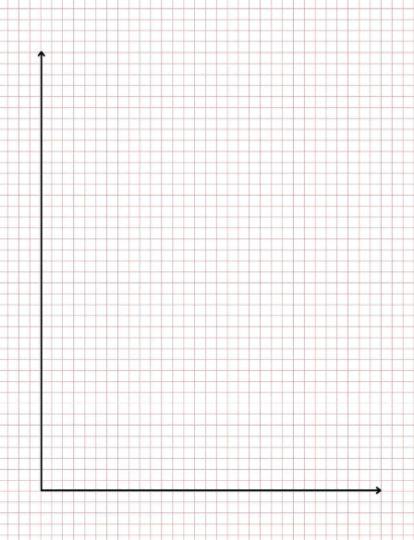

#### Questions

1. What are the dependent and independent variables in this model?
2. What is the slope of your equation and what does it represent in this model?
3. What is the $y$-intercept and what does it represent in this model?
4. Based on this model what would be the maximum number of rubber bands so that the doll could safely jump from 400 cm? How accurate were the guesses of people in your group?
5. How accurate do you think your model for the doll’s bungee jump is? What could be some limitations of this model?
6. Could this model be used for other dolls or be extrapolated for humans? Justify your answer.

## Sample solutions

### Appendix B – example of a scatter plot

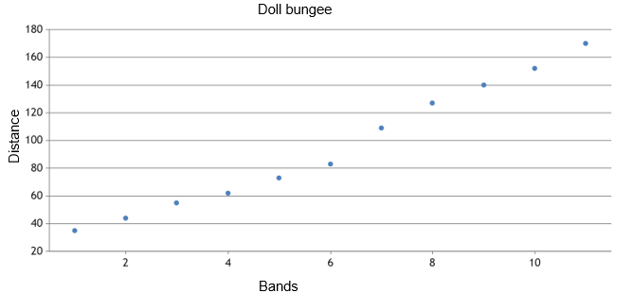

Bands

## References

This resource contains NSW Curriculum and syllabus content. The NSW Curriculum is developed by the NSW Education Standards Authority. This content is prepared by NESA for and on behalf of the Crown in right of the State of New South Wales. The material is protected by Crown copyright.

Please refer to the NESA Copyright Disclaimer for more information [https://educationstandards.nsw.edu.au/wps/portal/nesa/mini-footer/copyright](https://aus01.safelinks.protection.outlook.com/?url=https%3A%2F%2Feducationstandards.nsw.edu.au%2Fwps%2Fportal%2Fnesa%2Fmini-footer%2Fcopyright&data=05%7C01%7CCaitlin.Pace1%40det.nsw.edu.au%7C9c2c1a9f59c94d2df30708dafa7edb23%7C05a0e69a418a47c19c259387261bf991%7C0%7C0%7C638097720042599463%7CUnknown%7CTWFpbGZsb3d8eyJWIjoiMC4wLjAwMDAiLCJQIjoiV2luMzIiLCJBTiI6Ik1haWwiLCJXVCI6Mn0%3D%7C3000%7C%7C%7C&sdata=BzQh0UsffVZE3eO22b2Xba3p0VMOBZSHfS21FGHXtZM%3D&reserved=0).

NESA holds the only official and up-to-date versions of the NSW Curriculum and syllabus documents. Please visit the NSW Education Standards Authority (NESA) website <https://educationstandards.nsw.edu.au/> and the NSW Curriculum website <https://curriculum.nsw.edu.au/>.

[Mathematics K–10 Syllabus](https://curriculum.nsw.edu.au/learning-areas/mathematics/mathematics-k-10-2022/overview) © NSW Education Standards Authority (NESA) for and on behalf of the Crown in right of the State of New South Wales, 2022.

**© State of New South Wales (Department of Education), 2024**

The copyright material published in this resource is subject to the *Copyright Act 1968* (Cth) and is owned by the NSW Department of Education or, where indicated, by a party other than the NSW Department of Education (third-party material).

Copyright material available in this resource and owned by the NSW Department of Education is licensed under a [Creative Commons Attribution 4.0 International (CC BY 4.0) license](https://creativecommons.org/licenses/by/4.0/).

[](https://creativecommons.org/licenses/by/4.0/)

This license allows you to share and adapt the material for any purpose, even commercially.

Attribution should be given to © State of New South Wales (Department of Education), 2024.

Material in this resource not available under a Creative Commons license:

* the NSW Department of Education logo, other logos and trademark-protected material
* material owned by a third party that has been reproduced with permission. You will need to obtain permission from the third party to reuse its material.

**Links to third-party material and websites**

Please note that the provided (reading/viewing material/list/links/texts) are a suggestion only and implies no endorsement, by the New South Wales Department of Education, of any author, publisher, or book title. School principals and teachers are best placed to assess the suitability of resources that would complement the curriculum and reflect the needs and interests of their students.

If you use the links provided in this document to access a third-party's website, you acknowledge that the terms of use, including licence terms set out on the third-party's website apply to the use which may be made of the materials on that third-party website or where permitted by the *Copyright Act 1968* (Cth). The department accepts no responsibility for content on third-party websites.