# Problem-solving quadratics

Students explore the practicalities of the vertex and intercepts in real-world scenarios.

Students will need at least one digital device per pair to interact with Desmos during this lesson.

## Visible learning

This lesson incorporates Path content.

### Learning intention

* To be able to solve problems that involve quadratics.

### Success criteria

* I can identify what the features of a parabola mean within a context.
* I can create an equation from a worded problem.
* I can find the roots and vertex of a parabola from a quadratic equation.
* I can interpret solutions to real-world problems.

Table 1: lesson summary

|  |  |  |  |
| --- | --- | --- | --- |
| Section | Summary of activity | Teaching strategy | Teaching points |
| Launch | Students attempt a worded problem to find the maximum amount of money an amusement park can make by finding the optimal price of tickets to maximise the number of people entering the park. | Visibly random groups  Vertical non-permanent surfaces  Assessing and advancing questions  Gallery walk | Students use their prior knowledge to apply to a real-world scenario. |
| Explore | Students explore how the equation, shown in the PowerPoint Problem-solving quadratics, came from the wording, before explaining what part of the parabola is used to solve the problem. | Think-Pair-Share  Pose-Pause-Pounce-Bounce  Visibly random groups  Vertical non-permanent surfaces | Students are stepped through how to interpret the problem. |
| Summarise | Students explore how Newman’s prompts can help to decipher worded problems. After writing notes to their future forgetful selves, they complete the banner task questions in Appendix A. | Pose-Pause-Pounce-Bounce  Think-Pair-Share | Students are given skills to approach new worded problems. |
| Apply | Students return to the Launch problem, thinking about the context of the problem. They explore possible solutions graphically on a Desmos graphing calculator ([bit.ly/amusementparkproblem](https://bit.ly/amusementparkproblem)) before attempting more worded problems in Appendix B to solve with Desmos. | Visibly random groups  Vertical non-permanent surfaces  Pose-Pause-Pounce-Bounce  Turn and talk | Students are asked to consider if a solution makes sense in the context of the problem. They use simultaneous equations graphically to solve more worded problems. |

### Syllabus outcomes

A student:

* develops understanding and fluency in mathematics through exploring and connecting mathematical concepts, choosing and applying mathematical techniques to solve problems, and communicating their thinking and reasoning coherently and clearly **MAO-WM-01**
* identifies and compares features of parabolas and exponential curves in various contexts **MA5-NLI-C-02**
* solves linear equations of more than 3 steps, monic and non-monic quadratic equations, and linear simultaneous equations **MA5-EQU-P-02** (Path)

[Mathematics K–10 Syllabus](https://curriculum.nsw.edu.au/learning-areas/mathematics/mathematics-k-10-2022/overview) © NSW Education Standards Authority (NESA) for and on behalf of the Crown in right of the State of New South Wales, 2022.

## Activity structure

Please use the associated PowerPoint Problem-solving quadratics (PQ PPT) to display images in this lesson.

### Launch

1. Assign students to visibly random groups of 3 ([bit.ly/visiblegroups](https://bit.ly/visiblegroups)) at vertical non-permanent surfaces ([bit.ly/VNPSstrategy](https://bit.ly/VNPSstrategy)) and read the scenario:

An amusement park has a daily ticket price of $48 and the average monthly attendance has been 22 000 people. A market survey indicates that for each $1 decrease in ticket price, attendance increases by 1000 people. What is the maximum amount of money the amusement park could make in a month?

1. Ask students to work through the task. Use the following assessing and advancing questions ([bit.ly/supportingstrategies](https://bit.ly/supportingstrategies)) to further student thinking.

Table 2: assessing and advancing questions

|  |  |
| --- | --- |
| Assessing questions | Advancing questions |
| What is the question asking you to find? | How much would you make if 10 people attended? What about 100 people? |
| What do you know so far? | How much would you earn if tickets were $48? What if they were $45? |
| Explain how you found these values for the revenue or amount of money that the amusement park can make. | Given the question is asking for a maximum amount, what do you expect the graph to look like? What feature of the graph might this relate to? |
| How did you create your equations for the cost per ticket? How about the number of people attending? | Can you point to the maximum amount of the graph? |

1. Ask students to do a gallery walk ([bit.ly/DLSgallerywalk](https://bit.ly/DLSgallerywalk)), noting how other groups approached the problem.
2. Ask random students to explain what they liked about another group's work.

Students are not required to find the solution to the problem but rather use their Working mathematically skills to think about how to approach it.

### Explore

1. Display slide 3 of the PowerPoint (PQ PPT), which displays the equation created to model the Launch problem.
2. In a Think-Pair-Share ([bit.ly/thinkpairsharestrategy](https://bit.ly/thinkpairsharestrategy)), ask students to discuss where each of the binomial expressions come from in the binomial product.
3. Use the Pose-Pause-Pounce-Bounce questioning strategy (PDF 557 KB) ([bit.ly/posepausepouncebounce](https://bit.ly/posepausepouncebounce)) to ask students:

* What words in the problem help us to create this equation?
* How does the equation help us to find the solution to the problem?
* The problem gives us an equation that can be represented by a parabola. What feature of a parabola might we be trying to find to answer this problem? How do we know?
* What do we already know to be the relationship between the vertex and the $x$-intercepts of a parabola? How might this help us to answer the problem?

Students explored the features of a parabola, including that the axis of symmetry and $x$-coordinate of the vertex are halfway between the $x$-intercepts in the activity ‘It’s a drag’ in Lesson 2 – features of a parabola of Unit 12 – investigating parabolas.

Students may notice that we can find the vertex from the $x$-intercepts.

1. Ask students to return to their visibly random groups of 3 to complete the Launch problem at their vertical non-permanent surface.
2. Extend the Launch problem for students by asking them to find the amount of money the park currently makes per month and the maximum amount they could add to the price before no one attends the park.

Students may recognise that the $y$-intercept represents the amount of money the park makes currently and that $22 is the amount they could add to ticket prices until no one attends anymore. This is because 22 is one of the $x$-intercepts. The other $x$-intercept represents when the admission price is zero.

Working for the amusement park problem is revisited in the Apply section, so students should document their working before continuing. This could be done by taking a picture or writing down a summary of their approach to the solution.

### Summarise

1. Using the Pose-Pause-Pounce-Bounce questioning strategy, ask students:

* How did we know what the question was asking us to do?
* How did we know what mathematics would help us to solve the problem?

1. Display slide 5 of the PowerPoint (PQ PPT) with Newman’s prompts. Ask students in a Think-Pair-Share to discuss how their process for approaching the Launch problem matched the prompts.
2. Ask students to write notes to their future forgetful selves ([bit.ly/notestofutureself](https://bit.ly/notestofutureself)) about what steps they could take to help them solve worded problems in mathematics.
3. Assign students into new visibly random groups of 3 at vertical non-permanent surfaces to complete the banner task ([bit.ly/supportingstrategies](https://bit.ly/supportingstrategies)) in Appendix A ‘Banner tasks’, using the starting letters of ‘Read, Comprehend, Transform, Process and Encode’, or similar to communicate each part of Newman’s prompts when answering questions.
4. Actively monitor groups for differing answers to the same problem. If this occurs, have the groups talk to each other. Rather than telling the groups if they are correct, ask them to discuss their differing answers.

### Apply

1. State to students that for the Launch problem, we did not consider the validity of the answer in context to see if it made sense.
2. Have students return to their groups at vertical non-permanent surfaces and extend the Launch problem by stating the following:

Do we think the number of people that are coming to our amusement park now is reasonable? How would we find the amount of money to discount tickets by, given the maximum number of people we could fit in the amusement park is 30 000?

1. Using the Pose-Pause-Pounce-Bounce questioning strategy, ask students:

* What approach did you take to the problem?
* How did the change in the problem change the mathematics you used to solve the problem?

1. Show students the Desmos graph ‘Amusement park graphs’ ([bit.ly/amusementparkproblem](https://bit.ly/amusementparkproblem)). This graph shows the parabola that models the Launch scenario and a straight line to represent the capacity of the amusement park.
2. Have students turn and talk ([bit.ly/classroomtalkmoves](https://bit.ly/classroomtalkmoves)) in their groups of 3 to discuss the solution.

Students will notice that the parabola has 2 points of intersection, with the straight line representing the capacity. This indicates that there are 2 possible answers, but you would want to use the smaller $x$-value, as $x$ is representing the amount you are deducting from the ticket price. A small $x$ value results in a higher ticket price and a larger profit.

1. Select random students to share what their group discussed.
2. Assign a digital device to each group and ask them to open the ‘Desmos graphing calculator’ ([desmos.com/calculator](https://www.desmos.com/calculator)).
3. Distribute Appendix B ‘Simultaneous equations using graphs’ and ask groups to use Desmos to assist them to solve the problems.

## Assessment and differentiation

### Suggested opportunities for differentiation

**Launch**

* Advancing questions are provided to prompt student thinking to progress in the problem.
* Students who are learning English as an additional language or dialect (EAL/D) may benefit from being supplied the question in words to translate into their most familiar language.

**Explore**

* Students may benefit from revisiting the activity ‘It’s a drag’ from Lesson 2 – features of a parabola of Unit 12 – investigating parabolas.
* To enable students, provide them with prompts prior to the lesson to help them engage in Think-Pair-Shares and class discussions.
* Challenge students to interpret what every feature of the parabola means in the context of the Launch problem.

**Summarise**

* Enable students to complete Appendix A by scaffolding the expected response or providing visuals.
* To extend students, ask them to create their own worded problem for another group to solve.

**Apply**

* Enable students to complete Appendix B by providing them with the graphs already created.
* Students can be provided a Newman’s prompts scaffold to ensure they are answering the question.
* Challenge students to graph without technology or use the substitution method to solve the simultaneous equations in Appendix B.

### Suggested opportunities for assessment

**Launch**

* Assessing questions have been provided to gauge students’ Working mathematically skills.

**Explore**

* Students give each other peer feedback, before sharing with the class in a Think-Pair-Share.
* Monitor responses in class discussions to check for student understanding of creating equations from worded problems.

**Summarise**

* Create an exit ticket where students need to submit one of the problems, explaining their solution method.
* Students provide peer feedback when grouped with ones with differing answers. This helps them to reflect on their communication skills and understanding.

**Apply**

* Students will demonstrate their Working mathematically skills in discussions and justifications.
* Collect students’ graphs and responses to Appendix B for evidence of the learning of solving simultaneous equations graphically.

## Appendix A

### Banner task

1. Find 2 positive numbers which differ by 3 and have a product of 88.
2. The product of 2 positive, consecutive, odd numbers is 143. Find the numbers.
3. The area of a rectangle with side lengths $2x$ cm and $x-2$ cm is equal to the area of a square with sides of length $x$ cm. What is the value of $x$?
4. A man walks $x$ km north, then $(x+7)$ km east. He is now 13 km from his starting point. Find the value of $x$.
5. A positive number exceeds 4 times its reciprocal by 3. Find the number.
6. The height of a photo exceeds the width by 7 cm. If the area is $60 \text{c}{\text{m}}^{\text{2}}$, find the height of the photo.
7. Find the 3 consecutive positive numbers, which are written as $x, x+1, x+2$, if the square of the largest number is 45 less than the sum of the squares of the other numbers.
8. The 2 sides of a rectangle are $x$ and $x-17$. The diagonal of the rectangle is 25 cm. Find the perimeter of the rectangle.

#### Challenge problems

1. The perimeter of a rectangle is 14 cm. If the diagonal is 5 cm, find the dimensions of the rectangle.
2. The numerator of a fraction is one less than the denominator. When both the numerator and denominator are increased by 2, the fraction is increased by a twelfth. Find the original fraction.

## Appendix B

### Simultaneous equations using graphs

1. A charity seeks to raise money by phoning people from a call centre and asking them to donate. Over the years, this charity has found the amount of money raised, $\$y,$ is related to the number of calls made, $x$, creating the relationship $y={0.008x}^{2}$.

If it costs the charity $2100 per week to run the call centre and an average of 50 cents per call, when does the charity break even?

1. A fence is built around a rectangular paddock. An internal fence is also to be built. The side lengths of the paddock are $x$ metres and $y$ metres, as shown in the diagram below.

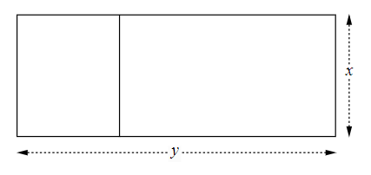

A total of 900 metres of fencing is to be used. Therefore, $3x+2y=900$.

1. Find an equation to represent the area of the paddock.
2. When will the paddock be the same area as a triangular paddock? A triangular paddock may be more beneficial to the farmer on their land. The equation for the area of a triangular paddock is $A=50x$.
3. During the Olympic shooting event, an object is projected vertically into the air. Its height, $y$ metres, above the ground after $x$ seconds is given by $y=-5x^{2}+80x-180$. If a bullet was fired in a straight line, following the equation $y=3x+4$, find the time it would take for the bullet to hit the projectile and at what height the hit would occur.

## Sample solutions

### Launch problem

Let $x$ be the number of $1 dollar deductions.

Ticket price $=48-x$

Attendance $=22 000+1000x$

Therefore, the revenue can be found using the equation, $y=\left(48-x\right)\left(22 000+1000x\right)$

The zeroes or roots of this equation are: $x=48, x=-22$

Axis of symmetry is at $x=\frac{48-22}{2}=13$

Vertex is $\left(48-13\right)\left(22 000+1000\left(13\right)\right)=35×35000=1 225 000$

$$(13, 1 225 000)$$

Therefore, the maximum amount they could make is $1 225 000 per month.

### Explore extension

Let $x=0,$

$$y=\left(48-0\right)\left(22 000+1000×0\right) \\ y=48×22 000 \\ y=\$1 056 000$$

Therefore, the current amount the park makes is $1 056 000.

The maximum amount they could add to the price is $22, as the $x$-intercept is (−22,0) which would have us adding to the price rather than decreasing it.

### Appendix A – banner tasks

1. $x\left(x-3\right)=88$ $$x^{2}-3x=88 \\ x^{2}-3x-88=0 \\ \left(x+8\right)\left(x-11\right)=0 \\ x=-8, x=11$$ Since we know the numbers are positive, we only take the solution of $x=11$. This gives us our other number to be 8, as it is 3 less than 11. $∴$ 
    The numbers are 8 and 11.

$x\left(x+2\right)=143$ $$x^{2}+x=143 \\ x^{2}+2x-143=0 \\ \left(x+13\right)\left(x-11\right)=0 \\ x=-13, x=11$$

We only take the positive, as the question asks for the positive, so the numbers are 11 and 13.

$2x\left(x-2\right)=x^{2}$ $$2x^{2}-4x=x^{2} \\ x^{2}-4x=0 \\ x\left(x-4\right)=0 \\ x=0, x=4$$

We do not use $x=0,$ as that would give us no area, so $x=4$.

1. 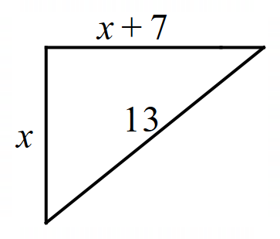 $$x^{2}+{\left(x+7\right)}^{2}={13}^{2} \\ x^{2}+x^{2}+14x+49=169 \\ 2x^{2}+14x-120=0 \\ x^{2}+7x-60=0 \\ \left(x+12\right)\left(x-5\right)=0 \\ x=-12, x=5$$

Length cannot be negative, so $x$ is 5 km.

$x+3=\frac{4}{x}$ $$x^{2}+3x=4 \\ x^{2}+3x-4=0 \\ \left(x+4\right)\left(x-1\right)=0 \\ x=-4, x=1$$

The number is 4, as it is positive.

$x\left(x-7\right)=60$ $$x^{2}-7x=60 \\ x^{2}-7x-60=0 \\ \left(x+5\right)\left(x-12\right)=0 \\ x=-5, x=12$$

The height is 12 cm, as height cannot be negative.

${\left(x+2\right)}^{2}+45=x^{2}+{\left(x+1\right)}^{2}$ $$x^{2}+4x+4+45=x^{2}+x^{2}+2x+1 \\ 0=x^{2}-2x-48 \\ 0=\left(x+6\right)\left(x-8\right) \\ x=-6, x=8$$

The 3 numbers are 8, 9 and 10, as they are positive numbers.

$x^{2}+{\left(x-17\right)}^{2}={25}^{2}$ $$x^{2}+x^{2}-34x+289=625 \\ 2x^{2}-34x-336=0 \\ x^{2}-17x-168=0 \\ x=\frac{\left(17±\sqrt{{(\left(-17\right)}^{2}-4×1×-168}\right)}{2} \\ x=\frac{17±31}{2} \\ x=24, x=-7$$

Length can only be positive, so $x=24$ $$24+24+\left(24-17\right)+\left(24-17\right)=62$$

The perimeter is 62 cm.

#### Challenge problems

$2x+2y=14$ $$x+y=7 \\ y=7-x \\ x^{2}+y^{2}=5^{2} \\ x^{2}+{\left(7-x\right)}^{2}=25 \\ x^{2}+49-14x+x^{2}=25 \\ 2x^{2}-14x+24=0 \\ x^{2}-7x+12=0 \\ \left(x-4\right)\left(x-3\right)=0 \\ x=4, x=3$$

The rectangle measures 4 cm × 3 cm. Verified with substitution.

$\frac{x-1}{x}+\frac{1}{12}=\frac{x+1}{x+2}$ $$12\left(x-1\right)\left(x+2\right)+x\left(x+2\right)=12x\left(x+1\right) \\ 13x^{2}+14x-24=12x^{2}+12x \\ x^{2}+2x-24=0 \\ \left(x+6\right)\left(x-4\right)=0 \\ x=-6, x=4$$

The original fraction is $\frac{3}{4}$ or $\frac{-7}{-6}$. Verified with substitution in the original equation.

### Appendix B – simultaneous equations using graphs

1. The charity breaks even after they have made 545 phone calls, equalling costs of around $2372.28, as you cannot make negative calls.

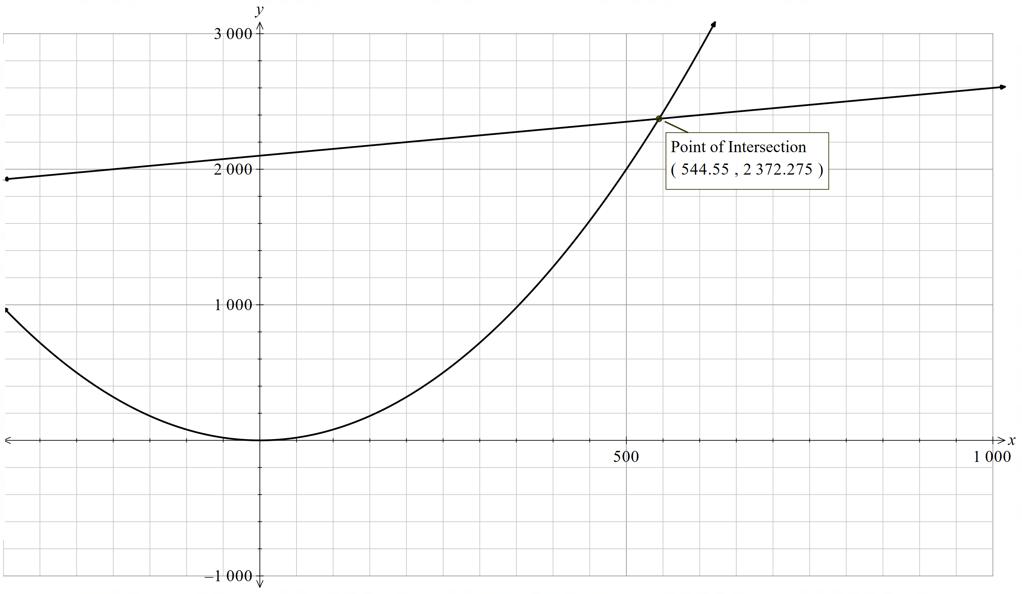

$Area of paddock=xy$ $$3x+2y=900 \\ y=450-\frac{3x}{2} \\ Area of paddock=x\left(450-\frac{3x}{2}\right) \\ =450x-\frac{3x^{2}}{2}$$

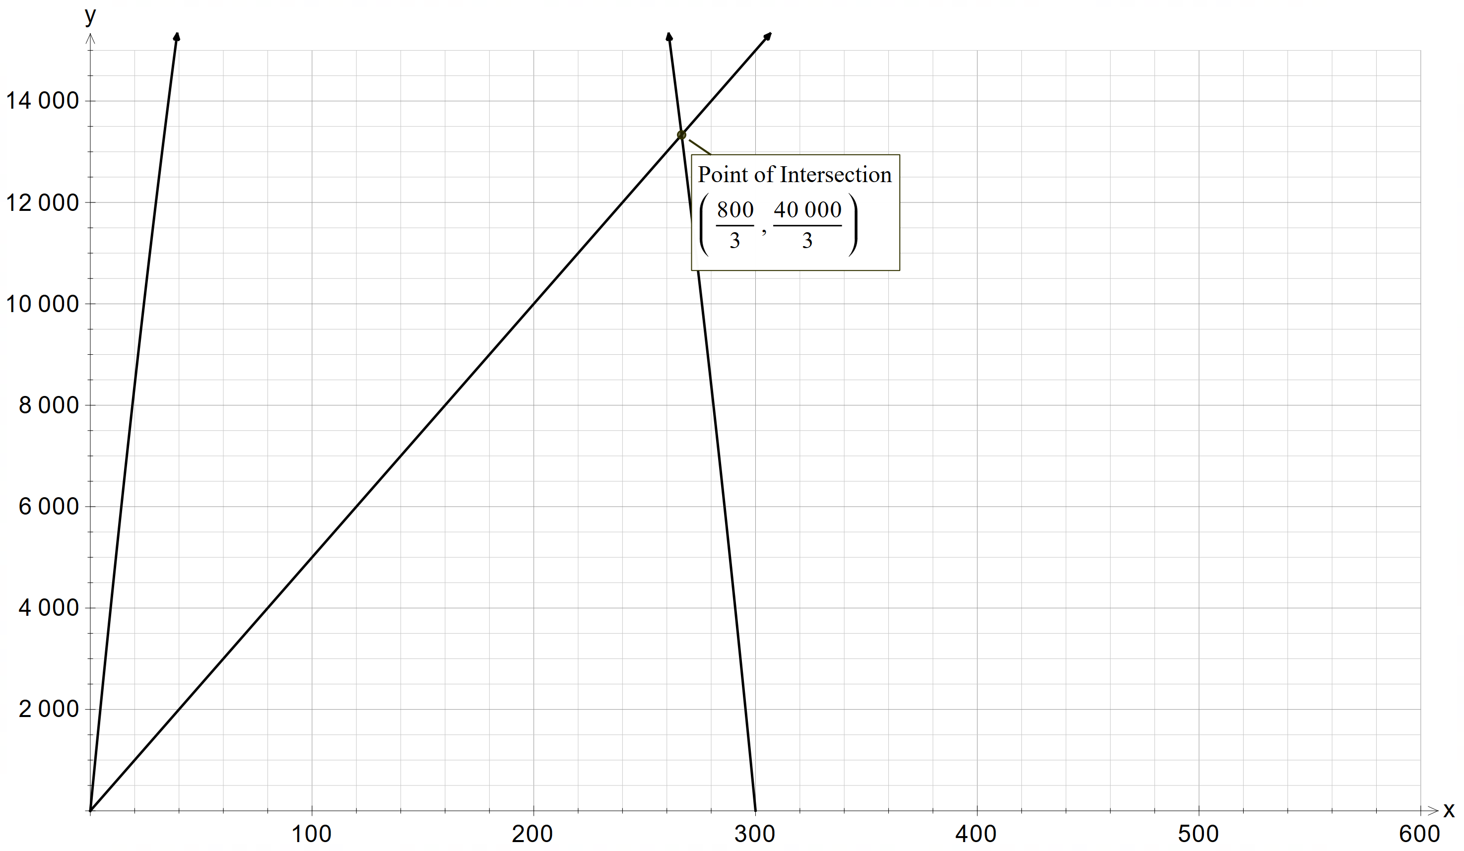

The paddocks are the same area when the length of $x$ is 266.7 m, making their areas around 13,333.3 $m^{2}$ , as you cannot have paddocks with an area of zero square metres.

1. The projectile will be hit after 2.958 seconds at a height of 12.873 metres, as it would hit at the first sign of contact, not the second.

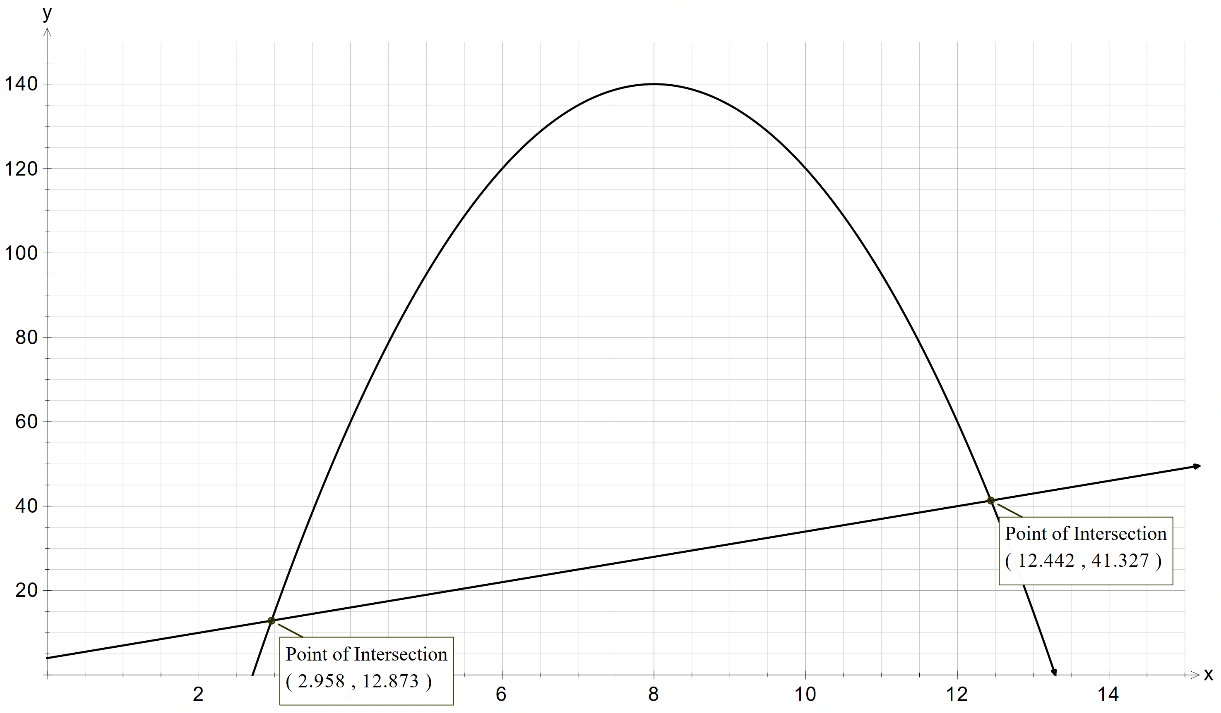

## References

This resource contains NSW Curriculum and syllabus content. The NSW Curriculum is developed by the NSW Education Standards Authority. This content is prepared by NESA for and on behalf of the Crown in right of the State of New South Wales. The material is protected by Crown copyright.

Please refer to the NESA Copyright Disclaimer for more information <https://educationstandards.nsw.edu.au/wps/portal/nesa/mini-footer/copyright>.

NESA holds the only official and up-to-date versions of the NSW Curriculum and syllabus documents. Please visit the NSW Education Standards Authority (NESA) website <https://educationstandards.nsw.edu.au> and the NSW Curriculum website <https://curriculum.nsw.edu.au>.

[Mathematics K–10 Syllabus](https://curriculum.nsw.edu.au/learning-areas/mathematics/mathematics-k-10-2022/overview) © NSW Education Standards Authority (NESA) for and on behalf of the Crown in right of the State of New South Wales, 2022.

**© State of New South Wales (Department of Education), 2024**

The copyright material published in this resource is subject to the Copyright Act 1968 (Cth) and is owned by the NSW Department of Education or, where indicated, by a party other than the NSW Department of Education (third-party material).

Copyright material available in this resource and owned by the NSW Department of Education is licensed under a [Creative Commons Attribution 4.0 International (CC BY 4.0) license](https://creativecommons.org/licenses/by/4.0/).

[](https://creativecommons.org/licenses/by/4.0/)

This license allows you to share and adapt the material for any purpose, even commercially.

Attribution should be given to © State of New South Wales (Department of Education), 2024.

Material in this resource not available under a Creative Commons license:

* the NSW Department of Education logo, other logos and trademark-protected material
* material owned by a third party that has been reproduced with permission. You will need to obtain permission from the third party to reuse its material.

**Links to third-party material and websites**

Please note that the provided (reading/viewing material/list/links/texts) are a suggestion only and implies no endorsement, by the New South Wales Department of Education, of any author, publisher, or book title. School principals and teachers are best placed to assess the suitability of resources that would complement the curriculum and reflect the needs and interests of their students.

If you use the links provided in this document to access a third-party's website, you acknowledge that the terms of use, including licence terms set out on the third-party's website apply to the use which may be made of the materials on that third-party website or where permitted by the Copyright Act 1968 (Cth). The department accepts no responsibility for content on third-party websites.