What is the data telling us?
Students look at the data presented by the Australian Bureau of Statistics and extract the
5-number summary from histograms to create box plots.
The histograms in this lesson vary from traditional histograms. They reflect how the data is presented by the Australian Bureau of Statistics.

Visible learning

Learning intention
- To compare the benefits of representing data in histograms with the benefits of representing data in box plots.

Success criteria
- I can interpret visual data to find the median.
- I can determine quartiles from datasets displayed as histograms
- I can find the 5-number summary from a histogram.
- I can represent data displayed as a histogram in a box plot.

Syllabus outcomes
A student:
- develops understanding and fluency in mathematics through exploring and connecting mathematical concepts, choosing and applying mathematical techniques to solve problems, and communicating their thinking and reasoning coherently and clearly MAO-WM-01
- compares and analyses datasets using summary statistics and graphical representations MA5-DAT-C-01
Mathematics K–10 Syllabus © NSW Education Standards Authority (NESA) for and on behalf of the Crown in right of the State of New South Wales, 2022.

Activity structure
Please use the associated PowerPoint What is the data telling us to display images in this lesson.

Launch
- Use slides 3–5 of the What is the data telling us PowerPoint for a slow reveal graph activity (slowrevealgraphs.com). For each slide, students will discuss in a Think-Pair-Share (bit.ly/thinkpairsharestrategy), what they notice and what they wonder (bit.ly/noticewonderstrategy) about the graph displayed.
- Discuss with the class what we have learnt from this data. Encourage students to talk about statistics they have found as well as the shape of the data. Record points on the board as these will be referred to later in the lesson.
- Inform students that the graph is from the 2021 Australian census data. When data is presented in a graph, we need to be able to extract the information from it to be able to compare data and make informed decisions.

Explore
- During this section, students will work in visibly random groups of 3 (bit.ly/visiblegroups) on vertical non-permanent surfaces (bit.ly/VNPSstrategy).
- Issue each group with a copy of Appendix A ‘Defence force service by age.’
- Ask students to find the lowest score for each dataset and the highest score for each dataset.
- Allow students time to check their answers with surrounding groups.
Teachers can discuss with students that their answers give a range of ages and that we can use the middle of this range, called the class centre, as our score to represent the group.
- Ask students to find the median of Graph 1 – currently serving in the regular service. Have students record the process they used on their vertical non-permanent surfaces.
Ideally, students would use cumulative frequency to find the exact 5-number summary however, cumulative frequency is not in the syllabus at this at this level?
- Students are to do a gallery walk (bit.ly/DLSgallerywalk) noticing the different methods used to find the median.
Methods that students may use include: a visual estimation of the middle, creating a frequency table, balancing the columns from the outside in or smoothing the histogram by combining columns.
- Bring the class back together and ask them to consider the methods used. Prompting questions could include:
- Which method do you think is the easiest?
- Which method do you think would be the fastest?
- Which method do you believe was the most accurate?
- Pose the question: ‘From the different methods you saw on the gallery walk, which method would you now use to find the lowest quartile and the highest quartile’?
- Have groups return to their vertical non-permanent surfaces and find the 5-number summary for each dataset.
- Have groups construct 3 box plots using their 5-number summaries from each dataset.
Advise students to use the middle value in the age range for their 5-number summaries, example 30–34 would become 32.
- Students are to do another gallery walk, this time providing feedback using the Two stars and a wish (bit.ly/2starwish) method.

Summarise
- Brainstorm with students any information they can determine from the 3 box plots.
- Facilitate a classroom discussion around which graphs, the histograms from Appendix A or the box plots they created, were more useful in understanding the data and why.
- Have students write notes to their future forgetful selves (bit.ly/notesstrategy) outlining the usefulness of each graph.

Apply
- Distribute Appendix B ‘Long-term health conditions’ to students and have them extract the 5-number summaries from each dataset and construct parallel box plots.
- During the Covid pandemic, people of an older age were prioritised for vaccinations. Write a letter to the editor or a comment to an online newspaper article supporting or objecting to this decision.

Assessment and differentiation

Suggested opportunities for differentiation
Explore
- Concrete manipulatives such as centicubes could be used to construct histograms that students can use to determine the median and quartiles.
- Students may benefit from explicit teaching of finding the 5-number summary from a histogram before attempting the task independently.
Apply
- Further practice with smaller histograms, where students can rule a line from the vertical axis, like in this example ‘Finding Median from Histogram (3:45)’ (bit.ly/histogrammedian), may be useful.
- Students could record their support or objections using video or voice recording.

Suggested opportunities for assessment
Explore
- Students are provided with various opportunities to provide and receive peer feedback on their understanding and processes.
- Teachers could observe student’s participation levels during discussion around finding the median and the creation of the box plots.
- Students are to explain and justify their strategies, demonstrating their working mathematically skills.
Apply
- Students will demonstrate their working mathematically skills by choosing a position and justifying it, using data.
- Students’ letters to the editor or comment replies could be collected and used as summative assessment for this unit of learning.

Appendix A

Defence force service by age
Graph 1: currently serving in the regular service
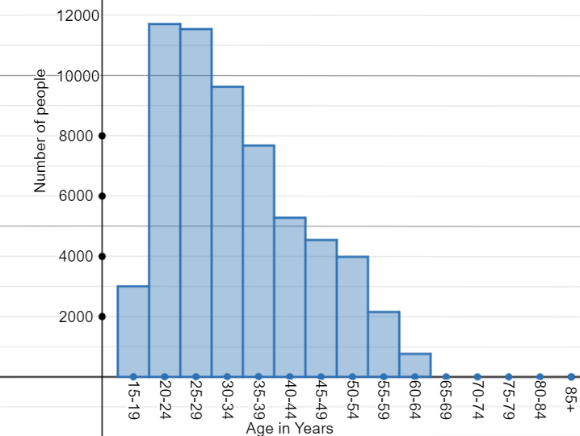

Graph 2: currently serving in the reserves service
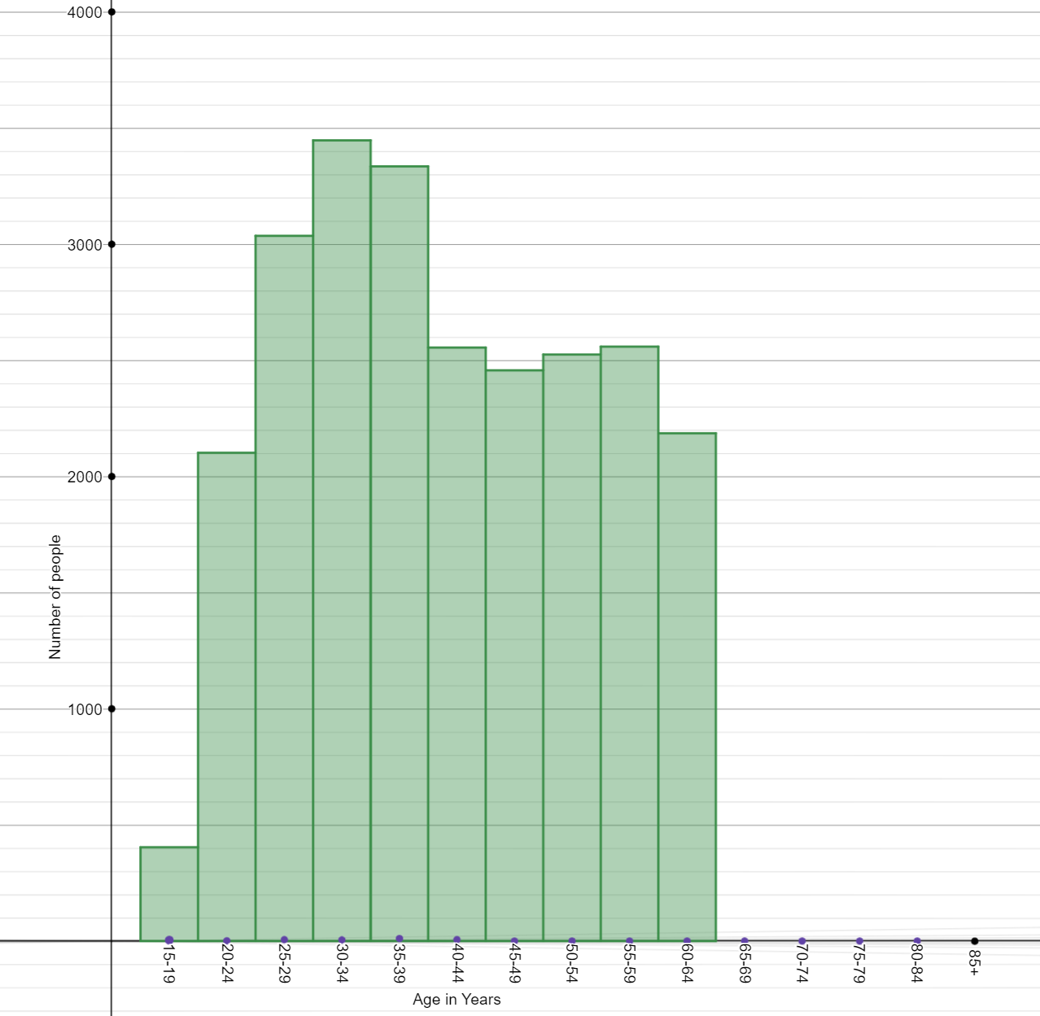

Graph 3: previously served and not currently serving
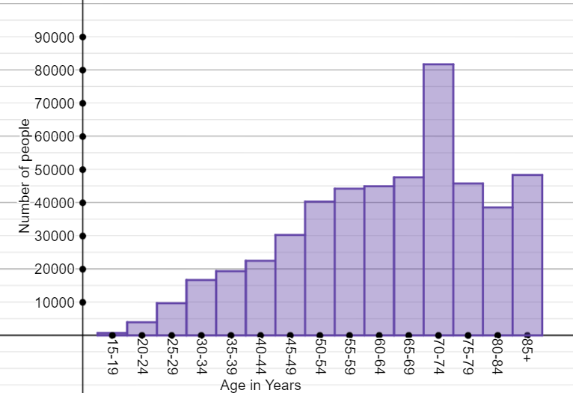

Appendix B

Long-term health conditions
Graph 4
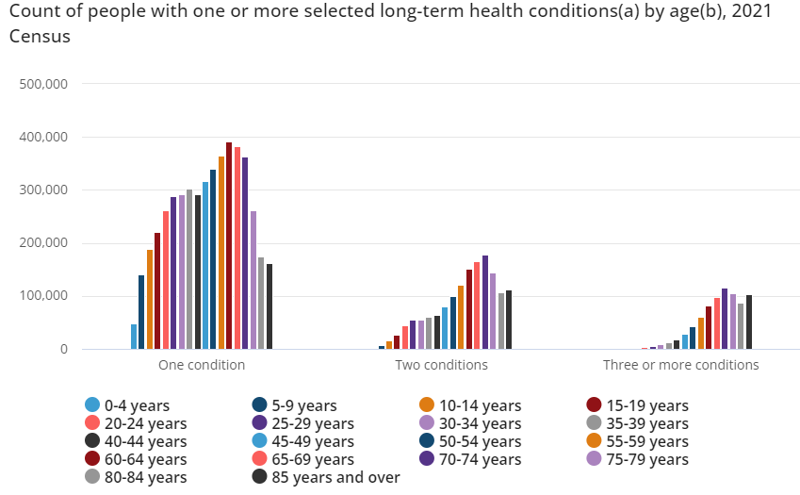
Source: Australian Bureau of Statistics (2021) Health: Census, ABS Website, accessed 26 February 2024.

Sample solutions

Appendix A – defence force service by age
Category | Currently serving in regular service | Currently serving in reserve service | Previously served and not currently serving
Minimum | 15–19 (17) | 15–19 (17) | 15–19 (17)
Lower quartile | 25–29 (27) | 30–34 (32) | 50–54 (52)
Median | 30–34 (32) | 35–39 (37) | 65–69 (67)
Upper quartile | 40–44 (42) | 50–54 (52) | 75–79 (77)
Maximum | 60–64 (62) | 60–64 (62) | 85+

Appendix B – long-term health conditions
Category | One condition | Two conditions | Three or more conditions
Minimum | 0–4 (2) | 0–4 (2) | 0–4 (2)
Lower quartile | 30–34 (32) | 45–49 (47) | 60–64 (62)
Median | 50–54 (52) | 65–69 (67) | 70–74 (72)
Upper quartile | 65–69 (67) | 75–79 (77) | 75–79 (77)
Maximum | 85+ | 85+ | 85+
Graph 5 – long term health conditions
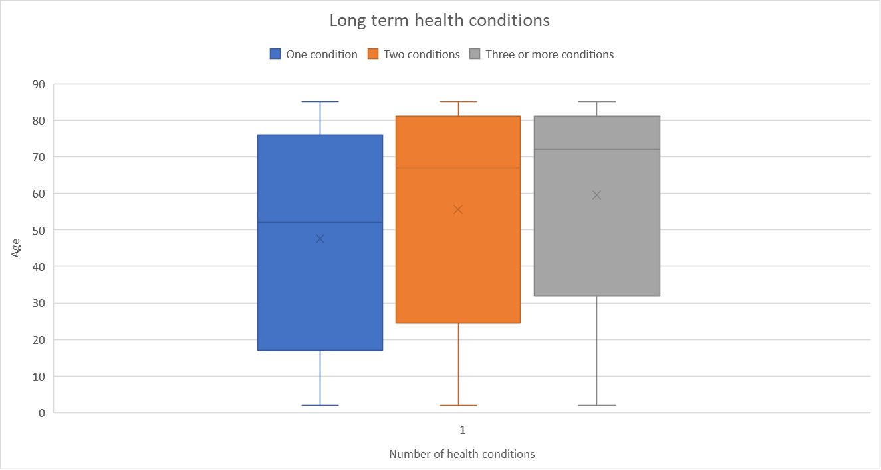

References
This resource contains NSW Curriculum and syllabus content. The NSW Curriculum is developed by the NSW Education Standards Authority. This content is prepared by NESA for and on behalf of the Crown in right of the State of New South Wales. The material is protected by Crown copyright.
Please refer to the NESA Copyright Disclaimer for more information https://educationstandards.nsw.edu.au/wps/portal/nesa/mini-footer/copyright.
NESA holds the only official and up-to-date versions of the NSW Curriculum and syllabus documents. Please visit the NSW Education Standards Authority (NESA) website https://educationstandards.nsw.edu.au and the NSW Curriculum website https://curriculum.nsw.edu.au.
Mathematics K–10 Syllabus © NSW Education Standards Authority (NESA) for and on behalf of the Crown in right of the State of New South Wales, 2022.
Australian Bureau of Statistics (2021) Health: Census, ABS Website, accessed 26 February 2024.

© State of New South Wales (Department of Education), 2024
The copyright material published in this resource is subject to the Copyright Act 1968 (Cth) and is owned by the NSW Department of Education or, where indicated, by a party other than the NSW Department of Education (third-party material).
Copyright material available in this resource and owned by the NSW Department of Education is licensed under a Creative Commons Attribution 4.0 International (CC BY 4.0) license.
This license allows you to share and adapt the material for any purpose, even commercially.
Attribution should be given to © State of New South Wales (Department of Education), 2024.
Material in this resource not available under a Creative Commons license:
- the NSW Department of Education logo, other logos and trademark-protected material
- material owned by a third party that has been reproduced with permission. You will need to obtain permission from the third party to reuse its material.
Links to third-party material and websites
Please note that the provided (reading/viewing material/list/links/texts) are a suggestion only and implies no endorsement, by the New South Wales Department of Education, of any author, publisher, or book title. School principals and teachers are best placed to assess the suitability of resources that would complement the curriculum and reflect the needs and interests of their students.
If you use the links provided in this document to access a third-party's website, you acknowledge that the terms of use, including licence terms set out on the third-party's website apply to the use which may be made of the materials on that third-party website or where permitted by the Copyright Act 1968 (Cth). The department accepts no responsibility for content on third-party websites.

