Distracted drivers
Students collect data from 2 applets related to distractions whilst driving. They use spreadsheets to analyse and present the data and decide, based on the data, whether the fines issued by police are justifiable.
Students will need at least one digital device per pair, or ideally, one digital device each to interact with this lesson.

Visible learning

Learning intention
- To compare box plots of similar data to inform decision making.

Success criteria
- I can describe the distribution of datasets.
- I can use technology to assist in analysing data.
- I can use technology to present data in a box plot.

Syllabus outcomes
A student:
- develops understanding and fluency in mathematics through exploring and connecting mathematical concepts, choosing and applying mathematical techniques to solve problems, and communicating their thinking and reasoning coherently and clearly MAO-WM-01
- compare and analyses datasets using summary statistics and graphical representations MA5-DAT-C-01
Mathematics K–10 Syllabus © NSW Education Standards Authority (NESA) for and on behalf of the Crown in right of the State of New South Wales, 2022.

Activity structure
Please use the associated Microsoft Excel spreadsheets Distracted drivers – Part 1 and Distracted drivers – Part 2 during this lesson.
The spreadsheet has been protected to prevent accidental changes. If teachers wish to change any aspect of the spreadsheet, they can unprotect the worksheets using the password ‘distracted24’.

Launch
- Read the following title and display the accompanying image to students from a 2011 article in the Economist:
‘Distracted driving is the new drunk driving’ (The economist 2011).
- In a Think-Pair-Share (bit.ly/thinkpairsharestrategy), students discuss the following questions.
- Do you think distracted driving has increased or decreased since 2011 when the article was published? Why or why not?
- What do you think are the greatest distractions for drivers?

Explore
The associated Excel spreadsheet Distracted drivers – Part 1 should be shared with students prior to this activity.
All students will need to be able to access the same spreadsheet file to enter their data. Share the file in a common place for all students to be able to open and change. Appendix C ‘Saving and sharing spreadsheet files’ will assist teachers with this.
- Using their digital device, direct students to ‘Heads up – the distracted driving challenge’ (bit.ly/teendrivegame).
- Students select a car and play Level 1, using their finger on a touchscreen or a mouse or trackpad to control the car. The goal of the game is to avoid obstacles and stay on the road.
- Have students access the Excel spreadsheet Distracted drivers – Part 1 to record their data. All students will enter their data in the same spreadsheet file. They will record their name and the total number of incidents during each run.
- Students are to complete Level 2 and Level 3 of the ‘Heads up – the distracted driving challenge’ recording their results in the Excel spreadsheet.
- Have students save their own local copy of the spreadsheet.
Students can do this by using the ‘save as’ function and saving the spreadsheet to their own storage area.
- Distribute, ideally in digital form, Appendix A ‘Using Microsoft Excel’ to each student.
- Using the information in the Appendix and their local copy of the spreadsheet, have students find the following for each level:
- the mean
- the standard deviation
- the 5-number summary.
- Have students construct a box plot for each level.
Excel will create vertical box plots. A discussion could be facilitated, comparing the benefits and drawbacks of vertical and horizontal box plots.

Summarise
- In a Think-Pair-Share, students decide which distraction has the most significant impact on driving by comparing the 3 box plots. Students should discuss the following questions.
- What do you notice when comparing the medians of the box plots?
- What do you notice about the range of the box plots?
- What do you notice when comparing the interquartile range of the box plots?
- Are there any outliers? If so, how do you know it is an outlier?
- Are any of the datasets symmetrical, positively skewed or negatively skewed?
- Based on their discussion, students are to write a summary explaining why their selected distraction has the most significant impact on driving.
Students could also be prompted to justify their summary with reference to measures of central tendency and spread.

Apply
The associated Excel spreadsheet Distracted drivers – Part 2 should be shared with students prior to this activity.
All students will need to be able to access the same spreadsheet file to enter their data. Share the file in a common place for all students to be able to open and change.
- With one device between each pair of students, direct students to the ‘Online reaction time test’ (bit.ly/reactionspeed).
- Students take turns in their pairs to test their reaction times (5 reaction times each), this will be the control group.
- Students record this data in the spreadsheet Distracted drivers – Part 2.
Similar to the previous spreadsheet, students will need access to the original file to enter their different scores. They will need to save their own local copy for analysis after all class data has been entered.
- Pairs simulate texting on a phone whilst repeating the ‘Online reaction time test’ and record 5 new reaction times each.
The simulation could just be the student holding a calculator in one hand and trying to enter a basic calculation or reading out a random 10-digit number on the calculator screen whilst completing the reaction time test.
- Students save their own local copy of the spreadsheet and, using Microsoft Excel, students are to:
- calculate the mean and standard deviation for each level
- calculate the 5-number summary for each level
- construct a box plot for each level’s data.
- Distribute Appendix B ‘NSW driving offences’ to students. Have students use the data from both simulations to conclude if the fine and the amount of demerit points lost is justifiable for driving using a mobile phone.

Assessment and differentiation

Suggested opportunities for differentiation
Explore
- Teachers could pair students who are not confident using Microsoft Excel with students who are confident.
- The teacher could access a how-to tutorial for students who are visual learners.
Summarise
- Students could be challenged to first find the values required and draw a box plot by hand, and then use Microsoft Excel to verify their answers.
- Students could find additional measures of central tendency and spread using Microsoft Excel.
- Students’ summaries could be written as dot points or instead shared as a discussion.
Apply
- Teachers could provide sentence scaffolds for students to encourage them to state a conclusion and justify their conclusion by referring to the data measures.

Suggested opportunities for assessment
Summarise
- Student contributions in the Think-Pair-Share section could demonstrate student reasoning and confidence describing the key characteristics of box plots.
- Students’ summaries could be collected and used to assess their confidence in interpreting data and box plots to draw conclusions and make inferences about the dataset.
Apply
- Teachers could collect the final activity where students must use the data to conclude if the NSW penalties for various traffic offences are justifiable.

Appendix A

Using Microsoft Excel
Figure 1: finding the mean
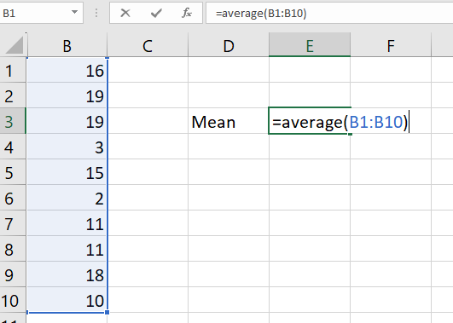
Figure 2: finding standard deviation
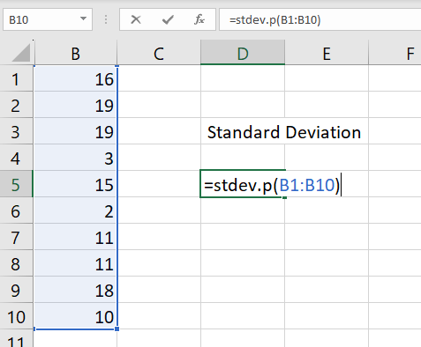
Figure 3: finding the minimum score
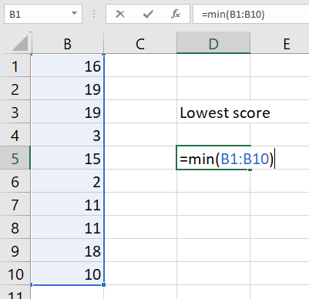
Figure 4: finding the maximum score
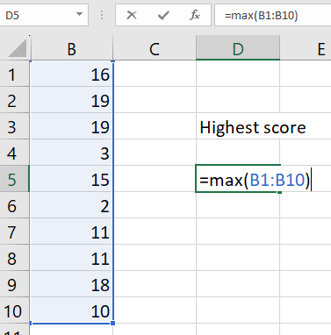

Figure 5: finding quartile lower
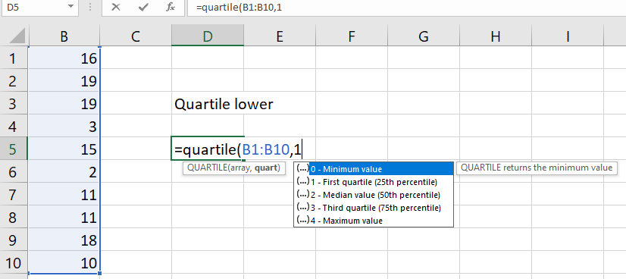
Figure 6: finding quartile upper
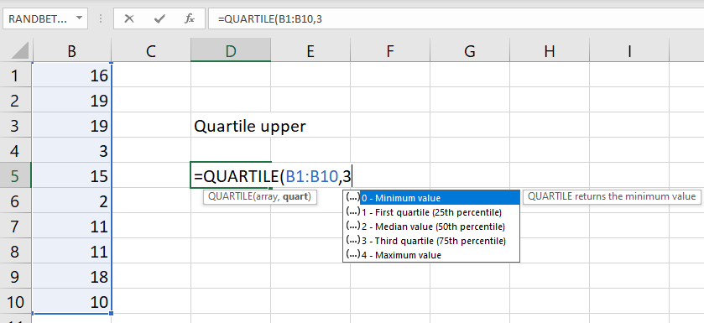
Figure 7: finding the median
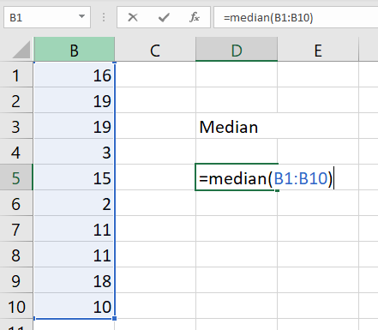

To draw a box plot
- Select your data – if all 3 datasets are selected at once, Microsoft Excel will graph all 3 box plots.
- Select Insert.
- Select Recommended Chart.
- In the new screen select the tab All Charts.
- Select Box & Whisker.
Figure 8: drawing a box plot
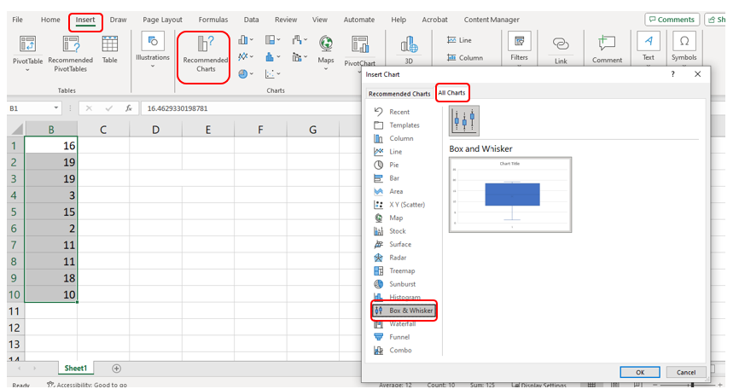

Appendix B

NSW driving offences
Offence | Penalty notice fine | Demerit points
No seatbelt | $387 | 3
Failing to give way | $387 | 3
Driving whilst using a mobile phone | $387 | 5
Driving in a school zone whilst using a mobile phone | $514 | 5
Illegal U turn | $302 | 2
Offensive sound from sound system | $200 | 2
Disobeying traffic sign and road markings | $302 | 2
Offences and penalties data (https://www.nsw.gov.au/driving-boating-and-transport/demerits-penalties-and-offences/offences/search-offences-and-penalties) sourced from the NSW Government website.

Appendix C

Saving and sharing spreadsheet files

Sharing spreadsheet files with your class
Whole class activities
Cloud storage is most suitable when you want your whole class to be entering and viewing data in the one spreadsheet file.
Cloud storage – Google Drive
Visit https://t4l.schools.nsw.gov.au/resources/professional-learning-resources/google-resources/google-drive.html to watch the short video ‘Sharing Data – Part 1: Sharing my data with others (1:00)’ explaining how to share Google Drive files with others.
Cloud storage – One Drive
Visit https://t4l.schools.nsw.gov.au/resources/professional-learning-resources/microsoft-resources/microsoft-onedrive.html to watch the short video ‘Sharing data part 1 – Sharing my data with others (1:11)’ explaining how to share One Drive files with others.

Individual student activities
Assignments in either Google Classroom or Microsoft Teams are useful when you want students to work on their own individual spreadsheet file.
Assignments in Microsoft Teams
Visit https://t4l.schools.nsw.gov.au/resources/professional-learning-resources/microsoft-resources/microsoft-teams/using-assignments-in-teams.html to learn how to create and manage assignments in Microsoft Teams.
Assignments in Google Classroom
Visit https://t4l.schools.nsw.gov.au/resources/professional-learning-resources/google-resources/google-classroom0/using-assignments-in-google-classroom.html to learn how to create and manage assignments in Google Classrooms.

References
This resource contains NSW Curriculum and syllabus content. The NSW Curriculum is developed by the NSW Education Standards Authority. This content is prepared by NESA for and on behalf of the Crown in right of the State of New South Wales. The material is protected by Crown copyright.
Please refer to the NESA Copyright Disclaimer for more information https://educationstandards.nsw.edu.au/wps/portal/nesa/mini-footer/copyright.
NESA holds the only official and up-to-date versions of the NSW Curriculum and syllabus documents. Please visit the NSW Education Standards Authority (NESA) website https://educationstandards.nsw.edu.au/ and the NSW Curriculum website https://curriculum.nsw.edu.au/.
Mathematics K–10 Syllabus © NSW Education Standards Authority (NESA) for and on behalf of the Crown in right of the State of New South Wales, 2022.
The Economist (14 April 2011) 'Think before you speak', The Economist, accessed 18 April 2024.
NSW Government (n.d.) Search offences and penalties, NSW Government, accessed 18 April 2024.

© State of New South Wales (Department of Education), 2024
The copyright material published in this resource is subject to the Copyright Act 1968 (Cth) and is owned by the NSW Department of Education or, where indicated, by a party other than the NSW Department of Education (third-party material).
Copyright material available in this resource and owned by the NSW Department of Education is licensed under a Creative Commons Attribution 4.0 International (CC BY 4.0) license.
This license allows you to share and adapt the material for any purpose, even commercially.
Attribution should be given to © State of New South Wales (Department of Education), 2024.
Material in this resource not available under a Creative Commons license:
- the NSW Department of Education logo, other logos and trademark-protected material
- material owned by a third party that has been reproduced with permission. You will need to obtain permission from the third party to reuse its material.
Links to third-party material and websites
Please note that the provided (reading/viewing material/list/links/texts) are a suggestion only and implies no endorsement, by the New South Wales Department of Education, of any author, publisher, or book title. School principals and teachers are best placed to assess the suitability of resources that would complement the curriculum and reflect the needs and interests of their students.
If you use the links provided in this document to access a third-party's website, you acknowledge that the terms of use, including licence terms set out on the third-party's website apply to the use which may be made of the materials on that third-party website or where permitted by the Copyright Act 1968 (Cth). The department accepts no responsibility for content on third-party websites.

