Balls and boxes
During this lesson, students collect the bounce height of various balls and use the data to produce parallel box plots. They make a claim about the data and support their claim using evidence.

Visible learning

Learning intention
- To be able to compare box plots to make informed decisions.

Success criteria
- I can compare box plots by referencing the median.
- I can compare box plots by referencing the interquartile range.
- I can compare box plots by referencing the shape of the data.

Syllabus outcomes
A student:
- develops understanding and fluency in mathematics through exploring and connecting mathematical concepts, choosing and applying mathematical techniques to solve problems, and communicating their thinking and reasoning coherently and clearly MAO-WM-01
- compares and analyses datasets using summary statistics and graphical representations MA5-DAT-C-01
Mathematics K–10 Syllabus © NSW Education Standards Authority (NESA) for and on behalf of the Crown in right of the State of New South Wales, 2022.

Activity structure
Please use the associated PowerPoint Balls and boxes to display images in this lesson.

Warm up
- Distribute Appendix A ‘Pass it on’, cut into cards and placed face down, to each pair of students. This Appendix shows a range of dot plots.
- Share the instructions of the game ‘Pass it on’ verbally. They can be found below or in Appendix A ‘Pass it on’.
In pairs, decide who will be Player 1 and Player 2.
Player 1 should select a card.
Player 1 is to describe the graph on their card for Person 2 to draw.
Once they have finished, they should compare the drawing with the original graph.
The pairs should then swap roles and repeat.
Students should complete 2 rounds of this activity so that each student has a chance to describe a graph twice.
- Start a class discussion by asking students which graphs they found the easiest and hardest to describe and why.
Use slides 3–6 of the Balls and boxes PowerPoint during the discussion to highlight and reinforce responses from students who used the language of positively or negatively skewed, symmetrical, unimodal, bimodal or trimodal.

Launch
- Display slide 8 of the PowerPoint Balls and boxes. In a Think-Pair-Share (bit.ly/thinkpairsharestrategy), ask students which one does not belong (bit.ly/wodb).
Figure 1: Which one doesn't belong?
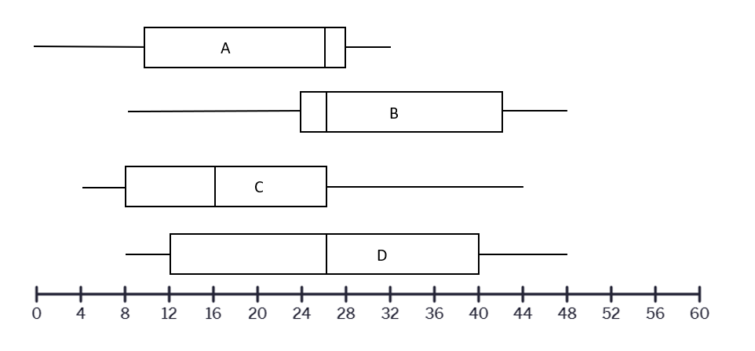
The data is set up such that one would not belong if students focused on either the difference in median, mode and mean. This should be drawn out during the share.

Explore
- Display different types of balls (see options from the equipment list below) and ask students to make 2 predictions using the following prompts.
- Which ball do you think will bounce the highest when dropped from one metre?
- Which ball do you think will be the most consistent (bounces the same each time) when repeatedly dropped from one metre?
- Facilitate a whole-class discussion by randomly choosing students who picked different types of balls to explain their reasoning.
- Students will now gather evidence by completing the following activity.

Equipment
- Different types of balls (golf ball, basketball, hand ball, tennis ball, ping pong ball). Teachers can provide each group with different types of balls or have a bucket with random balls for the students to come and collect after each testing.
- Tape measures (1 per group)
- Chalk (1 per group)

Method
- Assign random groups of 3 (bit.ly/visiblegroups) and provide each group with the equipment listed above.
Students should be provided with a minimum of 3 different types of balls.
Ideally, each group should have a different ball but if this is not possible allow groups to use the same ball type and collate the data at the end of the experiment.
- Take students to an area with a hard consistent floor surface, against a wall.
- Students are to fix the tape measure to the wall, marking where one metre is.
- One student drops their ball from the one metre mark whilst the other team members watch closely and record how far the ball bounces back.
This measurement will be difficult to get accurate, so it is suggested that 2 team members record their answers and students find the average of these measurements. Students should be encouraged to discuss how they will perform the experiment, where they are measuring from on the ball (the top of the ball or the bottom of the ball) and how they are going to maintain consistency in their measurements.
- Repeat the process until they have 15 measurements for each ball.

- Back in the classroom, students need to record their results on vertical non-permanent surfaces (bit.ly/VNPSstrategy).
This could also be done using a spreadsheet.
- Have students find the 5-number summary for each ball they bounced and construct a box plot for their data set.
The aim of this lesson is to compare box plots, so the data could be entered into a spreadsheet and the box plots constructed digitally.
- Have groups write 3 things that are similar about 2 or more box plots and 3 things that are different.
- Students are to do a gallery walk (bit.ly/DLSgallerywalk) of the graphs providing feedback on the similarities and differences using the Two stars and a wish method (bit.ly/2starwish) of peer feedback.

Summarise
- Use slide 10 from the Balls and boxes PowerPoint to model how students can make a claim based on the data gathered.
A claim is a statement or conclusion that answers the original question or it's the point you're trying to make or prove.
- Have students write their own claim based on the data. This may be the same or different from their prediction.
- Ask students what evidence they can use to support their claim and to construct a logical argument.
Students should recognise that the data collected in the investigation would be appropriate and sufficient to support their claim.
- Ask students what components of the box plots they could compare to form this argument.
Students should mention range, interquartile range, median or even skew.
- Use slides 11 to 19 of the Balls and boxes PowerPoint to explicitly teach 4 specific talking points and sentence starters that students could use to provide evidence for their claim.
An outlier in a box plot is a stand-alone point outside the minimum and maximum. It is represented as a small cross.
- Students will now use the discussed sentence starters to write evidence to support their claim.

Apply
- Establish new random groups of 3 and distribute a copy of Appendix B ‘More golf data’ to each group.
- Have each group analyse the data to support or dismiss the claim.
- Allow time for students to view each group’s work by performing a gallery walk. Students may like to provide each group with feedback using the peer feedback strategy ‘Two stars and a wish’.

Assessment and differentiation

Suggested opportunities for differentiation
Explore
- If students have used the same ball type but different balls, a separate comparison could be done of this data.
- Students may copy other student’s box plots if there is not enough time to draw all of them.
Summarise
- Provide students with a worksheet that has the sentence starters written as cloze passages for students to fill in the gaps with their own observations.
- Allow students to do voice recordings explaining the evidence for their claim using the sentence starter prompts.
Apply
- Print the graphs in colour on A4 paper to hand out to each group. This allows students to see greater details from the graphs.
- Ask students to use both sets of data to make a claim about the type of clubs which may be more suitable at the golf courses.

Suggested opportunities for assessment
Explore
- When placed in groups of 3, students provide and receive peer feedback on their understanding of interpreting collected data as evidence to substantiate a claim.
Summarise
- Students will demonstrate their Working mathematically skills in discussions and justifications for their claim. Teachers can use the suggested differentiation options to collect students’ justifications for their claims to formatively assess their use of comparative mathematical language to communicate their arguments.
Apply
- Monitor responses in class discussions to check for student understanding of box plots and how they are compared.

Appendix A

Pass it on
Rules
- In pairs, decide who will be Player 1 and Player 2.
- Player 1 should select a card.
- Player 1 is to describe the graph on their card for Person 2 to draw.
- Once they have finished, they should compare the drawing with the original graph.
- The pairs should then swap roles and repeat.

Graphs

Dot plot 1

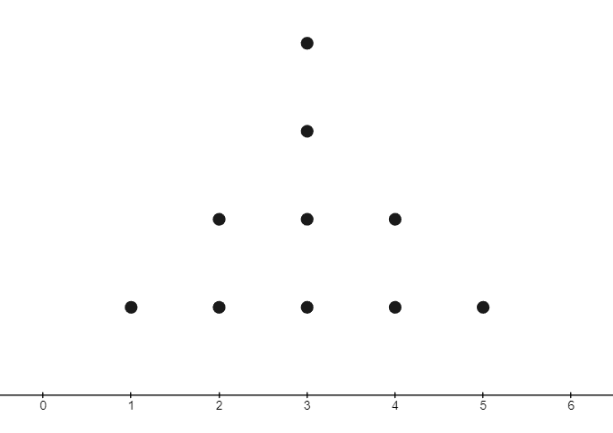

Dot plot 2
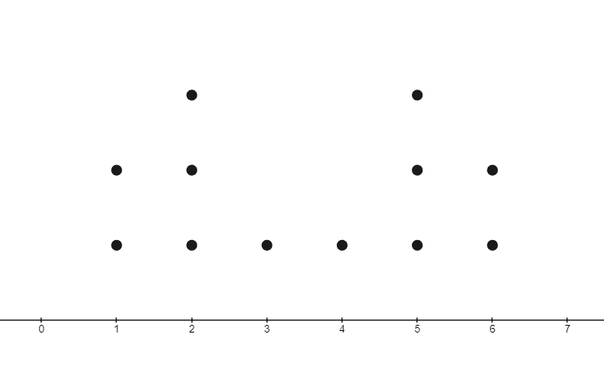

Dot plot 3
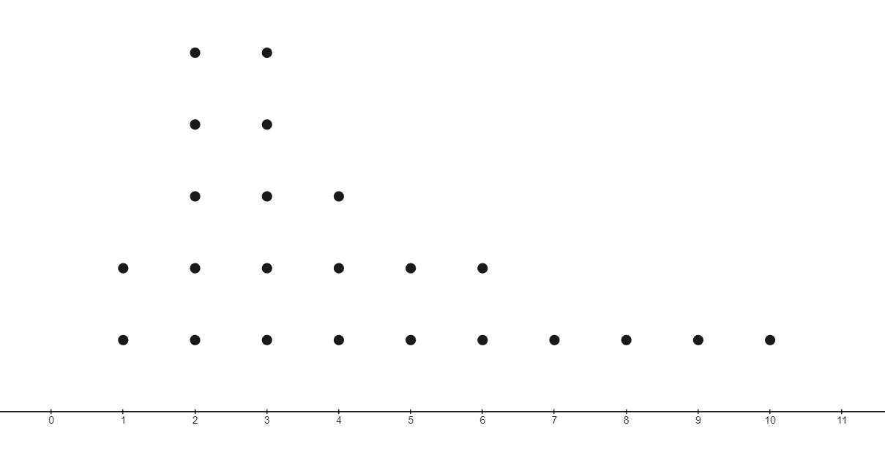

Dot plot 4
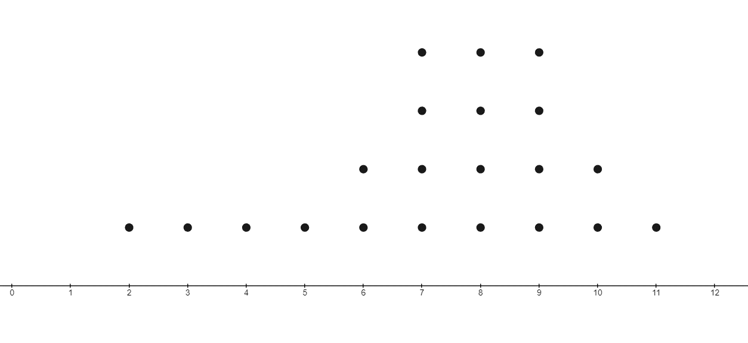

Appendix B

More golf data
Claim: a golf player would use a driver if they wanted to consistently hit the ball a long distance.
Claim: the Newcastle course requires players to walk the furtherest.
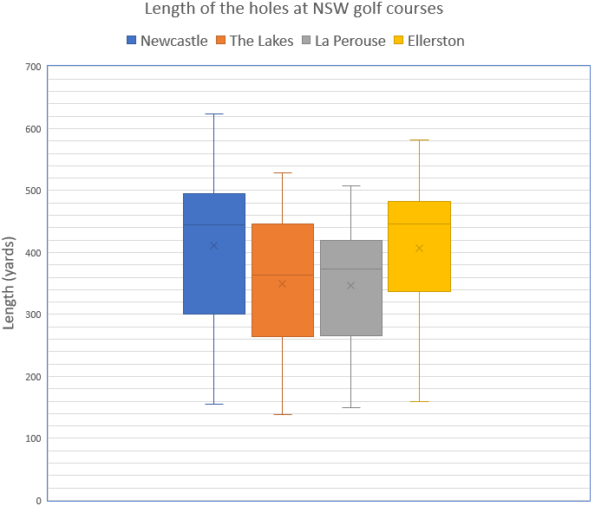

Sample solutions

Appendix A – pass it on
Possible description: the dot plot is symmetrical with numbers going from 1 to 5 on the horizontal axis. The dot plot is unimodal. It has a mode score of 3, which occurs 4 times. Both scores 2 and 4 have a frequency of 2 and scores 1 and 5 have a frequency of one.
Possible description: the dot plot is symmetrical with numbers on the horizontal axis going from 1 to 6 The dot plot is bimodal on scores 2 and 5, which have a frequency of 3. Both scores 1 and 6 have a frequency of 2 and scores 3 and 4 have a frequency of one.

Possible description: the dot plot is positively skewed with numbers on the horizontal axis going from 1 to 10. There are more dots between 1 and 6 than between 7 and 10. The dot plot is bimodal on scores 2 and 3, which have a frequency of 5. The fourth score has a frequency of 3. Scores 1, 5 and 6 have a frequency of 2 and scores 7 to 10 have a frequency of one.

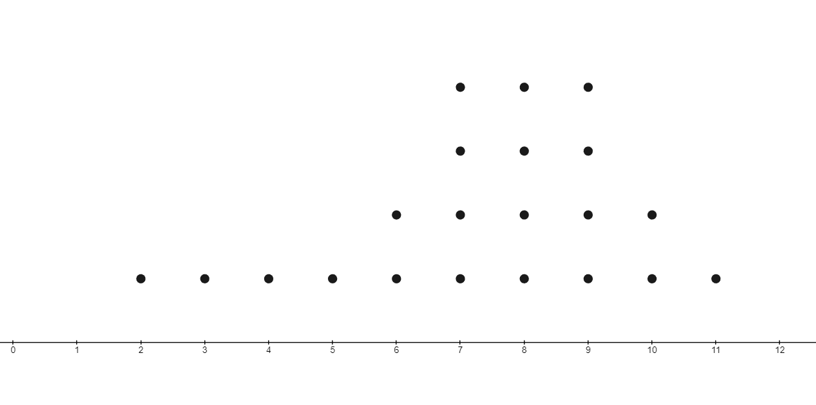
Possible description: the dot plot is negatively skewed with numbers on the horizontal axis going from 1 to 11. There are more dots between 6 and 11 than between 2 and 5. The dot plot is trimodal on scores 7, 8 and 9, which have a frequency of 4. The scores of 6 and 10 have a frequency of 2. Scores 2 to 5 and score 11 all have a frequency of one.

References
This resource contains NSW Curriculum and syllabus content. The NSW Curriculum is developed by the NSW Education Standards Authority. This content is prepared by NESA for and on behalf of the Crown in right of the State of New South Wales. The material is protected by Crown copyright.
Please refer to the NESA Copyright Disclaimer for more information https://educationstandards.nsw.edu.au/wps/portal/nesa/mini-footer/copyright.
NESA holds the only official and up-to-date versions of the NSW Curriculum and syllabus documents. Please visit the NSW Education Standards Authority (NESA) website https://educationstandards.nsw.edu.au and the NSW Curriculum website https://curriculum.nsw.edu.au.
Mathematics K–10 Syllabus © NSW Education Standards Authority (NESA) for and on behalf of the Crown in right of the State of New South Wales, 2022.

© State of New South Wales (Department of Education), 2024
The copyright material published in this resource is subject to the Copyright Act 1968 (Cth) and is owned by the NSW Department of Education or, where indicated, by a party other than the NSW Department of Education (third-party material).
Copyright material available in this resource and owned by the NSW Department of Education is licensed under a Creative Commons Attribution 4.0 International (CC BY 4.0) license.
This license allows you to share and adapt the material for any purpose, even commercially.
Attribution should be given to © State of New South Wales (Department of Education), 2024.
Material in this resource not available under a Creative Commons license:
- the NSW Department of Education logo, other logos and trademark-protected material
- material owned by a third party that has been reproduced with permission. You will need to obtain permission from the third party to reuse its material.
Links to third-party material and websites
Please note that the provided (reading/viewing material/list/links/texts) are a suggestion only and implies no endorsement, by the New South Wales Department of Education, of any author, publisher, or book title. School principals and teachers are best placed to assess the suitability of resources that would complement the curriculum and reflect the needs and interests of their students.
If you use the links provided in this document to access a third-party's website, you acknowledge that the terms of use, including licence terms set out on the third-party's website apply to the use which may be made of the materials on that third-party website or where permitted by the Copyright Act 1968 (Cth). The department accepts no responsibility for content on third-party websites.

