Average from the average
Students define standard deviation as the average difference from the mean. Students explore visual and concrete representations of standard deviation to understand standard deviation as a measure of spread.
This lesson aims to introduce students to the concept and purpose of standard deviation. The mean calculated in this way (the mean of the absolute deviations from the mean) will not yield the same results as if calculated using the square root of variance formula on a calculator. Students should be told that this method is a simplification which a calculator can perform with greater accuracy.
In this lesson, when referring to standard deviation, population standard deviation ($σ$) is used.

Visible learning

Learning intention
- To understand standard deviation as a measure of spread.

Success criteria
- I can define standard deviation.
- I can calculate the difference from the mean for individual data.
- I can calculate the average difference from the mean.
- I can describe the effect that changing data values has on the standard deviation of a set of data.

Syllabus outcomes
A student:
- develops understanding and fluency in mathematics through exploring and connecting mathematical concepts, choosing and applying mathematical techniques to solve problems, and communicating their thinking and reasoning coherently and clearly MAO-WM-01
- compares and analyses datasets using summary statistics and graphical representations MA5-DAT-C-01
Mathematics K–10 Syllabus © NSW Education Standards Authority (NESA) for and on behalf of the Crown in right of the State of New South Wales, 2022.

Activity structure
Please use the associated PowerPoint Average from the average to display images in this lesson.

Launch
- Display Figure 1 on slide 3 of the PowerPoint Average from the average as students enter the classroom.
Figure 1: 4 polygons
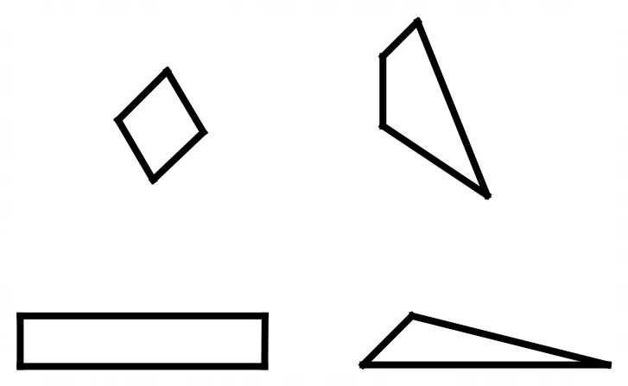
- Ask students to identify a polygon that does not belong. Explain that there are no correct answers and they will have to use reasoning to support their answer.
- Students complete a Think-Pair-Share (bit.ly/thinkpairsharestrategy) to discuss:
- which polygon they think doesn’t belong
- why they think that that polygon doesn’t belong.
- Randomly select students to share what they discussed with the class.
- Display Figure 2 with dimensions on slide 4 of the PowerPoint Average from the average.
Figure 2: 4 polygons with dimensions
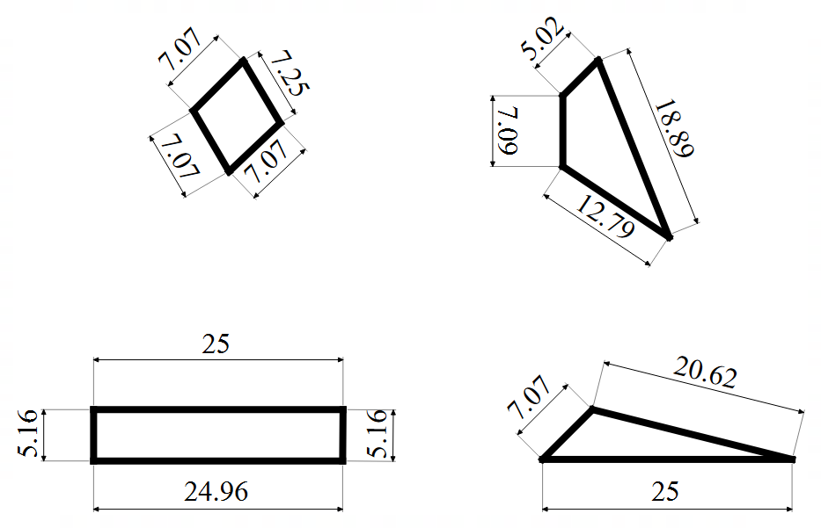
- Ask students to again identify a polygon that does not belong. Ask students to use a Think-Pair-Share to discuss if revealing the dimensions influenced them to change their mind about which shape did not belong.
- Randomly select students to share if the dimensions confirmed or changed their decision and why?
- Ask students to consider the variation in the lengths of the sides of the shapes. Then, ask students which shape would be the odd one out regarding the variation in the side lengths.
Students may need ‘variation’ to be formally defined. In statistics, ‘variation’ is how far away the data points are from each other.
- Use a questioning strategy such as Pose-Pause-Pounce-Bounce (PDF 557KB) (bit.ly/posepausepouncebounce) to facilitate a class discussion about which polygon has the smallest variation in the side lengths.
Teachers and students are not expected to calculate these.
The standard deviation of each polygon’s dimensions is:
- Top left: 0.078
- Top right: 5.397
- Bottom left: 9.910
- Bottom right: 7.632
Population standard deviation has been found in this example.

Explore
- Assign students to random groups of 3 (bit.ly/visiblegroups) and position students at vertical non-permanent surfaces (VNPS) (bit.ly/VNPSstrategy) around the room.
If completing the Summarise activity using Appendix B ‘Four quadrant notes’, the plastic sleeves can be reversed and used as vertical non-permanent surfaces for this activity.
- Ask each student to cut or pull one single strand of hair from their own head. If students don’t wish to cut or pull a strand of hair, they can instead measure from the scalp using a ruler.
Students could be asked the day before to bring in a strand of hair from home.
- Students measure the length of each strand to the nearest centimetre and record the length of each strand on their vertical non-permanent surface.
- Display the following instructions, from slide 6 of the PowerPoint Average from the average:
- Calculate the mean hair length for your group. This is represented as $\overline{x}$.
- Find the difference between the mean length and each hair length.
- Find the mean of the differences found above. This is called ‘mean difference’.
Differences are found as positive values.
- Conduct a gallery walk (bit.ly/DLSgallerywalk), for students to compare the mean difference calculated for each group. Students should consider how the hair lengths, the mean length and the mean difference are related.
- Explain to students that they have just calculated the standard deviation. Explain that standard deviation is a measure of the spread of data. It is a calculation of how far, on average, each individual piece of data is from the mean.
- Print and distribute one copy of Appendix A ‘Standard deviation reflections’ to each group. Groups are to discuss the questions, then write a single response to each question on their whiteboards.
- Use a questioning strategy such as Pose-Pause-Pounce-Bounce to facilitate a class discussion on each reflection.

Summarise
- Use slides 8–15 of the PowerPoint Average from the average for the explicit teaching of manually calculating standard deviation.
The explicit teaching technique used in the PowerPoint is ‘Your turn’. The first slide is a worked example which should be displayed for the students before using the following steps.
- Reveal the question to students and its solution.
- Students read in silence.
- Students individually explain to themselves what is happening in each step.
- Students hold a thumbs up to the teacher when they have finished reading and have some sort of understanding.
- Think-Pair-Share. Students explain the solution to their partner.
- In pairs, students then answer the self-explanation questions.
- Finally, randomly select students to share their answers with the whole class.
- Place a copy of the Appendix B ‘Four quadrant notes’, printed on A3 paper, in reusable plastic sleeves and use adhesive putty to stick the plastic sleeves up around the room.
- Assign new random groups of 3 and allocate each group to a VNPS. Provide each group with one whiteboard marker and cloth.
- Groups are to discuss and work through Appendix B ‘Four quadrant notes’ as described below:
Fill in the blanks: students choose numbers to fill in the blanks, completing the worked example.
Example 1: students complete the worked example.
Example 2: students repeat the worked example process, this time, choosing the number of values in the dataset.
Things to remember: students write down anything they think would be important for their future forgetful selves to remember.
- Conduct a gallery walk for students to see how other groups completed the examples.
- Distribute Appendix B ‘Four quadrant notes’ to each student. Have the students complete the notes for their own future learning.

Apply
- With groups remaining at vertical non-permanent surfaces, either write up or display the following prompts on slide 17 of the PowerPoint Average from the average:
- Draw a polygon with side lengths that have a standard deviation of 0.
- Draw a rectangle with side lengths that have a standard deviation of 5.
- Draw a triangle with side lengths that have a standard deviation greater than 5.
- Draw a triangle with side lengths that have a standard deviation between 1 and 2.

Assessment and differentiation

Suggested opportunities for differentiation
Launch
- Variation could be explained further by prompting students to find the difference between the largest and smallest sides.
Explore
- Groups could find the mean difference when the difference contains both negative and positive values.
- Groups could be challenged to add hair lengths from another group and consider how that changes the mean difference.
- Students could be challenged to predict what would happen if they calculated the standard deviation for the whole class. Would it vary from their calculations? Why? Why not?
- Students could use a random handful of building blocks instead of hair. Students could use the length of the block instead of hair. This will allow students to physically manipulate the blocks to show the mean and standard deviation.
Summarise
- Students should be encouraged to look at the work of other groups to help with organising their own work or knowing what to do next.
Apply
- Challenge students to draw as many polygons as they can for each constraint.
- Students could be challenged to draw a triangle, a rectangle, pentagon and so on, for each constraint.
- Students could instead draw several rectangles and find the standard deviation of the lengths of each rectangle.

Suggested opportunities for assessment
Explore
- Listen for student reasoning and justification as they share discussions.
- Group responses to Appendix A ‘Standard deviation reflections’ could be captured to provide insight into student thinking.
Summarise
- The teacher could take photos of students’ Four quadrant notes to upload to a shared classroom space. This also provides the teacher an opportunity to assess what students have understood from the lesson.
Apply
- Students could be asked to create 2 datasets as an exit ticket. One with a standard deviation greater than 10 and one with a standard deviation less than 10.

Appendix A

Standard deviation reflections
- What do you notice about the standard deviation of the groups where the hair lengths are similar?
- What do you notice about the standard deviation of the groups where the hair lengths are very different?
- What conclusion(s) can you arrive at if the standard deviation for the hair length of an entire ‘class’ is zero?
- A new student was added to the class and their hair length was equal to the average hair length of the class. What impact will this addition have on the standard deviation for the class? What impact will this addition have on the mean?
- If everyone cut 2 cm off their hair, what would happen to the standard deviation for the class? What impact will this have on the mean?
- If everyone ate a ton of bananas and their hair length doubled, what would happen to the standard deviation for the class? What impact will this have on the mean?

Appendix B

Four quadrant notes
Fill in the blanks  Find the average difference from the mean.  $$1, 3, 5, 7$$  $$\overline{x}=\frac{☐+☐+☐+☐}{4}$$  $$\overline{x}=☐$$  Difference from the mean: ☐, ☐, ☐, ☐  $$σ=\frac{☐+☐+☐+☐}{4}$$  $$σ=☐$$ | Example 1  Find the average difference from the mean.  $$2, 3, 5, 6, 7, 7$$
Things to remember | Example 2  Find the average difference from the mean.

Suggested solutions

Appendix A – standard deviation reflections
- The standard deviation would be close to zero.
- The standard deviation would be a larger number.
- Everyone has the same hair length.
- This student will have no impact on the mean or the standard deviation of the class.
- The mean would reduce by 2 cm but the standard deviation would stay the same.
- The standard deviation would increase as the long hair change would be more than the shorter hair change. The mean would also get larger.
Apply
- Draw a polygon with side lengths that have a standard deviation of 0.
- A polygon with all sides equal would have a standard deviation of 0.
- Draw a rectangle with side lengths that have a standard deviation of 5.
- A rectangle with sides of 2 and 12 would have a standard deviation of 5.
- Draw a triangle with side lengths that have a standard deviation greater than 5.
- A triangle with sides 1, 12, 13 would have a standard deviation greater than 5.
- Draw a triangle with side lengths that have a standard deviation between 1 and 2.
- A triangle with sides 5, 6, 8 would have a standard deviation between 1 and 2.

References
This resource contains NSW Curriculum and syllabus content. The NSW Curriculum is developed by the NSW Education Standards Authority. This content is prepared by NESA for and on behalf of the Crown in right of the State of New South Wales. The material is protected by Crown copyright.
Please refer to the NESA Copyright Disclaimer for more information https://educationstandards.nsw.edu.au/wps/portal/nesa/mini-footer/copyright.
NESA holds the only official and up-to-date versions of the NSW Curriculum and syllabus documents. Please visit the NSW Education Standards Authority (NESA) website https://educationstandards.nsw.edu.au and the NSW Curriculum website https://curriculum.nsw.edu.au.
Mathematics K–10 Syllabus © NSW Education Standards Authority (NESA) for and on behalf of the Crown in right of the State of New South Wales, 2022.

© State of New South Wales (Department of Education), 2024
The copyright material published in this resource is subject to the Copyright Act 1968 (Cth) and is owned by the NSW Department of Education or, where indicated, by a party other than the NSW Department of Education (third-party material).
Copyright material available in this resource and owned by the NSW Department of Education is licensed under a Creative Commons Attribution 4.0 International (CC BY 4.0) license.
This license allows you to share and adapt the material for any purpose, even commercially.
Attribution should be given to © State of New South Wales (Department of Education), 2024.
Material in this resource not available under a Creative Commons license:
- the NSW Department of Education logo, other logos and trademark-protected material
- material owned by a third party that has been reproduced with permission. You will need to obtain permission from the third party to reuse its material.
Links to third-party material and websites
Please note that the provided (reading/viewing material/list/links/texts) are a suggestion only and implies no endorsement, by the New South Wales Department of Education, of any author, publisher, or book title. School principals and teachers are best placed to assess the suitability of resources that would complement the curriculum and reflect the needs and interests of their students.
If you use the links provided in this document to access a third-party's website, you acknowledge that the terms of use, including licence terms set out on the third-party's website apply to the use which may be made of the materials on that third-party website or where permitted by the Copyright Act 1968 (Cth). The department accepts no responsibility for content on third-party websites.

