# Solving equations

Students will explore linear equations and their graphs, recognising that there are an infinite number of ordered pairs that satisfy a linear relationship and that each point on the graph of a linear relationship satisfies the equation of the line.

Students will need at least one digital device per pair to interact with Desmos during this lesson.

## Visible learning

### Learning intention

* To understand the relationship between a straight-line graph and its equation.

### Success criteria

* I can substitute values into an equation.
* I can explain why there are an infinite number of ordered pairs that make up a linear graph.
* I can solve an equation algebraically.
* I can solve an equation graphically.

### Syllabus outcomes

A student:

* develops understanding and fluency in mathematics through exploring and connecting mathematical concepts, choosing and applying mathematical techniques to solve problems, and communicating their thinking and reasoning coherently and clearly **MAO-WM-01**
* creates and displays number patterns and finds graphical solutions to problems involving linear relationships **MA4-LIN-C-01**

[Mathematics K–10 Syllabus](https://curriculum.nsw.edu.au/learning-areas/mathematics/mathematics-k-10-2022/overview) © NSW Education Standards Authority (NESA) for and on behalf of the Crown in right of the State of New South Wales, 2022.

Table 1: lesson summary

|  |  |  |  |
| --- | --- | --- | --- |
| Section | Summary of activity | Teaching strategies | Teaching points |
| **Launch** | Students are given a scenario involving temperature in degrees Fahrenheit and degrees Celsius for 2 different places and shown a map of the world from slide 3 of the PowerPoint *Solving equations* (SE PPT) and asked what they notice and wonder. | Notice and wonder | Recognise that the temperatures are different, despite being the same number. Consider how the temperatures might be compared. |
| **Explore** | Students complete the Desmos Classroom activity ‘Linear relationships’ ([bit.ly/analysingpatterns](https://bit.ly/analysingpatterns)), where students generate output and graph points. In Appendix A they determine if points lie on a pair of straight lines. They return to the Desmos Classroom activity to use a slider to solve an equation. | Think-Pair-Share  Notice and wonder  Pose-Pause-Pounce-Bounce | Understand that all types of numbers can be substituted into an equation and that pairs of numbers that satisfy a linear equation form a straight line. |
| **Summarise** | Students are asked to solve an equation graphically and algebraically using slides 5–12, in the PowerPoint (SE PPT) and then return to the Desmos Classroom activity to solve equations. | Worked examples (Your turn) | Recognise that equations can be solved both graphically and algebraically. |
| **Apply** | Students return to the Desmos Classroom activity and the scenario from the Launch. They convert the temperature from degrees Fahrenheit to degrees Celsius. |  | Students understand that they can use an equation or graph to compare values. |

## Activity structure

Please use the associated PowerPoint *Solving equations* (SE PPT) to display images in this lesson.

### Launch

1. Display slide 3 of the PowerPoint *Solving equations* (SE PPT).
2. In a class discussion, ask students what they notice and wonder.

Students might notice that the temperatures have the same number value, but one is in degrees Celsius and the other is in degrees Fahrenheit.

Students might wonder where Fargo, North Dakota is, what degrees Fahrenheit and degrees Celsius mean, what the equivalent of 37 degrees Fahrenheit is in degrees Celsius and vice versa.

Students will return to this scenario later in the lesson.

### Explore

1. Distribute one device to each pair of students.
2. Assign the Desmos Classroom activity ‘Linear relationships’ ([bit.ly/analysingpatterns](https://bit.ly/analysingpatterns)).

Before completing this activity, you will need to set up a Desmos Classroom ([bit.ly/createdesmosclassroom](https://bit.ly/createdesmosclassroom)) and use the pacing feature to restrict the students to screen 2.

1. Display screen 2 and ask students to predict what number will come out of the function machine if we put the number 1 into the machine. Students could record their predictions on a mini whiteboard or in their workbooks.
2. Demonstrate how to use the function machine by dragging the ‘1’ tile to the left-hand side of the function machine.

The function machine will display a dotted outline when the tile is moved to the correct area. The number tile will pass through the function machine and will output a number from the right side of the machine.

Figure 1: inputting a number into a Desmos function machine



Image created using [Desmos](https://www.desmos.com/?lang=en) and is licensed under the [Desmos Terms of Service](https://www.desmos.com/terms?lang=en).

1. Fill in the second row of the table with the input number and output number from the function machine.
2. Give students time to put other numbers through the function machine and complete the table, using their own device.
3. In a Think-Pair-Share ([bit.ly/thinkpairsharestrategy](https://bit.ly/thinkpairsharestrategy)), ask students to discuss what they noticed and what they wonder about the activity.
4. Students can create their own numbers to put through the machine, by typing their number into the grey number card on the left side of the screen.

Figure 2: creating a new number tile



Image created using the free virtual manipulatives from [Polypad by Amplify](https://polypad.amplify.com/).

Students might notice that the input numbers are doubled and 1 is added to create the output, points are plotted on the line shown on the number plane, and the numbers used in the machine can be positive or negative, decimals, fractions and integers.

Students may wonder if all numbers, not just the ones shown on the number plane, could be put into the function machine to create a pair of numbers that could be graphed on the number line. They may also wonder if irrational numbers such as $\sqrt{2}$ would work.

1. Use the Pose-Pause-Pounce-Bounce questioning strategy (PDF 557 KB) ([bit.ly/posepausepouncebounce](https://bit.ly/posepausepouncebounce)) for pairs to share what they noticed during the activity.

Discussion should highlight that the relationship between the numbers entering the function machine, and the output of the machine, can be represented as a table of values, graph or rule/equation.

1. Distribute Appendix A ‘Points on a line’ to pairs of students and ask them to complete the table.
2. Ask students assessing and advancing questions ([bit.ly/supportingstrategies](https://bit.ly/supportingstrategies)) to further student thinking. Some suggestions are provided in the following table.

Table 2: assessing and advancing questions

|  |  |
| --- | --- |
| Assessing questions | Advancing questions |
| How did you decide if a point lies on one of the lines? | Is the graph or the equation more accurate when checking if points lie on a line? |
| What do you notice about the points that lie on both lines? | How many points lie on each line? |
| How can you tell if a point does not lie on either line? | Can you create your own point that lies on both lines? |
| If a point was too big for the graph, what did you do? | How many points lie on both lines? |

1. Initiate a sharing of ideas and reasoning using the Pose-Pause-Pounce-Bounce questioning strategy.

Discussion should highlight different ways of determining if a point lies on a line, and that there are an infinite number of points that lie on a line.

1. Ask students to return to the Desmos Classroom activity and complete the next activity, on screen 3.

You will need to adjust the pacing feature in the Desmos Classroom activity to allow access to screen 3.

Students can click on the point to reveal its coordinate.

Allow students to revisit incorrect answers and encourage them to consider other ways to determine the correct solution.

1. Initiate a sharing of ideas and reasoning using the Pose-Pause-Pounce-Bounce questioning strategy. Some useful question prompts may include:

* How did you use the slider to complete the table?
* Why is the point always on the line?
* What strategy did you use for the value $x=10$ to ensure you were correct?

Encourage students to recognise that all the points share the same relationship, which is the equation of the line and that the number of points on the line is infinite in both directions.

### Summarise

1. Use slides 5−12 of the PowerPoint (SE PPT) for explicit teaching of solving equations graphically and algebraically using the Worked examples (Your turn) method ([bit.ly/supportingstrategies](https://bit.ly/supportingstrategies)).
2. Ask students to return to the Desmos classroom activity and complete the activities on screens 4 and 5. Students should be encouraged to find the solution through substitution, and only use the graph to check their answers.

You will need to adjust the pacing feature in Desmos classroom activity to allow access to screens 4 and 5. Students can see coordinates on the line if they click on the line, hold and drag.

Appendix B ‘Solving equations’ has been provided as a non-digital alternative.

1. In a class discussion, ask students to explain the strategies they used to solve the equations. Some useful question prompts may include:

* When is it easier to solve the equation graphically?
* When is it easier to solve the equation algebraically?
* How can we ensure our solution is accurate?

### Apply

Return to the scenario from the Launch and ask students to use screen 6 of the Desmos Classroom activity to answer the Launch question.

You will need to adjust the pacing feature in the Desmos Classroom activity to allow access to screen 6.

## Assessment and differentiation

### Suggested opportunities for differentiation

**Launch**

* A notice and wonder activity has no correct answers and provides an opportunity for all students to participate.

**Explore**

* In a Think-Pair-Share, the ownership of answers is with a pair of students when sharing with the whole group, helping students feel more comfortable and confident to contribute.
* To support students, the equation used by the function machine can be made visible.
* A notice and wonder activity has no correct answers and provides an opportunity for all students to participate.
* Students may benefit from practising plotting points, which is the focus of Lesson 1 – plotting points in this unit.
* Extend students to consider when a graph is appropriate and when an algebraic solution is necessary.
* Challenge students to solve an equation and construct the graph of the equation.

**Summarise**

* Extend students by providing alternative equations and graphs or points to test.

**Apply**

* Challenge students to use points on the graph to derive the equation.
* Ask students to compare the graph for converting degrees Fahrenheit to degrees Celsius with the graph for converting degrees Celsius to degrees Fahrenheit.

### Suggested opportunities for assessment

**Explore**

* The teacher dashboard in the Desmos Classroom activity allows teachers to collect evidence of student learning.
* The teacher can monitor responses in the Desmos Classroom activity and in the discussions following to determine the extent of student understanding.
* Appendix A could be collected as evidence of learning towards Unit 14 – analysing patterns.

**Summarise**

* The teacher dashboard in the Desmos Classroom activity allows teachers to collect evidence of student learning.
* Students will demonstrate their Working mathematically skills in discussions and justifications**.**

**Apply**

* The teacher dashboard in the Desmos Classroom activity allows teachers to collect evidence of student learning.

## Appendix A − points on a line

The equation of line AB is $y=2x+1$ and the equation of line CD is $x+y=4$.

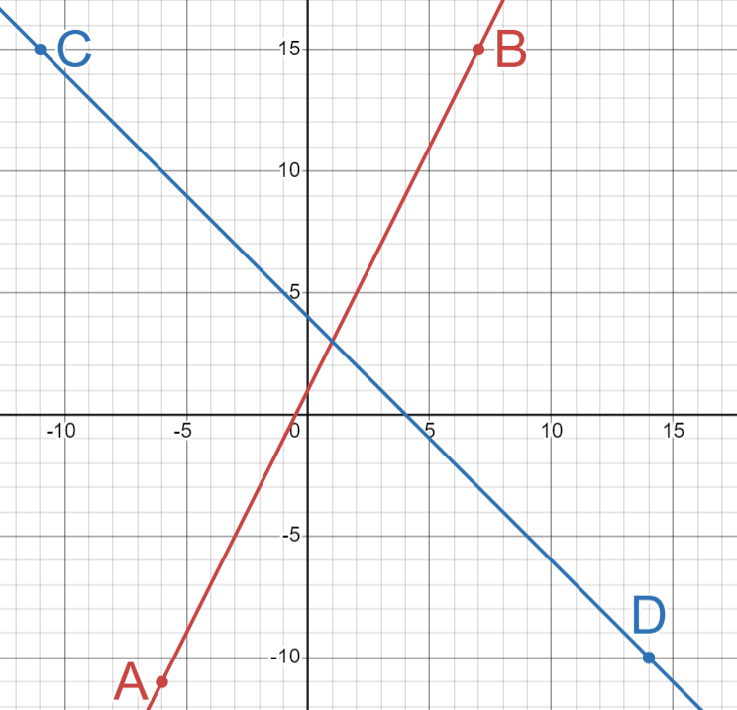

Determine if the following points lie on the line AB, the line CD or neither.

|  |  |  |  |
| --- | --- | --- | --- |
| Point | Lies on AB | Lies on CD | Doesn’t lie on either |
| $$\left(2, 2\right)$$ |  |  |  |
| $$\left(-5, -9\right)$$ |  |  |  |
| $$\left(5, 9\right)$$ |  |  |  |
| $$\left(20, -11\right)$$ |  |  |  |
| $$\left(6, 13\right)$$ |  |  |  |
| $$\left(1, 3\right)$$ |  |  |  |
| $$\left(-\frac{1}{3}, \frac{1}{3}\right)$$ |  |  |  |
| $$\left(2.6, 1.5\right)$$ |  |  |  |

## Appendix B − solving equations

The diagram shows the graph of the equations $y=x+1, y=x+2, y=-2x+1$ and $y=3x-2$. Use the diagram to complete the table.

|  |  |  |
| --- | --- | --- |
| Question | Equation | Solution |
|  | Solve $y=x+1$ for $x=2$. |  |
|  | Solve $y=x+1$ for $x=3$. |  |
|  | Solve $y=x+1$ for $x=4$. |  |
|  | Solve $y=x+2$ for $x=2$. |  |
|  | Solve $y=x+2$ for $x=-3$. |  |
|  | Solve $y=-2x+1$ for $x=-2$. |  |
|  | Solve $y=-2x+1$ for $x=\frac{1}{2}$. |  |
|  | Solve $y=-2x+1$ for $x=0.3$. |  |
|  | Solve $y=3x-2$ for $x=2$. |  |
|  | Solve $y=3x-2$ for $y=-5$. |  |

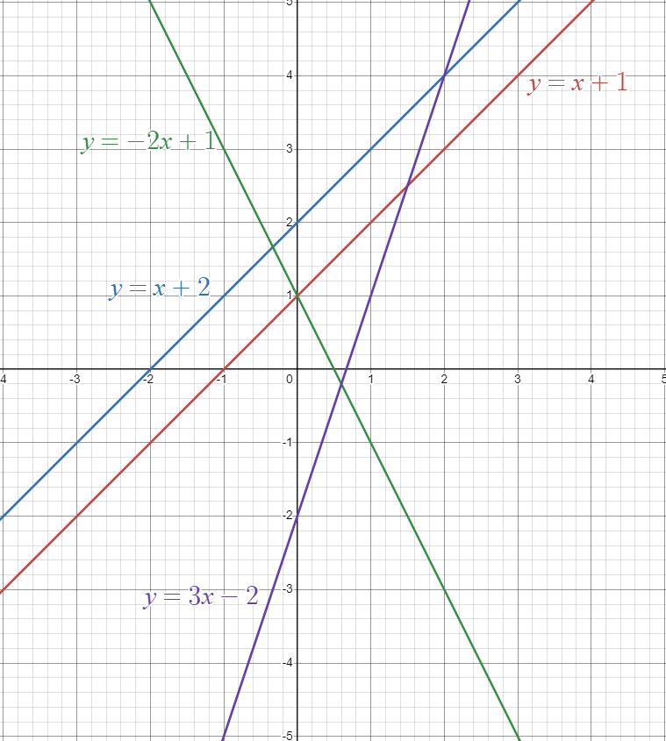

## Sample solutions

### Appendix A – points on a line

|  |  |  |  |
| --- | --- | --- | --- |
| Point | Lies on AB | Lies on CD | Doesn’t lie on either |
| $$\left(2,2\right)$$ | no | yes |  |
| $$\left(-5,-9\right)$$ | yes | no |  |
| $$\left(5,9\right)$$ | no | no | yes |
| $$\left(20,-11\right)$$ | no | yes | yes |
| $$\left(6,13\right)$$ | yes | no |  |
| $$\left(1,3\right)$$ | yes | yes |  |
| $$\left(-\frac{1}{3},\frac{1}{3}\right)$$ | yes | no |  |
| $$\left(2.6,1.5\right)$$ | no | no | yes |

### Appendix B – solving equations

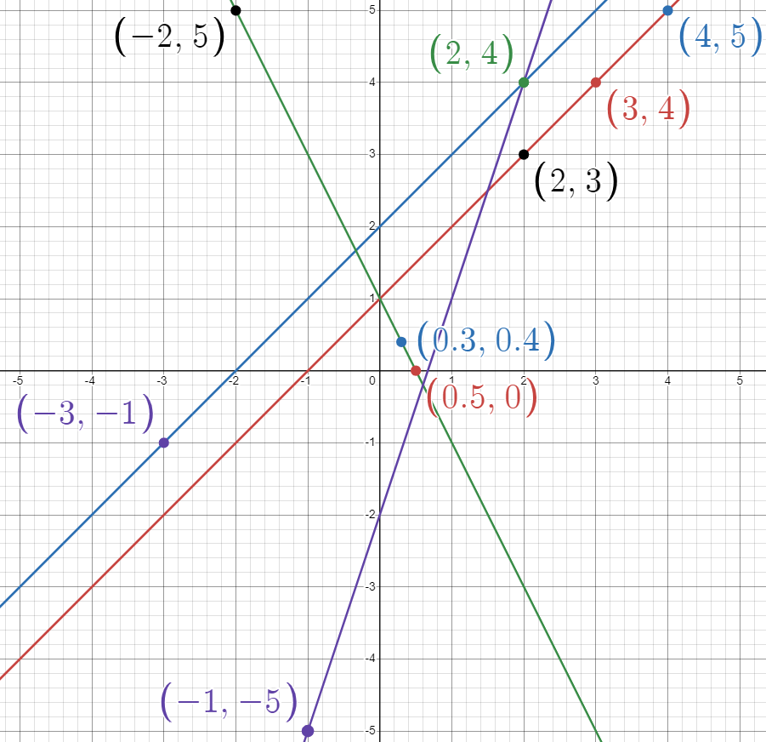

|  |  |  |
| --- | --- | --- |
| 1. Solve for . | 1. Solve for . | 1. Solve for . |
| 1. Solve for . | 1. Solve for . | 1. Solve for . |
| 1. Solve for . | 1. Solve for . | 1. Solve for  . |
| 1. Solve for $y=-5$. $$-5=3x-2 \\ -3=3x \\ \frac{3x}{3}=\frac{-3}{3} \\ x=-1$$ |  |  |

## References

This resource contains NSW Curriculum and syllabus content. The NSW Curriculum is developed by the NSW Education Standards Authority. This content is prepared by NESA for and on behalf of the Crown in right of the State of New South Wales. The material is protected by Crown copyright.

Please refer to the NESA Copyright Disclaimer for more information <https://educationstandards.nsw.edu.au/wps/portal/nesa/mini-footer/copyright>.

NESA holds the only official and up-to-date versions of the NSW Curriculum and syllabus documents. Please visit the NSW Education Standards Authority (NESA) website <https://educationstandards.nsw.edu.au> and the NSW Curriculum website <https://curriculum.nsw.edu.au>.

[Mathematics K–10 Syllabus](https://curriculum.nsw.edu.au/learning-areas/mathematics/mathematics-k-10-2022/overview) © NSW Education Standards Authority (NESA) for and on behalf of the Crown in right of the State of New South Wales, 2022.

**© State of New South Wales (Department of Education), 2024**

The copyright material published in this resource is subject to the Copyright Act 1968 (Cth) and is owned by the NSW Department of Education or, where indicated, by a party other than the NSW Department of Education (third-party material).

Copyright material available in this resource and owned by the NSW Department of Education is licensed under a [Creative Commons Attribution 4.0 International (CC BY 4.0) license](https://creativecommons.org/licenses/by/4.0/).

[](https://creativecommons.org/licenses/by/4.0/)

This license allows you to share and adapt the material for any purpose, even commercially.

Attribution should be given to © State of New South Wales (Department of Education), 2024.

Material in this resource not available under a Creative Commons license:

* the NSW Department of Education logo, other logos and trademark-protected material
* material owned by a third party that has been reproduced with permission. You will need to obtain permission from the third party to reuse its material.

**Links to third-party material and websites**

Please note that the provided (reading/viewing material/list/links/texts) are a suggestion only and implies no endorsement, by the New South Wales Department of Education, of any author, publisher, or book title. School principals and teachers are best placed to assess the suitability of resources that would complement the curriculum and reflect the needs and interests of their students.

If you use the links provided in this document to access a third-party's website, you acknowledge that the terms of use, including licence terms set out on the third-party's website apply to the use which may be made of the materials on that third-party website or where permitted by the Copyright Act 1968 (Cth). The department accepts no responsibility for content on third-party websites.