# Ratio

Students are introduced to ratios by connecting them to their prior knowledge of fractions. Students apply their understanding to find ratios in a tangram puzzle and solve problems involving colours.

Students will need at least one digital device per pair to interact with an activity in the Apply section of this lesson.

## Visible learning

Learning intentions and success criteria should be shared with students later in the learning episode.

### Learning intention

* To understand the relationship between fractions and ratios.

### Success criteria

* I can define ratio.
* I can explain how a ratio is like a fraction.
* I can show a ratio using a visual representation.
* I can write a ratio from a visual representation.

### Syllabus outcomes

A student:

* develops understanding and fluency in mathematics through exploring and connecting mathematical concepts, choosing and applying mathematical techniques to solve problems, and communicating their thinking and reasoning coherently and clearly **MAO-WM-01**
* solves problems involving ratios and rates, and analyses distance–time graphs   
  **MA4-RAT-C-01**

[Mathematics K–10 Syllabus](https://curriculum.nsw.edu.au/learning-areas/mathematics/mathematics-k-10-2022/overview) © NSW Education Standards Authority (NESA) for and on behalf of the Crown in right of the State of New South Wales, 2022.

Table 1: lesson summary

|  |  |  |  |
| --- | --- | --- | --- |
| Section | Summary of activity | Teaching strategy | Teaching points |
| **Launch** | Students record everything they know about the bar model on slide 3 of the PowerPoint *Ratio*. Students discuss what they notice and wonder about slide 4 of the PowerPoint. | Think-Pair-Share | The purpose of the Launch is to connect the introduction of ratios to students' prior understanding of fractions and the visual representation of bar models. |
| **Explore** | Students find the fraction of each polygon in a tangram. Use slides 6 to 10 of the PowerPoint to introduce ratio as a way of comparing a quantity to a total and comparing 2 quantities. Students then find as many ratios as they can within the tangram. | Vertical non-permanent surfaces  Assessing and advancing questions  Pose-Pause-Pounce-Bounce | The purpose of the Explore is to teach students how a ratio can be used to compare a quantity to a total or compare 2 quantities. |
| **Summarise** | Use slides 12 to 19 of the PowerPoint for explicit teaching of writing ratios. Pairs complete Appendix B by colouring 3 of the grids in the ratio $2 :1 :3$ and the fourth in a different ratio. Pairs swap sheets and attempt to determine the grid not coloured in the ratio $2 :1 :3$. Students write notes defining ratio and providing examples. | Worked examples (Your turn)  Gallery walk  Notes to future forgetful selves | The purpose of the Summarise is to explicitly teach writing ratios from a bar model. Students then apply their knowledge in an easily assessable activity. |
| **Apply** | Model an example turn of the colour mixing game via the ‘Trycolours’ website ([trycolors.com/games/guess-mix](https://trycolors.com/games/guess-mix)), and then allow pairs to play. |  | The purpose of the Apply is to show students a practical application of ratios. |

## Activity structure

Please use the associated PowerPoint *Ratio* (R PPT) to display images in this lesson.

### Launch

1. In a Think-Pair-Share ([bit.ly/thinkpairsharestrategy](https://bit.ly/thinkpairsharestrategy)), ask students to record everything they know about the bar model shown in Figure 1, which can be displayed on slide 3 of the PowerPoint (R PPT).

Figure 1: bar model

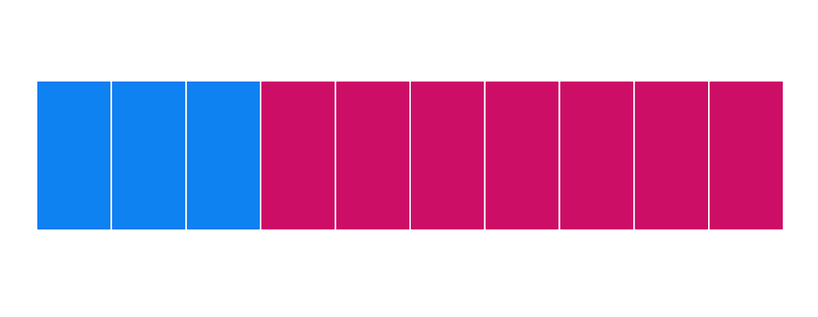

Students are exposed to using number lines and bar models to represent fractions in Stage 4 – Unit 4 – Additive thinking.

1. Continuing in a Think-Pair-Share students discuss what they notice and wonder ([bit.ly/noticewonderstrategy](https://bit.ly/noticewonderstrategy)) about the bar model and expressions in Table 2, which can be displayed on slide 4 of the PowerPoint.

Table 2: bar model and expressions

|  |  |
| --- | --- |
| Bar model with 3 blue parts and 7 pink parts. |  |
|  |  |

Students may notice that each expression is referring to a different proportion of the bar model:

* $3 :7$ is comparing the blue length to the pink length
* $\frac{7}{10}$ is comparing the pink length to the total length
* $\frac{3}{10}$ is comparing the blue length to the total length.

Students may wonder what the ratio (colon :) notation represents, how the ratio is different or the same as a fraction, and why we need another way to write fractions.

1. Reveal the learning intentions and success criteria for this lesson. Explain to students that in this lesson they will be learning about how a ratio is like a fraction but also how ratios serve a different purpose.

### Explore

1. Display Figure 2 which is on slide 6 of the PowerPoint (R PPT).

Figure 2: tangram

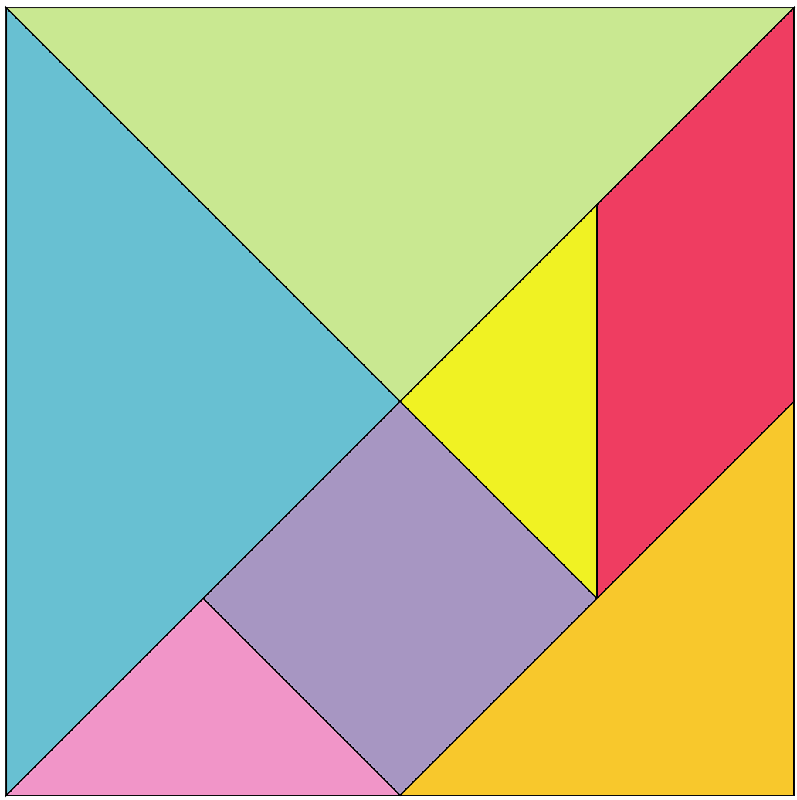

Appendix A ‘Tangram’ may be printed and distributed to each group to have their own copy.

The tangram is a dissection puzzle, consisting of 7 polygons, called tans, which are put together to form shapes. The objective is to replicate a pattern (given only an outline) generally found in a puzzle book using all seven pieces without overlap. You could explore some patterns and the history of tangrams with students, reputed to have been invented in China in the late eighteenth century.

1. Assign visibly random groups of 3 ([bit.ly/visiblegroups](https://bit.ly/visiblegroups)) and position students at vertical non-permanent surfaces ([bit.ly/VNPSstrategy](https://bit.ly/VNPSstrategy)).
2. Challenge students to:

* record the fraction of each polygon compared to the whole square
* represent each fraction as a bar model.

You might provide an example, such as the blue triangle is $\frac{1}{4}$ of the square.

Figure 3: bar model



1. Allow students to conduct a gallery walk ([bit.ly/DLSgallerywalk](https://bit.ly/DLSgallerywalk)) to observe how their peers completed the task and set out their thinking.
2. Bring students back to their regular seats and use a questioning strategy such as Pose-Pause-Pounce-Bounce (PDF 557 KB) ([bit.ly/posepausepouncebounce](https://bit.ly/posepausepouncebounce)) to facilitate a discussion about the task. Some question prompts are provided:

* Which polygons were the easiest to write as a fraction?
* Which polygons were more difficult to write as a fraction and how did you confirm you were correct?
* Which polygons represent an equivalent fraction of the square?

1. Explain to students that fractions are one measure of proportion, another measure of proportion we use in mathematics is ratio. Ratios are useful for comparing quantities to each other.
2. Use slides 7 to 8 of the PowerPoint to introduce ratio by comparing the blue triangle to the total area of the square. Have students discuss the self-explanation prompts on slide 8 in a Think-Pair-Share.
3. Use slides 9 to 10 of the PowerPoint to continue introducing ratio by comparing 2 polygons within the tangram. Have students discuss the self-explanation prompts on slide 10 in a Think-Pair-Share.

We make use of ratios to compare 2 quantities or more. In the tangram examples, that could be comparing the blue triangle to the total area of the square, $1 :4$, the blue triangle compared to the rest of the square, $1 :3$, or comparing the blue triangle to another polygon, such as the purple square, $2 :1$, seen in slides 9 to 10. The sign used to denote a ratio is ':', which is read as ‘to’.

1. Challenge students to return to their vertical non-permanent surfaces and find as many ratios as possible within the tangram puzzle.
2. Ask students assessing and advancing questions ([bit.ly/supportingstrategies](https://bit.ly/supportingstrategies)) to further student thinking.

|  |  |
| --- | --- |
| Assessing questions | Advancing questions |
| How did you translate your found fractions into ratios? | Is the ratio of purple square to blue triangle equivalent to the ratio of blue triangle to purple square? |
| How do you know which ratios are comparing a polygon to the total area or comparing 2 polygons? | How could you group your found ratios? |

1. Allow students to conduct a gallery walk to observe how their peers approached the problem.
2. Use a questioning strategy such as Pose-Pause-Pounce-Bounce to discuss the following prompts:

* How are ratios the same as fractions?
* How are ratios different from fractions?
* What could the ratio $1 :4$ represent in the tangram? What about the ratio $4 :1$?

### Summarise

1. Use slides 12 to 19 of the PowerPoint (R PPT) for explicit teaching of writing ratios, using the Worked examples (Your turn) method ([bit.ly/supportingstrategies](https://bit.ly/supportingstrategies)).
2. Assign students to pairs. Print and distribute Appendix B ‘Colour ratio’ to each pair.
3. Pairs are to randomly colour in 3 of the provided grids using 3 colours in the ratio of $2 :1 :3$. The fourth grid is to be coloured using the same colours but not in the ratio of $2 :1 :3$. When students have completed the activity, they will swap with another pair and attempt to determine which grid is not coloured in the ratio of $2 :1 :3$.
4. Once all students have completed the activity, Appendix B can be left on students’ desks for students to complete a gallery walk and attempt to determine each grid not coloured in the ratio of $2 :1 :3$.
5. Students are to create notes to their future forgetful selves ([bit.ly/notestofutureself](http://www.bit.ly/notestofutureself)), defining ratio and providing examples of ratios.

### Apply

1. Go to the ‘Trycolors’ website ([trycolors.com/games/guess-mix](https://trycolors.com/games/guess-mix)) and select **Easy**.
2. Explain the game to students.

By selecting colours at the bottom of the screen, students are to create the **Target** colour.

1. Complete one or 2 colours as a class by asking students to suggest a colour to add. There are some key features to highlight before students complete the activity themselves:

* The percentage under **Your Mix** indicates how close you are to the target colour.
* The number on each colour represents the number of parts in the ratio. For example, 2 yellow and 1 blue could be written as $2 :1$.
* A bar model is created along the bottom of the colour frame, representing the ratio of colours selected.
* If students want to reset the colours used, there is a **Reset** icon in the bottom left corner. Otherwise, students can skip a colour by selecting **Next** in the bottom right corner.

1. With one device between pairs of students, direct students to the ‘Trycolors’ website to play the colour mixing game.

## Assessment and differentiation

### Suggested opportunities for differentiation

**Launch**

* Students may benefit from revisiting representing fractions, specifically using a bar model, prior to completing this lesson. Stage 4 – Unit 4 – Lesson 7 – Seeing double, introduces students to using a bar model to represent fractions.
* Challenge students to create a set like Table 2, representing a different proportion bar model.

**Explore**

* Students could be provided concrete tangram puzzles to compare and overlay to verify their reasoning.
* Students could be introduced to simplifying ratios in this activity; however, it is introduced in Lesson 2 – simplifying ratios of this unit.
* Encourage students to use the correct name of each polygon.
* Students can be extended to find the fractions and ratios of a stomachion ([mathworld.wolfram.com/Stomachion.html](https://mathworld.wolfram.com/Stomachion.html)).

**Summarise**

* Provide counters or other manipulatives for students to use for the worked examples.
* Simplifying ratios could be introduced using worked example 2. For example, 6:3 is equivalent to 2:1.
* Challenge students to explain in their notes to future forgetful selves, how ratio can be used to both compare a quantity to a whole or compare 2 quantities.

**Apply**

* **Connect to students’ prior knowledge by discussing colour mixing. Students may have experience creating colours such as green using blue and yellow or brown using green and red.**
* **Explore the importance of order in a ratio by considering the visual difference between mixing one part white paint with 3 parts blue paint and 3 parts white paint and one part blue paint.**
* **Students may benefit from the concrete experience of mixing paint in given ratios. Overlaying cellophane can also be used to the same effect.**

### Suggested opportunities for assessment

**Launch**

* A pretest could be conducted to assess students’ prior knowledge of ratios and proportional relationships.
* Observe student responses to both Figure 1 and Table 2 to assess their prior learning of fractions. If students are not confident with fractions, additional instruction and support may be required before completing this lesson.

**Explore**

* By students first completing the tangram activity with fractions, it provides an opportunity to observe misconceptions and address any errors in proportion before working with ratio.
* Observe the type of ratio students focus on to determine which students may need to be supported or extended. For example, if a student has only identified ratios comparing a polygon to the total area, challenge them to write a ratio comparing 2 polygons.
* A gallery walk allows students to self and peer assess following the activity.

**Summarise**

* Observe students’ completion of ‘Your turn’ problems to ensure they have understood each example.
* Observe students’ responses to the self-explanation prompts to assess their understanding of ratio.
* A gallery walk allows students to self and peer assess following the activity. In this instance, they get to observe many ways of representing a ratio.

**Apply**

* Observe student discussions about making colours using ratio to identify any connections students have drawn to their prior knowledge or schema.

## Appendix A

### Tangram



## Appendix B

### Colour ratio

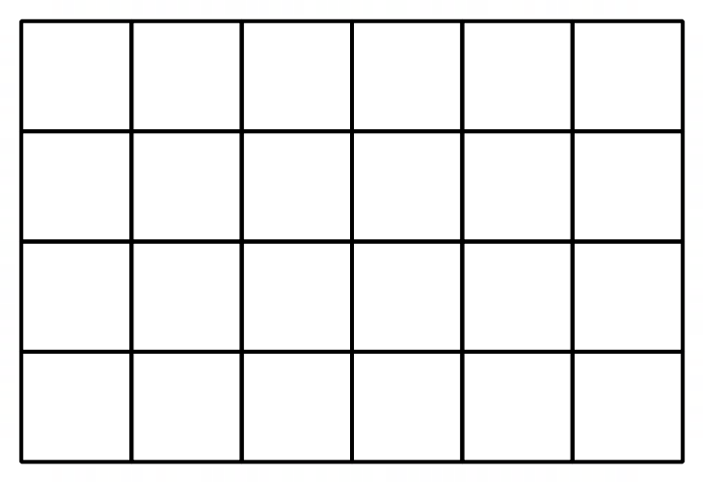

## References

This resource contains NSW Curriculum and syllabus content. The NSW Curriculum is developed by the NSW Education Standards Authority. This content is prepared by NESA for and on behalf of the Crown in right of the State of New South Wales. The material is protected by Crown copyright.

Please refer to the NESA Copyright Disclaimer for more information <https://educationstandards.nsw.edu.au/wps/portal/nesa/mini-footer/copyright>.

NESA holds the only official and up-to-date versions of the NSW Curriculum and syllabus documents. Please visit the NSW Education Standards Authority (NESA) website <https://educationstandards.nsw.edu.au/> and the NSW Curriculum website <https://curriculum.nsw.edu.au/>.

[Mathematics K–10 Syllabus](https://curriculum.nsw.edu.au/learning-areas/mathematics/mathematics-k-10-2022/overview) © NSW Education Standards Authority (NESA) for and on behalf of the Crown in right of the State of New South Wales, 2022.

**© State of New South Wales (Department of Education), 2024**

The copyright material published in this resource is subject to the Copyright Act 1968 (Cth) and is owned by the NSW Department of Education or, where indicated, by a party other than the NSW Department of Education (third-party material).

Copyright material available in this resource and owned by the NSW Department of Education is licensed under a [Creative Commons Attribution 4.0 International (CC BY 4.0) license](https://creativecommons.org/licenses/by/4.0/).

[](https://creativecommons.org/licenses/by/4.0/)

This license allows you to share and adapt the material for any purpose, even commercially.

Attribution should be given to © State of New South Wales (Department of Education), 2024.

Material in this resource not available under a Creative Commons license:

* the NSW Department of Education logo, other logos and trademark-protected material
* material owned by a third party that has been reproduced with permission. You will need to obtain permission from the third party to reuse its material.

**Links to third-party material and websites**

Please note that the provided (reading/viewing material/list/links/texts) are a suggestion only and implies no endorsement, by the New South Wales Department of Education, of any author, publisher, or book title. School principals and teachers are best placed to assess the suitability of resources that would complement the curriculum and reflect the needs and interests of their students.

If you use the links provided in this document to access a third-party's website, you acknowledge that the terms of use, including licence terms set out on the third-party's website apply to the use which may be made of the materials on that third-party website or where permitted by the Copyright Act 1968 (Cth). The department accepts no responsibility for content on third-party websites.