# Distribution centre

Students explore removing grouping symbols to simplify algebraic expressions.

## Visible learning

### Learning intention

* To be able to apply the distributive law to expand grouping symbols.

### Success criteria

* I can explain the role of grouping symbols in algebraic expressions.
* I can expand algebraic expressions with grouping symbols.
* I can simplify algebraic expressions that have been expanded.
* I can explain what a binomial expression is.

### Syllabus outcomes

A student:

* develops understanding and fluency in mathematics through exploring and connecting mathematical concepts, choosing and applying mathematical techniques to solve problems, and communicating their thinking and reasoning coherently and clearly **MAO-WM-01**
* generalises number properties to operate with algebraic expressions including expansion and factorisation **MA4-ALG-C-01**

[Mathematics K–10 Syllabus](https://curriculum.nsw.edu.au/learning-areas/mathematics/mathematics-k-10-2022/overview) © NSW Education Standards Authority (NESA) for and on behalf of the Crown in right of the State of New South Wales, 2022.

Table 1: lesson summary

|  |  |  |  |
| --- | --- | --- | --- |
| ****Section**** | ****Summary of activity**** | ****Teaching strategy**** | ****Teaching points**** |
| ****Warm up**** | Students view a video of a mother of a large family preparing meals (0:22) ([bit.ly/Dohertydozen](https://bit.ly/Dohertydozen)). | Notice and wonder  Think-Pair-Share | Students see a real-life example where multiples of groupings can be used. |
| ****Launch**** | Calculate 23 × 5 using different strategies. | Visibly random groups of 3  Vertical non-permanent surfaces  Gallery walk | Students review the area model. |
| ****Explore**** | Students explore the distributive property using an area model by looking at slide 3 from the PowerPoint Distribution centre. Students then do a banner task, with the teacher using questions from Appendix A. | Visibly random groups of 3  Vertical non-permanent surfaces  Pose-Pause-Pounce-Bounce  Think-Pair-Share  Variation Theory | Students explore the use of the area model for expanding algebraic expressions. |
| ****Summarise**** | Students look at the worked examples from slides 5 to 12 from the PowerPoint Distribution centre (DC PPT)*.* Students then complete the ‘Four quadrant notes’ from Appendix B and the ‘Spider activity’ from Appendix C. | Four quadrant notes  Worked examples (Your turn) | Explicit teaching of expanding grouping symbols. |
| ****Apply**** | Students apply their skills in expanding grouping symbols to the area and perimeter problems from Appendix D. Students could complete the extension activity from slide 14 from the PowerPoint. | Think-Pair-Share  Same surface, different deep  Exit ticket | Applications of expanding grouping symbols using area and perimeter calculations. |

### Activity structure

Please use the associated PowerPoint Distribution centre to display images in this lesson.

### Warm up

1. Show students the video ‘Packing Lunches For 10 Kids! (0:22)’ ([bit.ly/Dohertydozen](https://bit.ly/Dohertydozen)) which shows a mum preparing lunch for her 10 children for school.
2. Ask students what they notice and wonder ([bit.ly/noticewonderstrategy](https://bit.ly/noticewonderstrategy)) about what they saw in the clip.

Students may notice:

* the amount of food needed to feed the family.
* how organised the mother needs to be to prepare the food.

Students may also wonder:

* How much it costs to feed the family?
* How much food is required?

1. In a Think-Pair-Share ([bit.ly/thinkpairsharestrategy](https://bit.ly/thinkpairsharestrategy)), ask students:

* How much food would be required for lunch if each lunch box contained 5 strawberries, 2 rice paper rolls and a drink?
* How would we know how much food she needs if we don’t know how many children she needs to prepare lunch for?
* Is there a way we could show how to work out how much food (total of each food item) is needed for each day?

### Launch

1. Assign students to visibly random groups of 3 ([bit.ly/visiblegroups](https://bit.ly/visiblegroups)) at vertical non-permanent surfaces ([bit.ly/VNPSstrategy](https://bit.ly/VNPSstrategy)).
2. Ask students to calculate, without the use of a calculator, 23 × 5 and show how they calculated the answer.
3. Students are to do a gallery walk ([bit.ly/DLSgallerywalk](https://bit.ly/DLSgallerywalk)) of other groups’ solutions, observing how they approached the problem and expressed their solution. Conduct a class discussion about different groups’ approaches, ending with a group that has taken an area model approach. If a group has not taken that approach, you might like to suggest a group look at the area model.
4. Ask students what the factors of 23 × 5 would be.

As both 23 and 5 are prime numbers, they will be the only factors of 23 × 5.

### Explore

1. Display slide 3 from the PowerPoint Distribution centre*,* which shows an area model diagram of the scenario below.

A field has a width of $x$ metres and a length of 5 metres more than the width.

1. In a Think-Pair-Share, ask students to determine what expression the area diagram is showing and what is the expanded solution. Students should be encouraged to look at a neighbouring group’s work. If their solution is different, they should work together toward a common solution.

Students should identify that $x+5$ is multiplied by $x$, which can be written as $x\left(x+5\right),$ and the solution is $x^{2}+5x$.

1. Use the Pose-Pause-Pounce-Bounce questioning strategy (PDF 557 KB) ([bit.ly/posepausepouncebounce](https://bit.ly/posepausepouncebounce)) to share students’ thoughts with the class. Question prompts may include:

* How did you determine the solution shown in the area model diagram?
* What are the 2 components that are being multiplied?
* How can we algebraically write this expression?

1. Place students back into their visibly random groups of 3 and position groups at vertical non-permanent surfaces around the classroom, with one marker between each group.
2. Students are to engage in a banner task ([bit.ly/supportingstrategies](https://bit.ly/supportingstrategies)) activity, using the questions from Appendix A ‘Expanding’, which uses Variation Theory ([variationtheory.com/introduction](https://variationtheory.com/introduction/)) to explore what an expansion can look like. Students should complete the questions by first drawing an area model to represent the expression. Students should be encouraged to look at a neighbouring group’s solutions if experiencing difficulty.

There are 15 questions listed in Appendix A and it is not expected that all questions would be completed by all groups. Teachers should choose the questions most suitable for their class and individual groups.

1. Use the Pose-Pause-Pounce-Bounce questioning strategy to ask students:

* Can you see a more efficient method to solve these questions?
* Can you solve these questions abstractly, without the visual representation?
* How could you test that your shorter method is correct?

### Summarise

1. Use slides 5 to 12 of the PowerPoint Distribution centre for explicit teaching of expanding brackets using the distributive law using the Worked examples (Your turn) method ([bit.ly/supportingstrategies](https://bit.ly/supportingstrategies)).
2. Distribute an A3 copy of Appendix C ‘Spider activity’ for each group to complete at their vertical non-permanent surface.

Students need to start with the expression on the inside of the diagram and follow the pathways outwards, expanding the bracket by the term shown.

1. Tell students, ‘Expressions like these are known as binomial expressions.’ In a Think-Pair-Share, ask students what they think ‘binomial’ may mean.

Students may connect ‘bi’ with bicycle, biannual or biathlon – all with the association of 2.

A binomial is an algebraic expression containing 2 distinct algebraic terms. For example, $2x+a$ and $2x+8$ are binomial expressions but $3x+2x$ is not, as it can be simplified to $5x$.

1. By continuing to work in their same visibly random groups of 3, students are to complete ‘Four quadrant notes’ ([bit.ly/supportingstrategies](https://bit.ly/supportingstrategies)) from Appendix B.

### Apply

1. Assign students to pairs and distribute Appendix D ‘Perimeter and area problems’ to each pair. Challenge students to use grouping symbols when writing their expressions, before expanding and simplifying.

This is a ‘Same Surface, Different Deep’ (SSDD) activity, based on work by Craig Barton (<https://bit.ly/S_S_D_D>). Before attempting the questions, have students do a Think-Pair-Share to discuss how each question differs from the previous question and how they would be able to approach the questions.

#### Extension

1. Show slide 14 from the PowerPoint.
2. In pairs, ask students to show why $2\left(2n+3\right)+ n-6$ is always a multiple of 5.

A solution is shown on slide 15 of the PowerPoint.

## Assessment and differentiation

### Suggested opportunities for differentiation

**Warm up**

* **The warm-up activity involves a notice and wonder, so the activity is achievable for all students, as there is no right answer.**

**Launch**

* Teachers could pose a more challenging question for students to use for the Launch section or allow them to select their own question.
* Students could be challenged to find multiple ways to find the solution.
* The answer could be given to students who are finding the task difficult so that they can concentrate on the solution.

**Explore**

* Students are working in visibly random groups of 3 and have the opportunity to view other teams' processes if they need assistance.
* Teachers could provide students more challenging questions in the banner task involving different pronumerals, indices (up to a power of 2) and negative numbers to meet their learning needs.

**Summarise**

* More challenging questions could be presented in the Worked examples if appropriate.
* Answers for other branches on the Appendix C ‘Spider activity’ can be provided for students so they can concentrate on the process of expansion rather than the solution.

**Apply**

* Teachers could provide the first 2 questions for the ‘Same Surface, Different Deep’ activity and have students create other questions. Alternatively, teachers could create one question and students could create the second question to continue on from.
* A simpler exit ticket could be created for students experiencing difficulties. Alternatively, a more challenging exit ticket could be developed that involves a binomial expression (for example, $5n+10$) that could be factorised, rather than a single-term answer like the example provided.
* A more challenging exit ticket could be provided where students need to expand and simplify multiple parts of an expression. For example, $4\left(2n+3\right)– 3\left(n+4\right)$.

### Suggested opportunities for assessment

**Warm up**

* **Through class discussions, teachers can gauge an understanding of a student’s ability to generalise problems through algebraic expressions.**

**Launch**

* Monitor responses to check for student understanding of area models.
* **Responses to the Launch section could give teachers an indication of a student’s recall of the area model approach to solving multiplication problems.**
* **Students working at vertical non-permanent surfaces means the teacher can assess student progress and provide support where appropriate.**

**Explore**

* **Through classroom discussion, teachers can gain an understanding of a student’s ability to connect algebraic expressions to the area model to solve problems.**

**Summarise**

* **The completion of Appendix C ‘Spider activity’ could be used as evidence of learning.**
* Students can review their peers’ four quadrant notes to check their understanding of what a binomial expression is and how to expand them, relating to the success criteria for the lesson.

**Apply**

* Collecting the exit ticket can serve as evidence of learning of expansion of brackets.
* The completed SSDD problems could be used as evidence of learning of expanding brackets.

## Appendix A

### Expanding

Expand the following expressions using the area model:

$4\left(x+2\right)$

$2\left(x+4\right)$

$2\left(x+1\right)$

$2\left(x-1\right)$

$3(x-1)$

$3\left(x-4\right)$

$4\left(x-3\right)$

$4\left(x+3\right)$

$4\left(2x+3\right)$

$2\left(2x+3\right)$

$2\left(3x-1\right)$

$-2\left(3x-1\right)$

$-2\left(3x+1\right)$

$2x\left(3x+1\right)$

1. $2x\left(3x+4\right)$.

## Appendix B

### Four quadrant notes

|  |  |
| --- | --- |
| **Example 1**  Expand the binomial expression. $$3\left(x-2\right) \\ =□×x-□×2 \\ =□x-□$$ | **Example 2**  Expand the binomial expression. $$4(x-3)$$ |
| **Things to remember** | **Example 3** |

## Appendix C

### Spider activity

Starting from the centre expression of $x+2$, expand out the brackets by the term shown on the branch. The expanded answer should be placed in the outer bubble.

The example of $3(x+2) = 3x+6$ is shown.

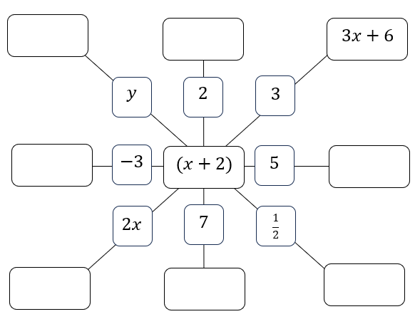

## Appendix D

### Perimeter and area problems

|  |  |
| --- | --- |
| Write an expression to find the area of the rectangle. Simplify the expression.  Rectangle with the expression 2x + 5 written along the length and the number 4 written along the width. | Write an expression to find the perimeter of the rectangle. Simplify the expression.  Rectangle with the expressions 2x + 5 written along the length and x + 4 written along the width. |
| If , find the perimeter of the rectangle.  Rectangle with the expressions 2x + 5 written along the length and x + 4 written along the width. | Write an expression to find the perimeter of the shape. Simplify the expression.  Upside-down L-shape. Expressions from the top, going in a clockwise direction are: 2x + 5, 2x + 8, x + 2 and x + 4. |

This activity is an adaptation of ‘Rectangular expressions’ (<https://ssddproblems.com/rectangular-expressions/>) from SSDD (Same Surface, Different Deep) Problems by Craig Barton (<https://ssddproblems.com/rectangular-expressions/>).

## Sample solutions

### Launch

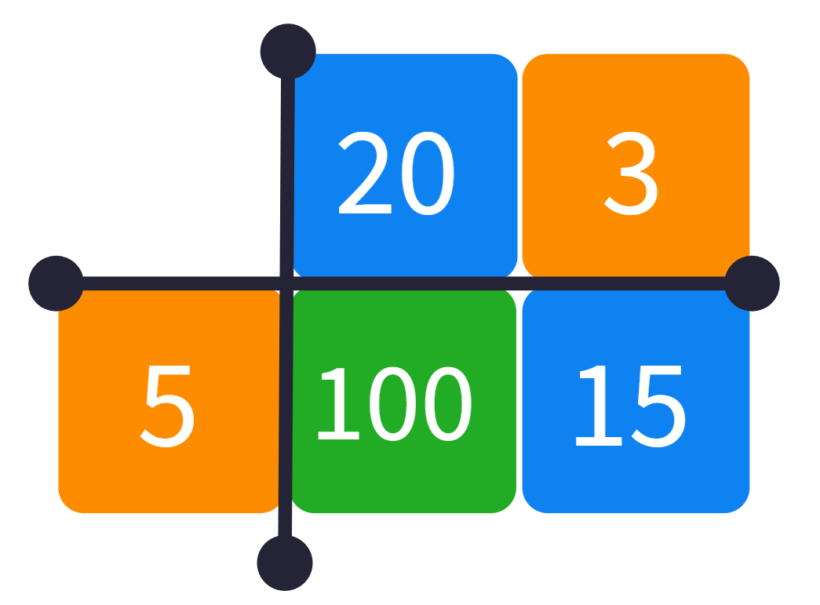

### Appendix A – expanding

|  |  |  |
| --- | --- | --- |
| Expression | Model | Expanded expression |
|  | Area model 4(x + 2).Area model 4(x + 2). |  |
|  | Area model 2(x + 4).Area model 2(x + 4). |  |
|  | Area model 2(x + 1).Area model 2(x + 1). |  |
|  | Area model 2(x − 1).Area model 2(x − 1). |  |
|  | Area model 3(x − 1).Area model 3(x − 1). |  |
|  | Area model 3(x − 4).Area model 3(x − 4). |  |
|  | Area model 4(x + 3).Area model 4(x + 3). |  |
|  | Area model 4(2x + 3).Area model 4(2x + 3). |  |
|  | Area model diagram 2(2x + 3).Area model diagram 2(2x + 3). |  |
|  | Area model diagram 2(2x − 1).Area model diagram 2(2x − 1). |  |
|  | Area model diagram 2(3x − 1).Area model diagram 2(3x − 1). |  |
|  | Area model diagram −2(3x − 1).Area model diagram −2(3x − 1). |  |
|  | Area model diagram −2(3x + 1).Area model diagram −2(3x + 1). |  |
|  | Area model diagram 2x(3x + 1).Area model diagram 2x(3x + 1). |  |
|  | Area model diagram 2x(3x + 4).Area model diagram 2x(3x + 4). |  |

### Appendix B – four quadrant notes

|  |  |
| --- | --- |
| **Example 1**  Expand the binomial expression.  Area model diagram 3(x − 2). | **Example 2**  Expand the binomial expression.  Area model diagram 4(x − 3). |
| **Things to remember**   * What is out the front of the brackets is multiplied by everything inside the brackets. * Be careful of the sign of the terms inside the brackets – whether they are positive or negative. | **Example 3**  Expand the binomial expression  Area model diagram 5(x + 3). |

### Appendix C – spider activity

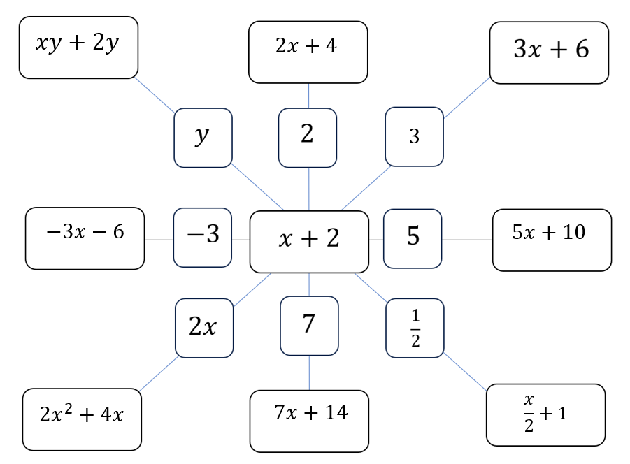

### Appendix D – perimeter and area problems

**First quadrant**

$$4×\left(2x+5\right) \\ =4(2x+5) \\ =8x+20$$

**Second quadrant**

$$2×\left(2x+5\right)+2×\left(x+4\right) \\ =4x+10+2x+8 \\ =6x+18$$

**Third quadrant**

$6x+18$ (expression from above) $$=6×3+18 \\ =36$$

**Fourth quadrant**

$$2×\left(2x+5\right)+2×\left(2x+8\right) \\ =4x+10+4x+16 \\ =8x+26$$

### Apply – extension

\The expression will always be 5 times the value of $n$.

## References

This resource contains NSW Curriculum and syllabus content. The NSW Curriculum is developed by the NSW Education Standards Authority. This content is prepared by NESA for and on behalf of the Crown in right of the State of New South Wales. The material is protected by Crown copyright.

Please refer to the NESA Copyright Disclaimer for more information <https://educationstandards.nsw.edu.au/wps/portal/nesa/mini-footer/copyright>.

NESA holds the only official and up-to-date versions of the NSW Curriculum and syllabus documents. Please visit the NSW Education Standards Authority (NESA) website <https://educationstandards.nsw.edu.au> and the NSW Curriculum website <https://curriculum.nsw.edu.au>.

[Mathematics K–10 Syllabus](https://curriculum.nsw.edu.au/learning-areas/mathematics/mathematics-k-10-2022/overview) © NSW Education Standards Authority (NESA) for and on behalf of the Crown in right of the State of New South Wales, 2022.

Barton C (n.d.) [*About the site*](https://ssddproblems.com/about-the-site/), SSDD Problems website, accessed 18 October 2024.

Barton C (n.d.) [*Rectangular expressions*](https://ssddproblems.com/rectangular-expressions/), SSDD Problems website, accessed 18 October 2024.

**© State of New South Wales (Department of Education), 2024**

The copyright material published in this resource is subject to the Copyright Act 1968 (Cth) and is owned by the NSW Department of Education or, where indicated, by a party other than the NSW Department of Education (third-party material).

Copyright material available in this resource and owned by the NSW Department of Education is licensed under a [Creative Commons Attribution 4.0 International (CC BY 4.0) license](https://creativecommons.org/licenses/by/4.0/).

[](https://creativecommons.org/licenses/by/4.0/)

This license allows you to share and adapt the material for any purpose, even commercially.

Attribution should be given to © State of New South Wales (Department of Education), 2024.

Material in this resource not available under a Creative Commons license:

* the NSW Department of Education logo, other logos and trademark-protected material
* material owned by a third party that has been reproduced with permission. You will need to obtain permission from the third party to reuse its material.

**Links to third-party material and websites**

Please note that the provided (reading/viewing material/list/links/texts) are a suggestion only and implies no endorsement, by the New South Wales Department of Education, of any author, publisher, or book title. School principals and teachers are best placed to assess the suitability of resources that would complement the curriculum and reflect the needs and interests of their students.

If you use the links provided in this document to access a third-party's website, you acknowledge that the terms of use, including licence terms set out on the third-party's website apply to the use which may be made of the materials on that third-party website or where permitted by the Copyright Act 1968 (Cth). The department accepts no responsibility for content on third-party websites.