Survival of the fittest
Students revise measures of centre and spread by splitting people into teams for the television show ‘Survivor’.

Visible learning

Learning intentions
- To be able to use data displays to compare datasets.
- To be able to use measures of centre and spread to compare datasets.

Success criteria
- I can find measures of centre and spread.
- I can create data displays to help inform decisions.
- I can explain the decisions I make using mathematical evidence.

Syllabus outcomes
A student:
- develops understanding and fluency in mathematics through exploring and connecting mathematical concepts, choosing and applying mathematical techniques to solve problems, and communicating their thinking and reasoning coherently and clearly MAO-WM-01
- classifies and displays data using a variety of graphical representations MA4-DAT-C-01
- analyses simple datasets using measures of centre, range and shape of the data
MA4-DAT-C-02
Mathematics K–10 Syllabus © NSW Education Standards Authority (NESA) for and on behalf of the Crown in right of the State of New South Wales, 2022.

Activity structure

Launch
- Start a class discussion by asking students if they have ever watched the TV show ‘Survivor’.
- Use a Think-Pair-Share (bit.ly/thinkpairsharestrategy) for students to discuss how they think the producers pick the teams in the beginning so that the teams are competitive.
The TV show ‘Survivor’ is a reality TV show. Participants are placed in teams, normally 2 teams, and are taken to a remote location. They compete in challenges, which are often very physical, to win rewards and to avoid going to tribal council. At tribal council, team members vote out a member of their own team. As the number of participants decreases, the teams merge. Eventually, there are 3 remaining participants. At this point, some of the participants who were voted out form a jury to decide who the winner is.
- Use a Pose-Pause-Pounce-Bounce (PDF 557 KB) (bit.ly/posepausepouncebounce) questioning strategy for pairs to share their thoughts and reasoning.

Explore
- Assign students into visibly random groups of 3 (bit.ly/visiblegroups) on vertical non-permanent surfaces (bit.ly/VNPSstrategy).
- Read the following scenario to students:
There is a new season of Survivor coming to our screens, but this year there is a twist! There are 3 teams competing. As the producers of the show, you must separate all the contestants into fair teams so that the challenges are competitive and make good television viewing.
- Distribute Appendix A ‘Contestant data’ to each group and ask students to create their teams.
- As students work on the task use the following assessing and advancing questions to progress student thinking.
Table 1: assessing and advancing questions
Assessing questions | Advancing questions
What have you noticed already? | What might you compare first?
What mathematical tools have you used so far? What others do you know? | What mathematical tools may help?
Which player would you want on your team? | How can we display the data to see patterns and trends?
Can you tell me why you have placed these people together? | How do you know your teams are even?
- Students are to do a gallery walk (bit.ly/DLSgallerywalk) of each other’s work and notice the similarities and differences in the teams.
- Start a class discussion using the following questions:
- What are the similarities and differences between the group’s team selections?
- What was similar or different to the way the groups approached the problem?
- What is interesting about the strategy you believe is best?
- After looking at the strategies used by other groups, how and why would you change your own strategy?

Summarise
- In their groups of 3, students are to write a description of the strategy they used for dividing the contestants into even teams, why they used this strategy and what they would change to make it more effective.
- Students are to do another gallery walk of each other’s working to give peer feedback using the TAG feedback strategy (bit.ly/TAGstrategy).

Apply
- Assign students into new visibly random groups of 3 at vertical non-permanent surfaces.
- Distribute Appendix B ‘Car data’ and ask students, given the data provided, can they rank the cars from the best to worst.
This statement is deliberately vague as we want students to determine what features will make cars the ‘best’ or the ‘worst’.
- Students are to create a presentation with data displays and statistics to justify their ranking of cars. They should also consider the following questions in their presentation:
- Was your approach effective? Why or why not?
- How would you modify your approach?
- What other data could we research to improve our list?
- Are there times when the best car might not be the best?

Assessment and differentiation

Suggested opportunities for differentiation
Launch
- There are no correct answers to how groups could be created, so all students should be encouraged to share their ideas and practise their communication and reasoning skills.
Explore
- Students could be challenged to perform their data analysis using a spreadsheet.
- To extend students, ask them what other information would be important when sorting the groups.
- Students with low readiness could be given a reduced list of participants to consider or a reduced number of fields.
- Students with low readiness will benefit from hearing the strategies used by other groups and can then practise using these strategies in the Apply section of the lesson.
Summarise
- Ask students to consider alternative scenarios, such as holding a year group team sports carnival at the school or hosting a robotics design and build day for visitors, in which participants need to be divided into teams.
Apply
- Students can be extended with the class discussion questions.
- Students with low readiness can use strategies suggested by other groups in the Explore and Summarise sections.
- Students with low readiness could be given a reduced list of cars to consider.

Suggested opportunities for assessment
Explore
- Monitor student’s calculations when making sense of the data.
- Monitor student responses to assessing and advancing questions, checking that students can refer to calculations and justify their decisions.
- Students could look at a different group’s working to evaluate how even their teams are.
Apply
- Students can provide peer feedback for another group using Two stars and a wish or the TAG strategy.
- Monitor student discussions, checking that students can refer to calculations and justify their decisions.
- Student presentations could be used as formative assessment.

Appendix A

Contestant data
Place the contestants into 3 even teams. Justify why you placed each person in a team.
Contestant | Fitness test | 100 m run | 800 m run | High jump | IQ puzzles completed
Betsy | Pass | 17.3s | 3:38 | 140 cm | 1
Caroline | Fail | 16.0s | 3:01 | 84 cm | 3
Daniel | Pass | 19.89s | 2:42 | 145 cm | 2
Ethan | Pass | 18.52s | 2:55 | 112 cm | 4
Jason | Pass | 16.48s | 2:55 | 94 cm | 2
Judi | Fail | 17.2s | 3:22 | 87 cm | 4
Linda | Pass | 20.2s | 4:00 | 132 cm | 3
Mack | Pass | 18.25s | 3:16 | 148 cm | 1
Maddi | Fail | 17.1s | 3:11 | 107 cm | 2
Margaret | Pass | 20.32s | 2:51 | 150 cm | 1
Michelle | Fail | 16.44s | 2:45 | 115 cm | 4
Rob | Fail | 19.2s | 3:12 | 127 cm | 6
Sandra | Fail | 17.34s | 3:50 | 135 cm | 5
Scott | Pass | 17.0s | 3:30 | 130 cm | 3
Susan | Pass | 18.3s | 3:00 | 140 cm | 2

Appendix B

Car data
Car | Fuel type | Cost | Fuel consumption (L/100 km) | Towing capacity (kg) | Transmission (speeds)
Toyota Land Cruiser Prado | Diesel | $66 552 | 8 | 3000 | 6
Nissan Navara | Diesel | $56 990 | 6.6 | 3500 | 7
Volkswagen Amarok | Diesel | $44 590 | 8.4 | 3250 | 6
Audi Q5 | Petrol | $78 950 | 5.4 | 2000 | 7
Kia Sorento | Petrol | $64 070 | 7.2 | 2000 | 6
Ford Ranger | Diesel | $66 190 | 8 | 3500 | 10
Mazda CX-8 | Petrol | $69 290 | 6 | 2000 | 6
Isuzu DMax | Diesel | $54 000 | 8 | 3500 | 6
BMW 5 Series | Petrol | $98 971 | 6.8 | 2000 | 1
Ford Everest | Diesel | $55 090 | 8.5 | 3000 | 10
Mitsubishi ASX | Petrol | $27 990 | 7.6 | 1300 | 1
Ram 1500 | Diesel | $94 450 | 12.2 | 4500 | 8
Hyundai Santa Fe | Diesel | $48 300 | 10.5 | 2500 | 6
Volvo XC60 | Petrol | $67 990 | 5.4 | 2300 | 8
BMW X1 | Diesel | $47 900 | 4.7 | 1400 | 1

Sample solutions

Appendix A – contestant data

Fitness test analysis
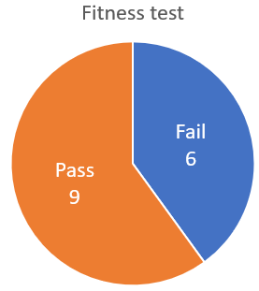
Since there is no extra information about what this is we placed this of high value as we assumed it may test their strength and fitness overall. Due to this we assigned contestants a score of zero or 5 depending on if they passed or failed to put them in a ranked list.

100 m run analysis

100 m run
Mean = 18.0 s
Median = 17.34
Range = 4.32
In context, 4 and a half seconds is a large difference for a 100 m run. There is a big difference in the mean and median when referring to the range as well. Because of this I rounded the numbers to the nearest second and used a frequency histogram.
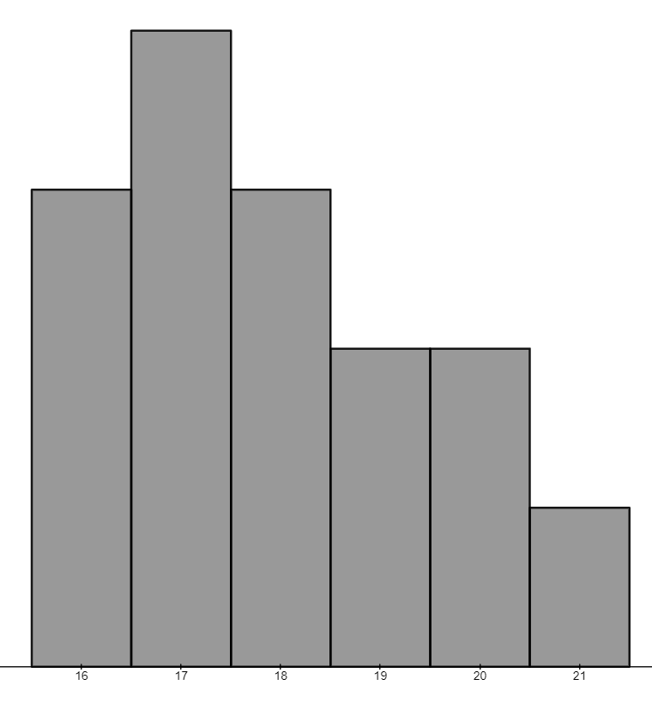
You can see from the shape of the data that you could say this is positively skewed so we will use the median as our best measure of centre.
We have aligned the values to the following for scores:
Rounded time | Score
16 | 0
17 | 1
18 | 1
19 | 3
20 | 5
21 | 5

800 m run analysis
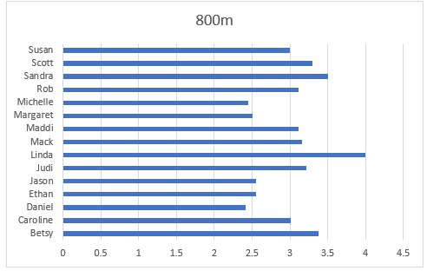
800 m run
Mean = 3.0 min
Median = 3.1 min
Range = 1:18
The range of this data suggests a big difference between participants. As the mean and median are similar, we are assuming this dataset is symmetrical and we can just use an ordered list.
We assigned their value by just the number of minutes they took to run the course and ignored the seconds. If they ran over 4 minutes, they were assigned a score of 2, 3 minutes earned a score of 3 and 2 minutes, a score of 4.

High jump analysis
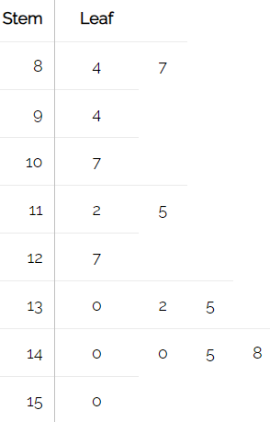
High jump
Mean = 123 cm
Median = 130 cm
Range = 66
This data is negatively skewed so we are using the median for our measure of centre. More people can jump high than those that can’t.
Due to this we have assigned the following values:
Height | Score
84–87 | 0
94–107 | 1
112–127 | 2
130–140 | 3
145–148 | 4
150 | 5

IQ puzzle analysis
IQ puzzles completed
Mean = 2.9
Median = 3
Mode = 2
Range = 5
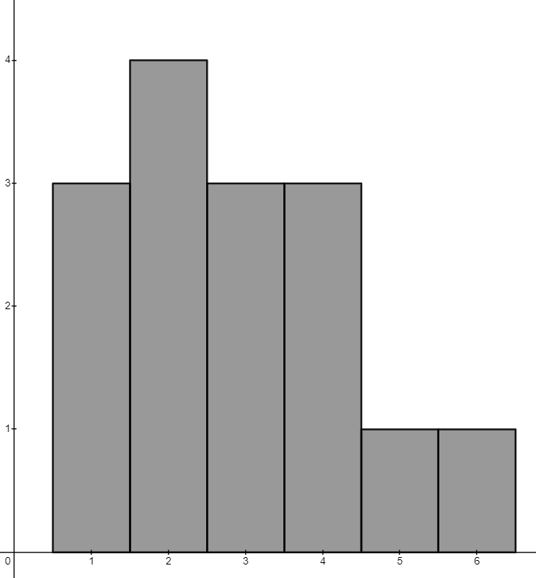
The graph is positively skewed which means that more people scored lower on the IQ test which means that we put more emphasis on the 2 people who scored higher.
Due to this we assigned the following scores:
IQ tests passed | Score
1 | 0
2 | 1
3 | 2
4 | 4
5–6 | 5

Overall analysis
Contestant | Fitness test | 100 m run | 800 m run | High jump | IQ puzzles | Total
Betsy | 5 | 1 | 3 | 3 | 0 | 12
Caroline | 0 | 0 | 3 | 0 | 2 | 5
Daniel | 5 | 5 | 4 | 4 | 1 | 19
Ethan | 5 | 2 | 4 | 2 | 4 | 17
Jason | 5 | 0 | 4 | 1 | 1 | 11
Judi | 0 | 1 | 3 | 0 | 4 | 8
Linda | 5 | 5 | 2 | 3 | 2 | 17
Mack | 5 | 1 | 3 | 4 | 0 | 13
Maddi | 0 | 1 | 3 | 1 | 1 | 6
Margaret | 5 | 5 | 4 | 5 | 0 | 19
Michelle | 0 | 0 | 4 | 2 | 4 | 10
Rob | 0 | 2 | 3 | 2 | 5 | 12
Sandra | 0 | 1 | 3 | 3 | 5 | 12
Scott | 5 | 1 | 3 | 3 | 2 | 14
Susan | 5 | 1 | 3 | 3 | 1 | 13
We tried to form the groups so their mean was as close as it could be for each group of our overall scores.
Team 1 | Team 2 | Team 3
19 – Daniel | 12 – Betsy | 11 – Jason
5 – Caroline | 17 – Linda | 12 – Rob
17 – Ethan | 10 – Michelle | 12 – Sandra
13 – Mack | 19 – Margaret | 14 – Scott
8 – Judi | 6 – Maddi | 13 – Susan
Mean = 12.4 | Mean = 12.8 | Mean= 12.4
The premise of the show may be ’Will an all-female team reign supreme?’

Appendix B – car data

Fuel type analysis
For the list I will be ignoring this measure as the fuel type doesn’t tell me much.

Cost analysis
I will look at cost last for value for money.
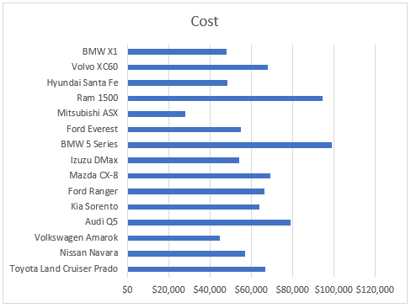
To see the spread better we rounded to the nearest $1000 and displayed in a stem and leaf.
You can see a big gap in the data between $28 000 and the larger values in the 90s.
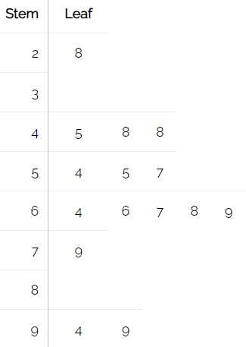
Cost
Mean = $62 755
Median = $64 070
Range = $70 981

Fuel consumption analysis
We rounded the numbers to show in a histogram.
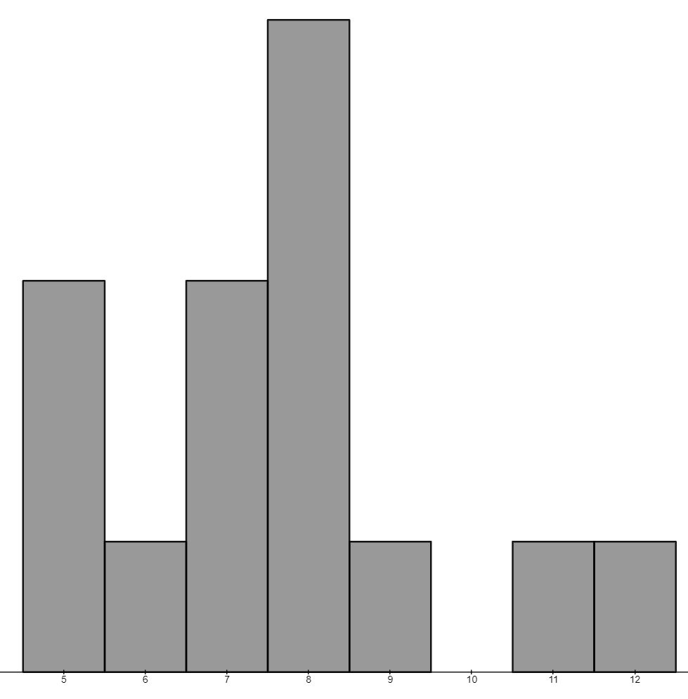
The graph shows most fuel efficiency is around 8L/100 km. 11 and 12 are quite large and the lower the better.
Fuel consumption (L/100 km)
Mean = 7.6 L/100 km
Median = 7.6 L/100 km
Range = 8

Towing capacity analysis
Towing is not high on our list of important things but is a great extra, especially if you like travelling.
An average caravan weighs 1800–2300 kg, and a boat weighs around 1550 kg.
Two values sit close below these values being 1300 and 1400. Four values sit within this range and may have some difficulties.
Towing capacity (kg)
Mean = 2650 kg
Median = 2500 kg
Mode = 2000 kg
Range = 3200 kg

Transmission analysis
The more gears the more efficient.
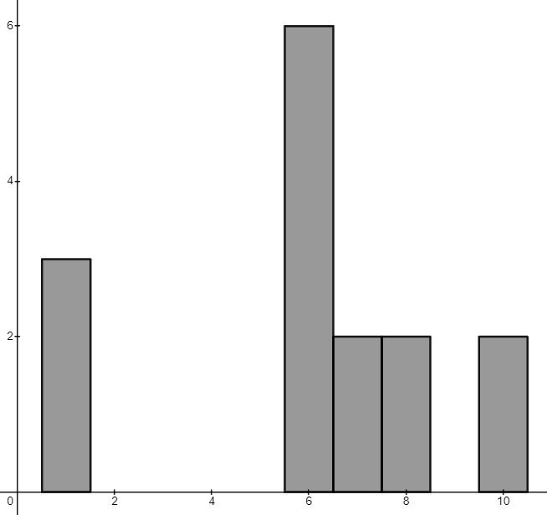
Transmission
Mean = 5.9
Median = 6
Mode = 6
Range = 9

Car list
Car | Fuel type | Cost | Fuel consumption (L/100 km) | Towing capacity (kg) | Transmission (speeds)
BMW X1 | Diesel | $47 900 | 4.7 | 1400 | 1
Volvo XC60 | Petrol | $67 990 | 5.4 | 2300 | 8
Audi Q5 | Petrol | $78 950 | 5.4 | 2000 | 7
Nissan Navara | Diesel | $56 990 | 6.6 | 3500 | 7
Mazda CX-8 | Petrol | $69 290 | 6 | 2000 | 6
Kia Sorento | Petrol | $64 070 | 7.2 | 2000 | 6
BMW 5 Series | Petrol | $98 971 | 6.8 | 2000 | 1
Toyota Land Cruiser Prado | Diesel | $66 552 | 8 | 3000 | 6
Mitsubishi ASX | Petrol | $27 990 | 7.6 | 1300 | 1
Ford Ranger | Diesel | $66 190 | 8 | 3500 | 10
Isuzu DMax | Diesel | $54 000 | 8 | 3500 | 6
Volkswagen Amarok | Diesel | $44 590 | 8.4 | 3250 | 6
Ford Everest | Diesel | $55 090 | 8.5 | 3000 | 10
Hyundai Santa Fe | Diesel | $48 300 | 10.5 | 2500 | 6
Ram 1500 | Diesel | $94 450 | 12.2 | 4500 | 8

References
This resource contains NSW Curriculum and syllabus content. The NSW Curriculum is developed by the NSW Education Standards Authority. This content is prepared by NESA for and on behalf of the Crown in right of the State of New South Wales. The material is protected by Crown copyright.
Please refer to the NESA Copyright Disclaimer for more information https://educationstandards.nsw.edu.au/wps/portal/nesa/mini-footer/copyright.
NESA holds the only official and up-to-date versions of the NSW Curriculum and syllabus documents. Please visit the NSW Education Standards Authority (NESA) website https://educationstandards.nsw.edu.au and the NSW Curriculum website https://curriculum.nsw.edu.au.
Mathematics K–10 Syllabus © NSW Education Standards Authority (NESA) for and on behalf of the Crown in right of the State of New South Wales, 2022.

© State of New South Wales (Department of Education), 2024
The copyright material published in this resource is subject to the Copyright Act 1968 (Cth) and is owned by the NSW Department of Education or, where indicated, by a party other than the NSW Department of Education (third-party material).
Copyright material available in this resource and owned by the NSW Department of Education is licensed under a Creative Commons Attribution 4.0 International (CC BY 4.0) license.
This license allows you to share and adapt the material for any purpose, even commercially.
Attribution should be given to © State of New South Wales (Department of Education), 2024.
Material in this resource not available under a Creative Commons license:
- the NSW Department of Education logo, other logos and trademark-protected material
- material owned by a third party that has been reproduced with permission. You will need to obtain permission from the third party to reuse its material.
Links to third-party material and websites
Please note that the provided (reading/viewing material/list/links/texts) are a suggestion only and implies no endorsement, by the New South Wales Department of Education, of any author, publisher, or book title. School principals and teachers are best placed to assess the suitability of resources that would complement the curriculum and reflect the needs and interests of their students.
If you use the links provided in this document to access a third-party's website, you acknowledge that the terms of use, including licence terms set out on the third-party's website apply to the use which may be made of the materials on that third-party website or where permitted by the Copyright Act 1968 (Cth). The department accepts no responsibility for content on third-party websites.

