The best centre
Students explore the location of the mean, median and mode in frequency graphs to determine the best measure of centre.

Visible learning

Learning intention
- To be able to select the best measure of centre to represent a dataset.

Success criteria
- I can explain how an outlier affects the measure of centre of a dataset.
- I can explain how a cluster affects the measure of centre of a dataset.
- I can select and explain the best measure of centre given the graph of its data.

Syllabus outcomes
A student:
- develops understanding and fluency in mathematics through exploring and connecting mathematical concepts, choosing and applying mathematical techniques to solve problems, and communicating their thinking and reasoning coherently and clearly MAO-WM-01
- analyses simple datasets using measures of centre, range and shape of the data
MA4-DAT-C-02
Mathematics K–10 Syllabus © NSW Education Standards Authority (NESA) for and on behalf of the Crown in right of the State of New South Wales, 2022.

Activity structure
Please use the associated PowerPoint The best centre to display images in this lesson.

Launch
- Start a class discussion by asking students if they know what the Big Bash League is and if someone could explain how it works to the class.
The Big Bash League is the Twenty20 national cricket competition in Australia. Each team has a maximum of 20 overs bowled to them, and each over has a total of 6 balls. Each ball you can run between the wickets to score runs. If the ball hits the boundary, you score 4 runs and if you hit the ball over the boundary, you score 6 runs.
- Display slide 2 from the PowerPoint The best centre. This slide contains a copy of Figure 1.
Figure 1: runs per over Brisbane Heat Big Bash final 2023.
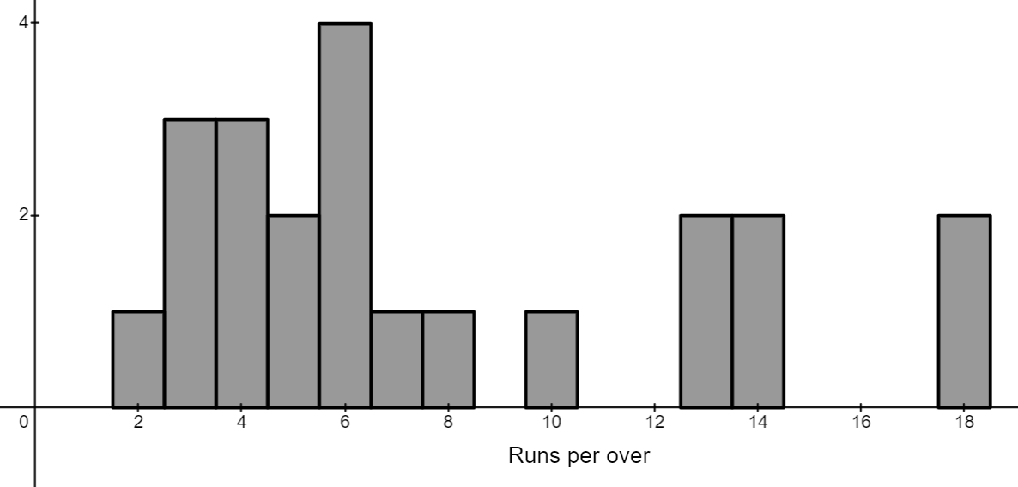
- In a Think-Pair-Share (bit.ly/thinkpairsharestrategy) ask students to discuss what they notice and what they wonder about the graph.
Students might notice that there were no overs where zero runs were scored. Students may wonder what combination of runs resulted in the over with 18 runs.
- Distribute Appendix A ‘Runs per over – Brisbane Heat Big Bash final 2023’ to each student, displayed in Figure 1.
- Ask students to estimate what the expected number of runs per over would be and to represent this by drawing a vertical line on their graph.
- Initiate a sharing of ideas and reasoning using the Pose-Pause-Pounce-Bounce question strategy (PDF 557 KB) (bit.ly/posepausepouncebounce). Students could also consider other factors that would affect the number of runs per over.
- Discuss with students what calculations we could perform to place our line and determine the expected number of runs more accurately.

Explore
During the Launch discussion, students should have suggested that we could use the mean, median or mode to determine a more accurate answer of how many runs to expect in an over.
- Distribute one graph from Appendix B ‘The best centre’ to each student.
- Ask students to find the mean, median and mode of their dataset and to draw and label vertical lines on their graph representing each measure of centre.
- Students are to find another student with the same graph and to compare their answers. If they are different, they are to discuss their methods and determine the correct solution together.
- Students are to display their graphs around the room.
- Using a gallery walk (bit.ly/DLSgallerywalk) students are to observe each graph and its measures of centre and pick 2 graphs that they find interesting to discuss with the class.

Students should pay attention to where the mean and median are on each graph and the shape of the graphs. Graphs that are symmetrical will show the mean and median to be similar numbers. In the more skewed graphs, there will be a greater difference between the mean and median. This can be seen in the sample solutions.
- Use the Pose-Pause-Pounce-Bounce question strategy to share what students discovered about the mean, median and mode in relation to the graphs and why they are in the positions that they are in relation to the data.
- Students are to do another gallery walk. This time they record which measure (mean, median or mode) they think best represents the middle of the data for each graph in their workbooks.
- Each graph can be found on slides 3–7 of the PowerPoint The best centre. Display each graph in turn and ask students to vote, using their fingers, which measure of centre they decided best represents the centre of each graph.
- Using the Pose-Pause-Pounce-Bounce questioning strategy, ask random students to explain why they selected the measure of centre they did.
When selecting students to elaborate on why they picked that measure, challenge them to use the terminology from previous lessons to describe the graphs, such as positively and negatively skewed, symmetrical, gaps, clusters and outliers.

Summarise
- In a class discussion, ask students ‘In what situations would you pick the median over the mean?’.
Students should establish that when data is skewed or includes outliers, we should use the median as our best measure of centre.
- Students are to create notes to their future forgetful selves (bit.ly/notesstrategy) on what the best measure of centre is to use in different situations.
- Assign students into visibly random groups of 3 (bit.ly/visiblegroups) on vertical non-permanent surfaces (bit.ly/VNPSstrategy).
- Distribute one copy of Appendix C ‘Runs per over’ to each group of students. This appendix contains the number of runs scored per over by 3 different teams in the last 6 matches of the Big Bash League 2023.
- Students are to complete the questions in the Appendix which include calculating and justifying the best measure of centre and using it to compare the teams.
Teachers can update the graphs to the most recent games for any team (men or women) from ‘Matches | cricket.com.au’ (cricket.com.au/matches).
- Initiate a sharing of responses by selecting random groups to explain their working.

Apply
- With students in new visibly random groups of 3 positioned at vertical non-permanent surfaces, distribute one copy of Appendix D ‘M and M’ to each group of students.
- Ask students to draw on their vertical non-permanent surfaces, a frequency distribution that satisfies each scenario.
- Groups of 3 are to combine with a neighbouring group of 3 to share their graphs and discuss if they each satisfied the conditions stated.
- Facilitate a class discussion using the Pose-Pause-Pounce-Bounce questioning strategy to have students describe the key features of the graphs they have drawn for each condition.

Assessment and differentiation

Suggested opportunities for differentiation
Launch
- The context of the data can be changed to best suit the interests of the class.
Explore
- To support students, modify the activity and give them the measures of centre to put on their graph and discuss with a partner in a Think-Pair-Share.
- To challenge students, give them a multimodal graph to justify what is the best measure of centre.
Summarise
- To enable students, you can give them sentence starters for their notes to their future forgetful selves.
- Students can use current data to compare the teams for the current season of the Big Bash cricket.
- Challenge students to explain why they can use the mean of one dataset to compare with the median or mode of another.
Apply
- Encourage students to draw a random data distribution and see where it fits the criteria.

Suggested opportunities for assessment
Explore
- Students finding the measures of centre on their graphs can be used as a formative assessment for calculating mean, median and mode.
- Students use of terminology can be assessed in class discussions.
Summarise
- Review students’ notes to their future forgetful selves.
- Collect Appendix C as an exit ticket.
Apply
- When placed in groups of 3, students provide and receive peer feedback on their understanding.
- Students will demonstrate their working mathematically skills in discussions and justifications.

Appendix A

Runs per over Brisbane Heat Big Bash final 2023

Appendix B

The best centre

Graph 1
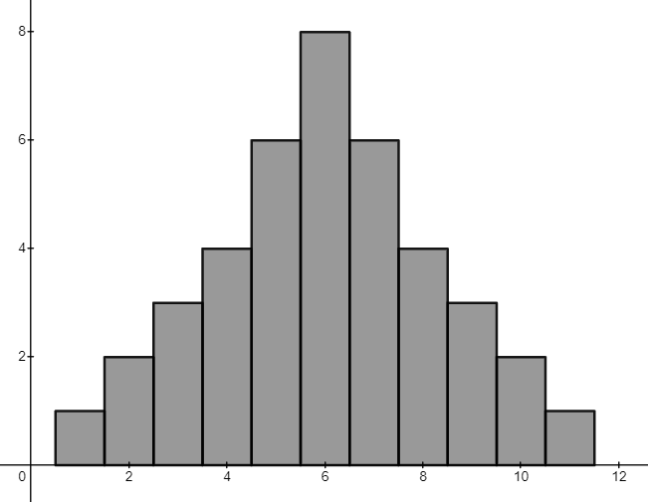

Graph 2
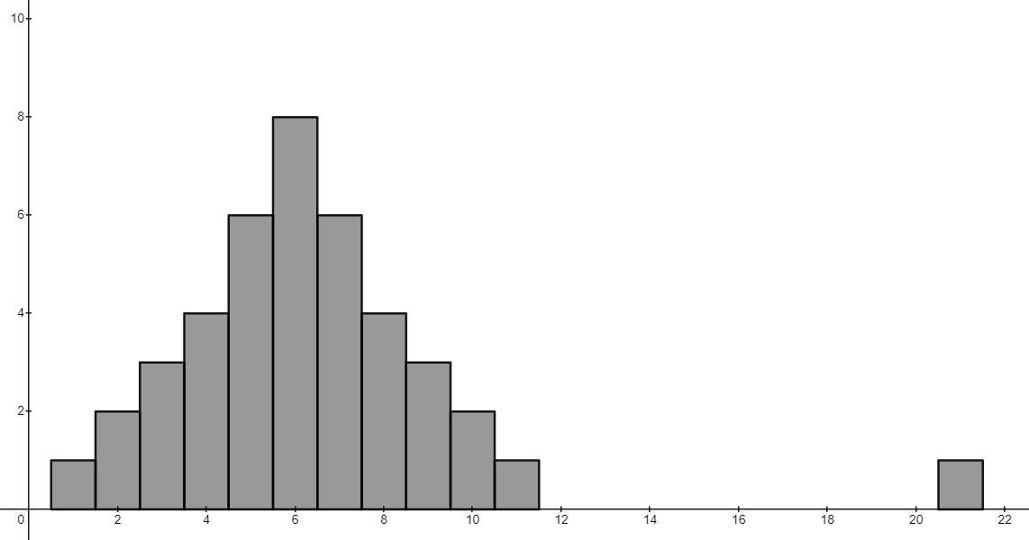

Graph 3
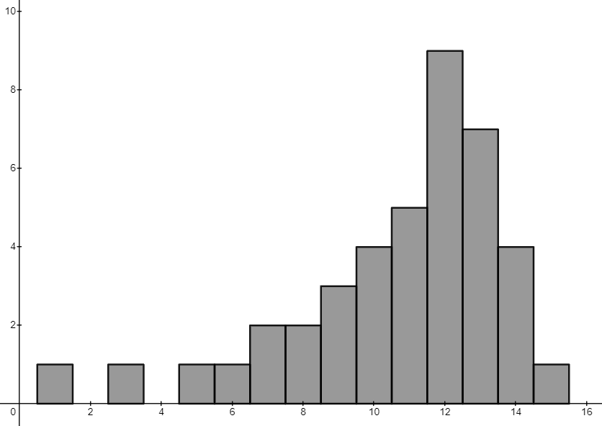

Graph 4
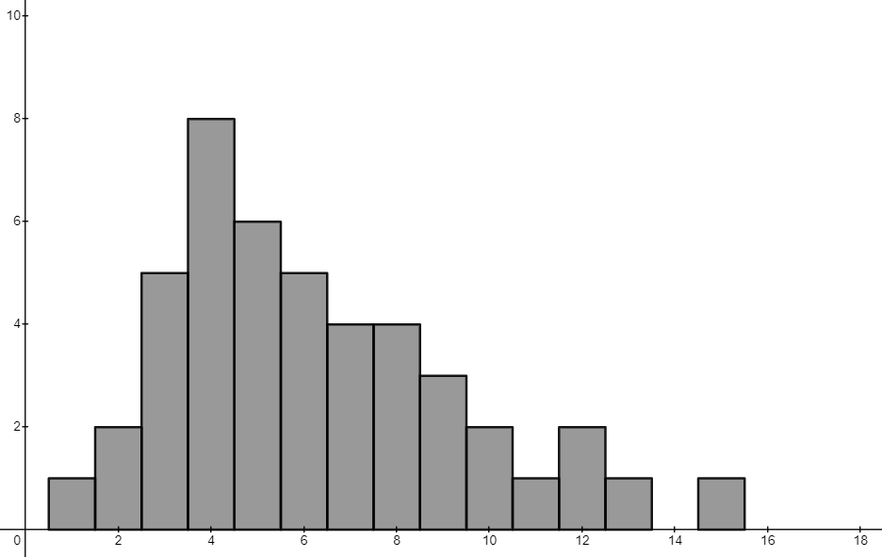

Graph 5
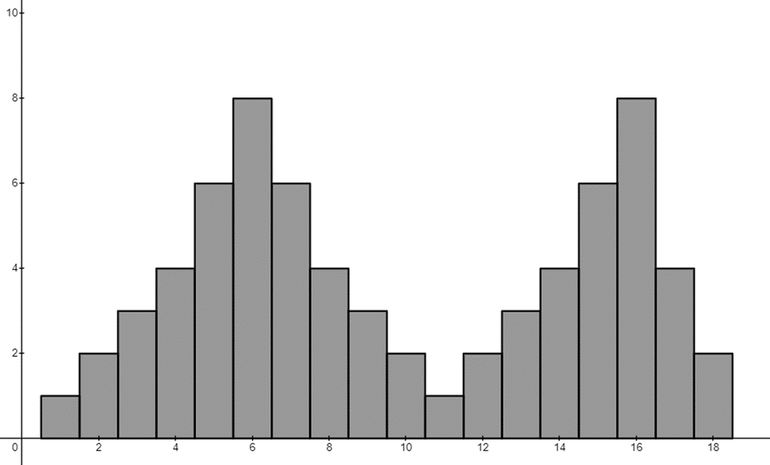

Appendix C

Runs per over

Sydney Sixers last 6 games for the 2023 season
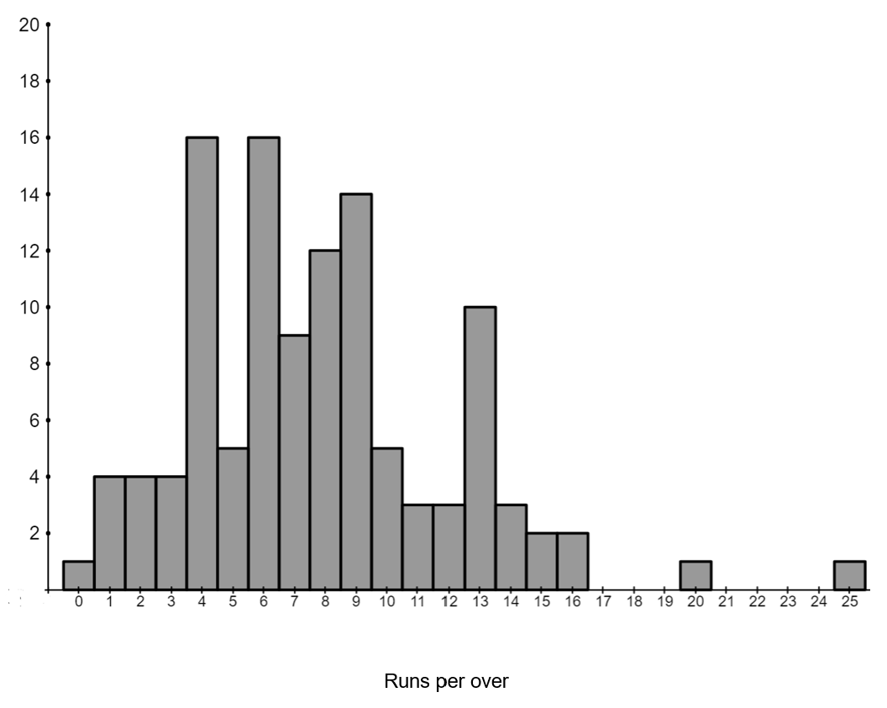

Sydney Thunders last 6 games for the 2023 season
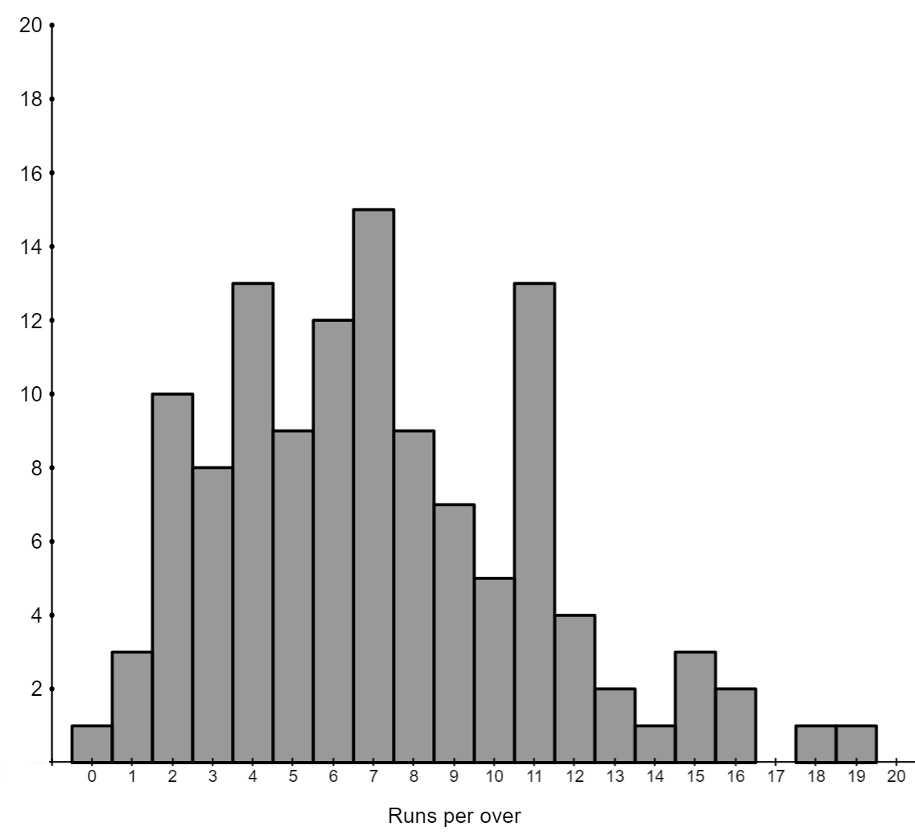

Brisbane Heat last 6 games for the 2023 season
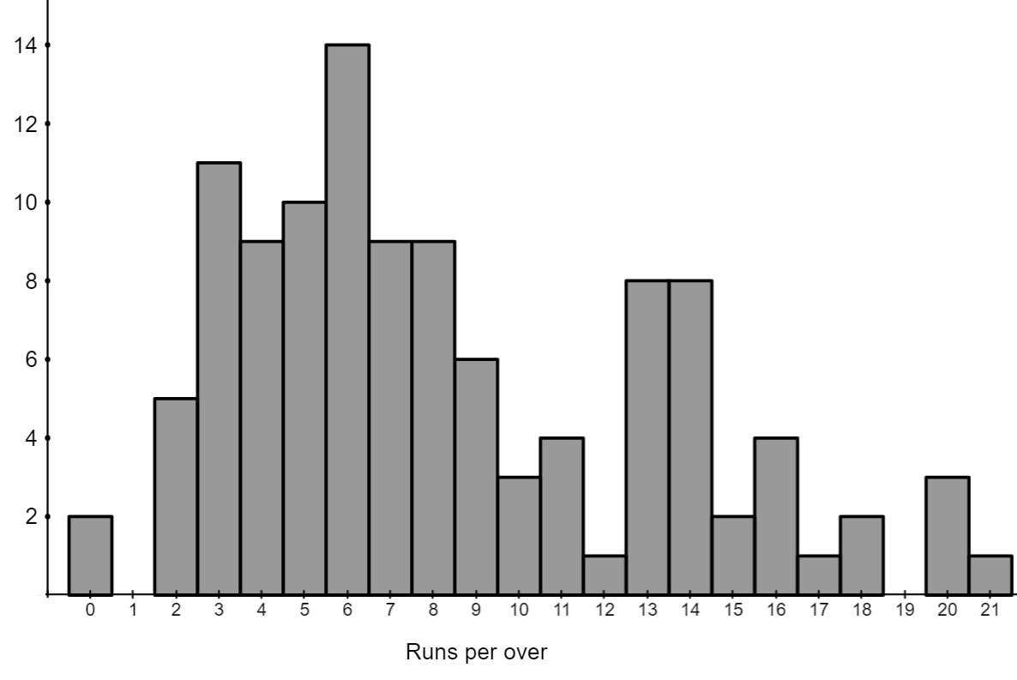

Questions
- Calculate the best measure of centre for each team and justify why that best represents the data.
- Explain what this number represents to the team, in terms of their runs per over.
- Which team would you consider the best? Justify, using your measures of centre.

Appendix D

M and M
Draw a frequency distribution that will satisfy the following properties.
- Mode < Median
- Mode < Mean
- Mean < Mode
- Mean < Median
- Median < Mode
- Median < Mean

Sample solutions

Appendix B – the best centre

Graph 1
Mean, median and mode are all 6.
Any measure of centre could be used to describe the centre as the data is symmetrical.

Graph 2
Median and mode are 6 and the mean is 6.36.
The outlier has moved the mean, so for this situation we can use the mode or median as our best measure of centre.

Graph 3
Median and mode are 12 and the mean is 10.66.
The median or mode would be the best measure of centre in this graph as it is negatively skewed, so the mean has been moved to a position that does not really represent the centre.

Graph 4
Mode is 4, median is 5 and the mean is 6.27.
It could be argued we can use either the mode or median in this situation to describe the centre of the data, as it is positively skewed which has shifted our mean. I would select the median as the best fit because when looking at the data as a whole.

Graph 5
Mode is 6 and 16, median is 9 and the mean is 9.87.
This situation is ambiguous and without a context of why we want to know the centre. Without that information I would argue that I would look at the mode of each as they are the centre of 2 separate clusters.

Appendix C – runs per over
- Calculate the best measure of centre for each team and justify why it represents the centre the best.
Graph | Measure of centre
- Sydney Sixers | The median is 7.  Median – as the data contains outliers and is also positively skewed which can affect the mean.
- Sydney Thunder | The mode is 7.  I believe the mode is the best measure for this data as it sits nicely within the main cluster of the data, which is slightly skewed.
- Brisbane Heat | The median is 7.  This data could be argued to be skewed. I compared all 3 measures of centre and took this on as the middle. The mean was 8.1 and the mode was 6. Since they are all around the same, I took the median as the data was not symmetrical.
- Explain what this number represents to the team, in terms of their runs per over.
This number represents the number of runs we would expect teams to score per over in a match.
We can use this to determine that teams should score $7×20=140$ runs in total for a match. This can tell us how a team went overall and if they played well or did not play well.
- Which team would you consider the best? Justify using your measures of centre.
Since they all had the same measure of centre, I would suspect these teams are pretty even. When looking at the mean of the teams Brisbane Heat comes out as the highest so even though they have the same 50% mark, for Brisbane Heat their top 50% included higher scores than that of the 2 Sydney teams.

Appendix D – M and M
- Mode < Median
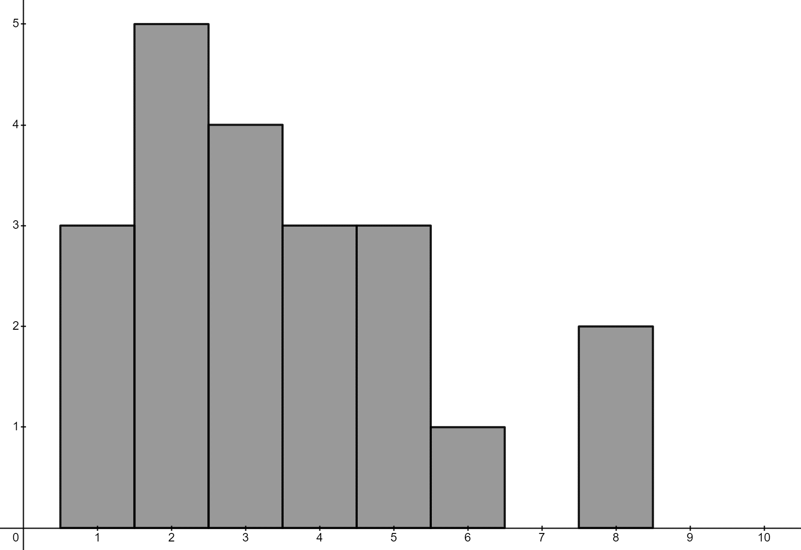
The mode of the data is less than 50% of the data provided, so it would be less than the median.
- Mode < Mean
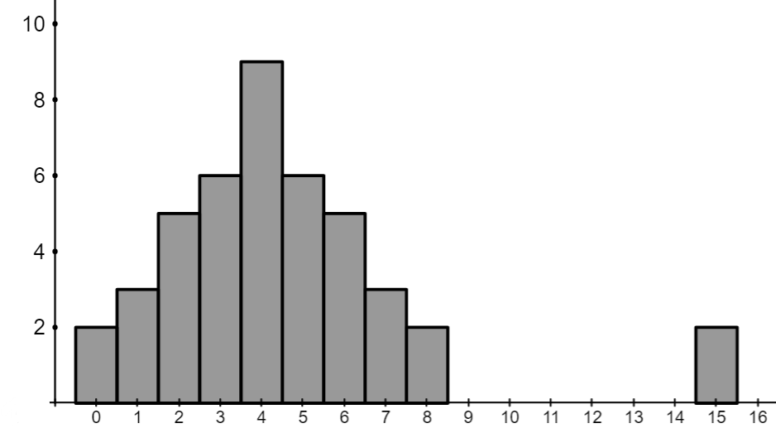
Since this graph contains an outlier it increases the value of the mean, but the mode would remain the same.

- Mean < Mode
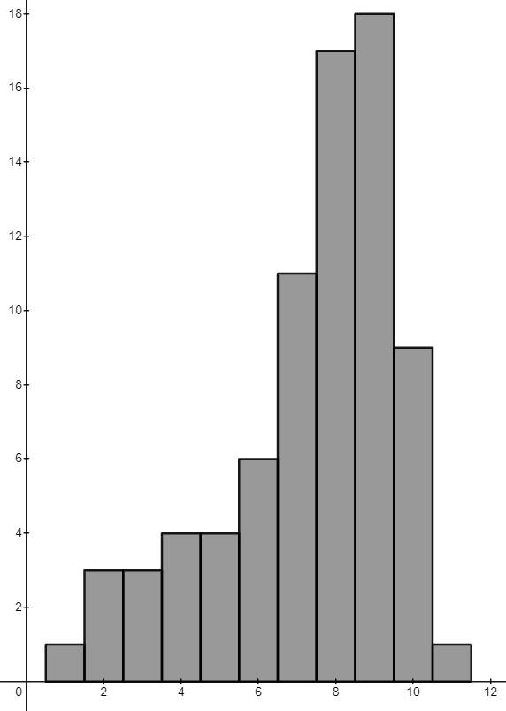
Since this graph is negatively skewed the mean would be less than the mode in this scenario.
- Mean < Median
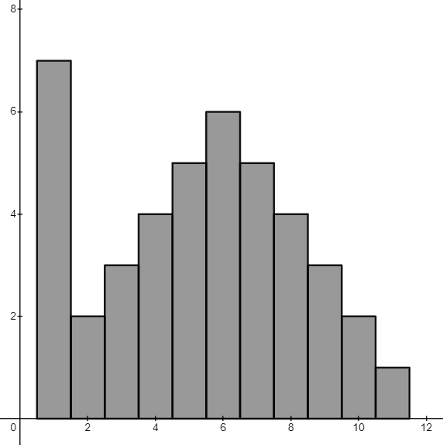
The cluster of scores at 1, would decrease the mean and move it closer to those values, making it less than the median as the cluster would not affect the median as significantly.

- Median < Mode
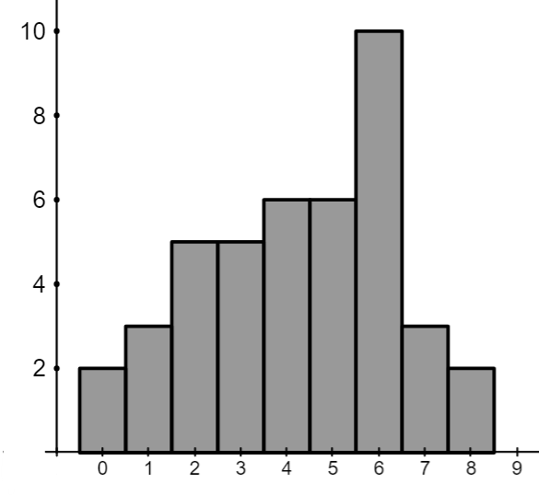
More than 50% of the scores are less than the mode in this scenario.
- Median < Mean
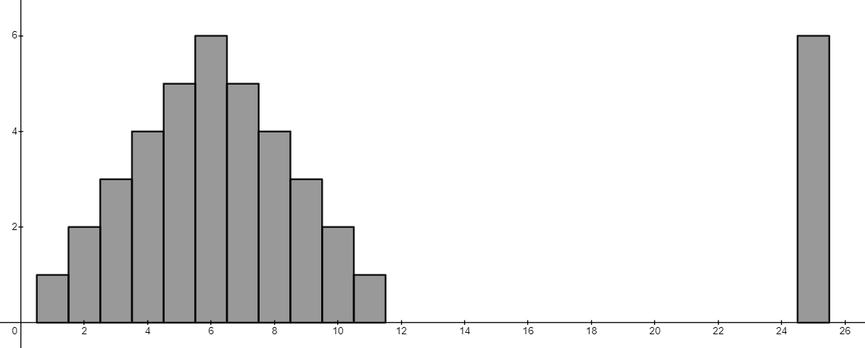
The outliers would increase the mean of the data, but not move the median as much. This would make the mean larger than the median.

References
This resource contains NSW Curriculum and syllabus content. The NSW Curriculum is developed by the NSW Education Standards Authority. This content is prepared by NESA for and on behalf of the Crown in right of the State of New South Wales. The material is protected by Crown copyright.
Please refer to the NESA Copyright Disclaimer for more information https://educationstandards.nsw.edu.au/wps/portal/nesa/mini-footer/copyright.
NESA holds the only official and up-to-date versions of the NSW Curriculum and syllabus documents. Please visit the NSW Education Standards Authority (NESA) website https://educationstandards.nsw.edu.au/ and the NSW Curriculum website https://curriculum.nsw.edu.au/home.
Mathematics K–10 Syllabus © NSW Education Standards Authority (NESA) for and on behalf of the Crown in right of the State of New South Wales, 2022.

© State of New South Wales (Department of Education), 2024
The copyright material published in this resource is subject to the Copyright Act 1968 (Cth) and is owned by the NSW Department of Education or, where indicated, by a party other than the NSW Department of Education (third-party material).
Copyright material available in this resource and owned by the NSW Department of Education is licensed under a Creative Commons Attribution 4.0 International (CC BY 4.0) license.
This license allows you to share and adapt the material for any purpose, even commercially.
Attribution should be given to © State of New South Wales (Department of Education), 2024.
Material in this resource not available under a Creative Commons license:
- the NSW Department of Education logo, other logos and trademark-protected material
- material owned by a third party that has been reproduced with permission. You will need to obtain permission from the third party to reuse its material.
Links to third-party material and websites
Please note that the provided (reading/viewing material/list/links/texts) are a suggestion only and implies no endorsement, by the New South Wales Department of Education, of any author, publisher, or book title. School principals and teachers are best placed to assess the suitability of resources that would complement the curriculum and reflect the needs and interests of their students.
If you use the links provided in this document to access a third-party's website, you acknowledge that the terms of use, including licence terms set out on the third-party's website apply to the use which may be made of the materials on that third-party website or where permitted by the Copyright Act 1968 (Cth). The department accepts no responsibility for content on third-party websites.

